Article
When Does a Career Contingency Hold? Between-Person and Within-Person Estimates of Sixteen Moderation Hypotheses in Two Longitudinal Cohorts of Young Workers
Xinyu Cai ¹ and Tiantian Mo ^{1,*}
Academic Editor: Firstname Lastname
Received: date
Revised: date
Accepted: date
Published: date
Citation: To be added by editorial staff during production.
Copyright: © 2026 by the authors. Submitted for possible open access publication under the terms and conditions of the Creative Commons Attribution (CC BY) license (https://creativecommons.org/licenses/by/4.0/).
¹ College of Business, Jiaxing University, Jiaxing 314001, China; caixinyu@zjxu.edu.cn
* Correspondence: 00008227@zjxu.edu.cn
Abstract
Career development theories describe what happens to a person as a career unfolds, whereas most evidence about the contingencies in those theories comes from moderation models fitted to comparisons between people. This study asked how far the two diverge for interaction terms specifically. 16 moderation hypotheses of the form routinely reported in the careers literature, each stating that the wage return to a career input depends on a characteristic of the worker or the job, were fixed in advance and estimated in two public longitudinal cohorts of young workers: 28,534 person-years on 4,711 women observed across 15 waves between 1968 and 1988, and 4,360 person-years on 545 men observed annually from 1980 to 1987. Each interaction was estimated one wave at a time, pooled across waves, and as separate between-person and within-person slopes in a single model, with standard errors clustered on the person and a false discovery rate correction across hypotheses. The between-person and within-person estimates carried opposite signs in 8 of 16 hypotheses and led to different substantive conclusions in 12; their equality was rejected in 6 after correction. The median divergence was 1.42 times the size of the within-person estimate itself. Of 160 single-wave estimates, 26 reached significance and 6 of those (23 per cent) pointed the opposite way to the within-person estimate. The two quantities answer different questions and should be reported separately rather than treated as one.
Keywords: career development; longitudinal data; moderation; within-person effects; youth employment

1. Introduction
Theories of career development describe a person moving through time. Social cognitive career theory has experience feeding self-efficacy and self-efficacy feeding further activity (Lent & Brown, 2013; Lent et al., 1994); career construction theory has a worker building a life story out of successive positions (Savickas, 2013). The claims are about accumulation inside a person, and the language used to state them — a career unfolds, a worker builds tenure, an interruption leaves a scar — is the language of within-person change.
The evidence assembled to test those claims mostly is not. Reviews of career success rest largely on samples of workers compared with one another at a moment (Ng et al., 2005; Spurk et al., 2019). Where a theory specifies a contingency — the return to some career input depends on some characteristic of the worker or the job — the contingency is usually tested by an interaction term in a regression across people. That coefficient is a statement about how workers who differ in the moderator also differ in the association between the input and the outcome. Whether it also describes what happens to a given worker as the input accumulates is a separate question, and it is one the design cannot answer.
That the two quantities can differ is not new. It is the substance of Mundlak’s decomposition of a panel slope into between-person and within-person parts (Mundlak, 1978), of the argument for treating the person as the unit of a psychological law (Molenaar, 2004), and of repeated methodological warnings in psychology that cross-sectional estimates are not summaries of longitudinal ones (Curran & Bauer, 2011; Hamaker et al., 2015; Maxwell & Cole, 2007). What has been much less examined is the size of the divergence for interaction terms, in real career data, for hypotheses of the kind the field actually reports. Main effects have been decomposed many times. Moderation, which is where the interesting theoretical claims live, has not.
There is reason to expect interactions to be the harder case. A between-person interaction is identified from the comparison of slopes across groups of people who differ in the moderator, and those groups differ in much else besides. Sorting on unobserved characteristics contaminates the difference of slopes as readily as it contaminates a slope, and the contamination need not have the same sign as the effect it disguises. A within-person interaction, by contrast, is identified from how a person’s own return to the input differs according to a characteristic that person carries, and the person’s fixed traits fall out of the comparison. Neither estimate is automatically the one wanted. They are answers to different questions, and the practical issue is how often, and how far, they disagree.
This study takes that question to data. Sixteen moderation hypotheses were written down in advance, each phrased as the careers literature phrases them, and each was estimated in two public longitudinal cohorts of young workers by four routes: one survey wave at a time, pooled across waves, and as separate between-person and within-person slopes inside a single model that permits a formal test of their equality. All sixteen are reported whatever they show.
Three questions are addressed. First, how often do the between-person and within-person estimates of the same interaction differ in sign, in significance, and by how much? Second, does a single survey wave — the design most career studies actually use — behave like the between-person estimate or the within-person one? Third, is the divergence robust, or an artefact of the transformation used to remove the person?

2. Background

2.1. What a Moderation Coefficient Is Identified From
Write the outcome for person $i$ at time $t$ as depending on a time-varying career input $x_{it}$, a moderator $w_{i}$ and their product, with a person term $α_{i}$ standing for everything stable about the person that the model does not measure. As Mundlak (1978) showed, pooled least squares then estimates a weighted average of two distinct quantities: how the product term differs across people, and how it operates inside them (Bell & Jones, 2015). The weights depend on how much of the variance in the input lies between people rather than within them, which is a property of the sample rather than of the theory.
The two components separate cleanly if the person mean of each time-varying term is entered alongside its deviation from that mean. The deviation carries the within-person slope, the mean carries the between-person slope, and the difference between them can be tested inside one model rather than by comparing two (Bell & Jones, 2015; Curran & Bauer, 2011; Mundlak, 1978). This is the specification used throughout what follows, because it makes the comparison the object of estimation rather than an informal contrast between separately reported tables.

2.2. Why the Moderator Is the Difficult Part
A moderator in career research is typically a characteristic that people possess rather than one they are assigned: a level of schooling, a union contract, a marriage, a region. People who possess it differ from those who do not in ways the model does not record, and those differences are the reason a between-person interaction is hard to read. Graduates do not merely hold degrees; they enter different firms, on different tracks, with different outside options. If those unmeasured differences also govern how the wage responds to tenure, the between-person interaction records their effect as if it were the effect of the degree.
A person-fixed comparison removes the stable part of that problem, and it can do so even when the moderator itself never changes. The main effect of a time-invariant moderator is absorbed, but its product with a time-varying input is not, because the input varies. The interaction therefore remains identified within the person while the person’s fixed traits do not (Baltagi, 2021; Wooldridge, 2010). What survives is not free of every difficulty: the transformation amplifies measurement error in the input, and time-varying confounders remain. The claim examined here is about divergence and its interpretation, not about one estimator being correct.

2.3. Career Inputs Whose Returns Are Thought to Be Contingent
The hypotheses used below are drawn from claims with a long record. That wages rise with employer tenure, and how much of that rise is specific to the employer rather than a property of the worker, has been contested for decades using exactly the panels analysed here: Altonji and Shakotko (1987) and Topel (1991) reached opposite conclusions from closely related data. The return to accumulated work experience is the oldest quantity in the field (Mincer, 1974). Whether an interruption to employment leaves a wage scar, and for whom, has been examined in several national cohorts (Arulampalam, 2001; Gregg & Tominey, 2005). Union coverage has been shown to raise wages by different amounts for different workers, in one of the two panels used here (Vella & Verbeek, 1998). Each of these literatures contains claims of the contingent form, and each is a claim about a career unfolding.

2.4. The Present Study
16 such claims were fixed in advance, eight in each cohort, and estimated by the four routes described above. The aim is not to adjudicate any one of them. It is to establish, across a set of hypotheses chosen before anything was estimated, how far the answer depends on which comparison the estimator makes.

3. Materials and Methods

3.1. Data
Two public longitudinal microdata sets on young workers were used. The first is the National Longitudinal Survey of Young Women (U.S. Bureau of Labor Statistics, 2024a), a cohort aged 14 to 24 when first interviewed in 1968 and followed to 1988. The extract analysed here is the one distributed with standard statistical software and reference packages, comprising 28,534 person-years on 4,711 women across 15 waves. Interviewing was annual early in the period and biennial later, so the intervals between observations are uneven.
The second is an extract from the National Longitudinal Survey of Youth 1979 (U.S. Bureau of Labor Statistics, 2024b) covering young men in full-time work, assembled for an earlier study of union wage effects (Vella & Verbeek, 1998). It is balanced: 545 men observed in each of the 8 years from 1980 to 1987, 4,360 person-years in all. Table 1 describes both panels and, for each variable, separates the standard deviation between people from the average standard deviation within them, which is what governs how much information each estimator has to work with.
Table 1. The two panels.
Panel | Variable | Mean | SD between people | SD within people
NLS Young Women | person-years | 28534 | — | —
— | people | 4711 | — | —
— | waves | 15 (1968-1988) | — | —
— | log hourly wage | 1.67 | 0.38 | 0.26
— | employer tenure | 3.12 | 2.70 | 1.88
— | work experience | 6.22 | 3.08 | 2.67
— | weekly hours | 36.56 | 6.37 | 6.52
— | weeks unemployed, per ten | 0.25 | 0.50 | 0.41
— | union coverage | 0.23 | 0.39 | 0.18
— | married | 0.60 | 0.37 | 0.24
— | years of schooling | 12.53 | 2.32 | 0.00
— | college graduate | 0.17 | 0.37 | 0.00
— | resident in the South | 0.41 | 0.47 | 0.06
— | urban residence | 0.72 | 0.41 | 0.08
— | Black | 0.28 | 0.45 | 0.00
NLSY79 young men | person-years | 4360 | — | —
— | people | 545 | — | —
— | waves | 8 (1980-1987) | — | —
— | log hourly wage | 1.65 | 0.39 | 0.32
— | work experience | 6.51 | 1.65 | 2.45
— | weekly hours | 21.91 | 3.81 | 3.73
— | union coverage | 0.24 | 0.33 | 0.20
— | married | 0.44 | 0.38 | 0.26
— | years of schooling | 11.77 | 1.75 | 0.00
— | college graduate | 0.01 | 0.09 | 0.00
— | post-secondary schooling | 0.24 | 0.43 | 0.00
— | resident in the South | 0.35 | 0.46 | 0.03
— | urban residence | 0.80 | 0.36 | 0.08
— | Black | 0.12 | 0.32 | 0.00
Note: Log hourly wage is the outcome throughout. The between-person standard deviation is taken over person means; the within-person standard deviation is the average of each person’s own standard deviation. Weekly hours are recorded per week in the women’s panel and per hundred annual hours in the men’s. Union coverage and weeks unemployed were not asked in every wave of the women’s panel, so those specifications use fewer observations. Source: authors’ calculations from the two panels.
As a check that the files had been read as intended, the person fixed-effects wage equation reported for the men’s extract in a standard econometrics text was refitted before anything else was done. All three reported coefficients were reproduced to four decimal places. The outcome throughout is the log hourly wage.

3.2. Hypotheses
The 16 hypotheses appear in Table 2. Each states that the wage return to a time-varying career input depends on a characteristic of the worker or the job, and each is phrased in the direction the literature usually asserts. They were written down, together with the control set and the estimation plan, before any of them was fitted. None was added, dropped or reworded afterwards, and all sixteen are reported below.
Table 2. The sixteen moderation hypotheses, fixed before estimation.
# | Panel | Career input | Moderator | Claim
W1 | NLS Young Women | employer tenure | college graduate | Employer tenure raises wages more for college graduates.
W2 | NLS Young Women | work experience | college graduate | General work experience raises wages more for college graduates.
W3 | NLS Young Women | employer tenure | union coverage | Employer tenure raises wages more under a union contract.
W4 | NLS Young Women | weeks unemployed, per ten | college graduate | Time spent unemployed depresses wages less for college graduates.
W5 | NLS Young Women | weeks unemployed, per ten | union coverage | Time spent unemployed depresses wages less for union members.
W6 | NLS Young Women | work experience | married | Work experience raises wages less for married women.
W7 | NLS Young Women | weekly hours | college graduate | Longer hours raise wages more for college graduates.
W8 | NLS Young Women | employer tenure | resident in the South | Employer tenure raises wages less in the South.
M1 | NLSY79 young men | work experience | post-secondary schooling | Work experience raises wages more for those with post-secondary schooling.
M2 | NLSY79 young men | work experience | union coverage | Work experience raises wages less under a union contract.
M3 | NLSY79 young men | work experience | married | Work experience raises wages more for married men.
M4 | NLSY79 young men | weekly hours | post-secondary schooling | Longer hours raise wages more for those with post-secondary schooling.
M5 | NLSY79 young men | union coverage | post-secondary schooling | The union wage premium is smaller for the more educated.
M6 | NLSY79 young men | work experience | resident in the South | Work experience raises wages less in the South.
M7 | NLSY79 young men | weekly hours | union coverage | Longer hours raise wages less under a union contract.
M8 | NLSY79 young men | married | post-secondary schooling | The marriage wage premium is smaller for the more educated.
Note: Each claim is stated in the direction the literature usually asserts. All sixteen are reported in Table 3 whatever they show. Source: authors’ calculations from the two panels.

3.3. Specification
Every specification carries the focal input, the moderator, their product, and a common set of controls: for the women, tenure and its square, experience and its square, weekly hours, union coverage, marital status, region and urban residence; for the men, experience and its square, hours, union coverage, marital status, region and urban residence. Cross-sectional and pooled specifications add the person-level variables that a fixed-effects specification absorbs: years of schooling, the education indicator and ethnicity. Calendar time is carried by year indicators. In the balanced men’s extract, recorded experience rises by exactly one year in every year for every man, so year indicators would absorb it entirely; those four specifications carry a linear trend instead, and the resulting within-person estimate mixes the accumulation of experience with the wage trend of the period. That limitation is confined to those four hypotheses and is noted where they appear.

3.4. Estimators
Each interaction was estimated four ways. The first fits the specification to a single survey wave, which is the design most career studies use; this was repeated for every wave with at least sixty observations, giving a distribution of single-wave answers rather than one. The second pools all waves. The third and fourth come from a single model in which the focal input and the product term each enter twice, once as the deviation from the person’s own mean and once as that mean, so that the within-person and between-person slopes are estimated jointly and their difference tested directly (Bell & Jones, 2015; Mundlak, 1978). The test of equality is the panel-data analogue of the classical specification test (Hausman, 1978), carried out here as a linear contrast within the clustered covariance matrix rather than as a separate procedure.

3.5. Inference
Repeated observations of one worker are not independent, so all standard errors cluster on the person (Cameron & Miller, 2015). Interactions are interpreted as differences in slope, and simple slopes are formed in the usual way (Aiken & West, 1991). Because sixteen equality tests are reported, the false discovery rate was controlled across them at 5 per cent (Benjamini & Hochberg, 1995); both the uncorrected probability and the adjusted value appear in the tables, and the counts in the text refer to the adjusted values. Estimators were implemented directly and verified against data generated with known between-person and within-person slopes before being applied to the panels.

4. Results

4.1. Four Estimates of Each Interaction
Table 3 reports all 16 interactions estimated the four ways. The first two columns summarise the single-wave estimates, giving their median and their range across waves. The remaining columns give the pooled estimate, the between-person and within-person estimates from the joint model, their difference, and the test that the difference is zero.
Table 3. Each interaction estimated four ways.
# | Single wave, median | Single wave, range | Pooled | Between-person | Within-person | Difference | p | q
W1 | −0.005 | −0.021 to 0.013 | −0.005* | −0.013*** | 0.004 | 0.017 | <.001 | <.001
W2 | −0.004 | −0.026 to 0.023 | −0.001 | −0.007* | 0.003 | 0.010 | .017 | .046
W3 | −0.011 | −0.022 to 0.001 | −0.006** | −0.002 | −0.005*** | −0.006 | .041 | .094
W4 | 0.016 | −0.469 to 0.187 | 0.006 | 0.048 | −0.015 | −0.061 | .133 | .221
W5 | 0.019 | −0.047 to 0.099 | 0.022 | 0.041 | 0.012 | −0.045 | .138 | .221
W6 | 0.006 | 0.002 to 0.013 | −0.000 | 0.002 | −0.004* | −0.007 | <.001 | .003
W7 | −0.006 | −0.015 to −0.003 | −0.006*** | −0.004 | −0.006*** | −0.002 | .274 | .365
W8 | −0.011 | −0.025 to −0.002 | −0.007*** | −0.007 | −0.004** | 0.005 | .169 | .246
M1 | 0.017 | −0.023 to 0.129 | 0.028** | −0.006 | 0.031*** | 0.035 | .397 | .445
M2 | 0.008 | −0.017 to 0.044 | −0.013 | 0.008 | −0.014* | −0.023 | .001 | .004
M3 | −0.016 | −0.033 to 0.006 | −0.013 | 0.004 | −0.016** | −0.028 | <.001 | <.001
M4 | 0.004 | −0.012 to 0.021 | 0.008 | 0.000 | 0.012* | 0.011 | .329 | .405
M5 | −0.066 | −0.231 to 0.038 | −0.083 | −0.140 | −0.075 | 0.063 | .663 | .663
M6 | −0.005 | −0.030 to 0.016 | −0.009 | −0.025* | −0.007 | 0.020 | .059 | .119
M7 | −0.010 | −0.028 to −0.005 | −0.014** | −0.008 | −0.008* | −0.006 | .009 | .030
M8 | 0.001 | −0.100 to 0.247 | 0.047 | −0.017 | 0.076 | 0.090 | .417 | .445
Note: Coefficients on the product of the career input and the moderator, from the specifications described in Section 3.3. Standard errors cluster on the person. The difference is the between-person estimate minus the within-person estimate; p tests that it is zero and q is that probability after controlling the false discovery rate across the sixteen tests. * p < .05, ** p < .01, *** p < .001. Source: authors’ calculations from the two panels.
The pattern is visible without any summary statistic. The between-person and within-person columns frequently differ in magnitude, often differ in sign, and the range of the single-wave estimates is in most rows wider than either panel estimate.

4.2. Where the Two Answers Disagree
Table 4 converts each pair of estimates into the verdict a reader would take from it — a positive moderation, a negative moderation, or none at the conventional threshold — and records where the two verdicts differ. The between-person and within-person estimates carried opposite signs in 8 of 16 hypotheses, and led to different substantive conclusions in 12. The formal test of their equality was rejected in 6 hypotheses after controlling the false discovery rate. The pooled estimate, which mixes the two components in proportions set by the data rather than by the question, reversed sign against the within-person estimate in 3 hypotheses and changed the verdict in 5.
Table 4. The verdict each estimate supports, and where the verdicts differ.
# | Panel | Interaction | Pooled | Between | Within | Sign reversed | Verdict changed | Equality rejected
W1 | NLS Young Women | employer tenure × college graduate | negative | negative | no moderation | yes | yes | yes
W2 | NLS Young Women | work experience × college graduate | no moderation | negative | no moderation | yes | yes | yes
W3 | NLS Young Women | employer tenure × union coverage | negative | no moderation | negative | no | yes | no
W4 | NLS Young Women | weeks unemployed, per ten × college graduate | no moderation | no moderation | no moderation | yes | no | no
W5 | NLS Young Women | weeks unemployed, per ten × union coverage | no moderation | no moderation | no moderation | no | no | no
W6 | NLS Young Women | work experience × married | no moderation | no moderation | negative | yes | yes | yes
W7 | NLS Young Women | weekly hours × college graduate | negative | no moderation | negative | no | yes | no
W8 | NLS Young Women | employer tenure × resident in the South | negative | no moderation | negative | no | yes | no
M1 | NLSY79 young men | work experience × post-secondary schooling | positive | no moderation | positive | yes | yes | no
M2 | NLSY79 young men | work experience × union coverage | no moderation | no moderation | negative | yes | yes | yes
M3 | NLSY79 young men | work experience × married | no moderation | no moderation | negative | yes | yes | yes
M4 | NLSY79 young men | weekly hours × post-secondary schooling | no moderation | no moderation | positive | no | yes | no
M5 | NLSY79 young men | union coverage × post-secondary schooling | no moderation | no moderation | no moderation | no | no | no
M6 | NLSY79 young men | work experience × resident in the South | no moderation | negative | no moderation | no | yes | no
M7 | NLSY79 young men | weekly hours × union coverage | negative | no moderation | negative | no | yes | yes
M8 | NLSY79 young men | married × post-secondary schooling | no moderation | no moderation | no moderation | yes | no | no
Note: A verdict is the reading a coefficient supports at the conventional threshold. Sign reversal and verdict change compare the between-person estimate with the within-person estimate; equality is rejected when the false discovery rate adjusted probability is below .05. Source: authors’ calculations from the two panels.
The divergence is not small relative to what is being estimated. Taking the absolute difference between the two estimates and comparing it with the magnitude of the within-person estimate itself, the median ratio was 1.42: the disagreement between the two answers was typically larger than the answer. The between-person estimate was the larger of the two in 8 of 16 hypotheses, so the divergence is not simply attenuation in one direction. Figure 1 places both estimates for every hypothesis on a common scale, expressing each as the difference it implies in the response of the log hourly wage to a one within-person standard deviation change in the career input. Open markers are the between-person estimates, filled markers the within-person estimates, and a dagger marks the six hypotheses whose equality test survived the correction.
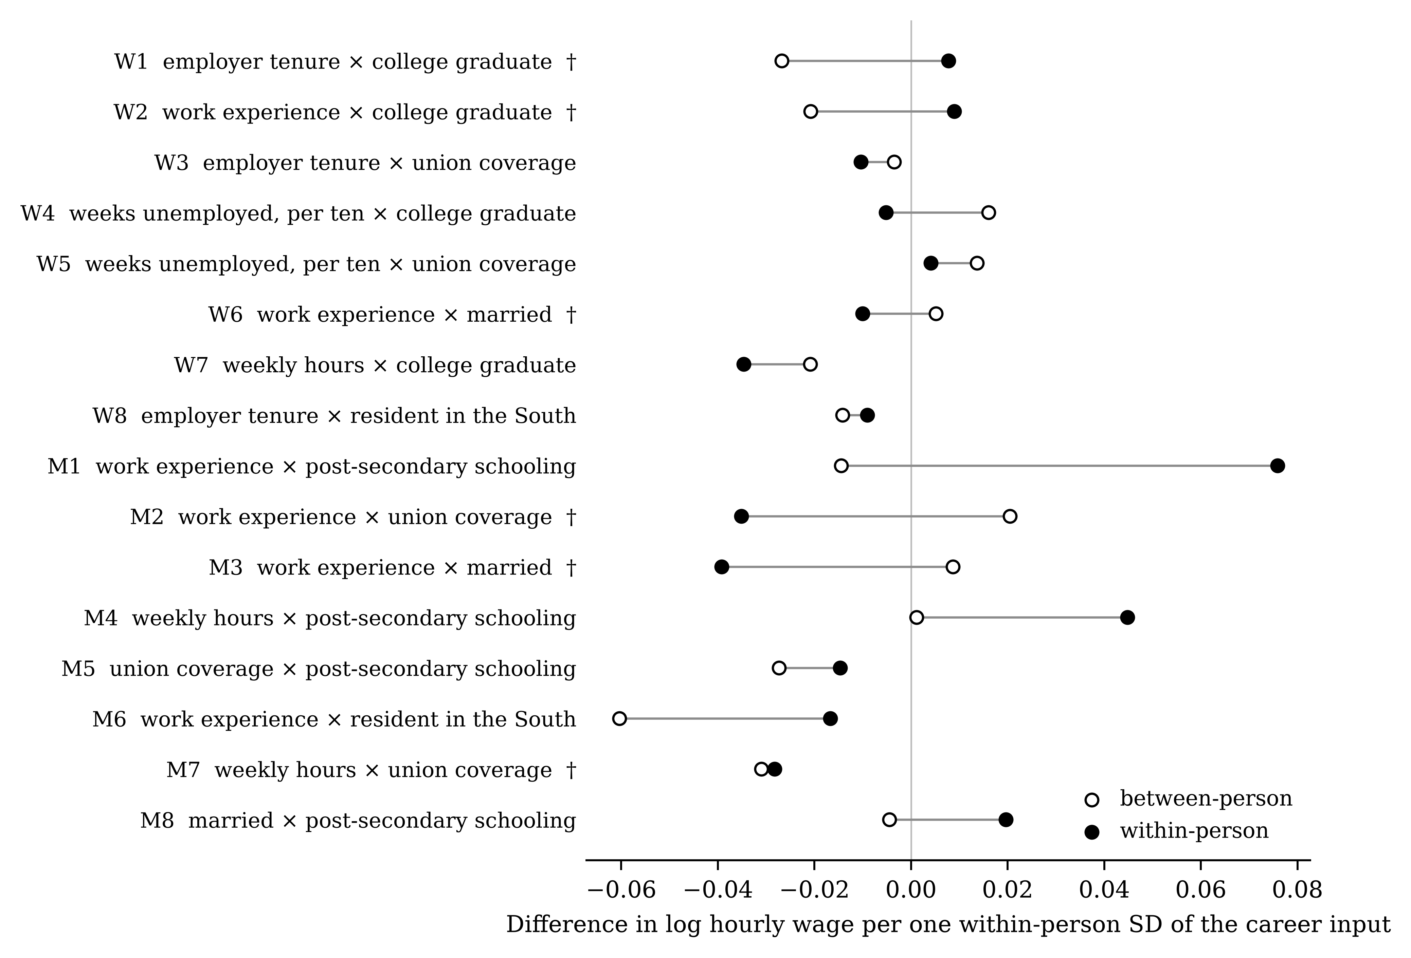
Figure 1. The between-person and within-person estimate of every interaction, expressed as the difference each implies in the response of the log hourly wage to a one within-person standard deviation change in the career input.

4.3. What a Single Wave Reports
The estimator most career studies actually use is none of these: it is a single cross-section. Table 5 treats each survey wave as a separate study. Across the 16 hypotheses this yields 160 single-wave estimates, with a median of 889 observations each, ranging from 545 to 2121. Of these, 26 reached the conventional threshold. 6 of those 26 significant findings (23 per cent) pointed the opposite way to the within-person estimate of the same quantity. Counting all single-wave estimates rather than only the significant ones, 60 of 160 carried the opposite sign.
Table 5. Every survey wave treated as a separate study.
# | Waves | Mean | SD | Significant | Positive | Negative | Within-person | Opposite sign
W1 | 12 | −0.005 | 0.010 | 2 | 0 | 2 | 0.004 | 10
W2 | 12 | −0.004 | 0.012 | 1 | 0 | 1 | 0.003 | 8
W3 | 12 | −0.011 | 0.006 | 2 | 0 | 2 | −0.005 | 1
W4 | 12 | −0.014 | 0.164 | 4 | 3 | 1 | −0.015 | 7
W5 | 12 | 0.016 | 0.038 | 0 | 0 | 0 | 0.012 | 3
W6 | 12 | 0.007 | 0.003 | 0 | 0 | 0 | −0.004 | 12
W7 | 12 | −0.007 | 0.004 | 6 | 0 | 6 | −0.006 | 0
W8 | 12 | −0.013 | 0.007 | 5 | 0 | 5 | −0.004 | 0
M1 | 8 | 0.023 | 0.047 | 0 | 0 | 0 | 0.031 | 3
M2 | 8 | 0.009 | 0.022 | 0 | 0 | 0 | −0.014 | 4
M3 | 8 | −0.016 | 0.013 | 0 | 0 | 0 | −0.016 | 1
M4 | 8 | 0.004 | 0.010 | 1 | 1 | 0 | 0.012 | 2
M5 | 8 | −0.088 | 0.106 | 1 | 0 | 1 | −0.075 | 2
M6 | 8 | −0.007 | 0.017 | 0 | 0 | 0 | −0.007 | 3
M7 | 8 | −0.013 | 0.008 | 3 | 0 | 3 | −0.008 | 0
M8 | 8 | 0.014 | 0.105 | 1 | 1 | 0 | 0.076 | 4
Note: Mean and SD are taken over the single-wave estimates of the interaction. Significant counts the waves reaching p < .05, split by sign in the two columns that follow. The last column counts the waves whose estimate carries the opposite sign to the within-person estimate of the same quantity. Source: authors’ calculations from the two panels.
Figure 2 shows the four hypotheses whose equality tests were most decisive, plotting each wave’s estimate with its interval against the two panel estimates. The single-wave estimates do not scatter around the within-person value. They scatter around the between-person value, which is what the algebra implies and what the figure makes plain: a cross-section estimates the between-person quantity, and repeating it in another year reproduces the same quantity rather than converging on the other one.
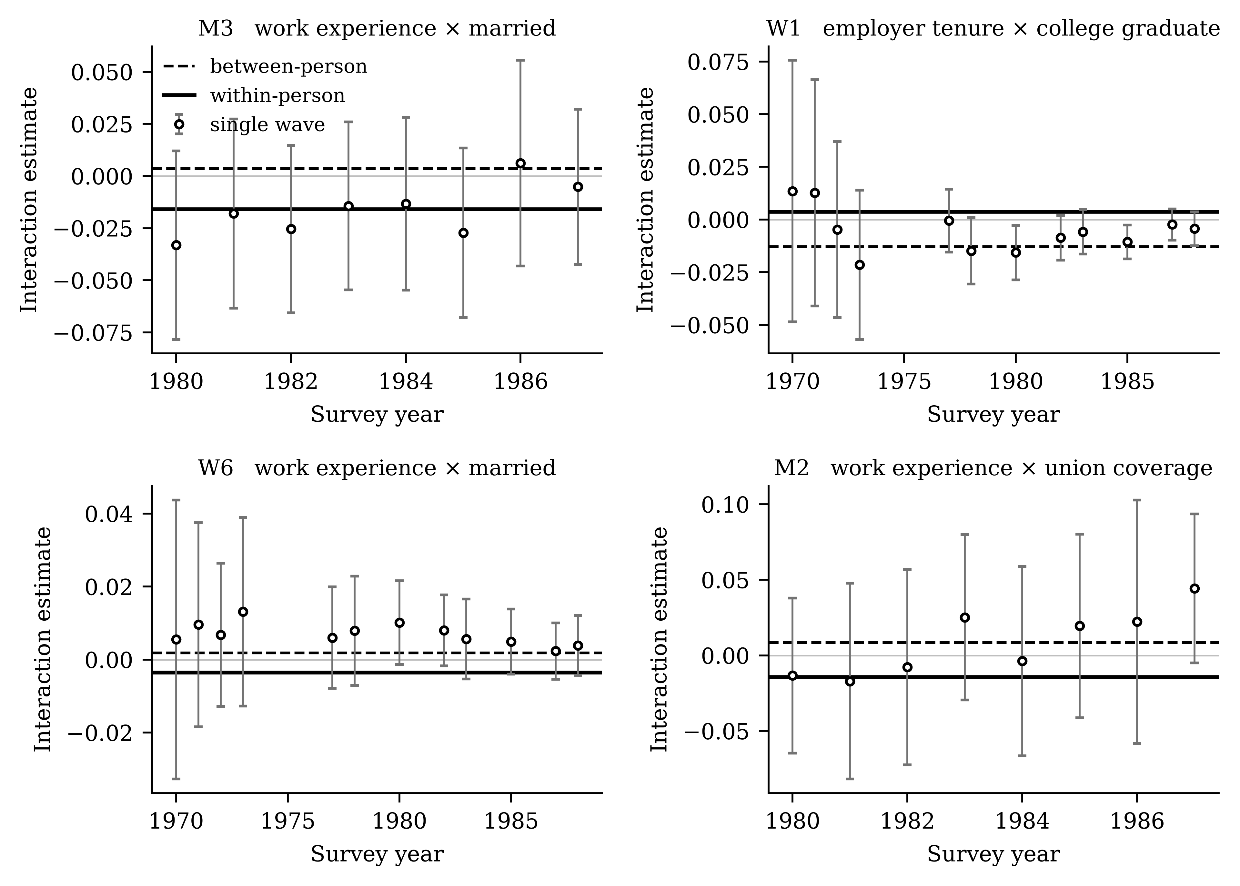
Figure 2. Single-wave estimates of four interactions, with 95% intervals, against the between-person and within-person estimates of the same quantities.

4.4. Robustness
If the divergence were an artefact of removing the person, it should not survive alternative ways of doing so. Table 6 refits every within-person estimate three further ways: restricted to workers observed at least three times, by first differences rather than the within transformation, and with the controls stripped back to the focal input, the moderator, their product and calendar time. The within-person estimate kept its sign under all three variations in 14 of 16 hypotheses. First differencing, which uses only consecutive pairs and is therefore the most demanding of the three, is where the two exceptions arise.
Table 6. The within-person estimate under three variations.
# | Baseline | Three or more waves | First differences | Minimal controls
W1 | 0.004 | 0.004* | 0.004 | 0.004
W2 | 0.003 | 0.004 | −0.001 | 0.004
W3 | −0.005*** | −0.005*** | −0.004* | −0.007***
W4 | −0.015 | −0.018 | −0.005 | −0.024
W5 | 0.012 | 0.010 | 0.001 | 0.009
W6 | −0.004* | −0.003* | −0.001 | −0.004*
W7 | −0.006*** | −0.006*** | −0.005*** | −0.007***
W8 | −0.004** | −0.004** | −0.005* | −0.003
M1 | 0.031*** | 0.031*** | 0.040*** | 0.037***
M2 | −0.014* | −0.014* | −0.011 | −0.015*
M3 | −0.016** | −0.016** | −0.008 | −0.022***
M4 | 0.012* | 0.012* | −0.004 | 0.014**
M5 | −0.075 | −0.075 | −0.010 | −0.095
M6 | −0.007 | −0.007 | −0.013 | −0.006
M7 | −0.008* | −0.008* | −0.002 | −0.009*
M8 | 0.076 | 0.076 | 0.031 | 0.093
Note: Minimal controls retains the career input, the moderator, their product and calendar time only. First differencing uses consecutive pairs of observations, which in the women’s panel are up to two years apart. * p < .05, ** p < .01, *** p < .001. Source: authors’ calculations from the two panels.

4.5. One Case in Detail
The clearest instance is the first hypothesis: that employer tenure raises wages more for college graduates. Estimated between people, the interaction was −.013 (SE = 0.004, p < .001) — tenure appearing to pay off substantially less for graduates. Estimated within people, it was .004 (SE = 0.002, p = .087), pointing weakly the other way. The two differ by .017 and their equality is rejected (t = 4.12, p < .001, q < .001). The pooled estimate, −.005 (p = .042), sits between them and would be read as supporting the between-person conclusion.
Figure 3 draws what each estimate implies for the wage profile over the first thirteen years of employer tenure, holding the rest of the specification fixed. Read between people, graduates gain markedly less from tenure than non-graduates; read within people, they gain slightly more. The substantive readings are not variants of one another. They point in opposite directions, and a study with one wave of data would have reported the first.
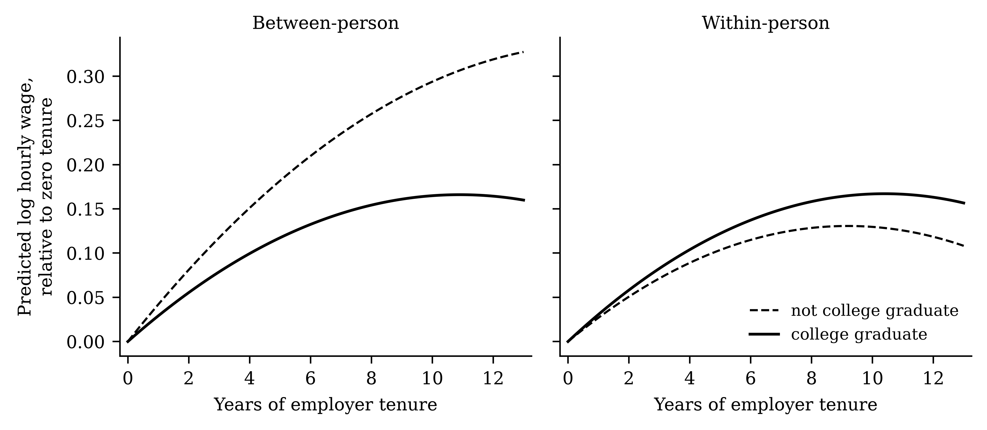
Figure 3. The wage profile over employer tenure that the between-person and within-person estimates imply for college graduates and non-graduates.

5. Discussion
Across sixteen career moderation hypotheses fixed in advance and estimated in two cohorts of young workers, the between-person and within-person answers disagreed often and by margins larger than the estimates themselves. Half the hypotheses produced estimates of opposite sign, three quarters produced different substantive verdicts, and in six the difference was too large to attribute to sampling variation even after correcting for multiplicity.
The result is not that one estimator is wrong. Between-person and within-person slopes are answers to different questions, and both questions are worth asking. Whether graduates enjoy steeper tenure profiles than non-graduates is a question about the structure of a labour market, and the between-person estimate answers it. Whether a given worker’s wage responds more to accumulating tenure because she holds a degree is a question about a career, and only the within-person estimate speaks to it. The difficulty is that career theories are written in the second language and tested with the first, and the translation is usually left implicit.
The single-wave results sharpen the practical point. A cross-sectional study does not produce a noisy version of the within-person estimate that more waves would refine. It produces the between-person estimate, and repeating it in a different year reproduces the between-person estimate again. Nearly a quarter of the significant single-wave findings here pointed the opposite way to the within-person estimate of the same quantity — not because those studies were underpowered or poorly executed, but because they were measuring something else.
This is the empirical counterpart of a warning psychology has issued repeatedly on theoretical grounds (Curran & Bauer, 2011; Hamaker et al., 2015; Molenaar, 2004), and of the parallel argument about mediation estimated on cross-sections (Cole & Preacher, 2014; Maxwell & Cole, 2007). What the present results add is a magnitude for the case of moderation, in real career data, for hypotheses of the kind the field reports: the disagreement is typically larger than the quantity in dispute. It also gives the warning of Hamaker et al. (2015) an interaction-shaped counterpart, since a moderation is the form in which career theories usually state their conditions.

5.1. What Follows for Practice
Three things follow. The first is a reporting convention. Where panel data exist, the between-person and within-person components of an interaction can be estimated in one model at no cost beyond two extra columns, and reporting both makes the ambiguity visible instead of leaving it to the reader (Bell & Jones, 2015; Curran & Bauer, 2011; Wang et al., 2017). Reporting only the pooled coefficient conceals a weighting whose value is a property of the sample.
The second is a matter of language. A cross-sectional moderation should be described as what it is: a statement about how workers who differ in the moderator differ in an association. Wording that implies accumulation — that a degree makes tenure pay off, that support buffers a person against a setback — asserts the within-person quantity, and the present results show that the two can point in opposite directions in the same data.
The third concerns design. Where the within-person question is the one of interest and no panel is available, the honest course is to state the limitation rather than to treat the cross-sectional estimate as an approximation to it. The two are not close in these data, and there was no feature of any single wave that would have signalled the difference to a researcher who had only that wave.

6. Limitations
The most obvious limitation is the vintage of the data. Both cohorts were surveyed between 1968 and 1988, and neither describes a contemporary labour market. The claim advanced here concerns how two estimators behave when applied to the same panel, which does not depend on the period; but the specific interactions reported should not be read as current estimates of anything. These two cohorts were chosen because they are among the few career panels with many waves that are public, documented and redistributable, so that the analysis can be checked.
Second, the within-person estimator is not a solution to confounding, only to the stable part of it. Anything that varies within a person and moves with both the career input and the wage remains. The transformation also amplifies measurement error in the input, which biases within-person estimates toward zero; that this would work against finding a within-person moderation makes the divergences reported here harder rather than easier to obtain, but it does not make the within-person estimate correct.
Third, the moderators are characteristics people hold rather than treatments they receive. Neither estimator recovers a causal effect of holding a degree or of being covered by a union contract. The comparison is between two descriptive quantities, and the paper claims no more.
Fourth, four of the sixteen hypotheses concern the return to experience in the balanced men’s panel, where experience and calendar time coincide within a person; those within-person estimates absorb the wage trend of the 1980s and should be read with that in mind. Finally, the outcome throughout is the log hourly wage. Career research also studies satisfaction, mobility and identity, and whether the divergence documented here is of similar size for those outcomes is an open question, and one that the growing number of long-running work and ageing panels now makes answerable.

7. Conclusions
Sixteen career moderation hypotheses, fixed in advance and estimated in two longitudinal cohorts of young workers, gave systematically different answers depending on whether the interaction was identified from differences between people or from change inside them. The estimates carried opposite signs in 8 of 16 cases and supported different conclusions in 12; their equality was rejected in 6 after correcting for multiplicity, and the typical disagreement exceeded the size of the estimate in dispute. Single-wave estimates tracked the between-person quantity rather than the within-person one, so collecting another cross-section does not close the gap.
Career theories make claims about people over time. Where panel data allow the two components of a moderation to be separated, they should be, and both should be reported. Where they do not, the quantity estimated should be named accurately, because in these data the two are not interchangeable and frequently point in opposite directions.
Author Contributions:
Conceptualization, X.C. and T.M.; methodology, X.C.; software, X.C.; validation, X.C. and T.M.; formal analysis, X.C.; data curation, X.C.; writing—original draft preparation, X.C.; writing—review and editing, T.M.; visualization, X.C.; supervision, T.M. All authors have read and agreed to the published version of the manuscript.
Funding:
This research received no external funding.
Institutional Review Board Statement:
Not applicable. The study is a secondary analysis of de-identified public-use microdata and involved no contact with human subjects.
Informed Consent Statement:
Not applicable. Informed consent was obtained by the agencies that conducted the original surveys.
Data Availability Statement:
The study analyses two public-use extracts of surveys conducted by the U.S. Bureau of Labor Statistics: the National Longitudinal Survey of Young Women (U.S. Bureau of Labor Statistics, 2024a) and the National Longitudinal Survey of Youth 1979 (U.S. Bureau of Labor Statistics, 2024b). Both extracts are redistributed with standard statistical software and reference packages; the men’s extract is the replication file of an earlier published study (Vella & Verbeek, 1998). No new data were created. The analysis code, which downloads the extracts, reproduces a published benchmark estimate as a check, and generates every table and figure in this article under a fixed random seed, is available from the corresponding author on request.
Conflicts of Interest:
The authors declare no conflicts of interest.

Appendix A
Table A1 reports, for each hypothesis, the slope of the focal career input estimated pooled and within the person, the two coefficients of determination, and the estimation sample. The focal slopes are shown because a difference in an interaction is easier to weigh against the main effect it modifies.
Table A1. The slope of the focal career input, and the estimation sample.
# | Career input | Pooled | Within-person | Pooled R² | Within R² | Person-years | People
W1 | employer tenure | 0.037*** | 0.028*** | 0.401 | 0.176 | 18964 | 4134
W2 | work experience | 0.042*** | 0.049*** | 0.401 | 0.176 | 18964 | 4134
W3 | employer tenure | 0.036*** | 0.030*** | 0.402 | 0.176 | 18964 | 4134
W4 | weeks unemployed, per ten | 0.001 | 0.005 | 0.401 | 0.174 | 13634 | 4010
W5 | weeks unemployed, per ten | −0.002 | 0.001 | 0.401 | 0.174 | 13634 | 4010
W6 | work experience | 0.042*** | 0.051*** | 0.401 | 0.176 | 18964 | 4134
W7 | weekly hours | 0.001* | −0.002* | 0.404 | 0.180 | 18964 | 4134
W8 | employer tenure | 0.040*** | 0.032*** | 0.402 | 0.176 | 18964 | 4134
M1 | work experience | 0.061*** | 0.059*** | 0.209 | 0.208 | 4360 | 545
M2 | work experience | 0.080*** | 0.070*** | 0.207 | 0.203 | 4360 | 545
M3 | work experience | 0.075*** | 0.068*** | 0.208 | 0.203 | 4360 | 545
M4 | weekly hours | −0.009*** | −0.017*** | 0.209 | 0.208 | 4360 | 545
M5 | union coverage | 0.198*** | 0.086*** | 0.208 | 0.205 | 4360 | 545
M6 | work experience | 0.080*** | 0.070*** | 0.207 | 0.202 | 4360 | 545
M7 | weekly hours | −0.004 | −0.012*** | 0.211 | 0.206 | 4360 | 545
M8 | married | 0.126*** | 0.029 | 0.208 | 0.205 | 4360 | 545
Note: The pooled coefficient of determination is computed on the outcome, the within-person one on the outcome after the person mean is removed, so the two are not comparable with one another. * p < .05, ** p < .01, *** p < .001. Source: authors’ calculations from the two panels.

References
Aiken, L. S., & West, S. G. (1991). Multiple regression: Testing and interpreting interactions. Sage.
Altonji, J. G., & Shakotko, R. A. (1987). Do wages rise with job seniority? The Review of Economic Studies, 54, 437–459.
Arulampalam, W. (2001). Is unemployment really scarring? Effects of unemployment experiences on wages. The Economic Journal.
Baltagi, B. H. (2021). Econometric analysis of panel data (6th ed.). Springer.
Bell, A., & Jones, K. (2015). Explaining fixed effects: Random effects modeling of time-series cross-sectional and panel data. Political Science Research and Methods, 3, 133–153.
Benjamini, Y., & Hochberg, Y. (1995). Controlling the false discovery rate: A practical and powerful approach to multiple testing. Journal of the Royal Statistical Society: Series B, 57, 289–300.
Cameron, A. C., & Miller, D. L. (2015). A practitioner’s guide to cluster-robust inference. Journal of Human Resources, 50, 317–372.
Cole, D. A., & Preacher, K. J. (2014). Manifest variable path analysis: Potentially serious and misleading consequences due to uncorrected measurement error. Psychological Methods, 19, 300–315.
Curran, P. J., & Bauer, D. J. (2011). The disaggregation of within-person and between-person effects in longitudinal models of change. Annual Review of Psychology, 62, 583–619.
Gregg, P., & Tominey, E. (2005). The wage scar from male youth unemployment. Labour Economics, 12, 487–509.
Hamaker, E. L., Kuiper, R. M., & Grasman, R. P. P. P. (2015). A critique of the cross-lagged panel model. Psychological Methods, 20, 102–116.
Hausman, J. A. (1978). Specification tests in econometrics. Econometrica, 46, 1251–1271.
Lent, R. W., & Brown, S. D. (2013). Social cognitive model of career self-management: Toward a unifying view of adaptive career behavior across the life span. Journal of Counseling Psychology, 60, 557–568.
Lent, R. W., Brown, S. D., & Hackett, G. (1994). Toward a unifying social cognitive theory of career and academic interest, choice, and performance. Journal of Vocational Behavior, 45, 79–122.
Maxwell, S. E., & Cole, D. A. (2007). Bias in cross-sectional analyses of longitudinal mediation. Psychological Methods, 12, 23–44.
Mincer, J. (1974). Schooling, experience, and earnings. National Bureau of Economic Research.
Molenaar, P. C. M. (2004). A manifesto on psychology as idiographic science: Bringing the person back into scientific psychology, this time forever. Measurement: Interdisciplinary Research and Perspectives, 2, 201–218.
Mundlak, Y. (1978). On the pooling of time series and cross section data. Econometrica, 46, 69–85.
Ng, T. W. H., Eby, L. T., Sorensen, K. L., & Feldman, D. C. (2005). Predictors of objective and subjective career success: A meta-analysis. Personnel Psychology, 58, 367–408.
Savickas, M. L. (2013). Career construction theory and practice. In S. D. Brown & R. W. Lent (Eds.), Career development and counseling: Putting theory and research to work (pp. 147–183). Wiley.
Spurk, D., Hirschi, A., & Dries, N. (2019). Antecedents and outcomes of objective versus subjective career success: Competing perspectives and future directions. Journal of Management, 45, 35–69.
Topel, R. H. (1991). Specific capital, mobility, and wages: Wages rise with job seniority. Journal of Political Economy, 99, 145–176.
U.S. Bureau of Labor Statistics. (2024a). National Longitudinal Survey of Young Women, 1968–1988. U.S. Department of Labor.
U.S. Bureau of Labor Statistics. (2024b). National Longitudinal Survey of Youth 1979. U.S. Department of Labor.
Vella, F., & Verbeek, M. (1998). Whose wages do unions raise? A dynamic model of unionism and wage rate determination for young men. Journal of Applied Econometrics, 13, 163–183.
Wang, M., Beal, D. J., Chan, D., Newman, D. A., Vancouver, J. B., & Vandenberg, R. J. (2017). Longitudinal research: A panel discussion on conceptual issues, research design, and statistical techniques. Work, Aging and Retirement, 3, 1–24.
Wooldridge, J. M. (2010). Econometric analysis of cross section and panel data (2nd ed.). MIT Press.

