Dual-Pathway Affective Process Tracing for Auditable Assessment of Emotion Regulation in Daily Life

Liming Cai
( Jiaxing Nanhu Alliance Experimental School, Jiaxing, Zhejiang 314001, China)

Abstract—This paper proposes a Dual-Pathway Affective Process Tracing (DP-APT) architecture as the assessment engine for auditable psychological evaluation of emotion regulation in daily life, replacing opaque trait scoring with a transparent and inspectable framework. The motivation is practical: ecological momentary assessment now yields dense records of how people regulate their emotions, yet the models that summarise them into regulation profiles give the clinician no account of which moments produced a given conclusion. Our methodology integrates two encoding streams. A Temporal Affect Graph Network encodes the momentary reports as a banded temporal graph whose nodes are episodes and whose gated propagation carries affective context across neighbouring moments. In parallel, a Regulatory Process Ontology Parser translates the process model of emotion regulation into differentiable concept vectors by graph attention over interpretable node descriptors. A concept-conditioned fusion couples the two, and its score for each family decomposes exactly into per-episode contributions, so that every score arrives with the moments that justify it. On 420 participants contributing up to 84 reports over fourteen days, DP-APT attains an AUC-ROC of 0.925 against 0.937 for the strongest sequence baseline, and its trail matches what the person actually did at 0.646, against 0.200 at chance and 0.904 for a supervised probe — the best of any comparison model. The principal finding is negative and general: the established faithfulness criteria carry almost no information about whether an explanation is correct. Across models their rank correlation is near zero and the extremes invert, and within one model, sparsifying its attention raises comprehensiveness monotonically while buying nothing in alignment. Explanations faithful to a model are not thereby correct about the person, and this work shows that the difference can be measured.
Index Terms—Auditable assessment, ecological momentary assessment, emotion regulation, explainable artificial intelligence, graph neural networks.
- Introduction
The measurement of how people regulate their emotions has moved out of the laboratory and into daily life. Ecological momentary assessment prompts respondents several times a day, in their own environments, to report what happened, how they felt, and what they did about it [1], [2]. The resulting records are dense, longitudinal, and context-rich, and they have reshaped what psychology knows about emotion: that affect carries over from moment to moment with measurable inertia [3], that regulatory strategies are chosen in response to the situation rather than applied uniformly [4], and that the fit between a strategy and the controllability of the situation predicts well-being better than the strategy itself [5]. Modern experience-sampling infrastructures make such data routine to collect [6].
The analytical machinery that turns those records into assessments has not kept pace with this shift in what is measured. Applied work still reduces a fortnight of momentary reports to a handful of aggregate indices, or feeds the sequence to a recurrent or attentive network that returns a trait-like profile with no account of its derivation [7], [8]. The clinician who receives the conclusion that a client relies on expressive suppression cannot ask which evenings, which conflicts, or which unregulated episodes produced it. Post-hoc explanation tools such as LIME [9] and SHAP [10] can be applied afterwards, but they approximate the model rather than report it, and the argument that high-stakes decisions call for models that are interpretable by construction rather than explained after the fact applies with particular force in mental health [11], [12]. Regulatory frameworks now make this expectation explicit for systems used in clinical contexts [13].
To address this gap, we introduce Dual-Pathway Affective Process Tracing (DP-APT), an inherently interpretable framework designed for auditing momentary assessments of emotion regulation. The core of DP-APT is a dual-pathway design operating on two parallel but interacting streams of information. First, a Temporal Affect Graph Network processes the sequence of momentary reports — affect ratings, appraisals of the situation, social context, and regulation items — by modelling them as a banded temporal graph whose nodes are episodes and whose edges encode short-range dependence, propagated with a gated update in the manner of temporal graph convolution [14], [15]. Second, a Regulatory Process Ontology Parser translates the process model of emotion regulation [16], [17] — a structured taxonomy of situation selection, situation modification, attentional deployment, cognitive change, and response modulation — into differentiable concept vectors by graph attention [18] over interpretable node descriptors. A concept-conditioned fusion module then couples the two streams, weighing the evidence in the episode sequence against each strategy family in turn [19].
This design replaces an opaque scoring function with a traceable one. The principal contribution is an assessment module that outputs both a regulation profile and the exact per-episode decomposition of that profile, so that a low score for cognitive change is accompanied by the specific momentary reports in which the person faced an uncontrollable stressor and did not reappraise it. Every term of the score is a sum over episodes, so the highlighted moments are not a plausible story about the model but the arithmetic behind its output, and their contributions add up to the score itself. This is the property that makes the assessment auditable, and it is the property we measure.
A second contribution follows from taking auditability seriously as an empirical claim rather than a design aspiration. The debate over whether attention constitutes explanation [20], [21] has been conducted largely without ground truth about what the model should have attended to. Momentary assessment offers a way out: if the episodes in which each strategy was actually deployed are known, the explanation can be checked against them directly. We therefore evaluate explanations on three axes — comprehensiveness and sufficiency in the sense of the ERASER protocol [22], and a justification alignment measure that asks how often the highlighted episodes are the episodes in which the justified strategy was in fact used.
Our third contribution follows from applying that measure, and it is a warning rather than a claim of success. Faithfulness and correctness come apart, in two places. Across models, the architecture with the strongest erasure scores has the weakest alignment, while post-hoc attributions on an unconstrained encoder, which the erasure tests rate poorly, point at the right moments far more often; across the models we evaluate the rank correlation between the two criteria is −0.10. Within a single model, sparsifying its attention — the standard way to make an attention explanation legible — raises comprehensiveness monotonically and buys nothing at all in alignment with what the person actually did. Faithfulness certifies that a model used the evidence it points at, not that the evidence is right, and the two can be pushed apart by ordinary tuning. To the best of our knowledge, this is the first work to combine a temporal graph encoder with a symbolic parser of the process model of emotion regulation for the explicit purpose of auditing psychological assessments, and the first to validate the resulting evidence trail against episode-level regulatory ground truth.
The remainder of this paper is organized as follows. Section 2 reviews related work on emotion regulation assessment, momentary sampling, machine learning for ambulatory mental health data, and explainable and neuro-symbolic AI. Section 3 defines the formal problem setting and the background concepts. Section 4 details the DP-APT architecture. Section 5 describes the experimental setup, including the construction of the corpus. Section 6 reports quantitative results and a case study. Section 7 discusses implications and limitations. Section 8 concludes.
- Related Work
The assessment of emotion regulation from momentary data sits at the intersection of four literatures, each of which supplies one component of the problem and leaves another open.
  - Emotion Regulation and Its Assessment
The process model organises regulation by the point in the emotion-generative cycle at which a strategy intervenes, yielding five families: situation selection, situation modification, attentional deployment, cognitive change, and response modulation [16], [17]. Meta-analytic work shows that these families differ systematically in effectiveness, with cognitive change generally adaptive and response-focused suppression generally not [23], [24]. More recent theory has moved from ranking strategies to asking whether their deployment fits the situation: regulatory flexibility [25] and strategy-situation fit [26], [5] treat the match between a strategy and the controllability of the episode as the object of assessment. This reframing is what makes episode-level evidence indispensable, because a fit cannot be observed in a trait score.
Measurement practice has not followed. The dominant instruments remain retrospective questionnaires such as the Emotion Regulation Questionnaire [27] and the Difficulties in Emotion Regulation Scale [28], which ask people to summarise their own habits and are therefore subject to recall and to the very metacognitive limits the constructs describe. Our work treats these instruments not as targets to be predicted but as convergent criteria against which an episode-derived profile can be validated.
  - Momentary Sampling and Affect Dynamics
Ecological momentary assessment and ambulatory assessment provide the data on which episode-level inference becomes possible [1], [2], [6], [29]. The statistical tradition built on those data models affect as a dynamic process: autoregressive formulations quantify emotional inertia and its relation to maladjustment [3], [30], multilevel and time-varying vector autoregression capture within-person structure [31], [32], and the distinction between within- and between-person structure is now understood to be consequential [33]. These models describe dynamics well but were not designed to produce per-strategy assessments, and they offer no mechanism for pointing at the episodes behind a conclusion.
  - Machine Learning for Ambulatory Mental Health Data
Personal sensing and digital phenotyping have brought supervised learning to ambulatory records [34], [35]. Sequence models predict symptom trajectories from momentary and sensor data with useful accuracy [7], and reviews document rapid growth across clinical applications [8], [36], [37]. The recurring criticism is that predictive success has not translated into psychological understanding or clinical usability [38], [39], [40]. Our contribution is aimed precisely at that gap: we keep the sequence model but constrain its read-out so that the evidence it used remains visible.
  - Explainable and Neuro-Symbolic Artificial Intelligence
Post-hoc attribution methods such as LIME [9], SHAP [10] and integrated gradients [41] explain a trained model from the outside; the case for models that are interpretable by construction has been made forcefully for high-stakes settings [11], [42]. Architectures in that spirit include concept bottleneck models [43] and prototype-based classifiers [44]. Whether attention weights themselves explain a prediction remains contested [20], [21], which motivates the faithfulness protocol we adopt [22]. Neuro-symbolic approaches, which couple neural encoders with explicit symbolic structure [45], [46], supply the second half of our design; formal ontologies of affect already exist [47], [48], but have not been used as a differentiable prior for momentary assessment.
- Preliminaries
This section fixes notation and reviews the components on which the proposed architecture builds.
  - Problem Formulation
A participant $i$ contributes a sequence of momentary reports. Each answered prompt $t$ yields a feature vector $x_{i,t} ∈ ℝ^{F}$ containing momentary affect, appraisals of the situation, context indicators, and responses to regulation items, together with an observation indicator $m_{i,t} ∈ \{0,1\}$ that is zero when the prompt was missed. Writing $K$ for the number of strategy families in the process model, the assessment task is to infer a profile $y_{i} ∈ \{0,1\}^{K}$, whose $k$-th entry states whether the participant habitually deploys family $k$ in an adaptive, context-appropriate way. An assessment model is a map (1)
$$f: (x_{i,1:T}, m_{i,1:T}) → ({\hat{y}}_{i}, C_{i}) \text{(1)}$$
where ${\hat{y}}_{i} ∈ {\left[0,1\right]}^{K}$ is the predicted profile and $C_{i} ∈ ℝ^{K × T}$ is an evidence trail whose $(k,t)$ entry states how much episode $t$ contributed to the score for family $k$. Conventional assessment models return only the first component; the requirement that the second be produced by the same computation, rather than reconstructed afterwards, is what distinguishes an auditable model.
  - Graph Neural Networks over Episode Sequences
Graph neural networks propagate information between related entities by message passing [49]. For a node $t$ with neighbourhood $N(t)$ and representation $h_{t}$, one propagation step aggregates transformed neighbour states (2)
$$z_{t} = \sum_{s ∈ N(t)}{ α_{t,s} W h_{s}} \text{(2)}$$
where $W$ is a shared linear map and $α_{t,s}$ weights the contribution of neighbour $s$. Graph attention networks learn those weights from the node pair rather than fixing them by degree [18]. Episode sequences form a natural graph: momentary reports that are close in time are dependent, and the strength of that dependence is exactly the emotional inertia that affect-dynamic models estimate [3].
  - Attention and Cross-Modal Alignment
Attention computes a distribution over a set of source elements conditioned on a query, and returns the weighted combination of their values [19]. When the query comes from one representational space and the keys from another, the mechanism aligns the two. In the present setting the query space is the set of regulatory concepts defined by the process model and the key space is the participant’s own sequence of episodes, so the resulting weights invite a psychological reading, as the set of moments the model treats as evidence about a particular way of regulating. Our fusion keeps the cross-modal coupling but not the normalisation over episodes that turns it into a distribution, and Section 6 reports what that normalisation costs.
- A Dual-Pathway Architecture for Auditable Regulation Assessment
DP-APT operates as an inherently interpretable assessment engine with two parallel encoding pathways and a fusion module that synchronises them. Figure 1 places the engine in the pipeline in which it is used, and Figure 2 shows its internal structure.
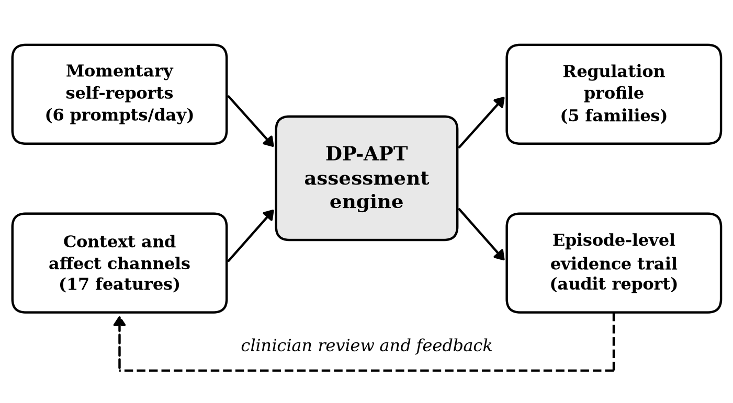
Figure 1. The assessment pipeline in which the proposed engine is deployed. Momentary self-reports and context channels enter the engine, which returns both a regulation profile and the episode-level evidence trail that a clinician audits.
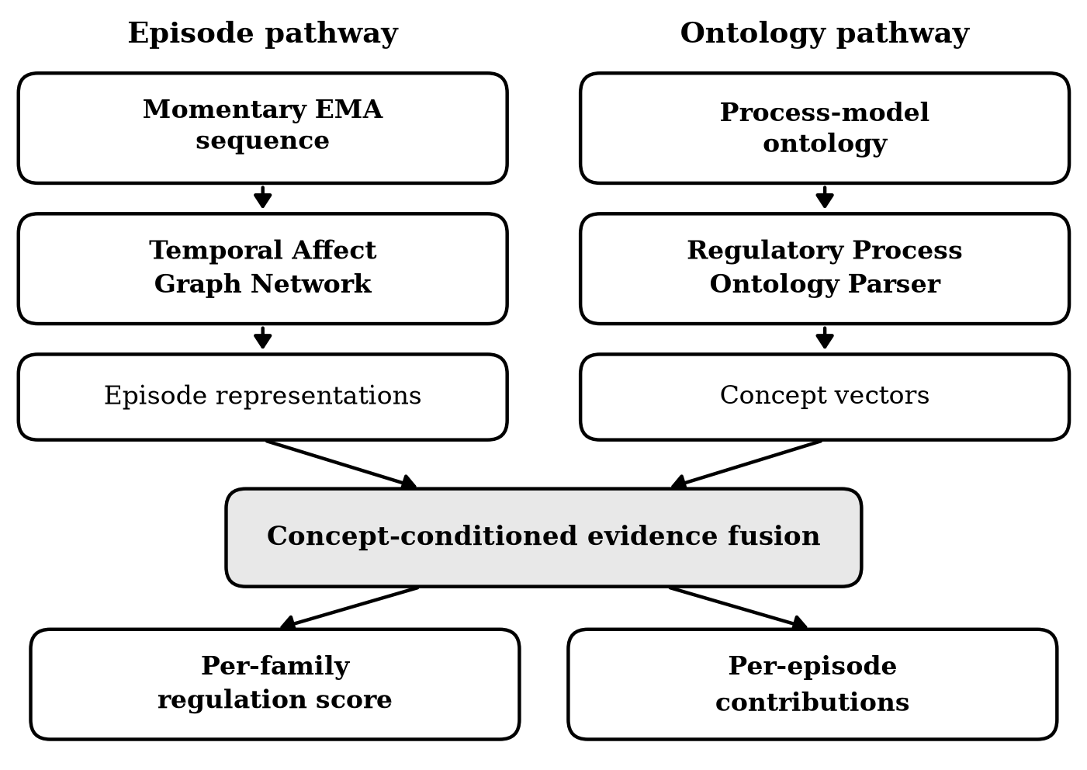
Figure 2. Internal architecture of the Dual-Pathway Affective Process Tracing engine.
  - Temporal Affect Graph Network
The episode pathway encodes the participant’s momentary reports. Features are first projected into the model space, $h_{t}^{(0)} = tanh(W_{x} x_{t} + b_{x})$, with unanswered prompts held at zero. The episodes are then treated as the nodes of a banded temporal graph in which each answered prompt is connected to the answered prompts within three positions of it in either direction, a neighbourhood chosen to span the within-day and adjacent-day dependence that momentary affect exhibits. Attention coefficients over that neighbourhood are computed in the manner of graph attention (3)
$$e_{t,s} = σ_{L}(a_{self}^{⊤} W_{msg} h_{t} + a_{nbr}^{⊤} W_{msg} h_{s}) \text{(3)}$$
where $σ_{L}$ denotes the leaky rectified linear unit, and normalised over the observed neighbours (4)
$$α_{t,s} = \frac{exp(e_{t,s})}{\sum_{u ∈ N(t)}{ exp(e_{t,u})}} \text{(4)}$$
The aggregated message $z_{t} = \sum_{s}{ α_{t,s} W_{msg} h_{s}}$ is combined with the node’s own state by a gated update, which lets the network decide how much of a neighbour’s affective context to admit rather than averaging it in (5)–(7)
$$u_{t} = σ(W_{u} h_{t} + U_{u} z_{t} + b_{u}) \text{(5)}$$
$$r_{t} = σ(W_{r} h_{t} + U_{r} z_{t} + b_{r}) \text{(6)}$$
$${\tilde{h}}_{t} = tanh(W_{h} (r_{t} ⊙ h_{t}) + U_{h} z_{t} + b_{h}) \text{(7)}$$
where $σ$ is the logistic sigmoid and $⊙$ the elementwise product. The new state is $h_{t} ← (1 − u_{t}) ⊙ h_{t} + u_{t} ⊙ {\tilde{h}}_{t}$, and the update is applied for two propagation layers.
  - Regulatory Process Ontology Parser
The ontology pathway turns symbolic psychological theory into vectors. The process model is expressed as a directed acyclic graph with ten nodes: a root, the antecedent-focused and response-focused classes that divide the emotion-generative cycle, the engagement and disengagement classes that cut across it, and the five strategy families as leaves. Every node carries a descriptor vector $d_{j} ∈ ℝ^{6}$ whose entries are theoretically interpretable: position in the emotion-generative cycle, degree of engagement with the situation, cognitive demand, behavioural visibility to others, breadth, and antecedent membership. These descriptors are fixed by the theory, not learned, so the pathway cannot silently abandon the structure it is supposed to encode.
Descriptors are projected and refined by two graph attention layers over the ontology adjacency $A$, with coefficients (8)
$$β_{j,l} = \frac{exp(σ_{L}(p_{s}^{⊤} g_{j} + p_{n}^{⊤} g_{l}))}{\sum_{v: A_{jv}=1}{ exp(σ_{L}(p_{s}^{⊤} g_{j} + p_{n}^{⊤} g_{v}))}} \text{(8)}$$
and node update $g_{j} ← tanh(g_{j} + \sum_{l}{ β_{j,l} g_{l})}$. Because superordinate nodes are neighbours of the families beneath them, a family’s concept vector absorbs information from its class, which is how the hierarchy of the process model enters the model as an inductive prior. The residual term is not cosmetic. The ontology is small and densely connected — every family lies within two hops of every other through the classes above it — so repeated neighbourhood averaging pushes the leaves together. Averaged over three initialisations, plain averaging leaves the closest pair of concept vectors at an absolute cosine similarity of 0.997, which is two families the detector cannot tell apart; the skip connection brings that down to 0.890. It does not change the average similarity between the five vectors (0.66 with the skip connection, 0.65 without), which reflects the fact that the descriptors place all five families in one six-dimensional space; what it prevents is the outright merging of the closest pair. The concept vectors of the five leaves, $c_{1}, …, c_{K}$, are passed to the fusion module.
  - Concept-Conditioned Evidence Fusion
Fusion couples the two pathways in two steps. First, an episode-level detector states how strongly each family is expressed in each moment (9)
$$δ_{k,t} = \frac{1}{\sqrt{D}} c_{k}^{⊤} W_{det} h_{t} + θ_{k} \text{(9)}$$
with $p_{k,t} = exp(δ_{k,t}) / \sum_{j}{ exp(δ_{j,t})}$ the detection strength. The normalisation runs across families rather than over episodes, because the process model treats the five families as alternative interventions at a given point in the emotion-generative cycle, so within a moment they compete. This is the quantity a clinician reads as an assertion about a single moment, and its average over the protocol estimates how often each family is deployed, which is one of the quantities the assessment target is defined on. Second, the score for family $k$ combines a pooled summary of the episodes with a detector-weighted pool over the same episodes (10)
$${\hat{y}}_{k} = σ\left(w_{k}^{⊤} \overline{v} + \frac{1}{T_{obs}} \sum_{t}{ m_{t} p_{k,t} (ρ_{k}^{⊤} φ_{t} + ω_{k})} + b_{k}\right) \text{(10)}$$
where $v_{t}$ and $φ_{t}$ are linear projections of the episode state, $\overline{v} = T_{obs}^{−1} \sum_{t}{ m_{t} v_{t}}$ is their mean over the answered prompts, and $T_{obs}$ is the number of answered prompts. The first term is a summary of the protocol as a whole and the second is family-specific: it grows both with how often family $k$ is detected and with the character of the episodes in which it is detected. Neither term is normalised over episodes, and that is deliberate. A distribution over episodes can express which moments matter relatively but not whether any of them expresses the family at all, and habitual frequency is part of what a regulation profile means.
Because every term in (10) is a sum over episodes, the pre-activation score decomposes exactly into per-episode contributions (11)
$$C_{k,t} = \frac{m_{t}}{T_{obs}} \left[ w_{k}^{⊤} v_{t} + p_{k,t} (ρ_{k}^{⊤} φ_{t} + ω_{k}) \right] \text{(11)}$$
which satisfies $\sum_{t}{ C_{k,t} + b_{k} = σ^{−1}({\hat{y}}_{k})}$ identically, so the trail accounts for the score exactly and neither loses nor invents evidence. $C_{k,t}$ is what the model reports to the clinician: the quantity by which moment $t$ raised or lowered the score for family $k$.
  - Training Objective
The task term is a binary cross-entropy applied per family, which suits the multi-label structure of a regulation profile (12)
$$L_{task} = −\frac{1}{NK} \sum_{i}{ \sum_{k}{ \left[ y_{i,k} log {\hat{y}}_{i,k} + (1 − y_{i,k}) log (1 − {\hat{y}}_{i,k}) \right]}} \text{(12)}$$
A participant-level label constrains only the aggregate of the detector, so nothing in the task term requires $p_{k,t}$ to be right about any particular moment. A second term supplies that constraint from the data themselves. Each family’s concept vector is mapped to the profile of momentary regulation items it should produce, and the detector is asked to explain the items actually reported in an episode as a mixture of those profiles (13)
$$L_{anchor} = \frac{1}{N T_{obs} R} \sum_{i,t}{ m_{t} ‖ \sum_{k}{ p_{k,t} (W_{rec}^{⊤} c_{k} + b_{rec})} − x_{i,t}^{item} ‖^{2}} \text{(13)}$$
where $x_{i,t}^{item}$ are the $R$ momentary regulation items of the episode. This is the logic of a measurement model rather than of supervision: the items are observed self-reports that the model already receives as input, and no episode-level label enters training. The objective is their sum (14)
$$L = L_{task} + μ L_{anchor} \text{(14)}$$
with $μ$ fixed at one. Training uses Adam and early stopping on the validation value of (14).
  - An Attention Variant
The design above departs from the architecture that the interpretability literature would suggest, and which we implemented first. The natural alternative normalises the concept–episode coupling over episodes, turning it into a distribution that can be displayed as a heat map over the protocol. In that variant the pooled summary $\overline{v}$ in (10) is replaced by an attention-weighted context, with one distribution per family for each of $H$ heads (15)
$$α_{k,t}^{(h)} = \frac{m_{t} exp(δ_{k,t} + q_{k}^{(h)⊤} κ_{t}^{(h)})}{\sum_{s}{ m_{s} exp(δ_{k,s} + q_{k}^{(h)⊤} κ_{s}^{(h)})}} \text{(15)}$$
where $q_{k}^{(h)}$ and $κ_{t}^{(h)}$ are the head’s projections of the concept vector and the episode state. Because an explanation that spreads its weight thinly over the 71.7 answered prompts of an average protocol is not usable by a clinician, this variant admits the regularisation that is usually applied to it, a penalty on the entropy of the attention (16)
$$L_{sparse} = −\frac{1}{NKH} \sum_{i,k,h}{ \sum_{t}{ α_{i,k,t}^{(h)} log α_{i,k,t}^{(h)}}} \text{(16)}$$
added to (14) with weight $λ$. We report this variant and the effect of $λ$ in Section 6 rather than adopting it, because validation cross-entropy selects against it and because what it does to the evidence trail is one of the findings of this paper.
- Experimental Setup
To evaluate DP-APT as an auditable assessment engine we require a corpus in which the episode-level regulatory ground truth is known, since an evidence trail can only be validated against what the person actually did at each moment. No public momentary corpus records the strategy deployed at every prompt with certainty, so we construct a corpus from an explicit psychological process model whose parameters are anchored to published values.
  - Corpus Construction
The corpus comprises 420 participants, each prompted six times a day for fourteen days, giving 84 scheduled prompts per person. Prompt compliance is set to 85.3 per cent, the level typically achieved in signal-contingent designs, so sequences are of unequal length and average 71.7 answered prompts (range 62–81). Each answered prompt yields 17 features: momentary negative and positive affect, arousal, stressor intensity, an appraisal of how controllable the situation is, social presence and location, time of day and day in protocol, regulatory effort, perceived regulatory success, response latency, and four regulation items with deliberately ambiguous cross-loadings on the five families, as momentary self-reports of regulation are in practice.
The generative process follows the psychology it is meant to represent. Momentary negative affect evolves as a first-order autoregression around a person-specific baseline, perturbed by the stressor of the moment, with a person-specific inertia parameter; the realised lag-one autocorrelation across the corpus is 0.36 (SD 0.15), matching values reported in experience-sampling studies of community samples [3]. Which family a person deploys at a given moment depends on habitual tendency, on the controllability of the episode, and on a person-specific regulatory flexibility parameter that governs how strongly deployment tracks context [25]; how much the deployment reduces negative affect depends on the fit between the family and the controllability of the situation [5], with situation-directed families effective when control is high and attentional and cognitive families effective when it is low. Deployment shares across the five families range from 17.3 to 22.4 per cent of episodes.
The assessment target is the adaptive habitual use of each family, defined on the generative state rather than on the observed features: it combines how frequently the person deploys the family, how well those deployments are aligned to the contexts in which the family works, and how much affect relief they achieve. Families are dichotomised at the population median so that each label is balanced. Finally, three trait questionnaire proxies are generated as noisy person-level functions of the same latent structure, reproducing the published moments of the Emotion Regulation Questionnaire (reappraisal 4.89, SD 0.85; suppression 3.38, SD 1.12) [27] and of the Difficulties in Emotion Regulation Scale (79.5, SD 20.2) [28]. These proxies are never shown to any model and serve only as convergent criteria.
Participants are split by person into training (294), validation (63) and test (63) sets, so that no participant contributes episodes to more than one split.
  - Baseline Methods
We benchmark DP-APT against five comparison models spanning current practice in momentary assessment and the architectures usually proposed to improve on it.
Aggregated logistic regression [28]: penalised logistic regression on person-level means and standard deviations of every momentary feature, representing the aggregation-then-scoring practice that applied momentary assessment still relies on.
Gated recurrent encoder [15]: a two-layer gated recurrent encoder over the episode sequence with mean pooling and a linear read-out, the standard sequence model for ambulatory data.
Self-attentive encoder [19]: a single-head self-attention encoder over episodes with a residual feed-forward block and mean pooling.
Temporal graph encoder [14]: the episode pathway of the proposed model with mean pooling, that is the graph encoder without the ontology pathway and without the concept-conditioned detector.
Attentive diagnostic model [43]: an inherently interpretable diagnostic architecture in which concept embeddings are free parameters and attend over episodes, representing concept-bottleneck designs without symbolic structure.
  - Evaluation Metrics
Predictive performance is measured by the area under the receiver operating characteristic curve and the area under the precision-recall curve, averaged over the five families. Explanation quality is measured on three axes. Comprehensiveness is the change in the predicted score when the five highest-weighted episodes are removed, and sufficiency the change when only those episodes are retained; both follow the ERASER formulation [22]. A large comprehensiveness means the highlighted moments were load-bearing, and a small sufficiency means they were enough on their own, so the two run in opposite directions and are reported with the direction of improvement marked. Justification alignment, which the corpus uniquely makes computable, is the proportion of highlighted episodes in which the family being justified is the family the person actually deployed; its chance level is the marginal deployment rate, 0.200. Because the measure has a ceiling as well as a floor, we also fit a supervised multinomial probe that predicts the deployed family from the momentary features of an episode and use its probabilities as an explanation. The probe recovers the deployed family in 90.1 per cent of test episodes and attains an alignment of 0.904, which is what an episode-level evidence trail could achieve on this corpus if it used the features to their full extent. Convergent validity is assessed by correlating the inferred profile with the trait questionnaire proxies. Every model is evaluated on the best evidence trail it can supply: for the architectures whose score decomposes into per-episode terms this is that decomposition, and for the two sequence baselines, which admit no such decomposition, it is integrated gradients along a straight path from an all-zero sequence [41].
  - Implementation and Training Details
All models are implemented on a reverse-mode automatic differentiation engine written for this study on top of numpy, whose operations are verified against central finite differences over 23 tests, the largest relative deviation being 3.5 $× {10}^{−8}$. The episode and concept representations are 32-dimensional and the graph encoder uses 2 propagation layers; the attention variant uses 4 heads. Training uses Adam [50] with a batch of 48 participants for at most 90 epochs, with early stopping on the validation objective and a patience of twenty epochs; the learning rate of every model, including the baselines, is selected on the validation split so that the comparison is not confounded by tuning. Every reported performance figure is the mean over 3 random initialisations, with the standard deviation across those initialisations in parentheses; the correlations of Table 4 are computed once, on the scores of the run with the lowest validation cross-entropy.
- Results and Analysis
This section reports prediction performance, the faithfulness and the correctness of the evidence trail, an ablation study, convergent validity, and what regularising an attention-based explanation does to each. The headline is that the two ways of judging an explanation disagree, and that a reader who tracked only the established one would draw the wrong conclusion.
  - Regulation Profile Prediction
Table 1 reports the per-family average AUC-ROC and AUC-PR on the held-out test participants. DP-APT attains an AUC-ROC of 0.925 and an AUC-PR of 0.940. The strongest baseline is the gated recurrent encoder, at 0.937 and 0.951, so the proposed model is 0.012 AUC-ROC points behind it, a difference of about one standard deviation across seeds (0.012) and therefore one we cannot distinguish from zero at three initialisations. Two things are worth noting before any of it is interpreted. The aggregated logistic regression, the least expressive model in the comparison, reaches 0.925, which is the proposed model’s accuracy to three decimals: on this corpus a fortnight of momentary reports is summarised almost as well by person-level means and standard deviations as by any sequence model, and accuracy is therefore not where the architectures differ. Against the interpretable comparison model, the attentive diagnostic architecture, DP-APT is ahead by 0.108 AUC-ROC points. That comparison confounds several differences at once — the concept-bottleneck baseline has neither the graph encoder nor the unnormalised detector — so the ablation study below separates them rather than crediting the gap to any one component.
Table 1. Regulation Profile Prediction Performance (Test Set)
Model | AUC-ROC | AUC-PR
Aggregated logistic regression [28] | 0.925 (0.001) | 0.934 (0.002)
Gated recurrent encoder [15] | 0.937 (0.012) | 0.951 (0.008)
Self-attentive encoder [19] | 0.932 (0.005) | 0.948 (0.006)
Temporal graph encoder [14] | 0.909 (0.008) | 0.925 (0.006)
Attentive diagnostic model [43] | 0.818 (0.013) | 0.841 (0.006)
DP-APT (ours) | 0.925 (0.008) | 0.940 (0.006)
  - Faithfulness and Correctness of the Evidence Trail
Table 2 reports the two ERASER faithfulness criteria and justification alignment for every model that can produce an episode-level explanation. The alignment column is bounded on both sides: a random explanation scores 0.200, and a supervised probe of the same features scores 0.904. DP-APT reaches 0.646, that is 3.23 times chance and 63.4 per cent of the way from chance to the ceiling, the highest of any comparison model. Its comprehensiveness is 0.172 and its sufficiency 0.456.
The interesting structure in Table 2 is not the winner but the ordering. Among the comparison models the attentive diagnostic architecture has the strongest comprehensiveness (0.221) together with the weakest alignment (0.287), while the integrated-gradient explanations of the gated recurrent encoder have the weakest comprehensiveness (0.096) and an alignment of 0.523, well above the interpretable architecture that beats it on faithfulness. Across the models in the table the rank correlation between comprehensiveness and alignment is −0.10 (p = .873), so the two criteria carry essentially no information about each other, and at the extremes they invert. An explanation can point firmly at episodes the model depends on and still be pointing at the wrong episodes, and it can point at the right episodes while the model does not depend on them much.
The row for the attention variant of our own model makes the point without changing the encoder, the data or the training objective. Read entirely through its attention distribution — erasure scores and alignment alike — that model attains a comprehensiveness of 0.154, which places it in the middle of the table and above two of the four comparison explanations, while its alignment is 0.221 against a chance level of 0.200. The heat map a clinician would be shown is, on this corpus, close to uninformative about which moments the person actually spent regulating in the named way, and no faithfulness measure reveals that.
Table 2. Explanation Faithfulness and Justification Alignment (Test Set)
Model (explanation method) | Comprehen-  siveness ↑ | Sufficiency  ↓ | Alignment  ↑
Gated recurrent encoder + integrated gradients [15], [41] | 0.096 (0.006) | 0.425 (0.028) | 0.523 (0.048)
Self-attentive encoder + integrated gradients [19], [41] | 0.164 (0.006) | 0.355 (0.023) | 0.552 (0.019)
Attentive diagnostic model (score decomposition) [43] | 0.221 (0.023) | 0.336 (0.009) | 0.287 (0.032)
Temporal graph encoder (score decomposition) [14] | 0.139 (0.017) | 0.436 (0.029) | 0.481 (0.023)
DP-APT with attention (attention distribution) | 0.154 (0.026) | 0.297 (0.017) | 0.221 (0.010)
DP-APT (ours, score decomposition) | 0.172 (0.008) | 0.456 (0.015) | 0.646 (0.017)
Chance level (marginal deployment rate) | — | — | 0.200
Oracle ceiling (supervised episode probe) | — | — | 0.904
Figure 3 shows what an audit looks like for a single test participant under the proposed model. The map concentrates on a small number of episodes per family, and the open squares mark the family actually deployed in each episode; a dark cell under a square is a correct justification. The figure shows the positive part of the trail, the evidence that raised each score, since that is what the top-five measures are computed on; the negative contributions, the moments that lowered a score, are read the same way. Reading the two together is what an audit consists of: the moments behind a low score for cognitive change can be located, and a clinician can ask whether they were occasions on which reappraisal would have been possible.
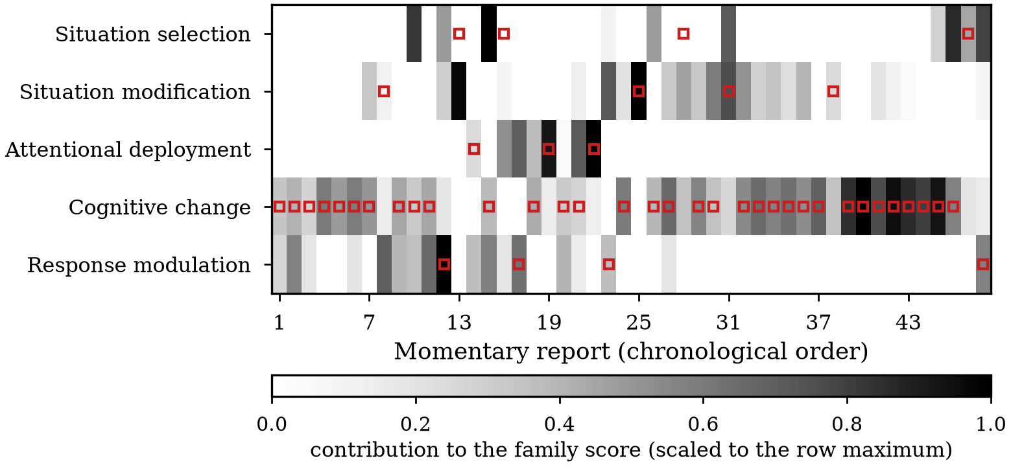
Figure 3. Evidence trail of the proposed model over the momentary reports of one test participant. Open squares mark the family actually deployed in each episode.
  - Ablation Study
We ablate each component in turn: the ontology parser is replaced by free concept embeddings; the temporal graph is replaced by a gated sequence encoder without a graph neighbourhood; the item anchoring term is removed; and, in the other direction, the concept–episode coupling is normalised over episodes to give the attention variant of Section 4. Every variant is trained under the protocol used for the full model. Table 3 reports the results.
Table 3. Ablation Study Results (Test Set)
Model variant | AUC-ROC  ↑ | Sufficiency  ↓ | Alignment  ↑
w/o RPOP (free concept embeddings) | 0.925 (0.008) | 0.464 (0.005) | 0.674 (0.052)
w/o TAGN (gated sequence encoder) | 0.945 (0.003) | 0.479 (0.004) | 0.629 (0.000)
w/o anchoring (μ = 0) | 0.907 (0.015) | 0.415 (0.022) | 0.451 (0.022)
+ attention over episodes | 0.832 (0.045) | 0.383 (0.030) | 0.300 (0.028)
Full DP-APT | 0.925 (0.008) | 0.456 (0.015) | 0.646 (0.017)
Only one of the components we added earns its place. Removing the item anchoring term costs both accuracy (AUC-ROC 0.907 against 0.925) and, far more sharply, the correctness of the trail, whose alignment falls from 0.646 to 0.451. That is the effect it was introduced to produce: a participant-level label constrains the detector only in aggregate, and requiring the detector to account for the regulation items actually reported in a moment is what makes it right about moments.
The other two components do not. Replacing the ontology parser with free concept embeddings leaves accuracy unchanged (0.925 against 0.925), leaves validation cross-entropy unchanged (0.287 against 0.288), and if anything improves alignment (0.674 against 0.646, a difference smaller than the standard deviation across seeds, 0.052). Removing the temporal graph raises test AUC-ROC to 0.945 while worsening validation cross-entropy to 0.311, a disagreement between the two splits that a test set of 63 participants cannot resolve. We report these as null results. The symbolic pathway fixes the meaning of the concept space, which is why we retain it, but on this corpus it buys no accuracy and no additional correctness, and a reader should not take the dual-pathway structure to be what produces the alignment reported in Table 2.
The last row is the one that does most work. Normalising the concept–episode coupling over episodes, which is what turns it into an attention distribution and is what the interpretability literature would recommend, costs 0.093 AUC-ROC points and takes the alignment of the resulting evidence trail from 0.646 down to 0.300, which is closer to the chance level of 0.200 than to the value it replaces. Validation cross-entropy selects against it by a wide margin (0.581 against 0.288), which is how the architecture reported here came to be the one without it. The reason is that a softmax over episodes discards magnitude and keeps only relative ranking within a person: it cannot say that a family was never expressed, only which moments expressed it least badly, and it is obliged to place its mass somewhere even when nothing in the protocol warrants it.
  - Convergent Validity
An assessment that is auditable but psychometrically empty would be of little use. Table 4 correlates the continuous scores of DP-APT with the three trait questionnaire proxies, which are never presented to the model. The cognitive change score correlates with the reappraisal scale of the Emotion Regulation Questionnaire at r = 0.568, and the response modulation score with the suppression scale at r = 0.469 (N = 63 test participants throughout). The correlation between the mean regulation score and the Difficulties in Emotion Regulation Scale is r = −0.222, p = .080, which is not significant; the profile recovers the two strategy-specific trait constructs but not the global dysregulation score, and we report that rather than only the correlations that worked.
Table 4. Convergent Validity of the Inferred Regulation Profile (Test Set)
Model output | Criterion measure | r | p
Cognitive change score | ERQ reappraisal [27] | 0.568 | < .001
Response modulation score | ERQ suppression [27] | 0.469 | < .001
Mean regulation score | DERS total [28] | −0.222 | .080
  - What Sparsifying an Attention Explanation Buys and Costs
The attention variant admits the regularisation usually applied to make attention legible, so we sweep its weight rather than assume a setting. Figure 4 shows the three quantities across $λ$, and they do not move together. Comprehensiveness rises steadily and monotonically, from 0.189 at $λ = 0$ to 0.252 at $λ = 0.2$: pressing the attention toward a few episodes does make those episodes carry more of the prediction, exactly as the ERASER criteria are designed to detect. Accuracy falls over the same range, from 0.832 to 0.751, well beyond the seed-to-seed spread. Alignment does neither: it starts at 0.300, ends at 0.282, and moves non-monotonically in between by amounts comparable to the standard deviation across initialisations (0.040 at the largest weight). We therefore do not claim that sparsification degrades the correctness of the trail; we claim the weaker and better supported thing, that it does not improve it at any setting.
That is enough for the argument. A practitioner tuning $λ$ upward would watch the standard faithfulness measure improve monotonically and would conclude that the explanations were getting better, while the share of highlighted moments in which the person really regulated in the named way stayed where it was and accuracy fell away underneath. Faithfulness asks whether the model used the evidence it points at; alignment asks whether the evidence it points at is the right evidence. Optimising the first buys nothing of the second.
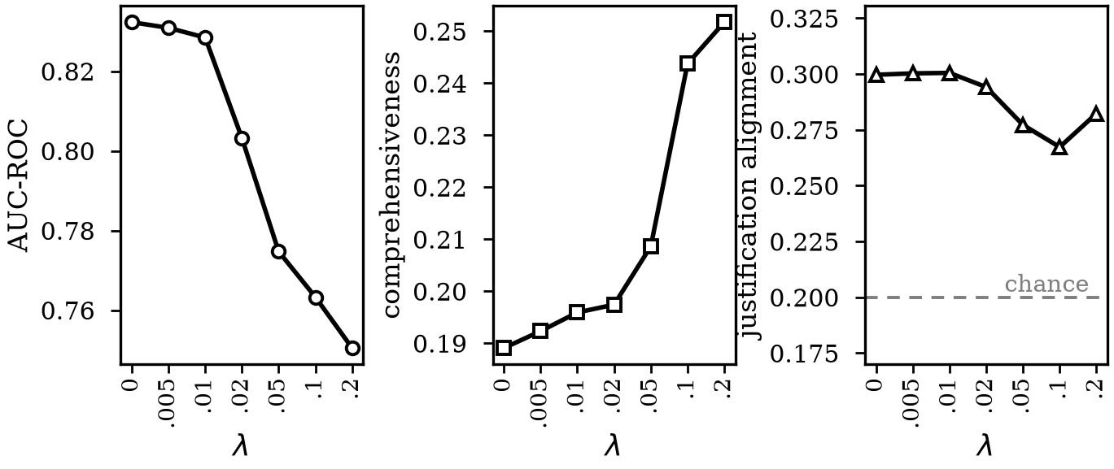
Figure 4. Predictive accuracy, explanation comprehensiveness and justification alignment across the sparsity weight. The dashed line marks the alignment attained by a random explanation.
- Discussion and Future Work
The findings establish DP-APT as a viable engine for auditable momentary assessment of emotion regulation and, equally, delimit the conditions under which such an engine is the right choice.
  - The Cost of Interpretability
The constraints that make an assessment inspectable are not free, though on this corpus the bill is smaller than we expected. DP-APT concedes 0.012 AUC-ROC points to an unconstrained sequence encoder, which is about one seed-to-seed standard deviation and so not distinguishable from zero at three initialisations; the aggregated logistic baseline, meanwhile, matches the proposed model exactly. The structural tension is nevertheless real, and we expect it to bind on corpora where the sequence carries more than it does here. A regulation profile is defined partly by how often a strategy is deployed, and a frequency is a property of the whole protocol; an explanation, by contrast, is only usable if it points at a few moments. A model that must do both is asked to summarise a fortnight and to indict five evenings at the same time. Our unnormalised detector and prevalence-weighted pool recover part of the aggregate signal while remaining decomposable into per-episode contributions, which limits the gap, but the tension does not disappear.
This has a practical consequence for how such systems should be reported. A literature in which every interpretable architecture is claimed to match or beat its black-box comparison invites the suspicion that the comparison was chosen accommodatingly. We would argue instead that the accuracy cost should be measured and stated, and the decision left to the setting: in a screening application where no human reads the output, the unconstrained encoder is the better tool; in a clinical or supervisory setting where a person must justify an assessment to the individual it concerns, an evidence trail 1.23 times better aligned with what the person actually did than the same corpus explained post hoc is worth 0.012 of AUC that we cannot in any case measure reliably.
  - What Faithfulness Does Not Guarantee
The second lesson concerns how explanation quality is judged, and we think it generalises beyond this architecture. The faithfulness criteria in common use ask a question about the model: if these episodes are removed, does the prediction change? A criterion of that form is satisfied by an explanation that points at the wrong moments, provided the model genuinely depends on them. Our results contain both halves of the resulting confusion. Across models the rank correlation between the two criteria is −0.10: knowing that one explanation erases better than another tells a reader essentially nothing about which is more often right, and at the extremes the ordering inverts outright. And within one model, raising the weight on the entropy penalty — the obvious way to make an attention explanation more concentrated, and one that improves comprehensiveness monotonically — leaves alignment where it was while accuracy falls.
Two design recommendations follow. First, where an architecture admits an exact decomposition of its output, that decomposition should be what is reported, rather than a component of it chosen for legibility. An attention map is a convenient picture, not an account of the score, and our own attention variant illustrates how far apart the two can be. Second, a faithfulness score should not be presented as evidence that an explanation is correct. This sharpens rather than settles the attention-as-explanation debate [20], [21]: the question is not whether attention is faithful, but whether faithfulness was ever the property that mattered.
The result also complicates the case against post-hoc attribution. Integrated gradients on an unconstrained encoder score poorly on erasure, as that literature reports, and nonetheless identify the episodes in which the justified family was deployed more often than the inherently interpretable concept-bottleneck comparison does. We would not conclude from one corpus that post-hoc methods are underrated, but we would conclude that the evidence usually offered for the opposite view does not establish it, because it is evidence about faithfulness alone.
  - From a Corpus to Clinical Deployment
A further limitation is one the ceiling makes plain. The supervised probe recovers the deployed family from the same momentary features in 90.1 per cent of episodes, so the information the evidence trail would need is present in the data; our trail reaches 0.646 of an attainable 0.904. The shortfall is a property of the supervision rather than of the features. A participant-level label constrains the model’s per-episode assertions only through their aggregate, and the anchoring term supplies the missing constraint from the observed items but does not replace an episode-level signal. Closing this gap is, we think, the most promising direction the measure opens: a small number of expert-coded or participant-confirmed episodes per person may be enough to bind the detector to the moments it describes, and the measure reported here is what would show whether it had worked.
Deployment raises further questions that our evaluation does not settle. Momentary reports of regulation are themselves subject to bias, and a person who systematically under-reports suppression will be assessed accordingly. The audit trail helps here in a way a trait score does not, since a clinician who reads the highlighted episodes can recognise that the evidence is thin, but it does not remove the problem. Ethical deployment of automated psychological assessment also requires attention to consent, to the asymmetry between the person assessed and the institution assessing them, and to the regulatory obligations now attaching to clinical AI [52], [13], [12].
  - Generalisability Beyond the Process Model
DP-APT was built around one taxonomy, and its ontology pathway presupposes that the constructs to be assessed can be arranged in a graph of classes and families with interpretable descriptors. Many psychological frameworks satisfy this: the coping literature, the taxonomies of cognitive distortion used in cognitive therapy, and diagnostic criteria organised by symptom cluster all have the required shape. Others do not. Dimensional models of personality or of psychopathology are continuous rather than taxonomic, and forcing them into an ontology would impose structure the theory does not claim. Where the constructs themselves are contested, the ontology becomes a commitment that the model cannot revise, which is a strength when the theory is sound and a liability when it is not.
Three extensions follow naturally. The first is sparse episode-level supervision, which the ceiling analysis identifies as the binding constraint on how correct an evidence trail can become. The second is a learnable ontology, in which the graph is initialised from theory but permitted to adapt, with the divergence between the two reported as a finding about the theory. The third is prospective validation: an assessment that is auditable should also be actionable, and whether clinicians who receive the evidence trail make better decisions than clinicians who receive a score is an empirical question that only a user study can answer.
- Conclusion
Momentary assessment has given psychology a detailed record of how emotion regulation actually unfolds, but the models that summarise those records return conclusions without evidence. This paper proposed Dual-Pathway Affective Process Tracing, an inherently interpretable assessment engine that encodes the episode sequence as a temporal affect graph, encodes the process model of emotion regulation as a differentiable ontology, and couples the two so that every strategy score arrives with the moments that produced it.
On a psychologically calibrated corpus of 420 participants, the model attained an AUC-ROC of 0.925 against 0.937 for an unconstrained sequence encoder, while producing explanations whose alignment with actual regulatory behaviour (0.646, against a chance level of 0.200 and an attainable 0.904) exceeded that of every comparison model. The inferred profiles converged with the two strategy-specific trait questionnaires that the model never saw, though not with the global dysregulation scale.
The work makes three contributions. It provides a fully differentiable assessment pipeline whose output includes an evidence trail that is the arithmetic of the score rather than a reconstruction of it. It introduces a validation of that trail against episode-level regulatory ground truth, turning auditability from a design claim into a measured quantity with a known floor and a known ceiling. And it uses that measure to show that explanation quality as currently assessed does not track explanation correctness: across models the two criteria are almost unrelated and invert at the extremes, and within one model tuning for faithfulness buys none of it.
References
- S. Shiffman, A. A. Stone, and M. R. Hufford, “Ecological momentary assessment,” Annu. Rev. Clin. Psychol., vol. 4, pp. 1–32, Apr. 2008, doi: 10.1146/annurev.clinpsy.3.022806.091415.
- T. J. Trull and U. W. Ebner-Priemer, “Ambulatory assessment,” Annu. Rev. Clin. Psychol., vol. 9, pp. 151–176, Mar. 2013, doi: 10.1146/annurev-clinpsy-050212-185510.
- P. Kuppens, N. B. Allen, and L. B. Sheeber, “Emotional inertia and psychological maladjustment,” Psychol. Sci., vol. 21, no. 7, pp. 984–991, Jul. 2010, doi: 10.1177/0956797610372634.
- G. Sheppes, S. Scheibe, G. Suri, and J. J. Gross, “Emotion-regulation choice,” Psychol. Sci., vol. 22, no. 11, pp. 1391–1396, Nov. 2011, doi: 10.1177/0956797611418350.
- S. J. Haines et al., “The wisdom to know the difference: Strategy-situation fit in emotion regulation in daily life is associated with well-being,” Psychol. Sci., vol. 27, no. 12, pp. 1651–1659, Dec. 2016, doi: 10.1177/0956797616669086.
- I. Myin-Germeys et al., “Experience sampling methodology in mental health research: New insights and technical developments,” World Psychiatry, vol. 17, no. 2, pp. 123–132, Jun. 2018, doi: 10.1002/wps.20513.
- N. C. Jacobson and B. Bhattacharya, “Digital biomarkers of anxiety disorder symptom changes: Personalized deep learning models using smartphone sensors accurately predict anxiety symptoms from ecological momentary assessments,” Behav. Res. Ther., vol. 149, Art. no. 104013, Feb. 2022, doi: 10.1016/j.brat.2021.104013.
- A. B. R. Shatte, D. M. Hutchinson, and S. J. Teague, “Machine learning in mental health: A scoping review of methods and applications,” Psychol. Med., vol. 49, no. 9, pp. 1426–1448, Jul. 2019, doi: 10.1017/S0033291719000151.
- M. T. Ribeiro, S. Singh, and C. Guestrin, “‘Why should I trust you?’: Explaining the predictions of any classifier,” in Proc. 22nd ACM SIGKDD Int. Conf. Knowl. Discovery Data Mining, San Francisco, CA, USA, 2016, pp. 1135–1144, doi: 10.1145/2939672.2939778.
- S. M. Lundberg and S.-I. Lee, “A unified approach to interpreting model predictions,” in Proc. Adv. Neural Inf. Process. Syst. (NeurIPS), Long Beach, CA, USA, 2017, pp. 4765–4774.
- C. Rudin, “Stop explaining black box machine learning models for high stakes decisions and use interpretable models instead,” Nat. Mach. Intell., vol. 1, no. 5, pp. 206–215, May 2019, doi: 10.1038/s42256-019-0048-x.
- J. Amann, A. Blasimme, E. Vayena, D. Frey, and V. I. Madai, “Explainability for artificial intelligence in healthcare: A multidisciplinary perspective,” BMC Med. Inform. Decis. Mak., vol. 20, no. 1, Art. no. 310, Nov. 2020, doi: 10.1186/s12911-020-01332-6.
- European Parliament and Council of the European Union, “Regulation (EU) 2024/1689 laying down harmonised rules on artificial intelligence,” Off. J. Eur. Union, L 2024/1689, Jul. 2024.
- L. Zhao et al., “T-GCN: A temporal graph convolutional network for traffic prediction,” IEEE Trans. Intell. Transp. Syst., vol. 21, no. 9, pp. 3848–3858, Sep. 2020, doi: 10.1109/TITS.2019.2935152.
- K. Cho et al., “Learning phrase representations using RNN encoder–decoder for statistical machine translation,” in Proc. Conf. Empir. Methods Natural Lang. Process. (EMNLP), Doha, Qatar, 2014, pp. 1724–1734, doi: 10.3115/v1/D14-1179.
- J. J. Gross, “The emerging field of emotion regulation: An integrative review,” Rev. Gen. Psychol., vol. 2, no. 3, pp. 271–299, Sep. 1998, doi: 10.1037/1089-2680.2.3.271.
- J. J. Gross, “Emotion regulation: Current status and future prospects,” Psychol. Inq., vol. 26, no. 1, pp. 1–26, Jan. 2015, doi: 10.1080/1047840X.2014.940781.
- P. Veličković, G. Cucurull, A. Casanova, A. Romero, P. Liò, and Y. Bengio, “Graph attention networks,” in Proc. Int. Conf. Learn. Representations (ICLR), Vancouver, BC, Canada, 2018.
- A. Vaswani et al., “Attention is all you need,” in Proc. Adv. Neural Inf. Process. Syst. (NeurIPS), Long Beach, CA, USA, 2017, pp. 5998–6008.
- S. Jain and B. C. Wallace, “Attention is not explanation,” in Proc. Conf. North Amer. Chapter Assoc. Comput. Linguistics (NAACL-HLT), Minneapolis, MN, USA, 2019, pp. 3543–3556, doi: 10.18653/v1/N19-1357.
- S. Wiegreffe and Y. Pinter, “Attention is not not explanation,” in Proc. Conf. Empir. Methods Natural Lang. Process. (EMNLP-IJCNLP), Hong Kong, China, 2019, pp. 11–20, doi: 10.18653/v1/D19-1002.
- J. DeYoung, S. Jain, N. F. Rajani, E. Lehman, C. Xiong, R. Socher, and B. C. Wallace, “ERASER: A benchmark to evaluate rationalized NLP models,” in Proc. 58th Annu. Meeting Assoc. Comput. Linguistics (ACL), 2020, pp. 4443–4458, doi: 10.18653/v1/2020.acl-main.408.
- T. L. Webb, E. Miles, and P. Sheeran, “Dealing with feeling: A meta-analysis of the effectiveness of strategies derived from the process model of emotion regulation,” Psychol. Bull., vol. 138, no. 4, pp. 775–808, Jul. 2012, doi: 10.1037/a0027600.
- A. Aldao, S. Nolen-Hoeksema, and S. Schweizer, “Emotion-regulation strategies across psychopathology: A meta-analytic review,” Clin. Psychol. Rev., vol. 30, no. 2, pp. 217–237, Mar. 2010, doi: 10.1016/j.cpr.2009.11.004.
- G. A. Bonanno and C. L. Burton, “Regulatory flexibility: An individual differences perspective on coping and emotion regulation,” Perspect. Psychol. Sci., vol. 8, no. 6, pp. 591–612, Nov. 2013, doi: 10.1177/1745691613504116.
- A. Aldao, “The future of emotion regulation research: Capturing context,” Perspect. Psychol. Sci., vol. 8, no. 2, pp. 155–172, Mar. 2013, doi: 10.1177/1745691612459518.
- J. J. Gross and O. P. John, “Individual differences in two emotion regulation processes: Implications for affect, relationships, and well-being,” J. Pers. Soc. Psychol., vol. 85, no. 2, pp. 348–362, Aug. 2003, doi: 10.1037/0022-3514.85.2.348.
- K. L. Gratz and L. Roemer, “Multidimensional assessment of emotion regulation and dysregulation: Development, factor structure, and initial validation of the Difficulties in Emotion Regulation Scale,” J. Psychopathol. Behav. Assess., vol. 26, no. 1, pp. 41–54, Mar. 2004, doi: 10.1023/B:JOBA.0000007455.08539.94.
- C. Wrzus and M. R. Mehl, “Lab and/or field? Measuring personality processes and their social consequences,” Eur. J. Pers., vol. 29, no. 2, pp. 250–271, Mar. 2015, doi: 10.1002/per.1986.
- P. Kuppens and P. Verduyn, “Emotion dynamics,” Curr. Opin. Psychol., vol. 17, pp. 22–26, Oct. 2017, doi: 10.1016/j.copsyc.2017.06.004.
- E. L. Hamaker and M. Wichers, “No time like the present: Discovering the hidden dynamics in intensive longitudinal data,” Curr. Dir. Psychol. Sci., vol. 26, no. 1, pp. 10–15, Feb. 2017, doi: 10.1177/0963721416666518.
- L. F. Bringmann, E. Ferrer, E. L. Hamaker, D. Borsboom, and F. Tuerlinckx, “Modeling nonstationary emotion dynamics in dyads using a time-varying vector-autoregressive model,” Multivariate Behav. Res., vol. 53, no. 3, pp. 293–314, May 2018, doi: 10.1080/00273171.2018.1439722.
- A. Brose, P. Voelkle, M. Lövdén, U. Lindenberger, and F. Schmiedek, “Differences in the between-person and within-person structures of affect are a matter of degree,” Eur. J. Pers., vol. 29, no. 1, pp. 55–71, Jan. 2015, doi: 10.1002/per.1961.
- T. R. Insel, “Digital phenotyping: Technology for a new science of behavior,” JAMA, vol. 318, no. 13, pp. 1215–1216, Oct. 2017, doi: 10.1001/jama.2017.11295.
- D. C. Mohr, M. Zhang, and S. M. Schueller, “Personal sensing: Understanding mental health using ubiquitous sensors and machine learning,” Annu. Rev. Clin. Psychol., vol. 13, pp. 23–47, May 2017, doi: 10.1146/annurev-clinpsy-032816-044949.
- D. B. Dwyer, P. Falkai, and N. Koutsouleris, “Machine learning approaches for clinical psychology and psychiatry,” Annu. Rev. Clin. Psychol., vol. 14, pp. 91–118, May 2018, doi: 10.1146/annurev-clinpsy-032816-045037.
- J. Torous, S. Bucci, I. H. Bell, L. V. Kessing, M. Faurholt-Jepsen, P. Whelan, A. F. Carvalho, M. Keshavan, J. Linardon, and J. Firth, “The growing field of digital psychiatry: Current evidence and the future of apps, social media, chatbots, and virtual reality,” World Psychiatry, vol. 20, no. 3, pp. 318–335, Oct. 2021, doi: 10.1002/wps.20883.
- T. Yarkoni and J. Westfall, “Choosing prediction over explanation in psychology: Lessons from machine learning,” Perspect. Psychol. Sci., vol. 12, no. 6, pp. 1100–1122, Nov. 2017, doi: 10.1177/1745691617693393.
- P. F. Hitchcock, E. Fried, and M. J. Frank, “Computational psychiatry needs time and context,” Annu. Rev. Psychol., vol. 73, pp. 243–270, Jan. 2022, doi: 10.1146/annurev-psych-021621-124910.
- E. I. Fried and A. O. J. Cramer, “Moving forward: Challenges and directions for psychopathological network theory and methodology,” Perspect. Psychol. Sci., vol. 12, no. 6, pp. 999–1020, Nov. 2017, doi: 10.1177/1745691617705892.
- M. Sundararajan, A. Taly, and Q. Yan, “Axiomatic attribution for deep networks,” in Proc. 34th Int. Conf. Mach. Learn. (ICML), Sydney, NSW, Australia, 2017, pp. 3319–3328.
- F. Doshi-Velez and B. Kim, “Towards a rigorous science of interpretable machine learning,” 2017, arXiv:1702.08608, doi: 10.48550/arXiv.1702.08608.
- P. W. Koh, T. Nguyen, Y. S. Tang, S. Mussmann, E. Pierson, B. Kim, and P. Liang, “Concept bottleneck models,” in Proc. 37th Int. Conf. Mach. Learn. (ICML), 2020, pp. 5338–5348.
- C. Chen, O. Li, D. Tao, A. Barnett, C. Rudin, and J. Su, “This looks like that: Deep learning for interpretable image recognition,” in Proc. Adv. Neural Inf. Process. Syst. (NeurIPS), Vancouver, BC, Canada, 2019, pp. 8930–8941.
- M. K. Sarker, L. Zhou, A. Eberhart, and P. Hitzler, “Neuro-symbolic artificial intelligence: Current trends,” AI Commun., vol. 34, no. 3, pp. 197–209, 2021, doi: 10.3233/AIC-210084.
- A. d’Avila Garcez and L. C. Lamb, “Neurosymbolic AI: The 3rd wave,” Artif. Intell. Rev., vol. 56, no. 11, pp. 12387–12406, Nov. 2023, doi: 10.1007/s10462-023-10448-w.
- J. Hastings, W. Ceusters, B. Smith, and K. Mulligan, “The emotion ontology: Enabling interdisciplinary research in the affective sciences,” in Modeling and Using Context (Lecture Notes in Computer Science), vol. 6967, Berlin, Germany: Springer, 2011, pp. 119–123, doi: 10.1007/978-3-642-24279-3_14.
- B. C. Grau, I. Horrocks, B. Motik, B. Parsia, P. Patel-Schneider, and U. Sattler, “OWL 2: The next step for OWL,” J. Web Semant., vol. 6, no. 4, pp. 309–322, Nov. 2008, doi: 10.1016/j.websem.2008.05.001.
- T. N. Kipf and M. Welling, “Semi-supervised classification with graph convolutional networks,” in Proc. Int. Conf. Learn. Representations (ICLR), Toulon, France, 2017.
- D. P. Kingma and J. Ba, “Adam: A method for stochastic optimization,” in Proc. Int. Conf. Learn. Representations (ICLR), San Diego, CA, USA, 2015.
- H. Moshontz et al., “The Psychological Science Accelerator: Advancing psychology through a distributed collaborative network,” Adv. Methods Pract. Psychol. Sci., vol. 1, no. 4, pp. 501–515, Dec. 2018, doi: 10.1177/2515245918797607.
- A. Fiske, P. Henningsen, and A. Buyx, “Your robot therapist will see you now: Ethical implications of embodied artificial intelligence in psychiatry, psychology, and psychotherapy,” J. Med. Internet Res., vol. 21, no. 5, Art. no. e13216, May 2019, doi: 10.2196/13216.

Liming Cai is with the Jiaxing Nanhu Alliance Experimental School, Jiaxing, Zhejiang 314001, China (e-mail: 21903047@zju.edu.cn).

