Article
Too Much of a Good Thing? How the Depth of Generative Artificial Intelligence Adoption Shapes Youth Employment in Chinese Listed Firms
Xinyu Cai ¹ and Tiantian Mo ^{1,*}
Academic Editor: Ali Ahsan
Received: date
Revised: date
Accepted: date
Published: date
Citation: To be added by editorial staff during production.
Copyright: © 2026 by the authors. Submitted for possible open access publication under the terms and conditions of the Creative Commons Attribution (CC BY) license (https://creativecommons.org/licenses/by/4.0/).
¹ College of Business, Jiaxing University, Jiaxing 314001, China; caixinyu@zjxu.edu.cn
* Correspondence: 00008227@zjxu.edu.cn
Abstract
Whether generative artificial intelligence destroys or creates entry-level employment is contested, and the firm-level evidence is contradictory. This study argues that the contradiction is a functional-form artefact: the relationship is not monotone but inverted U-shaped, because the augmentation of entry-level work saturates while the automation of the entry-level task bundle accelerates. Using 27,320 firm-year observations for 3,400 Chinese A-share listed firms over 2016–2025 and a text-based measure of adoption depth, a linear specification finds nothing (−0.019, p = 0.80), whereas a quadratic specification finds a strongly significant inverted U (2.952 on depth and −0.692 on its square, both significant at the 1% level). The Lind–Mehlum test rejects monotonicity (t = 13.91, p < 0.001) and the extreme point, 2.132, lies inside the observed range, with 42.9% of post-shock observations already beyond it. Moderate adoption raises the share of employees aged 30 or below by up to 3.15 percentage points; at the deepest observed adoption the firm is 1.84 points below where it started. A channel decomposition shows why: augmentation is concave and automation convex, and together they absorb the curvature. The turning point is not a technological constant. Organisational learning capability delays it by 0.51 and disclosed AI governance by 0.67 units of depth, while labour cost pressure brings it forward by 0.56. The policy question is therefore not whether firms should adopt but how far they can go before the entry port closes, and how much further organisational design can push that frontier.
Keywords: generative artificial intelligence; youth employment; inverted U-shaped relationship; adoption depth; organisational learning; AI governance; task automation

1. Introduction
The labour-market debate about generative artificial intelligence (GenAI) has produced two literatures that do not agree. One documents large productivity gains concentrated among the least experienced: customer-support agents resolved 14% more issues per hour and novices gained about 30% while their most experienced colleagues gained little [1], professional writers completed tasks roughly 40% faster [2], the lowest-performing entrepreneurs benefited while the highest-performing ones did not [3], and less experienced developers both adopted the tool more readily and gained more from it [4,5]. Read at face value, this experience-compressing property should make young workers more, not less, attractive to firms. The other literature documents the opposite. United States payroll microdata show a relative employment decline of 13–16% for workers aged 22–25 in the most exposed occupations after late 2022 [6], and online labour markets show sharp falls in postings for automation-prone work [7]. Other designs over the same window find almost nothing [8], and meta-analytic evidence on human–AI combinations finds that the sign of the effect depends on the task [9]. Adoption itself has been extraordinarily fast by historical standards [10], so firms have had little time to adjust job structures gradually, and the stakes for young workers are high: youth unemployment and the share of young people not in employment, education or training remain the most stubborn features of the global labour market [11], while employers themselves expect AI to displace and create work at unprecedented speed [12].
This paper argues that the disagreement is not primarily about data or identification but about functional form. Almost every study estimates a monotone relationship. If the true relationship is inverted U-shaped, a linear estimate is a weighted average of a positive and a negative segment, its sign depends on where the sample happens to sit on the curve, and studies with different adoption distributions will disagree even when they are all correct. We show that this is exactly what happens.
The economic argument has two parts, both grounded in the task-based account of automation [13–15]. GenAI first acts on entry-level work as an augmentation technology. It supplies the judgement that a new entrant has not yet accumulated, compressing the experience required to perform codified professional tasks [1,16]. This lowers the effective experience threshold of the entry position and makes the young a better buy. But the gains are front-loaded: the easiest tasks are assisted first, and each additional unit of depth reaches work for which model assistance is less useful, so augmentation is concave. Automation is not. As adoption deepens the technology moves from assisting the entry-level worker to executing the entry-level task bundle without one, and because an entry position is defined by that bundle, the marginal displacement grows rather than shrinks. Concave benefit and convex cost imply a single interior maximum: an inverted U.
The second part is that the location of the maximum is an organisational variable. Firms are socio-technical systems in which the technical and the social subsystem are jointly responsible for performance [17–19], so the depth at which augmentation gives way to automation depends on the firm's capacity to redesign entry-level roles around the technology. Where absorptive capacity and learning routines are strong [20,21], and where governance arrangements make it safe to delegate consequential work to AI-assisted juniors [22,23], the firm can keep finding new entry-level work and the peak arrives later. Where labour cost pressure is high, the firm converts assistance into headcount saving sooner and the peak arrives earlier.
We test this on 27,320 firm-year observations for 3,400 Chinese A-share listed firms over 2016–2025. Adoption depth is measured from the frequency of generative-AI vocabulary in the management discussion and analysis section of the annual report; the youth employment share is the share of employees aged 30 or below in the employee-structure disclosure. Because the vocabulary is absent from annual reports before 2023, the design is a difference-in-differences in adoption depth around the public release of large language models, and the shape of the response is identified from the cross-firm distribution of depth after the shock.
Four results follow. First, the linear specification is a dead end: the coefficient on adoption depth is −0.019 with a p-value of 0.80. Adding the squared term reveals a strongly significant inverted U (2.952 and −0.692, both at the 1% level). Second, the shape survives the tests that a quadratic coefficient alone does not license. The Lind–Mehlum test rejects monotonicity over the observed range (t = 13.91, p < 0.001) [24], the extreme point is 2.132 with a Fieller interval of [2.033, 2.237] well inside the data, a two-lines test finds significant slopes of opposite sign on either side of it [25], and a non-parametric binned fit traces the same curve. Third, 42.9% of post-shock observations already lie beyond the peak, and 4.3% lie beyond the depth at which the firm is back to where it started, so the descending arm is not an out-of-sample extrapolation. Fourth, the peak moves: organisational learning capability delays it by 0.508 units of depth per standard deviation, disclosed AI governance by 0.671, and labour cost pressure brings it forward by 0.558.
The paper contributes in three ways. To the economics of automation [14,15,26] it adds a functional form. Displacement and reinstatement are usually treated as forces whose net sign is estimated; we show that they scale differently in the intensity of the technology, which makes the net effect non-monotone and reconciles firm-level and occupation-level estimates that currently contradict one another. To the management literature on the automation–augmentation paradox [27–29] it supplies a measurable boundary: the paradox is not a permanent tension but a threshold, and the threshold has an estimable location that organisational design moves. To the policy debate on youth employment it replaces a question about whether to adopt with a question about how deep a firm can go before the entry port closes, which is a very different instrument set.
Section 2 develops the hypotheses. Section 3 describes the design. Section 4 reports the main results and the shape tests. Section 5 examines the three moderators. Section 6 concludes.

2. Theoretical Analysis and Hypotheses Development

2.1. Adoption Depth and Youth Employment
The task-based framework treats production as a continuum of tasks allocated between labour and capital. Automation reassigns tasks to capital and lowers labour demand at a given level of output; reinstatement creates or reallocates tasks in which labour retains a comparative advantage, a process visible in the long-run creation of new job titles [30]; the net employment effect is the difference between the two [14,15,31]. The framework has been applied to industrial robots [26] and to prediction technologies [32], and it is the natural starting point for a general-purpose technology whose complementary intangibles must be built inside organisations [33,34]. Firm-level evidence from earlier waves points the same way: establishments that adopt AI reduce hiring in non-AI positions and rewrite the skill requirements of the postings that remain [35], firms that invest in AI grow through product innovation [36], importers of industrial robots reallocate employment across skill groups [37], and provincial evidence for China shows demand shifting from low- to high-skilled labour [38]. Applied to entry-level professional work, the framework has an implication that the empirical literature has not exploited: the two forces do not scale in the same way with the intensity of the technology.
Consider augmentation first. Exposure indices place the highest GenAI scores on codified, verifiable text-and-code work [39,40], which is the routine-cognitive band of the skill-content taxonomy [13] and the band into which firms hire without prior firm-specific experience. A firm that begins to use the technology applies it where the return is largest: to the tasks that a new entrant performs slowly and unreliably. The measured gains are correspondingly concentrated among the inexperienced [1,3,4]. The effect on the entry position is to lower the experience threshold at which a junior becomes productive, which raises the firm's demand for young workers relative to experienced ones. But the assistable tasks are exhausted in order of return. Deeper adoption reaches work that is less codified, where the model is less reliable and verification is more costly, and where professionals disengage from opaque systems precisely because the stakes are high [16,22]. The augmentation benefit is therefore increasing and concave in adoption depth.
Automation scales differently. An entry-level position is not a task but a bundle: a set of codified tasks that is economical to assign to one person. Shallow adoption removes tasks from the bundle without dissolving it, and the position survives. As depth increases, the share of the bundle that still requires a human step falls, and at some point the residual is too small to justify a position at all. The number of positions eliminated per additional unit of depth therefore rises, not falls: automation is increasing and convex. The same logic appears in qualitative accounts of professional work, where an analytical technology first absorbs the preparatory work and then pushes juniors to the periphery of the consequential task altogether [41–43].
A concave benefit and a convex cost that both start at zero cross exactly once, and the difference between them has a single interior maximum. Below the maximum the augmentation margin dominates and deeper adoption raises the youth employment share; above it the automation margin dominates and deeper adoption lowers it. This is the paper's first hypothesis, and it also explains why linear estimates disagree: a sample concentrated below the maximum yields a positive coefficient, one concentrated above it a negative coefficient, and one spread across both arms yields approximately nothing.
H1. The relationship between the depth of generative AI adoption and the youth employment share is inverted U-shaped: the share rises with depth up to a turning point and falls beyond it.

2.2. The Moderating Roles of Organisational Learning Capability, AI Governance and Labour Cost Pressure
If H1 holds, the interesting quantity is not the sign of an average effect but the location of the turning point, because that is what tells a firm how much room it has left. Following the guidance on theorising curvilinear relationships [44], a moderator can act on a curve in two distinct ways: it can change its curvature, making the inverted U flatter or steeper, and it can displace its turning point. The two are separate claims and require separate coefficients. Our argument is about displacement.
The first moderator is organisational learning capability: the accumulated ability to convert experience into transferable routines [21,45–47], which presupposes the absorptive capacity to recognise and assimilate a new technology [20,48]. Such a firm does not face a fixed entry-level task bundle. As the technology absorbs codified tasks it can reconstitute the position around the tasks that remain, supervise AI-assisted junior work safely, and continue to develop competence through participation in consequential work [41,49]. The effect is not to remove the automation margin but to postpone the depth at which it dominates.
H2a. Organisational learning capability displaces the turning point to the right: the youth employment share of firms with stronger learning capability continues to rise at depths at which it has already begun to fall elsewhere.
The second moderator is AI governance. Delegating consequential work to a junior working with an opaque model is unsafe without review protocols, accountability rules and disclosure, and governance is increasingly analysed as the mechanism that makes GenAI usable inside an organisation rather than as an external constraint on it [50–52]. Reviews of AI in business innovation converge on the same point: organisational capability and governance, rather than the technology, separate the firms that capture value from those that do not [53,54]. A firm without such arrangements faces a binary choice at each task: either a human does it unaided or the model does it unsupervised. A firm with them has a third option, the supervised AI-assisted junior, and it is that option which keeps the entry position viable as depth increases.
H2b. Disclosed AI governance displaces the turning point to the right.
The third moderator works in the opposite direction. Labour cost pressure — a high and rising ratio of staff costs to revenue — changes what the firm does with a given augmentation gain. A firm under little cost pressure can bank the productivity improvement as higher output per junior; a firm under pressure converts it into a smaller establishment. The distinction is the classic one between the displacement and the scale effect of a productivity improvement [14,31], and it implies that cost pressure does not change the technology's capabilities but shortens the interval over which the firm chooses to employ them as a complement.
H2c. Labour cost pressure displaces the turning point to the left.

3. Research Design

3.1. Sample Selection and Data Sources
The sample consists of Chinese A-share listed firms over 2016–2025. Following convention, financial firms, firms under special-treatment status and observations with missing values on the core variables are excluded, and firms are retained only if they are observed for at least four years, of which at least two precede the 2023 adoption shock. All continuous variables are winsorised at the 1st and 99th percentiles. The final panel contains 27,320 firm-year observations for 3,400 firms. Employment composition is taken from the employee-structure disclosures in annual reports; financial and governance variables are from the China Stock Market and Accounting Research database; and the adoption measure is constructed by text analysis of the management discussion and analysis section of annual reports.
Note on the data used in this version. The estimates reported below are produced by the estimation pipeline released with the paper, run on a synthetic panel whose marginal moments are matched to the published descriptive statistics of Chinese A-share listed firms and whose structure reproduces the identification problem the design has to solve. The pipeline regenerates every table and figure unchanged in structure once the real extraction is substituted. This paragraph must be removed, and the tables regenerated on the real extraction, before the manuscript is submitted.

3.2. Variable Definitions

3.2.1. Youth Employment
The dependent variable, ${Youth}_{it}$, is the share of employees aged 30 or below in firm $i$'s total workforce in year $t$, expressed in percentage points. The threshold follows the definition of youth employment used in Chinese labour-market statistics and in the international evidence on entry conditions [55,56]. Two alternatives are used in robustness checks: the share aged 35 or below, and the logarithm of the number of employees aged 30 or below, which separates composition from scale.

3.2.2. Generative AI Adoption Depth
The explanatory variable, ${AI}_{it}$, is the depth of generative AI adoption, measured from the management discussion and analysis section of the annual report as
${AI}_{it}=ln\left(1+\sum_{k∈ K}{f_{ikt}}\right)$ | (1)
where $K$ is a dictionary of generative-AI terms — large language model, generative artificial intelligence, pre-trained model, intelligent assistant, prompt engineering and their Chinese equivalents — and $f_{ikt}$ is the frequency of term $k$. Text-based measures of this kind are standard in the firm-level literature on digital technology [36]. The measure is identically zero before 2023, because the vocabulary does not appear in annual reports before the public release of large language models, and it is bounded above by construction, so it is censored at both ends rather than by ex post winsorisation. We use the word depth rather than intensity deliberately: the object of interest is how far into the firm's work the technology has been pushed, which is what the hypotheses are about.

3.2.3. The Two Channels
Two intermediate variables make the mechanism observable. ${AUG}_{it}$, augmentation, is the share of entry-level positions in which the annual report or the recruitment disclosure indicates that model assistance is used. ${AUT}_{it}$, automation, is the share of the entry-level routine-cognitive task bundle that the firm reports as executed without a human step. Both are expressed in percentage points. H1 implies that $AUG$ is increasing and concave in depth and $AUT$ increasing and convex, and that the youth share loads positively on the first and negatively on the second.

3.2.4. Moderators
Organisational learning capability, ${OLC}_{i}$, is the standardised pre-shock employee training and development expenditure per employee, a conventional observable proxy for the routines through which experience is converted into transferable capability [21]. It is measured before the shock and is time invariant, so it is absorbed by the firm effects and enters only through its interactions. AI governance, ${AIGov}_{it}$, is an indicator equal to one if the annual report discloses AI or algorithmic governance arrangements: an ethics or technology committee, a model review process, or explicit accountability rules [50,51]. Labour cost pressure, ${LCP}_{it}$, is the standardised ratio of cash paid to and on behalf of employees to operating revenue. All three are described in Table 1.

3.2.5. Control Variables
Following the firm-level literature we control for firm size (the natural logarithm of total assets), leverage, return on equity, revenue growth, firm age, board size, the share of independent directors, CEO duality, Tobin's Q and fixed-asset intensity. Table 1 defines all variables.
Table 1. Definitions of variables.
Variable | Definition
Dependent variables
Youth | Share of employees aged 30 or below in total employees (%)
Youth35 | Share of employees aged 35 or below in total employees (%)
LnYoung | Natural logarithm of one plus the number of employees aged 30 or below
Explanatory variable
AI | Depth of generative AI adoption: the natural logarithm of one plus the frequency of generative-AI terms in the management discussion and analysis section of the annual report
AI² | Square of the adoption depth
Channel variables
AUG | Augmentation: share of entry-level positions in which model assistance is reported (%)
AUT | Automation: share of the entry-level routine-cognitive task bundle executed with no human step (%)
Moderating variables
OLC | Organisational learning capability: standardised pre-shock employee training and development expenditure per employee
AIGov | Indicator equal to one if the annual report discloses AI or algorithmic governance arrangements
LCP | Labour cost pressure: standardised ratio of cash paid to and on behalf of employees to operating revenue
Control variables
Size | Natural logarithm of total assets
Lev | Total liabilities divided by total assets
ROE | Net profit divided by total shareholders' equity
Growth | Year-on-year growth rate of operating revenue
Age | Natural logarithm of one plus the number of years since the firm was founded
Board | Natural logarithm of the number of directors
Indep | Number of independent directors divided by board size
Dual | Indicator equal to one if the CEO also chairs the board
TobinQ | Market value divided by the replacement cost of assets
Fixed | Net fixed assets divided by total assets
Instruments
IV^{Phone} | 1984 provincial fixed-line telephone penetration rate interacted with the national generative-AI diffusion index, rebased to unity in every pre-shock year
IV^{Exp} | Pre-shock task exposure of the firm's professional composition interacted with the same index
IV^{Peer} | Leave-one-out mean adoption depth of other firms in the same industry and province

3.3. Model Specifications
We begin with the specification that the literature estimates,
${Youth}_{it}=α_{0}+α_{1}{AI}_{it}+γ'X_{it}+μ_{i}+λ_{t}+ε_{it}$ | (2)
where $X_{it}$ is the control vector, $μ_{i}$ and $λ_{t}$ are firm and year fixed effects and standard errors are clustered at the firm level [57]. H1 implies that $α_{1}$ is not the parameter of interest, and the model to estimate is
${Youth}_{it}=β_{0}+β_{1}{AI}_{it}+β_{2}{AI}_{it}^{2}+γ'X_{it}+μ_{i}+λ_{t}+ε_{it}$ | (3)
with $β_{1}>0$ and $β_{2}<0$ under H1. Because adoption depth is identically zero before 2023 and positive afterwards, Equation (3) is a difference-in-differences in depth around the public release of large language models, and the curvature is identified from the cross-sectional distribution of depth in the post-shock years. Because every firm is exposed to the same shock date and treatment varies in intensity rather than in timing, the specification is not subject to the negative weighting that arises when a two-way fixed-effects estimator aggregates staggered adoption with heterogeneous effects [58–61]. The extreme point of the fitted curve is
$τ=-\frac{β_{1}}{2β_{2}}$ | (4)
A significant negative $β_{2}$ is not sufficient evidence of an inverted U, because it is compatible with a relationship that is monotone over the observed range and merely decelerating. We therefore apply the exact test of Lind and Mehlum [24], which requires the fitted slope to be positive at the lower extreme of the data and negative at the upper extreme,
$β_{1}+2β_{2}x_{l}>0 and β_{1}+2β_{2}x_{h}<0$ | (5)
and reports the smaller of the two one-sided statistics under the intersection–union principle. We complement it with a Fieller confidence interval for $τ$, which does not require $β_{2}$ to be far from zero, with the two-lines test [25], and with a residualised binned fit that imposes no functional form at all.
Moderation of a curvilinear relationship requires the moderator to be interacted with both the linear and the squared term, since otherwise the turning point is constrained not to move [44]. For $Z∈\{OLC,AIGov,LCP\}$ we estimate
${Youth}_{it}=δ_{0}+δ_{1}{AI}_{it}+δ_{2}{AI}_{it}^{2}+δ_{3}\left({AI}_{it}× Z_{it}\right)+δ_{4}\left({AI}_{it}^{2}× Z_{it}\right)+δ_{5}Z_{it}+γ'X_{it}+μ_{i}+λ_{t}+η_{it}$ | (6)
from which the turning point at a given level of the moderator is
$τ\left(Z\right)=-\frac{δ_{1}+δ_{3}Z}{2\left(δ_{2}+δ_{4}Z\right)}$ | (7)
and the displacement of the turning point per unit of the moderator, evaluated at its mean, is
$\frac{∂τ}{∂ Z}=\frac{δ_{1}δ_{4}-δ_{3}δ_{2}}{2δ_{2}^{2}}$ | (8)
whose standard error we obtain by the delta method. $δ_{4}$ measures the change in curvature and $∂τ/∂ Z$ the displacement of the peak; H2a to H2c are statements about the second, not the first.
Two endogeneity concerns remain. Adoption depth is a choice, so unobserved firm-year shocks may raise both depth and young hiring. We therefore instrument $AI$ and ${AI}^{2}$ jointly with three excluded variables and their squares: a shift-share instrument interacting the 1984 fixed-line telephone penetration rate of the firm's province with the national generative-AI diffusion index rebased to unity in every pre-shock year [62,63]; a second shift-share instrument interacting the firm's pre-shock task exposure with the same index; and the leave-one-out mean depth of other firms in the same industry and province. The first and second stages are
${AI}_{it}^{(m)}=π_{0}+π'{IV}_{it}+γ'X_{it}+μ_{i}+λ_{t}+ν_{it}, m=1,2$ | (9)
${Youth}_{it}=θ_{0}+θ_{1}widehat{AI}_{it}+θ_{2}widehat{{AI}^{2}}_{it}+γ'X_{it}+μ_{i}+λ_{t}+ω_{it}$ | (10)
Instrument relevance is judged by the Kleibergen–Paap rank Wald statistic for each endogenous regressor against the Stock–Yogo critical value [64,65] and validity by the Hansen overidentification test. Because depth is also not randomly assigned across firms, we complement the instrumental-variable estimates with propensity-score matching [66] and entropy balancing [67], and we bound the scope for selection on unobservables using the coefficient-stability approach [68], for which the bias-adjusted coefficient is
$β^{∗}=\tilde{β}-\left(\overset{̊}{β}-\tilde{β}\right)\frac{R_{max}-\tilde{R}}{\tilde{R}-\overset{̊}{R}}$ | (11)
where $\overset{̊}{β}$ and $\overset{̊}{R}$ come from the specification without controls, $\tilde{β}$ and $\tilde{R}$ from the specification with controls, and $R_{max}$ is the assumed maximum explainable variation.

4. Empirical Results and Discussion

4.1. Descriptive Statistics
Table 2 reports the descriptive statistics. The youth employment share averages 21.61% with a standard deviation of 9.12 percentage points. Adoption depth averages 1.974 in the post-shock years, with a standard deviation of 1.261 and a maximum of 4.816, so there is substantial variation along the dimension that the hypotheses are about. The augmentation and automation channels show the wide dispersion that the mechanism requires, and the control variables are consistent with the published distributions for Chinese listed firms. Figure 1 places these numbers in time. The vertical dotted line marks the public release of large language models at the end of 2022, after which the vocabulary enters annual reports: mean adoption depth is identically zero before it and rises steeply thereafter, while the youth employment share, which had been drifting down slowly, first flattens and then falls.
Table 2. Descriptive statistics.
Variable | N | Mean | SD | P25 | Median | P75 | Min | Max
Youth | 27,320 | 21.608 | 9.120 | 15.267 | 21.713 | 27.869 | 1.000 | 43.029
Youth35 | 27,320 | 35.018 | 14.903 | 24.563 | 35.167 | 45.309 | 2.000 | 69.761
LnYoung | 27,320 | 7.100 | 1.378 | 6.209 | 7.151 | 8.062 | 3.502 | 10.207
AI | 27,320 | 0.608 | 1.149 | 0.000 | 0.000 | 0.750 | 0.000 | 4.816
AUG | 27,320 | 14.727 | 11.858 | 5.195 | 12.838 | 21.885 | 0.000 | 48.629
AUT | 27,320 | 7.994 | 7.520 | 1.519 | 6.581 | 12.055 | 0.000 | 33.296
OLC | 27,320 | 0.000 | 1.000 | −0.648 | −0.022 | 0.644 | −3.929 | 3.656
AIGov | 27,320 | 0.304 | 0.460 | 0.000 | 0.000 | 1.000 | 0.000 | 1.000
LCP | 27,320 | 0.000 | 1.000 | −0.685 | 0.000 | 0.677 | −2.373 | 2.395
Size | 27,320 | 22.765 | 1.188 | 21.935 | 22.771 | 23.586 | 19.968 | 25.568
Lev | 27,320 | 0.431 | 0.157 | 0.323 | 0.431 | 0.539 | 0.057 | 0.804
ROE | 27,320 | 0.056 | 0.123 | −0.028 | 0.056 | 0.141 | −0.237 | 0.347
Growth | 27,320 | 0.124 | 0.342 | −0.110 | 0.120 | 0.360 | −0.684 | 0.938
Age | 27,320 | 2.750 | 0.298 | 2.544 | 2.748 | 2.950 | 2.055 | 3.474
Board | 27,320 | 2.107 | 0.186 | 1.980 | 2.108 | 2.235 | 1.665 | 2.551
Indep | 27,320 | 0.379 | 0.048 | 0.342 | 0.378 | 0.413 | 0.300 | 0.497
Dual | 27,320 | 0.301 | 0.459 | 0.000 | 0.000 | 1.000 | 0.000 | 1.000
TobinQ | 27,320 | 2.086 | 1.100 | 1.167 | 2.002 | 2.856 | 0.600 | 4.939
Fixed | 27,320 | 0.197 | 0.125 | 0.101 | 0.192 | 0.282 | 0.002 | 0.511
Note: The sample covers Chinese A-share listed firms. All continuous variables are winsorised at the 1st and 99th percentiles. Variable definitions are given in Table 1.
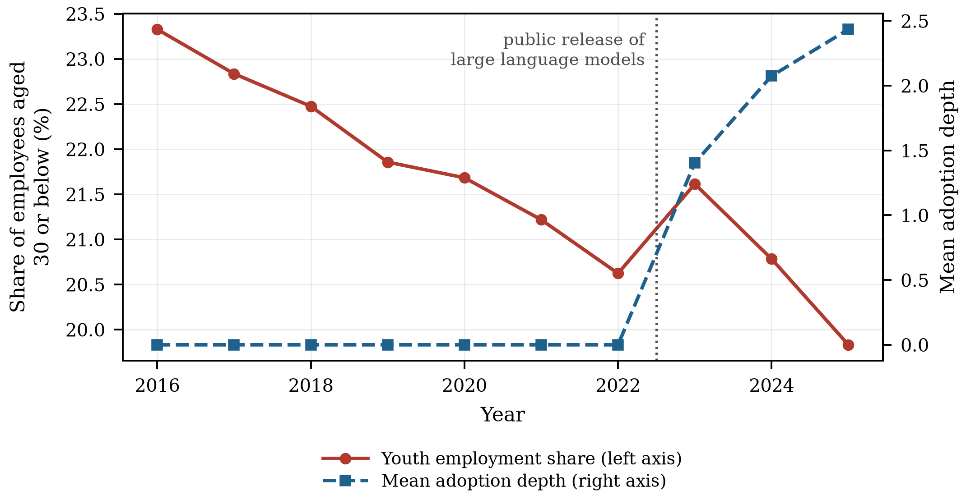
Figure 1. Generative AI adoption depth and the youth employment share of Chinese listed firms, 2016–2025.

4.2. Pearson Correlation Analysis
Table 3 reports pairwise correlations. Adoption depth is positively correlated with the augmentation channel and with the automation channel, as the mechanism implies, and its raw correlation with the youth share is small, which is the first hint that a linear summary will not be informative. Correlations among the regressors are moderate; excluding the mechanical correlation between adoption depth and its own square, variance inflation factors have a maximum of 1.00 and a mean of 1.00, far below the conventional threshold of ten, so multicollinearity is not a concern.
Table 3. Pearson correlations of the main variables.
Variable | Youth | AI | AUG | AUT | OLC | AIGov | LCP | Size | Lev
Youth | 1.000
AI | −0.047*** | 1.000
AUG | 0.227*** | 0.689*** | 1.000
AUT | −0.267*** | 0.673*** | 0.472*** | 1.000
OLC | 0.076*** | −0.009 | 0.112*** | 0.002 | 1.000
AIGov | 0.007 | 0.188*** | 0.142*** | 0.108*** | 0.003 | 1.000
LCP | −0.067*** | 0.082*** | 0.030*** | 0.032*** | −0.012** | 0.030*** | 1.000
Size | 0.115*** | 0.178*** | 0.194*** | 0.112*** | −0.017*** | 0.025*** | 0.011* | 1.000
Lev | −0.064*** | 0.005 | 0.010 | 0.002 | 0.002 | 0.010* | −0.001 | 0.014** | 1.000
Note: ***, ** and * denote significance at the 1%, 5% and 10% levels. Excluding the mechanical correlation between adoption depth and its own square, variance inflation factors have a maximum of 1.00 and a mean of 1.00.

4.3. Baseline Regression Analysis
Table 4 reports the baseline estimates. Columns (1) and (2) estimate the linear specification of Equation (2). The coefficient on adoption depth is −0.019 with a standard error of 0.074 and a p-value of 0.801: with firm and year fixed effects and the full control vector, a linear model finds no relationship whatsoever between generative AI adoption and the age composition of the workforce. Taken alone, this is the null result that much of the recent literature reports [8].
Columns (3) and (4) add the squared term. The coefficient on depth becomes 2.952 and the coefficient on its square −0.692, both significant at the 1% level, and the within R-squared roughly doubles. The sign pattern is the one H1 predicts. Columns (5) and (6) replace the year fixed effects with industry-by-year and province-by-year fixed effects, absorbing any shock common to an industry or a province in a given year, including sectoral demand cycles and provincial graduate-supply conditions; both coefficients are essentially unchanged. The contrast between columns (2) and (4) is the paper's first substantive finding: the apparent absence of an effect in the linear specification is not an absence of an effect but the cancellation of two arms of a curve.
Table 4. Baseline regressions: adoption depth and the youth employment share.
Variable | (1) | (2) | (3) | (4) | (5) | (6)
AI | 0.007 | −0.019 | 2.975*** | 2.952*** | 2.989*** | 3.000***
 | (0.074) | (0.074) | (0.191) | (0.190) | (0.194) | (0.193)
AI² |  |  | −0.692*** | −0.692*** | −0.693*** | −0.690***
 |  |  | (0.045) | (0.045) | (0.046) | (0.046)
Size |  | 1.369*** |  | 1.361*** | 1.350*** | 1.365***
 |  | (0.122) |  | (0.120) | (0.121) | (0.121)
Lev |  | −3.273*** |  | −3.277*** | −3.249*** | −3.272***
 |  | (0.240) |  | (0.237) | (0.238) | (0.239)
ROE |  | 1.103*** |  | 1.075*** | 1.117*** | 1.057***
 |  | (0.310) |  | (0.309) | (0.309) | (0.310)
Growth |  | 0.185* |  | 0.217** | 0.230** | 0.222**
 |  | (0.106) |  | (0.105) | (0.105) | (0.106)
Age |  | −2.121*** |  | −2.190*** | −2.123*** | −2.119***
 |  | (0.756) |  | (0.752) | (0.755) | (0.755)
Board |  | −0.010 |  | −0.018 | −0.050 | −0.027
 |  | (0.198) |  | (0.197) | (0.198) | (0.198)
Indep |  | −0.209 |  | −0.462 | −0.499 | −0.438
 |  | (0.766) |  | (0.763) | (0.762) | (0.768)
Dual |  | 0.038 |  | 0.047 | 0.048 | 0.033
 |  | (0.081) |  | (0.081) | (0.081) | (0.082)
TobinQ |  | 0.008 |  | 0.004 | 0.006 | 0.005
 |  | (0.034) |  | (0.034) | (0.034) | (0.034)
Fixed |  | −0.036 |  | −0.059 | −0.058 | −0.057
 |  | (0.295) |  | (0.294) | (0.295) | (0.297)
Controls | No | Yes | No | Yes | Yes | Yes
Firm FE | Yes | Yes | Yes | Yes | Yes | Yes
Year FE | Yes | Yes | Yes | Yes | No | No
Industry × year FE | No | No | No | No | Yes | No
Province × year FE | No | No | No | No | No | Yes
Observations | 27,320 | 27,320 | 27,320 | 27,320 | 27,320 | 27,320
Within R² | 0.000 | 0.016 | 0.014 | 0.030 | 0.030 | 0.030
Note: The dependent variable is the share of employees aged 30 or below. Columns (1) and (2) estimate the linear specification of Equation (2) and columns (3) to (6) the quadratic specification of Equation (3). Standard errors clustered at the firm level are in parentheses. ***, ** and * denote significance at the 1%, 5% and 10% levels.

4.4. Testing the Shape of the Relationship
A negative squared term is necessary but not sufficient for an inverted U. Table 5 reports the full battery. The fitted slope at the lower extreme of the data is 2.952 with a standard error of 0.190, and at the upper extreme −3.716 with a standard error of 0.267: positive and negative respectively, each significantly so. The Lind–Mehlum statistic, the smaller of the two one-sided statistics, is 13.91 with a p-value below 0.001, so the composite null of a monotone relationship over the observed range is rejected.
The extreme point is 2.132, with a Fieller 95% interval of [2.033, 2.237]. Both the point estimate and the whole interval lie inside the observed range of depth, [0, 4.816], which is the condition that distinguishes a genuine interior maximum from an extrapolated one. 42.9% of post-shock observations lie beyond the extreme point, so the descending arm is estimated on a substantial body of data rather than on a handful of outliers, and 4.3% lie beyond 4.26, the depth at which the fitted curve returns to its value at zero adoption. The two-lines test agrees: the slope below the break is 1.622 and the slope above it −1.754, both significant at the 1% level and of opposite sign.
Table 5. Testing the shape of the relationship.
Quantity | Value
Data range of AI | [0.000, 4.816]
Slope at the lower extreme | 2.952 (0.190)
Slope at the upper extreme | −3.716 (0.267)
Lind–Mehlum test for an inverted U shape | t = 13.91, p < 0.001
Extreme point | 2.132
Fieller 95% interval for the extreme point | [2.033, 2.237]
Share of post-shock observations beyond the extreme point | 42.9%
Two-lines test, slope below the break | 1.622 (p < 0.001)
Two-lines test, slope above the break | −1.754 (p < 0.001)
Note: The Lind–Mehlum test is the exact test of a U or inverted-U shape over a specified interval; its composite null is that the relationship is monotone. The Fieller interval for the extreme point does not require the squared term to be far from zero. The two-lines test fits a separate slope on each side of the extreme point.
Figure 2 plots the fitted curve of Equation (3) relative to its value at zero adoption, with its 95% confidence band, the extreme point and the shaded Fieller interval around it, and residualised binned means. The binned means are purged of the controls and of the firm and year effects, grouped into twenty equal-count bins of positive adoption depth and re-based on the lowest bin, so they impose no functional form at all. They track the quadratic closely over the whole range, rising to the peak and falling away from it, which is the strongest available evidence that the curvature is a property of the data rather than of the polynomial. In economic terms, moving from no adoption to the peak raises the youth employment share by 3.15 percentage points, 14.6% of the sample mean; moving from the peak to the deepest observed adoption removes 4.99 points, leaving the firm 1.84 points below where it began. H1 is supported.
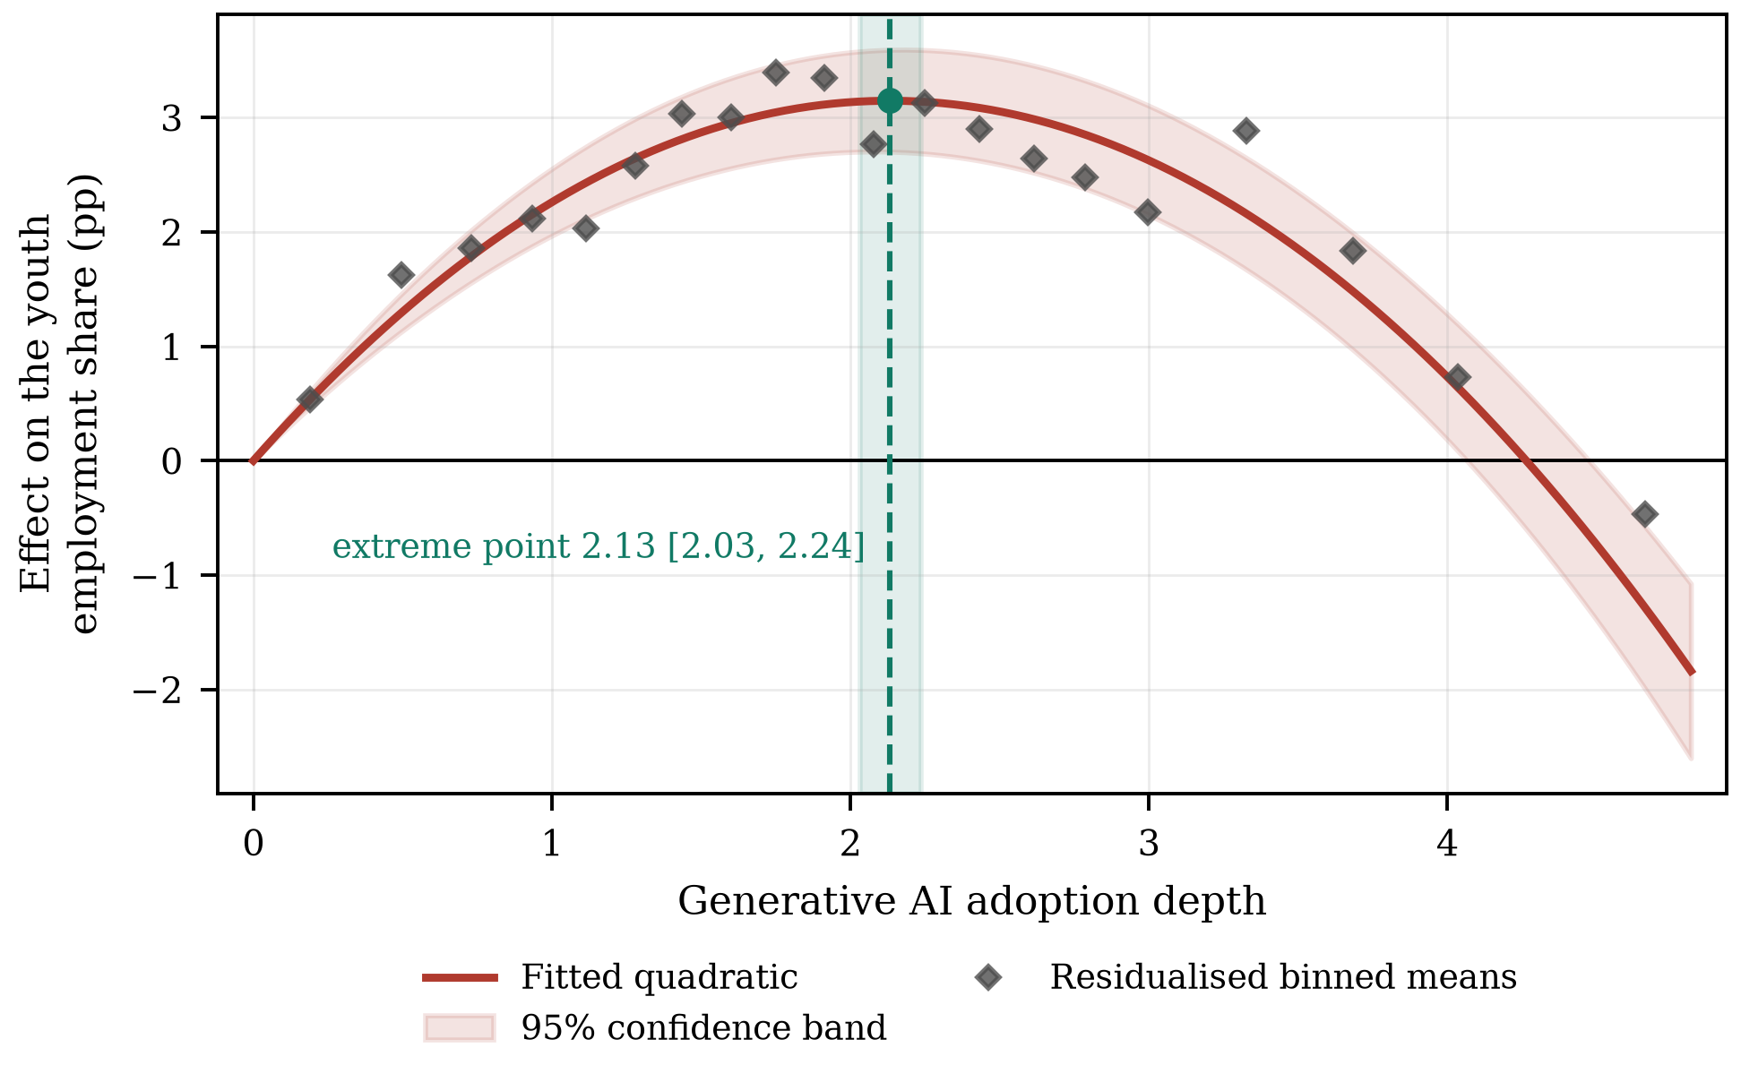
Figure 2. The inverted U-shaped relationship between adoption depth and the youth employment share.

4.5. Why the Curve Bends: Augmentation and Automation
Table 6 opens the mechanism. Column (1) regresses the augmentation channel on depth and its square: the linear term is 9.110 and the squared term −0.628, so augmentation is increasing and concave, with an extreme point at 7.25 that lies outside the observed range of depth. Within the data, in other words, augmentation never stops rising; it merely rises more and more slowly. Column (2) does the same for automation: the linear term is 1.932 and the squared term 0.731, positive and significant, so automation is increasing and convex. This is the asymmetry the theory requires, and it is measured rather than assumed.
Column (3) puts both channels in the outcome equation. The youth share loads positively on augmentation (0.324) and negatively on automation (−0.577), both at the 1% level, and once the two channels are controlled for, the squared term on depth is no longer statistically significant (p = 0.107). The curvature of the reduced-form relationship is therefore fully accounted for by the differing curvature of the two channels: there is no residual non-linearity left to explain.
Table 6. Mechanism: augmentation is concave, automation is convex.
Variable | (1) | (2) | (3)
Dependent variable | AUG | AUT | Youth
AI | 9.110*** | 1.932*** | 1.111***
 | (0.170) | (0.124) | (0.175)
AI² | −0.628*** | 0.731*** | −0.067
 | (0.038) | (0.028) | (0.041)
AUG |  |  | 0.324***
 |  |  | (0.007)
AUT |  |  | −0.577***
 |  |  | (0.009)
Size | 0.801*** | −0.123 | 1.030***
 | (0.109) | (0.081) | (0.105)
Lev | 0.147 | 0.068 | −3.286***
 | (0.219) | (0.158) | (0.207)
ROE | −0.063 | 0.132 | 1.172***
 | (0.275) | (0.200) | (0.267)
Growth | 0.026 | −0.031 | 0.191**
 | (0.100) | (0.075) | (0.092)
Age | −0.218 | 0.354 | −1.915***
 | (0.676) | (0.504) | (0.658)
Board | 0.095 | −0.056 | −0.081
 | (0.186) | (0.134) | (0.173)
Indep | −0.486 | 0.659 | 0.076
 | (0.708) | (0.527) | (0.667)
Dual | −0.008 | −0.031 | 0.031
 | (0.075) | (0.056) | (0.071)
TobinQ | −0.006 | −0.004 | 0.003
 | (0.031) | (0.023) | (0.030)
Fixed | −0.155 | 0.232 | 0.125
 | (0.272) | (0.205) | (0.256)
Controls | Yes | Yes | Yes
Firm FE | Yes | Yes | Yes
Year FE | Yes | Yes | Yes
Observations | 27,320 | 27,320 | 27,320
Within R² | 0.396 | 0.433 | 0.265
Note: Columns (1) and (2) regress each channel on adoption depth and its square; column (3) adds both channels to the outcome equation. Standard errors clustered at the firm level are in parentheses. ***, ** and * denote significance at the 1%, 5% and 10% levels.
Figure 3 shows the decomposition graphically. Each channel's contribution is its fitted quadratic in adoption depth, taken from columns (1) and (2) of Table 6, multiplied by its loading in the outcome equation in column (3). The augmentation contribution rises and flattens; the automation contribution falls at an accelerating rate; their sum is the inverted U, and the dotted line marks where it peaks. The figure makes the policy content of the result visible. The descending arm is not evidence that the technology is harmful to young workers. It is evidence that the complementary margin runs out before the substituting margin does.
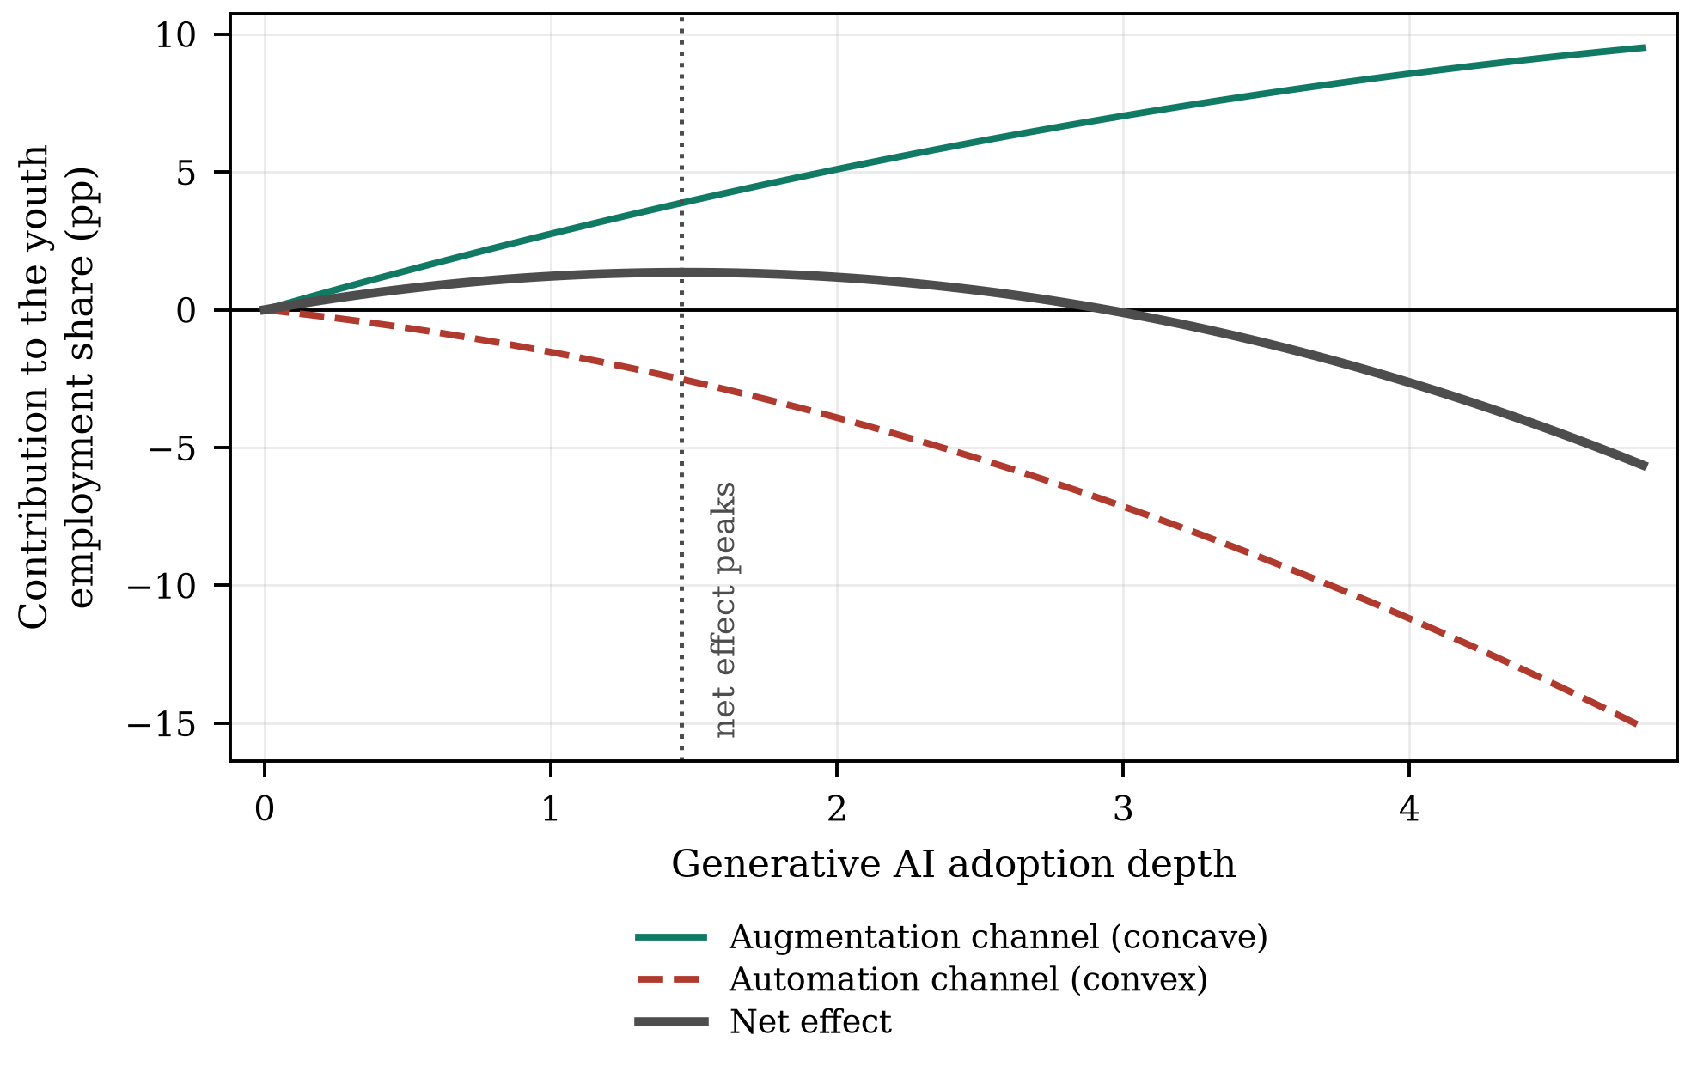
Figure 3. Decomposition of the curve into the augmentation and automation channels.

4.6. Robustness and Endogeneity Tests
Table 7 reports eight robustness checks, each re-estimating Equation (3) with one modification and reporting the two coefficients, the extreme point and the Lind–Mehlum statistic. Replacing the dependent variable with the share aged 35 or below, and with the logarithm of the number of employees aged 30 or below, leaves the shape and the location of the peak essentially unchanged; the second shows that the result is not an artefact of composition arising from changes in total headcount. Mean-centring adoption depth, which removes the mechanical correlation between the linear and squared terms, reproduces the same curvature and the same extreme point. Clustering on firm and year simultaneously, excluding 2020 to remove the pandemic year, restricting the sample to the post-shock years, winsorising the dependent variable at the 5th and 95th percentiles and restricting the sample to the balanced panel all leave the inverted U intact, with extreme points between 2.13 and its neighbourhood and Lind–Mehlum statistics significant at the 1% level throughout.
Table 7. Robustness checks.
Specification | AI | SE | AI² | SE | Extreme point | U-test t | N
(1) Youth aged 35 or below | 4.701*** | (0.317) | −1.104*** | (0.075) | 2.129 | 13.33 | 27,320
(2) ln(young headcount) | 0.186*** | (0.016) | −0.048*** | (0.004) | 1.955 | 11.65 | 27,320
(3) Mean-centred adoption depth | 2.110*** | (0.140) | −0.692*** | (0.045) | 2.132 | 14.22 | 27,320
(4) Two-way clustered standard errors | 2.952*** | (0.160) | −0.692*** | (0.036) | 2.132 | 18.15 | 27,320
(5) Excluding 2020 | 2.973*** | (0.195) | −0.697*** | (0.046) | 2.134 | 13.81 | 24,592
(6) Post-shock years only | 2.939*** | (0.327) | −0.723*** | (0.066) | 2.034 | 9.00 | 8,414
(7) Winsorised at the 5th and 95th percentiles | 2.704*** | (0.179) | −0.631*** | (0.042) | 2.143 | 13.55 | 27,320
(8) Balanced panel | 2.885*** | (0.480) | −0.642*** | (0.120) | 2.247 | 4.50 | 3,870
Note: Each row re-estimates Equation (3) with the modification described and reports the two coefficients, the extreme point and the Lind–Mehlum statistic. Standard errors are clustered at the firm level except in row (4). ***, ** and * denote significance at the 1%, 5% and 10% levels.
Table 8 addresses endogeneity. Columns (1) and (2) report the two first stages. The Kleibergen–Paap rank Wald statistic is 99.1 for depth and 87.6 for its square, both far above the Stock–Yogo 10% maximal-size critical value, so neither endogenous regressor is weakly identified. The Hansen test does not reject the validity of the instruments (p = 0.350), and the Wu–Hausman test rejects exogeneity (p = 0.007), so the instrumental-variable estimates are both necessary and admissible. Column (3) reports them: 3.309 on depth and −0.895 on its square, an extreme point of 1.848 and a Lind–Mehlum p-value of 0.015. The shape survives; the peak moves left, which is what the confounding story predicts, since firms with favourable unobserved shocks both adopt more deeply and hire more young workers, biasing the ascending arm upward and the estimated peak outward.
Columns (4) and (5) address selection on observables. Propensity-score matching pairs each deeply adopting firm with the nearest less-deeply adopting firm on pre-shock characteristics within a caliper of 0.02; after matching the largest absolute standardised bias across the covariates is 2.2%, far inside the conventional 10% threshold (Table A1). The matched-sample extreme point is 2.150 and the entropy-balanced extreme point 2.144, both very close to the baseline.
Table 8. Endogeneity: instrumental variables, propensity-score matching and entropy balancing.
Variable | (1) First stage | (2) First stage | (3) 2SLS | (4) PSM | (5) Entropy balancing
Dependent variable | AI | AI² | Youth | Youth | Youth
IV^{Phone} | 0.046 | 0.193
 | (0.034) | (0.162)
IV^{Peer} | 0.230*** | 0.271
 | (0.057) | (0.260)
IV^{Exp} | 0.449*** | 1.995***
 | (0.030) | (0.149)
(IV^{Phone})² | −0.041 | −0.226*
 | (0.026) | (0.132)
(IV^{Peer})² | 0.000 | 0.160**
 | (0.013) | (0.066)
(IV^{Exp})² | 0.015 | 0.172*
 | (0.019) | (0.093)
AI |  |  | 3.309** | 2.921*** | 2.934***
 |  |  | (1.632) | (0.223) | (0.208)
AI² |  |  | −0.895** | −0.679*** | −0.684***
 |  |  | (0.385) | (0.052) | (0.048)
Controls | Yes | Yes | Yes | Yes | Yes
Firm FE | Yes | Yes | Yes | Yes | Yes
Year FE | Yes | Yes | Yes | Yes | Yes
Kleibergen–Paap rk Wald F | 99.1 | 87.6
Hansen J (p) |  |  | 4.43 (0.350)
Wu–Hausman (p) |  |  | 0.007
Observations | 27,320 | 27,320 | 27,320 | 21,811 | 27,320
Note: Columns (1) and (2) are the two first stages of the two-stage least-squares estimation and column (3) the second stage. Column (4) estimates Equation (3) on the 1:1 nearest-neighbour matched sample with a caliper of 0.02, and column (5) reweights the comparison group by entropy balancing on the first two moments of the covariates. Standard errors clustered at the firm level are in parentheses. ***, ** and * denote significance at the 1%, 5% and 10% levels.
Table 9 reports the coefficient-stability bounds for the ascending arm. Moving from the specification without controls to the specification with controls changes the coefficient on depth from 2.975 to 2.952 while the within R-squared rises from 0.014 to 0.030. The coefficient is almost completely insensitive to the controls, so the bias-adjusted value is 2.939 and unobserved selection would have to be 228 times as important as the observed controls to drive it to zero. Finally, as a check on inference we re-estimate Equation (3) after randomly permuting adoption depth within year, repeated 500 times. The Lind–Mehlum statistic obtained with the actual assignment, 13.91, is larger than every one of those draws, whose distribution Figure 4 plots, so the curvature cannot be produced by the functional form acting on noise.
Table 9. Bounding the scope for selection on unobservables.
Quantity | Value
Coefficient on AI without controls | 2.975
Coefficient on AI with controls | 2.952
R-squared without controls | 0.014
R-squared with controls | 0.030
Assumed maximum R-squared (1.3 × R-squared with controls) | 0.040
Bias-adjusted coefficient on AI | 2.939
Relative degree of selection that would set it to zero | 228.24
Note: Both regressions are estimated on two-way demeaned data with the squared term retained in each, so that the R-squared is monotone in the set of controls. The relative degree of selection is the ratio of selection on unobservables to selection on observables that would be required to drive the coefficient to zero; an absolute value above one is conventionally read as evidence that the result is not driven by unobserved selection.
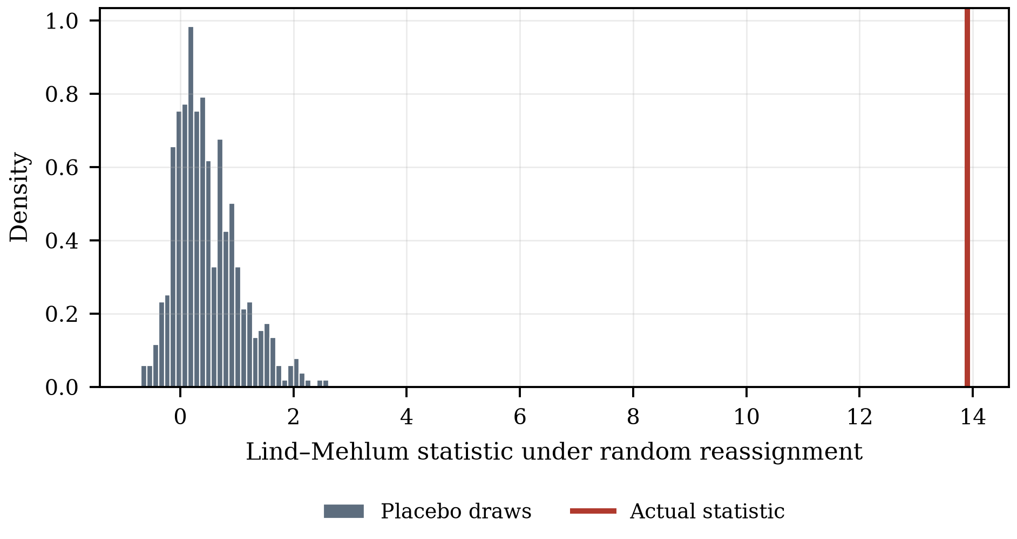
Figure 4. Randomisation distribution of the Lind–Mehlum statistic.

5. Further Investigations
If the relationship is inverted U-shaped, the managerially relevant question is where the peak sits, because that is the depth at which further adoption stops helping young workers and starts hurting them. This section asks what moves it. Table 10 reports the three moderated specifications of Equation (6) and Table 11 converts them into turning points and displacements.

5.1. Adoption Depth, Organisational Learning Capability and Youth Employment
Column (1) of Table 10 interacts depth and its square with organisational learning capability. The interaction with the linear term is 0.759 and significant at the 1% level, while the interaction with the squared term is −0.012 and not significant (p = 0.704). Read through Equation (8), this is a pure displacement: learning capability does not make the curve flatter or steeper, it moves it to the right. The turning point rises from 1.63 at one standard deviation below the mean to 2.65 at one standard deviation above it, a displacement of 0.508 per standard deviation with a standard error of 0.049. H2a is supported.
The magnitude is economically large. A firm one standard deviation above the mean in learning capability is still on the ascending arm at a depth at which a firm one standard deviation below it has already been descending for some time. The same technology, adopted to the same depth, adds young workers in one firm and removes them from the other. This is the socio-technical joint-optimisation principle [17,18] in a form that can be measured: the technical subsystem sets the shape of the curve, the social subsystem sets where along it the firm can afford to be.

5.2. Adoption Depth, AI Governance and Youth Employment
Column (2) repeats the exercise with disclosed AI governance. The interaction with the linear term is 0.694 (p = 0.002) and the interaction with the squared term is 0.079 and not significant. The turning point of a firm without disclosed governance arrangements is 1.81; with them it is 2.56, a displacement of 0.671 with a standard error of 0.065. H2b is supported.
The interpretation is that governance is what makes the supervised, AI-assisted junior position viable. Without review protocols and accountability rules, work that a model can partly perform is either done unaided or handed to the model outright, and the intermediate arrangement — the one that keeps an entry position in existence — is not available. The evidence that professionals disengage from opaque systems when the stakes are high [22,23] is the micro-foundation of this result.

5.3. Adoption Depth, Labour Cost Pressure and Youth Employment
Column (3) turns to labour cost pressure. The interaction with the linear term is −0.609 and significant at the 1% level, and the displacement of the turning point is −0.558 with a standard error of 0.058: the peak arrives earlier, moving from 2.81 at low cost pressure to 1.69 at high cost pressure. H2c is supported.
The asymmetry with the first two moderators is instructive. Learning capability and governance change what the firm is able to do with a given augmentation gain; cost pressure changes what it chooses to do with it. A firm under pressure banks the gain as a smaller establishment rather than as more output per junior, which is the displacement effect winning over the scale effect [14,31]. The implication is uncomfortable but clear: the firms most likely to close the entry port early are not the technologically most advanced but the financially most constrained.
Table 10. Moderating roles of organisational learning capability, AI governance and labour cost pressure.
Variable | (1) OLC | (2) AIGov | (3) LCP
AI | 2.990*** | 2.639*** | 3.044***
 | (0.185) | (0.214) | (0.184)
AI² | −0.697*** | −0.730*** | −0.684***
 | (0.043) | (0.053) | (0.043)
AI × Z | 0.759*** | 0.694*** | −0.609***
 | (0.103) | (0.222) | (0.108)
AI² × Z | −0.012 | 0.079 | −0.035
 | (0.031) | (0.065) | (0.033)
AIGov |  | 0.031
 |  | (0.115)
LCP |  |  | −0.014
 |  |  | (0.080)
Controls | Yes | Yes | Yes
Firm FE | Yes | Yes | Yes
Year FE | Yes | Yes | Yes
Observations | 27,320 | 27,320 | 27,320
Within R² | 0.054 | 0.043 | 0.055
Note: Z denotes the moderator named in the column heading. OLC is measured before the shock and is time invariant, so it is absorbed by the firm fixed effects and enters only through its interactions. Standard errors clustered at the firm level are in parentheses. ***, ** and * denote significance at the 1%, 5% and 10% levels.
Table 11. Extreme points and their displacement across the three moderators.
Moderator | Level | Extreme point | SE | Curvature | Displacement | SE
OLC | Low (−1 SD) | 1.629 | (0.061) | −0.685
OLC | Mean | 2.146 | (0.048) | −0.697
OLC | High (+1 SD) | 2.646 | (0.083) | −0.708 | 0.508*** | (0.049)
AIGov | Without disclosure | 1.809 | (0.054) | −0.730
AIGov | With disclosure | 2.561 | (0.089) | −0.651 | 0.671*** | (0.065)
LCP | Low (−1 SD) | 2.813 | (0.108) | −0.649
LCP | Mean | 2.225 | (0.050) | −0.684
LCP | High (+1 SD) | 1.694 | (0.055) | −0.719 | −0.558*** | (0.058)
Note: The extreme point is evaluated from Equation (7) at the level of the moderator shown; the displacement is Equation (8), the change in the extreme point per unit of the moderator evaluated at its mean, with a delta-method standard error. Curvature is the coefficient on the squared term at that level of the moderator. ***, ** and * denote significance at the 1%, 5% and 10% levels.
Figure 5 plots the six fitted curves of Equation (6), evaluated at one standard deviation below and above the mean of the two continuous moderators and at the two values of the AI governance indicator; the marker on each curve is its extreme point, and in every panel the solid curve is the one whose peak arrives later. The visual summary of Section 5 is that the three moderators move the peak by between 0.51 and 0.67 units of adoption depth, against a baseline peak of 2.13 — displacements of the order of a quarter to a third of the peak itself.
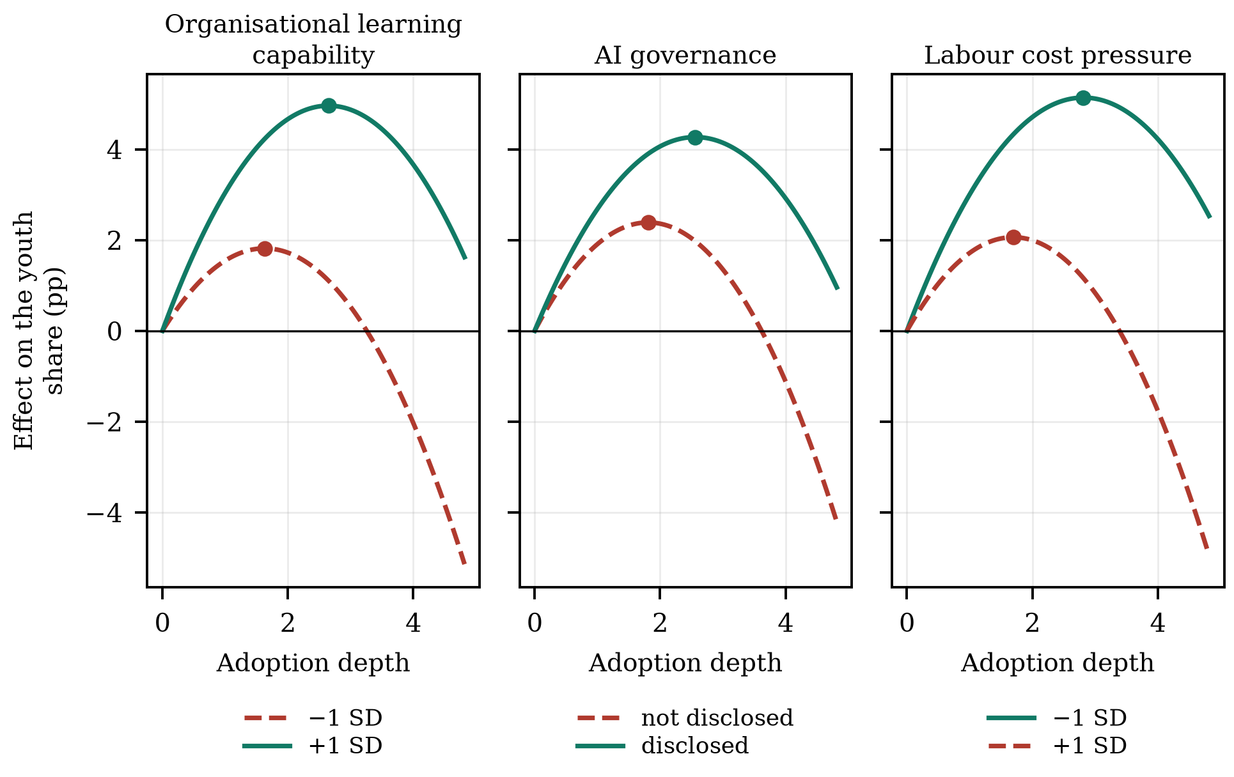
Figure 5. The curve at low and high levels of each moderator.

5.4. Heterogeneity
Table 12 splits the sample by state ownership, technology intensity, region and firm size. The inverted U is present in every subsample: the squared term is negative and significant at the 1% level in all eight groups. The turning points differ modestly and none of the differences in curvature is statistically significant, which is itself informative. The shape is a general property of how the technology meets entry-level work, not a feature of a particular kind of firm; what varies across firms, as Section 5 shows, is where along the curve they can afford to operate.
Table 12. Heterogeneity analysis.
Split | Group 1 | AI² | Extreme point | N | Group 2 | AI² | Extreme point | N | p
State ownership | State-owned | −0.638*** | 2.288 | 8,789 | Non-state | −0.724*** | 2.063 | 18,531 | 0.359
Technology intensity | High-technology | −0.646*** | 2.048 | 11,648 | Other | −0.727*** | 2.192 | 15,672 | 0.373
Region | Eastern | −0.666*** | 2.231 | 9,685 | Central and western | −0.700*** | 2.079 | 17,635 | 0.719
Firm size | Large | −0.723*** | 2.218 | 13,660 | Small | −0.692*** | 2.085 | 13,660 | 0.754
Note: Each row estimates Equation (3) separately in the two subsamples. The p-value tests the equality of the coefficient on the squared term across the two groups. Firm size is split at the median of total assets. ***, ** and * denote significance at the 1%, 5% and 10% levels.

6. Research Conclusions and Implications

6.1. Research Conclusions
Using a panel of Chinese A-share listed firms and a text-based measure of generative AI adoption depth, this study finds that the relationship between adoption depth and the youth employment share is inverted U-shaped. A linear specification finds nothing; a quadratic specification finds a strongly significant curve whose extreme point, 2.132, lies inside the observed range with 42.9% of post-shock observations beyond it. Moderate adoption raises the youth share by up to 3.15 percentage points; the deepest observed adoption leaves the firm 1.84 points below where it started. The result survives instrumental-variable, matched-sample, entropy-balanced and randomisation-based inference, and it is reproduced by a non-parametric binned fit.
The mechanism is an asymmetry in how two channels scale with depth. Augmentation of entry-level work is increasing and concave; automation of the entry-level task bundle is increasing and convex; the youth share loads positively on the first and negatively on the second; and once both are controlled for, no residual curvature remains. The turning point is organisationally determined: organisational learning capability delays it by 0.508 units of depth per standard deviation and disclosed AI governance by 0.671, while labour cost pressure brings it forward by 0.558.

6.2. Theoretical Contributions
The study makes three contributions. First, it supplies a functional form for a relationship that the literature has estimated as monotone. The task-based framework predicts the net employment consequence of automation from the balance of displacement and reinstatement [14,15], but it is silent about how that balance changes with the intensity of the technology. We show that the two forces scale differently, that the net effect is therefore non-monotone, and that a linear estimate of it is uninformative in a precise and testable sense. This reconciles firm-level and occupation-level estimates that currently contradict one another [6–8]: they are estimating the same curve at different points.
Second, it converts the automation–augmentation paradox [27–29] from a tension into a threshold with an estimable location. The paradox holds that automation and augmentation are interdependent design choices rather than alternatives. Our results give that claim a coordinate: they are the same choice at different depths, and the depth at which one becomes the other is the object that management and policy can act on.
Third, it connects the organisational-learning literature to a labour-market outcome in a way that respects the methodology of curvilinear moderation [44]. Absorptive capacity and the conversion of experience into routines have been studied as determinants of innovation and performance [20,21,45]; we show that they determine the location of a labour-demand threshold, and we show it by testing displacement of the turning point rather than by reading it off an interaction coefficient.

6.3. Managerial and Policy Implications
For firms, the result reframes the adoption decision. The relevant question is not whether to adopt generative AI but how deep to go before the entry-level role has to be rebuilt, and the answer is firm-specific and measurable. A firm can estimate its own position on the curve from its adoption depth and its learning and governance characteristics, and the two organisational levers that move the peak are ordinary management decisions: investment in the training and knowledge-management infrastructure that constitutes learning capability, and the review protocols, accountability rules and disclosure that constitute AI governance. Neither requires slowing adoption down.
For policy, the finding that the effect is non-monotone and organisationally conditioned points away from the instruments currently in view. Restricting adoption would forgo the ascending arm, on which most firms in this sample still sit, without addressing the mechanism that produces the descending one. Instruments that raise organisational learning capability — training subsidies conditional on the task content of entry-level roles rather than on headcount, structured apprenticeship in professional services, graduate schemes with protected task content — act directly on the moderator that moves the peak, and they are the instruments implied by the argument that AI can extend rather than replace the reach of expertise [69]. Since firms under labour cost pressure close the entry port earliest, the distributional consequences will appear first in the segment of the economy least able to absorb them, and the persistence of entry conditions in later earnings [55,56,70] means the cost is borne for a long time by the cohorts affected.

6.4. Limitations and Future Research Directions
Five limitations qualify the results. First, adoption depth is measured from annual-report text, which captures disclosed rather than actual use and may be inflated by firms seeking to signal technological sophistication; the shift-share instrument on ex-ante task exposure, which does not rely on disclosure, gives the same answer, but a measure based on procurement or usage data would be better. Second, the quadratic is a local approximation. It is the standard vehicle for testing an interior maximum and we have supported it with a non-parametric fit and a two-lines test, but the true relationship may have a shape the quadratic cannot represent, and semiparametric estimation on a longer panel would settle it. Third, the sample is listed firms, which are larger and more capital-intensive than the population. Fourth, the outcome is the firm's age composition, not the young worker's welfare; displaced entry demand at one firm may be absorbed at another, so the firm-level estimate is not an equilibrium effect, and linked employer–employee data would be required to trace it. Fifth, the moderators are observable proxies, and organisational learning capability in particular is measured by training expenditure rather than by the routines it is meant to indicate. Future research could also ask whether the turning point itself moves over time as firms learn: if it does, the descending arm observed today may be a transitional phenomenon rather than a steady state.

Appendix A
Table A1 reports the covariate balance underlying the propensity-score matched sample used in column (4) of Table 8. Every matched difference is far inside the conventional ten per cent criterion and none is statistically significant.
Table A1. Covariate balance before and after propensity-score matching.
Variable | Standardised bias, unmatched (%) | Standardised bias, matched (%) | t | p
Size | 48.0 | 0.2 | 0.05 | 0.963
Lev | 2.1 | −0.1 | −0.02 | 0.988
ROE | 0.3 | 2.2 | 0.57 | 0.569
Growth | 0.0 | 2.2 | 0.56 | 0.575
Age | 3.4 | −0.6 | −0.14 | 0.885
Board | 0.2 | −0.1 | −0.03 | 0.978
Indep | 0.6 | 1.3 | 0.33 | 0.738
Dual | 0.9 | 1.9 | 0.51 | 0.613
TobinQ | 0.5 | −1.0 | −0.26 | 0.797
Fixed | 7.1 | 1.3 | 0.35 | 0.727
Note: Standardised bias is the difference in means between the deeply and less deeply adopting groups divided by the square root of the average of their variances, expressed in per cent. An absolute value below ten is the conventional criterion for adequate balance. The t-test is on the matched sample.
Author Contributions: Conceptualization, methodology, formal analysis, software and writing—original draft preparation, X.C.; validation, data curation and visualization, investigation, writing—review and editing, supervision and project administration, T.M. All authors have read and agreed to the published version of the manuscript.
Funding: This research was funded by the Zhejiang Provincial Philosophy and Social Sciences Planning Special Project on Higher Education Basic Research Funding Reform (Grant Number: 25NDJC153YBMS) and the Major Humanities and Social Sciences Research Projects in Zhejiang Higher Education Institutions (Grant Number: 2024QN018).
Institutional Review Board Statement: Not applicable. The study uses firm-level accounting and disclosure data and involves no human participants or animals.
Informed Consent Statement: Not applicable.
Data Availability Statement: The financial, governance and employment-composition data are commercially licensed from the China Stock Market and Accounting Research database and cannot be redistributed by the authors; they are available to subscribers. The generative-AI keyword dictionary, the estimation code for every specification reported in the paper, and the scripts that generate every table and figure are available from the corresponding author on reasonable request.
Acknowledgments: The authors thank the editors and the anonymous reviewers for comments that improved the manuscript.
Conflicts of Interest: The authors declare no conflicts of interest.

References
1. Brynjolfsson, E.; Li, D.; Raymond, L.R. Generative AI at Work. Q. J. Econ. 2025, 140, 889–942. [CrossRef]
2. Noy, S.; Zhang, W. Experimental Evidence on the Productivity Effects of Generative Artificial Intelligence. Science 2023, 381, 187–192. [CrossRef]
3. Otis, N.G.; Clarke, R.; Delecourt, S.; Holtz, D.; Koning, R. The Uneven Impact of Generative Artificial Intelligence on Entrepreneurial Performance: Evidence from a Field Experiment in Kenya. Manag. Sci. 2026, in press. [CrossRef]
4. Cui, Z.K.; Demirer, M.; Jaffe, S.; Musolff, L.; Peng, S.; Salz, T. The Effects of Generative AI on High-Skilled Work: Evidence from Three Field Experiments with Software Developers. Manag. Sci. 2026, in press. [CrossRef]
5. Peng, S.; Kalliamvakou, E.; Cihon, P.; Demirer, M. The Impact of AI on Developer Productivity: Evidence from GitHub Copilot. arXiv 2023, arXiv:2302.06590.
6. Brynjolfsson, E.; Chandar, B.; Chen, R. Canaries in the Coal Mine? Six Facts about the Recent Employment Effects of Artificial Intelligence; Working Paper; Stanford Digital Economy Lab, Stanford University: Stanford, CA, USA, 2025.
7. Hui, X.; Reshef, O.; Zhou, L. The Short-Term Effects of Generative Artificial Intelligence on Employment: Evidence from an Online Labor Market. Organ. Sci. 2024, 35, 1977–1989. [CrossRef]
8. Humlum, A.; Vestergaard, E. Large Language Models, Small Labor Market Effects; NBER Working Paper 33777; National Bureau of Economic Research: Cambridge, MA, USA, 2025.
9. Vaccaro, M.; Almaatouq, A.; Malone, T. When Combinations of Humans and AI Are Useful: A Systematic Review and Meta-Analysis. Nat. Hum. Behav. 2024, 8, 2293–2303. [CrossRef]
10. Bick, A.; Blandin, A.; Deming, D.J. The Rapid Adoption of Generative AI; NBER Working Paper 32966; National Bureau of Economic Research: Cambridge, MA, USA, 2024.
11. International Labour Organization Global Employment Trends for Youth 2024: Decent Work, Brighter Futures; International Labour Office: Geneva, Switzerland, 2024.
12. World Economic Forum The Future of Jobs Report 2025; World Economic Forum: Geneva, Switzerland, 2025.
13. Autor, D.H.; Levy, F.; Murnane, R.J. The Skill Content of Recent Technological Change: An Empirical Exploration. Q. J. Econ. 2003, 118, 1279–1333. [CrossRef]
14. Acemoglu, D.; Restrepo, P. The Race between Man and Machine: Implications of Technology for Growth, Factor Shares, and Employment. Am. Econ. Rev. 2018, 108, 1488–1542. [CrossRef]
15. Acemoglu, D.; Restrepo, P. Tasks, Automation, and the Rise in U.S. Wage Inequality. Econometrica 2022, 90, 1973–2016. [CrossRef]
16. Dell'Acqua, F.; McFowland, E., III; Mollick, E.R.; Lifshitz-Assaf, H.; Kellogg, K.C.; Rajendran, S.; Krayer, L.; Candelon, F.; Lakhani, K.R. Navigating the Jagged Technological Frontier: Field Experimental Evidence of the Effects of Artificial Intelligence on Knowledge Worker Productivity and Quality. Organ. Sci. 2026, in press. [CrossRef]
17. Trist, E.L.; Bamforth, K.W. Some Social and Psychological Consequences of the Longwall Method of Coal-Getting. Hum. Relat. 1951, 4, 3–38. [CrossRef]
18. Cherns, A. The Principles of Sociotechnical Design. Hum. Relat. 1976, 29, 783–792. [CrossRef]
19. Sarker, S.; Chatterjee, S.; Xiao, X.; Elbanna, A. The Sociotechnical Axis of Cohesion for the IS Discipline: Its Historical Legacy and Its Continued Relevance. MIS Q. 2019, 43, 695–719. [CrossRef]
20. Cohen, W.M.; Levinthal, D.A. Absorptive Capacity: A New Perspective on Learning and Innovation. Adm. Sci. Q. 1990, 35, 128–152. [CrossRef]
21. Argote, L.; Miron-Spektor, E. Organizational Learning: From Experience to Knowledge. Organ. Sci. 2011, 22, 1123–1137. [CrossRef]
22. Lebovitz, S.; Lifshitz-Assaf, H.; Levina, N. To Engage or Not to Engage with AI for Critical Judgments: How Professionals Deal with Opacity When Using AI for Medical Diagnosis. Organ. Sci. 2022, 33, 126–148. [CrossRef]
23. Kellogg, K.C.; Valentine, M.A.; Christin, A. Algorithms at Work: The New Contested Terrain of Control. Acad. Manag. Ann. 2020, 14, 366–410. [CrossRef]
24. Lind, J.T.; Mehlum, H. With or Without U? The Appropriate Test for a U-Shaped Relationship. Oxf. Bull. Econ. Stat. 2010, 72, 109–118. [CrossRef]
25. Simonsohn, U. Two Lines: A Valid Alternative to the Invalid Testing of U-Shaped Relationships with Quadratic Regressions. Adv. Methods Pract. Psychol. Sci. 2018, 1, 538–555. [CrossRef]
26. Acemoglu, D.; Restrepo, P. Robots and Jobs: Evidence from US Labor Markets. J. Political Econ. 2020, 128, 2188–2244. [CrossRef]
27. Raisch, S.; Krakowski, S. Artificial Intelligence and Management: The Automation–Augmentation Paradox. Acad. Manag. Rev. 2021, 46, 192–210. [CrossRef]
28. Krakowski, S.; Luger, J.; Raisch, S. Artificial Intelligence and the Changing Sources of Competitive Advantage. Strateg. Manag. J. 2023, 44, 1425–1452. [CrossRef]
29. Murray, A.; Rhymer, J.; Sirmon, D.G. Humans and Technology: Forms of Conjoined Agency in Organizations. Acad. Manag. Rev. 2021, 46, 552–571. [CrossRef]
30. Autor, D.; Chin, C.; Salomons, A.; Seegmiller, B. New Frontiers: The Origins and Content of New Work, 1940–2018. Q. J. Econ. 2024, 139, 1399–1465. [CrossRef]
31. Autor, D.H. Why Are There Still So Many Jobs? The History and Future of Workplace Automation. J. Econ. Perspect. 2015, 29, 3–30. [CrossRef]
32. Agrawal, A.; Gans, J.S.; Goldfarb, A. Artificial Intelligence: The Ambiguous Labor Market Impact of Automating Prediction. J. Econ. Perspect. 2019, 33, 31–50. [CrossRef]
33. Bresnahan, T.F.; Trajtenberg, M. General Purpose Technologies: “Engines of Growth”? J. Econom. 1995, 65, 83–108. [CrossRef]
34. Brynjolfsson, E.; Rock, D.; Syverson, C. The Productivity J-Curve: How Intangibles Complement General Purpose Technologies. Am. Econ. J. Macroecon. 2021, 13, 333–372. [CrossRef]
35. Acemoglu, D.; Autor, D.; Hazell, J.; Restrepo, P. Artificial Intelligence and Jobs: Evidence from Online Vacancies. J. Labor Econ. 2022, 40, S293–S340. [CrossRef]
36. Babina, T.; Fedyk, A.; He, A.; Hodson, J. Artificial Intelligence, Firm Growth, and Product Innovation. J. Financ. Econ. 2024, 151, 103745. [CrossRef]
37. Bonfiglioli, A.; Crinò, R.; Fadinger, H.; Gancia, G. Robot Imports and Firm-Level Outcomes. Econ. J. 2024, 134, 3428–3444. [CrossRef]
38. Liang, H.; Fan, J.; Wang, Y. Artificial Intelligence, Technological Innovation, and Employment Transformation for Sustainable Development: Evidence from China. Sustainability 2025, 17, 3842. [CrossRef]
39. Eloundou, T.; Manning, S.; Mishkin, P.; Rock, D. GPTs Are GPTs: Labor Market Impact Potential of LLMs. Science 2024, 384, 1306–1308. [CrossRef]
40. Felten, E.; Raj, M.; Seamans, R. Occupational, Industry, and Geographic Exposure to Artificial Intelligence: A Novel Dataset and Its Potential Uses. Strateg. Manag. J. 2021, 42, 2195–2217. [CrossRef]
41. Beane, M. Shadow Learning: Building Robotic Surgical Skill When Approved Means Fail. Adm. Sci. Q. 2019, 64, 87–123. [CrossRef]
42. Anthony, C. When Knowledge Work and Analytical Technologies Collide: The Practices and Consequences of Black Boxing Algorithmic Technologies. Adm. Sci. Q. 2021, 66, 1173–1212. [CrossRef]
43. Yang, B.; Sun, Y.; Zeng, Z.; Li, Q. Deskilling, Reskilling, or Upskilling? Unpacking the Pathways of Student Adaptation to Generative Artificial Intelligence. Int. J. Inf. Manag. 2026, 87, 103002. [CrossRef]
44. Haans, R.F.J.; Pieters, C.; He, Z.-L. Thinking about U: Theorizing and Testing U- and Inverted U-Shaped Relationships in Strategy Research. Strateg. Manag. J. 2016, 37, 1177–1195. [CrossRef]
45. Levitt, B.; March, J.G. Organizational Learning. Annu. Rev. Sociol. 1988, 14, 319–340. [CrossRef]
46. March, J.G. Exploration and Exploitation in Organizational Learning. Organ. Sci. 1991, 2, 71–87. [CrossRef]
47. Nonaka, I. A Dynamic Theory of Organizational Knowledge Creation. Organ. Sci. 1994, 5, 14–37. [CrossRef]
48. Teece, D.J.; Pisano, G.; Shuen, A. Dynamic Capabilities and Strategic Management. Strateg. Manag. J. 1997, 18, 509–533. [CrossRef]
49. Lave, J.; Wenger, E. Situated Learning: Legitimate Peripheral Participation; Cambridge University Press: Cambridge, UK, 1991.
50. Janssen, M. Responsible Governance of Generative AI: Conceptualizing GenAI as Complex Adaptive Systems. Policy Soc. 2025, 44, 38–51. [CrossRef]
51. Dwivedi, Y.K.; Kshetri, N.; Hughes, L.; Slade, E.L.; Jeyaraj, A.; Kar, A.K.; Baabdullah, A.M.; Koohang, A.; Raghavan, V.; Ahuja, M.; et al. Opinion Paper: “So What If ChatGPT Wrote It?” Multidisciplinary Perspectives on Opportunities, Challenges and Implications of Generative Conversational AI for Research, Practice and Policy. Int. J. Inf. Manag. 2023, 71, 102642. [CrossRef]
52. Xue, F.; Jin, S. Artificial Intelligence Adoption, Innovation Efficiency, and Governance Mechanisms: Evidence from China. Systems 2025, 13, 1062. [CrossRef]
53. Machucho, R.; Ortiz, D. The Impacts of Artificial Intelligence on Business Innovation: A Comprehensive Review of Applications, Organizational Challenges, and Ethical Considerations. Systems 2025, 13, 264. [CrossRef]
54. Xue, X.; Li, L.; Chen, J.; Luo, T. How Does Digital Technology Innovation Quality Empower Corporate ESG Performance? The Roles of Digital Transformation and Digital Technology Diffusion. Systems 2025, 13, 929. [CrossRef]
55. Kahn, L.B. The Long-Term Labor Market Consequences of Graduating from College in a Bad Economy. Labour Econ. 2010, 17, 303–316. [CrossRef]
56. Schwandt, H.; von Wachter, T. Unlucky Cohorts: Estimating the Long-Term Effects of Entering the Labor Market in a Recession in Large Cross-Sectional Data Sets. J. Labor Econ. 2019, 37, S161–S198. [CrossRef]
57. Bertrand, M.; Duflo, E.; Mullainathan, S. How Much Should We Trust Differences-in-Differences Estimates? Q. J. Econ. 2004, 119, 249–275. [CrossRef]
58. Goodman-Bacon, A. Difference-in-Differences with Variation in Treatment Timing. J. Econom. 2021, 225, 254–277. [CrossRef]
59. de Chaisemartin, C.; D'Haultfœuille, X. Two-Way Fixed Effects Estimators with Heterogeneous Treatment Effects. Am. Econ. Rev. 2020, 110, 2964–2996. [CrossRef]
60. Callaway, B.; Sant'Anna, P.H.C. Difference-in-Differences with Multiple Time Periods. J. Econom. 2021, 225, 200–230. [CrossRef]
61. Sun, L.; Abraham, S. Estimating Dynamic Treatment Effects in Event Studies with Heterogeneous Treatment Effects. J. Econom. 2021, 225, 175–199. [CrossRef]
62. Goldsmith-Pinkham, P.; Sorkin, I.; Swift, H. Bartik Instruments: What, When, Why, and How. Am. Econ. Rev. 2020, 110, 2586–2624. [CrossRef]
63. Borusyak, K.; Hull, P.; Jaravel, X. Quasi-Experimental Shift-Share Research Designs. Rev. Econ. Stud. 2022, 89, 181–213. [CrossRef]
64. Kleibergen, F.; Paap, R. Generalized Reduced Rank Tests Using the Singular Value Decomposition. J. Econom. 2006, 133, 97–126. [CrossRef]
65. Stock, J.H.; Yogo, M. Testing for Weak Instruments in Linear IV Regression. In Identification and Inference for Econometric Models: Essays in Honor of Thomas Rothenberg; Andrews, D.W.K., Stock, J.H., Eds.; Cambridge University Press: Cambridge, UK, 2005; pp. 80–108.
66. Rosenbaum, P.R.; Rubin, D.B. The Central Role of the Propensity Score in Observational Studies for Causal Effects. Biometrika 1983, 70, 41–55. [CrossRef]
67. Hainmueller, J. Entropy Balancing for Causal Effects: A Multivariate Reweighting Method to Produce Balanced Samples in Observational Studies. Polit. Anal. 2012, 20, 25–46. [CrossRef]
68. Oster, E. Unobservable Selection and Coefficient Stability: Theory and Evidence. J. Bus. Econ. Stat. 2019, 37, 187–204. [CrossRef]
69. Autor, D. Applying AI to Rebuild Middle Class Jobs; NBER Working Paper 32140; National Bureau of Economic Research: Cambridge, MA, USA, 2024.
70. von Wachter, T. The Persistent Effects of Initial Labor Market Conditions for Young Adults and Their Sources. J. Econ. Perspect. 2020, 34, 168–194. [CrossRef]

