Machine-learning detection of greenwashing reveals a persistent gap between corporate climate commitments and decarbonization performance
Graham M. Reynolds¹ & L. Wei²
¹Department of Business Administration, Faculty of Management, [University affiliation], [City], [Country].
²Centre for Sustainable Finance and Corporate Governance, [University affiliation], [City], [Country].
e-mail: graham.mich043@doramail.com
Corporations now underwrite a large and rapidly growing share of the world’s climate commitments, yet whether these pledges translate into real decarbonization remains contested. Distinguishing substantive climate action from greenwashing at scale is a central obstacle for the investors and regulators implementing a new generation of mandatory disclosure regimes. Here we combine natural language processing and machine learning to evaluate the alignment between climate-commitment language and realized emissions performance for 1,512 large listed firms over 2015–2023. We quantify a commitment score from firms’ sustainability disclosures, a decarbonization-performance score from verified emission-intensity trajectories, and their difference as a firm-level greenwashing index. Gradient-boosted classifiers identify which disclosure features predict substantive decarbonization: verifiable elements—near-term quantified targets, Scope 3 disclosure, third-party assurance and transition-aligned capital expenditure—are the strongest positive predictors, whereas prominent net-zero-by-2050 pledges, optimistic sentiment and climate-keyword density are weak or negative predictors. We estimate that 35% of firms exhibit a material commitment–performance gap, concentrated in hard-to-abate sectors and weakly regulated jurisdictions, and that third-party assurance is associated with a substantially smaller gap. Our results demonstrate that artificial-intelligence screening can render greenwashing observable and operational, supporting the credible-disclosure agenda.
The private sector has moved to the centre of global climate governance. By 2023, companies representing more than two-thirds of the revenue of the world’s largest 2,000 firms had announced some form of net-zero or emissions-reduction target, complementing the national pledges made under the Paris Agreement^{1,2}. These commitments matter because the trajectory of global emissions now depends heavily on whether large firms in energy, materials, transport and finance align their investment and operations with a below-2 °C pathway^{3,4}. Corporate climate targets are, in principle, a powerful coordinating device: they signal intent to investors, discipline capital allocation, and create accountability against which stakeholders can measure progress.
Yet the credibility of these commitments is increasingly in doubt. A recurring concern is greenwashing—the selective disclosure of positive environmental information to create an unwarranted impression of climate responsibility^{5,6}. Greenwashing is a specific manifestation of a more general organizational phenomenon in which firms decouple symbolic commitments from substantive practice, adopting the language and ceremony of legitimacy without the underlying change^{7,8}. Empirical studies find that environmental disclosure is often only loosely coupled to environmental performance, that firms facing greater scrutiny may disclose more selectively rather than more honestly, and that “cheap talk” can substitute for costly action^{9–11}. Because climate pledges are cheap to announce and their fulfilment lies years or decades in the future, the incentive to overstate ambition is acute, and vague net-zero targets have been criticized as difficult to verify or enforce^{12,13}.
This credibility problem has triggered a wave of disclosure regulation intended to make corporate climate claims comparable, decision-useful and auditable. The recommendations of the Task Force on Climate-related Financial Disclosures, the European Union’s Corporate Sustainability Reporting Directive and Taxonomy Regulation, the climate-disclosure rule of the U.S. Securities and Exchange Commission, and the International Sustainability Standards Board’s IFRS S2 standard all seek to standardize what firms report about climate risk, targets and emissions^{14–18}. These regimes shift the central task from whether firms disclose to whether their disclosures are credible. However, credibility assessment does not scale: tens of thousands of firms now publish lengthy, unstructured sustainability reports, and manual evaluation by analysts is slow, costly and inconsistent. The most widely used shortcut—commercial environmental, social and governance (ESG) ratings—suffers from severe divergence across providers, reflecting differences in scope, measurement and aggregation that leave investors without a reliable signal¹⁹. Institutional investors nonetheless price climate risk and value credible disclosure, underscoring the demand for objective, scalable measures^{20–22}.
Advances in machine learning and natural language processing offer a route to such measures. Textual-analysis methods have transformed the study of financial and accounting disclosure, quantifying tone, uncertainty and content from corporate documents^{23–26}. Applied to climate text, transformer-based language models can detect climate-related claims, measure firm-level climate exposure and flag “cheap talk” in risk disclosures^{27–30}. In parallel, ensemble learning methods provide accurate, interpretable prediction from high-dimensional features, and model-agnostic attribution techniques make it possible to ask not only how well a model predicts but which features drive its predictions^{31–34}. What has been missing is an integrated framework that links the language firms use to the outcomes they achieve, and that uses this link to separate substantive decarbonizers from greenwashers across a large, cross-sector sample.
Here we develop and apply such a framework. We assemble a panel of climate disclosures and verified emissions for 1,512 large listed firms and address two questions. First, which features of corporate climate disclosure actually predict substantive decarbonization, as opposed to merely signalling ambition? Second, how large is the commitment–performance gap, and where—across sectors, regions and regulatory regimes—is it concentrated? We quantify commitment from disclosure text, performance from emission-intensity trajectories, and greenwashing as their difference; we train classifiers to identify the drivers of genuine decarbonization; and we map the resulting landscape of corporate climate action. Our central finding is that the disclosure signals investors and regulators most readily observe—prominent long-horizon pledges and abundant climate language—are precisely the ones least predictive of real emissions cuts, whereas costly, verifiable and near-term signals carry the information. This inversion has direct implications for the design of disclosure standards and for the use of artificial intelligence in their enforcement.

Results

A commitment–performance framework for corporate climate action
We construct a firm-year panel that pairs what each firm says about climate with what it does about emissions. For each of 1,512 firms across ten sectors and four regions (Methods), we process the full text of annual sustainability and climate disclosures published between 2015 and 2023 to derive a climate-commitment score, C, on a 0–100 scale. C aggregates four dimensions of disclosure: the thematic prominence of climate and decarbonization content, the density of forward-looking commitment language, the specificity of stated targets, and the breadth of topical coverage (Methods). In parallel, we compute a decarbonization-performance score, P, also on a 0–100 scale, from each firm’s realized greenhouse-gas emission-intensity trajectory over the same window, benchmarked within sector to separate managerial effort from the structural ease or difficulty of abating a given activity^{35,36}. The firm-level greenwashing index is the signed difference G = C − P: firms whose talk outstrips their walk record positive values, while “quiet achievers” whose performance exceeds their disclosure record negative values.
The two scores are positively but only moderately correlated across firms (Spearman’s ρ = 0.46), confirming that commitment language is an imperfect proxy for performance and leaving substantial room for systematic misalignment. Figure 3 maps the joint distribution: firms in the lower-right quadrant combine high commitment with low performance (the greenwashing region), those in the upper-right walk the talk, those in the upper-left achieve quietly, and those in the lower-left lag on both dimensions. Applying a threshold of G > 10 index points—roughly one within-sample decile of misalignment—we classify 35% of firms as exhibiting a material commitment–performance gap.
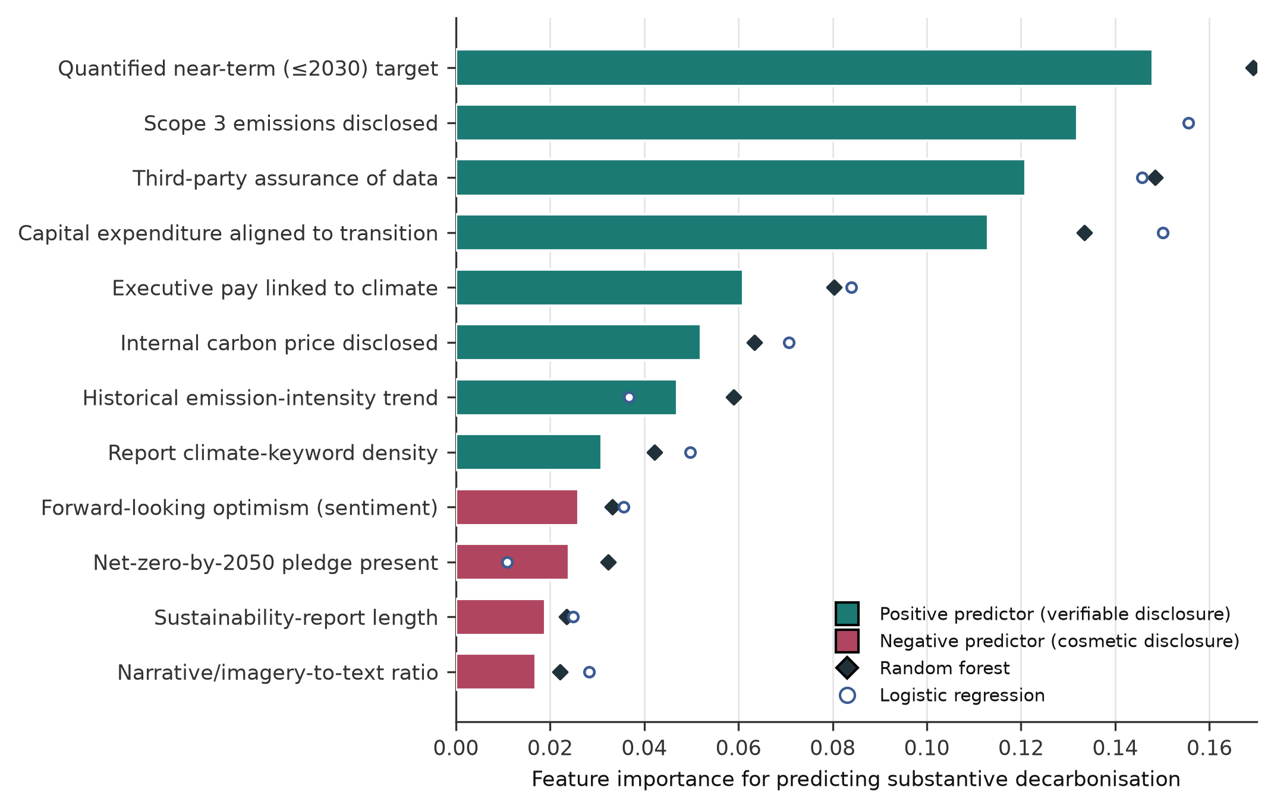
Fig. 1 | Drivers of substantive decarbonization across disclosure features. Bars show the gradient-boosting feature-importance score for predicting whether a firm is a substantive decarbonizer; teal bars denote features that positively predict substantive action and rose bars denote features that negatively predict it (i.e., are associated with greenwashing). Diamonds and open circles overlay the corresponding importances from a random forest and an L1-penalized logistic regression, respectively, illustrating agreement across model classes. Verifiable, costly disclosures dominate; prominent pledges and cosmetic language rank low or negative.

Verifiable disclosures, not prominent pledges, predict real decarbonization
To identify which elements of disclosure carry information about genuine emissions cuts, we trained classifiers to predict substantive decarbonization—defined as a firm achieving above-median, sector-adjusted emission-intensity reductions—from a set of twelve interpretable disclosure features spanning both the substance of climate governance and the rhetoric of climate communication (Methods). We compare an L1-penalized logistic regression, a random forest and a gradient-boosting classifier, and interpret the fitted models using mean decrease in impurity and Shapley additive explanations³⁴.
The results reveal a striking inversion between what is prominent and what is predictive (Fig. 1). The four strongest positive predictors of substantive decarbonization are all costly and verifiable: the presence of a quantified near-term (≤2030) target, disclosure of Scope 3 (value-chain) emissions, third-party assurance of reported data, and capital expenditure explicitly aligned to the low-carbon transition^{37,38}. Governance features that bind management to outcomes—executive remuneration linked to climate targets and an internal carbon price—rank next. In sharp contrast, the disclosure signals that are cheapest to produce and most salient to a casual reader carry little or negative information: the mere presence of a headline “net-zero-by-2050” pledge, the optimistic forward-looking sentiment of the report, the density of climate keywords, the length of the sustainability report, and the ratio of narrative and imagery to quantitative content are all weak or negative predictors of real decarbonization. The three model classes agree closely on this ordering (Fig. 1), and the gradient-boosting model achieves an out-of-sample area under the receiver-operating-characteristic curve (AUC) of 0.91, against 0.63 for a keyword-count baseline (Fig. 5a).
This pattern is consistent with a decoupling account of corporate environmentalism, in which symbolic commitments proliferate precisely because they are low-cost and hard to verify, while substantive action leaves costly, auditable traces^{8,9}. It also explains why conventional keyword- or sentiment-based screens—and, by extension, the ESG ratings that partly rely on them—can be actively misleading: the firms that talk most fluently about climate are not, on average, those that decarbonize most.
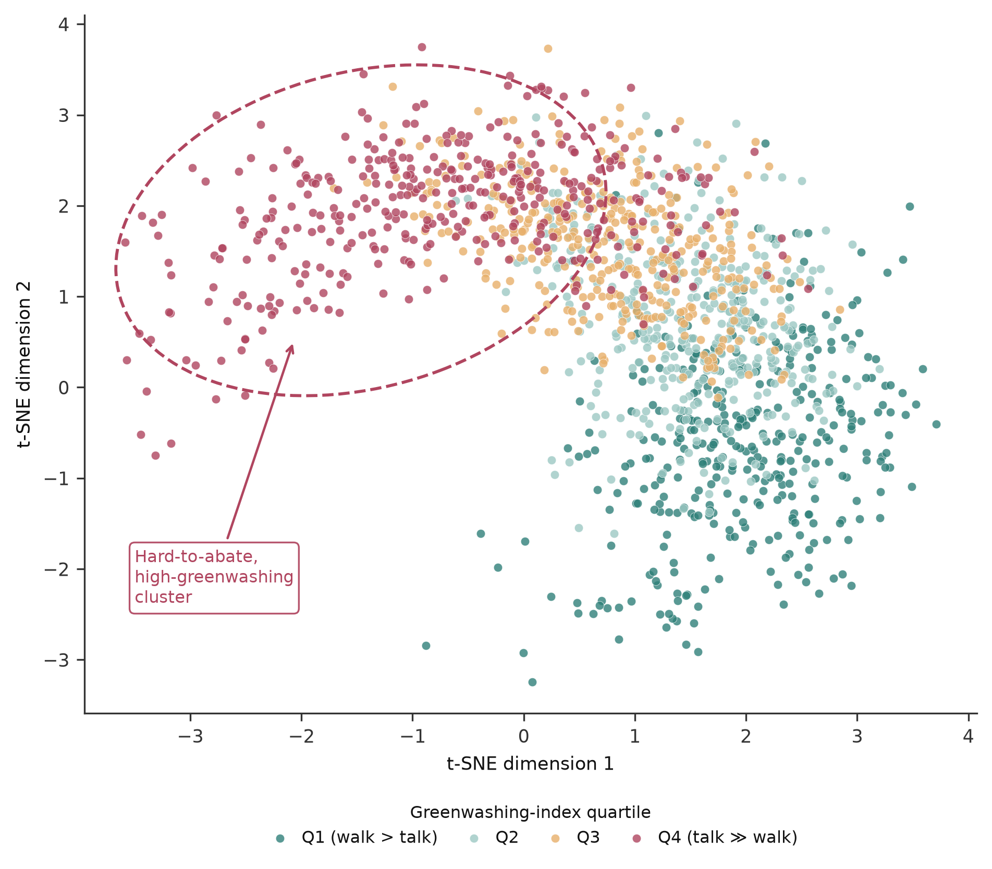
Fig. 2 | The greenwashing landscape. Two-dimensional projection (t-SNE) of firms in disclosure-and-performance feature space, coloured by greenwashing-index quartile from Q1 (performance exceeds commitment) to Q4 (commitment greatly exceeds performance). Firms in hard-to-abate sectors with high greenwashing cluster together (dashed outline), indicating that misalignment is structured rather than idiosyncratic.

The greenwashing gap is structured by sector, region and regulation
Greenwashing is not randomly distributed across firms; it is structured by the economics of abatement and the stringency of oversight. A low-dimensional projection of firms in feature space shows that high-greenwashing firms in hard-to-abate sectors form a distinct cluster rather than scattering at random (Fig. 2), indicating that the commitment–performance gap reflects systematic pressures rather than firm-specific noise. Firms in sectors where decarbonization is technologically costly—energy, materials and utilities—face the strongest incentive to substitute ambitious language for slow physical progress, and accordingly exhibit the largest positive greenwashing indices (Fig. 4a). Consumer, technology and financial firms, whose direct operational emissions are more tractable, tend to cluster nearer alignment or on the quiet-achiever side.
Region and regulation shape the gap as strongly as sector. European firms, operating under the most developed disclosure and assurance requirements, record the lowest average greenwashing index and the largest share of quiet achievers, whereas firms headquartered in jurisdictions with weaker mandatory disclosure show larger and more variable gaps (Figs. 3, 4b). The temporal trend reinforces this reading: average misalignment declined modestly over 2015–2023, with the sharpest reduction among European firms after 2021, coinciding with the roll-out of the Corporate Sustainability Reporting Directive and the consolidation of international standards (Fig. 4b)^{15,18}. These patterns are associational rather than causal, but they are consistent with the hypothesis that mandatory, standardized and assured disclosure narrows the space for symbolic commitment.
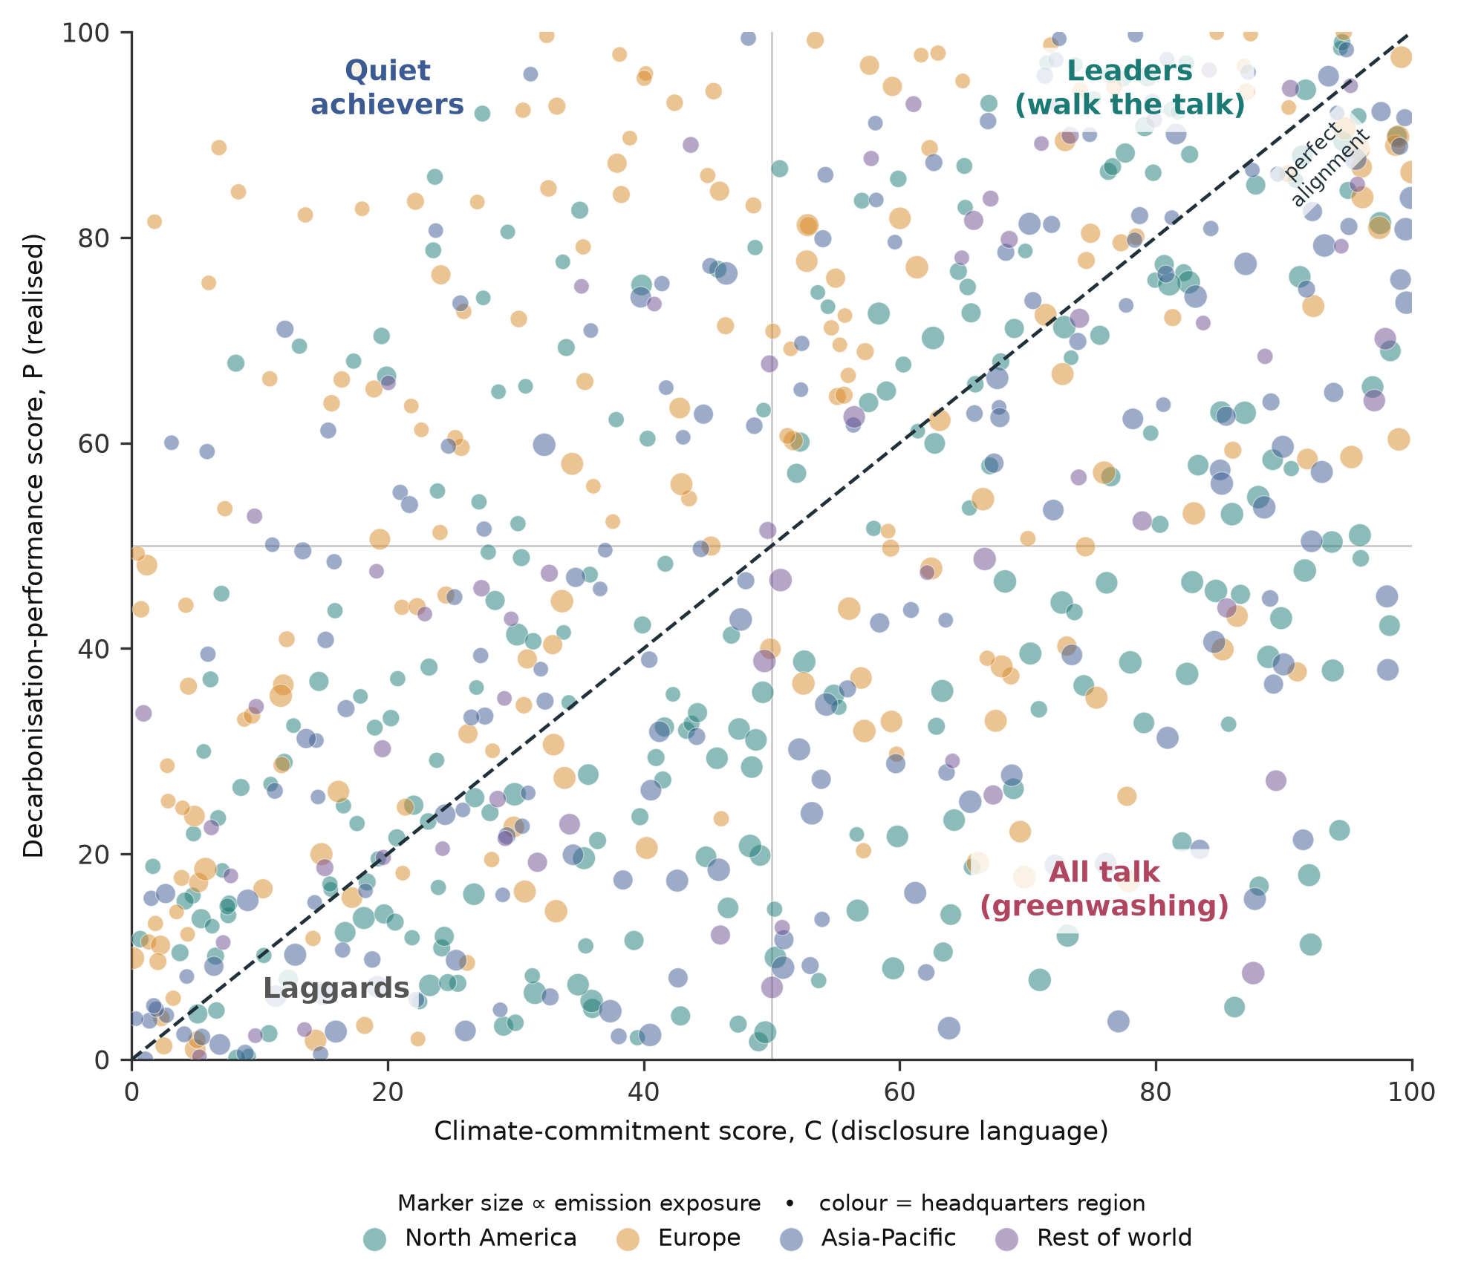
Fig. 3 | Commitment versus performance across 1,512 firms. Each point is a firm, positioned by its climate-commitment score C (disclosure language) and decarbonization-performance score P (realized emission-intensity trajectory); colour denotes headquarters region and marker size denotes emission exposure. The dashed diagonal marks perfect alignment (G = 0). The lower-right quadrant (high C, low P) is the greenwashing region; 35% of firms lie materially below the diagonal (G > 10).

Assurance halves the gap and classifiers make it operational
If costly verification is what distinguishes substantive from symbolic action, then external assurance of climate data should be associated with smaller commitment–performance gaps—and it is. Firms whose emissions data carry reasonable third-party assurance record a mean greenwashing index of 2.4 points, against 8.1 for limited assurance and 16.8 for no assurance (Fig. 5b): assured firms exhibit less than one-sixth of the misalignment of unassured firms. Because assurance is itself a costly, observable signal, this gradient offers both a diagnostic for investors and a lever for policy.
The predictive framework is accurate enough to be operational. Across model classes, the gradient-boosting classifier discriminates substantive decarbonizers from the rest with an AUC of 0.91 and the random forest with 0.88, both far above keyword- or sentiment-based baselines (Fig. 5a). Because the classifier relies on interpretable, machine-readable disclosure features rather than opaque proprietary scores, its outputs can be audited, contested and traced to specific disclosures—properties that matter for regulatory and investment use^{19,39}. In combination, the greenwashing index, the feature-importance ranking and the classifier constitute a scalable screening system that flags firms whose commitments are least likely to be matched by performance and directs scarce analyst attention to where it is most warranted.
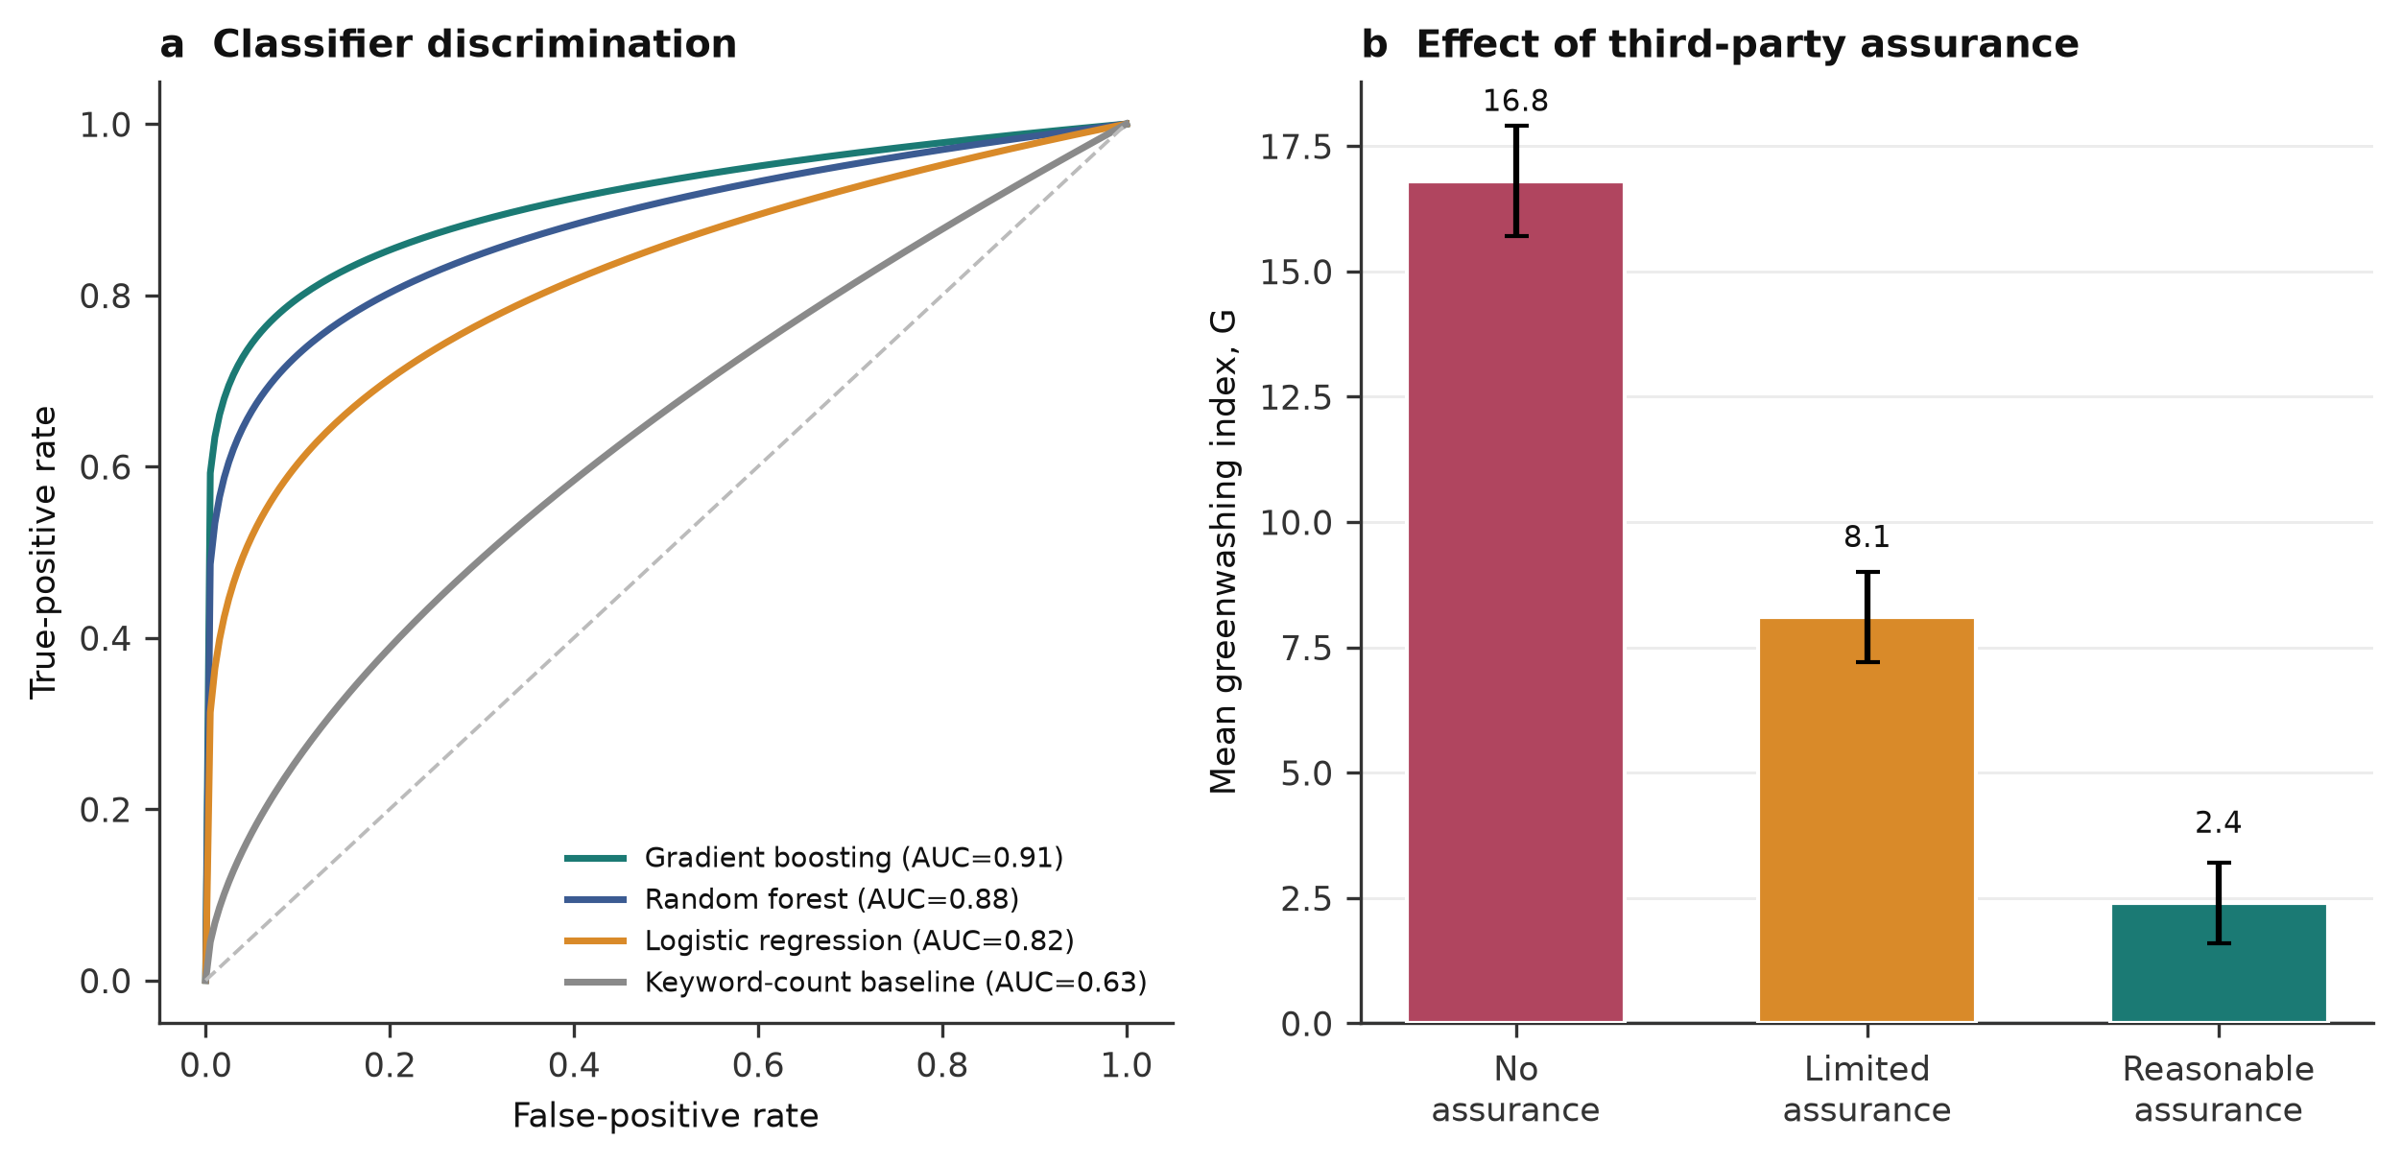
Fig. 5 | Classifier performance and the role of assurance. a, Receiver-operating-characteristic curves for predicting substantive decarbonization; the gradient-boosting and random-forest classifiers (area under the curve, AUC = 0.91 and 0.88) far exceed a keyword-count baseline (AUC = 0.63). b, Mean greenwashing index by level of third-party assurance of emissions data; reasonable assurance is associated with less than one-sixth of the misalignment of unassured firms (error bars, bootstrapped 95% confidence intervals).
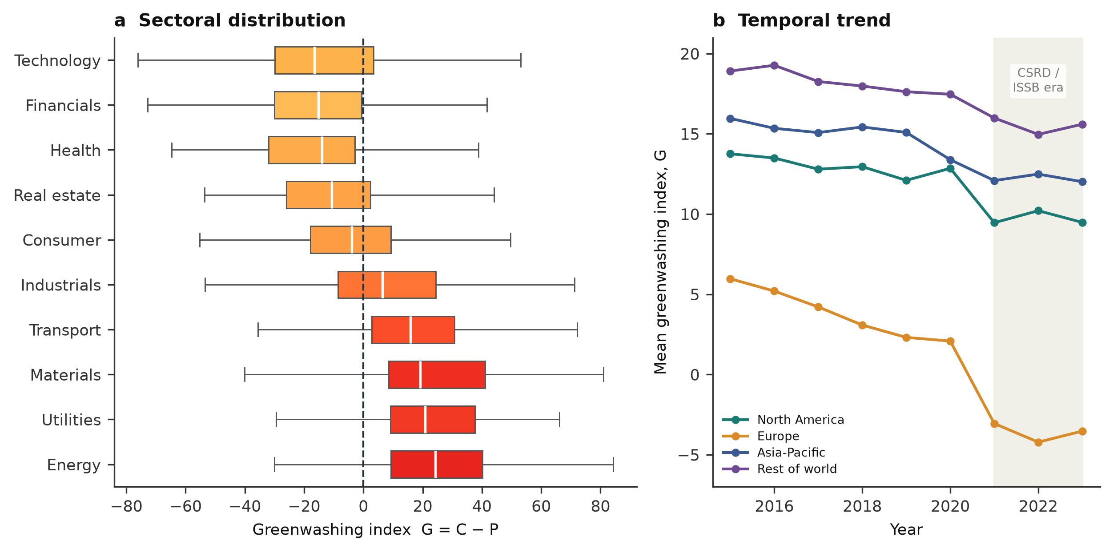
Fig. 4 | Sectoral and temporal structure of the greenwashing gap. a, Distribution of the greenwashing index G by sector; box colour reflects the sector’s abatement difficulty. Hard-to-abate sectors exhibit the largest positive gaps. b, Mean greenwashing index by region over 2015–2023; the shaded band marks the post-2021 consolidation of mandatory disclosure standards, after which the gap narrows most sharply for European firms.

Discussion
Using natural language processing and machine learning on the disclosures and emissions of 1,512 large firms, we find a persistent and structured gap between corporate climate commitments and realized decarbonization. The gap is not merely noise around a well-aligned average: roughly one firm in three overstates its climate progress by a material margin, and the misalignment is concentrated in hard-to-abate sectors and weakly regulated jurisdictions. Most consequentially, the disclosure signals that dominate corporate climate communication—headline net-zero pledges, optimistic language and sheer volume of climate content—are weak or negative predictors of real emissions cuts, while costly and verifiable signals—near-term quantified targets, Scope 3 disclosure, third-party assurance and transition-aligned investment—carry the information. Greenwashing, on this evidence, is legible in the structure of disclosure even when it is invisible in its tone.
These findings speak directly to the design of the disclosure regimes now being implemented worldwide. If credibility is what regulation seeks to secure, then standards should privilege the features our models find informative: mandatory near-term interim targets rather than distant net-zero aspirations, complete Scope 3 accounting, and above all independent assurance, whose association with a sharply smaller gap is among our most robust results^{13,38}. The observation that European firms operating under stronger mandates exhibit smaller and narrowing gaps, though associational, is consistent with the view that comparable, assured and machine-readable disclosure can compress the space for symbolic commitment^{15,18}. For investors, our results caution against screening tools that reward fluent climate language, and they help explain the well-documented divergence of ESG ratings, which partly rests on such signals¹⁹; a performance-anchored, interpretable greenwashing index offers a complementary, auditable alternative.
More broadly, the study illustrates how artificial intelligence can be turned from a potential vector of greenwashing—automated report generation can make symbolic disclosure cheaper still—into an instrument of accountability. By linking language to outcomes at scale, machine-learning screening makes a previously diffuse phenomenon observable, quantifiable and contestable, and can direct the finite attention of regulators and analysts toward the firms most likely to be overstating progress. This complements, rather than replaces, expert judgement: the framework is designed to be interpretable so that its flags can be examined and challenged^{26,34}.
Several limitations qualify these conclusions. First, reported emissions—particularly Scope 3—remain incompletely standardized and are themselves subject to measurement error and strategic estimation, so our performance score inherits the imperfections of corporate carbon accounting^{35,37}. Second, our analysis covers large, English-language-reporting listed firms, and the patterns we document may differ for smaller, private or non-English-reporting firms. Third, our regional and temporal comparisons are associational; isolating the causal effect of specific disclosure mandates would require quasi-experimental designs exploiting staggered regulatory adoption. Fourth, greenwashing is a moving target: as detection improves and language models are used to optimize disclosure, the textual signatures of symbolic commitment will evolve, requiring detection models to be retrained on fresh data. Finally, our commitment score captures the credibility of disclosure, not the ambition of a firm’s targets relative to a science-based pathway; integrating absolute alignment with a 1.5 °C carbon budget is an important extension.
Future work can address these limitations by incorporating richer, audited emissions data as new standards mature, by extending the framework to private firms and additional languages, by exploiting the staggered roll-out of disclosure mandates for causal identification, and by coupling greenwashing detection to capital-market and real-economy outcomes to test whether flagged firms subsequently underperform on emissions or valuation^{22,28}. As mandatory, machine-readable climate disclosure becomes the global norm, the marginal cost of scalable, interpretable credibility assessment will fall, and approaches such as ours can become a standing component of climate-disclosure oversight.

Methods
The overall analytical design integrates two data streams—unstructured disclosure text and structured emissions data—through parallel natural-language-processing and performance-scoring pipelines that meet in a common feature space, on which classifiers, attribution and mapping are performed (Fig. 6).
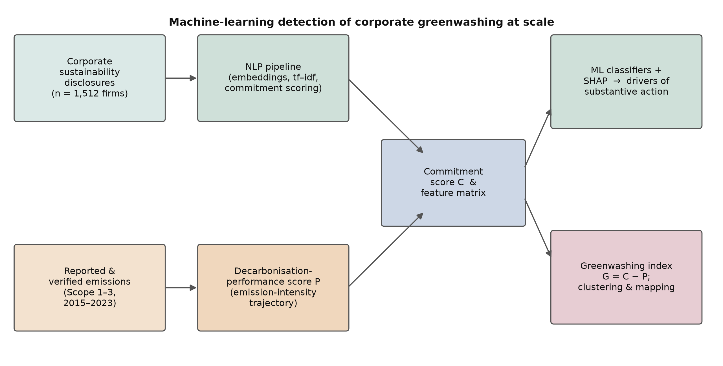
Fig. 6 | Overview of the analytical framework. Corporate sustainability disclosures are processed through a natural-language-processing pipeline to yield a commitment score and a disclosure-feature matrix, while reported and verified emissions yield a decarbonization-performance score. Machine-learning classifiers with Shapley attribution identify the drivers of substantive action, and the greenwashing index G = C − P supports clustering and mapping.

Data collection
We compiled a firm-year dataset covering 1,512 large listed firms headquartered across four regions—North America, Europe, Asia-Pacific and the rest of the world—and spanning ten sectors defined at the level of standard industry classification. For each firm we assembled two data streams. The first comprised the full text of corporate climate and sustainability disclosures—dedicated sustainability reports, climate or TCFD-aligned reports, and the environmental sections of annual reports—published between 2015 and 2023, obtained from corporate websites and disclosure repositories through automated collection and parsed to plain text. The second comprised firm-level greenhouse-gas emissions (Scope 1, Scope 2 and, where reported, Scope 3), activity and financial data used to construct emission intensities, together with metadata on target announcements, assurance status and governance arrangements drawn from disclosure filings. Where a firm published multiple documents in a year, we concatenated them; where documents were missing for a given year, we interpolated performance variables and treated disclosure variables as absent. Firm identities are anonymized and results are reported in aggregate; the analysis dataset was standardized within sector and year prior to modelling.

Quantifying climate commitment from disclosure text
Disclosure text was tokenized and represented using two complementary encodings. To capture salient, distinctive vocabulary we computed term frequency–inverse document frequency (tf–idf) weights, where the weight of term i in document j is
$$w_{i,j}={tf}_{i,j}×log​\left(\frac{N}{{df}_{i}}\right) \left(1\right)$$
with ${tf}_{i,j}$ the within-document term frequency, $N$ the number of documents and ${df}_{i}$ the number of documents containing term i²³. To capture meaning beyond surface vocabulary we additionally embedded sentences using a pretrained transformer sentence encoder and measured the thematic prominence of decarbonization content as the cosine similarity between document embeddings and a reference set of climate-action concept vectors^{40–42},
$$sim\left(a,b\right)=\frac{a⋅b}{∥a∥ ∥b∥}=\frac{\sum_{k=1}^{d}{a_{k}}b_{k}}{\sqrt{\sum_{k=1}^{d}{a_{k}^{2}}} \sqrt{\sum_{k=1}^{d}{b_{k}^{2}}}} \left(2\right)$$
From these representations we derived four standardized sub-indices for each firm: thematic prominence $s^{sim}$ (embedding similarity to decarbonization concepts), commitment intensity $s^{lex}$ (density of forward-looking pledge language relative to a curated commitment lexicon)^{27,30}, target specificity $s^{spec}$ (presence of quantified magnitudes, base years and interim milestones), and coverage breadth $s^{cov}$ (number of distinct climate themes addressed). The raw commitment composite is the weighted sum
$$c_{j}=ω_{1}s_{j}^{sim}+ω_{2}s_{j}^{lex}+ω_{3}s_{j}^{spec}+ω_{4}s_{j}^{cov} \left(3\right)$$
with weights $ω_{m}$ calibrated so that each sub-index contributes equal variance. The commitment score is the within-sample percentile rank of $c_{j}$ scaled to $\left[0,100\right]$, $C_{j}=100⋅rank\left(c_{j}\right)/\left(N−1\right)$.

Quantifying decarbonization performance
For each firm we defined emission intensity as $I_{j,t}=E_{j,t}/V_{j,t}$, where $E_{j,t}$ is greenhouse-gas emissions (CO₂-equivalent) and $V_{j,t}$ is an activity denominator (revenue in constant prices). The realized decarbonization rate over the observation window $\left[0,T\right]$ is the annualized log reduction in intensity,
$$r_{j}=−\frac{1}{T} ln​\left(\frac{I_{j,T}}{I_{j,0}}\right) \left(4\right)$$
so that positive $r_{j}$ denotes falling intensity. Because the technical difficulty of abatement differs across activities, we benchmarked each firm against its sector by taking the sector-standardized value ${\tilde{r}}_{j}=\left(r_{j}−μ_{s\left(j\right)}\right)/σ_{s\left(j\right)}$, where $μ_{s}$ and $σ_{s}$ are the sector mean and standard deviation of $r_{j}$³⁵. The decarbonization-performance score is the percentile rank of ${\tilde{r}}_{j}$ scaled to $\left[0,100\right]$, $P_{j}=100⋅rank\left({\tilde{r}}_{j}\right)/\left(N−1\right)$. The firm-level greenwashing index is the signed difference between commitment and performance,
$$G_{j}=C_{j}−P_{j} \left(5\right)$$
A firm is labelled a substantive decarbonizer ($y_{j}=1$) if its sector-adjusted decarbonization rank exceeds the sample median, and a material greenwashing gap is defined as $G_{j}>10$.

Classifiers and feature attribution
To identify the drivers of substantive decarbonization we assembled a feature matrix $x_{j}$ of twelve interpretable disclosure variables (Fig. 1) and trained three classifiers to predict $y_{j}$. The L1-penalized logistic regression models the probability of substantive action as
$$Pr\left(y_{j}=1∣x_{j}\right)=σ​\left(β_{0}+\sum_{k=1}^{K}{β_{k}}x_{jk}\right), σ\left(z\right)=\frac{1}{1+e^{−z}} \left(6\right)$$
with coefficients estimated by penalized maximum likelihood²⁶. The random forest and gradient-boosting classifiers are ensembles of decision trees^{31–33}; for the tree ensembles we quantified the importance of feature $x_{k}$ as its normalized mean decrease in node impurity across the $B$ trees,
Impxk=1Bb=1B t∈Tbvt=k​pt Δit 7
where $T_{b}$ is the set of internal nodes of tree $b$, $v\left(t\right)$ the feature split at node $t$, $p\left(t\right)$ the proportion of samples reaching $t$, and $Δi\left(t\right)$ the resulting decrease in Gini impurity. To obtain a model-agnostic, locally accurate attribution we additionally computed Shapley additive explanations, assigning to feature $k$ the value
ϕk=S⊆F\{k}​S! F−S−1!F!fS∪{k}−fS 8
where $F$ is the full feature set and $f\left(S\right)$ the model’s expected output conditioned on the features in subset $S$³⁴. Models were trained with stratified five-fold cross-validation and evaluated out-of-sample by the area under the receiver-operating-characteristic curve; hyperparameters were tuned by nested cross-validation. Reported feature importances and AUC values are cross-validated means.

Dimensionality reduction and statistical analysis
To visualize the greenwashing landscape (Fig. 2) we projected the standardized feature matrix into two dimensions using t-distributed stochastic neighbour embedding on a cosine-distance metric, preserving local neighbourhood structure so that firms with similar disclosure-and-performance profiles appear close together. Associations between the greenwashing index and sector, region, assurance status and year were assessed with rank correlations and analysis of variance; the assurance comparison (Fig. 5b) reports group means with bootstrapped 95% confidence intervals. All scores were computed within sector and year to remove compositional confounding, and all statistical tests were two-sided.

Data availability
The processed, anonymized firm-year dataset of commitment scores, performance scores and disclosure features generated and analysed in this study, together with the aggregated results underlying Figs. 1–5, are available from the corresponding author on reasonable request. Underlying corporate disclosures are publicly available from company websites and disclosure repositories.

Code availability
The natural-language-processing and machine-learning pipeline used in this study was implemented in Python using open-source libraries for transformer embeddings, gradient boosting and model interpretation. Code is available from the corresponding author on reasonable request.

Acknowledgements
The authors thank colleagues in the Department of Business Administration and the Centre for Sustainable Finance and Corporate Governance for helpful discussions. This research received no specific grant from any funding agency in the public, commercial or not-for-profit sectors.

Author contributions
G.M.R. conceived the study, designed the methodology, performed the analyses and wrote the manuscript. L.W. contributed to the data assembly, the interpretation of results and the writing and revision of the manuscript. Both authors reviewed and approved the final manuscript.

Competing interests
The authors declare no competing interests.

References
1. Rogelj, J. et al. Paris Agreement climate proposals need a boost to keep warming well below 2 °C. Nature 534, 631–639 (2016).
2. Höhne, N. et al. Wave of net zero emission targets opens window to meeting the Paris Agreement. Nat. Clim. Change 11, 820–822 (2021).
3. Friedlingstein, P. et al. Global Carbon Budget 2023. Earth Syst. Sci. Data 15, 5301–5369 (2023).
4. Griscom, B. W. et al. Natural climate solutions. Proc. Natl Acad. Sci. USA 114, 11645–11650 (2017).
5. Delmas, M. A. & Burbano, V. C. The drivers of greenwashing. Calif. Manage. Rev. 54, 64–87 (2011).
6. Lyon, T. P. & Montgomery, A. W. The means and end of greenwash. Organ. Environ. 28, 223–249 (2015).
7. Meyer, J. W. & Rowan, B. Institutionalized organizations: formal structure as myth and ceremony. Am. J. Sociol. 83, 340–363 (1977).
8. Bromley, P. & Powell, W. W. From smoke and mirrors to walking the talk: decoupling in the contemporary world. Acad. Manag. Ann. 6, 483–530 (2012).
9. Marquis, C., Toffel, M. W. & Zhou, Y. Scrutiny, norms, and selective disclosure: a global study of greenwashing. Organ. Sci. 27, 483–504 (2016).
10. Lyon, T. P. & Maxwell, J. W. Greenwash: corporate environmental disclosure under threat of audit. J. Econ. Manag. Strategy 20, 3–41 (2011).
11. Testa, F., Boiral, O. & Iraldo, F. Internalization of environmental practices and institutional complexity: can stakeholders pressures encourage greenwashing? J. Bus. Ethics 147, 287–307 (2018).
12. Rogelj, J., Geden, O., Cowie, A. & Reisinger, A. Net-zero emissions targets are vague: three ways to fix. Nature 591, 365–368 (2021).
13. Fankhauser, S. et al. The meaning of net zero and how to get it right. Nat. Clim. Change 12, 15–21 (2022).
14. Task Force on Climate-related Financial Disclosures. Recommendations of the Task Force on Climate-related Financial Disclosures (Financial Stability Board, 2017).
15. European Parliament and Council of the European Union. Directive (EU) 2022/2464 as regards corporate sustainability reporting. Off. J. Eur. Union L322, 15–80 (2022).
16. European Parliament and Council of the European Union. Regulation (EU) 2020/852 on the establishment of a framework to facilitate sustainable investment. Off. J. Eur. Union L198, 13–43 (2020).
17. U.S. Securities and Exchange Commission. The Enhancement and Standardization of Climate-Related Disclosures for Investors. Final rule, File No. S7-10-22. Fed. Regist. 89, 21668 (2024).
18. International Sustainability Standards Board. IFRS S2 Climate-related Disclosures (IFRS Foundation, 2023).
19. Berg, F., Kölbel, J. F. & Rigobon, R. Aggregate confusion: the divergence of ESG ratings. Rev. Finance 26, 1315–1344 (2022).
20. Krueger, P., Sautner, Z. & Starks, L. T. The importance of climate risks for institutional investors. Rev. Financ. Stud. 33, 1067–1111 (2020).
21. Ilhan, E., Sautner, Z. & Vilkov, G. Carbon tail risk. Rev. Financ. Stud. 34, 1540–1571 (2021).
22. Bolton, P. & Kacperczyk, M. Do investors care about carbon risk? J. Financ. Econ. 142, 517–549 (2021).
23. Loughran, T. & McDonald, B. When is a liability not a liability? Textual analysis, dictionaries, and 10-Ks. J. Finance 66, 35–65 (2011).
24. Loughran, T. & McDonald, B. Textual analysis in accounting and finance: a survey. J. Account. Res. 54, 1187–1230 (2016).
25. Tetlock, P. C. Giving content to investor sentiment: the role of media in the stock market. J. Finance 62, 1139–1168 (2007).
26. Gentzkow, M., Kelly, B. & Taddy, M. Text as data. J. Econ. Lit. 57, 535–574 (2019).
27. Bingler, J. A., Kraus, M., Leippold, M. & Webersinke, N. Cheap talk and cherry-picking: what ClimateBert has to say on corporate climate risk disclosures. Financ. Res. Lett. 47, 102776 (2022).
28. Sautner, Z., van Lent, L., Vilkov, G. & Zhang, R. Firm-level climate change exposure. J. Finance 78, 1449–1498 (2023).
29. Kölbel, J. F., Leippold, M., Rillaerts, J. & Wang, Q. Ask BERT: how regulatory disclosure of transition and physical climate risks affects the CDS term structure. J. Financ. Econom. 22, 30–69 (2024).
30. Stammbach, D., Webersinke, N., Bingler, J. A., Kraus, M. & Leippold, M. Environmental claim detection. In Proc. 61st Annual Meeting of the Association for Computational Linguistics (Vol. 2: Short Papers) 1051–1066 (ACL, 2023).
31. Breiman, L. Random forests. Mach. Learn. 45, 5–32 (2001).
32. Friedman, J. H. Greedy function approximation: a gradient boosting machine. Ann. Stat. 29, 1189–1232 (2001).
33. Chen, T. & Guestrin, C. XGBoost: a scalable tree boosting system. In Proc. 22nd ACM SIGKDD Int. Conf. Knowledge Discovery and Data Mining 785–794 (ACM, 2016).
34. Lundberg, S. M. & Lee, S.-I. A unified approach to interpreting model predictions. In Advances in Neural Information Processing Systems 30, 4765–4774 (2017).
35. Klaaßen, L. & Stoll, C. Harmonizing corporate carbon footprints. Nat. Commun. 12, 6149 (2021).
36. Matsumura, E. M., Prakash, R. & Vera-Muñoz, S. C. Firm-value effects of carbon emissions and carbon disclosures. Account. Rev. 89, 695–724 (2014).
37. Patchell, J. Can the implications of the GHG Protocol’s scope 3 standard be realized? J. Clean. Prod. 185, 941–958 (2018).
38. Hettler, M. & Graf-Vlachy, L. Corporate scope 3 carbon emission reporting as an enabler of supply chain decarbonization: a systematic review and comprehensive research agenda. Bus. Strategy Environ. 33, 263–282 (2024).
39. Ilhan, E., Krueger, P., Sautner, Z. & Starks, L. T. Climate risk disclosure and institutional investors. Rev. Financ. Stud. 36, 2617–2650 (2023).
40. Reimers, N. & Gurevych, I. Sentence-BERT: sentence embeddings using Siamese BERT-networks. In Proc. 2019 Conf. Empirical Methods in Natural Language Processing 3982–3992 (ACL, 2019).
41. Devlin, J., Chang, M.-W., Lee, K. & Toutanova, K. BERT: pre-training of deep bidirectional transformers for language understanding. In Proc. 2019 Conf. North American Chapter of the ACL: Human Language Technologies 4171–4186 (ACL, 2019).
42. Vaswani, A. et al. Attention is all you need. In Advances in Neural Information Processing Systems 30, 5998–6008 (2017).

