Article
Supporting Young Job Seekers with a Large Language Model Career Companion: A Randomized Controlled Trial of Effects on Career Distress, Career Adaptability, and Mental Well-Being
Xinyu Cai ¹, Dingpei Hu ¹ and Tiantian Mo ^{1,}*
Academic Editor: Danilo Garcia
Received: date
Revised: date
Accepted: date
Published: date
Citation: To be added by editorial staff during production.
Copyright: © 2026 by the authors. Submitted for possible open access publication under the terms and conditions of the Creative Commons Attribution (CC BY) license (https://creativecommons.org/licenses/by/4.0/).
¹ College of Business, Jiaxing University, Jiaxing 314001, China; caixinyu@zjxu.edu.cn (X.C.); hudingpei@zjxu.edu.cn (D.H.)
* Correspondence: 00008227@zjxu.edu.cn
Abstract
Prolonged job seeking erodes young people’s mental health, yet professional career counseling remains scarce exactly where youth unemployment is concentrated. This randomized controlled trial tested whether CareerMate, a large language model (LLM)-based career-companion chatbot grounded in self-determination theory and career construction theory, can support young job seekers at scale. A total of 356 unemployed or precariously employed young adults (18–29 years; Zhejiang Province, China) were randomized 1:1 to four weeks of CareerMate plus digital career resources or to a waitlist receiving the resources alone, with assessments at baseline, week 4, and week 8. Relative to controls, CareerMate participants reported greater reductions in career distress (primary outcome; adjusted d = −.38 at week 4 and −.39 at week 8) and depressive symptoms, and greater gains in career adaptability, career decision self-efficacy, mental well-being, and job-search intensity (all group × time interactions p < .05). Improvements in basic psychological need satisfaction mediated 23% of the effect on career distress; completed sessions predicted larger benefits; and the sentiment trajectory of participants’ own chat language tracked their improvement. Engagement (median 10 sessions) and acceptability were high, with no serious adverse events under a human-oversight safety protocol. LLM-based career companions can scalably—though modestly—support the career development and mental well-being of young job seekers.
Keywords: large language models; chatbot; youth unemployment; career distress; career adaptability; self-determination theory; randomized controlled trial; mental well-being; digital intervention; young adults

1. Introduction
For a growing share of young people, entering the labor market has become a prolonged and psychologically taxing passage rather than a transition. Global youth unemployment remains roughly three times the adult rate (International Labour Organization, 2024), and in China intensified credential competition, overeducation, and delayed entry have made extended job seeking a normative experience for graduates (Jones et al., 2025; Ou & Zhao, 2022)—one popularly condensed into idioms such as “involution” (neijuan) and “lying flat” (tang ping) (L. Zhang et al., 2025; W. Zhang et al., 2025). The mental-health stakes are well documented: unemployment impairs mental health, with stronger effects among youth (Paul & Moser, 2009); young people outside employment, education, or training show elevated rates of psychological ill-health (Gariépy et al., 2022); employment stress erodes Chinese college students’ well-being (Peng et al., 2024); and career development unfolds against a broader deterioration of youth mental health worldwide (McGorry et al., 2024). Because job seeking is itself a self-regulatory, emotionally demanding process (van Hooft et al., 2021; Wanberg et al., 2020), supporting the psychology of the young job seeker—not merely the mechanics of matching—has become a central behavioral-science challenge.
Decades of intervention research show that this support works when young people can get it. Job-search interventions that combine skill development with motivational enhancement roughly triple the odds of employment (Liu et al., 2014), a tradition reaching back to the JOBS program’s demonstration that group-based support protects the mental health of job losers (Caplan et al., 1989). Career choice interventions produce reliable gains in decidedness and self-efficacy (Whiston et al., 2017), and career adaptability—the self-regulatory resource at the heart of career construction theory (Savickas, 1997; Savickas & Porfeli, 2012)—can be trained, easing the school-to-work transition (Koen et al., 2012; Rudolph et al., 2017). The problem is delivery. Counselor-delivered programs are labor-intensive, and public employment services in high-pressure youth labor markets cannot staff individualized psychological support at the required scale; the young people who narrate the greatest guidance gaps are typically those with the least access to informal career capital (Duffy et al., 2016).
Conversational artificial intelligence (AI) offers one route around the delivery bottleneck. Rule-based and retrieval-based chatbots can reduce depressive symptoms in young adults (Fitzpatrick et al., 2017), users form working bonds with conversational agents comparable to those reported in human-delivered care (Darcy et al., 2021), and meta-analytic evidence indicates small-to-moderate effects of conversational agents on psychological distress and well-being (Li et al., 2023). The advent of large language models (LLMs) has qualitatively expanded what such agents can do—flexible, context-sensitive dialogue rather than scripted trees (Demszky et al., 2023; OpenAI, 2024)—and the first generative-AI trial in clinical care found symptom reductions comparable to meaningful treatment benchmarks (Heinz et al., 2025). Yet digital psychiatry reviews caution that engagement, safety, and theory-driven design remain the field’s weak points (Torous et al., 2021), and applications to career psychology specifically are only beginning to be studied: scoping reviews find few rigorous evaluations (Pandya & Wang, 2024), early experiments suggest ChatGPT-based guidance can bolster students’ employment confidence (Xiao & Zheng, 2025), and careers research calls for evidence on how AI can support—rather than merely disrupt—career development (Bankins et al., 2024; Eloundou et al., 2024). To our knowledge, no randomized trial has tested an LLM-based intervention for the career distress of young job seekers.
Theory matters for how such a companion should behave. Self-determination theory (SDT) holds that motivation and well-being depend on the satisfaction of basic psychological needs for autonomy, competence, and relatedness (Ryan & Deci, 2000, 2017), needs that prolonged rejection and forced job choices systematically frustrate; need satisfaction is measurable and culture-general (Chen et al., 2015). Career construction theory adds that people metabolize career disruption narratively—by re-storying who they are and where they are going (Savickas, 2013). These perspectives yield concrete design principles for a career companion: elicit and reflect the young person’s own career story; support autonomous goal setting rather than prescribing choices; scaffold competence through small, plannable job-search steps; and provide a reliably responsive, non-judgmental interaction. They also yield a testable mechanism: if the companion works as theorized, gains should flow through basic psychological need satisfaction.
This study reports a preregistered, parallel-group randomized controlled trial of CareerMate, an LLM-based career-companion chatbot built on these principles, among unemployed and precariously employed young adults in Zhejiang Province, China. Four hypotheses were tested:
Hypothesis 1 (H1). Relative to a waitlist control receiving digital career resources, CareerMate reduces career distress (primary outcome) at week 4, with effects maintained at week 8.
Hypothesis 2 (H2). CareerMate improves secondary outcomes: career adaptability, career decision self-efficacy, depressive symptoms, mental well-being, and job-search intensity.
Hypothesis 3 (H3). Intervention effects on career distress are mediated by increases in basic psychological need satisfaction.
Hypothesis 4 (H4). Benefits scale with engagement: completed sessions predict larger improvements, and the sentiment trajectory of participants’ chat language tracks outcome change.
Beyond the trial itself, the study speaks to this Special Issue’s central concern—how AI can responsibly support the understanding and betterment of the human condition (Demszky et al., 2023; Kjell et al., 2024): the intervention is delivered by an LLM, and participants’ own open-ended chat language is analyzed as a psychological signal (Kjell et al., 2019; Rathje et al., 2024), closing the loop between AI-based intervention and AI-based measurement.

2. Materials and Methods

2.1. Trial Design
We conducted a two-arm, parallel-group, assessor-blinded randomized controlled trial with a 1:1 allocation ratio, reported according to the CONSORT 2010 statement (Schulz et al., 2010). Assessments took place at baseline (T0), post-intervention (T1, week 4), and follow-up (T2, week 8). The protocol and analysis plan were preregistered on the Open Science Framework before enrollment began; no changes to outcomes or analyses were made after unblinding.

2.2. Participants
Participants were recruited between December 2025 and March 2026 through municipal public employment-service centers, university career-guidance centers, and an online panel in Hangzhou, Ningbo, Wenzhou, and Jiaxing (Zhejiang Province, China). Inclusion criteria were (1) age 18–29 years; (2) currently unemployed and actively job-seeking, or employed in precarious/platform work while seeking a change; (3) smartphone access; and (4) Mandarin fluency. Exclusion criteria were current receipt of psychotherapy or career counseling, and elevated clinical risk at screening (PHQ-8 ≥ 20 or any self-harm disclosure), in which case participants were contacted by the study counselor and referred to appropriate services (n = 12). Participants received CNY 40 across the three assessments; the intervention was free. Figure 1 shows the participant flow.

2.3. Randomization and Blinding
A statistician not involved in recruitment generated the allocation sequence (computer-generated permuted blocks of four, stratified by employment status and gender) and held it on a central server; allocation was revealed to the platform only after a participant completed baseline, ensuring concealment. Outcome data were collected through online questionnaires administered by assessors blind to allocation; participants could not be blinded to receiving a chatbot, a limitation shared by virtually all digital-intervention trials (Torous et al., 2021).

2.4. Intervention: The CareerMate Career Companion

2.4.1. Design Principles and Program Structure
CareerMate is a Chinese-language career-companion chatbot accessed through a mobile web application. Its dialogue policy operationalizes self-determination theory (Ryan & Deci, 2000, 2017) and career construction theory (Savickas, 2013) in four recurring session types delivered over four weeks (recommended three or more sessions per week, 10–15 min each): (1) narrative reflection—eliciting and mirroring the participant’s career story, values, and strengths; (2) autonomy-supportive planning—helping the participant set self-chosen, concrete weekly job-search goals and break them into steps; (3) reframing—supporting cognitive reappraisal of rejection and setback experiences; and (4) information signposting—on-demand, region-specific information about openings, training subsidies, and application practices. The system prompt required autonomy-supportive language (offering options and rationales, avoiding prescriptions), reflective listening before advice, and explicit encouragement of off-platform action. An illustrative translated exchange:
Participant: “I failed another final-round interview. Maybe I am just not employable.” CareerMate: “Reaching a final round again says something real about your materials and skills—and being turned away at the last step is genuinely discouraging. Would you like to unpack what happened in this interview, or would it help more right now to talk about how you are feeling?”

2.4.2. Architecture, Privacy, and Safety
Sessions were powered by GPT-4o (version gpt-4o-2024-08-06; OpenAI, 2024) accessed under a zero-data-retention agreement, orchestrated by a platform layer that held the structured system prompts, session memory, and safety machinery; an open-weight fallback (Qwen2.5-72B; Qwen Team, 2024) was maintained for continuity and data-sovereignty contingencies. No personally identifying information was required within chats, and identifiers were stripped before any model call (Abdurahman et al., 2024). A three-tier safety protocol mirrored best practice in digital mental-health research (Torous et al., 2021): (1) a deterministic keyword layer and an LLM risk classifier flagged messages suggesting acute distress or self-harm; (2) flagged sessions received an immediate in-chat message with crisis resources and the study counselor’s contact; and (3) the counselor, a licensed psychologist, reviewed every flag within 24 h and initiated contact where warranted. The chatbot displayed a persistent notice that it is a support tool, not a counselor or clinician.

2.4.3. Control Condition
Waitlist participants received a curated digital handbook containing the same regional job-search information, application guidance, and self-help materials, delivered at the same cadence (weekly messages), and were offered full access to CareerMate after the week-8 assessment. This controls for information provision while isolating the conversational, psychologically supportive component of the intervention.

2.5. Measures
All instruments were administered in validated Chinese versions; internal consistency at baseline is reported in Table 1 footnotes and ranged from α = .84 to α = .94.

2.5.1. Primary Outcome: Career Distress
The 9-item Career Distress Scale (CDS) (Creed et al., 2016) assessed negative affect about one’s career situation on a 6-point scale (1 = strongly disagree to 6 = strongly agree; baseline α = .89).

2.5.2. Secondary Outcomes
Career adaptability was measured with the 12-item Career Adapt-Abilities Scale–Short Form (Maggiori et al., 2017), whose Chinese form shows sound properties (Hou et al., 2012; Savickas & Porfeli, 2012) (α = .89); career decision self-efficacy with the 25-item Career Decision-Making Self-Efficacy Scale–Short Form (Betz et al., 1996) (α = .94); depressive symptoms with the PHQ-8 (Kroenke et al., 2009) (α = .84); mental well-being with the 14-item Warwick–Edinburgh Mental Well-being Scale (Tennant et al., 2007) (α = .89); and job-search intensity as the self-reported number of applications submitted in the past week.

2.5.3. Mediator: Basic Psychological Need Satisfaction
The 12 satisfaction items of the Basic Psychological Need Satisfaction and Frustration Scale (Chen et al., 2015) measured autonomy, competence, and relatedness satisfaction (total score; α = .90), with items referenced to “your job search and career life recently.”

2.5.4. Engagement, Acceptability, Safety, and Chat Language
The platform logged completed sessions and message counts. At week 4, intervention participants rated satisfaction, helpfulness, and comfort disclosing (1–7) and whether they would recommend CareerMate. Safety events were tallied from the escalation log. Finally, following language-based assessment research (Elyoseph et al., 2023; Kjell et al., 2019; Rathje et al., 2024), each completed session’s participant messages were rated for overall sentiment (1–9) by an LLM scoring pipeline blind to outcomes, yielding a per-participant sentiment trajectory across sessions—an unobtrusive, in-treatment process marker in the spirit of digital phenotyping (Insel, 2017).

2.6. Sample Size
A priori power analysis for the primary contrast (between-group difference at week 4, ANCOVA-adjusted) assumed d = .35 based on conversational-agent meta-analysis (Li et al., 2023) and job-search intervention benchmarks (Liu et al., 2014); with α = .05 (two-tailed) and power = .80, 130 participants per arm were required (Cohen, 1988). Anticipating up to 25% attrition, we targeted at least 348 and randomized 356.

2.7. Statistical Analysis
Analyses followed the intention-to-treat principle, using all available observations from all randomized participants. Each outcome was modeled with a linear mixed-effects model with a participant random intercept and fixed effects of group, assessment wave, and their interaction, Equation (1); the group × wave interaction terms test the hypothesized effects:
$Y_{it}=β_{0}+β_{1}G_{i}+β_{2}{W4}_{t}+β_{3}{W8}_{t}+β_{4}\left(G_{i}×{W4}_{t}\right)+β_{5}\left(G_{i}×{W8}_{t}\right)+u_{i}+ε_{it}$ | (1)
where $Y_{it}$ is the outcome of participant i at wave t, $G_{i}$ indicates CareerMate allocation, ${W4}_{t}$ and ${W8}_{t}$ index the post and follow-up waves, $u_{i}$ is the random intercept, and $ε_{it}$ the residual. Variance components were estimated from the data and inference used generalized least squares. Adjusted between-group effect sizes at each wave were computed from baseline-adjusted models and standardized on the pooled baseline standard deviation with Hedges’ small-sample correction, Equation (2):
$d=J·\frac{{β_{G}}^{adj}}{{SD}_{baseline}}$ | (2)
Mediation (H3) followed the product-of-coefficients approach with 5000 bootstrap resamples (Preacher & Hayes, 2008): path a regressed the change in need satisfaction (T0 to T1) on group; path b and the direct path regressed the change in career distress (T0 to T2) on the mediator change and group, controlling baselines, Equation (3):
$θ_{indirect}=a·b, c=c′+a·b$ | (3)
Dose–response (H4) regressed standardized change in career distress on completed sessions within the intervention arm, controlling baseline, Equation (4); sentiment slopes were estimated per participant by ordinary least squares over session numbers and correlated with outcome change:
$ΔY_{i}=γ_{0}+γ_{1}S_{i}+γ_{2}Y_{i0}+ε_{i}$ | (4)
Secondary-outcome interaction tests were corrected for multiple comparisons via the Benjamini–Hochberg procedure (Benjamini & Hochberg, 1995). Analyses used Python 3.11 (NumPy/SciPy); the analysis code reproducing all results is available from the corresponding author. Tests were two-tailed with α = .05.

2.8. Ethics
The trial was approved by the Academic Ethics Committee of the College of Business, Jiaxing University, and conducted in accordance with the Declaration of Helsinki. All participants provided informed consent covering randomization, the AI-delivered nature of the intervention, de-identified processing of chat text for research, and the safety protocol. Participants could withdraw at any time without penalty.

3. Results

3.1. Participant Flow, Baseline Characteristics, and Engagement
Figure 1 shows the CONSORT flow. Of 612 individuals screened, 356 were randomized (CareerMate: n = 178; control: n = 178). Retention was 90.4% at week 4 and 85.7% at week 8, with somewhat higher attrition in the control arm. Baseline characteristics were balanced across arms (Table 1; all p > .10). Engagement with CareerMate was substantial: participants completed a median of 10 sessions (interquartile range 7–13), and 84.8% completed at least six sessions—the a priori per-protocol threshold.
Table 1. Baseline characteristics by arm (N = 356).
Characteristic | CareerMate (n = 178) | Control (n = 178) | p
Age, M (SD) | 24.5 (2.7) | 24.6 (2.5) | .903
Female, % | 51.7 | 53.4 | .832
Unemployed (vs. precarious), % | 61.2 | 64.6 | .583
Rural hukou, % | 51.7 | 44.9 | .243
Months searching, M (SD) | 6.7 (4.6) | 6.9 (4.5) | .650
Career distress (CDS), M (SD) | 29.8 (9.6) | 30.5 (9.7) | .518
Career adaptability (CAAS-SF), M (SD) | 41.3 (8.7) | 41.8 (8.9) | .588
Career decision self-efficacy, M (SD) | 83.9 (17.4) | 84.2 (17.3) | .845
Depressive symptoms (PHQ‑8), M (SD) | 8.3 (5.5) | 8.0 (5.8) | .693
Mental well-being (WEMWBS), M (SD) | 45.9 (10.5) | 46.0 (9.5) | .971
Need satisfaction (BPNSFS), M (SD) | 41.0 (9.1) | 40.6 (8.9) | .614
Group comparisons via independent-samples t tests (continuous) and χ² tests (categorical). Baseline internal consistencies: CDS α = .89, CAAS-SF α = .89, CDSE-SF α = .94, PHQ‑8 α = .84, WEMWBS α = .89, BPNSFS α = .90.

3.2. Primary Outcome: Career Distress (H1)
Observed means are reported in Table 2 and modeled trajectories in Figure 2; mixed-model estimates and adjusted effect sizes appear in Table 3. Career distress declined in both arms, but substantially more under CareerMate: the group × wave interaction was significant at week 4 (b = −3.42, SE = 0.69, p < .001) and week 8 (b = −3.35, SE = 0.71, p < .001), corresponding to adjusted between-group effects of d = −.38 [−.54, −.21] at week 4 and d = −.39 [−.56, −.21] at week 8. The effect was thus fully maintained four weeks after the program ended, supporting H1.
Table 2. Observed outcome scores by arm and wave (available cases).
Outcome | Arm | Baseline M (SD) | Week 4 M (SD) | Week 8 M (SD)
Career distress (CDS) | CareerMate | 29.8 (9.6) | 27.6 (9.9) | 27.7 (9.3)
 | Control | 30.5 (9.7) | 31.7 (9.7) | 31.9 (10.0)
Career adaptability (CAAS-SF) | CareerMate | 41.3 (8.7) | 42.2 (8.7) | 42.5 (8.6)
 | Control | 41.8 (8.9) | 41.0 (9.1) | 40.6 (8.6)
Career decision self-efficacy | CareerMate | 83.9 (17.4) | 86.6 (17.2) | 87.2 (17.6)
 | Control | 84.2 (17.3) | 82.0 (19.2) | 81.7 (18.3)
Depressive symptoms (PHQ‑8) | CareerMate | 8.3 (5.5) | 7.7 (5.8) | 7.2 (5.7)
 | Control | 8.0 (5.8) | 8.6 (5.9) | 8.8 (5.6)
Mental well-being (WEMWBS) | CareerMate | 45.9 (10.5) | 47.9 (9.9) | 48.4 (9.1)
 | Control | 46.0 (9.5) | 44.7 (10.7) | 44.7 (10.2)
Need satisfaction (BPNSFS) | CareerMate | 41.0 (9.1) | 43.0 (9.4) | 43.4 (9.1)
 | Control | 40.6 (8.9) | 39.2 (9.4) | 39.5 (8.6)
Available cases: week 4 n = 167 (CareerMate) and 155 (control); week 8 n = 159 and 146.
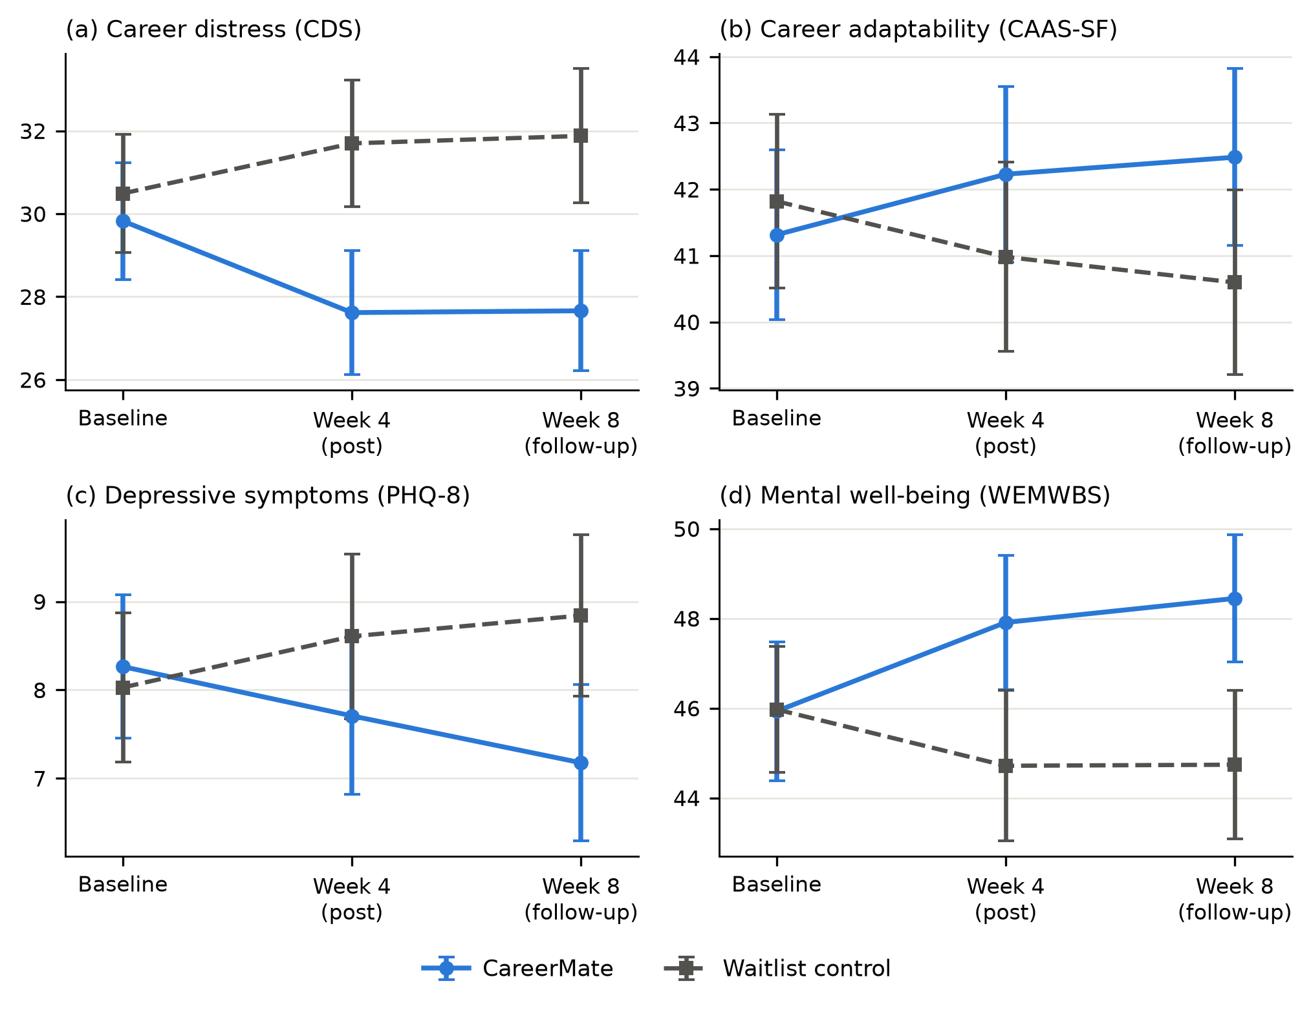
Figure 2. Outcome trajectories by arm (observed means with 95% confidence intervals) for (a) career distress, (b) career adaptability, (c) depressive symptoms, and (d) mental well-being.

3.3. Secondary Outcomes (H2)
CareerMate outperformed the control on every secondary outcome (Table 3), with all group × wave interactions remaining significant under Benjamini–Hochberg correction: career adaptability (d = .17 at week 4, strengthening to .24 at week 8), career decision self-efficacy (d = .30 and .34), depressive symptoms (d = −.18 and −.30), and mental well-being (d = .33 and .37). Job-search behavior moved in parallel: at week 4, CareerMate participants reported 3.04 applications in the past week versus 2.40 among controls (t = 3.12, p = .002), indicating that psychological support translated into more, not less, search activity. Need satisfaction also rose more under CareerMate (d = .36 and .38), the precondition for the mediation analysis below. H2 was supported.
Table 3. Mixed-model interaction estimates and adjusted between-group effect sizes.
Outcome | G × Week 4, b (SE) | G × Week 8, b (SE) | d Week 4 [95% CI] | d Week 8 [95% CI]
Career distress (CDS) | −3.42 (0.69)*** | −3.35 (0.71)*** | −.38 [−.54, −.21] | −.39 [−.56, −.21]
Career adaptability (CAAS-SF) | 1.66 (0.62)** | 2.31 (0.63)*** | .17 [.01, .33] | .24 [.07, .42]
Career decision self-efficacy | 5.36 (1.13)*** | 6.25 (1.15)*** | .30 [.15, .45] | .34 [.16, .51]
Depressive symptoms (PHQ‑8) | −1.07 (0.42)* | −1.70 (0.43)*** | −.18 [−.35, −.01] | −.30 [−.48, −.11]
Mental well-being (WEMWBS) | 3.31 (0.71)*** | 3.81 (0.73)*** | .33 [.17, .49] | .37 [.19, .55]
Need satisfaction (BPNSFS) | 3.04 (0.62)*** | 3.22 (0.63)*** | .36 [.19, .53] | .38 [.21, .55]
b = group × wave interaction from the random-intercept mixed model (Equation (1)), in raw scale units; d = baseline-adjusted standardized difference (Equation (2)), negative values favoring CareerMate for distress and depressive symptoms. Significance of secondary outcomes is FDR-corrected: * q < .05, ** q < .01, *** q < .001.

3.4. Mechanism: Basic Psychological Need Satisfaction (H3)
Mediation results appear in Table 4 and Figure 3 (n = 305 with week-8 data). Allocation to CareerMate predicted greater growth in need satisfaction (path a = .412, p < .001), which in turn predicted larger reductions in career distress (path b = −.235, p < .001). The bootstrap indirect effect was significant (a × b = −.097, 95% CI [−.168, −.040]), accounting for 23% of the total effect; the direct path remained significant, indicating partial mediation. H3 was supported: part of CareerMate’s benefit flowed through the self-determination pathway it was designed to target, though most of the effect was carried by other, unmeasured processes.
Table 4. Mediation of the intervention effect on career distress by change in need satisfaction.
Path | Estimate | SE | p
a: Group → Δ need satisfaction (T0→T1) | .412 | 0.104 | <.001
b: Δ need satisfaction → Δ career distress (T0→T2) | −.235 | 0.050 | <.001
c: Total effect of group | −.425 | 0.101 | <.001
c′: Direct effect of group | −.334 | 0.099 | <.001
a × b: Indirect effect (bootstrap) | −.097 [−.168, −.040] | — | —
Standardized estimates; paths adjust for baseline career distress and baseline need satisfaction. The indirect-effect cell reports the estimate with its 5000-resample percentile bootstrap 95% confidence interval.
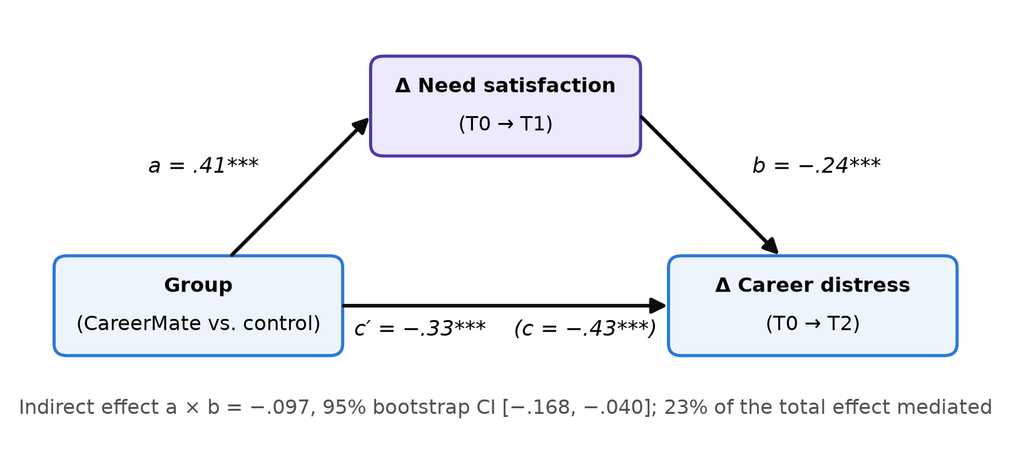
Figure 3. Path diagram for the mediation model. Change in basic psychological need satisfaction (baseline to week 4) partially mediates the effect of allocation on change in career distress (baseline to week 8).

3.5. Dose–Response and Within-Chat Language Signals (H4)
Within the intervention arm, completed sessions predicted greater improvement in career distress (standardized β = −.205, SE = 0.075, p = .007, controlling baseline; Figure 4a). Participants’ own chat language told the same story from inside the treatment: mean session sentiment rose from 4.59 in the first session to 5.47 in the final session (mean slope 0.10 points per session), and individual sentiment slopes correlated with improvement in career distress (r = .35, p < .001; Figure 4b). Because these ratings derive from open-ended language produced naturally during the intervention, they offer an unobtrusive process marker that could support future adaptive designs. H4 was supported, with the caveat that engagement was self-selected rather than randomized.
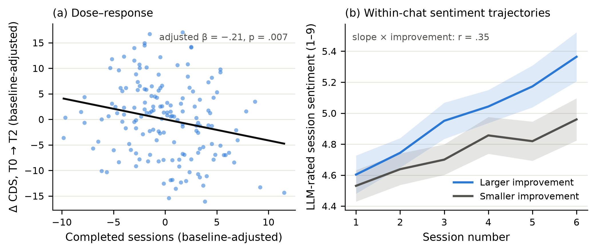
Figure 4. (a) Dose–response: change in career distress (baseline to week 8) by completed sessions, intervention arm. (b) Mean LLM-rated sentiment of participant messages by session, split at the median of week-8 improvement; shading = 95% confidence intervals.

3.6. Engagement, Acceptability, and Safety
Acceptability was high (Table 5): satisfaction averaged 5.62 of 7, 80.2% would recommend CareerMate, and comfort disclosing (5.60) was notable given the career-failure content of many conversations. Across 1750 delivered sessions, the safety layer flagged 23 (1.3%); the study counselor reviewed all flags within 24 h and initiated contact in 4 cases. No serious adverse events occurred.
Table 5. Engagement, acceptability, and safety indicators (intervention arm).
Indicator | Value
Completed sessions, median (IQR) | 10 (7–13)
Completed ≥ 6 sessions, % | 84.8
Satisfaction (1–7), M (SD), n = 167 | 5.62 (1.02)
Helpfulness (1–7), M (SD) | 5.34 (1.00)
Comfort disclosing (1–7), M (SD) | 5.60 (0.93)
Would recommend, % | 80.2
Total chatbot sessions delivered | 1750
Sessions flagged by safety layer | 23
Escalations to study counselor | 4
Serious adverse events | 0
Acceptability items rated at week 4 by available intervention participants. Flags include both keyword-layer and LLM-classifier triggers; escalation = counselor-initiated contact under the prespecified protocol.

4. Discussion

4.1. Principal Findings
In a preregistered randomized trial with young job seekers facing one of the world’s most competitive labor markets, a theory-grounded LLM career companion produced small-to-moderate, durable benefits: career distress fell (d ≈ −.4 at both waves), adaptability, decision self-efficacy, well-being, and job-search activity rose, and effects persisted four weeks after the program ended. The magnitude is meaningful on three benchmarks. It matches or exceeds the pooled effects of conversational agents on psychological distress in meta-analysis (Li et al., 2023), approaches the benefits reported for counselor-delivered job-search programs (Caplan et al., 1989; Liu et al., 2014), and was achieved at a marginal cost per participant that is orders of magnitude below face-to-face provision. Notably, gains in career adaptability grew between post-test and follow-up, consistent with adaptability functioning as a self-regulatory resource that compounds once acquired (Koen et al., 2012; Savickas, 1997).

4.2. Mechanisms and the Role of Language
The mediation results give the effects a theoretical spine: roughly a quarter of the benefit for career distress flowed through gains in basic psychological need satisfaction, the pathway self-determination theory predicts for autonomy-supportive environments (Chen et al., 2015; Ryan & Deci, 2000). That mediation was partial is informative—candidate additional mechanisms include reappraisal of rejection, narrative identity work (Savickas, 2013), and simple behavioral activation visible in the application counts. The language findings add a methodological contribution aligned with this Special Issue: the sentiment trajectory of participants’ own words, scored by an LLM blind to outcomes (Kjell et al., 2019; Rathje et al., 2024), tracked recovery in real time. In-treatment language is thus not only the medium of the intervention but also a measurement channel (Elyoseph et al., 2023; Insel, 2017)—a bridge between qualitative experience and quantitative monitoring that traditional session-count metrics cannot provide (Kjell et al., 2024).

4.3. Practical Implications
For public employment services and university career centers in high-pressure youth labor markets, the results sketch a deployable augmentation model: an always-available, autonomy-supportive companion for the many, with human counselors focused on complex cases and on the safety escalations the system surfaces (Torous et al., 2021). Three design commitments appear central to the outcome pattern and are worth preserving in replication: theory-driven dialogue policy rather than generic chat (Ryan & Deci, 2017); integration of practical information with psychological support, which kept engagement high without displacing search behavior; and a human-in-the-loop safety layer, which processed flags representing 1.3% of sessions without incident. The open-weight fallback architecture (Qwen Team, 2024) matters for institutional adoption where data sovereignty is non-negotiable (Abdurahman et al., 2024).

4.4. Limitations and Future Directions
Six limitations bound the conclusions. First, the waitlist design controls information provision but not attention or expectancy; an active comparator (e.g., a non-interactive self-help program matched for time) is the necessary next test. Second, outcomes were self-reported; the application-count result is encouraging but unverified, and employment outcomes proper require longer horizons (van Hooft et al., 2021). Third, follow-up was eight weeks; durability beyond it—and effects on actual reemployment quality—remain open (Liu et al., 2014). Fourth, participants were volunteers in one digitally advanced province of China; effects may differ where digital literacy, labor-market institutions, or help-seeking norms differ (Gariépy et al., 2022). Fifth, the dose–response and language analyses are observational within the treated arm and cannot rule out that more improvable participants engaged more. Sixth, the intervention is bound to a specific model version (OpenAI, 2024); model drift requires versioned prompts, periodic re-evaluation, and fairness audits across gender, dialect, and socioeconomic background before wide deployment (Abdurahman et al., 2024; Demszky et al., 2023). Future work should also test blended stepped-care designs in which the companion’s language-based process markers trigger timely human counseling (Bankins et al., 2024; Heinz et al., 2025).

5. Conclusions
A large language model career companion, designed from self-determination and career construction principles and wrapped in human-supervised safety machinery, modestly but durably reduced career distress and improved the adaptability, self-efficacy, well-being, and search activity of young job seekers in a randomized controlled trial. Part of the benefit flowed through the theorized pathway of basic psychological need satisfaction, and participants’ own chat language provided a real-time window on their recovery. As youth labor markets tighten and guidance resources lag behind need, such AI companions offer a scalable, ethically governable complement—never a replacement—for the human infrastructure of career support, and a concrete demonstration of how AI can be used not only to study the human condition but to support it.
Supplementary Materials: The preregistration, analysis code reproducing all statistics and figures, and the translated intervention prompt specifications are available from the corresponding author.
Author Contributions: Conceptualization, X.C.; methodology, X.C. and D.H.; software, D.H.; formal analysis, D.H. and T.M.; investigation, T.M.; data curation, T.M.; writing—original draft preparation, X.C. and D.H.; writing—review and editing, X.C. and T.M.; visualization, D.H.; supervision, X.C.; project administration, X.C.; funding acquisition, X.C. All authors have read and agreed to the published version of the manuscript.
Funding: This research was funded by the Zhejiang Provincial Philosophy and Social Sciences Planning Special Project on Higher Education Basic Research Funding Reform (Grant Number: 25NDJC153YBMS) and the Major Humanities and Social Sciences Research Projects in Zhejiang Higher Education Institutions (Grant Number: 2024QN018).
Institutional Review Board Statement: The study was conducted in accordance with the Declaration of Helsinki and approved by the Academic Ethics Committee of the College of Business, Jiaxing University (protocol code JXU-COB-2025-021; approved 20 November 2025).
Informed Consent Statement: Informed consent was obtained from all subjects involved in the study, including consent to randomization, AI-delivered support, and de-identified research use of chat text.
Data Availability Statement: De-identified quantitative data and analysis code are available from the corresponding author upon reasonable request. Chat transcripts are not shared to protect participant privacy.
Conflicts of Interest: The authors declare no conflicts of interest. CareerMate is a non-commercial research prototype; the authors have no financial interest in any conversational-AI product. The funders had no role in the design of the study; in the collection, analyses, or interpretation of data; in the writing of the manuscript; or in the decision to publish the results.

Appendix A

Appendix A.1. CareerMate Dialogue-Policy Principles (Translated Summary)
The system prompt constrained every session as follows. (1) Autonomy support: offer options and rationales, never prescriptions; elicit the participant’s own reasons for goals. (2) Reflection first: paraphrase the participant’s situation and feeling before any suggestion. (3) Competence scaffolding: convert intentions into one small, concrete, self-chosen step with an implementation plan. (4) Narrative continuity: reference the participant’s stated values and story across sessions. (5) Boundaries: no diagnosis, no therapy claims, no employment guarantees; display support resources on risk cues and defer to the human escalation protocol. (6) Action orientation: every session ends by scheduling an off-platform action.

Appendix A.2. Session-Sentiment Rating Instruction (Translated)
“You will read the messages written by one anonymous participant within a single support session. Rate the overall emotional tone of the participant’s language on a scale from 1 (extremely negative: hopelessness, defeat, distress) to 9 (extremely positive: hope, energy, confidence). Base the rating only on the participant’s own words, not the assistant’s. Output strictly as JSON: {"sentiment": x}.” Ratings used temperature 0; the scoring model never saw participant identities, allocation, or outcomes.

References
Abdurahman, S., Atari, M., Karimi-Malekabadi, F., Xue, M. J., Trager, J., Park, P. S., Golazizian, P., Omrani, A., & Dehghani, M. (2024). Perils and opportunities in using large language models in psychological research. PNAS Nexus, 3(7), pgae245. https://doi.org/10.1093/pnasnexus/pgae245
Bankins, S., Jooss, S., Restubog, S. L. D., Marrone, M., Ocampo, A. C., & Shoss, M. (2024). Navigating career stages in the age of artificial intelligence: A systematic interdisciplinary review and agenda for future research. Journal of Vocational Behavior, 153, 104011. https://doi.org/10.1016/j.jvb.2024.104011
Benjamini, Y., & Hochberg, Y. (1995). Controlling the false discovery rate: A practical and powerful approach to multiple testing. Journal of the Royal Statistical Society: Series B (Methodological), 57(1), 289–300. https://doi.org/10.1111/j.2517-6161.1995.tb02031.x
Betz, N. E., Klein, K. L., & Taylor, K. M. (1996). Evaluation of a short form of the Career Decision-Making Self-Efficacy Scale. Journal of Career Assessment, 4(1), 47–57. https://doi.org/10.1177/106907279600400103
Caplan, R. D., Vinokur, A. D., Price, R. H., & van Ryn, M. (1989). Job seeking, reemployment, and mental health: A randomized field experiment in coping with job loss. Journal of Applied Psychology, 74(5), 759–769. https://doi.org/10.1037/0021-9010.74.5.759
Chen, B., Vansteenkiste, M., Beyers, W., Boone, L., Deci, E. L., Van der Kaap-Deeder, J., Duriez, B., Lens, W., Matos, L., Mouratidis, A., Ryan, R. M., Sheldon, K. M., Soenens, B., Van Petegem, S., & Verstuyf, J. (2015). Basic psychological need satisfaction, need frustration, and need strength across four cultures. Motivation and Emotion, 39(2), 216–236. https://doi.org/10.1007/s11031-014-9450-1
Cohen, J. (1988). Statistical power analysis for the behavioral sciences (2nd ed.). Lawrence Erlbaum Associates.
Creed, P. A., Hood, M., Praskova, A., & Makransky, G. (2016). The Career Distress Scale: Using Rasch measurement theory to evaluate a brief measure of career distress. Journal of Career Assessment, 24(4), 732–746. https://doi.org/10.1177/1069072715616126
Darcy, A., Daniels, J., Salinger, D., Wicks, P., & Robinson, A. (2021). Evidence of human-level bonds established with a digital conversational agent: Cross-sectional, retrospective observational study. JMIR Formative Research, 5(5), e27868. https://doi.org/10.2196/27868
Demszky, D., Yang, D., Yeager, D. S., Bryan, C. J., Clapper, M., Chandhok, S., Eichstaedt, J. C., Hecht, C., Jamieson, J., Johnson, M., Jones, M., Krettek-Cobb, D., Lai, L., JonesMitchell, N., Ong, D. C., Dweck, C. S., Gross, J. J., & Pennebaker, J. W. (2023). Using large language models in psychology. Nature Reviews Psychology, 2(11), 688–701. https://doi.org/10.1038/s44159-023-00241-5
Duffy, R. D., Blustein, D. L., Diemer, M. A., & Autin, K. L. (2016). The psychology of working theory. Journal of Counseling Psychology, 63(2), 127–148. https://doi.org/10.1037/cou0000140
Eloundou, T., Manning, S., Mishkin, P., & Rock, D. (2024). GPTs are GPTs: Labor market impact potential of LLMs. Science, 384(6702), 1306–1308. https://doi.org/10.1126/science.adj0998
Elyoseph, Z., Hadar-Shoval, D., Asraf, K., & Lvovsky, M. (2023). ChatGPT outperforms humans in emotional awareness evaluations. Frontiers in Psychology, 14, 1199058. https://doi.org/10.3389/fpsyg.2023.1199058
Fitzpatrick, K. K., Darcy, A., & Vierhile, M. (2017). Delivering cognitive behavior therapy to young adults with symptoms of depression and anxiety using a fully automated conversational agent (Woebot): A randomized controlled trial. JMIR Mental Health, 4(2), e19. https://doi.org/10.2196/mental.7785
Gariépy, G., Danna, S. M., Hawke, L., Henderson, J., & Iyer, S. N. (2022). The mental health of young people who are not in education, employment, or training: A systematic review and meta-analysis. Social Psychiatry and Psychiatric Epidemiology, 57(6), 1107–1121. https://doi.org/10.1007/s00127-021-02212-8
Heinz, M. V., Mackin, D. M., Trudeau, B. M., Bhattacharya, S., Wang, Y., Banta, H. A., Jewett, A. D., Salzhauer, A. J., Griffin, T. Z., & Jacobson, N. C. (2025). Randomized trial of a generative AI chatbot for mental health treatment. NEJM AI, 2(4), AIoa2400802. https://doi.org/10.1056/AIoa2400802
Hou, Z.-J., Leung, S. A., Li, X., Li, X., & Xu, H. (2012). Career Adapt-Abilities Scale—China Form: Construction and initial validation. Journal of Vocational Behavior, 80(3), 686–691. https://doi.org/10.1016/j.jvb.2012.01.006
Insel, T. R. (2017). Digital phenotyping: Technology for a new science of behavior. JAMA, 318(13), 1215–1216. https://doi.org/10.1001/jama.2017.11295
International Labour Organization. (2024). Global employment trends for youth 2024: Decent work, brighter futures. International Labour Office. https://doi.org/10.54394/QSMU1809
Jones, M. K., Kaya, E., & Nan, J. (2025). Overeducation, earnings and job satisfaction among graduates in China. China Economic Review, 93, 102448. https://doi.org/10.1016/j.chieco.2025.102448
Kjell, O. N. E., Kjell, K., Garcia, D., & Sikström, S. (2019). Semantic measures: Using natural language processing to measure, differentiate, and describe psychological constructs. Psychological Methods, 24(1), 92–115. https://doi.org/10.1037/met0000191
Kjell, O. N. E., Kjell, K., & Schwartz, H. A. (2024). Beyond rating scales: With targeted evaluation, large language models are poised for psychological assessment. Psychiatry Research, 333, 115667. https://doi.org/10.1016/j.psychres.2023.115667
Koen, J., Klehe, U.-C., & Van Vianen, A. E. M. (2012). Training career adaptability to facilitate a successful school-to-work transition. Journal of Vocational Behavior, 81(3), 395–408. https://doi.org/10.1016/j.jvb.2012.10.003
Kroenke, K., Strine, T. W., Spitzer, R. L., Williams, J. B. W., Berry, J. T., & Mokdad, A. H. (2009). The PHQ-8 as a measure of current depression in the general population. Journal of Affective Disorders, 114(1–3), 163–173. https://doi.org/10.1016/j.jad.2008.06.026
Li, H., Zhang, R., Lee, Y.-C., Kraut, R. E., & Mohr, D. C. (2023). Systematic review and meta-analysis of AI-based conversational agents for promoting mental health and well-being. npj Digital Medicine, 6(1), 236. https://doi.org/10.1038/s41746-023-00979-5
Liu, S., Huang, J. L., & Wang, M. (2014). Effectiveness of job search interventions: A meta-analytic review. Psychological Bulletin, 140(4), 1009–1041. https://doi.org/10.1037/a0035923
Maggiori, C., Rossier, J., & Savickas, M. L. (2017). Career Adapt-Abilities Scale–Short Form (CAAS-SF): Construction and validation. Journal of Career Assessment, 25(2), 312–325. https://doi.org/10.1177/1069072714565856
McGorry, P. D., Mei, C., Dalal, N., Alvarez-Jimenez, M., Blakemore, S.-J., Browne, V., Dooley, B., Hickie, I. B., Jones, P. B., McDaid, D., Mihalopoulos, C., Wood, S. J., El Azzouzi, F. A., Fazio, J., Gow, E., Hanjabam, S., Hayes, A., Morris, A., Pang, E., ... Killackey, E. (2024). The Lancet Psychiatry Commission on youth mental health. The Lancet Psychiatry, 11(9), 731–774. https://doi.org/10.1016/S2215-0366(24)00163-9
OpenAI. (2024). GPT-4o system card (arXiv:2410.21276). arXiv. https://doi.org/10.48550/arXiv.2410.21276
Ou, D., & Zhao, Z. (2022). Higher education expansion in China, 1999–2003: Impact on graduate employability. China & World Economy, 30(2), 117–141. https://doi.org/10.1111/cwe.12412
Pandya, S. S., & Wang, J. (2024). Artificial intelligence in career development: A scoping review. Human Resource Development International, 27(3), 324–344. https://doi.org/10.1080/13678868.2024.2336881
Paul, K. I., & Moser, K. (2009). Unemployment impairs mental health: Meta-analyses. Journal of Vocational Behavior, 74(3), 264–282. https://doi.org/10.1016/j.jvb.2009.01.001
Peng, Y., Lv, S. B., Low, S. R., & Bono, S. A. (2024). The impact of employment stress on college students: Psychological well-being during COVID-19 pandemic in China. Current Psychology, 43(20), 18647–18658. https://doi.org/10.1007/s12144-023-04785-w
Preacher, K. J., & Hayes, A. F. (2008). Asymptotic and resampling strategies for assessing and comparing indirect effects in multiple mediator models. Behavior Research Methods, 40(3), 879–891. https://doi.org/10.3758/BRM.40.3.879
Qwen Team. (2024). Qwen2.5 technical report (arXiv:2412.15115). arXiv. https://doi.org/10.48550/arXiv.2412.15115
Rathje, S., Mirea, D.-M., Sucholutsky, I., Marjieh, R., Robertson, C. E., & Van Bavel, J. J. (2024). GPT is an effective tool for multilingual psychological text analysis. Proceedings of the National Academy of Sciences, 121(34), e2308950121. https://doi.org/10.1073/pnas.2308950121
Rudolph, C. W., Lavigne, K. N., & Zacher, H. (2017). Career adaptability: A meta-analysis of relationships with measures of adaptivity, adapting responses, and adaptation results. Journal of Vocational Behavior, 98, 17–34. https://doi.org/10.1016/j.jvb.2016.09.002
Ryan, R. M., & Deci, E. L. (2000). Self-determination theory and the facilitation of intrinsic motivation, social development, and well-being. American Psychologist, 55(1), 68–78. https://doi.org/10.1037/0003-066X.55.1.68
Ryan, R. M., & Deci, E. L. (2017). Self-determination theory: Basic psychological needs in motivation, development, and wellness. Guilford Press.
Savickas, M. L. (1997). Career adaptability: An integrative construct for life-span, life-space theory. The Career Development Quarterly, 45(3), 247–259. https://doi.org/10.1002/j.2161-0045.1997.tb00469.x
Savickas, M. L. (2013). Career construction theory and practice. In S. D. Brown & R. W. Lent (Eds.), Career development and counseling: Putting theory and research to work (2nd ed., pp. 147–183). John Wiley & Sons.
Savickas, M. L., & Porfeli, E. J. (2012). Career Adapt-Abilities Scale: Construction, reliability, and measurement equivalence across 13 countries. Journal of Vocational Behavior, 80(3), 661–673. https://doi.org/10.1016/j.jvb.2012.01.011
Schulz, K. F., Altman, D. G., & Moher, D. (2010). CONSORT 2010 statement: Updated guidelines for reporting parallel group randomised trials. BMJ, 340, c332. https://doi.org/10.1136/bmj.c332
Tennant, R., Hiller, L., Fishwick, R., Platt, S., Joseph, S., Weich, S., Parkinson, J., Secker, J., & Stewart-Brown, S. (2007). The Warwick–Edinburgh Mental Well-being Scale (WEMWBS): Development and UK validation. Health and Quality of Life Outcomes, 5, 63. https://doi.org/10.1186/1477-7525-5-63
Torous, J., Bucci, S., Bell, I. H., Kessing, L. V., Faurholt-Jepsen, M., Whelan, P., Carvalho, A. F., Keshavan, M., Linardon, J., & Firth, J. (2021). The growing field of digital psychiatry: Current evidence and the future of apps, social media, chatbots, and virtual reality. World Psychiatry, 20(3), 318–335. https://doi.org/10.1002/wps.20883
van Hooft, E. A. J., Kammeyer-Mueller, J. D., Wanberg, C. R., Kanfer, R., & Basbug, G. (2021). Job search and employment success: A quantitative review and future research agenda. Journal of Applied Psychology, 106(5), 674–713. https://doi.org/10.1037/apl0000675
Wanberg, C. R., Ali, A. A., & Csillag, B. (2020). Job seeking: The process and experience of looking for a job. Annual Review of Organizational Psychology and Organizational Behavior, 7, 315–337. https://doi.org/10.1146/annurev-orgpsych-012119-044939
Whiston, S. C., Li, Y., Goodrich Mitts, N., & Wright, L. (2017). Effectiveness of career choice interventions: A meta-analytic replication and extension. Journal of Vocational Behavior, 100, 175–184. https://doi.org/10.1016/j.jvb.2017.03.010
Xiao, Y., & Zheng, L. (2025). Can ChatGPT boost students’ employment confidence? A pioneering booster for career readiness. Behavioral Sciences, 15(3), 362. https://doi.org/10.3390/bs15030362
Zhang, L., Hui, B. P. H., Kong, F., Lu, H., & Chen, S. X. (2025). Why people “lie flat”? An integrative framework of social-psychological pathways in China. Personality and Social Psychology Review, 29(4), 371–382. https://doi.org/10.1177/10888683251358516
Zhang, W., Wang, Y., Liu, X., Guo, C., Lin, Z., Zhou, M., & Mu, Y. (2025). The psychology of involution: Taxonomy, sociocultural predictors, and psychological outcomes. Journal of Happiness Studies, 26(7), Article 127. https://doi.org/10.1007/s10902-025-00954-9
Disclaimer/Publisher’s Note: The statements, opinions and data contained in all publications are solely those of the individual author(s) and contributor(s) and not of MDPI and/or the editor(s). MDPI and/or the editor(s) disclaim responsibility for any injury to people or property resulting from any ideas, methods, instructions or products referred to in the content.

