Article
Enterprise Digital Leadership, Data-Driven Decision Making, and Youth Labor-Market Outcomes in Europe: Multivariate Modeling and Socio-Technical Country Typologies
Xinyu Cai ¹, Dingpei Hu ¹ and Tiantian Mo ^{1,}*
Academic Editor: Firstname Lastname
Received: date
Revised: date
Accepted: date
Published: date
Citation: To be added by editorial staff during production.
Copyright: © 2025 by the authors. Submitted for possible open access publication under the terms and conditions of the Creative Commons Attribution (CC BY) license (https://creativecommons.org/licenses/by/4.0/).
¹ College of Business, Jiaxing University, Jiaxing 314001, China; caixinyu@zjxu.edu.cn
* Correspondence: 00008227@zjxu.edu.cn
Abstract
Digital transformation confronts organizational leaders with consequential decisions about building digital capabilities—whether to employ dedicated ICT specialists, invest in the digital training of personnel, adopt artificial intelligence, and embed data analytics in decision processes. This paper analyzes how the aggregate footprint of such leadership decisions across enterprises relates to youth labor-market outcomes at the country level. Using harmonized Eurostat data for the 27 European Union countries, we link four enterprise-level indicators of digital leadership and data-driven decision making—the shares of enterprises employing ICT specialists, providing ICT training, using AI technologies, and performing data analytics—to the youth employment rate and the NEET rate (ages 15–29). The methodology combines MANOVA-type multivariate general linear models, exploratory factor analysis, and hierarchical and k-means clustering to examine direct associations, the latent structure of digital leadership, and emergent country typologies. Results indicate a clear gradient of associations: the employment of ICT specialists and the provision of ICT training show the strongest links with higher youth employment and lower NEET rates, while AI use and data analytics show weaker yet significant associations. A single latent factor of organizational digital leadership capability explains about three-quarters of the shared variance and is strongly associated with both youth outcomes. Cluster analysis identifies two socio-technical regimes—a digitally led, youth-inclusive group and a lagging group with weaker youth outcomes. The findings highlight leadership capability building, rather than technology adoption alone, as the systemic lever connecting digital transformation to youth opportunity, without implying causal relationships.
Keywords: digital transformation; digital leadership; data-driven decision making; youth employment; NEET; artificial intelligence; socio-technical systems; exploratory factor analysis; cluster analysis; European Union

1. Introduction
Digital transformation is revolutionizing the way organizations operate, and it does so through the decisions of their leaders. Whether an enterprise employs dedicated ICT specialists, invests in the digital training of its personnel, adopts artificial intelligence (AI), or embeds data analytics in its decision processes reflects deliberate strategic choices made by executives navigating complex technological landscapes [1–3]. These leadership decisions do not remain inside the firm. Aggregated across the enterprise population of a country, they shape the structure of labor demand, the kinds of entry-level jobs available, and the skills that young people must bring to the labor market [4,5]. How the collective footprint of enterprise digital leadership relates to the labor-market prospects of young people is therefore a question of first-order importance for both management research and employment policy.
Young people occupy a paradoxical position in the digital transition. On the one hand, the International Labour Organization reports that youth unemployment and the share of young people not in employment, education, or training (NEET) remain persistent concerns even where overall labor markets have tightened [6,7]. School-to-work transitions in Europe remain slow and uneven across countries [8,9]. On the other hand, as digital natives, young workers hold a comparative advantage in exactly the digitally intensive tasks that transforming enterprises create, and cross-country evidence suggests that digitalization is associated with lower youth unemployment [10–12]. Which of these forces dominates plausibly depends on the organizational side of the transition: enterprises whose leaders build digital capabilities—specialist teams, training systems, AI applications, and data-driven decision routines—create the complementary structures through which young people can be absorbed into digitally transformed work [13,14].
This study addresses this question from a socio-technical systems perspective combined with an upper-echelons view of organizational decision making. Socio-technical systems theory conceptualizes technological change as effective only when technical and social subsystems are jointly optimized [15–17]. Upper-echelons theory adds that organizational outcomes reflect the characteristics and choices of top decision makers [2,18,19]: digital capability building is not an automatic response to technological opportunity but a leadership decision taken under uncertainty [3,20]. From this perspective, the four enterprise indicators analyzed here—employment of ICT specialists, provision of ICT training, use of AI technologies, and performance of data analytics—are observable traces of digital leadership and data-driven decision making within national enterprise populations. Youth employment and NEET rates, in turn, are system-level outcomes that emerge from the interaction between these organizational choices and national institutions [21,22].
The present literature offers significant contributions but also limitations. First, research on digital leadership concentrates on firm-level outcomes—innovation, performance, and transformation success—and rarely traces its aggregate labor-market consequences [1,23]. Second, the labor-economics literature on technology and employment usually measures technology exposure through robots, patents, or occupational task content, paying less attention to the organizational decision structures—specialists, training, and data-driven decision making—through which technology is actually deployed [4,24,25]. Third, although European digitalization is known to be highly uneven, few studies analyze how configurations of enterprise digital capability and youth labor-market outcomes cluster across countries [5,26].
We address these shortcomings with a comparative, quantitative approach grounded in harmonized Eurostat data for the 27 European Union countries and a combination of complementary statistical techniques. Multivariate general linear models explore the direct relationships between the four dimensions of enterprise digital leadership and two youth labor-market indicators; exploratory factor analysis tests for a common latent factor of organizational digital leadership capability; and hierarchical and k-means cluster analyses identify typologies of countries with similar profiles. The research thus moves beyond a linear view of technology's impact and provides a systemic analysis of the embedding of digital leadership within organizational, institutional, and labor-market interactions.
The study contributes to the existing research in several ways. First, it shifts the focus of the digital-leadership literature from firm performance to youth labor-market outcomes, connecting management research on leadership and decision making with labor economics [1,27]. Second, it conceptualizes and measures digital leadership at the level of national enterprise populations through four complementary, harmonized indicators, distinguishing capability building (specialists, training) from technology deployment (AI, data analytics). Third, it identifies a latent dimension of organizational digital leadership capability and shows that it is strongly associated with youth employment and NEET rates. Fourth, it derives socio-technical country typologies that reveal how digital leadership and youth outcomes co-occur in distinct European regimes, informing differentiated policy responses [26,28].
The paper is structured as follows: the introduction outlines the research topic, purpose, gaps, contribution, and novelty; Section 2 presents the theoretical framework and the hypotheses concerning the four dimensions of enterprise digital leadership, the latent capability factor, and the socio-technical differentiation across countries; Section 3 describes the data, variables, and statistical methods; Section 4 presents the results of the multivariate modeling, factor analysis, and clustering; Section 5 interprets the results in the context of the specialized literature; and Section 6 summarizes the main findings, implications, and limitations of the research and directions for future analysis.
2. Theoretical Framework, Literature Review, and Hypotheses Development
The theoretical framework of this study combines the upper-echelons perspective on strategic decision making with the socio-technical systems perspective on digital transformation. From the upper-echelons viewpoint, the digital capabilities observable in an enterprise population condense sequences of leadership decisions: hiring dedicated digital specialists, allocating budgets to ICT training, approving AI adoption, and institutionalizing data-driven decision routines [2,3,18]. From the socio-technical viewpoint, these decisions succeed or fail depending on how the technical subsystem is aligned with skills, work organization, and institutional context [15,21]. The study therefore interprets cross-country differences in enterprise digital leadership and youth labor-market indicators as socio-technical configurations shaped by both organizational decision making and institutional environments.
2.1. Enterprise Digital Leadership, Data-Driven Decision Making, and Youth Labor-Market Outcomes
Digital leadership refers to the capacity of organizational leaders to initiate, resource, and govern digital transformation [1,13]. Recent reviews emphasize that effective digital leadership combines a transformational vision with concrete capability investments: recruiting digital talent, developing the digital skills of the existing workforce, and redesigning decision processes around data [23,29,30]. The employment of ICT specialists and the provision of ICT training are the most direct observable traces of such investments in enterprise surveys, while the adoption of AI technologies and the use of data analytics capture the extent to which decision making itself has been transformed [3,20,31].
Each of these leadership choices carries a distinct implication for young workers. First, enterprises that employ ICT specialists create professional digital roles for which recent graduates—the primary carriers of up-to-date digital skills—are natural candidates [5,10]. Second, enterprises that train their personnel signal a human-capital-augmenting rather than labor-displacing transformation strategy; training systems lower the effective cost of hiring inexperienced young workers and ease their integration [14,32]. Third, AI adoption reallocates tasks from routine execution toward supervision, analysis, and human–machine collaboration, task categories in which young digital natives hold a comparative advantage, although displacement risks for entry-level routine positions cut in the opposite direction [4,25,33]. Fourth, data analytics embodies data-driven decision making, which is associated with higher productivity and growth—and expanding, data-driven organizations recruit disproportionately from the external labor market where young job seekers are concentrated [3,34].
The macro-level counterpart of these micro-level mechanisms is a cross-country association between the prevalence of digitally capable enterprises and youth labor-market performance. Cross-country studies find that digitalization is associated with lower youth unemployment in Europe and beyond [10–12], and that innovation can create employment through firm growth [35]. At the same time, associations may differ across the four dimensions: capability-building indicators (specialists, training) are direct employment channels, whereas deployment indicators (AI, data analytics) affect youth employment more indirectly through task reallocation and productivity [26,36]. This literature justifies the following hypothesis:
H1. The four enterprise-level dimensions of digital leadership and data-driven decision making show significant cross-sectional associations with the youth employment rate and the NEET rate across European Union countries.
2.2. The Latent Dimension of Organizational Digital Leadership Capability
The four dimensions of enterprise digital leadership can be evaluated independently, but the literature suggests that they also share a deeper common component. Digital leadership is theorized as a coherent managerial capability in which vision, talent, skills development, and data-driven decision routines reinforce one another [1,23,30]. Enterprises that employ ICT specialists are more likely to train their personnel, to experiment with AI, and to analyze data; at the country level, these choices co-vary with digital infrastructure, managerial quality, and institutional support [5,37]. From a socio-technical systems perspective, such co-variation reflects the systemic character of digital transformation: isolated technology adoption without complementary skills and decision structures rarely persists [16,21,38].
If the four indicators share a common latent factor, this factor can be interpreted as the aggregate organizational digital leadership capability of a country's enterprise population. Its association with youth labor-market outcomes then provides a synthetic test of whether digitally led enterprise systems are also youth-inclusive ones. Prior factor-analytic work on country-level digitalization indicators supports the existence of such common dimensions [26,39]. This literature justifies the following hypothesis:
H2. The four dimensions of enterprise digital leadership share a common latent factor, and this latent capability factor is significantly associated with the youth employment rate and the NEET rate.
2.3. Socio-Technical Typologies of Digital Leadership and Youth Employment in Europe
European digital transformation is highly uneven. Northern and Western European countries systematically lead in enterprise digitalization, digital skills, and AI adoption, while Southern and Eastern European countries lag, reflecting differences in industrial structure, investment capacity, institutions, and digital infrastructure [5,26,37]. Youth labor markets are similarly heterogeneous, with NEET rates ranging from around four percent to just above twenty percent across member states [40,41]. From a complex adaptive systems perspective, such joint heterogeneity is unlikely to be random: technology, human capital, organizational decision making, and institutions co-evolve into persistent national configurations [21,22,28].
The clustering approach therefore connects management research on digital leadership with labor economics through the identification of socio-technical regimes: groups of countries in which similar levels of enterprise digital capability co-occur with similar youth labor-market outcomes. Identifying such typologies has direct policy value, because interventions that work in digitally led, youth-inclusive regimes may be ineffective in lagging regimes where complementary capabilities are missing [26,27,42]. This literature justifies the following hypothesis:
H3. European Union countries form distinct socio-technical clusters according to enterprise digital leadership, data-driven decision making, and youth labor-market outcomes.
3. Materials and Methods
3.1. Research Design
The paper uses a quantitative, cross-sectional, and comparative research design to investigate the systemic linkages between enterprise digital leadership and youth labor-market outcomes in a European context. Given the cross-sectional nature of the data, the analysis identifies statistical associations between digital-leadership indicators and youth labor-market indicators, but it does not establish causal relationships or temporal sequences. The perspective of complex socio-technical systems informs this approach: the digital capability profile of an enterprise population is not seen as a separate event but as an integral part of the interaction among managerial decision making, human agency, institutional frameworks, and economic performance [21,22].
The design examines cross-sectional associations between specific dimensions of enterprise digital leadership and youth labor-market indicators, as well as broader relational patterns emerging from their interaction. The research combines multivariate modeling, dimensionality reduction, and segmentation approaches to describe the relational dynamics and latent structure of the phenomenon under study. The resulting analysis provides an integrated description of how digital leadership is statistically linked to youth labor-market characteristics at the system level, without implying causal direction.
The sample consists of the 27 European Union countries, corresponding to the availability of harmonized country-level data for the variables included in the analysis. This sample size is at the lower end of the range for multivariate modeling and exploratory factor analysis, and the results should therefore be interpreted with caution. The objective of the empirical strategy is not to provide definitive causal estimates, but to identify exploratory cross-sectional associations and broad socio-technical patterns across EU countries. The limited number of observations also justifies parsimonious specifications and a cautious interpretation of the factor-analytic results.
3.2. Selected Data
The study uses Eurostat, which provides harmonized European-level data that allow for consistent comparisons between the countries in the sample. Enterprise digital-leadership data come from the EU survey on ICT usage and e-commerce in enterprises, which covers enterprises with ten or more persons employed. Four indicators are used: the share of enterprises that employ ICT specialists (EDL_SPEC), the share that provided training to develop or upgrade the ICT skills of their personnel (EDL_TRAIN), the share that use at least one AI technology (EDL_AI), and the share that perform data analytics (EDL_DA) [43]. The first two indicators capture leadership decisions to build digital human capital; the latter two capture the deployment of AI and data-driven decision making in organizational processes.
The micro image is supplemented by a macro interpretation using youth labor-market data. The youth employment rate ($YER$) refers to employed persons aged 15–29 as a percentage of the same-age population [44]. The NEET rate ($NEET$) is the share of persons aged 15–29 neither in employment nor in education and training [45]. Both indicators are widely used markers of youth labor-market performance and school-to-work transition quality [7,8]. All variables refer to the most recent available reference year, so that the enterprise and labor-market data are temporally compatible. Table 1 lists the variables and their roles in the analysis.
Table 1. Variables and measures.
Variable | Dataset | Measures | Source
EDL_SPEC | Enterprises that employ ICT specialists | Percentage of enterprises (10+ persons employed) | [43]
EDL_TRAIN | Enterprises that provided ICT training to their personnel | Percentage of enterprises (10+ persons employed) | [43]
EDL_AI | Enterprises using at least one artificial intelligence technology | Percentage of enterprises (10+ persons employed) | [43]
EDL_DA | Enterprises performing data analytics | Percentage of enterprises (10+ persons employed) | [43]
YER | Youth employment rate (15–29) | Percentage of the population aged 15–29 | [44]
NEET | Young people neither in employment nor in education and training (15–29) | Percentage of the population aged 15–29 | [45]
Notes: Source: authors’ design based on Eurostat datasets [43–45].
3.3. Methods
The empirical analysis employs an integrated methodological strategy to investigate both the direct relationships between enterprise digital leadership and youth labor-market indicators and the latent structure and emerging patterns of the socio-technical system under study. The approach integrates multivariate modeling, dimensionality reduction, and unsupervised classification techniques, providing a cohesive explanation of the co-evolutionary processes of organizational decision making and youth employment [39,46].
In the first stage, the association between each dimension of enterprise digital leadership and the two youth labor-market indicators was examined using four separate multivariate general linear models, estimated in a MANOVA-type framework. In each model, the youth employment rate and the NEET rate were treated as correlated dependent variables, with one digital-leadership indicator serving as the explanatory variable, according to Equation (1):
$\left(Y_{1i}, Y_{2i}\right) = α + βX_{ki} + ε_{i}$ (1)
where $Y_{1i}$ is the youth employment rate ($YER$) and $Y_{2i}$ the NEET rate of country $i$; $X_{ki}$ is one digital-leadership indicator at a time (EDL_SPEC, EDL_TRAIN, EDL_AI, or EDL_DA); $α$ is the intercept vector; $β$ is the vector of regression coefficients; and $ε_{i}$ is the error term. The four indicators were not entered simultaneously in the same model because they are conceptually related and empirically correlated, and the limited cross-sectional sample of 27 countries does not support a stable model with several closely related predictors. Therefore, the models should be interpreted as parallel exploratory tests of simple associations, not as evidence of distinct partial effects. The analysis evaluates the global significance of the models using multivariate statistics, namely Pillai's Trace and Wilks' Lambda, while examining individual associations using univariate tests and regression coefficients [46]. Before interpreting the models, residual normality was assessed using normal probability plots and Shapiro–Wilk tests, while standardized residuals, leverage values, and Cook's distance were inspected to identify influential observations.
To capture the aggregate pattern of digital leadership, the study uses exploratory factor analysis on the four indicators. Prior to extraction, all variables were standardized according to Equation (2):
$z_{ij} = \frac{x_{ij} − {\bar{x}}_{j}}{s_{j}}$ (2)
where $z_{ij}$ is the standardized value of indicator $j$ in country $i$, and ${x̄}_{j}$ and $s_{j}$ are the sample mean and standard deviation of indicator $j$. The factorial model can be expressed as in Equation (3):
$X = ΛF + ε$ (3)
where $X$ is the vector of observed variables, $Λ$ is the matrix of factor loadings, $F$ is the latent factor, and $ε$ is the vector of unique errors. Principal Axis Factoring was used as the extraction method, based on the correlation matrix, with sampling adequacy assessed by the Kaiser–Meyer–Olkin measure and Bartlett's test of sphericity [46,47]. A one-factor solution was retained to capture the common latent structure of digital leadership across the capability-building and deployment domains. Since only one factor was extracted, no rotation was applied. Factor scores were generated using the regression method and subsequently used as a synthetic indicator of organizational digital leadership capability (FACT_EDL). This latent factor then enters two simple linear regression models, estimated separately for each youth labor-market indicator, according to Equation (4):
$Y_{i} = β_{0} + β_{1} {FACT}_{EDL,i} + ε_{i}$ (4)
where $Y_{i}$ alternatively denotes the youth employment rate and the NEET rate, $β_{0}$ is the intercept, $β_{1}$ is the regression coefficient of the factor score, and $ε_{i}$ is the error term. Such models enable the evaluation of the overall association of digital leadership capability with youth labor-market performance, providing a synthetic perspective on the correlation between organizational decision making and youth opportunity.
Finally, cluster analysis is applied to identify emergent national-level typologies based on the four digital-leadership indicators and the two youth labor-market indicators. The initial data structure and the candidate number of groups are determined by hierarchical clustering with a correlation-based proximity measure and the average linkage agglomeration method [46,48]. This is an exploratory step, and the study then uses the k-means algorithm to stabilize the clusters by minimizing the within-cluster sum of squared distances between standardized profiles and cluster centres, according to Equation (5):
$W = \sum_{k=1}^{K}{\sum_{i∈C_{k}}{{\left\|z_{i} − μ_{k}\right\|}^{2}}}$ (5)
where $K$ is the number of clusters, $C_{k}$ denotes the set of countries assigned to cluster $k$, $z_{i}$ is the standardized profile of country $i$, and $μ_{k}$ is the centre of cluster $k$ [49]. Cluster separation is assessed with the average silhouette coefficient [50], and differences between clusters are described using analysis of variance (ANOVA). Since the clusters were constructed from the same variables used in the ANOVA, these results are interpreted descriptively rather than as independent statistical confirmation of cluster separation. This combination of methods allows the study to capture direct linear relationships, the latent structure, and the system's emergent typologies, providing an integrated reading of the relationship among enterprise digital leadership, data-driven decision making, and youth labor-market dynamics within a complex adaptive socio-technical systems framework [21,22].
4. Results
4.1. Cross-Sectional Relationships Between Enterprise Digital Leadership and Youth Labor-Market Outcomes
Across the 27 EU countries, the four digital-leadership indicators display wide variation: the share of enterprises employing ICT specialists ranges from 9.7% to 36.1% (mean 21.5%), ICT training from 6.3% to 44.3% (mean 23.0%), AI use from 2.0% to 31.9% (mean 14.3%), and data analytics from 8.0% to 48.4% (mean 31.4%). The youth employment rate averages 48.3% (range 32.2–72.0%) and the NEET rate 10.4% (range 4.2–20.6%). The first multivariate model analyzed the association between the employment of ICT specialists (EDL_SPEC) and the two youth labor-market indicators. The multivariate tests indicate a significant global association with a large effect size (Pillai's Trace = 0.605, Wilks' Lambda = 0.395, F(2, 24) = 18.400, p < 0.001), suggesting that the prevalence of dedicated digital specialists is associated with both youth indicators. At the univariate level, EDL_SPEC is associated with approximately 51% of the cross-sectional variance in the youth employment rate and 50% of the variation in the NEET rate. Higher shares of specialist-employing enterprises are associated with a significantly larger youth employment rate and, at the same time, a lower NEET rate (Table 2).
Table 2. Parameter estimates for the relationship between the employment of ICT specialists and youth labor-market indicators.
Dependent Variable | Parameter | B | Std. Error | t | Sig. | 95% CI  Lower | 95% CI  Upper | Partial Eta  Squared
YER | Intercept | 30.223 | 3.771 | 8.014 | 0.000 | 22.456 | 37.990 | 0.720
 | EDL_SPEC | 0.840 | 0.166 | 5.057 | 0.000 | 0.498 | 1.182 | 0.506
NEET | Intercept | 17.866 | 1.560 | 11.451 | 0.000 | 14.652 | 21.079 | 0.840
 | EDL_SPEC | −0.345 | 0.069 | −5.027 | 0.000 | −0.487 | −0.204 | 0.503
Notes: Source: authors’ calculations. Note: N = 27. CI = confidence interval.
The curve-fit analysis suggests a linear relationship between EDL_SPEC and both outcomes. Figure 1 illustrates divergent trajectories for the two dependent variables: the youth employment rate shows an upward trend, whereas the NEET rate exhibits a downward slope as the prevalence of ICT specialists increases.
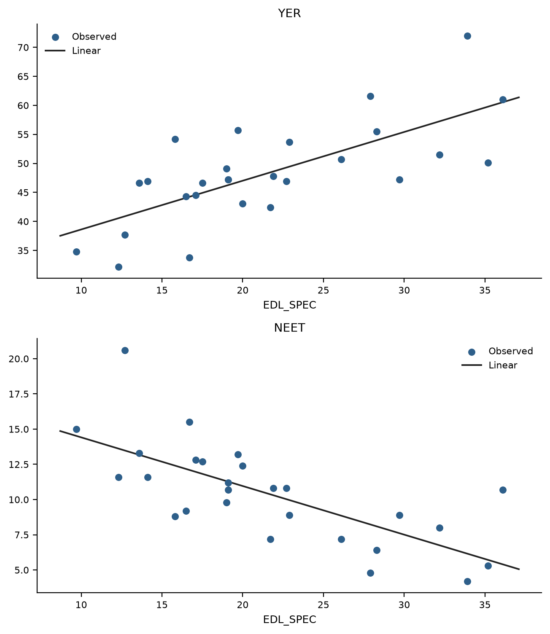
Figure 1. Youth employment rate (YER) and NEET rate according to the share of enterprises employing ICT specialists (EDL_SPEC). Source: authors’ design.
The second model evaluated the provision of ICT training (EDL_TRAIN). The multivariate effect remains significant and substantial (Pillai's Trace = 0.479, Wilks' Lambda = 0.521, F(2, 24) = 11.050, p < 0.001). At the individual level, EDL_TRAIN is positively associated with the youth employment rate (p = 0.001) and negatively with the NEET rate (p < 0.001), accounting for roughly 38% and 41% of their respective variances. Training decisions thus correlate almost as strongly with youth outcomes as specialist employment, consistent with the interpretation that internal skill-formation systems ease the integration of young workers (Table 3, Figure 2).
Table 3. Parameter estimates for the relationship between the provision of ICT training and youth labor-market indicators.
Dependent Variable | Parameter | B | Std. Error | t | Sig. | 95% CI  Lower | 95% CI  Upper | Partial Eta  Squared
YER | Intercept | 34.357 | 3.777 | 9.097 | 0.000 | 26.579 | 42.136 | 0.768
 | EDL_TRAIN | 0.605 | 0.153 | 3.949 | 0.001 | 0.290 | 0.921 | 0.384
NEET | Intercept | 16.397 | 1.520 | 10.786 | 0.000 | 13.266 | 19.528 | 0.823
 | EDL_TRAIN | −0.259 | 0.062 | −4.197 | 0.000 | −0.386 | −0.132 | 0.413
Notes: Source: authors’ calculations. Note: N = 27. CI = confidence interval.
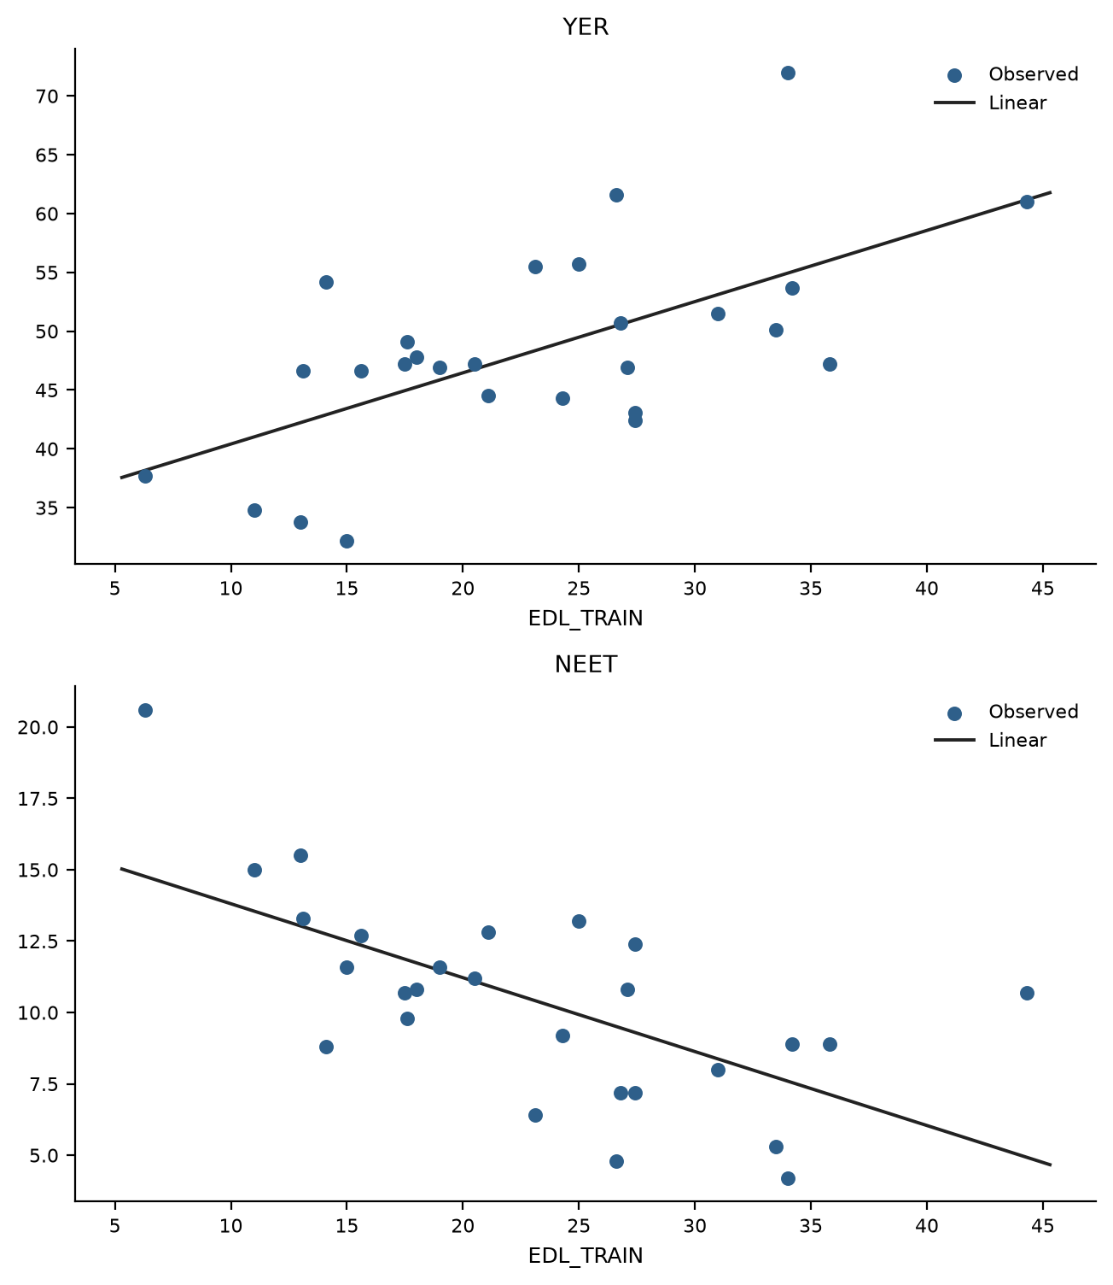
Figure 2. Youth employment rate (YER) and NEET rate according to the share of enterprises providing ICT training (EDL_TRAIN). Source: authors’ design.
The third model, centered on the use of AI technologies (EDL_AI), points to a weaker but still significant systemic association (Pillai's Trace = 0.342, Wilks' Lambda = 0.658, F(2, 24) = 6.239, p = 0.007). EDL_AI explains approximately 24% of the variation in the youth employment rate (p = 0.009) and 32% of the variation in the NEET rate (p = 0.002). An increase in enterprise AI adoption is associated simultaneously with higher youth employment and a consistent decrease in the NEET rate, although the strength of the association is clearly below that of the capability-building indicators (Table 4, Figure 3).
Table 4. Parameter estimates for the relationship between enterprise AI use and youth labor-market indicators.
Dependent Variable | Parameter | B | Std. Error | t | Sig. | 95% CI  Lower | 95% CI  Upper | Partial Eta  Squared
YER | Intercept | 40.105 | 3.264 | 12.286 | 0.000 | 33.382 | 46.828 | 0.858
 | EDL_AI | 0.575 | 0.204 | 2.821 | 0.009 | 0.155 | 0.995 | 0.241
NEET | Intercept | 14.311 | 1.277 | 11.210 | 0.000 | 11.682 | 16.940 | 0.834
 | EDL_AI | −0.272 | 0.080 | −3.414 | 0.002 | −0.437 | −0.108 | 0.318
Notes: Source: authors’ calculations. Note: N = 27. CI = confidence interval.
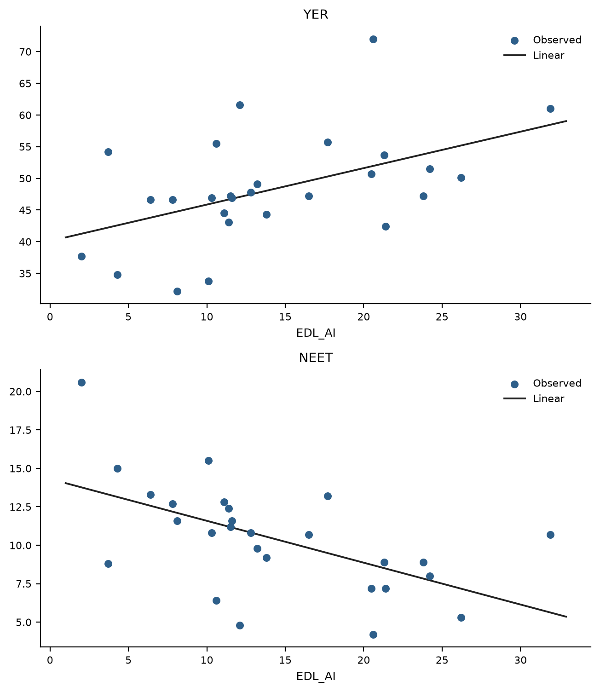
Figure 3. Youth employment rate (YER) and NEET rate according to the share of enterprises using AI technologies (EDL_AI). Source: authors’ design.
The final model investigated the performance of data analytics (EDL_DA), the most direct marker of data-driven decision making. The multivariate effect remains significant but is the weakest of the four (Pillai's Trace = 0.271, Wilks' Lambda = 0.729, F(2, 24) = 4.458, p = 0.023). EDL_DA shows a statistically significant positive association with the youth employment rate (p = 0.013) and a negative association with the NEET rate (p = 0.012), each accounting for roughly 22–23% of the cross-sectional variance. This result suggests that data-driven decision making relates to youth outcomes mainly as part of a broader capability configuration rather than as an isolated tool (Table 5, Figure 4).
Table 5. Parameter estimates for the relationship between enterprise data analytics and youth labor-market indicators.
Dependent Variable | Parameter | B | Std. Error | t | Sig. | 95% CI  Lower | 95% CI  Upper | Partial Eta  Squared
YER | Intercept | 34.923 | 5.220 | 6.691 | 0.000 | 24.173 | 45.674 | 0.642
 | EDL_DA | 0.427 | 0.159 | 2.677 | 0.013 | 0.098 | 0.755 | 0.223
NEET | Intercept | 16.017 | 2.145 | 7.467 | 0.000 | 11.599 | 20.435 | 0.690
 | EDL_DA | −0.178 | 0.066 | −2.720 | 0.012 | −0.313 | −0.043 | 0.228
Notes: Source: authors’ calculations. Note: N = 27. CI = confidence interval.
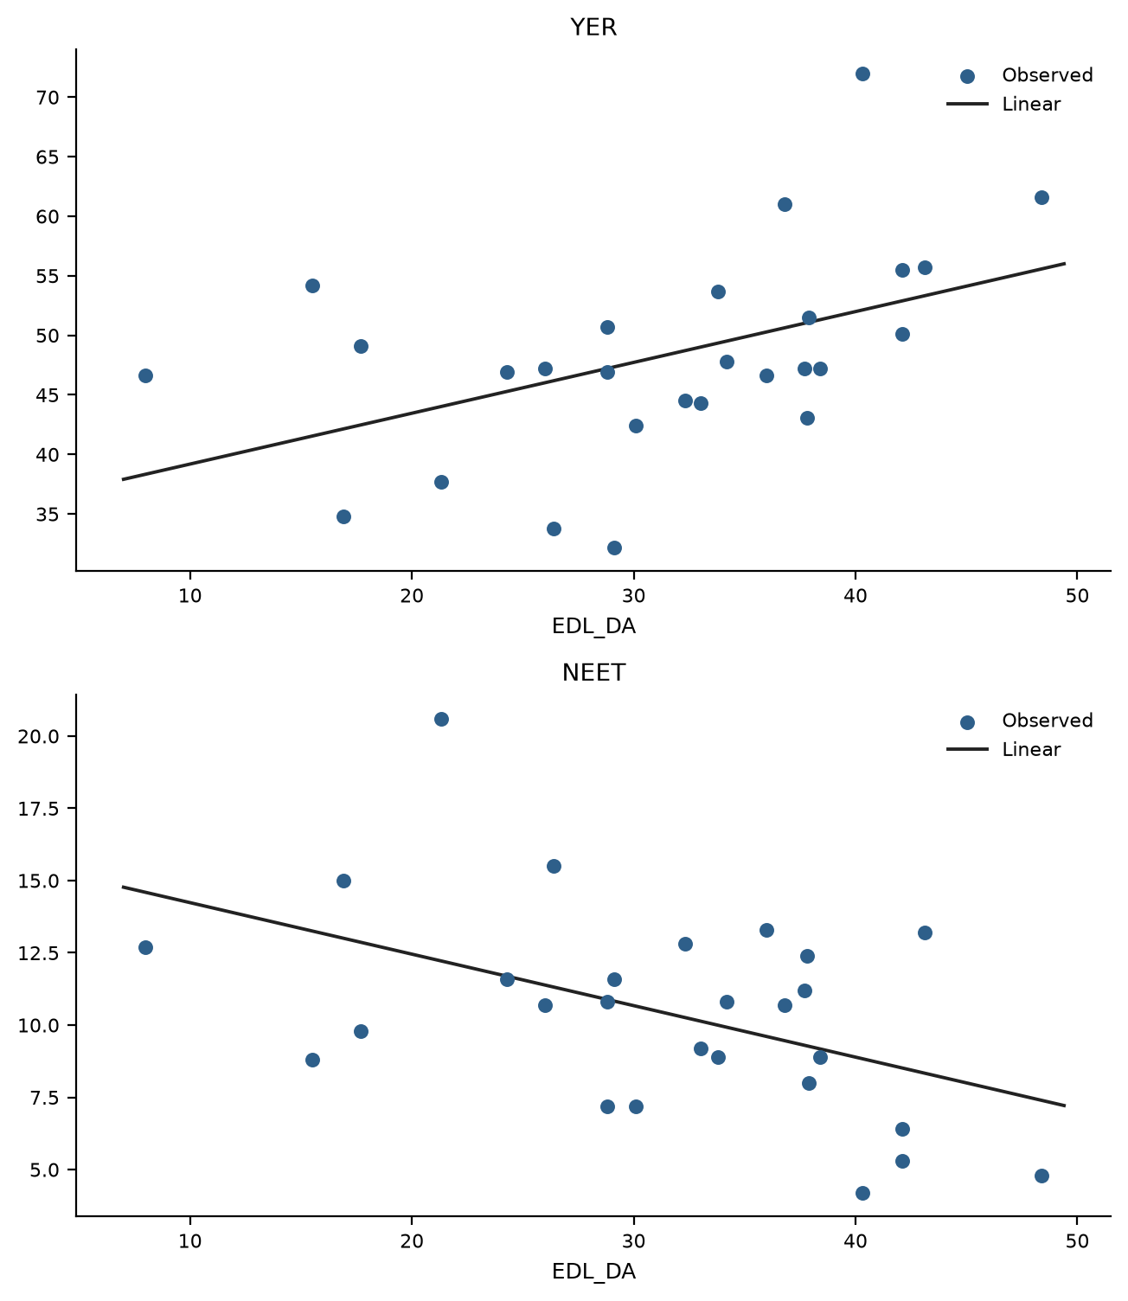
Figure 4. Youth employment rate (YER) and NEET rate according to the share of enterprises performing data analytics (EDL_DA). Source: authors’ design.
Overall, the four models suggest a clear gradient rather than uniform associations. The capability-building dimensions of digital leadership—employing ICT specialists and training personnel—are most strongly associated with both youth labor-market indicators, while the deployment dimensions—AI use and data analytics—show weaker though still significant associations. Therefore, H1 is supported, with the qualification that the strength of the association differs systematically across the dimensions of digital leadership.
Given the low values recorded for Romania across several indicators, an additional robustness check was conducted by excluding Romania from the sample. The direction of all associations remained unchanged and the capability-building models remained significant at the 1% level; however, the multivariate significance of the AI model weakened to p = 0.029 and that of the data-analytics model to the 5% boundary (p = 0.044). These results suggest that the weaker deployment-side associations are somewhat sensitive to country-level outliers and should be interpreted as exploratory cross-sectional associations.
To address the possible role of broader structural country characteristics, a supplementary bivariate correlation analysis was conducted. The four digital-leadership indicators were correlated with contextual variables available in the dataset, namely the share of the population aged 25–34 with tertiary education, R&D intensity (gross domestic expenditure on R&D as a share of GDP), and real labour productivity per person (Table 6). This analysis was not intended to replace a controlled regression model, but rather to provide a robustness check on whether digital leadership covaries with broader educational and productivity-related country characteristics.
Table 6. Supplementary bivariate correlations with structural contextual variables.
Structural Contextual Variable | EDL_SPEC | EDL_TRAIN | EDL_AI | EDL_DA
Tertiary education share (PTE) | 0.501 (p = 0.008) | 0.491 (p = 0.009) | 0.453 (p = 0.018) | 0.368 (p = 0.059)
R&D intensity (GERD) | 0.587 (p = 0.001) | 0.725 (p < 0.001) | 0.767 (p < 0.001) | 0.486 (p = 0.010)
Real labour productivity per person (RLPP) | 0.616 (p = 0.001) | 0.492 (p = 0.009) | 0.430 (p = 0.025) | 0.530 (p = 0.004)
Notes: Source: authors’ calculations. Note: Pearson correlation coefficients are reported, with p-values in parentheses. N = 27. PTE = population aged 25–34 with tertiary education; GERD = gross domestic expenditure on R&D as a share of GDP; RLPP = real labour productivity per person.
The supplementary correlations indicate that enterprise digital leadership is not independent of broader structural country characteristics. The strongest and most consistent positive associations are observed with R&D intensity and productivity, while the correlation between data analytics and tertiary education is only marginal. These results suggest that the observed relationships between digital leadership and youth labor-market indicators may partly overlap with broader differences in innovation capacity and productivity across countries. Therefore, the main results should continue to be interpreted as exploratory cross-sectional associations rather than as estimates of the independent effect of digital leadership.
4.2. The Latent Dimension of Organizational Digital Leadership Capability and Its Systemic Associations
The exploratory factor analysis aimed to reduce the four observable variables to a common factor structure, capturing the aggregate process by which multiple leadership decisions articulate into a cohesive socio-technical dynamic. The KMO value of 0.797, the significance of Bartlett's test (χ² = 85.338; df = 6; p < 0.001), and significant correlations among the variables indicate that the data are suitable for extracting a common latent construct (Table 7). The factorial solution converges to a single factor that accounts for 74.4% of the overall variance after extraction, indicating a unified dimension of organizational digital leadership capability across enterprise populations.
The communalities indicate that the common latent factor effectively represents the employment of ICT specialists, the provision of ICT training, and AI use. By contrast, EDL_DA has a considerably lower extracted communality (0.390), suggesting that data analytics shares less variance with the other indicators. This finding does not justify excluding the variable, since its factor loading remains positive and meaningful (0.625), but it indicates that data-driven decision making captures a more specific dimension of digital leadership. Therefore, the latent factor mainly reflects capability building and AI deployment, while the data-analytics dimension should be interpreted more cautiously.
Table 7. Exploratory factor analysis of enterprise digital-leadership indicators.
Indicator/Statistic | Value
Kaiser–Meyer–Olkin measure | 0.797
Bartlett’s test of sphericity | χ² = 85.338; df = 6; p < 0.001
Extraction method | Principal Axis Factoring
Number of factors extracted | 1
Initial eigenvalue, Factor 1 | 3.182
Initial variance explained | 79.556%
Extraction sum of squared loadings | 2.975
Variance explained after extraction | 74.379%
Rotation | No rotation
Communalities (initial/extraction) — EDL_SPEC | 0.772/0.842; loading 0.918
Communalities (initial/extraction) — EDL_TRAIN | 0.861/0.946; loading 0.973
Communalities (initial/extraction) — EDL_AI | 0.818/0.796; loading 0.892
Communalities (initial/extraction) — EDL_DA | 0.424/0.390; loading 0.625
Notes: Source: authors’ calculations.
This latent factor, labelled FACT_EDL, reflects an emerging construct of the socio-technical system of work, in which enterprise-level leadership decisions aggregate into a coherent macro-level signal of digital capability. The first regression analyzed the relationship between FACT_EDL and the youth employment rate. The model indicates a positive and statistically significant relationship, with a correlation coefficient of 0.665 and an explanatory capacity of approximately 44% of the variation in youth employment (R² = 0.442; adjusted R² = 0.420). The F test indicates that the model is statistically significant (F = 19.803, p < 0.001). Given the cross-sectional structure of the data and the absence of a meaningful ordering of countries, no autocorrelation interpretation is reported (Table 8).
Table 8. Regression results for the relationship between the latent digital-leadership factor and the youth employment rate.
Model summary | R | R Square | Adjusted  R Square | Std. Error of  the Estimate
 | 0.665 | 0.442 | 0.420 | 6.615
ANOVA | Sum of  Squares | df | Mean  Square | F (Sig.)
Regression | 866.434 | 1 | 866.434 | 19.803 (p < 0.001)
Residual | 1093.824 | 25 | 43.753
Total | 1960.259 | 26
Coefficients | B | Std.  Error | Beta  (standardized) | t (Sig.)
(Constant) | 48.307 | 1.273 |  | 37.933 (p < 0.001)
FACT_EDL | 5.770 | 1.298 | 0.665 | 4.446 (p < 0.001)
Notes: Source: authors’ calculations.
The regression coefficient indicates that, on average, a one-unit rise in the factor score is associated with an increase of about 5.8 percentage points in the youth employment rate (B = 5.770, p < 0.001). The standardized coefficient (β = 0.665) indicates a moderate to strong association, suggesting that the latent dimension of digital leadership is significantly associated with youth workforce participation. In socio-technical terms, these results suggest that the latent factor may be interpreted as a broader indicator of organizational digital capability among national enterprise populations. Its positive association with youth employment is consistent with the idea that digital leadership, skills formation, and youth labor-market integration co-occur in more digitally prepared national contexts. However, this interpretation remains exploratory and should not be taken as evidence that digital leadership increases youth employment.
The second regression examines the association between FACT_EDL and the NEET rate. The model shows a substantial negative association (R = 0.682, with a negative slope) and explains around 47% of the variation in the NEET rate (R² = 0.465; adjusted R² = 0.444). The F test indicates that the model is statistically significant (F = 21.729, p < 0.001) (Table 9).
Table 9. Regression results for the relationship between the latent digital-leadership factor and the NEET rate.
Model summary | R | R Square | Adjusted  R Square | Std. Error of  the Estimate
 | 0.682 | 0.465 | 0.444 | 2.671
ANOVA | Sum of  Squares | df | Mean  Square | F (Sig.)
Regression | 155.039 | 1 | 155.039 | 21.729 (p < 0.001)
Residual | 178.378 | 25 | 7.135
Total | 333.416 | 26
Coefficients | B | Std.  Error | Beta  (standardized) | t (Sig.)
(Constant) | 10.430 | 0.514 |  | 20.294 (p < 0.001)
FACT_EDL | −2.443 | 0.524 | −0.682 | −4.664 (p < 0.001)
Notes: Source: authors’ calculations.
The regression coefficient indicates that, on average, a one-unit increase in the factor score is associated with a decrease of around 2.4 percentage points in the NEET rate (B = −2.443, p < 0.001). The standardized coefficient (β = −0.682) indicates a moderate-to-strong relationship, implying that the latent dimension of digital leadership is consistently associated with lower youth exclusion. From a socio-technical perspective, the negative association between FACT_EDL and the NEET rate suggests that countries whose enterprises invest more coherently in digital capabilities also tend to integrate their young people more successfully. This pattern may reflect broader differences in productivity, digital readiness, organizational adaptation, or economic structure, but the cross-sectional data do not allow these mechanisms to be tested directly. These results provide exploratory support for H2 by showing that the latent factor of digital leadership is statistically associated with both youth labor-market indicators.
4.3. Emerging Socio-Technical Typologies: National Profiles of Digital Leadership and Youth Labor-Market Dynamics
To explore the latent structure of the relationships between enterprise digital leadership and youth labor-market indicators, the analysis began with hierarchical clustering, using the average linkage method and a correlation-based proximity measure between country profiles. The dendrogram presented in Figure 5 suggests a possible two-group structure in the sample. Following this exploratory indication, the k-means algorithm was applied to describe two country profiles. The resulting two-cluster solution should be interpreted as an exploratory and descriptive typology, not as a definitive classification of European countries. The k-means partition agrees with the hierarchical two-group cut for 26 of the 27 countries, indicating a stable exploratory structure.
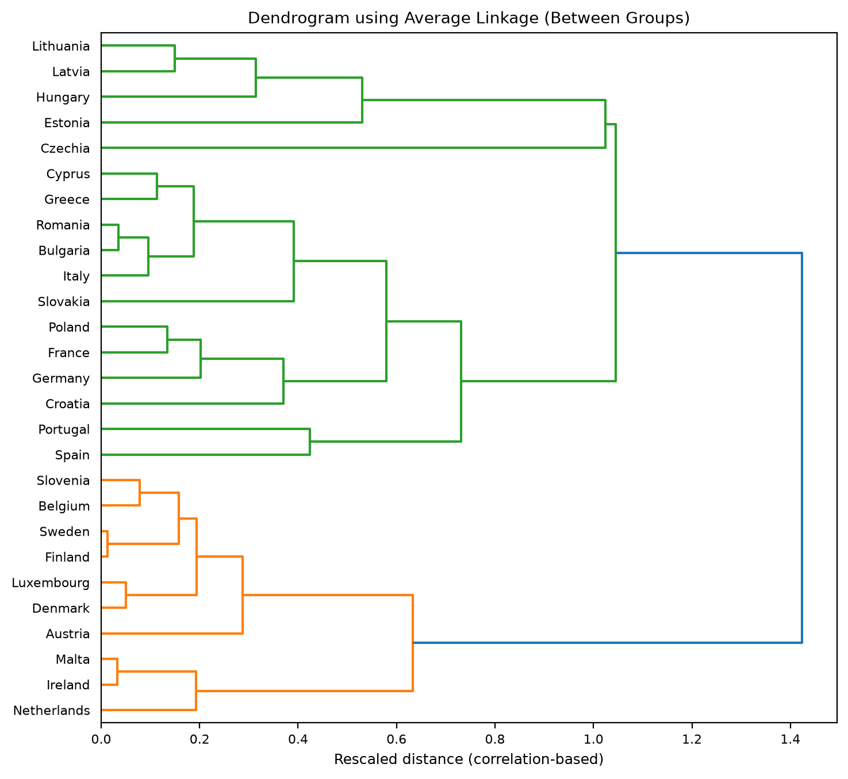
Figure 5. Dendrogram of the hierarchical clustering of European countries based on enterprise digital leadership and youth labor-market indicators. Source: authors’ design.
The cluster centers provide a synthetic view of the two exploratory typologies. In the first cluster (11 countries), the average levels are 28.5% for enterprises employing ICT specialists, 31.1% for ICT training, 20.9% for AI use, and 38.3% for data analytics. These leadership profiles are associated with an average youth employment rate of 54.7% and a NEET rate of 7.7%. This profile corresponds to an environment with strong digital leadership capability and favorable youth labor-market dynamics, with high participation and low exclusion. Conversely, the second cluster (16 countries) has substantially lower levels across all dimensions of digital leadership: 16.7% for ICT specialists, 17.5% for training, 9.7% for AI use, and 26.6% for data analytics. This technological profile is marked by a lower youth employment rate of 43.9% and a considerably higher NEET rate of 12.3%. The resulting typology suggests a less digitally led socio-technical system, in which weaker organizational capability building is associated with more severe youth labor-market difficulties.
As a minimal validation metric, the average silhouette coefficient was computed for the final two-cluster solution using the six variables included in the clustering procedure. The average silhouette coefficient is 0.382, with mean values of 0.340 for Cluster 1 and 0.411 for Cluster 2. These positive values suggest that the two-cluster solution has acceptable internal coherence for exploratory purposes, although the level of separation should not be interpreted as strong. Therefore, the silhouette results support the descriptive usefulness of the two-cluster typology and confirm that the classification should remain exploratory rather than definitive. The ANOVA results provide a descriptive characterization of the differences between the two clusters (Table 10).
Table 10. Differences between clusters for enterprise digital leadership and youth labor-market indicators (ANOVA).
Variable | Cluster  Mean Square | df | Error  Mean Square | df | F | Sig.
EDL_SPEC | 904.669 | 1 | 20.049 | 25 | 45.122 | 0.000
EDL_TRAIN | 1192.604 | 1 | 34.533 | 25 | 34.535 | 0.000
EDL_AI | 828.504 | 1 | 24.057 | 25 | 34.439 | 0.000
EDL_DA | 905.018 | 1 | 59.744 | 25 | 15.148 | 0.001
YER | 752.102 | 1 | 48.326 | 25 | 15.563 | 0.001
NEET | 137.387 | 1 | 7.841 | 25 | 17.521 | 0.000
Notes: Source: authors’ calculations.
The high F values for ICT specialists, training, and AI use indicate that these variables strongly influence cluster separation and are the primary markers of socio-technical divergence. The observed disparities in the youth employment rate and the NEET rate indicate that the two exploratory profiles differ not only in digital leadership but also in youth labor-market characteristics. These ANOVA results should be interpreted with caution: because the clusters were formed using the same variables that are subsequently compared, the F values are descriptive and should not be treated as independent hypothesis tests.
Table A1 in Appendix A shows the composition of each country across the two clusters, with a strong concentration of Nordic and Western European economies in the digitally led category, joined by Slovenia and Malta. The second cluster is primarily composed of Southern, Central, and Eastern European countries together with France. From the perspective of complex adaptive systems, these findings show how interactions among technology, human capital, organizational decision making, and institutional frameworks produce persistent, emerging patterns [21,22]. The discovered clusters are socio-technical regimes in which the co-evolution of digital leadership, youth engagement, and skill formation produces distinct paths of economic adaptability. Overall, the cluster analysis supports Hypothesis H3, that European countries can be grouped into meaningful typologies based on the profiles of enterprise digital leadership and youth labor-market indicators. The typologies compare socio-technical regimes with varying degrees of digital capability, youth participation, and exclusion, thus presenting a full picture of the heterogeneity of digital transformation in Europe.
5. Discussion
The data suggest a differentiated pattern of associations between enterprise digital leadership, data-driven decision making, and youth labor-market outcomes across European countries. Rather than implying a causal process, these findings point to cross-sectional co-occurrences that may reflect broader socio-technical and economic conditions. This interpretation is consistent with the literature, which characterizes digital transformation as a systemic phenomenon whose labor-market effects depend on the adoption context and on the complementarities between technology and the human factor [4,5,16].
The four models should not be interpreted as comparing the independent or partial contribution of each leadership dimension. Since the digital-leadership variables are conceptually related and highly correlated, each single-predictor model may partly reflect the same broader underlying pattern of digital capability. For this reason, the results are interpreted as simple cross-sectional associations, while the exploratory factor analysis provides a complementary means of summarizing their common latent structure. The observed associations should also be interpreted in relation to broader national development conditions, since countries with higher income levels, stronger digital infrastructure, higher educational attainment, and greater R&D intensity may be more likely to build enterprise digital capabilities earlier and more intensively—a pattern confirmed by the supplementary correlations with tertiary education, R&D intensity, and productivity.
The results of the multivariate models support H1 with a clear gradient. The capability-building dimensions of digital leadership—employing ICT specialists and providing ICT training—are most strongly associated with youth labor-market performance. This pattern is consistent with the upper-echelons argument that leadership commitments to digital human capital are the binding constraint of transformation [2,13], and with evidence that training and automation technologies are complements rather than substitutes in modern workplaces [14,32]. It also aligns with cross-country evidence that digitalization is associated with lower youth unemployment [10,11]. For young workers specifically, enterprises with specialist teams and training systems offer structured entry ports: professional digital roles, apprenticeship-like skill development, and career ladders in which recently acquired digital skills are valued [5,51].
The deployment dimensions—AI use and data analytics—show weaker although still significant associations. This finding echoes the task-based literature, in which the employment effects of AI and automation are theoretically ambiguous, combining displacement of routine entry-level tasks with the creation of new digitally intensive activities [4,25,36]. Recent experimental evidence indicates that generative AI disproportionately raises the productivity of less experienced workers [33,52], which may benefit young employees inside adopting organizations, but our country-level associations suggest that deployment alone is a weaker marker of youth-inclusive digital transformation than the leadership decision to build human digital capability. The lower communality of data analytics in the factor solution reinforces this reading: data-driven decision making captures a partly distinct dimension of organizational practice [3,34], whose youth-employment implications depend on the capability context in which it is embedded.
The second hypothesis is supported by the latent factor of digital leadership derived from factor analysis and regression models. The KMO score, the significance of Bartlett's test, and the presence of a single component explaining about three-quarters of the total variance suggest that the four dimensions are not independent occurrences but rather represent a shared dimension of organizational digital capability. The latent factor is strongly positively associated with youth employment and negatively with the NEET rate. This outcome aligns with the notion of digital leadership as an aggregate process—the fusion of specialist talent, workforce training, AI deployment, and data-driven decision routines into a general profile of organizational adaptability to the digital economy [1,23,30]. This finding theoretically supports the socio-technical systems perspective, which posits that technology does not produce effects solely through its technical availability, but rather in conjunction with organizational processes, human skills, and institutional frameworks [15,16,21].
The cluster analysis, finally, situates these associations in space. The two exploratory typologies—a digitally led, youth-inclusive regime concentrated in Northern and Western Europe, and a lagging regime spanning Southern, Central, and Eastern Europe—mirror known patterns of the European digital divide [26,37] and extend them by showing that the divide is jointly organizational and generational: where enterprise digital leadership is weak, young people are both less employed and more excluded. For policymakers, this suggests that youth employment strategies and enterprise digitalization policies are complementary levers of the same socio-technical system, and that active labor-market programs for youth are likely to be more effective when they are coordinated with programs that raise the digital capability of enterprises [27,42,53].
6. Conclusions
Using harmonized Eurostat data for the 27 European Union countries, this study examined how four enterprise-level dimensions of digital leadership and data-driven decision making—the employment of ICT specialists, the provision of ICT training, the use of AI technologies, and the performance of data analytics—relate to the youth employment rate and the NEET rate. The analysis combined MANOVA-type multivariate general linear models, exploratory factor analysis, and hierarchical and k-means clustering within a socio-technical systems framework.
Three main findings emerge. First, all four dimensions of enterprise digital leadership are significantly associated with youth labor-market outcomes, with a clear gradient: capability-building decisions (specialists and training) show the strongest associations, while technology-deployment decisions (AI and data analytics) show weaker ones. Second, the four dimensions share a single latent factor of organizational digital leadership capability, which explains about three-quarters of their common variance and is strongly associated with higher youth employment (β = 0.665) and lower NEET rates (β = −0.682). Third, European countries form two exploratory socio-technical typologies—a digitally led, youth-inclusive regime and a lagging regime—confirming that digital leadership and youth opportunity co-evolve into persistent national configurations.
The findings carry implications for leaders and policymakers navigating digital transformation. For organizational leaders, the results suggest that the youth-inclusive potential of digital transformation lies less in the adoption of particular technologies than in the decision to build digital capability: recruiting specialist talent, training the workforce, and institutionalizing data-driven decision processes. Digital transformation strategies that pair AI deployment with human-capital investment are the configurations in which young workers appear to thrive. For policymakers, the typologies indicate that closing Europe's digital divide is simultaneously a youth-employment policy: support for enterprise digital capability building—particularly in Southern, Central, and Eastern Europe—complements active labor-market programs for young people, and the two policy families are likely to reinforce each other within the same socio-technical system.
This study has several limitations that provide directions for future research. First, the analysis is cross-sectional and country-level: it identifies associations, not causal effects, and aggregation may mask within-country heterogeneity across sectors, firm sizes, and regions. Panel data on enterprise digitalization and youth outcomes would allow dynamic and quasi-experimental designs. Second, the sample of 27 countries is small for multivariate analysis; the parsimonious specifications adopted here mitigate but do not eliminate this constraint, and the factor and cluster solutions should be treated as exploratory. Third, the enterprise indicators capture the prevalence of digital capabilities, not their quality or depth; linked employer–employee data would permit analyzing which young people are hired into digitally led organizations and how their careers develop. Finally, future research could extend the framework beyond the EU and incorporate direct measures of leadership styles and decision-making processes from management surveys, connecting the macro-level typologies identified here to the micro-level behavior of leaders navigating digital transformation [1,28].
Author Contributions: Conceptualization, X.C. and T.M.; methodology, X.C.; software, X.C.; validation, X.C., D.H. and T.M.; formal analysis, X.C.; investigation, D.H.; resources, T.M.; data curation, D.H.; writing—original draft preparation, X.C.; writing—review and editing, T.M.; visualization, D.H.; supervision, T.M.; project administration, T.M.; funding acquisition, X.C. All authors have read and agreed to the published version of the manuscript.
Funding: This research was funded by the Zhejiang Provincial Philosophy and Social Sciences Planning Special Project on Higher Education Basic Research Funding Reform (Grant Number: 25NDJC153YBMS) and the Major Humanities and Social Sciences Research Projects in Zhejiang Higher Education Institutions (Grant Number: 2024QN018).
Institutional Review Board Statement: Not applicable.
Informed Consent Statement: Not applicable.
Data Availability Statement: The data analyzed in this study are publicly available from Eurostat (https://ec.europa.eu/eurostat). The processed dataset and analysis code are available from the authors upon reasonable request.
Conflicts of Interest: The authors declare no conflicts of interest.
Appendix A
Table A1 presents the composition of the two exploratory clusters.
Table A1. Cluster membership of the EU-27 countries.
Cluster | Countries
Cluster 1 — digitally led, youth-inclusive (n = 11) | Austria, Belgium, Denmark, Finland, Germany, Ireland, Luxembourg, Malta, Netherlands, Slovenia, Sweden
Cluster 2 — lagging digital leadership (n = 16) | Bulgaria, Croatia, Cyprus, Czechia, Estonia, France, Greece, Hungary, Italy, Latvia, Lithuania, Poland, Portugal, Romania, Slovakia, Spain
Notes: Source: authors’ calculations (k-means, k = 2, on standardized indicators).
References
1. Lin, Q. Digital leadership: A systematic literature review and future research agenda. Eur. J. Innov. Manag. 2025, 28, 2469–2488.
2. Hambrick, D.C.; Mason, P.A. Upper Echelons: The Organization as a Reflection of Its Top Managers. Acad. Manag. Rev. 1984, 9, 193–206.
3. Brynjolfsson, E.; McElheran, K. The Rapid Adoption of Data-Driven Decision-Making. Am. Econ. Rev. 2016, 106, 133–139.
4. Acemoglu, D.; Restrepo, P. Automation and New Tasks: How Technology Displaces and Reinstates Labor. J. Econ. Perspect. 2019, 33, 3–30.
5. Gomes, A.; Dias, J.G. Digital Divide in the European Union: A Typology of EU Citizens. Soc. Indic. Res. 2025, 176, 149–172.
6. International Labour Organization (ILO). Global Employment Trends for Youth 2024: Decent Work, Brighter Futures; ILO: Geneva, Switzerland, 2024.
7. Rahmani, H.; Groot, W.; Rahmani, A.M. Unravelling the NEET phenomenon: A systematic literature review and meta-analysis of risk factors for youth not in education, employment, or training. Int. J. Adolesc. Youth 2024, 29, 2331576.
8. Pastore, F.; Quintano, C.; Rocca, A. Some young people have all the luck! The duration dependence of the school-to-work transition in Europe. Labour Econ. 2021, 70, 101982.
9. Marczuk, A. Literature review of comparative school-to-work research: How institutional settings shape individual labour market outcomes. J. Labour Mark. Res. 2024, 58, 19.
10. Başol, O.; Sevgi, H.; Yalçın, E.C. The Effect of Digitalization on Youth Unemployment for EU Countries: Treat or Threat?. Sustainability 2023, 15, 11080.
11. Ogbonna, A.E.; Adediran, I.A.; Oloko, T.F.; Isah, K.O. Information and Communication Technology (ICT) and youth unemployment in Africa. Qual. Quant. 2023, 57, 5055–5077.
12. Azu, N.P.; Jelivov, G.; Aras, O.N.; Işık, A. Influence of digital economy on youth unemployment in West Africa. Transnatl. Corp. Rev. 2021, 13, 32–42.
13. AlNuaimi, B.K.; Singh, S.K.; Ren, S.; Budhwar, P.; Vorobyev, D. Mastering digital transformation: The nexus between leadership, agility, and digital strategy. J. Bus. Res. 2022, 145, 636–648.
14. Heß, P.; Janssen, S.; Leber, U. The effect of automation technology on workers’ training participation. Econ. Educ. Rev. 2023, 96, 102438.
15. Trist, E.L.; Bamforth, K.W. Some Social and Psychological Consequences of the Longwall Method of Coal-Getting. Hum. Relat. 1951, 4, 3–38.
16. Makarius, E.E.; Mukherjee, D.; Fox, J.D.; Fox, A.K. Rising with the machines: A sociotechnical framework for bringing artificial intelligence into the organization. J. Bus. Res. 2020, 120, 262–273.
17. Kudina, O.; van de Poel, I. A sociotechnical system perspective on AI. Minds Mach. 2024, 34, 21.
18. Hambrick, D.C. Upper Echelons Theory: An Update. Acad. Manag. Rev. 2007, 32, 334–343.
19. Schulz, C.; Bendig, D.; Kriebel, J.; Haubner, K.; Fainshmidt, S. CEO Human Capital and Digital Product Innovation: A Dynamic Managerial Capabilities Perspective. Inf. Syst. Res. 2026, 37, 863–885.
20. Steyvers, M.; Kumar, A. Three Challenges for AI-Assisted Decision-Making. Perspect. Psychol. Sci. 2024, 19, 722–734.
21. Iden, J.; Bygstad, B. Sociotechnical micro-foundations for digital transformation. Eur. J. Inf. Syst. 2025, 34, 367–382.
22. Benbya, H.; Nan, N.; Tanriverdi, H.; Yoo, Y. Complexity and Information Systems Research in the Emerging Digital World. MIS Q. 2020, 44, 1–17.
23. Philip, J.; Gilli, K.; Knappstein, M. Identifying key leadership competencies for digital transformation: Evidence from a cross-sectoral Delphi study of global managers. Leadersh. Organ. Dev. J. 2023, 44, 392–406.
24. Frey, C.B.; Osborne, M.A. The future of employment: How susceptible are jobs to computerisation?. Technol. Forecast. Soc. Change 2017, 114, 254–280.
25. Eloundou, T.; Manning, S.; Mishkin, P.; Rock, D. GPTs are GPTs: Labor market impact potential of LLMs. Science 2024, 384, 1306–1308.
26. Sofrankova, B.; Sira, E.; Horvathova, J.; Mokrisova, M. Digital Skills and Digital Transformation Performance in the EU-27: A DESI-Based Nonparametric and Panel Data Study. Economies 2025, 13, 315.
27. Card, D.; Kluve, J.; Weber, A. What Works? A Meta Analysis of Recent Active Labor Market Program Evaluations. J. Eur. Econ. Assoc. 2018, 16, 894–931.
28. Browder, R.E.; Dwyer, S.M.; Koch, H. Upgrading adaptation: How digital transformation promotes organizational resilience. Strateg. Entrep. J. 2024, 18, 128–164.
29. Qiao, G.; Li, Y.; Hong, A. The Strategic Role of Digital Transformation: Leveraging Digital Leadership to Enhance Employee Performance and Organizational Commitment in the Digital Era. Systems 2024, 12, 457.
30. Tursunbayeva, A.; Chalutz-Ben Gal, H. Adoption of artificial intelligence: A TOP framework-based checklist for digital leaders. Bus. Horiz. 2024, 67, 357–368.
31. Song, Y.; Qiu, X.; Liu, J. The Impact of Artificial Intelligence Adoption on Organizational Decision-Making: An Empirical Study Based on the Technology Acceptance Model in Business Management. Systems 2025, 13, 683.
32. Konings, J.; Vanormelingen, S. The Impact of Training on Productivity and Wages: Firm-Level Evidence. Rev. Econ. Stat. 2015, 97, 485–497.
33. Noy, S.; Zhang, W. Experimental evidence on the productivity effects of generative artificial intelligence. Science 2023, 381, 187–192.
34. Chatterjee, S.; Chaudhuri, R.; Gupta, S.; Sivarajah, U.; Bag, S. Assessing the impact of big data analytics on decision-making processes, forecasting, and performance of a firm. Technol. Forecast. Soc. Change 2023, 196, 122824.
35. Fernández-Portillo, A.; Ramos-Vecino, N.; Calzado-Barbero, M.; Robina-Ramírez, R. Does Innovation Create Employment Indirectly through the Improvement Generated in the Company’s Economic and Financial Results?. Systems 2023, 11, 381.
36. Acemoglu, D.; Restrepo, P. Tasks, Automation, and the Rise in U.S. Wage Inequality. Econometrica 2022, 90, 1973–2016.
37. Drago, C.; Costantiello, A.; Savorgnan, M.; Leogrande, A. Macroeconomic and Labor Market Drivers of AI Adoption in Europe: A Machine Learning and Panel Data Approach. Economies 2025, 13, 226.
38. Herrmann, T.; Pfeiffer, S. Keeping the organization in the loop: A socio-technical extension of human-centered artificial intelligence. AI Soc. 2023, 38, 1523–1542.
39. Ionascu, C.M. Artificial Intelligence Adoption in the European Union: A Data-Driven Cluster Analysis (2021–2024). Economies 2025, 13, 145.
40. Pennoni, F.; Bal-Domańska, B. NEETs and Youth Unemployment: A Longitudinal Comparison Across European Countries. Soc. Indic. Res. 2022, 162, 739–761.
41. Karma, E. NEET Youth in Central and Eastern European Countries: A Panel Model Approach. J. Youth Stud. 2025, 28, 1458–1475.
42. Kluve, J.; Puerto, S.; Robalino, D.; Romero, J.M.; Rother, F.; Stöterau, J.; Weidenkaff, F.; Witte, M. Do youth employment programs improve labor market outcomes? A quantitative review. World Dev. 2019, 114, 237–253.
43. Eurostat. ICT Usage and E-Commerce in Enterprises (isoc_e); Eurostat: Luxembourg, 2025. Available online: https://ec.europa.eu/eurostat (accessed on 11 July 2026).
44. Eurostat. Youth Employment (yth_empl); Eurostat: Luxembourg, 2025. Available online: https://ec.europa.eu/eurostat (accessed on 11 July 2026).
45. Eurostat. Young People Neither in Employment nor in Education and Training (edat_lfse_20); Eurostat: Luxembourg, 2025. Available online: https://ec.europa.eu/eurostat (accessed on 11 July 2026).
46. Hair, J.F.; Black, W.C.; Babin, B.J.; Anderson, R.E. Multivariate Data Analysis, 8th ed.; Cengage Learning EMEA: Andover, UK, 2019.
47. Kaiser, H.F. An index of factorial simplicity. Psychometrika 1974, 39, 31–36.
48. Ward, J.H., Jr. Hierarchical Grouping to Optimize an Objective Function. J. Am. Stat. Assoc. 1963, 58, 236–244.
49. Jain, A.K. Data clustering: 50 years beyond K-means. Pattern Recognit. Lett. 2010, 31, 651–666.
50. Rousseeuw, P.J. Silhouettes: A graphical aid to the interpretation and validation of cluster analysis. J. Comput. Appl. Math. 1987, 20, 53–65.
51. Bankins, S.; Jooss, S.; Restubog, S.L.D.; Marrone, M.; Ocampo, A.C.; Shoss, M. Navigating career stages in the age of artificial intelligence: A systematic interdisciplinary review and agenda for future research. J. Vocat. Behav. 2024, 153, 104011.
52. Brynjolfsson, E.; Li, D.; Raymond, L. Generative AI at Work. Q. J. Econ. 2025, 140, 889–942.
53. O’Higgins, N.; Brockie, K. The Youth Guarantee, Vulnerability, and Social Exclusion Among NEETs in Southern Europe. Polit. Gov. 2024, 12, 7469.
Disclaimer/Publisher’s Note: The statements, opinions and data contained in all publications are solely those of the individual author(s) and contributor(s) and not of MDPI and/or the editor(s). MDPI and/or the editor(s) disclaim responsibility for any injury to people or property resulting from any ideas, methods, instructions or products referred to in the content.

