Article
From Narratives to Numbers: Using Large Language Models to Assess Career Distress in Chinese Young Adults’ Open-Ended Employment Narratives
Xinyu Cai ¹, Dingpei Hu ¹ and Tiantian Mo ^{1,}*
Academic Editor: Danilo Garcia
Received: date
Revised: date
Accepted: date
Published: date
Citation: To be added by editorial staff during production.
Copyright: © 2026 by the authors. Submitted for possible open access publication under the terms and conditions of the Creative Commons Attribution (CC BY) license (https://creativecommons.org/licenses/by/4.0/).
¹ College of Business, Jiaxing University, Jiaxing 314001, China; caixinyu@zjxu.edu.cn (X.C.); hudingpei@zjxu.edu.cn (D.H.)
* Correspondence: 00008227@zjxu.edu.cn
Abstract
Young people increasingly describe their employment and career difficulties in words that closed-ended rating scales cannot fully capture. This study examined whether large language models (LLMs) can transform open-ended career narratives into reliable, valid, and incrementally informative psychological measurements. In a cross-sectional survey, 947 Chinese young adults (18–29 years; Zhejiang Province) wrote three short narratives about their employment situation, feelings, and support needs, and completed validated measures of career distress, career adaptability, anxiety, depressive symptoms, perceived employability, and life satisfaction. Two LLMs (GPT-4o and Qwen2.5-72B; three runs each at temperature 0) rated each de-identified narrative for career distress, employment anxiety, and career confidence. Ratings were highly stable across runs (ICC ≥ .97), consistent across models (r = .77–.80), and the pooled LLM distress score agreed with human expert coding (r = .80). Convergent–discriminant patterns matched theoretical expectations (LLM distress–Career Distress Scale r = .52). Semantic clustering of narrative embeddings identified six interpretable difficulty themes; narratives centered on meaning and motivational struggles showed the poorest psychological adjustment. LLM narrative distress predicted depressive symptoms and life satisfaction beyond all questionnaires (ΔR² = .024 and .013) and improved identification of elevated depressive symptoms (AUC .754 to .777). Language-based AI assessment can complement—not replace—traditional instruments in youth career services.
Keywords: large language models; natural language processing; psychological assessment; career distress; youth employment; career development; semantic analysis; open-ended responses; computational psychology; young adults

1. Introduction
Youth labor markets have recovered unevenly from successive global shocks, and difficulties in finding, keeping, and making sense of work have become a defining developmental stressor for young adults (International Labour Organization, 2024). Beyond its economic costs, problematic school-to-work passage carries a substantial psychological burden: unemployment impairs mental health with effects that are stronger for youth and for people in countries with weaker protection systems (Paul & Moser, 2009), young people not in employment, education, or training (NEET) show elevated rates of mental ill-health (Gariépy et al., 2022; Rahmani et al., 2024), and youth mental health more broadly has deteriorated at precisely the ages when careers are launched (McGorry et al., 2024). Understanding how young people experience employment difficulty—and detecting who is struggling most—has therefore become a behavioral-science problem as much as an economic one (van Hooft et al., 2021; Wanberg et al., 2020).
These pressures are particularly visible in China. Higher-education expansion has intensified positional competition among graduates (Ou & Zhao, 2022), overeducation and major–job mismatch depress early-career earnings and satisfaction (Jones et al., 2025), employment stress measurably erodes college students’ psychological well-being (Peng et al., 2024), and digitalization is reshaping the quality and stability of the jobs available to young workers (Xiong & Yu, 2024). Popular idioms such as “involution” (neijuan), “lying flat” (tang ping), and “slow employment” (man jiuye) have entered public and academic discourse as shorthand for competitive escalation, motivational withdrawal, and postponed labor-market entry among Chinese youth (L. Zhang et al., 2025; W. Zhang et al., 2025). At the same time, generative artificial intelligence (AI) is transforming the entry-level task structure that has traditionally absorbed young labor-market entrants (Brynjolfsson et al., 2025; Eloundou et al., 2024; Noy & Zhang, 2023), adding a novel layer of career uncertainty that unfolds across career stages (Bankins et al., 2024). Zhejiang Province—one of China’s most digitalized provincial economies and the national “common prosperity” demonstration zone—concentrates these dynamics, making its young adults an informative population for studying contemporary career difficulty.
Psychologically, the experience of career difficulty is captured by constructs such as career distress—negative affect directed at one’s vocational situation and prospects (Creed et al., 2016)—and by the resources people mobilize against it, notably career adaptability (Rudolph et al., 2017; Savickas & Porfeli, 2012) and perceived employability (Rothwell & Arnold, 2007). Career construction theory holds that people build careers by narrating them: vocational identity takes shape in the stories people tell about who they are and where they are going (Savickas, 2013). The psychology of working theory adds that structural constraints—economic resources, marginalization, geographic and family obligations—shape whether work can fulfill basic needs (Duffy et al., 2016). Both perspectives imply that the words young people use about their careers carry diagnostic information that numeric scale scores summarize only partially.
Behavioral research has nonetheless relied overwhelmingly on closed-ended rating scales, which constrain respondents to researcher-defined dimensions and lose the nuance, context, and idiosyncrasy of individual experience (Kjell et al., 2019). Language-based measurement offers a complementary route: word use reliably indexes psychological states (Tausczik & Pennebaker, 2010), social-media language predicts clinically relevant outcomes such as depression (Eichstaedt et al., 2018; Insel, 2017), and statistical-semantic methods can quantify open-ended answers with an accuracy approaching the reliability ceiling of the questionnaires they are validated against (Kjell et al., 2022; Sikström & Garcia, 2020). Historically, however, such pipelines demanded corpus-specific dictionaries or task-specific training data, limiting their reach into applied field settings (Boyd & Schwartz, 2021).
Large language models (LLMs) change this calculus. Zero-shot LLM scoring produces psychological text ratings that correlate with expert judgment across constructs and languages (Rathje et al., 2024), annotates text more consistently than crowd workers (Gilardi et al., 2023), matches or exceeds human performance on emotion-inference tasks (Elyoseph et al., 2023), infers psychological dispositions from everyday digital text (Peters & Matz, 2024), and predicts mental-health status from natural language (Xu et al., 2024). Reviews conclude that LLMs are poised to become standard instruments of psychological assessment—provided they are evaluated with the same psychometric rigor as any other measurement device, including reliability, convergent and discriminant validity, and demonstrable added value over existing instruments (Demszky et al., 2023; Kjell et al., 2024; Ziems et al., 2024), and provided their risks around privacy, bias, and construct drift are managed (Abdurahman et al., 2024). Three gaps remain. First, applications to career psychology are scarce: the constructs that LLM scoring has targeted are mostly clinical or affective, not vocational. Second, most validation evidence comes from English-language, Western samples; evidence for Chinese-language narratives from non-WEIRD youth populations is thin. Third, few studies test incremental validity—whether narrative-derived scores add predictive information beyond a full battery of validated questionnaires rather than merely correlating with one of them.
The present study addresses these gaps with a preregistered-style, multi-criteria psychometric evaluation of LLM narrative scoring in a large sample of Chinese young adults facing a difficult labor market. Participants wrote three short open-ended narratives about their employment situation and completed six validated scales. Two LLMs—one proprietary (GPT-4o) and one open-weight (Qwen2.5-72B)—independently rated every de-identified narrative for career distress, employment anxiety, and career confidence; a human expert panel coded a stratified subsample; and multilingual sentence embeddings were clustered to map the thematic structure of narrated difficulty. Four hypotheses were tested:
Hypothesis 1 (H1). LLM narrative ratings are reliable: stable across repeated runs, consistent across architecturally independent models, and convergent with human expert coding.
Hypothesis 2 (H2). LLM narrative ratings show a convergent–discriminant pattern: each rated dimension correlates most strongly with its matching self-report construct and more weakly with non-matching constructs.
Hypothesis 3 (H3). LLM narrative distress shows incremental validity: it predicts depressive symptoms and life satisfaction over and above demographics, employment status, and all closed-ended scales, and improves classification of elevated depressive symptoms.
Hypothesis 4 (H4). Narrated career difficulties form interpretable semantic themes whose members differ systematically in psychological adjustment and in social-structural composition.
By treating LLM output as a measurement instrument to be audited—rather than an oracle to be trusted—the study contributes a template for evaluating AI-based assessment in the behavioral sciences and provides substantive evidence on what troubles young people in a rapidly digitalizing labor market, with practical implications for scalable, language-based triage in youth career services (Demszky et al., 2023; Kjell et al., 2024).

2. Materials and Methods

2.1. Participants and Procedure
Participants were young adults aged 18–29 years residing in Zhejiang Province, China, recruited between November 2025 and January 2026 through a professional online survey panel supplemented by advertisements distributed via university career-guidance centers and municipal youth-service centers in Hangzhou, Ningbo, Wenzhou, and Jiaxing. Quota targets on gender, education, and current employment status were used to obtain a heterogeneous—though not probability-based—sample spanning employed, precariously employed, unemployed, exam-preparing, and other non-employed youth. Of 1216 individuals who opened the survey, 1102 completed it; 74 were excluded for failing at least one of two embedded attention checks, 49 for unusable narratives (fewer than 20 Chinese characters in total or non-substantive strings), and 32 for total completion times under five minutes, leaving a final sample of N = 947 (52.0% female; M age = 23.9 years, SD = 2.8). Table 1 reports sample characteristics. Participants received CNY 15 for completion.
The study was approved by the Academic Ethics Committee of the College of Business, Jiaxing University, and conducted in accordance with the Declaration of Helsinki. All participants provided informed consent on the opening page, which explained that anonymized excerpts of their written answers might be quoted in translated form, that de-identified text would be processed by AI systems for research purposes, and that participation could be withdrawn at any time without penalty. No personally identifying information was requested in the narrative prompts, and automated plus manual screening removed incidental identifiers (names, employers, phone numbers) before any text left the research environment, following current guidance for responsible LLM use in psychological research (Abdurahman et al., 2024).

2.2. Open-Ended Career Narratives
Following the logic of narrative career assessment (Savickas, 2013) and open-ended semantic-measurement designs (Kjell et al., 2019), participants answered three writing prompts before any rating scale was displayed: (1) “Please describe your current employment or career situation and the biggest difficulties you are facing”; (2) “How do you feel when you think about job seeking and your career future?”; and (3) “Where would you like your career to be in three years, and what support would help you get there?” (full wording in Appendix A). Responses were written in Chinese with a 10-character minimum per prompt. Combined narrative length ranged from 34 to 1307 characters (Mdn = 155, interquartile range 107–217). Narrative length was retained as a covariate in all incremental-validity models to guard against verbosity artifacts.

2.3. Closed-Ended Measures
Unless noted otherwise, established Chinese versions of all instruments were administered, and internal consistency was estimated with both Cronbach’s alpha and McDonald’s omega (Hayes & Coutts, 2020). Descriptive statistics and reliabilities appear in Table 2.

2.3.1. Career Distress
The 9-item Career Distress Scale (CDS) (Creed et al., 2016) measured negative affect about one’s career situation and prospects (e.g., feeling stressed, discouraged, or stuck when thinking about one’s career) on a 6-point scale (1 = strongly disagree to 6 = strongly agree; α = .89, ω = .89).

2.3.2. Career Adaptability
The 12-item Career Adapt-Abilities Scale–Short Form (CAAS-SF) (Maggiori et al., 2017), derived from the international CAAS (Savickas & Porfeli, 2012) whose Chinese form shows sound psychometric properties (Hou et al., 2012), measured concern, control, curiosity, and confidence resources on a 5-point scale (1 = not strong to 5 = strongest). The total score was used (α = .88, ω = .88).

2.3.3. Anxiety Symptoms
The 7-item Generalized Anxiety Disorder scale (GAD-7) (Spitzer et al., 2006) measured anxiety symptoms over the past two weeks on a 4-point scale (0 = not at all to 3 = nearly every day; α = .85, ω = .85).

2.3.4. Depressive Symptoms
The 8-item Patient Health Questionnaire (PHQ-8) (Kroenke et al., 2009) measured depressive symptoms over the past two weeks on the same 4-point response format (α = .84, ω = .84). Following convention, total scores of 10 or above were classified as elevated depressive symptoms for the classification analyses; this cutoff is a screening indicator, not a diagnosis.

2.3.5. Perceived Employability
Ten items adapted from the self-perceived employability scale (Rothwell & Arnold, 2007) measured perceived internal and external employability (e.g., confidence in one’s skills relative to labor-market demand) on a 5-point agreement scale (α = .86, ω = .86).

2.3.6. Life Satisfaction
The 5-item Satisfaction With Life Scale (SWLS) (Diener et al., 1985) measured global life satisfaction on a 7-point agreement scale (α = .86, ω = .86).

2.4. LLM Narrative Scoring
Each participant’s three de-identified narratives were concatenated and scored independently by two architecturally unrelated LLMs: GPT-4o (version gpt-4o-2024-08-06) (OpenAI, 2024) accessed through its application programming interface with a zero-data-retention agreement, and Qwen2.5-72B-Instruct (Qwen Team, 2024), an open-weight model deployed on local infrastructure so that no text left institutional servers. Both models received the same Chinese-language instruction (translated in Appendix A) asking them to act as a career-psychology rater and return integer ratings from 1 to 10 for three dimensions: career distress (criterion construct: CDS), employment anxiety (criterion: GAD-7), and career confidence (criteria: CAAS-SF and perceived employability), in machine-readable JSON with no free-text commentary. Temperature was fixed at 0; each model scored every narrative three times using three semantically equivalent instruction variants to quantify run-to-run stability. The analysis composite for each dimension averaged the six model-by-run ratings, as in Equation (1):
${\bar{S}}_{i}=\frac{1}{MR}\sum_{m=1}^{M}{\sum_{r=1}^{R}{S_{imr}}}$ | (1)
where $S_{imr}$ is the rating of participant i by model m (M = 2) on run r (R = 3). Zero-shot scoring was chosen deliberately: it requires no training data, is reproducible from the published prompt, and reflects how career services could realistically deploy such tools (Kjell et al., 2024; Rathje et al., 2024).

2.5. Human Expert Coding
Two master’s-level raters in applied psychology, blind to all scale scores and LLM outputs, independently rated a random subsample of 200 narrative sets (stratified by employment status) for career distress on the same 1–10 rubric after 12 h of joint training on 30 pilot cases excluded from the study data. The two raters agreed at ICC(2,2) = .71. The same raters independently assigned each of the 200 cases to one of the six semantic themes described below to validate the automated thematic solution.

2.6. Semantic Embeddings and Thematic Clustering
To map what young people narrate—not only how distressed they sound—each concatenated narrative was embedded with the multilingual BGE-M3 sentence-embedding model (Chen et al., 2024), which extends the sentence-transformer paradigm (Reimers & Gurevych, 2019) to Chinese text. Embeddings were reduced to two dimensions with UMAP (15 neighbors, minimum distance 0.1) (McInnes et al., 2018) and partitioned with k-means for candidate solutions k = 2–8, following the topic-modeling logic of embedding-based clustering (Grootendorst, 2022). Solution quality was indexed by the mean silhouette coefficient (Rousseeuw, 1987), Equation (2) below; the k = 6 solution maximized silhouette (.462) and was most interpretable. Two researchers then read the 20 narratives closest to each cluster centroid, labeled the themes, and reviewed all boundary cases; 9.1% of assignments were manually reassigned, yielding the final thematic solution (mean silhouette .412):
$s\left(i\right)=\frac{b\left(i\right)−a\left(i\right)}{max\left\{a\left(i\right),b\left(i\right)\right\}}$ | (2)
where a(i) is the mean embedding distance of narrative i to members of its own theme and b(i) the smallest mean distance to another theme.

2.7. Statistical Analysis
Reliability was quantified with two-way random-effects intraclass correlation coefficients for absolute agreement (Koo & Li, 2016; Shrout & Fleiss, 1979), Equation (3), where ${MS}_{R}$, ${MS}_{C}$, and ${MS}_{E}$ are the row (target), column (rater), and error mean squares for n targets and k raters:
$ICC\left(2,1\right)=\frac{{MS}_{R}−{MS}_{E}}{{MS}_{R}+\left(k−1\right){MS}_{E}+\frac{k}{n}\left({MS}_{C}−{MS}_{E}\right)}$ | (3)
Convergent and discriminant validity were evaluated with Pearson correlations under Benjamini–Hochberg false-discovery-rate control across the 45 unique coefficients (Benjamini & Hochberg, 1995); theme validation used Cohen’s kappa (Cohen, 1960); theme and status differences used one-way analyses of variance with η² effect sizes and chi-square tests of independence. Incremental validity used hierarchical ordinary-least-squares regressions, Equation (4), entering demographic covariates $D_{i}$ (gender, age, education, employment status, log narrative length) in Step 1, all closed-ended predictors $Q_{i}$ (CDS, CAAS-SF, perceived employability, GAD-7) in Step 2, and the LLM narrative distress composite in Step 3:
$Y_{i}=β_{0}+{B_{1}}^{⊤}D_{i}+{B_{2}}^{⊤}Q_{i}+γ{\bar{S}}_{i}+ε_{i}$ | (4)
Classification of elevated depressive symptoms (PHQ-8 ≥ 10) compared logistic models with and without LLM narrative scores using areas under the receiver-operating-characteristic curve and DeLong’s test for correlated curves (DeLong et al., 1988), with five-fold cross-validation as a robustness check. Analyses used Python 3.11 (NumPy/SciPy); the full analysis pipeline and de-identified quantitative data are available from the corresponding author. Tests were two-tailed with α = .05. The study design and analysis pipeline are summarized in Figure 1.
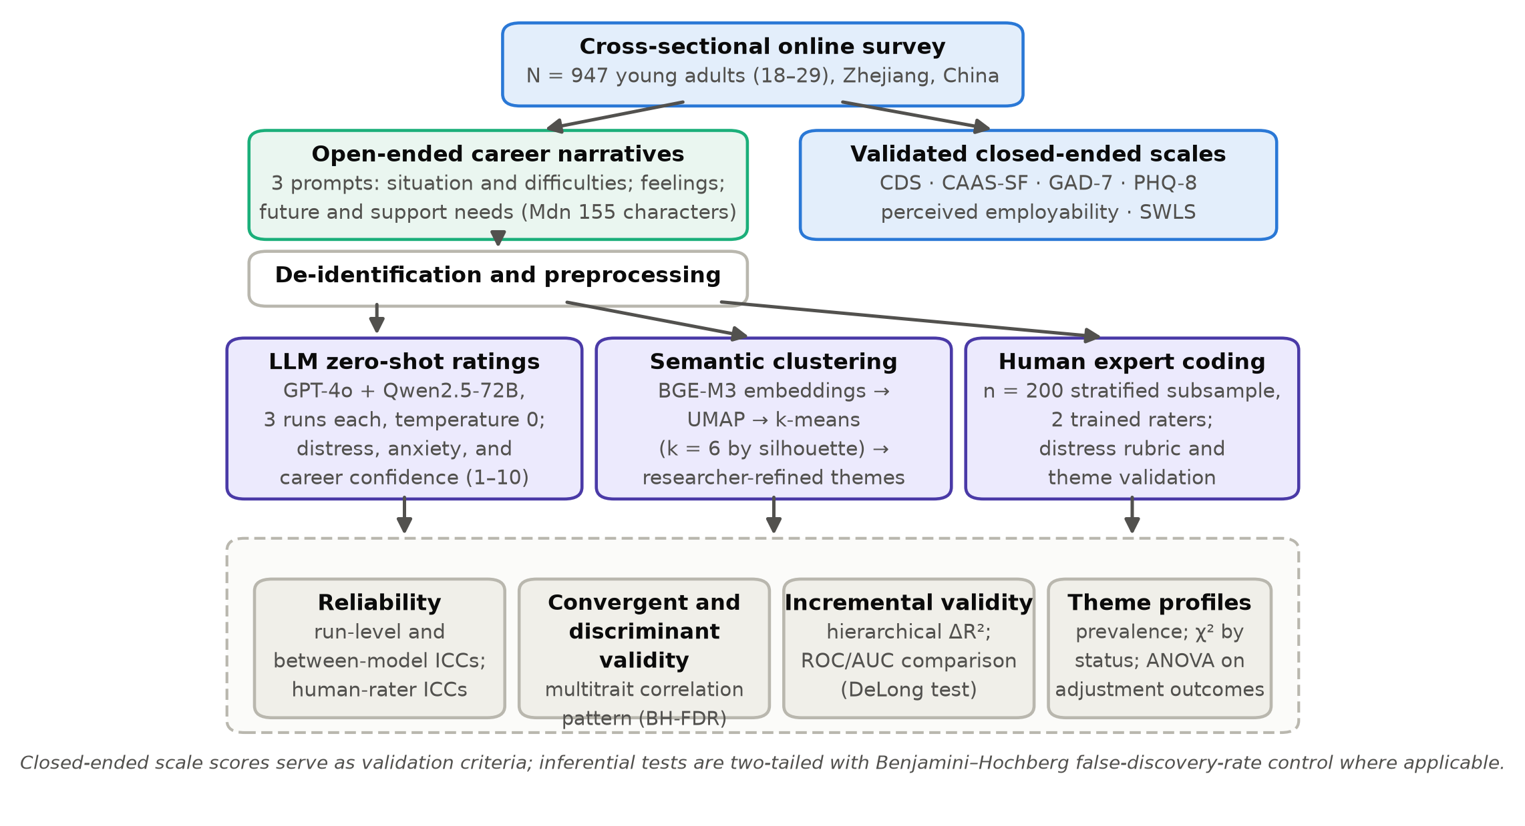
Figure 1. Study design and analysis pipeline. CDS = Career Distress Scale; CAAS-SF = Career Adapt-Abilities Scale–Short Form; GAD-7 = Generalized Anxiety Disorder scale; PHQ-8 = Patient Health Questionnaire; SWLS = Satisfaction With Life Scale; ICC = intraclass correlation coefficient; AUC = area under the receiver-operating-characteristic curve.

3. Results

3.1. Descriptive Statistics and Group Differences
Tables 1 and 2 present sample characteristics and measure descriptives. Symptom levels were consistent with a community sample under labor-market strain: mean GAD-7 was 6.66 (SD = 4.95) and mean PHQ-8 was 6.93 (SD = 5.31), with 266 participants (28.1%) at or above the PHQ-8 screening threshold of 10. Career distress differed strongly across employment situations (F(4, 942) = 21.45, p < .001, η² = .083): standard employees reported the lowest CDS scores (M = 25.9), while unemployed job seekers (M = 31.9) and other non-employed youth (M = 33.0) reported the highest, with precarious workers and exam preparers in between—a gradient consistent with meta-analytic evidence on unemployment and mental health (Gariépy et al., 2022; Paul & Moser, 2009).
Table 1. Sample characteristics (N = 947).
Characteristic | Category | n | %
Gender | Female | 492 | 52.0
 | Male | 455 | 48.0
Age (years) | M = 23.9, SD = 2.8, range 18–29
Education | High school or below | 77 | 8.1
 | Vocational college | 245 | 25.9
 | Bachelor's degree | 529 | 55.9
 | Master's degree or above | 96 | 10.1
Household registration | Rural hukou | 394 | 41.6
First-generation college | Yes (among post-secondary) | 585 | 61.8
Employment status | Employed (standard contract) | 399 | 42.1
 | Precarious/platform work | 174 | 18.4
 | Unemployed, actively job-seeking | 194 | 20.5
 | Preparing for further exams | 104 | 11.0
 | Other non-employed (NEET) | 76 | 8.0
Table 2. Descriptive statistics and internal consistency of study measures.
Measure | Items | Possible Range | M | SD | α | ω
Career distress (CDS) | 9 | 9–54 | 28.97 | 9.64 | .89 | .89
Career adaptability (CAAS-SF) | 12 | 12–60 | 41.43 | 8.63 | .88 | .88
Anxiety (GAD-7) | 7 | 0–21 | 6.66 | 4.95 | .85 | .85
Depressive symptoms (PHQ-8) | 8 | 0–24 | 6.93 | 5.31 | .84 | .84
Perceived employability | 10 | 10–50 | 31.68 | 7.23 | .86 | .86
Life satisfaction (SWLS) | 5 | 5–35 | 20.48 | 6.32 | .85 | .86
LLM career distress (composite) | — | 1–10 | 5.33 | 1.67 | — | —
LLM employment anxiety (composite) | — | 1–10 | 5.33 | 1.68 | — | —
LLM career confidence (composite) | — | 1–10 | 5.37 | 1.69 | — | —
CDS = Career Distress Scale; CAAS-SF = Career Adapt-Abilities Scale–Short Form; GAD-7 = Generalized Anxiety Disorder scale; PHQ-8 = Patient Health Questionnaire; SWLS = Satisfaction With Life Scale. LLM composites average two models × three runs on a 1–10 rubric. α = Cronbach’s alpha; ω = McDonald’s omega.

3.2. Reliability of LLM Narrative Ratings (H1)
Table 3 summarizes reliability. Repeated runs of the same model were nearly interchangeable (ICC(2,3) = .969–.971 across the three dimensions and both models), and the two architecturally independent models converged substantially on all three dimensions (r = .77–.80). In the human-coded subsample (n = 200), the two expert raters agreed at ICC(2,2) = .71 (single-rater ICC(2,1) = .55), and the pooled LLM distress composite correlated r = .80 with the pooled human rating—that is, the six-rating LLM ensemble agreed with the human panel at least as strongly as the human raters agreed with each other, mirroring reports that LLM annotation can exceed the consistency of individual human coders (Gilardi et al., 2023; Rathje et al., 2024). H1 was supported.
Table 3. Reliability of LLM narrative ratings across runs and models.
Consistency Index | Career Distress | Employment Anxiety | Career Confidence
Across runs, GPT-4o, ICC(2,3) | .971 | .971 | .971
Across runs, Qwen2.5-72B, ICC(2,3) | .969 | .971 | .971
Between models, r | .797 | .770 | .776
Between models, ICC(2,1) | .774 | .751 | .753
ICC = two-way random-effects intraclass correlation, absolute agreement. Human coding (n = 200): inter-rater ICC(2,2) = .71; human–LLM composite agreement r = .80. All coefficients p < .001.

3.3. Convergent and Discriminant Validity (H2)
Table 4 reports the full correlation matrix; Figure 2 will be discussed in Section 3.4, and the multitrait pattern is visualized in Figure 3. Each LLM dimension correlated most strongly with its matching criterion: LLM distress with the CDS (r = .52; disattenuated for unreliability, .59), LLM anxiety with the GAD-7 (r = .45), and LLM career confidence with career adaptability and perceived employability (r = .37 and .34). Matching (monotrait) correlations averaged .44 versus .27 for non-matching (heterotrait) pairs, and the differences held for every dimension, supporting H2. The magnitudes align with zero-shot LLM validity coefficients reported for other constructs and languages (Kjell et al., 2024; Rathje et al., 2024). Narrative length correlated only weakly with LLM distress (r = .12), indicating that the ratings did not simply reward verbosity; 43 of the 45 correlations remained significant under false-discovery-rate control.
Table 4. Pearson correlations among self-report scales, LLM narrative ratings, and narrative length.
Variable | 1 | 2 | 3 | 4 | 5 | 6 | 7 | 8 | 9
1. Career distress (CDS)
2. Career adaptability (CAAS-SF) | −.37***
3. Anxiety (GAD-7) | .46*** | −.25***
4. Depressive symptoms (PHQ-8) | .45*** | −.25*** | .49***
5. Perceived employability | −.42*** | .41*** | −.27*** | −.34***
6. Life satisfaction (SWLS) | −.45*** | .30*** | −.33*** | −.45*** | .38***
7. LLM distress | .52*** | −.24*** | .33*** | .41*** | −.29*** | −.37***
8. LLM anxiety | .28*** | −.19*** | .45*** | .35*** | −.20*** | −.25*** | .32***
9. LLM career confidence | −.27*** | .37*** | −.17*** | −.23*** | .34*** | .24*** | −.26*** | −.21***
10. Narrative length (log) | .20*** | −.04 | .10** | .11*** | −.09** | −.11*** | .12*** | .03 | −.08**
N = 947. Variable numbers follow the first column. FDR-adjusted significance: * q < .05, ** q < .01, *** q < .001.
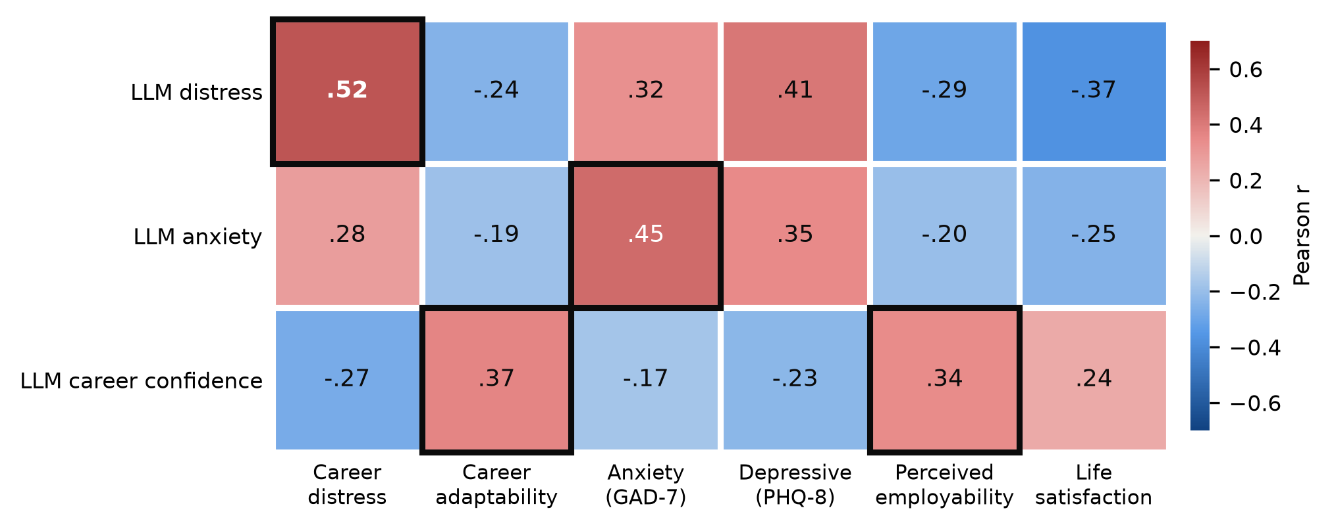
Figure 3. Convergent–discriminant pattern: Pearson correlations of the three LLM narrative dimensions (rows) with the six self-report measures (columns). Monotrait pairs lie on the highlighted diagonal blocks (LLM distress–CDS, LLM anxiety–GAD-7, LLM confidence–adaptability/employability).

3.4. The Thematic Structure of Narrated Career Difficulty
K-means solutions on the reduced embedding space favored six clusters (mean silhouette: k = 2: .420, k = 3: .450, k = 4: .436, k = 5: .443, k = 6: .462, k = 7: .420, k = 8: .419); after researcher review and boundary reassignment (9.1% of cases), the final six-theme solution retained a mean silhouette of .412. Figure 2 maps the narratives; Table 5 describes the themes with translated excerpts. Independent human assignment in the coded subsample agreed with the automated themes in 79.5% of cases (Cohen’s κ = .75). Theme membership was far from random with respect to objective situation (χ²(20) = 331.7, p < .001): 53.8% of exam preparers narrated competitive pressure (T1); 42.0% of precarious workers narrated instability (T3); half of other non-employed youth (50.0%) narrated meaning and motivational struggles (T5); T4 (family and place constraints) was predominantly rural-hukou (73.3% vs. 41.6% overall); and T6 (guidance gaps) was overwhelmingly first-generation (84.4% vs. 61.8% overall)—patterns consistent with the psychology-of-working emphasis on structural constraint (Duffy et al., 2016).
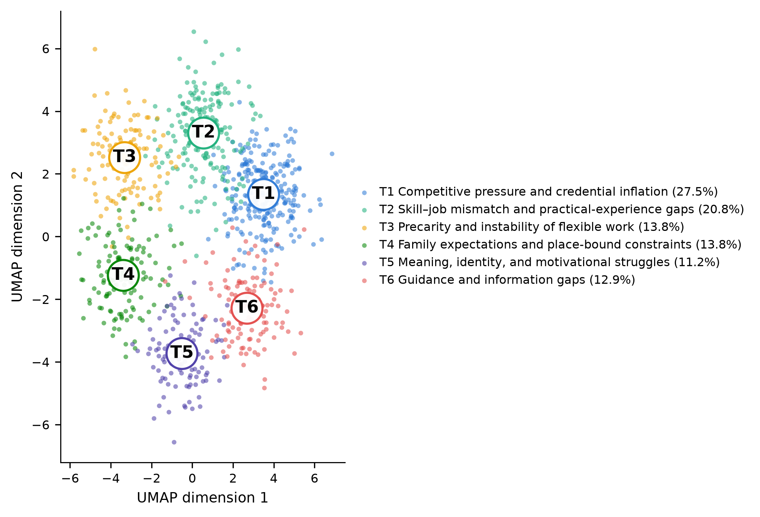
Figure 2. Semantic map of 947 career-difficulty narratives (UMAP projection of BGE-M3 embeddings). Points are participants, colored by final theme; circled labels mark theme centroids; percentages give theme prevalence.
Table 5. Six themes of narrated career difficulty.
Theme | Core Content | n (%) | Illustrative Excerpt (Translated)
T1. Competitive pressure and credential inflation | Escalating competition for degrees, exams, and positions; feeling that effort no longer differentiates | 260 (27.5%) | “Everyone around me is taking the postgraduate or civil-service exams. However hard I try, the bar keeps rising.”
T2. Skill–job mismatch and practical-experience gaps | Perceived gap between education and job requirements; lack of practical experience; fear of skill obsolescence | 197 (20.8%) | “My major taught me theory, but every position asks for two years of hands-on experience I never had a chance to get.”
T3. Precarity and instability of flexible work | Unstable platform, gig, or short-contract work; income volatility; missing social insurance | 131 (13.8%) | “Delivery and livestream jobs pay by the day. I cannot see where I will be in six months, let alone pay into insurance.”
T4. Family expectations and place-bound constraints | Parental expectations, pressure to return to the home county, and hukou or housing constraints tying choices to place | 131 (13.8%) | “My parents want me back in the county for a ‘stable’ job. Staying in Hangzhou means disappointing them and paying rent I cannot afford.”
T5. Meaning, identity, and motivational struggles | Exhaustion of meaning and motivation after repeated rejection; withdrawal from active search | 106 (11.2%) | “I have sent out more than a hundred résumés. Lately I just do not see the point of getting up in the morning.”
T6. Guidance and information gaps | Not knowing how to search, prepare, or network; absent career guidance; information asymmetry | 122 (12.9%) | “Nobody in my family has ever job-hunted with a résumé. I do not even know whom to ask about interviews.”
Excerpts are English translations of Chinese narratives, lightly edited and de-identified; each is a prototypical composite drawn from the 20 narratives closest to the theme centroid.

3.5. Theme Profiles in Psychological Adjustment (H4)
Themes differed reliably on every adjustment indicator (Table 6; Figure 5). The gradient was steepest for career distress (F(5, 941) = 15.82, p < .001, η² = .078): participants whose narratives centered on meaning and motivational struggles (T5) averaged 36.1 on the CDS—about three-quarters of a standard deviation above the sample mean—alongside the highest anxiety (M = 8.2), the highest depressive symptoms (M = 9.2), and the lowest life satisfaction (M = 17.1). Competitive-pressure narratives (T1) showed the second-highest anxiety (M = 7.9), whereas family/place narratives (T4) showed the most favorable profile (CDS M = 26.3; SWLS M = 21.9), suggesting that externally anchored difficulties are less corrosive than internally anchored ones. H4 was supported: what young people write about is informative over and above how distressed they sound.
Table 6. Psychological adjustment by narrative theme: means (standard deviations) and one-way ANOVAs.
Theme | n | Career Distress (CDS) | Anxiety (GAD‑7) | Depressive Symptoms (PHQ‑8) | Life Satisfaction (SWLS)
T1. Competitive pressure and credential inflation | 260 | 28.9 (8.9) | 7.9 (5.1) | 7.4 (5.7) | 20.8 (6.4)
T2. Skill–job mismatch and practical-experience gaps | 197 | 28.6 (9.5) | 6.3 (4.7) | 6.6 (5.3) | 20.7 (6.4)
T3. Precarity and instability of flexible work | 131 | 27.8 (10.0) | 5.4 (4.3) | 6.1 (4.4) | 20.6 (6.1)
T4. Family expectations and place-bound constraints | 131 | 26.3 (9.4) | 5.3 (4.8) | 6.0 (5.0) | 21.9 (6.1)
T5. Meaning, identity, and motivational struggles | 106 | 36.1 (8.2) | 8.2 (5.0) | 9.2 (5.6) | 17.1 (5.7)
T6. Guidance and information gaps | 122 | 27.7 (9.7) | 6.2 (4.9) | 6.3 (4.9) | 20.8 (6.1)
F(5, 941) |  | 15.82*** | 9.63*** | 6.44*** | 8.04***
η² |  | .078 | .049 | .033 | .041
*** p < .001. η² = proportion of variance explained by theme membership.
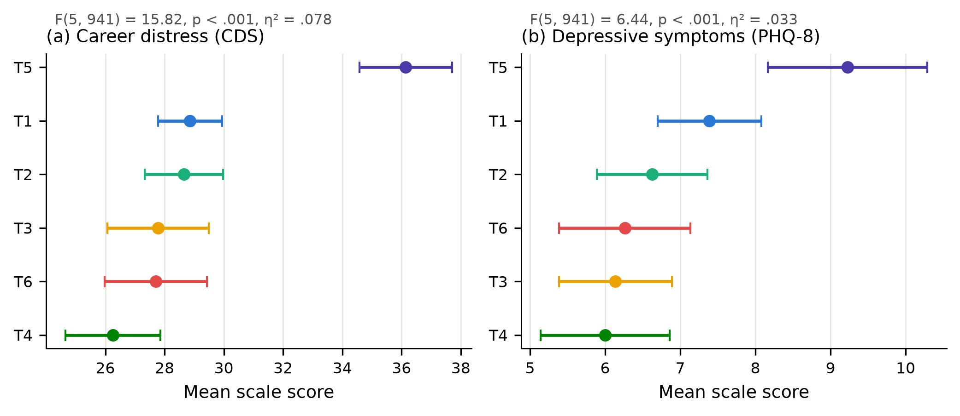
Figure 5. Theme profiles for (a) career distress and (b) depressive symptoms: theme means with 95% confidence intervals, ordered by mean level within each panel. Colors match Figure 2.

3.6. Incremental Validity of LLM Narrative Scores (H3)
Hierarchical regressions (Table 7) tested whether a single LLM-derived narrative distress score adds information beyond demographics, employment status, narrative length, and four validated questionnaires. For depressive symptoms, adding the LLM score in Step 3 increased explained variance from .332 to .356 (ΔR² = .024, F(1, 931) = 35.18, p < .001; β = .185); for life satisfaction, ΔR² = .013 (F(1, 931) = 18.03, p < .001; β = −.138). Table 8 shows that the LLM score outpredicted the CDS itself in the depressive-symptoms model and retained a coefficient of comparable magnitude for life satisfaction, implying that narratives carry adjustment-relevant signal that the matching questionnaire does not fully absorb—consistent with findings that language-based measures capture variance beyond rating scales (Eichstaedt et al., 2018; Kjell et al., 2022).
Table 7. Hierarchical regressions predicting depressive symptoms (PHQ-8) and life satisfaction (SWLS).
Step (Predictors Added) | R² | ΔR² | ΔF (df) | R² | ΔR² | ΔF (df)
1. Demographics + status + length | .070 | — | — | .100 | — | —
2. + CDS, CAAS‑SF, employability, GAD‑7 | .332 | .261 | 91.04 (4, 932)*** | .293 | .192 | 63.42 (4, 932)***
3. + LLM narrative distress | .356 | .024 | 35.18 (1, 931)*** | .306 | .013 | 18.03 (1, 931)***
Left panel: PHQ-8; right panel: SWLS (both standardized). Step 1 covariates: gender, age, education, employment status, log narrative length. *** p < .001.
Table 8. Focal standardized coefficients in the final (Step 3) models.
Predictor (Step 3 Model) | β | SE | t | p | β | SE | t | p
Career distress (CDS) | .117 | .036 | 3.26 | .001 | −.169 | .037 | −4.52 | <.001
Career adaptability (CAAS-SF) | −.019 | .030 | −0.62 | .534 | .102 | .031 | 3.28 | .001
Perceived employability | −.127 | .031 | −4.08 | <.001 | .174 | .032 | 5.40 | <.001
Anxiety (GAD-7) | .324 | .030 | 10.74 | <.001 | −.099 | .031 | −3.16 | .002
LLM narrative distress | .185 | .031 | 5.93 | <.001 | −.138 | .032 | −4.25 | <.001
Demographic and status covariates included but omitted from the table. β = standardized coefficient; SE = standard error; df = 931.
Classification results converged (Figure 4). A logistic model with demographics and all closed-ended scales identified elevated depressive symptoms with AUC = .754 (95% CI [.720, .788]); adding the two LLM narrative scores raised AUC to .777 [.745, .810] (ΔAUC = .023; DeLong z = 3.10, p = .002). Five-fold cross-validation showed the same increment out of sample (AUC .731 vs. .747), indicating the gain is not an overfitting artifact. H3 was supported.
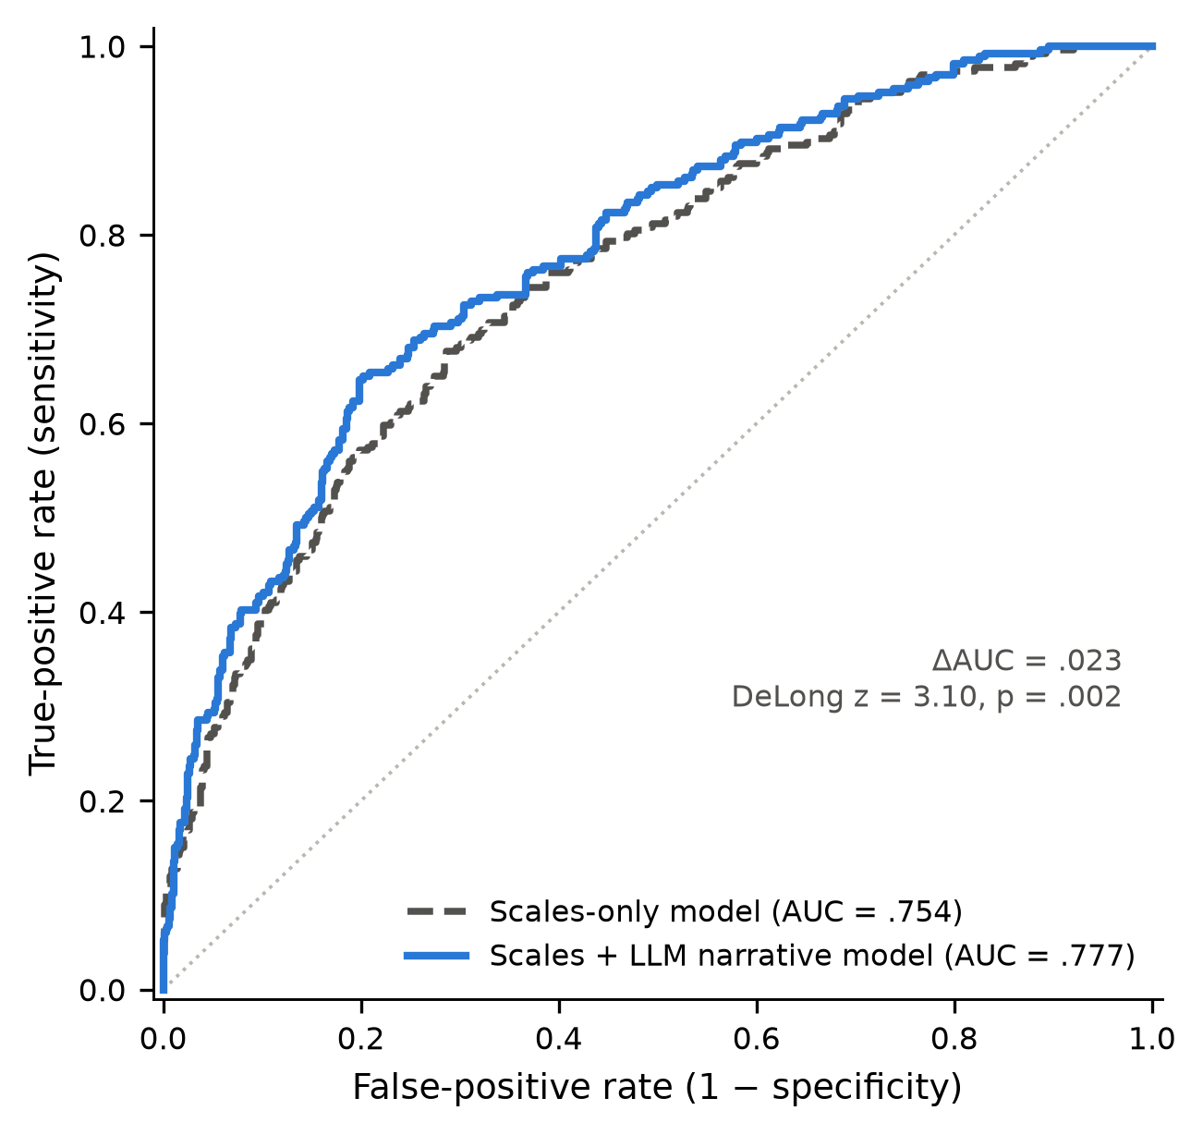
Figure 4. Receiver-operating-characteristic curves for identifying elevated depressive symptoms (PHQ-8 ≥ 10) from questionnaires only versus questionnaires plus LLM narrative scores.

4. Discussion

4.1. Principal Findings
This study asked whether large language models can turn young adults’ own words about their careers into psychologically meaningful numbers. Four answers emerged. First, zero-shot LLM ratings of career distress, employment anxiety, and career confidence behaved like reliable measurements: virtually deterministic across repeated runs, convergent across two independent architectures, and in agreement with a human expert panel at the level the human raters achieved with each other. Second, the ratings displayed the convergent–discriminant structure that psychometric theory demands, correlating most with their matching constructs and distinctly less with non-matching ones. Third, narratives contained incremental signal: a single LLM distress score improved the prediction of depressive symptoms and life satisfaction beyond six validated questionnaires and measurably sharpened the identification of young people with elevated depressive symptoms. Fourth, the semantic structure of narrated difficulty was interpretable and socially patterned, resolving into six themes—from competitive escalation to meaning loss—whose members differed in adjustment and in structural position.

4.2. LLMs as Psychometric Instruments
The convergent validities observed here (r ≈ 0.34–0.52; disattenuated up to 0.59) sit squarely in the range reported when zero-shot GPT ratings are benchmarked against dictionary-based and fine-tuned pipelines across 15 datasets and multiple languages (Rathje et al., 2024), and approach the levels achieved by trained transformer models on well-being scales (Kjell et al., 2022). Two features of the present design strengthen the measurement claim. The dual-model strategy—one proprietary, one open-weight and locally deployable—shows that the construct signal is not an artifact of a single vendor’s training pipeline, echoing calls for reproducibility safeguards in LLM-based research (Abdurahman et al., 2024; Demszky et al., 2023). And the ensemble logic of Equation (1) explains an apparent paradox in the reliability results: averaging six machine ratings suppresses unsystematic error, so the composite can agree with a two-rater human panel more strongly than two humans agree with each other, exactly as classical test theory predicts and as crowd-annotation comparisons have found (Gilardi et al., 2023). In sensitivity terms, the incremental contribution was modest in variance metrics (ΔR² ≈ 0.01–0.02) yet diagnostic at the decision margin (ΔAUC ≈ 0.02 replicated out of sample)—a profile typical of useful auxiliary indicators rather than replacement instruments.

4.3. What Young Adults Narrate: Themes and Theory
The thematic map gives empirical shape to constructs that career theory has long emphasized. That narratives—not just symptom levels—differentiate adjustment supports the career construction claim that vocational identity lives in stories (Savickas, 2013): participants narrating meaning loss and motivational withdrawal (T5) were markedly worse off than those narrating equally objective but externally anchored obstacles such as family and place constraints (T4), even though both groups face real structural pressure. The social patterning of themes—rural-hukou youth over-represented in place-bound narratives, first-generation youth in guidance-gap narratives—operationalizes the psychology-of-working insight that constraint and marginalization shape career experience (Duffy et al., 2016). The prominence of competitive-pressure narratives among exam preparers resonates with accounts of involution and delayed labor-market entry among Chinese youth (Ou & Zhao, 2022; L. Zhang et al., 2025; W. Zhang et al., 2025), and the precarity theme tracks the platform-work realities documented in China’s digital economy (Xiong & Yu, 2024). Notably, guidance-gap narratives (T6) describe a remediable deficit: unlike credential competition, information asymmetry is exactly what career services can address (Wanberg et al., 2020).

4.4. Practical Implications
For youth career services operating at scale—university career centers, public employment services, online guidance platforms—the findings sketch a concrete augmentation pathway. Open-ended intake questions are already common; language-based scoring can convert them into (a) a triage signal that flags clients whose narratives indicate elevated distress for priority human follow-up, (b) a thematic router that matches the type of narrated difficulty to the type of support (e.g., skill-gap clients to training and internship pipelines, T6 clients to structured guidance and mentoring, T5 clients to counseling rather than yet more job listings), and (c) an aggregate dashboard tracking how the composition of youth career difficulty shifts with policy and labor-market conditions—a form of population-level digital phenotyping (Insel, 2017). Locally deployable open-weight models make this feasible under strict data-sovereignty requirements (Qwen Team, 2024). Two guardrails follow directly from the results: scores are screening aids below diagnostic thresholds, and every consequential decision requires human review, since even well-calibrated ratings misorder individual cases (Abdurahman et al., 2024; Kjell et al., 2024). For AI-assisted career interventions themselves, evidence is emerging but still preliminary—scoping reviews find mostly small, heterogeneous studies (Pandya & Wang, 2024), though early experiments suggest that tools such as ChatGPT can bolster students’ employment confidence and career readiness (Xiao & Zheng, 2025)—reinforcing the complement-not-replace framing.

4.5. Ethical Considerations
Language is more identifying than a Likert response, and career narratives can reveal employers, families, and health information. The protocol here—explicit consent for AI processing, removal of identifiers before any model call, a zero-retention agreement for the proprietary model, and local deployment of the open-weight alternative—illustrates a practicable floor, not a ceiling (Abdurahman et al., 2024). Fairness auditing is a further obligation: rating models may encode dialectal, gender, or class biases in how they read distress, and the present design cannot fully rule out differential validity across subgroups. Finally, deploying distress scoring creates a duty of care—flagged individuals must be routed to qualified support, echoing escalation standards in digital mental-health research (Demszky et al., 2023).

4.6. Limitations and Future Directions
Several limitations bound the conclusions. First, the design is cross-sectional; the adjustment differences across themes and the incremental prediction of symptoms are associations, not causal effects, and reverse influence (distress shaping both narration and symptom reports) is plausible. Second, the sample, while heterogeneous and quota-guided, is a non-probability online sample from a single, economically advanced province; generalization to other regions and to youth without internet access requires caution. Third, narratives were short (median 155 characters); richer prompts or interview transcripts might raise—or complicate—validity. Fourth, common-method variance operates on the text side: LLM distress and human coding read the same words, so their agreement partly reflects shared surface cues; the questionnaire criteria mitigate but do not eliminate this. Fifth, only two models and one language were tested, and model updates may drift; versioned prompts and periodic revalidation are essential (Demszky et al., 2023; Ziems et al., 2024). Sixth, the PHQ-8 threshold is a screening convention, not a clinical diagnosis (Kroenke et al., 2009). Future work should follow narrators longitudinally across the school-to-work passage (van Hooft et al., 2021), test fairness across dialects and demographic groups, benchmark newer and smaller models against the present zero-shot baseline, and embed narrative scoring in randomized evaluations of career services so that measurement gains can be traced to counseling outcomes (Bankins et al., 2024).

5. Conclusions
Treating large language models as measurement instruments—and auditing them accordingly—this study showed that the words Chinese young adults use about their careers can be converted into reliable, construct-valid, and incrementally informative assessments of career distress. Narrative-based AI scoring reproduced expert judgment, respected the convergent–discriminant structure of established questionnaires, added predictive signal beyond an entire battery of validated scales, and mapped the difficulty landscape of a generation navigating credential competition, precarious work, place-bound obligations, guidance gaps, and, most consequentially, struggles of meaning and motivation. For the behavioral sciences, the results support a methodological fusion in which open-ended language supplements—rather than supplants—psychometric tradition; for youth employment policy and services, they offer a scalable way to hear, quantify, and act on what young people are actually saying about their working lives.
Supplementary Materials: The analysis code that reproduces all statistics and figures from the de-identified data is available from the corresponding author.
Author Contributions: Conceptualization, X.C.; methodology, X.C. and D.H.; software, D.H.; formal analysis, D.H. and T.M.; investigation, T.M.; data curation, T.M.; writing—original draft preparation, X.C. and D.H.; writing—review and editing, X.C. and T.M.; visualization, D.H.; supervision, X.C.; project administration, X.C.; funding acquisition, X.C. All authors have read and agreed to the published version of the manuscript.
Funding: This research was funded by the Zhejiang Provincial Philosophy and Social Sciences Planning Special Project on Higher Education Basic Research Funding Reform (Grant Number: 25NDJC153YBMS) and the Major Humanities and Social Sciences Research Projects in Zhejiang Higher Education Institutions (Grant Number: 2024QN018).
Institutional Review Board Statement: The study was conducted in accordance with the Declaration of Helsinki and approved by the Academic Ethics Committee of the College of Business, Jiaxing University (protocol code JXU-COB-2025-014; approved 16 October 2025).
Informed Consent Statement: Informed consent was obtained from all subjects involved in the study, including explicit consent for de-identified narrative text to be processed by AI systems for research purposes.
Data Availability Statement: De-identified quantitative data and analysis code are available from the corresponding author upon reasonable request. Raw narrative texts are not publicly shared to protect participant privacy.
Conflicts of Interest: The authors declare no conflicts of interest. The funders had no role in the design of the study; in the collection, analyses, or interpretation of data; in the writing of the manuscript; or in the decision to publish the results.

Appendix A

Appendix A.1. Open-Ended Narrative Prompts (Translated from Chinese)
Prompt 1. “Please describe your current employment or career situation and the biggest difficulties you are facing. There are no right or wrong answers—please write whatever feels true to your experience (at least 10 characters).”
Prompt 2. “How do you feel when you think about job seeking and your career future? Please describe your feelings and thoughts in your own words.”
Prompt 3. “Where would you like your career to be in three years, and what support or help would make the biggest difference in getting there?”

Appendix A.2. LLM Rating Instruction (Translated from Chinese)
“You are an experienced career-psychology rater. Below are three anonymous written answers from one young adult describing their employment situation, feelings about their career future, and support needs. Read all three answers together and rate the writer on the following dimensions, using integers from 1 (extremely low) to 10 (extremely high): (1) career distress—negative affect about their career situation and prospects; (2) employment anxiety—worry, nervousness, or dread connected to job seeking and work; (3) career confidence—confidence in their own resources and prospects for career development. Output strictly as JSON in the format {"distress": x, "anxiety": x, "confidence": x} with no additional text. Base your ratings only on the text provided.”
Three semantically equivalent Chinese variants of this instruction (identical rubric, re-ordered sentences and synonyms) defined the three scoring runs per model. Temperature was 0 for all calls; outputs failing JSON validation (0.4% of calls) were re-requested once.

References
Abdurahman, S., Atari, M., Karimi-Malekabadi, F., Xue, M. J., Trager, J., Park, P. S., Golazizian, P., Omrani, A., & Dehghani, M. (2024). Perils and opportunities in using large language models in psychological research. PNAS Nexus, 3(7), pgae245. https://doi.org/10.1093/pnasnexus/pgae245
Bankins, S., Jooss, S., Restubog, S. L. D., Marrone, M., Ocampo, A. C., & Shoss, M. (2024). Navigating career stages in the age of artificial intelligence: A systematic interdisciplinary review and agenda for future research. Journal of Vocational Behavior, 153, 104011. https://doi.org/10.1016/j.jvb.2024.104011
Benjamini, Y., & Hochberg, Y. (1995). Controlling the false discovery rate: A practical and powerful approach to multiple testing. Journal of the Royal Statistical Society: Series B (Methodological), 57(1), 289–300. https://doi.org/10.1111/j.2517-6161.1995.tb02031.x
Boyd, R. L., & Schwartz, H. A. (2021). Natural language analysis and the psychology of verbal behavior: The past, present, and future states of the field. Journal of Language and Social Psychology, 40(1), 21–41. https://doi.org/10.1177/0261927X20967028
Brynjolfsson, E., Li, D., & Raymond, L. (2025). Generative AI at work. The Quarterly Journal of Economics, 140(2), 889–942. https://doi.org/10.1093/qje/qjae044
Chen, J., Xiao, S., Zhang, P., Luo, K., Lian, D., & Liu, Z. (2024). M3-Embedding: Multi-linguality, multi-functionality, multi-granularity text embeddings through self-knowledge distillation. In Findings of the Association for Computational Linguistics: ACL 2024 (pp. 2318–2335). Association for Computational Linguistics.
Cohen, J. (1960). A coefficient of agreement for nominal scales. Educational and Psychological Measurement, 20(1), 37–46. https://doi.org/10.1177/001316446002000104
Creed, P. A., Hood, M., Praskova, A., & Makransky, G. (2016). The Career Distress Scale: Using Rasch measurement theory to evaluate a brief measure of career distress. Journal of Career Assessment, 24(4), 732–746. https://doi.org/10.1177/1069072715616126
DeLong, E. R., DeLong, D. M., & Clarke-Pearson, D. L. (1988). Comparing the areas under two or more correlated receiver operating characteristic curves: A nonparametric approach. Biometrics, 44(3), 837–845. https://doi.org/10.2307/2531595
Demszky, D., Yang, D., Yeager, D. S., Bryan, C. J., Clapper, M., Chandhok, S., Eichstaedt, J. C., Hecht, C., Jamieson, J., Johnson, M., Jones, M., Krettek-Cobb, D., Lai, L., JonesMitchell, N., Ong, D. C., Dweck, C. S., Gross, J. J., & Pennebaker, J. W. (2023). Using large language models in psychology. Nature Reviews Psychology, 2(11), 688–701. https://doi.org/10.1038/s44159-023-00241-5
Diener, E., Emmons, R. A., Larsen, R. J., & Griffin, S. (1985). The Satisfaction With Life Scale. Journal of Personality Assessment, 49(1), 71–75. https://doi.org/10.1207/s15327752jpa4901_13
Duffy, R. D., Blustein, D. L., Diemer, M. A., & Autin, K. L. (2016). The psychology of working theory. Journal of Counseling Psychology, 63(2), 127–148. https://doi.org/10.1037/cou0000140
Eichstaedt, J. C., Smith, R. J., Merchant, R. M., Ungar, L. H., Crutchley, P., Preoţiuc-Pietro, D., Asch, D. A., & Schwartz, H. A. (2018). Facebook language predicts depression in medical records. Proceedings of the National Academy of Sciences, 115(44), 11203–11208. https://doi.org/10.1073/pnas.1802331115
Eloundou, T., Manning, S., Mishkin, P., & Rock, D. (2024). GPTs are GPTs: Labor market impact potential of LLMs. Science, 384(6702), 1306–1308. https://doi.org/10.1126/science.adj0998
Elyoseph, Z., Hadar-Shoval, D., Asraf, K., & Lvovsky, M. (2023). ChatGPT outperforms humans in emotional awareness evaluations. Frontiers in Psychology, 14, 1199058. https://doi.org/10.3389/fpsyg.2023.1199058
Gariépy, G., Danna, S. M., Hawke, L., Henderson, J., & Iyer, S. N. (2022). The mental health of young people who are not in education, employment, or training: A systematic review and meta-analysis. Social Psychiatry and Psychiatric Epidemiology, 57(6), 1107–1121. https://doi.org/10.1007/s00127-021-02212-8
Gilardi, F., Alizadeh, M., & Kubli, M. (2023). ChatGPT outperforms crowd workers for text-annotation tasks. Proceedings of the National Academy of Sciences, 120(30), e2305016120. https://doi.org/10.1073/pnas.2305016120
Grootendorst, M. (2022). BERTopic: Neural topic modeling with a class-based TF-IDF procedure (arXiv:2203.05794). arXiv. https://doi.org/10.48550/arXiv.2203.05794
Hayes, A. F., & Coutts, J. J. (2020). Use omega rather than Cronbach's alpha for estimating reliability. But… Communication Methods and Measures, 14(1), 1–24. https://doi.org/10.1080/19312458.2020.1718629
Hou, Z.-J., Leung, S. A., Li, X., Li, X., & Xu, H. (2012). Career Adapt-Abilities Scale—China Form: Construction and initial validation. Journal of Vocational Behavior, 80(3), 686–691. https://doi.org/10.1016/j.jvb.2012.01.006
Insel, T. R. (2017). Digital phenotyping: Technology for a new science of behavior. JAMA, 318(13), 1215–1216. https://doi.org/10.1001/jama.2017.11295
International Labour Organization. (2024). Global employment trends for youth 2024: Decent work, brighter futures. International Labour Office. https://doi.org/10.54394/QSMU1809
Jones, M. K., Kaya, E., & Nan, J. (2025). Overeducation, earnings and job satisfaction among graduates in China. China Economic Review, 93, 102448. https://doi.org/10.1016/j.chieco.2025.102448
Kjell, O. N. E., Kjell, K., Garcia, D., & Sikström, S. (2019). Semantic measures: Using natural language processing to measure, differentiate, and describe psychological constructs. Psychological Methods, 24(1), 92–115. https://doi.org/10.1037/met0000191
Kjell, O. N. E., Kjell, K., & Schwartz, H. A. (2024). Beyond rating scales: With targeted evaluation, large language models are poised for psychological assessment. Psychiatry Research, 333, 115667. https://doi.org/10.1016/j.psychres.2023.115667
Kjell, O. N. E., Sikström, S., Kjell, K., & Schwartz, H. A. (2022). Natural language analyzed with AI-based transformers predict traditional subjective well-being measures approaching the theoretical upper limits in accuracy. Scientific Reports, 12(1), 3918. https://doi.org/10.1038/s41598-022-07520-w
Koo, T. K., & Li, M. Y. (2016). A guideline of selecting and reporting intraclass correlation coefficients for reliability research. Journal of Chiropractic Medicine, 15(2), 155–163. https://doi.org/10.1016/j.jcm.2016.02.012
Kroenke, K., Strine, T. W., Spitzer, R. L., Williams, J. B. W., Berry, J. T., & Mokdad, A. H. (2009). The PHQ-8 as a measure of current depression in the general population. Journal of Affective Disorders, 114(1–3), 163–173. https://doi.org/10.1016/j.jad.2008.06.026
Maggiori, C., Rossier, J., & Savickas, M. L. (2017). Career Adapt-Abilities Scale–Short Form (CAAS-SF): Construction and validation. Journal of Career Assessment, 25(2), 312–325. https://doi.org/10.1177/1069072714565856
McGorry, P. D., Mei, C., Dalal, N., Alvarez-Jimenez, M., Blakemore, S.-J., Browne, V., Dooley, B., Hickie, I. B., Jones, P. B., McDaid, D., Mihalopoulos, C., Wood, S. J., El Azzouzi, F. A., Fazio, J., Gow, E., Hanjabam, S., Hayes, A., Morris, A., Pang, E., ... Killackey, E. (2024). The Lancet Psychiatry Commission on youth mental health. The Lancet Psychiatry, 11(9), 731–774. https://doi.org/10.1016/S2215-0366(24)00163-9
McInnes, L., Healy, J., & Melville, J. (2018). UMAP: Uniform manifold approximation and projection for dimension reduction (arXiv:1802.03426). arXiv. https://doi.org/10.48550/arXiv.1802.03426
Noy, S., & Zhang, W. (2023). Experimental evidence on the productivity effects of generative artificial intelligence. Science, 381(6654), 187–192. https://doi.org/10.1126/science.adh2586
OpenAI. (2024). GPT-4o system card (arXiv:2410.21276). arXiv. https://doi.org/10.48550/arXiv.2410.21276
Ou, D., & Zhao, Z. (2022). Higher education expansion in China, 1999–2003: Impact on graduate employability. China & World Economy, 30(2), 117–141. https://doi.org/10.1111/cwe.12412
Pandya, S. S., & Wang, J. (2024). Artificial intelligence in career development: A scoping review. Human Resource Development International, 27(3), 324–344. https://doi.org/10.1080/13678868.2024.2336881
Paul, K. I., & Moser, K. (2009). Unemployment impairs mental health: Meta-analyses. Journal of Vocational Behavior, 74(3), 264–282. https://doi.org/10.1016/j.jvb.2009.01.001
Peng, Y., Lv, S. B., Low, S. R., & Bono, S. A. (2024). The impact of employment stress on college students: Psychological well-being during COVID-19 pandemic in China. Current Psychology, 43(20), 18647–18658. https://doi.org/10.1007/s12144-023-04785-w
Peters, H., & Matz, S. C. (2024). Large language models can infer psychological dispositions of social media users. PNAS Nexus, 3(6), pgae231. https://doi.org/10.1093/pnasnexus/pgae231
Qwen Team. (2024). Qwen2.5 technical report (arXiv:2412.15115). arXiv. https://doi.org/10.48550/arXiv.2412.15115
Rahmani, H., Groot, W., & Rahmani, A. M. (2024). Unravelling the NEET phenomenon: A systematic literature review and meta-analysis of risk factors for youth not in education, employment, or training. International Journal of Adolescence and Youth, 29(1), 2331576. https://doi.org/10.1080/02673843.2024.2331576
Rathje, S., Mirea, D.-M., Sucholutsky, I., Marjieh, R., Robertson, C. E., & Van Bavel, J. J. (2024). GPT is an effective tool for multilingual psychological text analysis. Proceedings of the National Academy of Sciences, 121(34), e2308950121. https://doi.org/10.1073/pnas.2308950121
Reimers, N., & Gurevych, I. (2019). Sentence-BERT: Sentence embeddings using Siamese BERT-networks. In Proceedings of the 2019 Conference on Empirical Methods in Natural Language Processing and the 9th International Joint Conference on Natural Language Processing (EMNLP-IJCNLP) (pp. 3982–3992). Association for Computational Linguistics.
Rothwell, A., & Arnold, J. (2007). Self-perceived employability: Development and validation of a scale. Personnel Review, 36(1), 23–41. https://doi.org/10.1108/00483480710716704
Rousseeuw, P. J. (1987). Silhouettes: A graphical aid to the interpretation and validation of cluster analysis. Journal of Computational and Applied Mathematics, 20, 53–65. https://doi.org/10.1016/0377-0427(87)90125-7
Rudolph, C. W., Lavigne, K. N., & Zacher, H. (2017). Career adaptability: A meta-analysis of relationships with measures of adaptivity, adapting responses, and adaptation results. Journal of Vocational Behavior, 98, 17–34. https://doi.org/10.1016/j.jvb.2016.09.002
Savickas, M. L. (2013). Career construction theory and practice. In S. D. Brown & R. W. Lent (Eds.), Career development and counseling: Putting theory and research to work (2nd ed., pp. 147–183). John Wiley & Sons.
Savickas, M. L., & Porfeli, E. J. (2012). Career Adapt-Abilities Scale: Construction, reliability, and measurement equivalence across 13 countries. Journal of Vocational Behavior, 80(3), 661–673. https://doi.org/10.1016/j.jvb.2012.01.011
Shrout, P. E., & Fleiss, J. L. (1979). Intraclass correlations: Uses in assessing rater reliability. Psychological Bulletin, 86(2), 420–428. https://doi.org/10.1037/0033-2909.86.2.420
Sikström, S., & Garcia, D. (Eds.). (2020). Statistical semantics: Methods and applications. Springer.
Spitzer, R. L., Kroenke, K., Williams, J. B. W., & Löwe, B. (2006). A brief measure for assessing generalized anxiety disorder: The GAD-7. Archives of Internal Medicine, 166(10), 1092–1097. https://doi.org/10.1001/archinte.166.10.1092
Tausczik, Y. R., & Pennebaker, J. W. (2010). The psychological meaning of words: LIWC and computerized text analysis methods. Journal of Language and Social Psychology, 29(1), 24–54. https://doi.org/10.1177/0261927X09351676
van Hooft, E. A. J., Kammeyer-Mueller, J. D., Wanberg, C. R., Kanfer, R., & Basbug, G. (2021). Job search and employment success: A quantitative review and future research agenda. Journal of Applied Psychology, 106(5), 674–713. https://doi.org/10.1037/apl0000675
Wanberg, C. R., Ali, A. A., & Csillag, B. (2020). Job seeking: The process and experience of looking for a job. Annual Review of Organizational Psychology and Organizational Behavior, 7, 315–337. https://doi.org/10.1146/annurev-orgpsych-012119-044939
Xiao, Y., & Zheng, L. (2025). Can ChatGPT boost students’ employment confidence? A pioneering booster for career readiness. Behavioral Sciences, 15(3), 362. https://doi.org/10.3390/bs15030362
Xiong, B., & Yu, B. (2024). The impact of Internet development on youth’s job quality in the digital economy era: Transmission mechanism and empirical test. Social Indicators Research, 175(1), 269–294. https://doi.org/10.1007/s11205-024-03439-z
Xu, X., Yao, B., Dong, Y., Gabriel, S., Yu, H., Hendler, J., Ghassemi, M., Dey, A. K., & Wang, D. (2024). Mental-LLM: Leveraging large language models for mental health prediction via online text data. Proceedings of the ACM on Interactive, Mobile, Wearable and Ubiquitous Technologies, 8(1), Article 31. https://doi.org/10.1145/3643540
Zhang, L., Hui, B. P. H., Kong, F., Lu, H., & Chen, S. X. (2025). Why people “lie flat”? An integrative framework of social-psychological pathways in China. Personality and Social Psychology Review, 29(4), 371–382. https://doi.org/10.1177/10888683251358516
Zhang, W., Wang, Y., Liu, X., Guo, C., Lin, Z., Zhou, M., & Mu, Y. (2025). The psychology of involution: Taxonomy, sociocultural predictors, and psychological outcomes. Journal of Happiness Studies, 26(7), Article 127. https://doi.org/10.1007/s10902-025-00954-9
Ziems, C., Held, W., Shaikh, O., Chen, J., Zhang, Z., & Yang, D. (2024). Can large language models transform computational social science? Computational Linguistics, 50(1), 237–291. https://doi.org/10.1162/coli_a_00502
Disclaimer/Publisher’s Note: The statements, opinions and data contained in all publications are solely those of the individual author(s) and contributor(s) and not of MDPI and/or the editor(s). MDPI and/or the editor(s) disclaim responsibility for any injury to people or property resulting from any ideas, methods, instructions or products referred to in the content.

