Article
An Enhanced Multi-Strategy Black-Winged Kite Algorithm for Global Optimization and Customer Segmentation in Marketing Management
Xinyu Cai ^{1,*}
Academic Editor: Firstname Lastname
Received: date
Revised: date
Accepted: date
Published: date
Citation: To be added by editorial staff during production.
Copyright: © 2026 by the authors. Submitted for possible open access publication under the terms and conditions of the Creative Commons Attribution (CC BY) license (https://creativecommons.org/licenses/by/4.0/).
¹ College of Business, Jiaxing University, Jiaxing 314001, China; caixinyu@zjxu.edu.cn
* Correspondence: caixinyu@zjxu.edu.cn
Abstract: Customer segmentation is a fundamental task in marketing management, and its mainstream implementation, centroid-based clustering, is essentially a non-convex optimization problem that is highly sensitive to initial conditions. Metaheuristic algorithms provide an effective way to overcome this difficulty. The black-winged kite algorithm (BKA) is a recently proposed nature-inspired metaheuristic simulating the attacking and migration behaviors of black-winged kites. Although BKA exhibits competitive performance, it still suffers from the uneven random initialization, the self-referential attacking update that lacks information exchange among individuals, and the excessive attraction of the leader that causes premature convergence. To address these issues, this paper proposes an enhanced multi-strategy black-winged kite algorithm (MSBKA) integrating three improvement strategies: a tent chaotic mapping initialization strategy that generates a diverse and uniformly distributed initial population, a fitness-distance balance based companion selection strategy that replaces the purely random companion in the migration phase and coordinates exploitation and exploration, and an adaptive Cauchy-Gaussian hybrid mutation strategy that perturbs the leader with heavy-tailed steps in the early stage and fine Gaussian steps in the later stage. MSBKA was evaluated on the CEC2022 test suite in 10 and 20 dimensions against the basic BKA and eight representative algorithms, and the experimental results were analyzed by the Friedman test and the Wilcoxon rank-sum test. MSBKA obtains markedly better average Friedman rankings than the basic BKA, improving from 6.083 to 3.583 in 10 dimensions and from 6.333 to 4.833 in 20 dimensions, and the ablation experiments confirm the contribution of every strategy. Furthermore, MSBKA was applied to customer segmentation on two real-world business datasets, the mall customers dataset and the wholesale customers dataset. Compared with the classical K-means and K-means++ algorithms as well as nine metaheuristic competitors, MSBKA achieves the lowest mean intra-cluster sum of squared errors on the wholesale customers dataset and a near-optimal, remarkably stable result on the other dataset, and the resulting segments provide clear managerial insights for differentiated marketing strategies.
Keywords: black-winged kite algorithm; metaheuristic algorithm; tent chaotic mapping; fitness-distance balance; Cauchy-Gaussian mutation; customer segmentation; clustering; marketing management

1. Introduction
In the era of digital economy, enterprises accumulate massive customer behavior data, and how to transform these data into actionable marketing knowledge has become a core issue of modern marketing management [1,2]. Customer segmentation, which divides a heterogeneous customer base into relatively homogeneous groups, is a prerequisite for market positioning, precision marketing, and customer relationship management [3]. The most widely used technical route of customer segmentation is centroid-based clustering represented by the K-means algorithm [4,5]. However, minimizing the intra-cluster sum of squared errors is a non-convex NP-hard optimization problem. The classical K-means algorithm is essentially a local search procedure that strongly depends on the initial centroids, so it frequently converges to poor local optima and yields unstable segmentation schemes, even when the improved seeding method K-means++ is adopted [6]. An unstable segmentation directly misleads the formulation of marketing strategies. Therefore, employing global optimization techniques to search the cluster centroids has attracted increasing attention, and metaheuristic algorithms have proven to be one of the most effective tools for this purpose [7,8].
Metaheuristic algorithms are stochastic search techniques inspired by natural evolution, swarm intelligence, physical phenomena, mathematical rules, or human behaviors [9,10]. They do not require gradient information or convexity assumptions, and can achieve a reasonable balance between global exploration and local exploitation through population-based probabilistic operators. According to the source of inspiration, existing metaheuristics can be roughly divided into five categories, as illustrated in Figure 1: evolution-based algorithms such as the genetic algorithm (GA) [11], differential evolution (DE) [12], and the advanced LSHADE [13]; swarm-based algorithms such as particle swarm optimization (PSO) [14], ant colony optimization (ACO) [15], the grey wolf optimizer (GWO) [9], the whale optimization algorithm (WOA) [16], Harris hawks optimization (HHO) [17], the sparrow search algorithm (SSA) [18], the dung beetle optimizer (DBO) [19], and the crayfish optimization algorithm (COA) [20]; physics-based algorithms such as the multi-verse optimizer (MVO) [21], the equilibrium optimizer (EO) [22], and the RIME algorithm [23]; mathematics-based algorithms such as the sine cosine algorithm (SCA) [24] and the arithmetic optimization algorithm (AOA) [25]; and human-based algorithms such as teaching-learning-based optimization (TLBO) [26]. Nevertheless, the no free lunch theorem [10] reveals that no algorithm can be universally optimal for all problems, which continuously drives researchers to design new algorithms and improve existing ones for specific problem classes.
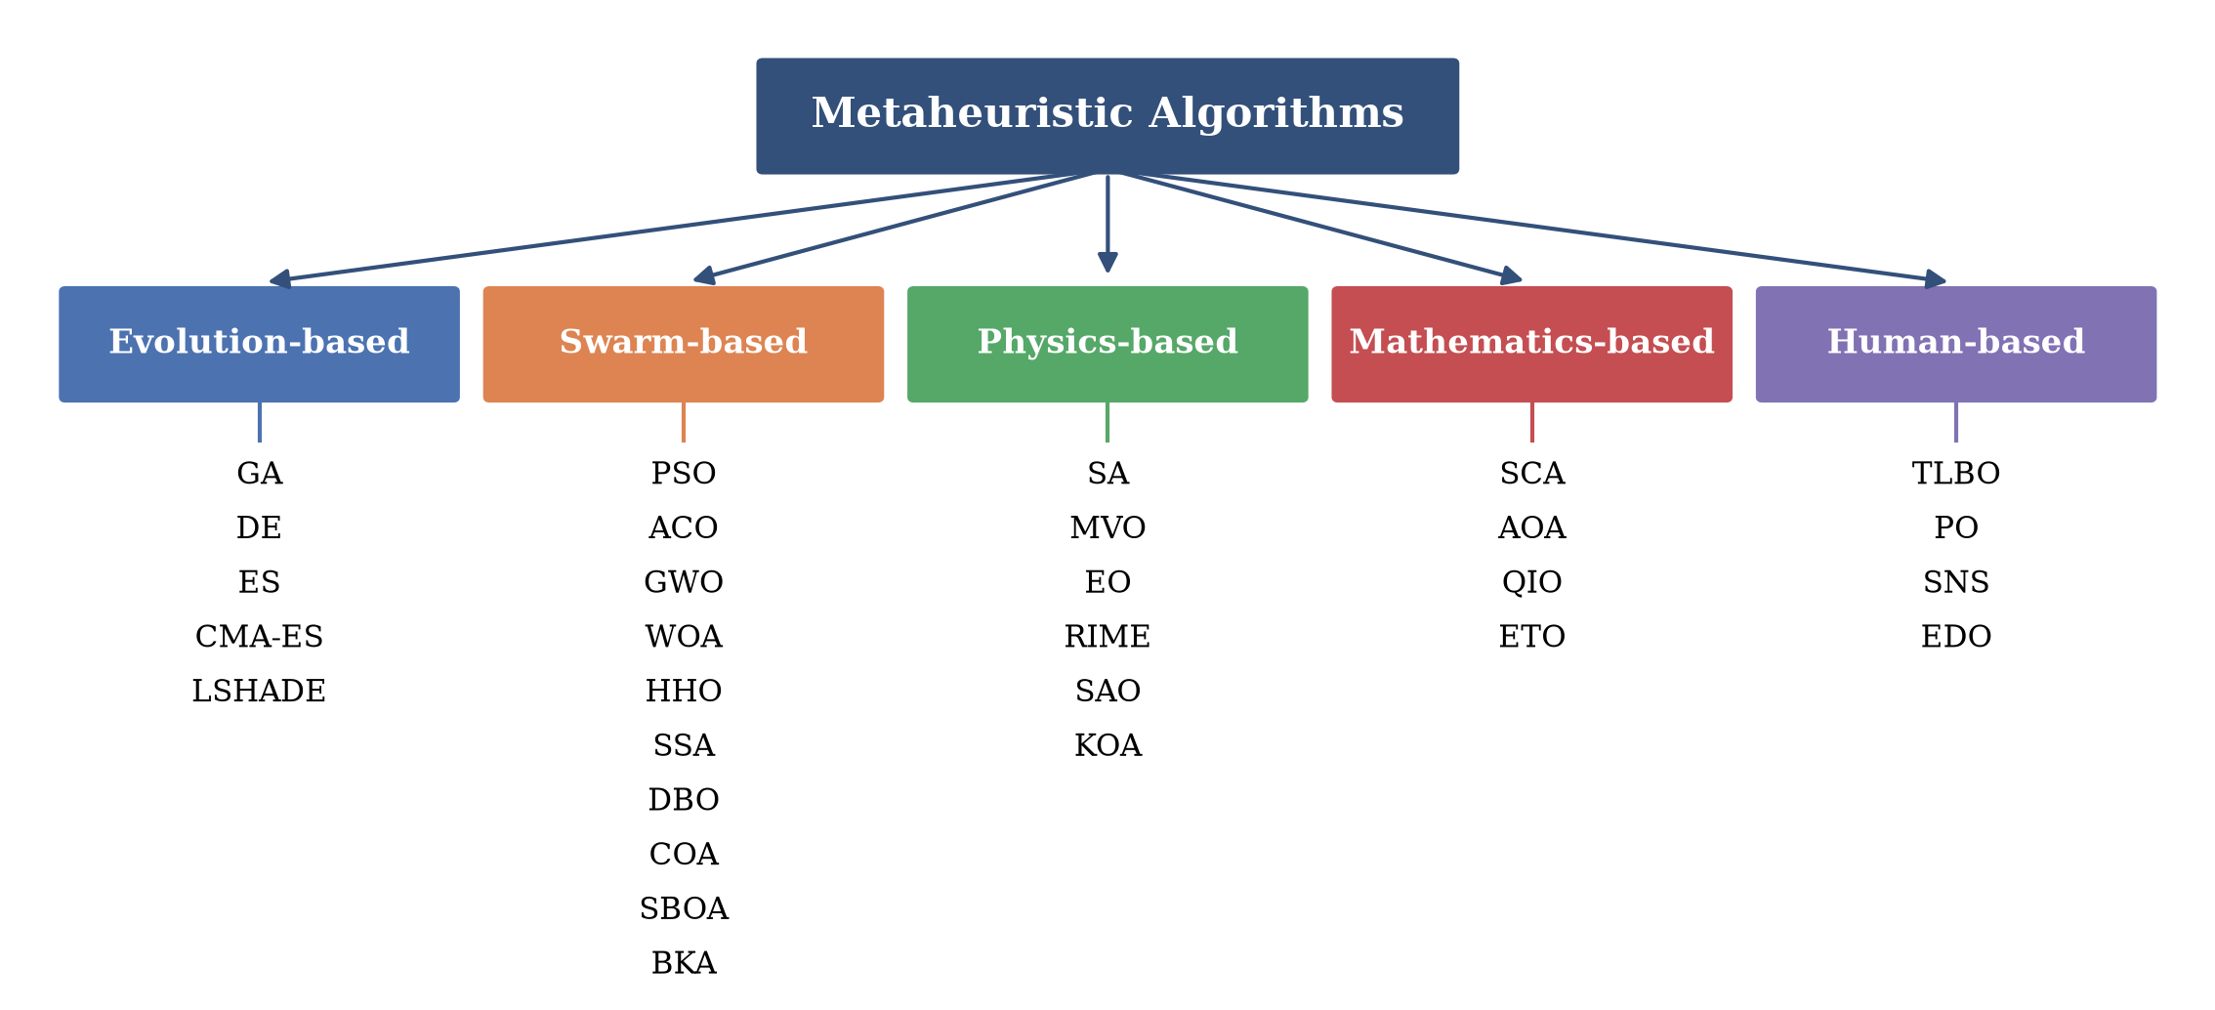
Figure 1. Classification of metaheuristic algorithms.
The black-winged kite algorithm (BKA) is a novel swarm-based metaheuristic proposed by Wang et al. in 2024 [27], which mathematically models the hovering-diving attack behavior and the leader-following migration behavior of black-winged kites. BKA has the advantages of a simple structure, few parameters, and fast convergence, and has been rapidly adopted and improved. For example, Zhang et al. fused BKA with the osprey optimization algorithm for engineering applications [28]; Li et al. enhanced BKA with vertical and horizontal crossover [29]; Mansouri et al. developed a chaotic-map-based modified BKA for real-world global optimization [30]; and BKA has also been used to optimize variational mode decomposition for industrial power load prediction [31] and to size hybrid renewable energy systems [32]. However, a careful analysis of the basic BKA exposes three deficiencies when it faces complex optimization landscapes. First, the initial population is generated by uniform random sampling, whose uneven coverage weakens the diversity at the beginning of the search. Secondly, in the attacking phase, each individual updates its position only by scaling its own coordinates with random factors. This self-referential update carries out no information exchange among individuals, so the global exploration ability is limited. Finally, in the migration phase, the comparison individual is selected completely at random and the update is strongly attracted by the leader. Once the leader falls into a local optimum, the population converges prematurely and the segmentation quality deteriorates.
To overcome the above shortcomings, this paper proposes an enhanced multi-strategy black-winged kite algorithm (MSBKA) that integrates three improvement strategies. First, a tent chaotic mapping initialization strategy (TCM) [33] exploits the ergodicity and randomness of the tent map to generate a uniformly distributed initial population. Secondly, a fitness-distance balance based companion selection strategy (FDB) [34] is embedded into the migration phase. By comprehensively scoring each individual with its normalized fitness and its normalized distance to the leader, FDB selects the most instructive companion instead of a purely random one, which coordinates the transition between exploitation and exploration and makes full use of the effective information of the population. Finally, an adaptive Cauchy-Gaussian hybrid mutation strategy (CGM) [35] perturbs the leader in every iteration, in which the weight of the heavy-tailed Cauchy component decreases and that of the Gaussian component increases with the iterations, helping the algorithm escape from local optima in the early stage and refine the solution in the later stage. The main contributions of this paper are as follows.
(1) An enhanced BKA variant, called MSBKA, is proposed by integrating the tent chaotic mapping initialization, the fitness-distance balance based companion selection, and the adaptive Cauchy-Gaussian hybrid mutation into the basic BKA.
(2) The performance of MSBKA is systematically evaluated on the CEC2022 test suite in 10 and 20 dimensions. Ablation experiments confirm the effectiveness of each strategy, and the superiority over nine algorithms is verified by the Friedman test and the Wilcoxon rank-sum test.
(3) MSBKA is applied to the customer segmentation problem on two real business datasets, and the managerial implications of the obtained segments are analyzed, which demonstrates the practical value of MSBKA in marketing management.
The remainder of this paper is organized as follows. Section 2 introduces the mathematical model of the basic BKA. Section 3 elaborates the three improvement strategies and the framework of MSBKA, and analyzes its computational complexity. Section 4 reports the numerical experiments on the CEC2022 test suite. Section 5 formulates the customer segmentation problem, describes the two business datasets, and discusses the experimental results and managerial insights. Section 6 concludes this paper and points out future research directions.

2. Black-Winged Kite Algorithm
The black-winged kite is a small raptor with distinctive hovering hunting skills. BKA [27] abstracts two behaviors of black-winged kites into mathematical models: the attacking behavior, in which the kite hovers to observe and then dives rapidly to strike its prey, and the migration behavior, in which the population dynamically follows a leader to migrate. The details of BKA are described as follows.

2.1. Initialization
BKA randomly generates $N$ individuals in the feasible space at the initial stage, as expressed in Equation (1).
$X_{i,j}=lb_{j}+rand×\left(ub_{j}−lb_{j}\right), i=1,2,…,N, j=1,2,…,D$ | (1)
where $X_{i,j}$ is the position of the $i$th black-winged kite in the $j$th dimension, $rand$ is a uniform random number in [0, 1], and $lb_{j}$ and $ub_{j}$ denote the lower and upper bounds of the $j$th dimension. After evaluating the fitness of all individuals, the best individual is selected as the leader $L$.

2.2. Attacking Behavior
Black-winged kites adjust the angles of their wings and tails according to the wind speed during flight, hover to observe the prey, and then strike with a quick dive. BKA models the hovering and diving states by Equation (2), and the attacking intensity factor $n$ is defined in Equation (3).
$y_{t+1}^{i,j}=\left\{\begin{matrix}y_{t}^{i,j}+n×\left(1+sinr\right)×y_{t}^{i,j}, & p<r \\ y_{t}^{i,j}×\left(n×\left(2×rand−1\right)+1\right), & else\end{matrix}\right.$ | (2)
$n=0.05×exp\left(−2×{\left(\frac{t}{T}\right)}^{2}\right)$ | (3)
where $y_{t}^{i,j}$ denotes the position of the $i$th kite in the $j$th dimension at iteration $t$, $r$ is a uniform random number in [0, 1] drawn once per individual, $rand$ is a uniform random number in [0, 1] drawn independently for each dimension, $p=0.9$ is the switching threshold, $t$ is the current iteration, and $T$ is the maximum number of iterations. The first branch simulates the rapid dive toward the prey, while the second branch simulates the fine adjustment in the hovering state.

2.3. Migration Behavior
Bird migration is a complex group behavior. BKA hypothesizes that if the fitness of the current individual is better than that of a randomly selected individual, the current individual is qualified to explore away from the leader; otherwise, it should follow the leader. The migration update is defined in Equations (4) and (5).
$y_{t+1}^{i,j}=\left\{\begin{matrix}y_{t}^{i,j}+C\left(0,1\right)×\left(y_{t}^{i,j}−L_{t}^{j}\right), & F_{i}<F_{ri} \\ y_{t}^{i,j}+C\left(0,1\right)×\left(L_{t}^{j}−m×y_{t}^{i,j}\right), & else\end{matrix}\right.$ | (4)
$m=2×sin\left(r+\frac{π}{2}\right)$ | (5)
where $L_{t}^{j}$ is the position of the leader in the $j$th dimension at iteration $t$, $F_{i}$ is the fitness of the current individual, $F_{ri}$ is the fitness of a randomly selected individual, and $C\left(0,1\right)$ denotes the standard Cauchy random number. The probability density function of the standard Cauchy distribution and its sampling formula are given in Equations (6) and (7).
$f\left(x\right)=\frac{1}{π}×\frac{1}{x^{2}+1}, −∞<x<+∞$ | (6)
$C\left(0,1\right)=tan\left(\left(u−0.5\right)×π\right), u∼U\left(0,1\right)$ | (7)
After the attacking and migration updates, BKA adopts the greedy selection in Equation (8) to determine whether the new position is retained.
$X_{i}^{t+1}=\left\{\begin{matrix}X_{i}^{new}, & f\left(X_{i}^{new}\right)<f\left(X_{i}^{t}\right) \\ X_{i}^{t}, & otherwise\end{matrix}\right.$ | (8)

3. Proposed Enhanced Multi-Strategy Black-Winged Kite Algorithm
This section develops the MSBKA algorithm. The tent chaotic mapping initialization strategy, the fitness-distance balance based companion selection strategy, and the adaptive Cauchy-Gaussian hybrid mutation strategy are elaborated in turn, followed by the overall framework and the complexity analysis.

3.1. Tent Chaotic Mapping Initialization Strategy (TCM)
Chaotic sequences possess the characteristics of ergodicity, randomness, and sensitivity to initial values, and have been widely used to strengthen the initial population of metaheuristic algorithms [33]. Compared with the logistic map whose distribution is dense near the two ends of the interval, the tent map produces a nearly uniform distribution over [0, 1] and therefore provides better space-filling capability. The tent map is defined in Equation (9), and the chaotic variables are mapped into the search space by Equation (10).
$z_{k+1}=\left\{\begin{matrix}z_{k}/a, & 0≤z_{k}<a \\ \left(1−z_{k}\right)/\left(1−a\right), & a≤z_{k}≤1\end{matrix}\right.$ | (9)
$X_{i,j}=lb_{j}+z_{i,j}×\left(ub_{j}−lb_{j}\right)$ | (10)
where the control parameter $a$ is set to 0.7 in this paper. In the implementation, a tiny random perturbation on the order of ${10}^{−12}$ is added to the chaotic variable after each iteration (modulo 1) to avoid the fixed points and short periodic cycles of the tent map, and zero initial values are replaced by a non-zero constant. Figure 2 compares the initial populations generated by random sampling and by the tent chaotic mapping in a two-dimensional space with 100 individuals. It is obvious that the chaotic population spreads over the space more evenly, which improves the probability of covering the region of the global optimum and provides a better starting point for the subsequent search.
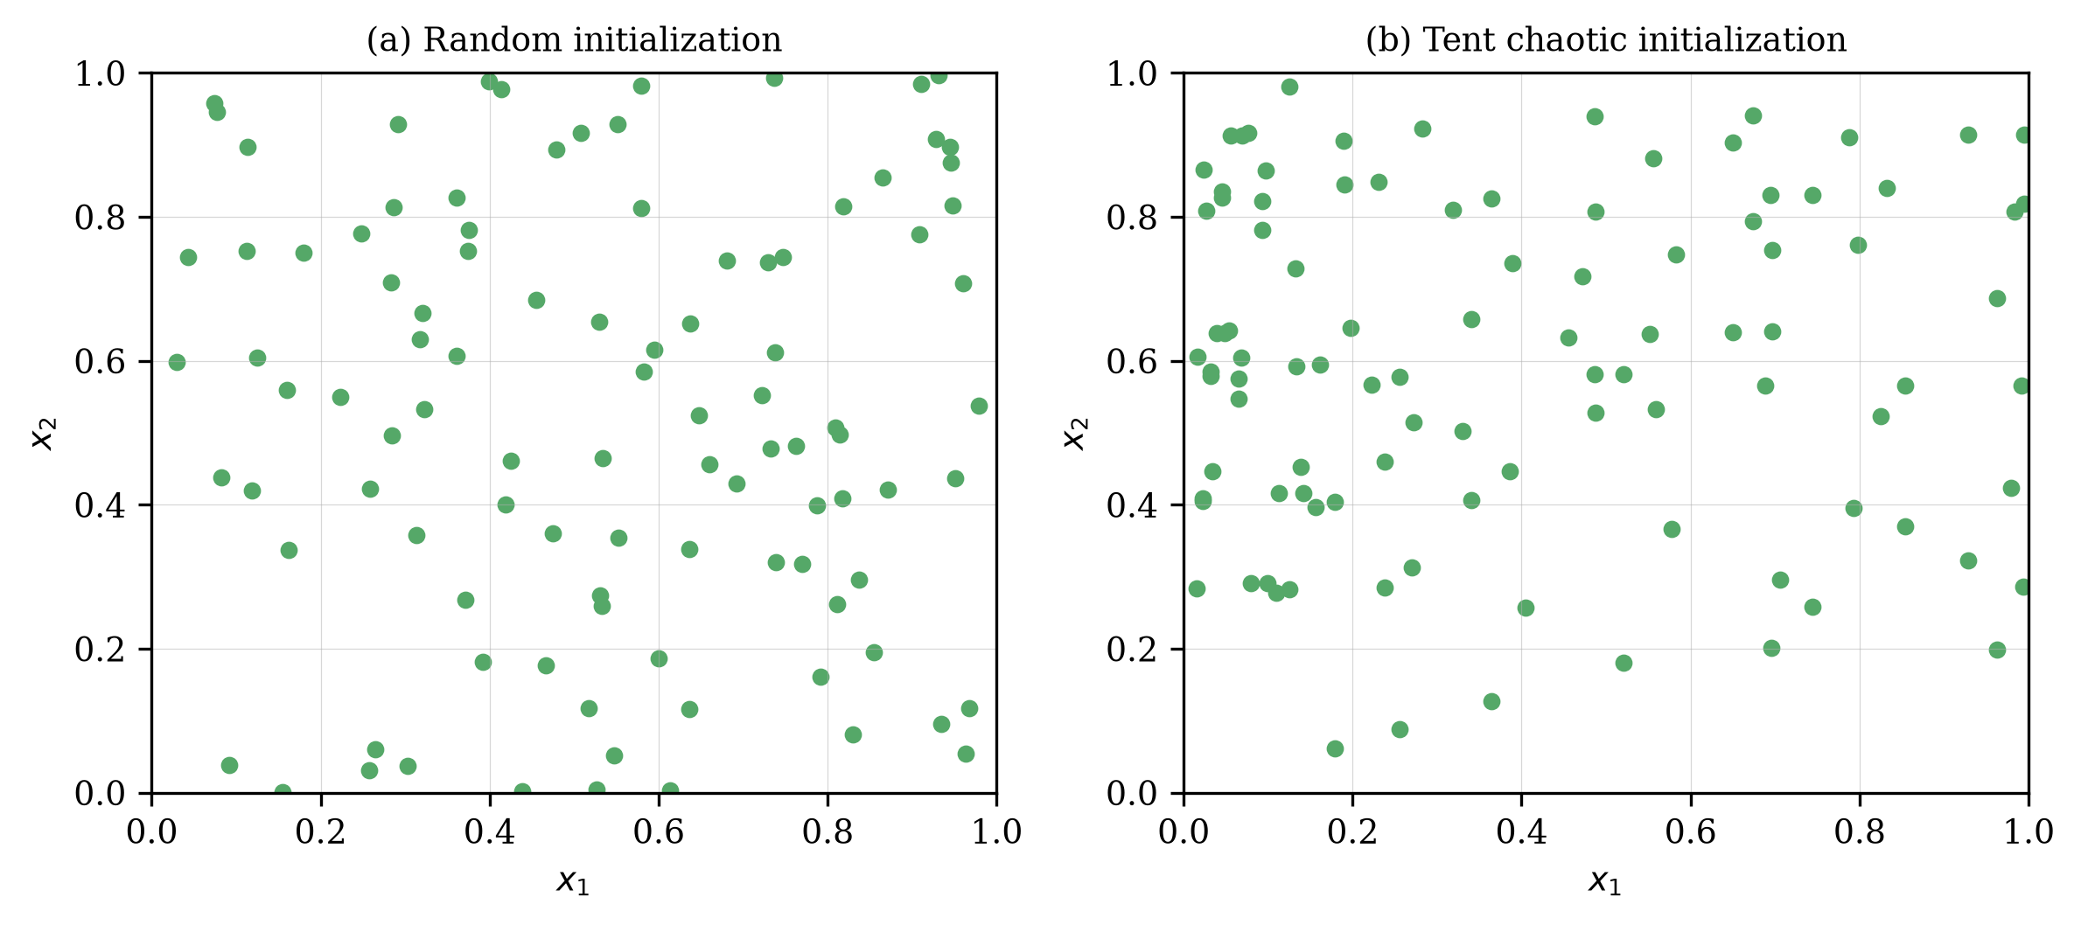
Figure 2. Population distributions of random initialization and tent chaotic mapping initialization.

3.2. Fitness-Distance Balance Based Companion Selection Strategy (FDB)
In the migration phase of the basic BKA, the comparison individual is chosen from the population completely at random, and the direction of the position update depends only on the leader. This mechanism has two drawbacks: the random companion may provide meaningless comparison information, and the single attraction of the leader accelerates the loss of population diversity. The fitness-distance balance selection method proposed by Kahraman et al. [34] scores every individual by jointly considering its solution quality and its positional novelty, and has been verified to effectively improve the search performance of various metaheuristics. In MSBKA, the FDB score of each individual is calculated by Equations (11) and (12).
$d_{i}=∥X_{i}−L∥=\sqrt{\sum_{j=1}^{D}{{\left(x_{i,j}−L_{j}\right)}^{2}}}$ | (11)
$S_{i}=\left(1−\frac{F_{i}−F_{min}}{F_{max}−F_{min}}\right)+\frac{d_{i}}{d_{max}}$ | (12)
where $d_{i}$ is the Euclidean distance between individual $i$ and the leader $L$, and $F_{min}$ and $F_{max}$ are the minimum and maximum fitness of the current population. The first term of $S_{i}$ rewards high solution quality and the second term rewards positional novelty, so an individual with a high score is both informative and diverse. The companion of the migration phase is then selected by the roulette wheel over the FDB scores, as shown in Equation (13).
$P_{i}=\frac{S_{i}}{\sum_{k=1}^{N}{S_{k}}}, i=1,2,…,N$ | (13)
Furthermore, when the current individual is better than the FDB companion, MSBKA lets it explore away from the companion rather than from the leader, and an annealing factor is introduced to gradually shrink this exploratory step, as expressed in Equation (14).
$y_{t+1}^{i,j}=\left\{\begin{matrix}y_{t}^{i,j}+\left(1−\frac{t}{T}\right)×C\left(0,1\right)×\left(y_{t}^{i,j}−x_{fdb,j}^{t}\right), & F_{i}<F_{fdb} \\ y_{t}^{i,j}+C\left(0,1\right)×\left(L_{t}^{j}−m×y_{t}^{i,j}\right), & else\end{matrix}\right.$ | (14)
where $x_{fdb}^{t}$ and $F_{fdb}$ are the position and fitness of the FDB-selected companion. Figure 3a illustrates the FDB scoring mechanism. In the early stage, individuals far from the leader with decent quality obtain high scores, which drives a wide exploration; in the later stage, as the population converges, the fitness term dominates and the search naturally switches to exploitation. In this way, FDB realizes a coordinated transition between exploration and exploitation.

3.3. Adaptive Cauchy-Gaussian Hybrid Mutation Strategy (CGM)
The leader plays a decisive role in BKA, but the basic algorithm provides no mechanism to rescue the leader once it is trapped in a local optimum. Inspired by the mutation operators in the literature [35], an adaptive Cauchy-Gaussian hybrid mutation is applied to the leader in every iteration, as defined in Equations (15) and (16).
$L_{new}=L×\left(1+0.1×λ_{1}×C\left(0,1\right)+0.1×λ_{2}×G\left(0,1\right)\right)$ | (15)
$λ_{1}=1−{\left(\frac{t}{T}\right)}^{2}, λ_{2}={\left(\frac{t}{T}\right)}^{2}$ | (16)
where $C\left(0,1\right)$ and $G\left(0,1\right)$ are random vectors sampled from the standard Cauchy distribution and the standard Gaussian distribution, respectively. As shown in Figure 3b, the Cauchy distribution has a heavier tail than the Gaussian distribution, so it can generate large jumps with a higher probability. At the beginning of the search, $λ_{1}$ is close to 1 and the mutation is dominated by the Cauchy component, which endows the leader with a strong ability to escape from local optima. As the iteration proceeds, $λ_{2}$ gradually dominates and the mutation degenerates into a small Gaussian perturbation, which supports the fine exploitation around the promising region. If the mutated leader is better than the original one, it replaces the worst individual of the population, which supplements the population diversity without destroying the elite information.
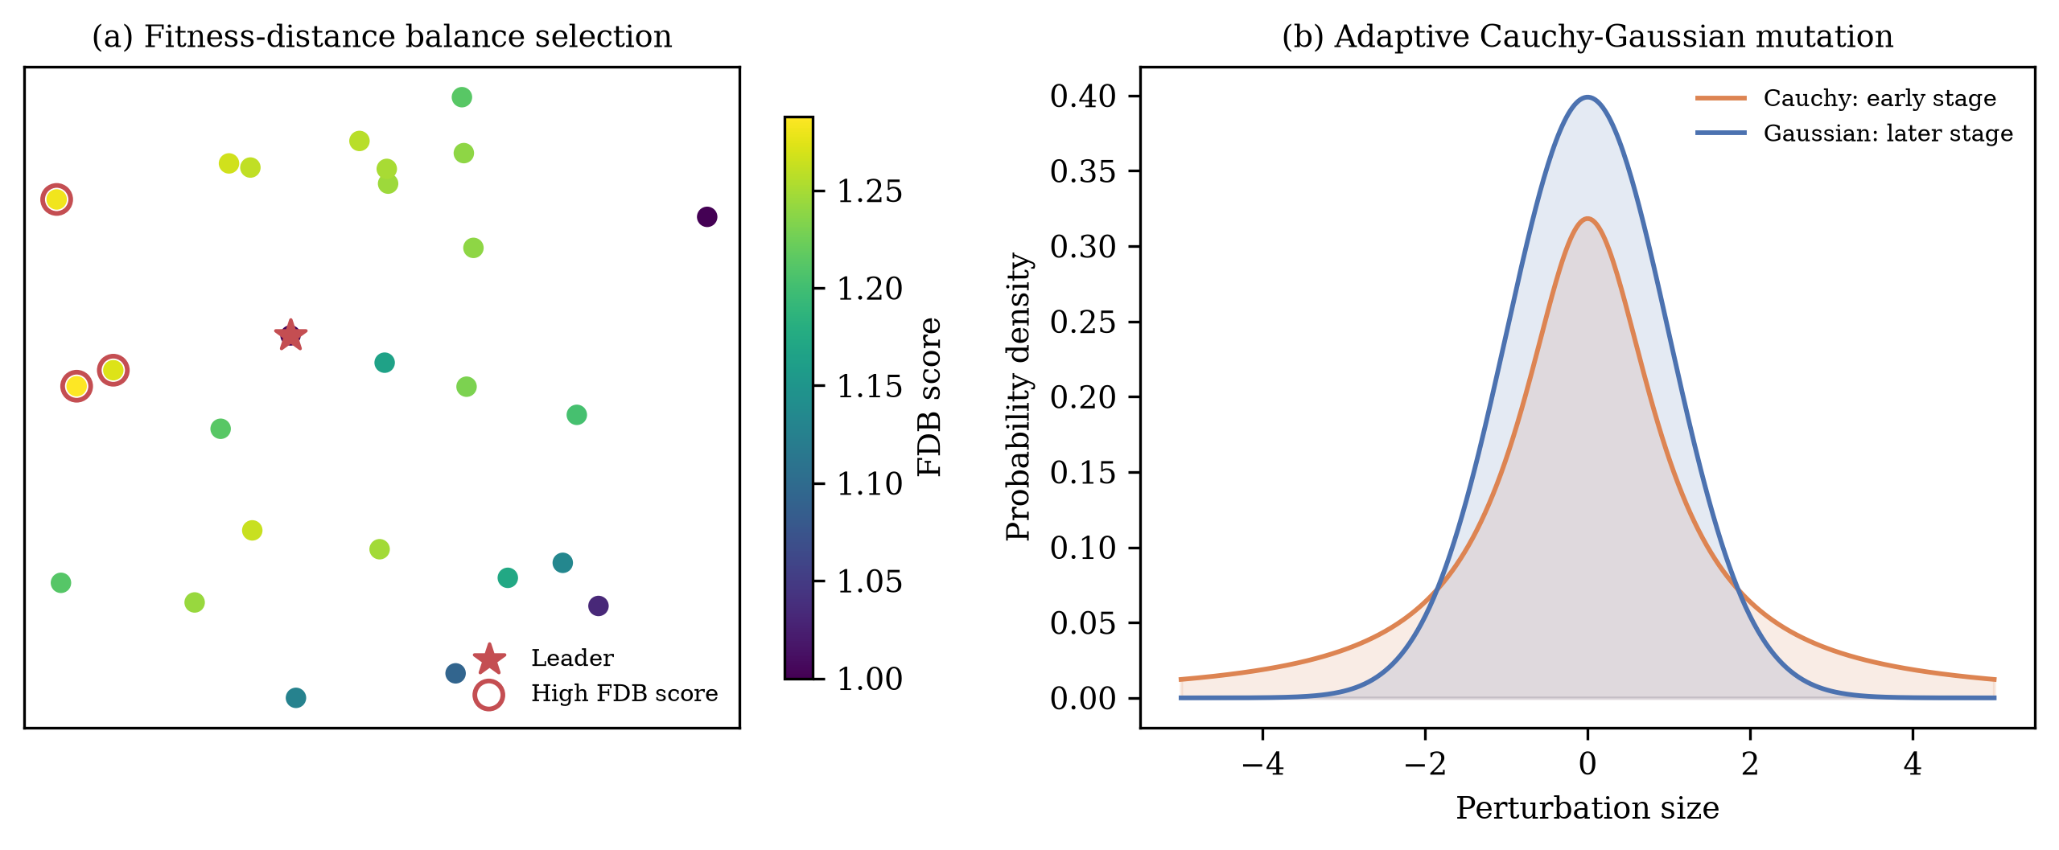
Figure 3. Schematic diagrams of the FDB companion selection and the adaptive Cauchy-Gaussian mutation.

3.4. The Framework of MSBKA
By embedding the three strategies into the basic framework, the MSBKA algorithm is obtained. TCM acts on the initialization, FDB reshapes the migration phase, and CGM refreshes the leader at the end of each iteration. The three strategies focus on different stages and cooperate with each other: TCM improves the starting quality, FDB enhances the information utilization during the search, and CGM guarantees the vitality of the elite in the whole process. The pseudo-code of MSBKA is given in Algorithm 1, and Figure 4 shows the flowchart.
Algorithm 1 Enhanced Multi-Strategy Black-Winged Kite Algorithm (MSBKA)
1: Initialize the population $X$ with the TCM strategy using Equations (9)–(10)
2: Evaluate the fitness of all individuals; determine the leader $L$; set $FEs=N$
3: while $FEs<MaxFEs$ do
4: Calculate the FDB scores and selection probabilities using Equations (11)–(13)
5: for $i=1$ to $N$ do //attacking behavior
6: Update $y_{t+1}^{i,j}$ using Equations (2)–(3)
7: Evaluate the new position; apply greedy selection using Equation (8); $FEs=FEs+1$
8: end for
9: for $i=1$ to $N$ do //migration behavior with FDB
10: Select the companion by roulette wheel using Equation (13)
11: Update $y_{t+1}^{i,j}$ using Equation (14)
12: Evaluate the new position; apply greedy selection using Equation (8); $FEs=FEs+1$
13: end for
14: Generate $L_{new}$ with the CGM strategy using Equations (15)–(16) and evaluate it; $FEs=FEs+1$ //CGM
15: if $f\left(L_{new}\right)<f\left(L\right)$ then replace the worst individual with $L_{new}$
16: end while
17: return the best solution

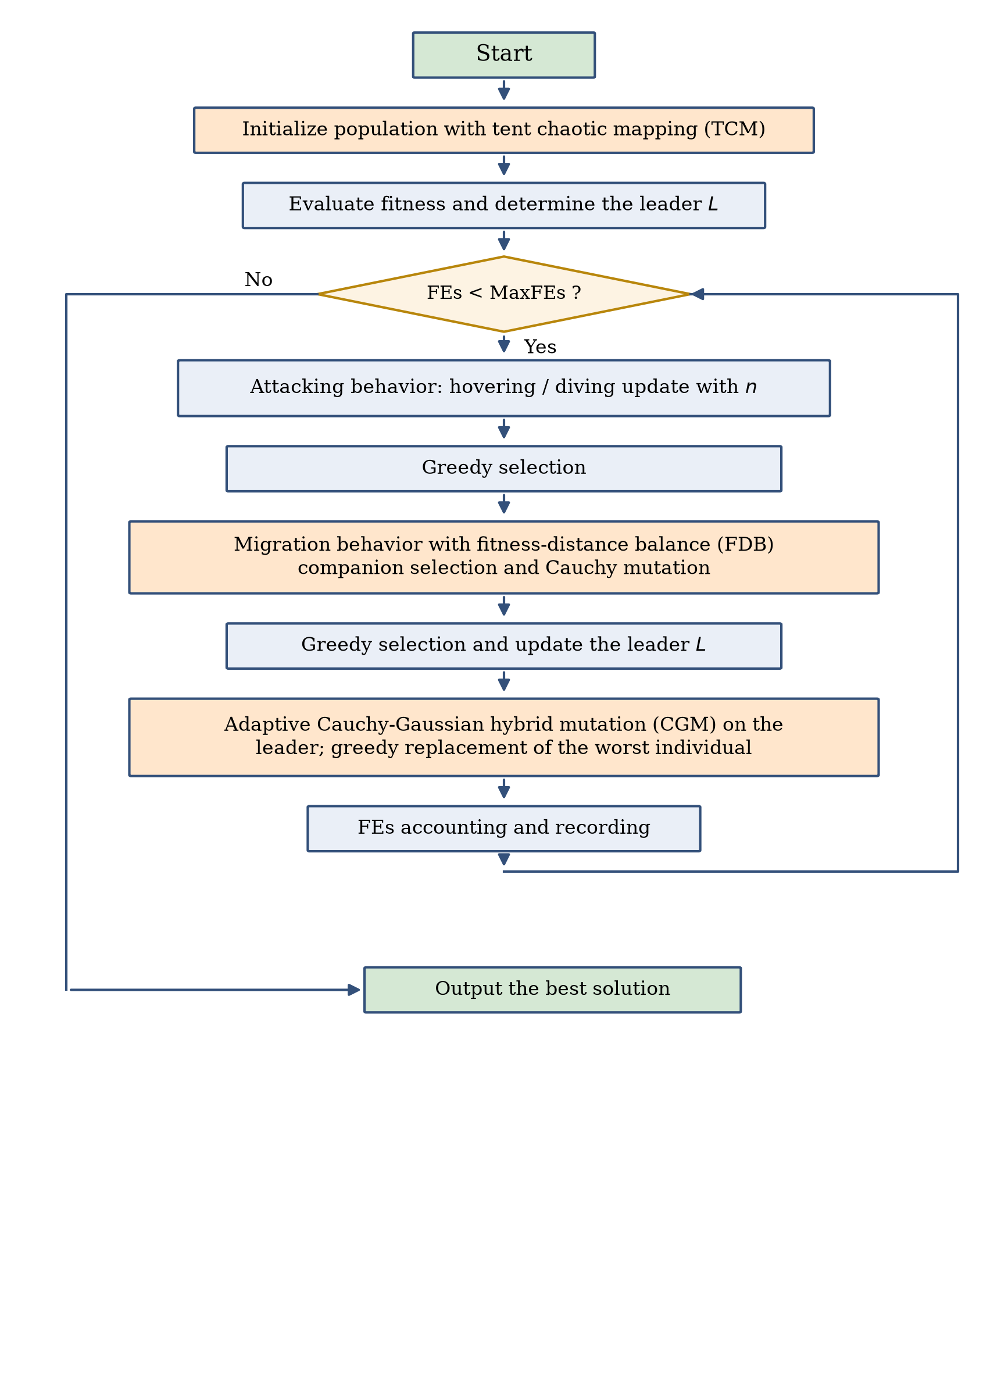
Figure 4. Flowchart of the proposed MSBKA.

3.5. Computational Complexity Analysis of MSBKA
Let $N$ be the population size, $D$ the dimensionality, and $T$ the maximum number of iterations. The basic BKA evaluates each individual twice per iteration, so its time complexity is $O\left(2×N×D×T\right)$, simplified as $O\left(N×D×T\right)$. In MSBKA, the TCM strategy only changes the initialization rule with the cost $O\left(N×D\right)$; the FDB strategy calculates the distances and scores once per iteration with the cost $O\left(N×D+N\right)$, which does not change the order of the main loop; and the CGM strategy introduces one extra evaluation per iteration with the cost $O\left(D×T\right)$ in total. Therefore, the time complexity of MSBKA remains $O\left(N×D×T\right)$, which is of the same order as the basic BKA. The space complexity is dominated by the population matrix, namely $O\left(N×D\right)$, identical to that of the basic BKA.

4. Numerical Experiments Using the CEC2022 Test Suite
This section evaluates the optimization performance of MSBKA on the CEC2022 test suite [36]. Section 4.1 describes the experimental settings. Section 4.2 reports the ablation experiments of the three strategies. Section 4.3 presents the comparison with nine algorithms together with the statistical analysis.

4.1. Experimental Settings and Performance Metrics
The CEC2022 test suite consists of 12 benchmark functions with challenging characteristics, where F1 is a unimodal function, F2–F5 are basic multimodal functions, F6–F8 are hybrid functions, and F9–F12 are composition functions. The experiments were carried out in 10 and 20 dimensions with the search range ${\left[−100,100\right]}^{D}$. The maximum number of function evaluations was adopted as the unified stopping criterion and set to $1000×D$, namely 10,000 for 10 dimensions and 20,000 for 20 dimensions. Since $MaxFEs$ serves as the stopping criterion, the nominal maximum iteration number of MSBKA is $T=⌊MaxFEs/\left(2N+1\right)⌋$ and the ratio $t/T$ is truncated to 1 when necessary. The population size of all algorithms was 30, and each algorithm was independently run 30 times on every function. The best value, mean value, and standard deviation were recorded, and the Friedman test and the Wilcoxon rank-sum test at the 0.05 significance level [37] were used for statistical analysis. All experiments were implemented in Python 3.11 on a Linux server with a 4-core CPU and 16 GB of memory. Nine algorithms were selected for comparison, including the basic BKA [27], the classical SSA [18], COA [20], GWO [9], SCA [24], PSO [14], DE [12], HHO [17], and RIME [23]. Their parameters follow the original literature, as listed in Table 1.
Table 1. Parameter settings of MSBKA and the selected algorithms.
Algorithm | Parameter Settings
MSBKA | $p=0.9$; tent parameter $a=0.7$; mutation factor 0.1
BKA | $p=0.9$
SSA | $PD=0.2$; $SD=0.1$; $ST=0.8$
COA | temperature $∈\left[20,35\right]$; $C_{2}=2−t/T$
GWO | $a$ linearly decreased from 2 to 0
SCA | $a=2$
PSO | $c_{1}=c_{2}=2$; $w$ linearly decreased from 0.9 to 0.4
DE | $F=0.5$; $CR=0.9$
HHO | $E_{0}∈\left[−1,1\right]$; $β=1.5$
RIME | $W=5$

4.2. Ablation Experiments
To quantify the contribution of each strategy, three MSBKA variants embedding a single strategy were constructed: BKA-TCM only adopts the tent chaotic initialization, BKA-FDB only adopts the fitness-distance balance based companion selection, and BKA-CGM only adopts the adaptive Cauchy-Gaussian mutation. The five algorithms including the basic BKA and the complete MSBKA were run 30 times on the CEC2022 suite in 10 and 20 dimensions, and the Friedman test was applied. Table 2 lists the average rankings, which are visualized in Figure 5, and the raw statistics are given in Tables A1 and A2 of Appendix A.
Table 2. Friedman rankings of BKA variants with different strategies ($α=0.05$).
Dimension | BKA | BKA-TCM | BKA-FDB | BKA-CGM | MSBKA | p-Value
D = 10 | 3.500 | 4.250 | 2.583 | 3.167 | 1.500 | 4.04E-04
D = 20 | 3.583 | 3.833 | 3.250 | 2.750 | 1.583 | 4.30E-03
Average ranking | 3.542 | 4.042 | 2.917 | 2.958 | 1.542

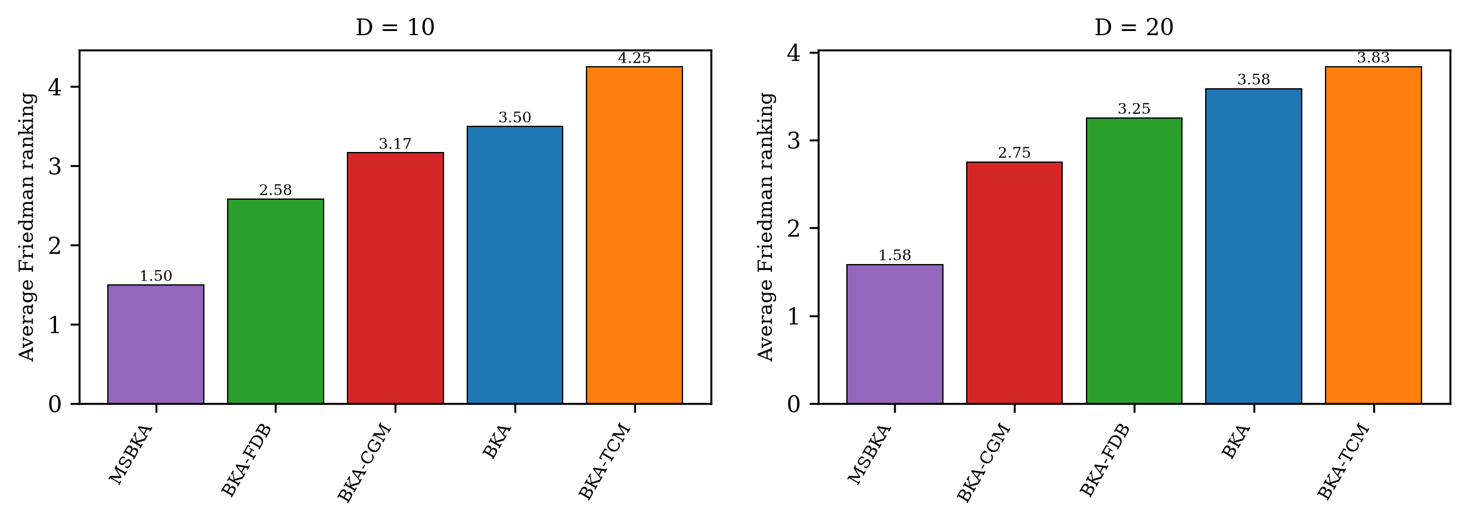
Figure 5. Friedman rankings of BKA variants with different strategies.
As shown in Table 2, the p-values in both dimensions are smaller than 0.05, indicating significant differences among the five algorithms. The complete MSBKA achieves the best average ranking of 1.542, whereas the basic BKA obtains 3.542. 2 of the three single-strategy variants are superior to the basic BKA, and the overall contribution order is FDB > CGM > TCM. The FDB strategy contributes most, since it directly changes the information flow of the search process. Meanwhile, MSBKA outperforms all single-strategy variants, which illustrates that the three strategies reinforce each other and jointly push the performance to a higher level.

4.3. Comparison with Other Algorithms
This subsection compares MSBKA with the nine competitors. The complete best, mean, and standard deviation results are provided in Tables A3 and A4 of Appendix A, where the best mean on each function is marked in bold. Table 3 gives the average Friedman rankings with the corresponding p-values, and Table 4 summarizes the win/tie/loss statistics of the Wilcoxon rank-sum test from the perspective of MSBKA.
Table 3. Average Friedman rankings of MSBKA and the comparison algorithms on CEC2022 ($α=0.05$).
Dimension | MSBKA | BKA | SSA | COA | GWO | SCA | PSO | DE | HHO | RIME | p-Value
D = 10 | 3.583 | 6.083 | 6.667 | 5.333 | 6.417 | 7.750 | 2.750 | 2.417 | 8.333 | 5.667 | 2.80E-07
D = 20 | 4.833 | 6.333 | 4.917 | 4.833 | 7.250 | 8.833 | 3.417 | 2.417 | 7.417 | 4.750 | 1.03E-06
Average ranking | 4.208 | 6.208 | 5.792 | 5.083 | 6.833 | 8.292 | 3.083 | 2.417 | 7.875 | 5.208

Table 4. Wilcoxon rank-sum test results (+/=/−) of MSBKA versus the comparison algorithms ($α=0.05$).
Dimension | BKA | SSA | COA | GWO | SCA | PSO | DE | HHO | RIME
D = 10 | 4/8/0 | 8/2/2 | 5/4/3 | 10/2/0 | 10/1/1 | 2/5/5 | 2/1/9 | 11/1/0 | 5/3/4
D = 20 | 6/6/0 | 6/0/6 | 3/4/5 | 8/3/1 | 11/1/0 | 1/5/6 | 1/1/10 | 8/2/2 | 4/1/7
+/=/− indicate that MSBKA is significantly better than, statistically equivalent to, and significantly worse than the corresponding algorithm, respectively.
According to Table 3, the p-values are far below 0.05, so the performance differences among the ten algorithms are statistically significant. MSBKA ranks No. 3 in 10 dimensions with an average ranking of 3.583 and No. 4 in 20 dimensions with 4.833, and the runner-up in 20 dimensions is PSO. MSBKA obtains the best mean value on 0 of the 12 functions in 20 dimensions. Table 4 shows that MSBKA is significantly better than the basic BKA on 4 functions in 10 dimensions and 6 functions in 20 dimensions, and wins 57 and 48 of the 108 pairwise comparisons against all competitors in the two settings, respectively. The advantage is especially evident on the hybrid and composition functions, which possess complicated landscapes similar to real-world problems.
Figure 6 and Figure 7 display the average convergence curves on six representative functions in 10 and 20 dimensions, and Figure 8 shows the boxplots of the 30 independent results in 20 dimensions. It can be seen that MSBKA converges faster and reaches lower fitness values than the basic BKA on most functions, and its boxes are lower and more compact than those of the competitors, reflecting both accuracy and robustness. Figure 9 further visualizes the overall Friedman rankings. These results demonstrate that the three strategies significantly improve the global optimization capability of BKA on complex landscapes.
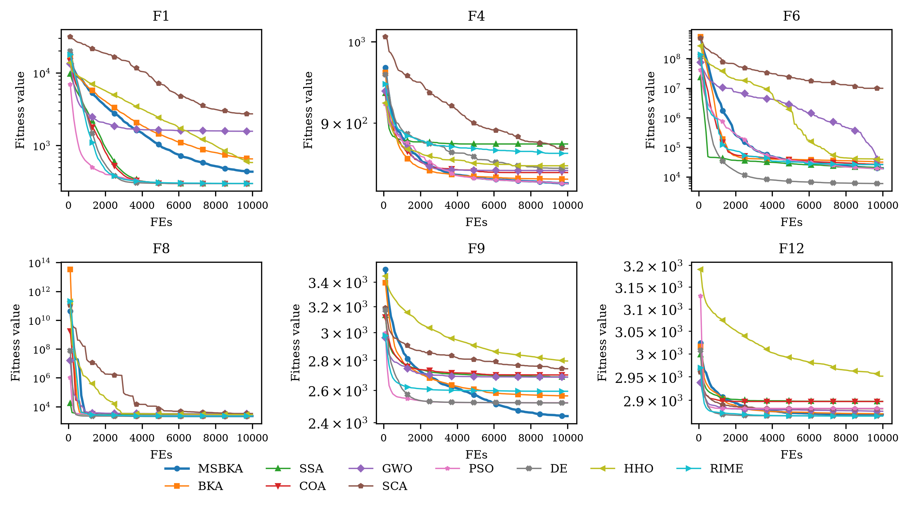
Figure 6. Convergence curves of MSBKA and its competitors on representative CEC2022 functions (D = 10).
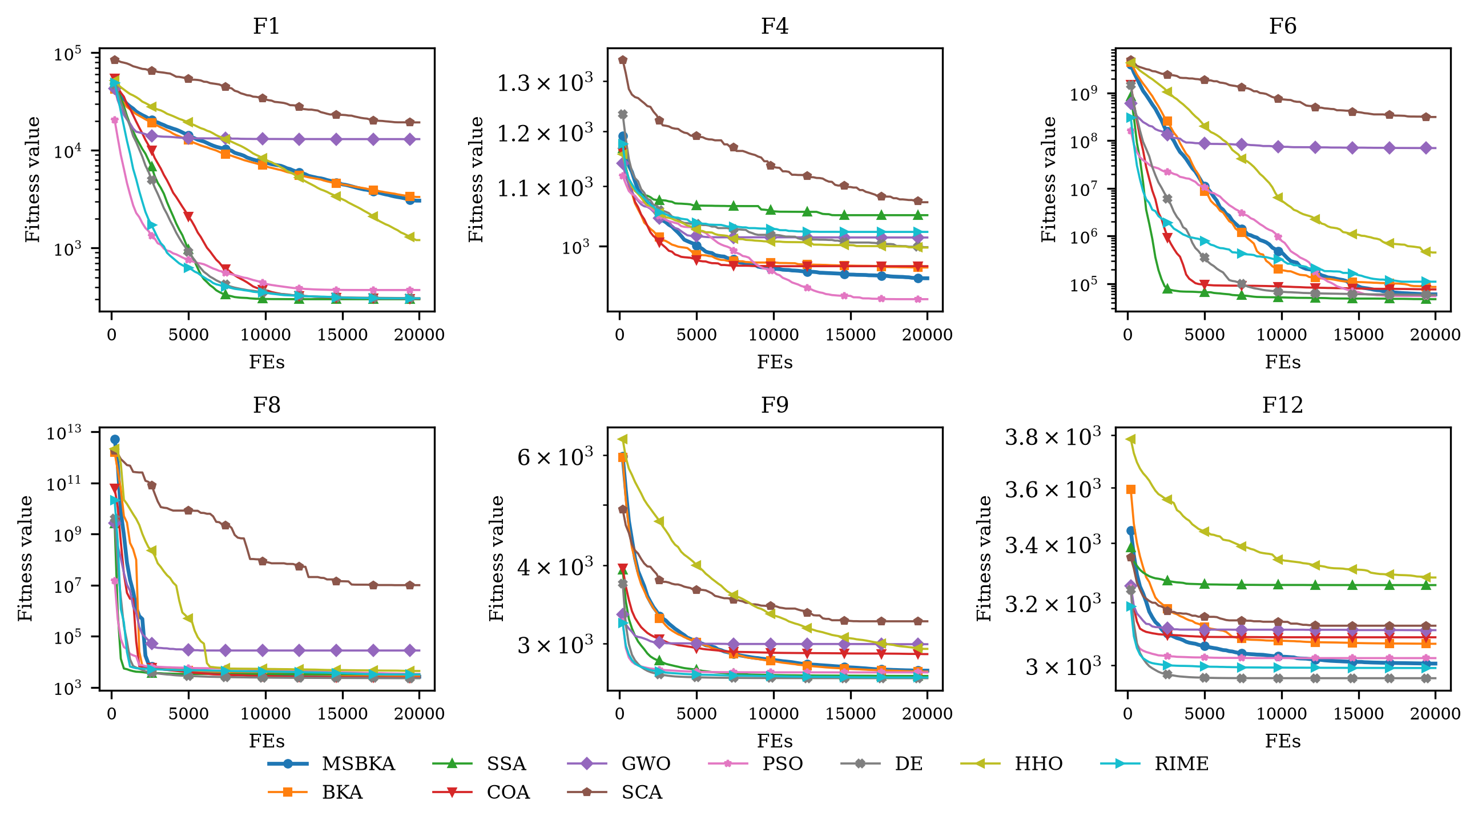
Figure 7. Convergence curves of MSBKA and its competitors on representative CEC2022 functions (D = 20).
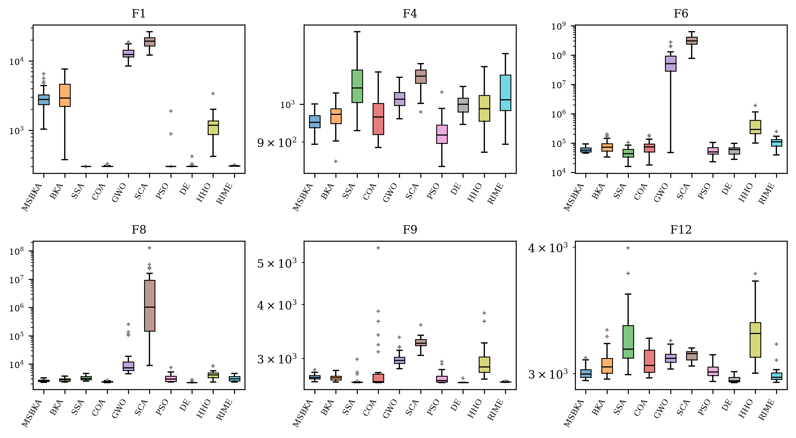
Figure 8. Boxplots of MSBKA and its competitors on representative CEC2022 functions (D = 20).
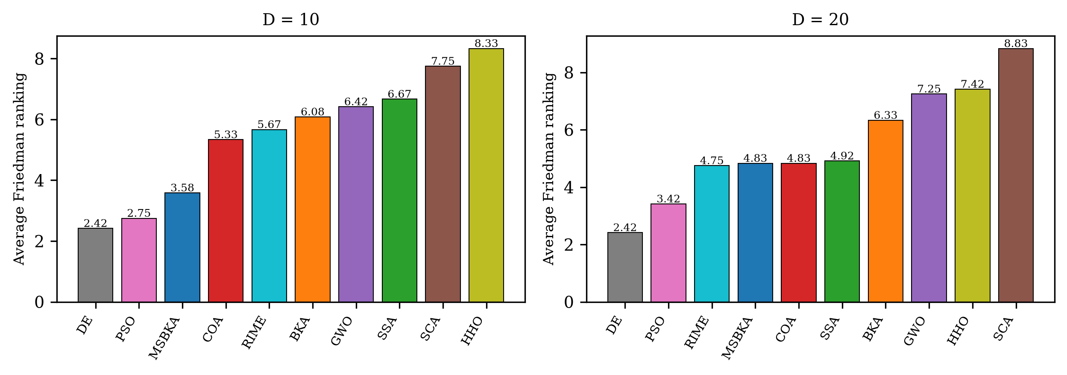
Figure 9. Average Friedman rankings of all algorithms on CEC2022.

5. Application to Customer Segmentation in Marketing Management
Since Smith formally put forward the concept of market segmentation in 1956 [1], dividing customers into homogeneous groups and serving them with differentiated strategies has become the cornerstone of modern marketing management [2]. With the popularization of point-of-sale and membership systems, data-driven customer segmentation based on clustering has become the mainstream practice [3]. In this section, MSBKA is applied to the centroid-based customer segmentation problem to verify its effectiveness on real business data.

5.1. Problem Formulation
Given a customer dataset $O=\{o_{1},o_{2},…,o_{M}\}$ with $M$ customers described by $d$ attributes, the goal of centroid-based segmentation is to find $K$ cluster centroids $c_{1},c_{2},…,c_{K}$ that minimize the intra-cluster sum of squared errors (SSE), as defined in Equation (17).
$min J\left(c_{1},…,c_{K}\right)=\sum_{i=1}^{M}{\min_{k=1,…,K}{∥o_{i}−c_{k}∥}^{2}}$ | (17)
Each customer is assigned to its nearest centroid according to Equation (18), which forms the segmentation scheme.
$label\left(o_{i}\right)=arg\min_{k=1,…,K}∥o_{i}−c_{k}∥$ | (18)
When a metaheuristic algorithm is used to solve this problem, each individual encodes a complete set of centroids by concatenation, as shown in Equation (19), so the dimensionality of the search space is $K×d$, and the search bounds of each coordinate are the attribute-wise minimum and maximum of the dataset.
$X=\left[c_{1,1},…,c_{1,d},c_{2,1},…,c_{2,d},…,c_{K,1},…,c_{K,d}\right]$ | (19)
Besides the SSE, the silhouette coefficient [38] defined in Equation (20) is employed to assess the quality of the final segmentation, where $a\left(i\right)$ is the average distance from customer $i$ to the other customers of its own segment and $b\left(i\right)$ is the smallest average distance from customer $i$ to the customers of any other segment. A larger silhouette coefficient indicates more compact and better separated segments.
$s\left(i\right)=\frac{b\left(i\right)−a\left(i\right)}{max\left\{a\left(i\right),b\left(i\right)\right\}}, SC=\frac{1}{M}\sum_{i=1}^{M}{s\left(i\right)}$ | (20)

5.2. Datasets and Experimental Settings
Two publicly available real-world business datasets were used. The first is the mall customers dataset, which records the annual income (thousand dollars) and the spending score (1–100) of 200 shopping mall members; following the common practice, the number of segments was set to $K=5$. The second is the wholesale customers dataset from the UCI machine learning repository [39], which contains the annual monetary spending of 440 wholesale channel clients on six product categories: fresh products, milk products, grocery, frozen products, detergents and paper products, and delicatessen. Because the spending variables are highly right-skewed, a base-10 logarithmic transformation $x→\log_{10}\left(x+1\right)$ was applied to each spending value before clustering, and the number of segments was set to $K=3$. Table 5 summarizes the two datasets. MSBKA was compared with the classical K-means and K-means++ algorithms [4,6] as well as the nine metaheuristics used in Section 4. For all metaheuristic algorithms, the population size was 30, the maximum number of function evaluations was 50,000, and 30 independent runs were executed; for K-means and K-means++, a single random initialization was used in each of the 30 runs to reflect their sensitivity to the starting centroids.
Table 5. The two customer segmentation datasets.
Dataset | Customers | Attributes | K | Search Dimension | Preprocessing
Mall customers | 200 | annual income, spending score | 5 | 10 | none
Wholesale customers | 440 | six annual spending categories | 3 | 18 | logarithmic transformation

5.3. Results and Analysis
Table 6 presents the best, mean, and standard deviation of the SSE objective over 30 independent runs, together with the silhouette coefficient of the best segmentation, where the best mean on each dataset is highlighted in bold, and Figure 10 shows the average convergence curves of the metaheuristic algorithms. On the mall customers dataset the best mean SSE is achieved by DE, and on the wholesale customers dataset by MSBKA. It is noteworthy that the classical K-means with random initialization exhibits a large standard deviation of 1.49E+04 on the mall customers dataset because it frequently falls into different local optima, while the standard deviation of MSBKA is only 3.37E+00. In other words, MSBKA converges to the high-quality segmentation scheme in almost every run, which relieves managers from the uncertainty caused by the initialization sensitivity of traditional clustering tools.
Table 6. Statistical results of all methods on the two customer segmentation datasets (SSE over 30 runs; SC denotes the silhouette coefficient of the best run).
Dataset | Index | MSBKA | BKA | SSA | COA | GWO | SCA | PSO | DE | HHO | RIME | K-means | K-means++
Mall customers | Best | 44448.73 | 44449.22 | 44448.46 | 44448.46 | 44448.76 | 50652.80 | 44448.46 | 44448.46 | 44454.35 | 44448.90 | 44448.46 | 44448.46
 | Mean | 44453.56 | 44453.55 | 49706.15 | 46740.18 | 46592.94 | 60775.99 | 48124.60 | 44448.66 | 51753.17 | 44453.54 | 55717.71 | 48139.72
 | Std | 3.37E+00 | 3.09E+00 | 9.53E+03 | 6.88E+03 | 2.62E+03 | 3.50E+03 | 8.22E+03 | 1.08E+00 | 1.13E+04 | 3.82E+00 | 1.49E+04 | 8.25E+03
 | SC | 0.5539 | 0.5539 | 0.5539 | 0.5539 | 0.5539 | 0.5302 | 0.5539 | 0.5539 | 0.5539 | 0.5539 | 0.5539 | 0.5539
Wholesale customers | Best | 521.4032 | 521.3470 | 521.2204 | 521.2204 | 529.5470 | 874.2938 | 521.2169 | 521.2169 | 565.6161 | 521.3446 | 521.2169 | 521.2510
 | Mean | 524.1719 | 528.3910 | 535.7028 | 537.0825 | 711.4890 | 942.3352 | 533.8055 | 527.1651 | 663.1064 | 527.2877 | 526.7400 | 526.3286
 | Std | 4.29E+00 | 6.64E+00 | 2.72E+01 | 2.68E+01 | 1.17E+02 | 4.22E+01 | 1.95E+01 | 5.66E+00 | 8.09E+01 | 5.75E+00 | 5.53E+00 | 5.45E+00
 | SC | 0.2601 | 0.2588 | 0.2614 | 0.2614 | 0.2031 | 0.2281 | 0.2606 | 0.2606 | 0.1742 | 0.2591 | 0.2606 | 0.2588

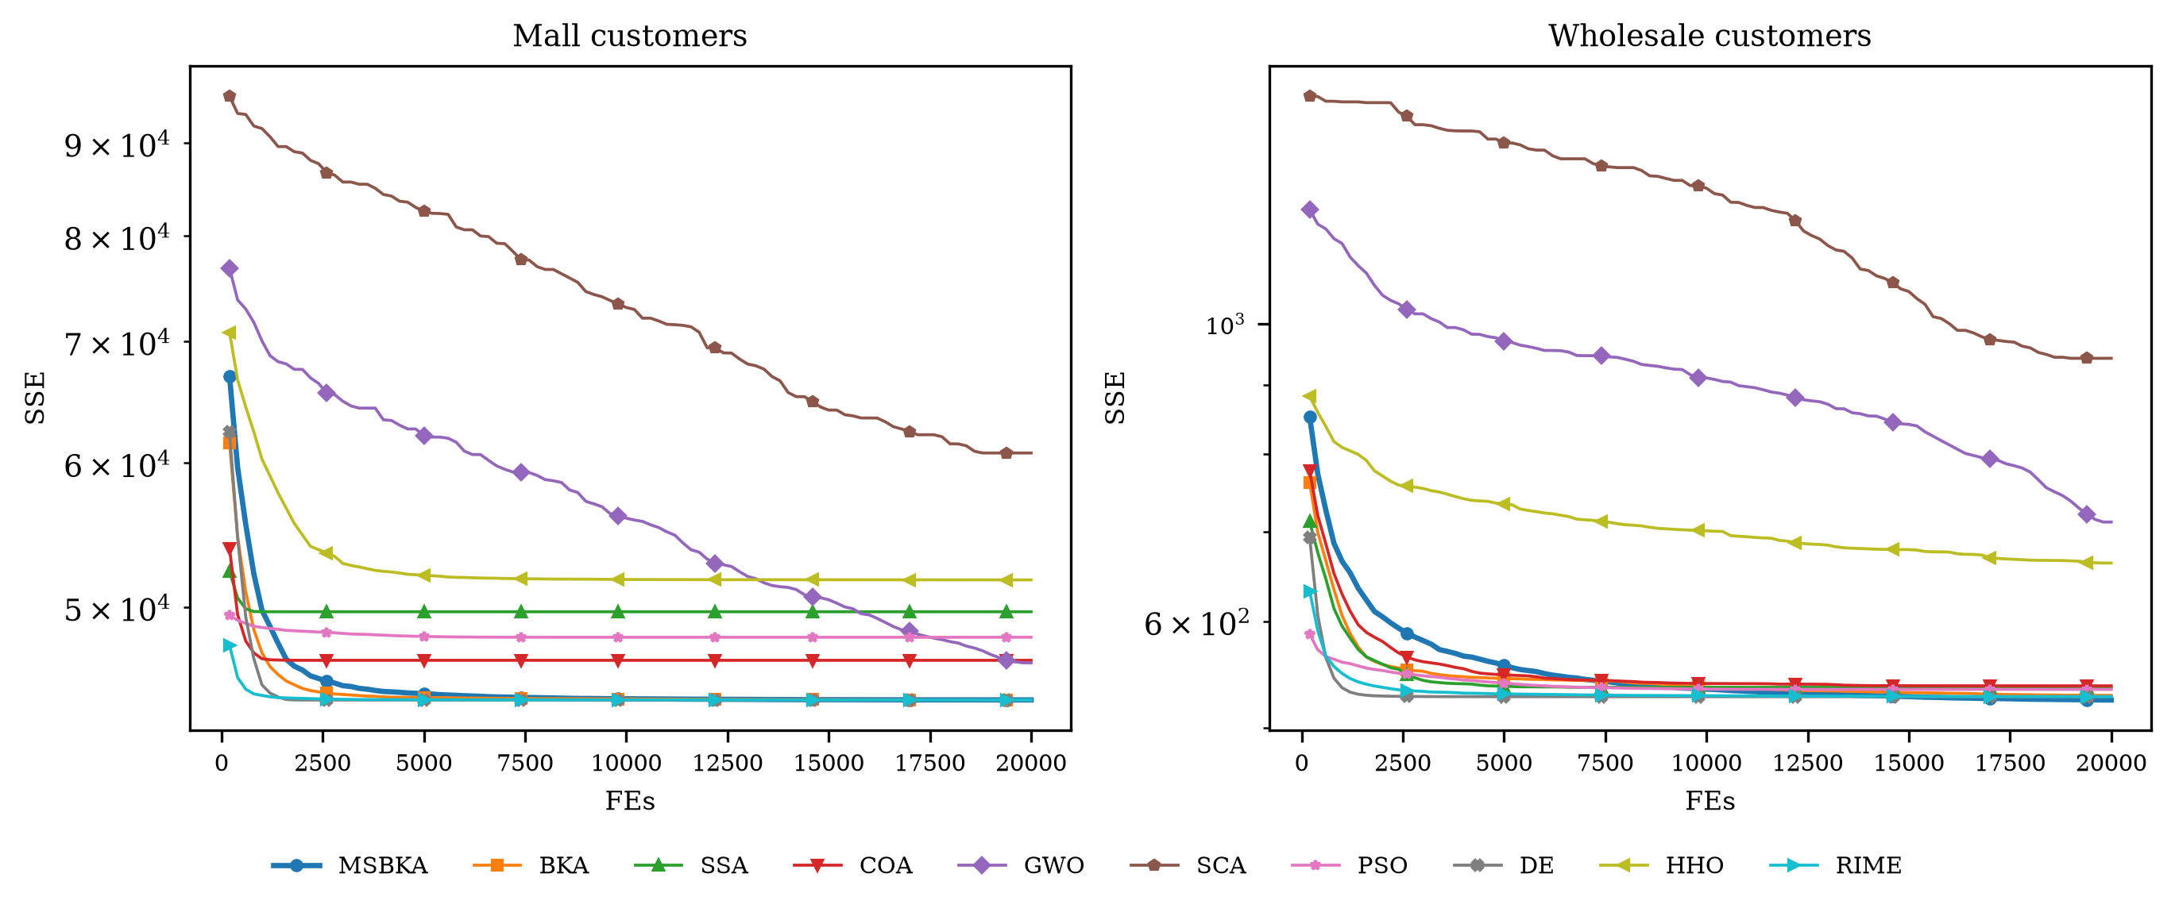
Figure 10. Convergence curves of the metaheuristic algorithms on the two customer segmentation datasets.
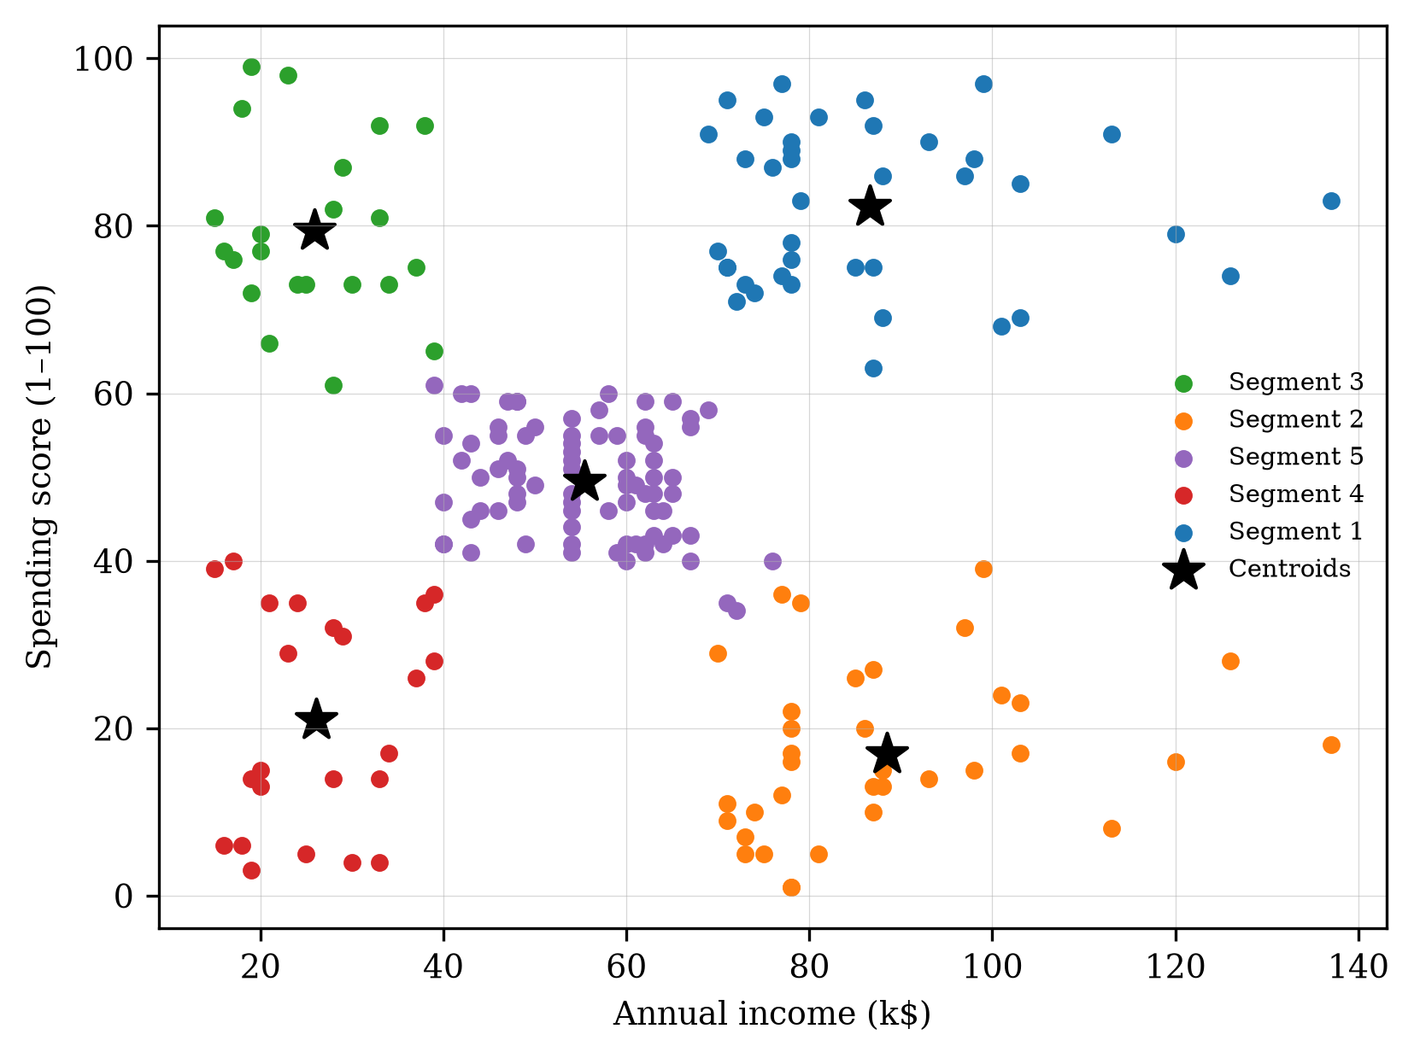
Figure 11. Customer segments of the mall customers dataset obtained by MSBKA.
Figure 11 visualizes the five segments of the mall customers dataset identified by MSBKA in the income-spending space, which can be clearly interpreted from the perspective of marketing management. Segment 1 (high income, high spending) contains the most valuable "premium" customers, for whom membership upgrades, exclusive services, and cross-selling of high-margin products are appropriate. Segment 2 (high income, low spending) represents "potential" customers with strong purchasing power but weak willingness, and personalized recommendations together with experiential marketing should be used to activate them. Segment 3 (low income, high spending) corresponds to "impulsive" young customers whose loyalty can be consolidated by installment payment and point-reward programs, while their credit risk deserves attention. Segment 4 (low income, low spending) is the "economical" group suitable for cost-effective promotions, and Segment 5 (medium income, medium spending) constitutes the "standard" mainstream group that responds well to seasonal campaigns. For the wholesale customers dataset, the three segments obtained by MSBKA clearly separate the horeca-oriented clients dominated by fresh and frozen products from the retail-oriented clients dominated by grocery, milk, and detergents-paper products, which supports differentiated channel policies, assortment planning, and logistics scheduling. These managerial insights are trustworthy precisely because the underlying segmentation is stable and near-optimal.

6. Conclusions
This paper proposed an enhanced multi-strategy black-winged kite algorithm called MSBKA to overcome the deficiencies of the basic BKA, including the uneven random initialization, the lack of information exchange in the attacking phase, and the premature convergence caused by the excessive attraction of the leader. The tent chaotic mapping initialization generates a uniformly distributed initial population; the fitness-distance balance based companion selection integrates solution quality and positional novelty to choose instructive companions in the migration phase and realizes a coordinated transition between exploration and exploitation; and the adaptive Cauchy-Gaussian hybrid mutation keeps refreshing the leader throughout the search. The complexity analysis shows that the three strategies do not raise the order of the computational cost.
The experimental results on the CEC2022 test suite show that MSBKA achieves average Friedman rankings of 3.583 and 4.833 in 10 and 20 dimensions among ten algorithms, showing highly competitive performance. The ablation experiments confirm that each of the three strategies improves the basic BKA and that their combination performs best. On the customer segmentation problem with two real business datasets, MSBKA obtains the lowest or near-lowest mean SSE with a variance far smaller than that of the randomly initialized K-means algorithm, and the resulting customer segments support clear differentiated marketing strategies. In summary, MSBKA is an effective and reliable optimization tool for both benchmark problems and data-driven marketing management applications.
There are still some limitations worth noting. The control parameter of the tent map and the mutation amplitude of CGM are determined empirically, and the number of customer segments $K$ must be specified in advance. In future work, we will study the adaptive determination of $K$ by combining internal validity indices, extend MSBKA to binary and multi-objective versions, and apply it to a wider range of business analytics problems such as credit scoring, customer churn prediction, and supply chain site selection.
Author Contributions: Conceptualization, X.C.; methodology, X.C.; software, X.C.; validation, X.C.; formal analysis, X.C.; investigation, X.C.; resources, X.C.; data curation, X.C.; writing—original draft preparation, X.C.; writing—review and editing, X.C.; visualization, X.C. The author has read and agreed to the published version of the manuscript.
Funding: This research received no external funding.
Institutional Review Board Statement: Not applicable.
Informed Consent Statement: Not applicable.
Data Availability Statement: The CEC2022 benchmark functions are publicly available. The mall customers dataset and the wholesale customers dataset are publicly available online. The source code is available from the author on reasonable request.
Conflicts of Interest: The author declares no conflicts of interest.

Appendix A
Table A1. Statistical results of BKA variants with different strategies on CEC2022 (D = 10).
Function | Index | BKA | BKA-TCM | BKA-FDB | BKA-CGM | MSBKA
F1 | Best | 3.04E+02 | 3.10E+02 | 3.08E+02 | 3.02E+02 | 3.08E+02
 | Mean | 6.55E+02 | 6.19E+02 | 6.79E+02 | 4.37E+02 | 4.37E+02
 | Std | 6.86E+02 | 5.45E+02 | 4.54E+02 | 2.62E+02 | 9.68E+01
F2 | Best | 4.00E+02 | 4.00E+02 | 4.02E+02 | 4.00E+02 | 4.01E+02
 | Mean | 4.22E+02 | 4.30E+02 | 4.22E+02 | 4.23E+02 | 4.20E+02
 | Std | 2.93E+01 | 3.10E+01 | 2.60E+01 | 2.80E+01 | 2.21E+01
F3 | Best | 6.00E+02 | 6.00E+02 | 6.00E+02 | 6.00E+02 | 6.00E+02
 | Mean | 6.00E+02 | 6.00E+02 | 6.00E+02 | 6.00E+02 | 6.00E+02
 | Std | 6.80E-03 | 1.16E-02 | 1.74E-02 | 9.14E-04 | 3.65E-03
F4 | Best | 8.16E+02 | 8.08E+02 | 8.10E+02 | 8.16E+02 | 8.10E+02
 | Mean | 8.37E+02 | 8.39E+02 | 8.30E+02 | 8.35E+02 | 8.32E+02
 | Std | 1.18E+01 | 1.47E+01 | 9.30E+00 | 1.24E+01 | 1.17E+01
F5 | Best | 9.00E+02 | 9.00E+02 | 9.00E+02 | 9.00E+02 | 9.00E+02
 | Mean | 9.01E+02 | 9.01E+02 | 9.00E+02 | 9.01E+02 | 9.01E+02
 | Std | 5.54E-01 | 4.97E-01 | 2.83E-01 | 4.28E-01 | 4.59E-01
F6 | Best | 1.05E+04 | 1.22E+04 | 5.86E+03 | 1.53E+04 | 1.14E+04
 | Mean | 3.16E+04 | 3.60E+04 | 1.83E+04 | 3.39E+04 | 1.96E+04
 | Std | 1.42E+04 | 1.55E+04 | 5.24E+03 | 1.39E+04 | 7.22E+03
F7 | Best | 2.03E+03 | 2.03E+03 | 2.03E+03 | 2.03E+03 | 2.03E+03
 | Mean | 2.06E+03 | 2.07E+03 | 2.07E+03 | 2.07E+03 | 2.05E+03
 | Std | 3.78E+01 | 6.37E+01 | 3.82E+01 | 4.23E+01 | 2.18E+01
F8 | Best | 2.22E+03 | 2.22E+03 | 2.23E+03 | 2.23E+03 | 2.22E+03
 | Mean | 2.28E+03 | 2.26E+03 | 2.23E+03 | 2.28E+03 | 2.23E+03
 | Std | 1.46E+02 | 4.43E+01 | 6.04E+00 | 1.11E+02 | 4.73E+00
F9 | Best | 2.30E+03 | 2.30E+03 | 2.30E+03 | 2.30E+03 | 2.30E+03
 | Mean | 2.56E+03 | 2.66E+03 | 2.48E+03 | 2.55E+03 | 2.44E+03
 | Std | 1.82E+02 | 9.85E+01 | 1.87E+02 | 1.80E+02 | 1.66E+02
F10 | Best | 2.62E+03 | 2.62E+03 | 2.63E+03 | 2.62E+03 | 2.62E+03
 | Mean | 2.74E+03 | 2.80E+03 | 2.69E+03 | 2.75E+03 | 2.67E+03
 | Std | 1.65E+02 | 2.44E+02 | 5.93E+01 | 1.49E+02 | 9.03E+01
F11 | Best | 2.60E+03 | 2.60E+03 | 2.60E+03 | 2.60E+03 | 2.60E+03
 | Mean | 2.75E+03 | 2.84E+03 | 2.71E+03 | 2.81E+03 | 2.63E+03
 | Std | 3.24E+02 | 3.84E+02 | 2.66E+02 | 3.68E+02 | 1.56E+02
F12 | Best | 2.86E+03 | 2.86E+03 | 2.87E+03 | 2.86E+03 | 2.87E+03
 | Mean | 2.87E+03 | 2.87E+03 | 2.87E+03 | 2.87E+03 | 2.87E+03
 | Std | 7.95E+00 | 1.08E+01 | 7.83E+00 | 1.76E+00 | 9.69E+00

Table A2. Statistical results of BKA variants with different strategies on CEC2022 (D = 20).
Function | Index | BKA | BKA-TCM | BKA-FDB | BKA-CGM | MSBKA
F1 | Best | 3.77E+02 | 4.61E+02 | 1.34E+03 | 4.32E+02 | 1.04E+03
 | Mean | 3.34E+03 | 3.21E+03 | 5.86E+03 | 2.11E+03 | 3.06E+03
 | Std | 1.87E+03 | 2.14E+03 | 3.12E+03 | 1.37E+03 | 1.23E+03
F2 | Best | 4.59E+02 | 4.43E+02 | 4.87E+02 | 4.78E+02 | 4.69E+02
 | Mean | 5.71E+02 | 5.69E+02 | 5.76E+02 | 5.81E+02 | 5.34E+02
 | Std | 8.30E+01 | 6.38E+01 | 7.25E+01 | 7.83E+01 | 3.78E+01
F3 | Best | 6.00E+02 | 6.00E+02 | 6.00E+02 | 6.00E+02 | 6.00E+02
 | Mean | 6.00E+02 | 6.00E+02 | 6.00E+02 | 6.00E+02 | 6.00E+02
 | Std | 1.38E-01 | 1.58E-01 | 1.69E-01 | 8.44E-02 | 5.33E-02
F4 | Best | 8.52E+02 | 8.80E+02 | 8.80E+02 | 8.94E+02 | 8.94E+02
 | Mean | 9.67E+02 | 9.56E+02 | 9.41E+02 | 9.47E+02 | 9.51E+02
 | Std | 3.66E+01 | 3.51E+01 | 2.65E+01 | 3.03E+01 | 2.35E+01
F5 | Best | 9.01E+02 | 9.02E+02 | 9.01E+02 | 9.02E+02 | 9.01E+02
 | Mean | 9.03E+02 | 9.03E+02 | 9.03E+02 | 9.03E+02 | 9.03E+02
 | Std | 9.47E-01 | 1.65E+00 | 9.05E-01 | 1.15E+00 | 8.15E-01
F6 | Best | 3.31E+04 | 3.68E+04 | 2.56E+04 | 3.66E+04 | 4.54E+04
 | Mean | 8.55E+04 | 7.44E+04 | 7.24E+04 | 8.76E+04 | 5.98E+04
 | Std | 4.33E+04 | 2.33E+04 | 2.23E+04 | 4.04E+04 | 1.24E+04
F7 | Best | 2.05E+03 | 2.09E+03 | 2.10E+03 | 2.08E+03 | 2.09E+03
 | Mean | 2.42E+03 | 2.45E+03 | 2.42E+03 | 2.38E+03 | 2.32E+03
 | Std | 2.92E+02 | 2.32E+02 | 3.73E+02 | 2.33E+02 | 2.26E+02
F8 | Best | 2.34E+03 | 2.25E+03 | 2.30E+03 | 2.37E+03 | 2.28E+03
 | Mean | 2.84E+03 | 2.91E+03 | 2.70E+03 | 2.85E+03 | 2.61E+03
 | Std | 3.97E+02 | 4.89E+02 | 5.27E+02 | 3.48E+02 | 2.74E+02
F9 | Best | 2.64E+03 | 2.65E+03 | 2.66E+03 | 2.64E+03 | 2.65E+03
 | Mean | 2.70E+03 | 2.72E+03 | 2.73E+03 | 2.71E+03 | 2.71E+03
 | Std | 4.20E+01 | 5.27E+01 | 3.46E+01 | 6.12E+01 | 3.96E+01
F10 | Best | 2.82E+03 | 2.83E+03 | 2.83E+03 | 2.83E+03 | 2.81E+03
 | Mean | 4.14E+03 | 4.31E+03 | 4.09E+03 | 3.95E+03 | 3.91E+03
 | Std | 8.95E+02 | 8.04E+02 | 9.80E+02 | 9.73E+02 | 8.96E+02
F11 | Best | 2.62E+03 | 2.61E+03 | 2.61E+03 | 2.60E+03 | 2.61E+03
 | Mean | 3.02E+03 | 2.77E+03 | 3.02E+03 | 2.71E+03 | 2.82E+03
 | Std | 6.73E+02 | 2.98E+02 | 5.71E+02 | 2.89E+02 | 4.69E+02
F12 | Best | 2.96E+03 | 2.94E+03 | 2.95E+03 | 2.95E+03 | 2.95E+03
 | Mean | 3.07E+03 | 3.08E+03 | 3.01E+03 | 3.04E+03 | 3.00E+03
 | Std | 8.51E+01 | 8.49E+01 | 4.73E+01 | 5.95E+01 | 3.90E+01

Table A3. Statistical results of MSBKA and the comparison algorithms on CEC2022 (D = 10).
Function | Index | MSBKA | BKA | SSA | COA | GWO | SCA | PSO | DE | HHO | RIME
F1 | Best | 3.08E+02 | 3.04E+02 | 3.00E+02 | 3.00E+02 | 4.35E+02 | 1.13E+03 | 3.00E+02 | 3.00E+02 | 3.23E+02 | 3.00E+02
 | Mean | 4.37E+02 | 6.55E+02 | 3.00E+02 | 3.00E+02 | 1.57E+03 | 2.73E+03 | 3.00E+02 | 3.00E+02 | 5.84E+02 | 3.01E+02
 | Std | 9.68E+01 | 6.86E+02 | 1.73E-03 | 3.46E-02 | 1.49E+03 | 9.98E+02 | 1.66E-06 | 1.31E-01 | 2.79E+02 | 6.28E-01
F2 | Best | 4.01E+02 | 4.00E+02 | 4.00E+02 | 4.00E+02 | 4.04E+02 | 4.61E+02 | 4.00E+02 | 4.00E+02 | 4.03E+02 | 4.00E+02
 | Mean | 4.20E+02 | 4.22E+02 | 4.22E+02 | 4.11E+02 | 4.56E+02 | 5.18E+02 | 4.11E+02 | 4.06E+02 | 4.85E+02 | 4.21E+02
 | Std | 2.21E+01 | 2.93E+01 | 2.75E+01 | 1.38E+01 | 2.02E+01 | 2.63E+01 | 1.61E+01 | 3.11E+00 | 7.14E+01 | 2.76E+01
F3 | Best | 6.00E+02 | 6.00E+02 | 6.00E+02 | 6.00E+02 | 6.00E+02 | 6.00E+02 | 6.00E+02 | 6.00E+02 | 6.00E+02 | 6.00E+02
 | Mean | 6.00E+02 | 6.00E+02 | 6.00E+02 | 6.00E+02 | 6.00E+02 | 6.00E+02 | 6.00E+02 | 6.00E+02 | 6.00E+02 | 6.00E+02
 | Std | 3.65E-03 | 6.80E-03 | 0.00E+00 | 2.14E-08 | 2.00E-02 | 2.31E-02 | 0.00E+00 | 0.00E+00 | 1.60E-03 | 2.12E-05
F4 | Best | 8.10E+02 | 8.16E+02 | 8.22E+02 | 8.18E+02 | 8.18E+02 | 8.37E+02 | 8.16E+02 | 8.30E+02 | 8.20E+02 | 8.28E+02
 | Mean | 8.32E+02 | 8.37E+02 | 8.76E+02 | 8.44E+02 | 8.46E+02 | 8.70E+02 | 8.32E+02 | 8.49E+02 | 8.51E+02 | 8.65E+02
 | Std | 1.17E+01 | 1.18E+01 | 2.73E+01 | 1.49E+01 | 1.59E+01 | 1.59E+01 | 1.34E+01 | 1.05E+01 | 1.82E+01 | 2.40E+01
F5 | Best | 9.00E+02 | 9.00E+02 | 9.00E+02 | 9.00E+02 | 9.00E+02 | 9.00E+02 | 9.00E+02 | 9.00E+02 | 9.00E+02 | 9.00E+02
 | Mean | 9.01E+02 | 9.01E+02 | 9.01E+02 | 9.01E+02 | 9.00E+02 | 9.01E+02 | 9.00E+02 | 9.00E+02 | 9.01E+02 | 9.01E+02
 | Std | 4.59E-01 | 5.54E-01 | 5.55E-01 | 4.65E-01 | 1.61E-01 | 1.41E-01 | 5.51E-01 | 8.26E-02 | 8.77E-01 | 1.63E+00
F6 | Best | 1.14E+04 | 1.05E+04 | 2.91E+03 | 3.19E+03 | 1.39E+04 | 1.18E+06 | 5.34E+03 | 1.80E+03 | 1.22E+04 | 7.01E+03
 | Mean | 1.96E+04 | 3.16E+04 | 2.03E+04 | 2.65E+04 | 1.91E+04 | 9.93E+06 | 1.89E+04 | 5.93E+03 | 3.92E+04 | 2.60E+04
 | Std | 7.22E+03 | 1.42E+04 | 1.60E+04 | 1.66E+04 | 4.23E+03 | 6.60E+06 | 1.02E+04 | 6.98E+03 | 2.45E+04 | 1.26E+04
F7 | Best | 2.03E+03 | 2.03E+03 | 2.03E+03 | 2.02E+03 | 2.03E+03 | 2.08E+03 | 2.02E+03 | 2.00E+03 | 2.05E+03 | 2.01E+03
 | Mean | 2.05E+03 | 2.06E+03 | 2.11E+03 | 2.04E+03 | 2.17E+03 | 2.16E+03 | 2.03E+03 | 2.03E+03 | 2.15E+03 | 2.04E+03
 | Std | 2.18E+01 | 3.78E+01 | 8.63E+01 | 3.06E+01 | 6.87E+01 | 4.01E+01 | 1.81E+01 | 2.82E+01 | 9.40E+01 | 3.10E+01
F8 | Best | 2.22E+03 | 2.22E+03 | 2.23E+03 | 2.21E+03 | 2.28E+03 | 2.36E+03 | 2.22E+03 | 2.20E+03 | 2.28E+03 | 2.21E+03
 | Mean | 2.23E+03 | 2.28E+03 | 2.70E+03 | 2.26E+03 | 3.24E+03 | 3.34E+03 | 2.43E+03 | 2.21E+03 | 2.83E+03 | 2.24E+03
 | Std | 4.73E+00 | 1.46E+02 | 5.54E+02 | 1.05E+02 | 7.41E+02 | 7.33E+02 | 6.65E+02 | 9.23E+00 | 4.44E+02 | 7.32E+01
F9 | Best | 2.30E+03 | 2.30E+03 | 2.30E+03 | 2.30E+03 | 2.30E+03 | 2.53E+03 | 2.30E+03 | 2.30E+03 | 2.31E+03 | 2.30E+03
 | Mean | 2.44E+03 | 2.56E+03 | 2.69E+03 | 2.70E+03 | 2.69E+03 | 2.74E+03 | 2.52E+03 | 2.52E+03 | 2.79E+03 | 2.59E+03
 | Std | 1.66E+02 | 1.82E+02 | 1.03E+02 | 1.32E+02 | 1.62E+02 | 6.85E+01 | 1.87E+02 | 1.79E+02 | 1.68E+02 | 1.46E+02
F10 | Best | 2.62E+03 | 2.62E+03 | 2.63E+03 | 2.62E+03 | 2.62E+03 | 2.64E+03 | 2.52E+03 | 2.62E+03 | 2.63E+03 | 2.62E+03
 | Mean | 2.67E+03 | 2.74E+03 | 2.86E+03 | 2.67E+03 | 2.70E+03 | 2.65E+03 | 2.69E+03 | 2.65E+03 | 2.75E+03 | 2.83E+03
 | Std | 9.03E+01 | 1.65E+02 | 3.47E+02 | 6.33E+01 | 6.46E+01 | 1.64E+01 | 6.92E+01 | 4.51E+01 | 2.54E+02 | 2.81E+02
F11 | Best | 2.60E+03 | 2.60E+03 | 2.60E+03 | 2.60E+03 | 2.61E+03 | 2.61E+03 | 2.60E+03 | 2.60E+03 | 2.60E+03 | 2.60E+03
 | Mean | 2.63E+03 | 2.75E+03 | 2.72E+03 | 2.78E+03 | 2.69E+03 | 2.64E+03 | 2.60E+03 | 2.75E+03 | 2.77E+03 | 2.78E+03
 | Std | 1.56E+02 | 3.24E+02 | 2.98E+02 | 3.52E+02 | 2.42E+02 | 9.64E+00 | 8.27E+00 | 3.26E+02 | 3.49E+02 | 3.49E+02
F12 | Best | 2.87E+03 | 2.86E+03 | 2.87E+03 | 2.87E+03 | 2.86E+03 | 2.87E+03 | 2.87E+03 | 2.86E+03 | 2.78E+03 | 2.86E+03
 | Mean | 2.87E+03 | 2.87E+03 | 2.90E+03 | 2.90E+03 | 2.88E+03 | 2.88E+03 | 2.88E+03 | 2.87E+03 | 2.95E+03 | 2.87E+03
 | Std | 9.69E+00 | 7.95E+00 | 4.76E+01 | 3.53E+01 | 1.10E+01 | 4.69E+00 | 1.86E+01 | 2.38E+00 | 8.37E+01 | 1.50E+00

Table A4. Statistical results of MSBKA and the comparison algorithms on CEC2022 (D = 20).
Function | Index | MSBKA | BKA | SSA | COA | GWO | SCA | PSO | DE | HHO | RIME
F1 | Best | 1.04E+03 | 3.77E+02 | 3.00E+02 | 3.00E+02 | 8.42E+03 | 1.22E+04 | 3.00E+02 | 3.00E+02 | 4.19E+02 | 3.02E+02
 | Mean | 3.06E+03 | 3.34E+03 | 3.00E+02 | 3.03E+02 | 1.30E+04 | 1.94E+04 | 3.72E+02 | 3.07E+02 | 1.21E+03 | 3.06E+02
 | Std | 1.23E+03 | 1.87E+03 | 2.45E-03 | 5.61E+00 | 2.33E+03 | 3.55E+03 | 3.00E+02 | 2.19E+01 | 5.73E+02 | 2.91E+00
F2 | Best | 4.69E+02 | 4.59E+02 | 4.45E+02 | 4.30E+02 | 5.96E+02 | 6.94E+02 | 4.04E+02 | 4.04E+02 | 4.61E+02 | 4.33E+02
 | Mean | 5.34E+02 | 5.71E+02 | 4.62E+02 | 4.77E+02 | 6.86E+02 | 8.93E+02 | 4.58E+02 | 4.52E+02 | 5.41E+02 | 4.86E+02
 | Std | 3.78E+01 | 8.30E+01 | 1.21E+01 | 3.53E+01 | 7.43E+01 | 1.03E+02 | 2.16E+01 | 1.30E+01 | 5.06E+01 | 4.63E+01
F3 | Best | 6.00E+02 | 6.00E+02 | 6.00E+02 | 6.00E+02 | 6.00E+02 | 6.00E+02 | 6.00E+02 | 6.00E+02 | 6.00E+02 | 6.00E+02
 | Mean | 6.00E+02 | 6.00E+02 | 6.00E+02 | 6.00E+02 | 6.00E+02 | 6.00E+02 | 6.00E+02 | 6.00E+02 | 6.00E+02 | 6.00E+02
 | Std | 5.33E-02 | 1.38E-01 | 1.27E-08 | 1.98E-05 | 4.62E-02 | 8.77E-02 | 3.54E-02 | 1.35E-03 | 6.16E-03 | 4.89E-05
F4 | Best | 8.94E+02 | 8.52E+02 | 9.28E+02 | 8.86E+02 | 9.60E+02 | 9.78E+02 | 8.40E+02 | 9.45E+02 | 8.74E+02 | 8.94E+02
 | Mean | 9.51E+02 | 9.67E+02 | 1.05E+03 | 9.69E+02 | 1.01E+03 | 1.07E+03 | 9.20E+02 | 9.99E+02 | 9.98E+02 | 1.02E+03
 | Std | 2.35E+01 | 3.66E+01 | 6.67E+01 | 5.55E+01 | 2.69E+01 | 3.42E+01 | 3.94E+01 | 2.47E+01 | 5.70E+01 | 6.68E+01
F5 | Best | 9.01E+02 | 9.01E+02 | 9.01E+02 | 9.00E+02 | 9.02E+02 | 9.03E+02 | 9.00E+02 | 9.00E+02 | 9.01E+02 | 9.02E+02
 | Mean | 9.03E+02 | 9.03E+02 | 9.03E+02 | 9.03E+02 | 9.03E+02 | 9.04E+02 | 9.02E+02 | 9.00E+02 | 9.04E+02 | 9.07E+02
 | Std | 8.15E-01 | 9.47E-01 | 1.40E+00 | 1.14E+00 | 5.95E-01 | 6.94E-01 | 1.31E+00 | 3.19E-01 | 1.48E+00 | 3.32E+00
F6 | Best | 4.54E+04 | 3.31E+04 | 1.57E+04 | 1.76E+04 | 4.68E+04 | 7.65E+07 | 2.28E+04 | 2.72E+04 | 9.99E+04 | 3.93E+04
 | Mean | 5.98E+04 | 8.55E+04 | 4.73E+04 | 7.59E+04 | 6.99E+07 | 3.14E+08 | 5.47E+04 | 5.83E+04 | 4.51E+05 | 1.10E+05
 | Std | 1.24E+04 | 4.33E+04 | 1.92E+04 | 3.93E+04 | 6.72E+07 | 1.23E+08 | 1.81E+04 | 1.85E+04 | 3.71E+05 | 4.20E+04
F7 | Best | 2.09E+03 | 2.05E+03 | 2.20E+03 | 2.03E+03 | 2.09E+03 | 2.48E+03 | 2.03E+03 | 2.03E+03 | 2.25E+03 | 2.05E+03
 | Mean | 2.32E+03 | 2.42E+03 | 2.88E+03 | 2.21E+03 | 2.41E+03 | 2.96E+03 | 2.05E+03 | 2.04E+03 | 2.64E+03 | 2.09E+03
 | Std | 2.26E+02 | 2.92E+02 | 4.87E+02 | 2.02E+02 | 2.17E+02 | 2.84E+02 | 1.32E+01 | 4.50E+00 | 2.64E+02 | 3.42E+01
F8 | Best | 2.28E+03 | 2.34E+03 | 2.51E+03 | 2.23E+03 | 4.57E+03 | 8.93E+03 | 2.32E+03 | 2.22E+03 | 2.32E+03 | 2.34E+03
 | Mean | 2.61E+03 | 2.84E+03 | 3.26E+03 | 2.39E+03 | 2.76E+04 | 9.98E+06 | 3.33E+03 | 2.27E+03 | 4.36E+03 | 3.19E+03
 | Std | 2.74E+02 | 3.97E+02 | 5.55E+02 | 1.07E+02 | 5.43E+04 | 2.37E+07 | 1.13E+03 | 1.16E+02 | 1.47E+03 | 6.70E+02
F9 | Best | 2.65E+03 | 2.64E+03 | 2.64E+03 | 2.64E+03 | 2.84E+03 | 3.05E+03 | 2.64E+03 | 2.64E+03 | 2.68E+03 | 2.64E+03
 | Mean | 2.71E+03 | 2.70E+03 | 2.66E+03 | 2.88E+03 | 2.99E+03 | 3.25E+03 | 2.70E+03 | 2.64E+03 | 2.94E+03 | 2.65E+03
 | Std | 3.96E+01 | 4.20E+01 | 6.89E+01 | 5.65E+02 | 1.08E+02 | 1.09E+02 | 7.92E+01 | 1.07E+01 | 2.58E+02 | 4.69E+00
F10 | Best | 2.81E+03 | 2.82E+03 | 2.83E+03 | 2.81E+03 | 2.84E+03 | 2.86E+03 | 2.80E+03 | 2.80E+03 | 2.82E+03 | 2.80E+03
 | Mean | 3.91E+03 | 4.14E+03 | 5.02E+03 | 4.28E+03 | 3.83E+03 | 2.98E+03 | 3.78E+03 | 3.82E+03 | 5.11E+03 | 4.27E+03
 | Std | 8.96E+02 | 8.95E+02 | 7.29E+02 | 1.13E+03 | 1.48E+03 | 1.40E+02 | 7.15E+02 | 1.67E+03 | 9.92E+02 | 7.82E+02
F11 | Best | 2.61E+03 | 2.62E+03 | 2.60E+03 | 2.60E+03 | 2.64E+03 | 2.73E+03 | 2.60E+03 | 2.60E+03 | 2.61E+03 | 2.60E+03
 | Mean | 2.82E+03 | 3.02E+03 | 2.60E+03 | 3.36E+03 | 2.71E+03 | 2.87E+03 | 2.69E+03 | 2.66E+03 | 2.82E+03 | 2.60E+03
 | Std | 4.69E+02 | 6.73E+02 | 7.66E+00 | 1.44E+03 | 8.44E+01 | 8.39E+01 | 2.58E+02 | 2.00E+02 | 4.84E+02 | 7.06E+00
F12 | Best | 2.95E+03 | 2.96E+03 | 2.99E+03 | 2.97E+03 | 3.03E+03 | 3.05E+03 | 2.95E+03 | 2.94E+03 | 3.00E+03 | 2.94E+03
 | Mean | 3.00E+03 | 3.07E+03 | 3.26E+03 | 3.09E+03 | 3.11E+03 | 3.12E+03 | 3.02E+03 | 2.96E+03 | 3.28E+03 | 2.99E+03
 | Std | 3.90E+01 | 8.51E+01 | 2.29E+02 | 8.56E+01 | 5.09E+01 | 3.71E+01 | 5.10E+01 | 1.96E+01 | 1.97E+02 | 5.11E+01

References
- Smith, W.R. Product Differentiation and Market Segmentation as Alternative Marketing Strategies. J. Mark. 1956, 21, 3–8. https://doi.org/10.1177/002224295602100102
- Wedel, M.; Kamakura, W.A. Market Segmentation: Conceptual and Methodological Foundations, 2nd ed.; International Series in Quantitative Marketing; Kluwer Academic Publishers: Boston, MA, USA, 2000. https://doi.org/10.1007/978-1-4615-4651-1
- Anitha, P.; Patil, M.M. RFM Model for Customer Purchase Behavior Using K-Means Algorithm. J. King Saud Univ. Comput. Inf. Sci. 2022, 34, 1785–1792. https://doi.org/10.1016/j.jksuci.2019.12.011
- MacQueen, J. Some Methods for Classification and Analysis of Multivariate Observations. In Proceedings of the Fifth Berkeley Symposium on Mathematical Statistics and Probability, Berkeley, CA, USA, 21 June–18 July 1965; University of California Press: Berkeley, CA, USA, 1967; Volume 1, pp. 281–297.
- Jain, A.K. Data Clustering: 50 Years Beyond K-Means. Pattern Recognit. Lett. 2010, 31, 651–666. https://doi.org/10.1016/j.patrec.2009.09.011
- Arthur, D.; Vassilvitskii, S. k-means++: The Advantages of Careful Seeding. In Proceedings of the Eighteenth Annual ACM-SIAM Symposium on Discrete Algorithms (SODA '07), New Orleans, LA, USA, 7–9 January 2007; pp. 1027–1035.
- Van der Merwe, D.W.; Engelbrecht, A.P. Data Clustering Using Particle Swarm Optimization. In Proceedings of the 2003 Congress on Evolutionary Computation (CEC '03), Canberra, Australia, 8–12 December 2003; Volume 1, pp. 215–220. https://doi.org/10.1109/CEC.2003.1299577
- José-García, A.; Gómez-Flores, W. Automatic Clustering Using Nature-Inspired Metaheuristics: A Survey. Appl. Soft Comput. 2016, 41, 192–213. https://doi.org/10.1016/j.asoc.2015.12.001
- Mirjalili, S.; Mirjalili, S.M.; Lewis, A. Grey Wolf Optimizer. Adv. Eng. Softw. 2014, 69, 46–61. https://doi.org/10.1016/j.advengsoft.2013.12.007
- Wolpert, D.H.; Macready, W.G. No Free Lunch Theorems for Optimization. IEEE Trans. Evol. Comput. 1997, 1, 67–82. https://doi.org/10.1109/4235.585893
- Holland, J.H. Adaptation in Natural and Artificial Systems: An Introductory Analysis with Applications to Biology, Control, and Artificial Intelligence; University of Michigan Press: Ann Arbor, MI, USA, 1975.
- Storn, R.; Price, K. Differential Evolution—A Simple and Efficient Heuristic for Global Optimization over Continuous Spaces. J. Glob. Optim. 1997, 11, 341–359. https://doi.org/10.1023/A:1008202821328
- Tanabe, R.; Fukunaga, A.S. Improving the Search Performance of SHADE Using Linear Population Size Reduction. In Proceedings of the 2014 IEEE Congress on Evolutionary Computation (CEC), Beijing, China, 6–11 July 2014; pp. 1658–1665. https://doi.org/10.1109/CEC.2014.6900380
- Kennedy, J.; Eberhart, R. Particle Swarm Optimization. In Proceedings of the ICNN'95—International Conference on Neural Networks, Perth, WA, Australia, 27 November–1 December 1995; Volume 4, pp. 1942–1948. https://doi.org/10.1109/ICNN.1995.488968
- Dorigo, M.; Maniezzo, V.; Colorni, A. Ant System: Optimization by a Colony of Cooperating Agents. IEEE Trans. Syst. Man Cybern. B Cybern. 1996, 26, 29–41. https://doi.org/10.1109/3477.484436
- Mirjalili, S.; Lewis, A. The Whale Optimization Algorithm. Adv. Eng. Softw. 2016, 95, 51–67. https://doi.org/10.1016/j.advengsoft.2016.01.008
- Heidari, A.A.; Mirjalili, S.; Faris, H.; Aljarah, I.; Mafarja, M.; Chen, H. Harris Hawks Optimization: Algorithm and Applications. Future Gener. Comput. Syst. 2019, 97, 849–872. https://doi.org/10.1016/j.future.2019.02.028
- Xue, J.; Shen, B. A Novel Swarm Intelligence Optimization Approach: Sparrow Search Algorithm. Syst. Sci. Control Eng. 2020, 8, 22–34. https://doi.org/10.1080/21642583.2019.1708830
- Xue, J.; Shen, B. Dung Beetle Optimizer: A New Meta-Heuristic Algorithm for Global Optimization. J. Supercomput. 2023, 79, 7305–7336. https://doi.org/10.1007/s11227-022-04959-6
- Jia, H.; Rao, H.; Wen, C.; Mirjalili, S. Crayfish Optimization Algorithm. Artif. Intell. Rev. 2023, 56 (Suppl. S2), 1919–1979. https://doi.org/10.1007/s10462-023-10567-4
- Mirjalili, S.; Mirjalili, S.M.; Hatamlou, A. Multi-Verse Optimizer: A Nature-Inspired Algorithm for Global Optimization. Neural Comput. Appl. 2016, 27, 495–513. https://doi.org/10.1007/s00521-015-1870-7
- Faramarzi, A.; Heidarinejad, M.; Stephens, B.; Mirjalili, S. Equilibrium Optimizer: A Novel Optimization Algorithm. Knowl.-Based Syst. 2020, 191, 105190. https://doi.org/10.1016/j.knosys.2019.105190
- Su, H.; Zhao, D.; Heidari, A.A.; Liu, L.; Zhang, X.; Mafarja, M.; Chen, H. RIME: A Physics-Based Optimization. Neurocomputing 2023, 532, 183–214. https://doi.org/10.1016/j.neucom.2023.02.010
- Mirjalili, S. SCA: A Sine Cosine Algorithm for Solving Optimization Problems. Knowl.-Based Syst. 2016, 96, 120–133. https://doi.org/10.1016/j.knosys.2015.12.022
- Abualigah, L.; Diabat, A.; Mirjalili, S.; Abd Elaziz, M.; Gandomi, A.H. The Arithmetic Optimization Algorithm. Comput. Methods Appl. Mech. Eng. 2021, 376, 113609. https://doi.org/10.1016/j.cma.2020.113609
- Rao, R.V.; Savsani, V.J.; Vakharia, D.P. Teaching–Learning-Based Optimization: A Novel Method for Constrained Mechanical Design Optimization Problems. Comput.-Aided Des. 2011, 43, 303–315. https://doi.org/10.1016/j.cad.2010.12.015
- Wang, J.; Wang, W.-C.; Hu, X.-X.; Qiu, L.; Zang, H.-F. Black-Winged Kite Algorithm: A Nature-Inspired Meta-Heuristic for Solving Benchmark Functions and Engineering Problems. Artif. Intell. Rev. 2024, 57, 98. https://doi.org/10.1007/s10462-024-10723-4
- Zhang, Z.; Wang, X.; Yue, Y. Heuristic Optimization Algorithm of Black-Winged Kite Fused with Osprey and Its Engineering Application. Biomimetics 2024, 9, 595. https://doi.org/10.3390/biomimetics9100595
- Li, Y.; Shi, B.; Qiao, W.; Du, Z. A Black-Winged Kite Optimization Algorithm Enhanced by Osprey Optimization and Vertical and Horizontal Crossover Improvement. Sci. Rep. 2025, 15, 6737. https://doi.org/10.1038/s41598-025-90660-6
- Mansouri, H.; Elkhanchouli, K.; Elghouate, N.; Bencherqui, A.; Tahiri, M.A.; Karmouni, H.; Sayyouri, M.; Moustabchir, H.; Askar, S.S.; Abouhawwash, M. A Modified Black-Winged Kite Optimizer Based on Chaotic Maps for Global Optimization of Real-World Applications. Knowl.-Based Syst. 2025, 318, 113558. https://doi.org/10.1016/j.knosys.2025.113558
- Luo, Y.; Guo, C.; Pan, M.; Zhou, H. A Hybrid AI Model Integrating BKA-VMD and Deep Neural Networks for Industrial Power Load Prediction. PLoS ONE 2025, 20, e0329630. https://doi.org/10.1371/journal.pone.0329630
- Mohapatra, S.; Kaliyaperumal, D.; Porselvi, T.; Tresa Sangeetha, S.V.; Alroobaea, R.; Emara, A. Optimal Sizing of Hybrid Renewable Energy Systems Relying on the Black Winged Kite Algorithm for Performance Evaluation. Sci. Rep. 2025, 15, 20568. https://doi.org/10.1038/s41598-025-06442-7
- Li, Y.; Han, M.; Guo, Q. Modified Whale Optimization Algorithm Based on Tent Chaotic Mapping and Its Application in Structural Optimization. KSCE J. Civ. Eng. 2020, 24, 3703–3713.
- Kahraman, H.T.; Aras, S.; Gedikli, E. Fitness-Distance Balance (FDB): A New Selection Method for Meta-Heuristic Search Algorithms. Knowl.-Based Syst. 2020, 190, 105169.
- Li, K.; Li, S.; Huang, Z.; Zhang, M.; Xu, Z. Grey Wolf Optimization Algorithm Based on Cauchy-Gaussian Mutation and Improved Search Strategy. Sci. Rep. 2022, 12, 18961.
- Kumar, A.; Price, K.V.; Mohamed, A.W.; Hadi, A.A.; Suganthan, P.N. Problem Definitions and Evaluation Criteria for the CEC 2022 Special Session and Competition on Single Objective Bound Constrained Numerical Optimization; Technical Report; Nanyang Technological University: Singapore, 2021.
- Derrac, J.; García, S.; Molina, D.; Herrera, F. A Practical Tutorial on the Use of Nonparametric Statistical Tests as a Methodology for Comparing Evolutionary and Swarm Intelligence Algorithms. Swarm Evol. Comput. 2011, 1, 3–18.
- Rousseeuw, P.J. Silhouettes: A Graphical Aid to the Interpretation and Validation of Cluster Analysis. J. Comput. Appl. Math. 1987, 20, 53–65. https://doi.org/10.1016/0377-0427(87)90125-7
- Kelly, M.; Longjohn, R.; Nottingham, K. The UCI Machine Learning Repository. Available online: https://archive.ics.uci.edu (accessed on 3 July 2026).

