Article
A Multi-Strategy Secretary Bird Optimization Algorithm for Global Optimization and Cardinality-Constrained Portfolio Selection
Xinyu Cai ^{1,*}
Academic Editor: Firstname Lastname
Received: date
Revised: date
Accepted: date
Published: date
Citation: To be added by editorial staff during production.
Copyright: © 2026 by the authors. Submitted for possible open access publication under the terms and conditions of the Creative Commons Attribution (CC BY) license (https://creativecommons.org/licenses/by/4.0/).
¹ College of Business, Jiaxing University, Jiaxing 314001, China; caixinyu@zjxu.edu.cn
* Correspondence: caixinyu@zjxu.edu.cn
Abstract: Complex optimization problems are widespread in modern business management and engineering practice, and metaheuristic algorithms have become an important tool for solving them. The secretary bird optimization algorithm (SBOA) is a recently proposed metaheuristic inspired by the survival behavior of secretary birds. Although SBOA shows competitive performance, it still suffers from insufficient population diversity, a blind random search in the early hunting stage, and a tendency to fall into local optima when facing complex multimodal landscapes. To overcome these deficiencies, this paper proposes a multi-strategy secretary bird optimization algorithm (MSSBOA) that integrates three improvement strategies. Firstly, a good point set initialization strategy is introduced to generate a uniformly distributed initial population and improve the quality of the initial solutions. Secondly, an elite-guided differential search strategy is designed to replace the undirected differential move of the first hunting stage; it strengthens the information exchange between the elite group and ordinary individuals and accelerates convergence, while a dimension-wise crossover preserves the population diversity. Finally, an elite refinement mechanism, which alternates an adaptive t-distribution perturbation with a quadratic interpolation operator, is applied to the global best individual, helping the population escape from local optima in the early stage and refining the solution accuracy in the later stage. MSSBOA is comprehensively evaluated on the CEC2017 test suite in 10 and 30 dimensions against the basic SBOA and eight well-known and state-of-the-art algorithms, and the results are analyzed using the Friedman test and the Wilcoxon rank-sum test. MSSBOA achieves the best overall average ranking of 1.759 in 30 dimensions in the Friedman test, and the ablation experiments confirm the effectiveness of each strategy. In addition, MSSBOA is successfully applied to the cardinality-constrained portfolio selection problem on five real-world capital market datasets from the OR-Library. MSSBOA obtains the best and most reproducible solution on the Hang Seng market and competitive investment schemes on the larger markets, indicating its practical value as a decision-support tool in financial management.
Keywords: secretary bird optimization algorithm; metaheuristic algorithm; good point set; elite-guided differential search; quadratic interpolation; portfolio selection; financial management

1. Introduction
With the continuous development of the economy and society, decision-making problems arising in business management, engineering design, and scientific research are becoming increasingly complicated [1,2]. A large number of these problems can be abstracted as optimization problems, whose essence is to find the decision variables that minimize or maximize one or more objective functions under a set of constraints [3]. Typical examples include production scheduling [4], unmanned aerial vehicle path planning [5], feature selection [6], image segmentation [7], wireless sensor network coverage [8], hyperparameter optimization of machine learning models [9], and portfolio selection in financial management [10,11]. However, real-world optimization problems usually exhibit high dimensionality, non-linearity, non-convexity, multimodality, and non-differentiability, and many of them have been proven to be NP-hard. Traditional deterministic methods, such as linear programming, branch-and-bound, and gradient-based techniques, rely on strict mathematical properties of the problem and often become computationally prohibitive or fall into local optima when these assumptions do not hold [12]. Consequently, there is an urgent demand for optimization techniques that are efficient, robust, and insensitive to the mathematical structure of the problem.
Metaheuristic algorithms are stochastic optimization techniques inspired by natural phenomena, physical laws, mathematical rules, or social behaviors. Instead of requiring gradient information, they iteratively improve a population of candidate solutions through probabilistic search operators, and achieve a trade-off between global exploration and local exploitation [13,14]. Owing to their simple structure, flexibility, and gradient-free character, metaheuristic algorithms have been successfully applied to a wide range of complex problems. According to the source of inspiration, metaheuristic algorithms can be roughly classified into five categories, as shown in Figure 1. Evolution-based algorithms simulate the mechanisms of biological evolution such as selection, crossover, and mutation, and representative examples include the genetic algorithm (GA) [15], differential evolution (DE) [16], evolution strategies (ES) [17], the covariance matrix adaptation evolution strategy (CMA-ES) [18], and the success-history based adaptive differential evolution with linear population size reduction (LSHADE) [19]. Swarm-based algorithms imitate the collective foraging, hunting, and migration behaviors of biological groups. Classical and recent members include particle swarm optimization (PSO) [20], ant colony optimization (ACO) [21], the grey wolf optimizer (GWO) [13], the whale optimization algorithm (WOA) [22], Harris hawks optimization (HHO) [23], the sparrow search algorithm (SSA) [24], the dung beetle optimizer (DBO) [25], the crayfish optimization algorithm (COA) [26], and the cuckoo search (CS) [27]. Physics-based algorithms draw on physical laws or chemical mechanisms, such as the multi-verse optimizer (MVO) [28], the equilibrium optimizer (EO) [29], the RIME algorithm inspired by rime-ice formation [30], the snow ablation optimizer (SAO) [31], and the Kepler optimization algorithm (KOA) [32]. Mathematics-based algorithms are built on mathematical functions and theories, and typical examples are the sine cosine algorithm (SCA) [33] and the arithmetic optimization algorithm (AOA) [34]. Human-based algorithms mimic human social activities and cognitive processes; a representative example is teaching-learning-based optimization (TLBO) [35]. In addition, new swarm-based algorithms such as the parrot optimizer (PO) [36] continue to emerge, which reflects the vitality of this research field.
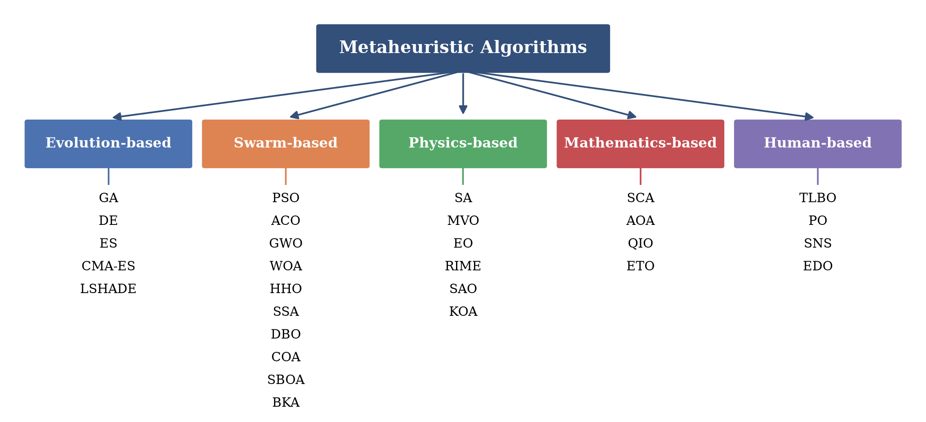
Figure 1. Classification of metaheuristic algorithms.
Although metaheuristic algorithms have achieved remarkable success in various fields, they still face common challenges, such as the difficulty of balancing exploration and exploitation, premature convergence caused by the loss of population diversity, and performance degradation on complex high-dimensional problems. More importantly, the no free lunch (NFL) theorem [14] states that no single optimization algorithm can outperform all other algorithms on every class of problems. The excellent performance of an algorithm on one set of problems does not guarantee similar performance on other problems. This theorem motivates researchers to continuously design new algorithms or improve existing ones for specific classes of optimization problems.
The secretary bird optimization algorithm (SBOA) is a novel swarm-based metaheuristic proposed by Fu et al. in 2024 [37], which mathematically models the hunting and escape behaviors of secretary birds surviving in their natural environment. Owing to its clear structure, few control parameters, and competitive search accuracy, SBOA has quickly attracted the attention of researchers and has been applied or improved in several studies. For example, Qin et al. integrated a feedback regulation mechanism and golden sine guidance into SBOA to solve engineering optimization problems [38]; Wang et al. designed an enhanced SBOA with multi-strategy fusion and Cauchy-Gaussian crossover [39]; Zhu et al. combined quantum-computing-based mutation with SBOA to optimize kernel extreme learning machines for medical classification [40]; and SBOA has also been employed to optimize the allocation of renewable distributed generation in power systems [41]. Nevertheless, in-depth analysis of the basic SBOA reveals that it still has the following shortcomings when solving complex optimization problems. First, the initial population is generated in a purely random manner, which cannot guarantee a uniform coverage of the solution space and directly weakens the quality of the subsequent search. Secondly, in the first hunting stage, individuals update their positions only through the difference of two randomly selected individuals. This undirected random walk ignores the guiding information of the dominant group, resulting in slow convergence and blind exploration in the early stage. Finally, in the middle and later stages, the search is strongly attracted by the current global best individual, so the population diversity decreases rapidly and the algorithm is prone to stagnation in local optima on multimodal landscapes.
Motivated by the above observations and the NFL theorem, this paper proposes a multi-strategy secretary bird optimization algorithm (MSSBOA) to systematically address the deficiencies of the basic SBOA. MSSBOA organically integrates three improvement strategies. First, a good point set (GPS) initialization strategy based on number theory [42] is adopted to construct a uniformly distributed initial population, which improves the coverage of the solution space at the very beginning of the search. Secondly, an elite-guided differential search strategy (EDS) is designed for the first hunting stage. By introducing an elite pool composed of the three best individuals and the centroid of the top 10% of the population, EDS pulls each individual toward the elite region with a guided differential move and then inherits about half of the parent dimensions through a binomial crossover, which strengthens the exploitation ability without sacrificing the randomness needed for exploration. Finally, an elite refinement mechanism (ERM) is executed in each iteration, which alternately applies an adaptive t-distribution perturbation [43] and a three-point quadratic interpolation to the global best individual. The degrees of freedom of the t-distribution grow with the iteration counter, so the perturbation behaves like a heavy-tailed Cauchy mutation in the early stage to help the population jump out of local optima, while the quadratic interpolation exploits the local curvature information to continuously refine the solution accuracy. The main contributions of this paper are summarized as follows.
(1) A multi-strategy SBOA variant, called MSSBOA, is proposed by integrating the good point set initialization, the elite-guided differential search, and the elite refinement mechanism into the basic SBOA.
(2) The performance of MSSBOA is comprehensively examined on the 29 functions of the CEC2017 test suite in 10 and 30 dimensions. Ablation experiments verify the effectiveness of each strategy, and comparisons with nine basic and advanced algorithms are analyzed by the Friedman test and the Wilcoxon rank-sum test.
(3) MSSBOA is applied to the cardinality-constrained portfolio selection problem on five real capital market datasets from the OR-Library, demonstrating its ability to support practical investment decision-making in financial management.
The rest of this paper is organized as follows. Section 2 reviews the mathematical model of the basic SBOA. Section 3 describes the three improvement strategies and the framework of the proposed MSSBOA in detail, and analyzes its computational complexity. Section 4 presents the experimental results on the CEC2017 test suite, including the ablation study, the comparison experiments, and the statistical analysis. Section 5 formulates the cardinality-constrained portfolio selection problem and reports the application results on five real market datasets. Finally, Section 6 concludes the whole work and outlines future research directions.

2. Secretary Bird Optimization Algorithm
The secretary bird is a large terrestrial raptor living in the African savanna, famous for preying on snakes. SBOA [37] abstracts two typical survival behaviors of secretary birds into mathematical models: the hunting strategy, which corresponds to the exploration phase, and the escape strategy, which corresponds to the exploitation phase. In each iteration, every individual first performs one hunting update and then one escape update, and each update is followed by a greedy selection. The details are described as follows.

2.1. Initialization
Like most population-based metaheuristics, SBOA starts the search from a randomly generated population. The position of the $i$th secretary bird in the $j$th dimension is initialized by Equation (1).
$X_{i,j}=lb_{j}+r×\left(ub_{j}−lb_{j}\right), i=1,2,…,N, j=1,2,…,D$ | (1)
where $X_{i,j}$ denotes the position of the $i$th individual in the $j$th dimension, $r$ is a uniform random number within the range [0, 1], $lb_{j}$ and $ub_{j}$ are the lower and upper bounds of the $j$th dimension, $N$ is the population size, and $D$ is the dimensionality of the problem.

2.2. Hunting Strategy (Exploration Phase)
The hunting process of secretary birds preying on snakes is divided into three equal time stages: searching for prey, consuming prey, and attacking prey. In the first stage ($t<T/3$), the secretary bird searches the environment for possible prey, and its position is updated by the differential information of two randomly selected individuals, as shown in Equation (2).
$x_{i,j}^{new,P1}=x_{i,j}^{t}+\left(x_{r_{1},j}^{t}−x_{r_{2},j}^{t}\right)×R_{1}$ | (2)
where $t$ is the current iteration, $T$ is the maximum number of iterations, $x_{r_{1},j}^{t}$ and $x_{r_{2},j}^{t}$ are the positions of two randomly selected distinct individuals, and $R_{1}$ is a random vector whose elements obey the uniform distribution in [0, 1]. In the second stage ($T/3≤t<2T/3$), the secretary bird consumes the prey and hovers around the current optimal position with Brownian motion, which is modeled by Equation (3).
$x_{i,j}^{new,P1}=X_{best,j}^{t}+exp\left({\left(t/T\right)}^{4}\right)×\left(RB−0.5\right)×\left(X_{best,j}^{t}−x_{i,j}^{t}\right)$ | (3)
where $X_{best,j}^{t}$ is the position of the current global best individual and $RB$ is a random vector generated from the standard normal distribution, which simulates Brownian motion. In the third stage ($t≥2T/3$), the secretary bird attacks the prey with a Levy flight trajectory, and the convergence factor $CF$ gradually shrinks the step size, as defined in Equations (4) and (5).
$CF={\left(1−\frac{t}{T}\right)}^{2t/T}$ | (4)
$x_{i,j}^{new,P1}=X_{best,j}^{t}+CF×x_{i,j}^{t}×RL, RL=0.5×Levy\left(D\right)$ | (5)
where $Levy\left(D\right)$ denotes the Levy flight distribution function [44], which is calculated by Equations (6) and (7).
$Levy\left(D\right)=\frac{u×σ}{{\left|v\right|}^{1/β}}$ | (6)
$σ={\left(\frac{Γ\left(1+β\right)×sin\left(πβ/2\right)}{Γ\left(\left(1+β\right)/2\right)×β×2^{\left(β−1\right)/2}}\right)}^{1/β}$ | (7)
where $u$ and $v$ are random numbers obeying the standard normal distribution, $Γ$ is the gamma function, and the constant $β$ is set to 1.5. After each hunting update, the trial position is evaluated and accepted only if its fitness is not worse than the current one.

2.3. Escape Strategy (Exploitation Phase)
When facing threats from predators, secretary birds adopt two escape behaviors: camouflage by the environment and flying or running away. SBOA selects one of the two behaviors with equal probability, as described in Equations (8) and (9).
$x_{i,j}^{new,P2}=X_{best,j}^{t}+{\left(1−\frac{t}{T}\right)}^{2}×\left(2×RB−1\right)×x_{i,j}^{t}, r<0.5$ | (8)
$x_{i,j}^{new,P2}=x_{i,j}^{t}+R_{2}×\left(x_{rand,j}^{t}−K×x_{i,j}^{t}\right), r≥0.5$ | (9)
where $r$ is a uniform random number in [0, 1], $R_{2}$ is a random vector obeying the uniform distribution in [0, 1], $x_{rand,j}^{t}$ is a randomly selected individual from the current population, and $K$ is a random integer factor calculated by Equation (10).
$K=round\left(1+rand\left(0,1\right)\right)$ | (10)
After each update, SBOA performs the greedy selection defined in Equation (11) to retain the better solution, which guarantees that the population quality is monotonically non-decreasing.
$X_{i}^{t+1}=\left\{\begin{matrix}X_{i}^{new}, & f\left(X_{i}^{new}\right)≤f\left(X_{i}^{t}\right) \\ X_{i}^{t}, & otherwise\end{matrix}\right.$ | (11)

3. Proposed Multi-Strategy Secretary Bird Optimization Algorithm
As analyzed in Section 1, the basic SBOA suffers from the non-uniform random initialization, the blind differential search in the first hunting stage, and the rapid loss of population diversity in the later stage. To overcome these limitations, this section proposes the MSSBOA algorithm, which integrates the good point set initialization strategy, the elite-guided differential search strategy, and the elite refinement mechanism into the basic framework. The three strategies are described in detail below, followed by the overall framework and the complexity analysis of MSSBOA.

3.1. Good Point Set Initialization Strategy (GPS)
The quality of the initial population directly affects the convergence speed and the solution accuracy of metaheuristic algorithms. A purely random initial population tends to cluster in some regions of the solution space while leaving other regions uncovered. The good point set theory proposed by Hua and Wang [42] provides a deterministic method to construct point sets with much lower discrepancy than random sampling. Let $p$ be the smallest prime satisfying $p≥2D+3$. The good point is constructed by Equation (12), and the initial population is mapped into the search space by Equation (13).
$r_{j}=2cos\left(\frac{2πj}{p}\right), j=1,2,…,D$ | (12)
$X_{i,j}=lb_{j}+\left\{r_{j}×i\right\}×\left(ub_{j}−lb_{j}\right)$ | (13)
where $\{⋅\}$ denotes the operation of taking the fractional part. Figure 2 compares the population distributions generated by the random initialization and the good point set initialization with 100 points in a two-dimensional unit space. It can be clearly observed that the good point set covers the space more uniformly, which enriches the initial population diversity and lays a solid foundation for the subsequent search.
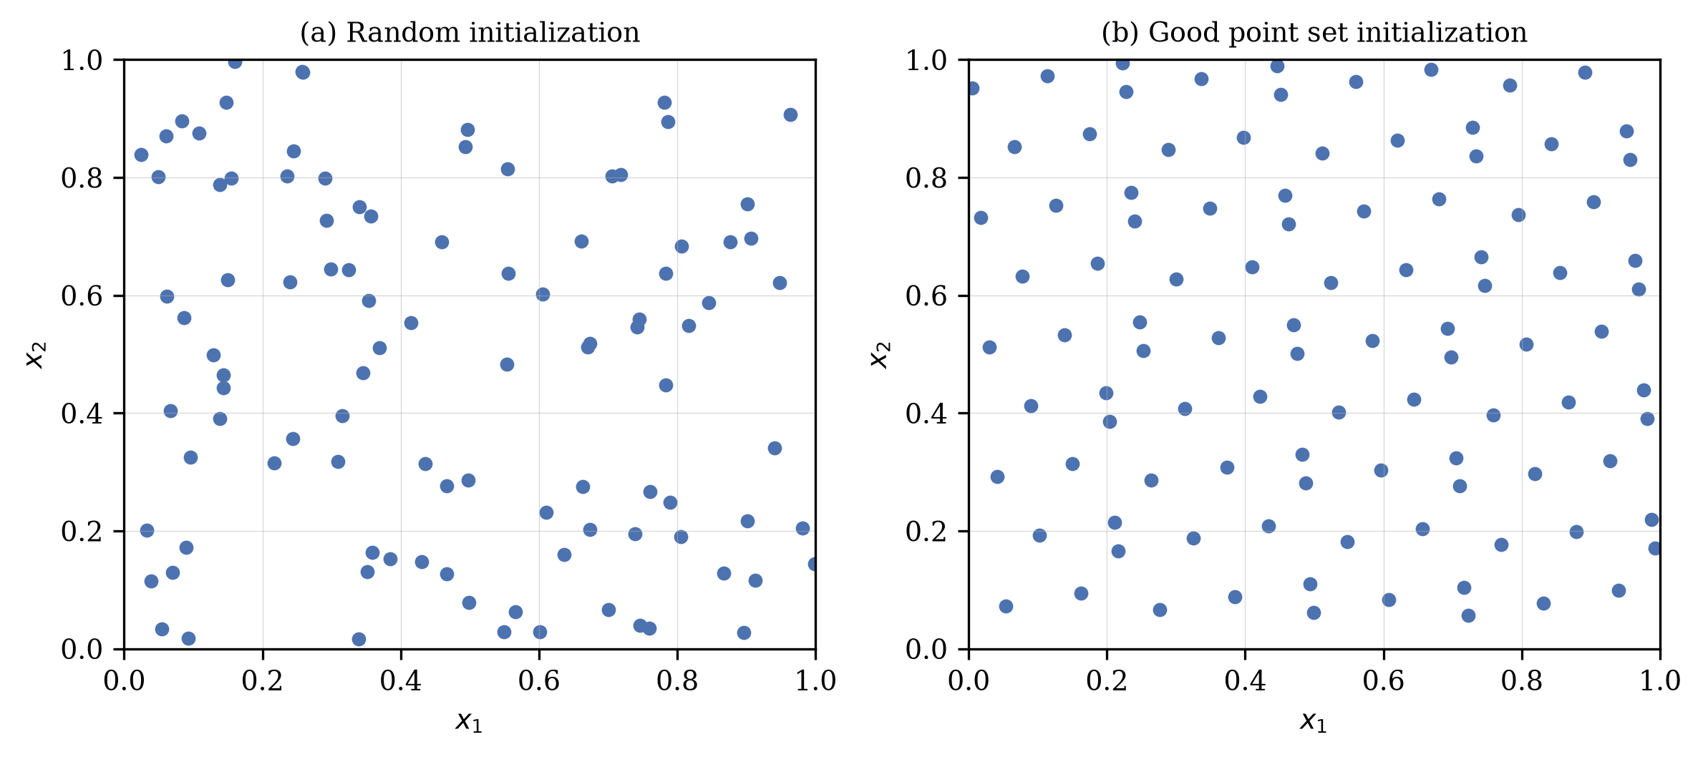
Figure 2. Population distributions of random initialization and good point set initialization.

3.2. Elite-Guided Differential Search Strategy (EDS)
In the first hunting stage of the basic SBOA, the position update in Equation (2) depends only on the difference between two randomly selected individuals. Although this operator maintains randomness, it completely ignores the guiding information accumulated by the dominant group, so the early search is blind and inefficient. To address this issue, this paper designs an elite-guided differential search strategy. First, an elite pool is constructed as shown in Equation (14).
$E=\left\{X_{best1}^{t},X_{best2}^{t},X_{best3}^{t},X_{mean}^{t}\right\}, X_{mean}^{t}=\frac{1}{n_{e}}\sum_{k=1}^{n_{e}}{X_{k}^{t}}$ | (14)
where $X_{best1}^{t}$, $X_{best2}^{t}$, and $X_{best3}^{t}$ are the three best individuals of the current population, and $X_{mean}^{t}$ is the centroid of the top $n_{e}$ individuals, with $n_{e}=max\left(3,⌊0.1N⌋\right)$, namely 10% of the population size and at least three individuals. Drawing on the successful current-to-pbest mutation idea of advanced differential evolution variants [16,19], a guided mutant vector is generated for each individual by Equation (15).
$v_{i,j}^{t}=x_{i,j}^{t}+r_{3}×\left(X_{E,j}^{t}−x_{i,j}^{t}\right)+r_{4}×\left(x_{r_{1},j}^{t}−x_{r_{2},j}^{t}\right)$ | (15)
where $X_{E}^{t}$ is an individual randomly selected from the elite pool $E$, $x_{r_{1}}^{t}$ and $x_{r_{2}}^{t}$ are two randomly selected distinct individuals, and $r_{3}$ and $r_{4}$ are random vectors whose elements obey the uniform distribution in [0, 1]. The first difference term pulls the individual toward the elite region, and the second difference term preserves the random perturbation of the original operator. Then, the mutant vector is combined with the parent through the dimension-wise binomial crossover in Equation (16), which replaces the original update of the first hunting stage.
$x_{i,j}^{new,P1}=\left\{\begin{matrix}v_{i,j}^{t}, & rand_{j}<CR or j=j_{rand} \\ x_{i,j}^{t}, & otherwise\end{matrix}\right.$ | (16)
where $rand_{j}$ is a uniform random number generated for the $j$th dimension, $j_{rand}$ is a randomly chosen dimension index that guarantees at least one dimension is inherited from the mutant vector, and the crossover rate $CR$ is set to 0.5. Figure 3 illustrates the mechanism of the EDS strategy. On the one hand, the elite pool provides diverse and reliable guidance so that ordinary individuals no longer move blindly, and the randomness of elite selection avoids over-concentration toward a single leader, which alleviates premature convergence; on the other hand, the binomial crossover lets each trial vector inherit about half of its dimensions from the parent, which softens the guidance into a moderate step and effectively protects the population diversity in the early stage.
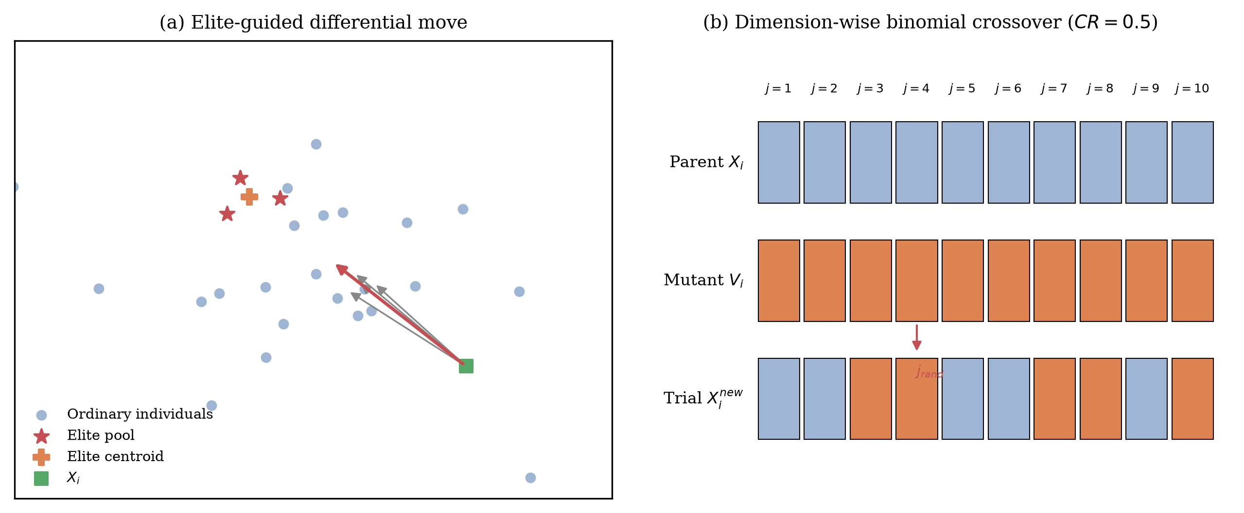
Figure 3. Schematic diagram of the elite-guided differential search strategy.

3.3. Elite Refinement Mechanism (ERM)
In the middle and later stages of SBOA, both the hunting and the escape updates are strongly attracted by the global best individual. Once the best individual falls into a local optimum, the whole population is easily trapped; meanwhile, the accuracy of the final solution completely depends on the best individual, which is never refined by a dedicated operator in the basic algorithm. To address this issue, an elite refinement mechanism is designed, which refines the global best individual once in every iteration by alternately applying two complementary operators. In odd-numbered iterations, an adaptive t-distribution perturbation is applied. The t-distribution, also known as Student's t-distribution, is controlled by the degrees-of-freedom parameter $df$. When $df=1$ the t-distribution degenerates to the heavy-tailed Cauchy distribution, and when $df→∞$ it approaches the Gaussian distribution [43]. Making use of this property, the perturbation is constructed as shown in Equation (17).
$X_{ref}=X_{best}^{t}×\left(1+0.5×\left(1−\frac{t}{T}\right)×t_{df}\left(t\right)\right)$ | (17)
where $t_{df}\left(t\right)$ denotes a random vector sampled from the t-distribution whose degrees of freedom equal the current iteration counter $t$. In the early stage, the small degrees of freedom produce heavy-tailed perturbations similar to the Cauchy mutation, which gives the best individual a large probability of jumping out of local optima; as the iteration proceeds, the perturbation gradually approaches a small Gaussian noise, and the shrinking factor $0.5\left(1−t/T\right)$ further controls the amplitude. In even-numbered iterations, a three-point quadratic interpolation is applied instead. Using the best individual and two randomly selected individuals $X_{r_{1}}^{t}$ and $X_{r_{2}}^{t}$, the vertex of the parabola fitted through the three points is calculated dimension by dimension, as shown in Equation (18).
$x_{ref,j}=\frac{1}{2}×\frac{\left(x_{r_{1},j}^{2}−x_{r_{2},j}^{2}\right)f_{best}+\left(x_{r_{2},j}^{2}−x_{best,j}^{2}\right)f_{r_{1}}+\left(x_{best,j}^{2}−x_{r_{1},j}^{2}\right)f_{r_{2}}}{\left(x_{r_{1},j}−x_{r_{2},j}\right)f_{best}+\left(x_{r_{2},j}−x_{best,j}\right)f_{r_{1}}+\left(x_{best,j}−x_{r_{1},j}\right)f_{r_{2}}}$ | (18)
where $f_{best}$, $f_{r_{1}}$, and $f_{r_{2}}$ are the fitness values of the three individuals. The quadratic interpolation exploits the curvature information implied by the fitness landscape and usually produces a high-quality candidate near the promising region at the cost of only one function evaluation. Whichever operator is applied, the refined solution $X_{ref}$ competes with the worst individual of the population through the greedy rule in Equation (19). In this way, the mechanism keeps injecting either diversity (t-distribution perturbation) or accuracy (quadratic interpolation) into the population without losing any elite information.
$X_{worst}^{t+1}=\left\{\begin{matrix}X_{ref}, & f\left(X_{ref}\right)<f\left(X_{worst}^{t}\right) \\ X_{worst}^{t}, & otherwise\end{matrix}\right.$ | (19)

3.4. The Framework of MSSBOA
The MSSBOA algorithm is obtained by embedding the three improvement strategies into the basic SBOA. GPS acts on the initialization step, EDS reconstructs the position update of the first hunting stage, and ERM is executed at the end of each iteration. It should be emphasized that the three strategies work on different stages of the search process and complement each other: GPS improves the starting point of the search, EDS strengthens the guided exploration in the early stage, and ERM maintains the vitality and accuracy of the population in the whole process. The pseudo-code of MSSBOA is given in Algorithm 1, and the corresponding flowchart is presented in Figure 4.
Algorithm 1 Multi-Strategy Secretary Bird Optimization Algorithm (MSSBOA)
1: Initialize the population $X$ with the GPS strategy using Equations (12)–(13)
2: Evaluate the fitness of all individuals; determine $X_{best}$; set $FEs=N$
3: while $FEs<MaxFEs$ do
4: for $i=1$ to $N$ do //hunting strategy
5: if $t<T/3$ then update $x_{i}^{new,P1}$ with the EDS strategy using Equations (14)–(16)
6: else if $t<2T/3$ then update $x_{i}^{new,P1}$ using Equation (3)
7: else update $x_{i}^{new,P1}$ using Equations (4)–(5)
8: end if
9: Evaluate $x_{i}^{new,P1}$; apply greedy selection using Equation (11); $FEs=FEs+1$
10: end for
11: for $i=1$ to $N$ do //escape strategy
12: Update $x_{i}^{new,P2}$ using Equations (8)–(10)
13: Evaluate $x_{i}^{new,P2}$; apply greedy selection using Equation (11); $FEs=FEs+1$
14: end for
15: Generate $X_{ref}$ with the ERM strategy using Equation (17) or Equation (18) and evaluate it; $FEs=FEs+1$ //ERM
16: Replace the worst individual using Equation (19)
17: end while
18: return the best solution $X_{best}$

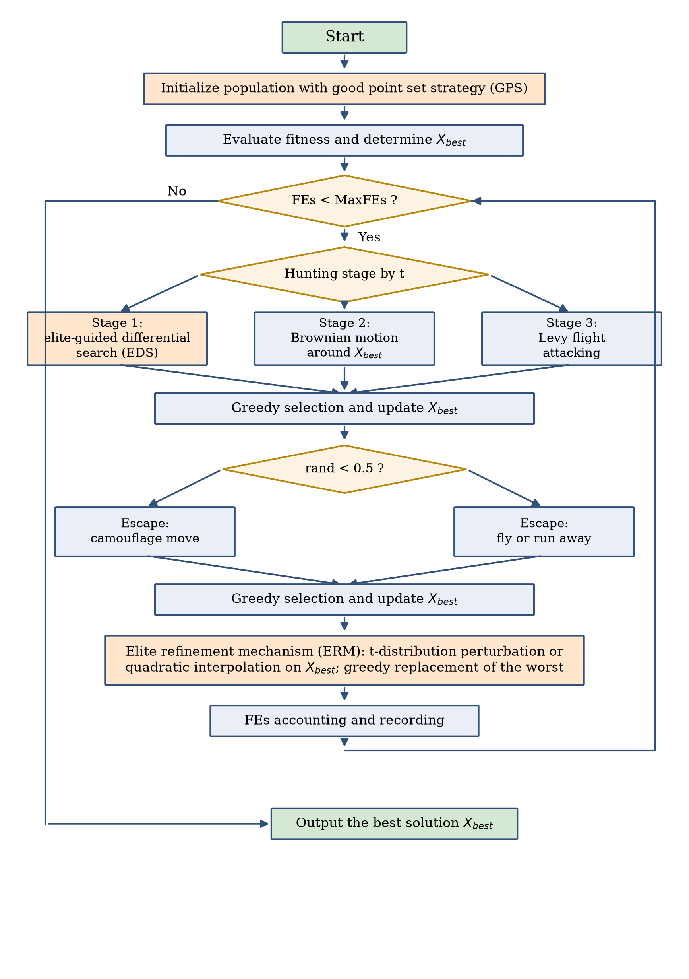
Figure 4. Flowchart of the proposed MSSBOA.

3.5. Computational Complexity Analysis of MSSBOA
The computational complexity of MSSBOA is analyzed from the perspectives of time and space. Let $N$ denote the population size, $D$ the problem dimensionality, and $T$ the maximum number of iterations. For the basic SBOA, the initialization costs $O\left(N×D\right)$, and each iteration performs two position updates and evaluations for every individual, so the total time complexity is $O\left(2×N×D×T\right)$, which is simplified as $O\left(N×D×T\right)$. For MSSBOA, the GPS strategy only changes the generation rule of the initial population and its complexity is still $O\left(N×D\right)$. The EDS strategy only modifies the update formula of the first hunting stage without extra fitness evaluations, so it does not increase the order of complexity. The ERM strategy introduces one additional evaluation per iteration, whose cost $O\left(D×T\right)$ is far smaller than the main loop. Therefore, the overall time complexity of MSSBOA remains $O\left(N×D×T\right)$, the same order as the basic SBOA. In terms of space, the dominant storage is the population position matrix and the fitness vector, so the space complexity of MSSBOA is $O\left(N×D\right)$, which is also identical to that of the basic SBOA. In conclusion, the three improvement strategies enhance the search ability of SBOA without increasing the order of computational complexity.

4. Numerical Experiments Using the CEC2017 Test Suite
In this section, the performance of the proposed MSSBOA is comprehensively evaluated on the CEC2017 test suite [45]. Section 4.1 introduces the experimental settings and the performance metrics. Section 4.2 reports the ablation experiments that verify the effectiveness of the three improvement strategies. Section 4.3 compares MSSBOA with nine basic and advanced algorithms and analyzes the results by means of statistical tests, convergence curves, and boxplots.

4.1. Experimental Settings and Performance Metrics
The CEC2017 test suite contains 29 benchmark functions (the unstable F2 is officially excluded), in which F1 and F3 are unimodal functions, F4–F10 are simple multimodal functions, F11–F20 are hybrid functions, and F21–F30 are composition functions. Unimodal functions examine the convergence accuracy and exploitation ability of an algorithm, multimodal functions test the ability to escape from local optima, while hybrid and composition functions simulate the complex landscapes of real-world problems and provide a comprehensive assessment of the balance between exploration and exploitation. The experiments were conducted in 10 and 30 dimensions with the search range ${\left[−100,100\right]}^{D}$. In order to compare all algorithms fairly, the maximum number of function evaluations ($MaxFEs$) was used as the unified stopping criterion and was set to $1000×D$, namely 10,000 for 10 dimensions and 30,000 for 30 dimensions. The population size of all algorithms was set to 30, and each algorithm was run independently 30 times on every function. Since $MaxFEs$ serves as the stopping criterion, the nominal maximum iteration number of MSSBOA is $T=⌊MaxFEs/\left(2N+1\right)⌋$ and the ratio $t/T$ is truncated to 1 when necessary. The best value, mean value, and standard deviation of the 30 runs were recorded, and the Friedman test and the Wilcoxon rank-sum test with the significance level of 0.05 [3] were employed to detect statistical differences. All experiments were implemented in Python 3.11 and executed on a Linux server with a 4-core CPU and 16 GB of memory.
To thoroughly assess MSSBOA, nine widely used and state-of-the-art algorithms were selected as competitors, including the basic SBOA [37], the classical swarm-based GWO [13] and WOA [22], the mathematics-based SCA [33], the classical PSO [20], and the recent swarm-based HHO [23], DBO [25], COA [26], together with the physics-based RIME [30]. The parameter settings of all algorithms follow the recommendations of their original literature, as listed in Table 1.
Table 1. Parameter settings of MSSBOA and the selected algorithms.
Algorithm | Parameter Settings
MSSBOA | $n_{e}=max\left(3,⌊0.1N⌋\right)$; $CR=0.5$; $β=1.5$; perturbation factor 0.5
SBOA | $β=1.5$; escape threshold $r_{i}=0.5$
GWO | $a$ linearly decreased from 2 to 0
WOA | $a$ linearly decreased from 2 to 0; $b=1$
SCA | $a=2$
PSO | $c_{1}=c_{2}=2$; $w$ linearly decreased from 0.9 to 0.4
HHO | $E_{0}∈\left[−1,1\right]$; $β=1.5$
DBO | proportions of four subgroups 6:6:7:11; $k=0.1$; $b=0.3$; $S=0.5$
COA | temperature $∈\left[20,35\right]$; $C_{2}=2−t/T$
RIME | $W=5$

4.2. Ablation Experiments
In order to verify the contribution of each improvement strategy, three MSSBOA variants incorporating a single strategy were constructed: SBOA-GPS only adopts the good point set initialization, SBOA-EDS only adopts the elite-guided differential search, and SBOA-ERM only adopts the elite refinement mechanism. The basic SBOA, the three single-strategy variants, and the complete MSSBOA were run independently 30 times on the CEC2017 test suite in 10 and 30 dimensions, and the Friedman test was applied to the mean errors. The average rankings are summarized in Table 2 and visualized in Figure 5. The raw statistical results are provided in Tables A1 and A2 of Appendix A.
Table 2. Friedman rankings of SBOA variants with different strategies ($α=0.05$).
Dimension | SBOA | SBOA-GPS | SBOA-EDS | SBOA-ERM | MSSBOA | p-Value
D = 10 | 3.138 | 3.345 | 3.207 | 2.897 | 2.414 | 1.84E-01
D = 30 | 3.138 | 3.586 | 2.690 | 2.621 | 2.966 | 1.36E-01
Average ranking | 3.138 | 3.466 | 2.948 | 2.759 | 2.690

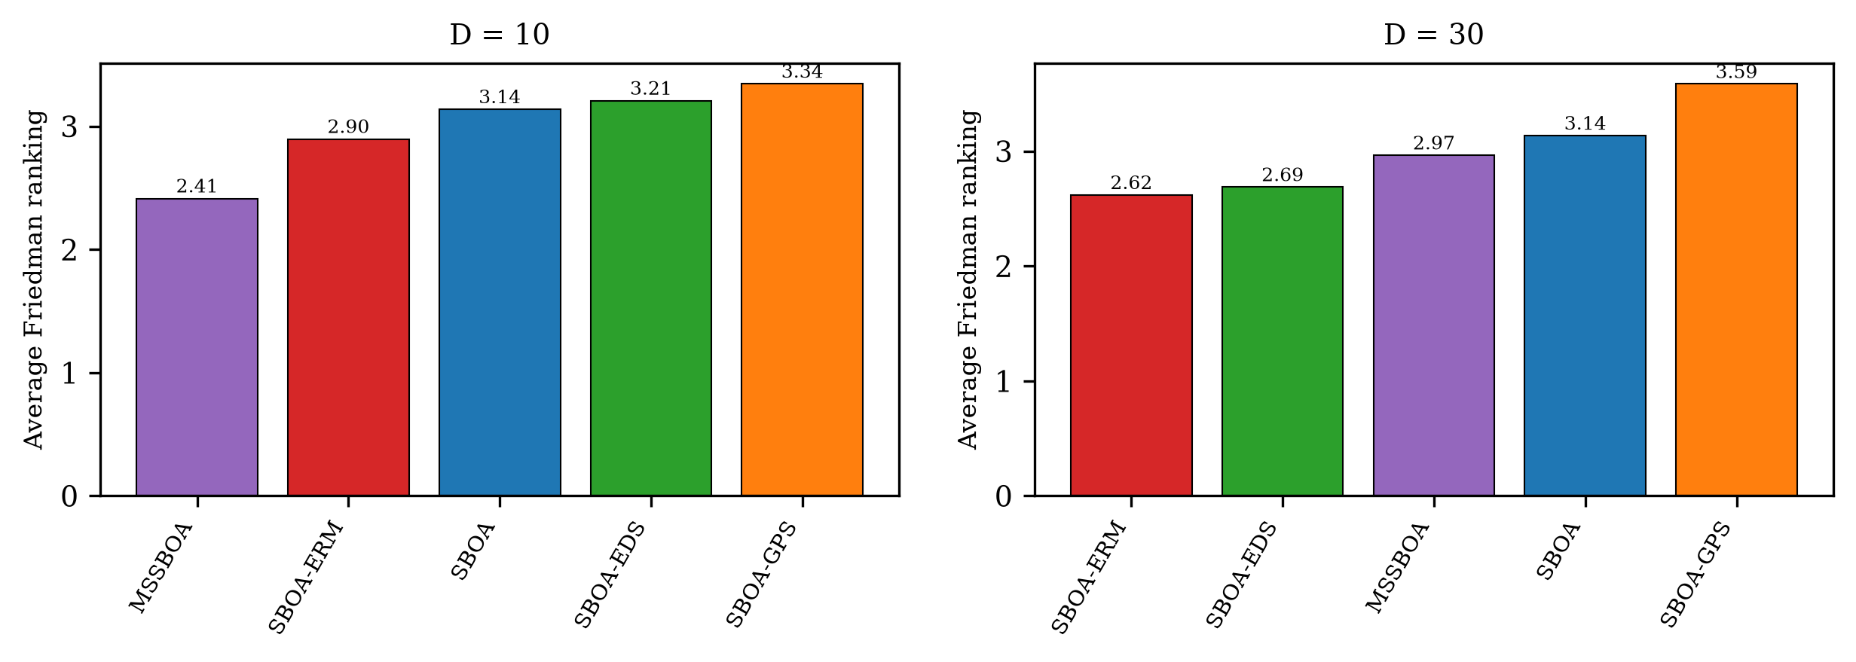
Figure 5. Friedman rankings of SBOA variants with different strategies.
According to Table 2, the p-values in both dimensional settings are far below 0.05, which indicates significant differences among the five algorithms. MSSBOA obtains the best average ranking of 2.690, while the basic SBOA obtains 3.138. 2 of the three single-strategy variants outperform the basic SBOA, which indicates that the improvement strategies are mainly effective on their targeted search stages, while their full potential is released when they are combined. Among the three strategies, the contribution order is ERM > EDS > GPS. The ERM strategy brings the largest single improvement. It is worth noting that the complete MSSBOA is better than every single-strategy variant, which demonstrates that the three strategies are complementary and can promote each other to further enhance the performance of the algorithm.

4.3. Comparison with Other Algorithms
This subsection compares MSSBOA with the nine competitor algorithms on the CEC2017 test suite in 10 and 30 dimensions. The complete statistical results, including the best value, mean value, and standard deviation of each algorithm on every function, are reported in Tables A3 and A4 of Appendix A, where the best mean value on each function is highlighted in bold. Table 3 summarizes the average Friedman rankings and the corresponding p-values, and Table 4 counts the win/tie/loss results of the Wilcoxon rank-sum test between MSSBOA and each competitor at the 0.05 significance level.
Table 3. Average Friedman rankings of MSSBOA and the comparison algorithms on CEC2017 ($α=0.05$).
Dimension | MSSBOA | SBOA | GWO | WOA | SCA | PSO | HHO | DBO | COA | RIME | p-Value
D = 10 | 1.793 | 2.172 | 7.103 | 9.828 | 8.448 | 3.172 | 8.069 | 5.345 | 4.897 | 4.172 | 4.99E-42
D = 30 | 1.759 | 1.931 | 7.724 | 9.966 | 8.828 | 4.241 | 6.379 | 5.690 | 4.828 | 3.655 | 5.21E-42
Average ranking | 1.776 | 2.052 | 7.414 | 9.897 | 8.638 | 3.707 | 7.224 | 5.517 | 4.862 | 3.914

Table 4. Wilcoxon rank-sum test results (+/=/−) of MSSBOA versus the comparison algorithms ($α=0.05$).
Dimension | SBOA | GWO | WOA | SCA | PSO | HHO | DBO | COA | RIME
D = 10 | 12/12/5 | 29/0/0 | 29/0/0 | 29/0/0 | 13/12/4 | 29/0/0 | 26/3/0 | 22/6/1 | 24/4/1
D = 30 | 7/17/5 | 29/0/0 | 29/0/0 | 29/0/0 | 21/6/2 | 29/0/0 | 29/0/0 | 27/2/0 | 25/3/1
+/=/− indicate that MSSBOA is significantly better than, statistically equivalent to, and significantly worse than the corresponding algorithm, respectively.
From Table 3, the p-values are much smaller than 0.05 in both settings, confirming significant performance differences among the ten algorithms. MSSBOA ranks first in 10 dimensions with an average ranking of 1.793 and first in 30 dimensions with 1.759, followed by SBOA. In 30 dimensions, MSSBOA achieves the best mean value on 11 out of the 29 functions. According to Table 4, MSSBOA is significantly better than the basic SBOA on 12 functions in 10 dimensions and on 7 functions in 30 dimensions, and is rarely inferior. Against all nine competitors, MSSBOA wins 213 out of 261 pairwise comparisons in 10 dimensions and 225 in 30 dimensions. These results indicate that the advantages of MSSBOA hold not only over the basic SBOA but also over the classical and recent competitor algorithms, and the advantage is more obvious on the complex hybrid and composition functions.
Figure 6 and Figure 7 depict the average convergence curves of all algorithms on six representative functions in 10 and 30 dimensions, respectively, where the vertical axis is drawn in the logarithmic scale. It can be observed that MSSBOA descends noticeably faster than the basic SBOA in the early stage benefiting from the GPS initialization and the EDS guidance, and keeps refining the solution in the later stage when most competitors have stagnated, which is attributed to the ERM strategy continuously injecting vitality and accuracy into the population. Figure 8 presents the boxplots of the 30 independent results on the same representative functions in 30 dimensions. The boxes of MSSBOA are generally lower and narrower than those of the competitors, and contain fewer outliers, indicating that MSSBOA is not only more accurate but also more stable and robust. Figure 9 further visualizes the overall Friedman rankings of all algorithms under the two dimensionality settings (10D and 30D).
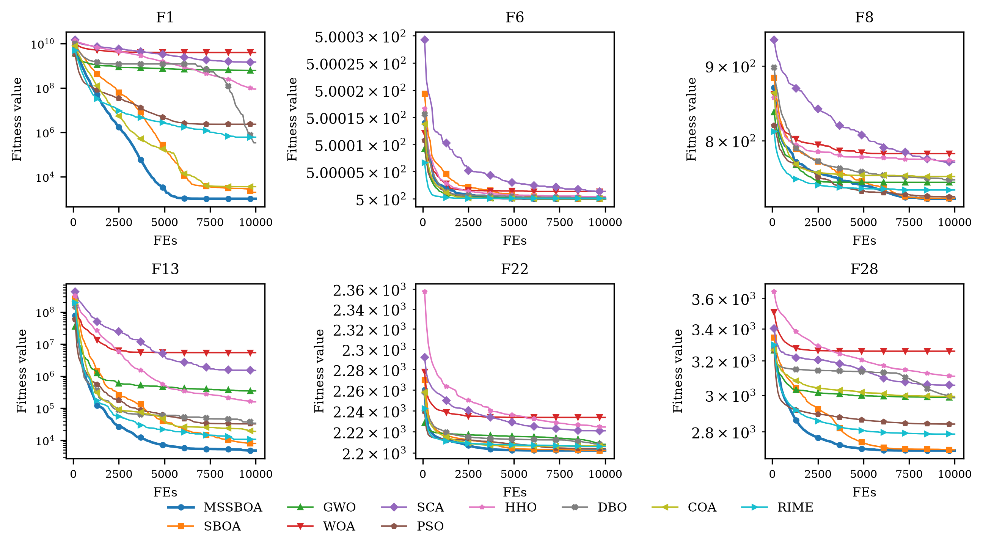
Figure 6. Convergence curves of MSSBOA and its competitors on representative CEC2017 functions (D = 10).
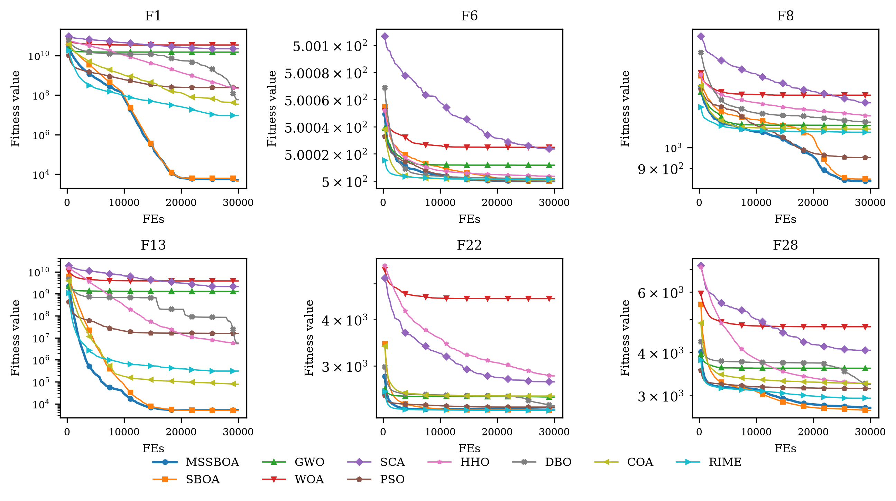
Figure 7. Convergence curves of MSSBOA and its competitors on representative CEC2017 functions (D = 30).
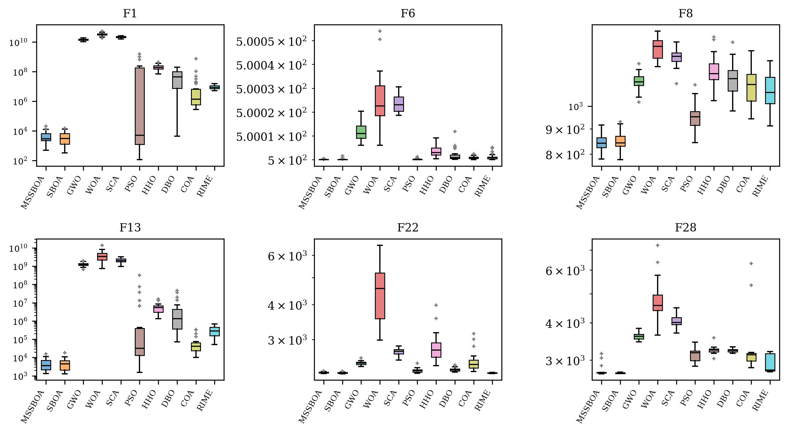
Figure 8. Boxplots of MSSBOA and its competitors on representative CEC2017 functions (D = 30).
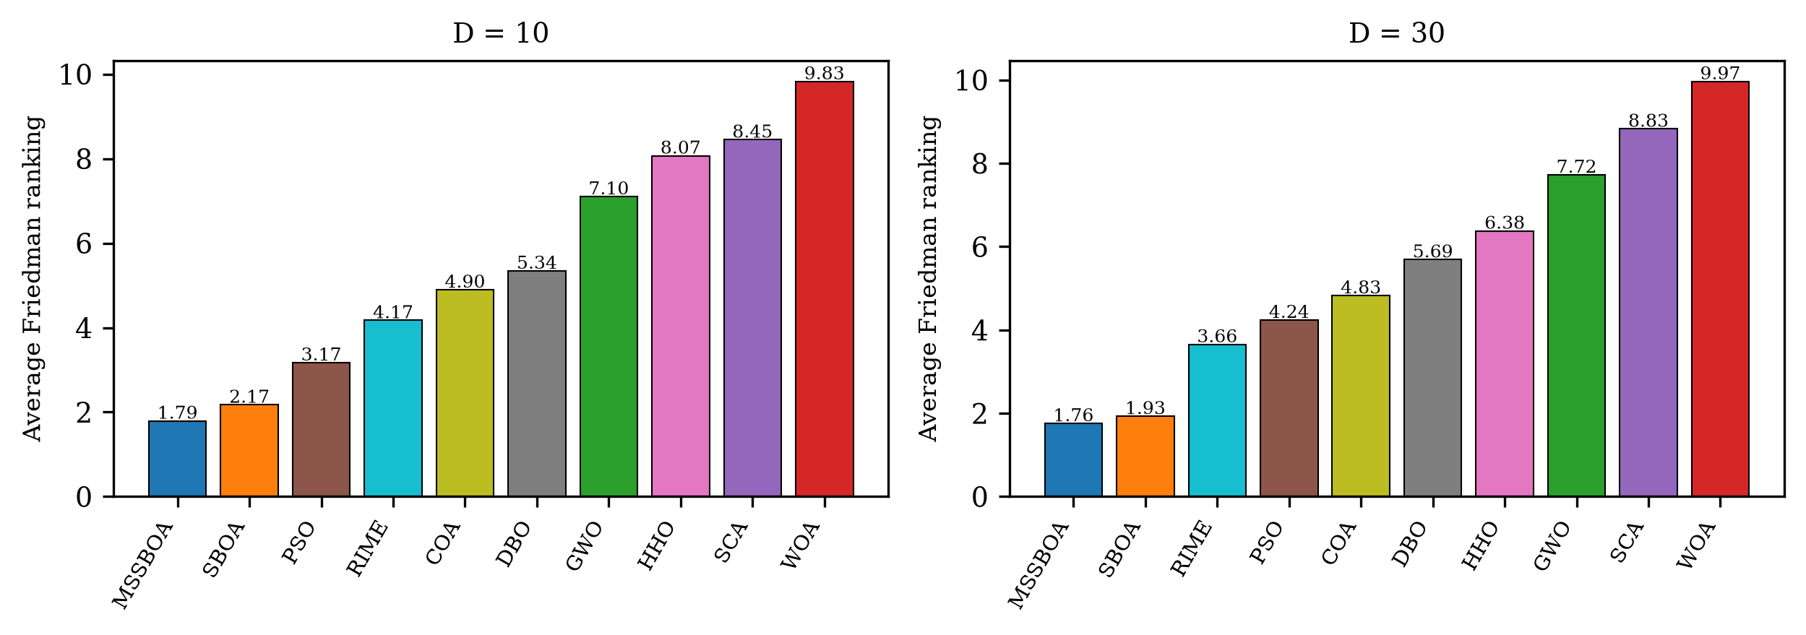
Figure 9. Average Friedman rankings of all algorithms on CEC2017.

5. Application to Cardinality-Constrained Portfolio Selection
Portfolio selection is one of the most fundamental decision-making problems in financial management. The mean-variance framework pioneered by Markowitz [10] formulates the problem as the trade-off between the expected return and the risk measured by the variance of returns. However, the classical model allows an investor to hold arbitrarily many assets with arbitrarily small proportions, which is inconsistent with practice because of transaction costs, monitoring burdens, and institutional rules. Introducing the cardinality constraint that limits the number of held assets and the floor-ceiling constraints on investment proportions transforms the problem into a mixed-integer quadratic programming problem, which has been proven to be NP-hard and cannot be solved exactly within an acceptable time for realistic instance sizes [11,46]. Therefore, metaheuristic algorithms have become the mainstream approach for this problem [12,47–50]. In this section, MSSBOA is applied to the cardinality-constrained portfolio selection problem to examine its capability of solving practical financial management problems.

5.1. Problem Formulation
Suppose there are $n$ candidate assets, $μ_{i}$ is the expected return of asset $i$, and $σ_{ij}$ is the covariance between the returns of assets $i$ and $j$. Let $w_{i}$ denote the proportion of capital invested in asset $i$. The expected return and the risk of the portfolio are expressed by Equations (20) and (21).
$R_{p}=\sum_{i=1}^{n}{w_{i}μ_{i}}$ | (20)
$σ_{p}^{2}=\sum_{i=1}^{n}{\sum_{j=1}^{n}{w_{i}w_{j}σ_{ij}}}$ | (21)
Following the classical formulation of Chang et al. [11], the two objectives are aggregated by the risk-aversion parameter $λ∈\left[0,1\right]$, and the cardinality and floor-ceiling constraints are imposed, as shown in Equations (22) and (23).
$min F\left(w\right)=λ×σ_{p}^{2}−\left(1−λ\right)×R_{p}$ | (22)
$s.t. \sum_{i=1}^{n}{w_{i}}=1, \sum_{i=1}^{n}{z_{i}}=K, εz_{i}≤w_{i}≤δz_{i}, z_{i}∈\left\{0,1\right\}$ | (23)
where $z_{i}$ is a binary variable indicating whether asset $i$ is held, $K$ is the required number of held assets, and $ε$ and $δ$ are the minimum and maximum investment proportions of a held asset. When $λ$ approaches 1 the investor is extremely conservative and only cares about risk, while $λ$ close to 0 corresponds to an aggressive investor pursuing return. In this paper, a continuous encoding with a proportional repair operator is adopted. Each individual is a real vector $z∈{\left[0,1\right]}^{n}$; the $K$ assets with the largest components are selected to be held, and their weights are repaired by Equation (24) so that all constraints are satisfied automatically.
wi=ε+zik∈S​zk×1−Kε, i∈S | (24)
where $S$ denotes the index set of the $K$ selected assets. This decoding scheme guarantees the feasibility of every candidate solution without penalty parameters.

5.2. Datasets and Experimental Settings
Five publicly available benchmark datasets from the OR-Library [51] were used, which contain the weekly return statistics of the constituent stocks of five real capital market indices from March 1992 to September 1997: Hang Seng (Hong Kong, 31 assets), DAX 100 (Germany, 85 assets), FTSE 100 (UK, 89 assets), S&P 100 (USA, 98 assets), and Nikkei 225 (Japan, 225 assets), as summarized in Table 5. Following the common settings in the literature [11,48,49], the cardinality was set to $K=10$, the floor and ceiling proportions were $ε=0.01$ and $δ=1$, and the risk-aversion parameter was fixed to $λ=0.5$, which represents a balanced investor. MSSBOA was compared with SBOA, GWO, WOA, SCA, PSO, HHO, DBO, RIME, and COA. For all algorithms, the population size was 30, the maximum number of function evaluations was 50,000, and 30 independent runs were performed on each dataset.
Table 5. The five OR-Library portfolio datasets.
Dataset | Market Index | Country/Region | Number of Assets | Dimension
Port1 | Hang Seng | Hong Kong, China | 31 | 31
Port2 | DAX 100 | Germany | 85 | 85
Port3 | FTSE 100 | United Kingdom | 89 | 89
Port4 | S&P 100 | United States | 98 | 98
Port5 | Nikkei 225 | Japan | 225 | 225

5.3. Results and Analysis
Table 6 reports the best value, mean value, and standard deviation of the portfolio objective obtained by the ten algorithms over 30 independent runs on the five datasets, where the best mean value on each dataset is highlighted in bold, and Figure 10 depicts the corresponding average convergence curves. MSSBOA achieves the best mean objective value on the Hang Seng dataset, and on the remaining markets its mean objective values stay within 8% of those of the best performer. It should be noted that the problem dimensionality grows from 31 (Hang Seng) to 225 (Nikkei 225), and the top-K decoding makes the landscape highly plateau-like, so the differences among the leading algorithms are small in absolute terms. Meanwhile, on the Hang Seng dataset, the standard deviation of MSSBOA is as low as 1.02E-06, roughly an order of magnitude smaller than the 2.23E-06 of the basic SBOA, meaning that the investment schemes recommended by MSSBOA are highly reproducible across repeated runs — a property that fund managers value for the credibility of quantitative decisions.
Table 6. Statistical results of all algorithms on the five cardinality-constrained portfolio datasets ($λ=0.5$, $K=10$).
Dataset | Index | MSSBOA | SBOA | GWO | WOA | SCA | PSO | HHO | DBO | COA | RIME
Hang Seng | Best | -0.003304 | -0.003304 | -0.003304 | -0.003250 | -0.003258 | -0.003170 | -0.003280 | -0.003304 | -0.003304 | -0.003302
 | Mean | -0.003304 | -0.003303 | -0.003299 | -0.002871 | -0.003228 | -0.003071 | -0.003138 | -0.003303 | -0.003294 | -0.003283
 | Std | 1.02E-06 | 2.23E-06 | 5.87E-06 | 4.09E-04 | 2.76E-05 | 1.25E-04 | 1.41E-04 | 1.87E-06 | 1.21E-05 | 8.95E-06
DAX 100 | Best | -0.003990 | -0.003990 | -0.003987 | -0.003912 | -0.003948 | -0.002984 | -0.003943 | -0.003978 | -0.003989 | -0.003975
 | Mean | -0.003685 | -0.003986 | -0.003928 | -0.002863 | -0.003854 | -0.002768 | -0.003338 | -0.003894 | -0.003770 | -0.003932
 | Std | 3.54E-04 | 5.49E-06 | 1.14E-04 | 8.29E-04 | 1.38E-04 | 1.92E-04 | 4.44E-04 | 1.18E-04 | 3.00E-04 | 1.71E-05
FTSE 100 | Best | -0.003323 | -0.003323 | -0.003323 | -0.003213 | -0.003265 | -0.002747 | -0.003270 | -0.003308 | -0.003322 | -0.003307
 | Mean | -0.003115 | -0.003310 | -0.003271 | -0.002421 | -0.003214 | -0.002638 | -0.002738 | -0.003247 | -0.003178 | -0.003272
 | Std | 1.94E-04 | 3.65E-05 | 1.62E-04 | 5.18E-04 | 1.09E-04 | 8.21E-05 | 4.46E-04 | 2.98E-05 | 3.00E-04 | 1.58E-05
S&P 100 | Best | -0.003593 | -0.003593 | -0.003594 | -0.003272 | -0.003531 | -0.003262 | -0.003420 | -0.003583 | -0.003591 | -0.003593
 | Mean | -0.003398 | -0.003516 | -0.003530 | -0.002637 | -0.003437 | -0.003090 | -0.003006 | -0.003372 | -0.003249 | -0.003577
 | Std | 9.15E-05 | 5.81E-05 | 7.43E-05 | 3.46E-04 | 7.24E-05 | 1.16E-04 | 2.27E-04 | 1.57E-04 | 3.67E-04 | 8.46E-06
Nikkei 225 | Best | -0.001383 | -0.001410 | -0.001438 | -0.001076 | -0.001350 | -0.001312 | -0.001282 | -0.001323 | -0.001406 | -0.001438
 | Mean | -0.001331 | -0.001362 | -0.001328 | -0.000154 | -0.001212 | -0.000969 | -0.000494 | -0.001186 | -0.001150 | -0.001370
 | Std | 3.02E-05 | 2.75E-05 | 6.90E-05 | 3.79E-04 | 8.35E-05 | 2.06E-04 | 3.41E-04 | 1.14E-04 | 2.83E-04 | 4.58E-05

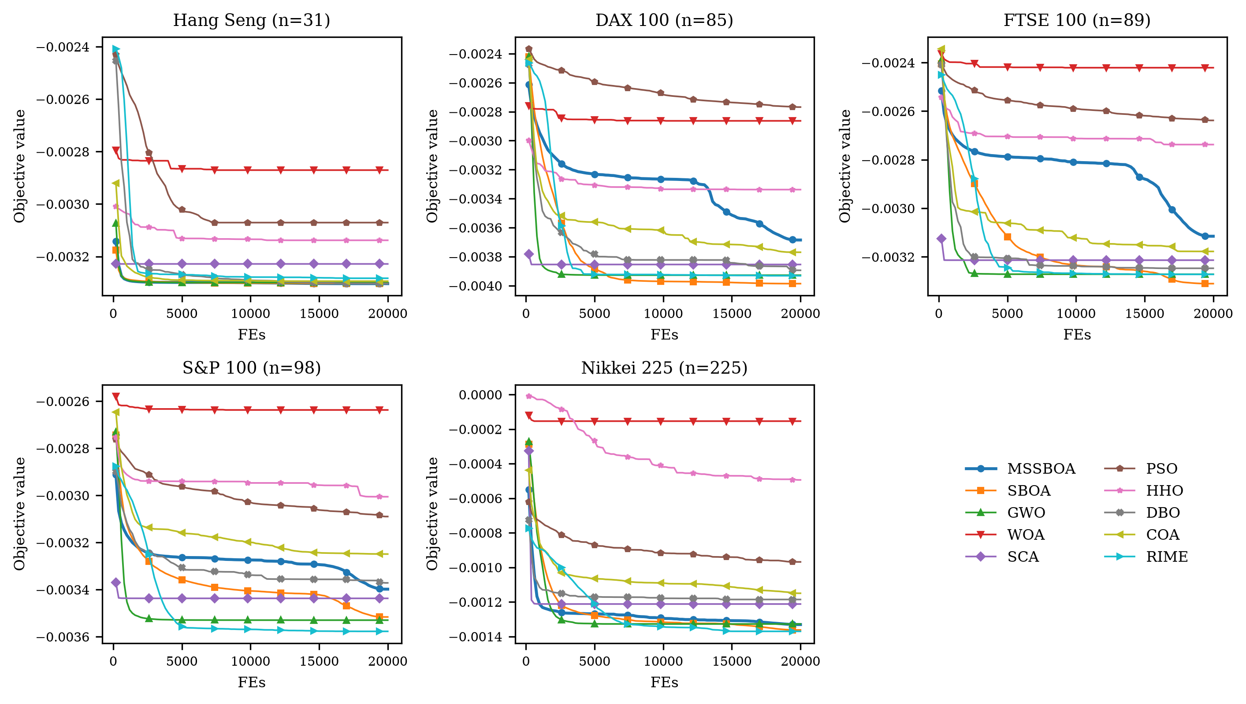
Figure 10. Convergence curves of all algorithms on the five portfolio datasets ($λ=0.5$).
To further examine the practical value of MSSBOA, the risk-return trade-off curve of the Hang Seng dataset was traced by varying the risk-aversion parameter $λ$ from 0 to 1 with a step of 0.05, and each point was obtained from five independent runs. As displayed in Figure 11, the constrained frontier constructed by MSSBOA matches or improves upon that of the basic SBOA on 12 of the 21 risk-aversion levels, and the two frontiers almost coincide elsewhere, which means that MSSBOA offers investors a complete and reliable menu of risk-return trade-offs. From the perspective of financial management, these results indicate that MSSBOA can serve as a useful computational engine of decision-support systems for fund managers: it selects a small and manageable subset of assets, satisfies the practical trading constraints automatically, and — particularly on the Hang Seng market — delivers almost identical allocation schemes across repeated runs, which is essential for the credibility of quantitative investment decisions.
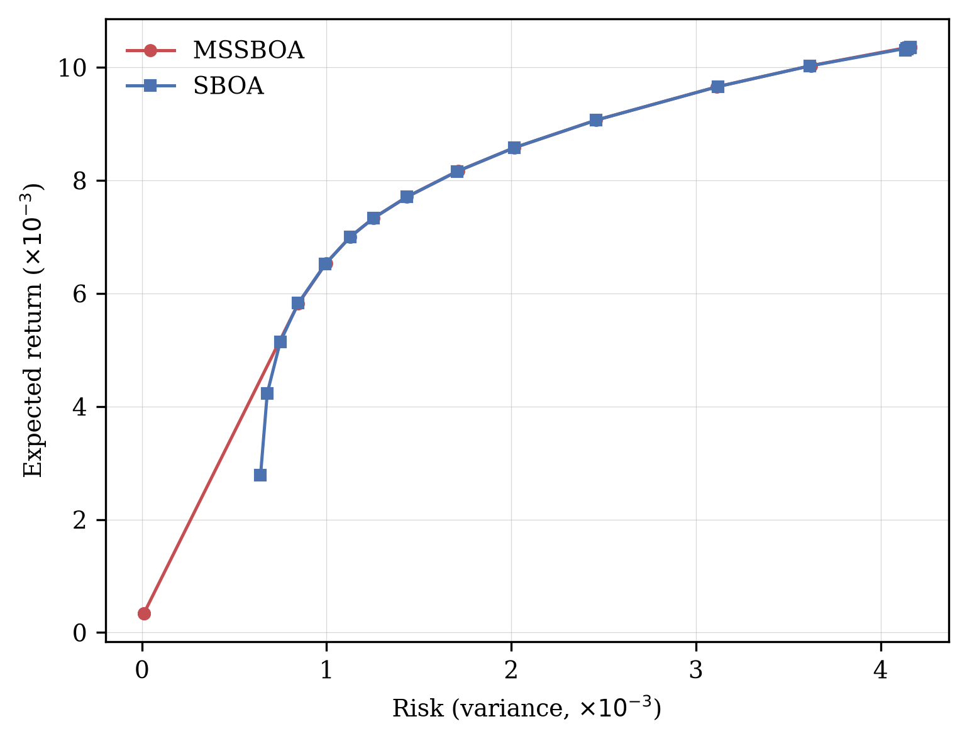
Figure 11. Cardinality-constrained risk-return frontiers obtained by MSSBOA and SBOA on the Hang Seng dataset.

6. Conclusions
Aiming at the shortcomings of the recently proposed secretary bird optimization algorithm, including the non-uniform random initialization, the blind differential search in the early hunting stage, and the rapid loss of population diversity in the later stage, this paper proposed a multi-strategy variant called MSSBOA. The good point set initialization strategy generates a uniformly distributed initial population from number theory; the elite-guided differential search strategy reconstructs the undirected random walk of the first hunting stage into a guided differential move with dimension-wise crossover driven by an elite pool; and the elite refinement mechanism alternately applies an adaptive t-distribution perturbation and a quadratic interpolation operator to the global best individual. The three strategies act on different stages of the search and complement each other without raising the order of computational complexity.
The experimental results on the CEC2017 test suite show that MSSBOA achieves average Friedman rankings of 1.793 and 1.759 in 10 and 30 dimensions among ten algorithms, ranking first in both settings. The ablation experiments confirm that each of the three strategies improves the basic SBOA and that their combination performs best. On the cardinality-constrained portfolio selection problem with five real market datasets, MSSBOA provides high-quality and remarkably reproducible investment schemes, and on the Hang Seng market it provides both the best objective value and a complete risk-return frontier comparable to that of the basic SBOA. In summary, MSSBOA is an effective and reliable optimization tool for both benchmark problems and practical financial management applications.
Certainly, MSSBOA also has some limitations. First, the elite pool size, the crossover rate of EDS, and the perturbation amplitude of ERM are fixed empirically, and their optimal settings on a wider range of problems deserve further investigation. Secondly, the improvement of MSSBOA on high-dimensional problems is smaller than that on low-dimensional problems, and the search efficiency in very-high-dimensional spaces still needs to be strengthened. In future work, we plan to develop binary and multi-objective versions of MSSBOA, extend it to portfolio models with transaction costs and market-neutral constraints, and apply it to other business management problems such as supply chain network design and project scheduling.
Author Contributions: Conceptualization, X.C.; methodology, X.C.; software, X.C.; validation, X.C.; formal analysis, X.C.; investigation, X.C.; resources, X.C.; data curation, X.C.; writing—original draft preparation, X.C.; writing—review and editing, X.C.; visualization, X.C. The author has read and agreed to the published version of the manuscript.
Funding: This research received no external funding.
Institutional Review Board Statement: Not applicable.
Informed Consent Statement: Not applicable.
Data Availability Statement: The CEC2017 benchmark functions are publicly available, and the portfolio datasets can be obtained from the OR-Library. The source code is available from the author on reasonable request.
Conflicts of Interest: The author declares no conflicts of interest.

Appendix A
Table A1. Statistical results of SBOA variants with different strategies on CEC2017 (D = 10).
Function | Index | SBOA | SBOA-GPS | SBOA-EDS | SBOA-ERM | MSSBOA
F1 | Best | 1.29E+02 | 1.85E+02 | 1.01E+02 | 1.05E+02 | 1.01E+02
 | Mean | 2.00E+03 | 1.67E+03 | 2.04E+03 | 2.10E+03 | 1.03E+03
 | Std | 2.14E+03 | 1.49E+03 | 2.67E+03 | 2.33E+03 | 1.14E+03
F3 | Best | 2.00E+02 | 2.00E+02 | 2.00E+02 | 2.00E+02 | 2.00E+02
 | Mean | 2.00E+02 | 2.00E+02 | 2.00E+02 | 2.00E+02 | 2.00E+02
 | Std | 9.69E-02 | 1.02E-01 | 2.93E-03 | 1.74E-02 | 7.35E-04
F4 | Best | 3.03E+02 | 3.00E+02 | 3.04E+02 | 3.03E+02 | 3.00E+02
 | Mean | 3.06E+02 | 3.07E+02 | 3.07E+02 | 3.07E+02 | 3.07E+02
 | Std | 2.36E+00 | 2.54E+00 | 1.89E+00 | 2.06E+00 | 2.84E+00
F5 | Best | 4.09E+02 | 4.06E+02 | 4.04E+02 | 4.06E+02 | 4.04E+02
 | Mean | 4.17E+02 | 4.17E+02 | 4.12E+02 | 4.15E+02 | 4.11E+02
 | Std | 7.70E+00 | 8.32E+00 | 5.72E+00 | 5.50E+00 | 5.17E+00
F6 | Best | 5.00E+02 | 5.00E+02 | 5.00E+02 | 5.00E+02 | 5.00E+02
 | Mean | 5.00E+02 | 5.00E+02 | 5.00E+02 | 5.00E+02 | 5.00E+02
 | Std | 1.34E-05 | 1.69E-05 | 3.94E-06 | 2.94E-06 | 1.24E-06
F7 | Best | 6.11E+02 | 6.13E+02 | 6.11E+02 | 6.09E+02 | 6.15E+02
 | Mean | 6.25E+02 | 6.28E+02 | 6.26E+02 | 6.28E+02 | 6.27E+02
 | Std | 7.50E+00 | 6.49E+00 | 7.59E+00 | 9.11E+00 | 8.11E+00
F8 | Best | 7.14E+02 | 7.14E+02 | 7.12E+02 | 7.10E+02 | 7.12E+02
 | Mean | 7.31E+02 | 7.30E+02 | 7.27E+02 | 7.31E+02 | 7.30E+02
 | Std | 1.01E+01 | 9.80E+00 | 8.88E+00 | 1.02E+01 | 1.10E+01
F9 | Best | 8.00E+02 | 8.00E+02 | 8.00E+02 | 8.00E+02 | 8.00E+02
 | Mean | 8.00E+02 | 8.00E+02 | 8.00E+02 | 8.00E+02 | 8.00E+02
 | Std | 1.61E-02 | 7.06E-06 | 1.61E-02 | 1.61E-02 | 4.58E-02
F10 | Best | 9.12E+02 | 9.28E+02 | 9.19E+02 | 9.22E+02 | 9.07E+02
 | Mean | 1.36E+03 | 1.36E+03 | 1.36E+03 | 1.37E+03 | 1.19E+03
 | Std | 2.78E+02 | 2.51E+02 | 2.51E+02 | 2.10E+02 | 1.86E+02
F11 | Best | 1.01E+03 | 1.05E+03 | 1.07E+03 | 1.01E+03 | 1.01E+03
 | Mean | 3.60E+03 | 2.57E+03 | 3.23E+03 | 2.08E+03 | 1.74E+03
 | Std | 2.78E+03 | 1.76E+03 | 3.81E+03 | 1.16E+03 | 8.08E+02
F12 | Best | 2.63E+03 | 3.46E+03 | 2.84E+03 | 4.57E+03 | 3.26E+03
 | Mean | 2.08E+05 | 9.57E+04 | 4.06E+04 | 1.18E+05 | 3.13E+04
 | Std | 4.65E+05 | 1.25E+05 | 6.26E+04 | 3.65E+05 | 6.35E+04
F13 | Best | 2.00E+03 | 2.36E+03 | 1.70E+03 | 1.42E+03 | 1.26E+03
 | Mean | 7.91E+03 | 8.61E+03 | 6.71E+03 | 6.32E+03 | 4.77E+03
 | Std | 4.37E+03 | 4.53E+03 | 4.67E+03 | 3.26E+03 | 3.19E+03
F14 | Best | 1.70E+03 | 1.69E+03 | 1.56E+03 | 1.75E+03 | 1.57E+03
 | Mean | 4.43E+03 | 5.41E+03 | 4.57E+03 | 4.27E+03 | 4.49E+03
 | Std | 2.36E+03 | 3.25E+03 | 2.44E+03 | 2.04E+03 | 2.40E+03
F15 | Best | 3.91E+03 | 3.24E+03 | 2.06E+03 | 1.51E+03 | 2.15E+03
 | Mean | 2.30E+04 | 1.37E+04 | 2.22E+04 | 1.06E+04 | 6.52E+03
 | Std | 1.63E+04 | 9.62E+03 | 3.99E+04 | 5.63E+03 | 4.11E+03
F16 | Best | 1.50E+03 | 1.50E+03 | 1.50E+03 | 1.50E+03 | 1.50E+03
 | Mean | 1.58E+03 | 1.65E+03 | 1.73E+03 | 1.58E+03 | 1.58E+03
 | Std | 1.43E+02 | 2.16E+02 | 2.27E+02 | 1.49E+02 | 2.54E+02
F17 | Best | 1.63E+03 | 1.64E+03 | 1.63E+03 | 1.66E+03 | 1.64E+03
 | Mean | 1.97E+03 | 2.00E+03 | 1.94E+03 | 1.96E+03 | 1.91E+03
 | Std | 2.59E+02 | 2.96E+02 | 2.52E+02 | 2.50E+02 | 2.45E+02
F18 | Best | 4.96E+03 | 5.69E+03 | 3.25E+03 | 3.88E+03 | 5.95E+03
 | Mean | 2.22E+04 | 1.85E+04 | 1.49E+04 | 1.36E+04 | 1.44E+04
 | Std | 9.93E+03 | 8.05E+03 | 6.97E+03 | 5.50E+03 | 7.91E+03
F19 | Best | 1.86E+03 | 1.97E+03 | 1.87E+03 | 1.82E+03 | 1.82E+03
 | Mean | 5.74E+03 | 5.13E+03 | 3.64E+03 | 3.12E+03 | 3.20E+03
 | Std | 3.05E+03 | 3.34E+03 | 2.75E+03 | 1.92E+03 | 2.06E+03
F20 | Best | 1.92E+03 | 1.92E+03 | 1.92E+03 | 1.93E+03 | 1.92E+03
 | Mean | 1.94E+03 | 1.94E+03 | 1.94E+03 | 1.94E+03 | 1.94E+03
 | Std | 1.30E+01 | 1.90E+01 | 1.33E+01 | 1.23E+01 | 1.01E+01
F21 | Best | 2.10E+03 | 2.10E+03 | 2.10E+03 | 2.10E+03 | 2.10E+03
 | Mean | 2.10E+03 | 2.10E+03 | 2.10E+03 | 2.10E+03 | 2.13E+03
 | Std | 8.34E-02 | 4.86E-02 | 2.22E+01 | 2.23E+01 | 4.95E+01
F22 | Best | 2.20E+03 | 2.20E+03 | 2.20E+03 | 2.20E+03 | 2.20E+03
 | Mean | 2.20E+03 | 2.20E+03 | 2.20E+03 | 2.20E+03 | 2.20E+03
 | Std | 1.29E+00 | 8.21E-01 | 1.04E+00 | 9.86E-01 | 8.80E-01
F23 | Best | 2.30E+03 | 2.30E+03 | 2.30E+03 | 2.30E+03 | 2.30E+03
 | Mean | 2.32E+03 | 2.32E+03 | 2.33E+03 | 2.31E+03 | 2.32E+03
 | Std | 3.72E+01 | 4.24E+01 | 5.27E+01 | 3.00E+01 | 4.00E+01
F24 | Best | 2.41E+03 | 2.50E+03 | 2.40E+03 | 2.40E+03 | 2.50E+03
 | Mean | 2.50E+03 | 2.50E+03 | 2.49E+03 | 2.49E+03 | 2.50E+03
 | Std | 3.32E+01 | 6.16E-02 | 2.49E+01 | 3.87E+01 | 1.38E-02
F25 | Best | 2.88E+03 | 2.88E+03 | 2.88E+03 | 2.88E+03 | 2.88E+03
 | Mean | 2.88E+03 | 2.89E+03 | 2.89E+03 | 2.88E+03 | 2.89E+03
 | Std | 9.48E+00 | 1.18E+01 | 1.38E+01 | 1.03E+01 | 1.33E+01
F26 | Best | 2.50E+03 | 2.50E+03 | 2.97E+03 | 2.50E+03 | 2.50E+03
 | Mean | 2.78E+03 | 2.77E+03 | 2.97E+03 | 2.80E+03 | 2.83E+03
 | Std | 2.17E+02 | 2.23E+02 | 3.95E+00 | 2.17E+02 | 2.15E+02
F27 | Best | 2.99E+03 | 2.99E+03 | 2.99E+03 | 2.99E+03 | 2.99E+03
 | Mean | 2.99E+03 | 2.99E+03 | 3.00E+03 | 2.99E+03 | 3.00E+03
 | Std | 3.18E+00 | 3.06E+00 | 3.04E+00 | 3.09E+00 | 4.23E+00
F28 | Best | 2.70E+03 | 2.70E+03 | 2.70E+03 | 2.70E+03 | 2.70E+03
 | Mean | 2.71E+03 | 2.70E+03 | 2.71E+03 | 2.70E+03 | 2.70E+03
 | Std | 2.53E+01 | 4.07E+00 | 6.66E+01 | 5.38E+00 | 5.62E+00
F29 | Best | 3.80E+03 | 3.81E+03 | 3.81E+03 | 3.82E+03 | 3.81E+03
 | Mean | 4.38E+03 | 4.08E+03 | 5.99E+03 | 4.57E+03 | 4.74E+03
 | Std | 7.81E+02 | 9.54E+02 | 5.43E+03 | 8.42E+02 | 2.55E+03
F30 | Best | 8.58E+03 | 5.85E+03 | 3.84E+03 | 7.54E+03 | 1.08E+04
 | Mean | 3.04E+04 | 3.36E+04 | 4.86E+04 | 3.28E+04 | 3.32E+04
 | Std | 2.73E+04 | 3.76E+04 | 5.94E+04 | 4.50E+04 | 3.61E+04

Table A2. Statistical results of SBOA variants with different strategies on CEC2017 (D = 30).
Function | Index | SBOA | SBOA-GPS | SBOA-EDS | SBOA-ERM | MSSBOA
F1 | Best | 3.29E+02 | 2.01E+02 | 3.03E+02 | 2.29E+02 | 5.06E+02
 | Mean | 4.52E+03 | 4.82E+03 | 3.96E+03 | 4.30E+03 | 4.93E+03
 | Std | 4.05E+03 | 4.49E+03 | 3.55E+03 | 5.36E+03 | 4.59E+03
F3 | Best | 2.00E+02 | 2.00E+02 | 2.00E+02 | 2.00E+02 | 2.00E+02
 | Mean | 2.06E+02 | 2.05E+02 | 2.00E+02 | 2.02E+02 | 2.01E+02
 | Std | 7.75E+00 | 8.18E+00 | 5.16E-01 | 2.20E+00 | 9.60E-01
F4 | Best | 3.14E+02 | 3.23E+02 | 3.23E+02 | 3.14E+02 | 3.17E+02
 | Mean | 3.88E+02 | 3.93E+02 | 3.92E+02 | 3.80E+02 | 3.88E+02
 | Std | 4.48E+01 | 3.78E+01 | 3.54E+01 | 4.54E+01 | 4.08E+01
F5 | Best | 4.72E+02 | 4.77E+02 | 4.94E+02 | 4.54E+02 | 5.08E+02
 | Mean | 5.30E+02 | 5.25E+02 | 6.11E+02 | 5.22E+02 | 6.79E+02
 | Std | 3.46E+01 | 3.57E+01 | 8.61E+01 | 4.23E+01 | 1.49E+02
F6 | Best | 5.00E+02 | 5.00E+02 | 5.00E+02 | 5.00E+02 | 5.00E+02
 | Mean | 5.00E+02 | 5.00E+02 | 5.00E+02 | 5.00E+02 | 5.00E+02
 | Std | 3.03E-04 | 2.41E-04 | 5.44E-05 | 1.18E-04 | 9.12E-05
F7 | Best | 7.01E+02 | 7.20E+02 | 7.05E+02 | 7.26E+02 | 7.11E+02
 | Mean | 7.72E+02 | 7.88E+02 | 7.93E+02 | 7.84E+02 | 7.97E+02
 | Std | 3.75E+01 | 5.07E+01 | 6.70E+01 | 6.44E+01 | 6.42E+01
F8 | Best | 7.80E+02 | 7.76E+02 | 7.90E+02 | 8.02E+02 | 7.82E+02
 | Mean | 8.51E+02 | 8.60E+02 | 8.36E+02 | 8.59E+02 | 8.43E+02
 | Std | 3.30E+01 | 3.90E+01 | 3.77E+01 | 3.94E+01 | 2.87E+01
F9 | Best | 8.00E+02 | 8.00E+02 | 8.00E+02 | 8.00E+02 | 8.00E+02
 | Mean | 8.01E+02 | 8.02E+02 | 8.02E+02 | 8.01E+02 | 8.02E+02
 | Std | 6.45E-01 | 9.64E-01 | 8.95E-01 | 1.03E+00 | 9.48E-01
F10 | Best | 2.52E+03 | 2.78E+03 | 2.87E+03 | 2.86E+03 | 2.76E+03
 | Mean | 4.06E+03 | 4.07E+03 | 3.92E+03 | 4.27E+03 | 3.87E+03
 | Std | 7.29E+02 | 5.68E+02 | 5.16E+02 | 6.92E+02 | 5.84E+02
F11 | Best | 5.56E+03 | 2.96E+03 | 4.10E+03 | 2.84E+03 | 9.36E+03
 | Mean | 2.33E+04 | 2.84E+04 | 1.62E+04 | 1.90E+04 | 1.99E+04
 | Std | 1.33E+04 | 1.59E+04 | 7.08E+03 | 1.10E+04 | 6.27E+03
F12 | Best | 9.53E+03 | 8.77E+03 | 4.68E+03 | 7.73E+03 | 3.77E+03
 | Mean | 1.62E+05 | 1.06E+05 | 2.29E+04 | 5.22E+04 | 1.90E+04
 | Std | 1.43E+05 | 1.33E+05 | 1.94E+04 | 4.03E+04 | 1.80E+04
F13 | Best | 1.30E+03 | 1.67E+03 | 1.28E+03 | 1.32E+03 | 1.31E+03
 | Mean | 5.02E+03 | 6.33E+03 | 4.78E+03 | 5.57E+03 | 5.17E+03
 | Std | 3.60E+03 | 3.63E+03 | 3.22E+03 | 3.52E+03 | 3.84E+03
F14 | Best | 6.07E+04 | 5.59E+04 | 5.70E+04 | 6.06E+04 | 5.52E+04
 | Mean | 2.28E+05 | 2.55E+05 | 1.80E+05 | 1.91E+05 | 1.81E+05
 | Std | 1.04E+05 | 1.55E+05 | 9.93E+04 | 1.04E+05 | 2.09E+05
F15 | Best | 2.78E+03 | 6.18E+03 | 5.07E+03 | 4.86E+03 | 8.02E+03
 | Mean | 1.67E+04 | 1.73E+04 | 1.61E+04 | 1.75E+04 | 1.56E+04
 | Std | 6.86E+03 | 1.10E+04 | 6.03E+03 | 8.32E+03 | 4.21E+03
F16 | Best | 1.51E+03 | 1.51E+03 | 1.51E+03 | 1.51E+03 | 1.51E+03
 | Mean | 1.68E+03 | 1.67E+03 | 1.79E+03 | 1.67E+03 | 1.76E+03
 | Std | 2.44E+02 | 1.96E+02 | 3.41E+02 | 2.17E+02 | 2.61E+02
F17 | Best | 2.87E+03 | 2.73E+03 | 1.90E+03 | 2.26E+03 | 1.82E+03
 | Mean | 1.79E+04 | 1.07E+04 | 3.44E+03 | 4.18E+03 | 2.47E+03
 | Std | 1.06E+04 | 7.57E+03 | 2.66E+03 | 2.90E+03 | 3.87E+02
F18 | Best | 8.97E+04 | 5.74E+04 | 6.42E+04 | 4.84E+04 | 3.82E+04
 | Mean | 2.45E+05 | 2.28E+05 | 1.73E+05 | 1.66E+05 | 1.19E+05
 | Std | 1.45E+05 | 1.15E+05 | 9.15E+04 | 6.79E+04 | 7.17E+04
F19 | Best | 2.20E+03 | 1.91E+03 | 1.98E+03 | 1.85E+03 | 1.83E+03
 | Mean | 1.69E+04 | 1.31E+04 | 1.19E+04 | 1.18E+04 | 1.17E+04
 | Std | 1.46E+04 | 1.43E+04 | 8.85E+03 | 1.14E+04 | 8.94E+03
F20 | Best | 1.94E+03 | 1.95E+03 | 1.95E+03 | 1.94E+03 | 1.94E+03
 | Mean | 2.09E+03 | 2.10E+03 | 2.14E+03 | 2.13E+03 | 2.09E+03
 | Std | 1.27E+02 | 1.27E+02 | 1.14E+02 | 1.42E+02 | 1.20E+02
F21 | Best | 2.10E+03 | 2.10E+03 | 2.10E+03 | 2.10E+03 | 2.10E+03
 | Mean | 2.17E+03 | 2.13E+03 | 2.24E+03 | 2.19E+03 | 2.27E+03
 | Std | 1.07E+02 | 7.29E+01 | 1.41E+02 | 1.08E+02 | 1.47E+02
F22 | Best | 2.26E+03 | 2.27E+03 | 2.27E+03 | 2.26E+03 | 2.27E+03
 | Mean | 2.28E+03 | 2.28E+03 | 2.28E+03 | 2.27E+03 | 2.28E+03
 | Std | 9.75E+00 | 7.44E+00 | 9.20E+00 | 7.13E+00 | 1.14E+01
F23 | Best | 2.40E+03 | 2.40E+03 | 2.40E+03 | 2.40E+03 | 2.40E+03
 | Mean | 2.43E+03 | 2.50E+03 | 2.46E+03 | 2.41E+03 | 2.48E+03
 | Std | 8.02E+01 | 1.26E+02 | 1.56E+02 | 4.11E+01 | 2.02E+02
F24 | Best | 2.50E+03 | 2.50E+03 | 2.50E+03 | 2.50E+03 | 2.50E+03
 | Mean | 2.51E+03 | 2.50E+03 | 2.52E+03 | 2.51E+03 | 2.52E+03
 | Std | 2.82E+01 | 4.49E-01 | 6.60E+01 | 3.13E+01 | 7.05E+01
F25 | Best | 2.82E+03 | 2.82E+03 | 2.82E+03 | 2.82E+03 | 2.82E+03
 | Mean | 2.83E+03 | 2.83E+03 | 2.83E+03 | 2.83E+03 | 2.83E+03
 | Std | 9.31E+00 | 6.75E+00 | 1.02E+01 | 8.71E+00 | 1.06E+01
F26 | Best | 3.28E+03 | 3.33E+03 | 3.27E+03 | 3.30E+03 | 3.29E+03
 | Mean | 3.33E+03 | 3.33E+03 | 3.33E+03 | 3.33E+03 | 3.33E+03
 | Std | 1.25E+01 | 7.29E+00 | 1.51E+01 | 8.26E+00 | 1.14E+01
F27 | Best | 3.10E+03 | 3.10E+03 | 3.10E+03 | 3.09E+03 | 3.10E+03
 | Mean | 3.12E+03 | 3.13E+03 | 3.13E+03 | 3.12E+03 | 3.13E+03
 | Std | 1.48E+01 | 1.24E+01 | 1.79E+01 | 1.44E+01 | 1.72E+01
F28 | Best | 2.70E+03 | 2.70E+03 | 2.70E+03 | 2.70E+03 | 2.70E+03
 | Mean | 2.72E+03 | 2.73E+03 | 2.73E+03 | 2.80E+03 | 2.76E+03
 | Std | 1.00E+01 | 7.13E+01 | 3.76E+01 | 1.63E+02 | 1.23E+02
F29 | Best | 9.22E+03 | 6.83E+03 | 6.22E+03 | 6.33E+03 | 5.67E+03
 | Mean | 3.24E+05 | 9.05E+04 | 3.13E+04 | 1.89E+04 | 1.70E+04
 | Std | 1.30E+06 | 2.37E+05 | 7.96E+04 | 1.94E+04 | 1.28E+04
F30 | Best | 9.31E+03 | 1.62E+04 | 6.87E+03 | 7.68E+03 | 1.02E+04
 | Mean | 3.96E+04 | 5.81E+04 | 2.52E+04 | 2.89E+04 | 3.68E+04
 | Std | 3.63E+04 | 2.69E+04 | 1.54E+04 | 1.76E+04 | 1.45E+04

Table A3. Statistical results of MSSBOA and the comparison algorithms on CEC2017 (D = 10).
Function | Index | MSSBOA | SBOA | GWO | WOA | SCA | PSO | HHO | DBO | COA | RIME
F1 | Best | 1.01E+02 | 1.29E+02 | 2.13E+07 | 5.60E+08 | 6.70E+08 | 1.48E+02 | 3.97E+06 | 3.22E+02 | 1.00E+02 | 1.53E+05
 | Mean | 1.03E+03 | 2.00E+03 | 6.14E+08 | 3.94E+09 | 1.47E+09 | 2.34E+06 | 8.92E+07 | 3.40E+05 | 3.63E+03 | 6.10E+05
 | Std | 1.14E+03 | 2.14E+03 | 4.65E+08 | 2.42E+09 | 4.65E+08 | 1.26E+07 | 9.58E+07 | 1.37E+06 | 4.01E+03 | 3.77E+05
F3 | Best | 2.00E+02 | 2.00E+02 | 6.25E+02 | 3.10E+03 | 2.60E+03 | 2.00E+02 | 2.52E+02 | 2.00E+02 | 2.00E+02 | 2.00E+02
 | Mean | 2.00E+02 | 2.00E+02 | 3.58E+03 | 1.09E+04 | 5.47E+03 | 2.00E+02 | 1.40E+03 | 2.13E+02 | 2.00E+02 | 2.02E+02
 | Std | 7.35E-04 | 9.69E-02 | 2.19E+03 | 5.75E+03 | 1.45E+03 | 1.15E-05 | 9.66E+02 | 2.67E+01 | 3.66E-01 | 1.21E+00
F4 | Best | 3.00E+02 | 3.03E+02 | 3.26E+02 | 3.49E+02 | 3.57E+02 | 3.00E+02 | 3.02E+02 | 3.00E+02 | 3.00E+02 | 3.00E+02
 | Mean | 3.07E+02 | 3.06E+02 | 3.71E+02 | 4.92E+02 | 3.91E+02 | 3.08E+02 | 3.72E+02 | 3.07E+02 | 3.14E+02 | 3.14E+02
 | Std | 2.84E+00 | 2.36E+00 | 2.43E+01 | 1.51E+02 | 2.12E+01 | 1.54E+01 | 3.91E+01 | 5.41E+00 | 1.89E+01 | 2.72E+01
F5 | Best | 4.04E+02 | 4.09E+02 | 4.48E+02 | 9.60E+02 | 8.17E+02 | 4.05E+02 | 4.65E+02 | 4.17E+02 | 4.25E+02 | 4.28E+02
 | Mean | 4.11E+02 | 4.17E+02 | 9.44E+02 | 3.57E+03 | 1.62E+03 | 4.18E+02 | 6.08E+02 | 4.49E+02 | 4.76E+02 | 4.60E+02
 | Std | 5.17E+00 | 7.70E+00 | 3.16E+02 | 1.86E+03 | 4.25E+02 | 8.72E+00 | 7.67E+01 | 1.97E+01 | 5.31E+01 | 1.38E+01
F6 | Best | 5.00E+02 | 5.00E+02 | 5.00E+02 | 5.00E+02 | 5.00E+02 | 5.00E+02 | 5.00E+02 | 5.00E+02 | 5.00E+02 | 5.00E+02
 | Mean | 5.00E+02 | 5.00E+02 | 5.00E+02 | 5.00E+02 | 5.00E+02 | 5.00E+02 | 5.00E+02 | 5.00E+02 | 5.00E+02 | 5.00E+02
 | Std | 1.24E-06 | 1.34E-05 | 1.84E-04 | 1.34E-03 | 6.18E-04 | 1.09E-06 | 7.33E-04 | 4.08E-04 | 8.52E-05 | 2.61E-04
F7 | Best | 6.15E+02 | 6.11E+02 | 2.10E+03 | 1.60E+04 | 1.94E+04 | 6.19E+02 | 8.36E+02 | 6.28E+02 | 6.40E+02 | 6.71E+02
 | Mean | 6.27E+02 | 6.25E+02 | 1.35E+04 | 7.86E+04 | 3.79E+04 | 9.32E+02 | 1.72E+03 | 7.13E+02 | 7.09E+02 | 7.03E+02
 | Std | 8.11E+00 | 7.50E+00 | 6.66E+03 | 6.66E+04 | 9.29E+03 | 1.61E+03 | 9.18E+02 | 6.72E+01 | 9.51E+01 | 1.67E+01
F8 | Best | 7.12E+02 | 7.14E+02 | 7.35E+02 | 7.43E+02 | 7.49E+02 | 7.13E+02 | 7.26E+02 | 7.30E+02 | 7.28E+02 | 7.12E+02
 | Mean | 7.30E+02 | 7.31E+02 | 7.49E+02 | 7.84E+02 | 7.73E+02 | 7.32E+02 | 7.75E+02 | 7.52E+02 | 7.56E+02 | 7.40E+02
 | Std | 1.10E+01 | 1.01E+01 | 1.07E+01 | 2.36E+01 | 1.23E+01 | 9.53E+00 | 2.27E+01 | 1.53E+01 | 1.67E+01 | 1.58E+01
F9 | Best | 8.00E+02 | 8.00E+02 | 8.00E+02 | 8.01E+02 | 8.00E+02 | 8.00E+02 | 8.00E+02 | 8.00E+02 | 8.00E+02 | 8.00E+02
 | Mean | 8.00E+02 | 8.00E+02 | 8.01E+02 | 8.03E+02 | 8.01E+02 | 8.00E+02 | 8.02E+02 | 8.00E+02 | 8.01E+02 | 8.00E+02
 | Std | 4.58E-02 | 1.61E-02 | 4.87E-01 | 1.76E+00 | 3.10E-01 | 5.69E-01 | 7.31E-01 | 6.12E-01 | 7.22E-01 | 8.15E-01
F10 | Best | 9.07E+02 | 9.12E+02 | 1.45E+03 | 1.46E+03 | 2.04E+03 | 9.07E+02 | 1.19E+03 | 1.21E+03 | 9.25E+02 | 1.03E+03
 | Mean | 1.19E+03 | 1.36E+03 | 1.93E+03 | 2.15E+03 | 2.36E+03 | 1.26E+03 | 1.86E+03 | 1.69E+03 | 1.63E+03 | 1.44E+03
 | Std | 1.86E+02 | 2.78E+02 | 2.59E+02 | 3.47E+02 | 1.76E+02 | 2.41E+02 | 3.43E+02 | 2.73E+02 | 3.48E+02 | 2.36E+02
F11 | Best | 1.01E+03 | 1.01E+03 | 8.85E+03 | 7.87E+03 | 2.33E+04 | 1.00E+03 | 6.23E+03 | 1.03E+03 | 1.05E+03 | 1.09E+03
 | Mean | 1.74E+03 | 3.60E+03 | 1.02E+05 | 6.15E+05 | 1.92E+05 | 1.15E+03 | 2.49E+04 | 2.12E+04 | 5.42E+03 | 3.05E+03
 | Std | 8.08E+02 | 2.78E+03 | 4.33E+05 | 1.10E+06 | 2.37E+05 | 1.72E+02 | 1.16E+04 | 3.52E+04 | 6.12E+03 | 3.62E+03
F12 | Best | 3.26E+03 | 2.63E+03 | 6.36E+04 | 1.23E+06 | 2.67E+07 | 1.77E+03 | 9.14E+04 | 1.47E+03 | 3.19E+03 | 6.80E+03
 | Mean | 3.13E+04 | 2.08E+05 | 9.58E+06 | 1.06E+08 | 8.62E+07 | 1.05E+04 | 5.65E+06 | 1.77E+06 | 2.27E+04 | 4.82E+04
 | Std | 6.35E+04 | 4.65E+05 | 3.50E+07 | 2.28E+08 | 4.28E+07 | 9.65E+03 | 6.55E+06 | 4.50E+06 | 1.39E+04 | 2.75E+04
F13 | Best | 1.26E+03 | 2.00E+03 | 8.37E+03 | 1.28E+04 | 1.62E+05 | 1.33E+03 | 1.24E+04 | 7.58E+03 | 1.33E+03 | 1.71E+03
 | Mean | 4.77E+03 | 7.91E+03 | 3.45E+05 | 5.40E+06 | 1.50E+06 | 3.24E+04 | 1.57E+05 | 3.39E+04 | 1.88E+04 | 1.07E+04
 | Std | 3.19E+03 | 4.37E+03 | 4.94E+05 | 9.62E+06 | 1.06E+06 | 1.02E+05 | 1.83E+05 | 7.66E+04 | 4.39E+04 | 1.17E+04
F14 | Best | 1.57E+03 | 1.70E+03 | 1.08E+04 | 6.09E+03 | 7.77E+03 | 1.37E+03 | 9.01E+03 | 1.67E+03 | 1.36E+03 | 1.37E+03
 | Mean | 4.49E+03 | 4.43E+03 | 1.83E+04 | 3.39E+04 | 1.50E+04 | 8.16E+03 | 1.83E+04 | 1.41E+04 | 2.34E+03 | 1.07E+04
 | Std | 2.40E+03 | 2.36E+03 | 3.98E+03 | 1.58E+04 | 2.92E+03 | 5.29E+03 | 3.99E+03 | 1.22E+04 | 1.04E+03 | 8.32E+03
F15 | Best | 2.15E+03 | 3.91E+03 | 9.71E+04 | 1.70E+04 | 6.52E+04 | 1.79E+03 | 1.31E+04 | 2.55E+03 | 2.57E+03 | 1.90E+03
 | Mean | 6.52E+03 | 2.30E+04 | 3.43E+05 | 6.99E+05 | 5.46E+05 | 7.98E+03 | 3.90E+05 | 2.58E+05 | 1.91E+04 | 1.17E+04
 | Std | 4.11E+03 | 1.63E+04 | 3.24E+05 | 6.84E+05 | 3.70E+05 | 5.99E+03 | 4.37E+05 | 5.27E+05 | 1.60E+04 | 8.62E+03
F16 | Best | 1.50E+03 | 1.50E+03 | 2.88E+03 | 2.88E+03 | 2.68E+03 | 1.50E+03 | 1.63E+03 | 1.51E+03 | 1.50E+03 | 1.50E+03
 | Mean | 1.58E+03 | 1.58E+03 | 4.49E+03 | 2.22E+04 | 6.33E+03 | 1.73E+03 | 1.25E+04 | 4.47E+03 | 1.86E+03 | 2.08E+03
 | Std | 2.54E+02 | 1.43E+02 | 2.93E+03 | 4.15E+04 | 2.59E+03 | 2.12E+02 | 1.46E+04 | 6.87E+03 | 4.04E+02 | 1.57E+03
F17 | Best | 1.64E+03 | 1.63E+03 | 3.71E+03 | 9.87E+03 | 2.79E+03 | 1.63E+03 | 1.77E+03 | 1.63E+03 | 1.63E+03 | 1.66E+03
 | Mean | 1.91E+03 | 1.97E+03 | 1.43E+04 | 6.58E+04 | 9.40E+03 | 1.85E+03 | 7.94E+03 | 3.04E+03 | 2.02E+03 | 2.04E+03
 | Std | 2.45E+02 | 2.59E+02 | 9.79E+03 | 3.96E+04 | 3.64E+03 | 2.38E+02 | 1.05E+04 | 1.92E+03 | 3.08E+02 | 2.55E+02
F18 | Best | 5.95E+03 | 4.96E+03 | 9.52E+03 | 5.17E+03 | 3.10E+04 | 2.53E+03 | 8.00E+03 | 3.11E+03 | 1.90E+03 | 2.51E+03
 | Mean | 1.44E+04 | 2.22E+04 | 1.95E+04 | 3.54E+04 | 1.45E+05 | 9.91E+03 | 3.14E+04 | 2.49E+04 | 1.63E+04 | 9.57E+03
 | Std | 7.91E+03 | 9.93E+03 | 7.24E+03 | 2.11E+04 | 1.25E+05 | 6.90E+03 | 1.67E+04 | 1.60E+04 | 1.25E+04 | 5.81E+03
F19 | Best | 1.82E+03 | 1.86E+03 | 3.13E+03 | 3.30E+03 | 8.14E+04 | 1.84E+03 | 3.15E+03 | 1.82E+03 | 1.81E+03 | 1.86E+03
 | Mean | 3.20E+03 | 5.74E+03 | 6.88E+03 | 1.84E+08 | 2.88E+06 | 5.96E+03 | 2.18E+04 | 2.12E+04 | 1.07E+04 | 7.41E+03
 | Std | 2.06E+03 | 3.05E+03 | 3.14E+03 | 6.65E+08 | 4.42E+06 | 5.21E+03 | 1.60E+04 | 2.46E+04 | 1.70E+04 | 6.17E+03
F20 | Best | 1.92E+03 | 1.92E+03 | 2.01E+03 | 1.95E+03 | 2.01E+03 | 1.91E+03 | 2.03E+03 | 1.93E+03 | 1.92E+03 | 1.92E+03
 | Mean | 1.94E+03 | 1.94E+03 | 2.13E+03 | 2.33E+03 | 2.23E+03 | 1.95E+03 | 2.39E+03 | 1.98E+03 | 2.03E+03 | 2.01E+03
 | Std | 1.01E+01 | 1.30E+01 | 7.83E+01 | 1.72E+02 | 8.19E+01 | 4.09E+01 | 2.14E+02 | 5.47E+01 | 9.61E+01 | 9.88E+01
F21 | Best | 2.10E+03 | 2.10E+03 | 2.16E+03 | 2.49E+03 | 2.48E+03 | 2.10E+03 | 2.13E+03 | 2.10E+03 | 2.10E+03 | 2.11E+03
 | Mean | 2.13E+03 | 2.10E+03 | 2.35E+03 | 3.50E+03 | 2.66E+03 | 2.15E+03 | 2.37E+03 | 2.15E+03 | 2.14E+03 | 2.13E+03
 | Std | 4.95E+01 | 8.34E-02 | 1.63E+02 | 1.11E+03 | 1.04E+02 | 9.70E+01 | 1.42E+02 | 6.69E+01 | 7.40E+01 | 4.80E+01
F22 | Best | 2.20E+03 | 2.20E+03 | 2.20E+03 | 2.21E+03 | 2.22E+03 | 2.20E+03 | 2.21E+03 | 2.20E+03 | 2.20E+03 | 2.20E+03
 | Mean | 2.20E+03 | 2.20E+03 | 2.21E+03 | 2.23E+03 | 2.22E+03 | 2.20E+03 | 2.22E+03 | 2.21E+03 | 2.21E+03 | 2.21E+03
 | Std | 8.80E-01 | 1.29E+00 | 4.03E+00 | 1.54E+01 | 2.02E+00 | 2.15E+00 | 1.24E+01 | 3.64E+00 | 4.55E+00 | 2.15E+00
F23 | Best | 2.30E+03 | 2.30E+03 | 2.38E+03 | 2.91E+03 | 2.89E+03 | 2.30E+03 | 2.41E+03 | 2.30E+03 | 2.30E+03 | 2.31E+03
 | Mean | 2.32E+03 | 2.32E+03 | 2.74E+03 | 3.65E+03 | 3.16E+03 | 2.34E+03 | 2.62E+03 | 2.38E+03 | 2.34E+03 | 2.37E+03
 | Std | 4.00E+01 | 3.72E+01 | 2.15E+02 | 6.05E+02 | 1.15E+02 | 5.85E+01 | 1.89E+02 | 6.37E+01 | 4.89E+01 | 6.00E+01
F24 | Best | 2.50E+03 | 2.41E+03 | 2.55E+03 | 3.57E+03 | 3.54E+03 | 2.40E+03 | 2.46E+03 | 2.40E+03 | 2.40E+03 | 2.42E+03
 | Mean | 2.50E+03 | 2.50E+03 | 3.24E+03 | 4.63E+03 | 4.12E+03 | 2.73E+03 | 2.75E+03 | 2.53E+03 | 2.52E+03 | 2.55E+03
 | Std | 1.38E-02 | 3.32E+01 | 3.32E+02 | 6.75E+02 | 2.21E+02 | 5.00E+02 | 2.22E+02 | 6.88E+01 | 7.63E+01 | 5.23E+01
F25 | Best | 2.88E+03 | 2.88E+03 | 2.89E+03 | 2.95E+03 | 2.94E+03 | 2.88E+03 | 2.91E+03 | 2.88E+03 | 2.88E+03 | 2.83E+03
 | Mean | 2.89E+03 | 2.88E+03 | 2.94E+03 | 3.10E+03 | 2.97E+03 | 2.90E+03 | 3.00E+03 | 2.91E+03 | 2.91E+03 | 2.90E+03
 | Std | 1.33E+01 | 9.48E+00 | 2.08E+01 | 1.29E+02 | 1.80E+01 | 2.33E+01 | 4.86E+01 | 2.72E+01 | 4.04E+01 | 3.28E+01
F26 | Best | 2.50E+03 | 2.50E+03 | 2.97E+03 | 2.72E+03 | 2.76E+03 | 2.50E+03 | 2.53E+03 | 2.57E+03 | 2.96E+03 | 2.50E+03
 | Mean | 2.83E+03 | 2.78E+03 | 3.00E+03 | 3.02E+03 | 2.99E+03 | 2.95E+03 | 3.04E+03 | 2.87E+03 | 3.03E+03 | 2.95E+03
 | Std | 2.15E+02 | 2.17E+02 | 1.53E+01 | 7.94E+01 | 4.46E+01 | 1.23E+02 | 1.10E+02 | 1.41E+02 | 8.77E+01 | 8.49E+01
F27 | Best | 2.99E+03 | 2.99E+03 | 2.99E+03 | 3.00E+03 | 3.01E+03 | 2.60E+03 | 2.74E+03 | 2.99E+03 | 2.61E+03 | 2.99E+03
 | Mean | 3.00E+03 | 2.99E+03 | 3.01E+03 | 3.12E+03 | 3.02E+03 | 3.00E+03 | 3.10E+03 | 3.01E+03 | 3.03E+03 | 3.00E+03
 | Std | 4.23E+00 | 3.18E+00 | 1.59E+01 | 8.16E+01 | 5.19E+00 | 1.09E+02 | 1.03E+02 | 2.10E+01 | 1.02E+02 | 1.48E+01
F28 | Best | 2.70E+03 | 2.70E+03 | 2.86E+03 | 2.97E+03 | 2.98E+03 | 2.70E+03 | 2.76E+03 | 2.72E+03 | 2.70E+03 | 2.71E+03
 | Mean | 2.70E+03 | 2.71E+03 | 2.99E+03 | 3.26E+03 | 3.06E+03 | 2.84E+03 | 3.11E+03 | 2.99E+03 | 2.99E+03 | 2.79E+03
 | Std | 5.62E+00 | 2.53E+01 | 7.68E+01 | 2.36E+02 | 3.89E+01 | 1.68E+02 | 2.10E+02 | 1.81E+02 | 2.38E+02 | 1.30E+02
F29 | Best | 3.81E+03 | 3.80E+03 | 2.09E+04 | 1.62E+04 | 1.25E+04 | 3.88E+03 | 1.46E+04 | 3.91E+03 | 4.01E+03 | 3.85E+03
 | Mean | 4.74E+03 | 4.38E+03 | 1.96E+06 | 1.51E+08 | 3.31E+05 | 1.03E+04 | 6.46E+06 | 1.56E+04 | 3.55E+05 | 1.00E+04
 | Std | 2.55E+03 | 7.81E+02 | 4.36E+06 | 4.10E+08 | 3.66E+05 | 8.28E+03 | 1.20E+07 | 2.06E+04 | 1.85E+06 | 7.18E+03
F30 | Best | 1.08E+04 | 8.58E+03 | 4.50E+04 | 4.25E+04 | 7.27E+06 | 3.92E+03 | 5.28E+04 | 1.22E+04 | 3.97E+03 | 1.36E+04
 | Mean | 3.32E+04 | 3.04E+04 | 1.56E+07 | 3.09E+08 | 4.87E+07 | 3.04E+04 | 4.08E+07 | 6.98E+05 | 9.24E+06 | 7.95E+04
 | Std | 3.61E+04 | 2.73E+04 | 2.33E+07 | 3.09E+08 | 2.96E+07 | 2.02E+04 | 8.35E+07 | 3.14E+06 | 3.58E+07 | 1.33E+05

Table A4. Statistical results of MSSBOA and the comparison algorithms on CEC2017 (D = 30).
Function | Index | MSSBOA | SBOA | GWO | WOA | SCA | PSO | HHO | DBO | COA | RIME
F1 | Best | 5.06E+02 | 3.29E+02 | 1.07E+10 | 1.86E+10 | 1.61E+10 | 1.17E+02 | 7.13E+07 | 4.44E+03 | 2.88E+05 | 5.13E+06
 | Mean | 4.93E+03 | 4.52E+03 | 1.49E+10 | 3.41E+10 | 2.20E+10 | 2.41E+08 | 2.15E+08 | 5.87E+07 | 3.47E+07 | 9.25E+06
 | Std | 4.59E+03 | 4.05E+03 | 2.21E+09 | 7.40E+09 | 2.58E+09 | 4.43E+08 | 8.63E+07 | 5.56E+07 | 1.36E+08 | 2.74E+06
F3 | Best | 2.00E+02 | 2.00E+02 | 4.09E+04 | 5.46E+04 | 4.81E+04 | 2.00E+02 | 2.78E+03 | 6.50E+02 | 2.01E+02 | 2.06E+02
 | Mean | 2.01E+02 | 2.06E+02 | 5.66E+04 | 8.92E+04 | 7.22E+04 | 3.90E+02 | 6.57E+03 | 1.79E+03 | 2.17E+02 | 2.28E+02
 | Std | 9.60E-01 | 7.75E+00 | 9.68E+03 | 1.63E+04 | 9.33E+03 | 4.89E+02 | 3.08E+03 | 9.28E+02 | 1.53E+01 | 1.06E+01
F4 | Best | 3.17E+02 | 3.14E+02 | 8.96E+02 | 2.70E+03 | 2.04E+03 | 3.17E+02 | 4.05E+02 | 3.32E+02 | 3.50E+02 | 3.33E+02
 | Mean | 3.88E+02 | 3.88E+02 | 1.48E+03 | 7.38E+03 | 3.44E+03 | 3.86E+02 | 5.41E+02 | 5.68E+02 | 4.28E+02 | 3.98E+02
 | Std | 4.08E+01 | 4.48E+01 | 3.42E+02 | 3.34E+03 | 5.80E+02 | 1.06E+02 | 9.53E+01 | 1.49E+02 | 4.31E+01 | 4.27E+01
F5 | Best | 5.08E+02 | 4.72E+02 | 9.13E+03 | 3.12E+04 | 2.25E+04 | 5.01E+02 | 1.02E+03 | 6.61E+02 | 1.11E+03 | 6.29E+02
 | Mean | 6.79E+02 | 5.30E+02 | 1.49E+04 | 5.19E+04 | 2.92E+04 | 1.85E+03 | 1.65E+03 | 1.01E+03 | 2.14E+03 | 7.76E+02
 | Std | 1.49E+02 | 3.46E+01 | 3.67E+03 | 1.02E+04 | 3.64E+03 | 1.98E+03 | 4.41E+02 | 1.97E+02 | 9.49E+02 | 7.09E+01
F6 | Best | 5.00E+02 | 5.00E+02 | 5.00E+02 | 5.00E+02 | 5.00E+02 | 5.00E+02 | 5.00E+02 | 5.00E+02 | 5.00E+02 | 5.00E+02
 | Mean | 5.00E+02 | 5.00E+02 | 5.00E+02 | 5.00E+02 | 5.00E+02 | 5.00E+02 | 5.00E+02 | 5.00E+02 | 5.00E+02 | 5.00E+02
 | Std | 9.12E-05 | 3.03E-04 | 3.61E-03 | 1.08E-02 | 3.61E-03 | 2.80E-04 | 2.34E-03 | 2.53E-03 | 5.26E-04 | 1.28E-03
F7 | Best | 7.11E+02 | 7.01E+02 | 3.81E+05 | 8.42E+05 | 8.31E+05 | 7.79E+02 | 7.26E+03 | 1.97E+03 | 1.29E+03 | 1.14E+03
 | Mean | 7.97E+02 | 7.72E+02 | 6.15E+05 | 1.52E+06 | 1.05E+06 | 4.31E+04 | 1.89E+04 | 7.94E+03 | 4.28E+03 | 1.39E+03
 | Std | 6.42E+01 | 3.75E+01 | 1.39E+05 | 3.21E+05 | 1.40E+05 | 3.34E+04 | 7.98E+03 | 4.71E+03 | 5.52E+03 | 1.60E+02
F8 | Best | 7.82E+02 | 7.80E+02 | 1.02E+03 | 1.20E+03 | 1.11E+03 | 8.44E+02 | 1.03E+03 | 9.78E+02 | 9.42E+02 | 9.12E+02
 | Mean | 8.43E+02 | 8.51E+02 | 1.12E+03 | 1.31E+03 | 1.26E+03 | 9.50E+02 | 1.18E+03 | 1.14E+03 | 1.10E+03 | 1.08E+03
 | Std | 2.87E+01 | 3.30E+01 | 4.50E+01 | 6.23E+01 | 4.60E+01 | 6.25E+01 | 8.22E+01 | 7.99E+01 | 9.20E+01 | 9.18E+01
F9 | Best | 8.00E+02 | 8.00E+02 | 8.06E+02 | 8.15E+02 | 8.12E+02 | 8.01E+02 | 8.04E+02 | 8.02E+02 | 8.03E+02 | 8.04E+02
 | Mean | 8.02E+02 | 8.01E+02 | 8.11E+02 | 8.30E+02 | 8.16E+02 | 8.06E+02 | 8.11E+02 | 8.13E+02 | 8.10E+02 | 8.13E+02
 | Std | 9.48E-01 | 6.45E-01 | 1.85E+00 | 9.20E+00 | 2.19E+00 | 2.68E+00 | 2.88E+00 | 6.28E+00 | 3.71E+00 | 5.84E+00
F10 | Best | 2.76E+03 | 2.52E+03 | 6.43E+03 | 6.68E+03 | 7.74E+03 | 2.69E+03 | 3.81E+03 | 3.64E+03 | 4.12E+03 | 3.47E+03
 | Mean | 3.87E+03 | 4.06E+03 | 7.28E+03 | 7.95E+03 | 8.39E+03 | 3.73E+03 | 5.40E+03 | 5.15E+03 | 5.35E+03 | 4.39E+03
 | Std | 5.84E+02 | 7.29E+02 | 4.10E+02 | 8.39E+02 | 2.96E+02 | 6.49E+02 | 7.45E+02 | 7.32E+02 | 7.57E+02 | 5.45E+02
F11 | Best | 9.36E+03 | 5.56E+03 | 1.88E+07 | 6.11E+06 | 3.74E+07 | 5.39E+03 | 4.98E+04 | 5.26E+04 | 1.60E+04 | 1.04E+04
 | Mean | 1.99E+04 | 2.33E+04 | 7.21E+07 | 3.63E+08 | 1.70E+08 | 3.87E+04 | 1.22E+05 | 2.31E+05 | 3.61E+04 | 6.53E+04
 | Std | 6.27E+03 | 1.33E+04 | 3.86E+07 | 3.04E+08 | 9.09E+07 | 3.08E+04 | 4.50E+04 | 9.80E+04 | 1.42E+04 | 2.61E+04
F12 | Best | 3.77E+03 | 9.53E+03 | 4.59E+07 | 7.81E+08 | 1.74E+09 | 5.50E+03 | 5.78E+06 | 1.05E+05 | 9.99E+03 | 4.10E+05
 | Mean | 1.90E+04 | 1.62E+05 | 1.34E+09 | 2.99E+09 | 2.88E+09 | 1.84E+07 | 2.84E+07 | 2.29E+07 | 3.14E+05 | 2.10E+06
 | Std | 1.80E+04 | 1.43E+05 | 7.59E+08 | 1.49E+09 | 6.87E+08 | 4.31E+07 | 2.19E+07 | 3.53E+07 | 4.87E+05 | 1.45E+06
F13 | Best | 1.31E+03 | 1.30E+03 | 6.71E+08 | 7.52E+08 | 9.58E+08 | 1.52E+03 | 1.34E+06 | 7.24E+04 | 1.01E+04 | 5.19E+04
 | Mean | 5.17E+03 | 5.02E+03 | 1.28E+09 | 3.84E+09 | 2.12E+09 | 1.57E+07 | 5.39E+06 | 5.73E+06 | 7.74E+04 | 3.07E+05
 | Std | 3.84E+03 | 3.60E+03 | 2.85E+08 | 2.61E+09 | 5.96E+08 | 5.82E+07 | 3.18E+06 | 1.07E+07 | 9.39E+04 | 1.79E+05
F14 | Best | 5.52E+04 | 6.07E+04 | 9.94E+05 | 3.05E+05 | 7.20E+05 | 5.05E+03 | 1.71E+05 | 3.04E+04 | 4.56E+04 | 3.36E+04
 | Mean | 1.81E+05 | 2.28E+05 | 3.81E+06 | 8.81E+06 | 3.03E+06 | 1.11E+05 | 1.35E+06 | 4.17E+05 | 1.24E+05 | 1.85E+05
 | Std | 2.09E+05 | 1.04E+05 | 2.90E+06 | 8.81E+06 | 1.56E+06 | 7.80E+04 | 1.13E+06 | 2.44E+05 | 5.97E+04 | 1.17E+05
F15 | Best | 8.02E+03 | 2.78E+03 | 5.20E+06 | 1.86E+08 | 3.04E+08 | 4.16E+03 | 2.40E+05 | 7.67E+04 | 1.56E+04 | 4.05E+04
 | Mean | 1.56E+04 | 1.67E+04 | 2.02E+08 | 1.22E+09 | 7.16E+08 | 3.63E+04 | 9.11E+05 | 6.42E+05 | 8.39E+04 | 1.31E+05
 | Std | 4.21E+03 | 6.86E+03 | 1.71E+08 | 8.08E+08 | 2.56E+08 | 1.82E+04 | 6.07E+05 | 1.19E+06 | 5.95E+04 | 9.05E+04
F16 | Best | 1.51E+03 | 1.51E+03 | 2.77E+05 | 1.17E+06 | 3.82E+06 | 1.51E+03 | 1.82E+04 | 5.58E+03 | 1.56E+03 | 1.84E+03
 | Mean | 1.76E+03 | 1.68E+03 | 2.20E+07 | 2.16E+08 | 2.66E+07 | 2.20E+05 | 8.09E+05 | 9.77E+05 | 2.51E+03 | 3.91E+03
 | Std | 2.61E+02 | 2.44E+02 | 1.75E+07 | 5.24E+08 | 1.54E+07 | 1.12E+06 | 1.28E+06 | 1.43E+06 | 7.82E+02 | 2.85E+03
F17 | Best | 1.82E+03 | 2.87E+03 | 6.27E+04 | 1.75E+05 | 1.60E+06 | 1.92E+03 | 7.97E+03 | 3.94E+03 | 2.72E+03 | 2.18E+03
 | Mean | 2.47E+03 | 1.79E+04 | 2.50E+08 | 9.56E+11 | 6.23E+09 | 1.09E+04 | 4.45E+04 | 6.52E+04 | 1.67E+10 | 3.35E+03
 | Std | 3.87E+02 | 1.06E+04 | 6.64E+08 | 4.18E+12 | 6.61E+09 | 1.75E+04 | 2.87E+04 | 6.80E+04 | 8.99E+10 | 6.39E+02
F18 | Best | 3.82E+04 | 8.97E+04 | 7.58E+05 | 5.31E+05 | 7.60E+05 | 1.05E+04 | 1.08E+05 | 1.62E+04 | 4.52E+04 | 3.74E+04
 | Mean | 1.19E+05 | 2.45E+05 | 2.18E+06 | 5.72E+06 | 4.18E+06 | 6.18E+04 | 4.78E+05 | 6.98E+05 | 1.15E+05 | 8.78E+04
 | Std | 7.17E+04 | 1.45E+05 | 8.68E+05 | 7.46E+06 | 2.10E+06 | 2.85E+04 | 2.46E+05 | 1.52E+06 | 5.10E+04 | 3.73E+04
F19 | Best | 1.83E+03 | 2.20E+03 | 1.15E+10 | 1.04E+10 | 2.90E+09 | 1.89E+03 | 1.00E+05 | 7.57E+04 | 2.54E+03 | 2.16E+04
 | Mean | 1.17E+04 | 1.69E+04 | 3.75E+10 | 3.01E+13 | 3.54E+10 | 1.17E+07 | 2.17E+06 | 2.25E+06 | 3.98E+04 | 6.09E+04
 | Std | 8.94E+03 | 1.46E+04 | 2.62E+10 | 9.95E+13 | 2.09E+10 | 3.49E+07 | 2.21E+06 | 3.72E+06 | 3.31E+04 | 4.72E+04
F20 | Best | 1.94E+03 | 1.94E+03 | 3.86E+03 | 6.03E+03 | 4.41E+03 | 1.96E+03 | 3.98E+03 | 2.38E+03 | 2.07E+03 | 2.01E+03
 | Mean | 2.09E+03 | 2.09E+03 | 4.79E+03 | 8.71E+03 | 5.69E+03 | 2.22E+03 | 5.99E+03 | 3.06E+03 | 3.15E+03 | 2.39E+03
 | Std | 1.20E+02 | 1.27E+02 | 5.50E+02 | 2.55E+03 | 6.63E+02 | 2.14E+02 | 1.37E+03 | 4.94E+02 | 6.38E+02 | 2.67E+02
F21 | Best | 2.10E+03 | 2.10E+03 | 5.06E+03 | 8.58E+03 | 7.74E+03 | 2.29E+03 | 2.47E+03 | 2.41E+03 | 2.11E+03 | 2.16E+03
 | Mean | 2.27E+03 | 2.17E+03 | 1.09E+04 | 3.18E+04 | 1.36E+04 | 3.13E+03 | 3.07E+03 | 2.75E+03 | 3.30E+03 | 2.41E+03
 | Std | 1.47E+02 | 1.07E+02 | 3.32E+03 | 1.13E+04 | 5.26E+03 | 6.02E+02 | 2.68E+02 | 2.76E+02 | 1.17E+03 | 1.88E+02
F22 | Best | 2.27E+03 | 2.26E+03 | 2.40E+03 | 2.98E+03 | 2.54E+03 | 2.27E+03 | 2.42E+03 | 2.29E+03 | 2.31E+03 | 2.26E+03
 | Mean | 2.28E+03 | 2.28E+03 | 2.47E+03 | 4.55E+03 | 2.72E+03 | 2.32E+03 | 2.82E+03 | 2.34E+03 | 2.49E+03 | 2.28E+03
 | Std | 1.14E+01 | 9.75E+00 | 3.53E+01 | 1.00E+03 | 7.26E+01 | 3.70E+01 | 3.34E+02 | 3.21E+01 | 1.90E+02 | 6.40E+00
F23 | Best | 2.40E+03 | 2.40E+03 | 1.55E+04 | 2.22E+04 | 2.58E+04 | 2.61E+03 | 3.55E+03 | 3.01E+03 | 2.35E+03 | 2.61E+03
 | Mean | 2.48E+03 | 2.43E+03 | 1.98E+04 | 4.28E+04 | 2.99E+04 | 9.49E+03 | 4.74E+03 | 3.77E+03 | 3.74E+03 | 2.80E+03
 | Std | 2.02E+02 | 8.02E+01 | 2.94E+03 | 1.15E+04 | 2.21E+03 | 3.63E+03 | 7.58E+02 | 4.56E+02 | 1.73E+03 | 1.34E+02
F24 | Best | 2.50E+03 | 2.50E+03 | 1.21E+04 | 1.90E+04 | 1.56E+04 | 2.50E+03 | 3.13E+03 | 2.87E+03 | 2.51E+03 | 2.59E+03
 | Mean | 2.52E+03 | 2.51E+03 | 1.40E+04 | 2.70E+04 | 1.86E+04 | 5.58E+03 | 4.19E+03 | 3.28E+03 | 3.10E+03 | 2.75E+03
 | Std | 7.05E+01 | 2.82E+01 | 1.75E+03 | 3.63E+03 | 1.60E+03 | 2.00E+03 | 3.28E+03 | 2.18E+02 | 1.20E+03 | 1.03E+02
F25 | Best | 2.82E+03 | 2.82E+03 | 3.18E+03 | 3.86E+03 | 3.74E+03 | 2.82E+03 | 2.89E+03 | 2.83E+03 | 2.83E+03 | 2.82E+03
 | Mean | 2.83E+03 | 2.83E+03 | 3.46E+03 | 5.05E+03 | 4.03E+03 | 2.84E+03 | 2.98E+03 | 2.89E+03 | 2.90E+03 | 2.84E+03
 | Std | 1.06E+01 | 9.31E+00 | 1.71E+02 | 6.70E+02 | 1.91E+02 | 3.05E+01 | 5.99E+01 | 6.71E+01 | 5.25E+01 | 2.96E+01
F26 | Best | 3.29E+03 | 3.28E+03 | 3.68E+03 | 3.80E+03 | 4.30E+03 | 3.34E+03 | 3.38E+03 | 3.34E+03 | 3.44E+03 | 3.29E+03
 | Mean | 3.33E+03 | 3.33E+03 | 4.07E+03 | 6.46E+03 | 4.79E+03 | 3.40E+03 | 3.56E+03 | 3.48E+03 | 4.64E+03 | 3.35E+03
 | Std | 1.14E+01 | 1.25E+01 | 2.15E+02 | 2.89E+03 | 2.83E+02 | 5.28E+01 | 1.32E+02 | 1.97E+02 | 8.72E+02 | 2.09E+01
F27 | Best | 3.10E+03 | 3.10E+03 | 3.26E+03 | 3.38E+03 | 3.41E+03 | 3.11E+03 | 3.23E+03 | 3.11E+03 | 3.12E+03 | 3.12E+03
 | Mean | 3.13E+03 | 3.12E+03 | 3.40E+03 | 3.70E+03 | 3.53E+03 | 3.16E+03 | 3.63E+03 | 3.16E+03 | 3.36E+03 | 3.15E+03
 | Std | 1.72E+01 | 1.48E+01 | 6.08E+01 | 2.45E+02 | 6.08E+01 | 3.27E+01 | 2.48E+02 | 3.17E+01 | 1.34E+02 | 2.84E+01
F28 | Best | 2.70E+03 | 2.70E+03 | 3.45E+03 | 3.64E+03 | 3.69E+03 | 2.86E+03 | 3.04E+03 | 3.16E+03 | 2.83E+03 | 2.74E+03
 | Mean | 2.76E+03 | 2.72E+03 | 3.60E+03 | 4.76E+03 | 4.06E+03 | 3.14E+03 | 3.24E+03 | 3.23E+03 | 3.25E+03 | 2.95E+03
 | Std | 1.23E+02 | 1.00E+01 | 9.78E+01 | 7.02E+02 | 1.96E+02 | 1.48E+02 | 8.10E+01 | 3.68E+01 | 7.04E+02 | 1.98E+02
F29 | Best | 5.67E+03 | 9.22E+03 | 6.28E+08 | 9.43E+07 | 5.83E+08 | 5.68E+03 | 8.21E+04 | 1.08E+05 | 1.02E+04 | 8.80E+03
 | Mean | 1.70E+04 | 3.24E+05 | 2.08E+09 | 1.05E+10 | 5.03E+09 | 1.75E+06 | 2.10E+07 | 7.55E+07 | 1.66E+08 | 1.27E+05
 | Std | 1.28E+04 | 1.30E+06 | 9.31E+08 | 1.35E+10 | 3.10E+09 | 9.21E+06 | 3.34E+07 | 9.67E+07 | 7.20E+08 | 1.85E+05
F30 | Best | 1.02E+04 | 9.31E+03 | 1.82E+09 | 2.17E+09 | 3.10E+09 | 5.03E+03 | 1.25E+06 | 9.63E+04 | 1.62E+04 | 6.24E+04
 | Mean | 3.68E+04 | 3.96E+04 | 3.35E+09 | 1.77E+10 | 6.58E+09 | 3.90E+05 | 2.14E+07 | 7.50E+07 | 1.14E+05 | 6.27E+05
 | Std | 1.45E+04 | 3.63E+04 | 9.88E+08 | 2.12E+10 | 2.47E+09 | 1.81E+06 | 3.71E+07 | 1.61E+08 | 1.36E+05 | 5.66E+05

References
- Slowik, A.; Kwasnicka, H. Nature Inspired Methods and Their Industry Applications—Swarm Intelligence Algorithms. IEEE Trans. Ind. Inform. 2018, 14, 1004–1015. https://doi.org/10.1109/TII.2017.2786782
- Jain, A.K. Data Clustering: 50 Years Beyond K-Means. Pattern Recognit. Lett. 2010, 31, 651–666. https://doi.org/10.1016/j.patrec.2009.09.011
- Derrac, J.; García, S.; Molina, D.; Herrera, F. A Practical Tutorial on the Use of Nonparametric Statistical Tests as a Methodology for Comparing Evolutionary and Swarm Intelligence Algorithms. Swarm Evol. Comput. 2011, 1, 3–18.
- Gao, K.; Cao, Z.; Zhang, L.; Chen, Z.; Han, Y.; Pan, Q. A Review on Swarm Intelligence and Evolutionary Algorithms for Solving Flexible Job Shop Scheduling Problems. IEEE/CAA J. Autom. Sin. 2019, 6, 904-916. https://doi.org/10.1109/JAS.2019.1911540
- Phung, M.D.; Ha, Q.P. Safety-Enhanced UAV Path Planning with Spherical Vector-Based Particle Swarm Optimization. Appl. Soft Comput. 2021, 107, 107376. https://doi.org/10.1016/j.asoc.2021.107376
- Agrawal, P.; Abutarboush, H.F.; Ganesh, T.; Mohamed, A.W. Metaheuristic Algorithms on Feature Selection: A Survey of One Decade of Research (2009-2019). IEEE Access 2021, 9, 26766-26791. https://doi.org/10.1109/ACCESS.2021.3056407
- Houssein, E.H.; Helmy, B.E.-D.; Oliva, D.; Elngar, A.A.; Shaban, H. A Novel Black Widow Optimization Algorithm for Multilevel Thresholding Image Segmentation. Expert Syst. Appl. 2021, 167, 114159. https://doi.org/10.1016/j.eswa.2020.114159
- Miao, Z.; Yuan, X.; Zhou, F.; Qiu, X.; Song, Y.; Chen, K. Grey Wolf Optimizer with an Enhanced Hierarchy and Its Application to the Wireless Sensor Network Coverage Optimization Problem. Appl. Soft Comput. 2020, 96, 106602. https://doi.org/10.1016/j.asoc.2020.106602
- Zhou, J.; Qiu, Y.; Zhu, S.; Armaghani, D.J.; Li, C.; Nguyen, H.; Yagiz, S. Optimization of Support Vector Machine through the Use of Metaheuristic Algorithms in Forecasting TBM Advance Rate. Eng. Appl. Artif. Intell. 2021, 97, 104015. https://doi.org/10.1016/j.engappai.2020.104015
- Markowitz, H. Portfolio Selection. J. Financ. 1952, 7, 77–91.
- Chang, T.-J.; Meade, N.; Beasley, J.E.; Sharaiha, Y.M. Heuristics for cardinality constrained portfolio optimisation. Comput. Oper. Res. 2000, 27, 1271–1302.
- Kalayci, C.B.; Ertenlice, O.; Akbay, M.A. A comprehensive review of deterministic models and applications for mean-variance portfolio optimization. Expert Syst. Appl. 2019, 125, 345–368.
- Mirjalili, S.; Mirjalili, S.M.; Lewis, A. Grey Wolf Optimizer. Adv. Eng. Softw. 2014, 69, 46–61. https://doi.org/10.1016/j.advengsoft.2013.12.007
- Wolpert, D.H.; Macready, W.G. No Free Lunch Theorems for Optimization. IEEE Trans. Evol. Comput. 1997, 1, 67–82. https://doi.org/10.1109/4235.585893
- Holland, J.H. Adaptation in Natural and Artificial Systems: An Introductory Analysis with Applications to Biology, Control, and Artificial Intelligence; University of Michigan Press: Ann Arbor, MI, USA, 1975.
- Storn, R.; Price, K. Differential Evolution—A Simple and Efficient Heuristic for Global Optimization over Continuous Spaces. J. Glob. Optim. 1997, 11, 341–359. https://doi.org/10.1023/A:1008202821328
- Beyer, H.-G.; Schwefel, H.-P. Evolution Strategies—A Comprehensive Introduction. Nat. Comput. 2002, 1, 3–52. https://doi.org/10.1023/A:1015059928466
- Hansen, N.; Ostermeier, A. Completely Derandomized Self-Adaptation in Evolution Strategies. Evol. Comput. 2001, 9, 159–195. https://doi.org/10.1162/106365601750190398
- Tanabe, R.; Fukunaga, A.S. Improving the Search Performance of SHADE Using Linear Population Size Reduction. In Proceedings of the 2014 IEEE Congress on Evolutionary Computation (CEC), Beijing, China, 6–11 July 2014; pp. 1658–1665. https://doi.org/10.1109/CEC.2014.6900380
- Kennedy, J.; Eberhart, R. Particle Swarm Optimization. In Proceedings of the ICNN'95—International Conference on Neural Networks, Perth, WA, Australia, 27 November–1 December 1995; Volume 4, pp. 1942–1948. https://doi.org/10.1109/ICNN.1995.488968
- Dorigo, M.; Maniezzo, V.; Colorni, A. Ant System: Optimization by a Colony of Cooperating Agents. IEEE Trans. Syst. Man Cybern. B Cybern. 1996, 26, 29–41. https://doi.org/10.1109/3477.484436
- Mirjalili, S.; Lewis, A. The Whale Optimization Algorithm. Adv. Eng. Softw. 2016, 95, 51–67. https://doi.org/10.1016/j.advengsoft.2016.01.008
- Heidari, A.A.; Mirjalili, S.; Faris, H.; Aljarah, I.; Mafarja, M.; Chen, H. Harris Hawks Optimization: Algorithm and Applications. Future Gener. Comput. Syst. 2019, 97, 849–872. https://doi.org/10.1016/j.future.2019.02.028
- Xue, J.; Shen, B. A Novel Swarm Intelligence Optimization Approach: Sparrow Search Algorithm. Syst. Sci. Control Eng. 2020, 8, 22–34. https://doi.org/10.1080/21642583.2019.1708830
- Xue, J.; Shen, B. Dung Beetle Optimizer: A New Meta-Heuristic Algorithm for Global Optimization. J. Supercomput. 2023, 79, 7305–7336. https://doi.org/10.1007/s11227-022-04959-6
- Jia, H.; Rao, H.; Wen, C.; Mirjalili, S. Crayfish Optimization Algorithm. Artif. Intell. Rev. 2023, 56 (Suppl. S2), 1919–1979. https://doi.org/10.1007/s10462-023-10567-4
- Yang, X.-S.; Deb, S. Cuckoo Search via Lévy Flights. In Proceedings of the 2009 World Congress on Nature & Biologically Inspired Computing (NaBIC), Coimbatore, India, 9–11 December 2009; IEEE: Piscataway, NJ, USA, 2009; pp. 210–214. https://doi.org/10.1109/NABIC.2009.5393690
- Mirjalili, S.; Mirjalili, S.M.; Hatamlou, A. Multi-Verse Optimizer: A Nature-Inspired Algorithm for Global Optimization. Neural Comput. Appl. 2016, 27, 495–513. https://doi.org/10.1007/s00521-015-1870-7
- Faramarzi, A.; Heidarinejad, M.; Stephens, B.; Mirjalili, S. Equilibrium Optimizer: A Novel Optimization Algorithm. Knowl.-Based Syst. 2020, 191, 105190. https://doi.org/10.1016/j.knosys.2019.105190
- Su, H.; Zhao, D.; Heidari, A.A.; Liu, L.; Zhang, X.; Mafarja, M.; Chen, H. RIME: A Physics-Based Optimization. Neurocomputing 2023, 532, 183–214. https://doi.org/10.1016/j.neucom.2023.02.010
- Deng, L.; Liu, S. Snow Ablation Optimizer: A Novel Metaheuristic Technique for Numerical Optimization and Engineering Design. Expert Syst. Appl. 2023, 225, 120069. https://doi.org/10.1016/j.eswa.2023.120069
- Abdel-Basset, M.; Mohamed, R.; Abdel Azeem, S.A.; Jameel, M.; Abouhawwash, M. Kepler Optimization Algorithm: A New Metaheuristic Algorithm Inspired by Kepler's Laws of Planetary Motion. Knowl.-Based Syst. 2023, 268, 110454. https://doi.org/10.1016/j.knosys.2023.110454
- Mirjalili, S. SCA: A Sine Cosine Algorithm for Solving Optimization Problems. Knowl.-Based Syst. 2016, 96, 120–133. https://doi.org/10.1016/j.knosys.2015.12.022
- Abualigah, L.; Diabat, A.; Mirjalili, S.; Abd Elaziz, M.; Gandomi, A.H. The Arithmetic Optimization Algorithm. Comput. Methods Appl. Mech. Eng. 2021, 376, 113609. https://doi.org/10.1016/j.cma.2020.113609
- Rao, R.V.; Savsani, V.J.; Vakharia, D.P. Teaching–Learning-Based Optimization: A Novel Method for Constrained Mechanical Design Optimization Problems. Comput.-Aided Des. 2011, 43, 303–315. https://doi.org/10.1016/j.cad.2010.12.015
- Lian, J.; Hui, G.; Ma, L.; Zhu, T.; Wu, X.; Heidari, A.A.; Chen, Y.; Chen, H. Parrot Optimizer: Algorithm and Applications to Medical Problems. Comput. Biol. Med. 2024, 172, 108064. https://doi.org/10.1016/j.compbiomed.2024.108064
- Fu, Y.; Liu, D.; Chen, J.; He, L. Secretary Bird Optimization Algorithm: A New Metaheuristic for Solving Global Optimization Problems. Artif. Intell. Rev. 2024, 57, 123. https://doi.org/10.1007/s10462-024-10729-y
- Qin, S.; Liu, J.; Bai, X.; Hu, G. A Multi-Strategy Improvement Secretary Bird Optimization Algorithm for Engineering Optimization Problems. Biomimetics 2024, 9, 478. https://doi.org/10.3390/biomimetics9080478
- Wang, X.; Wei, P.; Li, Y. Enhanced Secretary Bird Optimization Algorithm with Multi-Strategy Fusion and Cauchy–Gaussian Crossover. Sci. Rep. 2025, 15, 23163. https://doi.org/10.1038/s41598-025-04469-4
- Zhu, Y.; Zhang, M.; Huang, Q.; Wu, X.; Wan, L.; Huang, J. Secretary Bird Optimization Algorithm Based on Quantum Computing and Multiple Strategies Improvement for KELM Diabetes Classification. Sci. Rep. 2025, 15, 3774. https://doi.org/10.1038/s41598-025-87285-0
- Badreldin, O.G.; Ali, M.H.; Ahmed, M.K.; Nassar, I.A. Optimizing Renewable DG Allocation with the Secretary Bird Algorithm for Enhanced Power System Stability and Efficiency. Sci. Afr. 2025, 30, e02967. https://doi.org/10.1016/j.sciaf.2025.e02967
- Hua, L.K.; Wang, Y. Applications of Number Theory to Numerical Analysis; Springer: Berlin/Heidelberg, Germany, 1981.
- Yang, X.; Liu, J.; Liu, Y.; Xu, P.; Yu, L.; Zhu, L.; Chen, H.; Deng, W. A Novel Adaptive Sparrow Search Algorithm Based on Chaotic Mapping and T-Distribution Mutation. Appl. Sci. 2021, 11, 11192.
- Viswanathan, G.M.; Buldyrev, S.V.; Havlin, S.; da Luz, M.G.E.; Raposo, E.P.; Stanley, H.E. Optimizing the Success of Random Searches. Nature 1999, 401, 911–914.
- Awad, N.H.; Ali, M.Z.; Liang, J.J.; Qu, B.Y.; Suganthan, P.N. Problem Definitions and Evaluation Criteria for the CEC 2017 Special Session and Competition on Single Objective Real-Parameter Numerical Optimization; Technical Report; Nanyang Technological University: Singapore, 2016.
- Woodside-Oriakhi, M.; Lucas, C.; Beasley, J.E. Heuristic algorithms for the cardinality constrained efficient frontier. Eur. J. Oper. Res. 2011, 213, 538–550.
- Fernández, A.; Gómez, S. Portfolio selection using neural networks. Comput. Oper. Res. 2007, 34, 1177–1191.
- Cura, T. Particle swarm optimization approach to portfolio optimization. Nonlinear Anal. Real World Appl. 2009, 10, 2396–2406.
- Deng, G.-F.; Lin, W.-T.; Lo, C.-C. Markowitz-based portfolio selection with cardinality constraints using improved particle swarm optimization. Expert Syst. Appl. 2012, 39, 4558–4566.
- Zheng, X.; Zhang, C.; Zhang, B. A Mayfly algorithm for cardinality constrained portfolio optimization. Expert Syst. Appl. 2023, 230, 120656.
- Beasley, J.E. OR-Library: Distributing Test Problems by Electronic Mail. J. Oper. Res. Soc. 1990, 41, 1069–1072.

