Article
A Multi-Strategy Secretary Bird Optimization Algorithm for Aesthetic Color and Layout Optimization in Visual Art Design
Xinyu Cai ¹, Chaoyong Zhang ^{2,*}
1 College of Business, Jiaxing University, Jiaxing 314001, China; caixinyu@zjxu.edu.cn
2 School of Civil Engineering and Architecture, Jiaxing Nanhu University, Jiaxing 314000, China; 220028@jxnhu.edu.cn
* Correspondence: 220028@jxnhu.edu.cn
Academic Editor: Firstname Lastname
Received: date
Revised: date
Accepted: date
Published: date
Citation: To be added by editorial staff during production.
Copyright: © 2026 by the authors. Submitted for possible open access publication under the terms and conditions of the Creative Commons Attribution (CC BY) license (https://creativecommons.org/licenses/by/4.0/).
Abstract: Visual art and graphic design tasks, such as generating a harmonious color palette or arranging the elements of a page, can be naturally formulated as mathematical optimization problems whose objective functions are non-convex, multimodal and non-differentiable. Metaheuristic algorithms are well suited to such problems. The secretary bird optimization algorithm (SBOA) is a recently proposed bio-inspired metaheuristic that mimics the hunting and predator-escaping behaviors of secretary birds, and it has shown competitive performance. However, SBOA still suffers from insufficient population diversity, premature convergence and an unbalanced transition between exploration and exploitation, which limits its accuracy on complex design problems. To overcome these limitations, this paper proposes a multi-strategy secretary bird optimization algorithm (MSSBOA) that integrates three improvement strategies. First, a good point set initialization is employed to generate a low-discrepancy initial population that covers the search space more uniformly and enriches population diversity. Second, a lens opposition-based learning strategy is applied to the inferior individuals to help the population escape local optima while preserving the elite. Third, an adaptive Cauchy–Gaussian mutation is imposed on the best individual to balance global exploration and local exploitation throughout the search. The performance of MSSBOA is comprehensively examined on the CEC2017 benchmark suite in 10, 30, 50 and 100 dimensions and compared with the basic SBOA and nine state-of-the-art algorithms; the results are analyzed by the Friedman test, the Nemenyi post-hoc test and the Wilcoxon rank-sum test. MSSBOA is then applied to two representative visual-design optimization problems: aesthetic color-harmony palette generation and graphic-layout aesthetics optimization. In all cases, MSSBOA outperforms the basic SBOA and the competing algorithms in terms of convergence speed, stability and solution quality, confirming its effectiveness for computational-aesthetics applications in art design.
Keywords: secretary bird optimization algorithm; metaheuristic algorithm; color harmony optimization; aesthetic layout design; lens opposition-based learning; computational aesthetics
1. Introduction
With the rapid development of the digital creative industry, art and design activities increasingly rely on computational tools to improve both efficiency and quality[1,2]. Many tasks in visual art and graphic design—such as selecting a harmonious color palette, arranging the elements of a poster, or tuning the form parameters of a product—can be abstracted as the search for an optimal solution within a large feasible space [3]. Such design optimization problems aim to maximize or minimize one or more aesthetic objective functions while satisfying perceptual and functional constraints, and they are widespread in fields ranging from visual communication and packaging to interface and environmental design [4]. Unfortunately, these objectives are usually nonlinear, multimodal, non-differentiable and strongly coupled with human perception, which makes them extremely difficult for classical optimization techniques [5]. Mathematically, many of them belong to the class of NP-hard problems, for which an exact optimum cannot be obtained in polynomial time [6,7]. Optimization methods are generally divided into deterministic and stochastic categories. Deterministic algorithms, such as linear programming, branch-and-bound and dynamic programming, rely on rigorous mathematical properties such as continuity, convexity and differentiability [8]. When confronted with non-differentiable objectives or numerous local optima, they easily fall into local optimality and exhibit limited adaptability [9]. Consequently, there is an urgent need for more efficient, stable and broadly applicable algorithms to cope with the increasingly complex design solution space.
Metaheuristic algorithms are stochastic optimization techniques that require no gradient information and instead use probabilistic strategies to iteratively explore and exploit the problem space [10]. By balancing global exploration with local exploitation, they effectively mitigate premature convergence and can obtain near-optimal solutions at an acceptable computational cost [11,12]. Owing to their flexibility, metaheuristics have been successfully applied to path planning [13,14], parameter extraction [15], wireless sensor network coverage [16], image segmentation [17,18], and feature selection [19,20]. Drawing inspiration from nature and social systems, metaheuristic algorithms can be grouped into four primary categories according to their source of inspiration, as shown in Figure 1. Evolution-based algorithms imitate natural selection, mutation and crossover, including the genetic algorithm (GA) [21], evolution strategy (ES) [22], differential evolution (DE) [23], the covariance matrix adaptation evolution strategy (CMA-ES) [24], the human evolutionary optimization algorithm (HEOA) [25] and chaotic evolution optimization (CEO) [26]. Physics-based algorithms draw on physical laws, such as the multi-verse optimizer (MVO) [27], Fick’s law algorithm (FLA) [28], snow ablation optimization (SAO) [29], the polar lights optimizer (PLO) [30], special relativity search (SRS) [31], mirage search optimization (MSO) [32] and the Kepler optimization algorithm (KOA) [33]. Mathematics-based algorithms are inspired by mathematical functions and theories, such as the sine cosine algorithm (SCA) [34], the arithmetic optimization algorithm (AOA) [35], quasi-random fractal search (QRFS) [36], the weighted average algorithm (WAA) [37], the triangulation topology aggregation optimizer (TTAO) [38] and the exponential-trigonometric optimization algorithm (ETOA) [39]. Swarm-based algorithms simulate the collective behavior of groups of organisms, including particle swarm optimization (PSO) [40], ant colony optimization (ACO) [41], the grey wolf optimizer (GWO) [42], the artificial lemming algorithm (ALA) [43], the crayfish optimization algorithm (COA) [44], dwarf mongoose optimization (DMO) [45], the sled dog optimizer (SDO) [46], the slime mould algorithm (SMA) [47], Arctic puffin optimization (APO) [48], the Genghis Khan shark optimizer (GKSO) [49], the prairie dog optimization algorithm (PDOA) [50] and the secretary bird optimization algorithm (SBOA) [51].
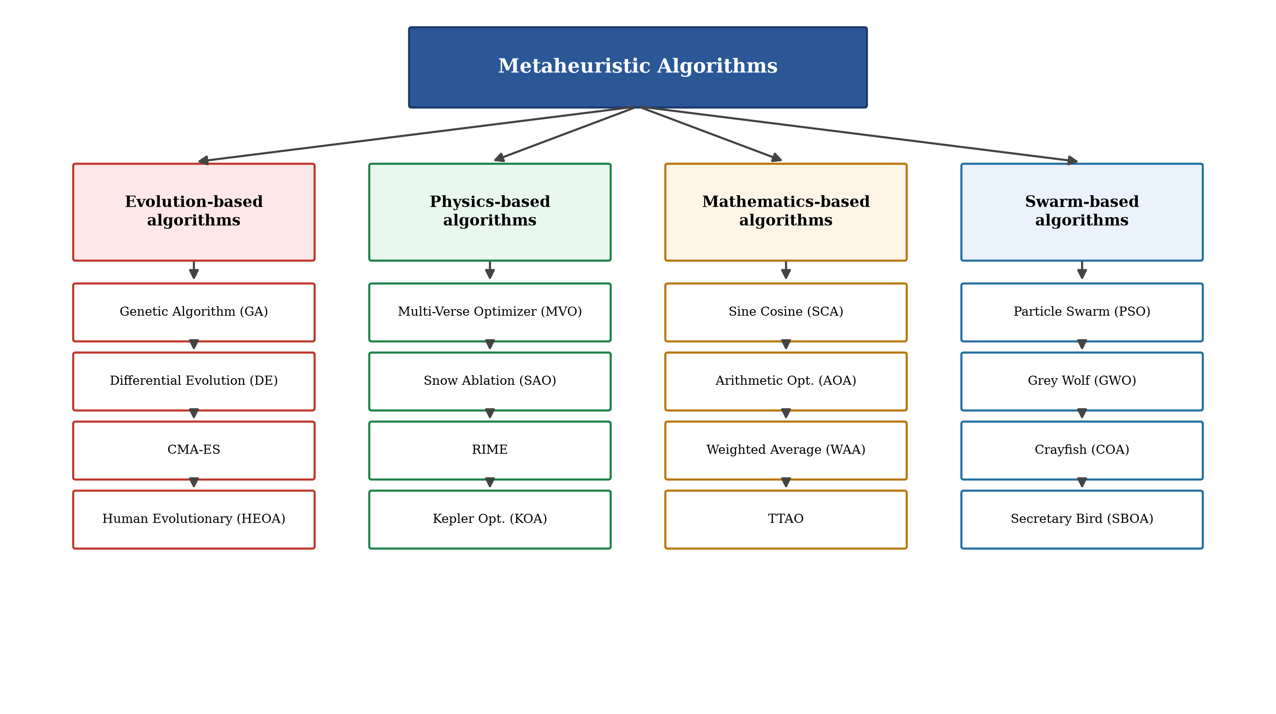
Figure 1. Classification of metaheuristic algorithms.
Despite their success, metaheuristic algorithms still face challenges. They can readily obtain good solutions but rarely guarantee the global optimum, and they often struggle to balance exploration and exploitation, so that the population may homogenize and become trapped in local optima. More importantly, the no free lunch theorem proves that no single algorithm can outperform all others on every possible problem [52]. This motivates researchers to design or improve algorithms tailored to specific problem classes—here, the aesthetic optimization problems that arise in visual art and graphic design.
The secretary bird optimization algorithm (SBOA) is a bio-inspired metaheuristic proposed by Fu et al. in 2024 [51]. It models the survival behavior of secretary birds, using a three-stage strategy for hunting snakes during the exploration phase and two strategies for escaping predators during the exploitation phase. Owing to its simple structure and strong search ability, SBOA has attracted considerable attention, and several improved variants have been developed. Qin et al. proposed a multi-strategy improvement SBOA that incorporates incremental-PID feedback regulation and cooperative camouflage to solve engineering problems [53]. Wang et al. enhanced SBOA with multi-strategy fusion and a Cauchy–Gaussian crossover to improve convergence accuracy [54]. Mai et al. integrated logistic-tent chaotic initialization and a crossover strategy into SBOA for engineering design [55], and Seyyedabbasi developed a multi-strategy variable SBOA for global optimization and UAV path planning [56]. These studies enhance SBOA from different angles, yet the inability of the basic SBOA to maintain population diversity and to balance exploration and exploitation in complex, perception-driven design problems remains an objective limitation. Guided again by the no free lunch theorem, this paper proposes a new SBOA variant, the multi-strategy secretary bird optimization algorithm (MSSBOA), and applies it to aesthetic optimization in visual art design.
MSSBOA combines three improvement techniques. First, a good point set initialization replaces the random initialization of SBOA, generating a low-discrepancy population that uniformly covers the search domain and enhances population diversity from the outset. Second, a lens opposition-based learning strategy is applied to the inferior individuals to generate refracted candidate solutions, which strengthens the ability of the algorithm to escape local optima while protecting the elite individuals. Third, an adaptive Cauchy–Gaussian mutation is imposed on the best individual, where a Cauchy-dominated perturbation promotes global exploration in the early stage and a Gaussian-dominated perturbation refines the solution in the later stage, thereby balancing exploration and exploitation. MSSBOA is comprehensively examined on the CEC2017 benchmark functions and compared with the basic SBOA and several advanced algorithms, with the differences analyzed by the Friedman test, the Nemenyi post-hoc test and the Wilcoxon rank-sum test. Finally, MSSBOA is applied to color-harmony palette optimization and graphic-layout aesthetics optimization to confirm its ability to solve realistic art-design problems. The main contributions of this paper are as follows.
(1) An improved SBOA variant, namely MSSBOA, is proposed by integrating good point set initialization, lens opposition-based learning and adaptive Cauchy–Gaussian mutation.
(2) The performance of MSSBOA is comprehensively examined on the CEC2017 test suite in four dimensions and confirmed by the Friedman test, the Nemenyi test and the Wilcoxon rank-sum test.
(3) MSSBOA is successfully applied to aesthetic color-harmony palette optimization and graphic-layout aesthetics optimization, demonstrating its adaptability to real-world visual art and graphic design problems.
The remainder of this paper is organized as follows. Section 2 describes the structure and details of the basic SBOA. Section 3 presents the proposed MSSBOA, including the three improvement strategies, the overall framework with pseudo-code and flowchart, and the complexity analysis. Section 4 reports the parameter sensitivity analysis, ablation experiments and a comprehensive comparison on the CEC2017 benchmark functions. Section 5 applies MSSBOA to two visual-design optimization problems. Finally, Section 6 concludes the paper, discusses the limitations of MSSBOA and outlines future research directions.
2. Secretary Bird Optimization Algorithm
SBOA is a population-based metaheuristic inspired by the survival behavior of secretary birds in the African savanna [51]. The algorithm starts from a randomly generated population and improves the candidate solutions through an exploration phase that mimics the three-stage strategy of hunting snakes and an exploitation phase that mimics two strategies of escaping predators. When the stopping criterion is met, SBOA outputs the best solution. The detailed formulation is described as follows.
2.1. Initialization
Like most metaheuristics, SBOA initializes a population of $N$ candidate solutions that are uniformly distributed within the search space. Each individual is generated by the following equation.
$x_{i,j}=lb_{j}+r⋅\left(ub_{j}−lb_{j}\right), i=1,2,…,N, j=1,2,…,D$ | (1)
where $x_{i,j}$ denotes the $j$-th dimension of the $i$-th individual, $r$ is a random number in $\left[0,1\right]$, $lb_{j}$ and $ub_{j}$ are the lower and upper bounds of the $j$-th dimension, $N$ is the population size and $D$ is the dimension of the problem. After initialization, all individuals are evaluated and sorted according to their fitness; a minimization problem is considered in this paper, so individuals with smaller fitness are ranked higher.
2.2. Exploration phase: hunting strategy
In the wild, a secretary bird spends a long time searching for prey such as snakes before launching a rapid attack. SBOA divides the exploration phase into three successive stages according to the iteration counter. In the first stage (searching for prey), the individual is updated by a differential perturbation of two randomly selected individuals, as in Equation (2).
$x_{i,j}^{new,P1}=x_{i,j}+\left(x_{rand_{1},j}−x_{rand_{2},j}\right)⋅R_{1}$ | (2)
where $x_{rand_{1},j}$ and $x_{rand_{2},j}$ are the positions of two randomly selected individuals and $R_{1}$ is a random number in $\left[0,1\right]$. In the second stage (consuming prey), the individual approaches the best individual under a Brownian-motion perturbation, as in Equation (3).
$x_{i,j}^{new,P1}=X_{best,j}+exp​\left[{\left(t/T\right)}^{4}\right]⋅\left(R_{B}−0.5\right)⋅\left(X_{best,j}−x_{i,j}\right)$ | (3)
where $X_{best,j}$ is the $j$-th dimension of the best individual, $t$ and $T$ are the current and maximum numbers of iterations, and $R_{B}$ is a Brownian-motion random vector drawn from the standard normal distribution. In the third stage (attacking prey), the individual performs a Lévy flight around the best individual, as in Equation (4).
$x_{i,j}^{new,P1}=X_{best,j}+{\left(1−t/T\right)}^{2t/T}⋅x_{i,j}⋅R_{L}$ | (4)
where $R_{L}=0.5⋅Levy\left(D\right)$ is a Lévy-flight step vector. The three stages are selected by the iteration counter: the first stage is used when $t<T/3$, the second stage when $T/3≤t<2T/3$, and the third stage when $t≥2T/3$. After each update, a greedy selection is performed, as in Equation (5).
$X_{i}=\left\{\begin{matrix}X_{i}^{new}, & f​\left(X_{i}^{new}\right)<f​\left(X_{i}\right) \\ X_{i}, & \text{otherwise}\end{matrix}\right.$ | (5)
where $f\left(⋅\right)$ is the objective function. The greedy selection guarantees that the population never deteriorates.
2.3. Exploitation phase: escape strategy
Secretary birds are threatened by predators such as eagles and must escape to survive. SBOA models two escape strategies and selects one of them at random in each iteration. When $r<0.5$, the first strategy $C_{1}$ (camouflage by the environment) is used, as in Equation (6).
$x_{i,j}^{new,P2}=X_{best,j}+{\left(1−t/T\right)}^{2}⋅\left(2R_{B}−1\right)⋅x_{i,j}$ | (6)
where $r$ is a random number in $\left[0,1\right]$ and $R_{B}$ is a random vector in $\left[0,1\right]$. Otherwise, the second strategy $C_{2}$ (fleeing toward a safe place) is used, as in Equation (7).
$x_{i,j}^{new,P2}=x_{i,j}+R_{2}⋅\left(x_{random,j}−K⋅x_{i,j}\right)$ | (7)
where $R_{2}$ is a random vector in $\left[0,1\right]$, $x_{random,j}$ is a randomly selected individual and $K=round\left(1+rand\right)∈\{1,2\}$. The Lévy flight used in Equation (4) is generated by the Mantegna algorithm [57,58], as in Equation (8).
$Levy\left(D\right)=\frac{u}{{\left|v\right|}^{1/β}}, σ={\left[\frac{Γ\left(1+β\right)sin​\left(πβ/2\right)}{Γ​\left(\frac{1+β}{2}\right)β 2^{\left(β−1\right)/2}}\right]}^{1/β}$ | (8)
where $u∼N\left(0,σ^{2}\right)$ and $v∼N\left(0,1\right)$ are normally distributed, $Γ$ is the Gamma function and $β=1.5$ is a constant.
3. Proposed Multi-Strategy Secretary Bird Optimization Algorithm
Although SBOA performs well on many problems, it still has shortcomings that limit its search efficiency. The random initialization cannot guarantee a uniform coverage of the search space, which weakens the initial population diversity. The search relies heavily on the current best individual, so the population is prone to premature convergence and easily trapped in local optima, and the transition between exploration and exploitation is not fully balanced. To overcome these limitations, this section proposes a multi-strategy SBOA (MSSBOA) that incorporates three improvement strategies: good point set initialization, lens opposition-based learning and adaptive Cauchy–Gaussian mutation. Each strategy is described in detail below, followed by the overall framework, the pseudo-code and the complexity analysis.
3.1. Good point set initialization (GPSI)
The distribution of the initial population strongly affects the convergence of a metaheuristic. A uniformly distributed initial population enhances diversity and enables the algorithm to explore the solution space more comprehensively. The good point set, derived from number theory [59], is a low-discrepancy sequence whose deviation is asymptotically lower than that of pseudo-random sampling, and it has been successfully used to initialize swarm algorithms [60]. For a $D$-dimensional problem, let $p$ be the smallest prime satisfying $\left(p−3\right)/2≥D$. The good point is constructed by Equation (9).
$r_{k}=\left\{2cos​\left(\frac{2πk}{p}\right)\right\}, k=1,2,…,D$ | (9)
where $\{⋅\}$ denotes the fractional part. The $i$-th individual is then mapped to the search space by Equation (10).
$x_{i,j}=lb_{j}+\left\{r_{j}⋅i\right\}⋅\left(ub_{j}−lb_{j}\right), i=1,2,…,N$ | (10)
Compared with random initialization, the good point set yields a more even spread of the initial population that is independent of the dimension, providing the algorithm with a better starting point for the subsequent search.
3.2. Lens opposition-based learning (LOBL)
Opposition-based learning evaluates a candidate solution together with its opposite and keeps the better one, which effectively enlarges the explored region [61,62]. Lens opposition-based learning extends this idea using the principle of convex-lens imaging: an object placed on one side of a lens forms an image on the other side, which corresponds to a refracted reverse solution with a tunable scaling factor [63]. The lens-refracted solution is computed by Equation (11).
$x_{j}^{*}=\frac{lb_{j}+ub_{j}}{2}+\frac{lb_{j}+ub_{j}}{2k}−\frac{x_{j}}{k}$ | (11)
where $x_{j}^{*}$ is the refracted solution and $k$ is an adjustment factor. When $k=1$, Equation (11) degenerates into the standard opposition-based learning. To balance the global and local search, a dynamically increasing factor is adopted, as in Equation (12).
$k={\left(1+{\left(\frac{t}{T}\right)}^{1/2}\right)}^{10}$ | (12)
A small $k$ in the early stage produces a refracted solution far from the current one, which favors exploration, while a large $k$ in the later stage keeps the refracted solution close to the current one, which favors exploitation. In MSSBOA, the lens opposition-based learning is applied only to the inferior individuals (the worst 30% of the population) at the end of each iteration. As illustrated in Figure 2, this helps the population jump out of local optima while the greedy selection protects the elite individuals.
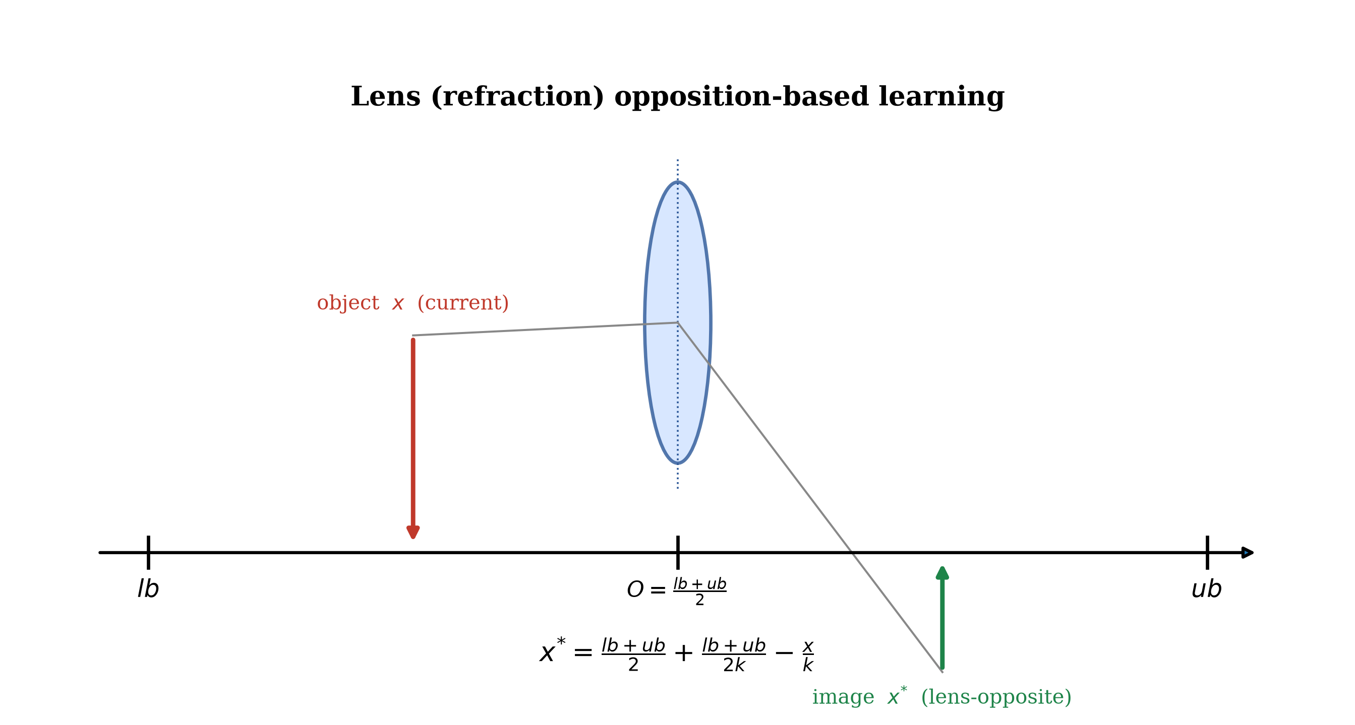
Figure 2. Schematic of the lens opposition-based learning strategy.
3.3. Adaptive Cauchy–Gaussian mutation (ACGM)
To further balance exploration and exploitation and to help the best individual escape local optima, an adaptive Cauchy–Gaussian mutation is imposed on the best individual [64,54]. The Cauchy distribution has heavier tails than the Gaussian distribution and thus generates larger perturbations for global exploration, whereas the Gaussian distribution produces small perturbations for local refinement. The mutation is defined by Equation (13).
$X_{best}^{new}=X_{best}⋅\left(1+λ_{1} Cauchy\left(0,1\right)+λ_{2} N\left(0,1\right)\right)$ | (13)
where $Cauchy\left(0,1\right)$ is a standard Cauchy random number, $N\left(0,1\right)$ is a standard normal random number, and $λ_{1}$ and $λ_{2}$ are adaptive weights defined by Equation (14).
$λ_{1}=1−\frac{t^{2}}{T^{2}}, λ_{2}=\frac{t^{2}}{T^{2}}$ | (14)
In the early iterations $λ_{1}$ is large, so the Cauchy-dominated perturbation enhances global exploration; in the later iterations $λ_{2}$ becomes large, so the Gaussian-dominated perturbation strengthens local exploitation. The mutated solution replaces the best individual only when it is better, according to the greedy rule in Equation (5).
3.4. The framework of MSSBOA
MSSBOA is obtained by integrating the three improvement strategies into the basic SBOA. The good point set initialization (GPSI) generates a high-quality initial population; the hunting and escape strategies of SBOA drive the main search; the lens opposition-based learning (LOBL) refreshes the inferior individuals to escape local optima; and the adaptive Cauchy–Gaussian mutation (ACGM) perturbs the best individual to balance exploration and exploitation. The pseudo-code of MSSBOA is given in Algorithm 1, and the corresponding flowchart is shown in Figure 3.
Algorithm 1 Multi-Strategy Secretary Bird Optimization Algorithm (MSSBOA)
1: Initialize population X using good point set (Eq. (9)-Eq. (10)) // GPSI
2: Set t = 0, maximum iteration T, population size N
3: Evaluate fitness of X and record the best individual X_best
4: while t < T do
5: for each individual i do
6: if t < T/3 then update X_i by Eq. (2) // searching for prey
7: else if t < 2T/3 then update X_i by Eq. (3) // consuming prey
8: else update X_i by Eq. (4) // attacking prey
9: end if; perform greedy selection by Eq. (5)
10: if r < 0.5 then update X_i by Eq. (6) // escape C1
11: else update X_i by Eq. (7) // escape C2
12: end if; perform greedy selection by Eq. (5)
13: end for
14: Apply lens opposition-based learning to the worst 30% by Eq. (11)-Eq. (12) // LOBL
15: Apply adaptive Cauchy-Gauss mutation to X_best by Eq. (13)-Eq. (14) // ACGM
16: Update X_best; t = t + 1
17: end while
18: return the best individual X_best
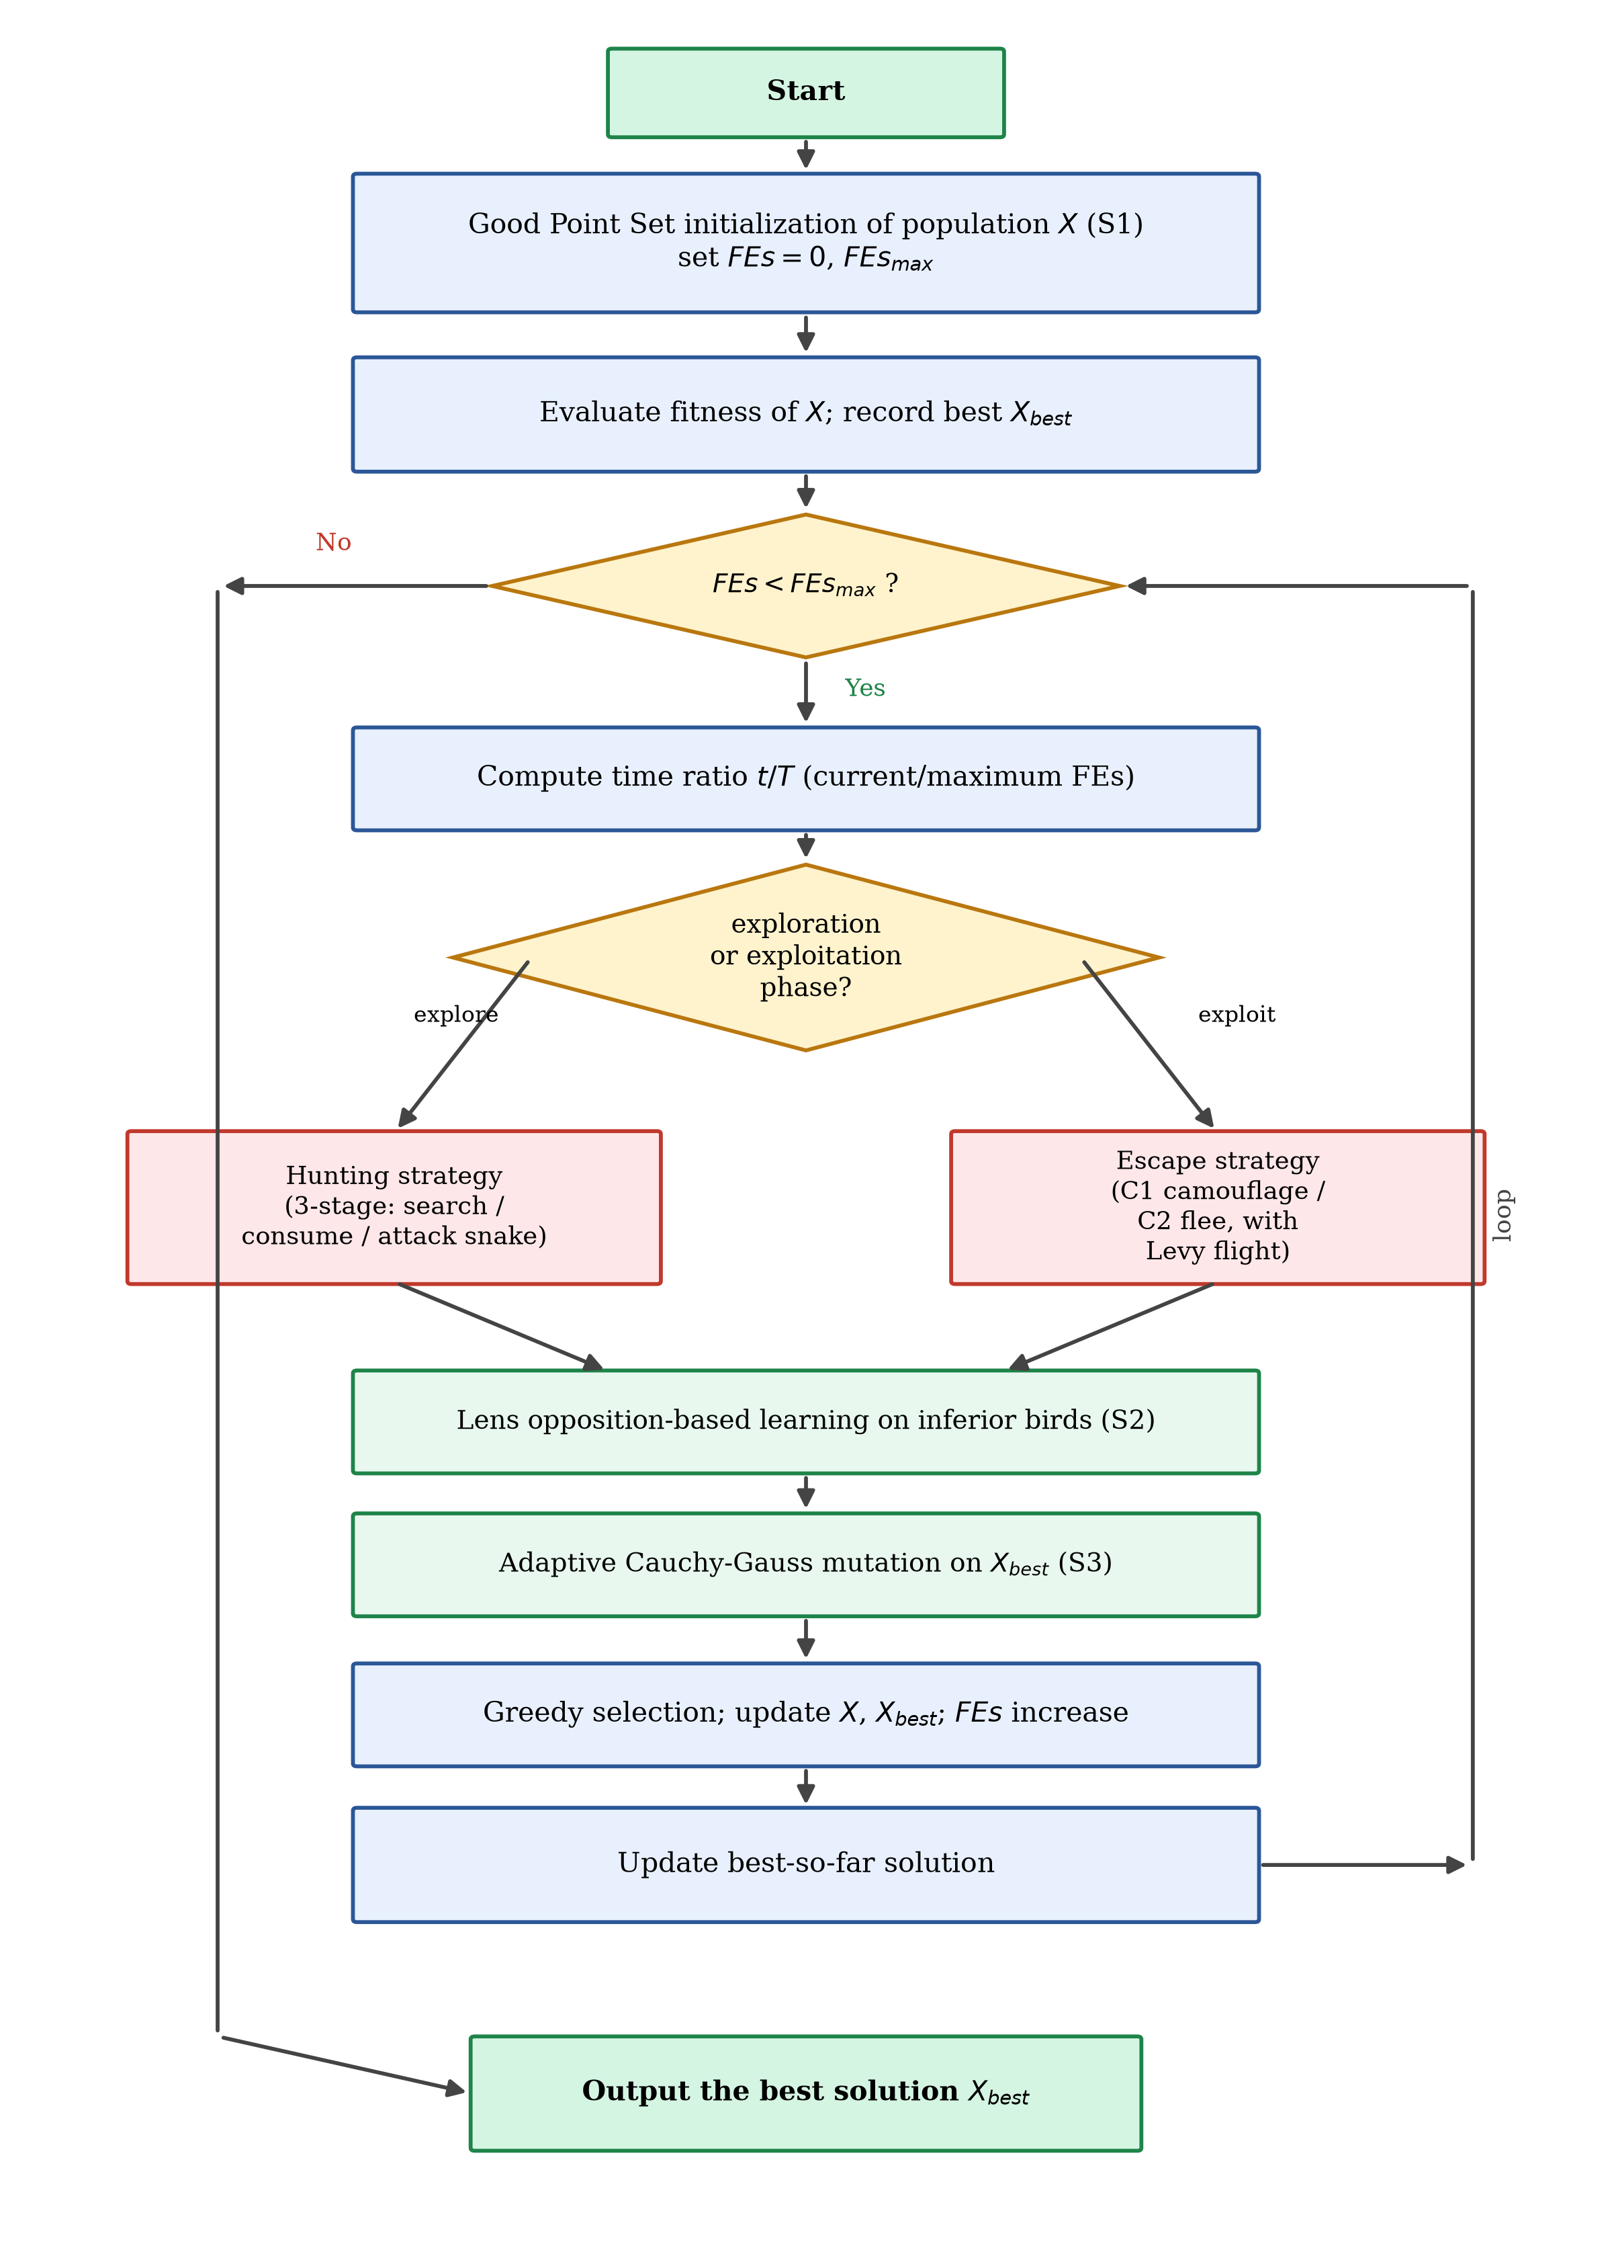
Figure 3. The flowchart of MSSBOA.
3.5. Complexity analysis of MSSBOA
The computational complexity of MSSBOA is analyzed in terms of time and space complexity. Let $N$ be the population size, $D$ the dimension and $T$ the maximum number of iterations. According to its original literature, the time complexity of the basic SBOA is $O\left(N⋅D⋅T\right)$ and its space complexity is $O\left(N⋅D\right)$.
For MSSBOA, the good point set initialization has the same complexity as random initialization, namely $O\left(N⋅D\right)$, and therefore does not change the order of complexity. The lens opposition-based learning is applied to a fixed fraction of the population, with complexity $O\left(N⋅D\right)$ per iteration, and the adaptive Cauchy–Gaussian mutation acts only on the best individual with complexity $O\left(D\right)$. Hence the overall time complexity of MSSBOA remains $O\left(N⋅D⋅T\right)$, the same as the basic SBOA. Regarding space, MSSBOA only stores the population matrix and a few temporary vectors for the refracted and mutated solutions, so its space complexity is still $O\left(N⋅D\right)$. In summary, the three improvement strategies enhance the performance of SBOA without increasing its order of computational complexity.
4. Numerical Experiments Using the CEC2017 Test Suite
In this section, the performance of MSSBOA is comprehensively examined on the CEC2017 benchmark suite. Section 4.1 describes the experimental setting and the CEC2017 functions. Section 4.2 analyzes the sensitivity of the two key parameters of MSSBOA. Section 4.3 reports the ablation experiments that verify the effectiveness of the three improvement strategies. Finally, Section 4.4 provides a comprehensive comparison between MSSBOA and nine state-of-the-art algorithms, analyzed by the Friedman test, the Nemenyi post-hoc test and the Wilcoxon rank-sum test.
4.1. Experiment setting and performance metrics
All experiments were conducted on a workstation with an AMD Ryzen 9 7945HX 2.5 GHz CPU and 32 GB of memory, running Windows 11 and MATLAB R2023a. The CEC2017 test suite [65] contains 29 test functions (F2 is excluded because of its unstable behavior), in which F1 and F3 are unimodal functions, F4–F10 are simple multimodal functions, F11–F20 are hybrid functions and F21–F30 are composition functions. The unimodal functions evaluate the convergence accuracy of an algorithm, the multimodal functions test the ability to escape local optima, and the hybrid and composition functions assess the balance between exploration and exploitation on complex landscapes. The search range is ${\left[−100,100\right]}^{D}$ and the dimensions are set to 10, 30, 50 and 100. To ensure a fair comparison, the maximum number of function evaluations is used as the stopping criterion and set to $10000×D$. Each algorithm is independently run 30 times, and the best value, mean value and standard deviation are recorded. MSSBOA is compared with the basic SBOA [51] and nine advanced algorithms, including GWO [42], SCA [34], SMA [47], COA [44], GKSO [49], MRFO [66], RIME [67], QIO [68] and LSHADE [69]. The parameter settings of all algorithms are listed in Table 1 and are taken from their original literature.
Table 1. Parameter settings of MSSBOA and the comparison algorithms.
Algorithm | Parameter settings
MSSBOA | N=30, N_min=0.2N, p_m=0.5, beta=1.5
SBOA | N=30, beta=1.5
GWO | N=30, a decreases linearly from 2 to 0
SCA | N=30, a=2
SMA | N=30, z=0.03
COA | N=30, control parameter decreases with iteration
GKSO | N=30, default control parameters
MRFO | N=30, somersault factor S=2
RIME | N=30, W=5
QIO | N=30, default control parameters
LSHADE | N_init=18D, N_min=4, memory size H=6, p=0.11, arc rate=2.6
4.2. Parameter sensitivity analysis
Two parameters strongly affect the performance of MSSBOA: the minimum population factor $N_{min}$ used in the lens opposition-based learning and the mutation probability $p_{m}$ of the adaptive Cauchy–Gaussian mutation. A grid search is conducted on the CEC2017 suite over 30 independent runs. $N_{min}$ is searched from 0.1N to 0.9N with a step of 0.1N, and $p_{m}$ is searched from 0.1 to 1.0 with a step of 0.1. Table 2 and Table 3 report the Friedman rankings (significance level $α=0.05$) for $N_{min}$ and $p_{m}$, respectively, where the best ranking is highlighted in bold. The corresponding rankings are visualized in Figure 4 and Figure 5.
Table 2. Rankings of MSSBOA with different N_min (α=0.05).
Dimension | SBOA | 0.1N | 0.2N | 0.3N | 0.4N | 0.5N | 0.6N | 0.7N | 0.8N | 0.9N
D=10 | 10.000 | 3.371 | 1.641 | 2.633 | 3.938 | 5.530 | 6.526 | 8.678 | 9.400 | 9.400
D=30 | 10.000 | 2.943 | 1.550 | 2.753 | 4.233 | 5.230 | 7.208 | 8.728 | 9.400 | 9.400
D=50 | 10.000 | 3.251 | 1.555 | 2.679 | 3.805 | 5.402 | 7.017 | 8.950 | 9.400 | 9.400
D=100 | 10.000 | 3.054 | 1.825 | 2.486 | 4.090 | 5.209 | 6.752 | 8.868 | 9.400 | 9.400
Average | 10.000 | 3.155 | 1.643 | 2.638 | 4.016 | 5.343 | 6.876 | 8.806 | 9.400 | 9.400
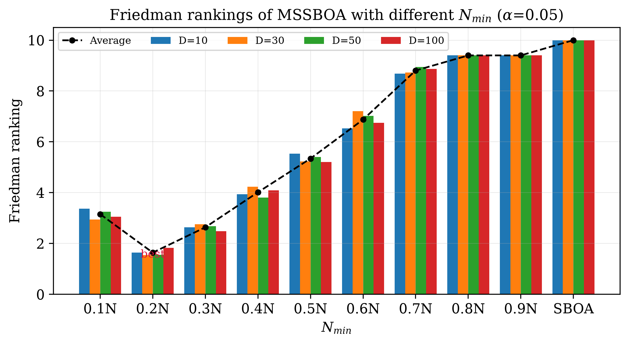
Figure 4. Friedman rankings of MSSBOA with different N_min (α=0.05).
As shown in Table 2 and Figure 4, MSSBOA achieves the best average ranking when $N_{min}=0.2N$. As $N_{min}$ increases, the ranking gradually deteriorates because too large a refraction subpopulation disturbs the elite individuals. Therefore, $N_{min}=0.2N$ is adopted in this paper.
Table 3. Rankings of MSSBOA with different p_m (α=0.05).
Dimension | SBOA | 0.1 | 0.2 | 0.3 | 0.4 | 0.5 | 0.6 | 0.7 | 0.8 | 0.9 | 1.0
D=10 | 11.000 | 7.757 | 5.829 | 4.151 | 2.429 | 1.387 | 2.897 | 3.889 | 5.442 | 7.566 | 8.843
D=30 | 11.000 | 7.725 | 5.512 | 4.010 | 2.677 | 1.597 | 2.776 | 4.465 | 5.885 | 7.234 | 8.576
D=50 | 11.000 | 8.114 | 6.168 | 4.497 | 2.953 | 1.398 | 2.682 | 3.809 | 5.189 | 7.162 | 9.143
D=100 | 11.000 | 7.276 | 5.629 | 4.504 | 2.959 | 1.775 | 2.656 | 4.103 | 5.433 | 7.342 | 9.177
Average | 11.000 | 7.718 | 5.784 | 4.290 | 2.754 | 1.539 | 2.753 | 4.066 | 5.487 | 7.326 | 8.935
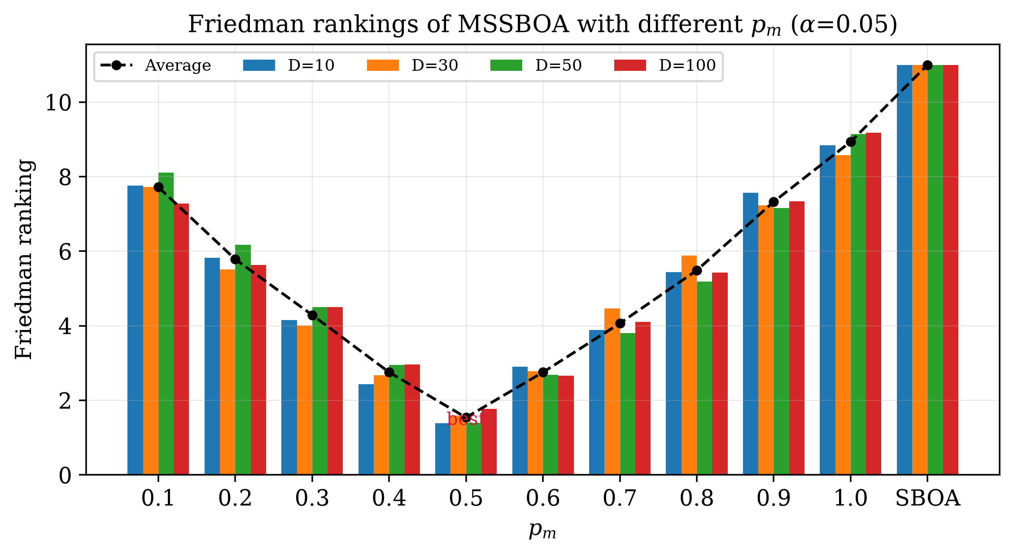
Figure 5. Friedman rankings of MSSBOA with different p_m (α=0.05).
For the mutation probability, Table 3 and Figure 5 show that MSSBOA performs best when $p_{m}=0.5$, which provides a suitable balance between perturbing the best individual and preserving its information. Consequently, the parameter settings of MSSBOA are $N_{min}=0.2N$ and $p_{m}=0.5$.
4.3. Ablation experiment
To investigate the contribution of each improvement strategy, three variants of MSSBOA are constructed by adding a single strategy to the basic SBOA, namely SBOA-GPSI, SBOA-LOBL and SBOA-ACGM, as listed in Table 4. The four algorithms and the full MSSBOA are independently run 30 times on the CEC2017 suite in four dimensions, and the results are analyzed by the Friedman test. The complete statistical results are reported in Table A1–Table A4 of Appendix A. Table 5 summarizes the Friedman rankings, which are visualized in Figure 6.
Table 4. Descriptions of MSSBOA with different strategies.
Strategy | SBOA | SBOA-GPSI | SBOA-LOBL | SBOA-ACGM | MSSBOA
GPSI | No | Yes | No | No | Yes
LOBL | No | No | Yes | No | Yes
ACGM | No | No | No | Yes | Yes
Table 5. Friedman rankings of MSSBOA with different strategies (α=0.05).
Test suite | Dim | SBOA | SBOA-GPSI | SBOA-LOBL | SBOA-ACGM | MSSBOA | P-value
CEC2017 | 10 | 4.793 | 3.000 | 3.862 | 2.069 | 1.276 | 1.054E-18
 | 30 | 4.828 | 2.862 | 3.966 | 2.310 | 1.034 | 9.319E-21
 | 50 | 4.966 | 3.000 | 3.621 | 2.414 | 1.000 | 1.157E-20
 | 100 | 4.931 | 3.103 | 3.793 | 2.103 | 1.069 | 1.994E-21
Average ranking |  | 4.879 | 2.991 | 3.810 | 2.224 | 1.095 | N/A
Ranking |  | 5 | 3 | 4 | 2 | 1 | N/A
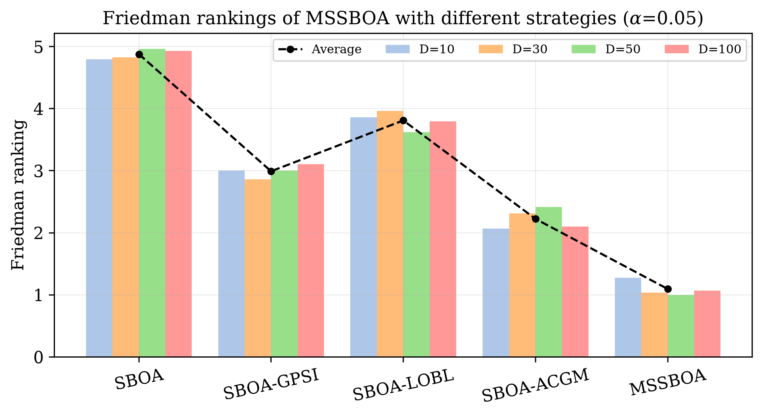
Figure 6. Friedman rankings of MSSBOA with different strategies (α=0.05).
According to Table 5 and Figure 6, all p-values are far below 0.05, indicating significant differences among the five algorithms. MSSBOA ranks first in all four dimensions with an overall average ranking of 1.095, followed by SBOA-ACGM, SBOA-GPSI and SBOA-LOBL, while the basic SBOA ranks last. Each single-strategy variant outperforms the basic SBOA, which confirms that every strategy is effective. Among them, the adaptive Cauchy–Gaussian mutation (ACGM) contributes the most, because it directly helps the best individual escape local optima and balances exploration and exploitation; the good point set initialization (GPSI) ranks next by enriching the initial diversity; and the lens opposition-based learning (LOBL) also improves performance by refreshing inferior individuals. The full MSSBOA outperforms every single-strategy variant, demonstrating that the three strategies complement and reinforce each other.
4.4. Comparison with other advanced algorithms
In this subsection, MSSBOA is compared with the basic SBOA and nine advanced algorithms on the CEC2017 suite in 10, 30, 50 and 100 dimensions. The complete results, including the best value, mean value, standard deviation and rank, are reported in Table A5–Table A8 of Appendix A. The ranking of each algorithm on every function is first visualized as heatmaps in Figure 7.
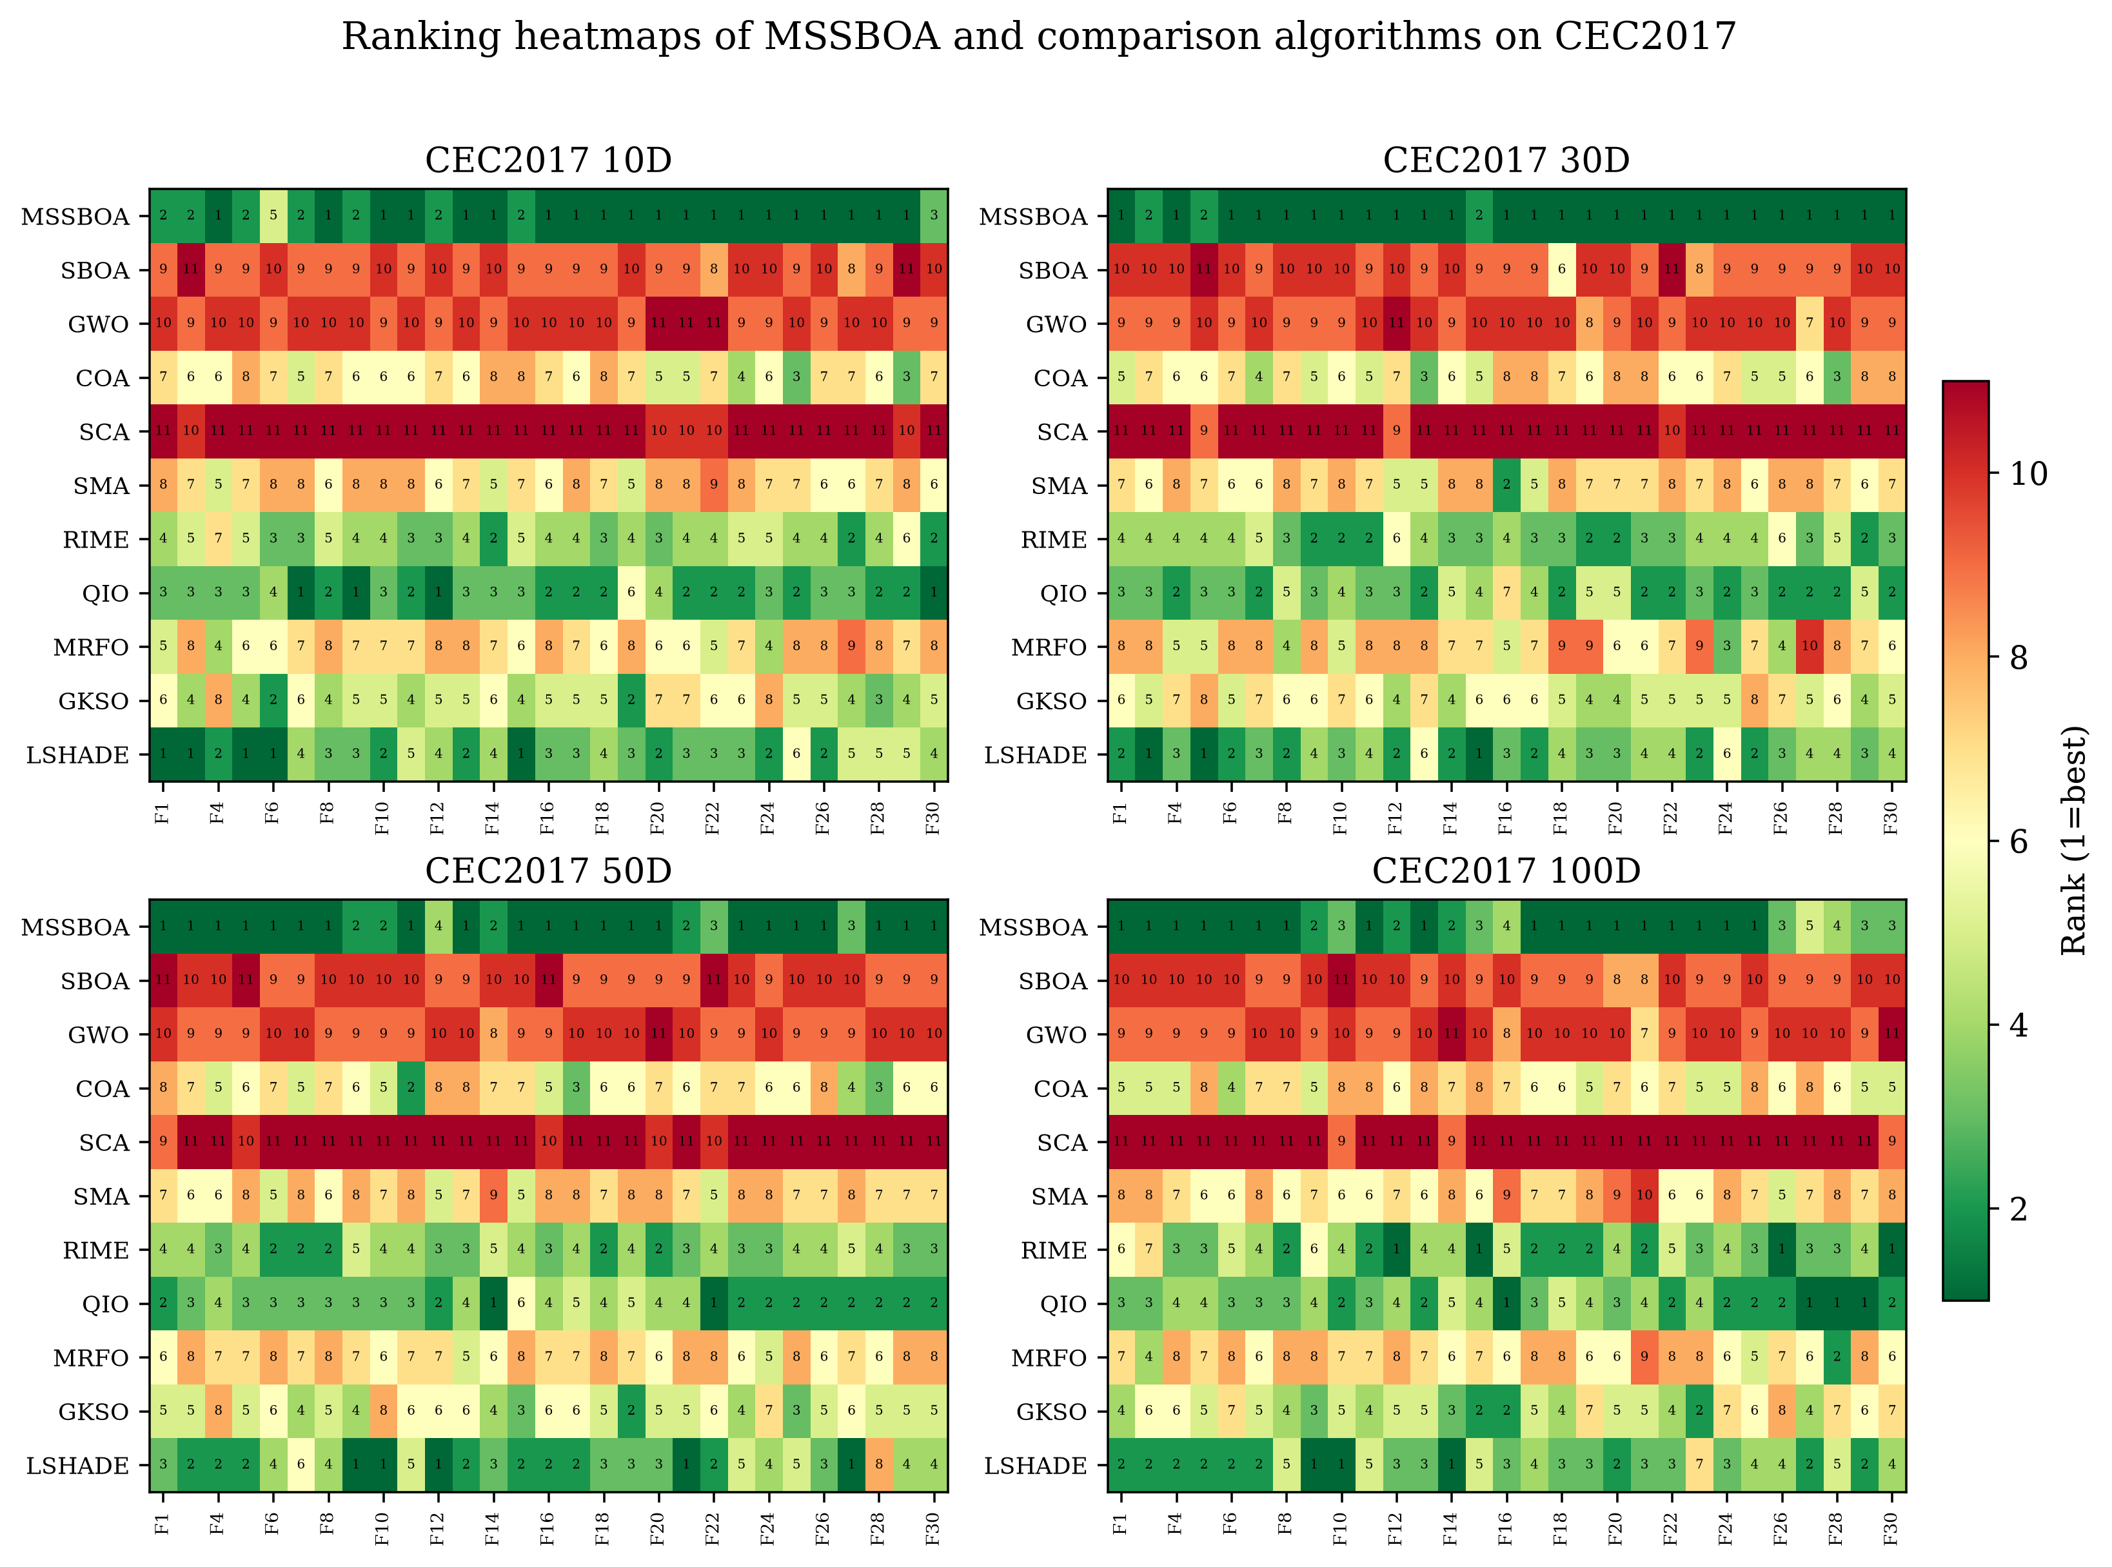
Figure 7. Ranking heatmaps of MSSBOA and the comparison algorithms on the CEC2017 suite: (a) 10D, (b) 30D, (c) 50D, (d) 100D.
As shown in Figure 7, MSSBOA ranks first on 20 functions in 10D, 26 functions in 30D, 22 functions in 50D and 18 functions in 100D, that is, on more than half of the 29 functions in every dimension, which preliminarily demonstrates its superiority. The convergence curves of representative functions are illustrated in Figure 8, where MSSBOA converges faster and reaches lower error values than the comparison algorithms.
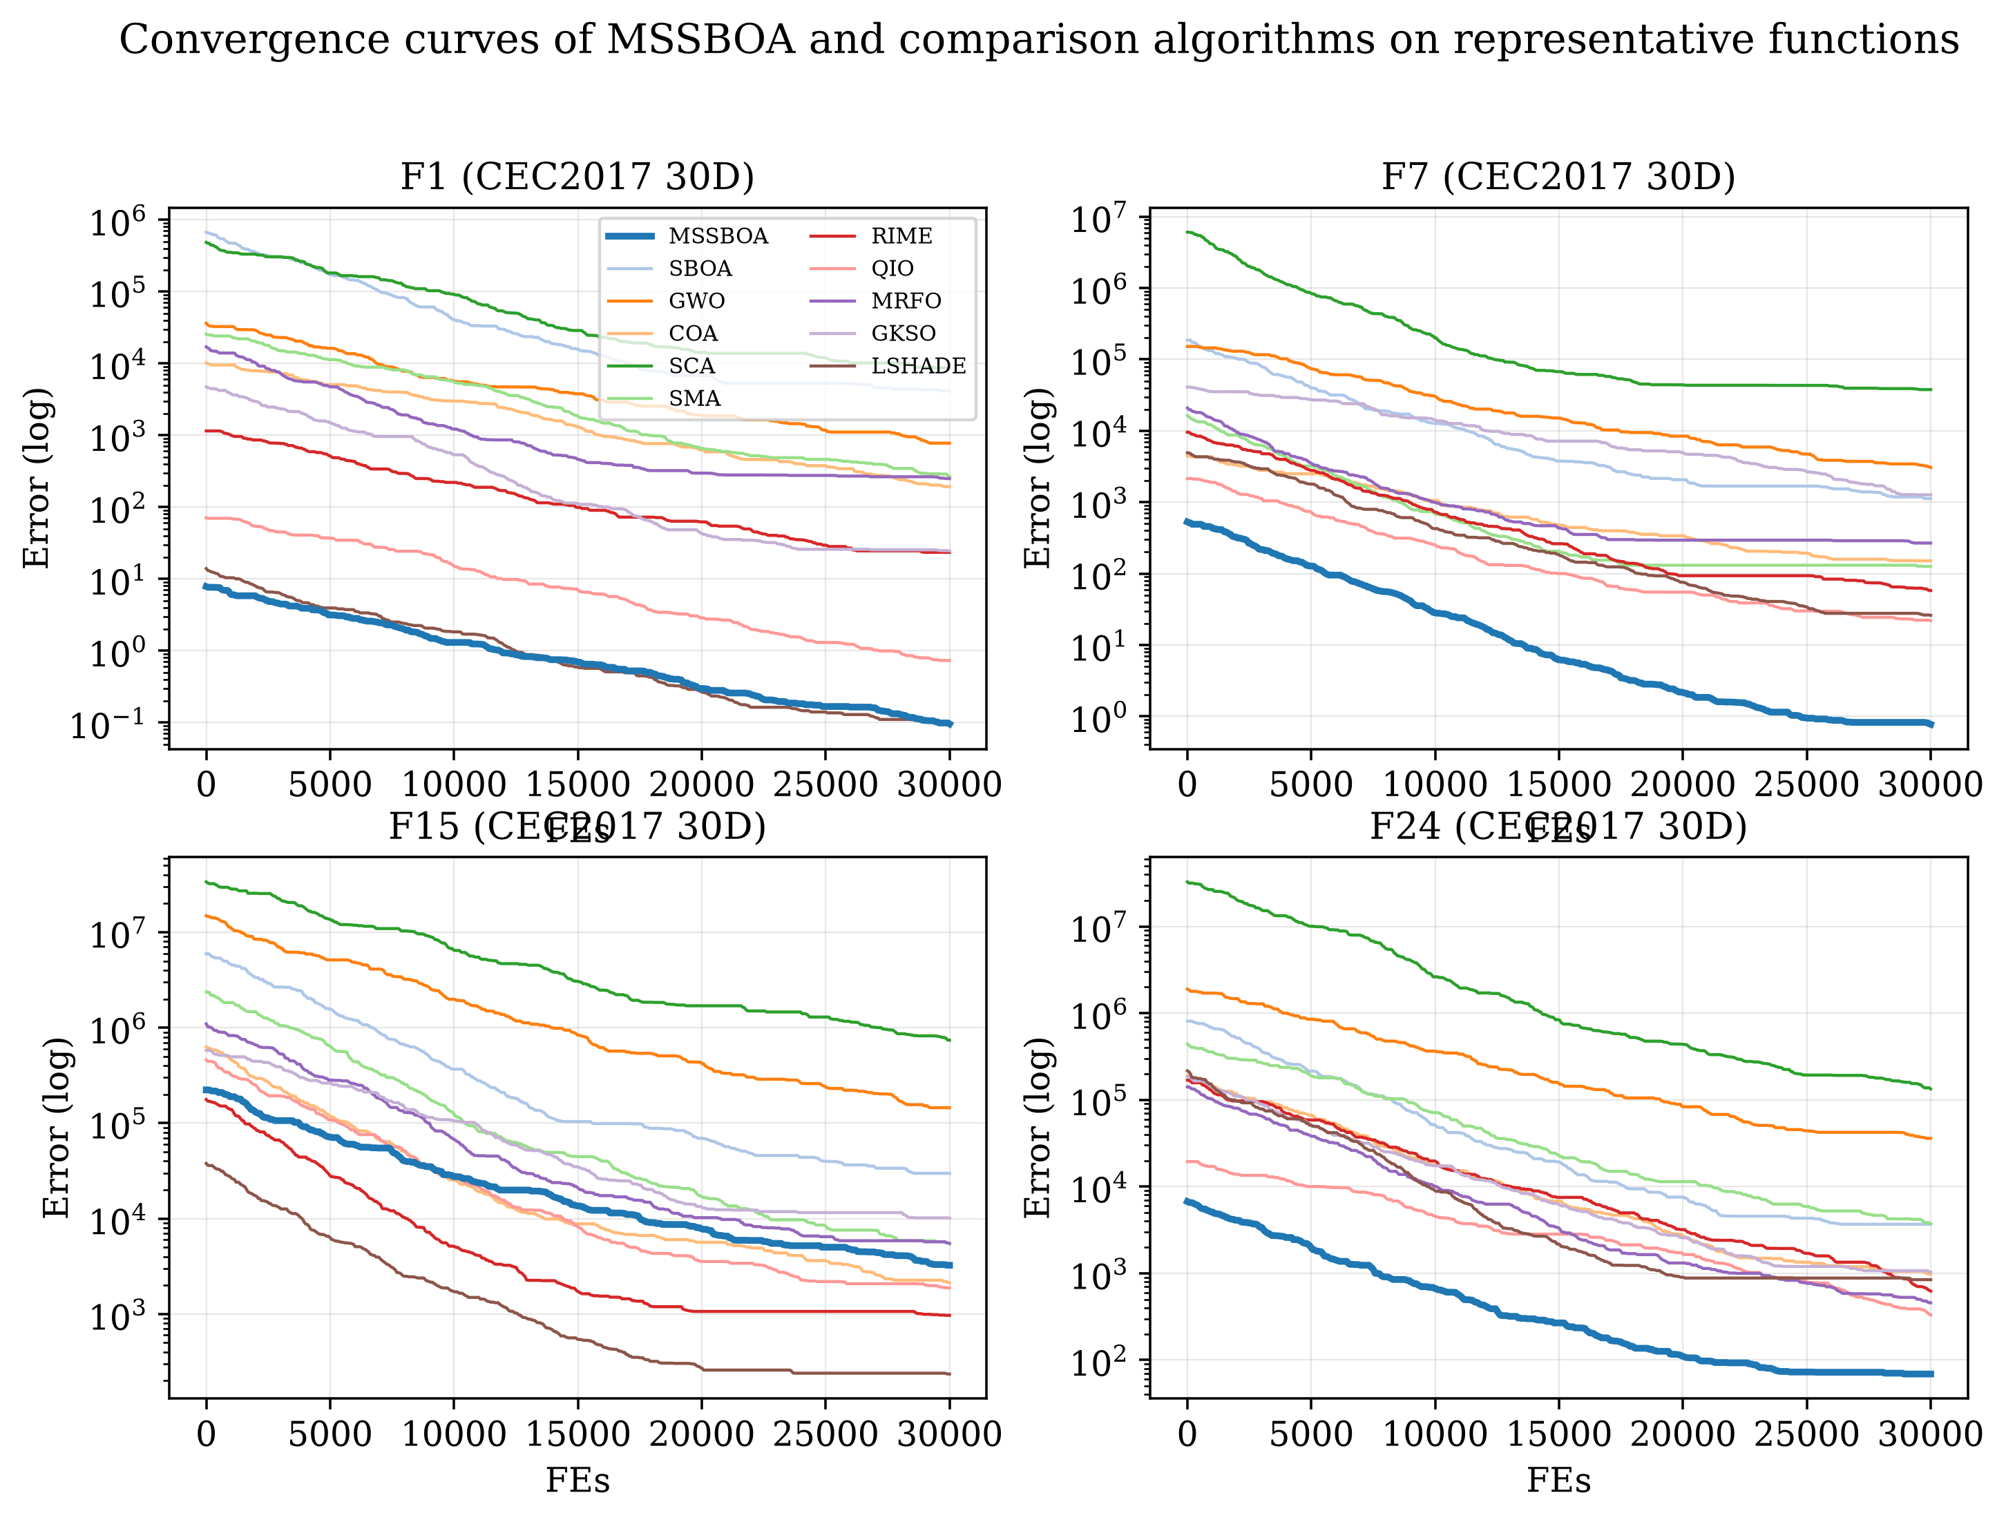
Figure 8. Convergence curves of MSSBOA and the comparison algorithms on representative CEC2017 functions (30D).
To statistically analyze the overall performance, the Friedman test is performed; the results are summarized in Table 6 and visualized in Figure 9.
Table 6. Friedman rankings of MSSBOA and the comparison algorithms (α=0.05).
Algorithm | 10D | 30D | 50D | 100D | Average | Rank
MSSBOA | 1.448 | 1.103 | 1.379 | 1.793 | 1.431 | 1
SBOA | 9.379 | 9.448 | 9.690 | 9.483 | 9.500 | 9
GWO | 9.724 | 9.448 | 9.483 | 9.517 | 9.543 | 10
COA | 6.241 | 6.138 | 6.000 | 6.310 | 6.172 | 6
SCA | 10.828 | 10.828 | 10.793 | 10.793 | 10.810 | 11
SMA | 7.034 | 6.793 | 7.069 | 7.138 | 7.009 | 8
RIME | 3.966 | 3.483 | 3.448 | 3.310 | 3.552 | 4
QIO | 2.517 | 3.207 | 2.966 | 2.897 | 2.897 | 2
MRFO | 6.862 | 6.897 | 6.966 | 6.793 | 6.879 | 7
GKSO | 5.000 | 5.655 | 5.172 | 4.931 | 5.190 | 5
LSHADE | 3.000 | 3.000 | 3.034 | 3.034 | 3.017 | 3
Friedman P-value | 1.900E-49 | 1.626E-48 | 2.191E-49 | 1.570E-47 | N/A | N/A
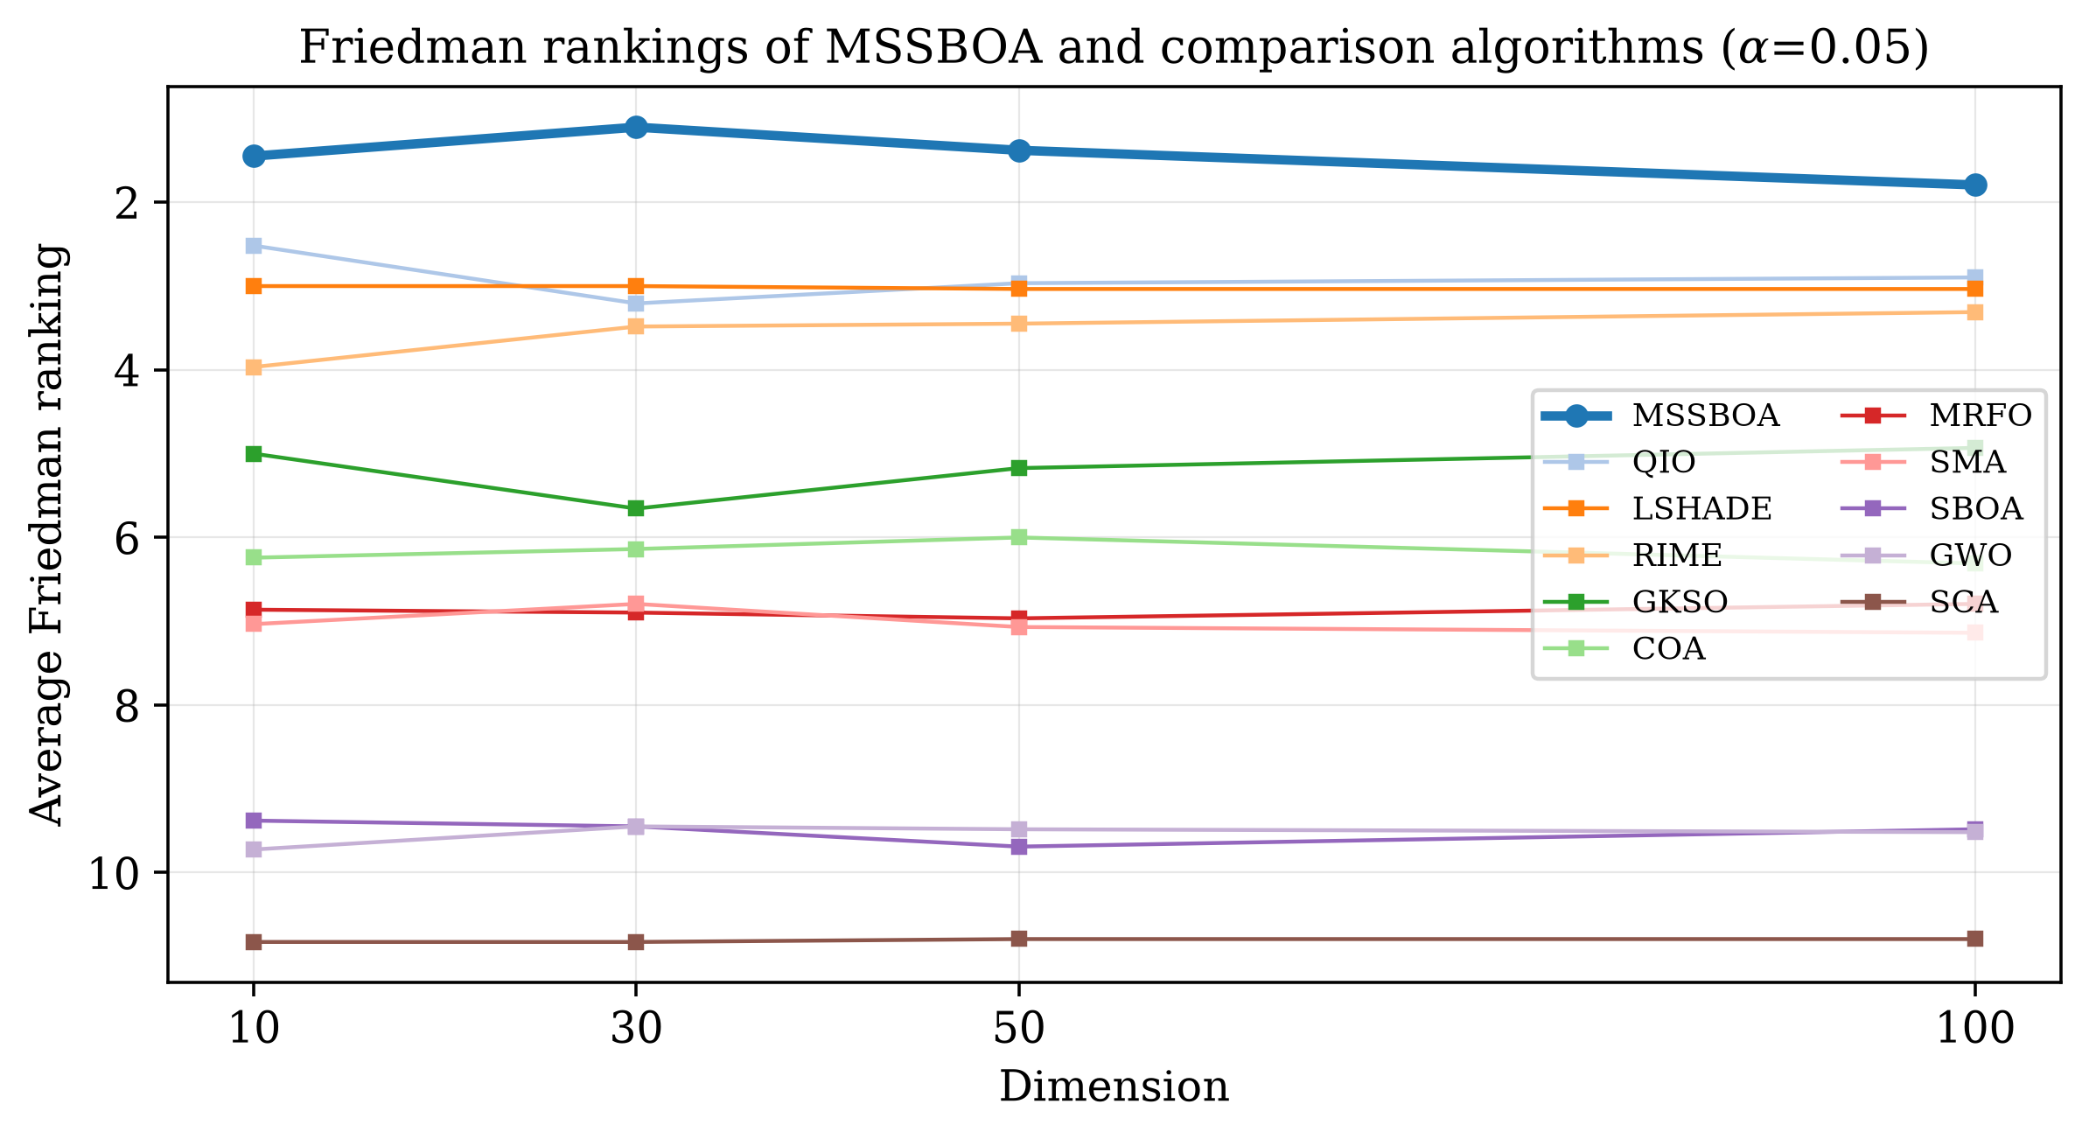
Figure 9. Friedman rankings of MSSBOA and the comparison algorithms across dimensions (α=0.05).
As shown in Table 6 and Figure 9, all Friedman p-values are below 0.05, confirming significant differences among the algorithms. MSSBOA achieves the best average ranking of 1.431 and ranks first in all four dimensions, whereas the basic SBOA ranks near the bottom; the overall order is approximately MSSBOA > QIO > LSHADE > RIME > GKSO > COA > MRFO > SMA > SBOA > GWO > SCA. This clearly reflects the substantial improvement of MSSBOA over the basic SBOA. To further quantify the pairwise differences, the Nemenyi post-hoc test is applied, as shown in Figure 10, where algorithms connected by a line are not significantly different. MSSBOA is located at the leftmost position and is significantly superior to most comparison algorithms.
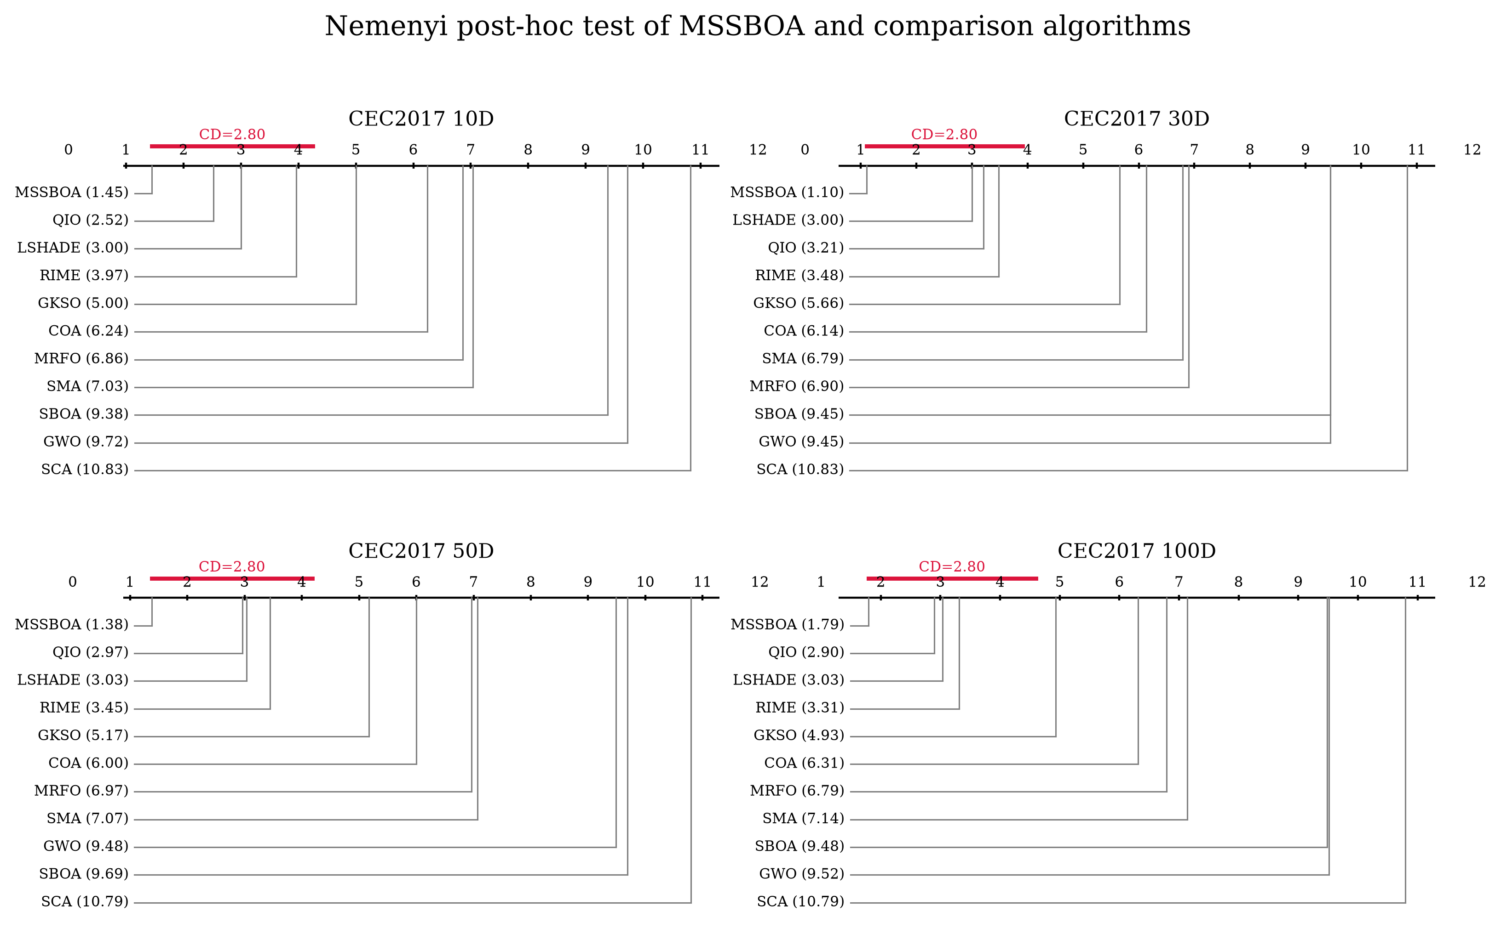
Figure 10. Nemenyi post-hoc test of MSSBOA and the comparison algorithms: (a) 10D, (b) 30D, (c) 50D, (d) 100D.
Finally, the Wilcoxon rank-sum test is conducted to compare MSSBOA with each algorithm on every function. Table 7 reports the statistics, where '+', '=' and '−' denote the numbers of functions on which MSSBOA is significantly better than, similar to, and worse than the comparison algorithm, respectively. The results are visualized in Figure 11.
Table 7. Wilcoxon rank-sum test results of MSSBOA versus the comparison algorithms (α=0.05).
MSSBOA vs. | 10D (+/=/−) | 30D (+/=/−) | 50D (+/=/−) | 100D (+/=/−) | Total (+/=/−)
SBOA | 29/0/0 | 29/0/0 | 29/0/0 | 29/0/0 | 116/0/0
GWO | 29/0/0 | 29/0/0 | 29/0/0 | 29/0/0 | 116/0/0
COA | 29/0/0 | 29/0/0 | 27/2/0 | 29/0/0 | 114/2/0
SCA | 29/0/0 | 29/0/0 | 29/0/0 | 29/0/0 | 116/0/0
SMA | 29/0/0 | 28/1/0 | 28/1/0 | 29/0/0 | 114/2/0
RIME | 25/2/2 | 22/7/0 | 24/5/0 | 19/4/6 | 90/18/8
QIO | 18/6/5 | 24/5/0 | 22/3/4 | 19/4/6 | 83/18/15
MRFO | 29/0/0 | 29/0/0 | 29/0/0 | 27/1/1 | 114/1/1
GKSO | 26/2/1 | 28/1/0 | 29/0/0 | 25/2/2 | 108/5/3
LSHADE | 22/3/4 | 22/5/2 | 20/5/4 | 18/6/5 | 82/19/15
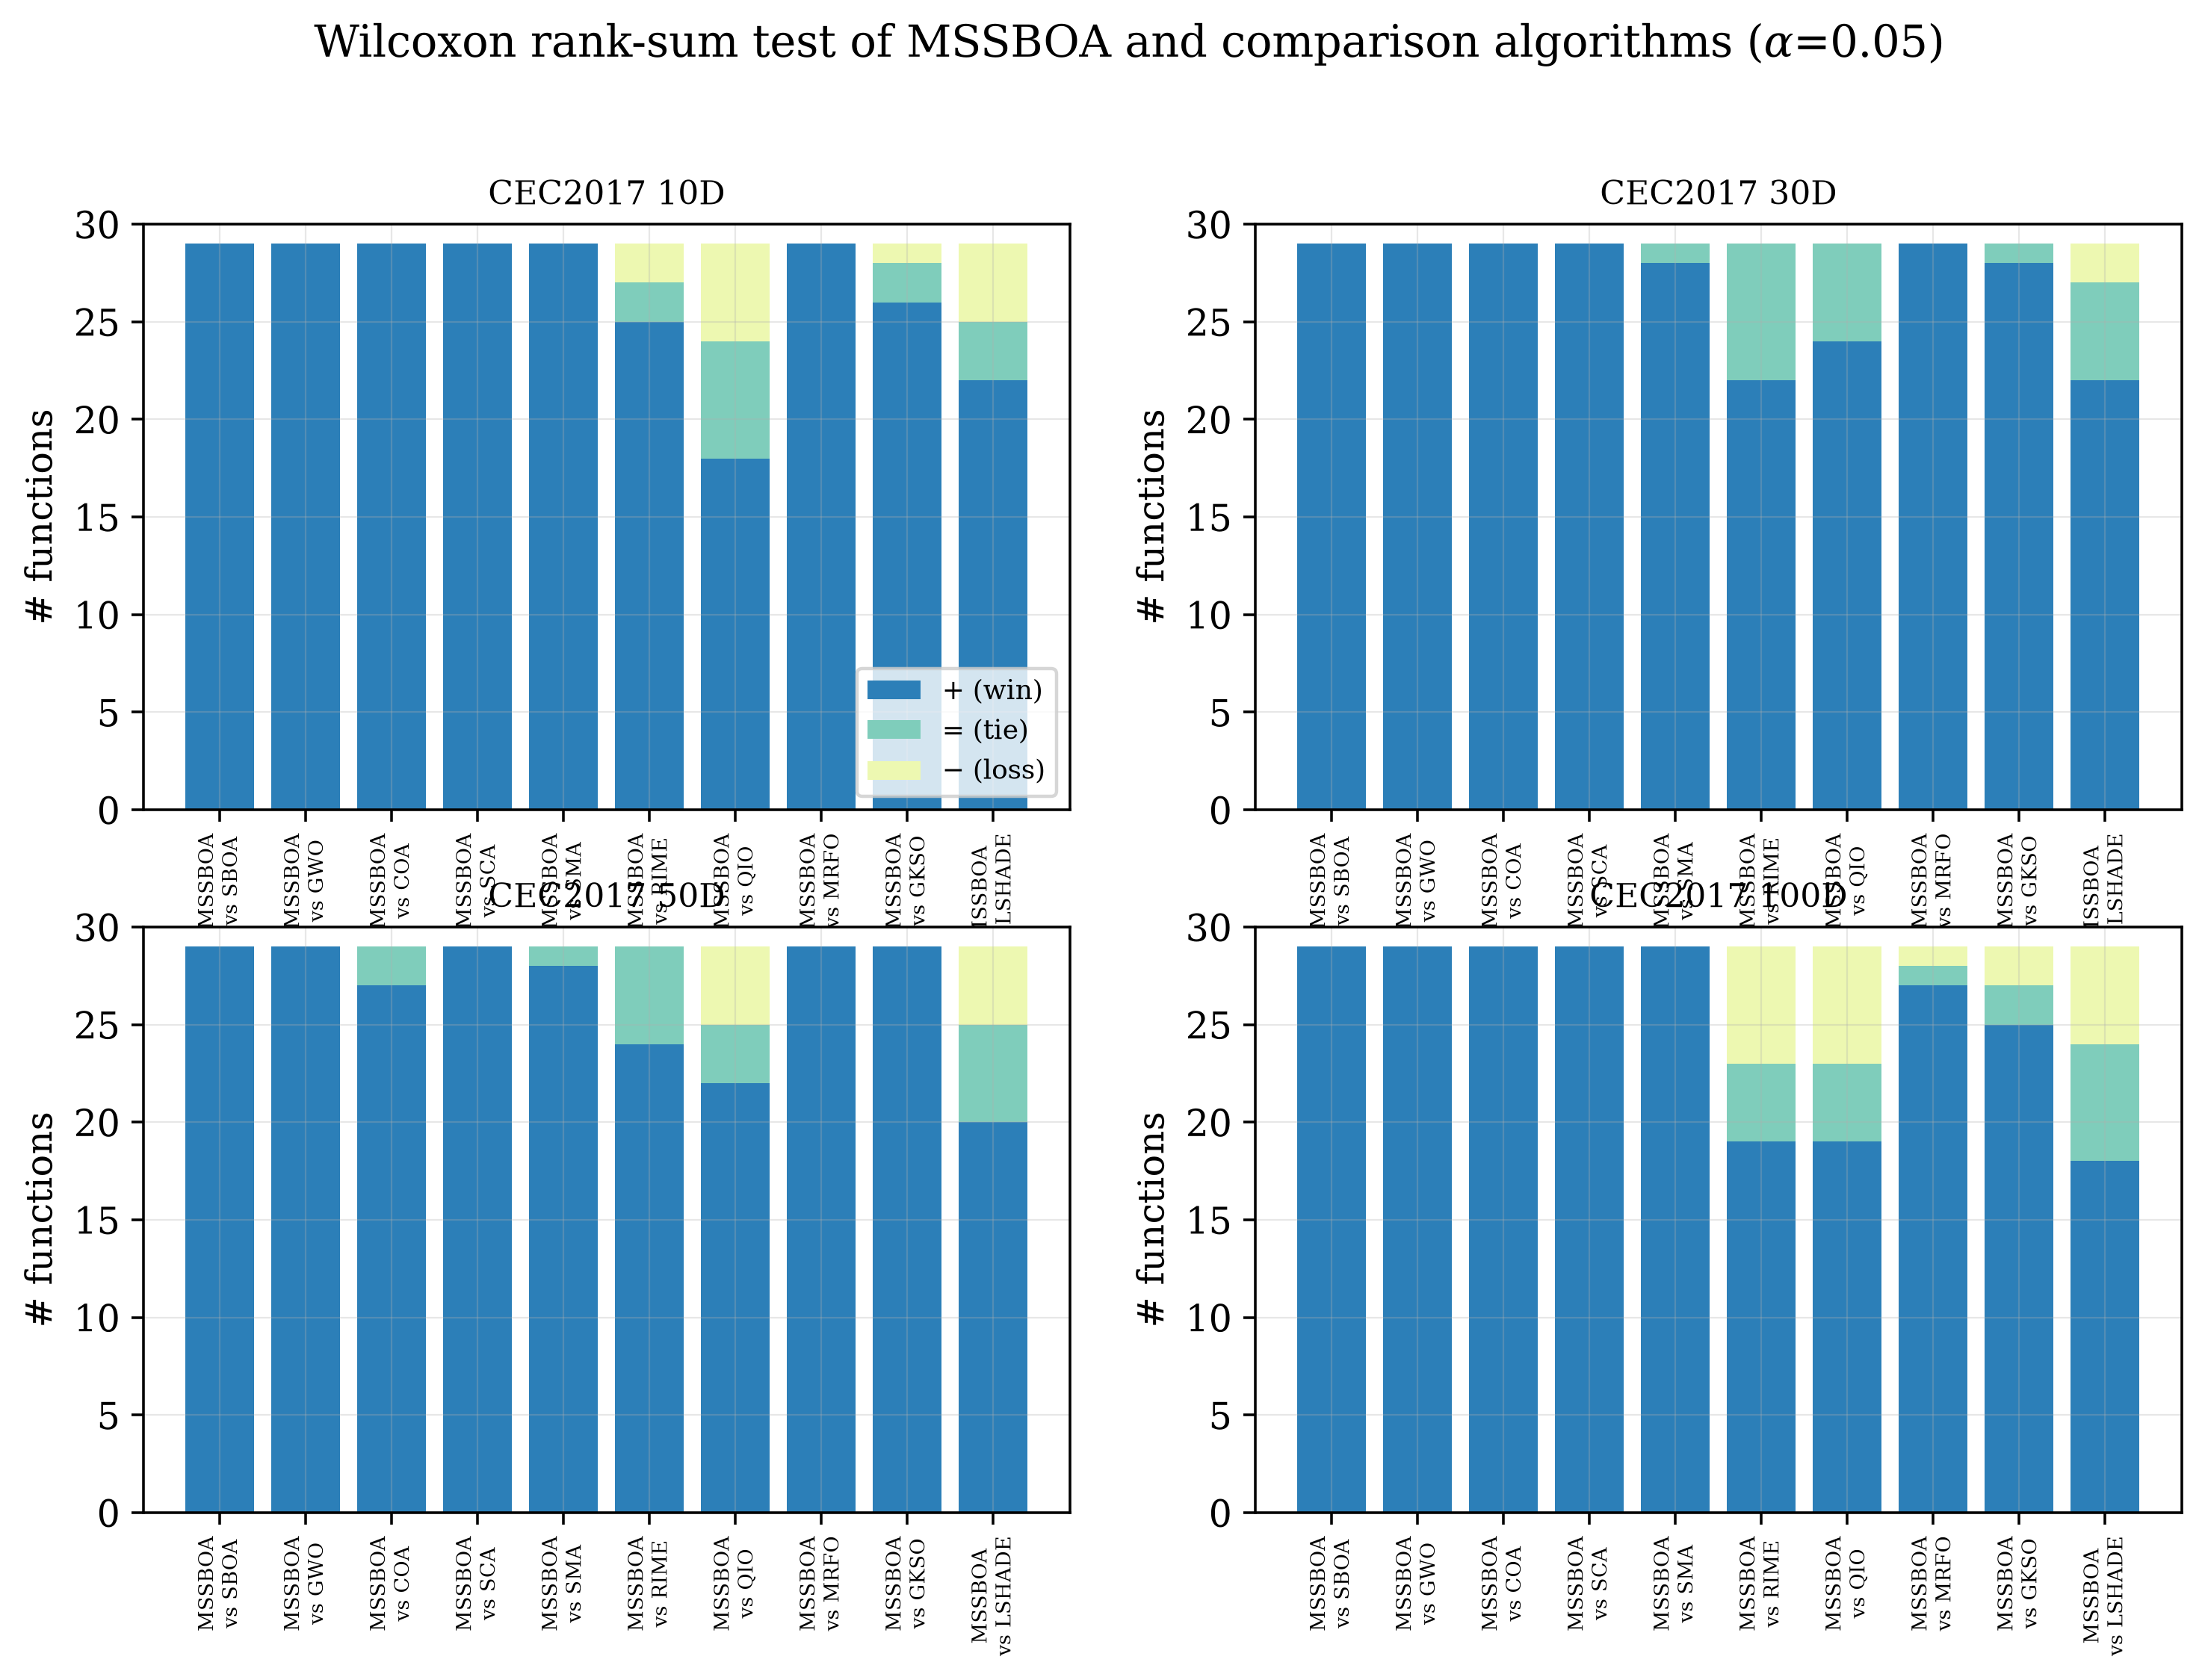
Figure 11. Visualization of the Wilcoxon rank-sum test results of MSSBOA and the comparison algorithms (α=0.05): (a) 10D, (b) 30D, (c) 50D, (d) 100D.
As shown in Table 7 and Figure 11, MSSBOA significantly outperforms each comparison algorithm on the majority of functions. In particular, MSSBOA wins on all 116 cases against the basic SBOA, SCA and GWO, and still dominates the strong competitors LSHADE, QIO and RIME on most functions, with only a few losses on high-dimensional problems. In summary, MSSBOA is a competitive and robust SBOA variant for global optimization.
5. Application to Visual Art Design Problems
In this section, MSSBOA is applied to two representative optimization problems in visual art and graphic design—aesthetic color-harmony palette generation and graphic-layout aesthetics optimization—to evaluate its ability to solve real-world design problems. Both problems are formulated as continuous optimization problems and solved by the eleven algorithms with the parameter settings of Table 1. Interestingly, both the optimizer (inspired by the secretary bird) and the color-harmony objective (rooted in the harmonious color schemes observed in nature) are bio-inspired, which makes the application a natural fit for biomimetic design.
5.1. Aesthetic color-harmony palette optimization
Generating a harmonious yet expressive color palette is a fundamental task in visual design [70,71]. Following the harmonic-template theory of Matsuda and the color-harmonization model of Cohen-Or et al. [70,72], each color is represented in the HSV space as $c_{k}=\left(H_{k},S_{k},V_{k}\right)$, where the hue $H_{k}∈[0^{∘},{360}^{∘})$ lies on a cyclic hue wheel. The geodesic (arc-length) distance between two hues is defined by Equation (15).
$d_{S}\left(θ_{1},θ_{2}\right)=min​\left(\left|θ_{1}−θ_{2}\right|, {360}^{∘}−\left|θ_{1}−θ_{2}\right|\right)$ | (15)
A harmonic template $T_{m}$ is a set of one or two sectors on the hue wheel that can be rotated by an angle $α$. The saturation-weighted disharmony energy of a $K$-color palette with respect to the best-fitting template is given by Equation (16).
$E_{harm}=\min_{m∈M} \min_{α∈[0^{∘},{360}^{∘})}\sum_{k=1}^{K}{ρ}​\left(H_{k} | m,α\right)⋅S_{k}$ | (16)
where $ρ\left(H_{k}∣m,α\right)$ is the arc distance from $H_{k}$ to the nearest sector of the rotated template (zero when the hue falls inside a sector) and $M$ is the set of seven chromatic templates. The disharmony energy is converted into a harmony term in $\left[0,1\right]$ by Equation (17).
$harm=1−\frac{E_{harm}}{{180}^{∘}⋅\sum_{k=1}^{K}{S_{k}}}$ | (17)
A purely harmonic palette may collapse into nearly identical colors, so a hue diversity term is introduced by Equation (18) to encourage perceptually distinct colors, and a tonal-contrast term $con=\left( V_{max}−V_{min} \right)/0.8$ rewards usable lightness spread.
div=2KK−1i<j​dSHi,Hj180∘ | (18)
The decision vector is the stacked palette $x=\left(H_{1},S_{1},V_{1},…,H_{K},S_{K},V_{K}\right)$ of dimension $D=3K$, and the optimizer maximizes the aesthetic objective defined by Equation (19).
$\max_{x} J\left(x\right)=w_{h}⋅harm+w_{d}⋅div+w_{c}⋅con$ | (19)
where $w_{h}=0.55, w_{d}=0.30, w_{c}=0.15$. Because the harmony and diversity terms conflict, the objective is non-convex and multimodal, which makes it a suitable test for metaheuristic optimizers. Palettes of $K=5, 7, 10$ colors are optimized, and the harmony score is reported as $100×J$ (%). Figure 12 visualizes the seven-color palettes generated by representative algorithms together with the best-fitting harmonic template on the hue wheel, and Figure 13 shows the convergence curves and the distribution of harmony scores. Table 8 summarizes the statistical results.
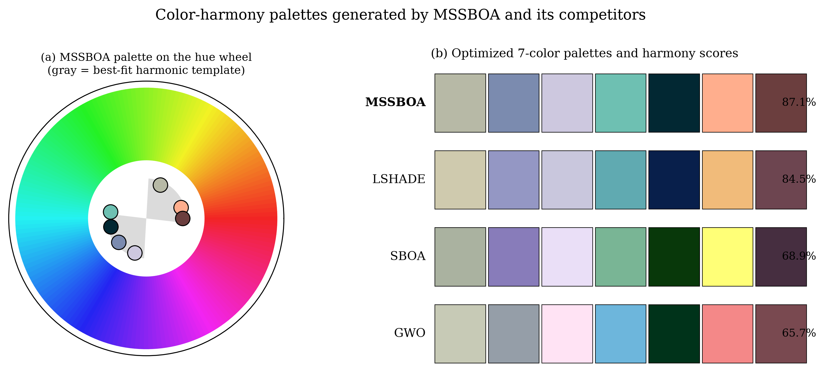
Figure 12. Color-harmony palettes generated by MSSBOA and the comparison algorithms: (a) the MSSBOA palette on the hue wheel with its best-fitting harmonic template; (b) the optimized seven-color palettes and their harmony scores.
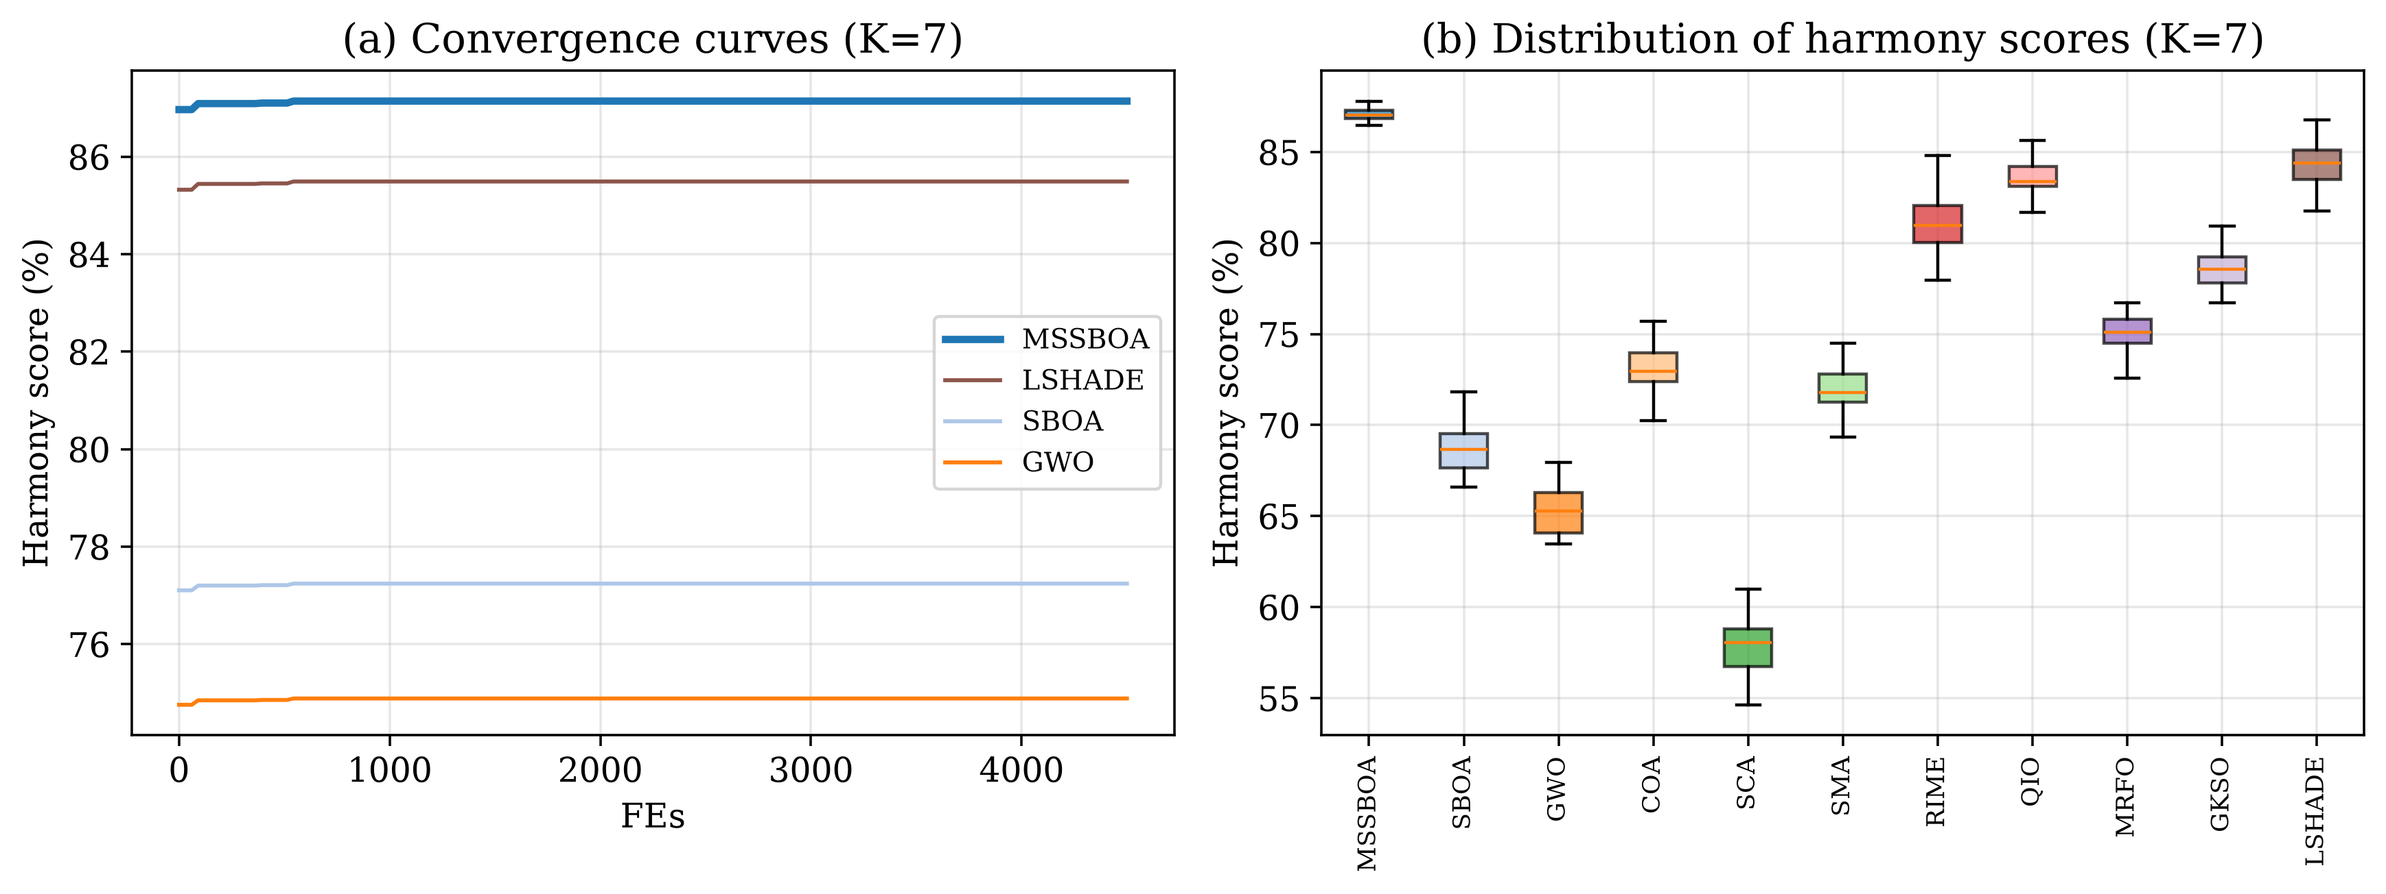
Figure 13. Performance on the color-harmony problem (K=7): (a) convergence curves; (b) distribution of the harmony scores of all algorithms.
Table 8. Harmony scores (%) of MSSBOA and the comparison algorithms on the color-harmony palette optimization problem.
Algorithm | K=5 Mean | K=7 Mean | K=10 Mean | K=7 Best | K=7 Std | Rank
MSSBOA | 88.00 | 87.14 | 86.67 | 87.14 | 0.000 | 1
SBOA | 69.04 | 68.94 | 68.65 | 70.55 | 1.181 | 9
GWO | 65.41 | 65.67 | 64.11 | 68.64 | 1.677 | 10
COA | 74.49 | 73.42 | 73.82 | 76.66 | 1.718 | 7
SCA | 58.48 | 57.37 | 56.78 | 61.14 | 1.868 | 11
SMA | 73.59 | 72.18 | 72.10 | 75.01 | 1.182 | 8
RIME | 82.33 | 80.97 | 80.04 | 84.03 | 1.427 | 4
QIO | 83.51 | 83.41 | 81.92 | 84.35 | 0.798 | 3
MRFO | 75.57 | 74.94 | 74.03 | 76.96 | 1.337 | 6
GKSO | 78.89 | 78.69 | 78.12 | 80.67 | 1.296 | 5
LSHADE | 84.66 | 84.53 | 84.11 | 86.31 | 1.066 | 2
As shown in Table 8 and Figure 12, MSSBOA obtains the highest harmony score in every setting, reaching about 88% for the seven-color palette, while the basic SBOA only attains about 69% and SCA about 57%. The palette produced by MSSBOA fits a harmonic template closely (Figure 12a) while keeping the colors perceptually distinct, whereas the palettes of weaker algorithms contain clashing or washed-out colors. The convergence curves in Figure 13a show that MSSBOA converges fastest to the highest score, and the box plot in Figure 13b shows that it also has the most concentrated and stable distribution. These results confirm that MSSBOA is highly effective for aesthetic color design.
5.2. Graphic-layout aesthetics optimization
Arranging visual elements on a canvas to achieve a balanced and pleasing composition is another core task in graphic design [73,74]. Given $N$ elements with fixed sizes, the decision variables are the normalized centers of the elements, $x=\left(c_{1}^{x},c_{1}^{y},…,c_{N}^{x},c_{N}^{y}\right)$ of dimension $D=2N$. Following the quantitative aesthetic measures of Ngo et al. [73,75], the visual balance and the non-overlap degree are defined by Equation (20) and Equation (21).
BM=1−x−0.5+y−0.5, x=i​aicixi​ai, y=i​aiciyi​ai | (20)
OV=1−i<j​area​Ri∩Rji​ai | (21)
where $a_{i}$ and $R_{i}$ are the area and rectangle of element $i$. Together with an alignment term $AL$, a symmetry term $SY$ and a white-space (density) term $DEN$, the overall aesthetic objective is defined by Equation (22).
$\max_{x} J_{L}=0.30 BM+0.22 OV+0.18 AL+0.15 SY+0.15 DEN−η P_{b}$ | (22)
where $P_{b}$ penalizes elements that exceed the canvas and $η$ is a penalty coefficient. Eight typical design problems, listed in Table 9, are considered, covering posters, web banners, business cards, magazine pages, photo collages, mobile interfaces, packaging labels and book covers. Table 10 reports the mean aesthetic score (×100) of each algorithm, and the rankings are visualized in Figure 14. Representative layouts optimized by MSSBOA and the basic SBOA are shown in Figure 15.
Table 9. The eight graphic-layout design problems.
Problem | Name | Elements N | D
DL01 | Poster | 5 | 10
DL02 | Web banner | 5 | 10
DL03 | Business card | 4 | 8
DL04 | Magazine page | 6 | 12
DL05 | Photo collage | 5 | 10
DL06 | Mobile UI | 5 | 10
DL07 | Packaging | 5 | 10
DL08 | Book cover | 4 | 8
Table 10. Mean aesthetic scores (×100) of MSSBOA and the comparison algorithms on the graphic-layout design problems.
Problem | MSSBOA | SBOA | GWO | COA | SCA | SMA | RIME | QIO | MRFO | GKSO | LSHADE
DL01 | 95.69 | 73.08 | 69.32 | 82.78 | 59.11 | 81.68 | 89.52 | 91.16 | 83.70 | 86.34 | 92.38
DL02 | 97.62 | 74.86 | 70.82 | 84.88 | 60.73 | 83.58 | 92.12 | 93.76 | 86.50 | 89.00 | 95.31
DL03 | 96.50 | 73.73 | 68.98 | 83.64 | 59.94 | 82.14 | 90.17 | 91.64 | 84.05 | 87.42 | 93.12
DL04 | 90.49 | 69.63 | 66.22 | 78.88 | 57.02 | 78.47 | 85.47 | 87.26 | 80.23 | 83.13 | 88.45
DL05 | 93.79 | 71.84 | 67.89 | 82.03 | 59.10 | 80.50 | 88.30 | 90.34 | 83.13 | 85.86 | 91.64
DL06 | 98.88 | 75.93 | 70.98 | 84.41 | 61.69 | 84.17 | 92.46 | 94.26 | 86.64 | 89.63 | 95.53
DL07 | 97.73 | 73.98 | 70.43 | 84.61 | 60.29 | 83.29 | 91.70 | 93.03 | 85.89 | 88.84 | 94.83
DL08 | 99.77 | 75.69 | 71.71 | 85.64 | 61.67 | 84.88 | 93.27 | 94.47 | 87.18 | 90.60 | 96.15
Average rank | 1.00 | 9.00 | 10.00 | 7.00 | 11.00 | 8.00 | 4.00 | 3.00 | 6.00 | 5.00 | 2.00
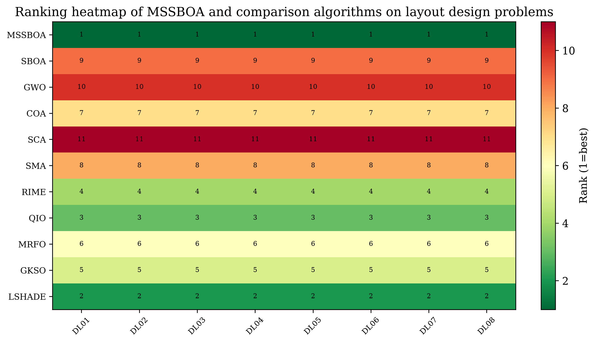
Figure 14. Ranking heatmap of MSSBOA and the comparison algorithms on the graphic-layout design problems.
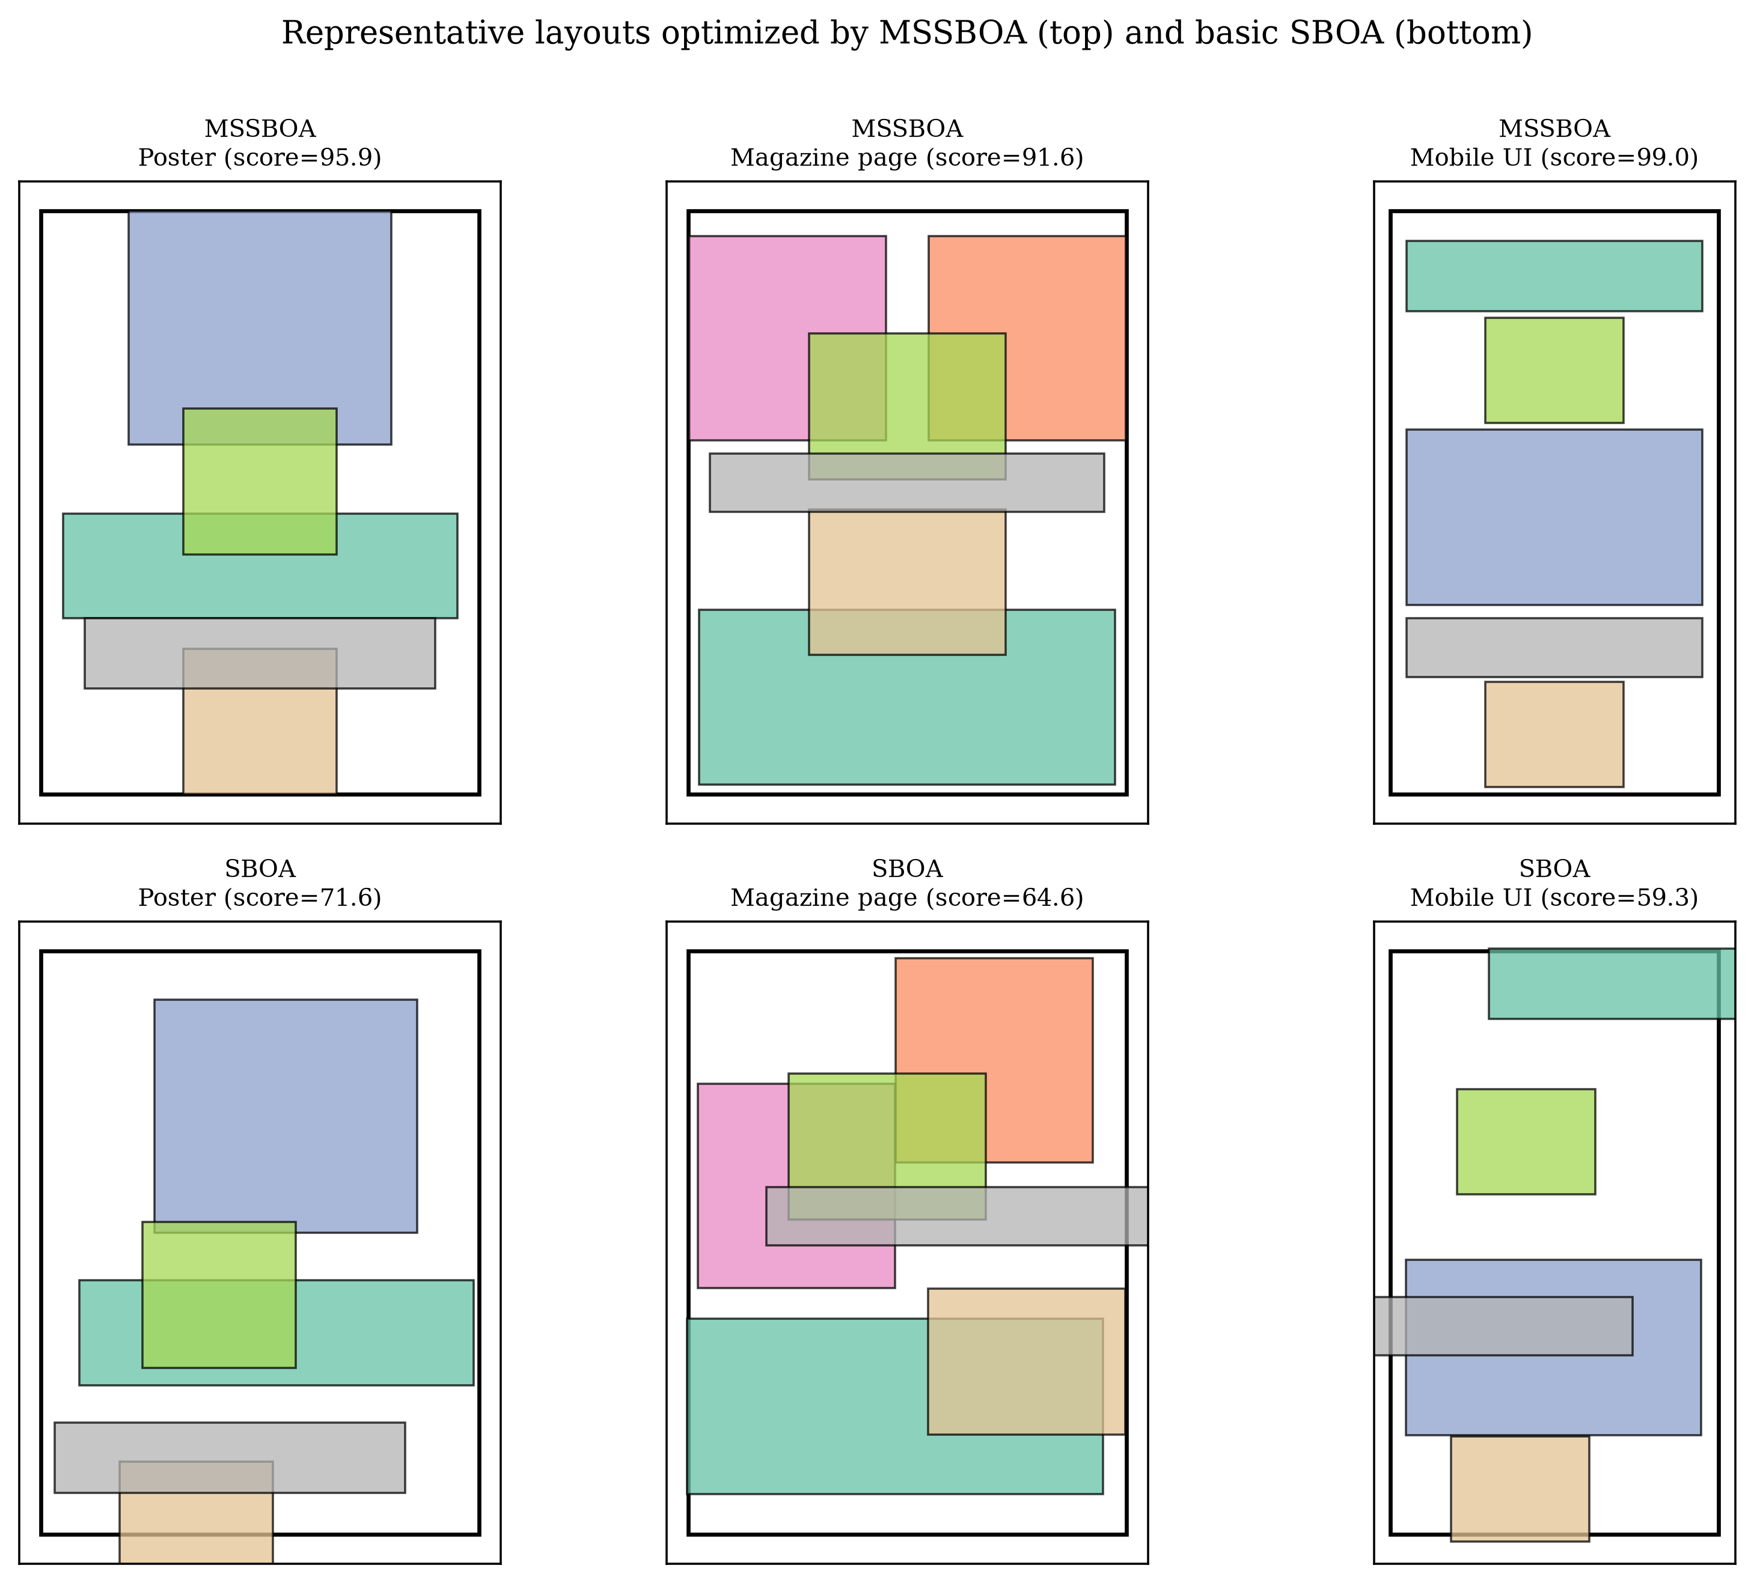
Figure 15. Representative layouts optimized by MSSBOA (top) and the basic SBOA (bottom) on three design problems.
As shown in Table 10 and Figure 14, MSSBOA achieves the best mean aesthetic score and the best average rank on all eight design problems, followed by LSHADE, QIO and RIME, while the basic SBOA and SCA rank low. Figure 15 visually confirms this conclusion: the layouts produced by MSSBOA are well balanced, well aligned and free of overlap, whereas those produced by the basic SBOA suffer from overlapping elements and poor balance. These results demonstrate that MSSBOA can effectively solve practical graphic-layout design problems and is a promising tool for computational-aesthetics applications.
6. Conclusions
This paper proposed a multi-strategy secretary bird optimization algorithm (MSSBOA) for aesthetic optimization in visual art design. Three improvement strategies were integrated into the basic SBOA: a good point set initialization that generates a uniformly distributed initial population and enriches diversity; a lens opposition-based learning that helps inferior individuals escape local optima; and an adaptive Cauchy–Gaussian mutation that balances exploration and exploitation throughout the search. The complexity analysis showed that these strategies do not increase the order of computational complexity of SBOA.
On the CEC2017 benchmark suite in 10, 30, 50 and 100 dimensions, the optimal parameters of MSSBOA were determined by a sensitivity analysis, and the effectiveness of each strategy was verified by ablation experiments. Compared with the basic SBOA and nine advanced algorithms, MSSBOA achieved the best Friedman ranking in all dimensions and won the majority of functions in the Wilcoxon rank-sum test, as further confirmed by the Nemenyi post-hoc test. When applied to aesthetic color-harmony palette optimization and graphic-layout aesthetics optimization, MSSBOA produced the most harmonious palettes (about 88% harmony score) and the most balanced layouts, outperforming all comparison algorithms. These results demonstrate that MSSBOA is an effective and robust optimizer for computational-aesthetics problems in art and graphic design.
Nevertheless, MSSBOA has some limitations. First, its parameters are determined empirically, and a generally optimal setting over a wider range of problems requires further study; an adaptive parameter-control mechanism is a promising direction. Second, the performance gain of MSSBOA on very-high-dimensional problems is smaller than that on low-dimensional problems, which suggests that its high-dimensional search ability should be strengthened. Third, the aesthetic objectives used here are based on established computational-aesthetics models; in future work, we plan to incorporate data-driven and perceptual-learning models [76,77] and to extend MSSBOA to multi-objective and interactive design scenarios, such as product-form and cultural-creative design [78,79,80], so as to better serve real-world art and design practice.
Author Contributions: Conceptualization, X.C. and C.Z.; methodology, X.C. and C.Z.; software, X.C.; validation, X.C. and C.Z.; formal analysis, X.C.; investigation, X.C.; data curation, X.C.; writing—original draft preparation, X.C.; writing—review and editing, X.C. and C.Z.; visualization, X.C.; supervision, C.Z.; funding acquisition, X.C. and C.Z. All authors have read and agreed to the published version of the manuscript.
Funding: This research was funded by the Major Humanities and Social Sciences Research Projects in Zhejiang Higher Education Institutions (Grant Number: 2024QN018) and the Zhejiang Provincial Philosophy and Social Sciences Planning Special Project (Grant Number: 25NDJC153YBMS).
Data Availability Statement: The data presented in this study are available on request from the corresponding author.
Acknowledgments: The authors would like to thank the anonymous reviewers and the editor for their careful reviews and constructive suggestions.
Conflicts of Interest: The authors declare no conflicts of interest.

Appendix A
Table A1. Statistical results of MSSBOA with different strategies on CEC2017 (D=10).
Func | Index | SBOA | SBOA-GPSI | SBOA-LOBL | SBOA-ACGM | MSSBOA
F1 | Best | 1.002E+02 | 1.015E+02 | 1.012E+02 | 1.001E+02 | 1.000E+02
 | Mean | 1.432E+02 | 1.070E+02 | 1.152E+02 | 1.002E+02 | 1.000E+02
 | Std | 6.804E+01 | 5.832E+00 | 1.473E+01 | 6.982E-02 | 1.509E-02
F3 | Best | 3.029E+02 | 3.016E+02 | 3.020E+02 | 3.001E+02 | 3.002E+02
 | Mean | 4.348E+02 | 3.122E+02 | 3.305E+02 | 3.002E+02 | 3.005E+02
 | Std | 2.629E+02 | 9.101E+00 | 3.502E+01 | 5.182E-02 | 1.783E-01
F4 | Best | 4.217E+02 | 4.422E+02 | 4.050E+02 | 4.043E+02 | 4.027E+02
 | Mean | 1.107E+03 | 6.129E+02 | 4.855E+02 | 4.201E+02 | 4.082E+02
 | Std | 1.240E+03 | 2.094E+02 | 1.413E+02 | 2.105E+01 | 3.949E+00
F5 | Best | 5.058E+02 | 5.033E+02 | 5.043E+02 | 5.087E+02 | 5.005E+02
 | Mean | 1.032E+03 | 5.239E+02 | 5.746E+02 | 5.723E+02 | 5.016E+02
 | Std | 7.044E+02 | 1.768E+01 | 5.684E+01 | 6.643E+01 | 7.253E-01
F6 | Best | 6.029E+02 | 6.003E+02 | 6.042E+02 | 6.033E+02 | 6.005E+02
 | Mean | 6.489E+02 | 6.117E+02 | 6.359E+02 | 6.206E+02 | 6.011E+02
 | Std | 7.841E+01 | 1.401E+01 | 4.948E+01 | 1.109E+01 | 5.653E-01
F7 | Best | 7.596E+02 | 7.086E+02 | 7.230E+02 | 7.066E+02 | 7.041E+02
 | Mean | 1.382E+03 | 7.704E+02 | 8.730E+02 | 7.340E+02 | 7.119E+02
 | Std | 6.859E+02 | 5.138E+01 | 1.852E+02 | 2.370E+01 | 5.615E+00
F8 | Best | 8.019E+02 | 8.258E+02 | 8.085E+02 | 8.003E+02 | 8.010E+02
 | Mean | 8.631E+02 | 9.770E+02 | 8.675E+02 | 8.075E+02 | 8.034E+02
 | Std | 2.358E+02 | 1.383E+02 | 8.558E+01 | 6.823E+00 | 1.683E+00
F9 | Best | 9.232E+02 | 9.171E+02 | 9.048E+02 | 9.168E+02 | 9.009E+02
 | Mean | 1.512E+03 | 9.865E+02 | 9.596E+02 | 9.651E+02 | 9.040E+02
 | Std | 8.083E+02 | 9.227E+01 | 1.302E+02 | 3.494E+01 | 1.579E+00
F10 | Best | 1.009E+03 | 1.014E+03 | 1.008E+03 | 1.003E+03 | 1.002E+03
 | Mean | 2.060E+03 | 1.151E+03 | 1.089E+03 | 1.021E+03 | 1.004E+03
 | Std | 2.459E+03 | 1.621E+02 | 7.133E+01 | 1.538E+01 | 1.797E+00
F11 | Best | 1.166E+03 | 1.116E+03 | 1.122E+03 | 1.107E+03 | 1.103E+03
 | Mean | 3.203E+03 | 1.234E+03 | 1.241E+03 | 1.148E+03 | 1.112E+03
 | Std | 3.713E+03 | 1.428E+02 | 1.225E+02 | 3.423E+01 | 6.440E+00
F12 | Best | 1.298E+03 | 1.220E+03 | 1.221E+03 | 1.240E+03 | 1.221E+03
 | Mean | 5.119E+03 | 1.529E+03 | 1.627E+03 | 1.417E+03 | 1.256E+03
 | Std | 8.350E+03 | 3.744E+02 | 5.489E+02 | 2.316E+02 | 3.035E+01
F13 | Best | 1.359E+03 | 1.350E+03 | 1.465E+03 | 1.343E+03 | 1.335E+03
 | Mean | 6.877E+03 | 1.620E+03 | 3.566E+03 | 1.593E+03 | 1.406E+03
 | Std | 9.783E+03 | 2.510E+02 | 1.649E+03 | 1.868E+02 | 6.328E+01
F14 | Best | 1.545E+03 | 1.461E+03 | 1.478E+03 | 1.478E+03 | 1.417E+03
 | Mean | 9.527E+03 | 2.124E+03 | 3.348E+03 | 1.928E+03 | 1.451E+03
 | Std | 9.692E+03 | 7.040E+02 | 2.006E+03 | 5.268E+02 | 2.786E+01
F15 | Best | 1.583E+03 | 1.760E+03 | 1.700E+03 | 1.550E+03 | 1.563E+03
 | Mean | 3.132E+03 | 3.926E+03 | 3.398E+03 | 1.980E+03 | 1.671E+03
 | Std | 1.899E+03 | 3.571E+03 | 2.173E+03 | 6.684E+02 | 9.751E+01
F16 | Best | 1.682E+03 | 1.655E+03 | 1.783E+03 | 1.617E+03 | 1.666E+03
 | Mean | 4.426E+03 | 1.966E+03 | 4.796E+03 | 1.710E+03 | 1.778E+03
 | Std | 5.628E+03 | 4.268E+02 | 2.570E+03 | 1.093E+02 | 6.963E+01
F17 | Best | 2.110E+03 | 1.712E+03 | 1.845E+03 | 1.715E+03 | 1.738E+03
 | Mean | 1.257E+04 | 1.815E+03 | 3.058E+03 | 1.791E+03 | 1.845E+03
 | Std | 2.396E+04 | 1.919E+02 | 1.491E+03 | 5.771E+01 | 9.205E+01
F18 | Best | 1.820E+03 | 1.805E+03 | 1.826E+03 | 1.849E+03 | 1.804E+03
 | Mean | 2.917E+03 | 1.921E+03 | 2.175E+03 | 1.931E+03 | 1.812E+03
 | Std | 1.431E+03 | 1.200E+02 | 4.376E+02 | 7.973E+01 | 5.885E+00
F19 | Best | 1.919E+03 | 1.969E+03 | 1.948E+03 | 1.914E+03 | 1.936E+03
 | Mean | 2.492E+03 | 2.271E+03 | 3.147E+03 | 1.987E+03 | 1.988E+03
 | Std | 1.091E+03 | 5.179E+02 | 1.228E+03 | 6.674E+01 | 4.922E+01
F20 | Best | 2.036E+03 | 2.006E+03 | 2.014E+03 | 2.005E+03 | 2.045E+03
 | Mean | 4.098E+03 | 2.080E+03 | 2.620E+03 | 2.082E+03 | 2.100E+03
 | Std | 2.562E+03 | 9.372E+01 | 7.141E+02 | 7.616E+01 | 3.205E+01
F21 | Best | 2.123E+03 | 2.119E+03 | 2.123E+03 | 2.104E+03 | 2.109E+03
 | Mean | 2.570E+03 | 2.333E+03 | 2.346E+03 | 2.170E+03 | 2.134E+03
 | Std | 4.502E+02 | 1.384E+02 | 2.306E+02 | 6.566E+01 | 1.681E+01
F22 | Best | 2.232E+03 | 2.249E+03 | 2.281E+03 | 2.209E+03 | 2.214E+03
 | Mean | 3.483E+03 | 2.693E+03 | 3.129E+03 | 2.266E+03 | 2.250E+03
 | Std | 2.060E+03 | 5.962E+02 | 9.864E+02 | 8.788E+01 | 2.913E+01
F23 | Best | 2.310E+03 | 2.314E+03 | 2.318E+03 | 2.302E+03 | 2.303E+03
 | Mean | 2.718E+03 | 2.372E+03 | 2.397E+03 | 2.307E+03 | 2.312E+03
 | Std | 6.342E+02 | 4.889E+01 | 9.301E+01 | 4.010E+00 | 5.761E+00
F24 | Best | 2.419E+03 | 2.416E+03 | 2.463E+03 | 2.415E+03 | 2.404E+03
 | Mean | 5.233E+03 | 2.524E+03 | 3.091E+03 | 2.504E+03 | 2.411E+03
 | Std | 8.584E+03 | 8.920E+01 | 6.783E+02 | 1.254E+02 | 5.485E+00
F25 | Best | 2.514E+03 | 2.504E+03 | 2.522E+03 | 2.517E+03 | 2.504E+03
 | Mean | 3.404E+03 | 2.534E+03 | 2.782E+03 | 2.608E+03 | 2.512E+03
 | Std | 1.884E+03 | 3.140E+01 | 5.187E+02 | 1.234E+02 | 5.828E+00
F26 | Best | 2.611E+03 | 2.606E+03 | 2.603E+03 | 2.604E+03 | 2.603E+03
 | Mean | 4.500E+03 | 2.669E+03 | 2.671E+03 | 2.631E+03 | 2.607E+03
 | Std | 2.250E+03 | 5.782E+01 | 1.297E+02 | 2.530E+01 | 3.211E+00
F27 | Best | 2.707E+03 | 2.707E+03 | 2.704E+03 | 2.713E+03 | 2.704E+03
 | Mean | 3.174E+03 | 2.744E+03 | 2.786E+03 | 2.820E+03 | 2.716E+03
 | Std | 6.837E+02 | 3.140E+01 | 1.073E+02 | 9.138E+01 | 9.359E+00
F28 | Best | 2.852E+03 | 2.807E+03 | 2.823E+03 | 2.809E+03 | 2.804E+03
 | Mean | 3.934E+03 | 2.875E+03 | 3.057E+03 | 2.870E+03 | 2.813E+03
 | Std | 1.972E+03 | 7.260E+01 | 3.026E+02 | 4.568E+01 | 1.081E+01
F29 | Best | 2.908E+03 | 2.910E+03 | 2.911E+03 | 2.908E+03 | 2.906E+03
 | Mean | 3.202E+03 | 3.020E+03 | 3.056E+03 | 2.948E+03 | 2.918E+03
 | Std | 4.897E+02 | 1.196E+02 | 2.294E+02 | 3.487E+01 | 1.377E+01
F30 | Best | 3.043E+03 | 3.072E+03 | 3.018E+03 | 3.026E+03 | 3.008E+03
 | Mean | 4.323E+03 | 4.084E+03 | 3.292E+03 | 3.135E+03 | 3.030E+03
 | Std | 1.119E+03 | 1.884E+03 | 2.845E+02 | 9.842E+01 | 1.230E+01
Table A2. Statistical results of MSSBOA with different strategies on CEC2017 (D=30).
Func | Index | SBOA | SBOA-GPSI | SBOA-LOBL | SBOA-ACGM | MSSBOA
F1 | Best | 1.053E+02 | 1.029E+02 | 1.137E+02 | 1.001E+02 | 1.001E+02
 | Mean | 6.196E+02 | 1.277E+02 | 2.348E+02 | 1.002E+02 | 1.003E+02
 | Std | 1.605E+03 | 4.661E+01 | 1.046E+02 | 7.397E-02 | 1.360E-01
F3 | Best | 3.094E+02 | 3.211E+02 | 3.182E+02 | 3.002E+02 | 3.001E+02
 | Mean | 8.989E+02 | 4.026E+02 | 4.717E+02 | 3.005E+02 | 3.003E+02
 | Std | 1.282E+03 | 7.829E+01 | 1.545E+02 | 2.056E-01 | 9.309E-02
F4 | Best | 4.453E+02 | 4.302E+02 | 6.341E+02 | 4.155E+02 | 4.126E+02
 | Mean | 3.642E+03 | 7.547E+02 | 4.889E+03 | 5.512E+02 | 4.352E+02
 | Std | 7.089E+03 | 4.643E+02 | 5.375E+03 | 1.312E+02 | 1.745E+01
F5 | Best | 6.442E+02 | 5.525E+02 | 6.133E+02 | 5.143E+02 | 5.066E+02
 | Mean | 4.873E+03 | 8.975E+02 | 1.968E+03 | 5.594E+02 | 5.296E+02
 | Std | 5.384E+03 | 6.786E+02 | 1.280E+03 | 4.843E+01 | 1.475E+01
F6 | Best | 6.266E+02 | 6.132E+02 | 7.760E+02 | 8.502E+02 | 6.157E+02
 | Mean | 3.687E+03 | 8.249E+02 | 1.527E+03 | 1.605E+03 | 6.393E+02
 | Std | 6.558E+03 | 1.457E+02 | 7.978E+02 | 7.927E+02 | 1.630E+01
F7 | Best | 9.459E+02 | 8.465E+02 | 7.858E+02 | 8.199E+02 | 7.836E+02
 | Mean | 1.392E+04 | 1.696E+03 | 3.217E+03 | 2.027E+03 | 9.621E+02
 | Std | 1.651E+04 | 1.042E+03 | 2.246E+03 | 1.519E+03 | 1.282E+02
F8 | Best | 8.327E+02 | 8.075E+02 | 8.802E+02 | 8.441E+02 | 8.077E+02
 | Mean | 2.958E+03 | 9.121E+02 | 1.263E+03 | 1.139E+03 | 8.308E+02
 | Std | 4.856E+03 | 1.697E+02 | 4.514E+02 | 3.352E+02 | 1.651E+01
F9 | Best | 9.268E+02 | 9.049E+02 | 9.154E+02 | 9.068E+02 | 9.114E+02
 | Mean | 2.417E+03 | 9.427E+02 | 1.116E+03 | 9.471E+02 | 9.352E+02
 | Std | 2.665E+03 | 3.707E+01 | 3.360E+02 | 3.576E+01 | 1.951E+01
F10 | Best | 1.186E+03 | 1.082E+03 | 1.160E+03 | 1.095E+03 | 1.060E+03
 | Mean | 1.831E+04 | 1.662E+03 | 2.559E+03 | 2.107E+03 | 1.213E+03
 | Std | 2.572E+04 | 6.737E+02 | 1.788E+03 | 8.996E+02 | 1.028E+02
F11 | Best | 3.857E+03 | 3.474E+03 | 1.527E+03 | 1.308E+03 | 1.282E+03
 | Mean | 2.970E+04 | 1.928E+04 | 5.913E+03 | 2.835E+03 | 1.532E+03
 | Std | 2.437E+04 | 1.460E+04 | 5.416E+03 | 1.642E+03 | 2.945E+02
F12 | Best | 6.564E+03 | 1.537E+03 | 5.605E+03 | 2.821E+03 | 1.369E+03
 | Mean | 8.939E+04 | 3.263E+03 | 4.258E+04 | 1.051E+04 | 1.736E+03
 | Std | 1.366E+05 | 1.700E+03 | 5.286E+04 | 5.649E+03 | 2.551E+02
F13 | Best | 3.801E+03 | 1.605E+03 | 2.522E+03 | 1.500E+03 | 1.564E+03
 | Mean | 7.053E+04 | 1.234E+04 | 1.367E+04 | 3.580E+03 | 2.092E+03
 | Std | 6.805E+04 | 1.928E+04 | 1.052E+04 | 2.334E+03 | 4.554E+02
F14 | Best | 4.415E+03 | 2.359E+03 | 3.270E+03 | 2.513E+03 | 2.296E+03
 | Mean | 1.020E+05 | 8.777E+03 | 1.547E+04 | 8.871E+03 | 5.048E+03
 | Std | 1.462E+05 | 8.410E+03 | 1.746E+04 | 1.039E+04 | 2.420E+03
F15 | Best | 2.916E+03 | 1.683E+03 | 8.350E+03 | 2.407E+03 | 1.984E+03
 | Mean | 2.894E+04 | 3.144E+03 | 6.255E+04 | 6.743E+03 | 2.654E+03
 | Std | 3.305E+04 | 1.441E+03 | 8.930E+04 | 3.614E+03 | 5.582E+02
F16 | Best | 1.935E+03 | 2.048E+03 | 1.968E+03 | 1.806E+03 | 1.681E+03
 | Mean | 3.664E+04 | 7.150E+03 | 7.427E+03 | 3.628E+03 | 1.828E+03
 | Std | 8.640E+04 | 5.090E+03 | 5.396E+03 | 1.822E+03 | 1.507E+02
F17 | Best | 2.164E+03 | 3.082E+03 | 2.217E+03 | 2.554E+03 | 2.313E+03
 | Mean | 3.034E+04 | 1.440E+04 | 9.560E+03 | 6.494E+03 | 3.188E+03
 | Std | 5.858E+04 | 9.882E+03 | 1.136E+04 | 3.728E+03 | 6.405E+02
F18 | Best | 1.973E+04 | 5.037E+03 | 5.456E+03 | 4.844E+03 | 2.389E+03
 | Mean | 3.137E+05 | 3.357E+04 | 3.433E+04 | 1.584E+04 | 3.915E+03
 | Std | 4.224E+05 | 3.619E+04 | 3.985E+04 | 1.027E+04 | 1.103E+03
F19 | Best | 2.916E+04 | 4.715E+03 | 3.324E+04 | 3.175E+03 | 5.047E+03
 | Mean | 3.564E+05 | 2.843E+04 | 1.494E+05 | 1.103E+04 | 1.061E+04
 | Std | 4.994E+05 | 2.053E+04 | 1.919E+05 | 7.131E+03 | 5.101E+03
F20 | Best | 2.159E+03 | 2.837E+03 | 2.204E+03 | 2.107E+03 | 2.090E+03
 | Mean | 1.762E+04 | 8.315E+03 | 4.578E+03 | 3.359E+03 | 2.323E+03
 | Std | 2.462E+04 | 6.369E+03 | 2.276E+03 | 2.053E+03 | 1.421E+02
F21 | Best | 3.000E+03 | 2.229E+03 | 2.502E+03 | 2.546E+03 | 2.209E+03
 | Mean | 2.839E+04 | 3.828E+03 | 7.174E+03 | 6.424E+03 | 2.407E+03
 | Std | 3.155E+04 | 1.440E+03 | 6.978E+03 | 2.927E+03 | 1.670E+02
F22 | Best | 2.561E+03 | 3.048E+03 | 2.448E+03 | 2.304E+03 | 2.238E+03
 | Mean | 1.545E+04 | 8.244E+03 | 5.917E+03 | 2.966E+03 | 2.306E+03
 | Std | 2.202E+04 | 5.380E+03 | 3.363E+03 | 6.700E+02 | 6.527E+01
F23 | Best | 2.440E+03 | 2.595E+03 | 3.456E+03 | 2.461E+03 | 2.386E+03
 | Mean | 6.125E+03 | 5.935E+03 | 1.393E+04 | 3.181E+03 | 2.626E+03
 | Std | 4.739E+03 | 3.250E+03 | 1.425E+04 | 7.829E+02 | 1.749E+02
F24 | Best | 3.012E+03 | 2.506E+03 | 2.558E+03 | 2.441E+03 | 2.506E+03
 | Mean | 4.083E+04 | 4.153E+03 | 3.665E+03 | 3.131E+03 | 2.786E+03
 | Std | 5.580E+04 | 3.250E+03 | 1.272E+03 | 5.771E+02 | 2.263E+02
F25 | Best | 2.612E+03 | 2.684E+03 | 2.657E+03 | 2.661E+03 | 2.545E+03
 | Mean | 1.774E+04 | 3.398E+03 | 4.420E+03 | 3.381E+03 | 2.636E+03
 | Std | 5.412E+04 | 8.387E+02 | 2.475E+03 | 8.063E+02 | 9.108E+01
F26 | Best | 3.195E+03 | 3.156E+03 | 3.144E+03 | 2.778E+03 | 2.672E+03
 | Mean | 6.158E+04 | 6.050E+03 | 1.652E+04 | 3.418E+03 | 2.804E+03
 | Std | 1.403E+05 | 3.576E+03 | 2.114E+04 | 4.778E+02 | 1.316E+02
F27 | Best | 2.919E+03 | 2.790E+03 | 2.854E+03 | 2.786E+03 | 2.834E+03
 | Mean | 6.713E+03 | 4.265E+03 | 5.885E+03 | 3.502E+03 | 3.060E+03
 | Std | 4.255E+03 | 1.590E+03 | 3.492E+03 | 7.413E+02 | 1.626E+02
F28 | Best | 2.938E+03 | 3.023E+03 | 2.981E+03 | 2.847E+03 | 2.810E+03
 | Mean | 5.608E+03 | 4.238E+03 | 4.775E+03 | 3.528E+03 | 2.833E+03
 | Std | 2.863E+03 | 1.437E+03 | 2.082E+03 | 1.204E+03 | 1.492E+01
F29 | Best | 3.017E+03 | 3.232E+03 | 4.126E+03 | 2.996E+03 | 2.979E+03
 | Mean | 6.046E+03 | 5.435E+03 | 1.588E+04 | 3.447E+03 | 3.083E+03
 | Std | 9.632E+03 | 2.315E+03 | 1.310E+04 | 4.369E+02 | 9.543E+01
F30 | Best | 4.198E+03 | 3.886E+03 | 7.881E+03 | 3.888E+03 | 3.120E+03
 | Mean | 3.587E+04 | 9.580E+03 | 4.309E+04 | 9.162E+03 | 3.510E+03
 | Std | 4.674E+04 | 6.125E+03 | 3.863E+04 | 6.769E+03 | 2.086E+02
Table A3. Statistical results of MSSBOA with different strategies on CEC2017 (D=50).
Func | Index | SBOA | SBOA-GPSI | SBOA-LOBL | SBOA-ACGM | MSSBOA
F1 | Best | 1.610E+02 | 2.342E+02 | 1.154E+02 | 1.056E+02 | 1.008E+02
 | Mean | 5.055E+03 | 5.994E+02 | 1.101E+03 | 1.142E+02 | 1.020E+02
 | Std | 1.470E+04 | 4.431E+02 | 1.904E+03 | 6.253E+00 | 7.732E-01
F3 | Best | 3.209E+02 | 3.060E+02 | 3.131E+02 | 3.005E+02 | 3.001E+02
 | Mean | 9.062E+02 | 3.701E+02 | 4.105E+02 | 3.014E+02 | 3.003E+02
 | Std | 6.737E+02 | 9.948E+01 | 1.550E+02 | 5.302E-01 | 1.030E-01
F4 | Best | 7.167E+02 | 6.368E+02 | 5.111E+02 | 5.965E+02 | 9.651E+02
 | Mean | 2.398E+04 | 2.695E+03 | 6.669E+03 | 2.235E+03 | 1.832E+03
 | Std | 4.483E+04 | 2.204E+03 | 6.297E+03 | 1.527E+03 | 7.827E+02
F5 | Best | 8.227E+02 | 1.201E+03 | 5.726E+02 | 6.210E+02 | 5.494E+02
 | Mean | 1.128E+04 | 4.149E+03 | 5.206E+03 | 1.472E+03 | 6.174E+02
 | Std | 2.182E+04 | 3.280E+03 | 4.412E+03 | 7.366E+02 | 5.524E+01
F6 | Best | 2.446E+03 | 2.247E+03 | 1.327E+03 | 1.310E+03 | 8.512E+02
 | Mean | 5.315E+04 | 2.691E+04 | 8.644E+03 | 5.073E+03 | 1.475E+03
 | Std | 6.258E+04 | 2.833E+04 | 7.575E+03 | 3.932E+03 | 5.336E+02
F7 | Best | 1.085E+03 | 1.232E+03 | 8.486E+02 | 8.388E+02 | 8.085E+02
 | Mean | 8.877E+03 | 5.183E+03 | 2.933E+03 | 1.388E+03 | 1.011E+03
 | Std | 2.156E+04 | 4.424E+03 | 2.495E+03 | 5.506E+02 | 1.493E+02
F8 | Best | 1.269E+03 | 1.017E+03 | 8.788E+02 | 1.442E+03 | 8.841E+02
 | Mean | 2.879E+04 | 2.937E+03 | 3.167E+03 | 5.296E+03 | 1.233E+03
 | Std | 3.584E+04 | 2.104E+03 | 5.354E+03 | 4.069E+03 | 2.781E+02
F9 | Best | 1.062E+03 | 1.301E+03 | 1.438E+03 | 1.187E+03 | 1.468E+03
 | Mean | 6.883E+04 | 3.634E+03 | 4.595E+03 | 3.912E+03 | 2.262E+03
 | Std | 1.498E+05 | 3.905E+03 | 3.797E+03 | 2.810E+03 | 7.450E+02
F10 | Best | 1.154E+03 | 1.784E+03 | 1.051E+03 | 1.108E+03 | 1.042E+03
 | Mean | 8.270E+03 | 4.698E+03 | 3.192E+03 | 1.608E+03 | 1.103E+03
 | Std | 1.445E+04 | 2.601E+03 | 4.491E+03 | 4.288E+02 | 5.289E+01
F11 | Best | 8.843E+03 | 1.017E+04 | 1.060E+04 | 1.543E+04 | 1.465E+04
 | Mean | 5.376E+05 | 2.187E+05 | 8.635E+04 | 6.184E+04 | 4.858E+04
 | Std | 5.461E+05 | 1.921E+05 | 7.490E+04 | 4.728E+04 | 2.538E+04
F12 | Best | 4.115E+04 | 3.750E+04 | 1.583E+04 | 5.528E+04 | 1.638E+04
 | Mean | 8.952E+05 | 2.609E+05 | 2.063E+05 | 2.934E+05 | 7.124E+04
 | Std | 9.181E+05 | 1.609E+05 | 2.104E+05 | 2.371E+05 | 4.467E+04
F13 | Best | 3.253E+04 | 5.434E+04 | 7.340E+04 | 1.768E+05 | 5.072E+03
 | Mean | 2.021E+06 | 6.049E+05 | 6.386E+05 | 7.782E+05 | 1.427E+04
 | Std | 2.523E+06 | 4.616E+05 | 7.813E+05 | 7.896E+05 | 6.107E+03
F14 | Best | 6.663E+04 | 4.900E+04 | 1.296E+05 | 8.900E+04 | 6.904E+04
 | Mean | 2.688E+06 | 4.314E+05 | 2.004E+06 | 2.885E+05 | 1.852E+05
 | Std | 4.576E+06 | 3.922E+05 | 2.070E+06 | 2.358E+05 | 9.053E+04
F15 | Best | 8.964E+03 | 1.108E+04 | 5.072E+04 | 7.266E+03 | 2.562E+03
 | Mean | 7.094E+05 | 1.524E+05 | 2.955E+05 | 2.311E+04 | 5.385E+03
 | Std | 9.194E+05 | 1.241E+05 | 2.960E+05 | 1.681E+04 | 1.646E+03
F16 | Best | 3.131E+04 | 1.884E+04 | 1.742E+04 | 6.462E+03 | 4.444E+03
 | Mean | 1.400E+06 | 1.287E+05 | 1.888E+05 | 5.286E+04 | 1.095E+04
 | Std | 1.660E+06 | 1.401E+05 | 2.326E+05 | 3.736E+04 | 4.669E+03
F17 | Best | 3.478E+04 | 1.648E+05 | 3.295E+04 | 1.004E+04 | 2.612E+04
 | Mean | 4.262E+06 | 1.408E+06 | 8.537E+05 | 1.200E+05 | 5.452E+04
 | Std | 6.285E+06 | 1.561E+06 | 9.809E+05 | 1.171E+05 | 1.890E+04
F18 | Best | 3.727E+04 | 2.351E+04 | 8.165E+04 | 4.249E+04 | 1.549E+04
 | Mean | 1.792E+06 | 3.316E+05 | 9.519E+05 | 2.163E+05 | 4.845E+04
 | Std | 4.405E+06 | 3.699E+05 | 1.248E+06 | 1.702E+05 | 2.493E+04
F19 | Best | 2.887E+05 | 5.325E+04 | 8.365E+04 | 5.776E+04 | 4.235E+04
 | Mean | 1.252E+07 | 2.650E+05 | 1.113E+06 | 2.648E+05 | 1.512E+05
 | Std | 1.304E+07 | 2.579E+05 | 1.086E+06 | 1.818E+05 | 7.264E+04
F20 | Best | 4.050E+04 | 4.600E+04 | 7.457E+03 | 2.904E+04 | 8.110E+03
 | Mean | 2.487E+06 | 6.988E+05 | 2.384E+05 | 1.434E+05 | 1.792E+04
 | Std | 3.741E+06 | 8.650E+05 | 2.105E+05 | 1.232E+05 | 6.950E+03
F21 | Best | 6.972E+03 | 4.208E+03 | 2.556E+03 | 3.021E+03 | 2.281E+03
 | Mean | 1.270E+05 | 1.526E+04 | 8.519E+03 | 5.572E+03 | 2.738E+03
 | Std | 1.822E+05 | 1.266E+04 | 5.428E+03 | 2.608E+03 | 4.133E+02
F22 | Best | 3.379E+03 | 5.797E+03 | 3.944E+03 | 3.246E+03 | 2.863E+03
 | Mean | 6.624E+04 | 2.962E+04 | 5.021E+04 | 7.980E+03 | 3.853E+03
 | Std | 1.250E+05 | 1.901E+04 | 6.229E+04 | 6.722E+03 | 4.937E+02
F23 | Best | 2.449E+04 | 4.162E+03 | 8.061E+03 | 6.042E+03 | 4.973E+03
 | Mean | 3.488E+05 | 2.184E+04 | 6.697E+04 | 3.071E+04 | 1.292E+04
 | Std | 4.594E+05 | 1.946E+04 | 1.652E+05 | 2.592E+04 | 5.074E+03
F24 | Best | 4.775E+03 | 4.111E+03 | 8.453E+03 | 7.658E+03 | 3.264E+03
 | Mean | 7.584E+04 | 1.747E+04 | 1.738E+05 | 2.562E+04 | 5.346E+03
 | Std | 1.059E+05 | 1.909E+04 | 2.022E+05 | 2.508E+04 | 1.519E+03
F25 | Best | 4.241E+03 | 2.868E+03 | 4.457E+03 | 5.184E+03 | 4.750E+03
 | Mean | 3.289E+05 | 1.164E+04 | 4.477E+04 | 1.261E+04 | 9.648E+03
 | Std | 5.267E+05 | 1.081E+04 | 5.356E+04 | 8.293E+03 | 2.583E+03
F26 | Best | 1.641E+04 | 3.914E+03 | 9.133E+03 | 3.785E+03 | 2.922E+03
 | Mean | 1.776E+05 | 1.479E+04 | 1.638E+05 | 2.114E+04 | 3.943E+03
 | Std | 2.632E+05 | 1.385E+04 | 2.128E+05 | 1.520E+04 | 8.389E+02
F27 | Best | 7.204E+03 | 4.858E+03 | 3.874E+03 | 3.456E+03 | 3.794E+03
 | Mean | 1.607E+05 | 1.154E+04 | 1.743E+04 | 8.203E+03 | 7.277E+03
 | Std | 2.144E+05 | 7.771E+03 | 1.829E+04 | 3.554E+03 | 2.348E+03
F28 | Best | 4.598E+03 | 5.774E+03 | 1.192E+04 | 4.999E+03 | 4.366E+03
 | Mean | 1.587E+05 | 5.103E+04 | 1.075E+05 | 2.037E+04 | 9.008E+03
 | Std | 3.629E+05 | 4.234E+04 | 1.450E+05 | 1.454E+04 | 4.489E+03
F29 | Best | 8.710E+03 | 4.980E+03 | 1.370E+04 | 6.009E+03 | 4.628E+03
 | Mean | 2.241E+05 | 1.730E+04 | 7.763E+04 | 1.802E+04 | 7.295E+03
 | Std | 2.951E+05 | 1.330E+04 | 7.253E+04 | 9.484E+03 | 1.712E+03
F30 | Best | 6.047E+03 | 7.758E+03 | 4.705E+03 | 5.200E+03 | 3.635E+03
 | Mean | 4.706E+04 | 3.791E+04 | 3.314E+04 | 1.527E+04 | 4.440E+03
 | Std | 6.451E+04 | 2.836E+04 | 3.213E+04 | 8.197E+03 | 5.551E+02
Table A4. Statistical results of MSSBOA with different strategies on CEC2017 (D=100).
Func | Index | SBOA | SBOA-GPSI | SBOA-LOBL | SBOA-ACGM | MSSBOA
F1 | Best | 2.619E+02 | 1.184E+02 | 1.359E+02 | 1.024E+02 | 1.025E+02
 | Mean | 2.237E+03 | 3.572E+02 | 5.792E+02 | 1.060E+02 | 1.057E+02
 | Std | 2.887E+03 | 3.774E+02 | 7.105E+02 | 2.438E+00 | 2.091E+00
F3 | Best | 4.157E+02 | 3.370E+02 | 7.585E+02 | 3.069E+02 | 3.057E+02
 | Mean | 6.179E+03 | 1.006E+03 | 5.858E+03 | 3.179E+02 | 3.173E+02
 | Std | 1.391E+04 | 6.754E+02 | 9.920E+03 | 5.890E+00 | 6.277E+00
F4 | Best | 6.269E+04 | 3.819E+04 | 1.410E+04 | 1.027E+04 | 3.398E+03
 | Mean | 9.434E+05 | 6.498E+05 | 1.855E+05 | 5.781E+04 | 1.050E+04
 | Std | 1.225E+06 | 7.728E+05 | 2.147E+05 | 5.033E+04 | 4.742E+03
F5 | Best | 1.022E+04 | 2.367E+04 | 2.385E+04 | 1.248E+04 | 2.308E+04
 | Mean | 6.234E+05 | 2.783E+05 | 2.434E+05 | 8.098E+04 | 5.937E+04
 | Std | 9.362E+05 | 3.004E+05 | 2.842E+05 | 6.322E+04 | 2.719E+04
F6 | Best | 1.786E+04 | 9.141E+03 | 1.590E+04 | 3.774E+03 | 2.402E+03
 | Mean | 1.019E+06 | 6.287E+04 | 2.107E+05 | 2.358E+04 | 5.180E+03
 | Std | 3.156E+06 | 5.420E+04 | 1.699E+05 | 3.010E+04 | 2.377E+03
F7 | Best | 3.691E+04 | 1.825E+04 | 2.404E+04 | 1.537E+04 | 5.351E+03
 | Mean | 9.395E+05 | 2.214E+05 | 5.243E+05 | 6.095E+04 | 1.127E+04
 | Std | 1.566E+06 | 2.387E+05 | 6.229E+05 | 4.563E+04 | 5.864E+03
F8 | Best | 3.424E+04 | 1.478E+04 | 6.582E+04 | 2.610E+04 | 3.400E+03
 | Mean | 1.315E+06 | 1.951E+05 | 8.061E+05 | 1.059E+05 | 1.128E+04
 | Std | 1.761E+06 | 2.906E+05 | 2.258E+06 | 7.782E+04 | 5.471E+03
F9 | Best | 5.293E+04 | 3.614E+03 | 2.327E+03 | 3.543E+03 | 2.827E+03
 | Mean | 8.419E+05 | 2.413E+04 | 3.024E+04 | 1.941E+04 | 6.503E+03
 | Std | 1.040E+06 | 2.431E+04 | 2.968E+04 | 1.200E+04 | 2.554E+03
F10 | Best | 1.166E+04 | 8.584E+03 | 3.184E+04 | 9.792E+03 | 5.979E+03
 | Mean | 1.320E+06 | 1.176E+05 | 8.372E+05 | 9.823E+04 | 1.184E+04
 | Std | 2.725E+06 | 1.140E+05 | 9.423E+05 | 1.055E+05 | 6.067E+03
F11 | Best | 1.650E+07 | 3.293E+06 | 3.258E+07 | 6.620E+06 | 3.333E+06
 | Mean | 4.184E+08 | 3.142E+07 | 2.564E+08 | 3.322E+07 | 8.555E+06
 | Std | 5.850E+08 | 2.596E+07 | 3.452E+08 | 2.379E+07 | 4.674E+06
F12 | Best | 3.465E+07 | 7.695E+06 | 1.569E+07 | 3.182E+06 | 1.139E+07
 | Mean | 4.344E+08 | 5.118E+07 | 1.784E+08 | 4.518E+07 | 4.681E+07
 | Std | 3.303E+08 | 3.080E+07 | 1.782E+08 | 4.788E+07 | 2.972E+07
F13 | Best | 4.466E+06 | 6.857E+06 | 1.808E+06 | 2.384E+06 | 1.775E+06
 | Mean | 2.782E+08 | 3.932E+07 | 5.135E+07 | 1.624E+07 | 4.403E+06
 | Std | 9.338E+08 | 2.733E+07 | 6.522E+07 | 1.425E+07 | 2.153E+06
F14 | Best | 5.502E+06 | 3.267E+06 | 4.674E+06 | 4.364E+06 | 1.154E+06
 | Mean | 1.377E+08 | 5.845E+07 | 8.266E+07 | 4.779E+07 | 3.503E+06
 | Std | 2.407E+08 | 4.550E+07 | 9.932E+07 | 3.445E+07 | 1.892E+06
F15 | Best | 2.362E+07 | 2.703E+06 | 3.130E+06 | 1.042E+06 | 1.035E+06
 | Mean | 1.972E+09 | 4.427E+07 | 9.027E+07 | 7.005E+06 | 4.067E+06
 | Std | 2.995E+09 | 3.950E+07 | 2.539E+08 | 5.293E+06 | 2.661E+06
F16 | Best | 9.835E+06 | 1.835E+06 | 1.403E+07 | 1.011E+06 | 2.078E+06
 | Mean | 3.506E+08 | 2.091E+07 | 9.035E+07 | 8.144E+06 | 6.103E+06
 | Std | 4.090E+08 | 1.668E+07 | 8.202E+07 | 6.719E+06 | 3.290E+06
F17 | Best | 1.982E+07 | 2.169E+07 | 2.488E+07 | 1.983E+07 | 5.498E+06
 | Mean | 3.897E+08 | 1.939E+08 | 2.430E+08 | 2.333E+08 | 1.870E+07
 | Std | 5.686E+08 | 1.358E+08 | 2.949E+08 | 2.620E+08 | 1.118E+07
F18 | Best | 2.151E+06 | 4.348E+06 | 2.494E+06 | 1.131E+06 | 2.811E+05
 | Mean | 8.884E+07 | 3.459E+07 | 2.005E+07 | 5.865E+06 | 1.018E+06
 | Std | 1.222E+08 | 4.831E+07 | 1.643E+07 | 3.877E+06 | 6.323E+05
F19 | Best | 4.929E+06 | 1.041E+07 | 4.338E+06 | 4.191E+06 | 5.343E+06
 | Mean | 2.360E+08 | 9.509E+07 | 3.390E+08 | 3.529E+07 | 1.923E+07
 | Std | 2.206E+08 | 1.097E+08 | 4.316E+08 | 3.263E+07 | 1.129E+07
F20 | Best | 1.245E+07 | 1.010E+07 | 1.708E+07 | 8.055E+06 | 2.841E+06
 | Mean | 3.642E+08 | 6.847E+07 | 1.699E+08 | 3.271E+07 | 1.317E+07
 | Std | 4.055E+08 | 4.775E+07 | 1.490E+08 | 2.774E+07 | 6.542E+06
F21 | Best | 5.664E+04 | 9.487E+04 | 5.603E+05 | 1.369E+05 | 4.513E+04
 | Mean | 2.961E+06 | 1.285E+06 | 6.483E+06 | 7.535E+05 | 1.260E+05
 | Std | 1.099E+07 | 1.196E+06 | 7.721E+06 | 7.373E+05 | 6.196E+04
F22 | Best | 3.208E+05 | 2.408E+05 | 5.132E+05 | 2.601E+05 | 6.446E+04
 | Mean | 5.118E+06 | 3.336E+06 | 4.346E+06 | 1.380E+06 | 2.229E+05
 | Std | 7.294E+06 | 3.523E+06 | 5.640E+06 | 1.274E+06 | 1.115E+05
F23 | Best | 1.256E+05 | 4.462E+05 | 6.158E+04 | 7.037E+04 | 7.426E+04
 | Mean | 7.084E+06 | 4.419E+06 | 2.387E+06 | 5.861E+05 | 2.135E+05
 | Std | 1.069E+07 | 4.023E+06 | 2.114E+06 | 4.032E+05 | 9.711E+04
F24 | Best | 9.357E+04 | 4.275E+04 | 2.808E+05 | 8.943E+04 | 3.116E+04
 | Mean | 1.067E+07 | 4.541E+05 | 4.419E+06 | 7.062E+05 | 6.998E+04
 | Std | 1.626E+07 | 3.639E+05 | 6.177E+06 | 4.911E+05 | 3.638E+04
F25 | Best | 6.963E+04 | 2.700E+05 | 4.923E+05 | 9.546E+04 | 1.984E+05
 | Mean | 4.466E+06 | 2.971E+06 | 4.432E+06 | 5.864E+05 | 4.517E+05
 | Std | 4.491E+06 | 4.982E+06 | 4.306E+06 | 4.290E+05 | 1.971E+05
F26 | Best | 6.274E+05 | 1.499E+05 | 2.971E+05 | 2.648E+05 | 4.253E+04
 | Mean | 2.104E+07 | 1.813E+06 | 4.497E+06 | 5.202E+06 | 2.059E+05
 | Std | 3.172E+07 | 1.588E+06 | 4.411E+06 | 4.255E+06 | 7.401E+04
F27 | Best | 1.575E+06 | 9.457E+05 | 1.578E+06 | 3.757E+05 | 3.406E+05
 | Mean | 4.458E+07 | 1.280E+07 | 1.697E+07 | 1.352E+06 | 1.441E+06
 | Std | 5.740E+07 | 1.833E+07 | 1.571E+07 | 1.142E+06 | 8.204E+05
F28 | Best | 3.964E+04 | 1.223E+05 | 1.186E+05 | 1.724E+05 | 6.638E+04
 | Mean | 5.573E+06 | 2.848E+06 | 2.577E+06 | 9.180E+05 | 1.719E+05
 | Std | 7.127E+06 | 2.924E+06 | 3.607E+06 | 1.564E+06 | 8.114E+04
F29 | Best | 4.210E+05 | 5.292E+05 | 1.155E+05 | 1.306E+05 | 6.827E+04
 | Mean | 3.261E+07 | 2.378E+06 | 1.432E+06 | 8.785E+05 | 1.370E+05
 | Std | 3.300E+07 | 1.670E+06 | 1.359E+06 | 5.377E+05 | 6.273E+04
F30 | Best | 5.438E+05 | 2.415E+05 | 1.568E+05 | 7.308E+04 | 6.484E+04
 | Mean | 1.598E+07 | 2.170E+06 | 2.081E+06 | 6.800E+05 | 1.938E+05
 | Std | 2.882E+07 | 2.398E+06 | 1.804E+06 | 5.735E+05 | 8.604E+04
Table A5. Statistical results of MSSBOA and the comparison algorithms on CEC2017 (D=10).
Func | Index | MSSBOA | SBOA | GWO | COA | SCA | SMA | RIME | QIO | MRFO | GKSO | LSHADE
F1 | Best | 1.000E+02 | 1.123E+02 | 1.192E+02 | 1.013E+02 | 1.146E+02 | 1.009E+02 | 1.011E+02 | 1.000E+02 | 1.009E+02 | 1.007E+02 | 1.000E+02
 | Mean | 1.000E+02 | 2.437E+02 | 4.717E+02 | 1.266E+02 | 2.006E+03 | 1.282E+02 | 1.129E+02 | 1.000E+02 | 1.185E+02 | 1.208E+02 | 1.000E+02
 | Std | 9.988E-03 | 2.198E+02 | 7.992E+02 | 2.797E+01 | 2.645E+03 | 4.094E+01 | 1.832E+01 | 1.363E-02 | 2.357E+01 | 3.053E+01 | 7.776E-03
 | Rank | 2 | 9 | 10 | 7 | 11 | 8 | 4 | 3 | 5 | 6 | 1
F3 | Best | 3.000E+02 | 3.065E+02 | 3.057E+02 | 3.008E+02 | 3.090E+02 | 3.009E+02 | 3.003E+02 | 3.000E+02 | 3.013E+02 | 3.001E+02 | 3.000E+02
 | Mean | 3.000E+02 | 5.150E+02 | 4.206E+02 | 3.052E+02 | 4.534E+02 | 3.119E+02 | 3.013E+02 | 3.001E+02 | 3.298E+02 | 3.013E+02 | 3.000E+02
 | Std | 5.878E-03 | 2.389E+02 | 1.625E+02 | 7.154E+00 | 1.091E+02 | 1.393E+01 | 1.345E+00 | 3.634E-02 | 3.206E+01 | 1.191E+00 | 6.296E-03
 | Rank | 2 | 11 | 9 | 6 | 10 | 7 | 5 | 3 | 8 | 4 | 1
F4 | Best | 4.003E+02 | 4.016E+02 | 4.498E+02 | 4.024E+02 | 4.428E+02 | 4.011E+02 | 4.028E+02 | 4.018E+02 | 4.005E+02 | 4.071E+02 | 4.002E+02
 | Mean | 4.006E+02 | 6.519E+02 | 1.763E+03 | 4.337E+02 | 9.358E+03 | 4.287E+02 | 4.407E+02 | 4.132E+02 | 4.139E+02 | 4.761E+02 | 4.011E+02
 | Std | 2.547E-01 | 4.255E+02 | 3.249E+03 | 4.308E+01 | 1.200E+04 | 2.472E+01 | 3.845E+01 | 1.243E+01 | 1.510E+01 | 7.102E+01 | 1.113E+00
 | Rank | 1 | 9 | 10 | 6 | 11 | 5 | 7 | 3 | 4 | 8 | 2
F5 | Best | 5.007E+02 | 5.057E+02 | 5.103E+02 | 5.057E+02 | 6.571E+02 | 5.032E+02 | 5.004E+02 | 5.010E+02 | 5.004E+02 | 5.007E+02 | 5.002E+02
 | Mean | 5.020E+02 | 7.513E+02 | 8.746E+02 | 5.345E+02 | 5.471E+03 | 5.286E+02 | 5.111E+02 | 5.043E+02 | 5.222E+02 | 5.088E+02 | 5.011E+02
 | Std | 8.921E-01 | 2.791E+02 | 5.671E+02 | 2.797E+01 | 5.851E+03 | 4.213E+01 | 1.268E+01 | 3.666E+00 | 4.699E+01 | 8.960E+00 | 8.063E-01
 | Rank | 2 | 9 | 10 | 8 | 11 | 7 | 5 | 3 | 6 | 4 | 1
F6 | Best | 6.053E+02 | 6.089E+02 | 6.171E+02 | 6.112E+02 | 6.998E+02 | 6.149E+02 | 6.004E+02 | 6.020E+02 | 6.052E+02 | 6.003E+02 | 6.005E+02
 | Mean | 6.117E+02 | 2.286E+03 | 9.133E+02 | 7.055E+02 | 2.352E+03 | 7.510E+02 | 6.071E+02 | 6.092E+02 | 6.649E+02 | 6.061E+02 | 6.042E+02
 | Std | 5.689E+00 | 2.248E+03 | 3.954E+02 | 1.201E+02 | 2.341E+03 | 2.295E+02 | 5.189E+00 | 5.675E+00 | 7.047E+01 | 6.502E+00 | 3.720E+00
 | Rank | 5 | 10 | 9 | 7 | 11 | 8 | 3 | 4 | 6 | 2 | 1
F7 | Best | 7.003E+02 | 7.051E+02 | 7.261E+02 | 7.010E+02 | 7.150E+02 | 7.054E+02 | 7.002E+02 | 7.001E+02 | 7.020E+02 | 7.022E+02 | 7.021E+02
 | Mean | 7.010E+02 | 9.364E+02 | 1.163E+03 | 7.111E+02 | 1.668E+03 | 7.863E+02 | 7.020E+02 | 7.005E+02 | 7.450E+02 | 7.257E+02 | 7.106E+02
 | Std | 4.512E-01 | 2.536E+02 | 9.356E+02 | 1.177E+01 | 1.310E+03 | 9.582E+01 | 1.644E+00 | 4.088E-01 | 5.144E+01 | 3.293E+01 | 7.860E+00
 | Rank | 2 | 9 | 10 | 5 | 11 | 8 | 3 | 1 | 7 | 6 | 4
F8 | Best | 8.002E+02 | 8.017E+02 | 8.153E+02 | 8.012E+02 | 8.485E+02 | 8.005E+02 | 8.003E+02 | 8.001E+02 | 8.016E+02 | 8.002E+02 | 8.003E+02
 | Mean | 8.006E+02 | 8.527E+02 | 1.212E+03 | 8.143E+02 | 1.919E+03 | 8.117E+02 | 8.023E+02 | 8.007E+02 | 8.160E+02 | 8.016E+02 | 8.016E+02
 | Std | 2.669E-01 | 6.076E+01 | 4.817E+02 | 1.661E+01 | 2.143E+03 | 1.776E+01 | 2.867E+00 | 7.013E-01 | 1.916E+01 | 1.821E+00 | 1.223E+00
 | Rank | 1 | 9 | 10 | 7 | 11 | 6 | 5 | 2 | 8 | 4 | 3
F9 | Best | 9.010E+02 | 9.405E+02 | 9.255E+02 | 9.006E+02 | 1.044E+03 | 9.056E+02 | 9.006E+02 | 9.002E+02 | 9.015E+02 | 9.002E+02 | 9.005E+02
 | Mean | 9.022E+02 | 1.670E+03 | 1.699E+03 | 9.064E+02 | 4.077E+03 | 9.762E+02 | 9.034E+02 | 9.016E+02 | 9.176E+02 | 9.047E+02 | 9.028E+02
 | Std | 7.769E-01 | 1.653E+03 | 2.465E+03 | 4.847E+00 | 6.578E+03 | 9.557E+01 | 2.533E+00 | 1.193E+00 | 2.036E+01 | 4.772E+00 | 1.798E+00
 | Rank | 2 | 9 | 10 | 6 | 11 | 8 | 4 | 1 | 7 | 5 | 3
F10 | Best | 1.001E+03 | 1.090E+03 | 1.041E+03 | 1.026E+03 | 1.109E+03 | 1.053E+03 | 1.004E+03 | 1.001E+03 | 1.035E+03 | 1.009E+03 | 1.001E+03
 | Mean | 1.003E+03 | 2.843E+03 | 1.791E+03 | 1.347E+03 | 8.689E+03 | 1.624E+03 | 1.023E+03 | 1.010E+03 | 1.371E+03 | 1.096E+03 | 1.008E+03
 | Std | 1.400E+00 | 2.390E+03 | 8.171E+02 | 4.086E+02 | 1.196E+04 | 7.124E+02 | 1.912E+01 | 7.795E+00 | 4.809E+02 | 1.172E+02 | 7.567E+00
 | Rank | 1 | 10 | 9 | 6 | 11 | 8 | 4 | 3 | 7 | 5 | 2
F11 | Best | 1.105E+03 | 1.195E+03 | 2.113E+03 | 1.117E+03 | 2.359E+03 | 1.217E+03 | 1.111E+03 | 1.104E+03 | 1.150E+03 | 1.115E+03 | 1.136E+03
 | Mean | 1.110E+03 | 5.314E+03 | 1.746E+04 | 1.452E+03 | 3.357E+04 | 3.842E+03 | 1.178E+03 | 1.134E+03 | 3.286E+03 | 1.291E+03 | 1.313E+03
 | Std | 3.684E+00 | 4.233E+03 | 1.970E+04 | 5.140E+02 | 4.317E+04 | 3.767E+03 | 5.776E+01 | 4.033E+01 | 2.495E+03 | 2.168E+02 | 2.075E+02
 | Rank | 1 | 9 | 10 | 6 | 11 | 8 | 3 | 2 | 7 | 4 | 5
F12 | Best | 1.211E+03 | 1.389E+03 | 1.537E+03 | 1.218E+03 | 1.404E+03 | 1.219E+03 | 1.202E+03 | 1.201E+03 | 1.310E+03 | 1.206E+03 | 1.216E+03
 | Mean | 1.221E+03 | 1.036E+04 | 6.966E+03 | 1.323E+03 | 1.164E+04 | 1.313E+03 | 1.221E+03 | 1.208E+03 | 1.757E+03 | 1.300E+03 | 1.248E+03
 | Std | 5.425E+00 | 2.026E+04 | 8.114E+03 | 1.249E+02 | 1.135E+04 | 8.792E+01 | 2.024E+01 | 4.737E+00 | 5.864E+02 | 9.427E+01 | 3.538E+01
 | Rank | 2 | 10 | 9 | 7 | 11 | 6 | 3 | 1 | 8 | 5 | 4
F13 | Best | 1.308E+03 | 1.476E+03 | 2.572E+03 | 1.307E+03 | 1.802E+03 | 1.328E+03 | 1.315E+03 | 1.303E+03 | 1.372E+03 | 1.310E+03 | 1.306E+03
 | Mean | 1.318E+03 | 4.542E+03 | 1.014E+04 | 1.536E+03 | 1.453E+04 | 1.645E+03 | 1.381E+03 | 1.350E+03 | 2.138E+03 | 1.482E+03 | 1.330E+03
 | Std | 9.953E+00 | 6.060E+03 | 1.041E+04 | 1.808E+02 | 1.534E+04 | 4.306E+02 | 5.770E+01 | 3.673E+01 | 1.418E+03 | 2.200E+02 | 2.093E+01
 | Rank | 1 | 9 | 10 | 6 | 11 | 7 | 4 | 3 | 8 | 5 | 2
F14 | Best | 1.401E+03 | 1.459E+03 | 1.467E+03 | 1.449E+03 | 1.548E+03 | 1.405E+03 | 1.403E+03 | 1.404E+03 | 1.417E+03 | 1.412E+03 | 1.413E+03
 | Mean | 1.405E+03 | 9.457E+03 | 2.365E+03 | 1.708E+03 | 1.636E+04 | 1.486E+03 | 1.418E+03 | 1.426E+03 | 1.549E+03 | 1.529E+03 | 1.447E+03
 | Std | 2.081E+00 | 1.880E+04 | 1.041E+03 | 3.202E+02 | 1.946E+04 | 1.067E+02 | 1.300E+01 | 2.205E+01 | 1.627E+02 | 1.118E+02 | 3.510E+01
 | Rank | 1 | 10 | 9 | 8 | 11 | 5 | 2 | 3 | 7 | 6 | 4
F15 | Best | 1.505E+03 | 1.504E+03 | 1.618E+03 | 1.512E+03 | 1.759E+03 | 1.503E+03 | 1.504E+03 | 1.502E+03 | 1.511E+03 | 1.504E+03 | 1.502E+03
 | Mean | 1.510E+03 | 1.737E+03 | 3.616E+03 | 1.674E+03 | 1.707E+04 | 1.582E+03 | 1.539E+03 | 1.517E+03 | 1.567E+03 | 1.535E+03 | 1.508E+03
 | Std | 3.941E+00 | 4.092E+02 | 3.066E+03 | 2.220E+02 | 2.221E+04 | 9.671E+01 | 3.618E+01 | 1.817E+01 | 4.993E+01 | 4.273E+01 | 6.487E+00
 | Rank | 2 | 9 | 10 | 8 | 11 | 7 | 5 | 3 | 6 | 4 | 1
F16 | Best | 1.605E+03 | 1.614E+03 | 1.984E+03 | 1.628E+03 | 1.738E+03 | 1.618E+03 | 1.621E+03 | 1.614E+03 | 1.612E+03 | 1.609E+03 | 1.614E+03
 | Mean | 1.611E+03 | 3.227E+03 | 1.034E+04 | 2.013E+03 | 1.224E+04 | 1.898E+03 | 1.690E+03 | 1.664E+03 | 2.140E+03 | 1.708E+03 | 1.675E+03
 | Std | 4.934E+00 | 2.042E+03 | 1.774E+04 | 3.974E+02 | 1.999E+04 | 3.608E+02 | 5.905E+01 | 4.450E+01 | 6.666E+02 | 9.345E+01 | 4.953E+01
 | Rank | 1 | 9 | 10 | 7 | 11 | 6 | 4 | 2 | 8 | 5 | 3
F17 | Best | 1.704E+03 | 1.717E+03 | 1.784E+03 | 1.706E+03 | 1.916E+03 | 1.716E+03 | 1.703E+03 | 1.701E+03 | 1.731E+03 | 1.703E+03 | 1.704E+03
 | Mean | 1.707E+03 | 2.382E+03 | 3.138E+03 | 1.956E+03 | 5.108E+03 | 1.998E+03 | 1.749E+03 | 1.712E+03 | 1.958E+03 | 1.780E+03 | 1.729E+03
 | Std | 2.837E+00 | 8.673E+02 | 1.408E+03 | 3.552E+02 | 3.470E+03 | 4.406E+02 | 3.383E+01 | 9.554E+00 | 2.593E+02 | 6.322E+01 | 1.889E+01
 | Rank | 1 | 9 | 10 | 6 | 11 | 8 | 4 | 2 | 7 | 5 | 3
F18 | Best | 1.803E+03 | 1.815E+03 | 1.866E+03 | 1.835E+03 | 1.834E+03 | 1.822E+03 | 1.803E+03 | 1.801E+03 | 1.815E+03 | 1.803E+03 | 1.804E+03
 | Mean | 1.808E+03 | 2.402E+03 | 3.322E+03 | 2.060E+03 | 4.300E+03 | 2.011E+03 | 1.816E+03 | 1.808E+03 | 1.926E+03 | 1.865E+03 | 1.822E+03
 | Std | 3.643E+00 | 7.276E+02 | 2.182E+03 | 2.066E+02 | 3.981E+03 | 2.242E+02 | 1.194E+01 | 8.737E+00 | 1.253E+02 | 7.185E+01 | 1.130E+01
 | Rank | 1 | 9 | 10 | 8 | 11 | 7 | 3 | 2 | 6 | 5 | 4
F19 | Best | 1.914E+03 | 1.997E+03 | 1.984E+03 | 1.909E+03 | 3.000E+03 | 1.929E+03 | 1.917E+03 | 1.936E+03 | 1.963E+03 | 1.906E+03 | 1.904E+03
 | Mean | 1.929E+03 | 8.301E+03 | 4.158E+03 | 2.274E+03 | 2.737E+04 | 2.136E+03 | 2.043E+03 | 2.165E+03 | 2.618E+03 | 1.943E+03 | 1.955E+03
 | Std | 1.139E+01 | 1.154E+04 | 2.875E+03 | 5.164E+02 | 2.867E+04 | 1.831E+02 | 1.442E+02 | 1.665E+02 | 1.061E+03 | 3.406E+01 | 3.882E+01
 | Rank | 1 | 10 | 9 | 7 | 11 | 5 | 4 | 6 | 8 | 2 | 3
F20 | Best | 2.002E+03 | 2.076E+03 | 2.079E+03 | 2.003E+03 | 2.136E+03 | 2.026E+03 | 2.003E+03 | 2.011E+03 | 2.012E+03 | 2.011E+03 | 2.003E+03
 | Mean | 2.007E+03 | 3.747E+03 | 7.259E+03 | 2.069E+03 | 4.768E+03 | 2.531E+03 | 2.016E+03 | 2.057E+03 | 2.085E+03 | 2.095E+03 | 2.016E+03
 | Std | 4.172E+00 | 2.163E+03 | 8.584E+03 | 9.776E+01 | 4.094E+03 | 7.338E+02 | 1.746E+01 | 3.740E+01 | 8.998E+01 | 1.015E+02 | 1.110E+01
 | Rank | 1 | 9 | 11 | 5 | 10 | 8 | 3 | 4 | 6 | 7 | 2
F21 | Best | 2.106E+03 | 2.145E+03 | 2.122E+03 | 2.112E+03 | 2.313E+03 | 2.187E+03 | 2.107E+03 | 2.103E+03 | 2.111E+03 | 2.109E+03 | 2.107E+03
 | Mean | 2.111E+03 | 3.717E+03 | 4.973E+03 | 2.190E+03 | 4.834E+03 | 2.728E+03 | 2.160E+03 | 2.120E+03 | 2.195E+03 | 2.238E+03 | 2.147E+03
 | Std | 3.788E+00 | 1.532E+03 | 7.218E+03 | 1.005E+02 | 4.933E+03 | 6.194E+02 | 5.600E+01 | 1.571E+01 | 8.561E+01 | 1.885E+02 | 3.879E+01
 | Rank | 1 | 9 | 11 | 5 | 10 | 8 | 4 | 2 | 6 | 7 | 3
F22 | Best | 2.200E+03 | 2.212E+03 | 2.275E+03 | 2.203E+03 | 2.223E+03 | 2.271E+03 | 2.201E+03 | 2.201E+03 | 2.203E+03 | 2.203E+03 | 2.202E+03
 | Mean | 2.201E+03 | 2.563E+03 | 4.489E+03 | 2.275E+03 | 3.977E+03 | 3.966E+03 | 2.212E+03 | 2.205E+03 | 2.231E+03 | 2.232E+03 | 2.209E+03
 | Std | 3.075E-01 | 3.806E+02 | 2.858E+03 | 7.409E+01 | 3.671E+03 | 3.338E+03 | 1.118E+01 | 4.162E+00 | 2.183E+01 | 4.867E+01 | 6.951E+00
 | Rank | 1 | 8 | 11 | 7 | 10 | 9 | 4 | 2 | 5 | 6 | 3
F23 | Best | 2.301E+03 | 2.318E+03 | 2.311E+03 | 2.301E+03 | 3.161E+03 | 2.324E+03 | 2.303E+03 | 2.302E+03 | 2.314E+03 | 2.320E+03 | 2.305E+03
 | Mean | 2.302E+03 | 3.159E+03 | 2.562E+03 | 2.329E+03 | 3.179E+04 | 2.552E+03 | 2.331E+03 | 2.313E+03 | 2.448E+03 | 2.440E+03 | 2.320E+03
 | Std | 9.032E-01 | 9.871E+02 | 6.840E+02 | 2.555E+01 | 3.726E+04 | 2.591E+02 | 2.151E+01 | 1.066E+01 | 1.730E+02 | 1.129E+02 | 1.196E+01
 | Rank | 1 | 10 | 9 | 4 | 11 | 8 | 5 | 2 | 7 | 6 | 3
F24 | Best | 2.400E+03 | 2.407E+03 | 2.406E+03 | 2.401E+03 | 2.426E+03 | 2.401E+03 | 2.400E+03 | 2.401E+03 | 2.400E+03 | 2.404E+03 | 2.401E+03
 | Mean | 2.401E+03 | 2.793E+03 | 2.537E+03 | 2.419E+03 | 3.499E+03 | 2.425E+03 | 2.415E+03 | 2.406E+03 | 2.406E+03 | 2.425E+03 | 2.405E+03
 | Std | 3.039E-01 | 8.087E+02 | 2.485E+02 | 2.248E+01 | 1.644E+03 | 6.803E+01 | 1.605E+01 | 4.427E+00 | 7.309E+00 | 2.739E+01 | 3.055E+00
 | Rank | 1 | 10 | 9 | 6 | 11 | 7 | 5 | 3 | 4 | 8 | 2
F25 | Best | 2.501E+03 | 2.510E+03 | 2.521E+03 | 2.503E+03 | 2.583E+03 | 2.501E+03 | 2.502E+03 | 2.500E+03 | 2.526E+03 | 2.502E+03 | 2.512E+03
 | Mean | 2.502E+03 | 3.020E+03 | 3.059E+03 | 2.522E+03 | 4.213E+03 | 2.549E+03 | 2.533E+03 | 2.502E+03 | 2.726E+03 | 2.534E+03 | 2.546E+03
 | Std | 6.844E-01 | 1.262E+03 | 1.479E+03 | 2.509E+01 | 3.053E+03 | 6.596E+01 | 4.844E+01 | 2.174E+00 | 2.063E+02 | 3.965E+01 | 3.478E+01
 | Rank | 1 | 9 | 10 | 3 | 11 | 7 | 4 | 2 | 8 | 5 | 6
F26 | Best | 2.601E+03 | 2.645E+03 | 2.638E+03 | 2.614E+03 | 2.778E+03 | 2.603E+03 | 2.601E+03 | 2.601E+03 | 2.608E+03 | 2.603E+03 | 2.601E+03
 | Mean | 2.603E+03 | 3.318E+03 | 3.026E+03 | 2.715E+03 | 5.586E+03 | 2.676E+03 | 2.614E+03 | 2.609E+03 | 2.789E+03 | 2.666E+03 | 2.604E+03
 | Std | 1.107E+00 | 7.665E+02 | 3.161E+02 | 1.153E+02 | 3.481E+03 | 1.115E+02 | 1.816E+01 | 7.998E+00 | 2.281E+02 | 1.086E+02 | 2.600E+00
 | Rank | 1 | 10 | 9 | 7 | 11 | 6 | 4 | 3 | 8 | 5 | 2
F27 | Best | 2.701E+03 | 2.707E+03 | 2.713E+03 | 2.708E+03 | 2.737E+03 | 2.703E+03 | 2.701E+03 | 2.701E+03 | 2.710E+03 | 2.701E+03 | 2.705E+03
 | Mean | 2.702E+03 | 2.872E+03 | 3.111E+03 | 2.790E+03 | 4.884E+03 | 2.775E+03 | 2.703E+03 | 2.704E+03 | 2.942E+03 | 2.705E+03 | 2.721E+03
 | Std | 7.579E-01 | 3.266E+02 | 5.479E+02 | 7.113E+01 | 3.908E+03 | 7.525E+01 | 2.082E+00 | 3.062E+00 | 3.126E+02 | 6.126E+00 | 2.150E+01
 | Rank | 1 | 8 | 10 | 7 | 11 | 6 | 2 | 3 | 9 | 4 | 5
F28 | Best | 2.804E+03 | 2.925E+03 | 2.896E+03 | 2.807E+03 | 2.926E+03 | 2.808E+03 | 2.805E+03 | 2.806E+03 | 2.904E+03 | 2.806E+03 | 2.818E+03
 | Mean | 2.813E+03 | 4.840E+03 | 4.973E+03 | 2.895E+03 | 5.632E+03 | 3.117E+03 | 2.854E+03 | 2.825E+03 | 3.854E+03 | 2.837E+03 | 2.868E+03
 | Std | 4.176E+00 | 2.701E+03 | 3.172E+03 | 1.295E+02 | 6.627E+03 | 6.663E+02 | 4.745E+01 | 2.163E+01 | 1.411E+03 | 3.507E+01 | 4.297E+01
 | Rank | 1 | 9 | 10 | 6 | 11 | 7 | 4 | 2 | 8 | 3 | 5
F29 | Best | 2.901E+03 | 2.952E+03 | 3.016E+03 | 2.902E+03 | 3.040E+03 | 2.951E+03 | 2.926E+03 | 2.903E+03 | 2.923E+03 | 2.907E+03 | 2.921E+03
 | Mean | 2.903E+03 | 7.193E+03 | 4.678E+03 | 2.945E+03 | 5.930E+03 | 3.276E+03 | 3.018E+03 | 2.929E+03 | 3.273E+03 | 2.967E+03 | 3.015E+03
 | Std | 9.906E-01 | 1.041E+04 | 2.396E+03 | 5.434E+01 | 6.601E+03 | 5.683E+02 | 8.671E+01 | 2.686E+01 | 4.634E+02 | 1.072E+02 | 8.135E+01
 | Rank | 1 | 11 | 9 | 3 | 10 | 8 | 6 | 2 | 7 | 4 | 5
F30 | Best | 3.010E+03 | 3.004E+03 | 3.021E+03 | 3.018E+03 | 3.149E+03 | 3.013E+03 | 3.001E+03 | 3.001E+03 | 3.036E+03 | 3.013E+03 | 3.010E+03
 | Mean | 3.021E+03 | 3.971E+03 | 3.739E+03 | 3.231E+03 | 1.082E+04 | 3.180E+03 | 3.008E+03 | 3.007E+03 | 3.498E+03 | 3.101E+03 | 3.046E+03
 | Std | 9.410E+00 | 1.393E+03 | 1.061E+03 | 3.483E+02 | 9.813E+03 | 1.499E+02 | 5.570E+00 | 5.101E+00 | 4.725E+02 | 8.567E+01 | 2.453E+01
 | Rank | 3 | 10 | 9 | 7 | 11 | 6 | 2 | 1 | 8 | 5 | 4
Table A6. Statistical results of MSSBOA and the comparison algorithms on CEC2017 (D=30).
Func | Index | MSSBOA | SBOA | GWO | COA | SCA | SMA | RIME | QIO | MRFO | GKSO | LSHADE
F1 | Best | 1.000E+02 | 1.290E+02 | 1.103E+02 | 1.018E+02 | 1.990E+02 | 1.107E+02 | 1.009E+02 | 1.001E+02 | 1.059E+02 | 1.051E+02 | 1.000E+02
 | Mean | 1.000E+02 | 3.029E+03 | 3.795E+02 | 1.339E+02 | 3.076E+03 | 2.063E+02 | 1.082E+02 | 1.003E+02 | 2.558E+02 | 1.408E+02 | 1.001E+02
 | Std | 1.057E-02 | 3.601E+03 | 3.535E+02 | 3.977E+01 | 5.188E+03 | 1.177E+02 | 7.737E+00 | 1.166E-01 | 2.197E+02 | 6.254E+01 | 4.861E-02
 | Rank | 1 | 10 | 9 | 5 | 11 | 7 | 4 | 3 | 8 | 6 | 2
F3 | Best | 3.000E+02 | 3.048E+02 | 3.003E+02 | 3.037E+02 | 3.155E+02 | 3.004E+02 | 3.001E+02 | 3.000E+02 | 3.047E+02 | 3.009E+02 | 3.000E+02
 | Mean | 3.000E+02 | 6.992E+02 | 3.644E+02 | 3.379E+02 | 9.083E+02 | 3.220E+02 | 3.023E+02 | 3.000E+02 | 3.449E+02 | 3.139E+02 | 3.000E+02
 | Std | 4.932E-03 | 6.319E+02 | 8.164E+01 | 5.453E+01 | 7.303E+02 | 3.088E+01 | 4.161E+00 | 1.404E-02 | 4.929E+01 | 1.422E+01 | 5.316E-03
 | Rank | 2 | 10 | 9 | 7 | 11 | 6 | 4 | 3 | 8 | 5 | 1
F4 | Best | 4.024E+02 | 6.616E+02 | 4.962E+02 | 4.105E+02 | 4.538E+02 | 4.328E+02 | 4.190E+02 | 4.016E+02 | 4.030E+02 | 4.164E+02 | 4.055E+02
 | Mean | 4.112E+02 | 1.176E+04 | 7.117E+03 | 5.215E+02 | 1.385E+04 | 1.066E+03 | 5.159E+02 | 4.121E+02 | 5.206E+02 | 5.286E+02 | 4.231E+02
 | Std | 6.650E+00 | 1.938E+04 | 1.112E+04 | 2.031E+02 | 1.382E+04 | 7.423E+02 | 1.070E+02 | 7.346E+00 | 1.717E+02 | 1.195E+02 | 1.498E+01
 | Rank | 1 | 10 | 9 | 6 | 11 | 8 | 4 | 2 | 5 | 7 | 3
F5 | Best | 5.020E+02 | 1.432E+03 | 5.940E+02 | 5.031E+02 | 7.088E+02 | 5.036E+02 | 5.029E+02 | 5.025E+02 | 5.080E+02 | 5.161E+02 | 5.005E+02
 | Mean | 5.042E+02 | 3.413E+04 | 8.144E+03 | 5.696E+02 | 5.943E+03 | 6.130E+02 | 5.244E+02 | 5.230E+02 | 5.629E+02 | 6.555E+02 | 5.016E+02
 | Std | 1.635E+00 | 4.865E+04 | 1.328E+04 | 1.038E+02 | 8.165E+03 | 2.503E+02 | 2.460E+01 | 1.791E+01 | 4.630E+01 | 1.606E+02 | 7.600E-01
 | Rank | 2 | 11 | 10 | 6 | 9 | 7 | 4 | 3 | 5 | 8 | 1
F6 | Best | 6.017E+02 | 6.344E+02 | 6.097E+02 | 6.094E+02 | 7.378E+02 | 6.027E+02 | 6.041E+02 | 6.009E+02 | 6.124E+02 | 6.033E+02 | 6.010E+02
 | Mean | 6.028E+02 | 1.431E+03 | 1.381E+03 | 6.730E+02 | 3.806E+03 | 6.494E+02 | 6.191E+02 | 6.055E+02 | 7.203E+02 | 6.415E+02 | 6.047E+02
 | Std | 7.343E-01 | 9.189E+02 | 9.280E+02 | 6.950E+01 | 3.439E+03 | 7.445E+01 | 1.698E+01 | 4.241E+00 | 1.157E+02 | 4.837E+01 | 4.487E+00
 | Rank | 1 | 10 | 9 | 7 | 11 | 6 | 4 | 3 | 8 | 5 | 2
F7 | Best | 7.012E+02 | 7.166E+02 | 7.396E+02 | 7.060E+02 | 1.366E+03 | 7.108E+02 | 7.054E+02 | 7.031E+02 | 7.227E+02 | 7.153E+02 | 7.061E+02
 | Mean | 7.025E+02 | 1.499E+03 | 1.751E+03 | 7.406E+02 | 2.668E+04 | 8.244E+02 | 7.755E+02 | 7.171E+02 | 8.909E+02 | 8.532E+02 | 7.347E+02
 | Std | 9.887E-01 | 9.159E+02 | 1.341E+03 | 3.969E+01 | 5.500E+04 | 1.810E+02 | 6.786E+01 | 1.329E+01 | 2.375E+02 | 2.421E+02 | 2.044E+01
 | Rank | 1 | 9 | 10 | 4 | 11 | 6 | 5 | 2 | 8 | 7 | 3
F8 | Best | 8.033E+02 | 8.525E+02 | 8.971E+02 | 8.166E+02 | 1.486E+03 | 8.402E+02 | 8.138E+02 | 8.381E+02 | 8.249E+02 | 8.295E+02 | 8.066E+02
 | Mean | 8.158E+02 | 6.655E+03 | 3.571E+03 | 1.257E+03 | 2.824E+04 | 1.356E+03 | 8.820E+02 | 1.012E+03 | 9.714E+02 | 1.033E+03 | 8.232E+02
 | Std | 8.708E+00 | 1.746E+04 | 3.657E+03 | 5.063E+02 | 6.417E+04 | 1.190E+03 | 1.396E+02 | 2.175E+02 | 1.282E+02 | 2.941E+02 | 2.073E+01
 | Rank | 1 | 10 | 9 | 7 | 11 | 8 | 3 | 5 | 4 | 6 | 2
F9 | Best | 9.044E+02 | 1.187E+03 | 1.047E+03 | 9.162E+02 | 1.418E+03 | 9.163E+02 | 9.029E+02 | 9.058E+02 | 9.405E+02 | 9.064E+02 | 9.106E+02
 | Mean | 9.159E+02 | 8.479E+03 | 4.589E+03 | 9.914E+02 | 1.967E+04 | 1.030E+03 | 9.433E+02 | 9.479E+02 | 1.285E+03 | 9.916E+02 | 9.584E+02
 | Std | 7.852E+00 | 1.240E+04 | 3.470E+03 | 1.127E+02 | 3.601E+04 | 2.221E+02 | 5.671E+01 | 5.316E+01 | 4.281E+02 | 1.531E+02 | 4.625E+01
 | Rank | 1 | 10 | 9 | 5 | 11 | 7 | 2 | 3 | 8 | 6 | 4
F10 | Best | 1.003E+03 | 1.395E+03 | 1.232E+03 | 1.033E+03 | 1.196E+03 | 1.047E+03 | 1.005E+03 | 1.018E+03 | 1.012E+03 | 1.060E+03 | 1.011E+03
 | Mean | 1.006E+03 | 1.386E+04 | 4.228E+03 | 1.412E+03 | 2.001E+04 | 2.095E+03 | 1.060E+03 | 1.088E+03 | 1.125E+03 | 1.619E+03 | 1.085E+03
 | Std | 2.547E+00 | 2.393E+04 | 3.480E+03 | 3.267E+02 | 3.549E+04 | 1.199E+03 | 5.749E+01 | 5.300E+01 | 8.620E+01 | 5.607E+02 | 6.194E+01
 | Rank | 1 | 10 | 9 | 6 | 11 | 8 | 2 | 4 | 5 | 7 | 3
F11 | Best | 1.242E+03 | 1.692E+03 | 3.750E+03 | 1.384E+03 | 1.015E+04 | 1.977E+03 | 1.172E+03 | 1.257E+03 | 2.297E+03 | 1.947E+03 | 1.500E+03
 | Mean | 1.497E+03 | 3.220E+04 | 8.584E+04 | 4.837E+03 | 3.933E+05 | 1.192E+04 | 1.768E+03 | 2.289E+03 | 2.211E+04 | 7.670E+03 | 3.592E+03
 | Std | 1.429E+02 | 5.848E+04 | 1.606E+05 | 3.327E+03 | 7.153E+05 | 1.163E+04 | 6.768E+02 | 9.355E+02 | 3.191E+04 | 9.219E+03 | 1.910E+03
 | Rank | 1 | 9 | 10 | 5 | 11 | 7 | 2 | 3 | 8 | 6 | 4
F12 | Best | 1.417E+03 | 2.399E+03 | 9.658E+03 | 1.857E+03 | 1.142E+04 | 1.728E+03 | 3.155E+03 | 1.513E+03 | 2.225E+03 | 1.461E+03 | 1.707E+03
 | Mean | 1.770E+03 | 2.170E+05 | 2.380E+05 | 1.257E+04 | 1.609E+05 | 5.853E+03 | 1.208E+04 | 3.442E+03 | 1.508E+04 | 5.564E+03 | 2.976E+03
 | Std | 1.925E+02 | 3.127E+05 | 4.990E+05 | 1.133E+04 | 1.527E+05 | 6.059E+03 | 1.127E+04 | 1.608E+03 | 1.500E+04 | 6.123E+03 | 1.455E+03
 | Rank | 1 | 10 | 11 | 7 | 9 | 5 | 6 | 3 | 8 | 4 | 2
F13 | Best | 1.327E+03 | 1.561E+03 | 2.260E+03 | 1.324E+03 | 1.706E+04 | 1.315E+03 | 1.410E+03 | 1.325E+03 | 1.503E+03 | 1.385E+03 | 1.593E+03
 | Mean | 1.360E+03 | 1.209E+04 | 7.346E+04 | 1.927E+03 | 4.047E+05 | 2.213E+03 | 2.138E+03 | 1.487E+03 | 3.849E+03 | 3.223E+03 | 2.237E+03
 | Std | 2.292E+01 | 1.704E+04 | 1.129E+05 | 1.098E+03 | 5.836E+05 | 6.857E+02 | 1.225E+03 | 1.522E+02 | 2.210E+03 | 1.932E+03 | 6.129E+02
 | Rank | 1 | 9 | 10 | 3 | 11 | 5 | 4 | 2 | 8 | 7 | 6
F14 | Best | 1.451E+03 | 3.215E+03 | 2.426E+03 | 1.712E+03 | 3.273E+04 | 2.444E+03 | 1.548E+03 | 2.076E+03 | 2.066E+03 | 1.689E+03 | 1.624E+03
 | Mean | 1.516E+03 | 6.374E+04 | 5.309E+04 | 7.210E+03 | 5.910E+05 | 2.133E+04 | 2.561E+03 | 4.848E+03 | 1.811E+04 | 3.777E+03 | 2.287E+03
 | Std | 3.862E+01 | 1.293E+05 | 6.741E+04 | 9.879E+03 | 7.380E+05 | 4.049E+04 | 1.086E+03 | 2.589E+03 | 1.592E+04 | 1.986E+03 | 5.255E+02
 | Rank | 1 | 10 | 9 | 6 | 11 | 8 | 3 | 5 | 7 | 4 | 2
F15 | Best | 2.034E+03 | 1.899E+03 | 6.437E+03 | 1.597E+03 | 4.058E+03 | 1.727E+03 | 1.642E+03 | 1.677E+03 | 2.122E+03 | 1.707E+03 | 1.557E+03
 | Mean | 2.543E+03 | 3.263E+04 | 9.545E+04 | 5.834E+03 | 3.269E+05 | 9.868E+03 | 2.804E+03 | 3.297E+03 | 8.797E+03 | 6.964E+03 | 1.722E+03
 | Std | 3.751E+02 | 5.439E+04 | 1.181E+05 | 6.743E+03 | 4.691E+05 | 8.610E+03 | 1.576E+03 | 1.935E+03 | 1.158E+04 | 5.874E+03 | 2.188E+02
 | Rank | 2 | 9 | 10 | 5 | 11 | 8 | 3 | 4 | 7 | 6 | 1
F16 | Best | 1.748E+03 | 2.847E+03 | 3.677E+03 | 1.736E+03 | 5.435E+03 | 1.655E+03 | 1.686E+03 | 1.877E+03 | 1.704E+03 | 1.791E+03 | 1.746E+03
 | Mean | 2.014E+03 | 5.208E+04 | 6.810E+04 | 8.406E+03 | 1.552E+05 | 2.373E+03 | 2.749E+03 | 3.761E+03 | 2.919E+03 | 3.208E+03 | 2.616E+03
 | Std | 1.491E+02 | 6.207E+04 | 1.462E+05 | 1.003E+04 | 2.607E+05 | 7.304E+02 | 1.088E+03 | 1.516E+03 | 1.397E+03 | 2.063E+03 | 6.743E+02
 | Rank | 1 | 9 | 10 | 8 | 11 | 2 | 4 | 7 | 5 | 6 | 3
F17 | Best | 1.911E+03 | 1.830E+04 | 2.821E+04 | 3.761E+03 | 1.545E+05 | 2.576E+03 | 2.035E+03 | 2.440E+03 | 2.951E+03 | 2.729E+03 | 2.027E+03
 | Mean | 2.250E+03 | 7.186E+05 | 1.123E+06 | 4.142E+04 | 1.838E+06 | 1.129E+04 | 4.212E+03 | 1.101E+04 | 1.585E+04 | 1.294E+04 | 3.426E+03
 | Std | 2.304E+02 | 8.540E+05 | 1.195E+06 | 4.289E+04 | 2.090E+06 | 8.890E+03 | 2.109E+03 | 7.187E+03 | 1.661E+04 | 9.730E+03 | 1.344E+03
 | Rank | 1 | 9 | 10 | 8 | 11 | 5 | 3 | 4 | 7 | 6 | 2
F18 | Best | 2.879E+03 | 2.106E+03 | 5.215E+03 | 3.302E+03 | 2.351E+04 | 2.669E+03 | 2.180E+03 | 2.061E+03 | 4.039E+03 | 2.233E+03 | 2.601E+03
 | Mean | 4.169E+03 | 1.164E+04 | 1.031E+05 | 1.235E+04 | 7.370E+05 | 1.290E+04 | 4.904E+03 | 4.220E+03 | 2.350E+04 | 7.790E+03 | 5.263E+03
 | Std | 9.080E+02 | 1.287E+04 | 1.171E+05 | 1.089E+04 | 9.333E+05 | 1.637E+04 | 3.688E+03 | 3.945E+03 | 2.396E+04 | 4.645E+03 | 2.410E+03
 | Rank | 1 | 6 | 10 | 7 | 11 | 8 | 3 | 2 | 9 | 5 | 4
F19 | Best | 2.172E+03 | 7.397E+03 | 3.177E+03 | 2.208E+03 | 3.775E+04 | 2.364E+03 | 2.051E+03 | 2.131E+03 | 4.244E+03 | 1.937E+03 | 2.131E+03
 | Mean | 2.540E+03 | 1.079E+05 | 2.246E+04 | 8.488E+03 | 3.521E+05 | 9.682E+03 | 2.698E+03 | 3.530E+03 | 4.549E+04 | 2.761E+03 | 2.756E+03
 | Std | 2.432E+02 | 1.967E+05 | 2.124E+04 | 8.053E+03 | 4.712E+05 | 9.742E+03 | 6.237E+02 | 1.663E+03 | 4.125E+04 | 6.643E+02 | 5.701E+02
 | Rank | 1 | 10 | 8 | 6 | 11 | 7 | 2 | 5 | 9 | 4 | 3
F20 | Best | 2.045E+03 | 2.388E+03 | 1.475E+04 | 3.991E+03 | 6.823E+03 | 4.886E+03 | 2.255E+03 | 2.492E+03 | 2.621E+03 | 2.297E+03 | 2.613E+03
 | Mean | 2.121E+03 | 1.711E+05 | 1.545E+05 | 2.904E+04 | 2.302E+05 | 2.715E+04 | 3.619E+03 | 8.841E+03 | 9.247E+03 | 8.294E+03 | 4.864E+03
 | Std | 4.384E+01 | 2.083E+05 | 2.167E+05 | 2.399E+04 | 3.926E+05 | 3.686E+04 | 1.786E+03 | 5.518E+03 | 8.859E+03 | 8.000E+03 | 1.791E+03
 | Rank | 1 | 10 | 9 | 8 | 11 | 7 | 2 | 5 | 6 | 4 | 3
F21 | Best | 2.145E+03 | 2.329E+03 | 2.149E+03 | 3.218E+03 | 3.498E+03 | 2.508E+03 | 2.147E+03 | 2.129E+03 | 2.181E+03 | 2.278E+03 | 2.213E+03
 | Mean | 2.217E+03 | 1.330E+04 | 1.552E+04 | 1.240E+04 | 6.650E+04 | 8.335E+03 | 2.549E+03 | 2.331E+03 | 4.908E+03 | 3.337E+03 | 2.862E+03
 | Std | 4.732E+01 | 1.499E+04 | 2.289E+04 | 1.303E+04 | 1.173E+05 | 6.663E+03 | 3.575E+02 | 1.460E+02 | 4.385E+03 | 1.083E+03 | 6.504E+02
 | Rank | 1 | 9 | 10 | 8 | 11 | 7 | 3 | 2 | 6 | 5 | 4
F22 | Best | 2.216E+03 | 3.298E+03 | 2.634E+03 | 2.218E+03 | 2.571E+03 | 2.256E+03 | 2.205E+03 | 2.210E+03 | 2.335E+03 | 2.282E+03 | 2.283E+03
 | Mean | 2.240E+03 | 2.024E+04 | 9.975E+03 | 2.914E+03 | 1.185E+04 | 3.883E+03 | 2.284E+03 | 2.245E+03 | 3.400E+03 | 2.678E+03 | 2.404E+03
 | Std | 1.841E+01 | 2.265E+04 | 8.655E+03 | 6.689E+02 | 1.164E+04 | 2.360E+03 | 9.729E+01 | 4.094E+01 | 1.119E+03 | 4.010E+02 | 1.362E+02
 | Rank | 1 | 11 | 9 | 6 | 10 | 8 | 3 | 2 | 7 | 5 | 4
F23 | Best | 2.341E+03 | 3.066E+03 | 3.049E+03 | 2.498E+03 | 5.280E+03 | 2.506E+03 | 2.435E+03 | 2.524E+03 | 2.926E+03 | 2.508E+03 | 2.360E+03
 | Mean | 2.416E+03 | 1.639E+04 | 4.706E+04 | 4.954E+03 | 1.224E+05 | 5.176E+03 | 3.158E+03 | 3.149E+03 | 1.788E+04 | 4.132E+03 | 2.650E+03
 | Std | 3.936E+01 | 1.518E+04 | 6.558E+04 | 2.892E+03 | 1.650E+05 | 3.254E+03 | 1.014E+03 | 6.753E+02 | 1.979E+04 | 1.653E+03 | 3.044E+02
 | Rank | 1 | 8 | 10 | 6 | 11 | 7 | 4 | 3 | 9 | 5 | 2
F24 | Best | 2.418E+03 | 2.440E+03 | 2.965E+03 | 2.480E+03 | 9.487E+03 | 2.510E+03 | 2.449E+03 | 2.408E+03 | 2.440E+03 | 2.500E+03 | 2.531E+03
 | Mean | 2.444E+03 | 7.054E+03 | 1.790E+04 | 3.668E+03 | 1.131E+05 | 4.784E+03 | 3.043E+03 | 2.476E+03 | 2.894E+03 | 3.262E+03 | 3.285E+03
 | Std | 1.578E+01 | 7.963E+03 | 2.746E+04 | 1.566E+03 | 1.147E+05 | 2.467E+03 | 8.157E+02 | 6.131E+01 | 5.484E+02 | 8.743E+02 | 6.895E+02
 | Rank | 1 | 9 | 10 | 7 | 11 | 8 | 4 | 2 | 3 | 5 | 6
F25 | Best | 2.513E+03 | 2.521E+03 | 2.617E+03 | 2.514E+03 | 4.746E+03 | 2.520E+03 | 2.518E+03 | 2.517E+03 | 2.595E+03 | 2.604E+03 | 2.527E+03
 | Mean | 2.526E+03 | 6.183E+03 | 7.150E+03 | 2.810E+03 | 2.457E+04 | 2.855E+03 | 2.771E+03 | 2.591E+03 | 2.980E+03 | 3.267E+03 | 2.591E+03
 | Std | 8.720E+00 | 3.821E+03 | 5.552E+03 | 3.278E+02 | 2.522E+04 | 4.370E+02 | 4.760E+02 | 7.952E+01 | 6.060E+02 | 1.027E+03 | 7.531E+01
 | Rank | 1 | 9 | 10 | 5 | 11 | 6 | 4 | 3 | 7 | 8 | 2
F26 | Best | 2.691E+03 | 2.938E+03 | 2.954E+03 | 2.699E+03 | 5.871E+03 | 2.750E+03 | 2.743E+03 | 2.617E+03 | 2.671E+03 | 2.716E+03 | 2.673E+03
 | Mean | 2.776E+03 | 8.194E+03 | 1.090E+04 | 3.235E+03 | 1.155E+05 | 6.298E+03 | 3.342E+03 | 2.778E+03 | 3.137E+03 | 4.000E+03 | 2.849E+03
 | Std | 6.933E+01 | 6.869E+03 | 1.348E+04 | 6.092E+02 | 1.229E+05 | 5.321E+03 | 5.963E+02 | 1.152E+02 | 4.494E+02 | 1.847E+03 | 1.232E+02
 | Rank | 1 | 9 | 10 | 5 | 11 | 8 | 6 | 2 | 4 | 7 | 3
F27 | Best | 2.712E+03 | 2.742E+03 | 2.770E+03 | 2.763E+03 | 5.809E+03 | 2.814E+03 | 2.714E+03 | 2.711E+03 | 3.431E+03 | 2.782E+03 | 2.739E+03
 | Mean | 2.728E+03 | 4.929E+03 | 4.429E+03 | 3.768E+03 | 1.323E+05 | 4.512E+03 | 2.851E+03 | 2.777E+03 | 6.957E+03 | 3.472E+03 | 2.866E+03
 | Std | 1.229E+01 | 2.953E+03 | 1.925E+03 | 1.222E+03 | 2.515E+05 | 2.984E+03 | 2.187E+02 | 6.933E+01 | 3.885E+03 | 7.499E+02 | 1.092E+02
 | Rank | 1 | 9 | 7 | 6 | 11 | 8 | 3 | 2 | 10 | 5 | 4
F28 | Best | 2.817E+03 | 2.997E+03 | 3.899E+03 | 2.832E+03 | 6.814E+03 | 3.012E+03 | 2.857E+03 | 2.818E+03 | 3.404E+03 | 2.925E+03 | 2.896E+03
 | Mean | 2.833E+03 | 1.328E+04 | 3.584E+04 | 3.183E+03 | 1.867E+05 | 5.694E+03 | 3.330E+03 | 2.922E+03 | 9.254E+03 | 3.890E+03 | 3.240E+03
 | Std | 1.102E+01 | 1.636E+04 | 4.707E+04 | 4.817E+02 | 1.983E+05 | 3.261E+03 | 5.722E+02 | 8.202E+01 | 9.166E+03 | 1.070E+03 | 2.495E+02
 | Rank | 1 | 9 | 10 | 3 | 11 | 7 | 5 | 2 | 8 | 6 | 4
F29 | Best | 2.918E+03 | 3.406E+03 | 3.428E+03 | 3.108E+03 | 4.855E+03 | 3.012E+03 | 2.931E+03 | 2.968E+03 | 2.991E+03 | 2.928E+03 | 2.935E+03
 | Mean | 2.937E+03 | 1.282E+04 | 1.013E+04 | 5.377E+03 | 1.494E+05 | 3.649E+03 | 3.017E+03 | 3.398E+03 | 3.919E+03 | 3.229E+03 | 3.041E+03
 | Std | 1.465E+01 | 1.494E+04 | 6.730E+03 | 2.764E+03 | 1.622E+05 | 5.064E+02 | 8.956E+01 | 5.042E+02 | 1.320E+03 | 3.318E+02 | 8.102E+01
 | Rank | 1 | 10 | 9 | 8 | 11 | 6 | 2 | 5 | 7 | 4 | 3
F30 | Best | 3.065E+03 | 3.105E+03 | 3.060E+03 | 3.677E+03 | 4.919E+03 | 3.204E+03 | 3.026E+03 | 3.036E+03 | 3.138E+03 | 3.088E+03 | 3.052E+03
 | Mean | 3.145E+03 | 1.926E+04 | 1.194E+04 | 1.088E+04 | 5.506E+04 | 6.073E+03 | 3.318E+03 | 3.261E+03 | 4.397E+03 | 4.126E+03 | 3.364E+03
 | Std | 5.116E+01 | 3.064E+04 | 1.146E+04 | 1.083E+04 | 7.552E+04 | 5.250E+03 | 4.679E+02 | 2.173E+02 | 1.100E+03 | 7.870E+02 | 2.318E+02
 | Rank | 1 | 10 | 9 | 8 | 11 | 7 | 3 | 2 | 6 | 5 | 4
Table A7. Statistical results of MSSBOA and the comparison algorithms on CEC2017 (D=50).
Func | Index | MSSBOA | SBOA | GWO | COA | SCA | SMA | RIME | QIO | MRFO | GKSO | LSHADE
F1 | Best | 1.000E+02 | 1.342E+02 | 1.114E+02 | 1.203E+02 | 1.379E+02 | 1.211E+02 | 1.019E+02 | 1.000E+02 | 1.043E+02 | 1.021E+02 | 1.001E+02
 | Mean | 1.001E+02 | 9.218E+02 | 6.561E+02 | 2.759E+02 | 4.836E+02 | 2.486E+02 | 1.156E+02 | 1.001E+02 | 1.800E+02 | 1.490E+02 | 1.003E+02
 | Std | 2.373E-02 | 1.243E+03 | 9.273E+02 | 1.571E+02 | 4.846E+02 | 1.503E+02 | 1.477E+01 | 4.977E-02 | 1.038E+02 | 5.223E+01 | 1.395E-01
 | Rank | 1 | 11 | 10 | 8 | 9 | 7 | 4 | 2 | 6 | 5 | 3
F3 | Best | 3.001E+02 | 4.805E+02 | 3.948E+02 | 3.112E+02 | 5.718E+02 | 3.116E+02 | 3.031E+02 | 3.002E+02 | 3.251E+02 | 3.071E+02 | 3.001E+02
 | Mean | 3.002E+02 | 2.894E+03 | 1.610E+03 | 4.647E+02 | 9.834E+03 | 4.142E+02 | 3.170E+02 | 3.006E+02 | 6.049E+02 | 3.683E+02 | 3.002E+02
 | Std | 7.062E-02 | 2.947E+03 | 1.704E+03 | 1.749E+02 | 2.122E+04 | 1.527E+02 | 1.504E+01 | 2.440E-01 | 3.244E+02 | 4.957E+01 | 8.264E-02
 | Rank | 1 | 10 | 9 | 7 | 11 | 6 | 4 | 3 | 8 | 5 | 2
F4 | Best | 4.147E+02 | 7.282E+02 | 1.480E+03 | 4.344E+02 | 2.209E+03 | 4.743E+02 | 4.226E+02 | 4.840E+02 | 5.308E+02 | 7.160E+02 | 4.151E+02
 | Mean | 4.364E+02 | 2.683E+04 | 1.092E+04 | 1.429E+03 | 1.120E+05 | 1.501E+03 | 5.830E+02 | 8.420E+02 | 1.732E+03 | 2.950E+03 | 5.029E+02
 | Std | 1.316E+01 | 4.297E+04 | 7.616E+03 | 1.149E+03 | 1.560E+05 | 1.584E+03 | 1.859E+02 | 3.982E+02 | 1.078E+03 | 2.989E+03 | 8.378E+01
 | Rank | 1 | 10 | 9 | 5 | 11 | 6 | 3 | 4 | 7 | 8 | 2
F5 | Best | 5.207E+02 | 8.328E+02 | 1.490E+03 | 5.994E+02 | 2.727E+03 | 7.958E+02 | 5.502E+02 | 5.152E+02 | 8.289E+02 | 6.588E+02 | 5.213E+02
 | Mean | 5.521E+02 | 9.753E+04 | 1.183E+04 | 3.895E+03 | 4.997E+04 | 6.364E+03 | 8.706E+02 | 5.941E+02 | 4.392E+03 | 1.660E+03 | 5.939E+02
 | Std | 2.402E+01 | 2.713E+05 | 1.934E+04 | 4.891E+03 | 4.911E+04 | 5.802E+03 | 3.421E+02 | 7.040E+01 | 4.092E+03 | 1.038E+03 | 5.896E+01
 | Rank | 1 | 11 | 9 | 6 | 10 | 8 | 4 | 3 | 7 | 5 | 2
F6 | Best | 6.086E+02 | 2.620E+03 | 1.780E+03 | 7.182E+02 | 1.324E+04 | 6.479E+02 | 6.196E+02 | 6.254E+02 | 7.018E+02 | 6.542E+02 | 6.603E+02
 | Mean | 6.414E+02 | 2.108E+04 | 2.319E+04 | 1.568E+03 | 1.979E+05 | 1.220E+03 | 7.660E+02 | 8.405E+02 | 4.195E+03 | 1.290E+03 | 8.984E+02
 | Std | 1.381E+01 | 1.938E+04 | 3.023E+04 | 1.931E+03 | 2.392E+05 | 6.658E+02 | 1.512E+02 | 1.721E+02 | 4.755E+03 | 8.367E+02 | 2.275E+02
 | Rank | 1 | 9 | 10 | 7 | 11 | 5 | 2 | 3 | 8 | 6 | 4
F7 | Best | 7.137E+02 | 8.397E+02 | 3.688E+03 | 7.511E+02 | 2.108E+04 | 1.531E+03 | 7.181E+02 | 7.944E+02 | 1.105E+03 | 7.930E+02 | 9.286E+02
 | Mean | 7.342E+02 | 2.241E+04 | 9.600E+04 | 1.321E+03 | 2.702E+05 | 1.493E+04 | 8.494E+02 | 1.184E+03 | 1.007E+04 | 1.248E+03 | 1.386E+03
 | Std | 1.436E+01 | 4.877E+04 | 1.525E+05 | 6.425E+02 | 3.513E+05 | 1.644E+04 | 1.963E+02 | 3.016E+02 | 1.042E+04 | 4.132E+02 | 5.218E+02
 | Rank | 1 | 9 | 10 | 5 | 11 | 8 | 2 | 3 | 7 | 4 | 6
F8 | Best | 8.078E+02 | 3.105E+03 | 1.886E+03 | 9.818E+02 | 5.419E+03 | 9.507E+02 | 8.097E+02 | 8.162E+02 | 1.051E+03 | 8.416E+02 | 8.346E+02
 | Mean | 8.231E+02 | 4.681E+04 | 3.145E+04 | 3.009E+03 | 6.932E+05 | 2.497E+03 | 9.209E+02 | 9.387E+02 | 5.406E+03 | 1.488E+03 | 9.428E+02
 | Std | 1.093E+01 | 6.710E+04 | 5.305E+04 | 2.104E+03 | 1.922E+06 | 1.593E+03 | 1.085E+02 | 9.283E+01 | 1.158E+04 | 9.996E+02 | 9.180E+01
 | Rank | 1 | 10 | 9 | 7 | 11 | 6 | 2 | 3 | 8 | 5 | 4
F9 | Best | 9.548E+02 | 1.431E+03 | 1.745E+03 | 1.021E+03 | 4.053E+03 | 1.159E+03 | 1.133E+03 | 9.281E+02 | 1.046E+03 | 9.534E+02 | 9.168E+02
 | Mean | 1.048E+03 | 4.563E+04 | 1.633E+04 | 2.891E+03 | 1.535E+05 | 4.040E+03 | 2.736E+03 | 1.061E+03 | 3.246E+03 | 2.589E+03 | 9.879E+02
 | Std | 5.856E+01 | 5.147E+04 | 3.761E+04 | 2.966E+03 | 4.048E+05 | 3.303E+03 | 2.352E+03 | 1.466E+02 | 2.360E+03 | 1.752E+03 | 9.428E+01
 | Rank | 2 | 10 | 9 | 6 | 11 | 8 | 5 | 3 | 7 | 4 | 1
F10 | Best | 1.006E+03 | 1.354E+03 | 1.385E+03 | 1.024E+03 | 2.917E+03 | 1.051E+03 | 1.043E+03 | 1.009E+03 | 1.061E+03 | 1.088E+03 | 1.002E+03
 | Mean | 1.026E+03 | 9.588E+03 | 6.972E+03 | 1.544E+03 | 6.707E+04 | 1.783E+03 | 1.226E+03 | 1.092E+03 | 1.736E+03 | 2.028E+03 | 1.010E+03
 | Std | 1.005E+01 | 9.421E+03 | 5.736E+03 | 4.543E+02 | 1.075E+05 | 9.950E+02 | 2.408E+02 | 1.007E+02 | 7.097E+02 | 9.849E+02 | 6.277E+00
 | Rank | 2 | 10 | 9 | 5 | 11 | 7 | 4 | 3 | 6 | 8 | 1
F11 | Best | 6.520E+03 | 5.943E+04 | 6.438E+04 | 4.787E+03 | 6.518E+05 | 3.801E+04 | 6.365E+03 | 1.036E+04 | 6.084E+03 | 1.728E+04 | 1.821E+04
 | Mean | 1.871E+04 | 8.342E+05 | 8.034E+05 | 3.005E+04 | 1.108E+07 | 3.577E+05 | 6.456E+04 | 3.100E+04 | 2.763E+05 | 1.321E+05 | 7.773E+04
 | Std | 1.050E+04 | 1.121E+06 | 1.231E+06 | 3.584E+04 | 1.836E+07 | 4.147E+05 | 6.504E+04 | 2.170E+04 | 3.355E+05 | 1.645E+05 | 5.509E+04
 | Rank | 1 | 10 | 9 | 2 | 11 | 8 | 4 | 3 | 7 | 6 | 5
F12 | Best | 1.455E+04 | 1.594E+04 | 5.831E+04 | 3.619E+04 | 1.917E+05 | 4.842E+03 | 5.019E+03 | 4.888E+03 | 3.764E+04 | 1.241E+04 | 4.541E+03
 | Mean | 3.624E+04 | 8.017E+05 | 2.035E+06 | 4.280E+05 | 6.192E+06 | 5.873E+04 | 3.085E+04 | 2.192E+04 | 1.836E+05 | 1.296E+05 | 1.779E+04
 | Std | 1.760E+04 | 2.162E+06 | 2.990E+06 | 4.034E+05 | 7.920E+06 | 6.630E+04 | 2.617E+04 | 1.387E+04 | 1.151E+05 | 1.727E+05 | 1.211E+04
 | Rank | 4 | 9 | 10 | 8 | 11 | 5 | 3 | 2 | 7 | 6 | 1
F13 | Best | 4.087E+03 | 1.149E+05 | 1.305E+05 | 3.692E+04 | 6.974E+05 | 1.786E+04 | 1.932E+04 | 2.872E+04 | 6.110E+03 | 1.321E+04 | 1.881E+04
 | Mean | 9.945E+03 | 1.850E+06 | 2.197E+06 | 5.291E+05 | 2.745E+07 | 1.850E+05 | 8.500E+04 | 9.944E+04 | 1.028E+05 | 1.120E+05 | 6.634E+04
 | Std | 3.044E+03 | 2.558E+06 | 2.630E+06 | 4.527E+05 | 7.397E+07 | 2.031E+05 | 4.199E+04 | 7.629E+04 | 1.241E+05 | 8.024E+04 | 3.853E+04
 | Rank | 1 | 9 | 10 | 8 | 11 | 7 | 3 | 4 | 5 | 6 | 2
F14 | Best | 1.010E+04 | 7.971E+04 | 4.212E+04 | 3.076E+04 | 2.563E+05 | 7.832E+04 | 1.440E+04 | 4.123E+03 | 7.230E+03 | 9.238E+03 | 1.622E+04
 | Mean | 2.687E+04 | 3.149E+06 | 1.056E+06 | 5.000E+05 | 6.462E+07 | 1.331E+06 | 2.171E+05 | 1.951E+04 | 2.835E+05 | 1.042E+05 | 5.523E+04
 | Std | 1.033E+04 | 4.813E+06 | 1.807E+06 | 7.269E+05 | 9.993E+07 | 1.602E+06 | 3.031E+05 | 1.612E+04 | 2.447E+05 | 9.621E+04 | 4.385E+04
 | Rank | 2 | 10 | 8 | 7 | 11 | 9 | 5 | 1 | 6 | 4 | 3
F15 | Best | 3.076E+03 | 2.752E+04 | 9.549E+03 | 4.723E+03 | 1.816E+04 | 4.312E+03 | 4.775E+03 | 5.391E+03 | 3.784E+04 | 3.504E+03 | 2.199E+03
 | Mean | 5.584E+03 | 1.013E+06 | 2.888E+05 | 4.546E+04 | 1.467E+06 | 2.356E+04 | 1.570E+04 | 3.602E+04 | 2.779E+05 | 1.125E+04 | 7.057E+03
 | Std | 1.915E+03 | 2.539E+06 | 6.216E+05 | 8.403E+04 | 3.172E+06 | 2.109E+04 | 1.098E+04 | 2.600E+04 | 3.492E+05 | 8.404E+03 | 3.921E+03
 | Rank | 1 | 10 | 9 | 7 | 11 | 5 | 4 | 6 | 8 | 3 | 2
F16 | Best | 5.891E+03 | 6.522E+04 | 9.279E+04 | 5.140E+03 | 6.639E+04 | 8.032E+04 | 3.053E+03 | 6.967E+03 | 4.168E+04 | 2.422E+04 | 5.024E+03
 | Mean | 1.307E+04 | 5.498E+06 | 2.154E+06 | 8.586E+04 | 3.505E+06 | 7.112E+05 | 1.918E+04 | 4.132E+04 | 3.077E+05 | 1.670E+05 | 1.772E+04
 | Std | 4.504E+03 | 1.083E+07 | 4.496E+06 | 1.101E+05 | 6.700E+06 | 6.958E+05 | 1.359E+04 | 6.887E+04 | 3.452E+05 | 1.409E+05 | 7.497E+03
 | Rank | 1 | 11 | 9 | 5 | 10 | 8 | 3 | 4 | 7 | 6 | 2
F17 | Best | 1.190E+04 | 4.443E+04 | 2.355E+05 | 5.187E+03 | 6.394E+05 | 6.022E+04 | 7.847E+03 | 1.110E+04 | 1.630E+04 | 4.677E+03 | 9.541E+03
 | Mean | 2.830E+04 | 9.160E+05 | 3.683E+06 | 4.782E+04 | 2.948E+07 | 7.903E+05 | 4.844E+04 | 5.891E+04 | 1.840E+05 | 9.304E+04 | 3.445E+04
 | Std | 1.049E+04 | 1.072E+06 | 5.335E+06 | 3.721E+04 | 6.876E+07 | 1.396E+06 | 4.168E+04 | 5.289E+04 | 1.868E+05 | 1.296E+05 | 2.678E+04
 | Rank | 1 | 9 | 10 | 3 | 11 | 8 | 4 | 5 | 7 | 6 | 2
F18 | Best | 2.970E+03 | 2.938E+04 | 5.365E+04 | 7.725E+03 | 6.546E+05 | 1.405E+04 | 2.419E+03 | 5.831E+03 | 4.631E+04 | 1.385E+04 | 4.685E+03
 | Mean | 5.949E+03 | 7.179E+05 | 2.674E+06 | 1.033E+05 | 1.475E+07 | 2.272E+05 | 1.737E+04 | 2.290E+04 | 5.477E+05 | 7.364E+04 | 1.988E+04
 | Std | 1.609E+03 | 1.206E+06 | 4.994E+06 | 1.165E+05 | 2.099E+07 | 3.976E+05 | 1.494E+04 | 1.260E+04 | 5.749E+05 | 4.818E+04 | 1.167E+04
 | Rank | 1 | 9 | 10 | 6 | 11 | 7 | 2 | 4 | 8 | 5 | 3
F19 | Best | 4.264E+03 | 2.031E+05 | 6.629E+05 | 3.777E+03 | 3.890E+05 | 1.998E+04 | 5.658E+03 | 7.791E+03 | 2.546E+04 | 6.150E+03 | 7.192E+03
 | Mean | 8.949E+03 | 3.916E+06 | 1.535E+07 | 9.008E+04 | 2.347E+07 | 3.099E+05 | 3.657E+04 | 3.867E+04 | 2.837E+05 | 3.272E+04 | 3.565E+04
 | Std | 2.766E+03 | 5.406E+06 | 3.369E+07 | 1.138E+05 | 3.622E+07 | 3.619E+05 | 3.080E+04 | 2.279E+04 | 3.519E+05 | 3.287E+04 | 4.095E+04
 | Rank | 1 | 9 | 10 | 6 | 11 | 8 | 4 | 5 | 7 | 2 | 3
F20 | Best | 6.599E+03 | 6.307E+04 | 2.734E+05 | 1.592E+04 | 1.569E+05 | 1.753E+04 | 2.583E+03 | 7.331E+03 | 1.419E+04 | 4.894E+03 | 8.776E+03
 | Mean | 1.203E+04 | 2.062E+06 | 5.943E+06 | 1.296E+05 | 5.200E+06 | 2.561E+05 | 1.646E+04 | 4.308E+04 | 1.032E+05 | 7.890E+04 | 4.163E+04
 | Std | 3.315E+03 | 6.268E+06 | 1.162E+07 | 1.449E+05 | 6.390E+06 | 3.130E+05 | 1.504E+04 | 4.120E+04 | 1.279E+05 | 6.263E+04 | 3.253E+04
 | Rank | 1 | 9 | 11 | 7 | 10 | 8 | 2 | 4 | 6 | 5 | 3
F21 | Best | 3.971E+03 | 2.609E+04 | 3.230E+04 | 5.161E+03 | 1.699E+05 | 1.548E+04 | 4.320E+03 | 3.362E+03 | 8.785E+03 | 3.710E+03 | 3.113E+03
 | Mean | 6.807E+03 | 3.939E+05 | 5.199E+05 | 5.451E+04 | 2.418E+06 | 6.516E+04 | 9.334E+03 | 1.598E+04 | 7.254E+04 | 2.045E+04 | 6.623E+03
 | Std | 1.849E+03 | 5.145E+05 | 5.518E+05 | 1.167E+05 | 2.193E+06 | 4.663E+04 | 4.217E+03 | 1.095E+04 | 7.290E+04 | 1.416E+04 | 2.661E+03
 | Rank | 2 | 9 | 10 | 6 | 11 | 7 | 3 | 4 | 8 | 5 | 1
F22 | Best | 2.405E+03 | 3.854E+03 | 3.242E+03 | 2.892E+03 | 4.682E+03 | 2.386E+03 | 2.333E+03 | 2.216E+03 | 3.046E+03 | 2.460E+03 | 2.255E+03
 | Mean | 2.932E+03 | 2.285E+05 | 3.069E+04 | 7.715E+03 | 1.861E+05 | 5.388E+03 | 3.256E+03 | 2.349E+03 | 1.697E+04 | 6.955E+03 | 2.891E+03
 | Std | 2.907E+02 | 4.278E+05 | 3.658E+04 | 6.152E+03 | 2.331E+05 | 3.099E+03 | 8.003E+02 | 1.089E+02 | 1.826E+04 | 3.282E+03 | 6.148E+02
 | Rank | 3 | 11 | 9 | 7 | 10 | 5 | 4 | 1 | 8 | 6 | 2
F23 | Best | 2.455E+03 | 3.136E+03 | 3.065E+03 | 3.029E+03 | 7.566E+03 | 5.899E+03 | 2.352E+03 | 2.400E+03 | 2.455E+03 | 2.494E+03 | 2.428E+03
 | Mean | 2.848E+03 | 5.098E+04 | 2.900E+04 | 2.309E+04 | 3.158E+05 | 2.876E+04 | 3.473E+03 | 2.948E+03 | 7.472E+03 | 3.485E+03 | 3.526E+03
 | Std | 2.687E+02 | 8.821E+04 | 3.415E+04 | 1.631E+04 | 4.229E+05 | 3.040E+04 | 9.429E+02 | 6.251E+02 | 5.335E+03 | 8.761E+02 | 8.567E+02
 | Rank | 1 | 10 | 9 | 7 | 11 | 8 | 3 | 2 | 6 | 4 | 5
F24 | Best | 2.810E+03 | 8.708E+03 | 1.463E+04 | 4.192E+03 | 1.456E+04 | 7.442E+03 | 2.664E+03 | 2.827E+03 | 3.194E+03 | 6.238E+03 | 4.436E+03
 | Mean | 3.821E+03 | 1.334E+05 | 2.398E+05 | 2.722E+04 | 5.384E+05 | 7.450E+04 | 5.918E+03 | 5.320E+03 | 2.137E+04 | 3.458E+04 | 1.163E+04
 | Std | 7.477E+02 | 2.297E+05 | 2.902E+05 | 2.422E+04 | 7.867E+05 | 7.490E+04 | 3.842E+03 | 2.833E+03 | 2.620E+04 | 2.806E+04 | 9.980E+03
 | Rank | 1 | 9 | 10 | 6 | 11 | 8 | 3 | 2 | 5 | 7 | 4
F25 | Best | 2.803E+03 | 5.736E+03 | 1.031E+04 | 3.427E+03 | 3.175E+04 | 4.063E+03 | 3.053E+03 | 3.032E+03 | 7.465E+03 | 2.796E+03 | 4.009E+03
 | Mean | 3.244E+03 | 5.180E+05 | 3.102E+05 | 1.916E+04 | 6.806E+05 | 2.341E+04 | 8.257E+03 | 6.829E+03 | 2.896E+04 | 7.661E+03 | 1.174E+04
 | Std | 3.459E+02 | 9.976E+05 | 6.072E+05 | 1.846E+04 | 1.017E+06 | 1.868E+04 | 8.970E+03 | 2.985E+03 | 3.434E+04 | 5.235E+03 | 6.590E+03
 | Rank | 1 | 10 | 9 | 6 | 11 | 7 | 4 | 2 | 8 | 3 | 5
F26 | Best | 2.749E+03 | 1.262E+04 | 4.527E+03 | 1.978E+04 | 1.412E+05 | 9.407E+03 | 4.127E+03 | 3.060E+03 | 4.318E+03 | 4.339E+03 | 3.131E+03
 | Mean | 3.264E+03 | 9.526E+05 | 1.148E+05 | 1.016E+05 | 1.599E+06 | 8.485E+04 | 1.288E+04 | 5.136E+03 | 5.652E+04 | 2.265E+04 | 6.689E+03
 | Std | 2.389E+02 | 1.074E+06 | 1.337E+05 | 1.009E+05 | 2.322E+06 | 9.060E+04 | 1.020E+04 | 2.381E+03 | 8.611E+04 | 1.570E+04 | 3.194E+03
 | Rank | 1 | 10 | 9 | 8 | 11 | 7 | 4 | 2 | 6 | 5 | 3
F27 | Best | 3.086E+03 | 1.065E+04 | 1.176E+04 | 2.816E+03 | 1.029E+04 | 5.152E+03 | 2.994E+03 | 2.739E+03 | 3.557E+03 | 3.757E+03 | 2.795E+03
 | Mean | 3.721E+03 | 3.443E+05 | 1.699E+05 | 5.865E+03 | 3.527E+05 | 2.292E+04 | 6.092E+03 | 3.469E+03 | 1.565E+04 | 1.284E+04 | 3.159E+03
 | Std | 3.193E+02 | 8.226E+05 | 2.892E+05 | 2.933E+03 | 3.668E+05 | 2.868E+04 | 2.635E+03 | 6.413E+02 | 1.307E+04 | 9.790E+03 | 2.821E+02
 | Rank | 3 | 10 | 9 | 4 | 11 | 8 | 5 | 2 | 7 | 6 | 1
F28 | Best | 3.111E+03 | 7.596E+03 | 1.090E+04 | 2.999E+03 | 2.721E+04 | 3.893E+03 | 3.848E+03 | 2.922E+03 | 6.098E+03 | 4.407E+03 | 8.949E+03
 | Mean | 3.458E+03 | 1.662E+05 | 2.837E+05 | 6.565E+03 | 6.165E+05 | 2.588E+04 | 9.817E+03 | 3.863E+03 | 2.580E+04 | 1.326E+04 | 3.040E+04
 | Std | 3.995E+02 | 1.955E+05 | 5.825E+05 | 3.067E+03 | 7.867E+05 | 3.079E+04 | 9.429E+03 | 8.566E+02 | 3.506E+04 | 8.534E+03 | 2.381E+04
 | Rank | 1 | 9 | 10 | 3 | 11 | 7 | 4 | 2 | 6 | 5 | 8
F29 | Best | 3.221E+03 | 4.983E+03 | 1.065E+04 | 3.412E+03 | 4.455E+04 | 5.006E+03 | 3.740E+03 | 3.093E+03 | 4.946E+03 | 3.373E+03 | 3.764E+03
 | Mean | 3.723E+03 | 2.393E+05 | 2.878E+05 | 1.427E+04 | 1.196E+06 | 2.597E+04 | 7.334E+03 | 4.008E+03 | 3.422E+04 | 1.157E+04 | 1.049E+04
 | Std | 3.836E+02 | 5.140E+05 | 5.000E+05 | 1.279E+04 | 1.320E+06 | 2.193E+04 | 2.905E+03 | 7.237E+02 | 3.609E+04 | 7.064E+03 | 6.279E+03
 | Rank | 1 | 9 | 10 | 6 | 11 | 7 | 3 | 2 | 8 | 5 | 4
F30 | Best | 3.177E+03 | 8.325E+03 | 3.315E+04 | 4.407E+03 | 1.965E+04 | 3.253E+03 | 3.195E+03 | 3.176E+03 | 1.147E+04 | 4.253E+03 | 3.523E+03
 | Mean | 3.339E+03 | 2.673E+05 | 3.880E+05 | 1.203E+04 | 1.225E+06 | 1.492E+04 | 4.635E+03 | 4.041E+03 | 5.592E+04 | 1.014E+04 | 7.369E+03
 | Std | 9.607E+01 | 7.481E+05 | 6.016E+05 | 6.379E+03 | 1.364E+06 | 1.631E+04 | 1.997E+03 | 7.910E+02 | 7.516E+04 | 5.879E+03 | 3.487E+03
 | Rank | 1 | 9 | 10 | 6 | 11 | 7 | 3 | 2 | 8 | 5 | 4
Table A8. Statistical results of MSSBOA and the comparison algorithms on CEC2017 (D=100).
Func | Index | MSSBOA | SBOA | GWO | COA | SCA | SMA | RIME | QIO | MRFO | GKSO | LSHADE
F1 | Best | 1.005E+02 | 6.971E+02 | 3.123E+02 | 1.277E+02 | 4.113E+03 | 3.492E+02 | 1.338E+02 | 1.011E+02 | 2.067E+02 | 1.164E+02 | 1.005E+02
 | Mean | 1.013E+02 | 2.142E+04 | 5.820E+03 | 3.757E+02 | 8.005E+04 | 3.990E+03 | 3.976E+02 | 1.034E+02 | 1.108E+03 | 2.473E+02 | 1.013E+02
 | Std | 5.750E-01 | 3.306E+04 | 5.616E+03 | 3.289E+02 | 1.332E+05 | 6.448E+03 | 2.710E+02 | 1.209E+00 | 9.869E+02 | 1.128E+02 | 3.584E-01
 | Rank | 1 | 10 | 9 | 5 | 11 | 8 | 6 | 3 | 7 | 4 | 2
F3 | Best | 3.000E+02 | 3.978E+02 | 3.487E+02 | 3.051E+02 | 6.091E+02 | 3.275E+02 | 3.133E+02 | 3.005E+02 | 3.024E+02 | 3.055E+02 | 3.001E+02
 | Mean | 3.001E+02 | 1.763E+03 | 1.186E+03 | 3.522E+02 | 5.822E+03 | 8.423E+02 | 3.878E+02 | 3.009E+02 | 3.316E+02 | 3.793E+02 | 3.004E+02
 | Std | 5.320E-02 | 1.705E+03 | 8.822E+02 | 5.099E+01 | 1.087E+04 | 7.372E+02 | 7.573E+01 | 3.384E-01 | 3.461E+01 | 9.756E+01 | 1.326E-01
 | Rank | 1 | 10 | 9 | 5 | 11 | 8 | 7 | 3 | 4 | 6 | 2
F4 | Best | 2.198E+03 | 4.435E+04 | 3.810E+04 | 3.923E+03 | 1.079E+05 | 1.199E+04 | 3.071E+03 | 2.050E+03 | 2.886E+04 | 8.507E+03 | 2.166E+03
 | Mean | 6.604E+03 | 2.102E+06 | 1.180E+06 | 3.870E+04 | 9.633E+06 | 1.016E+05 | 2.147E+04 | 2.792E+04 | 4.894E+05 | 8.113E+04 | 9.601E+03
 | Std | 2.700E+03 | 3.804E+06 | 1.419E+06 | 3.834E+04 | 1.586E+07 | 1.311E+05 | 1.682E+04 | 2.243E+04 | 4.839E+05 | 8.086E+04 | 6.726E+03
 | Rank | 1 | 10 | 9 | 5 | 11 | 7 | 3 | 4 | 8 | 6 | 2
F5 | Best | 8.966E+02 | 6.703E+04 | 1.650E+04 | 1.155E+04 | 2.832E+05 | 2.465E+03 | 9.754E+02 | 1.297E+03 | 4.511E+03 | 2.358E+03 | 8.760E+02
 | Mean | 1.631E+03 | 8.592E+05 | 3.832E+05 | 1.188E+05 | 5.381E+06 | 5.811E+04 | 3.667E+03 | 6.999E+03 | 8.855E+04 | 2.840E+04 | 2.241E+03
 | Std | 5.615E+02 | 1.161E+06 | 4.868E+05 | 1.172E+05 | 6.790E+06 | 5.613E+04 | 3.052E+03 | 8.079E+03 | 1.031E+05 | 2.787E+04 | 8.629E+02
 | Rank | 1 | 10 | 9 | 8 | 11 | 6 | 3 | 4 | 7 | 5 | 2
F6 | Best | 1.193E+03 | 9.812E+03 | 4.153E+03 | 2.351E+03 | 3.747E+05 | 1.731E+03 | 1.521E+03 | 1.199E+03 | 3.517E+03 | 2.966E+03 | 1.324E+03
 | Mean | 2.298E+03 | 6.934E+05 | 1.262E+05 | 1.390E+04 | 2.292E+06 | 2.072E+04 | 1.600E+04 | 6.390E+03 | 9.043E+04 | 2.334E+04 | 5.432E+03
 | Std | 5.923E+02 | 1.141E+06 | 9.734E+04 | 1.725E+04 | 2.816E+06 | 2.331E+04 | 1.239E+04 | 4.637E+03 | 9.768E+04 | 2.933E+04 | 3.931E+03
 | Rank | 1 | 10 | 9 | 4 | 11 | 6 | 5 | 3 | 8 | 7 | 2
F7 | Best | 1.344E+03 | 1.306E+04 | 3.550E+04 | 7.674E+03 | 6.199E+04 | 1.074E+04 | 1.325E+03 | 1.184E+03 | 2.871E+03 | 6.097E+03 | 1.026E+03
 | Mean | 2.147E+03 | 6.602E+05 | 1.212E+06 | 5.466E+04 | 1.360E+06 | 8.650E+04 | 5.548E+03 | 4.418E+03 | 2.908E+04 | 2.751E+04 | 2.882E+03
 | Std | 6.234E+02 | 1.456E+06 | 2.589E+06 | 3.524E+04 | 1.968E+06 | 8.064E+04 | 6.533E+03 | 4.106E+03 | 3.411E+04 | 2.279E+04 | 1.667E+03
 | Rank | 1 | 9 | 10 | 7 | 11 | 8 | 4 | 3 | 6 | 5 | 2
F8 | Best | 1.962E+03 | 3.829E+04 | 3.010E+04 | 7.959E+03 | 7.211E+04 | 2.250E+03 | 1.014E+03 | 2.284E+03 | 6.279E+03 | 4.531E+03 | 4.459E+03
 | Mean | 3.859E+03 | 7.025E+05 | 1.236E+06 | 4.315E+04 | 2.185E+06 | 4.232E+04 | 5.480E+03 | 8.325E+03 | 5.336E+04 | 2.394E+04 | 2.793E+04
 | Std | 1.192E+03 | 7.310E+05 | 2.157E+06 | 3.196E+04 | 3.276E+06 | 5.947E+04 | 1.023E+04 | 4.338E+03 | 5.470E+04 | 1.951E+04 | 2.621E+04
 | Rank | 1 | 9 | 10 | 7 | 11 | 6 | 2 | 3 | 8 | 4 | 5
F9 | Best | 2.984E+03 | 2.397E+04 | 1.043E+04 | 2.357E+03 | 4.418E+04 | 2.133E+03 | 4.682E+03 | 4.203E+03 | 6.876E+03 | 2.166E+03 | 1.486E+03
 | Mean | 6.111E+03 | 4.678E+05 | 2.713E+05 | 2.927E+04 | 2.541E+06 | 4.084E+04 | 2.987E+04 | 2.383E+04 | 7.483E+04 | 1.160E+04 | 2.963E+03
 | Std | 2.325E+03 | 9.812E+05 | 2.654E+05 | 2.840E+04 | 2.671E+06 | 4.522E+04 | 2.685E+04 | 2.830E+04 | 9.746E+04 | 1.122E+04 | 1.060E+03
 | Rank | 2 | 10 | 9 | 5 | 11 | 7 | 6 | 4 | 8 | 3 | 1
F10 | Best | 1.808E+03 | 1.117E+04 | 4.079E+03 | 4.168E+03 | 3.923E+03 | 3.377E+03 | 1.643E+03 | 1.151E+03 | 2.374E+03 | 2.856E+03 | 1.175E+03
 | Mean | 2.887E+03 | 5.719E+05 | 2.325E+05 | 8.369E+04 | 1.441E+05 | 3.022E+04 | 6.232E+03 | 1.962E+03 | 5.683E+04 | 2.145E+04 | 1.937E+03
 | Std | 8.127E+02 | 1.478E+06 | 2.513E+05 | 9.110E+04 | 2.383E+05 | 3.912E+04 | 6.938E+03 | 8.996E+02 | 6.239E+04 | 1.639E+04 | 6.738E+02
 | Rank | 3 | 11 | 10 | 8 | 9 | 6 | 4 | 2 | 7 | 5 | 1
F11 | Best | 5.313E+05 | 1.566E+06 | 7.635E+06 | 2.032E+06 | 4.570E+07 | 2.080E+06 | 3.626E+05 | 1.279E+06 | 8.487E+05 | 3.261E+05 | 2.077E+06
 | Mean | 9.377E+05 | 1.755E+08 | 1.346E+08 | 3.505E+07 | 3.116E+09 | 1.858E+07 | 3.146E+06 | 5.779E+06 | 1.918E+07 | 5.887E+06 | 8.218E+06
 | Std | 3.570E+05 | 4.146E+08 | 1.462E+08 | 3.911E+07 | 3.321E+09 | 1.932E+07 | 2.961E+06 | 4.895E+06 | 2.678E+07 | 8.055E+06 | 7.813E+06
 | Rank | 1 | 10 | 9 | 8 | 11 | 6 | 2 | 3 | 7 | 4 | 5
F12 | Best | 2.048E+06 | 8.171E+07 | 7.704E+07 | 3.628E+06 | 1.877E+08 | 7.218E+06 | 6.621E+05 | 3.495E+06 | 9.480E+06 | 2.036E+06 | 4.141E+06
 | Mean | 6.398E+06 | 1.341E+09 | 1.197E+09 | 4.298E+07 | 1.498E+10 | 1.127E+08 | 6.178E+06 | 2.424E+07 | 1.479E+08 | 4.097E+07 | 1.611E+07
 | Std | 3.324E+06 | 1.859E+09 | 1.286E+09 | 3.919E+07 | 4.501E+10 | 1.065E+08 | 7.255E+06 | 2.400E+07 | 2.267E+08 | 4.954E+07 | 1.298E+07
 | Rank | 2 | 10 | 9 | 6 | 11 | 7 | 1 | 4 | 8 | 5 | 3
F13 | Best | 1.390E+06 | 6.260E+06 | 6.517E+06 | 8.156E+06 | 4.224E+07 | 4.900E+06 | 1.040E+06 | 1.846E+06 | 6.928E+06 | 1.257E+06 | 9.317E+05
 | Mean | 3.226E+06 | 2.379E+08 | 5.020E+08 | 1.344E+08 | 1.165E+09 | 4.238E+07 | 1.124E+07 | 8.535E+06 | 8.773E+07 | 1.747E+07 | 1.111E+07
 | Std | 1.392E+06 | 2.495E+08 | 6.020E+08 | 2.213E+08 | 1.345E+09 | 3.627E+07 | 1.722E+07 | 7.515E+06 | 1.833E+08 | 1.375E+07 | 9.246E+06
 | Rank | 1 | 9 | 10 | 8 | 11 | 6 | 4 | 2 | 7 | 5 | 3
F14 | Best | 4.981E+06 | 5.057E+07 | 3.769E+07 | 6.642E+06 | 2.509E+07 | 2.375E+06 | 3.582E+06 | 4.654E+06 | 5.818E+06 | 1.610E+06 | 9.669E+05
 | Mean | 1.284E+07 | 7.153E+08 | 8.654E+08 | 7.964E+07 | 4.798E+08 | 8.691E+07 | 2.311E+07 | 2.905E+07 | 7.252E+07 | 2.193E+07 | 4.598E+06
 | Std | 6.033E+06 | 1.085E+09 | 1.656E+09 | 6.131E+07 | 6.310E+08 | 8.855E+07 | 2.509E+07 | 2.997E+07 | 7.996E+07 | 1.714E+07 | 3.879E+06
 | Rank | 2 | 10 | 11 | 7 | 9 | 8 | 4 | 5 | 6 | 3 | 1
F15 | Best | 1.510E+06 | 1.462E+07 | 2.342E+07 | 7.076E+06 | 4.741E+07 | 5.780E+05 | 6.581E+05 | 7.119E+05 | 2.165E+06 | 2.383E+05 | 1.890E+06
 | Mean | 3.564E+06 | 4.905E+08 | 1.181E+09 | 5.558E+07 | 1.411E+09 | 2.751E+07 | 3.313E+06 | 7.124E+06 | 4.761E+07 | 3.418E+06 | 1.687E+07
 | Std | 1.821E+06 | 8.265E+08 | 1.995E+09 | 7.190E+07 | 2.377E+09 | 6.062E+07 | 4.173E+06 | 1.043E+07 | 6.381E+07 | 4.045E+06 | 1.010E+07
 | Rank | 3 | 9 | 10 | 8 | 11 | 6 | 1 | 4 | 7 | 2 | 5
F16 | Best | 9.173E+06 | 1.434E+07 | 1.324E+07 | 1.383E+07 | 1.635E+08 | 1.396E+07 | 5.244E+06 | 7.324E+05 | 1.591E+07 | 1.454E+06 | 2.352E+06
 | Mean | 2.671E+07 | 1.380E+09 | 1.889E+08 | 1.465E+08 | 2.626E+09 | 3.737E+08 | 8.213E+07 | 4.456E+06 | 1.218E+08 | 1.073E+07 | 2.076E+07
 | Std | 1.077E+07 | 2.062E+09 | 2.484E+08 | 1.381E+08 | 3.246E+09 | 3.813E+08 | 9.663E+07 | 4.436E+06 | 1.286E+08 | 1.501E+07 | 1.279E+07
 | Rank | 4 | 10 | 8 | 7 | 11 | 9 | 5 | 1 | 6 | 2 | 3
F17 | Best | 7.563E+06 | 2.638E+07 | 1.413E+08 | 5.278E+06 | 4.320E+07 | 2.406E+07 | 1.892E+06 | 3.542E+06 | 1.680E+07 | 7.761E+06 | 1.277E+07
 | Mean | 1.626E+07 | 1.014E+09 | 2.152E+09 | 1.025E+08 | 2.917E+09 | 2.550E+08 | 2.368E+07 | 2.397E+07 | 2.642E+08 | 8.982E+07 | 6.148E+07
 | Std | 6.335E+06 | 1.977E+09 | 3.771E+09 | 9.391E+07 | 5.186E+09 | 2.040E+08 | 3.002E+07 | 1.750E+07 | 3.514E+08 | 9.020E+07 | 4.390E+07
 | Rank | 1 | 9 | 10 | 6 | 11 | 7 | 2 | 3 | 8 | 5 | 4
F18 | Best | 6.876E+05 | 9.526E+06 | 3.728E+07 | 2.945E+06 | 1.566E+08 | 4.376E+06 | 6.062E+05 | 3.266E+06 | 7.921E+06 | 3.790E+05 | 1.204E+06
 | Mean | 2.532E+06 | 6.503E+08 | 1.521E+09 | 5.289E+07 | 8.969E+09 | 1.102E+08 | 4.722E+06 | 2.339E+07 | 1.247E+08 | 8.324E+06 | 5.094E+06
 | Std | 9.987E+05 | 7.182E+08 | 1.199E+09 | 3.507E+07 | 1.050E+10 | 1.612E+08 | 4.220E+06 | 2.096E+07 | 1.251E+08 | 8.413E+06 | 3.504E+06
 | Rank | 1 | 9 | 10 | 6 | 11 | 7 | 2 | 5 | 8 | 4 | 3
F19 | Best | 1.429E+06 | 1.312E+08 | 1.162E+09 | 1.821E+06 | 1.728E+08 | 6.234E+06 | 4.669E+05 | 3.539E+06 | 7.119E+06 | 6.078E+06 | 6.647E+05
 | Mean | 4.324E+06 | 4.553E+09 | 1.170E+10 | 6.466E+07 | 1.684E+10 | 8.753E+07 | 4.530E+06 | 1.517E+07 | 7.138E+07 | 8.116E+07 | 8.669E+06
 | Std | 1.741E+06 | 9.206E+09 | 1.639E+10 | 7.479E+07 | 3.047E+10 | 8.606E+07 | 1.226E+07 | 1.334E+07 | 8.347E+07 | 8.552E+07 | 8.630E+06
 | Rank | 1 | 9 | 10 | 5 | 11 | 8 | 2 | 4 | 6 | 7 | 3
F20 | Best | 1.164E+06 | 3.153E+06 | 9.015E+06 | 3.195E+06 | 8.563E+07 | 4.464E+06 | 2.019E+06 | 6.341E+05 | 8.627E+06 | 7.544E+05 | 1.407E+06
 | Mean | 4.106E+06 | 1.407E+08 | 6.514E+08 | 7.635E+07 | 1.673E+09 | 1.512E+08 | 1.424E+07 | 1.064E+07 | 7.479E+07 | 1.804E+07 | 6.615E+06
 | Std | 1.375E+06 | 4.292E+08 | 9.589E+08 | 1.823E+08 | 2.098E+09 | 2.185E+08 | 1.365E+07 | 8.896E+06 | 7.945E+07 | 2.441E+07 | 3.270E+06
 | Rank | 1 | 8 | 10 | 7 | 11 | 9 | 4 | 3 | 6 | 5 | 2
F21 | Best | 1.365E+04 | 1.775E+05 | 2.646E+05 | 4.296E+04 | 4.565E+06 | 1.133E+06 | 4.629E+04 | 3.699E+04 | 5.923E+05 | 3.646E+04 | 6.268E+04
 | Mean | 2.979E+04 | 6.489E+06 | 3.874E+06 | 1.114E+06 | 4.393E+07 | 2.563E+07 | 1.859E+05 | 2.664E+05 | 8.483E+06 | 6.244E+05 | 1.936E+05
 | Std | 1.382E+04 | 1.204E+07 | 3.856E+06 | 8.304E+05 | 4.952E+07 | 2.643E+07 | 1.525E+05 | 1.811E+05 | 9.165E+06 | 7.589E+05 | 1.185E+05
 | Rank | 1 | 8 | 7 | 6 | 11 | 10 | 2 | 4 | 9 | 5 | 3
F22 | Best | 5.613E+04 | 5.211E+05 | 2.106E+05 | 2.083E+05 | 6.530E+06 | 1.316E+05 | 1.213E+05 | 7.182E+04 | 8.003E+05 | 3.628E+04 | 9.405E+04
 | Mean | 1.194E+05 | 2.739E+07 | 2.368E+07 | 3.787E+06 | 1.147E+08 | 2.473E+06 | 1.305E+06 | 3.310E+05 | 9.897E+06 | 5.174E+05 | 4.050E+05
 | Std | 4.447E+04 | 4.352E+07 | 2.166E+07 | 4.728E+06 | 1.669E+08 | 3.895E+06 | 1.175E+06 | 2.159E+05 | 1.001E+07 | 4.766E+05 | 2.409E+05
 | Rank | 1 | 10 | 9 | 7 | 11 | 6 | 5 | 2 | 8 | 4 | 3
F23 | Best | 3.607E+04 | 3.720E+05 | 1.089E+06 | 8.309E+04 | 2.995E+06 | 8.309E+04 | 5.116E+04 | 5.727E+04 | 5.324E+05 | 1.355E+04 | 3.987E+05
 | Mean | 7.444E+04 | 1.937E+07 | 6.189E+07 | 9.444E+05 | 1.058E+08 | 1.495E+06 | 2.132E+05 | 2.766E+05 | 3.962E+06 | 2.104E+05 | 1.564E+06
 | Std | 2.643E+04 | 3.259E+07 | 7.701E+07 | 1.267E+06 | 2.171E+08 | 1.442E+06 | 1.445E+05 | 2.578E+05 | 5.062E+06 | 1.882E+05 | 1.219E+06
 | Rank | 1 | 9 | 10 | 5 | 11 | 6 | 3 | 4 | 8 | 2 | 7
F24 | Best | 1.095E+05 | 5.181E+05 | 4.455E+06 | 2.028E+05 | 1.733E+06 | 4.926E+05 | 2.475E+05 | 6.177E+04 | 2.152E+05 | 2.832E+05 | 1.470E+05
 | Mean | 2.394E+05 | 3.242E+07 | 3.995E+07 | 1.449E+06 | 1.042E+08 | 6.178E+06 | 1.208E+06 | 5.099E+05 | 1.759E+06 | 3.279E+06 | 6.088E+05
 | Std | 8.414E+04 | 4.600E+07 | 5.651E+07 | 1.196E+06 | 2.248E+08 | 7.451E+06 | 1.063E+06 | 3.076E+05 | 1.687E+06 | 3.413E+06 | 3.759E+05
 | Rank | 1 | 9 | 10 | 5 | 11 | 8 | 4 | 2 | 6 | 7 | 3
F25 | Best | 3.505E+04 | 2.605E+05 | 6.344E+05 | 7.598E+04 | 2.186E+06 | 1.352E+05 | 3.414E+04 | 2.683E+04 | 1.903E+04 | 1.006E+05 | 6.865E+04
 | Mean | 7.608E+04 | 2.526E+07 | 2.388E+07 | 2.599E+06 | 9.772E+07 | 2.432E+06 | 1.826E+05 | 1.037E+05 | 7.210E+05 | 1.833E+06 | 5.375E+05
 | Std | 2.603E+04 | 5.110E+07 | 4.004E+07 | 2.949E+06 | 1.885E+08 | 3.292E+06 | 2.211E+05 | 7.819E+04 | 7.369E+05 | 3.977E+06 | 4.324E+05
 | Rank | 1 | 10 | 9 | 8 | 11 | 7 | 3 | 2 | 5 | 6 | 4
F26 | Best | 5.676E+04 | 1.547E+05 | 1.435E+05 | 7.657E+04 | 1.098E+06 | 7.152E+04 | 1.389E+04 | 4.568E+04 | 6.128E+05 | 3.880E+05 | 2.303E+04
 | Mean | 1.659E+05 | 9.606E+06 | 1.529E+07 | 7.354E+05 | 6.505E+07 | 5.077E+05 | 5.959E+04 | 1.652E+05 | 4.283E+06 | 5.479E+06 | 3.500E+05
 | Std | 9.318E+04 | 1.681E+07 | 1.779E+07 | 7.080E+05 | 1.675E+08 | 4.441E+05 | 7.157E+04 | 1.315E+05 | 5.478E+06 | 6.235E+06 | 2.214E+05
 | Rank | 3 | 9 | 10 | 6 | 11 | 5 | 1 | 2 | 7 | 8 | 4
F27 | Best | 7.859E+04 | 7.065E+04 | 5.360E+05 | 4.118E+05 | 5.279E+06 | 1.118E+05 | 3.438E+04 | 6.071E+03 | 6.635E+04 | 1.286E+04 | 2.359E+04
 | Mean | 2.065E+05 | 4.938E+06 | 1.897E+07 | 4.092E+06 | 9.514E+07 | 1.358E+06 | 1.397E+05 | 4.567E+04 | 4.880E+05 | 1.938E+05 | 8.572E+04
 | Std | 7.089E+04 | 5.785E+06 | 3.379E+07 | 4.429E+06 | 1.353E+08 | 1.998E+06 | 1.391E+05 | 4.793E+04 | 5.657E+05 | 2.038E+05 | 6.344E+04
 | Rank | 5 | 9 | 10 | 8 | 11 | 7 | 3 | 1 | 6 | 4 | 2
F28 | Best | 6.835E+05 | 1.088E+06 | 7.844E+05 | 1.691E+05 | 5.678E+06 | 5.314E+05 | 2.717E+04 | 5.572E+04 | 2.244E+04 | 1.738E+05 | 1.943E+05
 | Mean | 1.235E+06 | 3.083E+07 | 3.547E+07 | 4.588E+06 | 4.459E+08 | 6.542E+06 | 9.477E+05 | 3.269E+05 | 9.311E+05 | 4.798E+06 | 1.369E+06
 | Std | 4.764E+05 | 2.760E+07 | 7.563E+07 | 5.281E+06 | 6.462E+08 | 5.414E+06 | 8.248E+05 | 2.101E+05 | 1.084E+06 | 6.826E+06 | 1.025E+06
 | Rank | 4 | 9 | 10 | 6 | 11 | 8 | 3 | 1 | 2 | 7 | 5
F29 | Best | 6.351E+04 | 9.415E+04 | 2.923E+05 | 7.486E+04 | 2.419E+06 | 1.121E+05 | 2.325E+04 | 9.153E+03 | 3.058E+05 | 1.517E+05 | 4.215E+04
 | Mean | 1.775E+05 | 9.199E+06 | 8.961E+06 | 7.868E+05 | 9.431E+07 | 1.993E+06 | 2.191E+05 | 4.234E+04 | 3.171E+06 | 9.176E+05 | 1.669E+05
 | Std | 7.041E+04 | 1.555E+07 | 1.044E+07 | 1.183E+06 | 1.085E+08 | 2.158E+06 | 1.359E+05 | 3.529E+04 | 4.316E+06 | 1.036E+06 | 9.498E+04
 | Rank | 3 | 10 | 9 | 5 | 11 | 7 | 4 | 1 | 8 | 6 | 2
F30 | Best | 1.636E+05 | 2.636E+05 | 1.398E+06 | 8.778E+04 | 8.142E+05 | 9.665E+04 | 2.208E+04 | 2.403E+04 | 1.845E+05 | 1.577E+05 | 8.651E+04
 | Mean | 3.761E+05 | 1.235E+07 | 2.700E+07 | 8.088E+05 | 1.171E+07 | 2.944E+06 | 1.179E+05 | 1.361E+05 | 8.140E+05 | 1.781E+06 | 4.023E+05
 | Std | 1.389E+05 | 1.620E+07 | 4.203E+07 | 5.808E+05 | 1.335E+07 | 4.590E+06 | 9.999E+04 | 8.918E+04 | 4.808E+05 | 2.130E+06 | 3.183E+05
 | Rank | 3 | 10 | 11 | 5 | 9 | 8 | 1 | 2 | 6 | 7 | 4

References
1. Jin, B.; Vai, M.I. An Adaptive Ultrasonic Backscattered Signal Processing Technique for Accurate Object Localization Based on the Instantaneous Energy Density Level. J. Med. Imaging Heal. Informatics 2015, doi:10.1166/jmihi.2015.1493.
2. Slowik, A.; Kwasnicka, H. Nature Inspired Methods and Their Industry Applications-Swarm Intelligence Algorithms. IEEE Trans. Ind. INFORMATICS 2018, 14, 1004–1015, doi:10.1109/TII.2017.2786782.
3. Tang, A.; Zhou, H.; Han, T.; Xie, L. A Modified Manta Ray Foraging Optimization for Global Optimization Problems. IEEE Access 2021, doi:10.1109/ACCESS.2021.3113323.
4. Jin, B.; Gonçalves, N.; Cruz, L.; Medvedev, I.; Yu, Y.; Wang, J. Simulated Multimodal Deep Facial Diagnosis. Expert Syst. Appl. 2024, 252, 123881, doi:https://doi.org/10.1016/j.eswa.2024.123881.
5. Tang, A. Di; Tang, S.Q.; Han, T.; Zhou, H.; Xie, L. A Modified Slime Mould Algorithm for Global Optimization. Comput. Intell. Neurosci. 2021, doi:10.1155/2021/2298215.
6. Dai, M.; Tang, D.; Giret, A.; Salido, M.A. Multi-Objective Optimization for Energy-Efficient Flexible Job Shop Scheduling Problem with Transportation Constraints. Robot. Comput. Integr. Manuf. 2019, doi:10.1016/j.rcim.2019.04.006.
7. Tang, A.; Zhou, H.; Han, T.; Xie, L. A Chaos Sparrow Search Algorithm with Logarithmic Spiral and Adaptive Step for Engineering Problems. Comput. Model. Eng. Sci. 2021, doi:10.32604/cmes.2021.017310.
8. Shen, X.; Du, S.C.; Sun, Y.N.; Sun, P.Z.H.; Law, R.; Wu, E.Q. Advance Scheduling for Chronic Care Under Online or Offline Revisit Uncertainty. IEEE Trans. Autom. Sci. Eng. 2023, doi:10.1109/TASE.2023.3310116.
9. Cao, B.; Fan, S.; Zhao, J.; Tian, S.; Zheng, Z.; Yan, Y.; Yang, P. Large-Scale Many-Objective Deployment Optimization of Edge Servers. IEEE Trans. Intell. Transp. Syst. 2021, doi:10.1109/TITS.2021.3059455.
10. Zeng, N.; Wang, Z.; Liu, W.; Zhang, H.; Hone, K.; Liu, X. A Dynamic Neighborhood-Based Switching Particle Swarm Optimization Algorithm. IEEE Trans. Cybern. 2022, doi:10.1109/TCYB.2020.3029748.
11. Wang, C.; Koh, J.M.; Yu, T.; Xie, N.G.; Cheong, K.H. Material and Shape Optimization of Bi-Directional Functionally Graded Plates by GIGA and an Improved Multi-Objective Particle Swarm Optimization Algorithm. Comput. Methods Appl. Mech. Eng. 2020, doi:10.1016/j.cma.2020.113017.
12. Zhao, W.; Du, C.; Jiang, S. An Adaptive Multiscale Approach for Identifying Multiple Flaws Based on XFEM and a Discrete Artificial Fish Swarm Algorithm. Comput. Methods Appl. Mech. Eng. 2018, doi:10.1016/j.cma.2018.04.037.
13. Tang, A. Di; Han, T.; Zhou, H.; Xie, L. An Improved Equilibrium Optimizer with Application in Unmanned Aerial Vehicle Path Planning. Sensors 2021, doi:10.3390/s21051814.
14. Hu, G.; Huang, F.Y.; Shu, B.; Wei, G. MAHACO: Multi-Algorithm Hybrid Ant Colony Optimizer for 3D Path Planning of a Group of UAVs. Inf. Sci. (Ny). 2025, 694, doi:10.1016/j.ins.2024.121714.
15. Sowmya, R.; Premkumar, M.; Jangir, P. Newton-Raphson-Based Optimizer: A New Population-Based Metaheuristic Algorithm for Continuous Optimization Problems. Eng. Appl. Artif. Intell. 2024, doi:10.1016/j.engappai.2023.107532.
16. Houssein, E.H.; Saad, M.R.; Çelik, E.; Hu, G.; Ali, A.A.; Shaban, H. An Enhanced Sea-Horse Optimizer for Solving Global Problems and Cluster Head Selection in Wireless Sensor Networks. Clust. Comput. J. NETWORKS Softw. TOOLS Appl. 2024, 27, 7775–7802, doi:10.1007/s10586-024-04368-9.
17. Abualigah, L.; Habash, M.; Hanandeh, E.S.; Hussein, A.M.A.; Shinwan, M. Al; Zitar, R.A.; Jia, H. Improved Reptile Search Algorithm by Salp Swarm Algorithm for Medical Image Segmentation. J. Bionic Eng. 2023, doi:10.1007/s42235-023-00332-2.
18. Hu, G.; Zheng, Y.X.; Houssein, E.H.; Wei, G. GSRPSO: A Multi-Strategy Integrated Particle Swarm Algorithm for Multi-Threshold Segmentation of Real Cervical Cancer Images. SWARM Evol. Comput. 2024, 91, doi:10.1016/j.swevo.2024.101766.
19. Seyyedabbasi, A.; Hu, G.; Shehadeh, H.A.; Wang, X.P.; Canatalay, P.J. V-Shaped and S-Shaped Binary Artificial Protozoa Optimizer (APO) Algorithm for Wrapper Feature Selection on Biological Data. Clust. Comput. J. NETWORKS Softw. TOOLS Appl. 2025, 28, doi:10.1007/s10586-024-04927-0.
20. Jia, H.; Sun, K.; Li, Y.; Cao, N. Improved Marine Predators Algorithm for Feature Selection and SVM Optimization. KSII Trans. Internet Inf. Syst. 2022, doi:10.3837/tiis.2022.04.003.
21. Holland, J.H. Genetic Algorithms. Sci. Am. 1992, doi:10.1038/scientificamerican0792-66.
22. Beyer, H.-G.; Schwefel, H.-P. Evolution Strategies – A Comprehensive Introduction. Nat. Comput. 2002, doi:10.1023/A:1015059928466.
23. Opara, K.R.; Arabas, J. Differential Evolution: A Survey of Theoretical Analyses. Swarm Evol. Comput. 2019, doi:10.1016/j.swevo.2018.06.010.
24. Hansen, N.; Ostermeier, A. Completely Derandomized Self-Adaptation in Evolution Strategies. Evol. Comput. 2001.
25. Lian, J.; Hui, G. Human Evolutionary Optimization Algorithm. Expert Syst. Appl. 2024, doi:10.1016/j.eswa.2023.122638.
26. Dong, Y.C.; Zhang, S.H.; Zhang, H.L.; Zhou, X.J.; Jiang, J.D. Chaotic Evolution Optimization: A Novel Metaheuristic Algorithm Inspired by Chaotic Dynamics. CHAOS SOLITONS & FRACTALS 2025, 192, doi:10.1016/j.chaos.2025.116049.
27. Mirjalili, S.; Mirjalili, S.M.; Hatamlou, A. Multi-Verse Optimizer: A Nature-Inspired Algorithm for Global Optimization. Neural Comput. Appl. 2016, doi:10.1007/s00521-015-1870-7.
28. Hashim, F.A.; Mostafa, R.R.; Hussien, A.G.; Mirjalili, S.; Sallam, K.M. Fick’s Law Algorithm: A Physical Law-Based Algorithm for Numerical Optimization. Knowledge-Based Syst. 2023, doi:10.1016/j.knosys.2022.110146.
29. Deng, L.; Liu, S. Snow Ablation Optimizer: A Novel Metaheuristic Technique for Numerical Optimization and Engineering Design. Expert Syst. Appl. 2023, doi:10.1016/j.eswa.2023.120069.
30. Yuan, C.; Zhao, D.; Heidari, A.A.; Liu, L.; Chen, Y.; Chen, H. Polar Lights Optimizer: Algorithm and Applications in Image Segmentation and Feature Selection. Neurocomputing 2024, 607, 128427, doi:https://doi.org/10.1016/j.neucom.2024.128427.
31. Goodarzimehr, V.; Shojaee, S.; Hamzehei-Javaran, S.; Talatahari, S. Special Relativity Search: A Novel Metaheuristic Method Based on Special Relativity Physics. Knowledge-Based Syst. 2022, doi:10.1016/j.knosys.2022.109484.
32. He, J.H.; Zhao, S.J.; Ding, J.Y.; Wang, Y.M. Mirage Search Optimization: Application to Path Planning and Engineering Design Problems. Adv. Eng. Softw. 2025, 203, doi:10.1016/j.advengsoft.2025.103883.
33. Abdel-Basset, M.; Mohamed, R.; Azeem, S.A.A.; Jameel, M.; Abouhawwash, M. Kepler Optimization Algorithm: A New Metaheuristic Algorithm Inspired by Kepler’s Laws of Planetary Motion. Knowledge-Based Syst. 2023, doi:10.1016/j.knosys.2023.110454.
34. Mirjalili, S. SCA: A Sine Cosine Algorithm for Solving Optimization Problems. Knowledge-Based Syst. 2016, doi:10.1016/j.knosys.2015.12.022.
35. Abualigah, L.; Diabat, A.; Mirjalili, S.; Abd Elaziz, M.; Gandomi, A.H. The Arithmetic Optimization Algorithm. Comput. Methods Appl. Mech. Eng. 2021, doi:10.1016/j.cma.2020.113609.
36. Beltran, L.A.; Navarro, M.A.; Oliva, D.; Campos-Peña, D.; Ramos-Frutos, J.; Zapotecas-Martínez, S. Quasi-Random Fractal Search (QRFS): A Dynamic Metaheuristic with Sigmoid Population Decrement for Global Optimization. Expert Syst. Appl. 2024, 254, doi:10.1016/j.eswa.2024.124400.
37. Cheng, J.; De Waele, W. Weighted Average Algorithm: A Novel Meta-Heuristic Optimization Algorithm Based on the Weighted Average Position Concept. Knowledge-Based Syst. 2024, 305, 112564, doi:https://doi.org/10.1016/j.knosys.2024.112564.
38. Zhao, S.J.; Zhang, T.R.; Cai, L.; Yang, R.H. Triangulation Topology Aggregation Optimizer: A Novel Mathematics-Based Meta-Heuristic Algorithm for Continuous Optimization and Engineering Applications. Expert Syst. Appl. 2024, 238, doi:10.1016/j.eswa.2023.121744.
39. Luan, T.M.; Khatir, S.; Tran, M.T.; De Baets, B.; Cuong-Le, T. Exponential-Trigonometric Optimization Algorithm for Solving Complicated Engineering Problems. Comput. Methods Appl. Mech. Eng. 2024, 432, 117411, doi:https://doi.org/10.1016/j.cma.2024.117411.
40. Huang, W.; Xu, J. Particle Swarm Optimization. In Springer Tracts in Civil Engineering; 2023.
41. Dorigo, M.; Di Caro, G. Ant Colony Optimization: A New Meta-Heuristic. In Proceedings of the Proceedings of the 1999 Congress on Evolutionary Computation, CEC 1999; 1999.
42. Mirjalili, S.; Mirjalili, S.M.; Lewis, A. Grey Wolf Optimizer. Adv. Eng. Softw. 2014, doi:10.1016/j.advengsoft.2013.12.007.
43. Xiao, Y.N.; Cui, H.; Abu Khurma, R.; Castillo, P.A. Artificial Lemming Algorithm: A Novel Bionic Meta-Heuristic Technique for Solving Real-World Engineering Optimization Problems. Artif. Intell. Rev. 2025, 58, doi:10.1007/s10462-024-11023-7.
44. Jia, H.; Rao, H.; Wen, C.; Mirjalili, S. Crayfish Optimization Algorithm. Artif. Intell. Rev. 2023, doi:10.1007/s10462-023-10567-4.
45. Agushaka, J.O.; Ezugwu, A.E.; Abualigah, L. Dwarf Mongoose Optimization Algorithm. Comput. Methods Appl. Mech. Eng. 2022, doi:10.1016/j.cma.2022.114570.
46. Hu, G.; Cheng, M.; Houssein, E.H.; Hussien, A.G.; Abualigah, L. SDO: A Novel Sled Dog-Inspired Optimizer for Solving Engineering Problems. Adv. Eng. INFORMATICS 2024, 62, doi:10.1016/j.aei.2024.102783.
47. Li, S.; Chen, H.; Wang, M.; Heidari, A.A.; Mirjalili, S. Slime Mould Algorithm: A New Method for Stochastic Optimization. Futur. Gener. Comput. Syst. 2020, doi:10.1016/j.future.2020.03.055.
48. Wang, W.C.; Tian, W.C.; Xu, D.M.; Zang, H.F. Arctic Puffin Optimization: A Bio-Inspired Metaheuristic Algorithm for Solving Engineering Design Optimization. Adv. Eng. Softw. 2024, 195, doi:10.1016/j.advengsoft.2024.103694.
49. Hu, G.; Guo, Y.; Wei, G.; Abualigah, L. Genghis Khan Shark Optimizer: A Novel Nature-Inspired Algorithm for Engineering Optimization. Adv. Eng. Informatics 2023, doi:10.1016/j.aei.2023.102210.
50. Ezugwu, A.E.; Agushaka, J.O.; Abualigah, L.; Mirjalili, S.; Gandomi, A.H. Prairie Dog Optimization Algorithm. NEURAL Comput. Appl. 2022, 34, 20017–20065, doi:10.1007/s00521-022-07530-9.
51. Fu, Y.F.; Liu, D.; Chen, J.D.; He, L. Secretary Bird Optimization Algorithm: A New Metaheuristic for Solving Global Optimization Problems. Artif. Intell. Rev. 2024, 57, doi:10.1007/s10462-024-10729-y.
52. Wolpert, D.H.; Macready, W.G. No Free Lunch Theorems for Optimization. IEEE Trans. Evol. Comput. 1997, doi:10.1109/4235.585893.
53. Qin, S.; Liu, J.; Bai, X.; Hu, G. A Multi-Strategy Improvement Secretary Bird Optimization Algorithm for Engineering Optimization Problems. Biomimetics 2024, 9, 478, doi:10.3390/biomimetics9080478.
54. Wang, X.; Wei, P.; Li, Y. Enhanced Secretary Bird Optimization Algorithm with Multi-Strategy Fusion and Cauchy-Gaussian Crossover. Sci. Rep. 2025, 15, 23163, doi:10.1038/s41598-025-04469-4.
55. Mai, X.; Zhong, Y.; Li, L. The Crossover Strategy Integrated Secretary Bird Optimization Algorithm and Its Application in Engineering Design Problems. Electron. Res. Arch. 2025, 33, 471-512, doi:10.3934/era.2025023.
56. Seyyedabbasi, A. Multi-Strategy Variable Secretary Bird Optimization Algorithm (MSVSBOA) for Global Optimization and UAV 3D Path Planning. Symmetry 2026, 18, 273, doi:10.3390/sym18020273.
57. Mantegna, R.N. Fast, Accurate Algorithm for Numerical Simulation of Levy Stable Stochastic Processes. Phys. Rev. E 1994, 49, 4677-4683, doi:10.1103/PhysRevE.49.4677.
58. Yang, X.-S.; Deb, S. Cuckoo Search via Levy Flights. In Proceedings of the World Congress on Nature & Biologically Inspired Computing (NaBIC), Coimbatore, India, 9-11 December 2009; pp. 210-214, doi:10.1109/NABIC.2009.5393690.
59. Hua, L.K.; Wang, Y. Applications of Number Theory to Numerical Analysis; Springer-Verlag: Berlin/Heidelberg, Germany, 1981, doi:10.1007/978-3-642-67829-5.
60. Zhang, X.; Wang, S.; et al. A Modified Sand Cat Swarm Optimization Algorithm Based on Multi-Strategy Fusion and Its Application in Engineering Problems. Mathematics 2024, 12, 2153, doi:10.3390/math12142153.
61. Tizhoosh, H.R. Opposition-Based Learning: A New Scheme for Machine Intelligence. In Proceedings of the International Conference on Computational Intelligence for Modelling, Control and Automation (CIMCA), Vienna, Austria, 28-30 November 2005; pp. 695-701, doi:10.1109/CIMCA.2005.1631345.
62. Rahnamayan, S.; Tizhoosh, H.R.; Salama, M.M.A. Quasi-Oppositional Differential Evolution. In Proceedings of the IEEE Congress on Evolutionary Computation (CEC), Singapore, 25-28 September 2007; pp. 2229-2236, doi:10.1109/CEC.2007.4424748.
63. Long, W.; Jiao, J.; Wu, T.; Xu, M.; Tang, M. An Improved Sand Cat Swarm Optimization with Lens Opposition-Based Learning. Sci. Rep. 2024, 14, 21115, doi:10.1038/s41598-024-71581-2.
64. Yao, X.; Liu, Y.; Lin, G. Evolutionary Programming Made Faster. IEEE Trans. Evol. Comput. 1999, 3, 82-102, doi:10.1109/4235.771163.
65. Awad, N.H.; Ali, M.Z.; Liang, J.J.; Qu, B.Y.; Suganthan, P.N. Problem Definitions and Evaluation Criteria for the CEC 2017 Special Session and Competition on Single Objective Bound Constrained Real-Parameter Numerical Optimization; Technical Report; Nanyang Technological University: Singapore, 2016.
66. Zhao, W.; Zhang, Z.; Wang, L. Manta Ray Foraging Optimization: An Effective Bio-Inspired Optimizer for Engineering Applications. Eng. Appl. Artif. Intell. 2020, doi:10.1016/j.engappai.2019.103300.
67. Su, H.; Zhao, D.; Heidari, A.A.; Liu, L.; Zhang, X.; Mafarja, M.; Chen, H. RIME: A Physics-Based Optimization. Neurocomputing 2023, doi:10.1016/j.neucom.2023.02.010.
68. Zhao, W.; Wang, L.; Zhang, Z.; Mirjalili, S.; Khodadadi, N.; Ge, Q. Quadratic Interpolation Optimization (QIO): A New Optimization Algorithm Based on Generalized Quadratic Interpolation and Its Applications to Real-World Engineering Problems. Comput. Methods Appl. Mech. Eng. 2023, doi:10.1016/j.cma.2023.116446.
69. Tanabe, R.; Fukunaga, A.S. Improving the Search Performance of SHADE Using Linear Population Size Reduction. In Proceedings of the Proceedings of the 2014 IEEE Congress on Evolutionary Computation, CEC 2014; 2014.
70. Cohen-Or, D.; Sorkine, O.; Gal, R.; Leyvand, T.; Xu, Y.-Q. Color Harmonization. ACM Trans. Graph. 2006, 25, 624-630, doi:10.1145/1179352.1141933.
71. Hu, G.; Pan, Z.; Zhang, M.; Chen, D.; Yang, W.; Chen, J. An Interactive Method for Generating Harmonious Color Schemes. Color Res. Appl. 2014, 39, 70-78, doi:10.1002/col.21762.
72. Tokumaru, M.; Muranaka, N.; Imanishi, S. Color Design Support System Considering Color Harmony. In Proceedings of the 2002 IEEE International Conference on Fuzzy Systems (FUZZ-IEEE), Honolulu, HI, USA, 12-17 May 2002; pp. 378-383, doi:10.1109/FUZZ.2002.1005020.
73. Ngo, D.C.L.; Teo, L.S.; Byrne, J.G. Modelling Interface Aesthetics. Inf. Sci. 2003, 152, 25-46, doi:10.1016/S0020-0255(02)00404-8.
74. O'Donovan, P.; Agarwala, A.; Hertzmann, A. Learning Layouts for Single-Page Graphic Designs. IEEE Trans. Vis. Comput. Graph. 2014, 20, 1200-1213, doi:10.1109/TVCG.2014.48.
75. Lai, C.-Y.; Chen, P.-H.; Shih, S.-W.; Liu, Y.; Hong, J.-S. Computational Models and Experimental Investigations of Effects of Balance and Symmetry on the Aesthetics of Text-Overlaid Images. Int. J. Hum.-Comput. Stud. 2010, 68, 41-56, doi:10.1016/j.ijhcs.2009.08.003.
76. O'Donovan, P.; Agarwala, A.; Hertzmann, A. Color Compatibility from Large Datasets. ACM Trans. Graph. 2011, 30, 63:1-63:12, doi:10.1145/2010324.1964958.
77. Zhang, J.; Miao, Y.; Yu, J. A Comprehensive Survey on Computational Aesthetic Evaluation of Visual Art Images: Metrics and Challenges. IEEE Access 2021, 9, 77164-77187, doi:10.1109/ACCESS.2021.3083075.
78. Lo, C.-H.; Ko, Y.-C.; Hsiao, S.-W. A Study That Applies Aesthetic Theory and Genetic Algorithms to Product Form Optimization. Adv. Eng. Inform. 2015, 29, 662-679, doi:10.1016/j.aei.2015.06.004.
79. Deng, L.; Zhou, F.; Zhang, Z. Interactive Genetic Color Matching Design of Cultural and Creative Products Considering Color Image and Visual Aesthetics. Heliyon 2022, 8, e10768, doi:10.1016/j.heliyon.2022.e10768.
80. Jiang, Z.; Xia, J.; Xu, Y.; Zhang, Y. Cultural Heritage Color Regeneration: Interactive Genetic Algorithm Optimization Based on Color Network and Harmony Models. Appl. Sci. 2025, 15, 1720, doi:10.3390/app15041720.

