Article
Narrowing the Gate, Not Breaking the Ladder: Artificial Intelligence, Entry-Level Access and the Under-Provision of On-the-Job Training
Xinyu Cai ¹, Dingpei Hu ¹ and Tiantian Mo ^{1,}*
Academic Editor: Firstname Lastname
Received: date
Revised: date
Accepted: date
Published: date
Citation: To be added by editorial staff during production.
Copyright: © 2026 by the authors. Submitted for possible open access publication under the terms and conditions of the Creative Commons Attribution (CC BY) license (https://creativecommons.org/licenses/by/4.0/).
¹ College of Business, Jiaxing University, Jiaxing 314001, China; caixinyu@zjxu.edu.cn
* Correspondence: 00008227@zjxu.edu.cn
Abstract
An entry-level job is a joint product: it delivers output today and it is the only technology that turns a novice into an experienced worker. Artificial intelligence substitutes for the first component and not for the second, which has made the fate of the career ladder an urgent question. We build a two-tier search-and-matching model with endogenous mentoring, Nash bargaining, free entry, poaching and real rigidity of the entry wage, and estimate eight parameters that reproduce eight Chinese labour-market moments exactly. Three results follow. The market provides about one seventh of the efficient amount of on-the-job training even though the Hosios condition holds exactly, so promotion takes three and a half years instead of one: Hosios decentralises vacancy creation but never training. Cheaper artificial intelligence is borne by entry-level access rather than entry-level pay, and only because entry wages are rigid; with flexible wages the same shock is absorbed by pay. Contrary to our prior, the technology neither breaks the ladder nor widens the training wedge, because firms mentor a smaller intake far more intensively: promotions and the stock of experienced workers barely change and the wedge narrows. Held out of estimation, the model reproduces the entry-level employment gradient across exposure found in payroll microdata. The efficient response is to price training, not to tax technology.
Keywords: entry-level employment; artificial intelligence; search and matching; on-the-job training; poaching externality; job ladder; wage rigidity; constrained efficiency; Hosios condition; youth unemployment

1. Introduction
A labour market has to reproduce itself. Experienced workers are not endowed; they are manufactured, and the factory is the entry-level job. A firm that hires a novice buys two things at once: the output the novice produces today, and an option on an experienced worker tomorrow. Every economy therefore depends on a quiet inter-temporal arrangement in which today’s employers carry the cost of producing tomorrow’s skilled labour force. Artificial intelligence acts on exactly one side of that arrangement. Large language models are good at the codifiable, supervised, low-context tasks that make up the junior job, and they are of no use for the thing that makes the junior job valuable to the system as a whole, which is turning a person into someone who no longer needs supervision [1,2]. The obvious worry is that the ladder will break.
The empirical record has begun to show the asymmetry the worry rests on. Using payroll records covering millions of United States workers, Brynjolfsson, Chandar and Chen [3] document a relative employment decline of about sixteen per cent for workers aged 22 to 25 in the occupations most exposed to generative artificial intelligence, with no comparable decline for experienced workers in the same occupations, and with adjustment running through headcount rather than through pay. In China the same pressure meets a much larger cohort. A record 12.22 million graduates entered the labour market in 2025 and 12.7 million are expected in 2026, the surveyed urban unemployment rate of 16–24-year-olds excluding students reached 18.9 per cent in August 2025, and graduate-facing job postings fell by more than a fifth in the first half of that year, while enterprise adoption of artificial-intelligence agents rose from under a tenth to roughly half of industrial enterprises within a single year [4,5]. Evidence from other settings is more muted—Danish administrative data show precise nulls for earnings and hours two years after chatbot adoption [6]—which is itself informative: the margin that moves first is not the price of labour but the decision to open the entry-level door.
Three questions follow, and none of them can be answered by an elasticity. Is the market’s provision of on-the-job training efficient to begin with? What determines whether a technology shock to junior tasks is absorbed by entry wages or by entry-level hiring? And does the shock damage the mechanism that produces experienced workers, or merely reallocate who passes through it? These are questions about a feedback structure and its prices, so they need a model in which the structure is explicit and the prices are estimated.
This paper supplies one. We treat the career ladder as a socio-technical system with a single reproduction loop: entry-level hiring produces experienced workers, experienced workers supply the mentoring without which no further entrants can be promoted, and the loop closes. We embed the loop in a two-tier search-and-matching economy with free entry on both tiers, Nash-bargained wages subject to real rigidity at the entry level, endogenous mentoring intensity, and an artificial-intelligence input that substitutes for entry-level task output but cannot mentor. Two frictions separate the private from the social return to training. Mentoring is chosen after the wage is agreed and is not contractible, so the firm bears its whole cost while keeping only its bargaining share of the return; and a trained worker is poached by rival firms at a positive rate, which the firm discounts and the planner does not, because the worker keeps the job [7,8]. Eight structural parameters are estimated to reproduce eight Chinese labour-market moments exactly, and the model is then asked a question it was never fitted to answer.
Four results follow. The first is an efficiency result. Under the Hosios condition, with no poaching and with contractible training, the decentralised steady state coincides exactly with the constrained planner’s allocation—a property we verify numerically to machine precision and use as an internal validity check on the entire system of value functions and costates. Relaxing the contracting frictions breaks efficiency on the training margin while leaving vacancy creation efficient, so a single condition cannot decentralise two margins. In the calibrated economy, where the Hosios condition holds exactly by construction, the market nevertheless provides about one seventh of the efficient amount of mentoring, and first promotion takes three and a half years instead of one.
The second is a result about incidence, and it is conditional in an informative way. When entry wages are flexible, a fall in the price of artificial intelligence is absorbed almost entirely by the entry wage and entry-level employment scarcely moves; when entry wages are rigid, the same shock is absorbed almost entirely by entry-level hiring. The observed pattern—large employment effects for the young, negligible pay effects—therefore does not follow from the technology alone. It requires the wage floor, which in China is provided by binding provincial minimum wages and heavily compressed graduate pay scales [9]. The incidence of automation on young workers is an institutional outcome, not a technological one.
The third result contradicts the premise we began with, and is the paper’s main substantive contribution. Cheaper artificial intelligence does not break the ladder. Firms respond to a smaller intake by mentoring each entrant far more intensively, so the flow of promotions and the stock of experienced workers are almost unchanged, and time to first promotion falls rather than rises. Nor does the technology aggravate the market failure: the gap between market and efficient training narrows as artificial intelligence spreads, because scarcer entrants are individually more worth training. The training externality is large, but it is pre-existing and is not created or worsened by artificial intelligence. Aggregate welfare rises while the cohort waiting to enter loses, so what the technology produces is a distributional problem sitting on top of an efficiency problem that was already there.
The fourth is a policy result. At a common fiscal cost, a mentoring credit dominates entry-level wage and vacancy subsidies on welfare, on entry-level access and on the marginal value of public funds, and a tax on artificial intelligence is dominated by all of them. Once the ladder subsidies are in place the optimal artificial-intelligence tax is zero: the input is efficiently priced conditional on the allocation, and taxing it destroys output without repairing the externality it is blamed for.
The paper speaks to three literatures at once. To the task-based literature on automation [10–12] it adds a joint-product structure in which the automatable component and the skill-formation component of the same job are separable and are priced differently by the market, and it shows that the second component is far more robust to automation than the first. To the literature on training in imperfect labour markets [7,13,14] it adds a general-equilibrium environment in which the return to training is endogenous to a technology shock, and a quantification of the resulting under-provision. To the emerging empirical literature on generative artificial intelligence and employment [1,3,6,15] it offers a structural account of why the young are affected first, why the adjustment runs through hiring rather than wages, and why that fact is evidence about wage-setting institutions rather than about the technology.
Section 2 places the paper in the literature. Section 3 sets out the model, defines equilibrium, characterises the constrained optimum and states the two propositions. Section 4 describes the calibration, its identification and its over-identifying checks. Section 5 reports the counterfactuals, the channel decomposition, the incidence analysis, the held-out validation, the policy comparison and the robustness analysis. Section 6 discusses interpretation and limitations, and Section 7 concludes.
2. Related Literature and Contribution
2.1. Automation, Tasks and the Level of Employment
The task-based framework treats technology as reallocating tasks between labour and capital, with a displacement effect that lowers labour demand and a reinstatement effect that creates new labour-intensive tasks [10,11]. Applied to robots, it has delivered credible negative employment estimates in the United States [16], sharply smaller ones in Japan [17], and mixed firm-level results in China, where adoption often coincides with expansion [18–21]. Age is where these studies come closest to the present paper: German production-unit data show that robot adoption reduces the hiring of young workers while leaving incumbents largely untouched [22], and Chinese evidence points the same way for youth employment quality [23]. Closest of all is the evidence that technological and organisational change reshapes the internal career paths of incumbent workers rather than only the level of employment [24], and firm-level Chinese evidence that intelligent manufacturing upgrades the human capital of the workforce it retains [25,26]. Generative artificial intelligence differs from robotics in exposing cognitive and codifiable work [1,27], which is disproportionately what junior employees do. Macroeconomic magnitudes remain contested [2], and micro-evidence ranges from large productivity gains in specific occupations [15,28] to precise nulls on earnings and hours [6]; numerical work on the skill premium points to the same tension between displacement and complementarity [29]. Our contribution is not another estimate of a displacement elasticity but a statement about which margin the elasticity operates on, what determines that, and whether the margin has an externality attached to it.
2.2. Training, Poaching and the Job Ladder
In a frictionless labour market firms never pay for general training, because the worker captures its whole return [13]. Acemoglu and Pischke showed that once wages are compressed by labour-market frictions firms do pay, because part of the return accrues to them, and that the same frictions generate a poaching externality, so that firm-sponsored training is positive but inefficiently low [7,14]. Stevens made the under-investment explicit as a property of imperfect competition [8]. Empirically, training raises productivity by more than it raises wages [30], and automation shifts who receives it [31]. The complementary literature on internal labour markets models promotion as the mechanism converting learning into rank and pay [32], and the early-career mobility literature documents how much of lifetime wage growth is produced in the first years of work [33,34], while the skills literature documents how fast the content of entry-level competence is now moving [35,36] and how unevenly formal vocational training pays off in China [37,38]. We combine the two strands: training is firm-sponsored, non-contractible and subject to poaching, and its output is the stock of experienced workers on which the whole economy’s production function depends. That general-equilibrium closure is what allows us to ask whether a technology shock damages the mechanism itself.
2.3. Search, Matching, Efficiency and the Wage Rule
The equilibrium environment is the Diamond–Mortensen–Pissarides framework [39–41], whose empirical matching function is well established [42] and whose efficiency properties are governed by the Hosios condition: the decentralised allocation is constrained-efficient when the worker’s bargaining power equals the elasticity of the matching function with respect to unemployment [43]. Extensions with on-the-job search change the bargaining problem materially [44–46]. A second strand is central to our incidence result: the volatility literature established that the response of employment to a productivity shock depends almost entirely on how much of the shock the wage absorbs [47–50]. We adopt the geometric real-rigidity rule of Blanchard and Galí [51], which nests flexible Nash bargaining and a fixed entry wage in a single parameter and, at the calibration point, is an identity—so the estimated economy is unaffected by the value that parameter takes, and only the responses differ. Our efficiency statement is more restrictive than the classical one: Hosios continues to decentralise vacancy creation but cannot, on its own, decentralise the training margin.
2.4. Youth Labour Markets and the Chinese Setting
China provides an unusually sharp test bed. Cohort size is large and rising, the surveyed youth unemployment rate is published monthly under a methodology that excludes students, mismatch and over-education are extensively documented, adoption of generative artificial intelligence by enterprises has been exceptionally fast, and provincial minimum wages bind for entry-level urban positions [9,52–56]. The international comparators matter too: youth transitions have deteriorated across many economies at once [57,58], and cross-country work links that deterioration to digitalisation [59–61]. The system-oriented literature has approached youth transition outcomes as emergent properties of interacting institutions rather than as the sum of individual choices [62–65], and recent work in this journal has examined how artificial intelligence reshapes organisational decision systems and career structures [66–69]. The present paper is complementary: it supplies the price-theoretic mechanism that determines whether the reproduction loop of the career ladder is operated at, above or below its socially efficient intensity, and it quantifies how a technology shock moves that intensity and who bears the cost.
2.5. What This Paper Adds
Three things are new. The first is the joint-product formalisation of the entry-level job, in which one technology shock hits the priced component and spares the under-priced one, together with the finding that the under-priced component is the robust one: the ladder narrows rather than breaks. The second is the efficiency characterisation—an exact statement of when the decentralised economy attains the constrained optimum, verified numerically to machine precision, with the residual wedge decomposed into a hold-up and a poaching component and quantified against an economy that is Hosios-efficient by construction. The third is that the incidence of the shock is shown to be an institutional rather than a technological fact, which reconciles the conflicting empirical findings in the literature and yields an instrument ranking with a marginal value of public funds attached to each instrument, before and after the shock, with the uncertainty quantified.
3. A Two-Tier Model of the Job Ladder
Time is continuous and agents are risk neutral and discount at rate $r$. The labour force is normalised to one and is partitioned into four states: entry-level jobseekers $u_{j}$, entry-level employed $e_{j}$, experienced jobseekers $u_{s}$ and experienced employed $e_{s}$. Workers leave the labour force at rate $ω$ and are replaced by an equal flow of entrants, who arrive as entry-level jobseekers. Figure 1 shows the structure.
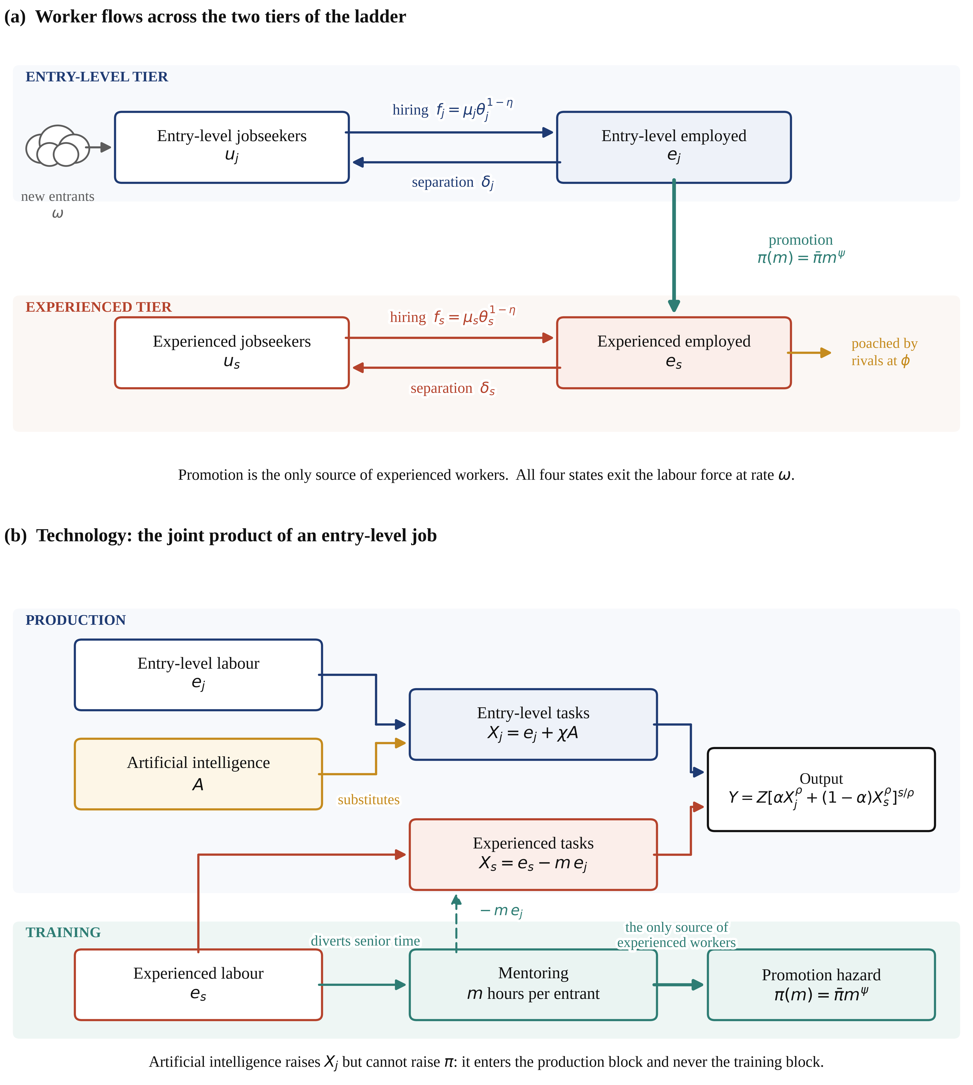
Figure 1. Structure of the model. Panel (a) shows the flows of workers across the four labour-market states; the promotion flow from entry-level to experienced employment is the only source of experienced workers in the economy. Panel (b) shows the technology: entry-level labour and artificial intelligence are substitutes inside the entry-level task bundle, whereas mentoring diverts experienced time away from production and is the sole input into the promotion hazard. Artificial intelligence therefore raises $X_{j}$ without raising $\backslash pi$.
3.1. Matching and Flows
Each tier has its own matching market. Meetings on tier $i \backslash in \backslash \{j,s\backslash \}$ are produced by a constant-returns Cobb–Douglas matching function, so flow rates depend only on market tightness [42]:
$M_{i}\left(u_{i}, v_{i}\right) = μ_{i} {u_{i}}^{η} {v_{i}}^{1 − η}, θ_{i} = \frac{v_{i}}{u_{i}}, i ∈ \left\{j, s\right\}$ (1)
where $η$ is the elasticity of matching with respect to unemployment. The job-finding and vacancy-filling rates follow:
$f_{i} = μ_{i} {θ_{i}}^{1 − η}, q_{i} = μ_{i} {θ_{i}}^{ − η}, f_{i} = θ_{i} q_{i}$ (2)
Entry-level matches dissolve at rate $δ_{j}$ and experienced matches at rate $δ_{s}$, with $δ_\{j\} > δ_\{s\}$. An entry-level employee is promoted at hazard $\backslash pi$, which is where the ladder is climbed. The four stocks evolve as
$\dot{u_{j}} = ω + δ_{j} e_{j} − \left(f_{j} + ω\right)u_{j}, \dot{e_{j}} = f_{j} u_{j} − \left(δ_{j} + π + ω\right)e_{j}$ (3)
$\dot{u_{s}} = δ_{s} e_{s} − \left(f_{s} + ω\right)u_{s}, \dot{e_{s}} = π e_{j} + f_{s} u_{s} − \left(δ_{s} + ω\right)e_{s}$ (4)
and sum to one. The promotion flow ${\backslash pi e}_{j}$ is the only inflow into the experienced tier from outside it: an economy that stops promoting entrants stops producing experienced workers, with a delay equal to the average time to promotion. This is the reproduction loop that the rest of the paper is about. Because the entrant flow is exogenous and the labour force is fixed, the correct measure of entry-level access is the entry-level employment rate rather than the entry-level employment stock, and the correct measure of the ladder’s output is the promotion flow ${\backslash pi e}_{j}$; we report both throughout.
3.2. Mentoring and the Promotion Technology
Promotion is produced, not received. Each entry-level employee absorbs $m$ units of experienced worker time per unit of time, and the promotion hazard is increasing and concave in that intensity:
$π\left(m\right) = \overline{π} m^{ψ}, 0 < ψ < 1$ (5)
with $\backslash psi < 1$ so that the marginal product of mentoring is diminishing. Mentoring is costly in the only currency that matters here: experienced time withdrawn from production. Because $m$ is a flow chosen by the firm after the wage has been agreed, and because training intensity is not verifiable by a third party, the firm cannot commit to it and the worker cannot be made to pay for it through a lower wage. This is the hold-up friction of Acemoglu and Pischke [7,8]; Section 3.6 reports the contractible benchmark in which it is switched off.
3.3. Technology: The Entry-Level Job as a Joint Product
Output is produced from two task bundles. The entry-level bundle combines entry-level labour with artificial intelligence; one entry-level worker supplies $z_{j}$ efficiency units of entry-level task input and one efficiency unit of artificial intelligence supplies $\backslash chi$, so that ${\backslash chi/z}_{j}$ is the number of entry-level workers displaced by one unit of artificial intelligence and is the natural measure of exposure. The experienced bundle is experienced labour net of the time it spends mentoring:
$X_{j} = e_{j} + χA, X_{s} = e_{s} − m e_{j}$ (6)
The two bundles combine in a constant-elasticity-of-substitution aggregate with substitution parameter $\backslash rho$, hence elasticity of substitution $\backslash sigma = 1/(1-\backslash rho)$. The bundle enters output with elasticity $s < 1$; the residual share accrues to a fixed factor—physical, organisational and land capital—that is not modelled explicitly. This is the standard span-of-control device and is what allows the model to reproduce an aggregate labour share below unity:
$Y = Z {\left[α {X_{j}}^{ρ} + \left(1 − α\right){X_{s}}^{ρ}\right]}^{\frac{s}{ρ}}$ (7)
with marginal products
$F_{j} = \frac{∂Y}{∂X_{j}}, F_{s} = \frac{∂Y}{∂X_{s}}$ (8)
Artificial intelligence is a rented input available at price $p_{a}$ per efficiency unit, taxed at rate $t_{a}$. Firms hire it until its marginal product equals its price:
$χ F_{j} = p_{a}\left(1 + t_{a}\right)$ (9)
Two features of this technology carry the argument. First, artificial intelligence enters $X_{j}$ and not $X_{s}$: it does the junior job, not the senior one. Second, and more important, it does not enter $\backslash pi$ at all. Hiring an entry-level worker therefore delivers a joint product—current task output plus an option on an experienced worker—and the technology shock reduces the first component while leaving the second intact. Because the market prices these two components very differently, a shock that would be neutral in a one-component world is not neutral here. Which way it is not neutral is a quantitative question and the answer, reported in Section 5, is not the one we expected.
3.4. Values, Wage Determination and Real Rigidity
Let $J_{i}$ denote the value to the firm of a filled job on tier $i$, $W_{i}$ the value to the worker of holding it and $U_{i}$ the value of searching on that tier. Experienced matches are lost to separation at rate $δ_{s}$ and to rival firms at the poaching rate $φ$. Poaching is the asymmetry that matters: the firm loses the match, whereas the worker moves to an identical job at the going wage and loses nothing, and the economy as a whole loses nothing either. The firm therefore discounts the experienced job at $r + δ_\{s\} + ω + φ$ and the worker at $r + δ_\{s\} + ω$:
$\left(r + δ_{s} + ω + φ\right)J_{s} = F_{s} − w_{s}$ (10)
$\left(r + δ_{s} + ω + f_{s}\right)\left(W_{s} − U_{s}\right) = w_{s} − b$ (11)
An entry-level match yields the marginal product of an entry-level worker, net of the wage and of the mentoring it absorbs, and it delivers the experienced job on promotion. Writing $s_{w}$ for a wage subsidy and $s_{m}$ for a mentoring credit,
$\left(r + δ_{j} + ω + π\right)J_{j} = F_{j} − \left(1 − s_{w}\right)w_{j} − \left(1 − s_{m}\right)m F_{s} + π J_{s}$ (12)
while the entry-level worker’s values satisfy
$\left(r + ω + π + δ_{j}\right)W_{j} = w_{j} + π W_{s} + δ_{j} U_{j}, \left(r + ω\right)U_{j} = b + f_{j}\left(W_{j} − U_{j}\right)$ (13)
Wages are bargained over the match surplus with worker bargaining power $β$, which yields the familiar sharing rule:
$w_{i} = arg max {\left(W_{i} − U_{i}\right)}^{β} {J_{i}}^{1 − β}, β J_{i} = \left(1 − β\right)\left(W_{i} − U_{i}\right)$ (14)
Entry wages, however, are not fully flexible. Provincial minimum wages bind for entry-level urban positions in China [9], graduate pay scales are heavily compressed, and the search literature has long held that how much of a shock the wage absorbs is decisive for how much employment moves [47–50]. We therefore adopt the geometric real-rigidity rule of Blanchard and Galí [51], in which the posted entry wage is a weighted geometric average of the bargained wage $w_{j}^{N}$ and a reference wage ${\backslash bar\{w\}}_{j}$ anchored by those institutions:
$w_{j} = {w_{j}^{N}}^{1 − γ_{w}} {\overline{w_{j}}}^{γ_{w}}, 0 ≤ γ_{w} ≤ 1$ (25)
The parameter $γ_{w}$ nests the flexible Nash economy at zero and a fixed entry wage at one. Two properties make it convenient. At the reference point the rule is an identity, so the estimated economy of Section 4 is numerically identical for every value of $γ_{w}$ and the calibration cannot be tuned through it; and the parameter has an observable implication, namely the split of a shock between pay and employment, which Section 5.4 uses to ask what value the data require. Experienced wages are left flexible, since neither minimum wages nor graduate pay scales bind for them.
Firms post vacancies until the expected cost of filling one equals its value, which closes the model on both tiers:
$\frac{c_{j}\left(1 − s_{v}\right)}{q_{j}} = J_{j}, \frac{c_{s}\left(1 − s_{vs}\right)}{q_{s}} = J_{s}$ (15)
The remaining decision is how much to mentor. Because the wage has already been set and mentoring is not contractible, the firm maximises $J_{j}$ over $m$ taking $w_{j}$ as given, which gives
$π′\left(m\right)\left(J_{s} − J_{j}\right) = \left(1 − s_{m}\right)F_{s}$ (16)
The left-hand side is the private return to mentoring: the marginal increase in the promotion hazard multiplied by the difference between what the firm holds after promotion and what it holds before. The right-hand side is the marginal cost in experienced time. Both terms move when artificial intelligence becomes cheaper, and in opposite directions, which is why the training response to the shock cannot be signed a priori. The contractible benchmark, in which the pair chooses $m$ to maximise the joint surplus $S_{j}$, replaces (16) by
$π′\left(m\right)\left(J_{s} + W_{s} − U_{j} − S_{j}\right) = \left(1 − s_{m}\right)F_{s}$ (17)
3.5. Equilibrium
A steady-state equilibrium is a triple $(θ_\{j\}, θ_\{s\}, m)$, an artificial-intelligence input $A$, wages $(w_\{j\}, w_\{s\})$ and stocks $(u_\{j\}, e_\{j\}, u_\{s\}, e_\{s\})$ such that the stocks are stationary given the flow rates, wages satisfy the bargaining problem and the rigidity rule, artificial intelligence satisfies (9), both free-entry conditions in (15) hold and the mentoring condition (16) holds. The three conditions in $(θ_\{j\}, θ_\{s\}, m)$ are solved numerically; every equilibrium reported below was located from at least eleven independent starting points and its residuals driven below ${10}^{-9}$.
3.6. The Constrained Planner and the Two Wedges
The relevant welfare benchmark is a planner who faces the same matching and promotion technologies and chooses vacancies on both tiers, mentoring intensity and the artificial-intelligence input to maximise the present value of output net of recruiting and technology costs plus the flow value of non-employment:
$max \int_{0}{e^{ − rt}\left[Y − c_{j}v_{j} − c_{s}v_{s} − p_{a}A + b\left(u_{j} + u_{s}\right)\right]dt}$ (18)
subject to the four laws of motion. Poaching does not appear in the planner’s problem, because a poached worker remains employed in an identical job: the flow is a private loss and not a social one. Denoting by $λ_\{uj\}, λ_\{ej\}, λ_\{us\}, λ_\{es\}$ the costates of the four stocks, the steady-state costate equations are
$\left(r + ω\right)λ_{u_{j}} = b + η f_{j}\left(λ_{e_{j}} − λ_{u_{j}}\right), \left(r + ω\right)λ_{u_{s}} = b + η f_{s}\left(λ_{e_{s}} − λ_{u_{s}}\right)$ (19)
$\left(r + δ_{j} + π + ω\right)λ_{e_{j}} = F_{j} − mF_{s} + δ_{j}λ_{u_{j}} + πλ_{e_{s}}, \left(r + δ_{s} + ω\right)λ_{e_{s}} = F_{s} + δ_{s}λ_{u_{s}}$ (20)
and the planner’s optimality conditions for vacancies and for mentoring are
$\left(1 − η\right)q_{i}\left(λ_{e_{i}} − λ_{u_{i}}\right) = c_{i}, π′\left(m\right)\left(λ_{e_{s}} − λ_{e_{j}}\right) = F_{s}$ (21)
Comparing these with the decentralised conditions (15) and (16) isolates the two wedges, which Figure 2 illustrates. The vacancy conditions differ by the familiar factor $(1-η)$ against the firm’s share $(1-β)$, so search externalities cancel exactly when $β = η$. The mentoring conditions differ by two further factors: the firm captures only $(1-β)$ of the promotion surplus but pays the whole mentoring cost, and it values the experienced job at a discount rate inflated by $φ$. This yields the two propositions.
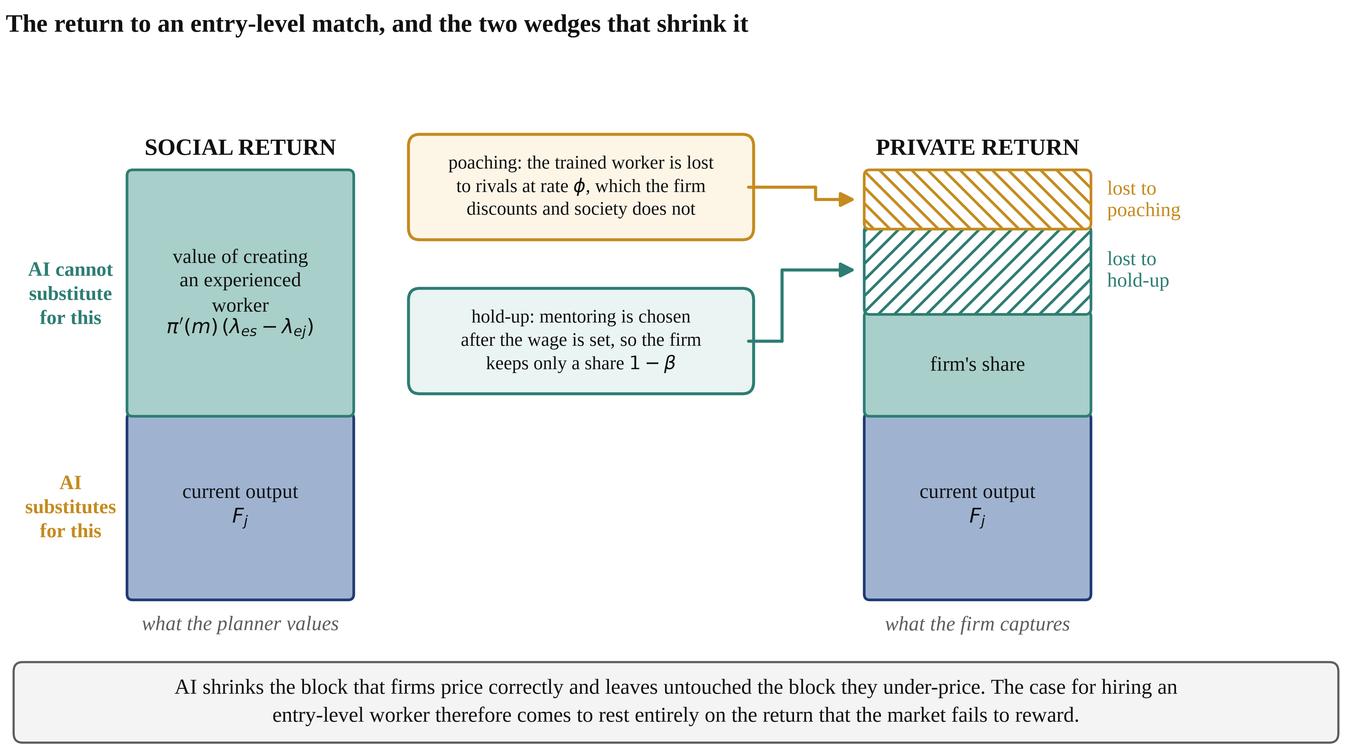
Figure 2. The return to an entry-level match and the two wedges that shrink it. Block heights are illustrative; estimated magnitudes are reported in Section 5. The lower block is current task output, which artificial intelligence substitutes for; the upper block is the value of producing an experienced worker, which it does not. Hold-up removes the share $β$ of the upper block from the firm’s calculation and poaching discounts what remains, so a technology that shrinks only the lower block shifts the hiring decision onto the part of the return the market fails to reward.
Proposition 1 (exact decentralisation).
If the Hosios condition holds $(β = η)$, there is no poaching $(φ = 0)$, mentoring is contractible and entry wages are flexible $(γ_\{w\} = 0)$, then the decentralised steady state coincides with the constrained planner’s allocation and no intervention can raise welfare. If either contracting friction is present, the decentralised allocation under-provides mentoring even when $β = η$.
The proof is by direct comparison of the two systems: under these conditions the costates satisfy $λ_\{ei\} - λ_\{ui\} = S_\{i\}$ and $λ_\{ui\} = U_\{i\}$ on both tiers, which converts each planner condition into the corresponding market condition. Because the argument runs through a simultaneous system of eight equations, we also verify it numerically: at the parameter values of Section 4, market and planner tightness, mentoring, stocks, output and welfare agree to a relative error below ${10}^{-13}$. That agreement is a joint test of the value functions, the costates and the numerical solver, and it is why the wedges reported below can be attributed to economics rather than to arithmetic.
Proposition 2 (incidence depends on the wage rule).
A fall in the price of artificial intelligence lowers the marginal product of an entry-level worker. Under flexible bargaining the entry wage absorbs the fall and the surplus, and hence entry-level tightness, is nearly unchanged; as $γ_{w}$ rises the wage absorbs progressively less and the free-entry condition transmits progressively more of the shock into entry-level hiring. The employment consequences of automation for young workers are therefore not a property of the technology alone but of the wage-setting institutions it meets. Section 5.4 traces the whole mapping and asks which values of $γ_{w}$ are consistent with the observed pattern.
4. Calibration
The model is calibrated to China in 2025 at annual frequency. Parameters divide into those set outside the model from external evidence and those estimated inside it. Three normalisations come first, because they determine what can be identified at all. Matching efficiency and vacancy cost enter every equilibrium object only through the ratio $μ_\{i\}^\{2\}/c_\{i\}$, so $μ_\{j\} = μ_\{s\} = 1$ and the vacancy costs carry that dimension; consequently market tightness is measured in normalised units and only its changes are meaningful. Task units are also free, so $z_\{j\} = \backslash chi = 1$, and only relative changes in $\backslash chi$—the exposure experiments of Section 5.5—have content. Finally, recruiting cost per hire equals $J_\{i\}/w_\{i\}$ by free entry and is therefore implied rather than free, which makes it available as an over-identifying check.
What remains is eight parameters and eight conditions: seven data moments and the output normalisation. The system is square, so rather than minimising a distance that stays positive at the optimum we solve the moment conditions exactly. A bounded least-squares solve started from a point derived analytically from the block recursion of the moment system reaches a maximum absolute log deviation of 7.0e-14 across all eight conditions. The criterion used by the global fallback stage is
$min \sum_{k = 1}^{9}{ϖ_{k}{\left(\frac{m_{k}\left(Θ\right)}{\overline{m_{k}}} − 1\right)}^{2}}$ (22)
where $m_\{k\}(\backslash Theta)$ is the model counterpart of the target $m_{k}$.
4.1. Externally Set Parameters
Table 1 lists the parameters fixed outside the estimation. The discount rate is 4 per cent and the labour-force exit rate 2.5 per cent, corresponding to a forty-year career. Separation rates are 0.22 for entry-level matches and 0.085 for experienced matches, reflecting the much higher turnover of first jobs [33]. The poaching rate is 0.18, in the range implied by job-to-job transition rates among early-career experienced workers [46]. The matching elasticity is 0.5, within the consensus range of the matching-function literature [42], and worker bargaining power is set equal to it, so the Hosios condition holds exactly in the baseline. That is a deliberately conservative choice: it removes the classical search externality by construction, so every wedge we report is attributable to training and poaching rather than to an assumption about bargaining power. The elasticity of substitution between the task bundles is 2.5 and the elasticity of the promotion hazard with respect to mentoring 0.4; both are varied widely in Section 5.8. Real rigidity of the entry wage is set to $γ_{w}$ = 0.8 [51], and because the rule is an identity at the calibration point this choice does not affect any estimated parameter—only the responses in Section 5, which are reported across the whole range.
Table 1. Parameters set outside the estimation, and the three normalisations.
Parameter | Symbol | Value | Source or justification
Discount rate | $r$ | 0.040 | Annual real rate
Labour-force exit rate | $ω$ | 0.025 | Forty-year working life
Entry-level separation rate | $δ_{j}$ | 0.220 | High turnover of first jobs [33]
Experienced separation rate | $δ_{s}$ | 0.085 | Separation rates of established matches [41]
Poaching rate | $φ$ | 0.180 | Job-to-job transitions of early-career experienced workers [46]
Matching elasticity | $η$ | 0.500 | Consensus range of the matching-function literature [42]
Worker bargaining power | $β$ | 0.500 | Hosios condition imposed: $β = η$ [43]
Elasticity of substitution | $\backslash sigma$ | 2.500 | Varied from 1.5 to 5.0 in Section 5.8
Elasticity of promotion to mentoring | $\backslash psi$ | 0.400 | Varied from 0.25 to 0.60 in Section 5.8
Real rigidity of the entry wage | $γ_{w}$ | 0.800 | Blanchard–Galí rule [51]; an identity at the calibration point, so it affects no estimate
Matching efficiency, both tiers | $μ_\{j\}=μ_\{s\}$ | 1.000 | Normalisation: only $μ_\{i\}^\{2\}/c_\{i\}$ is identified
Entry-level task efficiency | $z_{j}$ | 1.000 | Normalisation of task units
Efficiency of artificial intelligence | $\backslash chi$ | 1.000 | Normalisation of task units; only changes in $\backslash chi$ have content
4.2. Estimated Parameters and Targeted Moments
The eight estimated parameters are total factor productivity, the two vacancy costs, the weight on the entry-level bundle, the promotion scale, the price of artificial intelligence, the output elasticity of the labour bundle and the flow value of non-employment. Table 2 lists the targets, their sources and the fit, which is exact by construction. Identification is close to one-to-one and can be read off the block recursion of the model: the two vacancy costs are pinned by the two unemployment rates, the flow value of non-employment by the replacement rate, the weight on the entry-level bundle by the experience wage premium, the promotion scale by the promotion hazard, the price of artificial intelligence by its task share, the output elasticity by the labour share, and total factor productivity by the output normalisation.
Table 2. Targeted moments, the fit, and the parameter each moment principally identifies.
Moment | Target | Model | Estimate | Parameter identified
Entry-level unemployment rate | 0.178 | 0.178 | 0.056 | $c_{j}$ entry-level vacancy cost
Experienced unemployment rate | 0.043 | 0.043 | 0.108 | $c_{s}$ experienced vacancy cost
Experience wage premium | 1.700 | 1.700 | 0.197 | $α$ weight on entry-level tasks
Promotion hazard | 0.286 | 0.286 | 1.718 | $\backslash bar\{\backslash pi\}$ promotion scale
AI share of entry-level tasks | 0.250 | 0.250 | 0.382 | $p_{a}$ price of artificial intelligence
Labour share of value added | 0.550 | 0.550 | 0.619 | $s$ output elasticity of the bundle
Flow value of non-employment, relative to the entry wage | 0.550 | 0.550 | 0.195 | $b$ flow value of non-employment
Output per member of the labour force | 1.000 | 1.000 | 1.281 | $Z$ total factor productivity
Notes: The system is square, so the fit is exact by construction; the largest absolute log deviation across all eight conditions is 7.0e-14. The final column reports the parameter that the block recursion of the model makes primarily responsible for each moment; the mapping is not exactly triangular but is close to it.
4.3. Over-Identifying Checks and the Held-Out Test
Several statistics are computed but never targeted and are therefore available as checks; Table 3 reports them. The mean duration of entry-level job search implied by the estimated economy is 4.9 months, which is close to what graduate-survey evidence reports. The share of employment held by experienced workers is 91.6 per cent, consistent with a labour force in which entrants spend three and a half years in the entry tier out of a forty-year career. Recruiting cost per hire is 4.6 months of the entry wage and 4.0 months of the experienced wage; these sit at the upper end of the international range for skilled hires, which is a genuine tension we record rather than resolve.
Table 3. Over-identifying checks: model statistics that were never targeted.
Statistic | Model | External benchmark
Mean duration of entry-level job search (months) | 4.9 | Graduate surveys report a first-job search of four to six months
Share of employment held by experienced workers (%) | 91.6 | Implied by a 3.5-year entry tier in a 40-year career
Recruiting cost per entry-level hire (months of the entry wage) | 4.6 | Upper end of the international range for skilled hires
Recruiting cost per experienced hire (months of the senior wage) | 4.0 | Upper end of the international range for skilled hires
Mentoring time as a share of experienced working time (%) | 0.10 | Not separately measured
Firm-financed training as a share of the wage bill (%) | 0.11 | Chinese enterprises report 1.5 to 2.5 per cent of the wage bill as employee-education expenditure; the model under-predicts this (Section 4.3)
One check fails informatively. Firm-financed mentoring in the estimated economy costs 0.11 per cent of the wage bill, an order of magnitude below the one-and-a-half to two-and-a-half per cent that Chinese enterprises report as employee-education expenditure. Part of the gap is definitional—reported spending covers compliance training and the upskilling of incumbents, not only the mentoring of entrants, and much of it is publicly subsidised—but part of it is the model’s central claim, that firm-financed training of entrants is small because firms capture little of its return. We flag the check as failed rather than reinterpreting it as evidence: a model in which the marginal private return to mentoring is this low will understate observed training expenditure, and the results of Section 5 should be read with that in mind.
Held out entirely from the estimation is the relationship between artificial-intelligence exposure and entry-level employment. No information about employment by exposure enters the calibration at any point, so the cross-occupation gradient the model predicts in Section 5.5 is a genuine out-of-sample test against the payroll-based estimate of Brynjolfsson, Chandar and Chen [3].
Two limitations of the calibration should be stated at the outset. The model is a steady-state, representative-agent structure: it compares long-run allocations, is silent about transition paths, and cannot address heterogeneity by field of study, institution or region. And the artificial-intelligence task share is the least well measured of the eight targets, since adoption surveys record whether a technology is used rather than what fraction of entry-level task content it performs; Section 5.2 therefore reports the whole path rather than a single counterfactual point.
5. Results
5.1. The Baseline Allocation and the Training Wedge
Table 4 sets the estimated equilibrium beside the constrained optimum. The difference is not marginal. The market provides 0.14 of the socially efficient amount of mentoring—about one seventh of it—so the promotion hazard is 259 per cent below its efficient level and first promotion takes 3.50 years instead of 0.97. The stock of experienced workers is 6.9 per cent below the optimum, output 3.6 per cent below it, and welfare 1.39 per cent below it.
What generates that gap matters more than its size. Worker bargaining power is set exactly equal to the matching elasticity, so the classical search externality is switched off by construction and none of this is a Hosios violation. Consistently with Proposition 1, entry-level tightness is close to efficient—the planner would raise it by only 12.9 per cent—while the training margin is not. Removing both contracting frictions raises mentoring by 633 per cent, and a Shapley decomposition of that log gap attributes 96 per cent of it to hold-up and 4 per cent to poaching. Neither friction is exotic: hold-up follows from the impossibility of writing an enforceable contract on how much attention a supervisor gives a recruit, and poaching from the fact that trained workers can quit. The numerical check behind Proposition 1 is reported alongside: with the Hosios condition, no poaching, contractible training and flexible wages, market and planner agree on every reported quantity to a relative error of 2e-14.
Table 4. The estimated equilibrium and the constrained optimum.
Quantity | Market | Constrained optimum | Gap
Entry-level market tightness | 6.013 | 6.790 | +12.9%
Experienced market tightness | 3.485 | 3.665 | +5.2%
Mentoring per entrant | 0.0113 | 0.2771 | +2348.9%
Aggregate mentoring time | 0.00089 | 0.00650 | +627.5%
Promotion hazard | 0.286 | 1.028 | +259.4%
Years to first promotion | 3.50 | 0.97 | −2.52
Promotion flow | 0.02260 | 0.02413 | +6.8%
Entry-level employed | 0.0790 | 0.0235 | −70.3%
Experienced employed | 0.8650 | 0.9245 | +6.9%
Total unemployment | 0.0560 | 0.0520 | −7.1%
Output | 1.0000 | 1.0358 | +3.6%
Welfare | 0.9805 | 0.9941 | +1.4%
One aggregate deserves comment because it recurs below. Entry-level employment measured as a stock is a poor welfare indicator in this economy. The planner holds 70 per cent fewer entry-level workers than the market does, not because it wants fewer people to have first jobs but because it moves them out of the entry tier 3.6 times faster. With an exogenous flow of entrants, the entry-level stock confounds inflow with duration. We therefore report entry-level access as the entry-level employment rate and the ladder’s output as the promotion flow.
5.2. The Artificial-Intelligence Shock
We now lower the price of one efficiency unit of artificial intelligence and trace the equilibrium and the optimum along the path. Figure 3 shows the whole trajectory; Table 5 reports the point at which artificial intelligence performs 50 per cent of the entry-level task bundle, twice its estimated share, which requires the price to fall by 7.2 per cent.
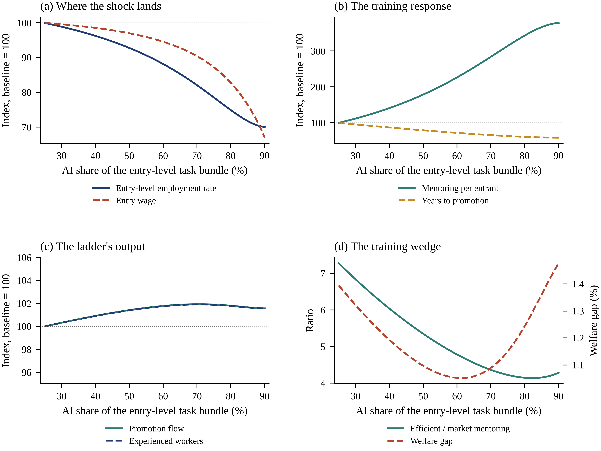
Figure 3. The economy as artificial intelligence becomes cheaper. Panel (a): the entry-level employment rate and the entry wage, indexed to the estimated baseline. Panel (b): mentoring per entrant and the expected time to promotion. Panel (c): the ladder’s output—the promotion flow and the stock of experienced workers. Panel (d): the training wedge, measured as the excess of efficient over market mentoring, and the welfare gap. The horizontal axis is the share of the entry-level task bundle performed by artificial intelligence; the estimated economy sits at 25 per cent.
Table 5. The artificial-intelligence shock: the entry-level task share doubles.
Outcome | Baseline | After the shock | Change
AI share of the entry-level task bundle | 0.2500 | 0.5000 | +0.25
Entry-level employment rate | 0.8220 | 0.7627 | −7.2%
Entry wage | 0.3549 | 0.3444 | −3.0%
Experienced wage | 0.6034 | 0.6004 | −0.5%
Mentoring per entrant | 0.0113 | 0.0202 | 79%
Aggregate mentoring time | 0.0009 | 0.0013 | 44%
Years to first promotion | 3.4965 | 2.7706 | −0.73 yr
Promotion flow | 0.0226 | 0.0229 | 1.4%
Experienced employed | 0.8650 | 0.8772 | 1.4%
Output | 1.0000 | 1.0159 | +1.59%
Welfare | 0.9805 | 0.9859 | +0.55%
Value of being a new entrant | 8.1382 | 8.1515 | +0.16%
Efficient / market mentoring | 7.2748 | 5.3457 | −1.93
Welfare gap to the optimum (%) | 1.3948 | 1.0966 | −0.30 pp
The first finding is that the burden falls on access rather than on pay. The entry-level employment rate falls by 7.2 per cent while the entry wage falls by only 3.0 per cent, a ratio of 2.5 to one, and the entry-level unemployment rate rises by 5.9 percentage points against 0.02 for experienced workers. This matches what the payroll evidence reports for the United States, where adjustment appears in headcount rather than in compensation [3], and it explains why studies that look for wage effects find little [6]. Section 5.4 shows that this pattern is not a property of the technology.
The second finding is the one we did not expect, and it is the paper’s main substantive result. The ladder does not break. Mentoring per entrant rises by 79 per cent, aggregate mentoring by 44 per cent, the expected time to first promotion falls from 3.50 to 2.77 years, the flow of promotions rises by 1.4 per cent and the stock of experienced workers rises by 1.4 per cent. Firms respond to a smaller intake by training it far more intensively. The mechanism is a general-equilibrium one that a partial-equilibrium account would miss: fewer entrants means more experienced time available per entrant and a lower opportunity cost of the mentor’s hour, while the promotion option itself is unaffected by a technology that cannot mentor. What artificial intelligence does to the career ladder is narrow the gate, not dismantle the staircase behind it.
The third finding follows from the second and reverses a natural prior. Panel (d) shows that the training wedge does not widen as artificial intelligence spreads; it narrows, from 7.3 to 5.3 times the market level, and the welfare gap falls from 1.39 to 1.10 per cent. Because scarcer entrants are individually more worth training, the private return to mentoring moves towards the social return. The training externality is large, but it is a pre-existing feature of the contracting environment, not something the technology creates or aggravates. Aggregate output rises by 1.6 per cent and aggregate welfare by 0.55 per cent, while the value of being a new entrant rises by 0.16 per cent. What the shock produces is a distributional problem sitting on top of an efficiency problem that was already there, and the two require different instruments.
5.3. Decomposing the Response
To identify what the employment response is made of we deactivate individual channels by holding the relevant object at its baseline value and re-solving, attributing the total by the Shapley value over all deactivation orders, which makes the decomposition exact and order-independent. Three channels are considered beyond direct substitution: the training margin, meaning the response of mentoring intensity; the promotion-value margin, meaning the revaluation of the experienced job that the entry-level match delivers on promotion; and the senior-scarcity margin, meaning the general-equilibrium response of the price of experienced time.
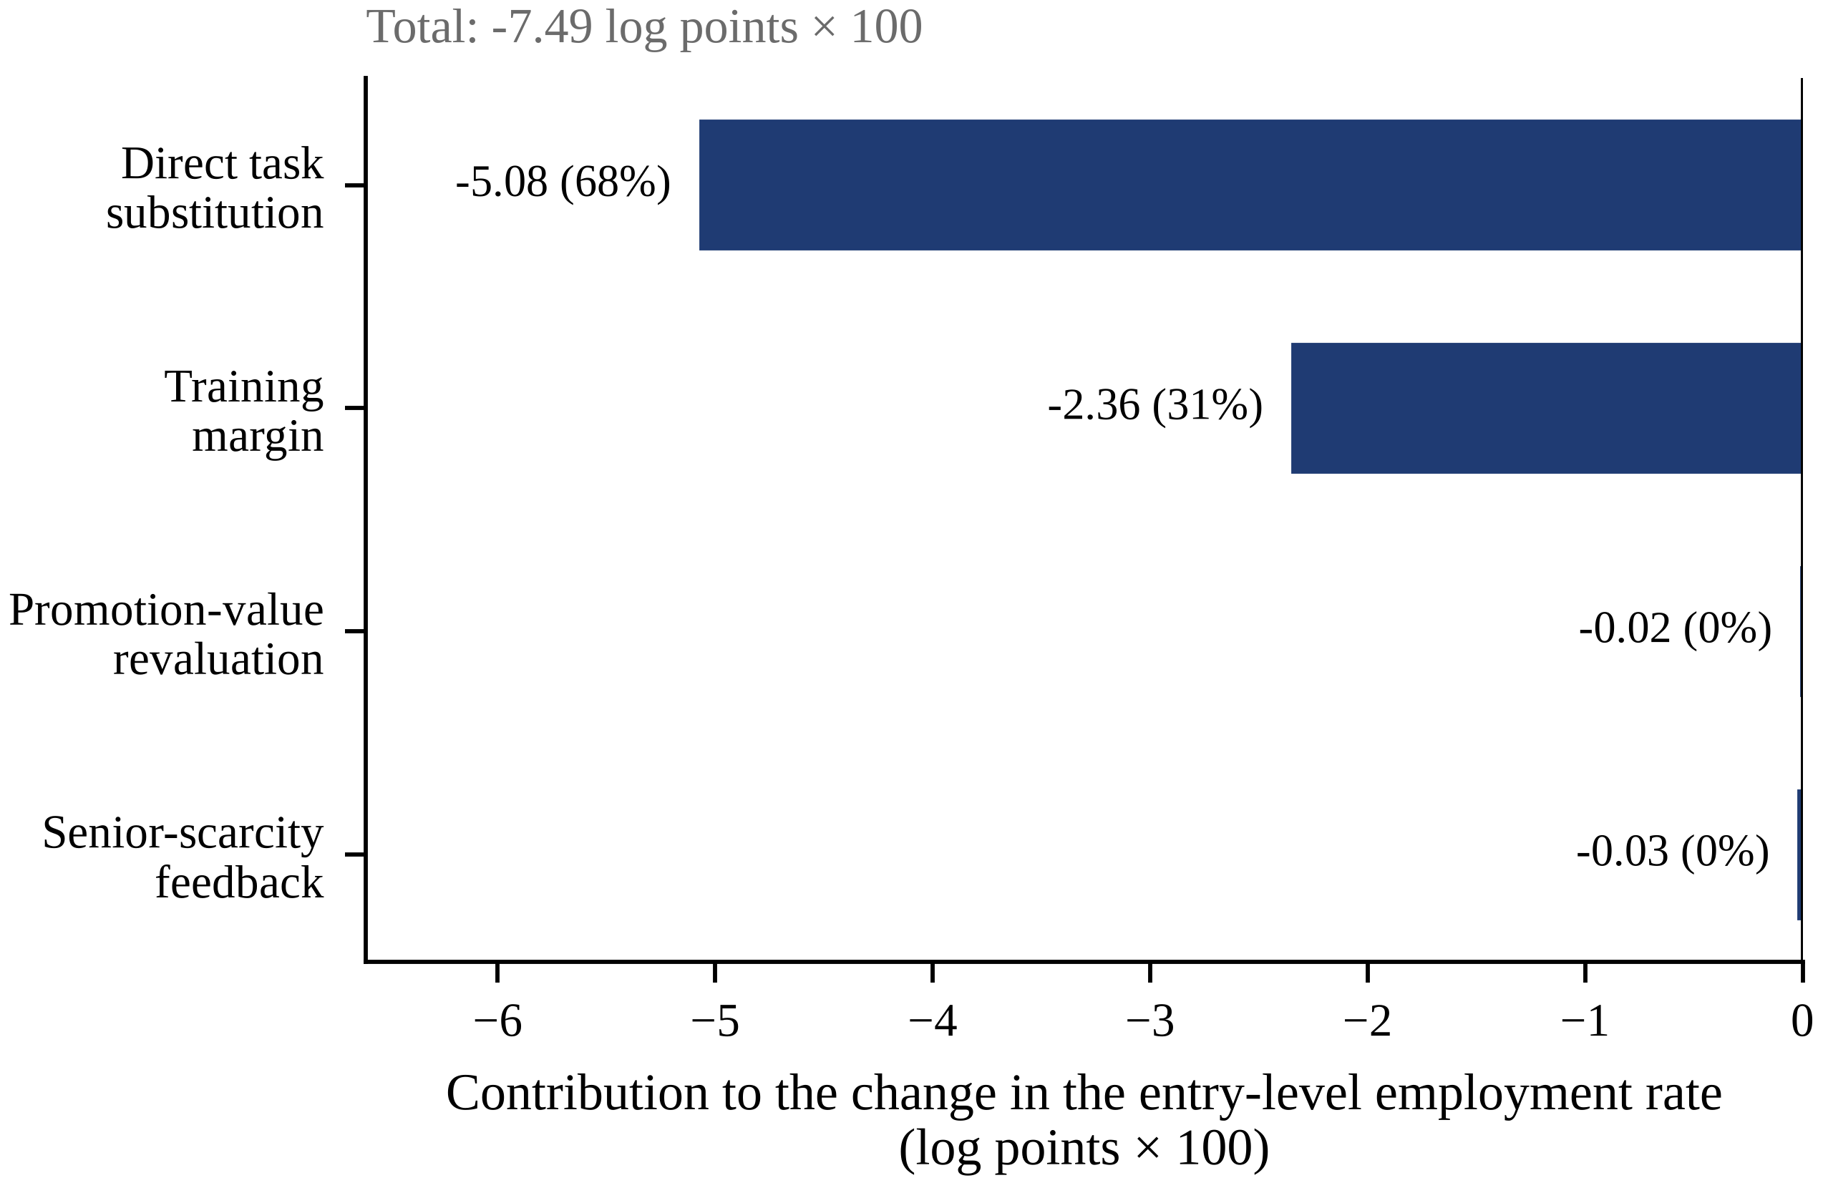
Figure 4. Shapley decomposition of the change in the entry-level employment rate when artificial intelligence doubles its share of the entry-level task bundle. Contributions are in log points multiplied by one hundred and sum exactly to the total; shares in parentheses are of the total response.
Direct task substitution accounts for 68 per cent of the fall in the entry-level employment rate and the training margin for 31 per cent, while the promotion-value and senior-scarcity margins together account for under 1 per cent. The decomposition is exact to 0e+00 log points. The training margin therefore does double duty: it is what saves the ladder, and it is also what deepens the fall in entry-level access, because a firm that intends to mentor an entrant intensively is more selective about opening the position in the first place. A reduced-form estimate of the displacement elasticity, however well identified, recovers only the first of these terms.
5.4. Who Bears the Shock: Wage Rigidity and Incidence
Proposition 2 says that the split of the shock between pay and employment is governed by the wage rule rather than by the technology. Table 6 and panel (a) of Figure 7 quantify it. In the flexible-wage economy $(γ_\{w\} = 0)$ the same shock lowers the entry wage by 7.6 per cent and the entry-level employment rate by only 0.21 per cent. With a fixed entry wage $(γ_\{w\} = 1)$ the wage does not move at all and the employment rate falls by 12.4 per cent. The ratio of the employment response to the wage response rises monotonically from 0.03 to infinity across that range, passing through 2.5 at our baseline value of 0.8.
Table 6. Incidence of the same shock as a function of the real rigidity of the entry wage.
$γ_{w}$ | Entry wage (%) | Entry-level employment rate (%) | Ratio | Aggregate mentoring (%)
0.0 | −7.58 | −0.21 | 0.03 | 1.5
0.2 | −6.81 | −1.32 | 0.19 | 8.9
0.4 | −5.88 | −2.69 | 0.45 | 17.7
0.6 | −4.68 | −4.52 | 0.97 | 28.7
0.8 | −2.98 | −7.21 | 2.47 | 43.8
0.9 | −1.77 | −9.26 | 5.44 | 54.2
1.0 | 0.00 | −12.42 | — | 68.9
This has an empirical payoff. The stylised fact that motivates the literature—large employment effects for young workers, negligible effects on their pay—is not evidence about artificial intelligence at all. It is evidence that entry wages are rigid. A flexible-wage economy hit by exactly the same technology shock would show the opposite pattern, and would generate the precise nulls on employment that the Danish evidence reports [6]. The apparent conflict between studies finding large employment effects and studies finding none is therefore not necessarily a conflict about the technology; it is consistent with a difference in wage-setting institutions between the settings studied. In China, where provincial minimum wages bind for entry-level urban positions [9] and graduate pay scales are compressed, the model places the economy towards the rigid end of that range.
5.5. Held-Out Validation: The Exposure Gradient
No information about employment by exposure entered the calibration, so we can ask the model a question it was not fitted to answer. Consider occupation groups differing only in how much of their entry-level task content artificial intelligence can perform, spanning shares from 5 to 55 per cent, and compute for each the change in entry-level and experienced employment relative to a pre-artificial-intelligence benchmark. The difference between the most and the least exposed group, of entry-level relative to experienced employment, is the model analogue of a difference-in-differences estimate.
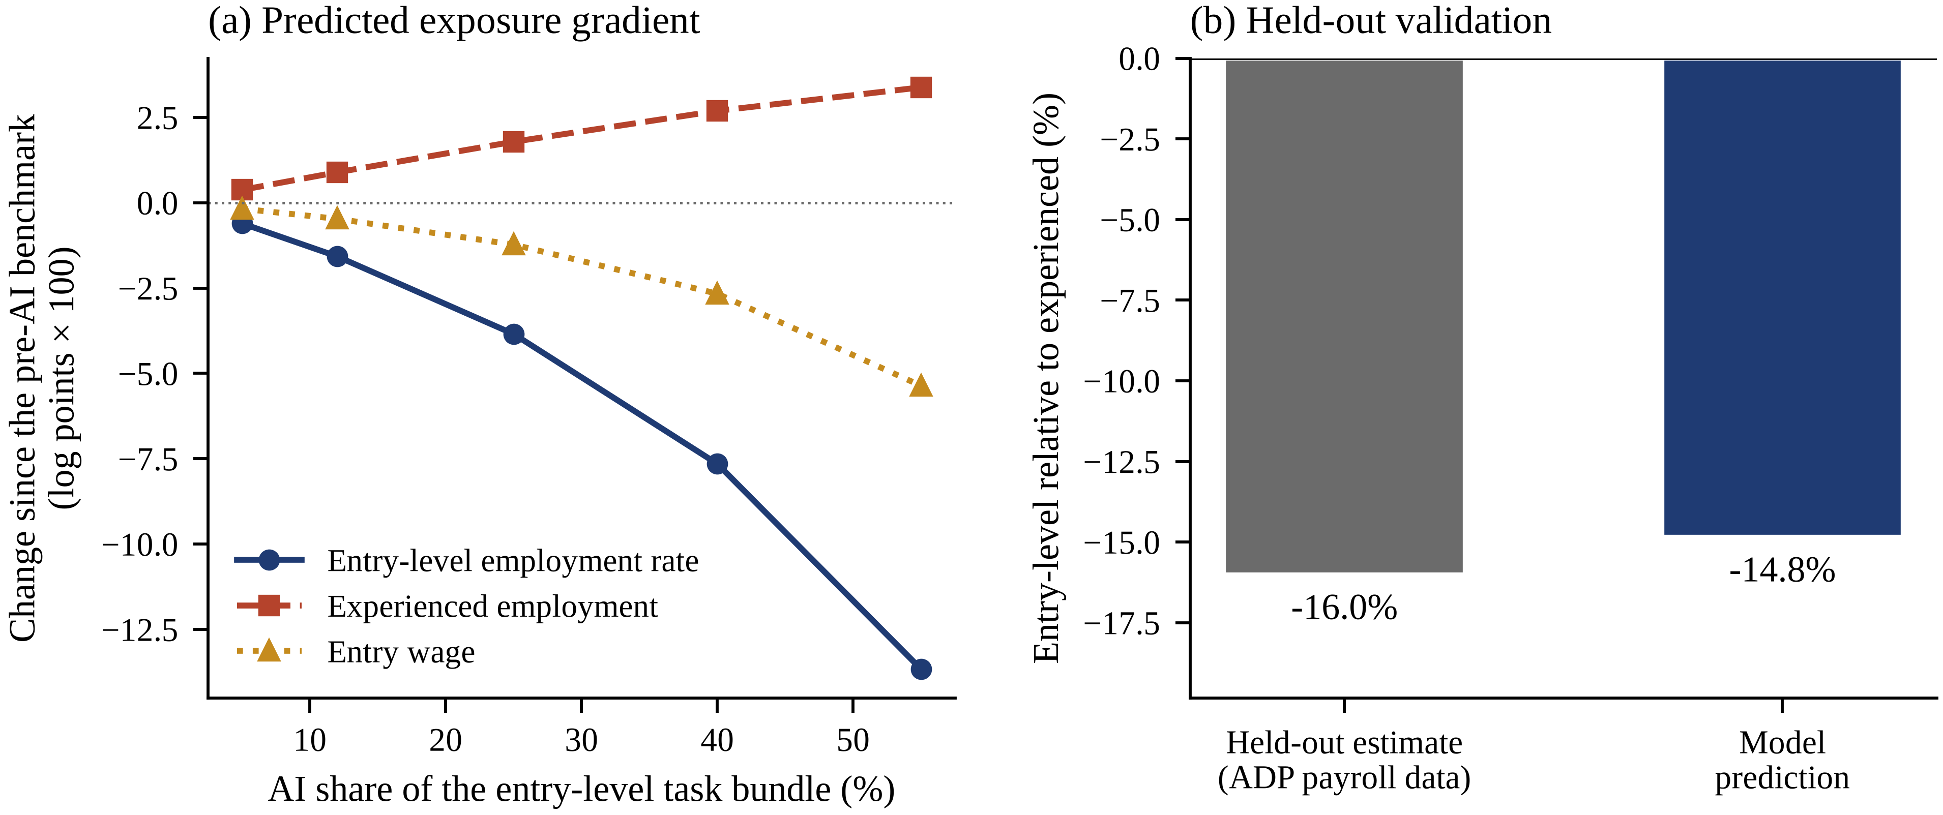
Figure 5. Held-out validation. Panel (a): the predicted change in entry-level and experienced employment, relative to a pre-artificial-intelligence benchmark, across occupation groups differing in the share of entry-level task content that artificial intelligence performs. Panel (b): the implied difference between the most and least exposed groups against the payroll-data estimate for United States workers aged 22 to 25 reported by Brynjolfsson, Chandar and Chen. Neither that estimate nor any employment-by-exposure information was used in the calibration.
The model predicts −14.8 per cent against a payroll estimate of −16.0 per cent [3]. It also reproduces two features of that study that were not targeted: the gradient is monotone in exposure, and the corresponding difference in entry wages is only −5.1 per cent, so the model delivers the employment-not-pay pattern at roughly the observed relative magnitude. We read this as corroboration rather than confirmation, for two reasons. The calibration targets are Chinese and the validation estimate American, so the comparison presumes that technology and contracting, rather than national institutions, dominate this margin—a presumption that Section 5.4 shows to be only partly warranted, since the wage rule matters a great deal. And the model compares steady states whereas the estimate is a medium-run difference, so the two objects coincide only if adjustment is substantially complete.
5.6. Implementing the Optimum, and the Tax That Should Not Be Levied
Because the wedges are known they can be priced. Table 7 reports the combination of an entry-level vacancy subsidy, a mentoring credit and an experienced-tier vacancy subsidy that reproduces the planner’s allocation exactly. At the baseline the required rates are −7.4 per cent of the entry-level vacancy cost, 91.7 per cent of the mentoring cost and 7.5 per cent of the experienced vacancy cost, at a fiscal cost of 0.46 per cent of output. They raise welfare by 1.39 per cent, raise aggregate mentoring by 627 per cent and cut time to first promotion to 0.97 years. After the shock the required mentoring credit is 87.5 per cent, lower than before, which is the policy counterpart of the narrowing wedge documented in Section 5.2.
Table 7. Subsidies that decentralise the constrained optimum.
Instrument | Baseline | After the shock
Entry-level vacancy subsidy (% of the vacancy cost) | −7.4 | 7.2
Mentoring credit (% of the mentoring cost) | 91.7 | 87.5
Experienced vacancy subsidy (% of the vacancy cost) | 7.5 | 7.5
Tax on artificial intelligence | 0.000 | 0.000
Fiscal cost (% of output) | 0.46 | 0.52
Welfare gain (%) | 1.39 | 1.10
Aggregate mentoring (%) | 627 | 435
Years to first promotion | 0.97 | 0.94
One entry in that table is a zero, and it is the most interesting number in the paper. The welfare-maximising tax on artificial intelligence, once the ladder subsidies are in place, is 0.000. Conditional on the allocation of labour, firms hire artificial intelligence until its marginal product equals its price, and the planner’s condition for the input is identical, so the input is efficiently priced. The distortion in this economy is not in the market for artificial intelligence; it is in the market for training. Taxing the technology to protect entry-level jobs treats a symptom at the cost of output, and once the ladder is correctly subsidised there is nothing left for the tax to correct.
5.7. Instruments at a Common Budget
Governments do not implement first-best packages; they choose an instrument and a budget. We therefore fix a common fiscal cost of 0.05 per cent of output—of the order of a national youth-employment programme—and ask what each of four instruments buys. Welfare is output net of recruiting and technology costs plus the flow value of non-employment, so transfers net out and only efficiency gains appear. The marginal value of public funds is aggregate willingness to pay over net government cost, which in this accounting is
$MVPF = \frac{Δ𝒲 + G}{G} = 1 + \frac{Δ𝒲}{G}$ (24)
so that a value above one identifies an instrument that returns more than it costs. Figure 6 and Table 8 report the comparison at the baseline and after the shock.
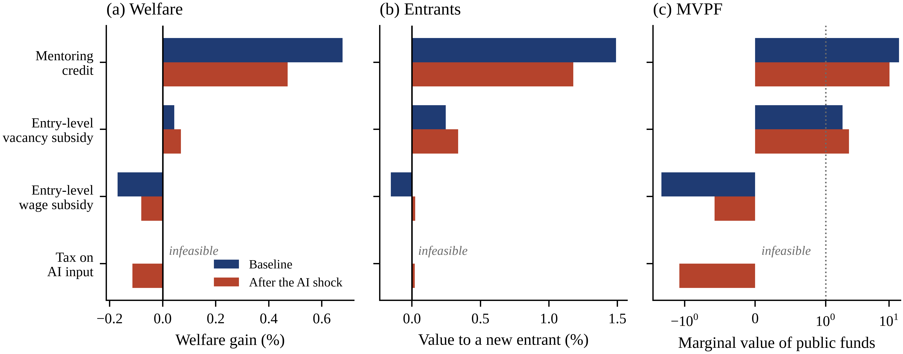
Figure 6. Four instruments at a common fiscal cost, evaluated at the estimated baseline and after artificial intelligence doubles its share of the entry-level task bundle. Panel (a): welfare gain. Panel (b): change in the value of being a new entrant. Panel (c): marginal value of public funds; the dotted line marks unity. The tax on artificial intelligence is absent from the baseline panels because its base is too elastic to raise the required revenue at any rate.
The ranking is unambiguous and the spread is large. The mentoring credit delivers a welfare gain of 0.678 per cent, raises aggregate mentoring by 76 per cent, raises the value of being a new entrant by 1.49 per cent and shortens time to promotion by 1.06 years, with a marginal value of public funds of 14.3. The entry-level vacancy subsidy is a distant second at 0.043 per cent and a marginal value of 1.85. The entry-level wage subsidy is worse than doing nothing: it lowers welfare by 0.170 per cent and has a marginal value of −2.34, because by raising the entry wage it raises the cost of the very matches whose training content is under-provided and crowds mentoring out by 11 per cent.
The tax on artificial intelligence cannot be assessed at the common budget in the baseline economy for an instructive reason: its base is too elastic. The largest revenue any rate can raise is 0.010 per cent of output, below the envelope we set, so the instrument is infeasible at that scale before its welfare properties are even considered. After the shock the base is larger and the tax becomes feasible, at which point it lowers welfare by 0.114 per cent with a marginal value of public funds of −1.22—the worst of the four. The ordering after the shock is otherwise preserved, with the mentoring credit delivering 0.471 per cent at a marginal value of 10.1.
Table 8. Four instruments at a common fiscal cost. The upper block is the estimated baseline, the lower block the economy after the artificial-intelligence shock.
Instrument | Rate | Welfare (%) | Entrant value (%) | Mentoring (%) | Promotion flow (%) | MVPF
Mentoring / training credit | 0.478 | 0.678 | 1.49 | 76.4 | 2.76 | 14.30
Entry-level vacancy subsidy | 0.082 | 0.043 | 0.25 | 2.8 | 0.26 | 1.85
Entry-level wage subsidy | 0.017 | −0.170 | −0.15 | −11.1 | −0.58 | −2.34
Tax on the AI input | infeasible | — | — | — | — | —
Mentoring / training credit | 0.391 | 0.471 | 1.18 | 52.3 | 1.84 | 10.14
Entry-level vacancy subsidy | 0.112 | 0.068 | 0.34 | 3.4 | 0.31 | 2.33
Entry-level wage subsidy | 0.022 | −0.081 | 0.02 | −7.8 | −0.26 | −0.58
Tax on the AI input | 0.028 | −0.114 | 0.02 | −10.1 | −0.35 | −1.22
Notes: A marginal value of public funds above one identifies an instrument that returns more than it costs. The tax on artificial intelligence is infeasible at this budget in the baseline economy because its base is too elastic; the maximum revenue any rate can raise is reported in Section 5.7.
The economics behind the ordering is transparent. The mentoring credit is the only instrument that pays for the activity whose private return falls short of its social return. The vacancy subsidy pays for entry-level matches without paying for what those matches are supposed to produce, so it buys quantity where the distortion is smallest. The wage subsidy is actively counter-productive because it raises the price of the input whose complementary investment is under-supplied. And the technology tax raises the cost of an efficiently priced input in order to shift demand back towards labour that remains under-trained. The policy conclusion is not that more should be spent on youth employment but that the same money should be spent on a different margin.
5.8. Robustness
Two dimensions of robustness matter here. The first is the elasticity of substitution between the entry-level and the experienced task bundle, which is set outside the estimation. Table 9 reports the baseline, the shock response and the training wedge across values of $\backslash sigma$ from 1.5 to 5.0, with the price of artificial intelligence re-targeted in each economy so that all of them start from the same estimated task share. The employment response to the shock is monotone in $\backslash sigma$, as one would expect, while the wedge is generated by the contracting structure and moves far less.
Table 9. Sensitivity to the elasticity of substitution between the two task bundles.
$\backslash sigma$ | Entry-level employment rate (%) | Aggregate mentoring (%) | Efficient / market mentoring | Welfare gap (%)
1.5 | −8.43 | 205.4 | 19.41 | 2.88
2.0 | −7.67 | 91.5 | 11.04 | 1.94
2.5 | −7.21 | 43.8 | 7.27 | 1.39
3.0 | −6.87 | 23.3 | 5.63 | 1.16
4.0 | −5.58 | 8.9 | 4.57 | 1.14
5.0 | −4.01 | 4.4 | 4.34 | 1.26
Notes: The price of artificial intelligence is re-targeted in each economy so that all of them start from the same estimated task share, and the same proportional price fall is then applied.
The second is the eight parameters set outside the estimation, which are the ones most open to dispute. We draw 192 Latin-hypercube samples over plausible ranges for the discount rate, the exit rate, both separation rates, the poaching rate, the matching elasticity, the elasticity of substitution and the elasticity of promotion to mentoring, imposing the Hosios condition on every draw. Crucially, the model is re-estimated on every draw, so each economy in the sample reproduces the eight targeted moments exactly and differs only in what was not estimated. Of the draws, 91 re-estimated and solved and 91 permitted the full policy comparison.
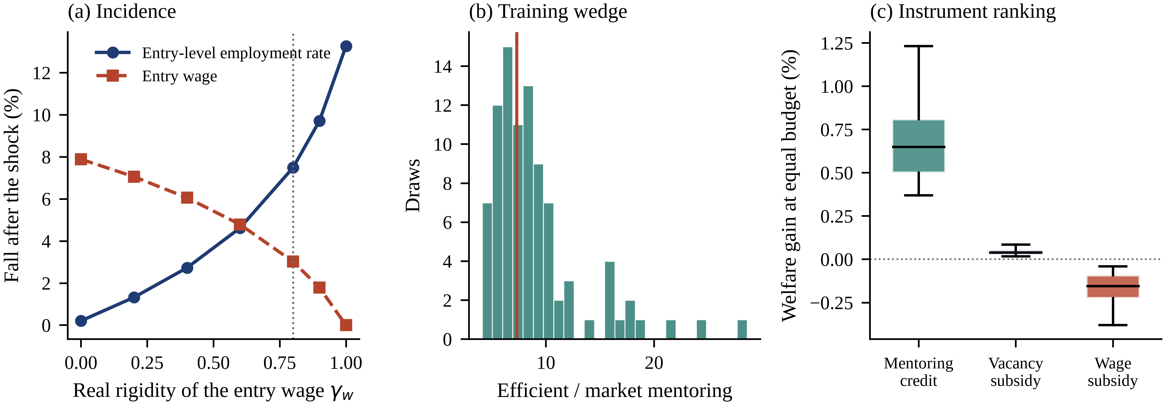
Figure 7. Robustness. Panel (a): the incidence of the shock between the entry wage and the entry-level employment rate as a function of the real rigidity of the entry wage. Panel (b): the distribution of the training wedge across Latin-hypercube draws over the externally set parameters, with the estimated value marked. Panel (c): the welfare gain of each instrument at a common budget across the same draws.
The wedge is not an artefact of a particular parameterisation. Its mean across draws is 9.0 times the market level, with a fifth-to-ninety-fifth-percentile range of 4.9 to 17.4, and it is positive in 100 per cent of draws. Welfare at the optimum exceeds welfare at the market allocation by a mean of 1.35 per cent, with a range of 0.91 to 1.76 per cent. The instrument ranking is equally stable: the mentoring credit is the best of the four in 99 per cent of draws, and the tax on artificial intelligence is infeasible at this budget in 100 per cent of them. What survives the sampling is not a point estimate of the wedge but its sign, its order of magnitude and the identity of the instrument that addresses it.
6. Discussion
6.1. Why the Ladder Does Not Break
The intuition that automating entry-level work must eventually starve the economy of experienced workers is a partial-equilibrium intuition. It treats training intensity per entrant as fixed and therefore reads a fall in entry-level hiring straight through into a fall in promotions. In general equilibrium training intensity is a choice, and it is a choice that moves in the opposite direction to hiring. When entrants become scarce, experienced time per entrant becomes abundant, the opportunity cost of mentoring falls, and the promotion option—untouched by a technology that cannot mentor—becomes a larger share of what an entry-level match is worth. The two effects nearly cancel at the aggregate level: in our estimated economy a doubling of the artificial-intelligence task share leaves the flow of promotions and the stock of experienced workers within 1.4 per cent of where they started.
This is a testable implication, and it is the sharpest one the paper offers. It predicts that firms in the most exposed occupations should shorten time to promotion and raise supervision intensity per junior hire even as they cut the number of junior hires. Linked employer–employee data with promotion records would settle it. If the prediction fails—if exposed firms cut hiring and mentoring together—then the joint product is more complementary than we have modelled it, and the pessimistic reading of the evidence would be the right one.
6.2. Incidence Is Institutional, Not Technological
The result that the pay-versus-employment split is governed by the wage rule rather than by the technology reframes a live empirical debate. Studies that find sizeable employment effects for young workers and studies that find precise nulls are often read as contradicting one another about what artificial intelligence does. Our model says they can both be right about their own settings and that the difference between them is informative in its own right: it is a measurement of how much of a shock entry wages are permitted to absorb. That reading suggests a research design—comparing the incidence of the same exposure measure across labour markets that differ in minimum-wage bite or in the compression of graduate pay—which would identify the wage rule from cross-country variation rather than assuming it, in the spirit of the cross-country work linking digitalisation to youth unemployment [59,60].
It also carries an uncomfortable policy corollary. The institutions that protect the pay of young workers who are employed are the same institutions that concentrate the burden of a technology shock on those who are not yet employed. We do not read this as an argument for lower entry wages: the flexible-wage economy delivers the shock as a large pay cut to a cohort that is already at the bottom of the distribution, and our welfare accounting is not equipped to rank those two outcomes. We read it as a reason to attach the compensating instrument to the margin that the rigidity displaces, which is entry.
6.3. Why the Standard Instruments Misfire
Youth employment policy is built on the premise that the problem is the price or the availability of a young worker. In a model without a ladder that premise would be right and a wage or hiring subsidy would be the appropriate answer. The analysis here says that the binding problem is different in kind. An entry-level job is a production process with two outputs, and the market has a mechanism for pricing one of them and no mechanism for pricing the other. Subsidising the wage lowers the cost of an input to a process whose output is mispriced; it buys more of the process without correcting the mispricing, and in our estimates it does active harm by crowding out the under-provided investment. Paying directly for mentoring corrects the mispricing, which is why at equal cost it does an order of magnitude more work. The point generalises beyond artificial intelligence: any shock that shifts the balance between the two outputs of an entry-level job—offshoring of routine junior work, outsourcing of junior functions, the flattening of hierarchies—has the same implication for which instrument to reach for. It also cautions against reading improvements in the measured quality of the jobs that survive as evidence that the transition is benign [70–72], since the workers the model identifies as bearing the cost are those who never enter.
6.4. Should Artificial Intelligence Be Taxed?
Proposals to tax automation have intuitive appeal and a weak analytical foundation, and this model shows why. Artificial intelligence is hired until its marginal product equals its price, and the planner’s condition for the input is the same, so at any given allocation of labour there is no wedge in this market to correct. A tax reduces output and reduces the resources available for everything else, including for training the workers it is meant to protect. In our comparison it is the worst-performing instrument wherever it is feasible at all, and once the ladder subsidies are in place its optimal rate is zero to three decimal places. The correct reading of the shock is not that the technology should be slowed but that the institution it stresses—the mechanism by which an economy produces its next generation of experienced workers—was under-funded before the technology arrived and is more visibly under-funded now.
This conclusion is conditional on the model’s scope, and the condition is worth stating. We assume artificial intelligence cannot mentor. If a future technology genuinely substitutes for the transmission of tacit know-how, the second component of the joint product is automatable too, the reproduction loop no longer requires entry-level jobs, and the case for subsidising them weakens rather than strengthens. Nothing in the current evidence suggests that point has been reached, but the model is explicit about where the argument would break.
6.5. Implications for China
Three features of the Chinese setting make the mechanism more acute rather than less. The cohort is large: 12.22 million graduates entered the labour market in 2025 and 12.7 million are expected in 2026, so the flow through the entry-level gate is enormous relative to the stock of experienced workers who must mentor them [5]. Adoption is fast, which compresses into months an adjustment that elsewhere is spread over years [4,73]. And entry wages are rigid, because provincial minimum wages bind for entry-level urban positions [9], which by Section 5.4 places China at the end of the range where the shock is borne almost entirely by access.
The instruments in use are the ones this analysis ranks last: expanded public-sector and state-owned-enterprise recruitment quotas, one-off hiring and wage subsidies, and enlarged postgraduate places, all of which act on the quantity of entry-level positions or postpone entry, and none of which pays for mentoring. The model’s recommendation is specific and implementable within existing administrative machinery: convert part of the hiring subsidy into a credit conditional on documented supervision and on promotion outcomes, and make the existing employee-education deduction contingent on training entrants rather than on training in general. The general lesson is that youth employment policy should be evaluated by what it does to the flow of promotions, not by what it does to the stock of entry-level hires—a criterion that sits naturally alongside the common-prosperity agenda’s emphasis on the quality rather than the quantity of employment [74].
6.6. Limitations
Six limitations bound the claims. First, the analysis compares steady states. It is silent on transition dynamics, which matter here because the stock of experienced workers adjusts with a lag of several times the average time to promotion; the comparisons we report are the destination, not the path, and a cohort passing through the transition can be much worse off than either steady state. Second, the labour force and the flow of entrants are exogenous, so the model cannot represent discouragement, delayed entry into postgraduate study or withdrawal from the labour force, all of which are prominent in the Chinese data; the entry-level employment rate is the right outcome variable in this model but it maps only imperfectly on to measured youth employment. Third, the economy is representative-agent within each tier, so it cannot address heterogeneity by field of study, institution, gender or region [54,55]. Fourth, poaching is a reduced-form flow: the poaching firm pays no recruiting cost, which is why the flow is a pure private loss; an explicit raiding market would attenuate the poaching wedge, though the hold-up wedge, the larger of the two, would remain. Fifth, the artificial-intelligence task share is the least well measured of the eight targets, which is why Section 5.2 reports a path rather than a point. Sixth, the model under-predicts observed enterprise training expenditure by an order of magnitude, as Section 4.3 records; if part of that gap reflects training margins the model omits rather than definitional differences, the estimated wedge is an upper bound.
Three extensions follow naturally. Endogenous participation would let the model speak to discouragement and to the measured youth employment rate directly. Allowing artificial intelligence to substitute partially for mentoring, with an estimated rather than assumed degree of substitutability, would let the data speak to the condition under which the paper’s central conclusion reverses. And embedding the ladder in a multi-sector economy would allow entry-level tasks automated in one sector to reappear in another, which is the reinstatement margin the task-based literature has shown to be decisive over long horizons [11].
7. Conclusions
An entry-level job produces two things: output today and an experienced worker tomorrow. Artificial intelligence is good at the first and useless at the second, and the natural inference is that the career ladder is in danger. This paper formalised that inference in a two-tier search economy with endogenous mentoring, estimated it to reproduce eight Chinese labour-market moments exactly, validated it against an employment gradient it was never shown, and found the inference to be wrong in an instructive way.
Four findings stand. The market provides about one seventh of the efficient amount of on-the-job training, so first promotion takes 3.5 years rather than 1.0, even though the Hosios condition holds exactly; hold-up accounts for 96 per cent of the gap and poaching for the rest. Cheaper artificial intelligence is borne by entry-level access rather than entry-level pay, in a ratio of 2.5 to one—but only because entry wages are rigid, and a flexible-wage economy would show the opposite. The ladder itself does not break: firms mentor a smaller intake 79 per cent more intensively, promotions and the stock of experienced workers barely move, and the training wedge narrows rather than widens. And at a common budget the mentoring credit dominates the vacancy subsidy, the wage subsidy and the technology tax, on welfare, on the value of being a new entrant and on the marginal value of public funds, in the estimated economy and in 99 per cent of draws over the parameters we did not estimate.
The policy implication is uncomfortable for both sides of the current debate. It does not support slowing the technology: the optimal tax on artificial intelligence is zero once the ladder is priced correctly, and where the tax is feasible at all it is the worst instrument we examine. Nor does it support the reassurance that markets will handle the transition, because the margin under pressure is one the market has never priced properly and the burden falls on a cohort with no standing in the transaction. What it supports is paying explicitly for the thing that entry-level jobs were quietly producing all along. Economies have been getting their supply of experienced workers as a by-product of a transaction undertaken for other reasons. The by-product turns out to be more robust than we feared, and more under-supplied than we assumed.
References
1. Eloundou, T.; Manning, S.; Mishkin, P.; Rock, D. GPTs are GPTs: Labor Market Impact Potential of LLMs. Science 2024, 384, 1306–1308.
2. Acemoglu, D. The Simple Macroeconomics of AI. Economic Policy 2025, 40, 13–58.
3. Brynjolfsson, E.; Chandar, B.; Chen, R. Canaries in the Coal Mine? Six Facts about the Recent Employment Effects of Artificial Intelligence. Stanford Digital Economy Lab Working Paper: Stanford, CA, USA 2025.
4. National Bureau of Statistics of China (NBS). Surveyed Urban Unemployment Rate of the Population Aged 16–24 Excluding Students; NBS: Beijing, China, 2026.
5. Ministry of Education of China. Notice on the Employment and Entrepreneurship of 2026 National College Graduates; Ministry of Education: Beijing, China, 2025.
6. Humlum, A.; Vestergaard, E. Large Language Models, Small Labor Market Effects. Becker Friedman Institute Working Paper 2025-56: Chicago, IL, USA 2025.
7. Acemoglu, D.; Pischke, J.-S. Beyond Becker: Training in Imperfect Labour Markets. The Economic Journal 1999, 109, F112–F142.
8. Stevens, M. A Theoretical Model of On-the-Job Training with Imperfect Competition. Oxford Economic Papers 1994, 46, 537–562.
9. Mayneris, F.; Poncet, S.; Zhang, T. Improving or Disappearing: Firm-Level Adjustments to Minimum Wages in China. Journal of Development Economics 2018, 135, 20-42.
10. Acemoglu, D.; Restrepo, P. The Race between Man and Machine: Implications of Technology for Growth, Factor Shares, and Employment. American Economic Review 2018, 108, 1488–1542.
11. Acemoglu, D.; Restrepo, P. Automation and New Tasks: How Technology Displaces and Reinstates Labor. J. Econ. Perspect. 2019, 33, 3–30.
12. Acemoglu, D.; Restrepo, P. Tasks, Automation, and the Rise in U.S. Wage Inequality. Econometrica 2022, 90, 1973–2016.
13. Becker, G.S. Human Capital: A Theoretical and Empirical Analysis, with Special Reference to Education. Columbia University Press: New York, NY, USA 1964.
14. Acemoglu, D.; Pischke, J.-S. Why Do Firms Train? Theory and Evidence. The Quarterly Journal of Economics 1998, 113, 79–119.
15. Brynjolfsson, E.; Li, D.; Raymond, L. Generative AI at Work. Q. J. Econ. 2025, 140, 889–942.
16. Acemoglu, D.; Restrepo, P. Robots and Jobs: Evidence from US Labor Markets. J. Polit. Econ. 2020, 128, 2188–2244.
17. Adachi, D.; Kawaguchi, D.; Saito, Y.U. Robots and Employment: Evidence from Japan, 1978–2017. J. Labor Econ. 2024, 42, 591–634.
18. Huang, K.; Liu, Q.; Tang, C. Which firms benefit from robot adoption? Evidence from China. J. Asian Econ. 2023, 86, 101612.
19. Wang, T.; Zhang, Y.; Liu, C. Robot adoption and employment adjustment: Firm-level evidence from China. China Econ. Rev. 2024, 84, 102137.
20. Zhu, G.; Nie, A. How industrial robots affect employment: firm-level evidence from China. J. Asia Pac. Econ. 2026, 31, 31–61.
21. Cheng, H.; Jia, R.; Li, D.; Li, H. The Rise of Robots in China. J. Econ. Perspect. 2019, 33, 71–88.
22. Deng, L.; Müller, S.; Plümpe, V.; Stegmaier, J. Robots, occupations, and worker age: A production-unit analysis of employment. Eur. Econ. Rev. 2024, 170, 104881.
23. Liang, F.; Liu, Y. Sustainable youth employment quality management: The impact of robotization in China. PLoS ONE 2024, 19, e0298081.
24. Battisti, M.; Dustmann, C.; Schönberg, U. Technological and Organizational Change and the Careers of Workers. J. Eur. Econ. Assoc. 2023, 21, 1551–1594.
25. Li, X.; Wang, Q.; Kong, D.; Tao, Y. Intelligent Manufacturing and Corporate Human Capital Upgrade in China. J. Asian Econ. 2025, 97, 101886.
26. Xu, Y.; Wei, Y.; Zeng, X.; Yu, H.; Chen, H. Big data development and labor income share: Evidence from China’s national big data comprehensive pilot zones. Econ. Anal. Policy 2024, 84, 1415–1437.
27. Frey, C.B.; Osborne, M.A. The future of employment: How susceptible are jobs to computerisation? Technol. Forecast. Soc. Change 2017, 114, 254–280.
28. Noy, S.; Zhang, W. Experimental evidence on the productivity effects of generative artificial intelligence. Science 2023, 381, 187–192.
29. Cheng, C.; Luo, J.; Zhu, C.; Zhang, S. Artificial intelligence and the skill premium: A numerical analysis of theoretical models. Technol. Forecast. Soc. Change 2024, 200, 123140.
30. Konings, J.; Vanormelingen, S. The Impact of Training on Productivity and Wages: Firm-Level Evidence. Rev. Econ. Stat. 2015, 97, 485–497.
31. Heß, P.; Janssen, S.; Leber, U. The effect of automation technology on workers’ training participation. Econ. Educ. Rev. 2023, 96, 102438.
32. Gibbons, R.; Waldman, M. A Theory of Wage and Promotion Dynamics inside Firms. The Quarterly Journal of Economics 1999, 114, 1321–1358.
33. Topel, R.H.; Ward, M.P. Job Mobility and the Careers of Young Men. The Quarterly Journal of Economics 1992, 107, 439–479.
34. Kambourov, G.; Manovskii, I. Occupational Specificity of Human Capital. International Economic Review 2009, 50, 63–115.
35. Rikala, P.; Braun, G.; Järvinen, M.; Stahre, J.; Hämäläinen, R. Understanding and measuring skill gaps in Industry 4.0—A review. Technol. Forecast. Soc. Change 2024, 201, 123206.
36. Li, L. Reskilling and upskilling the future-ready workforce for Industry 4.0 and beyond. Inf. Syst. Front. 2024, 26, 1697–1712.
37. Dai, L.; Martins, P.S. Does vocational education pay off in China? Evidence from city-level education supply shocks. Econ. Model. 2024, 140, 106863.
38. Zhao, K.; Wu, Y.; Kuang, Z. Dynamic evolution and impact mechanism of human capital mismatch in strategic emerging industries: Evidence from the Yangtze River Delta region of China. Heliyon 2023, 9, e21684.
39. Diamond, P.A. Aggregate Demand Management in Search Equilibrium. Journal of Political Economy 1982, 90, 881–894.
40. Mortensen, D.T.; Pissarides, C.A. Job Creation and Job Destruction in the Theory of Unemployment. The Review of Economic Studies 1994, 61, 397–415.
41. Pissarides, C.A. Equilibrium Unemployment Theory, 2nd ed.. MIT Press: Cambridge, MA, USA 2000.
42. Petrongolo, B.; Pissarides, C.A. Looking into the black box: A survey of the matching function. J. Econ. Lit. 2001, 39, 390–431.
43. Hosios, A.J. On the Efficiency of Matching and Related Models of Search and Unemployment. The Review of Economic Studies 1990, 57, 279–298.
44. Burdett, K.; Mortensen, D.T. Wage Differentials, Employer Size, and Unemployment. International Economic Review 1998, 39, 257–273.
45. Postel-Vinay, F.; Robin, J.-M. Equilibrium Wage Dispersion with Worker and Employer Heterogeneity. Econometrica 2002, 70, 2295–2350.
46. Cahuc, P.; Postel-Vinay, F.; Robin, J.-M. Wage Bargaining with On-the-Job Search: Theory and Evidence. Econometrica 2006, 74, 323–364.
47. Shimer, R. The Cyclical Behavior of Equilibrium Unemployment and Vacancies. American Economic Review 2005, 95, 25–49.
48. Hall, R.E.; Milgrom, P.R. The Limited Influence of Unemployment on the Wage Bargain. American Economic Review 2008, 98, 1653–1674.
49. Hagedorn, M.; Manovskii, I. The Cyclical Behavior of Equilibrium Unemployment and Vacancies Revisited. American Economic Review 2008, 98, 1692-1706.
50. Pissarides, C.A. The Unemployment Volatility Puzzle: Is Wage Stickiness the Answer? Econometrica 2009, 77, 1339-1369.
51. Blanchard, O.; Gali, J. Real Wage Rigidities and the New Keynesian Model. Journal of Money, Credit and Banking 2007, 39, 35-65.
52. Ou, D.; Zhao, Z. Higher Education Expansion in China, 1999–2003: Impact on Graduate Employability. China World Econ. 2022, 30, 117–141.
53. Xiong, B.; Yu, B. The Impact of Internet Development on Youth’s Job Quality in the Digital Economy Era: Transmission Mechanism and Empirical Test. Soc. Indic. Res. 2024, 175, 269–294.
54. Jiang, S.; Guo, Y. Reasons for college major-job mismatch and labor market outcomes: Evidence from China. China Econ. Rev. 2022, 74, 101822.
55. Pan, Z.; Wang, Y.; Liu, Z. Over-education, job satisfaction, and intention to quit: Evidence from China. Soc. Indic. Res. 2025, 176, 287–307.
56. Jones, M.K.; Kaya, E.; Nan, J. Overeducation, earnings and job satisfaction among graduates in China. China Econ. Rev. 2025, 93, 102448.
57. International Labour Organization (ILO). Global Employment Trends for Youth 2024: Decent Work, Brighter Futures; ILO: Geneva, Switzerland, 2024.
58. Organisation for Economic Co-operation and Development (OECD). Education at a Glance 2025: OECD Indicators; OECD Publishing: Paris, France, 2025.
59. Başol, O.; Sevgi, H.; Yalçın, E.C. The Effect of Digitalization on Youth Unemployment for EU Countries: Treat or Threat? Sustainability 2023, 15, 11080.
60. Ogbonna, A.E.; Adediran, I.A.; Oloko, T.F.; Isah, K.O. Information and Communication Technology (ICT) and youth unemployment in Africa. Qual. Quant. 2023, 57, 5055–5077.
61. Tleppayev, A.; Zeinolla, S. Forecasting Youth Unemployment Through Educational and Demographic Indicators: A Panel Time-Series Approach. Forecasting 2025, 7, 37.
62. Grigorescu, A.; Alistar, T.V.; Lincaru, C. Digital Skills, Ethics, and Integrity—The Impact of Risky Internet Use, a Multivariate and Spatial Approach to Understanding NEET Vulnerability. Systems 2025, 13, 649.
63. Chacón-Cuberos, R.; Rodríguez-Sabiote, C.; Expósito-López, J.; Olmedo-Moreno, E.; Serrano-García, J.; Hortas-Aliaga, O. Development of an Employability Thinking Scale for Use with Young People in Training: Exploratory and Confirmatory Factor Analysis. Systems 2025, 13, 479.
64. Chen, C.; Zhu, J.; Sun, H. Mechanisms and Pathways of Promoting High-Quality Full Employment Under the Dual Circulation Paradigm: An Evolutionary Simulation Approach Based on System Dynamics. Systems 2026, 14, 737.
65. Marczuk, A. Literature review of comparative school-to-work research: How institutional settings shape individual labour market outcomes. J. Labour Mark. Res. 2024, 58, 19.
66. Song, Y.; Qiu, X.; Liu, J. The Impact of Artificial Intelligence Adoption on Organizational Decision-Making: An Empirical Study Based on the Technology Acceptance Model in Business Management. Systems 2025, 13, 683.
67. Bankins, S.; Jooss, S.; Restubog, S.L.D.; Marrone, M.; Ocampo, A.C.; Shoss, M. Navigating career stages in the age of artificial intelligence: A systematic interdisciplinary review and agenda for future research. J. Vocat. Behav. 2024, 153, 104011.
68. Herrmann, T.; Pfeiffer, S. Keeping the organization in the loop: A socio-technical extension of human-centered artificial intelligence. AI Soc. 2023, 38, 1523–1542.
69. Makarius, E.E.; Mukherjee, D.; Fox, J.D.; Fox, A.K. Rising with the machines: A sociotechnical framework for bringing artificial intelligence into the organization. J. Bus. Res. 2020, 120, 262–273.
70. Wang, X.; Jiang, Y.; Yi, F. Digital Revolution and Job Quality of Lower Class Workers: Quasi-experimental Evidence from the Broadband China Program. China World Econ. 2024, 32, 146–178.
71. Jin, X.; Ma, B.; Zhang, H. Impact of fast internet access on employment: Evidence from a broadband expansion in China. China Econ. Rev. 2023, 81, 102038.
72. Wang, H.; Wang, H.; Guan, R. Digitalization of industries and labor mobility in China. China Econ. Rev. 2024, 87, 102248.
73. Zhong, S.; Zhang, X.; Zhang, L.; Zhao, C. How does digital economy influence urban common prosperity? Evidence from China’s demonstration area for common prosperity. Int. Rev. Econ. Financ. 2025, 104, 104629.
74. Tong, W.; Guo, J.; Lo, K.; Xu, W. Bridging the gap to common prosperity: Rural development and urban–rural income disparities in Zhejiang Province, China. Chin. Geogr. Sci. 2026, 36, 207–221.
Disclaimer/Publisher’s Note: The statements, opinions and data contained in all publications are solely those of the individual author(s) and contributor(s) and not of MDPI and/or the editor(s). MDPI and/or the editor(s) disclaim responsibility for any injury to people or property resulting from any ideas, methods, instructions or products referred to in the content.

