Article
The Queue Absorbs the Shock: Administrative Job Rationing, Delayed Retirement and the Blind Spot in Youth Unemployment Statistics
Xinyu Cai ¹, Dingpei Hu ¹ and Tiantian Mo ^{1,}*
Academic Editor: Firstname Lastname
Received: date
Revised: date
Accepted: date
Published: date
Citation: To be added by editorial staff during production.
Copyright: © 2026 by the authors. Submitted for possible open access publication under the terms and conditions of the Creative Commons Attribution (CC BY) license (https://creativecommons.org/licenses/by/4.0/).
¹ College of Business, Jiaxing University, Jiaxing 314001, China; caixinyu@zjxu.edu.cn
* Correspondence: 00008227@zjxu.edu.cn
Abstract
China raised its statutory retirement age from January 2025, and the obvious worry is that older workers will hold on to jobs the young would otherwise take. We show that the worry is misdirected and that the indicator used to monitor it cannot detect what actually happens. In a two-sector search model, an establishment sector whose headcount is fixed administratively coexists with a free-entry market sector; because the rationed sector pays a premium, young workers queue for it as in Harris and Todaro. Six parameters are estimated to match six Chinese moments exactly. Three results follow. First, the lump-of-labour hypothesis is rejected: the crowding-out coefficient is essentially zero. Second, the chance that a cohort member ever holds a rationed job nonetheless falls 5.7 per cent, about 127,000 young people a year, and a Shapley decomposition attributes all of it to the establishment's shrinking replacement flow. Third, the youth unemployment rate moves by 0.03 percentage points, because three channels of opposite sign almost exactly cancel: access falls thirty-five times more than the headline rate moves. The queue itself costs 1.9 per cent of output, and expanding the establishment—the intuitive remedy—lowers welfare, because a larger prize draws a longer line.
Keywords: youth unemployment; delayed retirement; job rationing; Harris–Todaro queueing; public-sector employment; search and matching; lump of labour; social indicators; rent seeking; China

1. Introduction
On 1 January 2025 China began raising its statutory retirement age for the first time since the 1950s: from 60 to 63 for men and from 55 and 50 to 58 and 55 for women, phased over fifteen years [1]. The reform arrived while the surveyed urban unemployment rate of 16–24-year-olds excluding students stood at 18.9 per cent, and it revived an old question in a new setting: if older workers stay longer, do younger workers wait longer? The question matters beyond China. Every ageing economy is raising pension ages, and the political economy of doing so turns on whether the young are made to pay for it.
The economics literature has a settled answer, and it is negative. Comparative evidence assembled across a dozen countries finds no systematic tendency for later retirement to displace the young [2]; theory shows that the two groups are complements as often as substitutes once vacancy creation is endogenous [3]; and quasi-experimental work on the United States finds that a slowdown in retirement did not reduce youth employment [4]. The lump-of-labour hypothesis is, in short, a fallacy. We reproduce that conclusion. What we then show is that it answers the wrong question in an economy where a large share of the jobs young people actually compete for is rationed administratively rather than allocated by a market.
That is the Chinese case, and it is not a detail. Government agencies and public institutions employ roughly an eighth of the urban labour force under an establishment system that fixes headcount by administrative rule. A unit with a full establishment cannot hire; it can only replace. Its vacancies are therefore its separations plus its retirements, and since separations are rare, retirements are the binding source of openings. Meanwhile the competition for those openings has become extraordinary: 3.718 million candidates qualified for the 2026 central civil-service examination, against 38,100 posts, and the age ceiling was raised from 35 to 38 in the same year. Provincial, public-institution and public-teaching examinations are larger still. Preparation is typically full time and frequently repeated.
A labour market with this structure is a coupled system, not a single market, and a policy shock propagates through it in ways that a one-sector intuition does not anticipate. We formalise it as a two-sector, two-age search economy. The rationed sector pays an administered premium and cannot expand; the market sector has free entry and a bargained wage. Because the premium is real and the posts are scarce, young workers queue for them exactly as rural migrants queue for urban jobs in Harris and Todaro [5,6]: queueing produces nothing, pays less than open search, and buys a lottery ticket on a rent. An age ceiling bars prime-age workers from the examinations, so only the young queue. Six structural parameters are estimated so that the model reproduces six Chinese labour-market moments exactly.
Raising the retirement age then acts on the young through three routes at once, and this is the paper’s organising idea. It shrinks the establishment’s replacement flow, because fewer incumbents retire. It lengthens the horizon of every job, which raises what both sides get from a match and so changes vacancy creation. And it enlarges the labour force, while the establishment stays fixed. The three routes do not have the same sign, and they do not reach the same outcomes.
Four results follow. The first confirms the received wisdom: the crowding-out coefficient—the change in young employment per unit change in prime-age employment—is essentially zero. Later retirement costs the young almost no jobs in aggregate. The second contradicts the comfort usually taken from that finding. The probability that a member of an entering cohort ever holds a rationed job falls by 5.7 per cent, from 17.5 to 16.4 per cent, which at a cohort of 12.7 million is about 127,000 young people a year; and a Shapley decomposition attributes the whole of that fall to the establishment route, with the other two contributing nothing. Access to the rationed sector is not a job-count question and the aggregate job count cannot see it.
The third result is about measurement, and it is the one we regard as most consequential. The youth unemployment rate moves by 0.03 percentage points over the entire fifteen-year reform. It does so not because nothing happens but because the three routes almost exactly cancel in that particular statistic: in log points the establishment route contributes −1.03, the horizon route +0.66 and the demographic route +0.52. Access falls about thirty-five times more than the headline rate moves. A statistic that adds together people queueing for a rationed rent and people searching an open market can be insensitive to a large change in what young people actually obtain. That is a general warning about indicator design, and an instance of the counterintuitive behaviour of social systems that motivated systems thinking in the first place [7,8].
The fourth result is a policy warning. The queue is expensive: young people withdrawn from production to prepare for examinations forgo output worth 1.9 per cent of gross domestic product in the estimated economy, and the examinations would have to raise the productivity of the rationed sector by 46 per cent to justify that cost. The intuitive remedy—expand the establishment so that more young people can get in—fails. At a common budget it lowers welfare and has a marginal value of public funds below one, because a larger prize draws a longer line, in the classic manner of a rationed sector that is expanded rather than de-rationed [5,9]. Cutting the administered premium dominates: it raises welfare, shrinks the queue, and raises revenue rather than spending it. It is best in every one of our uncertainty draws.
The paper contributes to three literatures. To the retirement and youth employment literature [2–4] it adds an economy in which part of labour demand is administratively rationed, and shows that the aggregate no-crowding-out result survives while a distributional result of comparable importance does not. To the literature on rationed public employment and rent-seeking queues [5,9–11] it supplies a quantitative, estimated application to the largest such queue in the world, and a decomposition of what a demographic policy does to it. And to the systems literature on indicators [7,8,12] it supplies a fully worked case in which a headline statistic is uninformative for a reason that can be measured rather than merely asserted.
Section 2 places the paper in the literature. Section 3 sets out the model and defines equilibrium. Section 4 describes the calibration, its identification and its over-identifying checks. Section 5 reports the reform counterfactual, the decomposition, the indicator result, the policy comparison and the robustness analysis. Section 6 discusses interpretation and limitations, and Section 7 concludes.
2. Related Literature
2.1. Retirement Age and Youth Employment
The proposition that jobs vacated by the old are taken by the young is the lump-of-labour hypothesis, and it has been tested more thoroughly than most propositions in labour economics. The comparative project assembled by Gruber and Wise across twelve countries found no evidence that inducing older workers to retire raises youth employment, and often the reverse [2]. Boeri, Garibaldi and Moen showed theoretically that with endogenous vacancy creation the sign depends on whether the two groups are substitutes in production and on how firms adjust hiring, and that complementarity is the more common configuration [3]. Mohnen exploited the slowdown in United States retirement to estimate the effect directly and found no adverse effect on youth employment, though he documents composition effects within firms [4]. Evidence from pension reforms in Norway and from ageing simulations elsewhere points the same way [13,14]. The one setting in which displacement is reliably found is the internal labour market: exploiting the 2011 Italian pension reform, Bianchi and co-authors show that delayed retirements slow the promotions of younger colleagues, but only in firms whose promotion ladders are short [15]. That is the same logic as ours—a fixed number of slots—applied inside the firm rather than to a sector. For China specifically, computable general-equilibrium work finds the retirement extension raises growth without displacing the young [16], and projections of the pension system make clear that the reform will not be reversed [17]. Our contribution is not to overturn this consensus—we reproduce it—but to show that in an economy with administrative rationing the aggregate employment test is not informative about the distributional question that motivates the political debate.
2.2. Rationed Sectors, Queues and Rent Seeking
When a sector pays above the market-clearing wage and cannot expand to meet the resulting supply, entry to it is rationed and workers queue. Harris and Todaro built the canonical model for rural–urban migration, in which expected-income equalisation drives queueing and generates equilibrium unemployment that is a pure social cost [5]; Zenou surveys the modern search-theoretic versions [6]. The activity of queueing is rent seeking in Krueger’s sense: resources are expended to capture a transfer rather than to create output [9]. Where the rationed sector is the state, the consequences are magnified, because the queue diverts precisely the workers whose alternative use is most productive—the allocation-of-talent problem set out by Murphy, Shleifer and Vishny [11]—and because public employment premia are themselves a policy choice, as Gelb, Knight and Sabot showed for developing economies [10] and as a ninety-one-country dataset confirms [18]. The empirical study of examination queues is recent and small. Mangal exploits a hiring freeze in Tamil Nadu and finds that when the odds worsen, candidates prepare longer rather than leave the queue, and that a decade later the affected cohorts have lower employment, lower earning capacity and delayed household formation [19]; Armijos Bravo and Vall Castelló document behavioural responses to examination competition in Spain [20]. Both findings are exactly what the indifference condition in our model implies. China’s examination queue is, by some margin, the largest instance of this structure now in existence, and it has grown steadily: qualified candidates for the central civil-service examination rose from about 2.6 million in 2023 to 3.718 million in 2026 while posts grew far more slowly. We supply an estimated general-equilibrium model of it.
2.3. Search, Matching and Two-Sector Labour Markets
The equilibrium environment is the Diamond–Mortensen–Pissarides framework [21–24], whose matching function is empirically well established [25] and whose efficiency properties are governed by the Hosios condition [26]. We impose that condition throughout, so that the market sector is efficient by construction and every distortion we report comes from the rationed sector. The two-sector structure, with one sector rationed and one free, is closer to the development literature than to the standard macro-labour setting, and the interaction between the two is what generates our results. Competitive-search alternatives [27] would change the wage rule but not the rationing mechanism, which is administrative rather than economic. A small literature already embeds a public sector in this framework: Albrecht, Robayo-Abril and Vroman study public wage and employment policy in a calibrated Diamond–Mortensen–Pissarides economy [28], Chassamboulli and Gomes add the education decision [29], and Zhang shows for China that acyclical public hiring amplifies aggregate fluctuations [30]. In all three the public sector chooses its employment level. Ours cannot: the headcount is an administrative constant, which is what makes the retirement hazard the binding determinant of entry.
2.4. Indicators and the Behaviour of Social Systems
A statistic used to steer a system eventually shapes it, and may stop measuring what it was chosen to measure [8,12]. Forrester’s argument that social systems respond counterintuitively to intervention, because the observable symptoms and the causal structure are only loosely connected, is the systems-theoretic statement of the same idea [7]. Youth transition outcomes have increasingly been approached in this spirit, as emergent properties of interacting institutions rather than as the sum of individual choices [31–34]. Our result is a sharp, quantified instance. The measurement literature has responded to the same concern by broadening the definition of slack—Houston and Lindsay construct full-time-equivalent utilisation rates that reveal considerably more of it, particularly among the young [35]—but a broader unemployment measure would not detect what we describe, because the people affected are employed. What is needed is a different object, not a wider one. We can say exactly why the headline rate does not move, decompose the offsetting forces, and measure how much larger the change in access is than the change in the indicator.
2.5. The Chinese Setting
Three features of China make the mechanism unusually visible. The entering cohort is enormous and still growing: 12.22 million graduates in 2025 and 12.7 million expected in 2026 [36]. The rationed sector is large, stable and highly attractive, and its compensation premium is understated by wage data because pension, housing and security provisions are the larger part of it. And mismatch, over-education and delayed entry are extensively documented [37–41], so the phenomenon of full-time examination preparation is measured well enough to discipline a model. Recent international work has linked youth transition difficulties to structural rather than cyclical forces [42–45], which is the reading our results support. Two further Chinese features matter for interpretation: vocational education offers a route into the labour market that does not run through the examination queue and that carries a measurable return [46], and the quality rather than the quantity of youth employment has become the object of policy attention [47,48].
3. A Two-Sector Model with Administrative Rationing
Time is continuous, agents are risk neutral and discount at rate $r$. Workers enter the labour market at age $a_{0}$ in a flow $n$, are young for $T_{y}$ years and prime-age thereafter until they retire at age $R$. The two hazards implied by that structure are
$γ = \frac{1}{T_{y}}, ρ = \frac{1}{R − a_{0} − T_{y}}$ (1)
so that raising the statutory retirement age lowers $ρ$. Figure 1 shows the seven states and the flows between them.
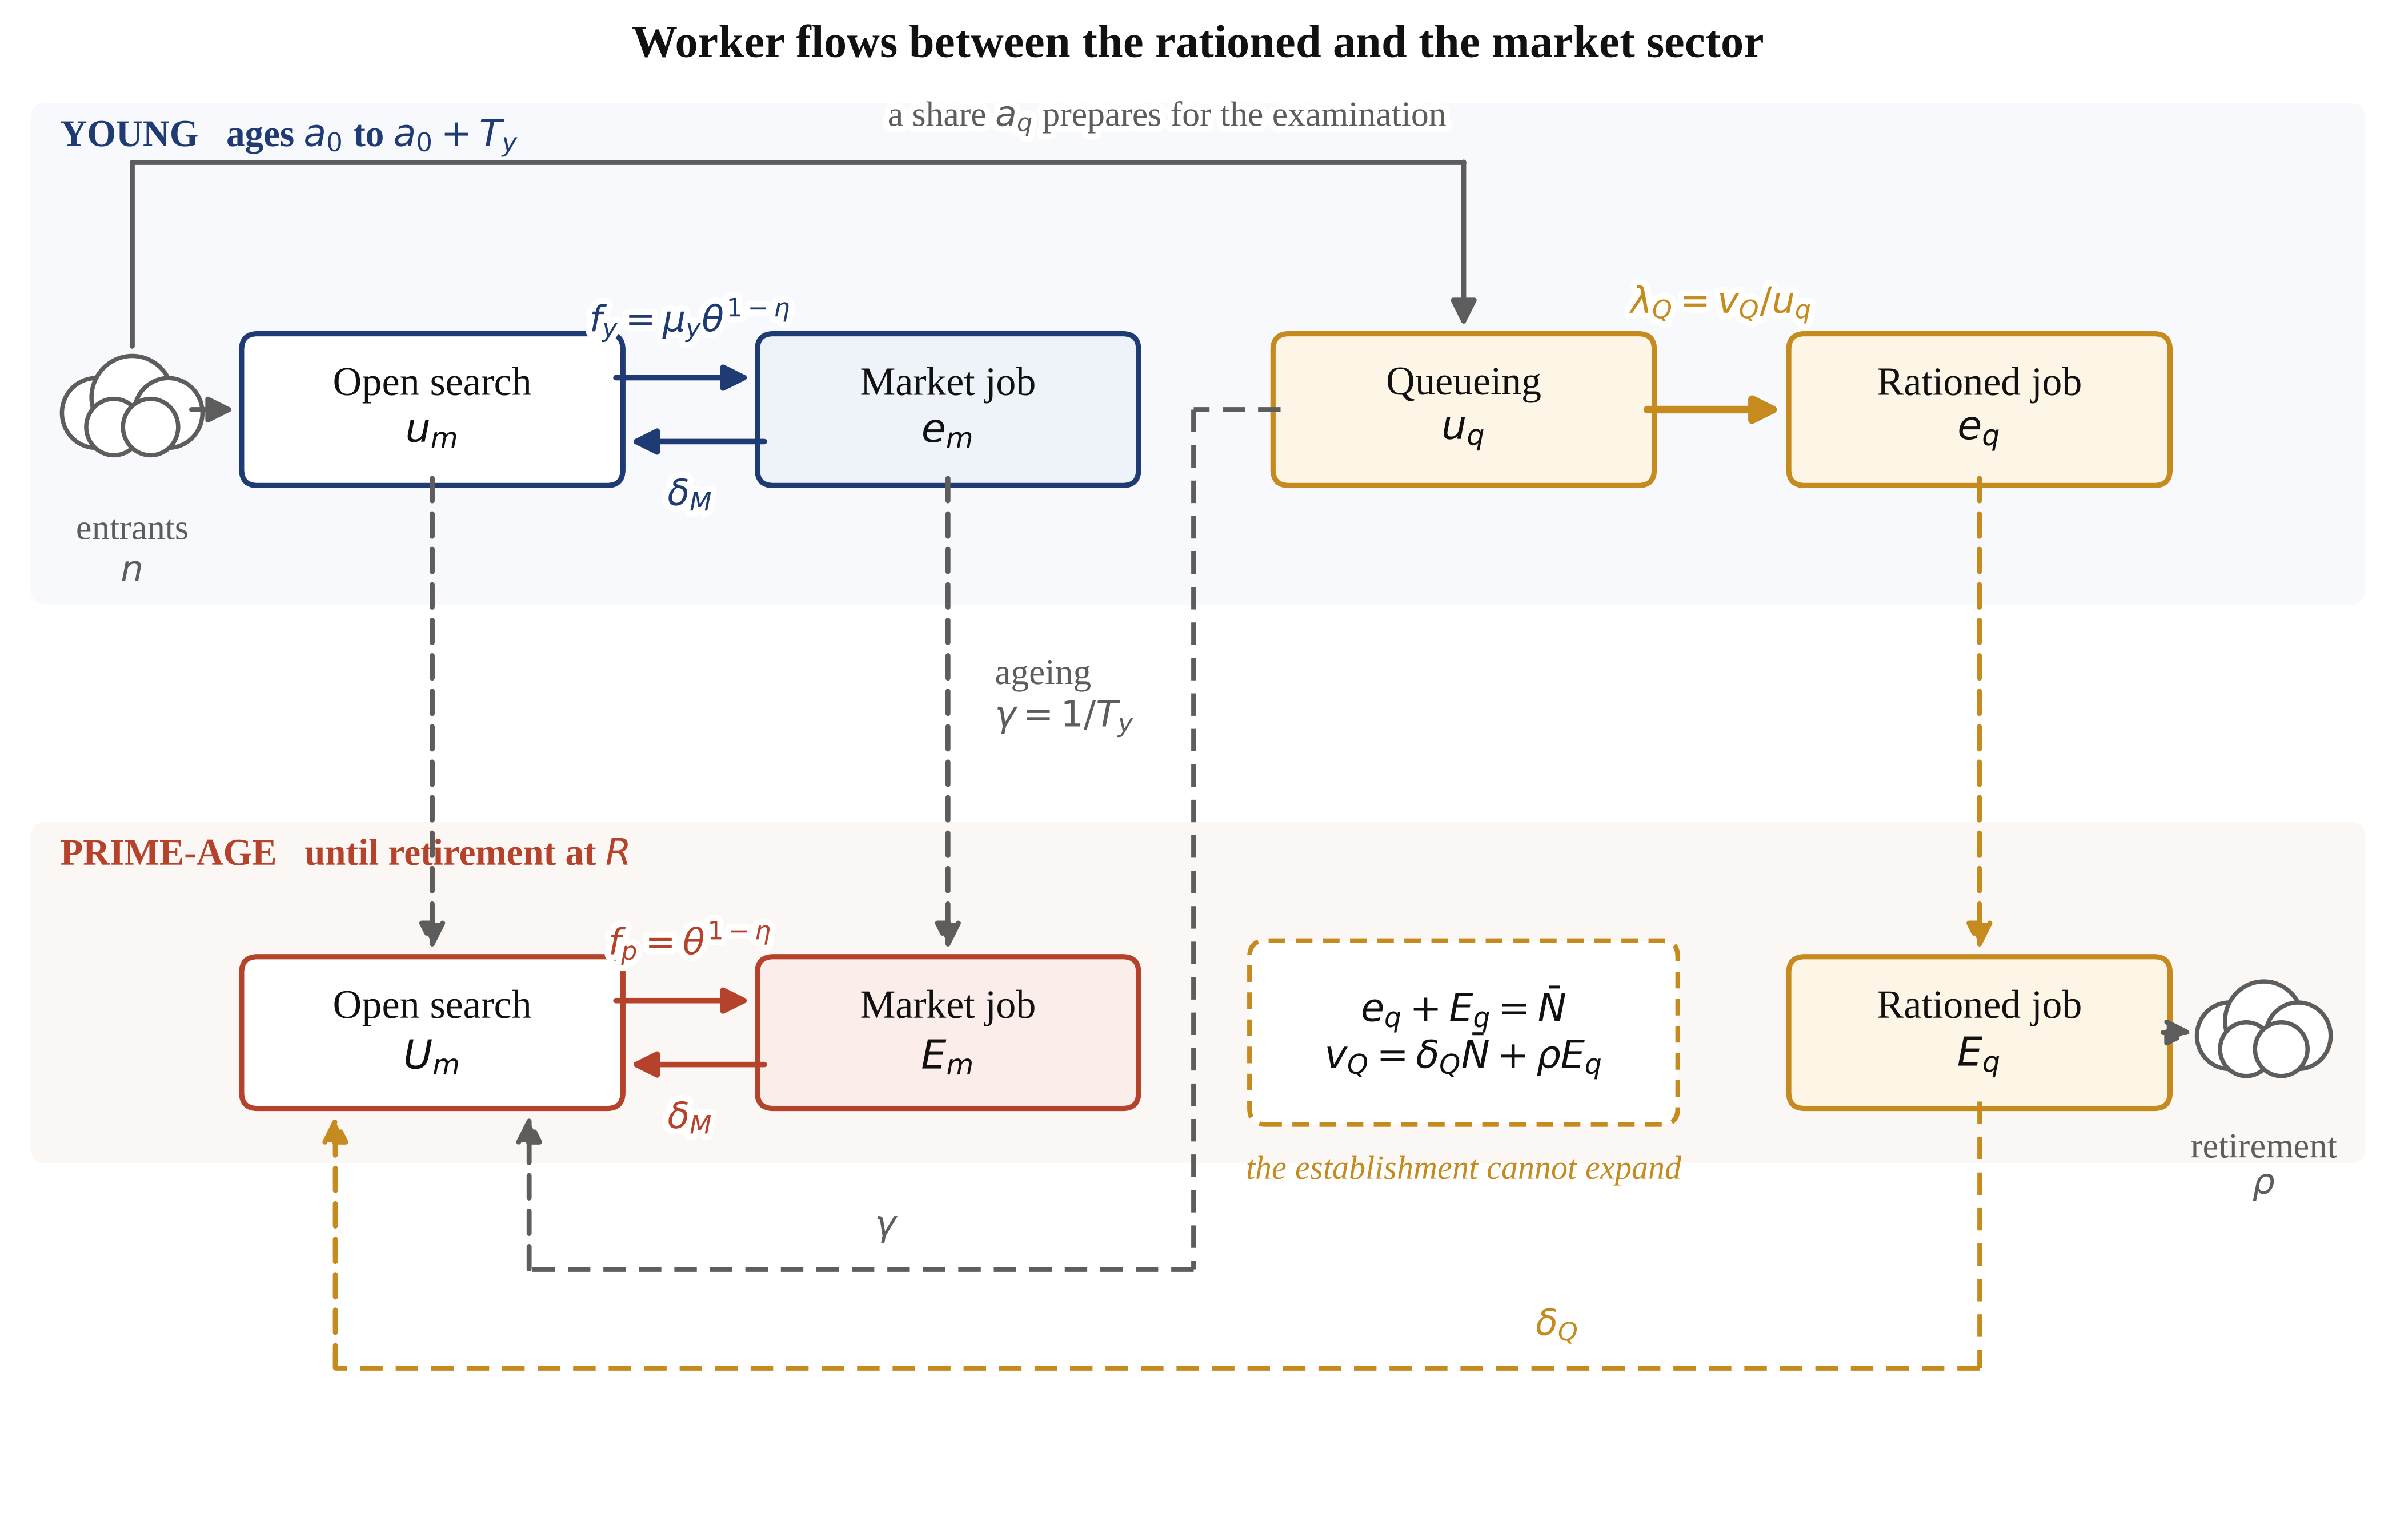
Figure 1. Structure of the model. Solid arrows are matching flows, dashed arrows are ageing, separation and retirement. The rationed sector cannot expand: its headcount is fixed at $\overline{N}$ by administrative rule, so its only vacancies are its separations plus its retirements. An age ceiling on the examinations means that only the young queue, and the young who age out of the queue without a post join open search. The market sector has free entry, so its tightness $θ$ adjusts. Every prime-age state exits to retirement at rate $ρ$; the figure draws the flow only from the rationed sector, which is the one the reform acts through.
3.1. Matching and Flows
The market sector has a constant-returns Cobb–Douglas matching function over effective searchers and vacancies. The young search less effectively than the prime-age, at relative efficiency $μ_{y}$:
$M\left(S_{e}, v_{M}\right) = {S_{e}}^{η} {v_{M}}^{1 − η}, θ = \frac{v_{M}}{S_{e}}, S_{e} = μ_{y}u_{m} + U_{m}$ (2)
which gives the job-finding and vacancy-filling rates
$f_{p} = θ^{1 − η}, f_{y} = μ_{y} θ^{1 − η}, q\left(θ\right) = θ^{ − η}$ (3)
Young workers are distributed across queueing $u_{q}$, open search $u_{m}$, a rationed job $e_{q}$ and a market job $e_{m}$; their stocks evolve as
$\dot{u_{q}} = a_{q}I_{y} − \left(λ_{Q} + γ\right)u_{q}, \dot{u_{m}} = \left(1 − a_{q}\right)I_{y} − \left(f_{y} + γ\right)u_{m}$ (4)
$\dot{e_{q}} = λ_{Q}u_{q} − \left(δ_{Q} + γ\right)e_{q}, \dot{e_{m}} = f_{y}u_{m} − \left(δ_{M} + γ\right)e_{m}$ (5)
where $I_{y}$ is the inflow into young non-employment and $a_{q}$ the share of it that joins the queue. Prime-age workers cannot queue, so they occupy three states:
$\dot{U_{m}} = γ\left(u_{q} + u_{m}\right) + δ_{Q}E_{q} + δ_{M}E_{m} − \left(f_{p} + ρ\right)U_{m}$ (6)
$\dot{E_{q}} = γe_{q} − \left(δ_{Q} + ρ\right)E_{q}, \dot{E_{m}} = γe_{m} + f_{p}U_{m} − \left(δ_{M} + ρ\right)E_{m}$ (7)
3.2. The Establishment Constraint
The rationed sector is defined by an administrative ceiling on headcount rather than by a hiring decision. Its employment is fixed and its vacancies are exactly what it loses:
$e_{q} + E_{q} = \overline{N}\left(1 + s_{N}\right), v_{Q} = δ_{Q}\overline{N} + ρE_{q} = \left(δ_{Q} + γ\right)e_{q}$ (8)
The second equality is the pivot of the paper. Because separations from establishment posts are rare, retirements are the binding source of openings, and the retirement hazard enters the vacancy flow directly. A policy that lowers $ρ$ lowers $v_{Q}$ mechanically, and no adjustment on the firm’s side offsets it, because there is no firm-side decision to adjust. This is what distinguishes a rationed sector from a market one: in the market sector free entry restores vacancy creation, and in the rationed sector nothing does.
Applicants are allocated across the available posts by examination, which we treat as a lottery among those who prepare. The hazard of winning a post is therefore the ratio of openings to queuers:
$λ_{Q} = \frac{v_{Q}}{u_{q}} = \frac{\left(δ_{Q} + γ\right)\overline{N}\left(δ_{Q} + ρ\right)}{u_{q}\left(δ_{Q} + ρ + γ\right)}$ (9)
3.3. Values and Wages
Market matches are worth more to a firm when the worker is young, because the match is not yet exposed to retirement. Writing $J_{i}$ for the firm’s value and $Δ_{i}$ for the worker’s surplus,
$\left(r + δ_{M} + ρ\right)J_{p} = p_{M} − w_{p}, \left(r + δ_{M} + γ\right)J_{y} = p_{M} − w_{y} + γJ_{p}$ (10)
$\left(r + δ_{M} + f_{p} + ρ\right)Δ_{p} = w_{p} − b, \left(r + δ_{M} + f_{y} + γ\right)Δ_{y} = w_{y} − b + γΔ_{p}$ (11)
Wages are set by Nash bargaining over each match surplus with worker bargaining power $β$:
$β J_{i} = \left(1 − β\right)Δ_{i}, i ∈ \left\{y, p\right\}$ (12)
and the values of search follow:
$\left(r + ρ\right)V_{p} = b + f_{p}Δ_{p}, \left(r + γ\right)V_{y} = b + f_{y}Δ_{y} + γV_{p}$ (13)
A rationed job pays the administered wage $w_{Q}$, which is not bargained, and is held until separation or retirement:
$\left(r + δ_{Q} + ρ\right)W_{q}^{p} = w_{Q}\left(1 − τ_{q}\right) + δ_{Q}V_{p}, \left(r + δ_{Q} + γ\right)W_{q}^{y} = w_{Q}\left(1 − τ_{q}\right) + δ_{Q}V_{y} + γW_{q}^{p}$ (14)
3.4. The Queue
A young worker who queues forgoes open search entirely: preparation is full time, so the two activities are mutually exclusive. Queueing yields the flow value $κ_{q} b$, which is below the value of open search and, once preparation courses are paid for, may be negative. In an interior equilibrium the two activities must be equally attractive, which is the Harris–Todaro condition:
$\left(r + γ\right)V_{y} = κ_{q}b + λ_{Q}\left(W_{q}^{y} − V_{y}\right) + γV_{p}$ (15)
This pins the queue. Solving for the hazard and inverting the definition in (9) gives the queue length directly:
$λ_{Q} = \frac{\left(r + γ\right)V_{y} − κ_{q}b − γV_{p}}{W_{q}^{y} − V_{y}}, u_{q} = \frac{v_{Q}}{λ_{Q}}$ (16)
The comparative statics are worth stating because they drive everything that follows. Anything that raises the value of a rationed job relative to open search lowers $λ_{Q}$, which is to say it lengthens the queue per opening. Anything that reduces the number of openings lowers $u_{q}$ for a given hazard. A later retirement age does both at once: it makes the post more valuable, because it is held for longer, and it makes posts rarer.
3.5. Equilibrium
Firms in the market sector post vacancies until the expected cost of filling one equals its expected value, where the value is averaged over the composition of searchers:
$\frac{c_{M}\left(1 − s_{v}\right)}{q\left(θ\right)} = ω_{y}J_{y} + \left(1 − ω_{y}\right)J_{p}, ω_{y} = \frac{μ_{y}u_{m}}{S_{e}}$ (17)
A steady-state equilibrium is a tightness $θ$, a queue hazard $λ_{Q}$, wages and stocks such that all stocks are stationary, wages solve the bargaining problem, the establishment constraint holds, the indifference condition (15) holds and free entry (17) holds. The system is recursive: given $θ$, wages and values follow in closed form, (16) delivers the queue, the stock equations deliver the remaining states, and (17) is a single equation in $θ$. Every equilibrium reported below was located by bracketing that equation on a scan of the whole admissible range, so it is a global rather than a local solution.
3.6. Output, Welfare and the Cost of the Queue
Output is produced by employment in both sectors, and welfare adds the value of non-market time and subtracts recruiting costs:
$Y = p_{Q}\overline{N}\left(1 + s_{N}\right) + p_{M}\left(e_{m} + E_{m}\right)$ (18)
$𝒲 = Y − c_{M}v_{M} + b\left(u_{m} + U_{m}\right) + κ_{q}bu_{q}$ (19)
The queue has a distinctive welfare status. The establishment hires $v_{Q}$ workers however long the line is, so at the margin queueing produces nothing; its whole social cost is the output the queuers would otherwise have produced, net of what they enjoy while preparing:
$L = u_{q}\left(p_{M} − κ_{q}b\right)$ (20)
This is the Harris–Todaro deadweight loss and it is the largest single distortion in the estimated economy. Because assuming that the examinations have no social value at all is strong, Section 5.8 reports the opposite calculation: the productivity gain the examinations would have to deliver, through better selection, for the observed queue to be efficient.
Finally, the object the retirement debate is really about is the crowding-out coefficient, the change in young employment per unit change in prime-age employment:
$Ξ = \frac{Δ\left(e_{q} + e_{m}\right)}{Δ\left(E_{q} + E_{m}\right)}$ (21)
A lump-of-labour world has $Ξ = −1$; a world in which the two groups do not compete has $Ξ = 0$.
Three distinct routes run from a later retirement age to the young, and Figure 2 sets them out because the rest of the paper is an accounting of their relative size. The quota route is the one just described: fewer retirements mean fewer establishment vacancies. The horizon route works through values rather than flows, since a job that will be held for longer is worth more to both sides of the match. The demographic route is the slowest and the least discussed: the labour force keeps growing while $\overline{N}$ does not, so the rationed sector shrinks as a share of employment whatever the retirement age does. The three do not share a sign, and Section 5.4 shows that in the headline indicator they very nearly cancel.
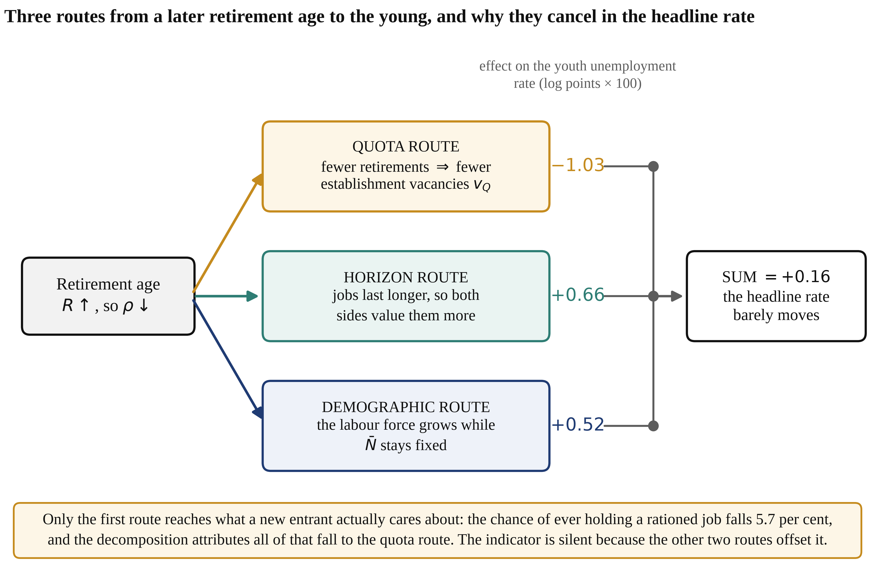
Figure 2. The three routes from a later retirement age to young workers, and the decomposition of Section 5.4. The figures on the right are Shapley contributions to the change in the youth unemployment rate over the full reform, in log points multiplied by one hundred. Only the quota route reaches the chance that a new entrant ever holds a rationed job; the other two routes offset it in the indicator without touching it.
4. Calibration
The model is calibrated to China in 2025 at annual frequency. Three normalisations come first because they determine what can be identified. Market productivity is the numeraire. Matching efficiency in the prime tier is set to one, because matching efficiency and vacancy cost enter every equilibrium object only through $μ_{i}^{2}/c_{M}$. And rationed-sector productivity is set equal to market productivity, so that the administered premium is a pure rent rather than a return to unobserved productivity; nothing in the allocation depends on that choice, and Section 5.8 varies it. What remains is six parameters and six moments. The system is square, so rather than minimising a distance that stays positive at the optimum we solve the moment conditions exactly:
$\sum_{k = 1}^{6}{{\left(ln m_{k}\left(Θ\right) − ln \overline{m_{k}}\right)}^{2}} = 0$ (22)
A bounded least-squares solve reaches a maximum absolute log deviation of 1.1e-16 across all six conditions, so every target is matched to machine precision.
4.1. Externally Set Parameters
Table 1 lists what is fixed outside the estimation. The young tier runs from age 23 to 30, which is where the examination age ceiling historically bound; the 2026 relaxation of that ceiling from 35 to 38 is discussed in Section 6. The pre-reform effective retirement age of 56.3 is the employment-weighted average of 60 for men, 55 for women in cadre posts and 50 for women in worker posts, and the post-reform value of 59.9 is the corresponding average of 63, 58 and 55. Separation from an establishment post is set at 2 per cent a year against 18 per cent in the market sector, which is the quantitative expression of what the phrase "iron rice bowl" describes. The matching elasticity is 0.5 and worker bargaining power is set equal to it, so the Hosios condition holds exactly and the market sector is efficient by construction; every distortion we report is therefore attributable to rationing rather than to an assumption about bargaining.
Table 1. Parameters set outside the estimation, and the three normalisations that determine what is identified.
Parameter | Symbol | Value | Source or justification
Discount rate | $r$ | 0.040 | Annual real rate
Age at labour-market entry | $a_{0}$ | 23.0 | Mean age of a graduating cohort
Length of the young tier | $T_{y}$ | 7.0 | Ages 23–30; the examination age ceiling binds thereafter
Effective retirement age, pre-reform | $R$ | 56.3 | Employment-weighted average of 60 for men, 55 and 50 for women
Separation rate, rationed sector | $δ_{Q}$ | 0.020 | Establishment posts are seldom lost
Separation rate, market sector | $δ_{M}$ | 0.180 | Turnover of urban private employment [49]
Matching elasticity | $η$ | 0.500 | Consensus range of the matching-function literature [25]
Worker bargaining power | $β$ | 0.500 | Hosios condition imposed, $β = η$ [26]
Market productivity | $p_{M}$ | 1.000 | Numeraire
Rationed-sector productivity | $p_{Q}$ | 1.000 | Set equal to $p_{M}$, so the administered premium is a pure rent; varied in Section 5.8
Matching efficiency, prime tier | — | 1.000 | Normalisation: only $μ_{i}^{2}/c_{M}$ is identified
Entrant cohort | $n$ | 1.000 | Normalisation; results are scaled to 12.7 million where stated
Notes: Matching efficiency and the vacancy cost enter every equilibrium object only through $μ_{i}^{2}/c_{M}$, so one of the two must be normalised; the units of output and of the entrant cohort are likewise free.
4.2. Estimated Parameters and Targeted Moments
The six estimated parameters are the market vacancy cost, the size of the establishment, the administered wage, the flow value of open search, the flow value while queueing and the matching efficiency of the young. Table 2 reports the targets, the fit and the parameter each moment principally identifies; the mapping is close to one-to-one and can be read off the recursive structure of the model. Two of the six targets deserve comment. The rationed sector is defined as government agencies and public institutions, about 12 per cent of urban employment, and deliberately excludes commercial state-owned enterprises, which hire without an establishment ceiling and so do not belong to the mechanism. And the compensation premium of 1.25 is a compensation-equivalent figure including pension, housing and security provisions, not a wage premium; the wage gap alone is much smaller.
Table 2. Targeted moments, the fit, and the parameter each moment principally identifies.
Moment | Target | Model | Estimate | Parameter identified
Youth unemployment rate | 0.178 | 0.178 | 0.497 | $μ_{y}$ matching efficiency of the young
Prime-age unemployment rate | 0.043 | 0.043 | 0.036 | $c_{M}$ market vacancy cost
Rationed share of employment | 0.120 | 0.120 | 3.711 | $\overline{N}$ size of the establishment
Compensation premium of a rationed job | 1.250 | 1.250 | 1.180 | $w_{Q}$ administered wage
Queue share of youth non-employment | 0.350 | 0.350 | −0.718 | $κ_{q}$ flow value while queueing
Flow value of open search, relative to the entry wage | 0.550 | 0.550 | 0.519 | $b$ flow value of open search
Notes: The system is square, so the fit is exact by construction; what the table reports is that an exact solution exists inside the admissible parameter space, which is not guaranteed and which failed for a broader definition of the rationed sector that included commercial state-owned enterprises. The negative estimate of $κ_{q}$ says that a full-time candidate is worse off during preparation than an open searcher, once courses, materials and forgone casual work are counted.
4.3. Over-Identifying Checks
Several statistics are computed but never targeted. Table 3 reports them, and one deserves emphasis. Three separately sourced targets—a rationed sector of 12 per cent of employment, a queue accounting for 35 per cent of youth non-employment, and a youth unemployment rate of 17.8 per cent—jointly imply an expected queueing duration of 2.50 years. That is not a target; it is an implication. It matches the independent observation that successful candidates commonly sit the annual examinations two or three times, which is a genuine consistency check across data sources that had no reason to agree.
Scaled to a cohort of 12.7 million, the estimated economy has 5.5 million young people queueing full time and 2.2 million rationed hires a year. Both are the right order of magnitude: 3.7 million candidates qualified for the central civil-service examination alone in 2026, before provincial, public-institution and public-teaching examinations are counted. The mean duration of open search by the young comes out at 6.4 months, close to what graduate surveys report. One check is weak by construction: the market sector is homogeneous, so the model produces almost no experience premium within it, and the true premium is larger. That limits what the model can say about wage profiles, though not about the rationing mechanism, which is what it is built for.
Table 3. Over-identifying checks: model statistics that were never targeted, against independent evidence.
Statistic | Model | External benchmark
Expected duration of queueing (years) | 2.50 | Candidates commonly sit the annual examinations two or three times
Chance that a cohort member ever holds a rationed job (%) | 17.5 | Consistent with a sector of 12 per cent of employment and a mean tenure of about twenty years
Mean duration of open search by the young (months) | 6.4 | Graduate surveys report a first-job search of four to six months
Rationed hires per year, scaled (millions) | 2.22 | Central and provincial civil-service, public-institution and public-teaching intakes combined
Queueing entrants, scaled (millions) | 5.54 | 3.7 million sat the 2026 central examination alone, before provincial and public-institution examinations
Market wage, prime relative to young | 1.028 | Not separately targeted; the market sector is homogeneous by construction, so this understates the true experience premium
Notes: Scaled figures use an entering cohort of 12.7 million, the expected size of the 2026 graduating class, and an urban labour force of 423 million.
5. Results
Section 5.1 describes the estimated economy and prices the queue. Sections 5.2 and 5.3 run the retirement reform and separate two questions the debate usually merges: whether the young are displaced, and whether their access to the rationed sector survives. Section 5.4 decomposes the response, Section 5.5 asks what a monitoring authority watching the headline rate would have seen, and Sections 5.6 to 5.9 compare instruments and test how far the conclusions survive the parameters we did not estimate.
5.1. The Estimated Economy and the Price of the Queue
Table 4 reports the estimated equilibrium. Market tightness is 14.1, which is high because a vacancy in this model is a recruiting effort rather than a posted position, and it delivers job-finding rates of 1.87 a year for the young and 3.75 for the prime-age. The quantity that matters is the other one. The establishment hires 0.175 workers for every entering cohort of one, 2.22 million a year at Chinese scale, and 5.54 million young people are queueing for them at any moment. The hazard of winning a post is 0.400 a year, so the expected wait is 2.50 years.
That wait is expensive because it is exclusive. A candidate who prepares full time is not searching, is not accumulating experience and is not producing, and the establishment hires the same 0.175 workers whether the line behind each post is two people long or twenty. The output forgone is 1.94 per cent of gross domestic product—larger than the entire measured contribution of many sectors that receive far more policy attention, and larger than the direct fiscal cost of most active labour-market programmes [50,51]. It is also, in the one setting where the long-run consequences have been measured, persistent: cohorts exposed to a harsher examination queue in Tamil Nadu still had lower employment and lower earning capacity a decade later [19]. And it is, on the estimates, the largest single distortion in the economy: the market sector satisfies the Hosios condition by construction, so there is nothing else of comparable size for it to compete with.
The obvious objection is that examinations are not pure waste, because they select. Suppose they do, and that a worker selected by examination is more productive in a rationed post by a factor $ξ$. The examination system breaks even when the extra output it generates covers the output the queue destroys:
$ξ^{*} = \frac{u_{q}\left(p_{M} − κ_{q}b\right)}{p_{Q}\overline{N}}$ (24)
The estimated economy gives $ξ^{*}$ = 0.456. Selection by examination would have to raise the productivity of every worker in every government agency and public institution by 45.6 per cent, permanently and over and above what an ordinary hiring process would achieve, for the observed queue to be socially efficient. That is not a refutation, because no one has measured the number. It does establish what would have to be true, and the magnitude is far outside the range that the personnel-economics literature reports for any selection instrument [11,52].
Table 4. The estimated equilibrium. Stocks are per entering cohort; the last column scales them by a cohort of 12.7 million.
Quantity | Symbol | Model | Scaled to China
Market tightness | $θ$ | 14.078 | —
Job-finding rate of the young, per year | $f_{y}$ | 1.866 | mean open search of 6.4 months
Job-finding rate of the prime-age, per year | $f_{p}$ | 3.752 | —
Hazard of winning a rationed post, per year | $λ_{Q}$ | 0.400 | expected wait of 2.50 years
Share of young non-employment entrants who queue | $a_{q}$ | 0.127 | —
Queueing | $u_{q}$ | 0.436 | 5.54 million
Openly searching, young | $u_{m}$ | 0.810 | 10.29 million
Young in a rationed job | $e_{q}$ | 1.072 | 13.61 million
Young in a market job | $e_{m}$ | 4.682 | 59.46 million
The establishment | $\overline{N}$ | 3.711 | 47.1 million
Rationed hires per year | $v_{Q}$ | 0.175 | 2.22 million
Chance of ever holding a rationed job | — | 17.46% | about one entrant in 5.7
Administered wage | $w_{Q}$ | 1.180 | 1.25 times the entry market wage
Entry market wage | $w_{y}$ | 0.944 | —
Prime-age market wage | $w_{p}$ | 0.971 | —
Output forgone by the queue | $ℒ$ | 0.599 | 1.94% of output
Break-even screening value | $ξ^{*}$ | 0.456 | 45.6% of rationed output
Notes: The queue hazard, the expected wait, the mean duration of open search and the break-even screening value are implications rather than targets.
5.2. The Reform, and the Absence of Crowding Out
The reform raises the effective retirement age from 56.3 to 59.9 over 15 years, which is the schedule announced in September 2024 expressed as an employment-weighted average [1]. The retirement hazard falls 12.0 per cent. Figure 3 traces the path and Table 5 reports the endpoints.
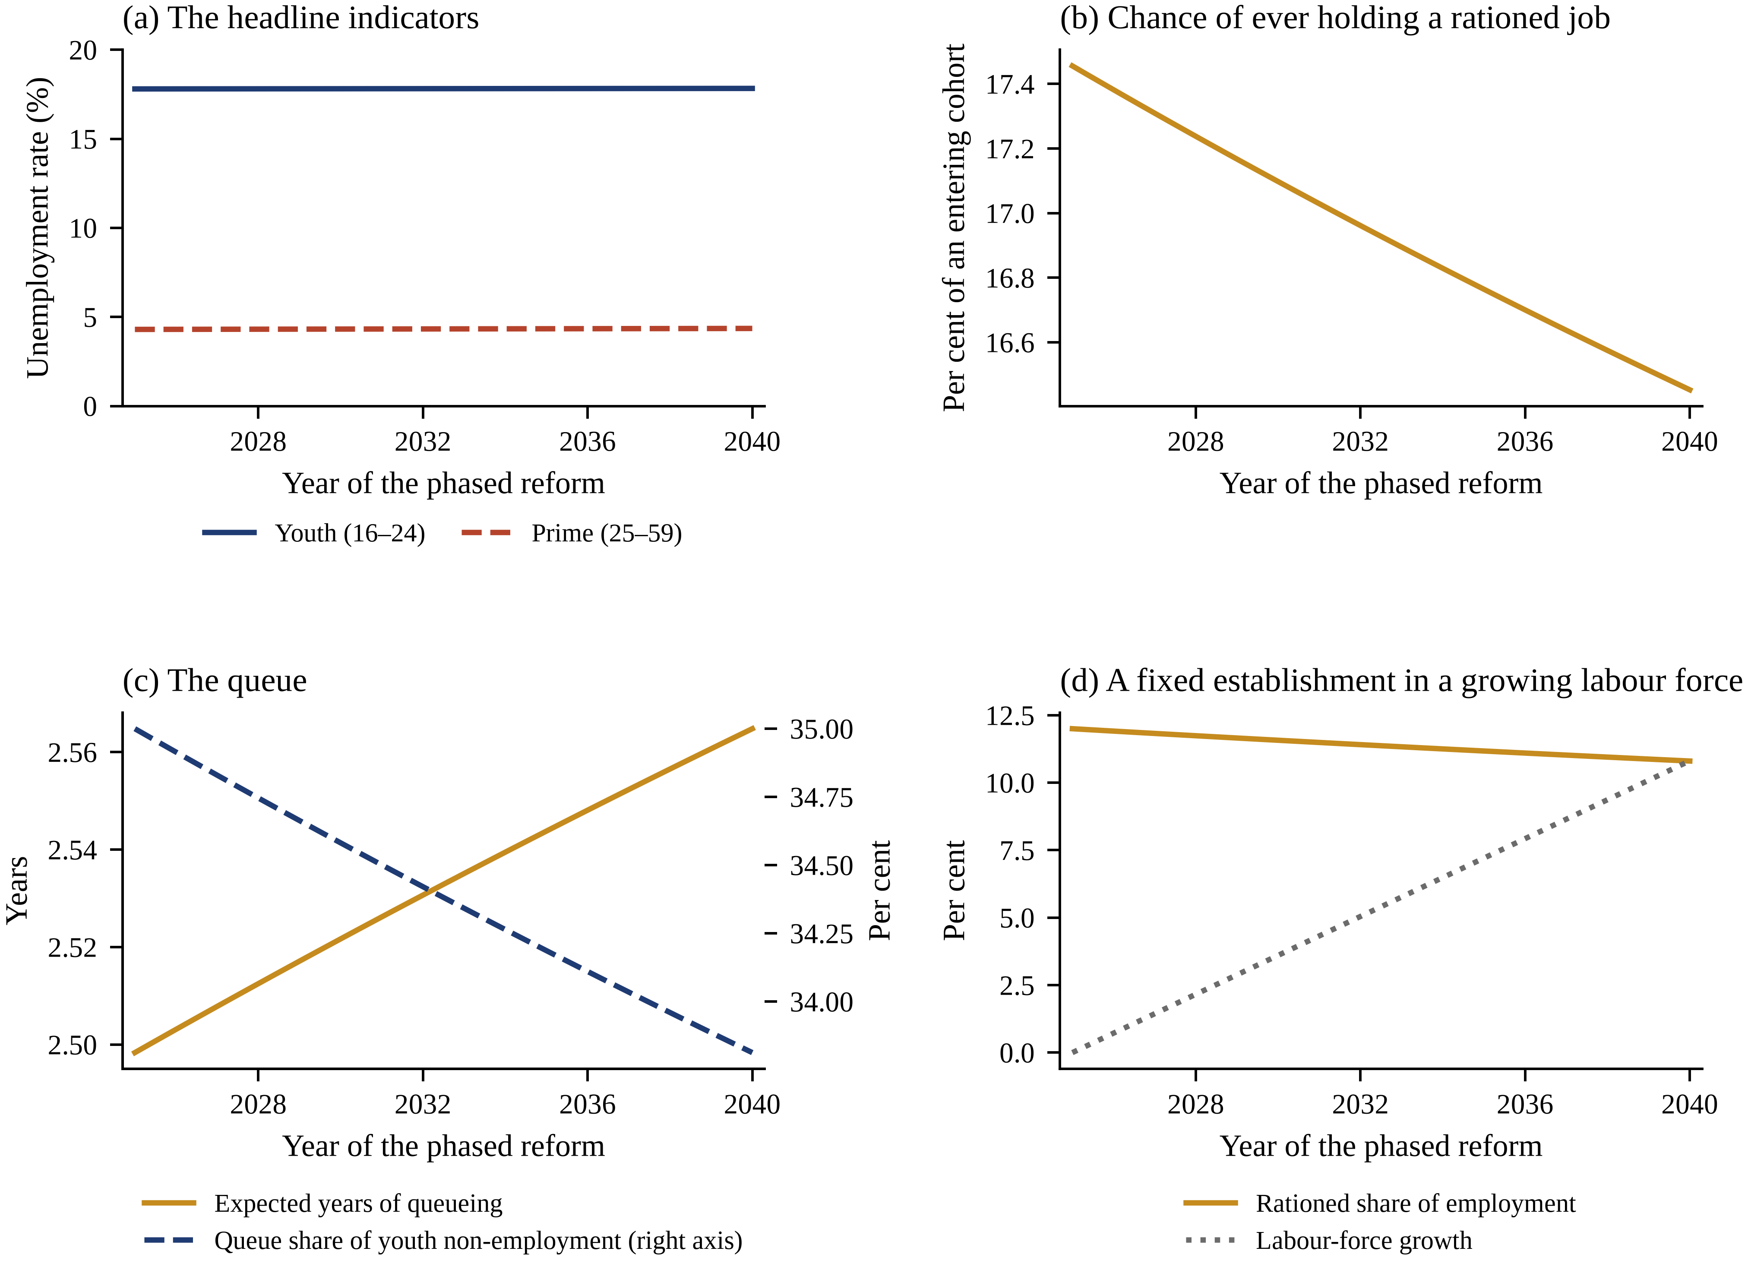
Figure 3. The phased reform, year by year. Panel (a) shows the two headline indicators; panel (b) the chance that a member of an entering cohort ever holds a rationed job; panel (c) the length of the queue and its share of youth non-employment; panel (d) the rationed share of employment against the growth of the labour force. The vertical scales differ: what moves in (b) does not move in (a).
Start with the question the public debate asks. Prime-age employment rises 13.6 per cent, because people who would have retired are still working. Young employment falls 0.035 per cent. The crowding-out coefficient is −0.0006, against $Ξ = −1$ under the lump-of-labour hypothesis and $Ξ = 0$ under no competition at all. For every hundred additional prime-age workers the economy retains, young employment falls by 0.06 of one worker. The lump-of-labour hypothesis is rejected, and it is not a close call.
The reason is that the market sector has free entry. A larger labour force is met by more recruiting, tightness falls only 1.41 per cent, the entry wage falls 0.029 per cent, and output rises 11.1 per cent—slightly more than the 10.8 per cent by which the labour force grows, because the additional workers are prime-age and prime-age workers are less often between jobs. This reproduces the finding that the cross-country and quasi-experimental literature has been reporting for two decades [2–4], and it reproduces it in a model that was never calibrated to any of those studies, and in a Chinese computable general-equilibrium model built for a quite different purpose [16]. Our contribution is not that finding. It is what the model says next.
Table 5. The retirement reform: from an effective retirement age of 56.3 to 59.9.
Outcome | Before | After | Change
Effective retirement age | 56.3 | 59.9 | +3.6 years
Retirement hazard $ρ$ | 0.0380 | 0.0334 | −12.04%
Labour force | 33.30 | 36.90 | +10.81%
Prime-age employment | 25.17 | 28.60 | +13.62%
Young employment | 5.754 | 5.752 | −0.035%
Crowding-out coefficient $Ξ$ | — | — | −0.0006
Youth unemployment rate (%) | 17.80 | 17.83 | +0.029 pp
Prime-age unemployment rate (%) | 4.30 | 4.35 | +0.054 pp
Chance of ever holding a rationed job (%) | 17.46 | 16.45 | −5.74%
Rationed hires per year (millions) | 2.217 | 2.090 | 127,000 fewer
Expected years of queueing | 2.498 | 2.565 | +0.066 years
Queue share of youth non-employment (%) | 35.00 | 33.81 | −3.39%
Rationed share of employment (%) | 12.00 | 10.80 | −1.20 pp
Market tightness $θ$ | 14.078 | 13.880 | −1.41%
Entry market wage | 0.9443 | 0.9440 | −0.029%
Output | 30.92 | 34.35 | +11.08%
Welfare per head | 0.9307 | 0.9334 | +0.293%
Value of being a new entrant | 14.291 | 14.882 | +4.13%
Notes: Stocks are per entering cohort. The crowding-out coefficient is the ratio of the change in young employment to the change in prime-age employment, Equation (21).
5.3. Access Falls Even Though Nobody Is Displaced
No young worker is pushed out of a job. What happens instead is that a door closes. The establishment cannot expand, so its vacancies are its separations plus its retirements; when retirements become rarer, so do vacancies. Rationed hiring falls from 2.22 million a year to 2.09 million. The chance that a member of an entering cohort ever holds a rationed job falls from 17.46 per cent to 16.45 per cent, a decline of 5.7 per cent. At a cohort of 12.7 million that is 127,000 young people a year for whom the outcome they were preparing for stops being available.
They are not unemployed. They queue slightly longer—the expected wait rises 0.07 of a year, from 2.50 to 2.56—and then most of them take a market job, which is why measured employment barely moves. The composition of what the young end up doing changes; the count of what they end up doing does not. An indicator built on the count is therefore blind to the change by construction, and the blindness is not a data problem that better sampling would fix.
The direction of the queue response is worth pausing on, because two forces pull against each other. Fewer openings shorten the line, since there is less to wait for. A longer working life lengthens it, since the prize is now held for 3.6 more years and is worth more. In the estimated economy the second force wins, narrowly: the queue gets longer per opening even as openings become scarcer, so the number of young people waiting falls only 3.4 per cent while the number of posts they are waiting for falls 5.7 per cent. Waiting becomes a worse bet and stays almost as popular.
5.4. Decomposing the Response
The retirement hazard enters the model in three distinct places, and the three do not have to agree. It sets the establishment’s replacement flow, through Equation (8); it sets how long any job is held, and therefore what a job is worth on both sides of the match, through Equations (10) to (14); and it sets the size of the prime-age population, and therefore the labour force against which a fixed $\overline{N}$ is measured. We call these the quota, horizon and demographic routes, shut each combination of them down in turn, and allocate the total by the Shapley value, which is the unique attribution that is symmetric and adds up. Table 6 reports the decomposition and Figure 4 draws it.
Table 6. Shapley decomposition of the response to the full reform, in log points multiplied by one hundred.
Outcome | Total | Quota route | Horizon route | Demographic route
Chance of ever holding a rationed job | −5.91 | −5.91 | +0.00 | +0.00
Youth unemployment rate | +0.16 | −1.03 | +0.66 | +0.52
Expected years of queueing | +2.63 | −0.01 | +2.38 | +0.25
Value of being a new entrant | +4.05 | +0.00 | +4.10 | −0.05
Rationed share of employment | −10.51 | −1.05 | +0.02 | −9.48
Notes: The three contributions sum to the total by construction; the residual is zero to within 4 × 10⁻¹⁸ for every outcome.
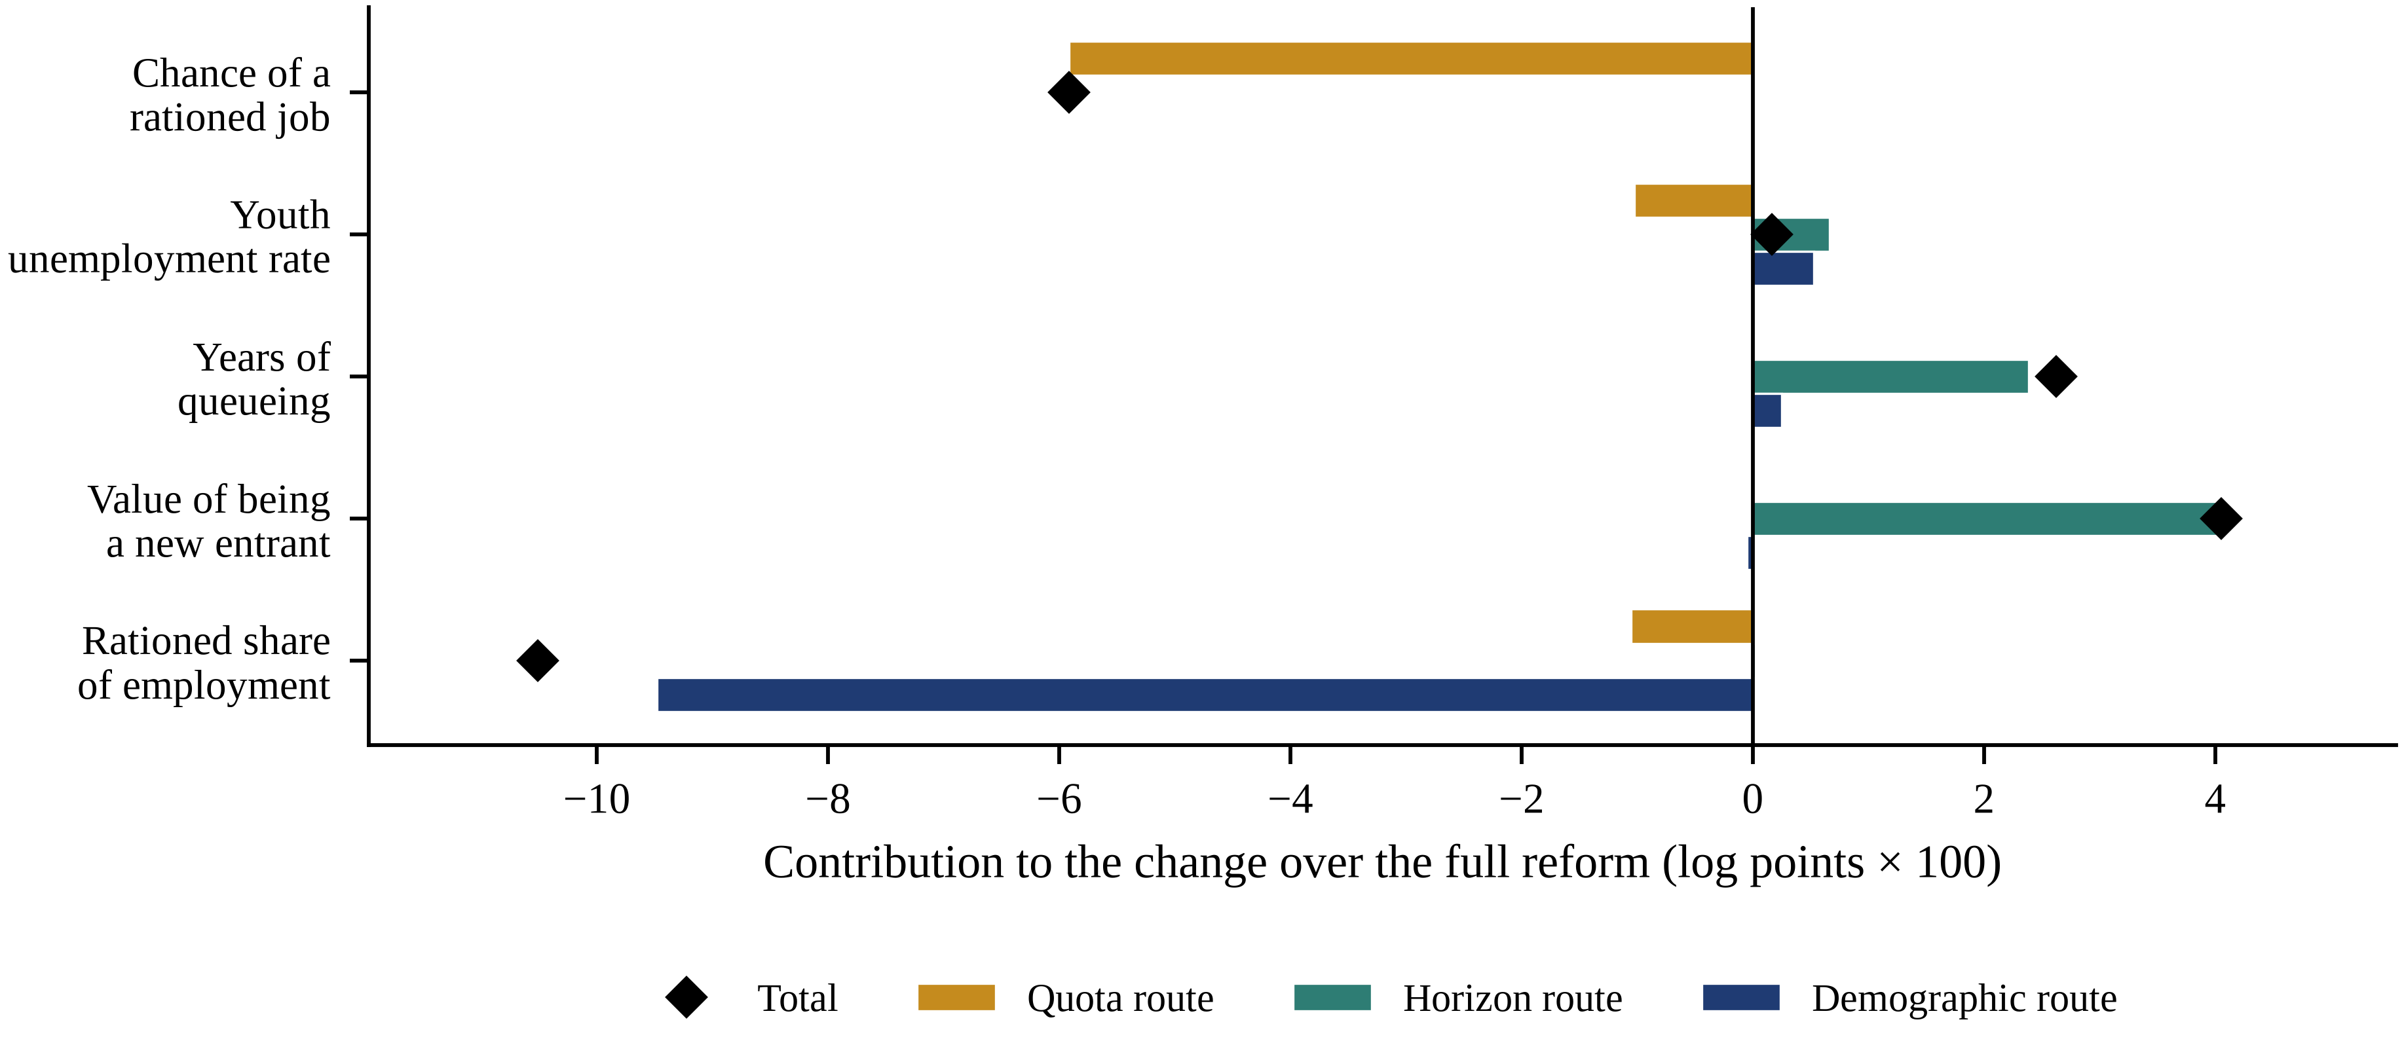
Figure 4. The same decomposition. Positive and negative contributions coexist in the youth unemployment rate and cancel; in the chance of ever holding a rationed job there is only one contribution and nothing to cancel it.
The decomposition is unusually clean. Access is 100 per cent quota route: the horizon and demographic contributions to the chance of ever holding a rationed job are +0.000 and +0.000 log points, which is to say exactly zero. This is not an approximation. The number of young people the establishment hires per cohort is $v_{Q}/n$, and by Equation (8) that depends on the retirement hazard and on nothing else that the reform touches; how much a post is worth and how large the labour force is do not enter.
The youth unemployment rate is the opposite case. Its three contributions are −1.03, +0.66 and +0.52 log points, and they sum to +0.16. The quota route pushes the rate down, because young people who would have queued instead search and are counted as employed sooner. The horizon route pushes it up, because a more valuable rationed post makes waiting more attractive. The demographic route pushes it up as well. The largest single contribution is 1.03 log points and the net is 0.16. More than four fifths of the largest single movement is cancelled inside the indicator by movements of the opposite sign.
The same arithmetic explains a result that would otherwise look like good news. The value of being a new entrant rises 4.13 per cent, which a welfare analysis that stopped there would read as the reform making young people better off. Of the +4.05 log points, the horizon route contributes +4.10, the demographic route −0.05 and the quota route +0.002. The gain is the mechanical consequence of a longer working life over which to collect the same flow payoffs, not of anything the reform did to the opportunities in front of an entrant. Strip the horizon out and the entrant is, to three decimal places, exactly where they started—except that the rationed door is 5.7 per cent less likely to open.
5.5. What the Headline Indicator Misses
Figure 5 puts the two series side by side, both indexed to their pre-reform values. Over the whole reform the youth unemployment rate moves by 0.029 percentage points, a small fraction of the month-to-month variation in the published Chinese series and far too little to be reported as a change by anyone. Over the same period the chance that an entrant ever holds a rationed job falls 5.7 per cent. The ratio of the two proportional movements is 35.5 to one.
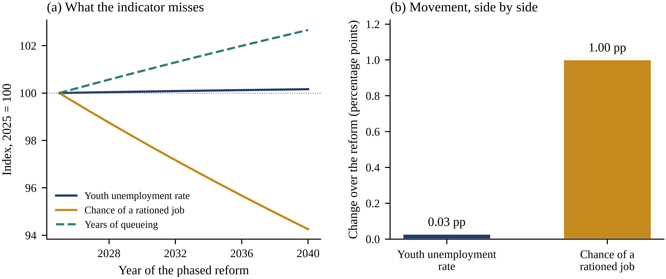
Figure 5. The monitoring problem. Panel (a) indexes the youth unemployment rate, the chance of ever holding a rationed job and the expected years of queueing to their pre-reform values. Panel (b) puts the two changes on a common percentage-point scale. An authority monitoring the reform through the headline rate would record it as having had no effect on the young.
This is a specific instance of a general problem that the systems literature has described for fifty years: an indicator selected because it is available and comparable comes to define the objective, and the parts of the system it does not measure drift without resistance [7,8,12]. What makes this instance sharp is that the blindness is structural rather than statistical. The youth unemployment rate is a stock divided by a stock at a point in time. Access to a rationed sector is a probability over a lifetime. A reform that moves the second without moving the first is not an unusual case to be guarded against; it is what the model predicts as the central case, and Section 5.9 shows that it happens in every draw of the parameters we did not estimate.
The practical implication is that the flow is observable and nobody is publishing it. Every province publishes its recruitment plan; the number of establishment posts filled each year is an administrative fact, not a survey estimate. Dividing it by the size of the entering cohort produces the series in panel (b) of Figure 5 directly, at negligible cost, with no sampling error and with a two-month rather than a two-year lag.
5.6. Three Instruments at a Common Budget
What should a government that accepts this diagnosis do? We give it a budget of 0.1 per cent of output and three instruments: expand the establishment, subsidise market vacancies, or cut the administered premium and rebate the saving. Each rate is solved to exhaust the same budget, so the comparison is like for like. Instruments are ranked by welfare per head and by the marginal value of public funds,
$MVPF = 1 + \frac{Δ𝒲}{G}$ (23)
which exceeds one for an instrument that returns more than it costs [53]. Table 7 reports the comparison before and after the reform and Figure 6 draws it.
Table 7. Three instruments at a common fiscal cost of 0.1 per cent of output. The upper block is the estimated baseline, the lower block the economy after the retirement reform.
Instrument | Rate | Welfare per head (%) | Access (%) | Youth unemployment (pp) | Queue loss (%) | MVPF
Cut in the administered premium | 0.0071 | 0.0585 | 0.000 | −0.172 | −3.21 | 1.59
Market vacancy subsidy | 0.0389 | 0.0133 | 0.000 | −0.249 | −0.67 | 1.13
Establishment expansion | 0.0071 | −0.0078 | 0.706 | +0.023 | 0.71 | 0.92
Cut in the administered premium | 0.0078 | 0.0567 | 0.000 | −0.185 | −3.57 | 1.57
Market vacancy subsidy | 0.0392 | 0.0117 | 0.000 | −0.253 | −0.68 | 1.12
Establishment expansion | 0.0078 | −0.0074 | 0.784 | +0.025 | 0.79 | 0.93
Notes: Access is the chance that a member of an entering cohort ever holds a rationed job. The queue loss is the output forgone by queueing, Equation (20). A marginal value of public funds above one identifies an instrument that returns more than it costs.
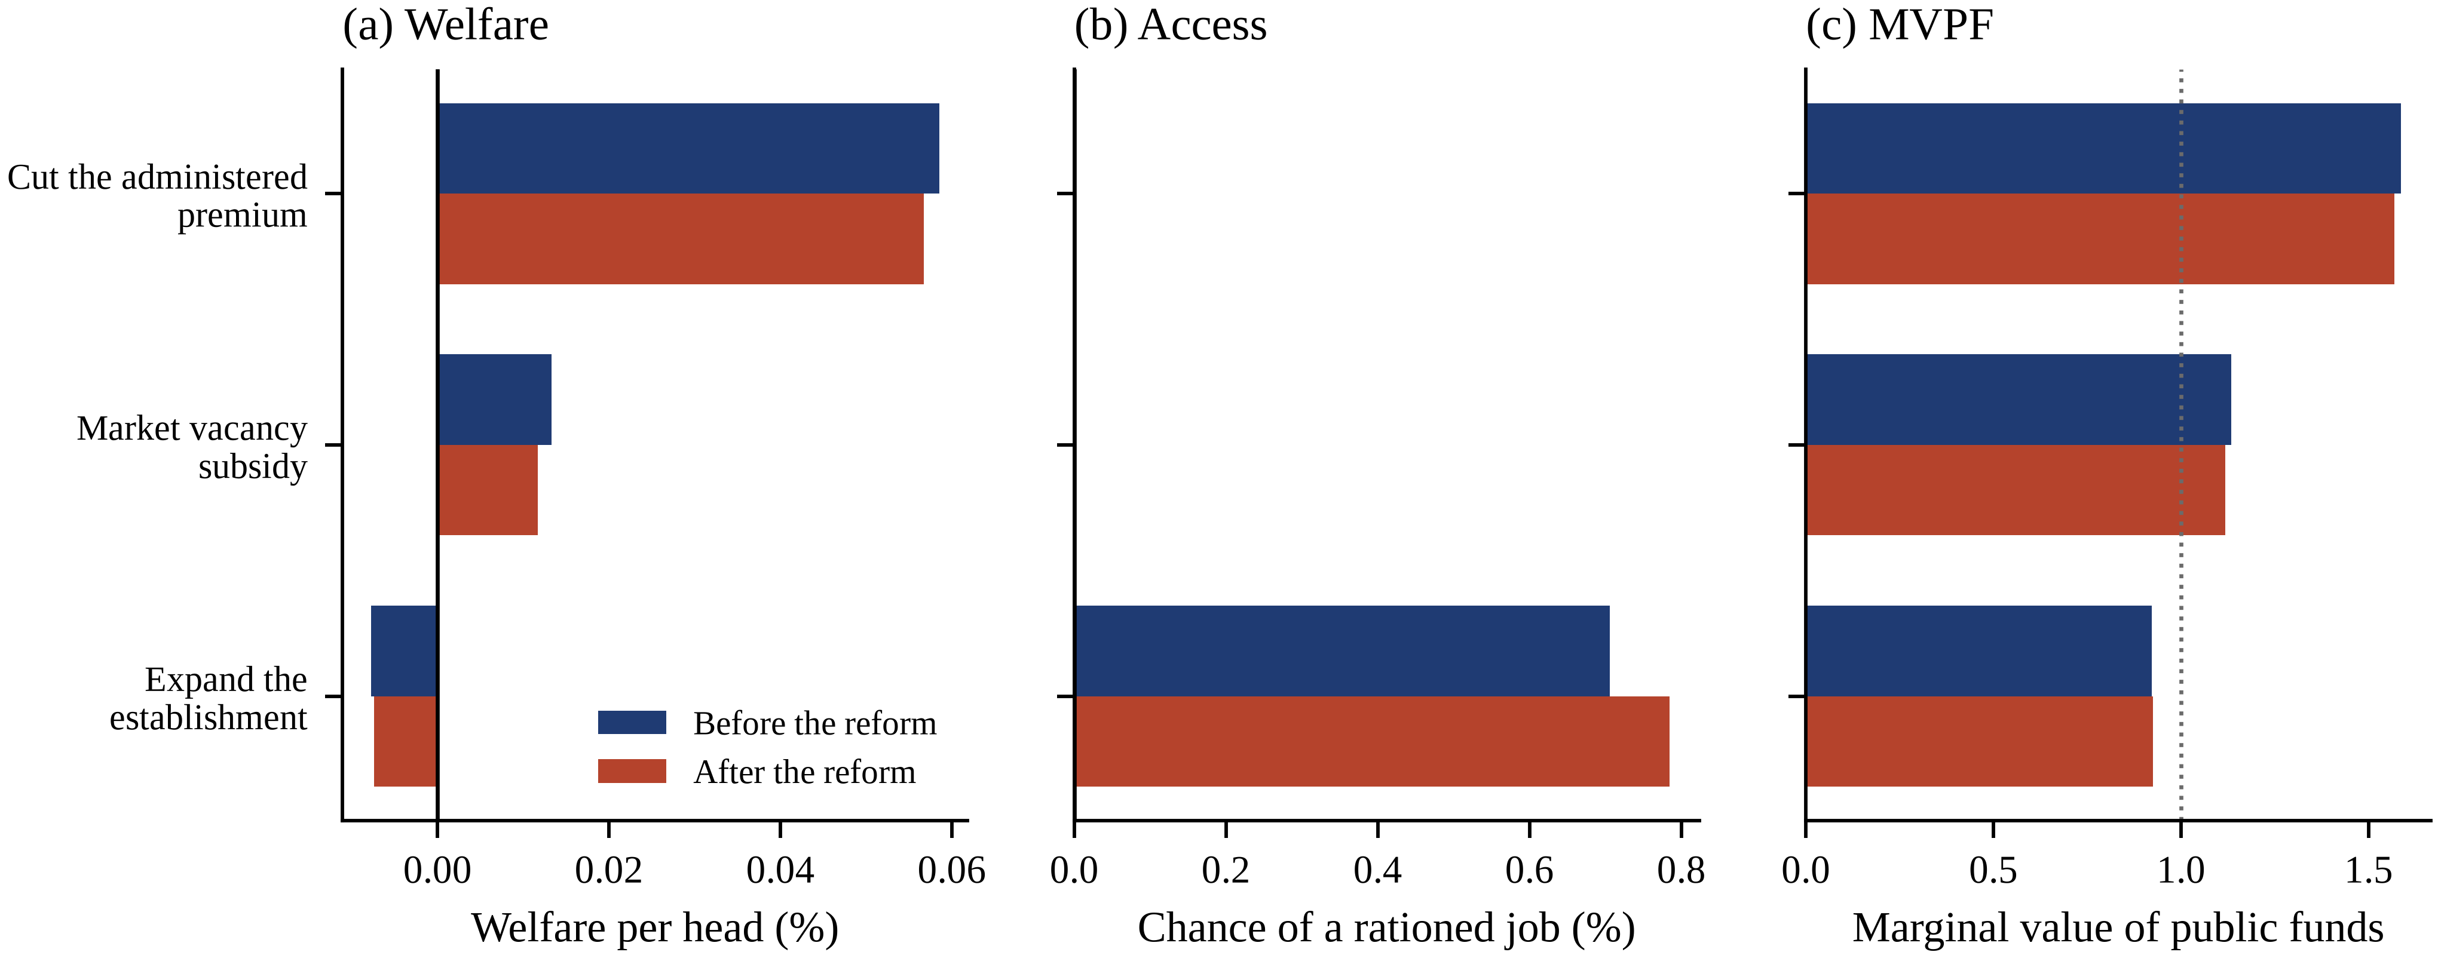
Figure 6. The same three instruments, before and after the reform. Expanding the establishment is the only instrument that raises access, and the only one that lowers welfare.
Cutting the administered premium wins on welfare and on the marginal value of public funds, in the baseline economy and after the reform. A 0.71 per cent cut in the premium raises welfare per head 0.059 per cent, shortens the queue by 0.080 of a year, cuts the output lost to queueing 3.2 per cent and returns 1.59 units of welfare per unit of public money. The market vacancy subsidy is second on welfare, at a marginal value of 1.13, and is the only instrument that does much for the value of being an entrant, raising it 0.15 per cent against 0.001 per cent for the premium cut.
Expanding the establishment is the intuitive response to a shortage of establishment posts, and it is the worst of the three. It raises access—by 0.71 per cent, mechanically, because access is the vacancy flow and the vacancy flow is what the instrument buys. It also lowers welfare per head by 0.0078 per cent, raises the output lost to queueing by 0.71 per cent, raises the youth unemployment rate by 0.023 percentage points, and returns 0.92 units of welfare per unit spent—less than the money would be worth left alone. A larger prize draws a longer line: the Harris–Todaro indifference condition (15) restores the queue in proportion to whatever is added to it, so the additional posts are paid for twice, once out of the budget and once out of the time of the people who queue for them [5,6].
The ranking is unchanged after the reform, and the case for the premium cut strengthens slightly: the queue is longer, so the same expenditure retires more of it, and the output saved rises from 3.21 to 3.57 per cent.
5.7. Indexing the Establishment to the Labour Force
The instruments in Table 7 are marginal. A government could instead index the establishment to the labour force, the reform aimed most directly at holding access constant. The labour force grows 10.8 per cent over the reform, so full indexation means $s_{N}$ = 0.108. Table 8 reports what that buys and what it costs.
Table 8. Indexing the establishment to the labour force, after the retirement reform.
Quantity | Establishment fixed | Establishment indexed
Expansion of the establishment $s_{N}$ | 0.000 | 0.1081
Chance of ever holding a rationed job (%) | 16.45 | 18.23
Relative to the pre-reform level of 17.46% | −5.7% | +4.4%
Share of the lost access restored (%) | 0.0 | 177.5
Fiscal cost (% of output) | 0.000 | 1.379
Welfare per head (%) | 0.000 | −0.1026
Output forgone by the queue (%) | 0.00 | +10.85
Youth unemployment rate (pp) | 0.000 | +0.338
Notes: Percentage changes are relative to the post-reform economy with a fixed establishment.
Indexation over-corrects. It restores 177 per cent of the lost access, which is to say it leaves an entrant 4.4 per cent more likely to hold a rationed job than before the reform, because it corrects for the retirement channel and for thirty years of accumulated labour-force growth at the same time. It costs 1.38 per cent of output, roughly fourteen times the budget of Table 7. And it lowers welfare per head by 0.103 per cent while raising the output lost to queueing 10.9 per cent and the youth unemployment rate 0.34 percentage points. The instrument that most directly fixes the thing this paper says is broken is not the instrument we would recommend, and the reason is the same as in Section 5.6.
5.8. Sensitivity: the Quota, the Premium and the Value of Screening
Table 9 varies the two features of the rationed sector that are hardest to pin down, re-estimating the model at each value so that all remaining moments continue to hold exactly. Two invariances are worth naming. The proportional fall in access is 5.74 per cent for every size of the rationed sector between 8 and 20 per cent of employment, and for every premium between 1.1 and 1.35, because Equation (8) makes the vacancy flow proportional to the establishment and the retirement hazard enters it multiplicatively. The result does not depend on getting the size of the rationed sector right. And the length of the queue is 2.50 years at every premium, because the queue is pinned by the data—by the share of youth non-employment that is preparing and by the youth unemployment rate—rather than by the premium. What the premium changes is the flow value of preparing, and therefore what the queue costs: the output forgone runs from 0.97 per cent of output at a premium of 1.10 to 2.58 per cent at 1.35.
Table 9. Sensitivity to the size of the rationed sector and to the administered premium. The model is re-estimated at each value so that the remaining moments continue to hold exactly.
Varied quantity | Value | Access change (%) | Youth unemployment (pp) | Queue length (years) | Queue loss (% of output)
Rationed share of employment | 8% | −5.74 | −0.022 | 2.50 | 1.34
 | 10% | −5.74 | +0.003 | 2.50 | 1.64
 | 12% | −5.74 | +0.029 | 2.50 | 1.94
 | 15% | −5.74 | +0.071 | 2.50 | 2.39
 | 20% | −5.74 | +0.152 | 2.50 | 3.13
Administered compensation premium | 1.10 | −5.74 | +0.014 | 2.50 | 0.97
 | 1.20 | −5.74 | +0.026 | 2.50 | 1.61
 | 1.25 | −5.74 | +0.029 | 2.50 | 1.94
 | 1.35 | −5.74 | +0.032 | 2.50 | 2.58
Notes: Access and the youth unemployment rate report the response to the full retirement reform. The estimated economy is the row at a rationed share of 12 per cent and a premium of 1.25.
The size of the rationed sector does move one thing: what the queue costs, from 1.34 per cent of output at a rationed share of 8 per cent to 3.13 per cent at 20 per cent. A country with a larger administered sector has more to gain from the policies of Section 5.6 and loses more from the ones it is tempted by. It also moves the sign of the indicator: at a rationed share of 8 per cent the youth unemployment rate falls 0.022 percentage points over the reform rather than rising, while access falls by exactly the same 5.7 per cent as everywhere else. The indicator does not merely understate the change; over a plausible range it does not reliably get the direction right either.
Finally, the calibration set rationed-sector productivity equal to market productivity, so that the administered premium is a pure rent. Relaxing that is the same calculation as the break-even screening value of Section 5.1: a premium that reflects genuine productivity by a factor $ξ$ is efficient when $ξ$ exceeds $ξ^{*}$ = 0.456. Below that threshold the queue destroys output on net and every conclusion in this section holds, with the cost of the queue falling proportionally as $ξ$ rises towards $ξ^{*}$; above it the examinations are an efficient sorting device and the welfare rankings of Section 5.6 no longer follow.
5.9. Parameter Uncertainty
Six parameters are set outside the estimation, and the results above are conditional on them. We draw 192 Latin hypercube points over the discount rate, the length of the young tier, the two separation rates, the matching elasticity and the age of entry, re-estimate all six structural parameters at every draw so that the six moments continue to hold exactly, and re-run the reform. All 192 draws solve. Figure 7 reports the distributions.
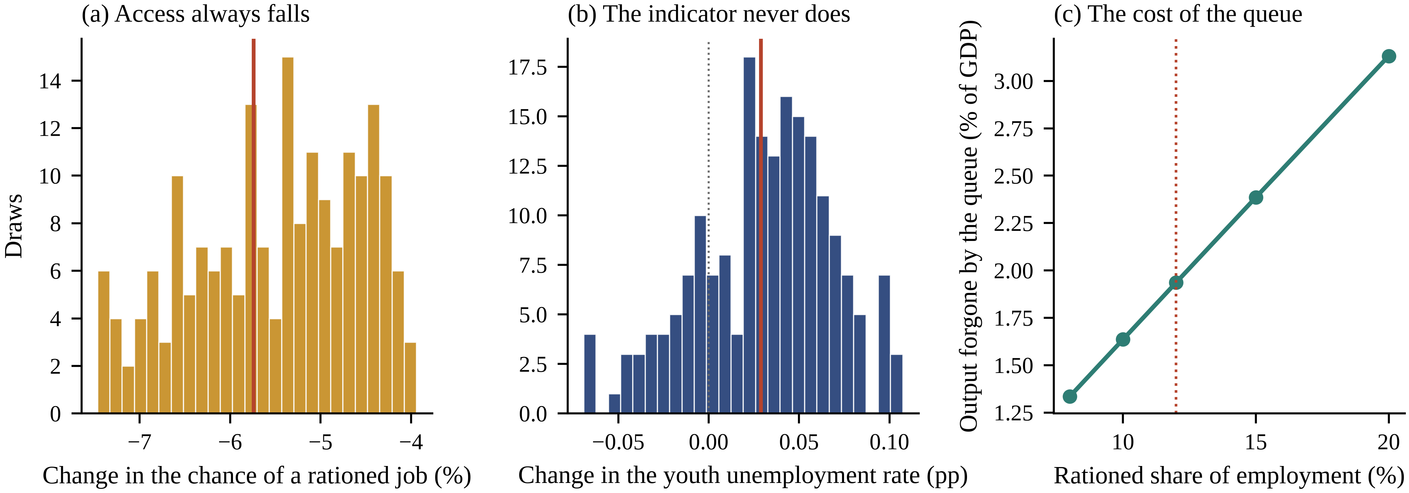
Figure 7. Robustness over the parameters that were set rather than estimated. Panels (a) and (b) show the distribution of the response to the reform across 192 draws, with the estimated economy marked. Panel (c) shows the output forgone by the queue as a function of the size of the rationed sector.
Access falls in 100 per cent of draws, with a mean of −5.5 per cent and a fifth-to-ninety-fifth-percentile range of −7.2 to −4.2 per cent. The youth unemployment rate moves by less than half a percentage point in 100 per cent of draws, with a range of −0.037 to 0.090 percentage points that straddles zero. The output forgone by the queue lies between 1.62 and 2.17 per cent of output. The two central claims of the paper—that access falls and that the indicator does not register it—hold in every draw.
The instrument ranking is equally stable. Cutting the administered premium is the best of the three in 100 per cent of draws, and expanding the establishment lowers welfare in 100 per cent. The one parameter that materially governs the size of the effect is the separation rate from establishment posts: its correlation with the fall in access across draws is 0.96. That is the right economics and it is a testable prediction. Where establishment posts turn over for reasons other than retirement, retirements are a smaller share of the vacancy flow and the reform matters less; where the iron rice bowl is most secure, it matters most. Two further correlations are worth recording: the cost of the queue rises with the length of the window in which candidates are eligible to sit the examinations, at 0.37, and falls with the discount rate, at −0.70, since impatient candidates will not wait.
6. Discussion
6.1. Two Questions That Are Not the Same Question
The literature on retirement and youth employment has converged on a clear answer to a clear question. Whether measured across countries and decades [2], in a matching model with endogenous vacancy creation [3], in Norwegian administrative data [13] or in recent United States evidence [4], older workers do not take jobs from younger ones. The exception proves the rule: displacement appears where the number of slots is fixed, as in the short promotion ladders studied by Bianchi and co-authors [15], and it appears by age group where technology fixes the number of tasks [54]. Our model reproduces the consensus answer, with a crowding-out coefficient of −0.0006, and we regard this as validation rather than as a finding.
The finding is that the answer is to a different question from the one young people are asking. "Will I be displaced from a job I hold?" and "will the job I am preparing for still be there?" have different answers when part of the labour market is rationed, because the two are governed by different equations. Displacement is governed by free entry, which restores what a shock takes away. Access to a rationed sector is governed by an administrative ceiling, which does not restore anything, because there is no decision on the employer’s side to be restored. In a labour market that is entirely market-clearing the two questions coincide and the literature’s answer covers both. In an economy where 12 per cent of urban employment sits behind a quota and 35 per cent of young non-employment is spent preparing for it, they do not.
This is a general point about aggregation, not a Chinese peculiarity. Any economy with a large rationed segment—licensed professions, academic tenure lines, public-sector establishments in southern Europe, protected incumbent contracts—will show the same divergence between an employment count and a lifetime probability of access, and will show it most strongly for the cohort that has not yet entered [9,10]. The youth-unemployment indicator is defined on the people who are already in the labour market. The cost falls on the ones deciding whether to be.
6.2. The Queue Is the Mechanism
The distinctive object in this model is not the retirement age; it is the queue, and the retirement reform is instructive mainly because of what it reveals about the queue. Three features are worth separating.
First, the queue is a stock of forgone production that no accounts record. 5.5 million young people preparing full time for an examination are not unemployed by the International Labour Organization definition if they are not actively searching, are not out of the labour force in any meaningful sense, and are not in education in the sense the not-in-education-employment-or-training literature uses [55–57]. They occupy a category the measurement system does not have, and the output they forgo is 1.9 per cent of gross domestic product a year.
Second, the queue is a rent-dissipation device of exactly the form Krueger described [9]. The establishment offers a premium of 1.25 over an entry-level market job. Access is rationed by examination rather than by price, so the premium is competed away in preparation time until the marginal candidate is indifferent. The rent is not transferred; it is destroyed. And because the number of posts is fixed, the dissipation is complete at the margin: a longer line produces no additional hire. The size of the premium is itself a policy variable rather than a fact of nature, and cross-country evidence shows how far it varies [18,20].
Third, the queue selects the wrong people to do the wrong thing with their twenties. Murphy, Shleifer and Vishny argued that the allocation of talent between production and rent seeking is a first-order determinant of growth [11], and the Chinese evidence on human-capital mismatch and on the returns to higher education points the same way [52,58,59]. The candidates who queue longest are those with the strongest preference for security and the highest expected examination scores, which is to say a group with substantial general human capital, and they spend 2.5 years of it on a screening technology that produces no output.
6.3. Why the Intuitive Remedy Backfires
Section 5.6 found that expanding the establishment—the response most often proposed when access to public-sector jobs tightens, and the one adopted in the 2023 and 2024 expansions of graduate recruitment—raises access, lowers welfare and raises the youth unemployment rate. The mechanism is worth stating plainly because it is the paper’s clearest example of counterintuitive behaviour in a social system [7,60].
Adding posts does two things. It adds hires, one for one. It also raises the expected value of queueing, because the hazard of winning rises for a given line length, and the Harris–Todaro indifference condition then draws more entrants into the line until indifference is restored. The second effect is not a friction that decays; it is an equilibrium response, and in the estimated economy it consumes the gain. This is where an administrative ceiling differs from a public sector that chooses its own headcount: in models where the state optimises over employment and wages, expansion is disciplined by the wage bill it implies [28,29], and there is no equilibrium queue for the expansion to feed. Welfare per head falls 0.0078 per cent and the marginal value of public funds is 0.92, below the value of leaving the money in private hands, in the estimated economy and in 100 per cent of parameter draws.
The instrument that works does the opposite. Cutting the administered premium reduces the prize, shortens the line and releases the time; it is regressive-looking and politically hard, and it returns 1.59 units of welfare per unit of public money. This is the standard result in the queueing literature—reduce the rent rather than expand the rationed good [5,6]—and its unpopularity is the reason the standard result keeps needing to be restated.
6.4. What to Measure Instead
If the youth unemployment rate cannot see this, what can? The model suggests three series, each constructible from data that already exist.
The first is the cohort access rate: establishment hires in a year divided by the size of the entering cohort. Both numbers are administrative. This is the series that falls 5.7 per cent in our reform while the headline rate moves 0.029 percentage points, and it is the series a young person is actually deciding against. The second is the queue itself: candidates registered for public-sector examinations, net of those already employed, expressed as a share of the cohort. Registration data are published. The third is the implied wait, the ratio of the first two, which is the expected number of years a candidate must prepare and which in our estimates is 2.5 years.
None of these requires a new survey and all three are timelier than the labour force survey. The obstacle is not measurement, and the systems literature has a name for the obstacle: an indicator that has been adopted as a target stops being available as a measure, and the institutional incentive is to keep monitoring the series whose behaviour is understood [8,12]. The argument for the three series above is precisely that nobody has yet had a reason to manage them. Broadening the unemployment concept does not help either. Full-time-equivalent utilisation rates uncover considerably more slack than the headline measure, especially among the young [35], and measures of employment quality uncover more still [48,61]; neither would register our reform, because the people it affects are employed and working full time.
6.5. Implications for China
Three implications follow for the Chinese policy debate specifically. The first is that the retirement reform should not be defended or attacked on youth-employment grounds. It does not displace young workers—the crowding-out coefficient is −0.0006—and the debate that has occupied commentary since September 2024 is aimed at an effect that does not exist. What the reform does do, quietly, is close 127,000 establishment openings a year to new entrants, and that is worth an explicit decision rather than an unnoticed consequence.
The second concerns the age ceiling on the examinations. The 2026 central civil-service examination raised the general upper age limit from 35 to 38, and several provinces have followed. Read through this model the relaxation is not obviously a favour to young people. It lengthens the window in which a candidate may keep queueing without changing the number of posts, and the parameter that governs the length of that window is positively correlated with the output lost to queueing across our draws, at 0.37. Widening eligibility for a fixed prize lengthens the line. The measure will be recorded as expanding opportunity and will show up in the data as more people preparing for longer.
The third is about the direction of the underlying trend, which is slower and larger than the retirement reform. The establishment is fixed in absolute terms while the urban labour force grows; the demographic route alone reduces the rationed share of employment by 9.5 log points over our horizon, which is nine tenths of the total decline in that share and by far the largest single contribution in Table 6. Public-sector employment as an aspiration is being priced by a ratio whose denominator grows every year, and the graduating cohort is expected to reach 12.7 million in 2026 [36]. The retirement reform accelerates a squeeze that was already underway; it did not create it, and reversing the reform would not relieve it. The constructive response is to make the routes that do not run through the examination more attractive—vocational training carries a measurable return in China [46], and regional development policy already treats the quality of local employment as an objective [47,62]—rather than to enlarge the prize at the end of the queue.
6.6. Limitations
Five limitations deserve statement. The model is a steady-state comparison, so the reform path in Figure 3 is a sequence of stationary equilibria rather than a transition; the direction of every result would survive a full transition but the timing would not, and a cohort caught mid-reform faces a worse draw than any steady state shows. The market sector is homogeneous, with no on-the-job search and no experience premium beyond the retirement horizon, which understates what a candidate gives up by queueing and therefore understates the cost of the queue [63–65]. Wages in the market sector are fully flexible, which is a strong assumption over a fifteen-year horizon even though the literature disagrees about how strong [66–69]; introducing rigidity would shift some of the adjustment from wages to employment and would raise, not lower, the measured crowding-out coefficient, so the central result is conservative in that direction. We also hold the market sector’s technology fixed, while entry-level demand is being reshaped by artificial intelligence over exactly the horizon we study [70–72], and by the reallocation of labour across Chinese regions and sectors [73–75]. Those forces move the market alternative to queueing, and therefore the queue; they do not move the establishment’s vacancy flow, which is what our results turn on.
The last is the most important. We treat the examination as a lottery among those who prepare, so preparation buys probability and nothing else. If preparation instead builds human capital that is useful in market employment, the queue is partly an investment and its cost is overstated; if candidates differ in ability and the examination sorts on it, the queue is partly a screen and Section 5.8 gives the threshold at which it pays for itself. Both extensions require individual-level data on candidates that is not currently collected, which is itself an argument for collecting it. Our reading is that the assumption is defensible because the content of the examinations is specific to public administration and the preparation industry is organised around the test rather than around the job, but it is a reading and not a measurement.
7. Conclusions
A retirement reform reduces the rate at which people leave jobs. Where jobs are created by firms deciding to create them, that is absorbed: firms create more, and nobody is displaced. Where jobs are created by an administrative rule that fixes their number, the only thing that creates a vacancy is somebody leaving, and slowing the leaving closes the door. Both mechanisms operate in the same economy at the same time, and the aggregate indicator we use to watch them adds them together.
We built a two-sector search model in which an establishment sector of fixed headcount coexists with a free-entry market sector, and in which the young queue for the rationed sector as in Harris and Todaro. Six parameters were estimated against six Chinese moments, exactly rather than approximately, and the estimated economy reproduced an untargeted queueing duration of 2.50 years that matches independent evidence on repeat candidates. Raising the effective retirement age from 56.3 to 59.9 produces a crowding-out coefficient of −0.0006, which rejects the lump-of-labour hypothesis. It also reduces the chance that a member of an entering cohort ever holds a rationed job by 5.7 per cent, about 127,000 young people a year, and a Shapley decomposition attributes all of that to the establishment’s shrinking replacement flow and none of it to anything else. Over the same reform the youth unemployment rate moves 0.029 percentage points, because three channels of opposite sign very nearly cancel inside it. Access falls 35 times more than the headline rate moves, in the estimated economy and in every one of 192 parameter draws.
The queue that produces this is not incidental. It costs 1.9 per cent of output a year, it would need to raise the productivity of every establishment worker by 46 per cent to justify itself, and it responds to policy in a way that defeats the obvious remedy: expanding the establishment raises access, lowers welfare and returns 0.92 units of welfare per unit of public money, because a larger prize draws a longer line. Cutting the administered premium returns 1.59, and does so in every draw.
The general lesson is about what an indicator can be asked to do. The youth unemployment rate answers a question about the people already in the labour market. Rationing operates on the people deciding whether to enter it, and it operates on a probability over a lifetime rather than on a stock at a moment. When a reform moves the second and not the first, a monitoring system built on the first will report that nothing happened, and it will be correct about what it measures and wrong about what matters. The series that would have caught this—establishment hires per cohort, candidates registered per cohort, and the implied wait—are administrative, cheap, and nobody publishes them. That is the recommendation this paper ends on, and it costs nothing.
Author Contributions: Conceptualization, methodology, formal analysis, software and writing—original draft preparation, X.C.; validation, data curation and visualization, D.H.; investigation, writing—review and editing, supervision and project administration, T.M. All authors have read and agreed to the published version of the manuscript.
Funding: This research received no external funding.
Institutional Review Board Statement: Not applicable. The study is a structural simulation calibrated to published aggregate statistics and involves no human participants or animals.
Informed Consent Statement: Not applicable.
Data Availability Statement: The model is fully specified by Equations (1)–(24). No individual-level data were used; every calibration target is drawn from the published sources listed in Table 2. The model code, the exact-identification routine, the counterfactual, decomposition, policy and uncertainty experiments and the scripts that generate every figure and table in this article are available from the corresponding author on reasonable request.
Acknowledgments: The authors thank the editors and the anonymous reviewers for comments that improved the manuscript.
Conflicts of Interest: The authors declare no conflicts of interest.
References
1. National Bureau of Statistics of China (NBS). Surveyed Urban Unemployment Rate of the Population Aged 16–24 Excluding Students; NBS: Beijing, China, 2026.
2. Gruber, J.; Wise, D.A. (Eds.) Social Security Programs and Retirement around the World: The Relationship to Youth Employment. University of Chicago Press: Chicago, IL, USA 2010.
3. Boeri, T.; Garibaldi, P.; Moen, E.R. In Medio Stat Victus: Labor Demand Effects of an Increase in the Retirement Age. Journal of Population Economics 2022, 35, 519-556.
4. Mohnen, P. The Impact of the Retirement Slowdown on the US Youth Labor Market. Journal of Labor Economics 2025, 43, 203-246.
5. Harris, J.R.; Todaro, M.P. Migration, Unemployment and Development: A Two-Sector Analysis. American Economic Review 1970, 60, 126-142.
6. Zenou, Y. Rural-Urban Migration and Unemployment: Theory and Policy Implications. Journal of Regional Science 2011, 51, 65-82.
7. Forrester, J.W. Counterintuitive Behavior of Social Systems. Technology Review 1971, 73, 52-68.
8. Meadows, D.H. Indicators and Information Systems for Sustainable Development. The Sustainability Institute: Hartland, VT, USA 1998.
9. Krueger, A.O. The Political Economy of the Rent-Seeking Society. American Economic Review 1974, 64, 291-303.
10. Gelb, A.; Knight, J.B.; Sabot, R.H. Public Sector Employment, Rent Seeking and Economic Growth. The Economic Journal 1991, 101, 1186-1199.
11. Murphy, K.M.; Shleifer, A.; Vishny, R.W. The Allocation of Talent: Implications for Growth. The Quarterly Journal of Economics 1991, 106, 503-530.
12. Goodhart, C.A.E. Problems of Monetary Management: The U.K. Experience. In Monetary Theory and Practice. Macmillan Education: London, UK 1984, 91-121.
13. Vestad, O.L. Labour Supply Effects of Early Retirement Provision. Labour Economics 2013, 25, 98-109.
14. Martins, J.O.; Gonand, F.; Antolin, P.; de la Maisonneuve, C.; Yoo, K.-Y. The Impact of Ageing on Demand, Factor Markets and Growth. OECD Economics Department Working Paper 420: Paris, France 2005.
15. Bianchi, N.; Bovini, G.; Li, J.; Paradisi, M.; Powell, M. Career Spillovers in Internal Labour Markets. The Review of Economic Studies 2023, 90, 1800-1831.
16. Jiang, M.; Kim, E. Measuring Impacts of Retirement Age Extension on Economic Growth and Labor Market in China Using a Recursively Dynamic CGE Model. Economic Systems Research 2025, 37, 306-334.
17. Gao, H.; Lu, B. Reforming China’s Public Pension System: Fiscal Sustainability and the Challenge of Formality-Based Inequality. Economic Modelling 2025, 153, 107336.
18. Gindling, T.H.; Hasnain, Z.; Newhouse, D.; Shi, R. Are Public Sector Workers in Developing Countries Overpaid? Evidence from a New Global Dataset. World Development 2020, 126, 104737.
19. Mangal, K. The Long-Run Costs of Highly Competitive Exams for Government Jobs. Journal of Development Economics 2024, 171.
20. Armijos Bravo, G.; Vall Castelló, J. Job Competition in Civil Service Public Exams and Sick Leave Behaviour. Fiscal Studies 2025, 46, 91-123.
21. Diamond, P.A. Aggregate Demand Management in Search Equilibrium. Journal of Political Economy 1982, 90, 881–894.
22. Mortensen, D.T.; Pissarides, C.A. Job Creation and Job Destruction in the Theory of Unemployment. The Review of Economic Studies 1994, 61, 397–415.
23. Pissarides, C.A. Equilibrium Unemployment Theory, 2nd ed.. MIT Press: Cambridge, MA, USA 2000.
24. Rogerson, R.; Shimer, R.; Wright, R. Search-Theoretic Models of the Labor Market: A Survey. Journal of Economic Literature 2005, 43, 959-988.
25. Petrongolo, B.; Pissarides, C.A. Looking into the black box: A survey of the matching function. J. Econ. Lit. 2001, 39, 390–431.
26. Hosios, A.J. On the Efficiency of Matching and Related Models of Search and Unemployment. The Review of Economic Studies 1990, 57, 279–298.
27. Moen, E.R. Competitive Search Equilibrium. Journal of Political Economy 1997, 105, 385-411.
28. Albrecht, J.; Robayo-Abril, M.; Vroman, S. Public-Sector Employment in an Equilibrium Search and Matching Model. The Economic Journal 2019, 129, 35-61.
29. Chassamboulli, A.; Gomes, P. Public-Sector Employment, Wages and Education Decisions. Labour Economics 2023, 82.
30. Zhang, X. Public Sector Employment Rigidity and Macroeconomic Fluctuation: A DSGE Simulation for China. PLoS ONE 2024, 19, e0308663.
31. Grigorescu, A.; Alistar, T.V.; Lincaru, C. Digital Skills, Ethics, and Integrity—The Impact of Risky Internet Use, a Multivariate and Spatial Approach to Understanding NEET Vulnerability. Systems 2025, 13, 649.
32. Chacón-Cuberos, R.; Rodríguez-Sabiote, C.; Expósito-López, J.; Olmedo-Moreno, E.; Serrano-García, J.; Hortas-Aliaga, O. Development of an Employability Thinking Scale for Use with Young People in Training: Exploratory and Confirmatory Factor Analysis. Systems 2025, 13, 479.
33. Chen, C.; Zhu, J.; Sun, H. Mechanisms and Pathways of Promoting High-Quality Full Employment Under the Dual Circulation Paradigm: An Evolutionary Simulation Approach Based on System Dynamics. Systems 2026, 14, 737.
34. Marczuk, A. Literature review of comparative school-to-work research: How institutional settings shape individual labour market outcomes. J. Labour Mark. Res. 2024, 58, 19.
35. Houston, D.; Lindsay, C. Reconceptualising Labour Utilisation and Underutilisation with New “Full-Time Equivalent” Employment and Unemployment Rates. Journal for Labour Market Research 2025, 59, 5.
36. Ministry of Education of China. Notice on the Employment and Entrepreneurship of 2026 National College Graduates; Ministry of Education: Beijing, China, 2025.
37. Ou, D.; Zhao, Z. Higher Education Expansion in China, 1999–2003: Impact on Graduate Employability. China World Econ. 2022, 30, 117–141.
38. Xiong, B.; Yu, B. The Impact of Internet Development on Youth’s Job Quality in the Digital Economy Era: Transmission Mechanism and Empirical Test. Soc. Indic. Res. 2024, 175, 269–294.
39. Jiang, S.; Guo, Y. Reasons for college major-job mismatch and labor market outcomes: Evidence from China. China Econ. Rev. 2022, 74, 101822.
40. Jones, M.K.; Kaya, E.; Nan, J. Overeducation, earnings and job satisfaction among graduates in China. China Econ. Rev. 2025, 93, 102448.
41. Pan, Z.; Wang, Y.; Liu, Z. Over-education, job satisfaction, and intention to quit: Evidence from China. Soc. Indic. Res. 2025, 176, 287–307.
42. International Labour Organization (ILO). Global Employment Trends for Youth 2024: Decent Work, Brighter Futures; ILO: Geneva, Switzerland, 2024.
43. Organisation for Economic Co-operation and Development (OECD). Education at a Glance 2025: OECD Indicators; OECD Publishing: Paris, France, 2025.
44. Tleppayev, A.; Zeinolla, S. Forecasting Youth Unemployment Through Educational and Demographic Indicators: A Panel Time-Series Approach. Forecasting 2025, 7, 37.
45. Başol, O.; Sevgi, H.; Yalçın, E.C. The Effect of Digitalization on Youth Unemployment for EU Countries: Treat or Threat? Sustainability 2023, 15, 11080.
46. Dai, L.; Martins, P.S. Does vocational education pay off in China? Evidence from city-level education supply shocks. Econ. Model. 2024, 140, 106863.
47. Liang, F.; Liu, Y. Sustainable youth employment quality management: The impact of robotization in China. PLoS ONE 2024, 19, e0298081.
48. Liu, J.; Fang, Y.; Xia, Y.; Zou, W.; Chan, K.-L.; Lam, J.F.I.; Chen, H. Can the digital economy promote sustainable improvement in the quality of employment for Chinese residents?—Moderated mediating effect model. Sustainability 2024, 16, 6071.
49. Topel, R.H.; Ward, M.P. Job Mobility and the Careers of Young Men. The Quarterly Journal of Economics 1992, 107, 439–479.
50. Card, D.; Kluve, J.; Weber, A. What Works? A Meta Analysis of Recent Active Labor Market Program Evaluations. J. Eur. Econ. Assoc. 2018, 16, 894–931.
51. Kluve, J.; Puerto, S.; Robalino, D.; Romero, J.M.; Rother, F.; Stöterau, J.; Weidenkaff, F.; Witte, M. Do youth employment programs improve labor market outcomes? A quantitative review. World Dev. 2019, 114, 237–253.
52. Zhao, K.; Wu, Y.; Kuang, Z. Dynamic evolution and impact mechanism of human capital mismatch in strategic emerging industries: Evidence from the Yangtze River Delta region of China. Heliyon 2023, 9, e21684.
53. Hendren, N.; Sprung-Keyser, B. A Unified Welfare Analysis of Government Policies. The Quarterly Journal of Economics 2020, 135, 1209-1318.
54. Deng, L.; Müller, S.; Plümpe, V.; Stegmaier, J. Robots, occupations, and worker age: A production-unit analysis of employment. Eur. Econ. Rev. 2024, 170, 104881.
55. Rahmani, H.; Groot, W.; Rahmani, A.M. Unravelling the NEET phenomenon: A systematic literature review and meta-analysis of risk factors for youth not in education, employment, or training. Int. J. Adolesc. Youth 2024, 29, 2331576.
56. Karma, E. NEET Youth in Central and Eastern European Countries: A Panel Model Approach. J. Youth Stud. 2025, 28, 1458–1475.
57. Rahmani, H.; Groot, W. Risk factors of being a youth not in education, employment or training (NEET): A scoping review. Int. J. Educ. Res. 2023, 120, 102198.
58. Zheng, Y.; Zhang, X.; Zhu, Y. Overeducation, major mismatch, and return to higher education tiers: Evidence from novel data source of a major online recruitment platform in China. China Econ. Rev. 2021, 66, 101584.
59. Li, S.; Whalley, J.; Xing, C. China’s higher education expansion and unemployment of college graduates. China Econ. Rev. 2014, 30, 567–582.
60. Meadows, D.H. Thinking in Systems: A Primer; Chelsea Green Publishing: White River Junction, VT, USA, 2008.
61. O’Higgins, N.; Brockie, K. The Youth Guarantee, Vulnerability, and Social Exclusion Among NEETs in Southern Europe. Polit. Gov. 2024, 12, 7469.
62. Tong, W.; Guo, J.; Lo, K.; Xu, W. Bridging the gap to common prosperity: Rural development and urban–rural income disparities in Zhejiang Province, China. Chin. Geogr. Sci. 2026, 36, 207–221.
63. Postel-Vinay, F.; Robin, J.-M. Equilibrium Wage Dispersion with Worker and Employer Heterogeneity. Econometrica 2002, 70, 2295–2350.
64. Cahuc, P.; Postel-Vinay, F.; Robin, J.-M. Wage Bargaining with On-the-Job Search: Theory and Evidence. Econometrica 2006, 74, 323–364.
65. Kambourov, G.; Manovskii, I. Occupational Specificity of Human Capital. International Economic Review 2009, 50, 63–115.
66. Shimer, R. The Cyclical Behavior of Equilibrium Unemployment and Vacancies. American Economic Review 2005, 95, 25–49.
67. Hall, R.E.; Milgrom, P.R. The Limited Influence of Unemployment on the Wage Bargain. American Economic Review 2008, 98, 1653–1674.
68. Hagedorn, M.; Manovskii, I. The Cyclical Behavior of Equilibrium Unemployment and Vacancies Revisited. American Economic Review 2008, 98, 1692-1706.
69. Pissarides, C.A. The Unemployment Volatility Puzzle: Is Wage Stickiness the Answer? Econometrica 2009, 77, 1339-1369.
70. Acemoglu, D. The Simple Macroeconomics of AI. Economic Policy 2025, 40, 13–58.
71. Brynjolfsson, E.; Chandar, B.; Chen, R. Canaries in the Coal Mine? Six Facts about the Recent Employment Effects of Artificial Intelligence. Stanford Digital Economy Lab Working Paper: Stanford, CA, USA 2025.
72. Humlum, A.; Vestergaard, E. Large Language Models, Small Labor Market Effects. Becker Friedman Institute Working Paper 2025-56: Chicago, IL, USA 2025.
73. Wang, H.; Wang, H.; Guan, R. Digitalization of industries and labor mobility in China. China Econ. Rev. 2024, 87, 102248.
74. Bankins, S.; Jooss, S.; Restubog, S.L.D.; Marrone, M.; Ocampo, A.C.; Shoss, M. Navigating career stages in the age of artificial intelligence: A systematic interdisciplinary review and agenda for future research. J. Vocat. Behav. 2024, 153, 104011.
75. Battisti, M.; Dustmann, C.; Schönberg, U. Technological and Organizational Change and the Careers of Workers. J. Eur. Econ. Assoc. 2023, 21, 1551–1594.
Disclaimer/Publisher’s Note: The statements, opinions and data contained in all publications are solely those of the individual author(s) and contributor(s) and not of MDPI and/or the editor(s). MDPI and/or the editor(s) disclaim responsibility for any injury to people or property resulting from any ideas, methods, instructions or products referred to in the content.

