Article
A Moving Target, Not a Tipping Point: Attractor Drift, Queue Congestion and Policy Sequencing in the Youth School-to-Work Transition System of China’s Prefecture-Level Cities
Xinyu Cai ¹, Dingpei Hu ¹ and Tiantian Mo ^{1,}*
Academic Editor: Firstname Lastname
Received: date
Revised: date
Accepted: date
Published: date
Citation: To be added by editorial staff during production.
Copyright: © 2026 by the authors. Submitted for possible open access publication under the terms and conditions of the Creative Commons Attribution (CC BY) license (https://creativecommons.org/licenses/by/4.0/).
¹ College of Business, Jiaxing University, Jiaxing 314001, China; caixinyu@zjxu.edu.cn
* Correspondence: 00008227@zjxu.edu.cn
Abstract
Youth non-employment has risen in China even where labour markets remain tight and the digital economy is expanding, which conventional shortage-of-jobs and shortage-of-skills accounts explain poorly. We model the graduate school-to-work transition of China’s prefecture-level cities as a six-state feedback system in which search, exam-oriented queueing, matched and mismatched employment, employability capital and aspirations co-evolve with an employer skill threshold that rises with digitalisation. Six structural parameters are estimated by simulated method of moments against seven published national moments, all reproduced within 1.7 per cent. Continuation and a multi-start search across forty parameter cells find a unique stable fixed point, so the system has no tipping point. Instead its attractor drifts: the equilibrium rate rises from 0.117 to 0.637 between 2015 and 2040 while the realised state lags it by 1.7 years, so measured indicators understate structural deterioration. A three-year demand shock decays with a half-life of 1.5 years, whereas the threshold drift does not decay. A Sobol decomposition attributes 66.3 per cent of output variance to threshold sensitivity and 0.1 per cent to training intensity. At equal standardised effort, moderating threshold escalation lowers the 2040 rate by 0.157, roughly nineteen times the effect of vacancy creation, and deployment sequencing matters at unchanged cumulative effort.
Keywords: youth employment; school-to-work transition; system dynamics; feedback loop dominance; slow employment; skill mismatch; digital economy; global sensitivity analysis; policy sequencing; prefecture-level cities

1. Introduction
Between 2015 and 2026 the number of graduates entering China’s labour market rose from roughly 7.5 million to 12.7 million a year, and the surveyed urban unemployment rate of 16–24-year-olds excluding students peaked at 18.9 per cent in August 2025 before easing to 16.3 per cent in the second quarter of 2026 [1,2]. What makes this pattern analytically awkward is that it did not occur in a slack labour market. Over the same decade the value added of China’s digital core industries rose to 10.5 per cent of gross domestic product in 2024 and is targeted to exceed 15 per cent by 2030 [1], and the vacancy-to-seeker ratio recorded by the public employment service has stayed above unity throughout. Jobs are being created; entry into them has nonetheless become slower and less certain. The phenomenon is national in scope but expressed locally: China’s roughly three hundred prefecture-level cities differ sharply in how fast their digital economies grow and in how many graduates they absorb [3,4], which makes the city the natural unit at which the mechanism operates.
Three families of explanation dominate the literature, and each captures part of the phenomenon. The first is a quantity story: higher-education expansion has outpaced the creation of graduate-suitable positions [5,6]. The second is a quality story: graduates lack the competences that a digitalising economy rewards, so mismatch and over-education rise [7–9]. The third is a behavioural story: young people delay entry, queue for public-sector and institutional posts, or withdraw altogether, a pattern captured in China by the term "slow employment" and in Europe by the NEET construct [10–14]. Each story is supported by credible evidence. None of them, on its own, explains why the three symptoms move together, why they persist once a cyclical disturbance has passed, or why the instruments that governments actually deploy—vacancy subsidies and training programmes—produce so much less than their nominal scale would suggest.
The reason, we argue, is that quantity, quality and behaviour are not three competing causes but three state variables of one feedback system. Employers set a hiring threshold that responds to the technology they deploy and to the mismatch they observe. Graduates accumulate and lose employability capital depending on how long they search and on what they do while waiting. Aspirations adapt to attainable job quality, but slowly and from a sticky anchor set by educational attainment and family reservation support. A queue for scarce institutional posts absorbs part of each cohort, and its attractiveness depends on a success probability that the queue itself destroys. These couplings generate behaviour that no single-cause account anticipates, and they are exactly the kind of structure that systems practice in the social sciences was developed to analyse [15–17].
This paper builds and analyses such a system. We formulate a six-state continuous-time model of the graduate school-to-work transition in China, calibrate six structural parameters by simulated method of moments against seven published moments, and subject the calibrated model to a sequence of structural and statistical tests: fixed-point continuation and a multi-start uniqueness search, eigenvalue analysis, loop-deactivation experiments in the sense of Ford [18], Latin-hypercube Monte Carlo, Sobol variance decomposition [19,20], logistic and tree-based meta-modelling of the simulation output, and equal-effort policy experiments including deployment sequencing. Because prefecture-level cities differ in the speed of their digital transition rather than in the structure of their transition system, city heterogeneity is represented by parameterising the same model three ways rather than by adding a spatial dimension.
Four findings follow, and three of them are negative results that we consider as informative as the positive ones. First, the system is globally monostable over the entire plausible parameter region we searched. There is no tipping point, no second attractor and no hysteresis. Second, what the system does have is a drifting attractor: the equilibrium towards which it moves rises from a non-employment rate of 0.117 in 2015 to 0.637 in 2040, and because the slowest relaxation time of the system is exactly eight years, the observed state lags this moving target by about 1.7 years on average. Measured youth non-employment therefore understates structural deterioration, systematically and by a knowable amount. Third, transitory demand shocks are absorbed: a three-year, 25 per cent reduction in the responsiveness of vacancies to digitalisation raises non-employment by at most 0.125 and decays with a half-life of 1.5 years. The youth employment problem of a digitalising economy is not a business-cycle problem. Fourth, the instrument that matters is not the one that is usually deployed. At equal standardised effort, moderating the rate at which employers raise the hiring bar reduces the 2040 non-employment rate by 0.157, against 0.008 for vacancy creation and 0.004 for training intensity.
The contribution is threefold. Theoretically, we show that the youth employment predicament of a rapidly digitalising economy is better described as attractor drift under a slowly adjusting state than as a trap in the bistability sense, and we identify the specific feedback—endogenous escalation of the employer skill threshold—that drives the drift. Methodologically, we combine loop-deactivation dominance analysis with a full variance-based sensitivity decomposition and a statistical meta-model of the simulation output, so that structural claims and statistical claims are made about the same object. Practically, we provide an effort-normalised ranking of five policy families, a sequencing result showing that expectation guidance should precede rather than follow matching-efficiency investment, and an archetype analysis showing that the most digitally advanced prefecture-level cities face the steepest deterioration, while the intermediate manufacturing cities offer the largest absolute policy dividend.
The remainder of the paper is organised as follows. Section 2 sets the system boundary and derives the feedback structure. Section 3 presents the model, the calibration and the analysis design. Section 4 reports results. Section 5 discusses their theoretical, methodological and policy implications, and their limits. Section 6 concludes.
2. Theoretical Background and System Boundary
2.1. Youth Non-Employment as a System-Level Outcome
A recurring insight of recent work on youth exclusion is that the outcome is emergent rather than attributable. Grigorescu, Alistar and Lincaru [12] model NEET vulnerability across 28 European countries as the joint product of digital-skill, behavioural and territorial subsystems, and show through a decision-tree analysis that the relationship between digital agency and exclusion is threshold-like rather than linear. Chacón-Cuberos and colleagues [21] approach the same construct from the individual side, validating a four-factor employability-thinking scale among 949 students in training and showing that ethical self-regulation, communication, proactivity and analytical thinking form a single inter-correlated competence system rather than separable skills. Both studies point in the same direction: youth labour-market outcomes are produced by interacting components whose joint behaviour differs from the sum of their separate effects. A parallel literature on institutional variation in school-to-work transitions [22,23] and on digital divides across European populations [24,25] reaches the same conclusion from different directions, as does work on how careers unfold under technological change [26–28].
Neither study, however, is dynamic. Cross-sectional and panel designs identify which variables matter; they cannot say how the configuration of those variables evolves, how fast it responds to intervention, or which of the couplings between them dominates observed behaviour at a given moment. That is the gap this paper addresses. The natural instrument is a small, transparent feedback model of the kind Ghaffarzadegan, Lyneis and Richardson [17] advocate for public policy: small enough that every loop can be named and tested, rich enough that the couplings which generate the puzzle are present.
2.2. Why the Received Explanations Under-Determine the Dynamics
The quantity account holds that graduate supply has outrun graduate-suitable demand. It is consistent with the expansion evidence [5] and with cross-country panel estimates linking tertiary enrolment to youth unemployment [29]. Yet the vacancy-to-seeker ratio recorded by China’s public employment service has remained above unity, and digital-industry expansion has been rapid and job-creating in the very cities where graduate non-employment has risen fastest [3,30,31]. A pure quantity account predicts falling market tightness alongside rising non-employment; the data show the two moving in opposite directions.
The quality account holds that graduates lack the competences employers now require. It is supported by the mismatch literature for China [8,32–34] and by evidence that digital and intelligent technologies shift demand towards higher-order skills [9,35–38]. But this account treats the required skill level as exogenous. If employers respond to observed mismatch by raising screening standards further—demanding more experience, higher credentials or narrower specialisation—then the gap between what graduates have and what employers require is partly self-generated, and training alone will chase a target that moves in response to being chased.
The behavioural account holds that young people delay entry. In China this takes an institutionally specific form. The national civil-service examination attracted 3.72 million qualified applicants for 38,100 posts in the 2026 cycle, and the ratio of candidates sitting the examination to posts rose from 77:1 to 98:1 over three cycles. Delayed entry of this kind is not idleness: it is a rational option purchase whose value depends on a success probability of roughly one per cent. That such a probability sustains a queue of this size is difficult to reconcile with expected-utility reasoning but entirely consistent with the systematic over-weighting of small probabilities documented in prospect theory [39,40]. The behavioural account therefore requires a specific functional form, not merely a taste parameter.
2.3. The Feedback Structure of the Transition System
Combining the three accounts as coupled state variables rather than competing causes yields the causal structure of Figure 1. Seven feedback loops are identified, four reinforcing and three balancing. Their polarities are derived analytically from the sign of the product of link polarities around each cycle, and are confirmed numerically in Section 4.5.
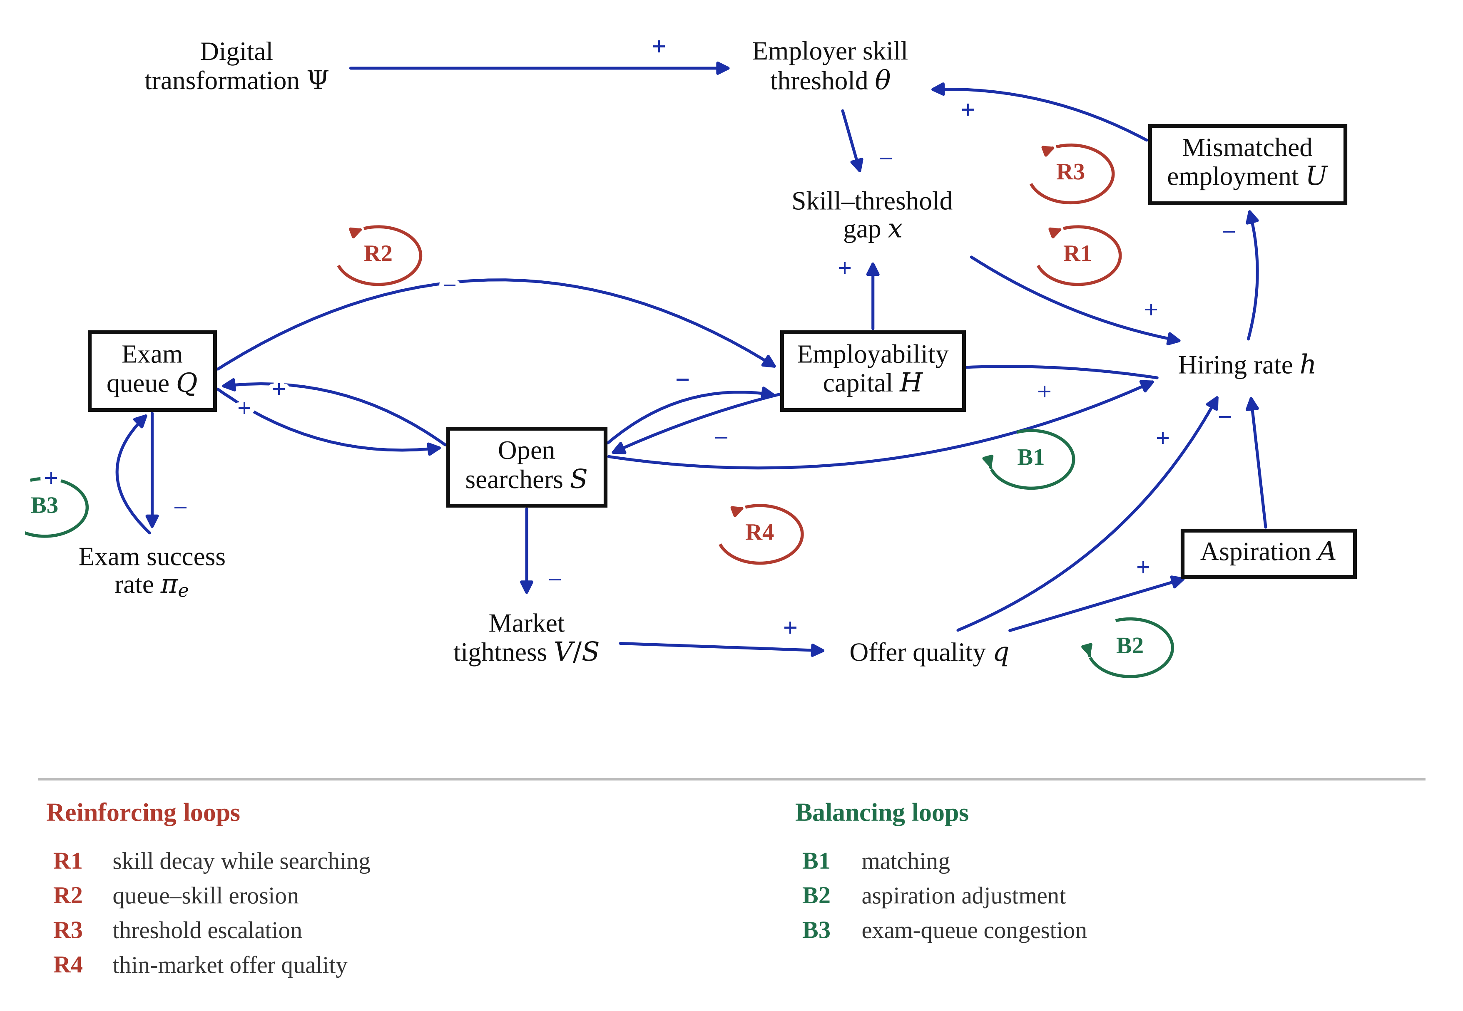
Figure 1. Causal loop diagram of the youth school-to-work transition system. Shaded boxes are stocks; the shaded oval at the top left is the exogenous driver. A plus sign denotes a same-direction link, a minus sign an opposite-direction link. Loop polarities are the products of the link polarities around each cycle.
Loop R1, skill decay while searching, is the classical scarring mechanism: a larger searcher pool dilutes the renewal of employability capital by fresh graduates and lengthens exposure to depreciation, which lowers the skill–threshold gap, reduces the screening pass rate, and enlarges the searcher pool further. Loop R2, queue–skill erosion, operates through the queue: time spent preparing for examinations builds credentials that the market does not price, so discouraged returnees re-enter search with degraded market-relevant capital, which lowers the value of open search and pushes the next cohort towards the queue. Loop R3, threshold escalation, is the mechanism the quality account omits: observed mismatch raises the effective hiring bar, which produces more mismatch. Loop R4, thin-market offer quality, is a congestion externality: a larger searcher pool lowers market tightness, which lowers offered job quality, which lowers acceptance and enlarges the pool.
Against these, three balancing loops operate. Loop B1 is the ordinary matching loop of search theory [41]: more searchers generate more meetings and therefore more hires. Loop B2 is aspiration adjustment: sustained failure lowers the reservation threshold, which raises acceptance. Loop B3 is exam-queue congestion: a longer queue lowers the realised success rate, which lowers the perceived value of queueing. Whether the system deteriorates therefore depends not on any single loop but on which loops dominate at which time—a question that can only be answered by deactivating them one at a time in a calibrated model [18].
2.4. Research Questions
The analysis is organised around four questions. RQ1: does the transition system possess multiple equilibria, so that the observed deterioration can be described as a trap in the bistability sense, or a single attractor that moves? RQ2: how fast does the system adjust, and how large is the gap between the realised state and its instantaneous equilibrium? RQ3: which feedback loops and which structural parameters dominate the behaviour, and how much of the outcome uncertainty does each explain? RQ4: at equal effort, which policy instruments move the system furthest, and does the order in which they are deployed matter?
3. Model and Methods
3.1. System Boundary
The model represents the population of degree-holding labour-market entrants in China during an eight-year youth window, indexed in units of 10 thousand persons. Endogenous are the allocation of that population across search, delayed entry, well-matched and mismatched employment; the mean employability capital of searchers; and the mean aspiration threshold. Exogenous are the size and growth of the entering cohort, the growth of vacancies, the intensity of digital transformation, and the number of institutional posts. Firms are not modelled as optimising agents; their behaviour enters through the hiring threshold and the offer-quality function. Wages appear only through a composite job-quality index. Geography enters through the prefecture-level city archetypes of Section 4.10: the same structure is re-parameterised to represent the three broad city types into which China’s prefecture-level cities fall, rather than being embedded in an explicit spatial model. The horizon is 2015 to 2040 with 2025 as the policy-intervention date.
3.2. Stocks, Flows and Rate Equations
Six state variables are tracked. Four are population stocks: open searchers $S$, exam-oriented queuers $Q$, well-matched employment $M$ and mismatched employment $U$. Two are intensive states: the mean employability capital of the searching pool $H$ and the mean aspiration threshold $A$, both indices on the unit interval. Table 1 defines them together with the outcome indicators. Figure 2 gives the stock-and-flow structure.
Table 1. State variables, auxiliary variables and outcome indicators.
Symbol | Name | Unit | Role
$S$ | Open searchers | 10⁴ persons | Stock
$Q$ | Exam-oriented queuers (delayed entry) | 10⁴ persons | Stock
$M$ | Well-matched employment | 10⁴ persons | Stock
$U$ | Mismatched (over-educated) employment | 10⁴ persons | Stock
$H$ | Mean employability capital of searchers | Index (0–1) | Stock
$A$ | Mean aspiration (reservation quality) | Index (0–1) | Stock
$\backslash Psi$ | Digital core industries, share of GDP | Share | Exogenous driver
$θ$ | Employer skill threshold | Index | Auxiliary
$x$ | Skill–threshold gap, $H$ − $θ$ | Index | Auxiliary
$ϑ$ | Market tightness, vacancies per searcher | Ratio | Auxiliary
$q$ | Offered job quality | Index | Auxiliary
$h$ | Hiring rate | 10⁴ persons yr⁻¹ | Auxiliary
NER | Youth non-employment rate, ($S$+$Q$)/pool | Share | Outcome
SE | Slow-employment share of entrants | Share | Outcome
MM | Vertical mismatch share of employment | Share | Outcome
$D$ | Mean transition duration to stable employment | Years | Outcome
$R$ | Queue-to-seat ratio (exam congestion) | Ratio | Outcome
Notes: The pool is $S$ + $Q$ + $M$ + $U$. GDP denotes gross domestic product. Transition duration is obtained from the stock–flow identity of Little’s law applied to the non-employed stock and the inflow into stable employment.
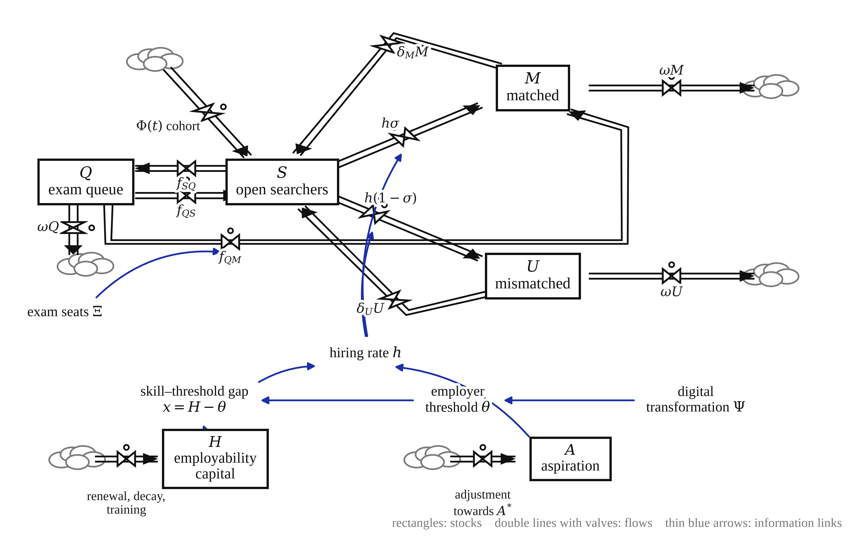
Figure 2. Stock-and-flow structure. Rectangles are stocks, bow-tie symbols are rate-controlling valves, clouds are boundaries of the system. The two intensive states and the behavioural rate equations are shown at the right.
Digital transformation follows a logistic path fitted by least squares to the published national share of digital core industries in gross domestic product for 2020, 2023 and 2024 together with the 2030 policy target, with a maximum absolute residual of 0.06 percentage points [1]:
$Ψ\left(t\right) = \frac{Ψ_{max}}{1 + \left(\frac{Ψ_{max}}{Ψ_{0}} − 1\right) \exp^{\left. − r_{Ψ}t\right.}}$ (1)
The employer skill threshold has an exogenous component that rises with digitalisation and an endogenous component that rises with observed mismatch, the latter being the link that closes loop R3:
$θ\left(t\right) = θ_{0} + κ\left(Ψ\left(t\right) − Ψ_{0}\right) + κ_{2} \frac{U\left(t\right)}{M\left(t\right) + U\left(t\right)}$ (2)
The skill–threshold gap is the difference between what searchers carry and what employers require; it is the single most consequential auxiliary in the model, and its sign change is the behavioural signature discussed in Section 4.1:
$x\left(t\right) = H\left(t\right) − θ\left(t\right)$ (3)
Meetings between searchers and vacancies follow a constant-returns Cobb–Douglas matching function of the form for which the empirical support is strongest [41], and market tightness is the vacancy-to-searcher ratio:
$m\left(t\right) = μ {S\left(t\right)}^{α} {V\left(t\right)}^{1 − α}, ϑ\left(t\right) = \frac{V\left(t\right)}{S\left(t\right)}$ (4)
Three behavioural probabilities convert meetings into hires. The screening pass rate is logistic in the skill–threshold gap; the acceptance rate is logistic in the difference between offered quality and aspiration; and the probability that a realised hire is a good match is logistic in the gap with its own intercept. Here $\backslash Lambda$ denotes the standard logistic function:
$p_{s} = Λ\left(β_{s}x\right), p_{a} = Λ\left(β_{a}\left(q − A\right)\right), σ = Λ\left(σ_{0} + β_{σ}x\right)$ (5)
Offered job quality rises with market tightness, which is the link that closes the congestion loop R4:
$q\left(t\right) = q_{0} + γ_{q} ln\left(1 + ϑ\left(t\right)\right)$ (6)
The hiring rate is the product of meetings and the two probabilities, subject to a smooth capacity limit that prevents the searcher stock from being depleted faster than the minimum feasible search duration allows. The smooth minimum preserves continuous differentiability, which is required for the Jacobian analysis of Section 3.6:
$h\left(t\right) = smin\left(m p_{s} p_{a}, \frac{S}{d_{min}}\right), smin\left(a, b\right) = \frac{ab}{a + b}$ (7)
The allocation between continued open search and entry into the examination queue is a normalised logit comparison of two values. The value of search is the expected quality of a job obtained this period. The value of queueing is the value of an institutional post weighted by a Prelec probability-weighting function of the realised success rate, the compound-invariant form for which axiomatic support exists [39,40]. Because the weighting function is concave near zero, a success rate of order one per cent still carries substantial decision weight, which is what allows the queue to persist:
$W_{S} = p_{s} p_{a} q, W_{Q} = Π w\left(π_{e}\right), w\left(π\right) = \exp^{\left. − {\left( − ln π\right)}^{ε}\right.}$ (8)
Entry into and exit from the queue follow from that comparison, with a discouragement rate returning queuers to open search:
$f_{SQ} = ν S Λ\left(β_{c}\frac{W_{Q} − W_{S}}{W_{Q} + W_{S}}\right), f_{QS} = ν_{r} Q\left[1 − Λ\left(·\right)\right]$ (9)
The four population stocks then obey the following accounting identities, in which $\backslash Phi$ is the entering cohort, $ω$ the rate of exit from the youth window, and $δ_{M}$ and $δ_{U}$ the separation rates from matched and mismatched employment:
$\dot{S} = Φ\left(t\right) + f_{QS} + δ_{M}M + δ_{U}U − h − f_{SQ} − ωS$ (10)
$\dot{Q} = f_{SQ} − f_{QS} − f_{QM} − ωQ, f_{QM} = smin\left(Ξ, Q\right), π_{e} = \frac{f_{QM}}{Q}$ (11)
$\dot{M} = hσ + f_{QM} − \left(δ_{M} + ω\right)M, \dot{U} = h\left(1 − σ\right) − \left(δ_{U} + ω\right)U$ (12)
Mean employability capital of the searching pool is renewed by fresh graduates, diluted by returning queuers whose market-relevant capital has eroded by a factor $\backslash chi$, depreciated at rate $δ_{H}$ during search, and raised by training effort $\backslash tau$. The first term carries loop R1: as the searcher stock grows, cohort renewal per searcher weakens:
$\dot{H} = \frac{Φ\left(t\right)\left(h_{new} − H\right) − f_{QS}\left(1 − χ\right)H}{S} − δ_{H}H + τ\left(h_{max} − H\right)$ (13)
Aspirations adjust towards a target that mixes a sticky anchor—set by educational attainment, family reservation support and peer reference points—with the currently attainable quality of a job. The anchoring weight $\backslash zeta$ and the adjustment speed $λ$ jointly determine how quickly loop B2 operates:
$\dot{A} = λ\left(A^{∗} − A\right), A^{∗} = ζA_{anch} + \left(1 − ζ\right)qp_{s}$ (14)
Finally, the outcome indicators reported throughout are defined as follows, where $D$ applies Little’s law to the non-employed stock:
$NER = \frac{S + Q}{S + Q + M + U}, MM = \frac{U}{M + U}, D = \frac{S + Q}{hσ + f_{QM}}$ (15)
3.3. Data, Calibration and Its Limits
The model is a policy-analysis model, not a forecasting model, and we are explicit about what the numbers are. Parameters fall into three classes. Twelve are set from published statistics or from the empirical literature and held fixed. Six are estimated. The remainder are structural constants of the functional forms. Table 2 reports all of them together with the uncertainty ranges used in the Monte Carlo and Sobol analyses. Where a value could not be sourced directly it is treated as uncertain and its influence is quantified rather than assumed away, following the reporting standards for simulation-based social science research set out by Rahmandad and Sterman [42].
Table 2. Model parameters: base values, uncertainty ranges and provenance.
Symbol | Meaning | Base | Range | Provenance
${\backslash Phi}_{0}$ | Entering graduate cohort, 2015 | 749.0 | — | Set, 10⁴ persons [2]
$g_{\backslash Phi}$ | Cohort growth rate | 0.050 | 0.030–0.070 | Uncertain [2]
$ω$ | Exit rate from the youth window | 0.125 | — | Set (8-year window)
$V_{0}$ | Vacancies, 2015 | 948.7 | — | Scale normalisation
$g_{V}$ | Autonomous vacancy growth | 0.030 | — | Set
$φ$ | Vacancy elasticity to digitalisation | 1.60 | 0.90–2.40 | Uncertain
${\backslash Psi}_{0}$, ${\backslash Psi}_{max}$, $r_{\backslash Psi}$ | Digital-intensity logistic | 0.0503, 0.2552, 0.1171 | — | Least squares on [1]
$θ_{0}$ | Baseline skill threshold | 0.500 | — | Normalisation
$κ$ | Threshold sensitivity to digitalisation | 1.855 | 1.10–2.80 | Estimated
$κ_{2}$ | Endogenous threshold escalation | 0.150 | 0.05–0.30 | Uncertain
$μ$ | Matching efficiency | 9.922 | 7.80–12.1 | Estimated
$α$ | Matching elasticity | 0.500 | — | Set [41]
$β_{s}$ | Screening sharpness | 6.00 | — | Set
${\backslash sigma}_{0}$ | Match-quality intercept | 0.679 | — | Estimated
$β_{\backslash sigma}$ | Match-quality slope | 4.00 | — | Set
$d_{min}$ | Minimum feasible search duration | 0.250 | — | Set (years)
$q_{0}$, $γ_{q}$ | Offer-quality intercept and slope | 0.560, 0.200 | — | Set
$β_{a}$ | Acceptance sharpness | 7.00 | — | Set
$A_{anch}$ | Aspiration anchor | 0.820 | — | Set
$\backslash zeta$ | Aspiration anchoring weight | 0.550 | 0.380–0.740 | Uncertain
$λ$ | Aspiration adjustment speed | 0.180 | 0.090–0.320 | Uncertain
$h_{new}$, $h_{max}$ | Graduate and maximum capital | 0.620, 0.880 | — | Normalisation
$δ_{H}$ | Skill decay while searching | 0.060 | 0.030–0.100 | Uncertain [43]
$\backslash chi$ | Skill retention while queueing | 0.880 | 0.780–0.960 | Uncertain
$\backslash tau$ | Training intensity | 0.020 | 0.008–0.040 | Uncertain [44]
$\backslash Pi$ | Perceived value of an institutional post | 1.868 | 1.27–2.67 | Estimated
$\backslash varepsilon$ | Probability-weighting curvature | 0.526 | 0.360–0.720 | Estimated [40]
$β_{c}$ | Choice sharpness (search versus queue) | 40.0 | — | Set
$\backslash nu$ | Maximal queue-entry rate | 0.755 | — | Estimated
${\backslash nu}_{r}$ | Discouragement rate | 0.450 | — | Set
$\backslash xi$ | Institutional posts per entrant | 0.0030 | — | Set from exam statistics
$δ_{M}$, $δ_{U}$ | Separation rates | 0.100, 0.280 | — | Set [33]
Notes: Ranges are the supports of the independent uniform priors used in the Latin-hypercube and Sobol designs; a dash indicates a parameter held fixed in those designs. "Estimated" denotes a parameter recovered by simulated method of moments (Table 3). Population stocks are in units of 10⁴ persons, so the model is scaled to the national graduate cohort; all reported outcomes are rates, shares and durations and are therefore invariant to that scaling. The higher separation rate for mismatched employment reflects the elevated quit intentions documented among over-educated Chinese graduates [33,34].
Six parameters—the sensitivity of the employer threshold to digitalisation, matching efficiency, the perceived value of an institutional post, the probability-weighting curvature, the maximal queue-entry rate and the match-quality intercept—are estimated by simulated method of moments. The objective is the weighted sum of squared relative deviations between simulated and observed moments. The 2015 moments are evaluated at the model’s own frozen-driver fixed point, which also supplies the initial condition; the 2025 moments are evaluated after ten years of transient dynamics. Minimisation uses differential evolution with a Sobol-initialised population, followed by local polishing. With seven moments and six free parameters the system is over-identified, so the fit is informative rather than mechanical.
Table 3. Calibration by simulated method of moments: targets, sources and fit.
Moment | Year | Observed | Simulated | Relative error | Source
Youth non-employment rate | 2015 | 0.115 | 0.117 | +1.70% | Surveyed unemployment, aged 16–24 [1]
Slow-employment share of entrants | 2015 | 0.060 | 0.060 | −0.14% | Graduate destination surveys
Vertical mismatch share | 2015 | 0.180 | 0.178 | −1.25% | Over-education literature [8]
Youth non-employment rate | 2025 | 0.180 | 0.178 | −1.10% | Aged 16–24 excluding students [1]
Slow-employment share of entrants | 2025 | 0.191 | 0.191 | +0.04% | Graduate destination survey, 2024
Vertical mismatch share | 2025 | 0.240 | 0.243 | +1.13% | Over-education literature [34,33]
Queue-to-seat ratio | 2026 cycle | 96.0 | 96.3 | +0.31% | National civil-service examination
Notes: Weighted objective value 0.000804. Root-mean-square percentage error across the seven moments is 1.16 per cent and the mean signed error +0.64 per cent, so the fit is close and very nearly unbiased. All targets are national series, which is the level at which the model is specified; Section 5.7 discusses what this implies for city-level inference.
Two limits of this calibration should be stated plainly. First, the model is specified and estimated at the national level, so its parameters are population-weighted averages over China’s prefecture-level cities. The archetype analysis of Section 4.10 shows how much behaviour differs once those averages are relaxed, but it does not substitute for city-level estimation. Second, the model aggregates all forms of delayed entry into a single queue, whereas the civil-service examination is only one of them. Consistent with this, the model reproduces the 2026 congestion ratio closely but under-predicts the 2015 ratio (36 against 63), that is, it attributes more of the growth in delayed entry to the recent period than the examination series alone implies. Neither limitation affects the qualitative results, all of which are shown in Section 4.6 to be robust across the full parameter uncertainty range.
3.4. Validation Protocol
Following the taxonomy of Barlas [45], validity is established in three stages: direct structure tests, structure-oriented behaviour tests and behaviour-pattern tests. Direct structure tests comprise dimensional consistency of every rate equation, verification that all stocks remain non-negative and that population accounting is closed, and extreme-condition tests. Structure-oriented behaviour tests comprise integration-error tests and the loop-deactivation experiments of Section 4.5. Behaviour-pattern tests compare simulated and published series on seven indicators, three of which were not used in estimation. Table 4 reports the results.
Table 4. Validation tests and outcomes.
Test | Class | Procedure | Result
Dimensional consistency | Direct structure | Units checked for all 20 rate equations | Passed
Boundary adequacy | Direct structure | Every endogenous variable has at least one feedback path | Passed
Extreme conditions | Direct structure | Zero cohort inflow, zero vacancies, zero institutional posts | Stocks converge to admissible limits; no negative stocks
Integration error | Structure-oriented | Time step halved from 1/6 to 1/48 year | Terminal NER identical to six decimal places
Fixed-point consistency | Structure-oriented | Residual of the frozen-driver fixed point | Maximum absolute residual < 10⁻⁷
Loop deactivation | Structure-oriented | Each link held at its 2015 value in turn | Signs of all six effects match the analytically derived polarities
Uniqueness of the fixed point | Structure-oriented | Multi-start solve from six initial guesses in 40 parameter cells | Exactly one admissible fixed point in every cell
Behaviour reproduction (in sample) | Behaviour pattern | Seven estimation moments | All within 1.7 per cent
Behaviour reproduction (out of sample) | Behaviour pattern | Digital-industry share 2024, vacancy-to-seeker ratio 2015, exam ratio 2015 | +0.5 per cent, +1.9 per cent, and under-prediction as discussed
Sign of the skill-gap reversal | Behaviour pattern | Year in which the skill–threshold gap changes sign | 2021, ahead of the observed post-2022 acceleration of youth non-employment
Notes: NER denotes the youth non-employment rate. Out-of-sample indicators were not used in the estimation objective.
3.5. Analysis Design
Eight analyses are performed on the calibrated model. First, a baseline run from 2015 to 2040 under unchanged structure, integrated by fourth-order Runge–Kutta with a monthly step. Second, fixed points of the frozen-driver system are computed for each year, together with the Jacobian and its eigenvalues, giving the moving attractor and the spectrum of relaxation times defined by
$f\left(y^{∗}; t\right) = 0, J\left(t\right) = {\frac{∂f}{∂y}}_{y^{∗}}, τ_{i} = − \frac{1}{Re λ_{i}}$ (16)
Third, two-directional continuation in the two candidate control parameters (the threshold sensitivity $κ$ and the value of an institutional post $\backslash Pi$) tests for fold bifurcations, and a multi-start search from six widely separated initial guesses across forty parameter cells—a 6 × 4 grid over the two strongest reinforcing parameters plus eight values each of $κ$ and $\backslash Pi$—tests for multiple equilibria. Fourth, loop dominance is assessed by deactivation: each candidate link is held at its 2015 value so that the loop passing through it cannot operate, while the level effect of the link is preserved [18]. Fifth, a temporary demand shock is applied and the recovery half-life measured. Sixth, parameter uncertainty is propagated by a Latin-hypercube design of 4096 draws over the twelve uncertain parameters. Seventh, a Sobol variance decomposition with the Saltelli estimator quantifies first- and total-order contributions [19,20], using a scrambled Sobol sequence with a base sample of 1024, hence 14,336 model evaluations per output, with bootstrap confidence intervals from 800 resamples. The estimands and their estimators are
$S_{i} = \frac{Var\left(E\left[Y | X_{i}\right]\right)}{Var\left(Y\right)}, S_{Ti} = \frac{E\left(Var\left[Y | X_{∼i}\right]\right)}{Var\left(Y\right)}$ (17)
$Ŝ_{i} = \frac{\frac{1}{N}\sum_{n=1}^{N}{\left(Y^{A}\left(Y_{i}^{AB} − Y^{B}\right)\right)}}{s^{2}}, Ŝ_{Ti} = \frac{\frac{1}{2N}\sum_{n=1}^{N}{{\left(Y^{B} − Y_{i}^{AB}\right)}^{2}}}{s^{2}}$ (18)
Eighth, the Monte Carlo output is summarised by two meta-models. A binary outcome is defined as a 2040 non-employment rate exceeding 0.36, that is twice the 2025 benchmark, and is modelled by logistic regression on the twelve standardised parameters:
$Pr\left(T_{j} = 1 | z_{j}\right) = Λ\left(γ_{0} + \sum_{k=1}^{K}{γ_{k}z_{jk}}\right)$ (19)
A cost-complexity-pruned classification tree with the penalty selected by five-fold cross-validated area under the receiver operating characteristic curve provides interpretable thresholds, echoing the decision-tree stage used by Grigorescu and colleagues on European NEET data [12]. Finally, policy experiments move one or more parameters by a common number of prior standard deviations, so that instruments of different units are compared at equal standardised effort:
$p_{k}^{pol} = p_{k} ± e s_{k}, s_{k} = \frac{b_{k} − a_{k}}{{12}^{1/2}}$ (20)
Five instrument families are considered: P1 skill upgrading, which raises training intensity; P2 matching efficiency, which raises the efficiency of the matching function through public placement services and information platforms; P3 expectation guidance, which raises the aspiration adjustment speed and lowers the anchoring weight through career education of the kind measured by employability-thinking instruments [21,28]; P4 vacancy creation, which raises the elasticity of vacancies to digitalisation through hiring subsidies; and P5 threshold moderation, which lowers both the exogenous and the endogenous sensitivity of the employer hiring bar through skills-based rather than credential-based hiring standards, publicly certified competence frameworks and structured internships that let employers observe ability directly [9,46]. All instruments are introduced in 2025 and held constant thereafter, except in the sequencing experiments, where the same cumulative effort is redistributed over time. Statistical comparison across instruments uses the Kruskal–Wallis test with Mann–Whitney post-hoc comparisons under Bonferroni correction, and paired within-draw differences are tested by the Wilcoxon signed-rank test.
4. Results
4.1. Baseline Behaviour and Validation
Figure 3 and Table 5 report the baseline run under unchanged structure. Three features deserve emphasis. First, the model reproduces the observed deterioration without any exogenous deterioration being imposed on it: the youth non-employment rate rises from 0.117 in 2015 to 0.178 in 2025, the slow-employment share of entrants from 0.060 to 0.191, and the vertical mismatch share from 0.178 to 0.243, all within 1.7 per cent of their published counterparts. Second, this happens while the market remains tight: the vacancy-to-seeker ratio falls only from 1.53 to 1.43 over the same decade, and is 1.36 in 2040. The system generates rising non-employment in a market that never becomes slack, which is the empirical puzzle set out in Section 1. Third, the mechanism is visible in panel (c). Employability capital is essentially flat, moving from 0.592 to 0.596 across twenty-five years, because cohort renewal continually replenishes it. What moves is the employer threshold, from 0.527 to 0.857. The skill–threshold gap consequently narrows, changes sign in 2021, and reaches −0.261 by 2040.
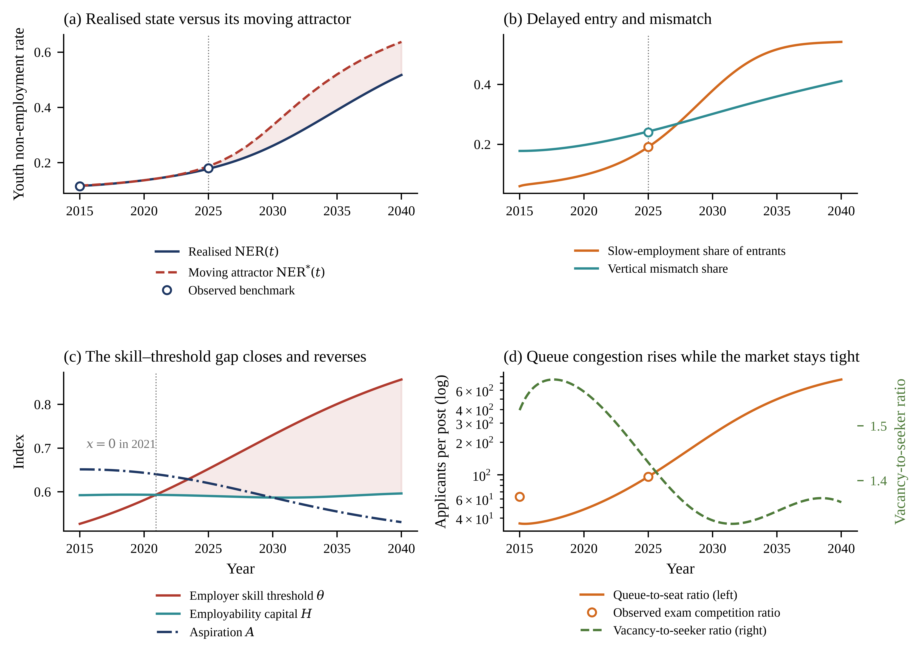
Figure 3. Baseline behaviour, 2015–2040. (a) The realised non-employment rate against its instantaneous (frozen-driver) equilibrium; circles are published benchmarks. (b) Slow-employment and mismatch shares against their 2025 benchmarks. (c) The employer threshold rises while employability capital stays flat and aspirations fall, so the skill–threshold gap changes sign in 2022. (d) Queue congestion on a logarithmic scale against the vacancy-to-seeker ratio.
Table 5. Baseline trajectory of the calibrated system under unchanged structure.
Year | NER | SE flow | Mismatch | Duration (yr) | Queue ratio | Threshold $θ$ | Capital $H$ | Aspiration $A$ | Gap $x$ | Tightness
2015 | 0.117 | 0.060 | 0.178 | 0.72 | 35.7 | 0.527 | 0.592 | 0.651 | +0.066 | 1.53
2020 | 0.137 | 0.097 | 0.197 | 0.84 | 48.1 | 0.581 | 0.593 | 0.643 | +0.012 | 1.56
2025 | 0.178 | 0.191 | 0.243 | 1.22 | 96.3 | 0.652 | 0.590 | 0.620 | −0.062 | 1.43
2030 | 0.261 | 0.380 | 0.301 | 2.28 | 237.2 | 0.730 | 0.587 | 0.587 | −0.143 | 1.33
2035 | 0.390 | 0.517 | 0.360 | 4.78 | 496.3 | 0.801 | 0.590 | 0.555 | −0.211 | 1.34
2040 | 0.517 | 0.542 | 0.411 | 8.63 | 753.8 | 0.857 | 0.596 | 0.531 | −0.261 | 1.36
Notes: NER is the youth non-employment rate; SE flow is the share of each entering cohort that chooses delayed entry. The 2030–2040 values are a structure-unchanged counterfactual, not a forecast: they describe where the present configuration of feedbacks leads if nothing in it changes.
4.2. The Attractor Moves and the State Lags It
Panel (a) of Figure 3 plots, alongside the realised trajectory, the instantaneous equilibrium of the system—the state to which it would converge if the exogenous drivers were frozen at their values in that year. This moving attractor rises from a non-employment rate of 0.117 in 2015 to 0.187 in 2025 and 0.637 in 2040. The realised state never reaches it. By 2040 the vertical gap between the two is 0.120, and the horizontal lag—the number of years by which the realised state trails the attractor—averages 1.72 years over the period and reaches 5.00 years at the end of the horizon.
This is not a modelling artefact but a direct consequence of the system’s time constants. The eigenvalues of the Jacobian at the 2040 fixed point are all real and negative (Table 6), so the fixed point is a stable node, but they differ by a factor of twenty. The slowest mode has a relaxation time of exactly eight years, equal to the reciprocal of the exit rate from the youth window: the system cannot adjust faster than a cohort can pass through it. Two further modes have relaxation times of 5.78 years. Since a first-order system requires roughly three time constants to complete 95 per cent of its adjustment, the transition system needs about a quarter of a century to express fully any change in its structure. The practical implication is that measured youth non-employment is a lagging indicator of structural deterioration by a knowable margin, and that policy evaluated on a three- or five-year horizon will systematically under-record both the damage already accumulated and the benefit of any correction.
Table 6. Eigenvalue spectrum of the frozen-driver system at 2040 and the associated relaxation times.
Mode | Eigenvalue (yr⁻¹) | Relaxation time (yr) | Interpretation
$λ_{1}$ | −2.459 | 0.41 | Search-flow equilibration
$λ_{2}$ | −1.752 | 0.57 | Aspiration and offer adjustment
$λ_{3}$ | −0.401 | 2.49 | Queue turnover
$λ_{4}$ | −0.173 | 5.78 | Mismatched-employment turnover
$λ_{5}$ | −0.173 | 5.78 | Matched-employment turnover
$λ_{6}$ | −0.125 | 8.00 | Cohort passage through the youth window
Notes: All eigenvalues are real and negative, so the fixed point is a stable node. The slowest mode equals $-ω$ exactly.
4.3. No Fold, No Hysteresis: A Negative Result
A natural hypothesis, and the one we began with, is that the transition system possesses two stable regimes—a fluid one and a trapped one—separated by an unstable threshold, so that a sufficiently large disturbance would flip it irreversibly. The hypothesis is not supported. Two-directional continuation in the threshold sensitivity $κ$ over [0.5, 5.0] and in the value of an institutional post $\backslash Pi$ over [0.4, 2.6] produces forward and backward branches that coincide to within 10⁻¹⁴ in non-employment rate at every grid point at which both sweeps converge (241 of 241 points for $κ$ and 232 of 241 for $\backslash Pi$), so no fold and no hysteresis loop exists in either direction (Figure 4a). A multi-start search from six widely separated initial guesses across forty parameter cells—a 6 × 4 grid spanning endogenous threshold escalation from 0 to 2.5 and screening sharpness from 3 to 22, plus eight values each of $κ$ and $\backslash Pi$—returns exactly one admissible fixed point in every cell.
The system is therefore globally monostable over the region examined, and the language of tipping points, critical transitions and early-warning signals [47] does not apply to it. This is worth stating explicitly because that language has become common in policy discussion of youth exclusion. What generates persistence here is not multiplicity of equilibria but the conjunction of a monotonically drifting attractor with a slow state, which produces behaviour that superficially resembles a trap—deterioration that does not reverse itself—without any of a trap’s formal properties, a pattern also visible in empirical work on the slow evolution of human-capital mismatch and youth employment quality in Chinese regions [48,49]. The distinction matters for policy: in a bistable system the objective is to avoid or escape a basin, and timing dominates magnitude; in a drifting monostable system the objective is to slow or reverse the drift, and sustained pressure on the driver dominates one-off intervention.
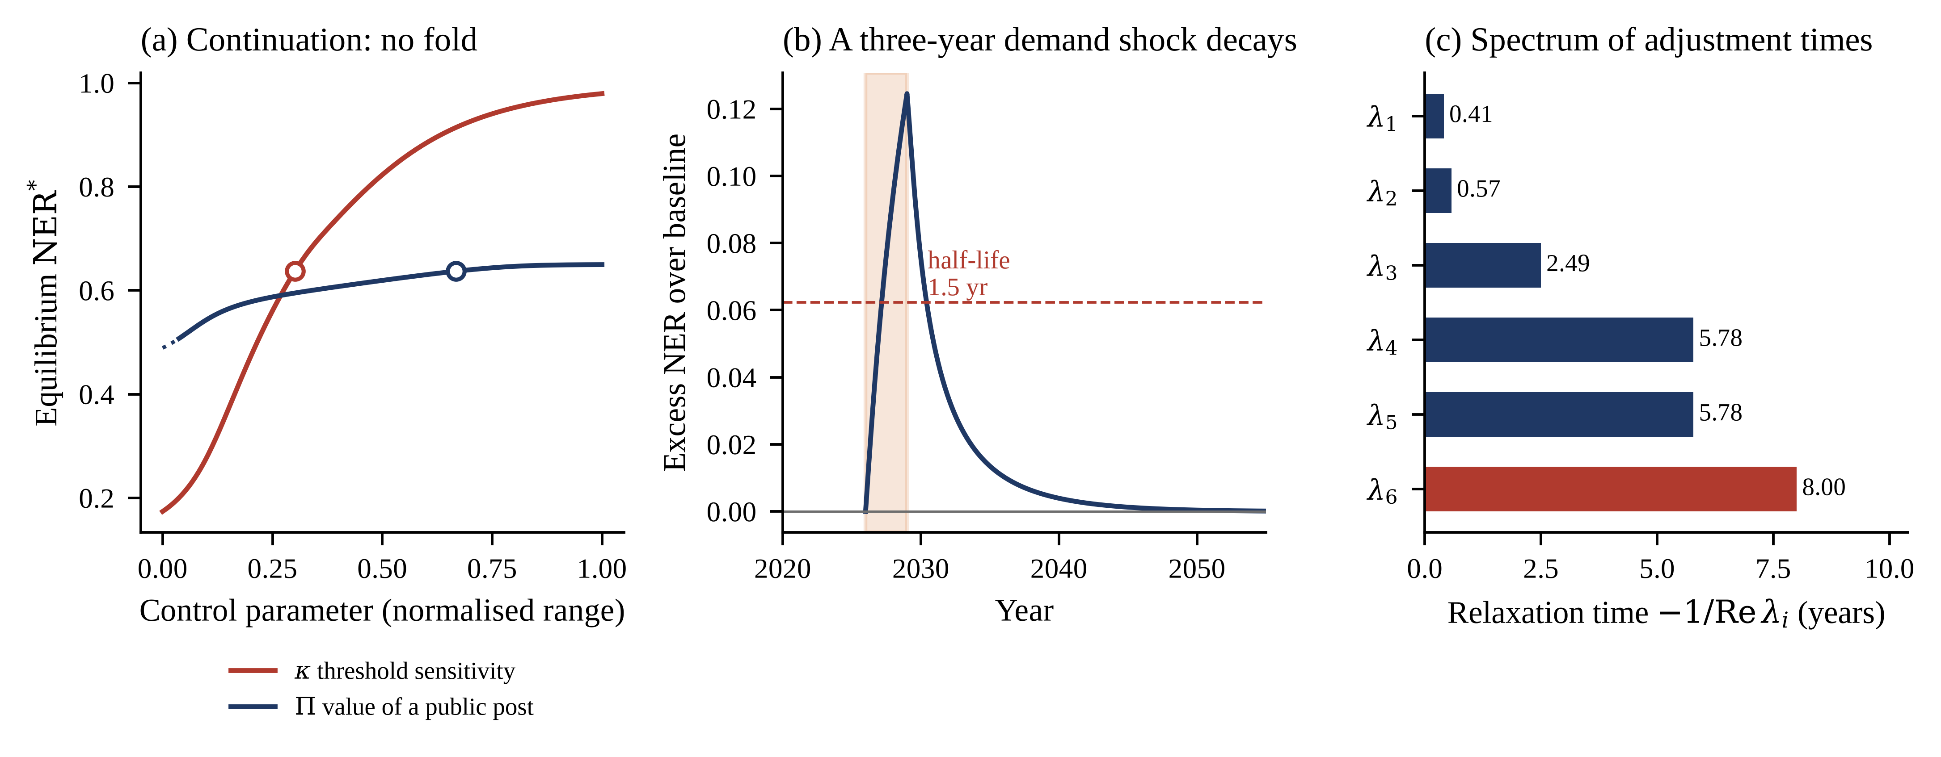
Figure 4. Structural properties. (a) Forward (solid) and backward (dotted) continuation in two control parameters; the branches coincide, so no fold exists. Circles mark the calibrated values. (b) Excess non-employment after a temporary three-year demand shock, with the shock window shaded. (c) Relaxation times implied by the eigenvalue spectrum at the 2040 fixed point.
4.4. Transitory Shocks Decay; Structural Drift Does Not
To separate cyclical from structural persistence we impose a temporary adverse demand shock: the elasticity of vacancies to digitalisation is cut by 25 per cent for three years from 2026, after which the original structure is restored. The shock is large by historical standards, and its immediate effect is substantial: excess non-employment peaks at 0.125 in 2029, more than half the contemporaneous baseline rate. Recovery, however, is brisk. The excess falls to half its peak within 1.50 years of the shock ending and to 0.0050—about four per cent of the peak—ten years after. Figure 4b shows the full path.
The contrast with the baseline drift is the substantive point. A large cyclical disturbance leaves almost no trace after a decade, whereas the slow upward march of the employer threshold produces a permanent and compounding deterioration. Youth non-employment in a digital-frontrunner region is therefore a structural problem wearing cyclical clothes. Counter-cyclical measures will appear to work—because the cycle would have reverted anyway—and will leave the underlying trajectory untouched.
4.5. Which Loops Dominate
Loop dominance is assessed by deactivation. Each candidate link is held at its 2015 value, so that the feedback passing through it cannot operate while its level effect is retained; the resulting change in the 2040 outcome measures that loop’s contribution to observed behaviour [18]. Table 7 reports the results. The signs recover exactly the polarities derived analytically in Section 2.3, which is itself a structure-oriented validation test: deactivating a reinforcing loop lowers non-employment, deactivating a balancing loop raises it.
Table 7. Loop-deactivation experiments: contribution of each feedback loop to the 2040 outcome.
Loop | Polarity | Link held at its 2015 value | 2040 NER | $\backslash Delta$NER | $\backslash Delta$Duration (yr) | Share of total effect
B2 Aspiration adjustment | Balancing | Aspiration level | 0.5791 | +0.0618 | +2.55 | 30.3%
R3 Threshold escalation | Reinforcing | Observed mismatch share | 0.4606 | −0.0567 | −2.28 | 27.8%
B3 Exam-queue congestion | Balancing | Realised exam success rate | 0.5530 | +0.0357 | +0.84 | 17.5%
R1 Skill decay while searching | Reinforcing | Searcher stock in renewal term | 0.4883 | −0.0290 | −1.19 | 14.2%
R4 Thin-market offer quality | Reinforcing | Offered job quality | 0.5061 | −0.0112 | −0.32 | 5.5%
R2 Queue–skill erosion | Reinforcing | Skill retention while queueing | 0.5079 | −0.0094 | −0.27 | 4.6%
Notes: The baseline 2040 non-employment rate is 0.5173 and the baseline mean transition duration 8.63 years. A positive $\backslash Delta$ means that deactivating the loop worsens the outcome, identifying a balancing loop. Shares are absolute effects normalised to sum to unity.
Three readings follow. First, the two balancing loops together account for almost half of the total deactivation effect: without aspiration adjustment and exam-queue congestion the 2040 non-employment rate would be 0.58 and 0.55 rather than 0.52. Congestion in particular is an unlovely but powerful brake—the fact that success rates collapse as the queue lengthens is what stops the queue absorbing the whole cohort. Policies that expand institutional recruitment without expanding anything else would weaken precisely this brake. Second, among the reinforcing loops, threshold escalation is the dominant amplifier by a wide margin, accounting for 27.8 per cent of the total deactivation effect—six times the queue-erosion loop—and adding 2.28 years to the mean transition. Third, the two loops most emphasised in the policy literature, skill decay during search and erosion while queueing, together account for under nineteen per cent. The scarring mechanism is real but it is not where the leverage is.
4.6. Uncertainty and Global Sensitivity
Twelve parameters are treated as uncertain over the ranges in Table 2. Propagating them through a Latin-hypercube design of 4096 draws gives a 2040 non-employment rate with mean 0.546, standard deviation 0.151 and a 95 per cent interval of [0.227, 0.795]; the median is 0.558 and the interquartile range [0.453, 0.662]. Mean transition duration has mean 16.06 years and a 95 per cent interval of [1.90, 57.28] years, the extreme right skew reflecting the multiplicative structure of the reinforcing loops. Appendix Table A1 reports the full distributions. The point to note is how little of the parameter space is benign: the 2.5th percentile of the 2040 distribution, 0.227, already exceeds the realised 2025 value of 0.178, so under essentially the entire uncertainty range the system continues to deteriorate rather than stabilising on its own.
The Sobol decomposition (Table 8, Figure 5a) attributes variance rather than merely ranking parameters, and the concentration is striking. The sensitivity of the employer threshold to digitalisation alone accounts for 66.3 per cent of the total output variance, six times the next parameter. Endogenous threshold escalation contributes 11.0 per cent, the probability-weighting curvature 8.9 per cent, cohort growth 7.3 per cent and aspiration anchoring 5.0 per cent. Matching efficiency contributes 3.7 per cent and training intensity 0.1 per cent. First- and total-order indices sum to 0.927 and 1.062 respectively, so the response surface is close to additive and interaction effects account for roughly six per cent of the variance. Taken together, the two threshold parameters explain more than three quarters of everything the model does not know.
Table 8. Sobol variance decomposition of the 2040 non-employment rate (base sample 1024; 14,336 model evaluations; 800 bootstrap resamples).
Parameter | Meaning | First order $S_{i}$ | 95% CI | Total order $S_{Ti}$ | 95% CI
$κ$ | Threshold sensitivity to digitalisation | 0.583 | [0.352, 0.850] | 0.663 | [0.611, 0.721]
$κ_{2}$ | Endogenous threshold escalation | 0.099 | [−0.005, 0.208] | 0.110 | [0.099, 0.122]
$\backslash varepsilon$ | Probability-weighting curvature | 0.060 | [−0.038, 0.158] | 0.089 | [0.078, 0.100]
$g_{\backslash Phi}$ | Graduate cohort growth | 0.076 | [−0.010, 0.164] | 0.073 | [0.067, 0.081]
$\backslash zeta$ | Aspiration anchoring weight | 0.059 | [−0.017, 0.131] | 0.050 | [0.045, 0.057]
$μ$ | Matching efficiency | 0.035 | [−0.029, 0.099] | 0.037 | [0.033, 0.041]
$\backslash Pi$ | Perceived value of a public post | 0.001 | [−0.048, 0.045] | 0.019 | [0.015, 0.022]
$δ_{H}$ | Skill decay while searching | 0.006 | [−0.033, 0.046] | 0.015 | [0.013, 0.017]
$φ$ | Vacancy elasticity to digitalisation | 0.003 | [−0.016, 0.021] | 0.003 | [0.003, 0.004]
$\backslash chi$ | Skill retention while queueing | 0.002 | [−0.010, 0.013] | 0.001 | [0.001, 0.002]
$λ$ | Aspiration adjustment speed | 0.000 | [−0.011, 0.013] | 0.001 | [0.001, 0.001]
$\backslash tau$ | Training intensity | 0.003 | [−0.007, 0.013] | 0.001 | [0.001, 0.001]
Sum |  | 0.927 |  | 1.062
Notes: Slightly negative lower bounds on small first-order indices are a known small-sample property of the Saltelli estimator and indicate indices statistically indistinguishable from zero. The excess of the total-order sum over unity measures interaction.
The policy reading of Table 8 is uncomfortable for the standard toolkit. The two parameters that public programmes address most directly—training intensity and, through hiring subsidies, the vacancy elasticity—jointly explain three tenths of one per cent of the outcome variance. The parameters that dominate describe how employers set the bar, how young people weight small probabilities, and how firmly aspirations are anchored. None of these is conventionally treated as a policy variable, and all three are in principle governable.
4.7. What Separates Trapped from Fluid Futures
To characterise the boundary between good and bad futures we define a binary outcome—a 2040 non-employment rate above 0.36, twice the 2025 benchmark—and model it on the twelve standardised parameters. In the Monte Carlo sample 86.5 per cent of draws cross that line, which is itself a result: under the great majority of the uncertainty range the rate at least doubles within fifteen years. The logistic meta-model (Table 9) fits extremely well: area under the receiver operating characteristic curve 0.998, Nagelkerke pseudo-$R^{2}$ 0.928, McFadden 0.895, likelihood-ratio ${\backslash chi}^{2}$(12) = 2900.56 with $p$ < 0.001. Calibration is excellent: the Hosmer–Lemeshow statistic is 4.07 on eight degrees of freedom with $p$ = 0.851, so the null of good fit is not rejected.
Table 9. Logistic meta-model of trap risk in the Monte Carlo sample (⟪n⟫ = 4096; outcome: 2040 non-employment rate above 0.36).
Parameter | Coefficient | SE | $z$ | $p$ | Odds ratio | 95% CI
$κ$ Threshold sensitivity | +13.125 | 0.996 | +13.17 | <0.001 | 5.0 × 10⁵ | [7.1 × 10⁴, 3.5 × 10⁶]
$\backslash varepsilon$ Probability weighting | −7.046 | 0.550 | −12.80 | <0.001 | 0.001 | [0.000, 0.003]
$κ_{2}$ Endogenous escalation | +4.560 | 0.369 | +12.35 | <0.001 | 95.6 | [46.4, 197.2]
$g_{\backslash Phi}$ Cohort growth | +4.461 | 0.363 | +12.27 | <0.001 | 86.5 | [42.5, 176.4]
$\backslash zeta$ Aspiration anchoring | +3.905 | 0.326 | +12.00 | <0.001 | 49.7 | [26.2, 94.0]
$\backslash Pi$ Value of a public post | +2.957 | 0.267 | +11.10 | <0.001 | 19.2 | [11.4, 32.4]
$μ$ Matching efficiency | −2.615 | 0.240 | −10.89 | <0.001 | 0.073 | [0.046, 0.117]
$δ_{H}$ Skill decay | +1.800 | 0.199 | +9.02 | <0.001 | 6.05 | [4.09, 8.94]
Notes: Coefficients are per standard deviation of the corresponding prior. The four parameters with the smallest absolute $z$ statistics ($φ$, $\backslash tau$, $λ$, $\backslash chi$) are omitted for space and are reported in Appendix Table A2. Model fit: AUC 0.998; Nagelkerke $R^{2}$ 0.928; Hosmer–Lemeshow ${\backslash chi}^{2}$ = 4.07, $p$ = 0.851.
A cross-validated classification tree recovers the same ordering in interpretable form (cross-validated AUC 0.923, fifteen leaves). The root split is on the threshold sensitivity at $κ$ = 1.456, and the calibrated value of 1.855 lies above it, that is, the estimated economy sits in the high-risk branch of the tree rather than on the boundary. Within the low-risk branch the next split is on the probability-weighting curvature at 0.526 and thereafter on endogenous escalation at 0.106 and on cohort growth at 0.047; within the high-risk branch the tree splits again on $κ$ at 1.758 and then on cohort growth at 0.054 and aspiration anchoring at 0.612 and 0.507. The structure of the decision rules therefore reproduces, in a calibrated dynamic model of the Chinese transition system, the threshold-type relationships that Grigorescu and colleagues detected cross-sectionally in European NEET data [12].
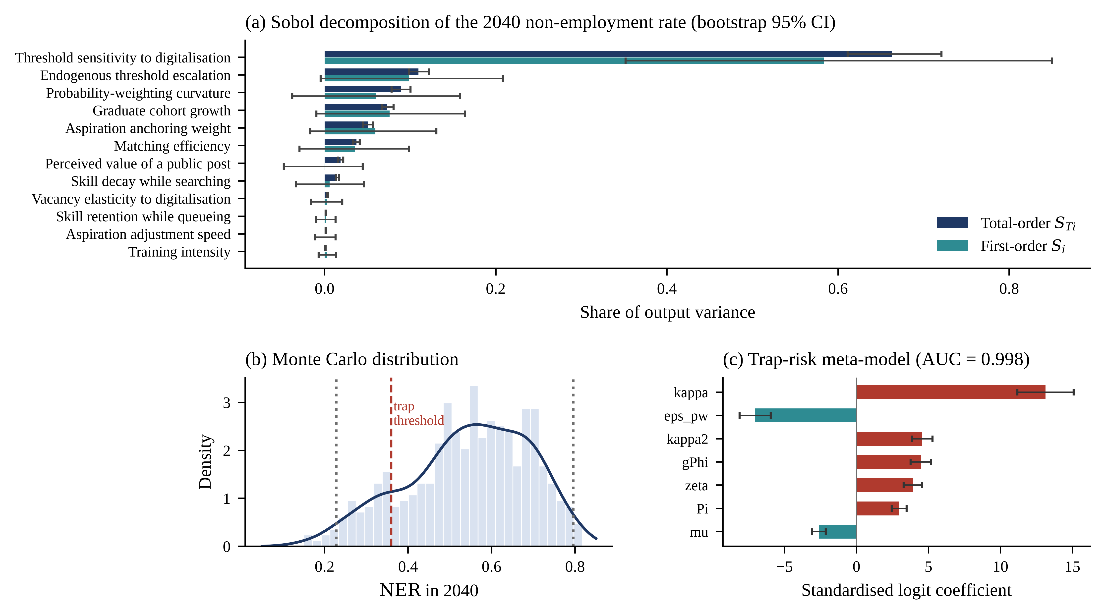
Figure 5. Uncertainty and sensitivity. (a) Sobol first- and total-order indices for the 2040 non-employment rate with bootstrap 95 per cent intervals. (b) Monte Carlo distribution of the 2040 non-employment rate; dotted lines mark the 2.5th and 97.5th percentiles and the dashed line the trap threshold. (c) Standardised logistic coefficients for trap risk with 95 per cent intervals.
4.8. Policy Experiments at Equal Effort
Five instrument families are compared at one prior standard deviation of effort each, introduced in 2025 and evaluated on the 2040 outcome, with parameter uncertainty propagated through 400 Latin-hypercube draws so that each comparison is within-draw and paired. Table 10 and Figure 6 report the results. Differences across instruments are highly significant (Kruskal–Wallis $H$ = 245.22, $p$ = 7.0 × 10⁻⁵²), and every instrument improves on the baseline in every draw (Wilcoxon signed-rank $p$ < 10$^\{-60\}$ throughout), so the interesting question is not whether they work but by how much.
Table 10. Policy experiments at one prior standard deviation of effort (400 paired draws; baseline mean 2040 non-employment rate 0.5441).
Instrument | Parameter moved | $\backslash Delta$NER | 95% interval | $\backslash Delta$Duration (yr) | Cliff’s $δ$ | Relative to P4
P5 Threshold moderation | $κ$ ↓, $κ_{2}$ ↓ | −0.1565 | [−0.2403, −0.0857] | −9.77 | 1.00 | 19.1×
P3 Expectation guidance | $λ$ ↑, $\backslash zeta$ ↓ | −0.0283 | [−0.0621, −0.0098] | −1.67 | 1.00 | 3.5×
P2 Matching efficiency | $μ$ ↑ | −0.0264 | [−0.0428, −0.0160] | −1.84 | 1.00 | 3.2×
P4 Vacancy creation | $φ$ ↑ | −0.0082 | [−0.0131, −0.0046] | −0.55 | 1.00 | 1.0×
P1 Skill upgrading | $\backslash tau$ ↑ | −0.0039 | [−0.0087, −0.0015] | −0.35 | 1.00 | 0.5×
Notes: Negative values denote improvement. Cliff’s $δ$ of unity indicates that the instrument improves on the baseline in every paired draw. The final column expresses the mean effect relative to vacancy creation.
The ranking is stark and stable. Moderating the escalation of the employer threshold is roughly nineteen times as effective as vacancy creation and forty times as effective as raising training intensity, at the same standardised effort. Expectation guidance—raising the speed at which aspirations adapt and loosening their anchor, the policy analogue of the employability-thinking competences measured by Chacón-Cuberos and colleagues [21]—and improving matching efficiency come next and are statistically indistinguishable from one another. The two instruments that dominate public spending come last.
This result must be read with its normalisation in mind. Equal standardised effort means equal movement in units of the prior standard deviation, not equal fiscal cost, and we make no claim about the relative expense of moving these parameters. What the comparison establishes is where the system is responsive, not where money is cheap. Panel (a) of Figure 6 shows the full effort–response curves and confirms that the ranking is not an artefact of the chosen effort level: the threshold-moderation curve dominates the others over the entire range from zero to three standard deviations, and the vacancy and training curves remain almost flat throughout.
Combining instruments at a fixed total effort of two units confirms the pattern. The best available combination is a double dose of threshold moderation, which lowers the 2040 rate to 0.193 ($\backslash Delta$ = −0.324), followed by threshold moderation paired with expectation guidance at 0.274 ($\backslash Delta$ = −0.243) and with matching efficiency at 0.291 ($\backslash Delta$ = −0.226). Every combination that includes threshold moderation outperforms every combination that does not, and the best combination without it reaches only 0.458.
4.9. Sequencing at Equal Cumulative Effort
Because the system’s modes differ by a factor of twenty in speed, the order in which instruments are deployed should matter even when the total effort is held constant. We test this with three pairs, comparing simultaneous deployment of one unit of each throughout with front-loading two units of one instrument until 2032.5 and then switching. Table 11 reports both the terminal rate and the mean rate over 2025–2040, the latter being proportional to cumulative person-years of non-employment and therefore the welfare-relevant quantity.
Table 11. Policy sequencing at identical cumulative effort (two units over fifteen years, switch date 2032.5).
Instrument pair | Deployment order | Mean NER 2025–2040 | NER in 2040
P3 guidance and P1 skill | P3 first, then P1 | 0.2893 | 0.4807
P3 guidance and P1 skill | Both throughout | 0.3027 | 0.4806
P3 guidance and P1 skill | P1 first, then P3 | 0.3149 | 0.4750
P1 skill and P2 matching | P1 first, then P2 | 0.3106 | 0.4699
P1 skill and P2 matching | Both throughout | 0.3072 | 0.4865
P1 skill and P2 matching | P2 first, then P1 | 0.3070 | 0.5066
P3 guidance and P2 matching | P3 first, then P2 | 0.2752 | 0.4422
P3 guidance and P2 matching | Both throughout | 0.2857 | 0.4583
P3 guidance and P2 matching | P2 first, then P3 | 0.2965 | 0.4719
Notes: The mean rate over the period is proportional to cumulative person-years of youth non-employment and is the welfare-relevant criterion; the terminal rate describes the state bequeathed to the following period.
Two results emerge. First, sequencing matters materially. For the guidance and matching pair, front-loading expectation guidance yields a mean rate of 0.2752 against 0.2965 when matching efficiency comes first, a difference of 0.021, or about seven per cent of the level, and it also produces the better terminal state, so for this pair the ordering is unambiguous. Second, the criterion can reverse the ranking. For the guidance and skill pair, guidance-first minimises the cumulative burden (0.2893) but skill-first leaves the marginally better terminal state (0.4750 against 0.4807). This is a genuine intertemporal trade-off rather than a modelling artefact: guidance acts on a fast state and relieves the current cohort, whereas training acts on a slow state and accumulates. A government optimising the electoral cycle and one optimising the state bequeathed to its successor will make different choices from the same model.
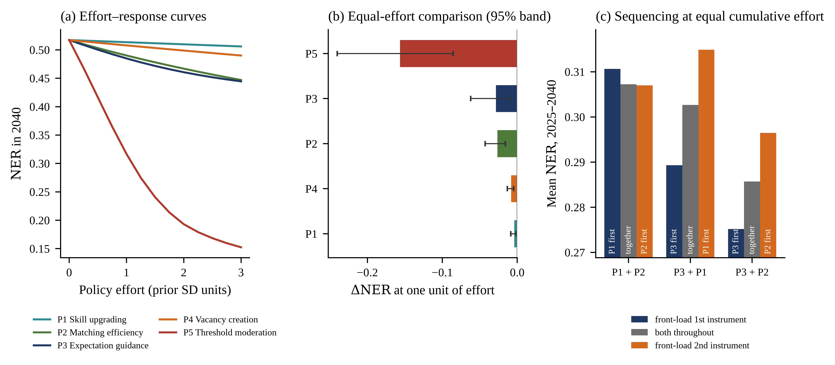
Figure 6. Policy analysis. (a) Effort–response curves for the five instrument families over zero to three prior standard deviations of effort. (b) Effects at one unit of effort with 95 per cent paired intervals. (c) Sequencing at identical cumulative effort, measured by the mean non-employment rate over 2025–2040.
4.10. Prefecture Archetypes
China’s prefecture-level cities are not homogeneous, and the model’s parameters differ systematically across them. We define three archetypes: a digital-core metropolitan type, with the fastest digital expansion, the strongest vacancy response, the steepest threshold escalation, the largest graduate inflow and the most efficient matching; an advanced-manufacturing type, intermediate on all counts; and a peripheral labour-exporting type, with slower digitalisation, weaker matching and a higher valuation of institutional posts. Table 12 and Figure 7 report the outcomes.
Table 12. Prefecture-level city archetypes: trajectories and policy responsiveness.
Archetype | NER 2025 | NER 2040 | SE flow 2040 | Mismatch 2040 | Duration 2040 (yr) | Best instrument | NER 2040 under policy | Gain
A. Digital-core metropolitan city | 0.251 | 0.732 | 0.658 | 0.548 | 31.99 | P5 | 0.578 | 0.155
B. Advanced-manufacturing city | 0.173 | 0.489 | 0.539 | 0.403 | 7.53 | P5 | 0.288 | 0.201
C. Peripheral labour-exporting city | 0.157 | 0.251 | 0.342 | 0.303 | 2.09 | P5 | 0.169 | 0.082
Notes: Archetypes are parameterised illustratively rather than estimated on city-level data; they are intended to show how the same structure generates different behaviour under different parameterisations, not to rank actual cities.
The ordering is the opposite of what a simple demand account predicts. The most digitally advanced archetype, which creates the most jobs and matches most efficiently, ends the horizon with by far the highest youth non-employment rate (0.732 against 0.251 in the periphery) and a mean transition duration of nearly thirty-two years, which is to say that in that parameterisation the cohort effectively never clears. The reason is visible in the parameterisation: the same digital dynamism that generates vacancies also drives the employer threshold upward, and in the calibrated system the threshold effect dominates the vacancy effect by more than two orders of magnitude (Table 8). The frontrunner runs faster and falls further behind its own bar.
The policy reading is more encouraging, and more specific than the deterioration ranking suggests. The largest absolute dividend accrues not to the digital core but to the intermediate manufacturing archetype, where threshold moderation lowers the 2040 rate by 0.201 against 0.155 in the core and 0.082 in the periphery. The core is the most damaged but also the most saturated: its threshold has risen so far by 2040 that a one-standard-deviation moderation cannot bring it back. The implication for a national programme is that intervention should be targeted at cities in the middle of the digital transition, where the bar is rising fast but has not yet run away.
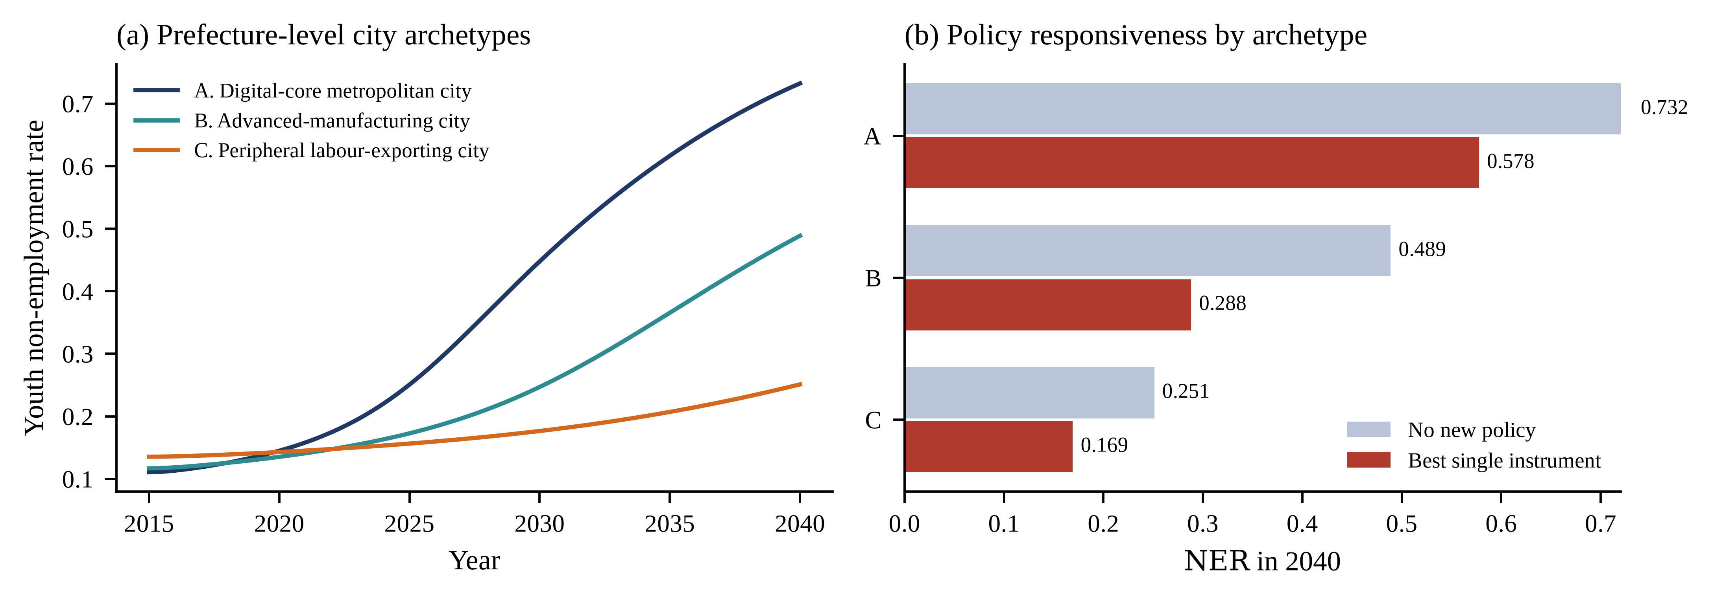
Figure 7. Prefecture-level city archetypes. (a) Non-employment trajectories under the three parameterisations. (b) The 2040 rate without new policy and under the best single instrument at one unit of effort.
5. Discussion
5.1. A Moving Target Rather Than a Tipping Point
The principal theoretical contribution of this study is a negative one with positive consequences. Youth employment deterioration in a rapidly digitalising economy behaves like a trap but is not one. The system has a single stable equilibrium throughout the parameter region examined; what changes is the location of that equilibrium, which drifts upward as the employer skill threshold rises with digitalisation and with the mismatch it produces. Because the slowest mode of the system equals the duration of the youth window, the observed state trails this moving target by 1.7 years on average and by five years by the end of the horizon.
This distinction has three consequences. It disciplines the language: early-warning indicators designed to detect critical slowing down before a fold [47] are not informative here, because there is no fold to anticipate. It changes the diagnosis: persistence arises from slow states chasing a moving equilibrium, not from lock-in, so recovery does not require escaping a basin and is not subject to irreversibility. And it relocates the urgency: in a bistable system delay risks crossing a threshold, whereas here delay simply allows the target to move further away, which is less dramatic but, because the drift compounds and adjustment is slow, no less costly. The measured indicator understating the structural position is the mechanism by which such a system escapes attention until the gap is large.
5.2. Why Job Creation Is Not the Binding Constraint
That vacancy creation is nearly inert in this model is the result most likely to attract objection, so its logic deserves to be stated carefully. Vacancies enter the model in two places: they raise meetings through the matching function, and they raise offered quality through market tightness. Neither channel is blocked. What limits them is that meetings only become hires after passing a screen whose stringency is itself rising, and after being accepted by a searcher whose reservation threshold adjusts only slowly. When the skill–threshold gap has turned negative, additional meetings mostly generate additional rejections. Formally, the elasticity of hires with respect to vacancies is bounded above by the screening and acceptance probabilities, both of which fall as the drift proceeds. Empirically, this is why the vacancy-to-seeker ratio can stay above unity while non-employment doubles: the constraint is not the number of doors but the height of the sill.
The finding is consistent with the broader evaluation literature, which reports modest and heterogeneous average effects for youth employment programmes and better results for interventions that change what employers or participants do rather than simply subsidising a transaction [44,50,51]. It also aligns with evidence that the returns to training depend on whether the skills acquired are the ones employers are screening on [46,52,53]. Our result sharpens rather than contradicts that literature: training raises employability capital, but in this system employability capital is not the state that is moving. The threshold is.
5.3. The Queue as an Institution
The examination queue turns out to be central in a way we did not anticipate. Its congestion loop is the second strongest stabiliser in the system after aspiration adjustment, accounting for 17.5 per cent of the total loop-deactivation effect: because success rates collapse as the queue lengthens, the queue is self-limiting. At the same time the queue is a major channel of delayed entry and of skill erosion, and the curvature of the probability-weighting function that sustains it is the third most important parameter in the variance decomposition (8.9 per cent of total-order variance). The queue is therefore simultaneously a safety valve and a sink.
The policy implication is a warning against the obvious intervention. Expanding institutional recruitment raises the realised success rate, which weakens exactly the congestion feedback that prevents the queue from absorbing a larger share of each cohort. In the model this operates as a partial offset: more posts are filled, but the queue grows. The productive lever is not the number of posts but the decision weight attached to a small probability, which is addressable through information—publishing realised success rates by post and by cohort, and integrating them into career education—rather than through recruitment quotas. This is one concrete route by which the employability-thinking construct validated by Chacón-Cuberos and colleagues [21] becomes a system-level lever: what their analytical-thinking and information-handling factor measures is precisely the capacity that reduces the over-weighting of small probabilities.
5.4. The Digital Paradox of a Frontrunner Region
The archetype analysis produces the paper’s most counter-intuitive result: the city archetype with the fastest digital growth, most vacancies and best matching ends with the worst youth outcome. This is not an argument against digital transformation, which raises output, wages and job quality in this model as in the evidence [4,30,54–58]. It is an argument about the joint distribution of its effects. Digitalisation shifts demand towards higher-order competences [9,35,36], and in doing so it raises the bar that entrants must clear at exactly the moment when it raises the number of doors. Where the first effect outruns the second, entrants face more opportunities they cannot access.
For Chinese cities specifically this suggests that a local policy advantage in digital-industry development [3] and an aggressive talent-attraction regime [59] are, from the perspective of local entrants, double-edged. Attracting experienced talent from elsewhere raises the observed competence distribution that employers screen against, which is formally equivalent in this model to raising the threshold. A common-prosperity agenda that treats youth transition quality as an objective alongside industrial upgrading [60,61] would need to monitor the skill–threshold gap directly rather than inferring it from vacancy counts, and would need to differentiate its instruments by where a city sits in the digital transition rather than applying one national package.
5.5. Implications for Policy Design
Four design implications follow from the results, stated in decreasing order of the confidence we attach to them. First, govern the bar. Instruments that slow the escalation of employer screening standards dominate every alternative at equal standardised effort. Concretely, this means competence-based rather than credential-based recruitment standards for public and state-owned employers, publicly certified micro-credentials that make competence legible so that employers do not over-screen on proxies, regulation of degree and experience requirements in advertised vacancies, and subsidised structured internships that let employers observe ability directly rather than inferring it. Second, manage expectations early. Expectation guidance is the second most effective instrument and, in two of the three pairs tested, should be front-loaded rather than run in parallel. Third, treat matching efficiency as a complement rather than a substitute: it is third in effectiveness and pairs well with threshold moderation, but it cannot compensate for a rising bar. Fourth, do not expand the queue. Enlarging institutional recruitment weakens the strongest stabilising feedback in the system.
A fifth implication concerns measurement rather than instruments. Because the realised state lags its equilibrium by two to five years, national and city monitoring that tracks only the youth unemployment rate will detect deterioration late and will credit interventions late as well. A monitoring system built on this model would track the skill–threshold gap—operationalised as the distance between the competence distribution of entrants and the requirements stated in vacancy postings—alongside the realised rate, because the gap is a leading indicator and the rate is a lagging one.
5.6. Contribution to Systems Practice in the Social Sciences
Methodologically, this study joins three techniques that are usually applied separately. Loop deactivation [18] establishes which feedbacks generate the observed behaviour; variance-based sensitivity analysis [19,20] establishes which parameters generate the uncertainty; and statistical meta-modelling of the simulation output establishes where in parameter space the qualitative outcome changes. Applied to the same calibrated object, the three agree: threshold escalation is the strongest reinforcing loop, threshold sensitivity is the largest variance contributor, and threshold sensitivity is the root split of the classification tree. That agreement is not automatic—structural dominance and variance contribution answer different questions—and its presence is itself evidence that the model’s behaviour is driven by a mechanism rather than by a parameterisation. We would encourage this triangulation as a routine step in simulation-based social science, alongside the reporting standards already proposed [42,45]. Recent systems-theoretic work published in this journal on digital adoption, decision-making and regional digital dividends [62–64] shares the same premise—that organisational and regional outcomes are properties of configurations rather than of variables—and could be linked to the transition system modelled here through the employer-threshold equation.
Substantively, the study complements the two recent contributions in this journal that motivated it. Grigorescu and colleagues [12] establish, cross-sectionally and spatially, that youth exclusion is an emergent property of interacting digital and socio-economic subsystems and that its determinants act through thresholds; we show what such a system does over time and which of its couplings dominates. Chacón-Cuberos and colleagues [21] establish that employability thinking is a coherent, measurable latent construct; we show the system-level pathway through which that construct operates—by accelerating aspiration adjustment and by reducing the over-weighting of small probabilities—and quantify its policy value relative to alternatives. Recent system-dynamics work on Chinese employment [65] identifies the education–technology–human-capital complex as the critical state variable at the macroeconomic level; our result that employability capital is flat while the threshold moves suggests that at the level of the transition itself the binding state is the requirement, not the endowment.
5.7. Limitations
Five limitations bound the claims. First, the model is specified and estimated at the national level, so its parameters are population-weighted averages across China’s prefecture-level cities; the archetype analysis shows how much behaviour varies once those averages are relaxed, but city-level point predictions should not be read off it. Second, the projections beyond 2026 are structure-unchanged counterfactuals, not forecasts. They answer the question "where does this configuration of feedbacks lead?" and are meaningless as predictions, since the whole point of the paper is that the configuration is governable. Third, the model is deterministic and representative-agent within each stock; it cannot speak to heterogeneity by field of study, gender, institution tier or family background, all of which the mismatch literature shows to be substantial [32,33,43]. Fourth, firms are not optimising agents; the threshold responds to digitalisation and mismatch through a reduced form whose parameters are estimated rather than derived, and a micro-founded screening model could change the elasticities though we would not expect it to change their sign. Fifth, the archetype analysis is illustrative: its parameterisations are stipulated to represent recognisable city types, not estimated on city data.
Three extensions follow naturally. Estimating the threshold equation directly from the text of vacancy postings would replace the reduced form with a measured one and would supply the leading indicator that Section 5.5 calls for. Disaggregating the model by field of study would let it speak to the humanities–science employment gap that graduate destination data show. And embedding the transition system in a spatial framework across China’s prefecture-level cities, in the manner of the spatial NEET analysis of Grigorescu and colleagues [12], would allow inter-city migration of graduates to be treated endogenously rather than as a parameter difference, and would let the model speak to whether the digital core exports its threshold escalation to the cities that supply it with graduates.
6. Conclusions
This paper asked why youth employment outcomes deteriorate in an economy where jobs are plentiful and the digital economy is expanding, and what to do about it. Treating the graduate school-to-work transition as a feedback system and calibrating it to seven published national moments, we find that the answer is neither a shortage of jobs nor a shortage of skills but the speed at which employers raise the bar. The system has no tipping point; it has a drifting attractor and a slow state, a combination that produces persistent deterioration while the measured indicator understates the structural position by two to five years.
Three findings are directly actionable. Cyclical shocks decay with a half-life of one and a half years and are not the problem; the threshold drift does not decay and is. Among five policy families compared at equal standardised effort, moderating threshold escalation is roughly nineteen times as effective as vacancy creation and forty times as effective as training intensity, and every effective combination contains it. Sequencing matters at unchanged cumulative effort: front-loading expectation guidance before matching-efficiency investment lowers cumulative youth non-employment by about seven per cent relative to the reverse order, though the ranking can invert when the terminal rather than the cumulative state is the criterion. A fourth result is spatial: the largest dividend accrues to cities in the middle of the digital transition rather than to those furthest along it.
The wider point is about where policy attention sits. Youth employment policy in China and elsewhere is organised around two levers—create jobs and train people—that this analysis places last among five. The levers that dominate concern how employers screen, how young people weight small probabilities, and how firmly aspirations are anchored. None of these has a budget line, and all three are governable. For a country whose stated ambition is common prosperity, the youth transition offers a case in which the binding constraint is not resources but the rules by which opportunity is rationed.
Author Contributions: Conceptualization, methodology, formal analysis, software and writing—original draft preparation, X.C.; validation, data curation and visualization, D.H.; investigation, writing—review and editing, supervision and project administration, T.M. All authors have read and agreed to the published version of the manuscript.
Funding: This research received no external funding.
Institutional Review Board Statement: Not applicable. The study is a simulation analysis calibrated to published aggregate statistics and involves no human participants or animals.
Informed Consent Statement: Not applicable.
Data Availability Statement: The model is fully specified by Equations (1)–(15) and Table 2. No individual-level data were used. All calibration targets are drawn from publicly available sources cited in Table 3. The simulation code, the calibration routine, the sensitivity and policy experiments and the scripts that generate every figure and table in this article are available from the corresponding author on reasonable request.
Acknowledgments: The authors thank the editors and the anonymous reviewers for comments that improved the manuscript.
Conflicts of Interest: The authors declare no conflicts of interest.
Appendix A
Table A1. Monte Carlo distributions of the 2040 outcomes over the twelve uncertain parameters (Latin hypercube, ⟪n⟫ = 4096).
Outcome | Mean | SD | 2.5% | 25% | Median | 75% | 97.5%
Youth non-employment rate | 0.546 | 0.151 | 0.227 | 0.453 | 0.558 | 0.662 | 0.795
Mean transition duration (yr) | 16.06 | 14.86 | 1.90 | 5.88 | 11.04 | 21.21 | 57.28
Slow-employment share of entrants | 0.560 | 0.147 | 0.174 | 0.480 | 0.579 | 0.664 | 0.779
Vertical mismatch share | 0.438 | 0.067 | 0.317 | 0.384 | 0.441 | 0.492 | 0.555
Table A2. Remaining coefficients of the logistic meta-model of trap risk.
Parameter | Coefficient | SE | $z$ | $p$ | Odds ratio
$φ$ Vacancy elasticity to digitalisation | −1.057 | 0.163 | −6.46 | <0.001 | 0.348
$\backslash tau$ Training intensity | −0.616 | 0.152 | −4.05 | <0.001 | 0.540
$λ$ Aspiration adjustment speed | −0.484 | 0.150 | −3.23 | 0.001 | 0.617
$\backslash chi$ Skill retention while queueing | −0.473 | 0.148 | −3.20 | 0.001 | 0.623
Notes: Coefficients are per standard deviation of the corresponding prior; signs are as expected but the magnitudes are an order of magnitude smaller than those of the dominant parameters in Table 9.
Table A3. Principal splits of the cross-validated classification tree for trap risk.
Depth | Splitting parameter | Threshold | Observations at the node
1 (root) | $κ$ Threshold sensitivity | 1.456 | 4096
2 | $\backslash varepsilon$ Probability-weighting curvature | 0.526 | 859
2 | $κ$ Threshold sensitivity | 1.758 | 3237
3 | $κ_{2}$ Endogenous escalation | 0.106 | 408
3 | $g_{\backslash Phi}$ Cohort growth | 0.054 | 451
4 | $g_{\backslash Phi}$ Cohort growth | 0.047 | 307
4 | $\backslash zeta$ Aspiration anchoring | 0.612 | 251
5 | $\backslash zeta$ Aspiration anchoring | 0.507 | 200
Notes: Cost-complexity penalty selected by five-fold cross-validated AUC; cross-validated AUC 0.923, fifteen terminal leaves. The calibrated value of $κ$ = 1.855 lies above both $κ$ splits, placing the estimated economy in the highest-risk region of the tree.
References
1. National Bureau of Statistics of China (NBS). Surveyed Urban Unemployment Rate of the Population Aged 16–24 Excluding Students; NBS: Beijing, China, 2026.
2. Ministry of Education of China. Notice on the Employment and Entrepreneurship of 2026 National College Graduates; Ministry of Education: Beijing, China, 2025.
3. Zhou, L.; Fan, J.; Ding, L.; Xu, Z.; Zhang, J. Can policy advantages be transformed into industrial advantages? Evidences from digital economy industry development in Zhejiang Province, China. PLoS ONE 2024, 19, e0298138.
4. Wang, H.; Wang, H.; Guan, R. Digitalization of industries and labor mobility in China. China Econ. Rev. 2024, 87, 102248.
5. Li, S.; Whalley, J.; Xing, C. China’s higher education expansion and unemployment of college graduates. China Econ. Rev. 2014, 30, 567–582.
6. Ou, D.; Zhao, Z. Higher Education Expansion in China, 1999–2003: Impact on Graduate Employability. China World Econ. 2022, 30, 117–141.
7. McGuinness, S.; Pouliakas, K.; Redmond, P. Skills mismatch: Concepts, measurement and policy approaches. J. Econ. Surv. 2018, 32, 985–1015.
8. Zheng, Y.; Zhang, X.; Zhu, Y. Overeducation, major mismatch, and return to higher education tiers: Evidence from novel data source of a major online recruitment platform in China. China Econ. Rev. 2021, 66, 101584.
9. Rikala, P.; Braun, G.; Järvinen, M.; Stahre, J.; Hämäläinen, R. Understanding and measuring skill gaps in Industry 4.0—A review. Technol. Forecast. Soc. Change 2024, 201, 123206.
10. Rahmani, H.; Groot, W. Risk factors of being a youth not in education, employment or training (NEET): A scoping review. Int. J. Educ. Res. 2023, 120, 102198.
11. Rahmani, H.; Groot, W.; Rahmani, A.M. Unravelling the NEET phenomenon: A systematic literature review and meta-analysis of risk factors for youth not in education, employment, or training. Int. J. Adolesc. Youth 2024, 29, 2331576.
12. Grigorescu, A.; Alistar, T.V.; Lincaru, C. Digital Skills, Ethics, and Integrity—The Impact of Risky Internet Use, a Multivariate and Spatial Approach to Understanding NEET Vulnerability. Systems 2025, 13, 649.
13. Karma, E. NEET Youth in Central and Eastern European Countries: A Panel Model Approach. J. Youth Stud. 2025, 28, 1458–1475.
14. O’Higgins, N.; Brockie, K. The Youth Guarantee, Vulnerability, and Social Exclusion Among NEETs in Southern Europe. Polit. Gov. 2024, 12, 7469.
15. Forrester, J.W. Industrial Dynamics; MIT Press: Cambridge, MA, USA, 1961.
16. Sterman, J.D. Business Dynamics: Systems Thinking and Modeling for a Complex World; Irwin/McGraw-Hill: Boston, MA, USA, 2000.
17. Ghaffarzadegan, N.; Lyneis, J.; Richardson, G.P. How small system dynamics models can help the public policy process. Syst. Dyn. Rev. 2011, 27, 22–44.
18. Ford, D.N. A behavioral approach to feedback loop dominance analysis. Syst. Dyn. Rev. 1999, 15, 3–36.
19. Sobol’, I.M. Global sensitivity indices for nonlinear mathematical models and their Monte Carlo estimates. Math. Comput. Simul. 2001, 55, 271–280.
20. Saltelli, A.; Annoni, P.; Azzini, I.; Campolongo, F.; Ratto, M.; Tarantola, S. Variance based sensitivity analysis of model output. Design and estimator for the total sensitivity index. Comput. Phys. Commun. 2010, 181, 259–270.
21. Chacón-Cuberos, R.; Rodríguez-Sabiote, C.; Expósito-López, J.; Olmedo-Moreno, E.; Serrano-García, J.; Hortas-Aliaga, O. Development of an Employability Thinking Scale for Use with Young People in Training: Exploratory and Confirmatory Factor Analysis. Systems 2025, 13, 479.
22. Marczuk, A. Literature review of comparative school-to-work research: How institutional settings shape individual labour market outcomes. J. Labour Mark. Res. 2024, 58, 19.
23. Organisation for Economic Co-operation and Development (OECD). Education at a Glance 2025: OECD Indicators; OECD Publishing: Paris, France, 2025.
24. Gomes, A.; Dias, J.G. Digital Divide in the European Union: A Typology of EU Citizens. Soc. Indic. Res. 2025, 176, 149–172.
25. Sofrankova, B.; Sira, E.; Horvathova, J.; Mokrisova, M. Digital Skills and Digital Transformation Performance in the EU-27: A DESI-Based Nonparametric and Panel Data Study. Economies 2025, 13, 315.
26. Bankins, S.; Jooss, S.; Restubog, S.L.D.; Marrone, M.; Ocampo, A.C.; Shoss, M. Navigating career stages in the age of artificial intelligence: A systematic interdisciplinary review and agenda for future research. J. Vocat. Behav. 2024, 153, 104011.
27. Battisti, M.; Dustmann, C.; Schönberg, U. Technological and Organizational Change and the Careers of Workers. J. Eur. Econ. Assoc. 2023, 21, 1551–1594.
28. De Vos, A.; Van der Heijden, B.I.J.M.; Akkermans, J. Sustainable careers: Towards a conceptual model. J. Vocat. Behav. 2020, 117, 103196.
29. Tleppayev, A.; Zeinolla, S. Forecasting Youth Unemployment Through Educational and Demographic Indicators: A Panel Time-Series Approach. Forecasting 2025, 7, 37.
30. Liu, J.; Fang, Y.; Xia, Y.; Zou, W.; Chan, K.-L.; Lam, J.F.I.; Chen, H. Can the digital economy promote sustainable improvement in the quality of employment for Chinese residents?—Moderated mediating effect model. Sustainability 2024, 16, 6071.
31. Jin, X.; Ma, B.; Zhang, H. Impact of fast internet access on employment: Evidence from a broadband expansion in China. China Econ. Rev. 2023, 81, 102038.
32. Jiang, S.; Guo, Y. Reasons for college major-job mismatch and labor market outcomes: Evidence from China. China Econ. Rev. 2022, 74, 101822.
33. Pan, Z.; Wang, Y.; Liu, Z. Over-education, job satisfaction, and intention to quit: Evidence from China. Soc. Indic. Res. 2025, 176, 287–307.
34. Jones, M.K.; Kaya, E.; Nan, J. Overeducation, earnings and job satisfaction among graduates in China. China Econ. Rev. 2025, 93, 102448.
35. Xie, M.; Ding, L.; Xia, Y.; Guo, J.; Pan, J.; Wang, H. Does artificial intelligence affect the pattern of skill demand? Evidence from Chinese manufacturing firms. Econ. Model. 2021, 96, 295–309.
36. Cheng, C.; Luo, J.; Zhu, C.; Zhang, S. Artificial intelligence and the skill premium: A numerical analysis of theoretical models. Technol. Forecast. Soc. Change 2024, 200, 123140.
37. Eloundou, T.; Manning, S.; Mishkin, P.; Rock, D. GPTs are GPTs: Labor market impact potential of LLMs. Science 2024, 384, 1306–1308.
38. Brynjolfsson, E.; Li, D.; Raymond, L. Generative AI at Work. Q. J. Econ. 2025, 140, 889–942.
39. Tversky, A.; Kahneman, D. Advances in prospect theory: Cumulative representation of uncertainty. J. Risk Uncertain. 1992, 5, 297–323.
40. Prelec, D. The probability weighting function. Econometrica 1998, 66, 497–527.
41. Petrongolo, B.; Pissarides, C.A. Looking into the black box: A survey of the matching function. J. Econ. Lit. 2001, 39, 390–431.
42. Rahmandad, H.; Sterman, J.D. Reporting guidelines for simulation-based research in social sciences. Syst. Dyn. Rev. 2012, 28, 396–411.
43. Pastore, F.; Quintano, C.; Rocca, A. Some young people have all the luck! The duration dependence of the school-to-work transition in Europe. Labour Econ. 2021, 70, 101982.
44. Card, D.; Kluve, J.; Weber, A. What Works? A Meta Analysis of Recent Active Labor Market Program Evaluations. J. Eur. Econ. Assoc. 2018, 16, 894–931.
45. Barlas, Y. Formal aspects of model validity and validation in system dynamics. Syst. Dyn. Rev. 1996, 12, 183–210.
46. Li, L. Reskilling and upskilling the future-ready workforce for Industry 4.0 and beyond. Inf. Syst. Front. 2024, 26, 1697–1712.
47. Scheffer, M.; Bascompte, J.; Brock, W.A.; Brovkin, V.; Carpenter, S.R.; Dakos, V.; Held, H.; van Nes, E.H.; Rietkerk, M.; Sugihara, G. Early-warning signals for critical transitions. Nature 2009, 461, 53–59.
48. Zhao, K.; Wu, Y.; Kuang, Z. Dynamic evolution and impact mechanism of human capital mismatch in strategic emerging industries: Evidence from the Yangtze River Delta region of China. Heliyon 2023, 9, e21684.
49. Liang, F.; Liu, Y. Sustainable youth employment quality management: The impact of robotization in China. PLoS ONE 2024, 19, e0298081.
50. Kluve, J.; Puerto, S.; Robalino, D.; Romero, J.M.; Rother, F.; Stöterau, J.; Weidenkaff, F.; Witte, M. Do youth employment programs improve labor market outcomes? A quantitative review. World Dev. 2019, 114, 237–253.
51. Caliendo, M.; Schmidl, R. Youth unemployment and active labor market policies in Europe. IZA J. Labor Policy 2016, 5, 1.
52. Heß, P.; Janssen, S.; Leber, U. The effect of automation technology on workers’ training participation. Econ. Educ. Rev. 2023, 96, 102438.
53. Dai, L.; Martins, P.S. Does vocational education pay off in China? Evidence from city-level education supply shocks. Econ. Model. 2024, 140, 106863.
54. Yang, Y.; Lin, G.T.R. Local Digital Economic Growth, Enterprise Digital Transformation, and Digital Dividends: Evidence from China. Systems 2025, 13, 297.
55. Dou, B.; Guo, S.; Chang, X.; Wang, Y. Corporate digital transformation and labor structure upgrading. Int. Rev. Financ. Anal. 2023, 90, 102904.
56. Li, X.; Wang, Q.; Kong, D.; Tao, Y. Intelligent Manufacturing and Corporate Human Capital Upgrade in China. J. Asian Econ. 2025, 97, 101886.
57. Wang, X.; Jiang, Y.; Yi, F. Digital Revolution and Job Quality of Lower Class Workers: Quasi-experimental Evidence from the Broadband China Program. China World Econ. 2024, 32, 146–178.
58. Zhu, G.; Nie, A. How industrial robots affect employment: firm-level evidence from China. J. Asia Pac. Econ. 2026, 31, 31–61.
59. Hua, Z.; Kong, S.; Yu, Y. Talent magnets in China: Can talent attraction policies catalyze digital transformation in enterprises? China Econ. Rev. 2025, 90, 102376.
60. Tong, W.; Guo, J.; Lo, K.; Xu, W. Bridging the gap to common prosperity: Rural development and urban–rural income disparities in Zhejiang Province, China. Chin. Geogr. Sci. 2026, 36, 207–221.
61. Zhong, S.; Zhang, X.; Zhang, L.; Zhao, C. How does digital economy influence urban common prosperity? Evidence from China’s demonstration area for common prosperity. Int. Rev. Econ. Financ. 2025, 104, 104629.
62. Wang, S.; Zhang, H. Digital transformation and innovation performance in small- and medium-sized enterprises: A systems perspective on the interplay of digital adoption, digital drive, and digital culture. Systems 2025, 13, 43.
63. Song, Y.; Qiu, X.; Liu, J. The Impact of Artificial Intelligence Adoption on Organizational Decision-Making: An Empirical Study Based on the Technology Acceptance Model in Business Management. Systems 2025, 13, 683.
64. Qiao, G.; Li, Y.; Hong, A. The Strategic Role of Digital Transformation: Leveraging Digital Leadership to Enhance Employee Performance and Organizational Commitment in the Digital Era. Systems 2024, 12, 457.
65. Chen, C.; Zhu, J.; Sun, H. Mechanisms and Pathways of Promoting High-Quality Full Employment Under the Dual Circulation Paradigm: An Evolutionary Simulation Approach Based on System Dynamics. Systems 2026, 14, 737.
Disclaimer/Publisher’s Note: The statements, opinions and data contained in all publications are solely those of the individual author(s) and contributor(s) and not of MDPI and/or the editor(s). MDPI and/or the editor(s) disclaim responsibility for any injury to people or property resulting from any ideas, methods, instructions or products referred to in the content.

