Article
Digital Transformation Leadership in Enterprise Systems: Multivariate Modeling and Cluster Typologies of Youth Employment and Retention Dynamics
Xinyu Cai ¹, Dingpei Hu ¹ and Tiantian Mo ^{1,}*
Academic Editor: Firstname Lastname
Received: date
Revised: date
Accepted: date
Published: date
Citation: To be added by editorial staff during production.
Copyright: © 2026 by the authors. Submitted for possible open access publication under the terms and conditions of the Creative Commons Attribution (CC BY) license (https://creativecommons.org/licenses/by/4.0/).
¹ College of Business, Jiaxing University, Jiaxing 314001, China; caixinyu@zjxu.edu.cn
* Correspondence: 00008227@zjxu.edu.cn
Abstract
Digital transformation is redefining not only how enterprises operate but also whom they employ, and both hinge on how leaders steer technology, decision processes, and people. This paper examines how digital transformation leadership and decision-making practices relate to the youth-employment profile of firms. Drawing on a survey of 308 enterprises in Zhejiang Province, China—one of the most digitalized regional economies—we measure four practice dimensions: digital transformation leadership, data-driven decision-making, the breadth of artificial intelligence application, and digital skills training for young employees. These are linked to two youth-employment outcomes reported by HR executives: the share of employees aged 16–29 and the voluntary turnover rate among young employees. The methodology combines MANOVA-type multivariate general linear models, exploratory factor analysis, and hierarchical and k-means clustering to examine direct associations, the latent structure of digital leadership–decision capability, and emergent organizational typologies. Results reveal differentiated rather than uniform associations: leadership and data-driven decision-making show the strongest links with a younger workforce and lower youth turnover, whereas the breadth of AI deployment is associated with lower turnover but not with a higher youth share. A single latent capability factor is significantly associated with both outcomes, and cluster analysis identifies two socio-technical configurations—a digitally led, youth-integrating group and a conventionally managed group with weaker youth outcomes. The findings position leadership and decision capability, rather than technology deployment alone, as the systemic lever connecting digital transformation to youth opportunity inside firms, without implying causal relationships.
Keywords: digital transformation; digital leadership; data-driven decision making; artificial intelligence; youth employment; employee retention; socio-technical systems; enterprise survey; multivariate general linear model; cluster analysis

1. Introduction
Digital transformation is revolutionizing the way organizations operate, requiring leaders to navigate complex technological landscapes and to make consequential decisions about strategy, structure, and people [1–3]. A growing literature examines how digital leadership and data-driven decision-making shape innovation, agility, and performance [4–7]. Yet one organizational consequence of these leadership choices has received far less attention: who gets hired, and who stays. As enterprises digitalize, they reconfigure the tasks they need, the entry-level positions they open, and the working environments they offer [8–10]. For young people entering the labor market, the leadership and decision-making practices of employers therefore constitute the proximate, demand-side gateway through which the digital transition translates into opportunity or exclusion [11,12].
The stakes are substantial. The International Labour Organization reports that youth labor markets remain fragile even where aggregate employment has recovered, with school-to-work transitions lengthening in many economies [13,14]. In China, elevated urban youth unemployment and intense competition for graduate positions have made the employment of young people a central policy concern [15,16], while digitalization is simultaneously reshaping the quality and structure of the jobs available to them [17,18]. At the same time, employers report difficulties in attracting and retaining a new generation of employees whose workplace expectations differ markedly from those of earlier cohorts [19–21]. Whether digitally transforming enterprises absorb young workers—and hold on to them—is thus a question that connects the digital transformation literature with the economics and management of youth employment.
The purpose of this article is to analyze how four enterprise-level practices at the intersection of leadership, decision making, and digital transformation relate to the youth-employment profile of firms: digital transformation leadership (DTL), data-driven decision-making (DDM), the breadth of artificial intelligence application (AIA), and digital skills training oriented toward young employees (DST). We link these practices to two outcomes reported by senior HR informants: the share of employees aged 16–29 (YES) and the voluntary turnover rate among employees younger than 30 (YTR). The empirical setting is Zhejiang Province, China, a coastal regional economy with a dense population of private manufacturing and platform-economy enterprises and one of the country's flagship digital-economy ecosystems [22,23].
The existing literature offers significant contributions but also three limitations. First, research on digital leadership and data-driven decision-making concentrates on innovation and performance outcomes [2,24,25], while firm-level employment outcomes—particularly the age structure of the workforce—are rarely examined. Second, studies of technology and youth employment operate mostly at the macro or industry level [8,26,27], leaving the organizational practices that mediate between digital transformation and youth hiring underexplored. Third, existing firm-level evidence typically considers hiring and retention separately, although a youthful workforce that cannot be retained yields little durable integration [20,28]. There are, in addition, few studies that treat these practices as a socio-technical configuration rather than as isolated levers [29,30].
We address these shortcomings with a quantitative, cross-sectional survey design and a combination of complementary statistical techniques. Multivariate general linear modeling estimates the direct associations between each practice dimension and the two youth-employment outcomes; exploratory factor analysis tests whether the four practices express a common latent dimension of digital leadership–decision capability; and hierarchical plus k-means clustering identifies typologies of firms with similar configurations of practices and outcomes. The research thereby moves beyond a linear view of technology's employment impact and provides a systemic analysis of how leadership, decision-making, and youth employment co-occur within enterprises understood as socio-technical systems [31,32].
The study contributes to the existing research in several ways. First, it shifts the level of analysis of the digital transformation–youth employment nexus from countries and industries to the organization, where hiring and retention decisions are actually made. Second, it connects the digital leadership literature with demand-side youth-employment research, treating the age structure of the workforce as a strategic outcome of leadership and decision practice. Third, it distinguishes conceptually and empirically between technology deployment (the breadth of AI application) and the leadership, decision, and training practices in which deployment is embedded, showing that their associations with youth outcomes differ. Fourth, the methodological contribution lies in combining multivariate modeling, exploratory factor analysis, and cluster analysis on primary survey data, which enables the examination of direct associations, a latent capability dimension, and emergent socio-technical typologies within a single design [33].
The paper is structured as follows: the introduction outlines the research topic, purpose, gaps, contribution, and novelty; Section 2 presents the theoretical framework and the hypotheses concerning the practice dimensions, the latent capability factor, and the socio-technical differentiation of firms; Section 3 describes the sample, measures, and statistical methods; Section 4 presents the results of the multivariate modeling, factor analysis, and clustering; Section 5 interprets the results in the context of the specialized literature; and Section 6 summarizes the main findings, implications, limitations, and directions for future analysis.
2. Theoretical Framework, Literature Review, and Hypotheses Development
The theoretical framework of this study combines insights from the upper echelons and dynamic capabilities perspectives with the socio-technical systems tradition. From the upper echelons viewpoint, organizational outcomes reflect the values, cognitions, and choices of top managers [3,34]; digital transformation leadership and data-driven decision-making are precisely the managerial capabilities through which firms sense and seize digital opportunities [35–37]. From the socio-technical systems perspective, technology does not generate organizational outcomes in isolation but through its joint optimization with social structures—skills, roles, decision routines, and training systems [29,31,38]. Applied to youth employment, this framework implies that the age profile and stability of a firm's workforce emerge from the interaction between the technical subsystem (what is digitalized and automated) and the social subsystem (how leaders decide, organize, and develop people). The study accordingly interprets differences in youth hiring and retention across firms as expressions of distinct socio-technical configurations rather than as mechanical effects of technology adoption [30,39].
2.1. Digital Leadership, Decision-Making Practices, and Firm-Level Youth Employment
Digital transformation leadership denotes the capacity of an organization's leaders to articulate a digital vision, champion change, and mobilize employees behind technology-enabled ways of working [4,5,40]. Empirical work links such leadership to digital strategy execution, organizational agility, employee performance, and commitment [2,41]. For young job seekers, visible digital leadership signals modern work practices, learning opportunities, and career relevance—attributes that figure prominently in what Generation Z employees report seeking from employers [19,21]. Firms led by digitally oriented executives also create more digitally intensive entry-level roles, which are disproportionately filled by young, recently trained workers [9,42]. We therefore expect digital transformation leadership to be associated with both a younger workforce and lower youth turnover.
Data-driven decision-making refers to the extent to which decisions about operations, markets, and people rest on systematically collected and analyzed data rather than on intuition or hierarchy alone [6,7]. Analytics-intensive decision cultures are associated with faster, more transparent, and more contestable decision processes [24,25], and increasingly extend to human resource decisions themselves [43]. Such environments plausibly appeal to young employees both because they demand the digital and analytical skills in which recent graduates hold a comparative advantage and because merit-legible decision processes reduce the perceived arbitrariness that features prominently in young Chinese employees' accounts of quitting [20,44]. Data-driven firms also detect emerging retention problems earlier, enabling corrective action before departures occur [43].
The breadth of artificial intelligence application captures how many business functions—from recruitment screening and customer service to production scheduling and quality control—employ AI technologies [45,46]. The relationship between AI deployment and youth employment is theoretically ambiguous. On the one hand, AI-rich workplaces offer young workers complementarity with the technologies they know best, and experimental evidence shows that generative AI disproportionately raises the productivity of less experienced workers [47,48]. On the other hand, AI substitutes for exactly the routine, entry-level tasks through which young employees have traditionally entered organizations [27,49,50], and Chinese firm-level evidence indicates that automation-driven restructuring can compress lower-skill hiring even as it upgrades the skill structure [10,51]. The net association of AI breadth with the youth share of employment is therefore an empirical question, while its association with turnover is expected to be negative insofar as AI removes the most repetitive task content from young employees' jobs [12].
Digital skills training directed at young employees, finally, represents the organizational investment that converts hiring into durable integration. Training signals employer commitment, builds firm-specific digital capital, and increases the opportunity cost of leaving [52,53]. Job embeddedness theory predicts that such investments deepen the links and fit that keep employees in place [28], and evidence from European SMEs identifies skills development as a central bottleneck of digital transformation [54]. Because training programs are typically targeted at, and disproportionately consumed by, younger cohorts [52], we expect training intensity to be associated primarily with a larger youth share, with a weaker direct association with turnover.
Taken together, these arguments suggest that the four practice dimensions are systematically related to firms' youth-employment profiles, though not necessarily uniformly across dimensions and outcomes. This literature justifies the following hypothesis:
Hypothesis H1. The four dimensions of digital transformation leadership and decision-making practice—digital transformation leadership, data-driven decision-making, AI application breadth, and digital skills training—show significant cross-sectional associations with the youth employee share and the youth turnover rate of firms.
2.2. The Latent Digital Leadership–Decision Capability and Youth-Employment Outcomes
Although the four practices can be evaluated independently, the literature suggests that they also share a deeper common component. Digital transformation is not a portfolio of disconnected initiatives but a capability-driven reconfiguration of the organization [1,35]. Firms whose leaders champion transformation also tend to embed data in decision processes, deploy AI more broadly, and train more intensively—not because the practices mechanically require one another, but because they express the same underlying managerial orientation toward technology-enabled organizing [2,37,45]. The dynamic capabilities view interprets this common component as a higher-order capacity to sense digital opportunities, seize them through resource commitments, and transform structures accordingly [35,36].
The socio-technical systems perspective reinforces this expectation. Because the technical and social subsystems must be jointly optimized, isolated adoption of any single practice yields limited returns; benefits accrue to configurations in which leadership vision, decision routines, technology, and skills co-evolve [29,32,38]. Analogous latent-factor logic has been applied to individual AI use across life domains and to national digital readiness [55,56]. We accordingly expect a single latent factor—digital leadership–decision capability—to underlie the four observed practice indicators, and we expect this aggregate capability, rather than any single practice, to carry the systematic association with youth-employment outcomes. This literature justifies the following hypothesis:
Hypothesis H2. A common latent factor of digital leadership–decision capability underlies the four practice indicators and is significantly associated with both the youth employee share and the youth turnover rate.
2.3. Organizational Typologies and Socio-Technical Configurations Within a Regional Economy
When examining how digital transformation relates to employment, one cannot assume that firms form a homogeneous population arrayed along a single continuum. The configurational tradition in management research holds that organizational attributes cohere in discrete, internally consistent bundles, and that cluster-analytic methods are the natural tool for recovering them [33,57]. Studies of digital transformation document persistent heterogeneity across firms in the same institutional environment, driven by differences in resources, absorptive capacity, and leadership [54,58]. Within a single regional economy such as Zhejiang, firms face broadly common labor-market conditions, policy incentives, and digital infrastructure [22,59]; the differentiation that remains is therefore primarily organizational rather than environmental.
From the socio-technical systems perspective, such differentiation should take the form of distinct regimes: configurations in which digital practices and workforce outcomes reinforce one another [30,39]. A digitally led regime combines strong leadership, data-driven decisions, broad AI deployment, and intensive training with a younger and more stable workforce; a conventional regime combines weaker digital practices with an older workforce and higher youth churn. Identifying such regimes matters practically, because policy and managerial levers that work for one configuration may be ineffective for another. This literature justifies the following hypothesis:
Hypothesis H3. Firms form distinct socio-technical clusters according to their digital leadership and decision-making practices and their youth-employment outcomes.
3. Materials and Methods
3.1. Research Design and Sample
The paper uses a quantitative, cross-sectional survey design to investigate the systemic linkages between digital transformation leadership, decision-making practices, and youth-employment outcomes at the firm level. Given the cross-sectional nature of the data, the analysis identifies statistical associations, but it does not establish causal relationships or temporal sequences. The perspective of complex socio-technical systems informs this approach: digital practices are not treated as isolated treatments but as elements of organizational configurations whose workforce correlates are of interest [31,32].
Data were collected between November 2025 and January 2026 in Zhejiang Province, China. Zhejiang combines a dense private-enterprise economy, a national leadership position in the digital and platform economy, and pronounced policy attention to youth employment, making it an appropriate single-region setting that holds macro conditions approximately constant across sampled firms [22,23,59]. Firms were approached through the enterprise membership lists of municipal industry and commerce federations and digital-economy industry parks in Hangzhou, Ningbo, Jiaxing, Wenzhou, Shaoxing, Taizhou, and Jinhua, using stratified quotas by sector (digital-core, manufacturing, and other services) and firm size. The target informant was the most senior executive responsible for human resources; where unavailable, a deputy general manager familiar with both digital initiatives and workforce composition completed the questionnaire.
Of 500 questionnaires distributed, 342 were returned (a 68.4% response rate). Questionnaires were excluded when more than 10% of items were missing, when the attention check embedded in the practice scales was failed, or when the respondent did not hold a qualifying position, leaving 308 valid observations (a 61.6% valid response rate). Table 1 reports the sample profile. Manufacturing firms account for the largest share of the sample, digital-core firms (software, e-commerce, information services) for just over a quarter, and other services for the remainder; the median firm employs approximately 130 people. Non-response bias was assessed by comparing the first and last quartiles of returned questionnaires on all six focal variables, following the extrapolation logic of Armstrong and Overton [60]; no comparison approached significance (all $p$ ≥ 0.28), suggesting that late respondents, who proxy for non-respondents, do not differ systematically from early ones.
Table 1. Sample profile (N = 308).
Characteristic | Category | n | %
Sector | Digital-core (ICT, e-commerce) | 87 | 28.2
 | Manufacturing | 141 | 45.8
 | Other services | 80 | 26.0
Firm size (employees) | 20–49 | 49 | 15.9
 | 50–249 | 176 | 57.1
 | 250–999 | 80 | 26.0
 | 1000+ | 3 | 1.0
Ownership | Private | 211 | 68.5
 | State-owned | 48 | 15.6
 | Foreign-invested | 28 | 9.1
 | Other | 21 | 6.8
Firm age (years) | 3–7 | 17 | 5.5
 | 8–14 | 116 | 37.7
 | 15–24 | 123 | 39.9
 | 25+ | 52 | 16.9
Region | Hangzhou | 63 | 20.5
 | Ningbo | 60 | 19.5
 | Wenzhou | 44 | 14.3
 | Jiaxing | 51 | 16.6
 | Shaoxing | 25 | 8.1
 | Taizhou | 20 | 6.5
 | Jinhua | 23 | 7.5
 | Other | 22 | 7.1
Respondent role | HR director | 140 | 45.5
 | HR manager | 110 | 35.7
 | General/deputy general manager | 58 | 18.8
Notes: Source: authors’ survey. Region refers to the prefecture-level city of the firm’s headquarters. Percentages may not sum to 100 due to rounding.
3.2. Measures
All multi-item constructs were measured with five-point Likert scales (1 = strongly disagree, 5 = strongly agree) adapted from established instruments; the full item wording appears in Appendix A. The questionnaire was administered in Chinese following the translation–back-translation procedure [61] and was piloted with 12 HR executives, whose feedback led to minor wording adjustments. Digital transformation leadership (DTL, six items) was adapted from digital leadership scales measuring vision, championing, and enablement [5,40]. Data-driven decision-making (DDM, five items) captures the extent to which operational, market, and HR decisions rest on data and analytics [6,7]. Digital skills training (DST, four items) measures the intensity and youth orientation of the firm's digital training provision [52,54]. AI application breadth (AIA) is a formative count: respondents marked which of ten listed business functions employ AI technologies, yielding a 0–10 index [45].
The two outcomes are workforce statistics reported by the HR informant for the most recent complete year: the youth employee share (YES), defined as the percentage of employees aged 16–29, and the youth turnover rate (YTR), defined as voluntary separations among employees younger than 30 during the past 12 months divided by the average number of such employees. Contextual variables comprise firm size (the natural logarithm of employees, lnSIZE), firm age in years (AGE), R&D intensity as a percentage of revenue (RDI), and a digital-core industry indicator (DIG).
Reliability is satisfactory for all reflective scales: Cronbach's α is 0.848 for DTL, 0.840 for DDM, and 0.786 for DST [62], with McDonald's ω of 0.849, 0.840, and 0.787, respectively [63]; all item loadings on their intended constructs exceed 0.65 (Appendix A). As AIA is a formative index, internal consistency is not required. Because all practice measures share a single informant, several procedural and statistical remedies for common method bias were applied [64,65]: respondents were assured of anonymity, practice and outcome blocks were separated in the questionnaire, and the outcomes are quasi-objective workforce statistics rather than perceptions. Harman's single-factor test on the 15 Likert items shows that the first unrotated factor accounts for 39.7% of the variance, below the conventional 40% threshold; while this test is recognized as insensitive, the use of factual outcome measures limits the scope for percept–percept inflation [65]. Table 2 summarizes all variables and measures.
Table 2. Variables and measures.
Variable | Construct/measure | Operationalization | Reliability | Source
DTL | Digital transformation leadership | 6 Likert items: digital vision, championing, enablement | α = 0.848; ω = 0.849 | [40,5]
DDM | Data-driven decision-making | 5 Likert items: data use in operational, market, and HR decisions | α = 0.840; ω = 0.840 | [6,7]
AIA | AI application breadth | Count of AI-enabled business functions (0–10), formative | n/a (index) | [45]
DST | Digital skills training | 4 Likert items: intensity and youth orientation of digital training | α = 0.786; ω = 0.787 | [52,54]
YES | Youth employee share | Share of employees aged 16–29 (%), HR-reported statistic | n/a | Survey
YTR | Youth turnover rate | Voluntary separations among employees younger than 30, past year (%) | n/a | Survey
lnSIZE; AGE; RDI; DIG | Structural controls | ln employees; firm age (years); R&D intensity (% of revenue); digital-core industry (0/1) | n/a | Survey
Notes: Source: authors’ design. Full item wording in Appendix A; α = Cronbach’s alpha [62]; ω = McDonald’s omega [63].
3.3. Statistical Methods
The empirical analysis employs an integrated methodological strategy to investigate both the direct relationships between the practice dimensions and youth-employment outcomes and the latent structure and emergent patterns of the socio-technical system under study. The approach integrates multivariate modeling, dimensionality reduction, and unsupervised classification, providing a cohesive description of the co-evolution of digital practice and workforce composition [33,66].
In the first stage, the association between each practice dimension and the two youth-employment outcomes was examined using four separate multivariate general linear models, estimated in a MANOVA-type framework. In each model, the youth employee share and the youth turnover rate were treated as correlated dependent variables, with one practice indicator serving as the explanatory variable; thus DTL, DDM, AIA, and DST were not entered simultaneously in the same model. This specification was chosen because the four indicators are conceptually related and empirically correlated, so that simultaneous entry would render individual coefficients unstable and difficult to interpret; the models are read as parallel exploratory tests of simple associations, not as evidence of distinct partial effects (1):
$\left(Y_{1i}, Y_{2i}\right) = α + βX_{ki} + ε_{i}$ (1)
where $Y_{1i}$ denotes the youth employee share (YES) and $Y_{2i}$ the youth turnover rate (YTR) of firm $i$; $X_{ki}$ is one practice indicator at a time (DTL, DDM, AIA, or DST); $α$ is the intercept vector; $β$ the regression coefficient vector; and $ε_{i}$ the error term. The analysis evaluates the global significance of each model using multivariate statistics, namely Pillai's Trace and Wilks' Lambda, while examining individual associations using univariate tests, regression coefficients, and partial eta squared [66]. Before interpretation, residual normality was assessed with normal probability plots and Shapiro–Wilk tests, and standardized residuals, leverage values, and Cook's distances were inspected for influential observations. As a robustness check, each model was re-estimated as a MANCOVA with firm size, firm age, R&D intensity, and the digital-core indicator as covariates, and supplementary bivariate correlations between the practice indicators and the structural variables were computed to gauge the extent to which practice differences overlap with structural firm characteristics.
To capture the aggregate pattern of digital leadership–decision capability, the study applies exploratory factor analysis to the four practice indicators, standardized as in (2), using Principal Axis Factoring on the correlation matrix; sampling adequacy is assessed with the Kaiser–Meyer–Olkin measure and Bartlett's test of sphericity [67,68]. The factorial model can be expressed as follows (3):
$z_{ij} = \frac{x_{ij} − {\bar{x}}_{j}}{s_{j}}$ (2)
$X = ΛF + ε$ (3)
where $X$ collects the observed indicators, $Λ$ the matrix of factor loadings, $F$ the latent factor, and $ε$ the unique errors. A one-factor solution was retained to capture the common latent structure of the four practices; since only one factor was extracted, no rotation was applied. Factor scores were generated by the regression method and subsequently used as a synthetic indicator of digital leadership–decision capability (FACT_DLDM). This latent factor then enters two simple linear regression models, estimated separately for each youth-employment outcome (4):
$Y_{i} = β_{0} + β_{1} {FACT}_{DLDM,i} + ε_{i}$ (4)
Finally, cluster analysis is applied to identify emergent firm-level configurations based on the six standardized variables (the four practices and the two outcomes). The initial data structure and the plausible number of groups are determined by hierarchical clustering with the Pearson-correlation-based distance and the average linkage agglomeration method [57,69]. This is an exploratory step, and the study uses the k-means algorithm to stabilize the clusters by minimizing the within-cluster sum of squared distances (5):
$W = \sum_{c=1}^{K}{\sum_{i∈C_{c}}{{\left\|z_{i} − μ_{c}\right\|}^{2}}}$ (5)
where $z_{i}$ is the standardized profile of firm $i$ and $μ_{c}$ denotes the centroid of the cluster. Candidate solutions with k = 2, 3, and 4 were compared using the average silhouette coefficient [70], and differences between the retained clusters were described using analysis of variance. Since the clusters were constructed from the same variables used in the ANOVA, these results are interpreted descriptively rather than as independent statistical confirmation of cluster separation. This combination of methods allows the study to capture direct linear relationships, the latent structure, and the system's emergent typologies within a complex adaptive socio-technical framework [32]. All analyses were conducted in Python 3.11 (NumPy 2.3, SciPy 1.17).
4. Results
4.1. Descriptive Statistics and Cross-Sectional Relationships Between Digital Practices and Youth-Employment Outcomes
Table 3 reports descriptive statistics and Pearson correlations for the six focal variables. The average firm employs 27.20% young workers (SD = 9.10) and reports a youth turnover rate of 17.83% (SD = 7.34). The four practice indicators are positively and significantly intercorrelated (r between 0.351 and 0.547), consistent with the expectation that they express a shared organizational orientation while remaining empirically distinguishable. All four practices correlate positively with the youth employee share and negatively with youth turnover at the bivariate level, although with clearly different strengths.
Table 3. Descriptive statistics and Pearson correlations (N = 308).
Variable | Mean | SD | 1 | 2 | 3 | 4 | 5
1. DTL | 3.32 | 0.58
2. DDM | 3.30 | 0.62 | 0.547 ***
3. AIA | 3.72 | 2.30 | 0.421 *** | 0.415 ***
4. DST | 3.28 | 0.65 | 0.480 *** | 0.428 *** | 0.351 ***
5. YES | 27.20 | 9.10 | 0.303 *** | 0.256 *** | 0.102 | 0.297 ***
6. YTR | 17.83 | 7.34 | −0.265 *** | −0.240 *** | −0.248 *** | −0.111 | −0.075
Notes: Source: authors’ calculations. * p < 0.05; ** p < 0.01; *** p < 0.001 (two-tailed). DTL, DDM, and DST are scale means (1–5); AIA is a 0–10 count; YES and YTR are percentages.
The first multivariate model analyzed the association between digital transformation leadership (DTL) and the two youth-employment outcomes. The multivariate tests indicate a significant global association (Pillai's Trace = 0.151, Wilks' Lambda = 0.849, F(2, 305) = 27.083, $p$ < 0.001), the strongest among the four practice dimensions. At the univariate level, DTL is associated with approximately 9% of the cross-sectional variance in the youth employee share and 7% of the variation in youth turnover. A one-point increase on the five-point leadership scale is associated with a 4.755-percentage-point higher youth share ($p$ < 0.001) and a 3.356-point lower youth turnover rate ($p$ < 0.001) (Table 4). Figure 1 displays the two associations; both scatters show the wide dispersion typical of firm-level survey data, with clearly sloped linear fits.
Table 4. Parameter estimates for the relationship between digital transformation leadership and youth-employment outcomes.
Dependent Variable | Parameter | B | Std. Error | t | Sig. | 95% CI  Lower | 95% CI  Upper | Partial Eta  Squared
YES | Intercept | 11.428 | 2.880 | 3.967 | 0.000 | 5.760 | 17.096 | 0.049
 | DTL | 4.755 | 0.855 | 5.559 | 0.000 | 3.072 | 6.438 | 0.092
YTR | Intercept | 28.960 | 2.351 | 12.318 | 0.000 | 24.334 | 33.587 | 0.331
 | DTL | −3.356 | 0.698 | −4.808 | 0.000 | −4.730 | −1.983 | 0.070
Notes: Source: authors’ calculations. Note: N = 308. CI = confidence interval.
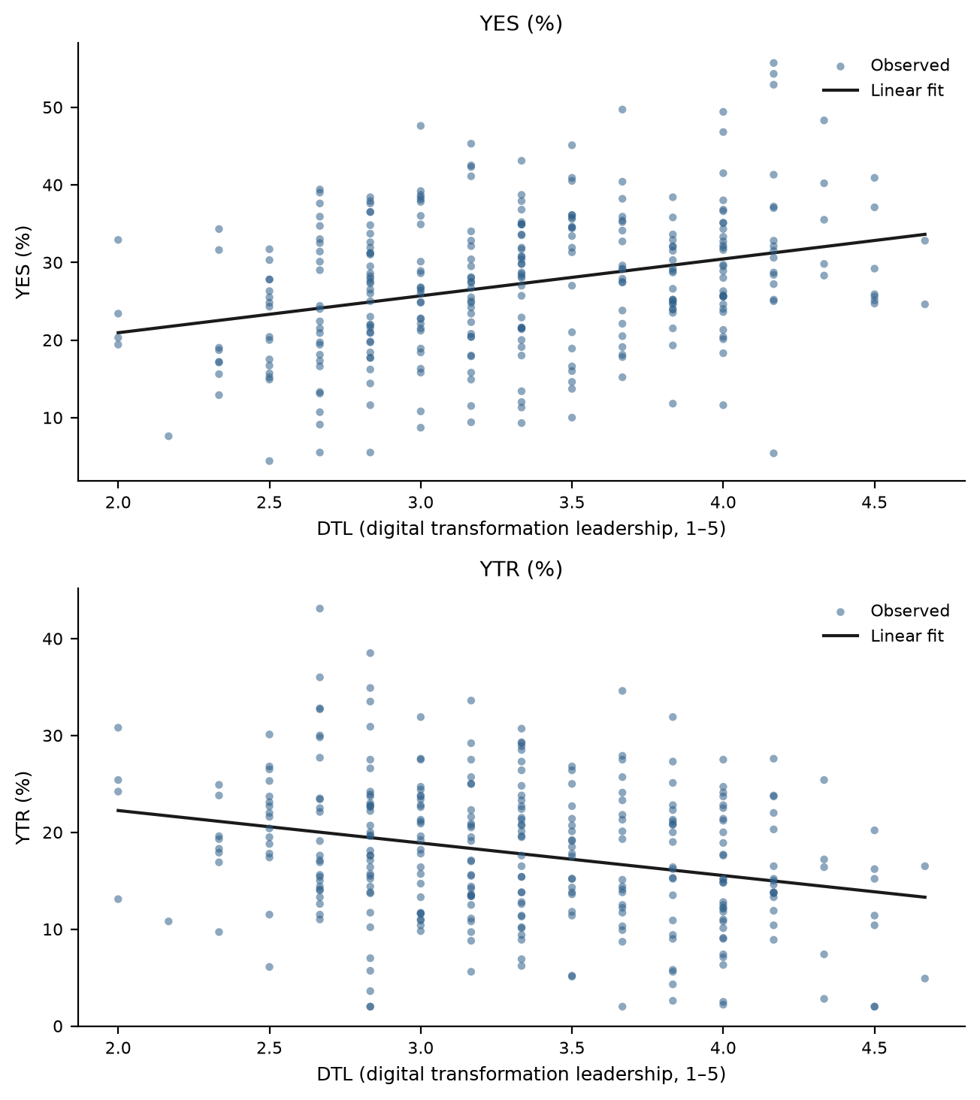
Figure 1. Youth employee share and youth turnover rate in relation to digital transformation leadership. Source: authors’ design.
The second model evaluated data-driven decision-making (DDM). The multivariate effect remains significant (Pillai's Trace = 0.115, Wilks' Lambda = 0.885, F(2, 305) = 19.746, $p$ < 0.001). DDM is positively associated with the youth employee share (B = 3.754, $p$ < 0.001, partial $η_{p}^{2}$ = 0.066) and negatively with youth turnover (B = −2.833, $p$ < 0.001, partial $η_{p}^{2}$ = 0.057) (Table 5, Figure 2). Analytics-intensive decision environments thus co-occur with both a younger workforce and greater retention of young employees.
Table 5. Parameter estimates for the relationship between data-driven decision-making and youth-employment outcomes.
Dependent Variable | Parameter | B | Std. Error | t | Sig. | 95% CI  Lower | 95% CI  Upper | Partial Eta  Squared
YES | Intercept | 14.827 | 2.715 | 5.462 | 0.000 | 9.486 | 20.169 | 0.089
 | DDM | 3.754 | 0.809 | 4.639 | 0.000 | 2.162 | 5.347 | 0.066
YTR | Intercept | 27.164 | 2.200 | 12.349 | 0.000 | 22.835 | 31.492 | 0.333
 | DDM | −2.833 | 0.656 | −4.320 | 0.000 | −4.124 | −1.543 | 0.057
Notes: Source: authors’ calculations. Note: N = 308. CI = confidence interval.
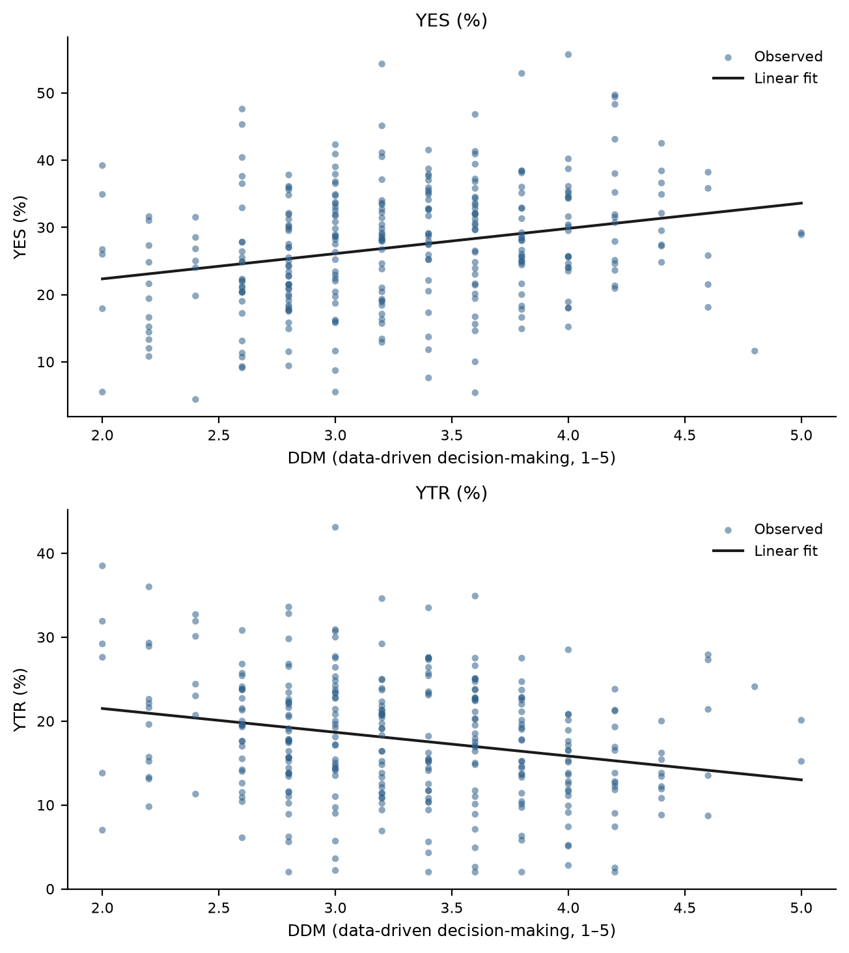
Figure 2. Youth employee share and youth turnover rate in relation to data-driven decision-making. Source: authors’ design.
The third model, centered on AI application breadth (AIA), reveals the most differentiated pattern (Pillai's Trace = 0.068, Wilks' Lambda = 0.932, F(2, 305) = 11.188, $p$ < 0.001). AIA is significantly associated with lower youth turnover (B = −0.790, $p$ < 0.001, partial $η_{p}^{2}$ = 0.061): each additional AI-enabled function is associated with roughly three-quarters of a percentage point less youth churn. By contrast, its association with the youth employee share does not reach the conventional 5% significance threshold (B = 0.402, $p$ = 0.074) and can only be interpreted as marginal at the 10% level; it is therefore treated cautiously. Deploying AI widely, in other words, is associated with keeping young employees but not, by itself, with employing more of them (Table 6, Figure 3).
Table 6. Parameter estimates for the relationship between AI application breadth and youth-employment outcomes.
Dependent Variable | Parameter | B | Std. Error | t | Sig. | 95% CI  Lower | 95% CI  Upper | Partial Eta  Squared
YES | Intercept | 25.703 | 0.984 | 26.128 | 0.000 | 23.768 | 27.639 | 0.691
 | AIA | 0.402 | 0.225 | 1.790 | 0.074 | −0.040 | 0.845 | 0.010
YTR | Intercept | 20.767 | 0.773 | 26.868 | 0.000 | 19.246 | 22.288 | 0.702
 | AIA | −0.790 | 0.177 | −4.473 | 0.000 | −1.137 | −0.442 | 0.061
Notes: Source: authors’ calculations. Note: N = 308. CI = confidence interval.
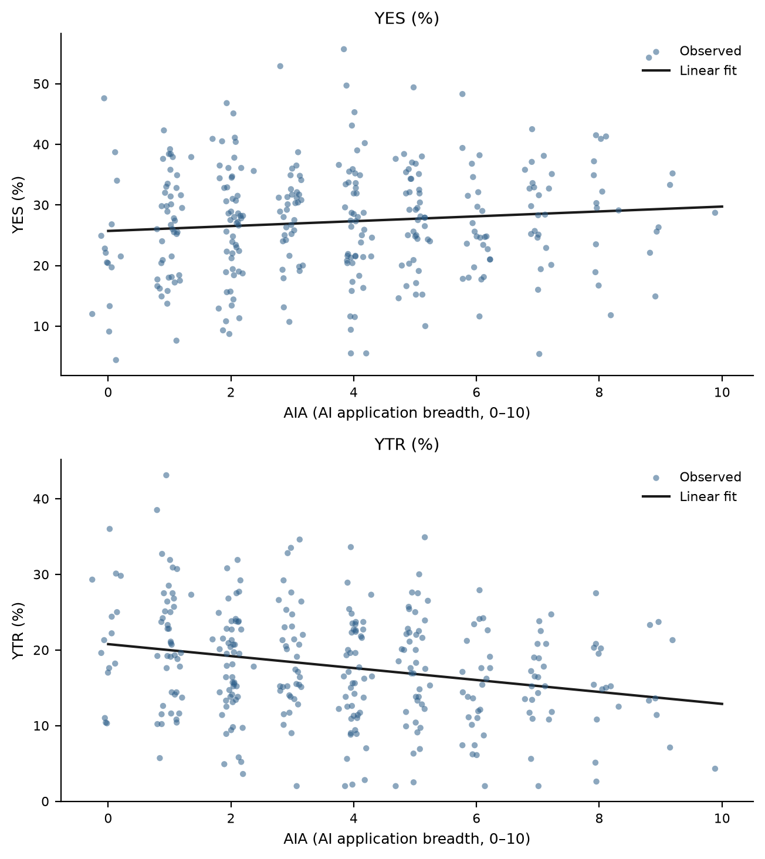
Figure 3. Youth employee share and youth turnover rate in relation to AI application breadth. Source: authors’ design.
The final model investigated digital skills training (DST). The multivariate test remains significant (Pillai's Trace = 0.096, Wilks' Lambda = 0.904, F(2, 305) = 16.248, $p$ < 0.001). DST shows a strong positive association with the youth employee share (B = 4.166, $p$ < 0.001, partial $η_{p}^{2}$ = 0.088), the second largest effect size among the four practices. However, its association with youth turnover is only marginal and does not meet the conventional 5% threshold (B = −1.255, $p$ = 0.052). Training-intensive firms thus employ markedly more young people, while the retention advantage of training is weaker and should not be overstated (Table 7, Figure 4).
Table 7. Parameter estimates for the relationship between digital skills training and youth-employment outcomes.
Dependent Variable | Parameter | B | Std. Error | t | Sig. | 95% CI  Lower | 95% CI  Upper | Partial Eta  Squared
YES | Intercept | 13.552 | 2.555 | 5.304 | 0.000 | 8.524 | 18.580 | 0.084
 | DST | 4.166 | 0.765 | 5.446 | 0.000 | 2.660 | 5.671 | 0.088
YTR | Intercept | 21.938 | 2.146 | 10.225 | 0.000 | 17.716 | 26.160 | 0.255
 | DST | −1.255 | 0.642 | −1.954 | 0.052 | −2.519 | 0.009 | 0.012
Notes: Source: authors’ calculations. Note: N = 308. CI = confidence interval.
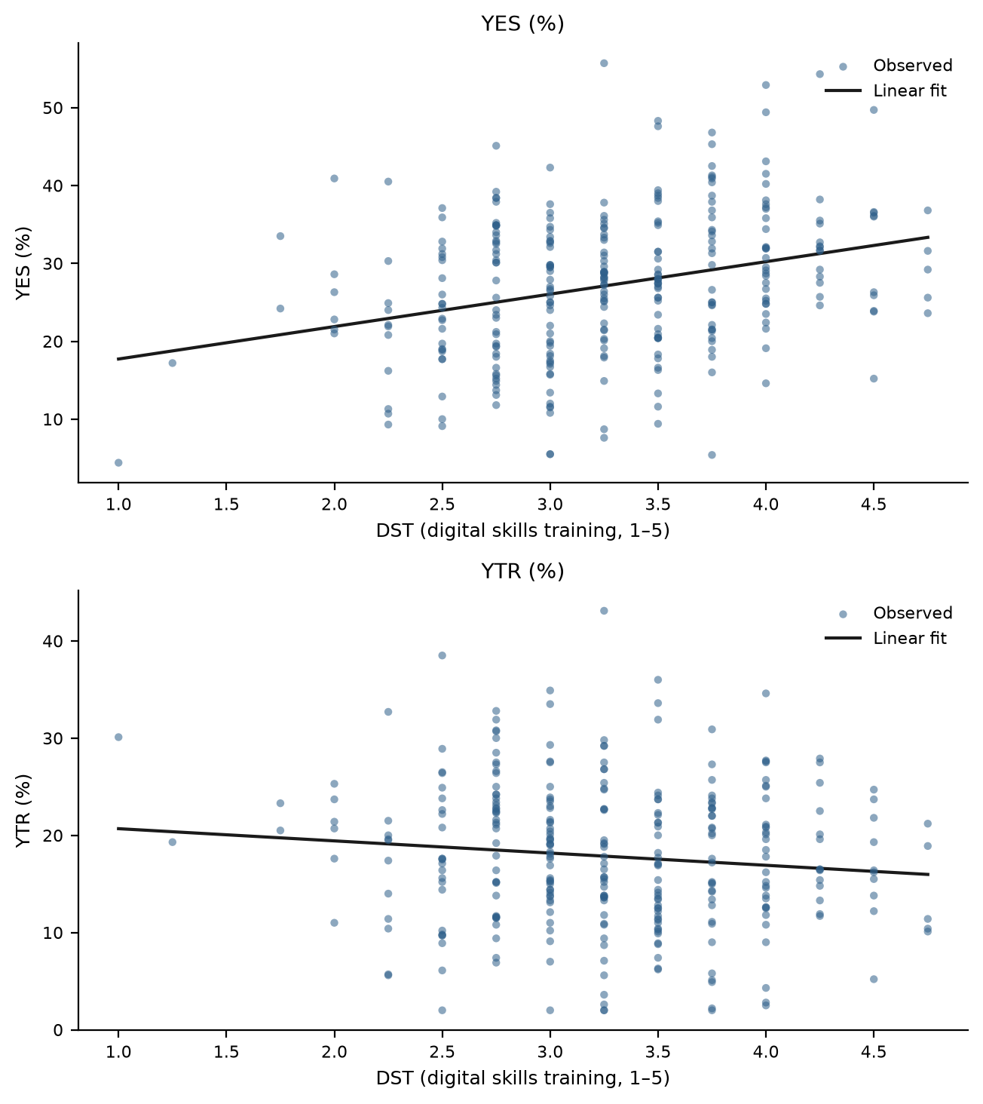
Figure 4. Youth employee share and youth turnover rate in relation to digital skills training. Source: authors’ design.
Overall, the four models suggest differentiated rather than uniform associations. Digital transformation leadership and data-driven decision-making are significantly associated with both outcomes; AI application breadth is significantly associated only with lower turnover, and digital skills training only with a higher youth share, each showing a marginal association with the respective other outcome. Therefore, H1 is only partially supported. Model diagnostics raise no concerns: Shapiro–Wilk tests do not reject residual normality in any of the eight univariate specifications (all $p$ ≥ 0.45), and the maximum Cook's distance across models is 0.08, well below common concern thresholds.
4.2. Robustness: Covariate-Adjusted Models and Structural Contextual Correlates
Because practice differences may overlap with structural firm characteristics, each model was re-estimated as a MANCOVA with firm size, firm age, R&D intensity, and the digital-core industry indicator as covariates (Table 8). The pattern of results is preserved in every model: the multivariate association of each practice remains significant, the adjusted coefficients of DTL, DDM, and DST on the youth share and of DTL, DDM, and AIA on turnover remain significant with essentially unchanged magnitudes, and the association of AIA with the youth share remains marginal ($p$ = 0.087). The only notable change is that the adjusted association of digital skills training with youth turnover strengthens slightly and crosses the 5% threshold ($p$ = 0.032), suggesting that the weak bivariate association partly reflected the confounding of training with firm size. These adjusted estimates should still be read as descriptive associations rather than causal effects.
Table 8. Covariate-adjusted (MANCOVA) estimates for the four practice dimensions.
Model (focal predictor) | Wilks' Lambda | F | Sig. | Adj. B  (YES) | Sig.  (YES) | Adj. B  (YTR) | Sig.  (YTR)
DTL | 0.840 | 28.625 | 0.000 | 4.960 | 0.000 | −3.463 | 0.000
DDM | 0.882 | 20.210 | 0.000 | 3.789 | 0.000 | −2.947 | 0.000
AIA | 0.927 | 11.782 | 0.000 | 0.390 | 0.087 | −0.826 | 0.000
DST | 0.904 | 16.055 | 0.000 | 4.124 | 0.000 | −1.388 | 0.032
Notes: Source: authors’ calculations. Covariates: lnSIZE, AGE, RDI, DIG. Adj. B = adjusted unstandardized coefficient of the focal predictor; multivariate statistics are Wilks’ Lambda F-tests for the focal predictor.
Supplementary bivariate correlations (Table 9) show that the practice indicators are largely independent of firm age and only weakly related to firm size, whereas the leadership, decision-making, and AI indicators correlate positively with R&D intensity and—most strongly for AIA—with operation in a digital-core industry; training intensity is essentially unrelated to R&D intensity. Practice differences therefore partly track the innovation profile and sector of firms, which is why the covariate-adjusted models above, rather than the bivariate models alone, underpin our conclusions. The non-response comparisons reported in Section 3.1 and the common-method checks in Section 3.2 complete the robustness assessment.
Table 9. Supplementary bivariate correlations of practice indicators with structural contextual variables.
Structural Contextual Variable | DTL | DDM | AIA | DST
Firm size (lnSIZE) | 0.099 (p = 0.082) | 0.067 (p = 0.239) | 0.052 (p = 0.366) | 0.053 (p = 0.354)
Firm age (AGE) | 0.016 (p = 0.773) | −0.092 (p = 0.106) | −0.072 (p = 0.207) | −0.017 (p = 0.765)
R&D intensity (RDI) | 0.065 (p = 0.257) | 0.034 (p = 0.549) | 0.031 (p = 0.594) | −0.026 (p = 0.653)
Digital-core industry (DIG) | 0.110 (p = 0.053) | 0.096 (p = 0.093) | 0.132 (p = 0.021) | 0.085 (p = 0.135)
Notes: Source: authors’ calculations. Pearson correlation coefficients with p-values in parentheses. N = 308.
4.3. The Latent Dimension of Digital Leadership–Decision Capability and Its Systemic Associations with Youth Employment
The exploratory factor analysis aimed to reduce the four observable practice indicators to a common factor structure, capturing the aggregate process by which leadership, decision-making, technology deployment, and training articulate into a cohesive organizational capability. The KMO value of 0.767, the significance of Bartlett's test (χ2(6) = 288.287, $p$ < 0.001), and the significant correlations among the variables indicate that the data are suitable for extracting a common latent construct (Table 10). The first eigenvalue (2.327) accounts for 58.2% of the total variance, and the retained single factor explains 44.9% after extraction—a moderate common dimension consistent with four practices that share an underlying orientation without being redundant.
The communalities indicate that the latent factor is anchored primarily in digital transformation leadership (extraction communality 0.584) and data-driven decision-making (0.510), with digital skills training intermediate (0.379). AI application breadth has the lowest extracted communality (0.321), indicating that technology deployment shares less variance with the common capability dimension than the leadership, decision, and training practices do. This finding does not justify excluding the variable, since its loading remains substantial (0.566), but it foreshadows a central interpretive theme: deploying AI is not the same thing as leading digitally. The latent factor, labelled FACT_DLDM, reflects an emerging construct of digital leadership–decision capability in which managerial practices, rather than technology inventories, carry most of the common signal.
Table 10. Exploratory factor analysis of the digital leadership and decision-making practice indicators.
Indicator/Statistic | Value
Kaiser–Meyer–Olkin measure | 0.767
Bartlett's test of sphericity | χ2 = 288.287; df = 6; p < 0.001
Extraction method | Principal Axis Factoring
Number of factors extracted | 1
Initial eigenvalue, Factor 1 | 2.327
Initial variance explained | 58.182%
Extraction sum of squared loadings | 1.794
Variance explained after extraction | 44.850%
Rotation | No rotation
Communalities (initial/extraction); factor loadings
DTL | 0.399 / 0.584; loading = 0.764
DDM | 0.364 / 0.510; loading = 0.714
AIA | 0.241 / 0.321; loading = 0.566
DST | 0.284 / 0.379; loading = 0.616
Notes: Source: authors’ calculations. Principal Axis Factoring on the correlation matrix of DTL, DDM, AIA, and DST; one factor retained; factor scores by the regression method.
The first regression analyzed the relationship between the latent capability factor and the youth employee share. The model indicates a positive and statistically significant relationship, with a correlation coefficient of 0.327 and an explanatory capacity of approximately 11% of the variation in the youth share ($R^{2}$ = 0.107; adjusted $R^{2}$ = 0.104). The F test indicates that the model is statistically significant (F = 36.665, $p$ < 0.001). On average, a one-standard-deviation rise in FACT_DLDM is associated with an increase of about 2.98 percentage points in the youth employee share (B = 2.980, β = 0.327) (Table 11).
Table 11. Regression results for the relationship between the latent digital leadership–decision capability factor and the youth employee share.
Model | R | R Square | Adjusted  R Square | Std. Error of  the Estimate
1 | 0.327 | 0.107 | 0.104 | 8.614
Model | Sum of  Squares | df | Mean Square | F | Sig.
Regression  Residual  Total | 2720.747  22706.792  25427.539 | 1  306  307 | 2720.747  74.205 | 36.665 | 0.000
Model | Unstandardized  Coefficients: B | Std.  Error | Standardized  Coefficients: Beta | t | Sig.
(Constant)  FACT_DLDM | 27.202  2.980 | 0.491  0.492 | 0.327 | 55.427  6.063 | 0.000  0.000
Notes: Source: authors’ calculations. Dependent variable: YES. Predictor: factor scores of FACT_DLDM (standardized).
The second regression examines the association between the latent factor and youth turnover. The model shows a negative association (r = −0.288) and explains around 8% of the variation in the youth turnover rate ($R^{2}$ = 0.083; adjusted $R^{2}$ = 0.080; F = 27.697, $p$ < 0.001). A one-standard-deviation rise in the factor score is associated with a decrease of about 2.12 percentage points in youth turnover (B = −2.119, β = −0.289) (Table 12). These results provide support for H2: the latent dimension of digital leadership–decision capability is significantly associated with both a younger and a more stable young workforce, consistent with the socio-technical expectation that configurations of practice, rather than single levers, carry systemic workforce correlates.
Table 12. Regression results for the relationship between the latent digital leadership–decision capability factor and the youth turnover rate.
Model | R | R Square | Adjusted  R Square | Std. Error of  the Estimate
1 | 0.288 | 0.083 | 0.080 | 7.042
Model | Sum of  Squares | df | Mean Square | F | Sig.
Regression  Residual  Total | 1373.615  15175.963  16549.578 | 1  306  307 | 1373.615  49.595 | 27.697 | 0.000
Model | Unstandardized  Coefficients: B | Std.  Error | Standardized  Coefficients: Beta | t | Sig.
(Constant)  FACT_DLDM | 17.825  −2.119 | 0.401  0.402 | −0.289 | 44.428  −5.273 | 0.000  0.000
Notes: Source: authors’ calculations. Dependent variable: YTR. Predictor: factor scores of FACT_DLDM (standardized).
4.4. Emerging Socio-Technical Typologies: Organizational Profiles of Digital Practice and Youth Employment
To explore the latent structure of the relationships between digital practices and youth-employment outcomes at the level of whole configurations, the analysis began with hierarchical clustering of the six standardized variables, using the average linkage method and the Pearson correlation coefficient to measure proximity between firms. The truncated dendrogram presented in Figure 5 suggests a two-group structure in the sample. Following this exploratory indication, the k-means algorithm was applied for k = 2, 3, and 4; the average silhouette coefficient favors the two-cluster solution (0.282 versus 0.190 and 0.173), and the hierarchical and k-means partitions agree for 82.8% of firms. The resulting two-cluster solution should be interpreted as an exploratory and descriptive typology, not as a definitive classification of enterprises.
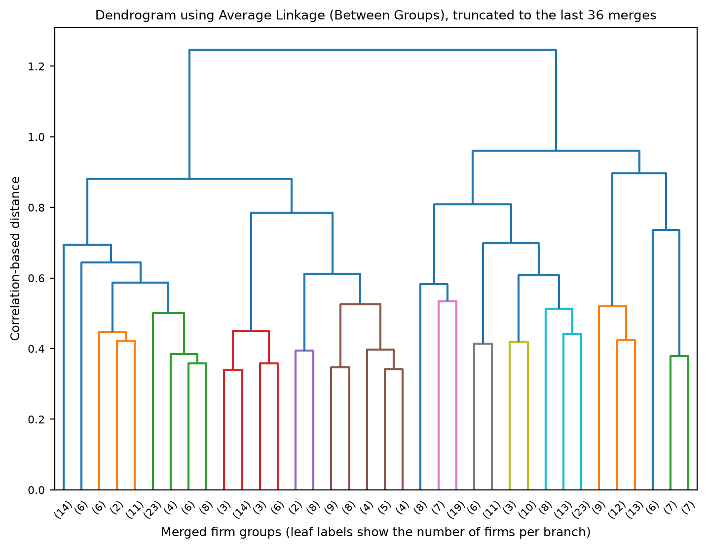
Figure 5. Dendrogram of the hierarchical clustering of firms based on digital practices and youth-employment outcomes (average linkage, truncated to the last 36 merges). Source: authors’ design.
The cluster centers provide a synthetic view of the two exploratory typologies (Table 13). The first cluster (n = 135) unites digitally led, youth-integrating firms: average digital leadership of 3.81 and data-driven decision-making of 3.78 on the five-point scales, 5.27 AI-enabled functions, training intensity of 3.71, a youth employee share of 30.24%, and youth turnover of 14.81%. The second cluster (n = 173) groups conventionally managed firms with substantially lower digital practice levels (2.94, 2.92, 2.52, and 2.93, respectively), a lower youth share (24.83%), and markedly higher youth turnover (20.18%). The digitally led cluster contains a higher share of digital-core firms (31.9% versus 25.4%), yet manufacturing firms form a plurality of both clusters, indicating that the typology cuts across sector boundaries rather than merely reproducing them.
As a minimal validation metric, the average silhouette coefficient of the final two-cluster solution is 0.282 (0.279 for Cluster 1 and 0.285 for Cluster 2). These positive values indicate modest but coherent internal structure, appropriate for exploratory purposes; the separation should not be interpreted as strong. The ANOVA results in Table 13 provide a descriptive characterization of the differences between the clusters. Because the clusters were formed using the same variables that are subsequently compared, the F values are descriptive and should not be treated as independent hypothesis tests. With this caveat, the practice variables separate the clusters most sharply, and both youth-employment outcomes also differ substantially between the profiles. Overall, the cluster analysis supports Hypothesis H3: firms can be grouped into meaningful socio-technical typologies in which digital leadership, decision practice, technology, training, and youth outcomes cohere.
Table 13. Cluster centers and differences between clusters (ANOVA).
Variable | Cluster 1 Mean  (n = 135) | Cluster 2 Mean  (n = 173) | Overall  Mean | F | Sig.
DTL | 3.81 | 2.94 | 3.32 | 387.542 | 0.000
DDM | 3.78 | 2.92 | 3.30 | 275.097 | 0.000
AIA | 5.27 | 2.52 | 3.72 | 165.805 | 0.000
DST | 3.71 | 2.93 | 3.28 | 169.299 | 0.000
YES | 30.24 | 24.83 | 27.20 | 29.170 | 0.000
YTR | 14.81 | 20.18 | 17.83 | 46.633 | 0.000
Notes: Source: authors’ calculations. k-means with k = 2 on standardized variables; means reported in original units. ANOVA df = (1, 306); F values are descriptive (see text).
5. Discussion
The data suggest a differentiated pattern of associations between digital transformation practices and the youth-employment profile of firms. Rather than implying a causal process, these findings point to cross-sectional co-occurrences that may reflect broader organizational and sectoral conditions. This interpretation is consistent with the literature that characterizes digital transformation as a capability-driven, organization-wide reconfiguration whose workforce consequences depend on the adoption context and on the complementarities between technology and the human factor [1,29,39].
The four models should not be interpreted as comparing the independent or partial contribution of each practice dimension. Since the practice variables are conceptually related and substantially correlated, each single-predictor model may partly reflect the same broader configuration of digitally oriented management. For this reason, the results are interpreted as parallel cross-sectional associations, while the exploratory factor analysis provides a complementary means of summarizing their common latent structure, and the covariate-adjusted models bound the extent to which structural firm characteristics account for the associations.
The results of the multivariate models provide partial support for H1, and the deviations from uniformity are themselves informative. Digital transformation leadership emerges as the practice most consistently associated with youth outcomes, echoing evidence that leadership is the binding constraint of digital transformation rather than technology itself [2,5,37]. The association of data-driven decision-making with both outcomes extends the analytics literature—which has concentrated on innovation and performance [6,24,25]—to workforce composition, and is consistent with survey evidence that merit-legible, data-transparent management appeals to new-generation employees in China [19,20].
The most striking asymmetry concerns AI application breadth. AI-rich firms retain young employees better—plausibly because AI absorbs the most repetitive task content of junior roles, improving job quality [12,47,48]—but breadth of deployment is not associated with employing proportionally more young people once its correlation with the other practices is set aside. This nuance aligns with task-based accounts in which automation both displaces entry-level routine work and reinstates new tasks [27,50], with Chinese firm-level evidence of skill-structure upgrading without lower-skill expansion [8,10,51], and with socio-technical arguments that technology divorced from complementary organizational practice yields limited social-subsystem benefits [29,38]. Deployment, in short, is associated with keeping the young, while leadership, decision, and training practices are associated with bringing them in.
The strong association of digital skills training with the youth employee share, and its weaker (bivariate) association with turnover, complete this picture. Training operates on the hiring margin—signaling learning opportunities that young applicants prioritize [19,21]—and builds the firm-specific digital capital documented in the training literature [52,53]. That the covariate-adjusted association with turnover reaches significance suggests an embeddedness mechanism [28] partially masked by firm size in the raw data. Together with the leadership results, this supports a demand-side reading of youth employment in which organizational practice, not merely macro conditions, shapes young people's chances of entering and staying in employment [11,13].
The second hypothesis is supported by the latent factor of digital leadership–decision capability derived from factor analysis and regression models. The KMO value, the significance of Bartlett's test, and a single factor explaining 45% of the shared variance after extraction indicate that the four practices are not independent occurrences but expressions of a common capability dimension. That AI breadth carries the lowest communality reinforces the dynamic-capabilities reading: what is common to digitally successful firms is a managerial capacity to sense, decide, and develop—technology inventories follow from it, not the reverse [1,35,36]. The latent factor's positive association with the youth share and negative association with turnover suggests that young workers, digital capability, and workforce stability co-occur in more digitally mature organizational contexts. However, this interpretation remains exploratory and should not be taken as evidence that building digital capability increases youth employment.
The cluster analysis supports the third hypothesis and points to two distinct socio-technical regimes within a single regional economy. The digitally led, youth-integrating profile (135 firms) combines high practice levels with a younger, more stable workforce; the conventionally managed profile (173 firms) combines low practice levels with an older workforce and more than a third more youth turnover. These differences are described using statistical testing (ANOVA), but the cluster results should be read as descriptive and hypothesis-generating. The observed profiles may also reflect broader structural conditions—innovation intensity, sector, and product-market position—although the covariate-adjusted models and the sectoral composition of the clusters indicate that the typology is not reducible to industry membership. This result aligns with configurational research in management [33] and with studies of heterogeneous digital transformation trajectories among firms [39,54,58]. Reverse causality remains plausible throughout: firms with younger workforces may find digital transformation easier to lead, and firms that retain young digital talent may accumulate capability faster [42,59].
5.1. Theoretical Implications
Theoretically, the findings extend upper echelons and dynamic-capabilities reasoning to an outcome those literatures rarely examine: the age composition and stability of the workforce. If organizational outcomes reflect managerial cognition and capability [3,34,35], then who gets hired and retained—not only how much is innovated—should bear the imprint of leadership; our results are consistent with exactly that imprint. The study also enriches the socio-technical systems tradition [29–31] by treating youth integration as a social-subsystem outcome that co-varies with the joint configuration of technical deployment and managerial practice, and by showing empirically that the technical element (AI breadth) is the configuration's weakest common denominator. Finally, the demonstration that a single latent capability factor summarizes four distinct practices, and that firms cluster into interpretable regimes, supports configurational over variable-centric theorizing about digital transformation [32,33].
5.2. Practical Implications
The findings offer several practical implications for executives, HR leaders, policy-makers, and educational institutions involved in youth-employment governance. For enterprise leaders, the differentiated pattern cautions against equating digital transformation with technology procurement. Firms that wish to rejuvenate their workforce should pair AI deployment with visible transformation leadership, data-transparent decision processes, and youth-oriented training pipelines—the practices associated with actually employing young people. Embedding analytics in HR decisions may additionally serve retention by making career processes legible to new-generation employees [20,43]. For young job seekers and career services, the typology suggests screening employers for leadership and training signals—not merely for technology stacks—when assessing where digital careers are likely to flourish [21].
For policy-makers concerned with youth employment, the results direct attention to the demand side: programs that subsidize digital-skills training inside firms, diffuse data-driven management practice to SMEs, and develop digital leadership in traditional sectors may complement conventional supply-side measures such as graduate skills programs [13,54]. In regional economies like Zhejiang, where digital infrastructure is already strong, the binding constraint indicated by our clusters is managerial rather than infrastructural: a majority of surveyed firms operate a conventionally managed regime with weak youth integration despite operating in the same environment as digitally led peers [22,59]. Policy instruments that pair technology-adoption subsidies with management-upgrading and youth-training conditions could address both subsystems simultaneously.
5.3. Limitations and Further Research
The research provides a useful systemic view of the relationship between digital transformation practices and youth employment inside firms, but the results need to be read alongside several constraints. The first is the cross-sectional design: the analysis reflects associations at a single point in time and cannot establish causal direction; reverse causality and omitted organizational variables remain plausible. Future studies should employ panel designs that track practices and workforce composition over time. The second limitation concerns measurement: practices are reported by a single senior informant per firm, and although the outcomes are quasi-objective workforce statistics and common-method checks were passed, mono-informant designs cannot fully exclude method variance [64,65]; matched multi-informant or administrative data would strengthen inference. Third, the youth employee share and turnover rate are coarse summary indicators that do not distinguish occupations, contract types, or job quality; linked employer–employee data could reveal which young workers digitally led firms actually employ [17].
A further limitation is the single-region scope. Zhejiang's dense digital economy makes it a revealing but non-representative setting; replication across regions with weaker digital infrastructure, and across institutional contexts outside China, would test the boundary conditions of the associations [11,54]. The exploratory factor analysis should be regarded as a preliminary identification of a common capability dimension rather than a definitive measurement model; confirmatory approaches with larger item pools are a natural next step. Cluster analysis, finally, is exploratory and depends on the selected variables, distance measure, and algorithm; the modest silhouette values counsel caution, and future research should validate the typology with additional criteria, external validation variables, and alternative clustering specifications [57,70]. Extending the outcome set to youth career progression inside firms—promotion, wage growth, and skill certification—would connect this organizational typology to the broader youth career-development agenda [12,71].
6. Conclusions
This study examined the cross-sectional associations between four digital transformation practices—digital transformation leadership, data-driven decision-making, AI application breadth, and digital skills training—and two youth-employment outcomes—the youth employee share and the youth turnover rate—in a survey of 308 enterprises in Zhejiang Province, China. By combining MANOVA-type multivariate models, exploratory factor analysis, and cluster analysis, the study provides a differentiated, system-level view of how leadership, decision-making, and digital transformation relate to the position of young people inside firms. The findings should be interpreted as exploratory associations, not as evidence of causal effects.
The results show that the relationship between digital practice and youth employment is not uniform across dimensions. Digital transformation leadership and data-driven decision-making are significantly associated with both a higher youth employee share and lower youth turnover. AI application breadth is significantly associated with lower youth turnover, but its association with the youth share does not reach the conventional significance threshold; digital skills training shows the mirror-image pattern. These findings indicate that the youth-employment relevance of digital transformation depends on the practice through which it is enacted, with managerial practices—not technology deployment—carrying the hiring-side association.
The factor analysis further suggests that the four practices share a moderate common latent dimension of digital leadership–decision capability, which is significantly associated with both outcomes, supporting the interpretation that youth-employment profiles attach to organizational capability configurations rather than to isolated practices. The cluster analysis identifies two exploratory socio-technical regimes—digitally led, youth-integrating firms and conventionally managed firms with weaker youth outcomes—that cut across sector boundaries within a single regional economy.
From a policy perspective, the findings do not justify claims that digital transformation directly improves youth employment. Rather, they suggest that leadership capability, decision practice, and training provision are the organizational sites where digital transformation and youth opportunity meet. Policies and corporate strategies focused exclusively on technological diffusion are unlikely to be sufficient; approaches that develop digital leadership, diffuse data-driven management, and condition support on youth-oriented skills investment address the configuration to which favorable youth outcomes attach. Future research should use longitudinal and multi-informant designs, extend the outcome set to career progression, and test whether the socio-technical typologies identified here generalize across regions and institutional contexts.
Author Contributions: Conceptualization, X.C. and T.M.; methodology, X.C.; software, X.C.; validation, X.C., D.H. and T.M.; formal analysis, X.C.; investigation, D.H.; resources, T.M.; data curation, D.H.; writing—original draft preparation, X.C.; writing—review and editing, T.M.; visualization, D.H.; supervision, T.M.; project administration, T.M.; funding acquisition, X.C. All authors have read and agreed to the published version of the manuscript.
Funding: This research was funded by the Zhejiang Provincial Philosophy and Social Sciences Planning Special Project on Higher Education Basic Research Funding Reform (Grant Number: 25NDJC153YBMS) and the Major Humanities and Social Sciences Research Projects in Zhejiang Higher Education Institutions (Grant Number: 2024QN018).
Institutional Review Board Statement: The study was conducted in accordance with the Declaration of Helsinki and approved by the Academic Ethics Committee of the College of Business, Jiaxing University (protocol code JXU-BUS-2025-108, approved on 28 October 2025).
Informed Consent Statement: Informed consent was obtained from all respondents involved in the study.
Data Availability Statement: The data presented in this study are available on request from the corresponding author due to the confidentiality commitments made to participating firms. The analysis code is available from the authors upon reasonable request.
Conflicts of Interest: The authors declare no conflicts of interest.
Abbreviations
The following abbreviations are used in this manuscript:
Abbreviation | Definition
DTL | Digital transformation leadership
DDM | Data-driven decision-making
AIA | AI application breadth
DST | Digital skills training
YES | Youth employee share (% of employees aged 16–29)
YTR | Youth turnover rate (% among employees younger than 30)
FACT_DLDM | Latent factor of digital leadership–decision capability
AI | Artificial intelligence
EFA | Exploratory factor analysis
PAF | Principal Axis Factoring
KMO | Kaiser–Meyer–Olkin measure of sampling adequacy
MANOVA/MANCOVA | Multivariate analysis of (co)variance
CI | Confidence interval
HR | Human resources
RDI | R&D intensity
SME | Small and medium-sized enterprise
Appendix A
Table A1 lists the measurement items of the three reflective constructs together with their standardized loadings from single-factor Principal Axis Factoring within each construct. All items were administered in Chinese on five-point Likert scales (1 = strongly disagree, 5 = strongly agree) following translation and back-translation [61].
Table A1. Measurement items and standardized factor loadings.
Construct | Code | Item wording (English translation) | Loading
DTL | DTL1 | Our top managers communicate a clear vision of the firm's digital future. | 0.660
 | DTL2 | Senior leaders personally champion major digital initiatives. | 0.659
 | DTL3 | Leaders in this firm encourage experimentation with new digital tools. | 0.692
 | DTL4 | Our executives allocate sufficient resources to digital transformation. | 0.720
 | DTL5 | Senior managers actively remove obstacles to digital ways of working. | 0.739
 | DTL6 | Our leadership team keeps digital transformation on the strategic agenda. | 0.701
DDM | DDM1 | Major operational decisions in this firm are based on data analysis. | 0.740
 | DDM2 | We routinely use data dashboards or analytics when making market decisions. | 0.673
 | DDM3 | Decisions about people (hiring, staffing, promotion) draw on HR data and metrics. | 0.701
 | DDM4 | When opinions differ, data usually settles the argument in this firm. | 0.727
 | DDM5 | We evaluate the outcomes of past decisions with quantitative indicators. | 0.737
DST | DST1 | This firm provides systematic training in digital skills. | 0.703
 | DST2 | Young employees receive priority access to digital upskilling programs. | 0.671
 | DST3 | Employees are given work time to learn new digital tools. | 0.690
 | DST4 | Digital training in this firm is updated as new technologies are adopted. | 0.708
Notes: Source: authors’ design. Loadings from within-construct Principal Axis Factoring (N = 308).
The AI application breadth (AIA) index asked whether AI technologies are used in each of the following ten business functions: customer service (chatbots or virtual assistants); recruitment and résumé screening; marketing content generation or targeting; sales forecasting; production scheduling or process optimization; quality inspection (machine vision); logistics and inventory optimization; financial analysis or risk control; internal knowledge search or office copilots; and product or R&D design assistance. The index is the count of functions marked.
References
1. Vial, G. Understanding digital transformation: A review and a research agenda. J. Strateg. Inf. Syst. 2019, 28, 118–144.
2. AlNuaimi, B.K.; Singh, S.K.; Ren, S.; Budhwar, P.; Vorobyev, D. Mastering digital transformation: The nexus between leadership, agility, and digital strategy. J. Bus. Res. 2022, 145, 636–648.
3. Hambrick, D.C.; Mason, P.A. Upper Echelons: The Organization as a Reflection of Its Top Managers. Acad. Manag. Rev. 1984, 9, 193–206.
4. Lin, Q. Digital leadership: A systematic literature review and future research agenda. Eur. J. Innov. Manag. 2025, 28, 2469–2488.
5. Philip, J.; Gilli, K.; Knappstein, M. Identifying key leadership competencies for digital transformation: Evidence from a cross-sectoral Delphi study of global managers. Leadersh. Organ. Dev. J. 2023, 44, 392–406.
6. Brynjolfsson, E.; McElheran, K. The Rapid Adoption of Data-Driven Decision-Making. Am. Econ. Rev. 2016, 106, 133–139.
7. Ghasemaghaei, M.; Calic, G. Does big data enhance firm innovation competency? The mediating role of data-driven insights. J. Bus. Res. 2019, 104, 69–84.
8. Qin, S.; Liu, Z.; Wang, J.; Wu, Y. The impact of digital transformation on labour demand quantity and structure: Evidence from China. Econ. Anal. Policy 2024, 84, 1452–1469.
9. Dou, B.; Guo, S.; Chang, X.; Wang, Y. Corporate digital transformation and labor structure upgrading. Int. Rev. Financ. Anal. 2023, 90, 102904.
10. Xie, M.; Ding, L.; Xia, Y.; Guo, J.; Pan, J.; Wang, H. Does artificial intelligence affect the pattern of skill demand? Evidence from Chinese manufacturing firms. Econ. Model. 2021, 96, 295–309.
11. Friedrich, A. School-leaving certificates and vocational education and training—The role of firms as gatekeepers in Germany. Int. J. Manpow. 2025, 46, 125–147.
12. Bankins, S.; Jooss, S.; Restubog, S.L.D.; Marrone, M.; Ocampo, A.C.; Shoss, M. Navigating career stages in the age of artificial intelligence: A systematic interdisciplinary review and agenda for future research. J. Vocat. Behav. 2024, 153, 104011.
13. International Labour Organization (ILO). Global Employment Trends for Youth 2024: Decent Work, Brighter Futures; ILO: Geneva, Switzerland, 2024.
14. Rahmani, H.; Groot, W.; Rahmani, A.M. Unravelling the NEET phenomenon: A systematic literature review and meta-analysis of risk factors for youth not in education, employment, or training. Int. J. Adolesc. Youth 2024, 29, 2331576.
15. Ou, D.; Zhao, Z. Higher Education Expansion in China, 1999–2003: Impact on Graduate Employability. China World Econ. 2022, 30, 117–141.
16. Jones, M.K.; Kaya, E.; Nan, J. Overeducation, earnings and job satisfaction among graduates in China. China Econ. Rev. 2025, 93, 102448.
17. Xiong, B.; Yu, B. The Impact of Internet Development on Youth’s Job Quality in the Digital Economy Era: Transmission Mechanism and Empirical Test. Soc. Indic. Res. 2024, 175, 269–294.
18. Zhong, S.; Zhang, X.; Zhang, L.; Zhao, C. How does digital economy influence urban common prosperity? Evidence from China’s demonstration area for common prosperity. Int. Rev. Econ. Financ. 2025, 104, 104629.
19. Benítez-Márquez, M.D.; Sánchez-Teba, E.M.; Bermúdez-González, G.; Núñez-Rydman, E.S. Generation Z Within the Workforce and in the Workplace: A Bibliometric Analysis. Front. Psychol. 2022, 12, 736820.
20. Lu, J.; Guo, S.; Qu, J.; Lin, W.; Lev, B. “Stay” or “Leave”: Influence of employee-oriented social responsibility on the turnover intention of new-generation employees. J. Bus. Res. 2023, 161, 113814.
21. Halová, D.; Müller, M. Being an Employer of Choice: Attracting Generation Z to Work by Building Brand via Social Media. Corp. Reput. Rev. 2024, 27, 283–298.
22. Yang, Y.; Lin, G.T.R. Local Digital Economic Growth, Enterprise Digital Transformation, and Digital Dividends: Evidence from China. Systems 2025, 13, 297.
23. Zhuang, T.; Zhao, S. Collaborative innovation relationship in Yangtze River Delta of China: Subjects collaboration and spatial correlation. Technol. Soc. 2022, 69, 101974.
24. Chatterjee, S.; Chaudhuri, R.; Gupta, S.; Sivarajah, U.; Bag, S. Assessing the impact of big data analytics on decision-making processes, forecasting, and performance of a firm. Technol. Forecast. Soc. Change 2023, 196, 122824.
25. Chaudhuri, R.; Chatterjee, S.; Mariani, M.M.; Fosso Wamba, S. Assessing the influence of emerging technologies on organizational data driven culture and innovation capabilities: A sustainability performance perspective. Technol. Forecast. Soc. Change 2024, 200, 123165.
26. Başol, O.; Sevgi, H.; Yalçın, E.C. The Effect of Digitalization on Youth Unemployment for EU Countries: Treat or Threat? Sustainability 2023, 15, 11080.
27. Acemoglu, D.; Restrepo, P. Automation and New Tasks: How Technology Displaces and Reinstates Labor. J. Econ. Perspect. 2019, 33, 3–30.
28. Mitchell, T.R.; Holtom, B.C.; Lee, T.W.; Sablynski, C.J.; Erez, M. Why people stay: Using job embeddedness to predict voluntary turnover. Acad. Manag. J. 2001, 44, 1102–1121.
29. Makarius, E.E.; Mukherjee, D.; Fox, J.D.; Fox, A.K. Rising with the machines: A sociotechnical framework for bringing artificial intelligence into the organization. J. Bus. Res. 2020, 120, 262–273.
30. Iden, J.; Bygstad, B. Sociotechnical micro-foundations for digital transformation. Eur. J. Inf. Syst. 2025, 34, 367–382.
31. Trist, E.L.; Bamforth, K.W. Some Social and Psychological Consequences of the Longwall Method of Coal-Getting. Hum. Relat. 1951, 4, 3–38.
32. Benbya, H.; Nan, N.; Tanriverdi, H.; Yoo, Y. Complexity and Information Systems Research in the Emerging Digital World. MIS Q. 2020, 44, 1–17.
33. Ketchen, D.J., Jr.; Shook, C.L. The application of cluster analysis in strategic management research: An analysis and critique. Strateg. Manag. J. 1996, 17, 441–458.
34. Hambrick, D.C. Upper Echelons Theory: An Update. Acad. Manag. Rev. 2007, 32, 334–343.
35. Teece, D.J. Explicating dynamic capabilities: The nature and microfoundations of (sustainable) enterprise performance. Strateg. Manag. J. 2007, 28, 1319–1350.
36. Schulz, C.; Bendig, D.; Kriebel, J.; Haubner, K.; Fainshmidt, S. CEO Human Capital and Digital Product Innovation: A Dynamic Managerial Capabilities Perspective. Inf. Syst. Res. 2026, 37, 863–885.
37. Merín-Rodrigáñez, J.; Dasí, À.; Alegre, J.; Hughes, M. Dynamic managerial capabilities for digital transformation in innovative SMEs: What are the effects on new product development performance? J. Bus. Res. 2025, 201, 115709.
38. Herrmann, T.; Pfeiffer, S. Keeping the organization in the loop: A socio-technical extension of human-centered artificial intelligence. AI Soc. 2023, 38, 1523–1542.
39. Browder, R.E.; Dwyer, S.M.; Koch, H. Upgrading adaptation: How digital transformation promotes organizational resilience. Strateg. Entrep. J. 2024, 18, 128–164.
40. Zeike, S.; Bradbury, K.; Lindert, L.; Pfaff, H. Digital Leadership Skills and Associations with Psychological Well-Being. Int. J. Environ. Res. Public Health 2019, 16, 2628.
41. Qiao, G.; Li, Y.; Hong, A. The Strategic Role of Digital Transformation: Leveraging Digital Leadership to Enhance Employee Performance and Organizational Commitment in the Digital Era. Systems 2024, 12, 457.
42. Li, X.; Wang, Q.; Kong, D.; Tao, Y. Intelligent Manufacturing and Corporate Human Capital Upgrade in China. J. Asian Econ. 2025, 97, 101886.
43. Budhwar, P.; Chowdhury, S.; Wood, G.; Aguinis, H.; Bamber, G.J.; Beltran, J.R.; Boselie, P.; Cooke, F.L.; Decker, S.; DeNisi, A.; et al. Human resource management in the age of generative artificial intelligence: Perspectives and research directions on ChatGPT. Hum. Resour. Manag. J. 2023, 33, 606–659.
44. Jiang, S.; Guo, Y. Reasons for college major-job mismatch and labor market outcomes: Evidence from China. China Econ. Rev. 2022, 74, 101822.
45. Baabdullah, A.M. The precursors of AI adoption in business: Towards an efficient decision-making and functional performance. Int. J. Inf. Manag. 2024, 75, 102745.
46. Song, Y.; Qiu, X.; Liu, J. The Impact of Artificial Intelligence Adoption on Organizational Decision-Making: An Empirical Study Based on the Technology Acceptance Model in Business Management. Systems 2025, 13, 683.
47. Noy, S.; Zhang, W. Experimental evidence on the productivity effects of generative artificial intelligence. Science 2023, 381, 187–192.
48. Brynjolfsson, E.; Li, D.; Raymond, L. Generative AI at Work. Q. J. Econ. 2025, 140, 889–942.
49. Frey, C.B.; Osborne, M.A. The future of employment: How susceptible are jobs to computerisation? Technol. Forecast. Soc. Change 2017, 114, 254–280.
50. Eloundou, T.; Manning, S.; Mishkin, P.; Rock, D. GPTs are GPTs: Labor market impact potential of LLMs. Science 2024, 384, 1306–1308.
51. Wang, T.; Zhang, Y.; Liu, C. Robot adoption and employment adjustment: Firm-level evidence from China. China Econ. Rev. 2024, 84, 102137.
52. Heß, P.; Janssen, S.; Leber, U. The effect of automation technology on workers’ training participation. Econ. Educ. Rev. 2023, 96, 102438.
53. Konings, J.; Vanormelingen, S. The Impact of Training on Productivity and Wages: Firm-Level Evidence. Rev. Econ. Stat. 2015, 97, 485–497.
54. Škare, M.; de Obesso, M.d.l.M.; Ribeiro-Navarrete, S. Digital transformation and European small and medium enterprises (SMEs): A comparative study using digital economy and society index data. Int. J. Inf. Manag. 2023, 68, 102594.
55. Gomes, A.; Dias, J.G. Digital Divide in the European Union: A Typology of EU Citizens. Soc. Indic. Res. 2025, 176, 149–172.
56. Ionascu, C.M. Artificial Intelligence Adoption in the European Union: A Data-Driven Cluster Analysis (2021–2024). Economies 2025, 13, 145.
57. Jain, A.K. Data clustering: 50 years beyond K-means. Pattern Recognit. Lett. 2010, 31, 651–666.
58. Lu, R.; Peng, X.; Reve, T. Firms’ digital transformation, competitive strategies, and innovation: Evidence from Chinese listed companies. J. Manag. Organ. 2025, 31, 575–601.
59. Hua, Z.; Kong, S.; Yu, Y. Talent magnets in China: Can talent attraction policies catalyze digital transformation in enterprises? China Econ. Rev. 2025, 90, 102376.
60. Armstrong, J.S.; Overton, T.S. Estimating nonresponse bias in mail surveys. J. Mark. Res. 1977, 14, 396–402.
61. Brislin, R.W. Back-translation for cross-cultural research. J. Cross-Cult. Psychol. 1970, 1, 185–216.
62. Cronbach, L.J. Coefficient alpha and the internal structure of tests. Psychometrika 1951, 16, 297–334.
63. Hayes, A.F.; Coutts, J.J. Use omega rather than Cronbach’s alpha for estimating reliability. But… Commun. Methods Meas. 2020, 14, 1–24.
64. Podsakoff, P.M.; MacKenzie, S.B.; Lee, J.-Y.; Podsakoff, N.P. Common method biases in behavioral research: A critical review of the literature and recommended remedies. J. Appl. Psychol. 2003, 88, 879–903.
65. Podsakoff, P.M.; Podsakoff, N.P.; Williams, L.J.; Huang, C.; Yang, J. Common method bias: It’s bad, it’s complex, it’s widespread, and it’s not easy to fix. Annu. Rev. Organ. Psychol. Organ. Behav. 2024, 11, 17–61.
66. Hair, J.F.; Black, W.C.; Babin, B.J.; Anderson, R.E. Multivariate Data Analysis, 8th ed.; Cengage Learning EMEA: Andover, UK, 2019.
67. Kaiser, H.F. An index of factorial simplicity. Psychometrika 1974, 39, 31–36.
68. Bartlett, M.S. A note on the multiplying factors for various χ2 approximations. J. R. Stat. Soc. Ser. B 1954, 16, 296–298.
69. Ward, J.H., Jr. Hierarchical Grouping to Optimize an Objective Function. J. Am. Stat. Assoc. 1963, 58, 236–244.
70. Rousseeuw, P.J. Silhouettes: A graphical aid to the interpretation and validation of cluster analysis. J. Comput. Appl. Math. 1987, 20, 53–65.
71. Battisti, M.; Dustmann, C.; Schönberg, U. Technological and Organizational Change and the Careers of Workers. J. Eur. Econ. Assoc. 2023, 21, 1551–1594.
Disclaimer/Publisher’s Note: The statements, opinions and data contained in all publications are solely those of the individual author(s) and contributor(s) and not of MDPI and/or the editor(s). MDPI and/or the editor(s) disclaim responsibility for any injury to people or property resulting from any ideas, methods, instructions or products referred to in the content.

