Article
Leadership and Decision Making in Digitally Transforming Enterprises: Multivariate Modeling and Cluster Typologies of Decision Agility and Young Managerial Advancement
Xinyu Cai ¹, Dingpei Hu ¹ and Tiantian Mo ^{1,}*
Academic Editor: Firstname Lastname
Received: date
Revised: date
Accepted: date
Published: date
Citation: To be added by editorial staff during production.
Copyright: © 2026 by the authors. Submitted for possible open access publication under the terms and conditions of the Creative Commons Attribution (CC BY) license (https://creativecommons.org/licenses/by/4.0/).
¹ College of Business, Jiaxing University, Jiaxing 314001, China; caixinyu@zjxu.edu.cn
* Correspondence: 00008227@zjxu.edu.cn
Abstract
Navigating digital transformation is, at its core, an exercise in leadership and decision making: executives must decide what to digitalize, how to decide with data and artificial intelligence, and who is given a seat at the decision table. This paper examines how four leadership and decision-making practices—digital transformation leadership, the breadth of AI-assisted managerial decision-making, the digitalization of decision processes, and the involvement of young employees in transformation decisions—relate to two outcomes of today's enterprise systems: organizational decision agility and the advancement of young people into management. Evidence comes from an executive survey of 285 enterprises in China's Yangtze River Delta. The methodology combines MANOVA-type multivariate general linear models, exploratory factor analysis, and hierarchical plus k-means clustering. Results indicate differentiated associations: transformation leadership and digitalized decision processes are significantly associated with both greater agility and a larger share of young managers, whereas AI-assisted decision-making is associated with agility but only marginally with young managerial presence, and youth involvement shows the reverse pattern. A single latent factor—the leadership–decision configuration—underlies the four practices and is significantly associated with both outcomes, although AI breadth and youth involvement carry the lowest communalities. Cluster analysis identifies two decision regimes: an agile, digitally led regime with younger management and a conventional hierarchical regime, a distinction that cuts across sectors. The findings portray decision agility and managerial rejuvenation as joint properties of socio-technical decision systems rather than by-products of technology adoption, without implying causal relationships.
Keywords: digital transformation; leadership; decision making; artificial intelligence; decision agility; young managers; employee involvement; socio-technical systems; multivariate general linear model; cluster analysis

1. Introduction
Beneath every digital transformation lies a stream of decisions. Executives decide which processes to digitalize, whether forecasts and budgets should be produced by algorithms or by argument, how quickly the organization must respond when markets move, and—less visibly—who is entitled to participate in these choices [1–3]. The Special Issue theme that motivates this study frames digital transformation precisely in these terms: as a challenge of leadership and decision making in today's systems. Yet empirical research has typically studied leadership, decision processes, and the human side of transformation in isolation. How the leadership and decision-making practices of digitally transforming enterprises hang together, and what organizational properties accompany them, remains an open systemic question [4–6].
Two such properties are of particular interest. The first is decision agility—the capacity to make fast, high-quality decisions under uncertainty—which a long research tradition links to performance in turbulent environments [7–9] and which digital technologies promise to enhance [10,11]. The second is generational: who rises into management while the enterprise transforms. China's discussion of youth employment has concentrated on entry into work, but career advancement into managerial roles is the stage at which young people begin to shape organizations rather than merely join them [12–14]. Recent evidence that younger chief executives are associated with deeper corporate digital transformation suggests that rejuvenated management and digital capability may be mutually constitutive [15,16]. Whether the everyday leadership and decision practices of firms are systematically related to the presence of young people in management has, to our knowledge, not been examined.
The purpose of this article is to analyze how four leadership and decision-making practices relate jointly to decision agility and to young managerial advancement in enterprises navigating digital transformation. The practices are digital transformation leadership (DLV), the breadth of AI-assisted managerial decision-making across decision domains (ADM), the digitalization of decision processes (DPD), and the involvement of young employees in transformation decisions (EDI). The outcomes are organizational decision agility (ODA) and young managerial presence (YMP), measured as the share of managerial positions held by employees aged 35 or younger. The empirical setting is the Yangtze River Delta—Shanghai, Jiangsu, Zhejiang, and Anhui—China's most economically integrated macro-region and a national testbed for digital-economy policy [17–19].
Three gaps motivate the design. First, research on AI in managerial decision making has advanced conceptually [2,20,21] and experimentally [22,23], but firm-level survey evidence connecting the breadth of AI-assisted deciding to organizational outcomes remains scarce, particularly outside North America and Europe [24,25]. Second, decision agility is usually explained by structure and capability [8,9], seldom by the configuration of concrete decision practices that leaders install. Third, the literature on young people at work addresses attraction and retention [26–28] far more often than advancement; the demand-side question of which organizational practices accompany young people's access to managerial authority is largely unexplored [12,29]. There is also little research treating these elements as one socio-technical configuration rather than separate levers [30,31].
We address these gaps with a quantitative, cross-sectional executive survey and an integrated analytical strategy. Four MANOVA-type multivariate general linear models estimate the associations between each practice and the two correlated outcomes; exploratory factor analysis tests whether the practices express a common latent leadership–decision configuration; and hierarchical plus k-means clustering recovers emergent decision regimes among firms. Covariate-adjusted models and supplementary correlations bound the role of structural firm characteristics. The design therefore yields three complementary readings of the same system: bivariate, latent, and configurational [32,33].
The study contributes to the literature in four ways. First, it brings the two signature outcomes of the digital-transformation debate—agility and human capital—into a single organizational analysis, showing that they attach to partly different practices. Second, it offers among the first firm-level evidence on the breadth of AI-assisted managerial decision-making in Chinese enterprises, distinguishing its agility correlates from its (weaker) generational correlates. Third, it introduces young managerial presence as a demand-side indicator of youth career development and links it to concrete decision practices, notably the involvement of young employees in transformation decisions. Fourth, methodologically, it demonstrates how multivariate modeling, factor analysis, and clustering can be combined on primary survey data to describe leadership–decision systems at three levels of aggregation.
The remainder of the paper proceeds as follows. Section 2 develops the theoretical framework and hypotheses. Section 3 describes the sample, measures, and statistical methods. Section 4 reports the results of the multivariate models, the factor analysis, and the cluster analysis. Section 5 discusses the findings, their theoretical and practical implications, and the study's limitations. Section 6 concludes.
2. Theoretical Framework, Literature Review, and Hypotheses Development
Three theoretical lenses structure the analysis. Upper echelons theory holds that organizations reflect the cognitions and choices of their leaders, so that observable practices—what is digitalized, how decisions are made, who participates—encode the leadership orientation of the firm [16,34,35]. Organizational information-processing theory views decision arrangements as mechanisms that match information-processing capacity to task uncertainty; digital tools, AI models, and participative channels are alternative (and complementary) ways of expanding that capacity [2,36]. The socio-technical systems tradition, finally, insists that the technical apparatus of deciding and the social order of deciding must be designed jointly: dashboards without empowered users, or algorithms without legitimate decision rights, yield little [5,37–39]. Together these lenses imply that decision agility and the generational composition of management are not independent accidents but joint expressions of how the leadership–decision system is configured [6,40].
2.1. Leadership and Decision-Making Practices, Agility, and the Advancement of the Young
Digital transformation leadership—articulating a digital vision, championing change, and enabling experimentation—is the most studied practice of the four [4,41,42]. Leadership of this kind compresses decision paths: it legitimates action under uncertainty, reduces escalation, and aligns middle management around shared priorities, all of which the decision-speed literature identifies as accelerants [7,43]. The same leadership plausibly opens the managerial ladder to younger employees, both because transformation creates new digitally intensive management roles for which recent cohorts are well suited [44,45] and because digitally oriented executives value the technological fluency of the young when staffing them [15,26].
AI-assisted managerial decision-making extends algorithmic support from operations into the managerial core: forecasting, budgeting, pricing, staffing, and strategic scenario analysis [2,22]. Where such support is broad, decisions can be delegated to hybrid human–machine routines that respond faster than committee cycles, and experimental evidence indicates that AI support particularly accelerates structured evaluations [20,23,46]. Its generational implications are, however, ambivalent. Algorithmic support may substitute for exactly the junior analytical roles through which young managers once proved themselves [47–49], and delegating judgment to models does not by itself redistribute decision rights toward younger people [2,50]. We therefore expect the breadth of AI-assisted decision-making to be associated primarily with agility, with a weaker association with young managerial presence.
The digitalization of decision processes—real-time dashboards, a shared factual basis for meetings, systematic post-decision review—raises the quality and tempo of organizational choice by shortening the distance between events and responses [3,11,51]. Information-processing theory predicts agility gains [36], and evidence links data-driven cultures to innovation and responsiveness [10,52]. Digitalized decision processes should also favor the young in a subtler way: when decisions are argued from shared data rather than from seniority, the authority premium of tenure declines and demonstrated analytical competence—more evenly distributed across age groups—matters more [27,53].
Involving young employees in transformation decisions—through cross-level digital councils, reverse mentoring, young-talent task forces, and idea platforms—is the most explicitly generational of the four practices [54,55]. Voice research shows that participation improves decision inputs and signals that contributions are valued [55]; reverse mentoring additionally moves digital knowledge upward while moving visibility downward, placing young employees on the radar of senior sponsors [54]. We accordingly expect involvement to be associated above all with young managerial presence. Its agility association is less clear-cut: broader participation enriches information but also multiplies voices in the room, and the net effect on decision speed is theoretically contested [7,55]. Taken together, these arguments justify the following hypothesis:
Hypothesis H1. The four leadership and decision-making practices—digital transformation leadership, AI-assisted decision-making breadth, decision-process digitalization, and young-employee decision involvement—show significant cross-sectional associations with organizational decision agility and young managerial presence.
2.2. The Latent Leadership–Decision Configuration
Although the four practices are conceptually distinct, they are unlikely to be adopted independently. Leaders who champion transformation tend also to digitalize decision processes; firms that build AI into managerial routines usually do so on a foundation of data-driven practice; and participative channels are easier to open where leadership already sponsors change [1,25,43]. The dynamic capabilities perspective interprets this covariation as a higher-order managerial capacity to sense, decide, and reconfigure [40,56]; the socio-technical perspective interprets it as joint optimization of the technical and social sides of deciding [30,38]. Both predict a common latent dimension—a leadership–decision configuration—beneath the observable practices. If the configuration, rather than any single practice, is what matters systemically, its factor score should relate to both outcomes. This reasoning justifies the following hypothesis:
Hypothesis H2. A common latent factor—the leadership–decision configuration—underlies the four practice indicators and is significantly associated with both organizational decision agility and young managerial presence.
2.3. Decision Regimes as Socio-Technical Typologies
Configurational research cautions against assuming that firms array smoothly along a single continuum: attributes cluster into discrete, internally coherent bundles [32,57]. In decision-making terms, organizational theory has long contrasted regimes—fast, informated, delegated deciding versus slow, hierarchical, seniority-ordered deciding [7,36]. Digital transformation sharpens this contrast, because the practices examined here reinforce one another within a regime: dashboards feed AI models, AI frees managerial attention, participation channels surface the data-literate young, and agile decisions reward the whole configuration [10,31]. Within a macro-region whose firms share policy, infrastructure, and labor-market conditions [17,58], the differentiation that remains should be organizational. We therefore expect firms to sort into distinct decision regimes that differ jointly in practices, agility, and the generational profile of management. This reasoning justifies the following hypothesis:
Hypothesis H3. Firms form distinct socio-technical decision regimes (clusters) according to their leadership and decision-making practices, decision agility, and young managerial presence.
3. Materials and Methods
3.1. Research Design and Sample
The study employs a quantitative, cross-sectional survey of enterprises, with the firm as the unit of analysis and senior executives as key informants. Because the data are cross-sectional, the analysis identifies statistical associations and emergent patterns; it does not establish causal direction, and reverse causality is explicitly entertained in the discussion. The design follows the socio-technical premise that decision practices and organizational outcomes should be studied as configurations rather than isolated variables [5,37].
Fieldwork was conducted from March to May 2026 in the Yangtze River Delta (Shanghai, Jiangsu, Zhejiang, and Anhui), a macro-region that combines China's densest concentration of private enterprise with flagship digital-economy institutions, making it a natural laboratory for leadership and decision making under digital transformation [17–19]. Firms were sampled through executive-education alumni networks of business schools in the region and through enterprise associations, with quotas by province, sector (digital-core, manufacturing, other services), and size. The target informant was the chief executive or general manager; where unavailable, a deputy general manager, strategy executive, or chief information/digital officer with direct knowledge of decision processes completed the questionnaire.
Of 460 questionnaires distributed, 316 were returned (68.7%). After excluding 31 questionnaires with excessive missingness, failed attention checks, or unqualified respondents, 285 valid responses remained (a 62.0% valid response rate). Table 1 profiles the sample: manufacturing accounts for about half of the firms, CEOs or general managers personally completed 39.6% of questionnaires, and the four provinces are represented in proportions close to their enterprise populations. Non-response bias was examined by comparing the earliest and latest quartiles of returned questionnaires on all six focal variables [59]; the largest difference yields $p$ = 0.337, indicating no detectable wave effects.
Table 1. Sample profile (N = 285).
Characteristic | Category | n | %
Region | Shanghai | 77 | 27.0
 | Jiangsu | 83 | 29.1
 | Zhejiang | 70 | 24.6
 | Anhui | 55 | 19.3
Sector | Digital-core (ICT, e-commerce) | 73 | 25.6
 | Manufacturing | 146 | 51.2
 | Other services | 66 | 23.2
Firm size (employees) | 20–49 | 44 | 15.4
 | 50–249 | 145 | 50.9
 | 250–999 | 86 | 30.2
 | 1000+ | 10 | 3.5
Ownership | Private | 183 | 64.2
 | State-owned | 32 | 11.2
 | Foreign-invested | 37 | 13.0
 | Other | 33 | 11.6
Firm age (years) | 3–7 | 17 | 6.0
 | 8–14 | 113 | 39.6
 | 15–24 | 123 | 43.2
 | 25+ | 32 | 11.2
Respondent role | CEO / general manager | 113 | 39.6
 | Deputy GM / strategy executive | 101 | 35.4
 | CIO / CDO / other senior executive | 71 | 24.9
Notes: Source: authors’ survey. Percentages may not sum to 100 due to rounding.
3.2. Measures
Multi-item constructs use five-point Likert scales (1 = strongly disagree, 5 = strongly agree) adapted from established sources; Appendix A reports full item wording. The Chinese questionnaire followed the translation–back-translation protocol [60] and was piloted with nine executives. Digital transformation leadership (DLV, six items) adapts digital-leadership measures of vision, championing, and enablement [41,42]. Decision-process digitalization (DPD, five items) captures the extent to which decisions rest on real-time data, shared dashboards, and systematic post-decision review [3,11]. Young-employee decision involvement (EDI, four items) measures the institutionalized participation of employees under 35 in transformation decisions, including reverse mentoring and cross-level councils [54,55]. Organizational decision agility (ODA, five items) adapts decision-speed and responsiveness measures [7–9]. AI-assisted decision-making breadth (ADM) is a formative count of the managerial decision domains—out of ten listed, from demand forecasting to strategic scenario analysis—in which AI or advanced analytics tools are used [2,22].
Young managerial presence (YMP) is a workforce statistic reported by the informant: the percentage of managerial positions (first-line supervisor and above) held by employees aged 35 or younger at the end of 2025. Contextual variables are firm size (ln employees, lnSIZE), firm age (AGE), R&D intensity (RDI, % of revenue), and a digital-core industry indicator (DIG).
Reliability is satisfactory: Cronbach's α is 0.864 (DLV), 0.819 (DPD), 0.795 (EDI), and 0.830 (ODA) [61], with McDonald's ω between 0.796 and 0.864 [62]; all item loadings exceed 0.63 (Appendix A). ADM, being formative, is not assessed for internal consistency. Because one informant reports both practices and the agility outcome, common method bias deserves attention [63,64]: the questionnaire separated practice and outcome blocks, guaranteed anonymity, and used a factual statistic (YMP) for the second outcome. Harman's single-factor test across the 20 Likert items yields a first unrotated factor of 33.4% of variance, well below the 40% threshold; this test is coarse, but the differentiated correlation pattern reported below is itself difficult to reconcile with a single method factor [64]. Table 2 summarizes the variables.
Table 2. Variables and measures.
Variable | Construct/measure | Operationalization | Reliability | Source
DLV | Digital transformation leadership | 6 Likert items: vision, championing, enablement of digital change | α = 0.864; ω = 0.864 | [42,41]
ADM | AI-assisted decision-making breadth | Count of managerial decision domains using AI/advanced analytics (0–10), formative | n/a (index) | [2,22]
DPD | Decision-process digitalization | 5 Likert items: real-time data, shared dashboards, data-based review of decisions | α = 0.819; ω = 0.819 | [3,11]
EDI | Young-employee decision involvement | 4 Likert items: participation of under-35 employees in transformation decisions | α = 0.795; ω = 0.796 | [54,55]
ODA | Organizational decision agility | 5 Likert items: speed, responsiveness, and quality of decisions under uncertainty | α = 0.830; ω = 0.831 | [7,8]
YMP | Young managerial presence | Share of managerial positions held by employees aged ≤35 (%), informant-reported statistic | n/a | Survey
lnSIZE; AGE; RDI; DIG | Structural controls | ln employees; firm age (years); R&D intensity (% of revenue); digital-core industry (0/1) | n/a | Survey
Notes: Source: authors’ design. Full item wording in Appendix A; α = Cronbach’s alpha [61]; ω = McDonald’s omega [62].
3.3. Statistical Methods
The analysis proceeds in three stages that examine the same leadership–decision system at increasing levels of aggregation [32,33]. In the first stage, each practice is related to the two outcomes through a separate multivariate general linear model estimated in a MANOVA-type framework, with decision agility and young managerial presence treated as correlated dependent variables and one practice indicator as the explanatory variable (1):
$\left(Y_{1i}, Y_{2i}\right) = α + βX_{ki} + ε_{i}$ (1)
where $Y_{1i}$ is ODA and $Y_{2i}$ is YMP for firm $i$, and $X_{ki}$ is one of DLV, ADM, DPD, or EDI. The four indicators are not entered simultaneously: they are substantially intercorrelated by design of the constructs, and parallel single-predictor models avoid unstable partial coefficients while the factor analysis below captures their common structure. Global significance is assessed with Pillai's Trace and Wilks' Lambda; univariate follow-ups report coefficients, 95% confidence intervals, and partial eta squared [33]. Diagnostics include Shapiro–Wilk tests of residual normality and inspection of leverage and Cook's distances. Robustness is probed twice: each model is re-estimated as a MANCOVA with lnSIZE, AGE, RDI, and DIG as covariates, and the practices are correlated with the structural variables to quantify their overlap with firm characteristics.
In the second stage, the four standardized indicators (2) enter a Principal Axis Factoring model (3); sampling adequacy is checked with the Kaiser–Meyer–Olkin measure and Bartlett's sphericity test [65,66]. A single factor is retained and its regression-method scores, labelled FACT_LDC (leadership–decision configuration), enter separate regressions for each outcome (4):
$z_{ij} = \frac{x_{ij} − {\bar{x}}_{j}}{s_{j}}$ (2)
$X = ΛF + ε$ (3)
$Y_{i} = β_{0} + β_{1} {FACT}_{LDC,i} + ε_{i}$ (4)
In the third stage, the six standardized variables (four practices and two outcomes) are submitted to hierarchical clustering with squared Euclidean distance and Ward's agglomeration method to gauge the plausible number of groups [57,67], followed by k-means partitioning, which minimizes the within-cluster sum of squared distances (5):
$W = \sum_{c=1}^{K}{\sum_{i∈C_{c}}{{\left\|z_{i} − μ_{c}\right\|}^{2}}}$ (5)
Candidate solutions with k = 2, 3, and 4 are compared on the average silhouette coefficient [68], and cluster differences are described with analysis of variance, interpreted descriptively because the clustering and the comparison use the same variables. All computations were performed in Python 3.11 (NumPy 2.3, SciPy 1.17).
4. Results
4.1. Descriptive Statistics and the Association of Decision Practices with Agility and Young Managerial Presence
Table 3 presents descriptive statistics and correlations. The average firm applies AI or advanced analytics in 3.63 of ten managerial decision domains (SD = 2.26), rates its decision agility at 3.41 on the five-point scale, and reports that 31.01% of managerial positions (SD = 11.47) are held by employees aged 35 or younger. The four practices are positively intercorrelated, and each correlates positively with both outcomes at the bivariate level—but with strengths that differ sharply across practice–outcome pairs, foreshadowing the differentiated pattern that the multivariate models formalize.
Table 3. Descriptive statistics and Pearson correlations (N = 285).
Variable | Mean | SD | 1 | 2 | 3 | 4 | 5
1. DLV | 3.31 | 0.63
2. ADM | 3.63 | 2.26 | 0.465 ***
3. DPD | 3.26 | 0.60 | 0.536 *** | 0.428 ***
4. EDI | 3.05 | 0.64 | 0.402 *** | 0.255 *** | 0.391 ***
5. ODA | 3.41 | 0.62 | 0.440 *** | 0.384 *** | 0.406 *** | 0.116
6. YMP | 31.01 | 11.47 | 0.194 ** | 0.105 | 0.178 ** | 0.396 *** | 0.011
Notes: Source: authors’ calculations. * p < 0.05; ** p < 0.01; *** p < 0.001 (two-tailed). DLV, DPD, EDI, and ODA are scale means (1–5); ADM is a 0–10 count; YMP is a percentage.
The first multivariate model concerns digital transformation leadership (Pillai's Trace = 0.230, Wilks' Lambda = 0.770, F(2, 282) = 42.025, $p$ < 0.001), the strongest global association among the four. At the univariate level, leadership accounts for 19% of the variance in decision agility (B = 0.434, $p$ < 0.001) and 3.7% of the variance in young managerial presence: one additional scale point of leadership is associated with 3.55 percentage points more young managers ($p$ = 0.001) (Table 4, Figure 1).
Table 4. Parameter estimates for the relationship between digital transformation leadership and the two outcomes.
Dependent Variable | Parameter | B | Std. Error | t | Sig. | 95% CI  Lower | 95% CI  Upper | Partial Eta  Squared
ODA | Intercept | 1.974 | 0.177 | 11.146 | 0.000 | 1.625 | 2.322 | 0.305
 | DLV | 0.434 | 0.053 | 8.253 | 0.000 | 0.330 | 0.537 | 0.194
YMP | Intercept | 19.271 | 3.600 | 5.353 | 0.000 | 12.186 | 26.357 | 0.092
 | DLV | 3.547 | 1.069 | 3.319 | 0.001 | 1.443 | 5.651 | 0.037
Notes: Source: authors’ calculations. Note: N = 285. CI = confidence interval.
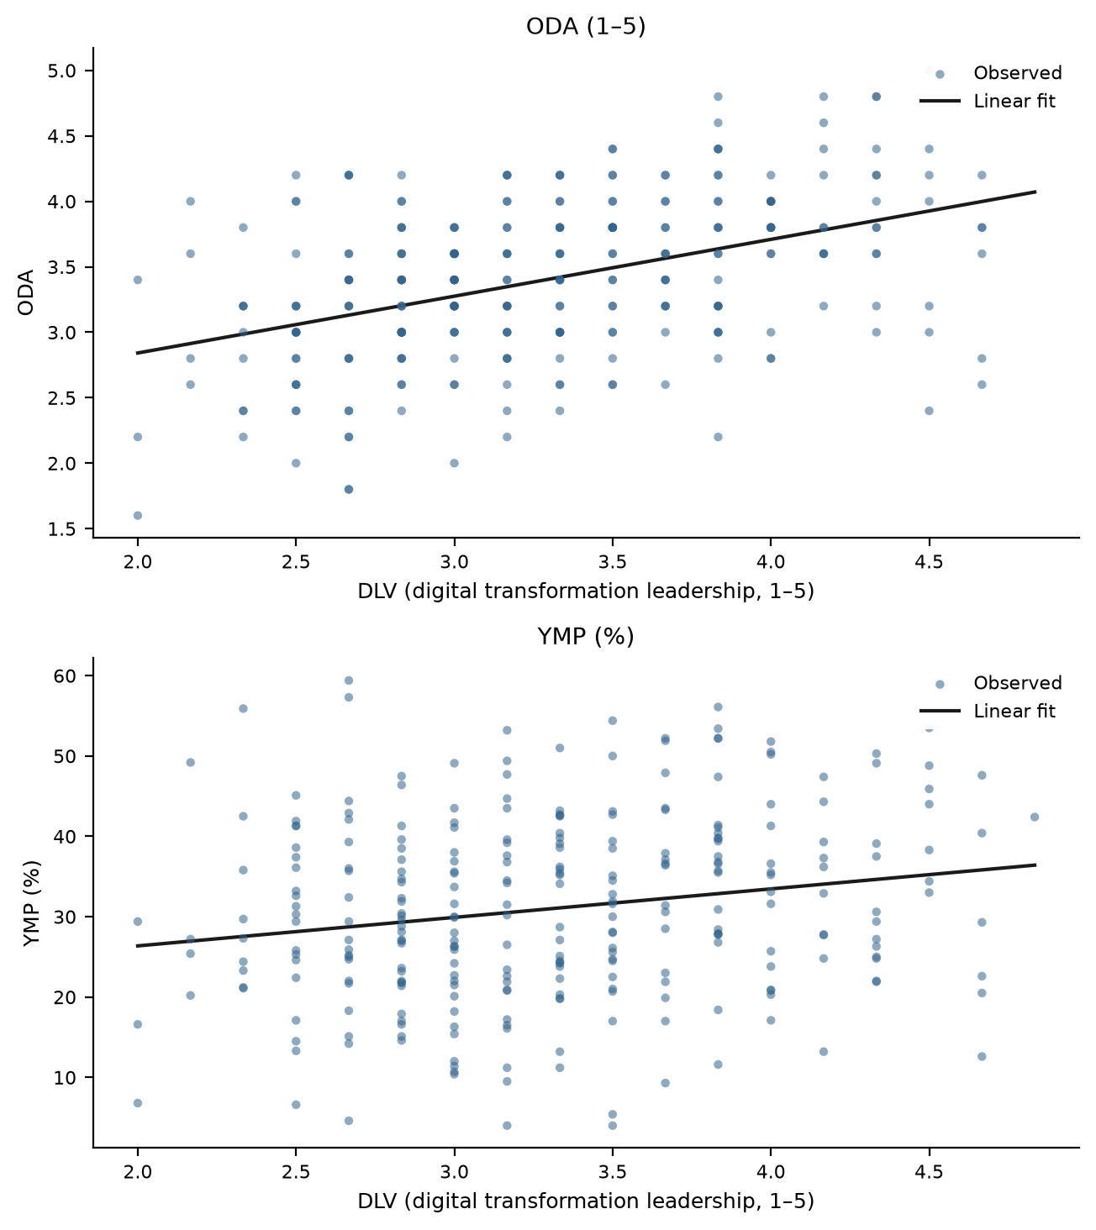
Figure 1. Decision agility and young managerial presence in relation to digital transformation leadership. Source: authors’ design.
The second model examines AI-assisted decision-making breadth (Pillai's Trace = 0.157, Wilks' Lambda = 0.843, F(2, 282) = 26.305, $p$ < 0.001). Here the two outcomes part ways. ADM is strongly associated with agility: each additional AI-supported decision domain corresponds to 0.105 scale points of agility ($p$ < 0.001, partial $η_{p}^{2}$ = 0.147). Its association with young managerial presence, however, does not reach the 5% threshold (B = 0.532, $p$ = 0.077) and is treated as marginal: automating the analytics of deciding is linked to faster firms, but not—by itself—to younger management (Table 5, Figure 2).
Table 5. Parameter estimates for the relationship between AI-assisted decision-making breadth and the two outcomes.
Dependent Variable | Parameter | B | Std. Error | t | Sig. | 95% CI  Lower | 95% CI  Upper | Partial Eta  Squared
ODA | Intercept | 3.031 | 0.064 | 47.390 | 0.000 | 2.905 | 3.156 | 0.888
 | ADM | 0.105 | 0.015 | 6.986 | 0.000 | 0.075 | 0.134 | 0.147
YMP | Intercept | 29.081 | 1.281 | 22.702 | 0.000 | 26.560 | 31.603 | 0.646
 | ADM | 0.532 | 0.300 | 1.774 | 0.077 | −0.058 | 1.122 | 0.011
Notes: Source: authors’ calculations. Note: N = 285. CI = confidence interval.
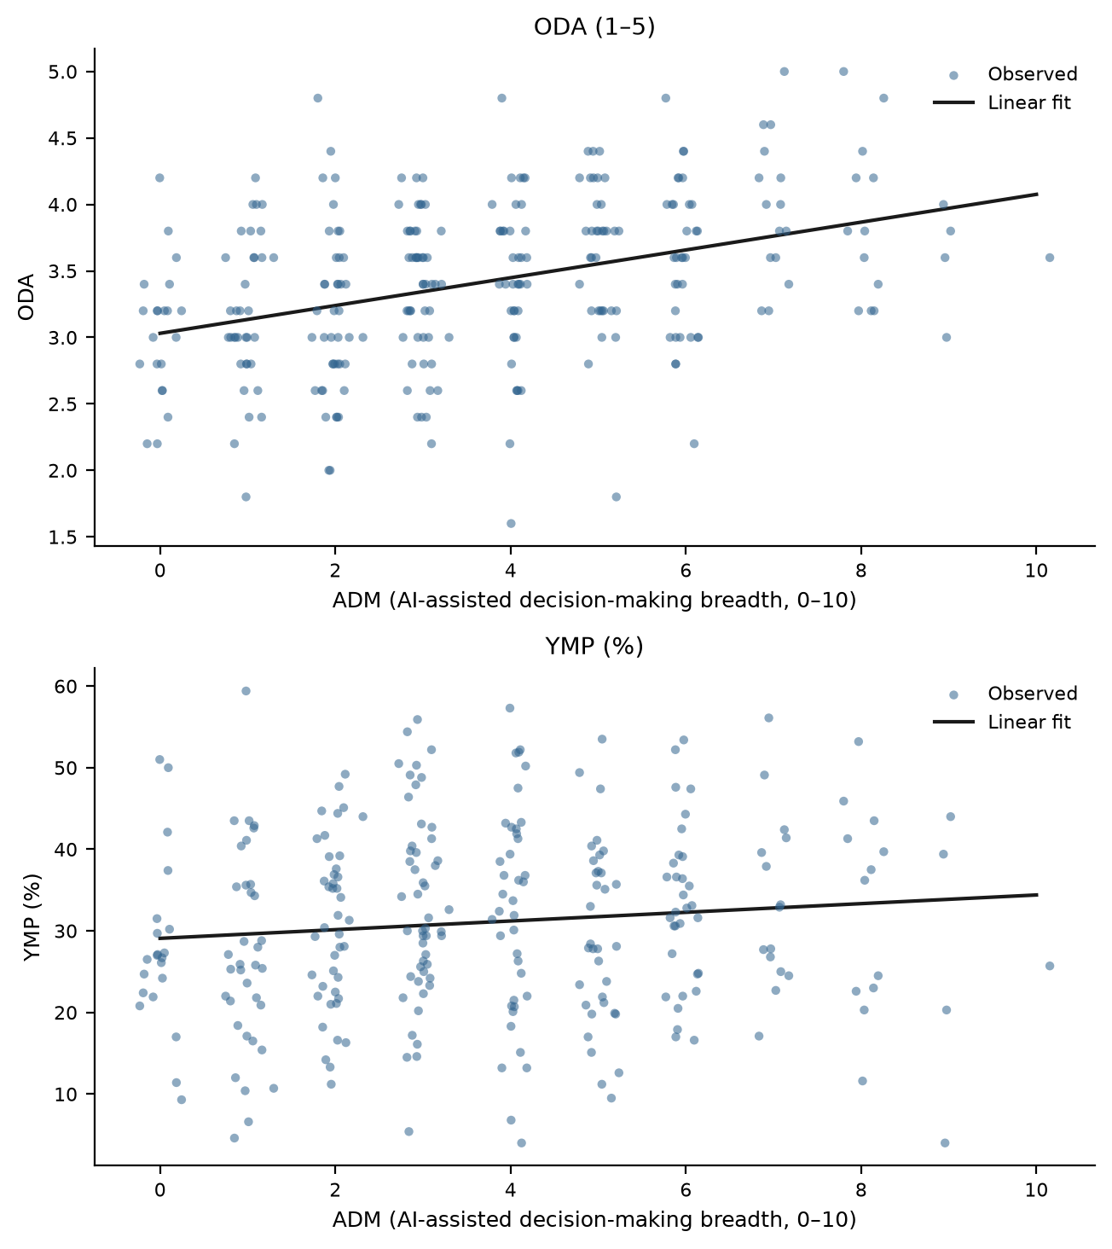
Figure 2. Decision agility and young managerial presence in relation to AI-assisted decision-making breadth. Source: authors’ design.
The third model addresses decision-process digitalization (Pillai's Trace = 0.195, Wilks' Lambda = 0.805, F(2, 282) = 34.255, $p$ < 0.001). Like leadership, digitalized decision processes are significantly associated with both outcomes: agility (B = 0.419, $p$ < 0.001, partial $η_{p}^{2}$ = 0.165) and young managerial presence (B = 3.42, $p$ = 0.003). Firms whose meetings begin from shared data and whose decisions are reviewed against outcomes are both faster and younger at the management level (Table 6, Figure 3).
Table 6. Parameter estimates for the relationship between decision-process digitalization and the two outcomes.
Dependent Variable | Parameter | B | Std. Error | t | Sig. | 95% CI  Lower | 95% CI  Upper | Partial Eta  Squared
ODA | Intercept | 2.042 | 0.186 | 10.989 | 0.000 | 1.676 | 2.408 | 0.299
 | DPD | 0.419 | 0.056 | 7.484 | 0.000 | 0.309 | 0.529 | 0.165
YMP | Intercept | 19.846 | 3.723 | 5.331 | 0.000 | 12.519 | 27.174 | 0.091
 | DPD | 3.421 | 1.122 | 3.049 | 0.003 | 1.212 | 5.630 | 0.032
Notes: Source: authors’ calculations. Note: N = 285. CI = confidence interval.
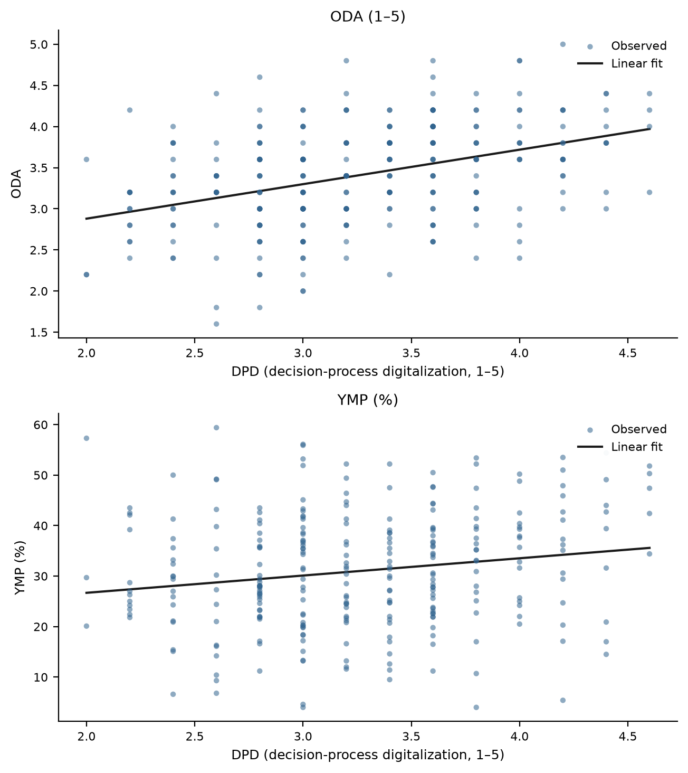
Figure 3. Decision agility and young managerial presence in relation to decision-process digitalization. Source: authors’ design.
The final model concerns young-employee decision involvement (Pillai's Trace = 0.169, Wilks' Lambda = 0.831, F(2, 282) = 28.683, $p$ < 0.001), and it mirrors the AI model in reverse. Involvement is the practice most strongly associated with young managerial presence: one scale point corresponds to 7.11 percentage points more young managers ($p$ < 0.001, partial $η_{p}^{2}$ = 0.157), the strongest association with young managerial presence among the four practices. Its association with agility is positive but only marginal (B = 0.112, $p$ = 0.051), consistent with the theoretical ambivalence of participation for decision speed (Table 7, Figure 4).
Table 7. Parameter estimates for the relationship between young-employee decision involvement and the two outcomes.
Dependent Variable | Parameter | B | Std. Error | t | Sig. | 95% CI  Lower | 95% CI  Upper | Partial Eta  Squared
ODA | Intercept | 3.068 | 0.178 | 17.262 | 0.000 | 2.718 | 3.418 | 0.513
 | EDI | 0.112 | 0.057 | 1.964 | 0.051 | 0.000 | 0.224 | 0.013
YMP | Intercept | 9.320 | 3.057 | 3.049 | 0.003 | 3.303 | 15.338 | 0.032
 | EDI | 7.114 | 0.981 | 7.248 | 0.000 | 5.182 | 9.045 | 0.157
Notes: Source: authors’ calculations. Note: N = 285. CI = confidence interval.
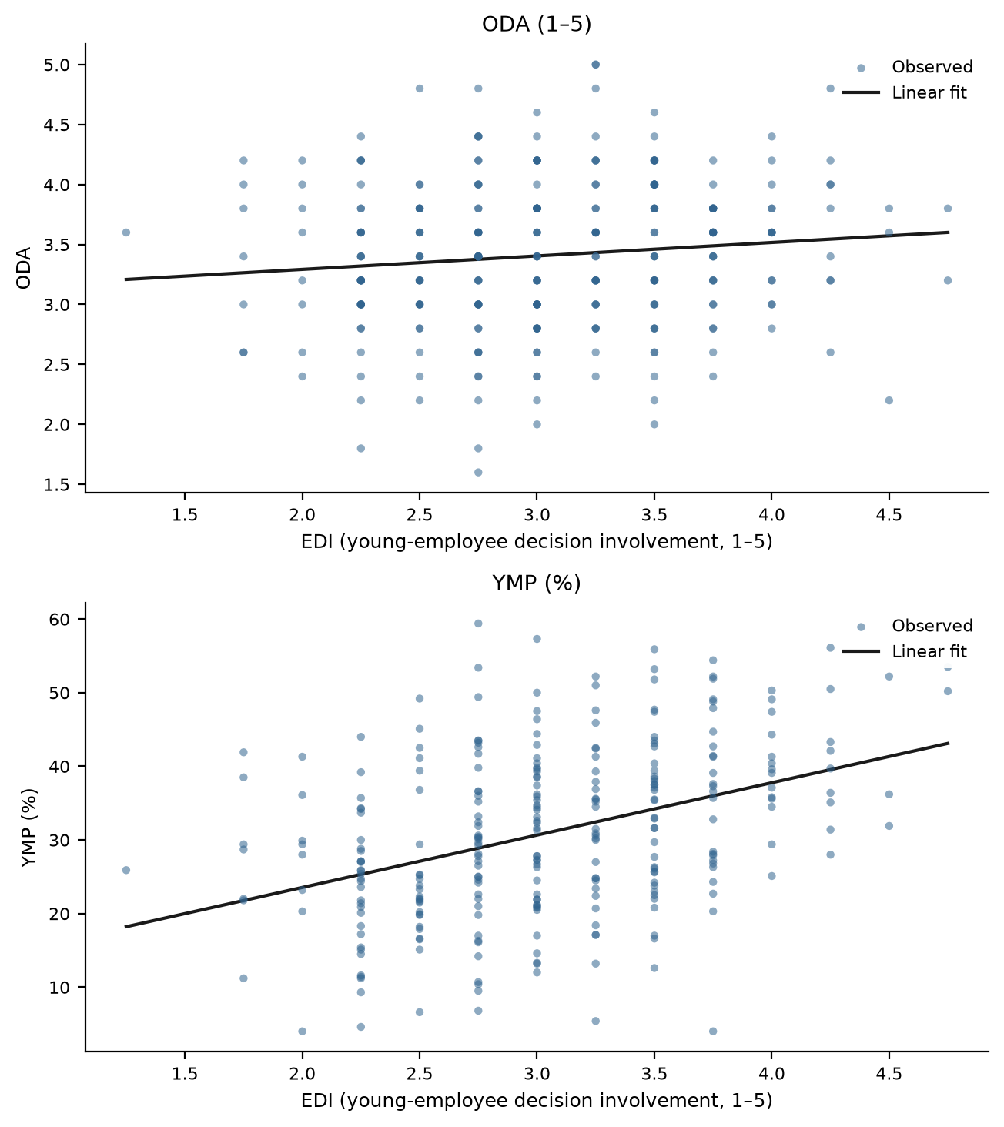
Figure 4. Decision agility and young managerial presence in relation to young-employee decision involvement. Source: authors’ design.
In sum, the four models describe a division of labor among practices: leadership and digitalized decision processes travel with both outcomes; AI-assisted decision-making travels with agility but only marginally with young management; and youth involvement travels with young management but only marginally with agility. H1 is therefore partially supported. Diagnostics are unremarkable: Shapiro–Wilk tests do not reject residual normality in any specification (all $p$ ≥ 0.076), and the largest Cook's distance is 0.066.
4.2. Robustness: Covariate Adjustment and Structural Correlates
Table 8 reports MANCOVA re-estimations with firm size, firm age, R&D intensity, and the digital-core indicator as covariates. The multivariate association of every practice survives adjustment, and the coefficient pattern is intact: DLV and DPD remain significant for both outcomes, ADM for agility, and EDI for young managerial presence. The two marginal associations shift slightly in opposite directions—the adjusted ADM–YMP association remains marginal ($p$ = 0.051), while the adjusted EDI–ODA association crosses the 5% threshold ($p$ = 0.041)—so both should be read as borderline rather than established. Supplementary correlations (Table 9) show that the practices are essentially unrelated to firm age, R&D intensity, and the digital-core indicator, with only a modest positive correlation between leadership and firm size; the practice constructs are thus not proxies for structural position; the covariate-adjusted models nevertheless anchor our conclusions.
Table 8. Covariate-adjusted (MANCOVA) estimates for the four practices.
Model (focal predictor) | Wilks' Lambda | F | Sig. | Adj. B  (ODA) | Sig.  (ODA) | Adj. B  (YMP) | Sig.  (YMP)
DLV | 0.754 | 45.398 | 0.000 | 0.443 | 0.000 | 4.153 | 0.000
ADM | 0.839 | 26.673 | 0.000 | 0.105 | 0.000 | 0.576 | 0.051
DPD | 0.796 | 35.706 | 0.000 | 0.426 | 0.000 | 3.714 | 0.001
EDI | 0.819 | 30.688 | 0.000 | 0.119 | 0.041 | 7.219 | 0.000
Notes: Source: authors’ calculations. Covariates: lnSIZE, AGE, RDI, DIG. Adj. B = adjusted unstandardized coefficient of the focal predictor; multivariate statistics are Wilks’ Lambda F-tests for the focal predictor.
Table 9. Supplementary bivariate correlations of the practices with structural contextual variables.
Structural Contextual Variable | DLV | ADM | DPD | EDI
Firm size (lnSIZE) | 0.157 (p = 0.008) | 0.042 (p = 0.477) | 0.082 (p = 0.167) | 0.039 (p = 0.509)
Firm age (AGE) | 0.019 (p = 0.745) | 0.037 (p = 0.537) | 0.005 (p = 0.933) | 0.000 (p = 0.993)
R&D intensity (RDI) | 0.062 (p = 0.300) | 0.030 (p = 0.611) | 0.083 (p = 0.162) | 0.095 (p = 0.111)
Digital-core industry (DIG) | 0.018 (p = 0.759) | 0.065 (p = 0.277) | 0.019 (p = 0.753) | 0.090 (p = 0.128)
Notes: Source: authors’ calculations. Pearson correlation coefficients with p-values in parentheses. N = 285.
4.3. The Latent Leadership–Decision Configuration and Its Association with the Two Outcomes
Factor-analytic prerequisites are met (KMO = 0.748; Bartlett's χ2(6) = 245.844, $p$ < 0.001), and Principal Axis Factoring retains a single factor whose initial eigenvalue (2.252) accounts for 56.3% of total variance, with 42.8% explained after extraction (Table 10). The loading hierarchy is informative. Digital transformation leadership (0.771) and decision-process digitalization (0.723) anchor the configuration; AI-assisted decision breadth (0.580) and youth involvement (0.509) load substantially but carry the lowest communalities (0.336 and 0.260). The configuration's core, in other words, is managerial rather than technological or participative: tools and voice are attached to it without being reducible to it. The factor is labelled FACT_LDC, the leadership–decision configuration.
Table 10. Exploratory factor analysis of the leadership and decision-making practice indicators.
Indicator/Statistic | Value
Kaiser–Meyer–Olkin measure | 0.748
Bartlett's test of sphericity | χ2 = 245.844; df = 6; p < 0.001
Extraction method | Principal Axis Factoring
Number of factors extracted | 1
Initial eigenvalue, Factor 1 | 2.252
Initial variance explained | 56.292%
Extraction sum of squared loadings | 1.713
Variance explained after extraction | 42.831%
Rotation | No rotation
Communalities (initial/extraction); factor loadings
DLV | 0.389 / 0.594; loading = 0.771
ADM | 0.262 / 0.336; loading = 0.580
DPD | 0.359 / 0.523; loading = 0.723
EDI | 0.206 / 0.260; loading = 0.509
Notes: Source: authors’ calculations. Principal Axis Factoring on the correlation matrix of DLV, ADM, DPD, and EDI; one factor retained; factor scores by the regression method.
Regressions of the outcomes on the factor scores support H2. For decision agility, the model yields R = 0.482 and $R^{2}$ = 0.232 (adjusted $R^{2}$ = 0.229; F = 85.490, $p$ < 0.001): one standard deviation of the configuration corresponds to 0.297 scale points of agility (β = 0.482) (Table 11). For young managerial presence, the association is smaller but clearly significant (R = 0.257; $R^{2}$ = 0.066; F = 19.998, $p$ < 0.001), with one standard deviation of the configuration corresponding to 2.94 percentage points more young managers (β = 0.256) (Table 12). The leadership–decision configuration is thus systematically related to both the tempo and the generational profile of enterprise decision systems, although it accounts for a considerably larger share of the variance in agility than in advancement.
Table 11. Regression results for the relationship between the leadership–decision configuration factor and organizational decision agility.
Model | R | R Square | Adjusted  R Square | Std. Error of  the Estimate
1 | 0.482 | 0.232 | 0.229 | 0.542
Model | Sum of  Squares | df | Mean Square | F | Sig.
Regression  Residual  Total | 25.068  82.984  108.052 | 1  283  284 | 25.068  0.293 | 85.490 | 0.000
Model | Unstandardized  Coefficients: B | Std.  Error | Standardized  Coefficients: Beta | t | Sig.
(Constant)  FACT_LDC | 3.410  0.297 | 0.032  0.032 | 0.482 | 106.305  9.246 | 0.000  0.000
Notes: Source: authors’ calculations. Dependent variable: ODA. Predictor: factor scores of FACT_LDC (standardized).
Table 12. Regression results for the relationship between the leadership–decision configuration factor and young managerial presence.
Model | R | R Square | Adjusted  R Square | Std. Error of  the Estimate
1 | 0.257 | 0.066 | 0.063 | 11.109
Model | Sum of  Squares | df | Mean Square | F | Sig.
Regression  Residual  Total | 2467.739  34922.249  37389.988 | 1  283  284 | 2467.739  123.400 | 19.998 | 0.000
Model | Unstandardized  Coefficients: B | Std.  Error | Standardized  Coefficients: Beta | t | Sig.
(Constant)  FACT_LDC | 31.011  2.941 | 0.658  0.659 | 0.256 | 47.120  4.461 | 0.000  0.000
Notes: Source: authors’ calculations. Dependent variable: YMP. Predictor: factor scores of FACT_LDC (standardized).
4.4. Two Decision Regimes: Cluster Typologies of Practice, Agility, and Managerial Rejuvenation
Ward-linkage hierarchical clustering of the six standardized variables suggests a two-group structure (Figure 5), and the k-means comparison concurs: the average silhouette coefficient is highest for k = 2 (0.283 versus 0.196 for k = 3 and 0.175 for k = 4), and the hierarchical and k-means partitions coincide for 76.8% of firms. The typology is exploratory and descriptive, not a definitive classification.
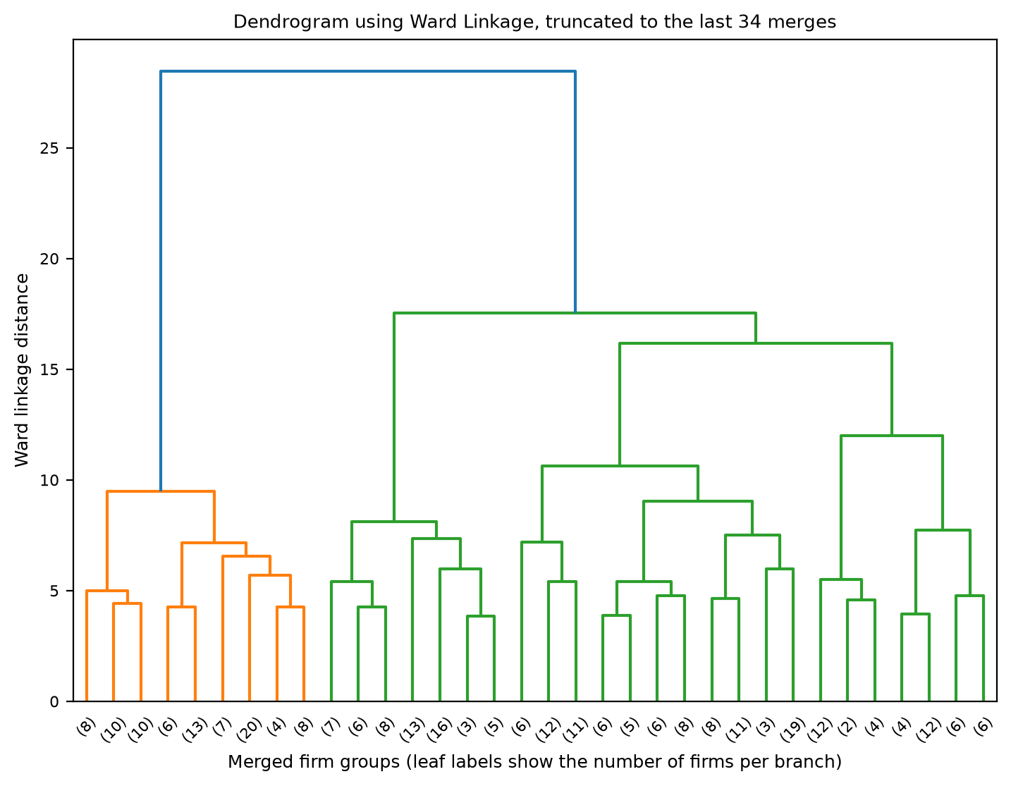
Figure 5. Dendrogram of the hierarchical clustering of firms based on decision practices, agility, and young managerial presence (Ward linkage, truncated to the last 34 merges). Source: authors’ design.
Table 13 contrasts the two regimes. The agile, digitally led regime (n = 133) combines strong leadership (3.81), broad AI-assisted deciding (5.11 of ten domains), digitalized processes (3.69), and institutionalized youth involvement (3.43) with high agility (3.71) and a young management corps (34.38% of managerial positions). The conventional hierarchical regime (n = 152) sits markedly lower on every practice (2.88, 2.33, 2.89, 2.72), decides more slowly (3.15), and promotes fewer young people (28.06%). Strikingly, the regimes barely differ in sectoral composition—digital-core firms make up 27.1% of the first and 24.3% of the second, with manufacturing the plurality in both—indicating that decision regimes are chosen, not sectorally determined.
The average silhouette coefficient of the final solution is 0.283 (0.257 and 0.306 for the two clusters), indicating modest but coherent separation appropriate for an exploratory typology. The ANOVA statistics in Table 13 describe the between-regime differences; because the clusters were built from the same variables, these F values characterize rather than test the separation. With that caveat, the practices—led by leadership itself—separate the regimes most strongly, and both outcomes differ substantially. Overall, the cluster analysis supports H3: leadership and decision-making practices, agility, and the generational profile of management cohere into recognizable socio-technical decision regimes.
Table 13. Cluster centers and differences between clusters (ANOVA).
Variable | Cluster 1 Mean  (n = 133) | Cluster 2 Mean  (n = 152) | Overall  Mean | F | Sig.
DLV | 3.81 | 2.88 | 3.31 | 348.809 | 0.000
ADM | 5.11 | 2.33 | 3.63 | 171.926 | 0.000
DPD | 3.69 | 2.89 | 3.26 | 229.439 | 0.000
EDI | 3.43 | 2.72 | 3.05 | 129.205 | 0.000
ODA | 3.71 | 3.15 | 3.41 | 73.228 | 0.000
YMP | 34.38 | 28.06 | 31.01 | 23.225 | 0.000
Notes: Source: authors’ calculations. k-means with k = 2 on standardized variables; means reported in original units. ANOVA df = (1, 283); F values are descriptive (see text).
5. Discussion
Read together, the three analytical stages tell a consistent story: in the enterprises of China's most digitalized macro-region, how leaders decide and whom they let decide are bound up with how fast the organization moves and how young its management is. The associations are cross-sectional and must not be read causally; agile, youthful firms may adopt the practices as readily as the practices may produce agility and youth, and unobserved quality of management may drive both [15,40]. What the data do establish is a systematic co-occurrence that variable-by-variable research would have missed.
The differentiated support for H1 sharpens several literatures. That digital transformation leadership and digitalized decision processes accompany both agility and rejuvenation extends the digital-leadership literature [4,43,69] beyond its usual performance outcomes, and gives micro-level content to the finding that younger executive cohorts and digital transformation go together [15,16]. The asymmetry between the AI and involvement models is the study's most instructive result. Broad AI-assisted deciding is linked to speed—consistent with experimental evidence on algorithmic decision support [20,22,23]—but not, on its own, to a younger managerial corps; conversely, institutionalized youth involvement is linked to a younger corps but only marginally to speed [54,55]. Technology and participation thus appear as complements with different comparative advantages, exactly as the socio-technical tradition would predict [30,37,38]: the technical subsystem accelerates, the social subsystem renews, and neither substitutes for the other.
The factor analysis qualifies the configuration argument in an important way. A single leadership–decision configuration exists, supports H2, and predicts both outcomes; but its core is carried by leadership and process digitalization, while AI breadth and youth involvement are its least redundant elements. Practically, this means the configuration cannot be inferred from a firm's AI inventory or its participation rhetoric alone [1,2]. Theoretically, it locates the 'engine' of the configuration in managerial practice, echoing dynamic-capabilities arguments that orchestration, not assets, differentiates firms [40,56]. The cluster analysis then shows that this configuration is lived as a regime: firms are either broadly in or broadly out, sector notwithstanding, and the two regimes differ in managerial age structure by more than six percentage points [31,32]. That the regimes cut across sectors within one macro-region suggests organizational choice, not environment, as the proximate differentiator [18,70].
5.1. Theoretical Implications
Three implications follow for theory. First, for upper echelons research, the results extend the theory's outcome space: leadership orientations are imprinted not only on strategy and performance but on the demography of the managerial pipeline itself [12,16,34]. Second, for the decision-making literature, decision agility emerges as a property of configurations—leadership, process, tools, and participation jointly—rather than of structures alone, refining classic speed-of-decision arguments [7,8] for the AI era [2,22]. Third, for socio-technical systems theory, the complementary asymmetry documented here (technology speeds, participation renews) offers a concrete, falsifiable instance of joint optimization in contemporary decision systems [5,38].
5.2. Practical Implications
For executives navigating digital transformation, the message is compositional. Firms seeking agility should extend AI-assisted deciding across managerial domains and digitalize the decision process itself; firms seeking to renew their management ranks should institutionalize youth involvement—councils, reverse mentoring, cross-level task forces—rather than expect rejuvenation to follow from technology [50,54]. Because the two marginal associations were borderline, neither shortcut is reliable: AI without involvement leaves the ladder unchanged, and involvement without digitalized process leaves speed on the table. For young professionals, the regime typology offers a screening heuristic: firms that decide from data and include the young in transformation governance are also the firms where young people reach management [26,27]. For policy-makers concerned with youth career development, demand-side instruments—recognizing youth decision-involvement practices in talent-program criteria, or diffusing digital decision infrastructure to SMEs—complement conventional supply-side training [58,70–72].
5.3. Limitations and Further Research
Several constraints bound the findings. The cross-sectional design precludes causal claims; longitudinal designs tracking regime shifts and subsequent agility and promotion outcomes are the natural next step. Practices and agility share one informant, and although the second outcome is a reported statistic, common-method checks were passed, and the differentiated pattern resists a single-factor explanation, multi-informant or archival replication would strengthen inference [63,64,73]. Young managerial presence is a stock indicator that conflates promotion, hiring, and attrition flows; personnel-record data could decompose it [12]. The Yangtze River Delta is a revealing but advanced setting, and the regime structure may differ where digital infrastructure is thinner [70]. Finally, the factor and cluster analyses are exploratory: the one-factor solution is a first approximation, the modest silhouette values counsel restraint, and alternative clustering specifications should be tested [32,57,68]. Extending the design to decision quality, error rates, and the career trajectories of the young managers themselves would deepen the link between decision systems and youth career development [13,74].
6. Conclusions
This study asked how the leadership and decision-making practices of digitally transforming enterprises relate to two properties of today's enterprise systems: the agility of organizational decisions and the advancement of young people into management. Drawing on an executive survey of 285 firms in the Yangtze River Delta and combining MANOVA-type models, exploratory factor analysis, and cluster analysis, it provides a system-level description of how transformation is steered—and by whom—inside firms. All findings are exploratory associations rather than causal effects.
Three conclusions stand out. First, the practices divide their labor: transformation leadership and digitalized decision processes accompany both agility and managerial rejuvenation, whereas broad AI-assisted deciding accompanies agility only, and institutionalized youth involvement accompanies rejuvenation only, each showing merely marginal associations with the other outcome. Second, a single leadership–decision configuration underlies the four practices—anchored in leadership and process, not in tools or rhetoric—and is significantly associated with both outcomes. Third, firms occupy one of two socio-technical decision regimes, agile-and-young versus conventional-and-senior, and the divide runs through sectors rather than between them.
For the navigation of digital transformation, these results counsel against equating transformation with technology and against expecting any single practice to deliver the whole configuration. Leadership that digitalizes how decisions are made, extends analytical support across decision domains, and deliberately seats young employees at the decision table is associated with enterprises that are at once faster and generationally renewed. Future research should establish the causal structure of this configuration, trace the careers of the young managers it surfaces, and test whether the two-regime topology generalizes beyond advanced digital regions.
Author Contributions: Conceptualization, X.C. and T.M.; methodology, X.C.; software, X.C.; validation, X.C., D.H. and T.M.; formal analysis, X.C.; investigation, D.H.; resources, T.M.; data curation, D.H.; writing—original draft preparation, X.C.; writing—review and editing, T.M.; visualization, D.H.; supervision, T.M.; project administration, T.M.; funding acquisition, X.C. All authors have read and agreed to the published version of the manuscript.
Funding: This research was funded by the Zhejiang Provincial Philosophy and Social Sciences Planning Special Project on Higher Education Basic Research Funding Reform (Grant Number: 25NDJC153YBMS) and the Major Humanities and Social Sciences Research Projects in Zhejiang Higher Education Institutions (Grant Number: 2024QN018).
Institutional Review Board Statement: The study was conducted in accordance with the Declaration of Helsinki and approved by the Academic Ethics Committee of the College of Business, Jiaxing University (protocol code JXU-BUS-2026-021, approved on 2 March 2026).
Informed Consent Statement: Informed consent was obtained from all respondents involved in the study.
Data Availability Statement: The data presented in this study are available on request from the corresponding author due to confidentiality commitments made to participating firms. The analysis code is available from the authors upon reasonable request.
Conflicts of Interest: The authors declare no conflicts of interest.
Abbreviations
The following abbreviations are used in this manuscript:
Abbreviation | Definition
DLV | Digital transformation leadership
ADM | AI-assisted decision-making breadth
DPD | Decision-process digitalization
EDI | Young-employee decision involvement
ODA | Organizational decision agility
YMP | Young managerial presence (% of managerial positions held by employees ≤35)
FACT_LDC | Latent leadership–decision configuration factor
AI | Artificial intelligence
EFA | Exploratory factor analysis
PAF | Principal Axis Factoring
KMO | Kaiser–Meyer–Olkin measure of sampling adequacy
MANOVA/MANCOVA | Multivariate analysis of (co)variance
CI | Confidence interval
RDI | R&D intensity
SME | Small and medium-sized enterprise
TMT | Top management team
Appendix A
Table A1 lists the measurement items of the four reflective constructs and their standardized loadings from within-construct Principal Axis Factoring. Items were administered in Chinese on five-point Likert scales after translation and back-translation [60].
Table A1. Measurement items and standardized factor loadings.
Construct | Code | Item wording (English translation) | Loading
DLV | DLV1 | Our senior leaders communicate a compelling vision of the firm's digital future. | 0.682
 | DLV2 | Top management personally sponsors major digital transformation projects. | 0.716
 | DLV3 | Our leaders encourage managers to experiment with digital ways of working. | 0.750
 | DLV4 | Senior leadership commits substantial resources to digital initiatives. | 0.722
 | DLV5 | Our leaders actively dismantle barriers to digital change. | 0.719
 | DLV6 | Digital transformation is a standing item on our top-management agenda. | 0.715
DPD | DPD1 | Key operating indicators are available to decision makers in real time. | 0.678
 | DPD2 | Management meetings in this firm start from a shared, data-based picture of the situation. | 0.663
 | DPD3 | We digitally track decisions and review their outcomes against data. | 0.703
 | DPD4 | Scenario analyses based on data or models inform our major decisions. | 0.721
 | DPD5 | When judgment and data conflict, we systematically re-examine the data before deciding. | 0.682
EDI | EDI1 | Employees under 35 are formally represented in our digital transformation committees or councils. | 0.634
 | EDI2 | We operate reverse-mentoring arrangements in which young employees advise senior managers on digital topics. | 0.666
 | EDI3 | Task forces for transformation projects deliberately include young employees. | 0.755
 | EDI4 | Ideas submitted by young employees regularly reach top management through dedicated channels. | 0.752
ODA | ODA1 | We make major decisions quickly compared with competitors. | 0.759
 | ODA2 | This firm responds rapidly when market conditions shift. | 0.658
 | ODA3 | Decisions here rarely stall while awaiting additional approvals. | 0.697
 | ODA4 | We can commit to a course of action under uncertainty and adjust as information arrives. | 0.731
 | ODA5 | The quality of our fast decisions is high. | 0.674
Notes: Source: authors’ design. Loadings from within-construct Principal Axis Factoring (N = 285).
The AI-assisted decision-making breadth (ADM) index asked whether AI or advanced analytics tools support each of the following ten managerial decision domains: demand forecasting; pricing; budgeting and resource allocation; hiring, staffing, or promotion analytics; production or service scheduling; risk assessment and compliance; marketing-mix decisions; supply-chain and inventory decisions; performance monitoring and target setting; and strategic scenario analysis. The index counts the domains marked.
References
1. Vial, G. Understanding digital transformation: A review and a research agenda. J. Strateg. Inf. Syst. 2019, 28, 118–144.
2. Shrestha, Y.R.; Ben-Menahem, S.M.; von Krogh, G. Organizational Decision-Making Structures in the Age of Artificial Intelligence. Calif. Manag. Rev. 2019, 61, 66–83.
3. Brynjolfsson, E.; McElheran, K. The Rapid Adoption of Data-Driven Decision-Making. Am. Econ. Rev. 2016, 106, 133–139.
4. Lin, Q. Digital leadership: A systematic literature review and future research agenda. Eur. J. Innov. Manag. 2025, 28, 2469–2488.
5. Benbya, H.; Nan, N.; Tanriverdi, H.; Yoo, Y. Complexity and Information Systems Research in the Emerging Digital World. MIS Q. 2020, 44, 1–17.
6. Iden, J.; Bygstad, B. Sociotechnical micro-foundations for digital transformation. Eur. J. Inf. Syst. 2025, 34, 367–382.
7. Eisenhardt, K.M. Making Fast Strategic Decisions in High-Velocity Environments. Acad. Manag. J. 1989, 32, 543–576.
8. Baum, J.R.; Wally, S. Strategic Decision Speed and Firm Performance. Strateg. Manag. J. 2003, 24, 1107–1129.
9. Teece, D.; Peteraf, M.; Leih, S. Dynamic Capabilities and Organizational Agility: Risk, Uncertainty, and Strategy in the Innovation Economy. Calif. Manag. Rev. 2016, 58, 13–35.
10. Troise, C.; Corvello, V.; Ghobadian, A.; O’Regan, N. How can SMEs successfully navigate VUCA environment: The role of agility in the digital transformation era. Technol. Forecast. Soc. Change 2022, 174, 121227.
11. Chatterjee, S.; Chaudhuri, R.; Gupta, S.; Sivarajah, U.; Bag, S. Assessing the impact of big data analytics on decision-making processes, forecasting, and performance of a firm. Technol. Forecast. Soc. Change 2023, 196, 122824.
12. Steindórsdóttir, B.D.; Sanders, K.; Arnulf, J.K.; Dysvik, A. Career transitions and career success from a lifespan developmental perspective: A 15-year longitudinal study. J. Vocat. Behav. 2023, 140, 103809.
13. Bankins, S.; Jooss, S.; Restubog, S.L.D.; Marrone, M.; Ocampo, A.C.; Shoss, M. Navigating career stages in the age of artificial intelligence: A systematic interdisciplinary review and agenda for future research. J. Vocat. Behav. 2024, 153, 104011.
14. Xiong, B.; Yu, B. The Impact of Internet Development on Youth’s Job Quality in the Digital Economy Era: Transmission Mechanism and Empirical Test. Soc. Indic. Res. 2024, 175, 269–294.
15. Zou, Z.; Fu, J.; Zeng, Y.; Huang, Y. Do young CEOs matter for corporate digital transformation? Econ. Lett. 2024, 237, 111636.
16. Hambrick, D.C.; Mason, P.A. Upper Echelons: The Organization as a Reflection of Its Top Managers. Acad. Manag. Rev. 1984, 9, 193–206.
17. Zhuang, T.; Zhao, S. Collaborative innovation relationship in Yangtze River Delta of China: Subjects collaboration and spatial correlation. Technol. Soc. 2022, 69, 101974.
18. Yang, Y.; Lin, G.T.R. Local Digital Economic Growth, Enterprise Digital Transformation, and Digital Dividends: Evidence from China. Systems 2025, 13, 297.
19. Zhong, S.; Zhang, X.; Zhang, L.; Zhao, C. How does digital economy influence urban common prosperity? Evidence from China’s demonstration area for common prosperity. Int. Rev. Econ. Financ. 2025, 104, 104629.
20. Steyvers, M.; Kumar, A. Three Challenges for AI-Assisted Decision-Making. Perspect. Psychol. Sci. 2024, 19, 722–734.
21. Tursunbayeva, A.; Chalutz-Ben Gal, H. Adoption of artificial intelligence: A TOP framework-based checklist for digital leaders. Bus. Horiz. 2024, 67, 357–368.
22. Csaszar, F.A.; Ketkar, H.; Kim, H. Artificial Intelligence and Strategic Decision-Making: Evidence from Entrepreneurs and Investors. Strategy Sci. 2024, 9, 322–345.
23. Noy, S.; Zhang, W. Experimental evidence on the productivity effects of generative artificial intelligence. Science 2023, 381, 187–192.
24. Song, Y.; Qiu, X.; Liu, J. The Impact of Artificial Intelligence Adoption on Organizational Decision-Making: An Empirical Study Based on the Technology Acceptance Model in Business Management. Systems 2025, 13, 683.
25. Baabdullah, A.M. The precursors of AI adoption in business: Towards an efficient decision-making and functional performance. Int. J. Inf. Manag. 2024, 75, 102745.
26. Benítez-Márquez, M.D.; Sánchez-Teba, E.M.; Bermúdez-González, G.; Núñez-Rydman, E.S. Generation Z Within the Workforce and in the Workplace: A Bibliometric Analysis. Front. Psychol. 2022, 12, 736820.
27. Lu, J.; Guo, S.; Qu, J.; Lin, W.; Lev, B. “Stay” or “Leave”: Influence of employee-oriented social responsibility on the turnover intention of new-generation employees. J. Bus. Res. 2023, 161, 113814.
28. Halová, D.; Müller, M. Being an Employer of Choice: Attracting Generation Z to Work by Building Brand via Social Media. Corp. Reput. Rev. 2024, 27, 283–298.
29. Friedrich, A. School-leaving certificates and vocational education and training—The role of firms as gatekeepers in Germany. Int. J. Manpow. 2025, 46, 125–147.
30. Makarius, E.E.; Mukherjee, D.; Fox, J.D.; Fox, A.K. Rising with the machines: A sociotechnical framework for bringing artificial intelligence into the organization. J. Bus. Res. 2020, 120, 262–273.
31. Browder, R.E.; Dwyer, S.M.; Koch, H. Upgrading adaptation: How digital transformation promotes organizational resilience. Strateg. Entrep. J. 2024, 18, 128–164.
32. Ketchen, D.J., Jr.; Shook, C.L. The application of cluster analysis in strategic management research: An analysis and critique. Strateg. Manag. J. 1996, 17, 441–458.
33. Hair, J.F.; Black, W.C.; Babin, B.J.; Anderson, R.E. Multivariate Data Analysis, 8th ed.; Cengage Learning EMEA: Andover, UK, 2019.
34. Hambrick, D.C. Upper Echelons Theory: An Update. Acad. Manag. Rev. 2007, 32, 334–343.
35. Schulz, C.; Bendig, D.; Kriebel, J.; Haubner, K.; Fainshmidt, S. CEO Human Capital and Digital Product Innovation: A Dynamic Managerial Capabilities Perspective. Inf. Syst. Res. 2026, 37, 863–885.
36. Tushman, M.L.; Nadler, D.A. Information processing as an integrating concept in organizational design. Acad. Manag. Rev. 1978, 3, 613–624.
37. Trist, E.L.; Bamforth, K.W. Some Social and Psychological Consequences of the Longwall Method of Coal-Getting. Hum. Relat. 1951, 4, 3–38.
38. Herrmann, T.; Pfeiffer, S. Keeping the organization in the loop: A socio-technical extension of human-centered artificial intelligence. AI Soc. 2023, 38, 1523–1542.
39. Kudina, O.; van de Poel, I. A sociotechnical system perspective on AI. Minds Mach. 2024, 34, 21.
40. Teece, D.J. Explicating dynamic capabilities: The nature and microfoundations of (sustainable) enterprise performance. Strateg. Manag. J. 2007, 28, 1319–1350.
41. Philip, J.; Gilli, K.; Knappstein, M. Identifying key leadership competencies for digital transformation: Evidence from a cross-sectoral Delphi study of global managers. Leadersh. Organ. Dev. J. 2023, 44, 392–406.
42. Zeike, S.; Bradbury, K.; Lindert, L.; Pfaff, H. Digital Leadership Skills and Associations with Psychological Well-Being. Int. J. Environ. Res. Public Health 2019, 16, 2628.
43. AlNuaimi, B.K.; Singh, S.K.; Ren, S.; Budhwar, P.; Vorobyev, D. Mastering digital transformation: The nexus between leadership, agility, and digital strategy. J. Bus. Res. 2022, 145, 636–648.
44. Dou, B.; Guo, S.; Chang, X.; Wang, Y. Corporate digital transformation and labor structure upgrading. Int. Rev. Financ. Anal. 2023, 90, 102904.
45. Li, X.; Wang, Q.; Kong, D.; Tao, Y. Intelligent Manufacturing and Corporate Human Capital Upgrade in China. J. Asian Econ. 2025, 97, 101886.
46. Brynjolfsson, E.; Li, D.; Raymond, L. Generative AI at Work. Q. J. Econ. 2025, 140, 889–942.
47. Acemoglu, D.; Restrepo, P. Automation and New Tasks: How Technology Displaces and Reinstates Labor. J. Econ. Perspect. 2019, 33, 3–30.
48. Eloundou, T.; Manning, S.; Mishkin, P.; Rock, D. GPTs are GPTs: Labor market impact potential of LLMs. Science 2024, 384, 1306–1308.
49. Wang, T.; Zhang, Y.; Liu, C. Robot adoption and employment adjustment: Firm-level evidence from China. China Econ. Rev. 2024, 84, 102137.
50. Budhwar, P.; Chowdhury, S.; Wood, G.; Aguinis, H.; Bamber, G.J.; Beltran, J.R.; Boselie, P.; Cooke, F.L.; Decker, S.; DeNisi, A.; et al. Human resource management in the age of generative artificial intelligence: Perspectives and research directions on ChatGPT. Hum. Resour. Manag. J. 2023, 33, 606–659.
51. Ghasemaghaei, M.; Calic, G. Does big data enhance firm innovation competency? The mediating role of data-driven insights. J. Bus. Res. 2019, 104, 69–84.
52. Chaudhuri, R.; Chatterjee, S.; Mariani, M.M.; Fosso Wamba, S. Assessing the influence of emerging technologies on organizational data driven culture and innovation capabilities: A sustainability performance perspective. Technol. Forecast. Soc. Change 2024, 200, 123165.
53. Jiang, S.; Guo, Y. Reasons for college major-job mismatch and labor market outcomes: Evidence from China. China Econ. Rev. 2022, 74, 101822.
54. Chaudhuri, S.; Park, S.; Johnson, K.R. Engagement, inclusion, knowledge sharing, and talent development: Is reverse mentoring a panacea to all? Findings from literature review. Eur. J. Train. Dev. 2022, 46, 468–483.
55. Chamberlin, M.; Newton, D.W.; LePine, J.A. A meta-analysis of voice and its promotive and prohibitive forms: Identification of key associations, distinctions, and future research directions. Pers. Psychol. 2017, 70, 11–71.
56. Merín-Rodrigáñez, J.; Dasí, À.; Alegre, J.; Hughes, M. Dynamic managerial capabilities for digital transformation in innovative SMEs: What are the effects on new product development performance? J. Bus. Res. 2025, 201, 115709.
57. Jain, A.K. Data clustering: 50 years beyond K-means. Pattern Recognit. Lett. 2010, 31, 651–666.
58. Hua, Z.; Kong, S.; Yu, Y. Talent magnets in China: Can talent attraction policies catalyze digital transformation in enterprises? China Econ. Rev. 2025, 90, 102376.
59. Armstrong, J.S.; Overton, T.S. Estimating nonresponse bias in mail surveys. J. Mark. Res. 1977, 14, 396–402.
60. Brislin, R.W. Back-translation for cross-cultural research. J. Cross-Cult. Psychol. 1970, 1, 185–216.
61. Cronbach, L.J. Coefficient alpha and the internal structure of tests. Psychometrika 1951, 16, 297–334.
62. Hayes, A.F.; Coutts, J.J. Use omega rather than Cronbach’s alpha for estimating reliability. But… Commun. Methods Meas. 2020, 14, 1–24.
63. Podsakoff, P.M.; MacKenzie, S.B.; Lee, J.-Y.; Podsakoff, N.P. Common method biases in behavioral research: A critical review of the literature and recommended remedies. J. Appl. Psychol. 2003, 88, 879–903.
64. Podsakoff, P.M.; Podsakoff, N.P.; Williams, L.J.; Huang, C.; Yang, J. Common method bias: It’s bad, it’s complex, it’s widespread, and it’s not easy to fix. Annu. Rev. Organ. Psychol. Organ. Behav. 2024, 11, 17–61.
65. Kaiser, H.F. An index of factorial simplicity. Psychometrika 1974, 39, 31–36.
66. Bartlett, M.S. A note on the multiplying factors for various χ2 approximations. J. R. Stat. Soc. Ser. B 1954, 16, 296–298.
67. Ward, J.H., Jr. Hierarchical Grouping to Optimize an Objective Function. J. Am. Stat. Assoc. 1963, 58, 236–244.
68. Rousseeuw, P.J. Silhouettes: A graphical aid to the interpretation and validation of cluster analysis. J. Comput. Appl. Math. 1987, 20, 53–65.
69. Qiao, G.; Li, Y.; Hong, A. The Strategic Role of Digital Transformation: Leveraging Digital Leadership to Enhance Employee Performance and Organizational Commitment in the Digital Era. Systems 2024, 12, 457.
70. Škare, M.; de Obesso, M.d.l.M.; Ribeiro-Navarrete, S. Digital transformation and European small and medium enterprises (SMEs): A comparative study using digital economy and society index data. Int. J. Inf. Manag. 2023, 68, 102594.
71. International Labour Organization (ILO). Global Employment Trends for Youth 2024: Decent Work, Brighter Futures; ILO: Geneva, Switzerland, 2024.
72. Rahmani, H.; Groot, W.; Rahmani, A.M. Unravelling the NEET phenomenon: A systematic literature review and meta-analysis of risk factors for youth not in education, employment, or training. Int. J. Adolesc. Youth 2024, 29, 2331576.
73. Lu, R.; Peng, X.; Reve, T. Firms’ digital transformation, competitive strategies, and innovation: Evidence from Chinese listed companies. J. Manag. Organ. 2025, 31, 575–601.
74. Battisti, M.; Dustmann, C.; Schönberg, U. Technological and Organizational Change and the Careers of Workers. J. Eur. Econ. Assoc. 2023, 21, 1551–1594.
Disclaimer/Publisher’s Note: The statements, opinions and data contained in all publications are solely those of the individual author(s) and contributor(s) and not of MDPI and/or the editor(s). MDPI and/or the editor(s) disclaim responsibility for any injury to people or property resulting from any ideas, methods, instructions or products referred to in the content.

