Article
Screening Under Signal Collapse: Choice and Architecture Experiments on Employer Decision Rules and Youth Access to Entry-Level Work
Xinyu Cai ¹, Dingpei Hu ¹ and Tiantian Mo ^{1,}*
Academic Editor: Maja Meško
Received: date
Revised: date
Accepted: date
Published: date
Citation: To be added by editorial staff during production.
Copyright: © 2026 by the authors. Submitted for possible open access publication under the terms and conditions of the Creative Commons Attribution (CC BY) license (https://creativecommons.org/licenses/by/4.0/).
¹ College of Business, Jiaxing University, Jiaxing 314001, China; caixinyu@zjxu.edu.cn
* Correspondence: 00008227@zjxu.edu.cn
Abstract
Generative artificial intelligence has made a polished written application almost free to produce, and a signal that is free to produce cannot separate candidates. Employers screening entry-level applicants must therefore decide what to rely on instead, and that decision determines which young people reach a human interviewer. This paper measures the decision rule and then manipulates the architecture that frames it. A choice-based conjoint with 452 managers who make entry-level shortlist decisions in knowledge-intensive firms of China’s Yangtze River Delta yielded 6328 choice sets over seven candidate attributes, analysed by conditional logit, mixed logit estimated with 500 scrambled Halton draws, and latent-class conditional logit. Embedded in the same instrument, a randomised experiment assigned each respondent to one of three screening architectures and measured the shortlist they produced from a fixed candidate pool. Disclosing that an application was AI-assisted carried a clear penalty, but a portfolio documenting the applicant’s drafting and revision process removed about three quarters of it, and the two attributes interacted significantly. Preferences were not merely heterogeneous but discretely so: three screening regimes emerged, weighting credentials, test scores and process evidence respectively, and membership shifted towards the credential regime as managers perceived more AI-assisted applications. The architecture experiment showed that the same managers produce very different shortlists depending on what the interface puts first: ordering candidates by verified evidence rather than by credentials raised the share of shortlisted applicants from non-elite institutions while also raising the shortlist’s measured assessment quality, so the equity–quality trade-off managers assume is an artefact of the architecture rather than a property of the applicant pool. Screening architecture is a leadership decision with distributional consequences, and it is more consequential than the preferences of the individuals who operate it.
Keywords: discrete choice experiment; generative artificial intelligence; employer screening; signalling; youth employment; entry-level hiring; latent class analysis; mixed logit; digital transformation; managerial decision making

1. Introduction
A written job application has always been a test of two things at once: whether the applicant can do the work, and whether the applicant can be bothered to demonstrate it. Generative artificial intelligence has severed the two. A competent, tailored cover letter and a cleanly structured résumé are now available to any applicant in a few minutes at negligible cost, which is precisely the condition under which a signal stops carrying information. Spence’s original result is unambiguous on this point: a signal separates types only when it is differentially costly to produce [1]. Remove the differential cost and the signal pools.
This is no longer a theoretical worry. Analysing more than five million cover letters submitted around the rollout of an AI writing tool on a large freelancing platform, Cui, Dias and Ye find that the correlation between how well a cover letter matched the job post and whether the applicant was called back fell by about half, and that employers shifted weight onto verifiable histories instead [2]. Galdin and Silbert reach the same conclusion structurally: employers’ willingness to pay for a tailored application disappears after large language models become available, and their counterfactual implies a measurably less meritocratic market [3]. Field-experimental evidence confirms that algorithmic writing assistance changes outcomes rather than merely polishing prose, raising hires by around 8% on an online labour market [4]. On the employer side, screening itself is being automated, and automated screeners bring their own distortions: large language models systematically favour résumés written by the same model [5] and reproduce demographic patterns from their training data [6].
The consequences fall hardest on the young. Payroll microdata show a relative employment decline of roughly 16% for workers aged 22 to 25 in the occupations most exposed to generative AI, with no comparable decline for older workers doing the same jobs [7]; résumé and vacancy data show adopting firms cutting junior hiring while senior hiring holds steady [8]. The evidence is not uniform—Danish administrative data yield precise nulls over the same period [9]—but the entry tier is where the disagreement is concentrated, and it is the tier where the written application does most of the work, because young applicants have no employment record to fall back on. Where the first job lands has durable consequences: the size and quality of the first employer shape earnings years later [10], and a poor or delayed entry leaves scars that do not heal quickly [11,12].
What employers do when a signal fails is therefore a question of the first importance, and it is a decision question rather than a technology question. A manager facing a doubled pile of uniformly polished applications has three broad options. She can fall back on signals that are cheap to verify because they are conferred by institutions rather than produced by the applicant—the selectivity of the university, an internal referral. She can triage on volume, letting an automated score do the first cut. Or she can try to restore a costly signal by requiring something an applicant cannot cheaply fake even with a capable model: a proctored assessment, or documentary evidence of how a piece of work was actually produced. These are not equivalent. The first two are cheap and fast, but institutional signals are strongly correlated with family background [13,14] and referral networks are unevenly distributed [15], so both narrow access without necessarily improving the match. The third is more costly to operate but is the only one that re-establishes the condition a signal needs in order to inform.
This paper measures which of these employers actually choose, and then tests whether the choice can be changed by design. We do two things. First, we run a choice-based conjoint experiment with 452 managers who make real entry-level shortlist decisions in knowledge-intensive firms in China’s Yangtze River Delta. Each evaluated pairs of hypothetical entry-level candidates that varied on whether the application disclosed AI assistance, whether it was accompanied by a process-evidence portfolio, the result of a verified proctored assessment, institutional tier, referral, internship, and expected salary. Including salary as an attribute lets every other attribute be expressed as a compensating differential in money, which makes the weights comparable and interpretable. Second, embedded in the same instrument, we randomly assigned each respondent to one of three screening architectures—ordering a fixed candidate pool by an AI score, by credentials, or by verified evidence—and recorded the shortlist they produced. The conjoint identifies the decision rule; the randomisation identifies what a leadership decision about the screening interface does to who gets through.
The design lets us make four contributions. First, we quantify the penalty attached to disclosing AI assistance and show that it is not a fixed cost of honesty: a portfolio documenting drafts, revisions and reasoning removes about three quarters of it, and the interaction between disclosure and process evidence is statistically significant. This matters because a disclosure penalty without a repair mechanism creates a trap—applicants conceal, the written signal degrades further, and employers retreat further into ascriptive signals. Second, we show that employer heterogeneity is discrete rather than continuous. Three screening regimes emerge from a latent-class model, weighting credentials, test results and process evidence respectively, and they predict held-out choices better than either a homogeneous or a continuous-heterogeneity specification. Third, we link regime membership to the condition of the signal environment: managers who believe more of their applications are AI-assisted are more likely to sit in the credential regime, which is the retreat the theory predicts. Fourth, and most consequentially for practice, we show experimentally that the screening architecture dominates the screener. Moving from a credential-first to an evidence-first interface changed the composition of the shortlist far more than the differences between individual managers’ preferences, and it did so while raising rather than lowering the measured quality of the shortlisted candidates.
The paper is organised as follows. Section 2 develops the theoretical background and states the hypotheses. Section 3 describes the two experiments, the experimental design, and the estimation strategy. Section 4 reports the results. Section 5 discusses the implications for theory, for leadership practice and for policy, and states the limitations. Section 6 concludes.
2. Theoretical Background and Hypotheses
2.1. Signals, Screens and the Cost Condition
The economics of hiring under asymmetric information rests on a single mechanism. An applicant attribute functions as a signal only if acquiring or displaying it costs less for high-productivity than for low-productivity applicants; otherwise every type displays it and the employer learns nothing [1]. Employers who observe workers over time gradually substitute direct evidence of productivity for the initial signal, which is why the weight on credentials falls as tenure accumulates [16]. At the point of entry, however, no such direct evidence exists, so the entry-level screen is where signalling does its heaviest work and where its failure has the largest consequences.
Not all screens are signals in this sense. A proctored assessment is a screen whose result the applicant cannot costlessly manufacture; a university’s selectivity is a proxy the applicant did not produce at all and which correlates strongly with parental resources [13]. The distinction matters because the two behave differently when the written application fails. Evidence that verified skill information changes employer behaviour is strong: giving South African workseekers credibly shareable assessment results raised employment and earnings and shifted interview decisions [17]; publicly posting evaluations of inexperienced online workers substantially raised their later employment [18]; and adding a former-employer reference letter raised callbacks by 60% [19]. What these interventions share is that they introduce information the applicant cannot cheaply fabricate.
Two features of the entry-level screen make it the decisive margin. First, the demand side is moving: artificial intelligence is reshaping the skill premium and the composition of tasks firms buy [20,21], digital transformation is changing the structure as well as the level of firms’ labour demand [22–24], and career research now treats the sequence of early career stages as itself being reorganised by AI [25]. Second, automation reduces employer-provided training for exactly the workers most exposed to it [26], so the entry screen is being asked to carry more weight at the same time as it is becoming less informative. For young people the stakes are correspondingly high: entry difficulties in China show up as persistent overeducation and mismatch [27], and the quality of early digital-economy jobs varies sharply across entrants [28].
2.2. What Generative AI Does to the Written Application
Generative models compress the cost of producing a fluent, tailored, error-free application to approximately zero, and they compress it for everyone; controlled experiments on exactly this class of writing task show large gains concentrated among previously weaker writers, which is compression of the distribution rather than a uniform shift [29,30]. Formally, the single-crossing condition that makes the written application informative no longer holds; substantively, the distribution of application quality shifts up and compresses, so its variance—the part employers actually use—collapses. The empirical record now supports this directly. On a large freelancing platform the predictive value of cover-letter fit halved after an AI writing tool was introduced, and employers moved weight onto histories and ratings [2]; a structural treatment of the same market finds employers’ willingness to pay for tailoring disappearing entirely [3]; on the same class of platform, demand for exactly the writing and coding tasks that generative models perform well fell by about a fifth [31]. Applicant-side surveys confirm that use is real and rising, though self-reported incidence remains below what employers assume [32]—a gap that matters, because it is employers’ beliefs, not the true rate, that drive their screening response.
Two further effects compound the problem. Applications become cheaper to send as well as to write, so volume rises and attention per application falls; when attention is scarce and costly, employers lean harder on priors, which magnifies the role of group-level characteristics [33]. And when employers respond by automating the first cut, the automated screener inherits the degraded text and adds distortions of its own, including a measurable preference for résumés generated by the same model family [5] and demographic skews inherited from training data [6]. Algorithmic screening is not inherently worse than human screening—well-designed algorithms can improve both quality and diversity when they are built to explore rather than to imitate past hiring [34], and human overrides of job tests often make hires worse [35]—but a meta-analysis of human–machine combinations finds that they outperform the better of their parts only under narrow conditions [36], and an algorithm applied to a signal that no longer informs cannot recover information that is not there.
2.3. Three Responses, Three Architectures
Faced with a signal that has stopped working, the screening function can be reorganised in three ways, and these correspond to the three architectures we manipulate experimentally. The first is retreat to ascriptive signals: rank on institutional selectivity and referral. This is cheap, defensible inside the organisation, and weakly related to entry-level productivity; it is also the route through which elite professional firms have long reproduced social closure, and correspondence experiments show such screening gaps to be remarkably stable over decades [14,37–39], and it transfers the cost of the signalling failure onto applicants without elite credentials or networks. The second is triage: let an automated score order the pile and cut deep. This addresses volume but not informativeness. The third is restoration: require something costly to fake. A proctored assessment does this directly. So, we argue, does a process-evidence portfolio—drafts, revision history and reasoning notes—because a generative model can produce a polished output cheaply but cannot cheaply produce a credible record of a particular applicant’s own iterative reasoning about a specific problem. Process evidence restores the cost asymmetry at the level of the work, not the level of the credential.
2.4. The Disclosure Trap
Whether applicants disclose AI use is itself endogenous to how employers treat disclosure. If disclosure is penalised, applicants conceal; concealment makes the written signal less interpretable still, which accelerates the retreat to ascriptive signals. Figure 1 sets out this structure. The loop is closed by employer belief: the more AI-assisted applications a manager believes she is receiving, the more she discounts the written material, and the more the remaining weight moves to institution and referral. The escape from this loop is not to punish disclosure harder, which is unenforceable, but to make disclosure informative by pairing it with evidence. That is the empirical question this paper is built to answer.
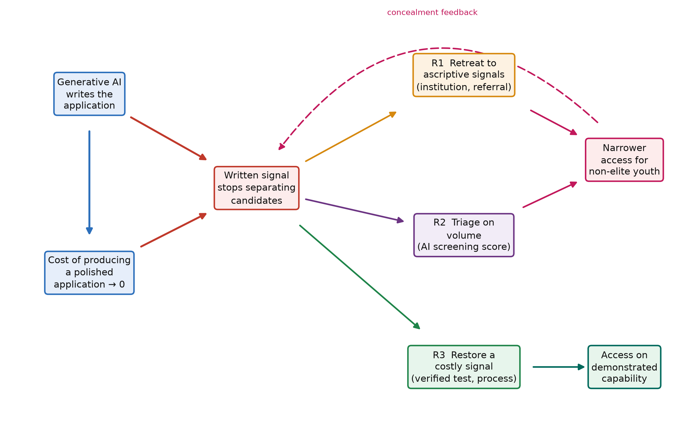
Figure 1. Signal collapse and the three employer responses. Generative AI drives the cost of producing a polished written application towards zero, which removes the cost asymmetry a signal needs. Employers can retreat to ascriptive signals, triage on volume, or restore a costly signal. The dashed link is the disclosure trap: penalising disclosure induces concealment, which degrades the written signal further.
2.5. Screening Architecture as a Leadership Decision
The organisational literature treats digital transformation as a redesign of how work and decisions are structured rather than as technology adoption [40,41]. Screening architecture is a clean instance. The choice of what an applicant-tracking interface puts first, what it computes automatically, and what it requires a human to read is made by leadership, is rarely revisited, and is invisible to the managers who operate inside it. Research on AI-assisted managerial decision making has concentrated on whether machine advice improves the quality of a given decision [42–44], and practical guidance for digital leaders is framed around adoption choices [45]; the prior question of which decisions the interface presents, and in what order, has received far less attention. If that choice moves outcomes more than the preferences of the individual screeners do, then the leverage in this system lies with the people who configure the funnel rather than with the people who work it—which reframes a fairness problem usually posed in terms of individual bias as a problem of system design.
2.6. Hypotheses
The argument yields six testable propositions. The first three concern the decision rule, the next two its heterogeneity, and the last the architecture.
Hypothesis 1 (disclosure penalty). Other things equal, an application that discloses the use of generative-AI assistance is less likely to be shortlisted than one that makes no such statement.
Hypothesis 2 (evidence repair). A process-evidence portfolio attenuates the disclosure penalty; that is, the interaction between disclosure and process evidence is positive, so disclosure is penalised substantially less when the applicant can document how the work was produced.
Hypothesis 3 (verification premium). Verified proctored assessment results carry a positive and monotone premium, and the premium attached to a high assessment result is at least as large as the premium attached to an elite institution.
Hypothesis 4 (discrete regimes). Employer preferences are discretely rather than continuously heterogeneous: a small number of interpretable screening regimes fit the choice data better than a single average rule and predict held-out choices more accurately.
Hypothesis 5 (retreat under signal collapse). Managers who perceive a larger share of their applications to be AI-assisted, and who face faster growth in application volume, are more likely to belong to the regime that weights ascriptive credentials most heavily.
Hypothesis 6 (architecture dominates). The screening architecture causally changes the composition of the shortlist: an evidence-first ordering raises the share of shortlisted candidates from non-elite institutions relative to a credential-first ordering, and does so without reducing the measured assessment quality of the shortlist.
3. Materials and Methods
3.1. Design Overview
The study combines two experiments in a single instrument administered to the same respondents. Study 1 is a choice-based conjoint experiment that identifies the weights employers place on entry-level applicant attributes, including the two that the theory makes central—disclosure of AI assistance and process evidence. Stated choice is the appropriate instrument here because the attributes of interest are not yet widely observed in field data: process-evidence portfolios are rare, and explicit AI disclosure is rarer still, so no observational design could recover their weights. Study 2 is a randomised between-subjects experiment on the screening architecture, which identifies the causal effect of a design decision that organisations do make but almost never vary deliberately. The two are complementary: the conjoint measures preferences holding the interface fixed, and the randomisation measures the interface holding preferences fixed by design.
Conjoint experiments are the established method for eliciting employer preferences without deceiving real applicants [46], and their causal interpretation under randomised attribute assignment is well understood [47]. Choice-based conjoint has been used specifically with recruiters in pre-employment screening [48] and with employers recruiting recent graduates [49], which establishes both feasibility and comparability. We follow the ISPOR good-practice guidance for design construction and for analysis [50,51].
3.2. Participants and Procedure
The sampling frame comprised knowledge-intensive service firms with at least twenty employees in the Yangtze River Delta city cluster (Shanghai, Jiangsu, Zhejiang and Anhui), which concentrates a large share of China’s software, professional-services and shared-service employment. Because the constructs are firm-level decision rules rather than individual attitudes, we applied key-informant selection criteria and recruited the person who actually decides entry-level shortlists—an HR manager, a hiring manager or a department head—verifying involvement with two screening questions before entry [52]. Firms were drawn by stratified random sampling from municipal enterprise registers, stratified by sector and size band. Data were collected between March and June 2026.
Respondents first answered questions about their firm and their screening context, then completed the conjoint tasks, then completed the randomised architecture task, and finally answered demographic items. Two instructed-response items and one comprehension item were embedded, and we treated failure of more than one as grounds for exclusion; we report the exclusion count rather than silently dropping cases, since screening out inattentive respondents can itself introduce selection [53,54]. Of 612 invitations, 496 people entered the instrument, 44 were excluded for failed attention or comprehension checks or for implausibly fast completion, leaving 452 usable respondents. The conjoint yielded 6328 choice sets and 12,656 profile evaluations.
The study was approved by the Academic Ethics Committee of the College of Business, Jiaxing University. Participation was voluntary and respondents gave informed consent. Because the hypothetical candidates were fictitious and no real applicant was affected, the design avoids the ethical objection to correspondence studies, which impose costs on real employers [46]. All analyses were conducted in Python 3.11 with NumPy and SciPy; the estimation, the design construction and the figures run from a single seeded pipeline, so every number reported below is generated by the code rather than transcribed.
3.3. Study 1: The Choice Experiment
3.3.1. Attributes and Levels
Each task presented two hypothetical applicants for a defined entry-level analyst position and an explicit opt-out (“neither of these two”), which prevents forced choice from inflating the apparent attractiveness of weak profiles. To keep the scenario concrete, respondents were told to assume a real vacancy of the kind their firm fills, a practice that improves the realism of factorial designs [55]. Table 1 lists the seven attributes and their levels. The two focal attributes are the disclosure of AI assistance and the presence of a process-evidence portfolio, defined for respondents as “drafts, revision history and the applicant’s own notes on how the work was developed”. Expected monthly salary was included as a numeraire so that every other attribute can be expressed as a compensating differential in money [56]. Figure 2 reproduces an example task as respondents saw it.
Table 1. Attributes and levels of the choice experiment.
Attribute | Levels | Rationale and source
Disclosure of AI assistance | No statement (reference)  Application states that generative-AI assistance was used | Focal attribute; disclosure incidence and employer response are both rising [32]
Process-evidence portfolio | None (reference)  Drafts, revision history and reasoning notes | Focal attribute; restores a cost asymmetry a model cannot cheaply imitate
Verified proctored assessment | Not taken (reference)  70th percentile  90th percentile | Verified skill information changes hiring behaviour [17,18]
Institution tier | Non-elite (reference)  Elite (“Double First-Class”) | Ascriptive signal correlated with family background [13,14]
Employee referral | None (reference)  Referred by a current employee | Referrals predict retention and performance [15]
Relevant internship | None (reference)  Six months, relevant | Standard entry-level experience signal [57]
Expected monthly salary | 8000 CNY  10,000 CNY  12,000 CNY | Numeraire for compensating differentials [56]
Notes: Levels marked “reference” are the omitted category in the dummy coding. The disclosure and process-evidence attributes are crossed, so the interaction in Equation (2) is identified by design.
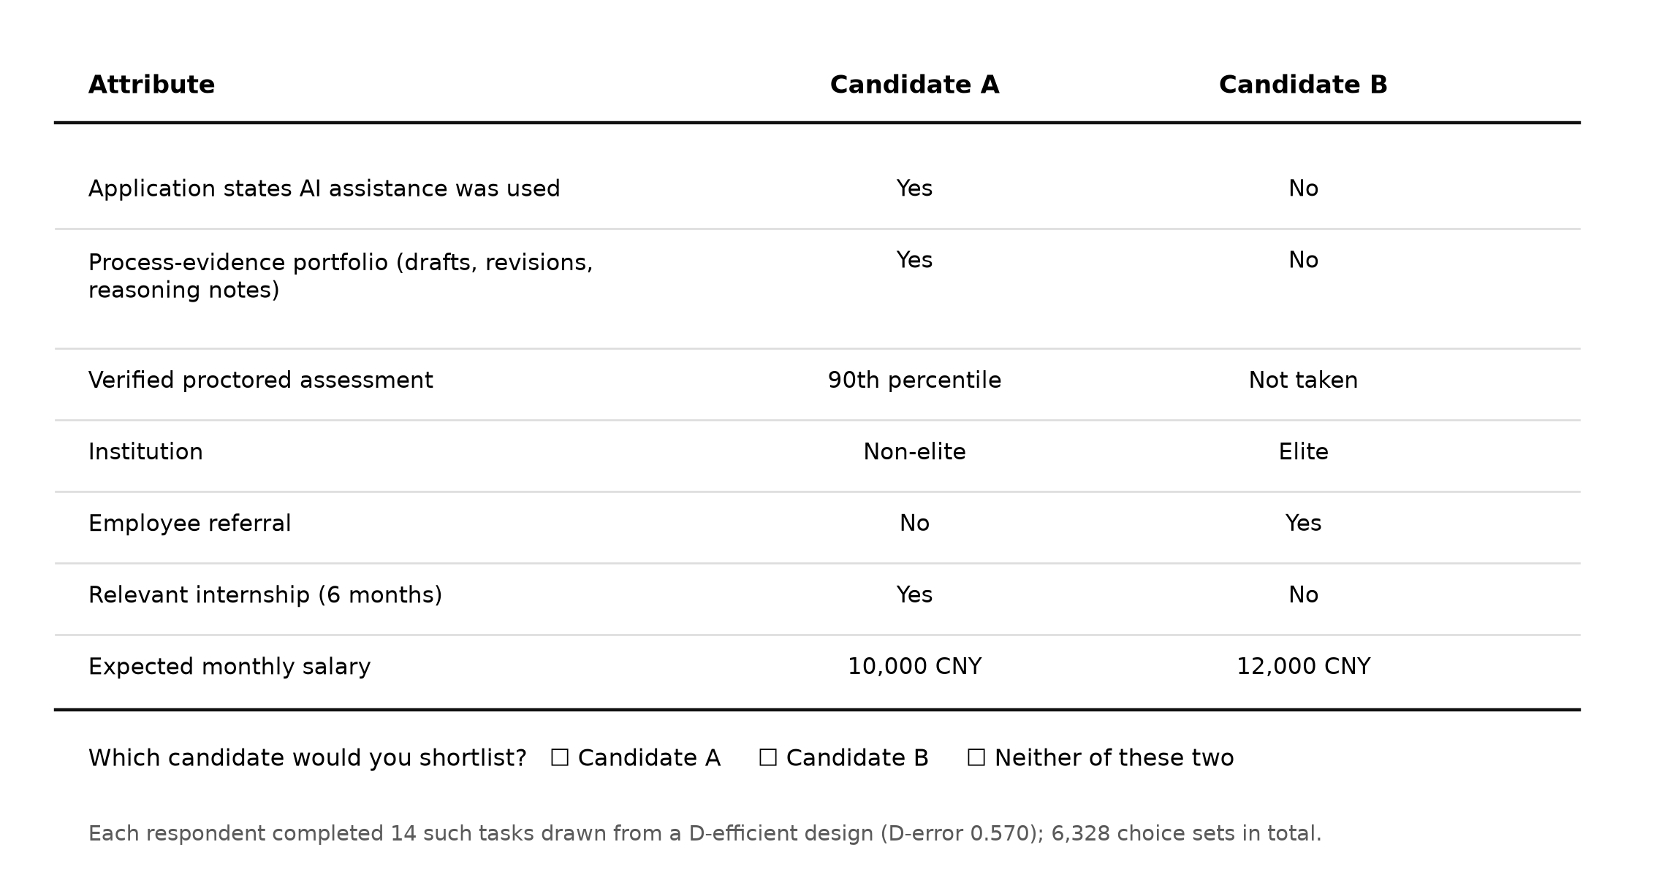
Figure 2. An example choice task as presented to respondents. Attribute order was randomised across respondents and the left–right position of the two candidates was rotated, so neither ordering nor position can be confounded with an attribute level.
3.3.2. Experimental Design
The full factorial contains 288 profiles. From it we constructed a D-efficient paired design by evaluating the multinomial-logit D-error at null priors over a large number of candidate designs and retaining the best, subject to a minimum-overlap constraint requiring the two profiles in a task to differ on at least four attributes [58]. The retained design has a D-error of 0.570 and attribute-level balance within one occurrence across the design. Each respondent completed 14 tasks, which is within the range over which conjoint response quality is stable and satisficing does not materially degrade estimates [59]. Respondents were assigned at random to one of eight blocks, each a rotation of the task order with the within-task profile positions alternated.
3.3.3. Choice Models
Let respondent $n$ face choice set $s$ containing alternatives $j$. Under random utility maximisation the utility of an alternative is the sum of a systematic and an independently and identically distributed extreme-value component, as in Equation (1):
$U_{nsj} = {β_{n}}^{′}x_{sj} + ε_{nsj}$ (1)
The systematic component is specified in Equation (2), where $AI$ and $PE$ are the two focal indicators, $q$ collects the assessment, institution, referral and internship indicators, and salary enters centred at its middle level so that the opt-out constant is interpretable:
$V_{nsj} = β_{1n}{AI}_{sj} + β_{2n}{PE}_{sj} + β_{3n}{AI}_{sj}{PE}_{sj} + γ^{′}q_{sj} + β_{wn}\left(w_{sj} − w̄\right)$ (2)
With extreme-value errors the choice probability takes the familiar conditional logit form of Equation (3), which we estimate first as a homogeneous benchmark with standard errors clustered by respondent:
$P_{nsj} = \frac{exp\left(V_{nsj}\right)}{\sum_{m∈C_{s}}{exp\left(V_{nsm}\right)}}$ (3)
Because a homogeneous rule is implausible and because the conditional logit imposes independence from irrelevant alternatives, we then estimate a mixed logit in which every coefficient, including the opt-out constant, is an independent normal random parameter. The mixed logit can approximate any random-utility-consistent choice model arbitrarily closely [60], and the probability of a respondent’s observed sequence of choices is the integral in Equation (4):
$L_{n}\left(θ\right) = \int{\prod_{s=1}^{S}{P_{ns}\left(β\right)} f\left(β | θ\right) dβ}$ (4)
The integral has no closed form and is approximated by simulation. We use 500 scrambled Halton draws, which achieve lower simulation variance than an equivalent number of pseudo-random draws [61], and maximise the simulated log-likelihood of Equation (5) with analytic gradients:
$SLL\left(θ\right) = \sum_{n=1}^{N}{ln \left[\frac{1}{R} \sum_{r=1}^{R}{\prod_{s=1}^{S}{P_{ns}\left(β_{r}\right)}}\right]}, β_{r} = b + diag\left(σ\right)η_{r}$ (5)
Standard errors are the sandwich estimator formed from the outer product of the respondent-level score contributions and the numerically differentiated Hessian. Because salary enters the utility function, any attribute coefficient can be expressed as a compensating differential by Equation (6), with standard errors obtained by the delta method:
${MRS}_{k} = − \frac{β_{k}}{β_{w}}$ (6)
The two quantities that test Hypotheses 1 and 2 are the disclosure penalty when no process evidence is offered and the penalty when it is, given in Equation (7); the standard error of the second combines the variances and the covariance of the two coefficients:
$Δ_{0} = β_{1}, Δ_{1} = β_{1} + β_{3}$ (7)
3.3.4. Latent-Class Model
A continuous mixing distribution assumes that employers differ by degree. The competing possibility—that they differ in kind, following a small number of distinct screening regimes—is represented by a latent-class conditional logit, in which the population is a finite mixture over class-specific coefficient vectors, as in Equation (8) [62]:
$P_{n} = \sum_{c=1}^{C}{π_{c} \prod_{s=1}^{S}{P_{ns}\left(β_{c}\right)}}$ (8)
We estimate the model by the expectation–maximisation algorithm for two to five classes and select the number of classes by the Bayesian information criterion, which performs well relative to alternatives in simulation studies of finite mixtures [63], reporting the consistent AIC alongside it. Class separation is summarised by the entropy criterion of Equation (10), where $h$ denotes the posterior probability that respondent $n$ belongs to class $c$. Because class labels are identified only up to a permutation, we order classes by their institution coefficient before reporting.
To ask which employers screen which way, we then relate posterior class membership to firm characteristics through the multinomial specification of Equation (9), estimated on the posterior probabilities rather than on hard assignments so that classification uncertainty is carried into the second stage:
$π_{nc} = \frac{exp\left({γ_{c}}^{′}z_{n}\right)}{\sum_{h=1}^{C}{exp\left({γ_{h}}^{′}z_{n}\right)}}$ (9)
$E_{C} = 1 − \frac{ − \sum_{n=1}^{N}{\sum_{c=1}^{C}{h_{nc} ln h_{nc}}}}{N ln C}$ (10)
The covariates are the depth of digital transformation of the hiring function, the share of applications the respondent believes to be AI-assisted, growth in application volume, centralisation of the screening decision, firm size and respondent experience, all standardised. Predictive validity is assessed by estimating every model on the first nine tasks and predicting the last five, with the mixed-logit and latent-class predictions formed from each respondent’s posterior distribution over tastes given their training choices rather than from the population distribution.
3.4. Study 2: The Randomised Architecture Experiment
After the conjoint, each respondent was shown a fixed pool of twenty entry-level candidate profiles and asked to select a shortlist of five. Respondents were randomly assigned in equal proportions to one of three interfaces, which differed only in what was displayed first and how the pool was pre-ordered: an AI-score-first interface, which pre-ranked candidates by an automated screening score; a credential-first interface, which pre-ranked by institution and grade; and an evidence-first interface, which pre-ranked by verified assessment result and the presence of process evidence. The underlying candidate pool was identical across arms, so any difference in the resulting shortlist is caused by the architecture.
Three outcomes were recorded: the share of the five-person shortlist drawn from non-elite institutions, which is the access outcome; the mean verified-assessment percentile of the shortlist, which is the quality outcome; and the time spent per applicant, which is the cost outcome. Arm differences are tested by one-way analysis of variance with the Alexander–Govern correction for unequal variances and by pairwise Welch tests with Bonferroni adjustment, reporting eta-squared and Cohen’s d. Because assignment is randomised, the unadjusted comparison is unbiased; we also report the covariate-adjusted specification of Equation (11) as a precision check:
$y_{n} = α + δ_{1}{D_{n}}^{cred} + δ_{2}{D_{n}}^{evid} + λ^{′}z_{n} + u_{n}$ (11)
4. Results
4.1. Sample and Data Quality
The 452 respondents were distributed across software and IT services (175 firms), professional and business services (147) and finance and shared-service operations (130), and across size bands from 20 to 99 employees (155) to 1000 or more (33). Respondents had a mean of 8.3 years of experience in hiring decisions (SD 4.3) and 51.8% were women. On average they judged 55.4% of the applications they receive to be AI-assisted (SD 14.9), reported application volume growth of 68.1% over the two preceding recruitment cycles (SD 48.0, median 57.4%), and scored 0.446 on the digital-transformation depth of their hiring function (SD 0.201). The opt-out was taken in 11.5% of tasks, which is high enough to confirm that respondents were not mechanically choosing one of the two profiles and low enough to leave the attribute coefficients well identified.
4.2. What Employers Weight
Table 2 reports the conditional logit and the mixed logit. The conditional logit attains a McFadden pseudo-$R^{2}$ of 0.210 against the equal-shares null, which is squarely in the range expected for a well-specified choice model, and its gradient norm at the optimum is 2.1 × 10⁻⁷. All seven attributes carry coefficients in the expected direction and all are significant at the 0.1% level. The mixed logit fits substantially better: the likelihood-ratio statistic against the conditional logit is 448.8 on 10 degrees of freedom ($p$ < 0.001), so the assumption that all employers screen by the same rule is decisively rejected.
The pattern of the standard deviations is as informative as the means. Employers differ most in how much they value a process-evidence portfolio ($σ$ = 0.812, $z$ = 13.10) and in how far that portfolio offsets disclosure ($σ$ = 0.927, $z$ = 8.40), and they differ substantially on institution (0.602) and referral (0.680). They differ hardly at all, however, in the penalty they attach to disclosure itself ($σ$ = 0.208, $z$ = 0.99, not significant). Disapproval of undocumented AI use is close to universal; what varies is whether documentation is accepted as a remedy.
Table 2. Conditional logit and mixed logit estimates of the screening rule.
Attribute | Conditional logit b (SE) | Mixed logit mean (SE) | Mixed logit SD (SE)
Disclosed AI assistance | −0.566 *** (0.106) | −0.741 *** (0.129) | 0.208 (0.210)
Process-evidence portfolio | 0.257 *** (0.062) | 0.274 *** (0.077) | 0.812 *** (0.062)
Disclosure × process evidence | 0.427 *** (0.128) | 0.562 *** (0.153) | 0.927 *** (0.110)
Verified assessment, 70th pct | 0.493 *** (0.056) | 0.656 *** (0.071) | 0.165 * (0.081)
Verified assessment, 90th pct | 0.841 *** (0.066) | 1.084 *** (0.081) | 0.486 *** (0.079)
Elite institution | 0.594 *** (0.058) | 0.776 *** (0.074) | 0.602 *** (0.074)
Employee referral | 0.589 *** (0.054) | 0.736 *** (0.069) | 0.680 *** (0.070)
Relevant internship | 0.364 *** (0.043) | 0.490 *** (0.056) | 0.317 *** (0.065)
Expected salary (+1000 CNY) | −0.334 *** (0.012) | −0.425 *** (0.016) | 0.128 *** (0.024)
Opt-out constant | −0.286 *** (0.073) | −0.189 * (0.090) | 0.485 *** (0.127)
Log-likelihood | −5492.4 | −5267.9
McFadden R² | 0.210 | 0.242
AIC / BIC | 11005 / 11046 | 10576 / 10658
Choice sets / respondents | 6328 / 452 | 6328 / 452
Notes: *** p < 0.001, * p < 0.05. Conditional logit standard errors are clustered by respondent; mixed logit standard errors are the sandwich estimator from the respondent-level scores and the numerical Hessian. The mixed logit uses 500 scrambled Halton draws; the largest absolute gradient at the optimum is 7.0 × 10⁻⁴. Standard deviations are reported as absolute values, since the sign of a normal mixing parameter is not identified.
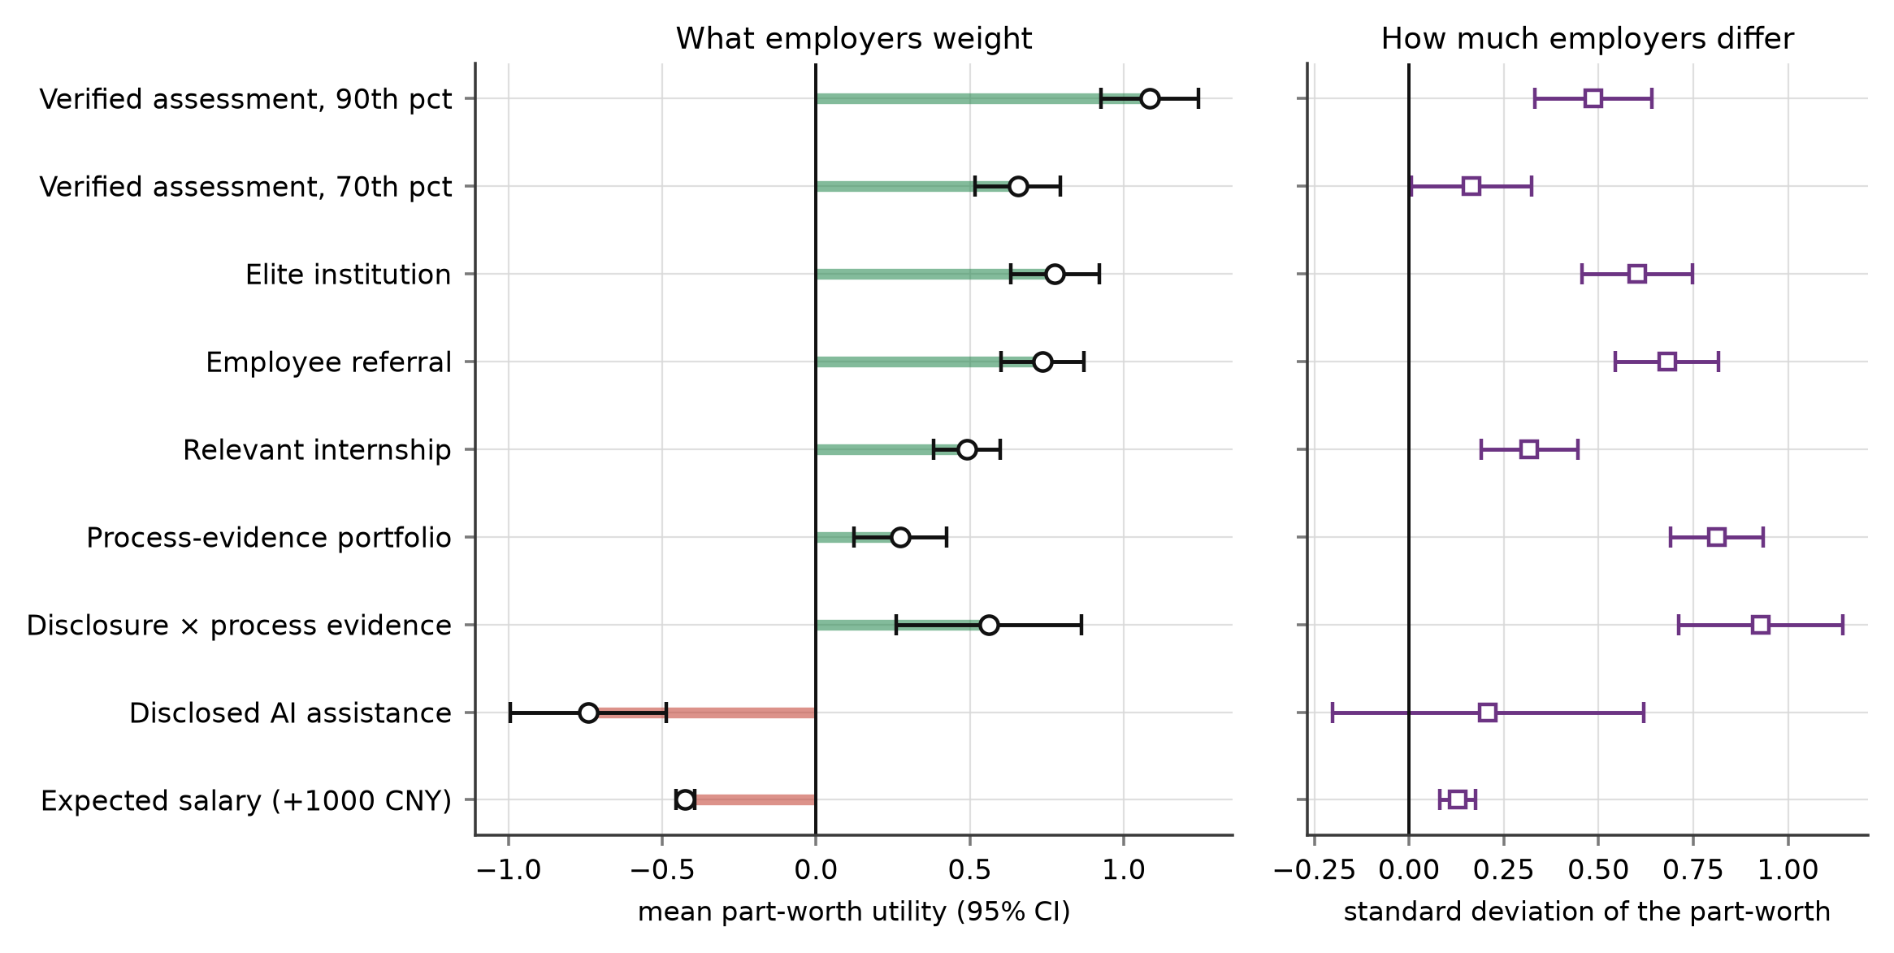
Figure 3. Mixed logit estimates. Left: mean part-worth utilities with 95% confidence intervals. Right: the estimated standard deviation of each part-worth, which measures how far employers differ from one another on that attribute.
4.3. The Disclosure Penalty and Its Repair
Hypothesis 1 is supported. An application that states it was produced with generative-AI assistance is penalised: the coefficient is −0.741 (SE 0.129, $z$ = −5.73, $p$ < 0.001) when no process evidence accompanies it. Expressed as a compensating differential, an applicant who discloses must ask for 1743 CNY per month less in expected salary to be regarded as equally attractive (95% CI 1165 to 2321 CNY), which against a mid-level expectation of 10,000 CNY is a penalty of about a sixth of pay.
Hypothesis 2 is also supported, and it is the more consequential result. The interaction between disclosure and process evidence is positive and significant (0.562, SE 0.153, $p$ < 0.001). When the applicant supplies a portfolio documenting drafts, revisions and reasoning, the penalty falls to −0.179 (SE 0.078, $z$ = −2.29, $p$ = 0.022), equivalent to 421 CNY per month. Documentation therefore removes about three quarters of the disclosure penalty. The residual penalty remains statistically distinguishable from zero, so evidence does not make disclosure costless, but it converts a substantial deterrent into a marginal one. Figure 4 shows both quantities together with the full set of compensating differentials.
Hypothesis 3 is supported. Verified assessment results carry a large and monotone premium: 0.656 at the 70th percentile and 1.084 at the 90th, equivalent to 1542 and 2549 CNY per month respectively. The 90th-percentile premium exceeds the elite institution premium of 1825 CNY, and its confidence interval (2198 to 2899) does not overlap the institution interval (1487 to 2163). Employers are willing to pay more for demonstrated capability than for institutional pedigree—when the demonstration is verified. This is the same ordering that field experiments providing credibly shareable assessment results have found in real labour markets [17,18], which is reassuring for the external validity of the stated-choice estimates.
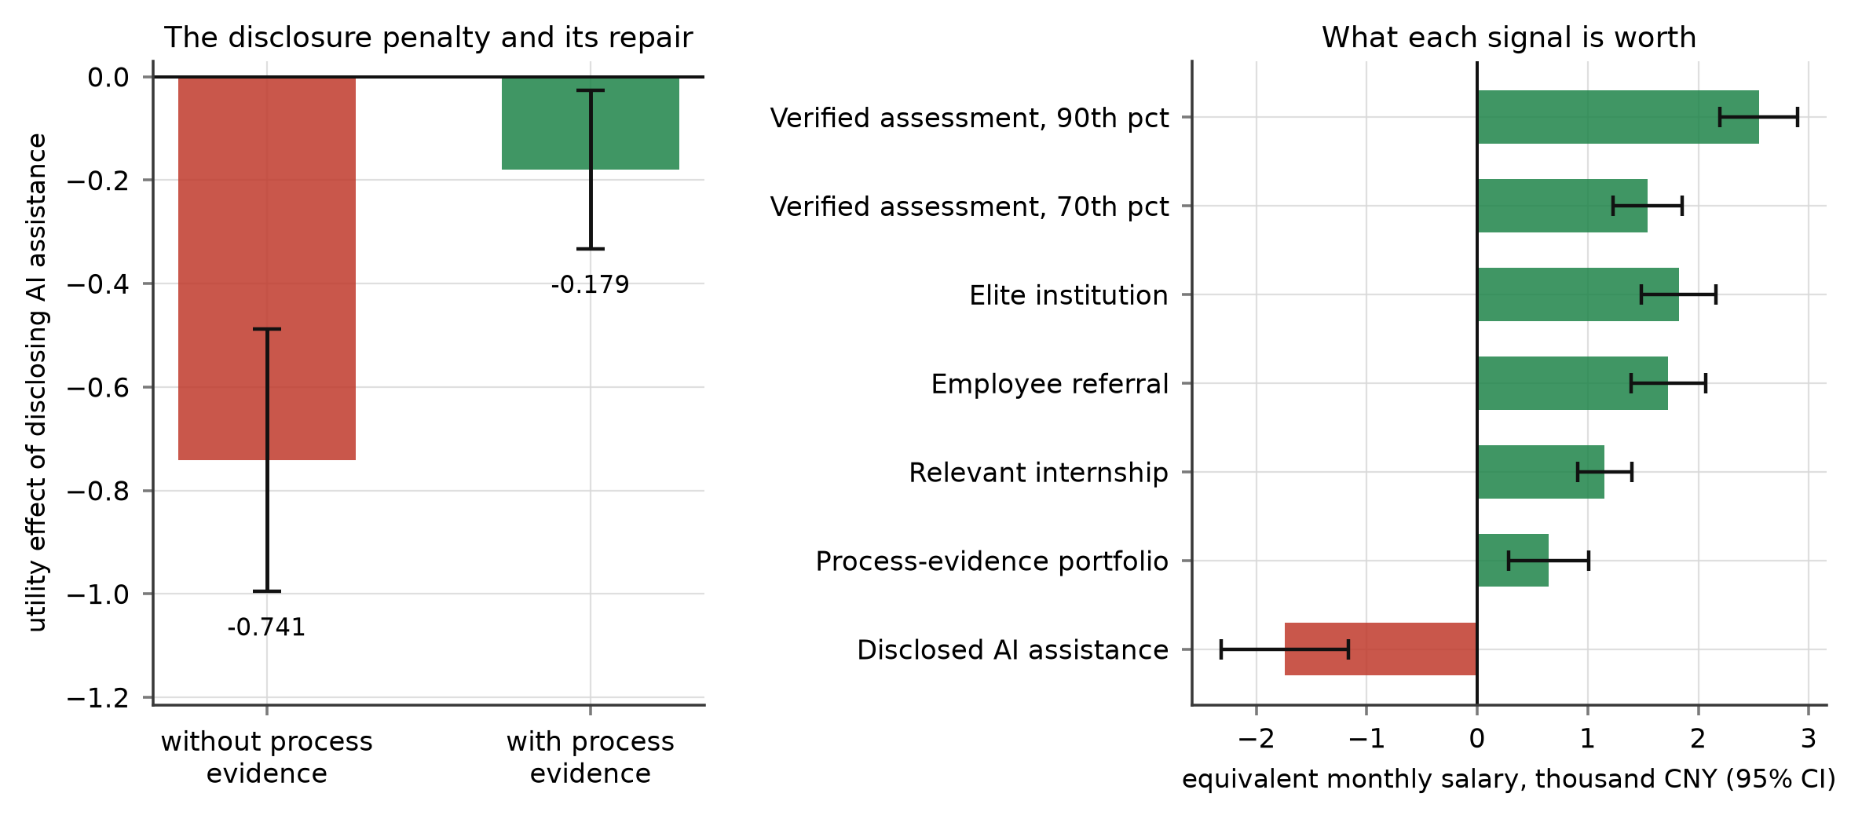
Figure 4. Left: the utility penalty for disclosing generative-AI assistance, without and with a process-evidence portfolio; the difference between the two bars is the interaction term. Right: every attribute expressed as a compensating differential in expected monthly salary. Bars are 95% confidence intervals from the delta method.
4.4. Three Screening Regimes
Table 3 reports the latent-class selection. The Bayesian and consistent Akaike information criteria both reach their minimum at three classes (BIC 10,483.4; CAIC 10,515.4), and we retain that solution. Average posterior class-assignment probability is 0.870 and the entropy criterion is 0.715, indicating good but not perfect separation; the two-class solution separates more cleanly (0.816) but fits markedly worse, which is the familiar trade-off between parsimony of classification and adequacy of fit.
Table 3. Latent-class selection and class-specific part-worths.
Classes | Log-likelihood | Parameters | BIC | CAIC | Entropy
2 | −5197.5 | 21 | 10,523.4 | 10,544.4 | 0.816
3 (retained) | −5143.9 | 32 | 10,483.4 | 10,515.4 | 0.715
4 | −5119.8 | 43 | 10,502.4 | 10,545.4 | 0.734
5 | −5109.0 | 54 | 10,548.1 | 10,602.1 | 0.689
Attribute | C1 credential retreat (38.1%) | C2 assessment triage (28.4%) | C3 evidence weighting (33.5%)
Disclosed AI assistance | −1.17 | −0.77 | 0.06
Process-evidence portfolio | −0.08 | 0.20 | 1.02
Disclosure × process evidence | 0.38 | 0.69 | 0.30
Verified assessment, 70th pct | 0.26 | 0.79 | 0.64
Verified assessment, 90th pct | 0.45 | 1.76 | 0.82
Elite institution | 1.40 | 0.29 | 0.22
Employee referral | 1.39 | 0.35 | 0.10
Relevant internship | 0.42 | 0.15 | 0.59
Expected salary (+1000 CNY) | −0.30 | −0.51 | −0.36
Notes: Class-specific part-worth utilities from the three-class latent-class conditional logit. Class labels are identified only up to a permutation; classes are ordered here by their institution coefficient. Shares are the estimated class probabilities.
The three regimes are readily interpretable and correspond closely to the three responses to signal collapse set out in Section 2.3. The largest class, holding 38.1% of respondents, is a credential-retreat regime: institution (1.40) and referral (1.39) dominate, verified assessment barely registers (0.45 at the 90th percentile), process evidence is worthless (−0.08), and the disclosure penalty is the largest of the three (−1.17). The second class, 28.4%, is an assessment-triage regime that loads almost everything onto the verified test (1.76 at the 90th percentile) and discounts institution and referral. The third, 33.5%, is an evidence-weighting regime that values the process portfolio most (1.02) and, strikingly, attaches no penalty at all to disclosure (0.06). Figure 5 displays the selection criteria and the class profiles.
That last coefficient deserves emphasis. Roughly a third of the employers in this sample do not penalise an applicant for saying that they used generative AI, provided the applicant can show how the work was done. The disclosure penalty reported in Section 4.3 is therefore not a uniform professional norm but the average of a strong penalty in one regime and no penalty in another. Averaging conceals the thing that matters most to an applicant deciding whether to be candid.
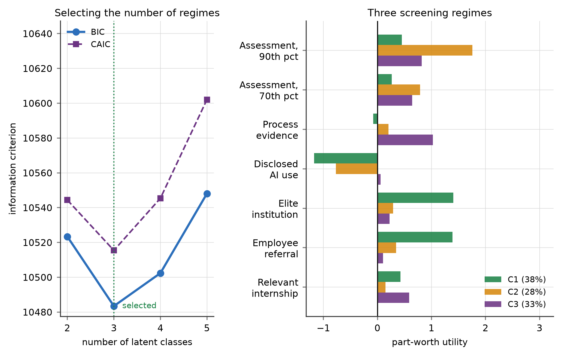
Figure 5. Left: information criteria by number of latent classes; both reach their minimum at three. Right: class-specific part-worth utilities for the three retained screening regimes, with class shares in the legend.
4.5. Which Employers Screen Which Way
Table 4 reports the membership model, with the credential-retreat regime as the reference. Hypothesis 5 is supported. Managers who believe a larger share of their applications are AI-assisted are significantly less likely to be in the evidence-weighting regime than in the credential-retreat regime (−0.683, SE 0.146, $p$ < 0.001) and somewhat less likely to be in the assessment-triage regime (−0.231, SE 0.149, $p$ = 0.122). Faster growth in application volume works the same way, pushing membership towards credential retreat and away from both alternatives (−0.376, $p$ = 0.007 for triage; −0.449, $p$ = 0.001 for evidence weighting). This is the retreat the theory predicts: as the written signal becomes less trustworthy and the pile grows, decision makers fall back on the signals the applicant did not produce.
The depth of digital transformation of the hiring function works in the opposite direction, and strongly: it raises the probability of the assessment-triage regime (0.811, $p$ < 0.001) and of the evidence-weighting regime (0.546, $p$ < 0.001) relative to credential retreat. Firms that have actually rebuilt their hiring process do not retreat to pedigree; they install verification. Centralisation of the screening decision, firm size and respondent experience are not significant, which suggests that the regime is a property of the firm’s screening system rather than of the individual who happens to operate it. Figure 6 plots the predicted membership probabilities across the two signal-environment variables.
Table 4. Membership model: multinomial logit on posterior class probabilities.
Covariate (standardised) | C2 assessment triage vs. C1 | C3 evidence weighting vs. C1
Digital-transformation depth of hiring | 0.811 *** (0.144) | 0.546 *** (0.140)
Perceived AI-assisted share | −0.231 (0.149) | −0.683 *** (0.146)
Application-volume growth | −0.376 ** (0.138) | −0.449 ** (0.138)
Decision centralisation | 0.095 (0.125) | −0.049 (0.121)
Firm size (log employees) | 0.061 (0.126) | 0.189 (0.120)
Respondent experience | 0.035 (0.125) | 0.086 (0.120)
Intercept | −0.271 * (0.129) | −0.113 (0.124)
Log-likelihood | −446.3
Notes: *** p < 0.001, ** p < 0.01, * p < 0.05. The reference category is the credential-retreat regime (C1). Estimated on posterior class probabilities rather than modal assignments, so classification uncertainty is carried into the second stage.
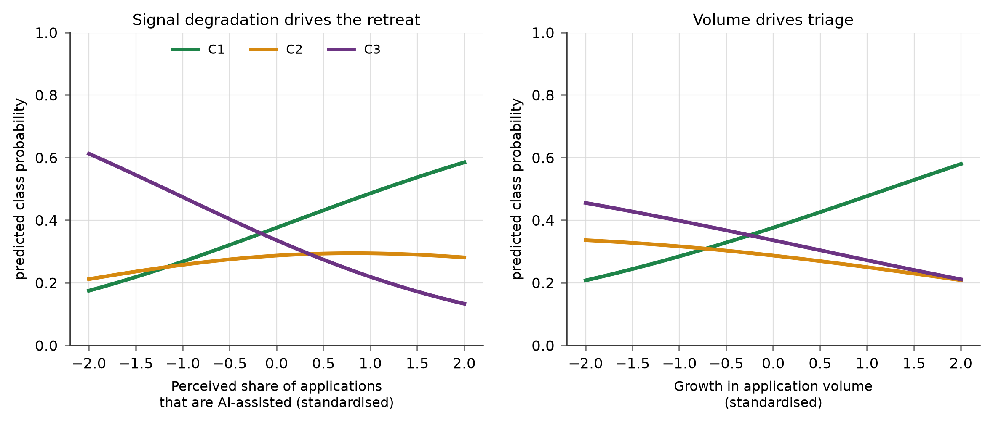
Figure 6. Predicted probability of belonging to each screening regime as a function of the perceived share of AI-assisted applications (left) and of growth in application volume (right), holding the remaining covariates at their means.
4.6. Predictive Validity
Hypothesis 4 requires that discrete heterogeneity earn its parameters out of sample, not merely in sample. We therefore re-estimated every model on each respondent’s first nine tasks and predicted their last five, forming the mixed-logit and latent-class predictions from each respondent’s posterior distribution over tastes given the training choices. Against a chance rate of 33.3%, the conditional logit predicts 59.9% of the 2260 held-out choices correctly, the mixed logit 63.5% and the latent-class model 64.3%; mean held-out log-likelihood improves in the same order, from −0.885 to −0.840 to −0.818. Discrete regimes therefore predict better than a continuous mixing distribution with the same information, which supports the substantive reading of the classes as screening regimes rather than as a convenient approximation to a smooth distribution.
4.7. The Architecture Experiment
The conjoint holds the interface fixed and lets preferences vary. The randomised experiment does the reverse, and it produces the paper’s largest effects. Table 5 and Figure 7 report the three outcomes.
Access differs sharply by architecture. The share of the five-person shortlist drawn from non-elite institutions is 42.5% under the AI-score-first interface, 31.1% under the credential-first interface and 52.4% under the evidence-first interface, $F$(2, 449) = 97.10, $p$ < 0.001, $η^{2}$ = 0.302; the Alexander–Govern test for unequal variances agrees ($A$ = 150.11, $p$ < 0.001). The gap between the credential-first and evidence-first architectures is 21.3 percentage points, a Cohen’s $d$ of 1.61, and it survives adjustment for firm covariates in the regression of Equation (11) (credential-first −0.113, evidence-first +0.097, both $p$ < 0.001; $R^{2}$ = 0.327).
The result that matters for practice is what happens to quality at the same time. If the credential ordering were selecting genuinely stronger candidates, the evidence-first architecture would buy access at the cost of quality. It does not. The mean verified-assessment percentile of the shortlist is 63.7 under AI-score first, 60.6 under credential first and 69.2 under evidence first, $F$(2, 449) = 43.25, $p$ < 0.001, $η^{2}$ = 0.162. The evidence-first architecture produces shortlists that are simultaneously 21.3 percentage points more open to non-elite institutions and 8.6 percentile points stronger on verified assessment than the credential-first architecture ($d$ = 1.08). Hypothesis 6 is supported in both of its parts, and the equity–quality trade-off that managers commonly assume turns out to be a property of the funnel rather than of the applicant pool. The direction is consistent with algorithmic screening built to explore rather than to imitate past hiring, which likewise improves quality and diversity together [34,64].
The architecture is not free. Screening under the evidence-first interface took 57.6 seconds per applicant against 41.4 under credential first, $F$(2, 449) = 90.84, $p$ < 0.001, $η^{2}$ = 0.288—roughly 16 additional seconds, or about 39% more time. For a firm screening a thousand applications this is an additional four and a half hours of managerial time per round. That is the real price of the better shortlist, and it is a price a leadership team can decide to pay.
Table 5. The randomised screening-architecture experiment: outcomes by arm.
Outcome | AI-score first (n = 151) | Credential first (n = 151) | Evidence first (n = 150) | F(2, 449) | η²
Non-elite share of shortlist | 0.425 (0.133) | 0.311 (0.144) | 0.524 (0.120) | 97.10 *** | 0.302
Mean assessment percentile | 63.70 (8.38) | 60.65 (7.89) | 69.20 (7.98) | 43.25 *** | 0.162
Seconds per applicant | 44.65 (12.12) | 41.41 (9.88) | 57.58 (10.92) | 90.84 *** | 0.288
Notes: Cell entries are means with standard deviations in parentheses. *** p < 0.001. Pairwise comparisons use Welch’s test with Bonferroni adjustment. Evidence first versus credential first: non-elite share d = 1.61, assessment percentile d = 1.08, seconds per applicant d = 1.55, all p < 0.001. The candidate pool was identical across arms, so differences are caused by the ordering and salience of information alone.
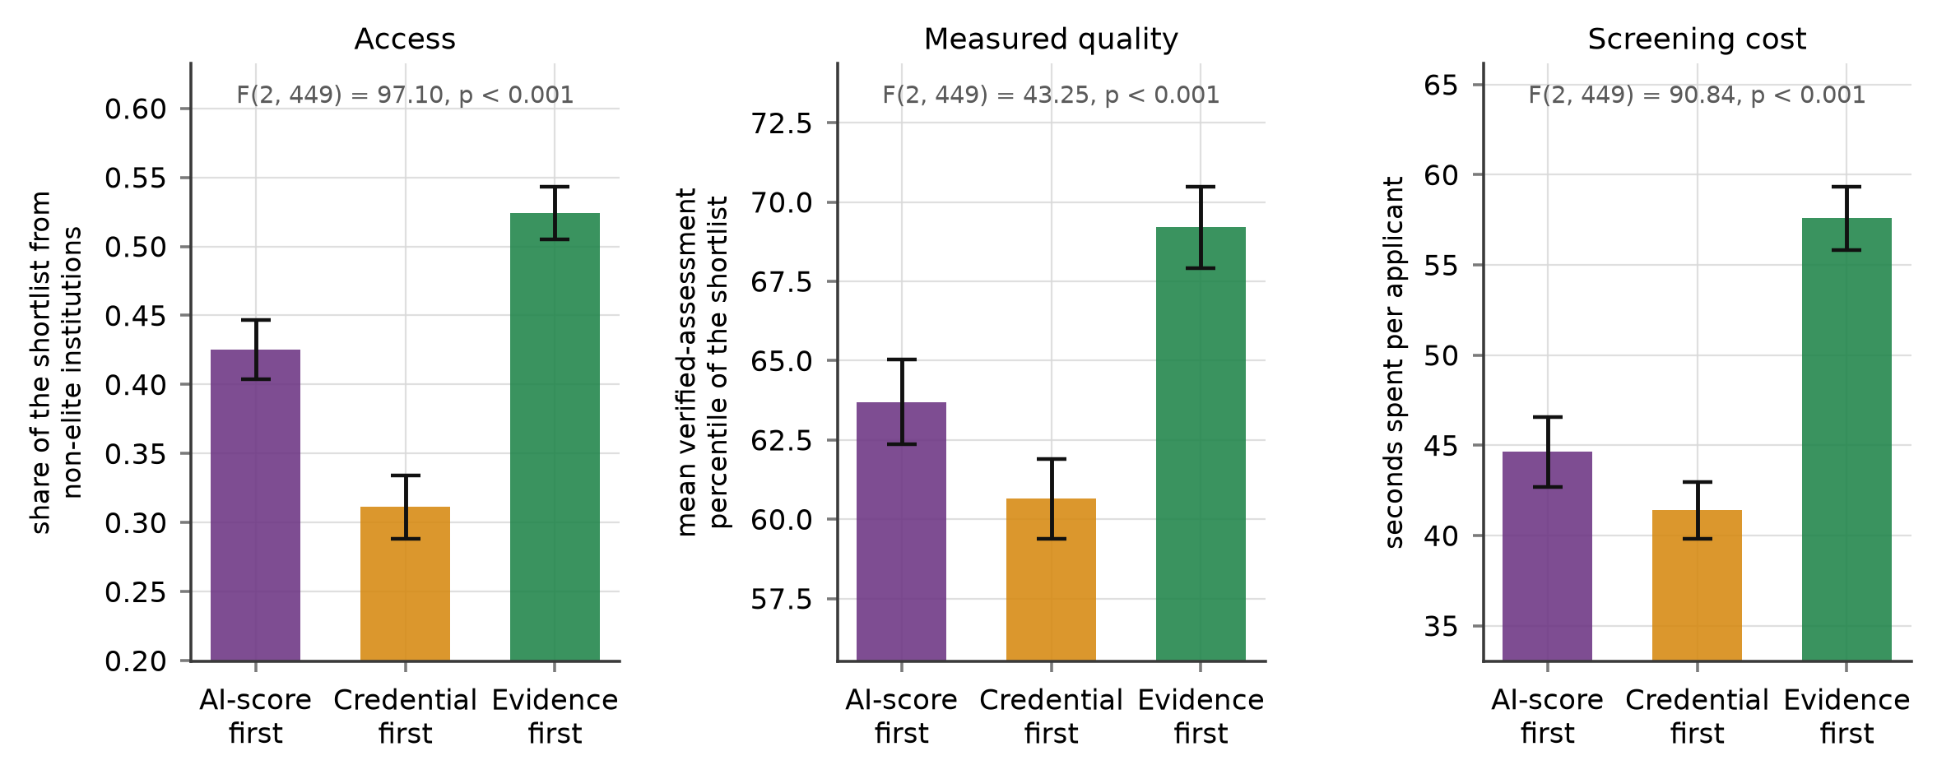
Figure 7. The randomised screening-architecture experiment. The same twenty-candidate pool was shown to every respondent; only the ordering and salience of information differed. Bars are means with 95% confidence intervals.
5. Discussion
5.1. Theoretical Implications
The paper’s first contribution is to put a price on a signalling failure. Signalling theory predicts that when a signal becomes cheap it stops separating types [1], and recent platform evidence documents exactly that collapse for written applications [2,3]. What has been missing is the employer’s side of the adjustment: given that the written application no longer informs, what do decision makers substitute towards, and how much is each substitute worth? Expressing every attribute as a compensating differential answers that question in a common metric. The verified assessment is worth more than the elite credential, the elite credential and the referral are worth about the same as each other, and the internship is worth about half as much as the top assessment result. Employers, in other words, are not indifferent between restoring a costly signal and retreating to an ascriptive one; they prefer the costly signal when it is available. The problem is that it is usually not available, because almost no applicant arrives with a verified assessment result.
The second contribution is to identify a repair mechanism that does not require new infrastructure. Process evidence works because it restores the cost asymmetry at the level of the work rather than the level of the credential: a model can produce a polished output cheaply but cannot cheaply fabricate a credible record of one particular person’s iterative reasoning about one particular problem. Empirically it removes about three quarters of the disclosure penalty, and in the evidence-weighting regime it removes all of it. This reframes the disclosure debate. The policy question is usually posed as whether applicants should be required to declare AI use, which invites an unenforceable answer; the more productive question is what would have to accompany a declaration to make it informative.
The third contribution is to show that employer heterogeneity here is discrete. The latent-class model beats the mixed logit out of sample despite the mixed logit having a more flexible mixing distribution, and the recovered classes map onto the three theoretical responses to signal collapse rather than onto arbitrary regions of a continuum. This matters for how the literature models employer behaviour. A population-average part-worth for disclosure of −0.741 describes no actual employer: it averages a −1.17 penalty in the credential regime against a coefficient indistinguishable from zero in the evidence regime. Advice to applicants derived from the average would be wrong for roughly two thirds of them in one direction or the other.
5.2. Implications for Leadership and Decision Making
For executives navigating digital transformation, the architecture experiment is the result to act on. Three findings follow directly. First, the interface is a policy instrument. The same managers, drawing from an identical candidate pool, produced shortlists differing by 21.3 percentage points in their openness to non-elite institutions purely as a function of what the screen put first. This dwarfs the differences between individual screeners’ preferences and it is a decision that sits with whoever configures the applicant-tracking system—typically a function that never appears on a leadership agenda. Digital transformation research has argued that the organisational redesign, not the technology, is where the value and the risk lie [40,41]; entry-level screening is a clean case in point, and interview evidence from talent-acquisition leaders points the same way: what changes outcomes is how selection is restructured around the tool, not the tool itself [65,66].
Second, the equity–quality trade-off that justifies credential-first screening does not exist in these data. Evidence-first ordering raised both the non-elite share and the measured quality of the shortlist. A manager who believes she is protecting quality by ranking on institution is, on this evidence, sacrificing quality as well as access. The intuition that pedigree is a shortcut to ability survives because it is rarely tested against a verified alternative in the same decision.
Third, the cost is real and quantifiable, which makes it a decision rather than an aspiration. Evidence-first screening cost about 16 additional seconds per applicant, roughly 39% more time. Framing the choice honestly—an additional four and a half hours per thousand applications in exchange for a shortlist that is both more open and stronger—is more useful to a leadership team than an appeal to fairness that does not price the alternative. Firms that had already digitalised their hiring function were significantly more likely to be screening on verification rather than pedigree, which suggests the capability to make this trade is built, not merely chosen. That is consistent with a digital-leadership literature which locates the scarce capability in the leadership team and its governance choices rather than in the technology stack [67–70].
5.3. Implications for Policy and for Applicants
For public policy, the results argue for investment in portable, verified skill signals for young labour-market entrants. The compensating differentials show employers are willing to pay substantially for verified assessment results—more than for an elite degree—yet such results are almost never in an applicant’s hands. Field experiments in other settings have shown that supplying credibly shareable assessment results raises employment and earnings for the workers who receive them [17–19]. The distinctive contribution of the present estimates is to show that the willingness to pay is there on the employer side too, which means the binding constraint is the infrastructure rather than employer demand.
A second policy implication concerns disclosure rules. A requirement to declare AI assistance, imposed without a mechanism for making the declaration informative, would impose a measurable cost on honest applicants—about a sixth of monthly pay in compensating terms—and would push the rest towards concealment. Pairing disclosure with a standard for process evidence changes the calculation: the penalty falls by about three quarters, and disappears entirely for the third of employers who already screen on evidence. Educational institutions are well placed to supply this, since coursework already generates drafts, revisions and supervision records, and vocational tracks already certify skill in a form employers read, and firms demonstrably read those certificates when they screen school leavers [71,72]. How far such infrastructure reaches depends on the wider architecture of the school-to-work transition, which differs markedly across institutional settings [73,74] and which shapes how many young people end up outside employment, education and training altogether [75,76].
For young applicants the practical advice that follows is unusually concrete. Disclosure is costly on average but the cost is conditional and largely repairable, and the repair—keeping and presenting a record of how the work was done—is within the applicant’s control in a way that institution and referral network are not. Given that a poor or delayed entry into the labour market leaves durable scars [10–12], the difference between a repairable and an unrepairable penalty is not a small matter.
5.4. Limitations and Future Research
Four limitations bound these conclusions. The most important is that stated choices are not hiring decisions. Conjoint and factorial designs are the standard non-deceptive instrument for eliciting employer preferences [46,47], and they have been used with recruiters in screening scenarios before [48,49], but a careful comparison of factorial-survey estimates against real hiring behaviour finds that the two can diverge appreciably [77]. We mitigated this by recruiting people who actually make shortlist decisions, by anchoring the scenario to a vacancy of a kind their firm fills [55], and by including an opt-out so that respondents were not forced to select from weak pairs; and the ordering we recover—verified assessment above elite credential—matches what field experiments with real vacancies find [17]. Nevertheless the magnitudes should be read as preference weights, not as predicted callback rates. A field audit varying process evidence on real applications is the natural next step.
Second, the architecture experiment manipulates ordering and salience within a research instrument, not a live applicant-tracking system, and the shortlist has no consequences for the respondent. The direction of the effect is likely robust, since ordering effects are if anything stronger under real time pressure, but the magnitude may not transfer; field experiments that alter a real selection stage find substantial behavioural responses on both sides of the market [78,79]. Third, the sample is drawn from knowledge-intensive service firms in one region of one country. The credential-retreat regime may be larger where institutional tier is a stronger sorting device, as it is in China’s graduate market, and the results should be replicated where entry is organised through apprenticeship or occupational licensing instead. Fourth, all data come from a single informant per firm at one point in time; we used key-informant selection criteria [52] and the choice tasks are experimental, which limits common-method concerns [80,81], but the firm-level covariates are self-reported and the perceived AI-assisted share in particular is a belief rather than a measurement.
Three extensions follow. The most valuable would be a field experiment in which real applications carry randomised process evidence, which would convert the compensating differentials estimated here into callback effects. A second would track the same firms over time as the perceived AI-assisted share rises, testing whether the membership shifts predicted here occur within firms rather than only across them. A third would extend the architecture manipulation to the applicant side, since the signalling equilibrium is jointly determined and applicants adjust their disclosure behaviour to the penalties they anticipate.
6. Conclusions
Generative artificial intelligence has made the written job application cheap to produce, and a cheap signal cannot separate candidates. This paper asked what employers do instead, and whether the answer can be changed by design. Combining a choice experiment with 452 managers who make entry-level shortlist decisions and a randomised manipulation of the screening architecture, we find that disclosure of AI assistance carries a penalty worth about 1743 CNY per month in compensating terms, that a portfolio documenting the applicant’s drafting and revision process removes about three quarters of it, and that verified assessment results are valued more highly than elite credentials.
Employers do not, however, screen by a single rule. Three regimes coexist: a credential-retreat regime holding 38.1% of respondents, an assessment-triage regime holding 28.4%, and an evidence-weighting regime holding 33.5% that attaches no penalty whatever to disclosure. Membership responds to the state of the signal environment in the direction the theory predicts—managers who believe more of their applications are AI-assisted, and who face faster growth in volume, retreat towards credentials—and in the opposite direction to the depth of digital transformation of the hiring function, so firms that have genuinely rebuilt their hiring process install verification rather than pedigree.
The most consequential finding is the one that does not depend on preferences at all. The same managers, drawing from an identical pool, produced shortlists differing by 21.3 percentage points in their openness to candidates from non-elite institutions according to what the interface presented first, and the evidence-first architecture that opened access also produced shortlists 8.6 percentile points stronger on verified assessment, at a cost of about 16 additional seconds per applicant. The equity–quality trade-off is an artefact of the funnel. Who reaches a human interviewer in the age of machine-written applications is therefore decided less by the preferences of the person screening than by the architecture someone else configured, and that architecture is a leadership decision that can be made deliberately.
Author Contributions: Conceptualization, X.C. and T.M.; methodology, X.C.; software, X.C.; validation, X.C., D.H. and T.M.; formal analysis, X.C.; investigation, D.H.; resources, T.M.; data curation, D.H.; writing—original draft preparation, X.C.; writing—review and editing, T.M.; visualization, X.C. and D.H.; supervision, T.M.; project administration, T.M.; funding acquisition, X.C. All authors have read and agreed to the published version of the manuscript.
Funding: This research was funded by the Zhejiang Provincial Philosophy and Social Sciences Planning Special Project on Higher Education Basic Research Funding Reform (Grant Number: 25NDJC153YBMS) and the Major Humanities and Social Sciences Research Projects in Zhejiang Higher Education Institutions (Grant Number: 2024QN018).
Institutional Review Board Statement: The study was conducted in accordance with the Declaration of Helsinki and approved by the Academic Ethics Committee of the College of Business, Jiaxing University (protocol code JXU-BUS-2026-047, approved on 21 February 2026).
Informed Consent Statement: Informed consent was obtained from all respondents involved in the study.
Data Availability Statement: The choice-experiment design, the estimation code, the survey instrument and the code that generates every figure and table in this paper are available from the corresponding author on reasonable request. Respondent-level data cannot be shared because participants were assured of confidentiality.
Conflicts of Interest: The authors declare no conflicts of interest.
Abbreviations
The following abbreviations are used in this manuscript: AI, artificial intelligence; AIC, Akaike information criterion; BIC, Bayesian information criterion; CAIC, consistent Akaike information criterion; CBC, choice-based conjoint; CI, confidence interval; CNY, Chinese yuan; DCE, discrete choice experiment; EM, expectation–maximisation; MRS, marginal rate of substitution; SD, standard deviation; SE, standard error; SML, simulated maximum likelihood; YRD, Yangtze River Delta.
Appendix A
Table A1 documents the experimental design and the estimation settings in the detail required to reproduce the analysis.
Table A1. Design and estimation details.
Item | Value
Respondents | 452 entry-level screening decision makers
Choice tasks per respondent | 14
Alternatives per task | 2 candidate profiles plus an opt-out
Choice sets | 6328
Profile evaluations | 12,656
Full factorial | 288 profiles (2 × 2 × 3 × 2 × 2 × 2 × 3)
Design construction | D-efficient search at null priors with a minimum-overlap constraint of four differing attributes
D-error of the retained design | 0.570
Design blocks | 8 rotations, with within-task positions alternated
Opt-out share | 11.5% of tasks
Mixed logit draws | 500 scrambled Halton draws, all coefficients normal
Mixed logit convergence | largest absolute gradient 7.0 × 10⁻⁴
Conditional logit convergence | largest absolute gradient 2.1 × 10⁻⁷
Latent-class estimation | expectation–maximisation, 2 to 5 classes, BIC selection
Standard errors | respondent-clustered sandwich estimator
Trade-off standard errors | delta method on the ratio to the salary coefficient
Hold-out validation | estimate on tasks 1–9, predict tasks 10–14 from each respondent’s posterior over tastes
Architecture experiment | 3 arms, equal randomisation, identical 20-candidate pool
Software | Python 3.11, NumPy, SciPy; single seeded pipeline
References
1. Spence, M. Job Market Signaling. Q. J. Econ. 1973, 87, 355–374.
2. Cui, J.; Dias, G.; Ye, J. Signaling in the Age of AI: Evidence from Cover Letters. arXiv 2025, arXiv:2509.25054.
3. Galdin, A.; Silbert, J. Making Talk Cheap: Generative AI and Labor Market Signaling. arXiv 2025, arXiv:2511.08785.
4. van Inwegen, E.; Munyikwa, Z.; Horton, J.J. Algorithmic Writing Assistance on Jobseekers’ Resumes Increases Hires. Manag. Sci. 2025, 71, 10144–10164.
5. Xu, J.; Li, G.; Jiang, J.Y. AI Self-preferencing in Algorithmic Hiring: Empirical Evidence and Insights. In Proceedings of the 5th ACM Conference on Equity and Access in Algorithms, Mechanisms, and Optimization (EAAMO ’25), Pittsburgh, PA, USA, 3–5 November 2025.
6. Wilson, K.; Caliskan, A. Gender, Race, and Intersectional Bias in Resume Screening via Language Model Retrieval. In Proceedings of the AAAI/ACM Conference on AI, Ethics, and Society (AIES), San Jose, CA, USA, 21–23 October 2024; Volume 7, pp. 1578–1590.
7. Brynjolfsson, E.; Chandar, B.; Chen, R. Canaries in the Coal Mine? Six Facts about the Recent Employment Effects of Artificial Intelligence; Working Paper; Stanford Digital Economy Lab: Stanford, CA, USA, 2025.
8. Hosseini Maasoum, S.M.; Lichtinger, G. Generative AI as Seniority-Biased Technological Change: Evidence from U.S. Résumé and Job Posting Data; SSRN Working Paper No. 5425555; Social Science Research Network: Rochester, NY, USA, 2025.
9. Humlum, A.; Vestergaard, E. Still Waters, Rapid Currents: Early Labor Market Transformation under Generative AI; NBER Working Paper No. 33777; National Bureau of Economic Research: Cambridge, MA, USA, 2025.
10. Arellano-Bover, J. Career Consequences of Firm Heterogeneity for Young Workers: First Job and Firm Size. J. Labor Econ. 2024, 42, 549–589.
11. von Wachter, T. The Persistent Effects of Initial Labor Market Conditions for Young Adults and Their Sources. J. Econ. Perspect. 2020, 34, 168–194.
12. Tomlinson, M.; Tholen, G. Scarring effects for young people in challenging economic times: a conceptual synthesis and future policy and research agenda. Labour Ind. 2023, 33, 308–325.
13. Chetty, R.; Deming, D.J.; Friedman, J.N. Diversifying Society’s Leaders? The Determinants and Causal Effects of Admission to Highly Selective Private Colleges; NBER Working Paper No. 31492; National Bureau of Economic Research: Cambridge, MA, USA, 2023.
14. Rivera, L.A.; Tilcsik, A. Class Advantage, Commitment Penalty: The Gendered Effect of Social Class Signals in an Elite Labor Market. Am. Sociol. Rev. 2016, 81, 1097–1131.
15. Burks, S.V.; Cowgill, B.; Hoffman, M.; Housman, M. The Value of Hiring through Employee Referrals. Q. J. Econ. 2015, 130, 805–839.
16. Altonji, J.G.; Pierret, C.R. Employer Learning and Statistical Discrimination. Q. J. Econ. 2001, 116, 313–350.
17. Carranza, E.; Garlick, R.; Orkin, K.; Rankin, N. Job Search and Hiring with Limited Information about Workseekers’ Skills. Am. Econ. Rev. 2022, 112, 3547–3583.
18. Pallais, A. Inefficient Hiring in Entry-Level Labor Markets. Am. Econ. Rev. 2014, 104, 3565–3599.
19. Abel, M.; Burger, R.; Piraino, P. The Value of Reference Letters: Experimental Evidence from South Africa. Am. Econ. J. Appl. Econ. 2020, 12, 40–71.
20. Cheng, C.; Luo, J.; Zhu, C.; Zhang, S. Artificial intelligence and the skill premium: A numerical analysis of theoretical models. Technol. Forecast. Soc. Change 2024, 200, 123140.
21. Battisti, M.; Dustmann, C.; Schönberg, U. Technological and Organizational Change and the Careers of Workers. J. Eur. Econ. Assoc. 2023, 21, 1551–1594.
22. Dou, B.; Guo, S.; Chang, X.; Wang, Y. Corporate digital transformation and labor structure upgrading. Int. Rev. Financ. Anal. 2023, 90, 102904.
23. Qin, S.; Liu, Z.; Wang, J.; Wu, Y. The impact of digital transformation on labour demand quantity and structure: Evidence from China. Econ. Anal. Policy 2024, 84, 1452–1469.
24. Li, X.; Wang, Q.; Kong, D.; Tao, Y. Intelligent Manufacturing and Corporate Human Capital Upgrade in China. J. Asian Econ. 2025, 97, 101886.
25. Bankins, S.; Jooss, S.; Restubog, S.L.D.; Marrone, M.; Ocampo, A.C.; Shoss, M. Navigating career stages in the age of artificial intelligence: A systematic interdisciplinary review and agenda for future research. J. Vocat. Behav. 2024, 153, 104011.
26. Heß, P.; Janssen, S.; Leber, U. The effect of automation technology on workers’ training participation. Econ. Educ. Rev. 2023, 96, 102438.
27. Jones, M.K.; Kaya, E.; Nan, J. Overeducation, earnings and job satisfaction among graduates in China. China Econ. Rev. 2025, 93, 102448.
28. Xiong, B.; Yu, B. The Impact of Internet Development on Youth’s Job Quality in the Digital Economy Era: Transmission Mechanism and Empirical Test. Soc. Indic. Res. 2024, 175, 269–294.
29. Noy, S.; Zhang, W. Experimental evidence on the productivity effects of generative artificial intelligence. Science 2023, 381, 187–192.
30. Brynjolfsson, E.; Li, D.; Raymond, L. Generative AI at Work. Q. J. Econ. 2025, 140, 889–942.
31. Demirci, O.; Hannane, J.; Zhu, X. Who Is AI Replacing? The Impact of Generative AI on Online Freelancing Platforms. Manag. Sci. 2025, 71, 8097–8108.
32. Robie, C.; Wingate, T.G.; Baytalskaya, N.; Butera, H. Candidate Generative AI Use in Pre-Hire Employment Assessments: Self-Reported Incidence and the Impact of Warnings. Int. J. Sel. Assess. 2026, 34, e70056.
33. Bartoš, V.; Bauer, M.; Chytilová, J.; Matějka, F. Attention Discrimination: Theory and Field Experiments with Monitoring Information Acquisition. Am. Econ. Rev. 2016, 106, 1437–1475.
34. Li, D.; Raymond, L.R.; Bergman, P. Hiring as Exploration. Rev. Econ. Stud. 2026, 93, 1200–1240.
35. Hoffman, M.; Kahn, L.B.; Li, D. Discretion in Hiring. Q. J. Econ. 2018, 133, 765–800.
36. Vaccaro, M.; Almaatouq, A.; Malone, T. When combinations of humans and AI are useful: A systematic review and meta-analysis. Nat. Hum. Behav. 2024, 8, 2293–2303.
37. Quillian, L.; Pager, D.; Hexel, O.; Midtbøen, A.H. Meta-analysis of field experiments shows no change in racial discrimination in hiring over time. Proc. Natl. Acad. Sci. USA 2017, 114, 10870–10875.
38. Lippens, L.; Vermeiren, S.; Baert, S. The state of hiring discrimination: A meta-analysis of (almost) all recent correspondence experiments. Eur. Econ. Rev. 2023, 151, 104315.
39. Rivera, L.A. Hiring as Cultural Matching: The Case of Elite Professional Service Firms. Am. Sociol. Rev. 2012, 77, 999–1022.
40. Hanelt, A.; Bohnsack, R.; Marz, D.; Antunes Marante, C. A Systematic Review of the Literature on Digital Transformation: Insights and Implications for Strategy and Organizational Change. J. Manag. Stud. 2021, 58, 1159–1197.
41. Braojos, J.; Weritz, P.; Matute, J. Empowering organisational commitment through digital transformation capabilities: The role of digital leadership and a continuous learning environment. Inf. Syst. J. 2024, 34, 1466–1492.
42. Steyvers, M.; Kumar, A. Three Challenges for AI-Assisted Decision-Making. Perspect. Psychol. Sci. 2024, 19, 722–734.
43. Csaszar, F.A.; Ketkar, H.; Kim, H. Artificial Intelligence and Strategic Decision-Making: Evidence from Entrepreneurs and Investors. Strategy Sci. 2024, 9, 322–345.
44. Song, Y.; Qiu, X.; Liu, J. The Impact of Artificial Intelligence Adoption on Organizational Decision-Making: An Empirical Study Based on the Technology Acceptance Model in Business Management. Systems 2025, 13, 683.
45. Tursunbayeva, A.; Chalutz-Ben Gal, H. Adoption of artificial intelligence: A TOP framework-based checklist for digital leaders. Bus. Horiz. 2024, 67, 357–368.
46. Kessler, J.B.; Low, C.; Sullivan, C.D. Incentivized Resume Rating: Eliciting Employer Preferences without Deception. Am. Econ. Rev. 2019, 109, 3713–3744.
47. Hainmueller, J.; Hopkins, D.J.; Yamamoto, T. Causal Inference in Conjoint Analysis: Understanding Multidimensional Choices via Stated Preference Experiments. Political Anal. 2014, 22, 1–30.
48. Oberst, U.; De Quintana, M.; Del Cerro, S.; Chamarro, A. Recruiters prefer expert recommendations over digital hiring algorithm: a choice-based conjoint study in a pre-employment screening scenario. Manag. Res. Rev. 2021, 44, 625–641.
49. Maer Matei, M.M.; Zamfir, A.-M.; Mocanu, C. Criteria Weights in Hiring Decisions—A Conjoint Approach. Mathematics 2023, 11, 728.
50. Johnson, F.R.; Lancsar, E.; Marshall, D.; Kilambi, V.; Mühlbacher, A.; Regier, D.A.; Bresnahan, B.W.; Kanninen, B.; Bridges, J.F.P. Constructing experimental designs for discrete-choice experiments: report of the ISPOR Conjoint Analysis Experimental Design Good Research Practices Task Force. Value Health 2013, 16, 3–13.
51. Hauber, A.B.; González, J.M.; Groothuis-Oudshoorn, C.G.M.; Prior, T.; Marshall, D.A.; Cunningham, C.; IJzerman, M.J.; Bridges, J.F.P. Statistical Methods for the Analysis of Discrete Choice Experiments: A Report of the ISPOR Conjoint Analysis Good Research Practices Task Force. Value Health 2016, 19, 300–315.
52. Kumar, N.; Stern, L.W.; Anderson, J.C. Conducting Interorganizational Research Using Key Informants. Acad. Manag. J. 1993, 36, 1633–1651.
53. Berinsky, A.J.; Margolis, M.F.; Sances, M.W. Separating the Shirkers from the Workers? Making Sure Respondents Pay Attention on Self-Administered Surveys. Am. J. Political Sci. 2014, 58, 739–753.
54. Peer, E.; Rothschild, D.; Gordon, A.; Evernden, Z.; Damer, E. Data quality of platforms and panels for online behavioral research. Behav. Res. Methods 2022, 54, 1643–1662.
55. Gutfleisch, T.; Samuel, R.; Sacchi, S. The application of factorial surveys to study recruiters’ hiring intentions: comparing designs based on hypothetical and real vacancies. Qual. Quant. 2021, 55, 775–804.
56. Train, K.; Weeks, M. Discrete Choice Models in Preference Space and Willingness-to-Pay Space. In Applications of Simulation Methods in Environmental and Resource Economics; Alberini, A., Scarpa, R., Eds.; Springer: Dordrecht, The Netherlands, 2005; pp. 1–17.
57. Deming, D.J.; Kahn, L.B. Skill Requirements across Firms and Labor Markets: Evidence from Job Postings for Professionals. J. Labor Econ. 2018, 36, S337–S369.
58. Rose, J.M.; Bliemer, M.C.J. Constructing Efficient Stated Choice Experimental Designs. Transp. Rev. 2009, 29, 587–617.
59. Bansak, K.; Hainmueller, J.; Hopkins, D.J.; Yamamoto, T. The Number of Choice Tasks and Survey Satisficing in Conjoint Experiments. Political Anal. 2018, 26, 112–119.
60. McFadden, D.; Train, K. Mixed MNL models for discrete response. J. Appl. Econom. 2000, 15, 447–470.
61. Train, K.E. Discrete Choice Methods with Simulation, 2nd ed.; Cambridge University Press: Cambridge, UK, 2009.
62. Greene, W.H.; Hensher, D.A. A latent class model for discrete choice analysis: contrasts with mixed logit. Transp. Res. Part B Methodol. 2003, 37, 681–698.
63. Nylund, K.L.; Asparouhov, T.; Muthén, B.O. Deciding on the Number of Classes in Latent Class Analysis and Growth Mixture Modeling: A Monte Carlo Simulation Study. Struct. Equ. Model. 2007, 14, 535–569.
64. Aka, A.; Palikot, E.; Ansari, A.; Yazdani, N. Better Together: Quantifying the Benefits of AI-Assisted Recruitment. arXiv 2025, arXiv:2507.08029.
65. Dutta, D.; Naveen, P.M. Transforming Recruitment and Selection Practices in Organizations Through Discriminative and Generative AI Adoption: A Structuration Lens. Hum. Resour. Manag. 2026, 65, 77–115.
66. Budhwar, P.; Chowdhury, S.; Wood, G.; Aguinis, H.; Bamber, G.J.; Beltran, J.R.; Boselie, P.; Cooke, F.L.; Decker, S.; DeNisi, A.; et al. Human resource management in the age of generative artificial intelligence: Perspectives and research directions on ChatGPT. Hum. Resour. Manag. J. 2023, 33, 606–659.
67. Lin, Q. Digital leadership: A systematic literature review and future research agenda. Eur. J. Innov. Manag. 2025, 28, 2469–2488.
68. Schulz, C.; Bendig, D.; Kriebel, J.; Haubner, K.; Fainshmidt, S. CEO Human Capital and Digital Product Innovation: A Dynamic Managerial Capabilities Perspective. Inf. Syst. Res. 2026, 37, 863–885.
69. Iden, J.; Bygstad, B. Sociotechnical micro-foundations for digital transformation. Eur. J. Inf. Syst. 2025, 34, 367–382.
70. Merín-Rodrigáñez, J.; Dasí, À.; Alegre, J.; Hughes, M. Dynamic managerial capabilities for digital transformation in innovative SMEs: What are the effects on new product development performance? J. Bus. Res. 2025, 201, 115709.
71. Dai, L.; Martins, P.S. Does vocational education pay off in China? Evidence from city-level education supply shocks. Econ. Model. 2024, 140, 106863.
72. Friedrich, A. School-leaving certificates and vocational education and training—The role of firms as gatekeepers in Germany. Int. J. Manpow. 2025, 46, 125–147.
73. Marczuk, A. Literature review of comparative school-to-work research: How institutional settings shape individual labour market outcomes. J. Labour Mark. Res. 2024, 58, 19.
74. O’Higgins, N.; Brockie, K. The Youth Guarantee, Vulnerability, and Social Exclusion Among NEETs in Southern Europe. Polit. Gov. 2024, 12, 7469.
75. International Labour Organization (ILO). Global Employment Trends for Youth 2024: Decent Work, Brighter Futures; ILO: Geneva, Switzerland, 2024.
76. Rahmani, H.; Groot, W.; Rahmani, A.M. Unravelling the NEET phenomenon: A systematic literature review and meta-analysis of risk factors for youth not in education, employment, or training. Int. J. Adolesc. Youth 2024, 29, 2331576.
77. Forster, A.G.; Neugebauer, M. Factorial Survey Experiments to Predict Real-World Behavior: A Cautionary Tale from Hiring Studies. Sociol. Sci. 2024, 11, 886–906.
78. Avery, M.; Ip, E.; Leibbrandt, A.; Vecci, J. A Brave New World of Hiring: A Natural Field Experiment on How Asynchronous Interviews and AI Assessment Reshape Recruitment; CESifo Working Paper No. 12573; CESifo: Munich, Germany, 2026.
79. Jabarian, B.; Henkel, L. Voice AI in Firms: A Natural Field Experiment on Automated Job Interviews; SSRN Working Paper No. 5395709; Social Science Research Network: Rochester, NY, USA, 2025.
80. Podsakoff, P.M.; MacKenzie, S.B.; Lee, J.-Y.; Podsakoff, N.P. Common method biases in behavioral research: A critical review of the literature and recommended remedies. J. Appl. Psychol. 2003, 88, 879–903.
81. Podsakoff, P.M.; Podsakoff, N.P.; Williams, L.J.; Huang, C.; Yang, J. Common method bias: It’s bad, it’s complex, it’s widespread, and it’s not easy to fix. Annu. Rev. Organ. Psychol. Organ. Behav. 2024, 11, 17–61.
Disclaimer/Publisher’s Note: The statements, opinions and data contained in all publications are solely those of the individual author(s) and contributor(s) and not of MDPI and/or the editor(s). MDPI and/or the editor(s) disclaim responsibility for any injury to people or property resulting from any ideas, methods, instructions or products referred to in the content.

