Article
The Vanishing First Rung: A System Dynamics Study of Entry-Level Automation, Senior Time Allocation and the Erosion of the Professional Expertise Pipeline
Xinyu Cai ¹, Dingpei Hu ¹ and Tiantian Mo ^{1,}*
Academic Editor: Maja Meško
Received: date
Revised: date
Accepted: date
Published: date
Citation: To be added by editorial staff during production.
Copyright: © 2026 by the authors. Submitted for possible open access publication under the terms and conditions of the Creative Commons Attribution (CC BY) license (https://creativecommons.org/licenses/by/4.0/).
¹ College of Business, Jiaxing University, Jiaxing 314001, China; caixinyu@zjxu.edu.cn
* Correspondence: 00008227@zjxu.edu.cn
Abstract
Generative artificial intelligence automates precisely the routine, supervised tasks that firms have historically used to train new graduates. Managers therefore face a decision whose costs and benefits are separated by more than a decade: every entry-level task delegated to a machine saves money now and removes a unit of practice that would have produced a proficient professional later. This paper asks what that decision does to the stock of expertise a firm can draw on, and which leadership levers can repair the damage. We combine an enterprise survey with a simulation model. Study 1 surveys 356 knowledge-intensive firms in China’s Yangtze River Delta and estimates the behavioural parameters that link automation depth to entry hiring, senior verification time, mentoring intensity and time to independent proficiency. Study 2 embeds those estimates in a five-stock system dynamics model of the entrant pool, the junior and senior workforce and the skill capital of excluded entrants, and subjects the model to dimensional, extreme-condition, structural and behaviour-reproduction tests. The calibrated model reproduces the entry-level hiring decline now observed in AI-exposed occupations and then generates a pronounced better-before-worse trajectory: productive capacity peaks 8.7% above the no-automation counterfactual in year 9, crosses back below it in year 16.6, and ends 15.4% below it in year 30, by which point the stock of proficient professionals is 46.3% smaller. Two successive regime shifts appear as automation deepens—a collapse of mentoring at an asymptotic automation depth of 0.475 and a verification bottleneck at 0.725. Structural decomposition shows that the initiating damage is done by task substitution and by the loss of learning content in the tasks that remain, not by the mentoring squeeze, which is a late-stage amplifier. Of four leadership levers, an AI-augmented apprenticeship that restores the learning content of entry work is 2.5 times more efficient than an entry-hiring subsidy per additional senior-year created, and is the only single lever that lifts the pipeline’s conversion rate back above its pre-automation level. The results identify the learning content of entry work, rather than the number of entry jobs, as the system’s true leverage point.
Keywords: system dynamics; generative artificial intelligence; entry-level employment; expertise pipeline; mentoring; digital transformation; managerial decision making; leverage points; simulation; youth employment

1. Introduction
Every profession maintains a pipeline. Graduates enter it, spend several years on supervised routine work, and emerge able to exercise independent judgement. The pipeline is slow, it is expensive, and until recently it was invisible, because the work that fed it was also work that had to be done. Generative artificial intelligence has made that work optional. Large language models now perform, at low marginal cost and acceptable quality, the document review, first-draft coding, reconciliation and summarisation tasks that constituted the training bundle of entry-level professionals [1–4]. Firms that automate these tasks obtain an immediate, measurable saving. What they give up is a flow of practice whose value will not be realised for six to eight years, and whose absence will not be visible on any current-period statement. Career research has begun to register the same tension from the individual side, showing that the stage sequence through which professional careers develop is being reorganised by artificial intelligence, and that automation reduces the training participation of exactly the workers most exposed to it [5–7].
The first evidence that firms are in fact making this trade is now arriving. Using high-frequency payroll data covering millions of United States workers, Brynjolfsson, Chandar and Chen document a relative decline of roughly 13% in employment of 22- to 25-year-olds in the occupations most exposed to generative AI, with no corresponding decline for older workers in the same occupations [8]. Analyses of résumé and vacancy data reach the same conclusion from the demand side: adopting firms reduce junior hiring while leaving senior hiring intact, a pattern described as seniority-biased technological change [9,10]. These findings are about the first year of a process. The question this paper addresses is what happens over the following three decades, when the cohorts that were not hired fail to become the seniors the system needs.
That question cannot be answered by extrapolating the hiring series, because the system contains feedback. Fewer juniors mean fewer future seniors; fewer seniors mean less time available to supervise the juniors who are hired; longer supervision means slower promotion, which reduces the replacement hiring that tracks promotion; and the entrants who are not hired accumulate no skill, so the pool from which firms later recruit becomes progressively less employable [11–14]. Meanwhile the same automation that removed the training tasks creates a new claim on senior time, because machine output must be checked before it can be used [15–17]. These processes have different signs, different delays and different strengths, and the behaviour they jointly produce is not obtainable by intuition. It requires an explicit dynamic model [18,19].
The problem is also, at its core, a leadership and decision-making problem, and this is what makes it a systems problem rather than a labour-economics problem. No single actor decides to dismantle the expertise pipeline. Each firm decides only how deeply to automate its own entry task bundle and how to allocate the finite time of its own senior professionals between delivery, verification of machine output and mentoring. Each of those decisions is locally rational and is reinforced by the performance measurement systems that firms already use, which reward current delivery and are silent about capability that will be needed in a decade. The resulting structure is the classic capability trap: an accumulation whose depletion is invisible in the short run and irreversible in the medium run [20–22]. Research on digital leadership has established that the competences and governance arrangements of the top team shape how deeply firms transform and which workforce consequences follow [23–26]; what it has not yet asked is what those decisions do to the supply of the people who will run the firm two decades later. Diagnosing where in such a structure a leader can usefully intervene is exactly the task for which system dynamics was developed [19,27,28].
This paper makes that diagnosis in two stages. Study 1 is an enterprise survey of 356 knowledge-intensive firms in the Yangtze River Delta, designed not to test a hypothesis about attitudes but to measure the six behavioural parameters the simulation needs: how far AI substitutes for junior labour in staffing decisions, how much senior time verification of machine output consumes, how intensely juniors are mentored, how strongly mentoring shortens time to proficiency, how much learning content automation removes from entry work, and how far structured AI-assisted practice offsets that loss. Study 2 embeds those estimates in a five-stock system dynamics model, validates it against the established protocol for dynamic models [29,30], and uses it to run counterfactual, threshold, structural-decomposition and policy experiments.
Three contributions follow. First, the paper supplies the longitudinal, feedback-based account that the emerging empirical literature on entry-level AI exposure explicitly calls for but cannot itself provide, since that literature observes at most two years of a thirty-year adjustment. Second, it locates the mechanism precisely. Structural decomposition shows that the mentoring squeeze—the intuitive villain, and the one on which most commentary has settled—is not the initiating cause. Automation initially frees senior time rather than consuming it; the damage is done by the removal of entry positions and by the degraded learning content of the positions that remain, and the mentoring squeeze only becomes decisive after year 23, when it triggers an abrupt regime shift. Third, it identifies a leverage point that differs from the one that dominates policy discussion. Subsidising entry hiring works, but it is expensive per unit of expertise created, because it puts more juniors into a pipeline whose learning content has been degraded. Restoring the learning content of entry work is 2.5 times more efficient, and it is the only single lever that raises the conversion rate from entry hires into proficient professionals above its counterfactual value.
The remainder of the paper is organised as follows. Section 2 develops the theoretical background, defines the model boundary and states the propositions that the simulation tests. Section 3 describes the survey and the simulation model, including the full equation system, the calibration procedure and the validation protocol. Section 4 reports the parameter estimates, the validation results, the reference behaviour, the two regime shifts, the structural decomposition, the policy experiments and the global sensitivity analysis. Section 5 discusses theoretical, managerial and policy implications and states the limitations. Section 6 concludes.
2. Theoretical Background and Model Boundary
2.1. Entry-Level Work as the Input to Expertise Formation
The premise of the model is that professional expertise is produced, not selected. It accumulates through repeated performance of graduated tasks under feedback, a process documented in economics as learning by doing [31] and in psychology as deliberate practice [32]. What makes the process fragile is that its input is a by-product of production. Firms do not buy practice; they buy output, and practice is what juniors accumulate while producing it. When the output can be bought more cheaply from a machine, the practice disappears as a side effect of a decision that was never about training.
Three strands of evidence establish that this input matters and that it is delivered through proximity to more experienced colleagues rather than through formal instruction. Jarosch, Oberfield and Rossi-Hansberg show, using matched employer–employee data, that workers accumulate human capital from the skill of the coworkers around them, and that the effect is large enough to account for a substantial share of wage growth early in a career [33]. Emanuel, Harrington and Pallais exploit a natural experiment in physical seating to show that proximity to colleagues raises the feedback young workers receive and their subsequent promotion rates, at a short-run cost to the senior colleagues who provide it [34]. Studies of managerial quality show the same asymmetry from the supervisor’s side: people-management effort raises retention and productivity but is under-rewarded relative to delivery [35,36]. Apprenticeship cost–benefit studies quantify the trade directly, showing that firms bear a net cost during training which is recovered only through subsequent retention, and that this net cost makes training volumes highly sensitive to short-run business expectations [37–39]. Longitudinal career evidence confirms that the transition to independent responsibility is the pivotal event in a professional career, and that delaying it has durable consequences for subsequent attainment [40,41].
The implication for the model boundary is that time to independent proficiency must be endogenous. It is not a technological constant but a variable that responds to how much supervised practice a junior actually receives, how much learning content that practice carries, and how well prepared the entering cohort is. All three of these are affected by automation.
2.2. What Generative AI Does to the Entry Task Bundle: Three Channels
Generative AI is unusual among automation technologies in that its comparative advantage runs opposite to the historical pattern. Industrial robots displaced manual routine work performed by mid-career and older workers [42–44]; large language models displace cognitive routine work performed disproportionately by the young [45–47]. Firm-level evidence on earlier waves of automation is consistent with this contrast: robot adoption in Chinese and Japanese manufacturing reallocated labour demand towards higher-skilled workers without removing the entry tier, whereas digital transformation in service firms changes the composition of labour demand at the point of entry [48–50]. The experimental literature is consistent about the size and shape of the effect: writing tasks completed 40% faster with 18% higher quality [1], customer-support productivity gains concentrated among novices [2], coding tasks completed 56% faster [4], and consulting tasks improved inside the technology’s frontier but degraded outside it [3]. For the present purpose the important feature is that the gains are largest exactly where the training value is largest—on standardised, correctable, feedback-rich tasks.
We represent the shock through three channels, each governed by a parameter that Study 1 estimates. The substitution channel (C1) captures the direct reduction in desired junior headcount as automation deepens; its strength is the substitutability parameter $φ$. The practice-displacement channel (C2) captures the reduction in the learning content of the entry work that remains, governed by $θ$, net of an offsetting AI-as-tutor effect governed by $λ$ that operates only where firms deliberately structure AI use as scaffolded practice. Evidence for both directions exists. On the loss side, a multicentre observational study of endoscopists found that routine exposure to AI assistance measurably degraded unassisted detection performance [51], and experimental work shows that users systematically over-rely on machine recommendations even when they are wrong [15,52]. On the gain side, meta-analytic evidence shows that human–AI combinations outperform humans alone in generative tasks, and that the benefit depends on how the collaboration is designed rather than on the technology itself [16,17]. The third channel (C3) is the verification load: machine output must be checked by someone whose judgement is already independent, so automation creates a new claim $ν$ on senior time that grows with the volume of machine output.
2.3. Why a Locally Rational Decision Produces a Collectively Costly Outcome
The firm’s automation decision has the structure of an investment problem in which the cost appears in an account nobody keeps. Reducing entry hiring lowers current cost and raises current measured productivity. The offsetting loss—a smaller cohort reaching proficiency six to eight years later—falls outside the horizon of the performance measures that govern the decision, and is in any case partly externalised, since a firm that under-trains can attempt to hire proficient professionals from the market. When all firms reason this way the market from which they intend to hire ceases to exist. This is the structure that Repenning and Sterman identified in process improvement, where effort is diverted from capability building to firefighting because firefighting is what gets measured, and which Rahmandad and Repenning generalised as capability erosion [20–22]. Ide models the same logic for AI specifically, showing that automating the tasks through which knowledge is transmitted between generations can reduce long-run output even when it raises short-run output [53]. The socio-technical tradition makes the same point in organisational terms: an intervention in the technical subsystem that is not matched by a corresponding redesign of the social subsystem degrades the joint system even when it optimises the technical one [54–56].
Two features make the resulting trajectory hard to detect in time. First, the system exhibits worse-before-better in reverse: capacity rises before it falls, so early evidence appears to vindicate the decision. Second, the losses accumulate in stocks with long adjustment times—the senior workforce turns over on a horizon of roughly seventeen years—so by the time the shortage is visible in the senior stock, more than a decade of entry cohorts has already been lost and cannot be recreated quickly at any price. Both features are diagnostic of a system in which the leverage points do not coincide with the symptoms [27,28].
2.4. Feedback Structure
Figure 1 sets out the causal structure. Automation depth enters as an exogenous driver through the three channels described above; within the human system, four feedback loops operate. R1, mentoring-budget dilution, is reinforcing: a smaller senior stock provides less mentoring per junior, which lengthens time to proficiency, which reduces the flow into the senior stock. R2, delivery-pressure crowd-out, is also reinforcing and runs through the residual-claimant status of mentoring: as the senior stock shrinks, the delivery workload per senior rises, encroaches on the non-delivery time budget from which mentoring is drawn, and reduces mentoring further. R3, entrant-pool scarring, is reinforcing and operates outside the firm: entrants who are not hired accumulate no job-specific skill and depreciate what they have, so the pool from which firms recruit becomes less employable, which lengthens time to proficiency for those who are eventually hired and further reduces the flow of promotions that drives replacement hiring [11,14,57]. B1, delayed scarcity correction, is the system’s only balancing loop: a perceived shortage of proficient professionals eventually raises desired junior headcount and hence entry hiring. Its delay is long, and—as Section 4.5 shows—its side effect through R1 is strong enough that the correction is partly self-defeating.
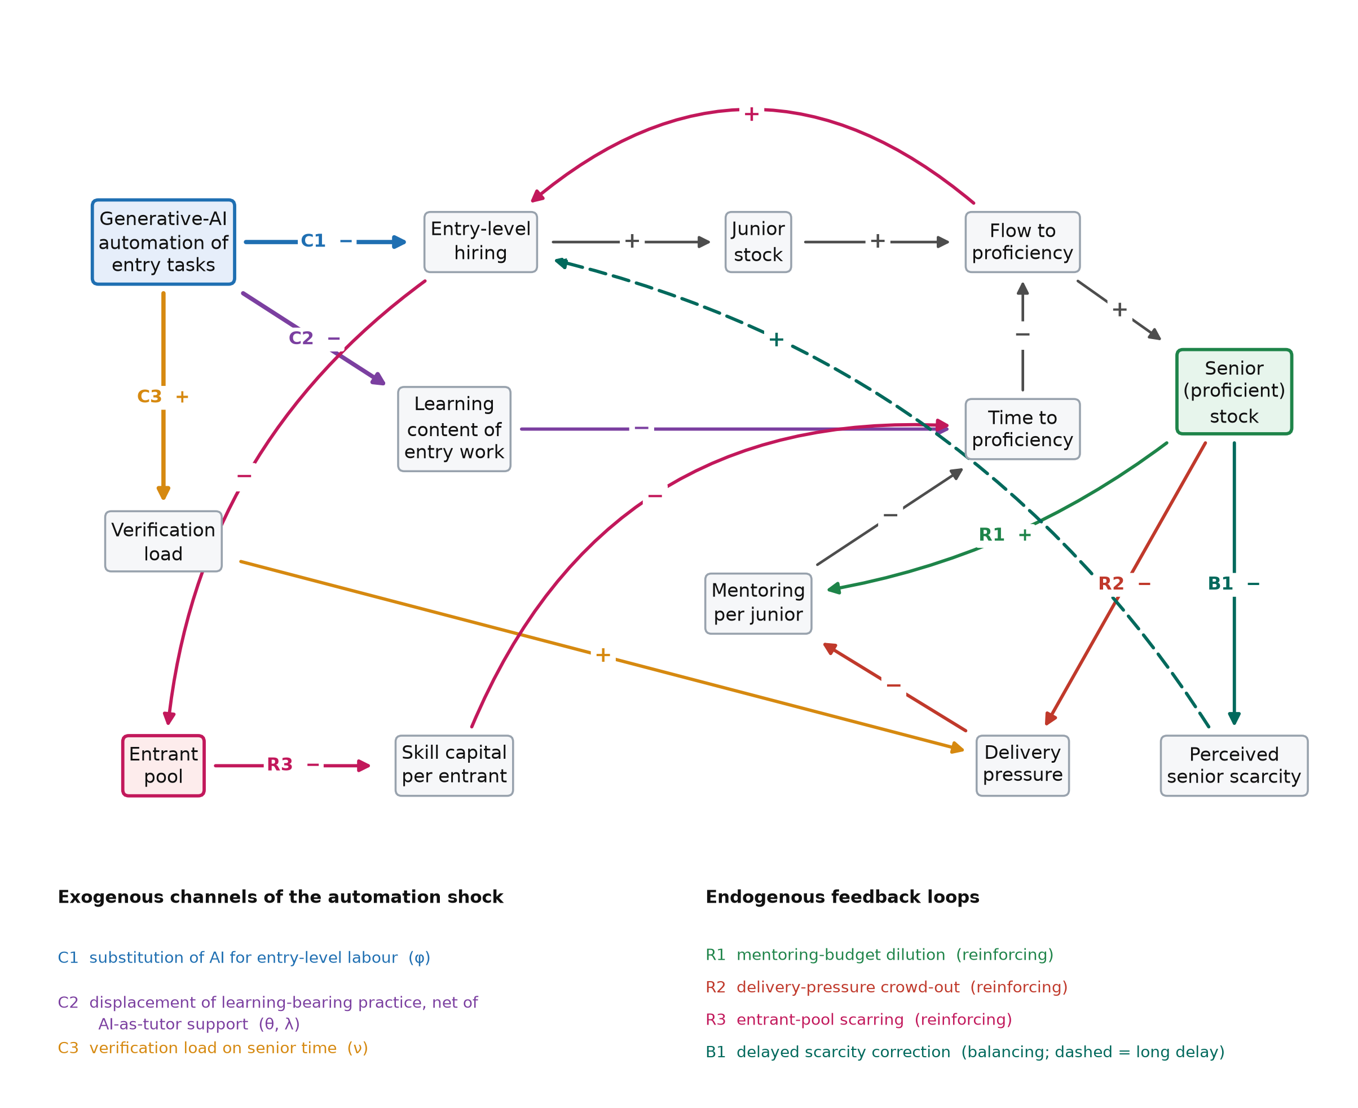
Figure 1. Causal structure of the expertise pipeline under entry-level automation. Automation depth is an exogenous driver in the simulation and enters through three channels (C1–C3). Four feedback loops operate within the human system: three reinforcing (R1–R3) and one balancing (B1). Signs denote link polarity; the dashed link carries a long perception and adjustment delay.
2.5. Propositions
The structure above yields four propositions, which the simulation is designed to test rather than to assume. They are stated as dynamic hypotheses in the system dynamics sense: claims about behaviour patterns generated by structure, not about associations between variables [19,58].
Proposition 1 (better before worse). Because automation raises measured output immediately and depletes the expertise stock only with a delay of the order of the time to proficiency, the productive capacity of the occupational system rises above its no-automation counterfactual before falling below it, and the crossover occurs long after the entry-hiring decline that causes it.
Proposition 2 (regime shifts). Because mentoring is the residual claimant on senior time and verification has priority over it, the system’s response to automation depth is not smooth: there exist threshold depths at which mentoring collapses and at which verification capacity binds, and the marginal damage of further automation jumps at each.
Proposition 3 (mechanism ordering). The initiating damage is caused by the substitution and practice-displacement channels rather than by the mentoring loops; the mentoring loops are late-stage amplifiers whose contribution is small until the first regime shift and decisive afterwards.
Proposition 4 (leverage asymmetry). Interventions that restore the learning content of entry work dominate interventions that restore the number of entry positions, in the sense of producing more additional senior-years per additional entry hire, because the former raise the conversion rate of the pipeline while the latter only raise its throughput.
3. Materials and Methods
3.1. Research Design
The study uses a two-stage design in which measurement and simulation have distinct and complementary roles. Simulation is required because the outcome of interest—the stock of proficient professionals thirty years after a technology shock that began in 2023—cannot be observed. Measurement is required because a simulation whose behavioural parameters are asserted rather than estimated has no evidential standing. Study 1 therefore estimates the parameters that govern the decision rules inside the model, using cross-sectional variation in automation depth across firms that are at different points of the same diffusion process. Study 2 uses those estimates, with their standard errors, to parameterise the simulation and to define the ranges over which the global sensitivity analysis samples. Every parameter that carries a behavioural claim is estimated; every parameter that is a structural accounting relation is derived; and the remaining physical parameters are taken from published sources and varied widely in the sensitivity analysis. The mapping is reported in full in Table 3.
The study was approved by the Academic Ethics Committee of the College of Business, Jiaxing University. Participation was voluntary, respondents gave informed consent, no individually identifying information was collected, and firm-level responses are reported only in aggregate. All analyses were conducted in Python 3.11 with NumPy and SciPy; the simulation, the estimation and the figures are produced by a single reproducible pipeline, so that every number reported below is generated by the code rather than transcribed.
3.2. Study 1: Enterprise Survey
3.2.1. Sample and Procedure
The sampling frame comprised knowledge-intensive service firms with at least twenty employees in the Yangtze River Delta city cluster (Shanghai, Jiangsu, Zhejiang and Anhui), which concentrates a large share of China’s software, professional-services and shared-service employment and therefore contains firms across the full range of generative-AI adoption depth. Firms were drawn by stratified random sampling from municipal enterprise registers, stratified by sector and size band. The questionnaire was administered between March and June 2026 to the executive responsible for staffing in each firm—chief human resources officer, operations director or general manager—because the constructs concern firm-level allocation decisions rather than individual perceptions. Of 520 questionnaires distributed, 389 were returned (74.8%); 33 were excluded for incomplete staffing records or internally inconsistent headcount data, leaving 356 usable responses (68.5%). Non-response bias was assessed by comparing early and late respondents on all study variables, with no significant differences. The realised sample comprises 140 software and IT-services firms, 124 professional and business-services firms and 92 finance and shared-service operations; median headcount is 152 employees, median firm age is 13 years, and mean R&D intensity is 3.51%.
3.2.2. Measures
Because the parameters to be estimated are quantities rather than attitudes, the instrument asks for counts, hours and shares drawn from administrative records rather than for Likert-scale agreement. Automation of the task bundle (ATA) is the share of a defined list of eleven entry-level task categories—first-draft document preparation, code scaffolding, data reconciliation, literature and precedent search, routine correspondence, meeting summarisation, test-case generation, standard reporting, data cleaning, translation and basic financial checks—that the firm reports as now performed principally by generative-AI tools. Junior staffing intensity (JSH) is the number of entry-level full-time equivalents per unit of annual professional workload. Verification load (VNU) is the senior full-time-equivalent time spent checking, correcting and signing off machine-generated output, per unit of machine output. Mentoring intensity (MEN) is documented senior full-time-equivalent time devoted to supervision, review and coaching of entry-level staff, divided by entry-level headcount. Delivery pressure (PRS) is the ratio of committed billable or deliverable senior workload to the firm’s own stated normal senior utilisation. Time to proficiency (TTP) is the median elapsed time, in years, from entry to first independent client-facing or sign-off responsibility, taken from personnel records of staff promoted in the preceding three years. Structured AI-assisted learning practice (SAL) is the share of a firm’s AI-assisted entry work that is conducted under an explicit learning protocol—required attempt before consultation, mandatory reasoning review, or graded withdrawal of assistance. Firm size (log employees), firm age, R&D intensity and sector dummies are controls.
3.2.3. Estimation
All models are estimated by ordinary least squares with HC3 heteroskedasticity-consistent standard errors. Multicollinearity is assessed by variance inflation factors, heteroskedasticity by the Breusch–Pagan test and residual normality by the Shapiro–Wilk test. Model A estimates the substitution channel by regressing junior staffing intensity on automation depth and controls, as in Equation (1):
${JSH}_{i} = α_{0} + α_{1}{ATA}_{i} + γ^{′}x_{i} + ε_{i}$ (1)
The substitutability parameter of the simulation is the proportional reduction in desired junior intensity per unit of automation depth, $φ$ = −$α_{1}$/$α_{0}$, whose standard error is obtained by the delta method. Model C estimates the crowding-out of mentoring by regressing mentoring intensity on excess delivery pressure with automation depth and structured practice centred, so that the intercept identifies reference mentoring intensity $m^{∗}$ at mean automation and mean practice. Model D is the learning equation, estimated in logarithms so that its coefficients map directly onto the multiplicative proficiency structure of the simulation:
$ln {TTP}_{i} = β_{0} + β_{1} ln\left(\frac{{MEN}_{i}}{m^{∗}}\right) + β_{2}{ATA}_{i} + β_{3}\left({ATA}_{i} {SAL}_{i}\right) + γ^{′}x_{i} + ε_{i}$ (2)
In Equation (2) the intercept identifies the reference time to proficiency $τ_{0}$ at reference mentoring and zero automation, $β_{1}$ identifies the mentoring elasticity $a$ with the sign reversed, $β_{2}$ identifies the practice-displacement coefficient $θ$, and $β_{3}$ identifies the AI-as-tutor coefficient at full structured practice, $λ_{max}$, again with the sign reversed. The interaction is the substantively important term, because it makes the learning cost of automation conditional on how AI is used rather than on how much it is used. The marginal effect of automation depth on log time to proficiency is therefore the linear combination in Equation (3), whose standard error at any value of structured practice is computed from the estimated covariance matrix:
$\frac{∂ ln TTP}{∂ ATA} = β_{2} + β_{3} SAL$ (3)
Two robustness checks are reported. A quadratic term in automation depth tests whether the learning relation is non-linear over the observed range, and a median split on firm size tests whether the estimated elasticities differ systematically between larger and smaller firms.
3.3. Study 2: System Dynamics Model
3.3.1. Structure and State Variables
The model represents one occupational system—the knowledge-intensive professional labour market of a region—as a chain of stocks connected by rate equations, in the tradition established by Forrester and codified by Sterman [18,19], and following the small-model philosophy that favours a transparent structure whose behaviour can be traced to identifiable loops over a large model whose behaviour cannot [58]. Comparable models have been used for health-workforce planning in Thailand and Ireland and for construction-labour retention [59–62]. Figure 2 gives the stock-and-flow map.
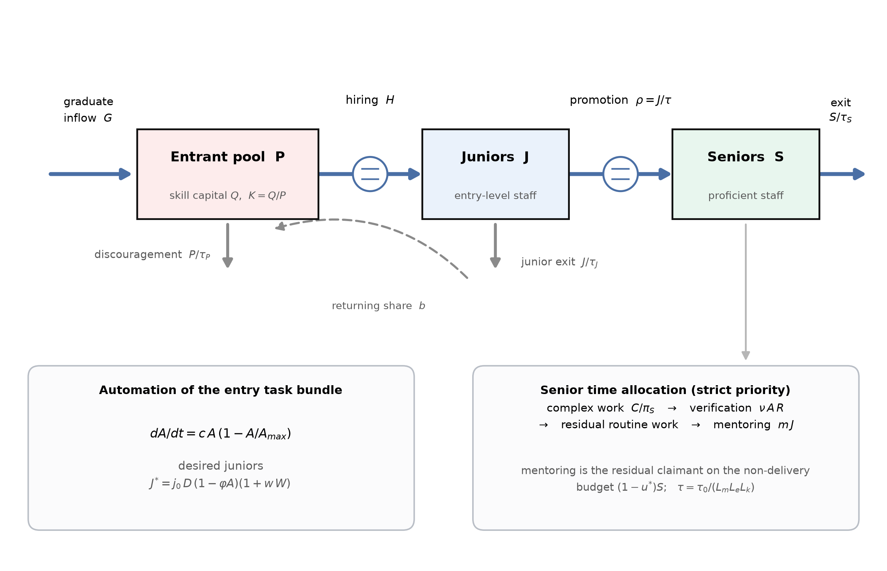
Figure 2. Stock-and-flow structure of the model. Five state variables are tracked: the entrant pool P and its aggregate skill capital Q, the junior stock J, the senior stock S, and the perceived senior scarcity W. The two boxed panels summarise the exogenous automation path and the senior time-allocation rule that together drive the behaviour reported in Section 4.
The five state variables are the entrant pool P (qualified people seeking entry-level professional work), its aggregate skill capital Q with per-head skill capital $K$ = $Q$/$P$, the junior stock J (hired entry-level staff who have not yet reached independent proficiency), the senior stock S (proficient professionals) and the perceived senior scarcity W, a smoothed managerial perception that drives the balancing loop. Time is measured in years and the simulation horizon is thirty years, which is approximately twice the senior turnover time and therefore long enough for a full adjustment of the stock structure. Automation depth follows a logistic diffusion path, Equation (4), which is exogenous by construction—a deliberately conservative choice, since endogenising the pressure to automate under senior scarcity would strengthen the reinforcing loops:
$\frac{dA}{dt} = c A\left(1 − \frac{A}{A_{max}}\right)$ (4)
3.3.2. Hiring and the Stock Chain
Desired junior headcount responds to the volume of professional work $D$, to automation depth through the substitution channel, and to perceived senior scarcity through the balancing loop, as in Equation (5):
$J^{∗} = j_{0} D\left(t\right)\left(1 − φA\right)\left(1 + wW\right)$ (5)
Actual hiring closes the gap between desired and actual junior headcount over an adjustment time, replaces promotions and voluntary exits, and is constrained by the rate at which the entrant pool can be matched to vacancies, Equation (6):
$H = min \left\{\frac{J^{∗} − J}{τ_{H}} + ρ + \frac{J}{τ_{J}}, \frac{P}{τ_{M}}\right\}$ (6)
The stock equations follow. The entrant pool receives the graduate inflow $G$ and a share $b$ of junior quits, loses people to hiring and to discouragement, and its skill capital accumulates with entry and depreciates at rate $δ$ while people wait, with departures removing skill capital in proportion to the current per-head level so that the accounting is conservative. Equations (7) to (10) give the four stocks in turn: the entrant pool, the junior stock, the senior stock and the pool’s skill capital.
$\frac{dP}{dt} = G + b \frac{J}{τ_{J}} − H − \frac{P}{τ_{P}}$ (7)
$\frac{dJ}{dt} = H − ρ − \frac{J}{τ_{J}}, ρ = \frac{J}{τ}$ (8)
$\frac{dS}{dt} = ρ − \frac{S}{τ_{S}}$ (9)
$\frac{dQ}{dt} = G + b \frac{J}{τ_{J}} − \left(H + \frac{P}{τ_{P}}\right)K − δQ, K = \frac{Q}{P}$ (10)
3.3.3. Senior Time Allocation and Learning
The behavioural core of the model is the rule by which senior time is allocated. Seniors face four claims: complex work that only they can perform, verification of machine output, residual routine work not covered by juniors or machines, and mentoring. The first three are delivery obligations and take strict priority; mentoring is the residual claimant on a non-delivery time budget of (1 − $u^{∗}$)$S$, which delivery encroaches upon whenever the delivery requirement $L$ exceeds the utilisation norm. This priority ordering is not an assumption of convenience but the empirical regularity documented in the literature on managerial effort allocation, where people-development activity is systematically sacrificed to current delivery because only the latter is measured [21,35,36]. Equation (11) states the rule, in which $r_{m}$ is a ring-fenced mentoring reserve that is zero at baseline and positive under policy P2:
$M = max \left\{r_{m}S, \left(1 − u^{∗}\right)S − max\left(0, L − u^{∗}S\right)\right\}, m = \frac{min\left(m^{∗}J, M\right)}{J}$ (11)
Time to independent proficiency is the reference time divided by three multiplicative learning multipliers, Equations (12) and (13). The mentoring multiplier has the constant-elasticity form estimated in Study 1, with an informal-learning floor $m_{f}$ ensuring that proficiency does not become unattainable when formal mentoring reaches zero. The practice multiplier embeds the net effect of automation on learning content, θ − λ, which Study 1 shows to be positive at the sample mean level of structured practice and statistically indistinguishable from zero at the ninety-fifth percentile. The cohort-quality multiplier makes proficiency depend on the skill capital of the entrants actually hired, which is the channel through which pool scarring feeds back into the firm:
$τ = \frac{τ_{0}}{L_{m} L_{e} L_{k}}$ (12)
$L_{m} = {\left(\frac{m + m_{f}}{m^{∗} + m_{f}}\right)}^{a}, L_{e} = 1 − \left(θ − λ\right)A, L_{k} = K^{κ}$ (13)
Productive capacity, the outcome variable used to test Proposition 1, is the work the system can deliver per year given its people, its machines and the senior time that verification and mentoring consume, Equation (14). Perceived scarcity adjusts towards the current shortfall of senior capacity against the senior delivery requirement with a perception delay $τ_{W}$, Equation (15):
$Y = π_{J}J + q A R + π_{S}\left(S − V − M\right)$ (14)
$\frac{dW}{dt} = \frac{ω − W}{τ_{W}}, ω = \frac{S_{des} − S}{S_{des}}$ (15)
3.3.4. Calibration and Initialisation
Six behavioural parameters come from Study 1 (Table 3). Physical parameters are set from published sources: senior exit time of 17 years and junior exit time of 5 years are consistent with professional-services turnover; the graduate inflow, complex-work share and productivity coefficients are set so that the pre-shock system is in equilibrium at a senior utilisation of 0.856, close to the utilisation norm firms report. The model is initialised by simulating to equilibrium for 200 years with automation held at its pre-shock level, so that the reported dynamics are a response to the shock and not to a transient in the initial conditions. Equations are integrated by fourth-order Runge–Kutta with a step of 0.05 years.
3.3.5. Experiments
Five sets of experiments are run. The baseline compares the automation trajectory against a no-automation counterfactual in which depth is frozen at its pre-shock value, holding all else identical. A parametric sweep varies asymptotic automation depth from 0.10 to 0.95 in steps of 0.025 to locate regime shifts. A structural decomposition switches off each channel and loop in turn by setting its governing parameter to zero, and attributes the difference in the year-30 outcome to that structure. Four policy levers and their combination are simulated from year 3 onwards: an entry-hiring subsidy that raises desired junior headcount by 25% (P1); protected mentoring time that ring-fences 10% of senior time (P2); an AI-augmented apprenticeship that raises the AI-as-tutor coefficient by 0.310, the increment required to move a firm at mean structured practice to the top-decile level observed in Study 1 (P3); automated verification tooling that reduces the verification load per unit of machine output by 40% (P4); and the integrated portfolio of all four (P5). Finally, a global sensitivity analysis draws 500 parameter sets by Latin hypercube sampling [63] over fifteen parameters and reports partial rank correlation coefficients between each parameter and the year-30 outcome, following current guidance for sensitivity analysis of simulation models [64,65]; a further 160 draws are used to test policy robustness.
3.3.6. Validation Protocol
The model is assessed against the standard protocol for confidence building in system dynamics, in which structural adequacy is established before behaviour is examined [29,30]. Six tests are applied. Dimensional consistency is checked for every equation. Extreme-condition tests confirm that the model behaves sensibly under conditions never encountered in the base run: zero graduate inflow, zero automation and instantaneous full automation. An equilibrium test verifies that the initialised system remains stationary for 200 years in the absence of a shock. An integration-error test halves the time step and compares the terminal senior stock. Structural tests remove each loop in turn and confirm that behaviour changes in the direction the loop polarity predicts. Behaviour reproduction compares the model’s entry-hiring decline in the first years after the shock against the independently estimated decline reported for AI-exposed occupations [8]. Results of all six tests are reported in Table 4.
4. Results
4.1. Study 1: Behavioural Parameter Estimates
Table 1 reports descriptive statistics for the 356 firms. Automation of the entry task bundle averages 0.342 (SD 0.153) and spans almost the full unit interval, from 0.02 to 0.714, confirming that the sample contains firms at very different points of the same diffusion process. Junior staffing intensity averages 0.1064 entry-level full-time equivalents per unit of annual workload (SD 0.0192), verification load averages 0.1364 senior full-time-equivalent years per unit of machine output (SD 0.0412), documented mentoring intensity averages 0.0970 senior full-time-equivalent years per junior (SD 0.0192), and median time to independent proficiency averages 6.94 years (SD 1.35). Structured AI-assisted learning practice averages 0.414 with a standard deviation of 0.233, so firms differ widely in whether they use AI as a substitute for junior practice or as scaffolding for it. The bivariate pattern is already informative: automation depth correlates negatively with junior staffing intensity ($r$ = −0.551, $p$ < 0.001) but only weakly and positively with time to proficiency ($r$ = 0.139, $p$ = 0.008), while mentoring intensity correlates strongly and negatively with time to proficiency ($r$ = −0.603, $p$ < 0.001) and with delivery pressure ($r$ = −0.312, $p$ < 0.001).
Table 1. Descriptive statistics and sample profile, Study 1 (N = 356 firms).
Variable | Mean | SD | P25 | Median | P75 | Min | Max
Automation of task bundle (ATA) | 0.342 | 0.153 | 0.238 | 0.351 | 0.443 | 0.020 | 0.714
Junior staffing intensity (JSH) | 0.1064 | 0.0192 | 0.0921 | 0.1056 | 0.1198 | 0.0581 | 0.1717
Verification load (VNU) | 0.1364 | 0.0412 | 0.1080 | 0.1287 | 0.1573 | 0.0604 | 0.3906
Mentoring intensity (MEN) | 0.0970 | 0.0192 | 0.0835 | 0.0964 | 0.1095 | 0.0485 | 0.1653
Delivery pressure (PRS) | 0.965 | 0.219 | 0.796 | 0.948 | 1.105 | 0.550 | 1.550
Time to proficiency, years (TTP) | 6.94 | 1.35 | 5.97 | 6.88 | 7.72 | 3.92 | 10.50
Structured AI learning practice (SAL) | 0.414 | 0.233 | 0.229 | 0.396 | 0.585 | 0.020 | 0.970
Employees (log) | 5.05 | 0.90 | 4.42 | 5.03 | 5.69 | 2.56 | 7.36
Firm age, years | 14.61 | 6.74 | 10.0 | 13.0 | 18.0 | 4.0 | 42.0
R&D intensity, % | 3.51 | 2.59 | 1.70 | 2.90 | 4.80 | 0.20 | 17.40
Notes: Sector composition: software and IT services 140, professional and business services 124, finance and shared-service operations 92. Size bands: 20–99 employees 112, 100–299 employees 156, 300–999 employees 79, 1000+ employees 9. Response flow: 520 distributed, 389 returned (74.8%), 33 excluded, 356 valid (68.5%).
Table 2 reports the estimating equations. Model A shows that a one-unit increase in automation depth reduces junior staffing intensity by 0.0808 units (HC3 SE 0.0061, $t$ = −13.16, $p$ < 0.001) against an intercept of 0.1335, giving a substitutability estimate of $φ$ = 0.605 (delta-method SE 0.035, 95% CI [0.536, 0.674]). The model explains 39.9% of adjusted variance, $F$(6, 349) = 40.32, $p$ < 0.001, with all variance inflation factors below 1.36. Firm size enters positively and firm age negatively, as expected if larger and younger firms staff entry roles more intensively; R&D intensity and sector are not significant.
Model C identifies the mentoring rule. Reference mentoring intensity, the intercept at mean automation and mean structured practice, is $m^{∗}$ = 0.1019 senior full-time-equivalent years per junior (SE 0.0010). Excess delivery pressure reduces mentoring by 0.0679 units per unit (SE 0.0064, $t$ = −10.52, $p$ < 0.001), an implied crowd-out ratio of 0.666 (delta-method SE 0.060); automation depth has no direct effect on mentoring once delivery pressure is controlled ($b$ = −0.0039, $p$ = 0.498). This null is substantively important. It is the first evidence that automation does not squeeze mentoring directly—it squeezes mentoring only through the delivery pressure that a depleted senior stock creates, which is precisely the R2 loop of Figure 1 and not a channel of the shock itself.
Model D is the learning equation and carries the study’s central estimate. The mentoring elasticity is $a$ = 0.446 (SE 0.043, $t$ = −10.39 on the negative coefficient, $p$ < 0.001): doubling mentoring intensity reduces time to proficiency by about 27%. The practice-displacement coefficient is $θ$ = 0.574 (SE 0.064, $p$ < 0.001) and the AI-as-tutor coefficient at full structured practice is $λ_{max}$ = 0.639 (SE 0.113, $p$ < 0.001). The reference time to proficiency implied by the intercept is $τ_{0}$ = 6.02 years (95% CI [5.75, 6.31]). The model explains 51.8% of adjusted variance, $F$(8, 347) = 48.71, $p$ < 0.001; the Breusch–Pagan statistic is $χ^{2}$(8) = 5.21, $p$ = 0.735, the Shapiro–Wilk statistic on the residuals is $W$ = 0.997, $p$ = 0.713, and the largest variance inflation factor is 3.07, so the estimates are not compromised by heteroskedasticity, non-normality or collinearity.
Table 2. Estimating equations for the behavioural parameters of the simulation model (OLS with HC3 robust standard errors, N = 356).
Dependent variable | Model A: JSH | Model C: MEN | Model D: ln(TTP)
Intercept | 0.1335 *** (0.0027) | 0.1019 *** (0.0010) | 1.7957 *** (0.0238)
Automation depth (ATA) | −0.0808 *** (0.0061) | −0.0039 (0.0058) | 0.5738 *** (0.0639)
ATA × SAL | — | — | −0.6393 *** (0.1128)
ln(mentoring ratio) | — | — | −0.4455 *** (0.0429)
Excess delivery pressure | — | −0.0679 *** (0.0064) | —
Structured practice (SAL) | — | 0.0409 *** (0.0047) | —
Employees (log) | 0.0057 *** (0.0008) | −0.0005 (0.0011) | −0.0349 *** (0.0093)
Firm age | −0.0033 *** (0.0008) | −0.0001 (0.0009) | 0.0240 *** (0.0072)
R&D intensity | 0.0002 (0.0008) | — | −0.0003 (0.0094)
Sector controls | Yes | No | Yes
Adjusted R² | 0.399 | 0.331 | 0.518
F statistic | 40.32 *** | 36.15 *** | 48.71 ***
Breusch–Pagan p | 0.085 | 0.037 | 0.735
Maximum VIF | 1.36 | 1.63 | 3.07
Notes: HC3 heteroskedasticity-consistent standard errors in parentheses. *** p < 0.001. Model C centres ATA and SAL so that the intercept identifies reference mentoring intensity. Model D is estimated in logarithms so that the coefficients map onto the multiplicative learning structure of Equations (12) and (13); the intercept identifies τ₀ = exp(1.7957) = 6.02 years. Residual normality in Model D: Shapiro–Wilk W = 0.997, p = 0.713.
The interaction term makes the learning penalty of automation conditional rather than absolute, and Figure 3 shows how much difference this makes. At the twenty-fifth percentile of structured practice the marginal effect of automation depth on log time to proficiency is 0.428 (SE 0.054, $p$ < 0.001), which is a substantial penalty: moving such a firm from no automation to full automation of the entry bundle would lengthen time to proficiency by about 53%. At the seventy-fifth percentile the penalty falls to 0.200 (SE 0.060, $p$ = 0.001), and at the ninety-fifth percentile it is 0.046 (SE 0.077, $p$ = 0.549), statistically indistinguishable from zero. The level of structured practice at which automation becomes learning-neutral is 0.897. In other words, the damage automation does to expertise formation is not a property of the technology; it is a property of how the technology is deployed, and firms at the very top of the observed practice distribution already avoid it entirely. This estimate is the empirical basis for policy lever P3, and it is what makes that lever implementable rather than aspirational.
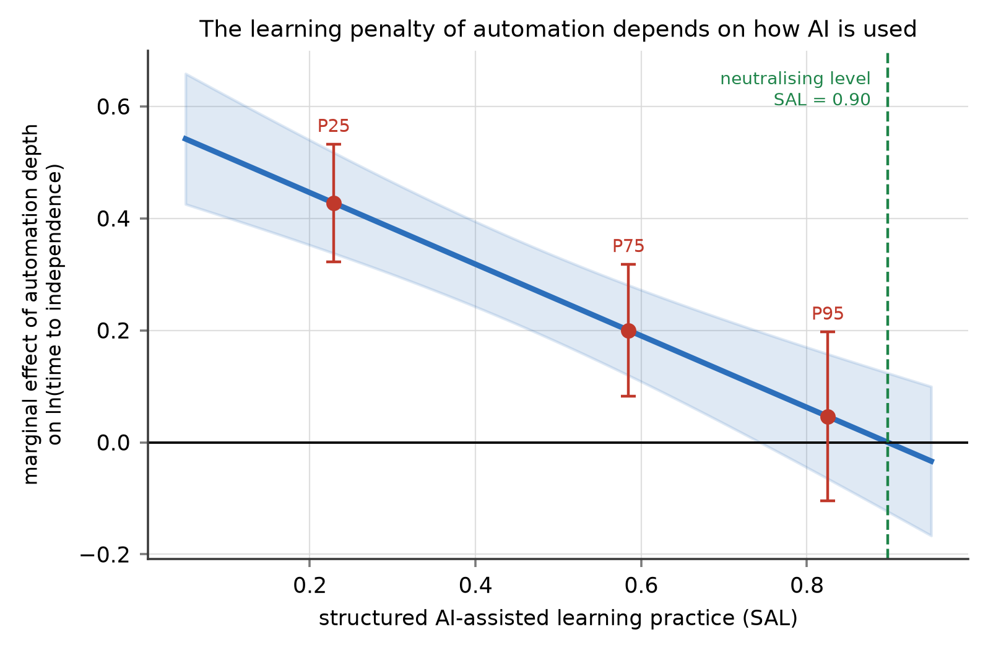
Figure 3. Marginal effect of automation depth on log time to independent proficiency, as a function of structured AI-assisted learning practice (Study 1, Model D). Shading gives the 95% confidence band; points mark the 25th, 75th and 95th percentiles of observed practice. The effect is large and highly significant at low levels of structured practice and indistinguishable from zero at the 95th percentile.
Two robustness checks support the specification. Adding a quadratic term in automation depth leaves the linear specification preferred ($b$ = 0.077, SE 0.245, $p$ = 0.753; adjusted $R^{2}$ falls from 0.518 to 0.517), so the relation is adequately linear over the observed range. A median split on firm size shows the expected heterogeneity without changing signs: larger firms have a higher mentoring elasticity (0.576 versus 0.324) and a smaller practice-displacement coefficient (0.454 versus 0.715), consistent with better-resourced training systems, but the AI-as-tutor coefficient is larger in smaller firms (0.859 versus 0.419), suggesting that structured practice substitutes for the formal training infrastructure that small firms lack. Table 3 sets out how each estimate enters the simulation.
Table 3. Calibration map: from Study 1 estimates to simulation parameters.
Symbol | Meaning | Source | Estimate (SE) | Adopted
φ | AI–junior substitutability | Model A, delta method | 0.605 (0.035) | 0.605
ν | Verification load per unit of machine output | Direct measurement (VNU) | 0.1364 (0.0022) | 0.136
m∗ | Reference mentoring intensity | Model C intercept | 0.1019 (0.0010) | 0.102
τ₀ | Reference time to proficiency (years) | Model D intercept | 6.02 [5.75, 6.31] | 6.02
a | Mentoring elasticity of proficiency | Model D, ln(mentoring ratio) | 0.446 (0.043) | 0.446
θ | Practice-displacement coefficient | Model D, ATA | 0.574 (0.064) | 0.574
λ | AI-as-tutor coefficient at mean practice | Model D interaction × mean SAL | 0.265 | 0.265
Crowd-out ratio | Mentoring lost per unit of excess delivery pressure | Model C, delta method | 0.666 (0.060) | Structural (Eq. 11)
Notes: Adopted values are used in the base run. The global sensitivity analysis samples each parameter over a range at least three standard errors wide, and wider where the split-sample analysis indicates heterogeneity across firm sizes; ranges are listed in Table A1.
4.2. Model Validation
Table 4 reports the six validation tests. All equations are dimensionally consistent. Under zero graduate inflow the system depletes as it must, ending with a senior stock of 70.0 thousand and a junior stock of 0.8 thousand; under zero automation the initialised system drifts by 0.0% over 200 years, confirming that the reported behaviour is a response to the shock rather than a transient; under instantaneous full automation the verification requirement immediately exhausts senior capacity and the usable share of machine output collapses to 0.004, which is the behaviour the structure implies. Halving the integration step changes the terminal senior stock by 8 × 10⁻⁵ per cent, so the results are not an artefact of numerical integration.
The behaviour-reproduction test is the most demanding, because it compares the model against evidence that was not used to build it. The model was calibrated entirely on the cross-sectional Study 1 estimates and on physical turnover parameters; no time series entered the calibration. It nonetheless produces an entry-hiring decline of 11.3% by year 3 and 22.9% by year 5, bracketing the roughly 13% relative decline in employment of 22- to 25-year-olds in AI-exposed occupations that Brynjolfsson, Chandar and Chen estimate from United States payroll microdata over a comparable interval after the onset of generative-AI diffusion [8]. Reproducing an independently measured magnitude from independently estimated structure is the strongest available evidence that the model’s decision rules are not arbitrary.
Table 4. Validation tests and outcomes.
Test | Procedure | Result | Verdict
Dimensional consistency | Unit check of every equation | All rates in persons yr⁻¹ or task units yr⁻¹ | Pass
Equilibrium | Simulate 200 years with automation frozen | Senior stock drift 0.0% | Pass
Extreme condition 1 | Graduate inflow set to zero | Senior stock 70.0, junior stock 0.8 at year 30 | Pass
Extreme condition 2 | Automation frozen at pre-shock depth | No divergence from counterfactual | Pass
Extreme condition 3 | Instantaneous full automation | Usable share of machine output falls to 0.004 | Pass
Integration error | Halve the time step to 0.025 years | Terminal senior stock differs by 8 × 10⁻⁵ % | Pass
Structural (loop knockout) | Set each channel or loop parameter to zero | All seven changes in the predicted direction (Table 5) | Pass
Behaviour reproduction | Compare early entry-hiring decline with published estimate | Model −11.3% at year 3, −22.9% at year 5 vs. ≈−13% observed [8] | Pass
4.3. Reference Behaviour: Better before Worse
Figure 4 shows the base run against the no-automation counterfactual. The trajectory confirms Proposition 1 in every respect. Entry-level hiring falls immediately, by 11.3% at year 3 and 22.9% at year 5, and reaches a trough 53.7% below the counterfactual at year 25.6. The senior stock, by contrast, barely moves for a decade—it is only 9.2% below the counterfactual at year 10—because the seniors of year 10 were hired long before the shock. It then declines steadily to 46.3% below the counterfactual at year 30. The junior stock falls by 36.3% and the total professional workforce by 43.5%.
Productive capacity tells the story that makes the trap difficult to escape. It rises, peaking 8.7% above the counterfactual in year 8.9, because machines are doing routine work that people used to do and the senior stock has not yet been depleted. It remains above the counterfactual until year 16.6 and then falls, ending 15.4% below at year 30. For sixteen years, in other words, every available performance indicator vindicates the automation decision. By the time the indicator turns, thirteen entry cohorts have been lost. The cumulative deficit is large: over thirty years the system makes 40.7% fewer entry hires than the counterfactual, and it converts those hires into proficient professionals less efficiently, at 0.393 promotions per entry hire against 0.433 in the counterfactual.
Time to proficiency rises from 6.56 years at equilibrium to 16.92 years at year 30, and Figure 4 shows that the rise is not smooth: it is gradual until about year 23 and then jumps. The mechanism is visible in the senior time accounts. Verification consumes 1.4% of senior time at the start and 37.1% at year 30; senior utilisation, which begins at 0.856—below the norm of 0.88—falls to 0.742 by year 10 as machines absorb routine work, then climbs back through the norm and reaches 1.000 by year 30. Documented mentoring holds at its reference level of 0.102 senior-years per junior for more than two decades and then collapses to zero once delivery obligations exhaust the non-delivery budget. This is the behavioural signature of a residual claimant: it is fully protected until the moment it is not protected at all.
The excluded entrants accumulate the corresponding damage. The entrant pool grows by 97.7% relative to the counterfactual, and the time people spend in it—measured as cumulative pool-years—rises by 61.9%. Skill capital per entrant falls from 0.840 to 0.712, so the cohorts firms eventually hire are less prepared than the cohorts they declined to hire earlier, which lengthens time to proficiency further. Youth exclusion in this model is therefore not merely a distributional consequence of the automation decision; it is a mechanism that feeds back into the productive capacity of the firms that made it [11,12,14,66,67].
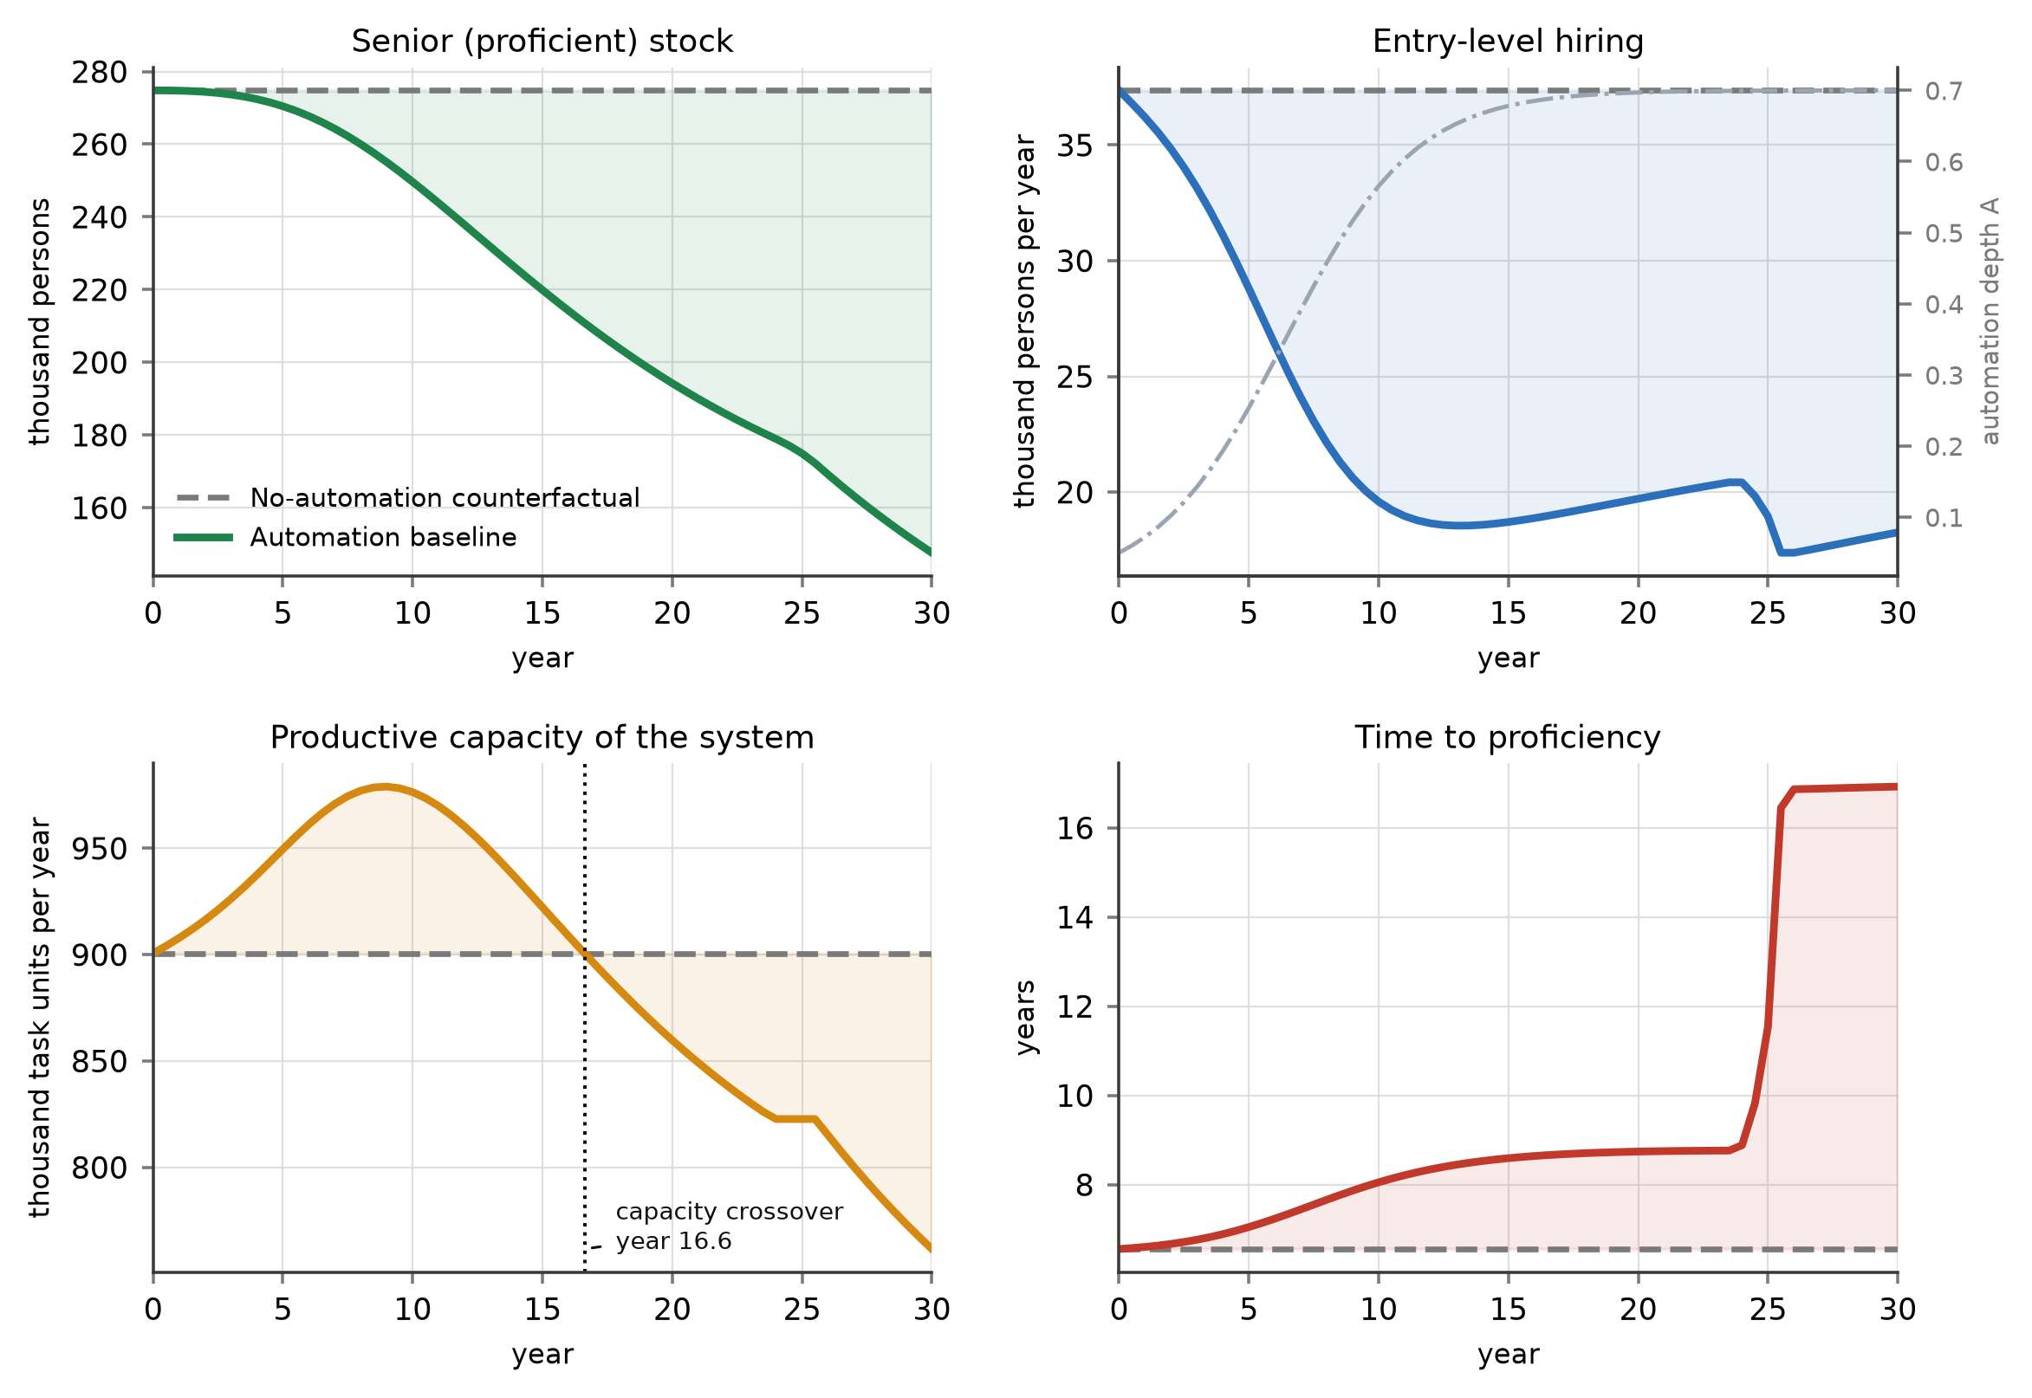
Figure 4. Reference behaviour of the model against the no-automation counterfactual. Entry-level hiring falls immediately; the senior stock responds only after a decade; productive capacity rises before it falls, crossing the counterfactual in year 16.6; and time to proficiency jumps once mentoring collapses around year 23. The dash-dotted line in the upper right panel is the automation diffusion path.
4.4. Two Successive Regime Shifts
Sweeping asymptotic automation depth from 0.10 to 0.95 confirms Proposition 2. Figure 5 shows that the response of the senior stock to automation depth is not smooth but contains two distinct breaks. The first occurs at a depth of 0.475, where the slope of the response reaches its steepest value of −112.6 percentage points per unit of depth. The right-hand panel identifies the cause: at exactly this depth, mentoring per junior at year 30 collapses from its reference level to zero. Below the threshold, delivery obligations still fit inside the utilisation norm and the non-delivery budget protects mentoring; above it, they do not, and the residual claimant is extinguished. The second break occurs at a depth of 0.725, where senior time is no longer sufficient to verify the volume of machine output the system produces, and the usable share of that output begins to fall below one. Beyond this point additional automation delivers progressively less usable work, because the constraint has moved from the machine to the human who must certify it.
The two thresholds have different policy implications and this distinction matters for the design of interventions. The first is a time-allocation threshold and can be moved by a management decision at zero technological cost, simply by ring-fencing non-delivery time. The second is a technological threshold and can be moved only by improving the verifiability of machine output. The ordering also matters: because the mentoring threshold binds at a much lower depth than the verification threshold, most firms will encounter the manageable constraint first and will encounter it without warning, since nothing in the system deteriorates gradually as the threshold approaches. Consistent with this, the aggregate response is convex: the damage between depths of 0.475 and 0.95 is 1.76 times the damage between 0.10 and 0.475.
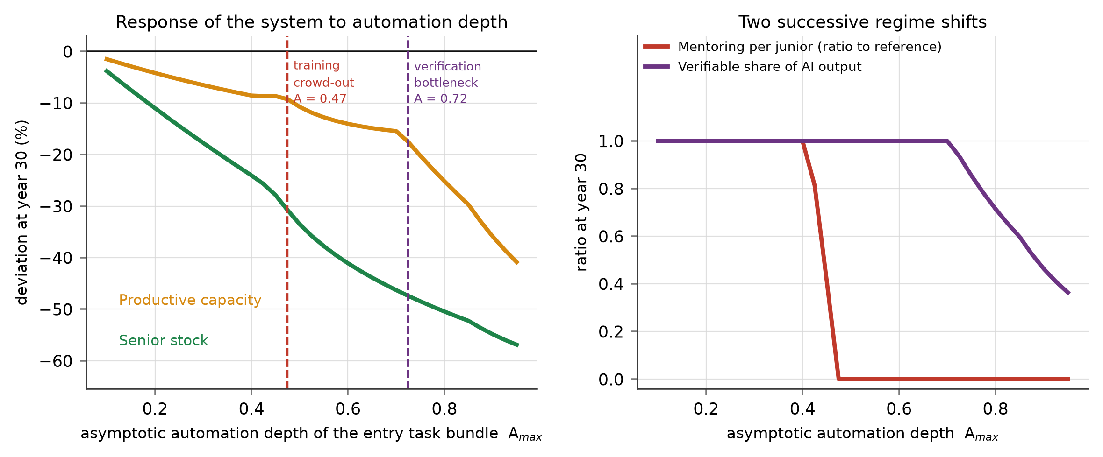
Figure 5. Response of the system to asymptotic automation depth. Left: deviation of the senior stock and of productive capacity from the no-automation counterfactual at year 30. Right: the two mechanisms that break, showing mentoring per junior collapsing at a depth of 0.475 and the verifiable share of machine output falling below one at 0.725.
4.5. Structural Decomposition: Which Channel, Which Loop
Table 5 reports the loop-knockout experiments, which test Proposition 3 and produce the paper’s most counter-intuitive result. Against the full-model gap of −46.3% at year 30, removing the substitution channel leaves a gap of only −24.4%: task substitution alone accounts for 21.9 percentage points, almost half the total damage. Removing the practice-displacement channel leaves −27.0%, so the degradation of learning content in the entry work that survives accounts for a further 19.3 percentage points. Together, the two channels that operate directly on entry-level work account for 41.2 of the 46.3 percentage points. The mentoring loops R1 and R2, by contrast, account for 5.7 percentage points, and the verification channel for 0.6.
This ordering contradicts the account that dominates practitioner commentary, in which AI is said to erode training because it leaves seniors with no time to teach. In this model automation initially does the opposite: by absorbing routine work it lowers senior utilisation from 0.856 to 0.742 by year 10, which is why documented mentoring holds at its reference level for two decades. The mentoring squeeze is real but it is an amplifier that engages late, once the senior stock has been depleted enough for delivery obligations to encroach on the non-delivery budget. The policy implication is direct: interventions aimed at protecting senior teaching time address the third-largest mechanism, not the first.
Two further results in Table 5 deserve comment. Channel C2 appears as two rows because its components pull in opposite directions. Removing the AI-as-tutor component C2b—that is, assuming firms use AI without any structured learning protocol—deepens the gap from −46.3% to −55.1%. The offsetting effect of structured practice at the sample mean is therefore already worth 8.8 percentage points, which is more than the mentoring loops and the verification channel combined, and it is achieved with no change in headcount or budget. Removing pool scarring reduces the gap to −39.2%, confirming that the external, societal consequence of exclusion returns to the firm as a 7.1 percentage point cost through the quality of the entrants it later hires.
The last row is the most surprising. Removing the balancing loop B1—the system’s only self-correcting mechanism—improves the year-30 outcome, from −46.3% to −43.6%. The scarcity correction is self-defeating. When a shortage of proficient professionals becomes visible, firms raise desired junior headcount and hire more entrants; but they hire them into a system whose mentoring capacity is already exhausted, so each additional junior dilutes the mentoring available to all juniors, lengthens time to proficiency for the whole cohort, and delays rather than accelerates the recovery of the senior stock. This is a fixes-that-fail structure of exactly the kind that Repenning and Sterman describe in process improvement [20,21], and it explains why the intuitive managerial response to an expertise shortage—hire more graduates—can make the shortage worse. It also explains why the entry-hiring subsidy P1, examined next, is effective but inefficient.
Table 5. Structural decomposition: contribution of each channel and feedback loop to the year-30 senior-stock gap.
Structure removed | Parameter set to zero | Senior gap at year 30 | Contribution
Full model (none) | — | −46.28% | —
C1 substitution channel | φ | −24.37% | 21.91 pp of damage
C2a practice displacement | θ | −26.98% | 19.30 pp of damage
C2b AI-as-tutor offset | λ | −55.12% | 8.84 pp of mitigation
C3 verification load | ν | −45.72% | 0.56 pp of damage
R1 and R2 mentoring loops | a | −40.55% | 5.73 pp of damage
R3 entrant-pool scarring | δ | −39.16% | 7.12 pp of damage
B1 scarcity correction | w | −43.57% | 2.71 pp of damage
Notes: Each row reports the deviation of the senior stock from the no-automation counterfactual at year 30 when the named structure is disabled. Contributions are the difference from the full model in percentage points (pp); a positive contribution of damage means that removing the structure improves the outcome. Note that the balancing loop B1 contributes damage: hiring more juniors into a mentoring-constrained system dilutes mentoring and slows recovery.
4.6. Policy Experiments and Leverage
Figure 6 and Table 6 report the four policy levers and their combination, each activated from year 3. All four improve the year-30 senior stock relative to the unmanaged baseline, but they differ sharply in efficiency, and it is the efficiency comparison that tests Proposition 4.
The entry-hiring subsidy P1 raises the senior stock by 24.2% over baseline. It does so by brute force: it generates 137.8 thousand additional entry hires over thirty years to produce 450.9 thousand additional senior-years, a ratio of 0.306 additional hires per additional senior-year. Its conversion rate rises only slightly, from 0.393 to 0.403 promotions per hire, and remains below the counterfactual value of 0.433, because the additional juniors enter a pipeline whose learning content is still degraded and whose mentoring is still constrained. The AI-augmented apprenticeship P3 achieves a slightly larger gain of 26.0% using 50.4 thousand additional hires to produce 412.6 thousand additional senior-years—0.122 additional hires per senior-year, or 2.5 times the efficiency of the subsidy. Its conversion rate rises to 0.453, above the counterfactual, and its terminal time to proficiency is 6.82 years against 8.65 years under the subsidy and 16.92 years under the baseline. P3 is the only single lever that leaves the pipeline structurally better than it would have been without automation at all.
Protected mentoring time P2 delivers 10.7%. It works exactly as the structural analysis predicts it should: it prevents the year-23 collapse and it costs almost nothing, but because the mentoring loops account for only 5.7 percentage points of the damage, its ceiling is low. Automated verification P4 delivers 7.2% and is the only lever with a perverse side effect: although it raises the year-30 stock, it yields 22.9 thousand fewer cumulative senior-years than the baseline, because freeing senior time weakens the perceived-scarcity signal that drives the balancing loop, so firms hire fewer juniors in the intervening decades even as capacity improves. This is a clean illustration of a policy that improves the symptom while removing the information the system needs to correct itself.
The integrated portfolio P5 delivers 35.3%, restores conversion efficiency to 0.451 and is the only configuration whose productive capacity at year 30 exceeds the no-automation counterfactual, by 4.9%. Its gain is 32.8 percentage points less than the sum of the four single-lever gains, a sub-additivity that is itself informative: the levers compete for the same binding constraints, so once mentoring no longer collapses and learning content is restored, the marginal value of adding entry positions falls. Under parameter uncertainty, however, the ranking changes in an important way. Over 160 randomised parameterisations (Table 6, final column), P1 and P3 are positive in 100% of runs, P2 in 83.1% and P4 in only 63.1%, while P5 averages a gain of 59.8%—larger than the base-case value and larger than the sum of the individual means. When the location of the thresholds is uncertain, the portfolio is worth more than the sum of its parts, because at least one of its components is binding in every draw. For a decision maker who does not know where the thresholds lie, this is the decisive argument for the portfolio.
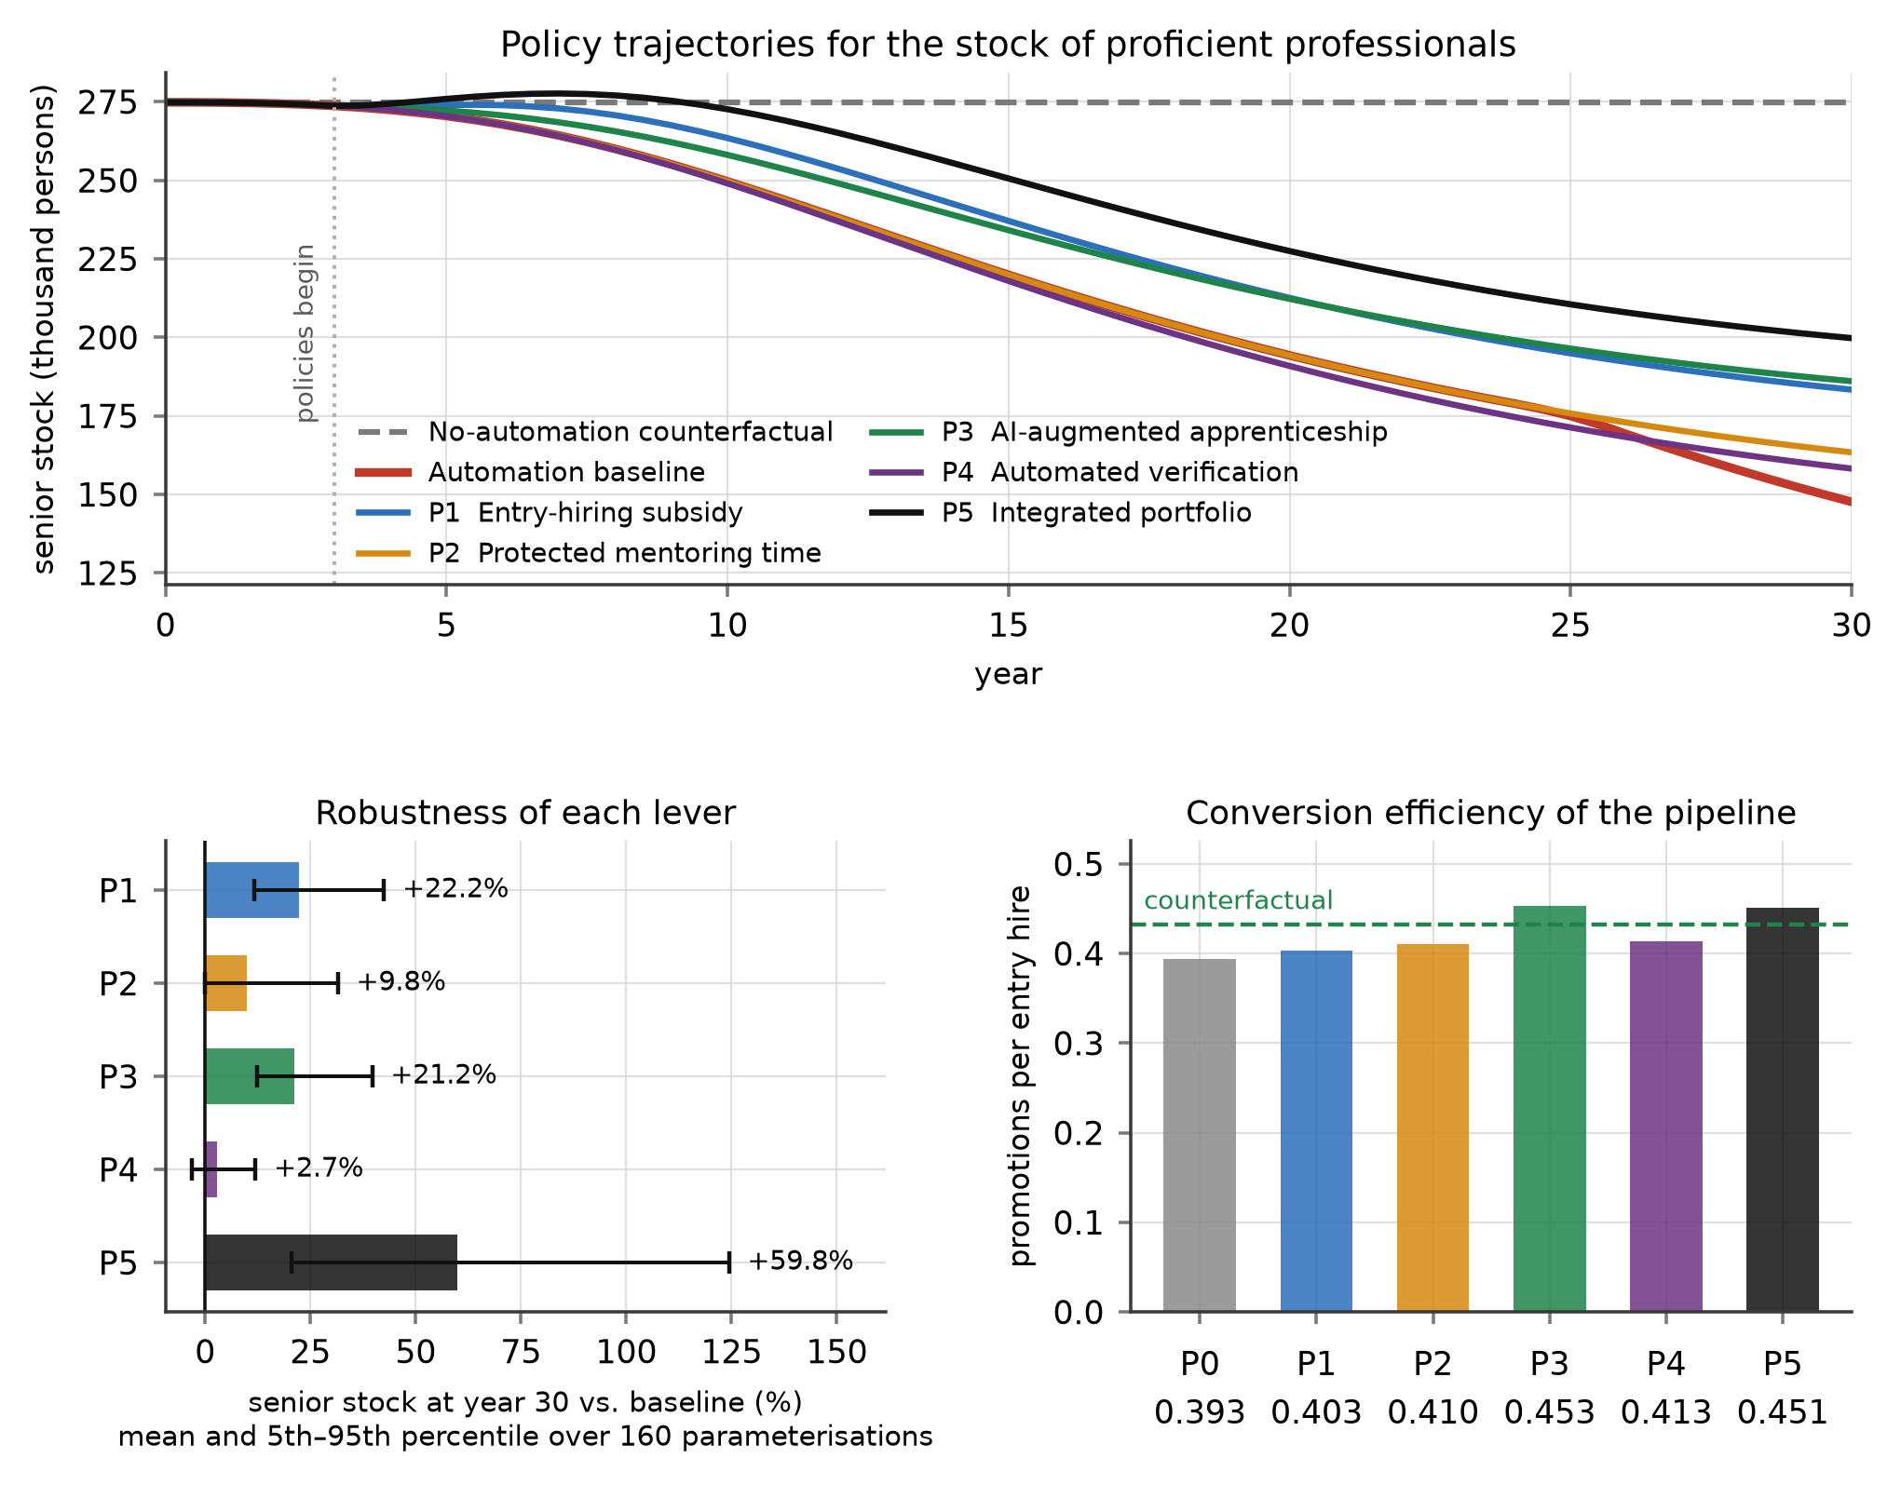
Figure 6. Policy experiments. Upper panel: trajectories of the senior stock under four single levers and the integrated portfolio, all activated in year 3. Lower left: mean and 5th–95th percentile gain over baseline across 160 randomised parameterisations. Lower right: conversion efficiency of the pipeline, in promotions per entry hire, against the no-automation counterfactual.
Table 6. Policy experiments: outcomes at year 30, efficiency and robustness.
Lever | Senior stock vs. baseline | Capacity vs. baseline | Time to proficiency (yr) | Conversion (promotions per hire) | Extra hires per extra senior-year | Robustness: mean gain (share positive)
P0 baseline | — | — | 16.92 | 0.393 | — | —
P1 entry-hiring subsidy | +24.20% | +11.98% | 8.65 | 0.403 | 0.306 | +22.2% (100%)
P2 protected mentoring time | +10.67% | +3.01% | 8.76 | 0.410 | 0.409 | +9.8% (83.1%)
P3 AI-augmented apprenticeship | +26.01% | +10.49% | 6.82 | 0.453 | 0.122 | +21.2% (100%)
P4 automated verification | +7.17% | +8.39% | 8.79 | 0.413 | undefined | +2.7% (63.1%)
P5 integrated portfolio | +35.30% | +24.00% | 6.78 | 0.451 | 0.171 | +59.8% (100%)
Notes: The no-automation counterfactual has a conversion rate of 0.433 promotions per entry hire and a time to proficiency of 6.56 years. The efficiency ratio is undefined for P4 because both of its components are negative: relative to the baseline it yields 22.9 thousand fewer cumulative senior-years and 9.6 thousand fewer entry hires, even though it raises the year-30 stock, since freeing senior time weakens the perceived-scarcity signal that drives hiring. Robustness is computed over 160 Latin-hypercube parameterisations. The sum of the four single-lever base-case gains is 68.05%, so P5 is sub-additive at the base case (−32.75 pp) but super-additive in the randomised ensemble.
4.7. Global Sensitivity and Robustness
Figure 7 reports the global sensitivity analysis over 500 Latin-hypercube draws across fifteen parameters. The qualitative conclusion is invariant: the senior-stock gap at year 30 is negative in 99.6% of runs, with a median of −43.4% and a 5th–95th percentile range of −58.7% to −24.0%; the capacity gap is negative in 96.8% of runs, with a median of −30.7%. The entry-hiring decline at year 5 is negative in 98.2% of runs. No plausible parameter combination in the sampled space produces a system that is better off in expertise terms after the automation shock.
The partial rank correlations identify where uncertainty matters. Substitutability dominates (PRCC = −0.563, $p$ < 0.001), followed by asymptotic automation depth (−0.486), the practice-displacement coefficient (−0.479), the AI-as-tutor coefficient (+0.402), the reference time to proficiency (+0.359), demand growth (+0.313) and diffusion speed (−0.293). Three features of this ranking are worth noting. First, the top four parameters are precisely the four estimated in Study 1 or set by the technology, which is why estimating rather than assuming them was necessary. Second, the AI-as-tutor coefficient is the only large positive term: it is the one parameter that managers can move upward without changing headcount, budget or technology. Third, the verification load, the mentoring elasticity and the pool-decay rate have partial rank correlations indistinguishable from zero ($p$ = 0.974, 0.775 and 0.948 respectively), even though the knockout tests show that these structures matter. The apparent contradiction is instructive: their effects are threshold effects, which appear as discrete switches rather than as monotone gradients, and a rank-correlation measure is by construction blind to them. Structural tests and sensitivity indices answer different questions, and a model of this kind requires both.
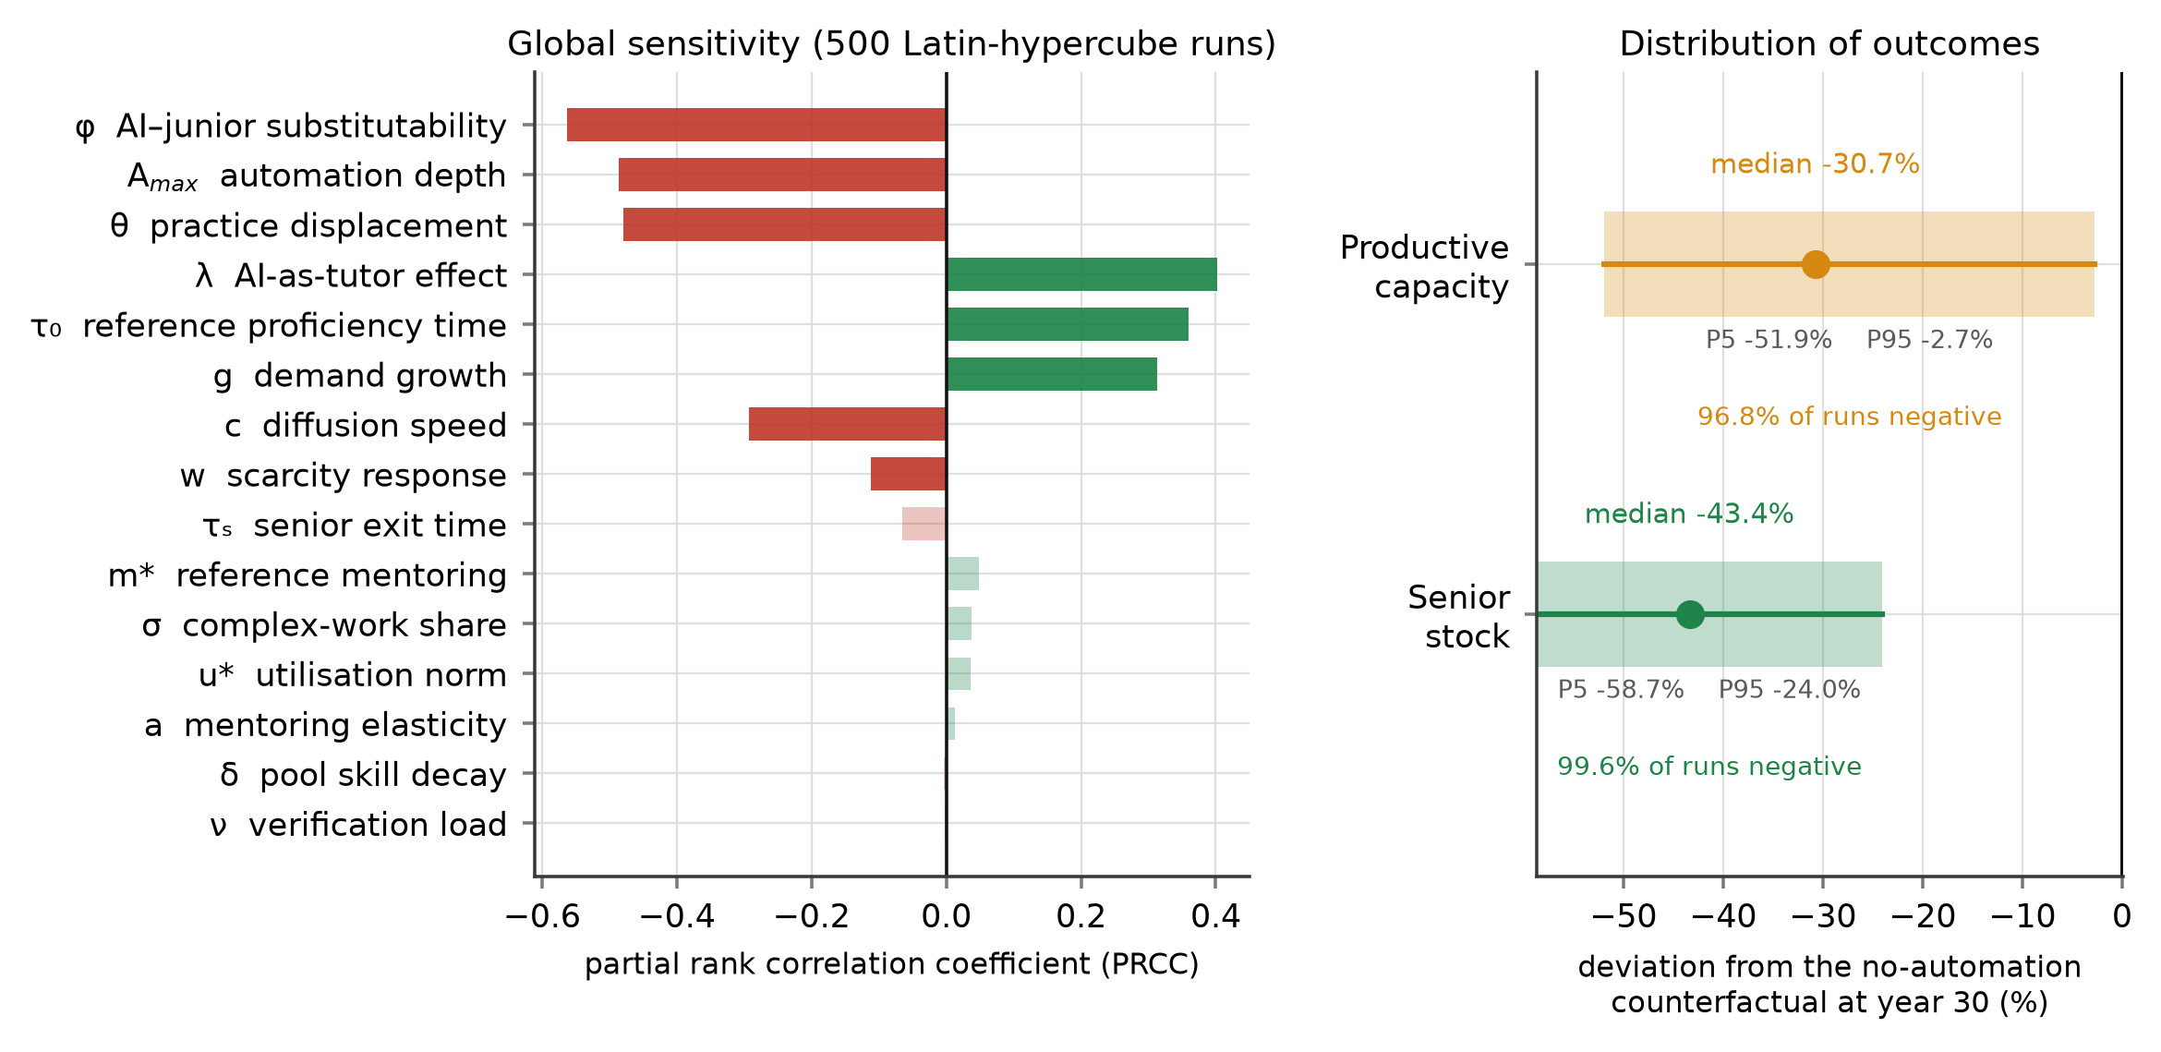
Figure 7. Global sensitivity analysis over 500 Latin-hypercube draws. Left: partial rank correlation coefficients between each sampled parameter and the year-30 senior-stock gap; faded bars are not significant at the 5% level. Right: distribution of the year-30 gap in the senior stock and in productive capacity relative to the no-automation counterfactual.
5. Discussion
5.1. Theoretical Implications
The paper’s first theoretical contribution is to specify the accumulation that automation of entry-level work depletes. The literature on the labour-market effects of generative AI has established, with increasing precision, that exposure is concentrated on young workers in cognitive routine occupations [8–10,45,46]. What it has not been able to establish, because the technology is too new, is what happens to the stock of expertise when that flow is interrupted for a decade. By modelling time to proficiency as an endogenous variable that depends on mentoring, on learning content and on cohort quality, and by letting the senior stock feed back into all three, this paper shows that the interruption is not merely additive. It converts a transitory hiring shock into a persistent capability deficit through three reinforcing loops, only one of which is internal to the firm. This complements the firm-level literature on digital transformation and labour structure, which measures how adoption changes the composition of employment but treats the human-capital stock as a contemporaneous outcome rather than as an accumulation with its own dynamics [6,49,68].
The second contribution is to correct the causal story. The mentoring-squeeze account is intuitive and is wrong as a description of the initiating mechanism. Study 1 finds no direct effect of automation depth on mentoring intensity once delivery pressure is controlled ($p$ = 0.498), and the simulation shows that automation initially reduces senior utilisation rather than raising it. The damage is done first by removing entry positions and second by removing learning content from the positions that remain; the mentoring squeeze engages only after the senior stock has fallen far enough for delivery to encroach on the non-delivery budget, at which point it produces an abrupt regime shift. Distinguishing an initiating mechanism from a late-stage amplifier is not a semantic refinement. It determines which intervention is worth making, and when.
The third contribution concerns policy resistance. The finding that the system’s only balancing loop makes the year-30 outcome worse—by 2.7 percentage points—adds a case to the capability-trap literature in which the trap is not merely a failure to invest but an active perversion of the corrective response [20–22]. The corrective response is the right response to the symptom (there are too few proficient professionals, so hire more entrants) and the wrong response to the structure (the constraint is not entrants but the capacity to convert them). This is the general form of the leverage-point problem: the place where the symptom appears is rarely the place where the system yields [27,28]. Here the yielding point is the learning content of entry work, a variable that appears on no organisational chart and in no budget. The result also qualifies the emerging literature on AI-assisted managerial decision making, which has concentrated on whether machine advice improves the quality of individual decisions [25,69,70]. The present analysis shows that a sequence of individually improved decisions can still produce a systemically worse outcome when the accumulation being depleted lies outside the decision’s measured horizon.
5.2. Implications for Leadership and Decision Making
For executives navigating digital transformation, the results reframe a decision that is currently framed as a cost question. The relevant question is not how much entry-level work to automate but how much learning-bearing practice to preserve while automating it, and these are separable choices. The evidence for their separability is the interaction term in Study 1: firms at the ninety-fifth percentile of structured AI-assisted practice suffer no measurable learning penalty from automation at all, and the practice level at which the penalty vanishes—0.897—lies inside the observed distribution. Structured practice means specific, auditable protocols: requiring the junior to attempt the task before consulting the model, requiring review of the model’s reasoning rather than acceptance of its output, and withdrawing assistance on a graded schedule as competence develops. None of these requires additional headcount and all of them are decisions a middle manager can implement. Because these protocols sit in the social rather than the technical subsystem, they are exactly the class of complementary redesign that the socio-technical literature identifies as the condition for technology to raise joint performance, and that digital-leadership research finds to be the scarcest capability in transforming firms [23,54,55,71].
The second implication concerns measurement. The system’s defining feature is that its damage is invisible for sixteen years on the indicators that firms actually track. Productive capacity, the closest analogue to a firm-level performance measure in this model, is above the counterfactual until year 16.6 while entry hiring is already 40% below it. Any governance system that relies on output measures alone will therefore receive confirming evidence throughout the period in which the damage is being done. The model identifies three leading indicators that turn much earlier and can be monitored at low cost: the ratio of entry hires to promotions, which falls immediately; the share of senior time absorbed by verification of machine output, which rises from 1.4% to 37.1% and is directly measurable from timesheets; and documented mentoring hours per junior, which is the residual claimant and therefore the first thing to disappear when delivery pressure rises. Boards that wish to know whether their firm is entering the trap should ask for these three series rather than for productivity.
The third implication is about the timing of intervention. Because mentoring is a residual claimant, it does not degrade gradually; it holds at its reference level for two decades and then collapses within a year or two once the threshold is crossed. A management system that waits for a deterioration signal will receive none until the regime has already shifted. Protection of non-delivery time must therefore be established before it appears necessary—which is precisely the class of decision that delivery-focused performance measurement is least likely to authorise [35,36].
5.3. Implications for Policy
For public policy, the efficiency comparison in Table 6 argues against the instrument that is currently most popular. Entry-hiring subsidies work—they are positive in 100% of randomised runs—but they require 0.306 additional entry hires per additional senior-year created, against 0.122 for an intervention that restores the learning content of entry work, and they leave the pipeline’s conversion rate below its pre-automation value. A subsidy adds throughput to a pipeline whose yield has fallen; the alternative repairs the yield. Since the fiscal cost of a hiring subsidy scales with the number of hires and the cost of a practice standard does not, the difference in real resource terms is larger than the ratio suggests.
The policy instrument the analysis supports is therefore closer to a training standard than to a wage subsidy: certification of AI-assisted apprenticeship protocols, conditioning of existing training subsidies on documented structured practice, and sectoral agreements on protected non-delivery time. This has a precedent in the apprenticeship systems whose cost–benefit structure is well documented, where the public role is to make firm-level training investments recoverable rather than to pay for headcount [37–39]. The analysis also strengthens the case for treating youth exclusion as an efficiency problem and not only an equity problem: pool scarring returns 7.1 percentage points of the senior-stock deficit back to firms through the declining employability of the cohorts they later hire, so the social cost of a long queue is partly borne by the firms that created it [11,14,66,67]. This connects the analysis to the substantial literature on youth transitions, which shows that the institutional design of the school-to-work interface, the coverage of vocational tracks and the reach of activation programmes determine how long the queue becomes and who joins it [72–75].
Finally, the robustness results argue for a portfolio rather than a single instrument. No single lever is positive in all randomised parameterisations except P1 and P3, and the portfolio outperforms the sum of its parts under uncertainty precisely because the binding constraint differs across parameter draws. When the location of a threshold is unknown, redundancy in the policy mix is not waste but insurance.
5.4. Limitations and Future Research
Four limitations bound the claims. First, Study 1 is cross-sectional, so the parameters it supplies are associations conditioned on observables rather than causal effects; firms that automate more deeply may differ in unmeasured ways from firms that do not. We mitigate this by controlling for size, age, R&D intensity and sector, by using administrative quantities rather than perceptions, and by sampling each parameter over wide ranges in the sensitivity analysis, but a panel or a staggered-adoption design would be stronger. Second, automation depth is exogenous in the simulation. This is conservative, since endogenising the pressure to automate under senior scarcity would close an additional reinforcing loop and worsen the outcome, but it means the model cannot represent firms that slow adoption in response to a training shortage. Third, the model has a single occupational system with no wage mechanism and no inter-regional mobility; in reality a firm facing senior scarcity can bid seniors away from other firms, which redistributes the shortage without resolving it and would require a multi-firm or multi-region extension to represent properly. Fourth, the sample is drawn from one region of one country, and institutional context plausibly moderates the crowd-out ratio and the mentoring elasticity; replication in economies with strong formal apprenticeship institutions, or in settings where youth labour-market entry is organised differently, would be a direct test of whether those institutions raise the mentoring threshold [72,76,77].
Three extensions follow naturally. The most valuable would be a longitudinal parameterisation: as more years of AI-exposure data accumulate, the model’s early trajectory can be tested against observed hiring and promotion series rather than against a single published magnitude. A second extension would endogenise the technology by letting verifiability improve with cumulative use, which would move the second threshold and might reverse the ranking of P3 and P4. A third would embed the model in a participatory setting with firms and regional authorities, using it as a boundary object for negotiating training standards—the use for which small, transparent system dynamics models are best suited [58,62].
6. Conclusions
Generative artificial intelligence automates the tasks through which professions reproduce themselves. This paper has asked what that does to the stock of expertise over three decades, and which decisions can repair it. Combining an enterprise survey of 356 knowledge-intensive firms with a validated five-stock system dynamics model, we find that the erosion is severe, delayed and initially invisible. The stock of proficient professionals ends 46.3% below the no-automation counterfactual, but productive capacity first rises 8.7% above it and does not cross back below until year 16.6, by which time more than a decade of entry cohorts has been foregone. The system contains two regime shifts, at automation depths of 0.475 and 0.725, at which mentoring and verification capacity respectively give way without prior warning.
The structural decomposition relocates the mechanism. Task substitution and the loss of learning content in surviving entry work account for 41.2 of the 46.3 percentage-point deficit; the mentoring squeeze, which dominates practitioner commentary, accounts for 5.7 and engages only after year 23. The system’s only self-correcting loop is self-defeating, worsening the year-30 outcome by 2.7 percentage points, because hiring more graduates into a mentoring-constrained pipeline dilutes the resource that converts them.
The leverage point follows directly. Restoring the learning content of entry work is 2.5 times more efficient than subsidising entry hiring per additional senior-year created, raises the pipeline’s conversion rate above its pre-automation level, and requires no additional headcount—only auditable protocols governing how AI assistance is used while juniors learn. Study 1 shows that the firms already at the top of the observed practice distribution suffer no measurable learning penalty from automation at all. The choice facing leaders is therefore not whether to automate entry-level work. It is whether to preserve the practice inside it, and that choice is still open.
Author Contributions: Conceptualization, X.C. and T.M.; methodology, X.C.; software, X.C.; validation, X.C., D.H. and T.M.; formal analysis, X.C.; investigation, D.H.; resources, T.M.; data curation, D.H.; writing—original draft preparation, X.C.; writing—review and editing, T.M.; visualization, X.C. and D.H.; supervision, T.M.; project administration, T.M.; funding acquisition, X.C. All authors have read and agreed to the published version of the manuscript.
Funding: This research was funded by the Zhejiang Provincial Philosophy and Social Sciences Planning Special Project on Higher Education Basic Research Funding Reform (Grant Number: 25NDJC153YBMS) and the Major Humanities and Social Sciences Research Projects in Zhejiang Higher Education Institutions (Grant Number: 2024QN018).
Institutional Review Board Statement: The study was conducted in accordance with the Declaration of Helsinki and approved by the Academic Ethics Committee of the College of Business, Jiaxing University (protocol code JXU-BUS-2026-034, approved on 18 February 2026).
Informed Consent Statement: Informed consent was obtained from all respondents involved in the study.
Data Availability Statement: The simulation model, the complete parameter set, the survey instrument and the code that generates every figure and table in this paper are available from the corresponding author on reasonable request. Firm-level survey responses cannot be shared because respondents were assured of confidentiality.
Conflicts of Interest: The authors declare no conflicts of interest.
Abbreviations
The following abbreviations are used in this manuscript: AI, artificial intelligence; ATA, automation of the entry task bundle; CI, confidence interval; HC3, heteroskedasticity-consistent covariance estimator of type 3; JSH, junior staffing intensity; LHS, Latin hypercube sampling; MEN, mentoring intensity; OLS, ordinary least squares; PRCC, partial rank correlation coefficient; PRS, delivery pressure; SAL, structured AI-assisted learning practice; SD, standard deviation; TTP, time to proficiency; VIF, variance inflation factor; VNU, verification load; YRD, Yangtze River Delta.
Appendix A
Table A1 lists every parameter of the simulation model, its base-case value, its source and the range over which the global sensitivity analysis samples it. Behavioural parameters are estimated in Study 1; physical parameters are set from published sources or derived so that the pre-shock system is in equilibrium. Sampling ranges are at least three standard errors wide for estimated parameters and are widened where the split-sample analysis in Section 4.1 indicates heterogeneity across firm sizes.
Table A1. Parameters of the system dynamics model.
Symbol | Meaning | Unit | Base case | Source | Sensitivity range
D₀ | Professional workload | 10³ task units yr⁻¹ | 822.7 | Derived (equilibrium) | —
g | Workload growth rate | yr⁻¹ | 0.000 | Stationary base case | 0.000–0.018
G | Qualified graduate inflow | 10³ persons yr⁻¹ | 40.0 | Derived (equilibrium) | —
σ | Complex-work share of workload | share | 0.30 | Published task studies | 0.24–0.36
A₀ | Pre-shock automation depth | share | 0.05 | Study 1 lower decile | —
A_{max} | Asymptotic automation depth | share | 0.70 | Task-exposure estimates | 0.55–0.85
c | Diffusion speed | yr⁻¹ | 0.40 | Logistic fit to adoption | 0.28–0.55
π_{J} | Junior output per year | task units | 1.60 | Derived (equilibrium) | —
π_{S} | Senior output per year | task units | 2.70 | Derived (equilibrium) | —
u∗ | Senior delivery-utilisation norm | share | 0.88 | Study 1 (PRS) | 0.84–0.92
j₀ | Junior requirement at zero automation | junior-yr per task unit | 0.13497 | Study 1 (JSH) | —
φ | AI–junior substitutability | dimensionless | 0.605 | Study 1, Model A | 0.45–0.78
ν | Verification load | senior-yr per output unit | 0.136 | Study 1 (VNU) | 0.08–0.185
τ₀ | Reference time to proficiency | yr | 6.02 | Study 1, Model D | 5.0–7.2
m∗ | Reference mentoring intensity | senior-yr per junior | 0.102 | Study 1, Model C | 0.075–0.13
m_{f} | Informal-learning floor | share of m∗ | 0.30 | Assumption | —
a | Mentoring elasticity of proficiency | dimensionless | 0.446 | Study 1, Model D | 0.30–0.62
θ | Practice-displacement coefficient | dimensionless | 0.574 | Study 1, Model D | 0.35–0.75
λ | AI-as-tutor coefficient at mean practice | dimensionless | 0.265 | Study 1, Model D | 0.08–0.38
κ | Cohort-quality elasticity | dimensionless | 0.40 | Assumption | —
τ_{J} | Junior exit time | yr | 5.0 | Turnover statistics | —
τ_{S} | Senior exit time | yr | 17.0 | Turnover statistics | 14.0–20.0
b | Junior quits returning to the pool | share | 0.55 | Assumption | —
τ_{H} | Hiring adjustment time | yr | 1.20 | Assumption | —
τ_{M} | Pool-to-vacancy matching time | yr | 0.60 | Assumption | —
τ_{P} | Discouragement exit time from pool | yr | 6.0 | Scarring literature | —
δ | Skill-decay rate in the pool | yr⁻¹ | 0.115 | Scarring literature | 0.07–0.165
w | Scarcity response of desired juniors | dimensionless | 0.55 | Assumption | 0.30–0.80
τ_{W} | Scarcity perception delay | yr | 5.0 | Assumption | —
Notes: Parameters marked “Derived (equilibrium)” are set jointly so that the pre-shock system is stationary at a senior utilisation of 0.856 and a capacity-to-workload ratio of 1.095. Integration is by fourth-order Runge–Kutta with a step of 0.05 years over a 30-year horizon; the model is initialised by simulating to equilibrium for 200 years with automation frozen at A₀.
References
1. Noy, S.; Zhang, W. Experimental evidence on the productivity effects of generative artificial intelligence. Science 2023, 381, 187–192.
2. Brynjolfsson, E.; Li, D.; Raymond, L. Generative AI at Work. Q. J. Econ. 2025, 140, 889–942.
3. Dell’Acqua, F.; McFowland, E., III; Mollick, E.R.; Lifshitz-Assaf, H.; Kellogg, K.C.; Rajendran, S.; Krayer, L.; Candelon, F.; Lakhani, K.R. Navigating the Jagged Technological Frontier: Field Experimental Evidence of the Effects of Artificial Intelligence on Knowledge Worker Productivity and Quality. Organ. Sci. 2026, 37, 403–423.
4. Peng, S.; Kalliamvakou, E.; Cihon, P.; Demirer, M. The Impact of AI on Developer Productivity: Evidence from GitHub Copilot. arXiv 2023, arXiv:2302.06590.
5. Bankins, S.; Jooss, S.; Restubog, S.L.D.; Marrone, M.; Ocampo, A.C.; Shoss, M. Navigating career stages in the age of artificial intelligence: A systematic interdisciplinary review and agenda for future research. J. Vocat. Behav. 2024, 153, 104011.
6. Battisti, M.; Dustmann, C.; Schönberg, U. Technological and Organizational Change and the Careers of Workers. J. Eur. Econ. Assoc. 2023, 21, 1551–1594.
7. Heß, P.; Janssen, S.; Leber, U. The effect of automation technology on workers’ training participation. Econ. Educ. Rev. 2023, 96, 102438.
8. Brynjolfsson, E.; Chandar, B.; Chen, R. Canaries in the Coal Mine? Six Facts about the Recent Employment Effects of Artificial Intelligence; Working Paper; Stanford Digital Economy Lab: Stanford, CA, USA, 2025.
9. Hosseini Maasoum, S.M.; Lichtinger, G. Generative AI as Seniority-Biased Technological Change: Evidence from U.S. Résumé and Job Posting Data; SSRN Working Paper No. 5425555; Social Science Research Network: Rochester, NY, USA, 2025.
10. Iscenko, Z.; Curto Millet, F. Looking for the Ladder: Is AI Impacting Entry-Level Jobs?; The American Worker Project; Economic Innovation Group: Washington, DC, USA, 2026.
11. von Wachter, T. The Persistent Effects of Initial Labor Market Conditions for Young Adults and Their Sources. J. Econ. Perspect. 2020, 34, 168–194.
12. Schmillen, A.; Umkehrer, M. The Scars of Youth: Effects of Early-Career Unemployment on Future Unemployment Experience. Int. Labour Rev. 2017, 156, 465–494.
13. Rothstein, J. The Lost Generation? Labor Market Outcomes for Post-Great Recession Entrants. J. Hum. Resour. 2023, 58, 1452–1479.
14. Filomena, M. Unemployment Scarring Effects: An Overview and Meta-Analysis of Empirical Studies. Ital. Econ. J. 2024, 10, 459–518.
15. Klingbeil, A.; Grützner, C.; Schreck, P. Trust and reliance on AI—An experimental study on the extent and costs of overreliance on AI. Comput. Hum. Behav. 2024, 160, 108352.
16. Vaccaro, M.; Almaatouq, A.; Malone, T. When combinations of humans and AI are useful: A systematic review and meta-analysis. Nat. Hum. Behav. 2024, 8, 2293–2303.
17. Fügener, A.; Grahl, J.; Gupta, A.; Ketter, W. Cognitive Challenges in Human–Artificial Intelligence Collaboration: Investigating the Path Toward Productive Delegation. Inf. Syst. Res. 2022, 33, 678–696.
18. Forrester, J.W. Industrial Dynamics; MIT Press: Cambridge, MA, USA, 1961.
19. Sterman, J.D. Business Dynamics: Systems Thinking and Modeling for a Complex World; Irwin/McGraw-Hill: Boston, MA, USA, 2000.
20. Repenning, N.P.; Sterman, J.D. Capability Traps and Self-Confirming Attribution Errors in the Dynamics of Process Improvement. Adm. Sci. Q. 2002, 47, 265–295.
21. Repenning, N.P.; Sterman, J.D. Nobody Ever Gets Credit for Fixing Problems That Never Happened: Creating and Sustaining Process Improvement. Calif. Manag. Rev. 2001, 43, 64–88.
22. Rahmandad, H.; Repenning, N. Capability Erosion Dynamics. Strateg. Manag. J. 2016, 37, 649–672.
23. Lin, Q. Digital leadership: A systematic literature review and future research agenda. Eur. J. Innov. Manag. 2025, 28, 2469–2488.
24. Tursunbayeva, A.; Chalutz-Ben Gal, H. Adoption of artificial intelligence: A TOP framework-based checklist for digital leaders. Bus. Horiz. 2024, 67, 357–368.
25. Song, Y.; Qiu, X.; Liu, J. The Impact of Artificial Intelligence Adoption on Organizational Decision-Making: An Empirical Study Based on the Technology Acceptance Model in Business Management. Systems 2025, 13, 683.
26. Merín-Rodrigáñez, J.; Dasí, À.; Alegre, J.; Hughes, M. Dynamic managerial capabilities for digital transformation in innovative SMEs: What are the effects on new product development performance? J. Bus. Res. 2025, 201, 115709.
27. Meadows, D.H. Leverage Points: Places to Intervene in a System; The Sustainability Institute: Hartland, VT, USA, 1999.
28. Meadows, D.H. Thinking in Systems: A Primer; Chelsea Green Publishing: White River Junction, VT, USA, 2008.
29. Barlas, Y. Formal aspects of model validity and validation in system dynamics. Syst. Dyn. Rev. 1996, 12, 183–210.
30. Sterman, J.D. All models are wrong: reflections on becoming a systems scientist. Syst. Dyn. Rev. 2002, 18, 501–531.
31. Arrow, K.J. The Economic Implications of Learning by Doing. Rev. Econ. Stud. 1962, 29, 155–173.
32. Ericsson, K.A.; Krampe, R.T.; Tesch-Römer, C. The Role of Deliberate Practice in the Acquisition of Expert Performance. Psychol. Rev. 1993, 100, 363–406.
33. Jarosch, G.; Oberfield, E.; Rossi-Hansberg, E. Learning From Coworkers. Econometrica 2021, 89, 647–676.
34. Emanuel, N.; Harrington, E.; Pallais, A. The Power of Proximity to Coworkers. Q. J. Econ. 2026, 141, 1825–1870.
35. Hoffman, M.; Tadelis, S. People Management Skills, Employee Attrition, and Manager Rewards: An Empirical Analysis. J. Polit. Econ. 2021, 129, 243–285.
36. Fenizia, A. Managers and Productivity in the Public Sector. Econometrica 2022, 90, 1063–1084.
37. Muehlemann, S.; Wolter, S.C. Return on investment of apprenticeship systems for enterprises: Evidence from cost-benefit analyses. IZA J. Labor Policy 2014, 3, 25.
38. Muehlemann, S.; Pfeifer, H.; Wittek, B.H. The effect of business cycle expectations on the German apprenticeship market: Estimating the impact of Covid-19. Empir. Res. Vocat. Educ. Train. 2020, 12, 8.
39. Schuss, E. Beyond windfall gains: The redistribution of apprenticeship costs and vocational education of care workers. Economica 2023, 90, 978–1002.
40. Steindórsdóttir, B.D.; Sanders, K.; Arnulf, J.K.; Dysvik, A. Career transitions and career success from a lifespan developmental perspective: A 15-year longitudinal study. J. Vocat. Behav. 2023, 140, 103809.
41. Jones, M.K.; Kaya, E.; Nan, J. Overeducation, earnings and job satisfaction among graduates in China. China Econ. Rev. 2025, 93, 102448.
42. Acemoglu, D.; Restrepo, P. The Race between Man and Machine: Implications of Technology for Growth, Factor Shares, and Employment. Am. Econ. Rev. 2018, 108, 1488–1542.
43. Deng, L.; Müller, S.; Plümpe, V.; Stegmaier, J. Robots, occupations, and worker age: A production-unit analysis of employment. Eur. Econ. Rev. 2024, 170, 104881.
44. Adachi, D.; Kawaguchi, D.; Saito, Y.U. Robots and Employment: Evidence from Japan, 1978–2017. J. Labor Econ. 2024, 42, 591–634.
45. Eloundou, T.; Manning, S.; Mishkin, P.; Rock, D. GPTs are GPTs: Labor market impact potential of LLMs. Science 2024, 384, 1306–1308.
46. Albanesi, S.; Dias da Silva, A.; Jimeno, J.F.; Lamo, A.; Wabitsch, A. New technologies and jobs in Europe. Econ. Policy 2025, 40, 71–139.
47. Cheng, C.; Luo, J.; Zhu, C.; Zhang, S. Artificial intelligence and the skill premium: A numerical analysis of theoretical models. Technol. Forecast. Soc. Change 2024, 200, 123140.
48. Zhu, G.; Nie, A. How industrial robots affect employment: firm-level evidence from China. J. Asia Pac. Econ. 2026, 31, 31–61.
49. Qin, S.; Liu, Z.; Wang, J.; Wu, Y. The impact of digital transformation on labour demand quantity and structure: Evidence from China. Econ. Anal. Policy 2024, 84, 1452–1469.
50. Dou, B.; Guo, S.; Chang, X.; Wang, Y. Corporate digital transformation and labor structure upgrading. Int. Rev. Financ. Anal. 2023, 90, 102904.
51. Budzyń, K.; Romańczyk, M.; Kitala, D.; Kołodziej, P.; Bugajski, M.; Adami, H.-O.; Blom, J.; Buszkiewicz, M.; Halvorsen, N.G.; Hassan, C.; et al. Endoscopist deskilling risk after exposure to artificial intelligence in colonoscopy: a multicentre, observational study. Lancet Gastroenterol. Hepatol. 2025, 10, 896–903.
52. Qin, X.; Zhou, X.; Chen, C.; Wu, D.; Zhou, H.; Dong, X.; Cao, L.; Lu, J.G. AI Aversion or Appreciation? A Capability–Personalization Framework and a Meta-Analytic Review. Psychol. Bull. 2025, 151, 580–599.
53. Ide, E. Automation, AI, and the Intergenerational Transmission of Knowledge; CEPR Discussion Paper; Centre for Economic Policy Research: London, UK, 2026.
54. Herrmann, T.; Pfeiffer, S. Keeping the organization in the loop: A socio-technical extension of human-centered artificial intelligence. AI Soc. 2023, 38, 1523–1542.
55. Iden, J.; Bygstad, B. Sociotechnical micro-foundations for digital transformation. Eur. J. Inf. Syst. 2025, 34, 367–382.
56. Budhwar, P.; Chowdhury, S.; Wood, G.; Aguinis, H.; Bamber, G.J.; Beltran, J.R.; Boselie, P.; Cooke, F.L.; Decker, S.; DeNisi, A.; et al. Human resource management in the age of generative artificial intelligence: Perspectives and research directions on ChatGPT. Hum. Resour. Manag. J. 2023, 33, 606–659.
57. Karma, E. NEET youth in central and eastern European countries: a panel model approach. J. Youth Stud. 2025, 28, 1458–1475.
58. Ghaffarzadegan, N.; Lyneis, J.; Richardson, G.P. How small system dynamics models can help the public policy process. Syst. Dyn. Rev. 2011, 27, 22–44.
59. Leerapan, B.; Teekasap, P.; Urwannachotima, N.; Jaichuen, W.; Chiangchaisakulthai, K.; Udomaksorn, K.; Meeyai, A.; Noree, T.; Sawaengdee, K. System dynamics modelling of health workforce planning to address future challenges of Thailand’s Universal Health Coverage. Hum. Resour. Health 2021, 19, 31.
60. Hynes, T.; Caulfield, P.; O’Connor, P.; Cullinan, J. Self-sufficiency in the healthcare workforce: a system dynamics model of the domestic and foreign educated nursing and midwifery workforce in Ireland. Hum. Resour. Health 2025, 23, 44.
61. Elbashbishy, T.; El-adaway, I.H. System Dynamic Modeling to Study the Impact of Construction Industry Characteristics and Associated Macroeconomic Indicators on Workforce Size and Labor Retention Rate. J. Constr. Eng. Manag. 2023, 149, 04023100.
62. Willis, G.; Cave, S.; Kunc, M. Strategic workforce planning in healthcare: A multi-methodology approach. Eur. J. Oper. Res. 2018, 267, 250–263.
63. McKay, M.D.; Beckman, R.J.; Conover, W.J. A Comparison of Three Methods for Selecting Values of Input Variables in the Analysis of Output from a Computer Code. Technometrics 1979, 21, 239–245.
64. Saltelli, A.; Annoni, P.; Azzini, I.; Campolongo, F.; Ratto, M.; Tarantola, S. Variance based sensitivity analysis of model output. Design and estimator for the total sensitivity index. Comput. Phys. Commun. 2010, 181, 259–270.
65. Razavi, S.; Jakeman, A.; Saltelli, A.; Prieur, C.; Iooss, B.; Borgonovo, E.; Plischke, E.; Lo Piano, S.; Iwanaga, T.; Becker, W.; et al. The Future of Sensitivity Analysis: An Essential Discipline for Systems Modeling and Policy Support. Environ. Model. Softw. 2021, 137, 104954.
66. International Labour Organization. Global Employment Trends for Youth 2024: Decent Work, Brighter Futures; International Labour Office: Geneva, Switzerland, 2024.
67. OECD. OECD Employment Outlook 2025: Can We Get Through the Demographic Crunch?; OECD Publishing: Paris, France, 2025.
68. Li, X.; Wang, Q.; Kong, D.; Tao, Y. Intelligent Manufacturing and Corporate Human Capital Upgrade in China. J. Asian Econ. 2025, 97, 101886.
69. Steyvers, M.; Kumar, A. Three Challenges for AI-Assisted Decision-Making. Perspect. Psychol. Sci. 2024, 19, 722–734.
70. Csaszar, F.A.; Ketkar, H.; Kim, H. Artificial Intelligence and Strategic Decision-Making: Evidence from Entrepreneurs and Investors. Strategy Sci. 2024, 9, 322–345.
71. Schulz, C.; Bendig, D.; Kriebel, J.; Haubner, K.; Fainshmidt, S. CEO Human Capital and Digital Product Innovation: A Dynamic Managerial Capabilities Perspective. Inf. Syst. Res. 2026, 37, 863–885.
72. Marczuk, A. Literature review of comparative school-to-work research: How institutional settings shape individual labour market outcomes. J. Labour Mark. Res. 2024, 58, 19.
73. Dai, L.; Martins, P.S. Does vocational education pay off in China? Evidence from city-level education supply shocks. Econ. Model. 2024, 140, 106863.
74. O’Higgins, N.; Brockie, K. The Youth Guarantee, Vulnerability, and Social Exclusion Among NEETs in Southern Europe. Polit. Gov. 2024, 12, 7469.
75. Rahmani, H.; Groot, W.; Rahmani, A.M. Unravelling the NEET phenomenon: A systematic literature review and meta-analysis of risk factors for youth not in education, employment, or training. Int. J. Adolesc. Youth 2024, 29, 2331576.
76. Başol, O.; Sevgi, H.; Yalçın, E.C. The Effect of Digitalization on Youth Unemployment for EU Countries: Treat or Threat? Sustainability 2023, 15, 11080.
77. Xiong, B.; Yu, B. The Impact of Internet Development on Youth’s Job Quality in the Digital Economy Era: Transmission Mechanism and Empirical Test. Soc. Indic. Res. 2024, 175, 269–294.
Disclaimer/Publisher’s Note: The statements, opinions and data contained in all publications are solely those of the individual author(s) and contributor(s) and not of MDPI and/or the editor(s). MDPI and/or the editor(s) disclaim responsibility for any injury to people or property resulting from any ideas, methods, instructions or products referred to in the content.

