Analysis
Environmental impact and net-zero pathways for sustainable artificial intelligence servers in China
[First Author]¹, [Second Author]², [Third Author]³ & [Corresponding Author]¹*
¹School of Environment / Institute for Carbon Neutrality, [University], Beijing, China. ²School of Environmental Science and Engineering, [University], Shanghai, China. ³Department of Energy and Resources Engineering, [University], China. *e-mail: corresponding.author@[university].edu.cn
The rapidly increasing demand for generative artificial intelligence (AI) models in China requires extensive server installation with sustainability implications in terms of the compound energy–water–climate impacts. Here we show that the deployment of AI servers across China could generate an annual water footprint ranging from 463 to 1,373 million m³ and additional annual carbon emissions from 46 to 136 Mt CO₂-equivalent by 2030, depending on the scale of expansion. Because China’s power system remains substantially more carbon-intensive than those of other leading AI markets, the climate burden per unit of computation is disproportionately large, even as the national ‘East Data, West Computing’ (东数西算) programme relocates capacity toward the resource-rich western provinces. Industry efficiency initiatives, grid decarbonization rates and the spatial distribution of servers across provinces drive deep uncertainties in the estimated water and carbon footprints. We show that the AI server industry is unlikely to align with China’s dual-carbon milestones—carbon peaking before 2030 and neutrality before 2060—without substantial reliance on highly uncertain carbon-offset and water-restoration mechanisms. Although best practices may reduce emissions and water footprints by up to 73% and 86%, respectively, their effectiveness is constrained by current energy and water infrastructure limits. These findings underscore the urgency of accelerating the energy transition and point to the need for AI firms to harness the wind and solar potential of the northern and western provinces while avoiding the water penalty of hydropower-rich siting. Coordinated efforts of private actors and regulatory interventions would ensure the competitive and sustainable development of China’s AI sector.
The accelerating deployment of artificial intelligence (AI) servers is being fuelled by the growing demand for generative AI applications, ignited by milestones such as the release of ChatGPT in 2022¹ and, in China, by the rapid rise of domestic large language models such as DeepSeek, Qwen and Ernie². Whereas AI has been employed across many fields to advance sustainability^{3–4}, the remarkable energy requirements of AI itself raise concerns regarding not only energy provisioning⁵ but also water scarcity and climate change stemming from the energy–water–climate nexus of AI data centres^{6–7}. These tensions are acute in China, which combines the world’s second-largest concentration of AI computing with a power system that still derives the majority of its electricity from coal and with severe, spatially uneven water stress^{8–9}. However, the holistic energy–water–climate implications of AI computing in China remain largely unknown, constrained by opaque industry reporting and limited public data⁶.
The climate impact of AI servers stems primarily from their operation (Scopes 1 and 2) and supply-chain activities (Scope 3), including manufacturing and end-of-life treatment¹⁰. The Scope 2 emissions from purchased electricity are expected to constitute a substantial portion and indicate a high dependency on AI server energy consumption. China’s data centres already consumed roughly 1.5×10² TWh of electricity in 2023—on the order of 1.6% of national consumption—and AI is expected to be the dominant driver of future load growth in the sector^{11–13}. This trajectory threatens the decarbonization milestones embedded in China’s ‘dual-carbon’ commitments—carbon peaking before 2030 and carbon neutrality before 2060^{14–15}. Growing AI server energy consumption further implies an increasing water footprint through Scope 1 (direct cooling) and Scope 2 (indirect procurement) water use^{7,16–17}. Centralized installation in water-stressed regions of northern and western China may perturb local water balances and threaten supply for millions^{9,18}.
Previous research has developed bottom-up and top-down methods to assess the energy–water–carbon outcomes of servers^{19–20}, but these approaches face challenges with the rise of AI servers. Top-down approaches based on activity indices such as data traffic fail to represent AI-driven workloads, whereas bottom-up approaches suffer from limited data availability and industry insight²¹. Assumptions valid for traditional collocation centres often fail for AI data centres, which differ in installation and operation. Recent studies have begun to quantify AI-related energy and resource consumption^{22–29}, and a 2025 analysis quantified the energy–water–climate impacts and net-zero pathways of AI servers in the United States³⁰. Although recent work has examined the carbon emissions of China’s data centres and the climate contribution of the ‘East Data, West Computing’ programme^{15,31–32}, a systematic, spatially explicit assessment of the compound energy–water–climate impacts for China—whose grid, water endowments and industrial policy differ fundamentally—has been missing. Our study addresses this gap by (1) developing an open-source, bottleneck-based modelling approach with comprehensive uncertainty analysis adapted to China’s domestic AI-accelerator supply chain; (2) systematically assessing energy, water and carbon impacts with province-level grid interactions; and (3) proposing actionable mitigation strategies for net-zero trajectories across AI server deployment scenarios.
Here we analyse the combined energy–water–climate impact of operational AI servers in China between 2024 and 2030, balancing importance and future uncertainties and addressing a series of fundamental questions. (1) What are the magnitude and spatiotemporal distributions of energy consumption, water footprint and climate impact from AI server deployment? We address this using temporal projection models and a provincial framework, assuming deployment mirrors current large-scale AI data-centre patterns and the ‘East Data, West Computing’ hub allocation³³. (2) What are the prospects for aligning the sector with China’s dual-carbon milestones? We evaluate this by analysing best- and worst-case scenarios of key drivers, including industry efficiency improvements, server location distribution and grid decarbonization. The results of these analyses are presented in the following sections.
AI servers’ environmental impact in China
This section provides a base depiction of AI servers’ energy, water and carbon impacts in China, emphasizing the spatiotemporal characteristics of the system. Figure 1a shows the projected cumulative AI server installations in China from 2024 to 2030 under five scenarios: low demand, low power, mid-case, high application and high demand. The mid-case serves as the base scenario, while the low- and high-demand cases set projection bounds. The low-power scenario assumes accelerator efficiency gains, and the high-application scenario accounts for increased adoption driven by efficiency (the rebound effect). Figure 1d illustrates the state-level allocation of AI servers, showing power usage effectiveness (PUE), projected grid carbon intensity, water usage effectiveness (WUE) and projected grid water intensity for each province. Coal-dependent northern provinces such as Inner Mongolia, Hebei and Ningxia exhibit high grid carbon factors but, owing to their cold, dry climate, achieve low PUE; hydropower-rich south-western provinces such as Sichuan and Yunnan exhibit very low grid carbon factors but high grid water factors because of reservoir evaporation³⁴. The grid factors thus show notable sensitivity to location, underscoring the importance of the local grid for AI servers’ environmental impacts.
Figure 1b,c shows the energy and water composition results. AI server (information-technology) energy predominates over infrastructure energy, accounting for about 79% of facility energy in the mid-case by 2030. The indirect (Scope 2) water footprint contributes 72% of the total, with direct on-site use at 28%—a split close to that reported for other major markets and a direct consequence of water embedded in thermoelectric generation and hydropower evaporation^{34–35}. Annual estimates of energy consumption, water footprint and carbon emissions of AI servers from 2024 to 2030 under each scenario are presented in Fig. 1e–g. Even the lowest scenarios outline a considerable increase in the energy, water and carbon footprints of AI servers. By 2030, annual facility electricity ranges from 86 to 253 TWh, the annual water footprint from 463 to 1,373 million m³, and annual carbon emissions from 46 to 136 Mt CO₂e across scenarios; the mid-case reaches 157 TWh, 848 million m³ and 84 Mt CO₂e. The highest scenario yields the greatest environmental impact, underscoring the risks of unchecked AI server expansion.
China is selected as the research region because of its position as the largest AI market outside the United States and the most carbon-intensive among major AI hosts, which makes the climate stakes of AI growth especially high¹³. The research period 2024–2030 is chosen as a trade-off between importance and uncertainty, and it brackets the national carbon-peaking deadline. Projection of the cumulative AI server capacity is the initial step, generated from the forecast of domestic AI-accelerator manufacturing capacity, AI server specifications and adoption patterns. We assume the spatial distribution aligns with current large-scale data-centre allocation and the eight national computing hubs of the ‘East Data, West Computing’ programme³³. PUE and WUE values are derived by a hybrid statistical and thermodynamics-based model³⁶ using provincial climate data, and projected grid factors are computed from province-level generation mixes consistent with national decarbonization plans⁸. Important uncertainties—PUE and WUE estimation, technology advancement, the spatial distribution of allocation and grid development—are examined in the following sections and in the sensitivity analysis.
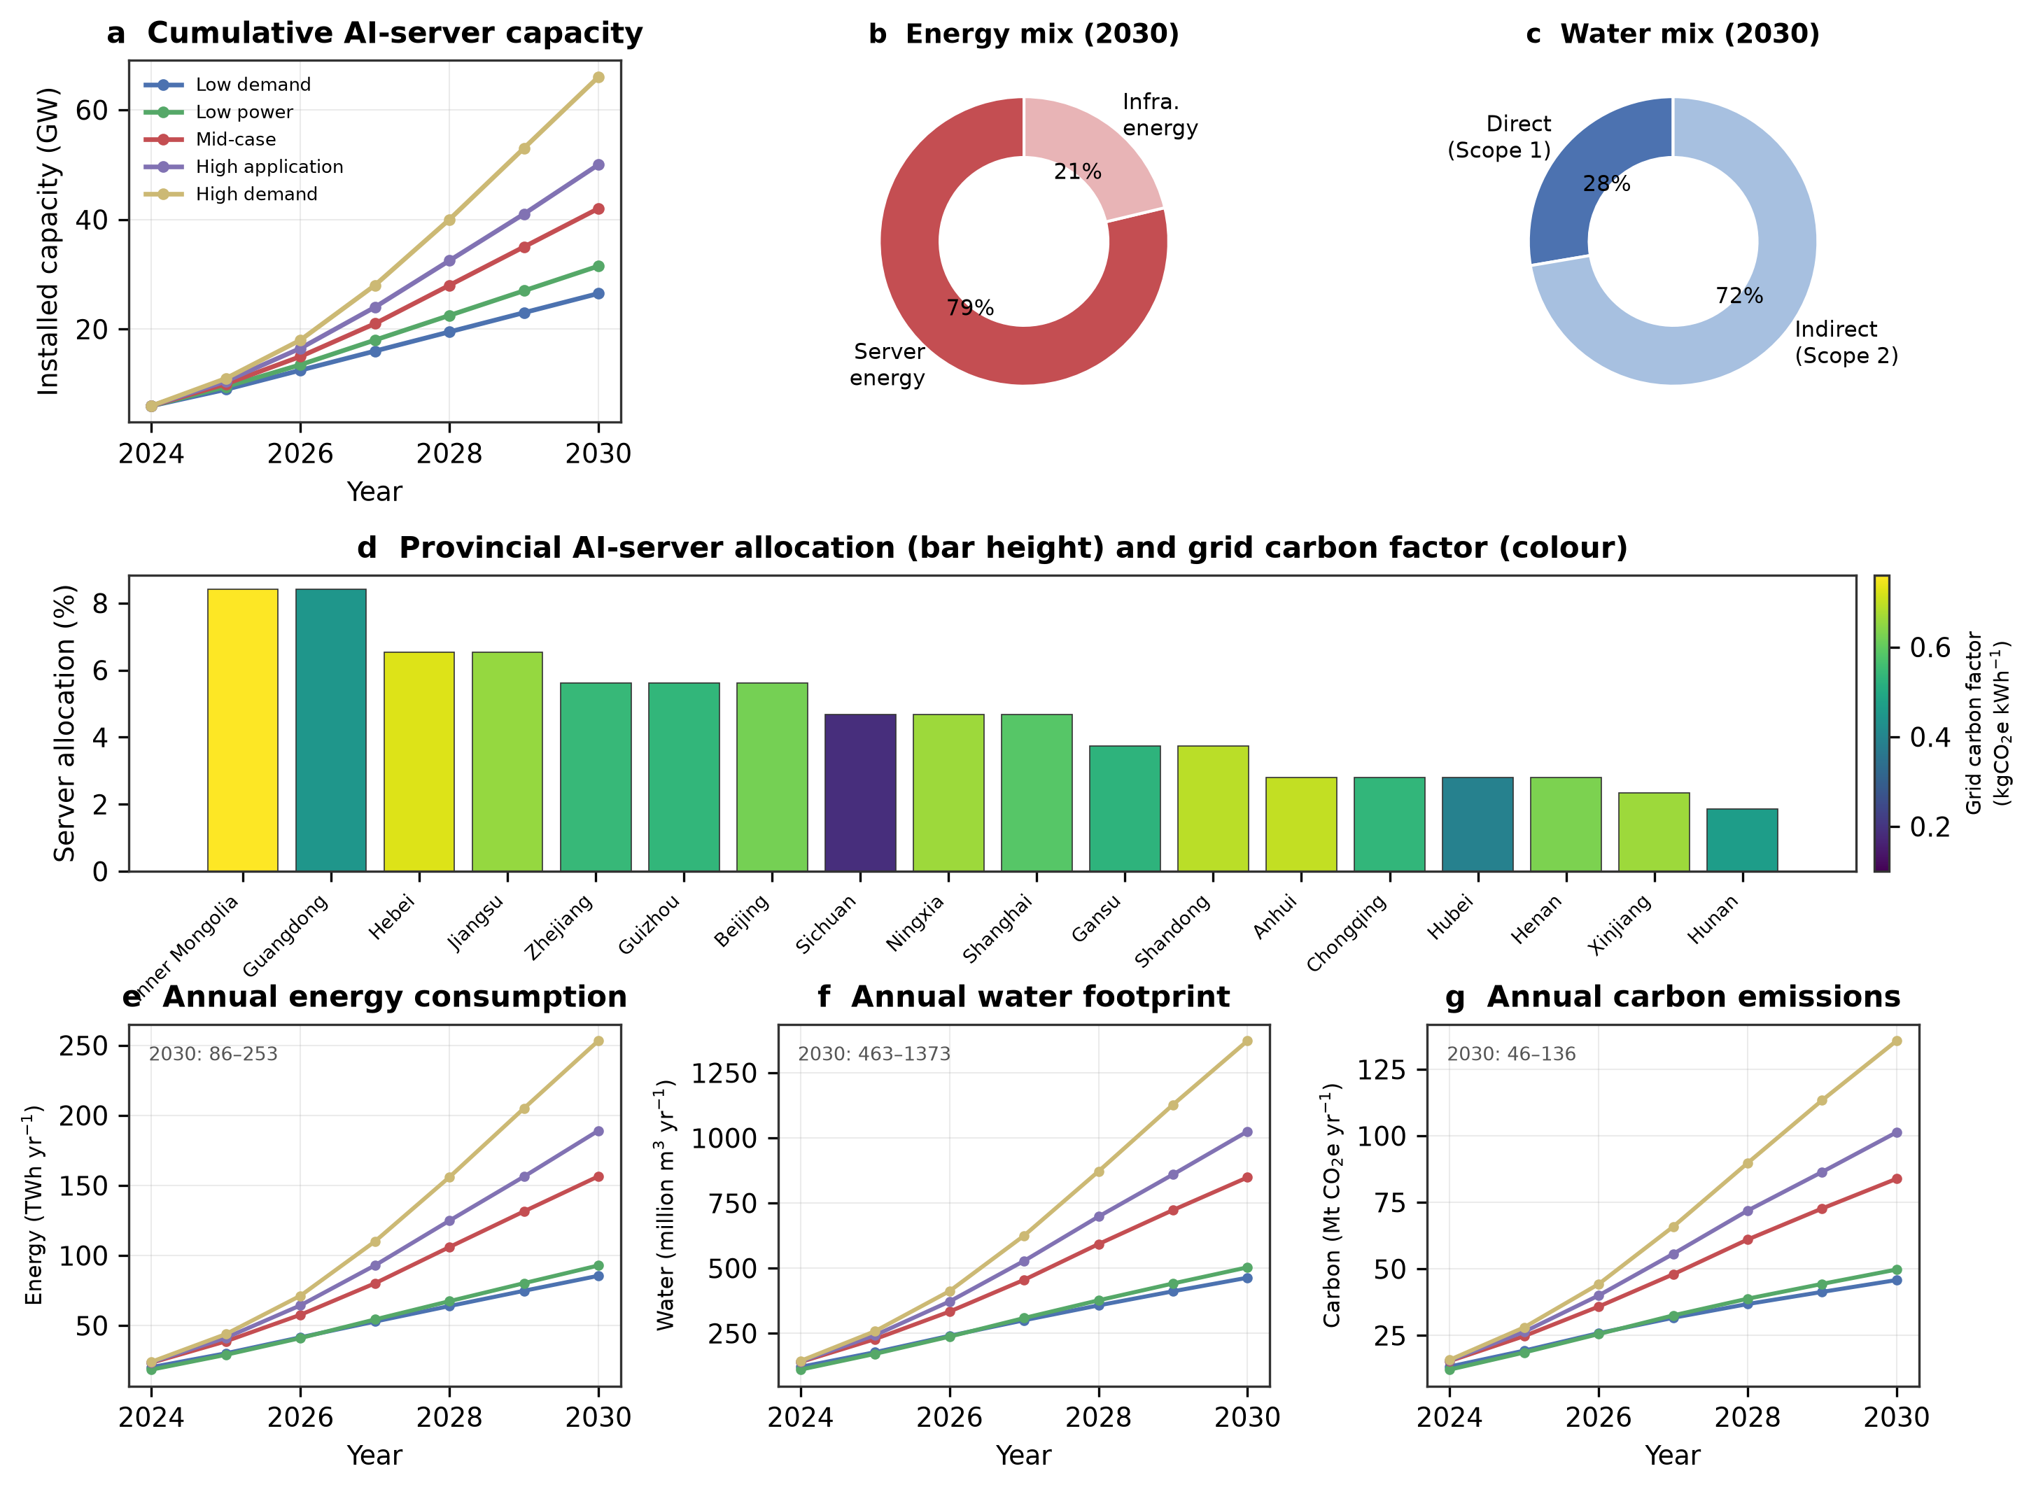
Fig. 1 | Projections of energy, water and carbon footprints of installed AI servers in China, 2024–2030. a, Projected cumulative AI server capacity under five scenarios. b,c, Energy composition (server vs infrastructure) and water composition (direct Scope 1 vs indirect Scope 2) in the mid-case in 2030. d, Provincial AI-server allocation (bar height) and grid carbon factor (colour). e–g, Annual energy consumption (e), water footprint (f) and carbon emissions (g) under the five scenarios.
Higher energy and water usage efficiencies
Efficiency gains in the data-centre industry have historically stabilized environmental costs despite rapidly rising computation¹⁹. This section examines the potential for further improvements through system optimization and technology adoption. Figure 2a–c illustrates the effect of best-, base- and worst-practice PUE and WUE on the energy, water and carbon footprints of AI servers. Chinese AI data centres already operate at relatively high efficiency under national PUE caps for the computing hubs³⁷, yet the best-practice scenario suggests a further reduction potential of over 7% in PUE and more than 30% in the total water footprint through WUE improvement. PUE reduction yields commensurate reductions in total energy consumption and carbon emissions, while WUE reduction efforts result in over a 28% reduction in the total water footprint (Fig. 2d,e). The worst-practice scenario underscores the risk of neglecting efficiency efforts, particularly where evaporative cooling is used to offset high PUE in hot, humid southern provinces.
Figure 2f examines the adoption of advanced technologies—advanced liquid cooling (ALC) and server utilization optimization (SUO). Best-case ALC adoption can reduce roughly 2% of energy, 3% of water and 2% of carbon by 2030, while full SUO adoption reduces all footprints by about 6%; frozen adoption (worst case) instead raises footprints by up to 8%. The maximum reductions in energy, water and carbon drawn from the existing efficiency potential are about 12%, 32% and 11%, respectively. Advances in domestic AI hardware—successive Ascend-class accelerators and improved interconnects—could further reduce footprints by improving energy efficiency, although these gains may be partially offset by the rebound effect as cheaper computation spurs additional demand⁵. These findings underscore the considerable, but bounded, impact of industry efforts on the environmental cost of AI servers.
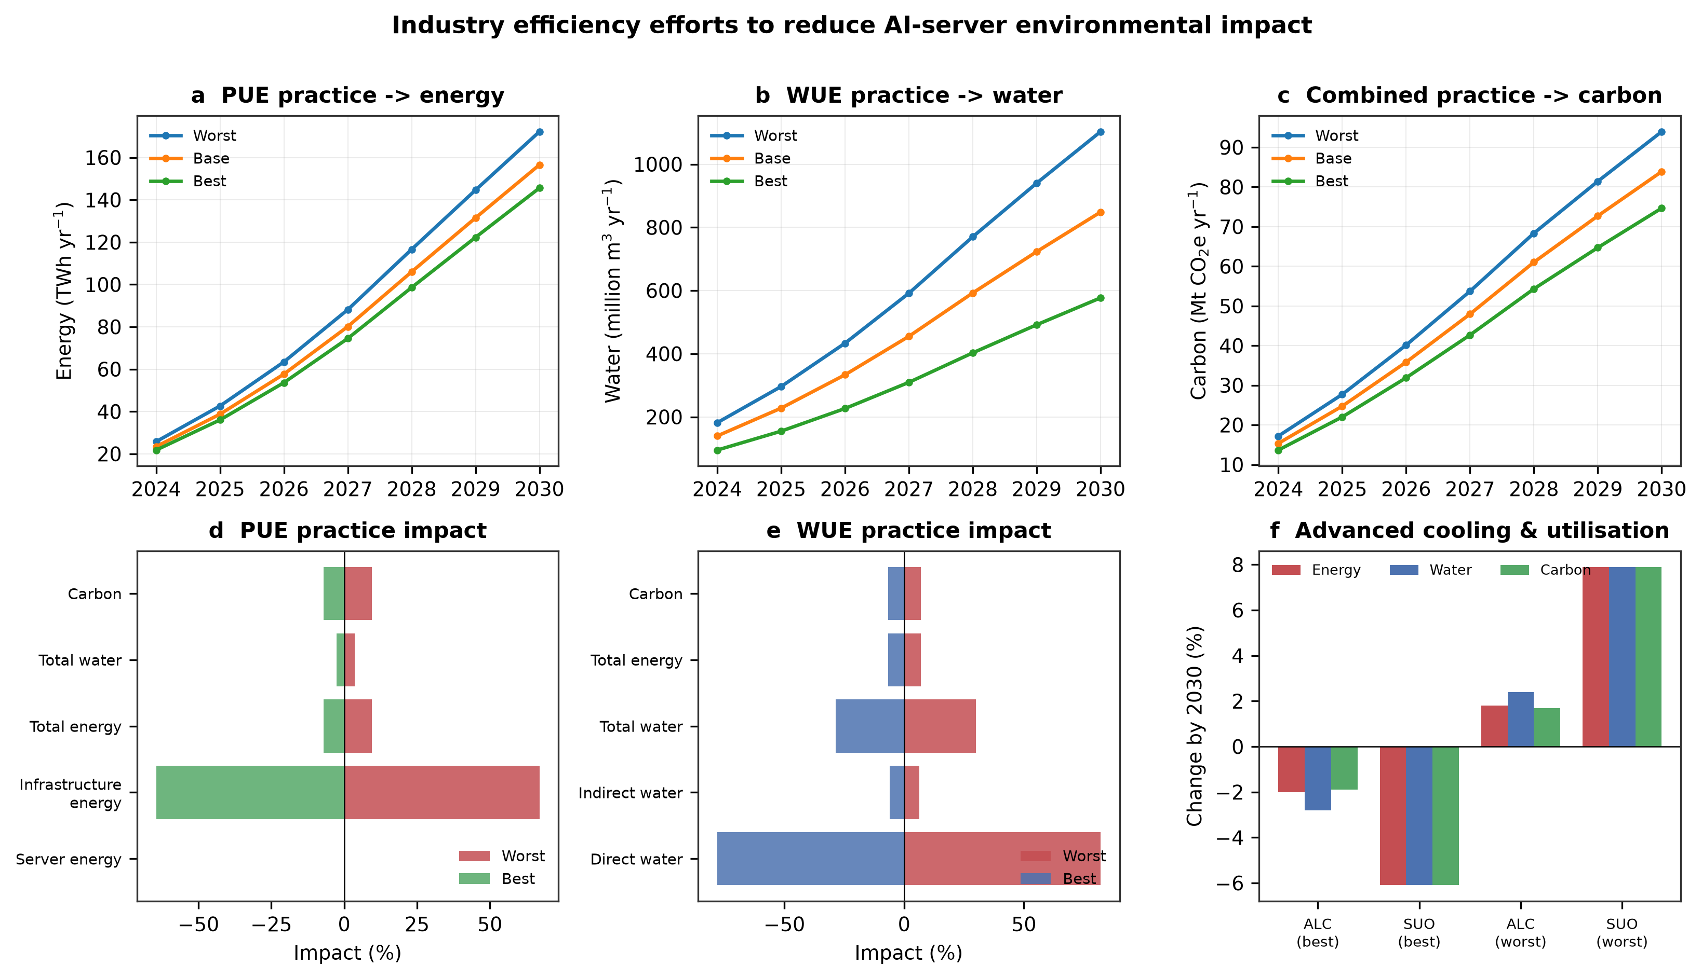
Fig. 2 | Assessment of industry efforts to reduce the environmental impact of AI servers. a–c, Effect of best/base/worst PUE, WUE and combined practices on annual energy, water and carbon. d,e, Percentage impacts of PUE and WUE practices on the energy, water and carbon footprints. f, Effect of advanced liquid cooling (ALC) and server utilization optimization (SUO) adoption by 2030.
Influence of AI server spatial distribution
The location of data centres critically shapes their environmental impact^{20,38}. This section projects how AI server spatial distribution may influence the environmental consequences of rapid expansion in China, a question made salient by the ‘East Data, West Computing’ programme, which deliberately relocates computing capacity from the eastern load centres to eight western and inland hubs^{32–33,39}. Figure 3a presents the provincial trade-off between unit carbon footprint and unit water footprint of server energy, with bubble size denoting current allocation and colour denoting wind-plus-solar potential. A clear tension emerges: the hydropower-rich south-western provinces (Sichuan, Yunnan, Qinghai) deliver the lowest unit carbon footprints (Fig. 3b) but the highest unit water footprints, because hydropower consumes large volumes of water through reservoir evaporation³⁴. Conversely, the cold, dry northern and north-western provinces (Inner Mongolia, Ningxia, Gansu, Xinjiang) offer low water footprints and abundant wind and solar resources, but their coal-heavy grids currently impose high unit carbon footprints.
Figure 3c quantifies the effect of three siting strategies relative to the base allocation. Concentrating servers in the top-quartile water-oriented provinces reduces the total water footprint by about 46% but cuts carbon by only 22%; a carbon-oriented strategy reduces carbon by about 52% but increases the water footprint by about 31% owing to hydropower siting; a combined strategy reduces water and carbon concurrently, by roughly 38% and 41%. Figure 3d maps the underlying driver—the joint distribution of wind-plus-solar potential and water-scarcity—revealing that several western hubs central to the optimal strategy (Inner Mongolia, Ningxia, Gansu, Xinjiang) lie in the water-scarce upper-right region. The genuinely sustainable solution is therefore not simply ‘go west’, but to pair western siting with wind and solar generation—which consumes negligible water and, in desert installations, can even reduce local evaporation⁴⁰—and with dry (air-side or closed-loop) cooling, rather than relying on either coal power or water-intensive hydropower. The Qinghai and parts of the Gansu corridor, which combine high renewable potential with lower-carbon grids, emerge as particularly favourable when water management is enforced⁴¹.
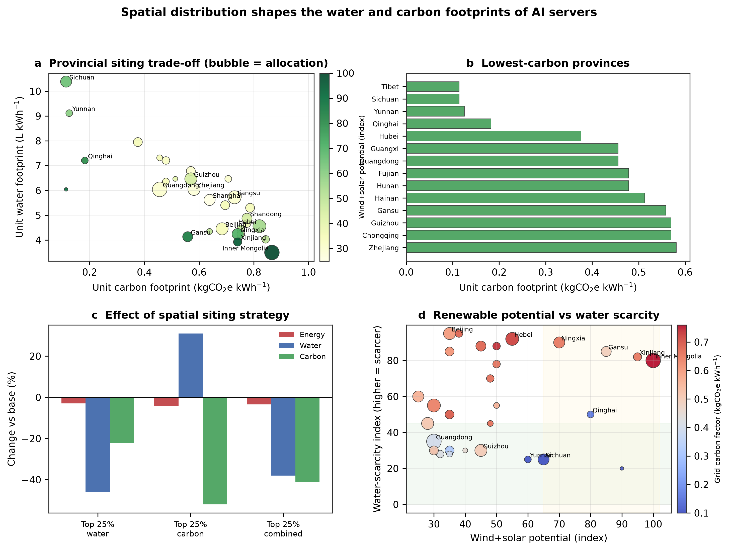
Fig. 3 | Spatial distribution shapes the water and carbon footprints of AI servers. a, Provincial trade-off between unit carbon and unit water footprints (bubble size = allocation, colour = wind+solar potential). b, Provinces with the lowest unit carbon footprint. c, Effect of water-, carbon- and combined-oriented siting strategies on total footprints. d, Joint distribution of wind+solar potential and water scarcity by province (colour = grid carbon factor); the shaded quadrants highlight low-water-stress and high-renewable regions.
Influence of grid renewable penetration
This section analyses how future grid development will affect AI server environmental impacts. We contrast a low-renewable-cost (LRC, best-practice) pathway with rapid wind and solar deployment against a high-renewable-cost (HRC, worst-practice) pathway with slower decarbonization, both consistent with the range of China’s published power-sector scenarios^{8,42–43}. Figure 4a,b shows the resulting national carbon and water trajectories for the mid-case server scenario. The HRC pathway raises 2030 carbon emissions by about 20% and water by about 2.5%, whereas the LRC pathway reduces carbon by about 16% with a small water co-benefit, because additional wind and solar—unlike coal and hydropower—generate electricity without consuming water. The carbon footprint of AI servers is thus heavily governed by the grid decarbonization pattern, indicating both considerable reduction potential and associated risk.
Figure 4c details the provincial sensitivity to grid development. Provinces hosting large planned wind and solar mega-bases—Inner Mongolia, Ningxia and Gansu—show the strongest response, with carbon swings of roughly ±20–26% between the LRC and HRC pathways^{41,44}. The hydropower-dominated provinces (Sichuan, Yunnan) are comparatively insensitive because their grids are already near-decarbonized, although they remain exposed to the water penalty of hydropower and to seasonal drought-driven generation shortfalls. These results connect to the importance of ambitious green-electricity policies and of routing the ‘desert and Gobi’ renewable mega-bases to serve co-located computing load, so that the environmental dividend of decarbonization is captured rather than curtailed^{12,44}.
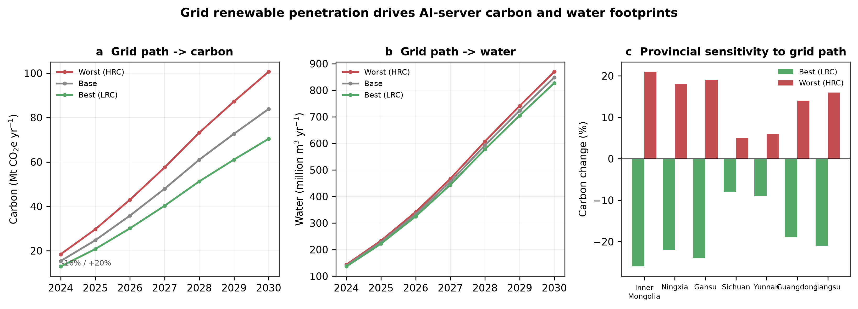
Fig. 4 | Grid renewable penetration drives AI-server carbon and water footprints. a,b, Mid-case carbon and water trajectories under best (LRC), base and worst (HRC) grid pathways. c, Provincial sensitivity of carbon emissions to the grid pathway for selected hub provinces.
Pathways to carbon-peak and net-zero water goals
Building on the preceding analyses of environmental cost, efficiency, spatial distribution and grid decarbonization, this section evaluates pathways for China’s AI servers to align with the national carbon-peak milestone and with operator-level neutrality and water-stewardship pledges⁴⁵. Figure 5a presents a contribution pathway under the mid-case scenario, decomposing the cumulative 2024–2030 carbon added by AI servers into the reductions achievable through industry efficiency, spatial siting and grid decarbonization, and the residual that must be addressed through offsets or further policy. Combined best practices cut residual emissions and water footprints by up to 73% and 86%, respectively, indicating a feasible—but demanding—pathway toward net zero. The single largest lever is grid decarbonization^{43,46}, followed by spatial siting and then on-site efficiency, reflecting the dominance of Scope 2 impacts in a coal-heavy system.
Figure 5b presents residual carbon across scenarios under best- and worst-practice bundles. Under the mid-case with best practices, residual annual emissions by 2030 fall to the order of tens of Mt CO₂e—still requiring tens of GW of additional wind or solar capacity to offset—whereas worst practices leave residuals several times larger that are nearly impossible to compensate over such a short horizon. Because renewable-energy certificates and offsets can threaten the integrity of corporate climate targets when poorly governed^{45,47}, we caution that headline neutrality claims should be underpinned by additional, local and verifiable clean generation rather than unbundled certificates. The results imply that, without substantial acceleration of the energy transition and disciplined siting, China’s AI server fleet is unlikely to be consistent with the sector’s share of a 2030 carbon peak, let alone deep mid-century neutrality, on the basis of efficiency gains alone.
Projected pathways could be further influenced by other uncertainties. Figure 6 presents a sensitivity analysis of key factors: server lifetime, domestic accelerator manufacturing capacity, national allocation ratio, server idle and maximum power ratios, training/inference distribution and green-power utilization. Changes in these factors result in up to roughly 40% variation in energy consumption, closely mirrored by water and carbon. The national allocation ratio and accelerator capacity dominate the uncertainty, reflecting the centrality of the domestic supply chain under export controls. Innovations such as DeepSeek can lower the power required per computing task², but may trigger a rebound effect that increases total demand—captured by our high-application scenario. The study’s key conclusions remain robust unless future uncertainties greatly exceed the modelled ranges, and the modelling approach enables revision as more data become available.
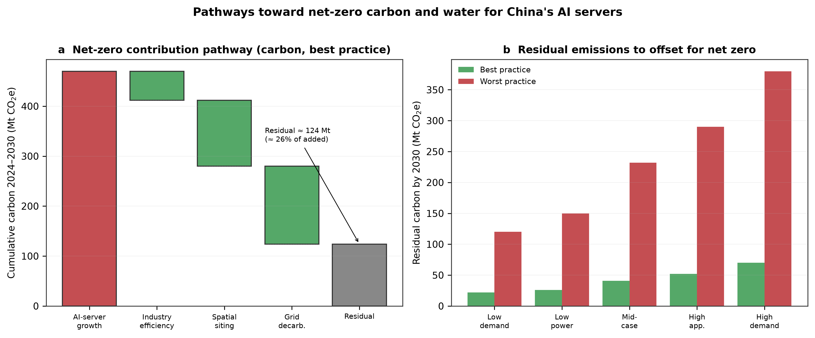
Fig. 5 | Pathways toward net-zero carbon and water for China’s AI servers. a, Contribution pathway decomposing cumulative 2024–2030 carbon added by AI servers into reductions from industry efficiency, spatial siting and grid decarbonization, and the residual. b, Residual carbon to offset by 2030 across the five scenarios under best- and worst-practice bundles.
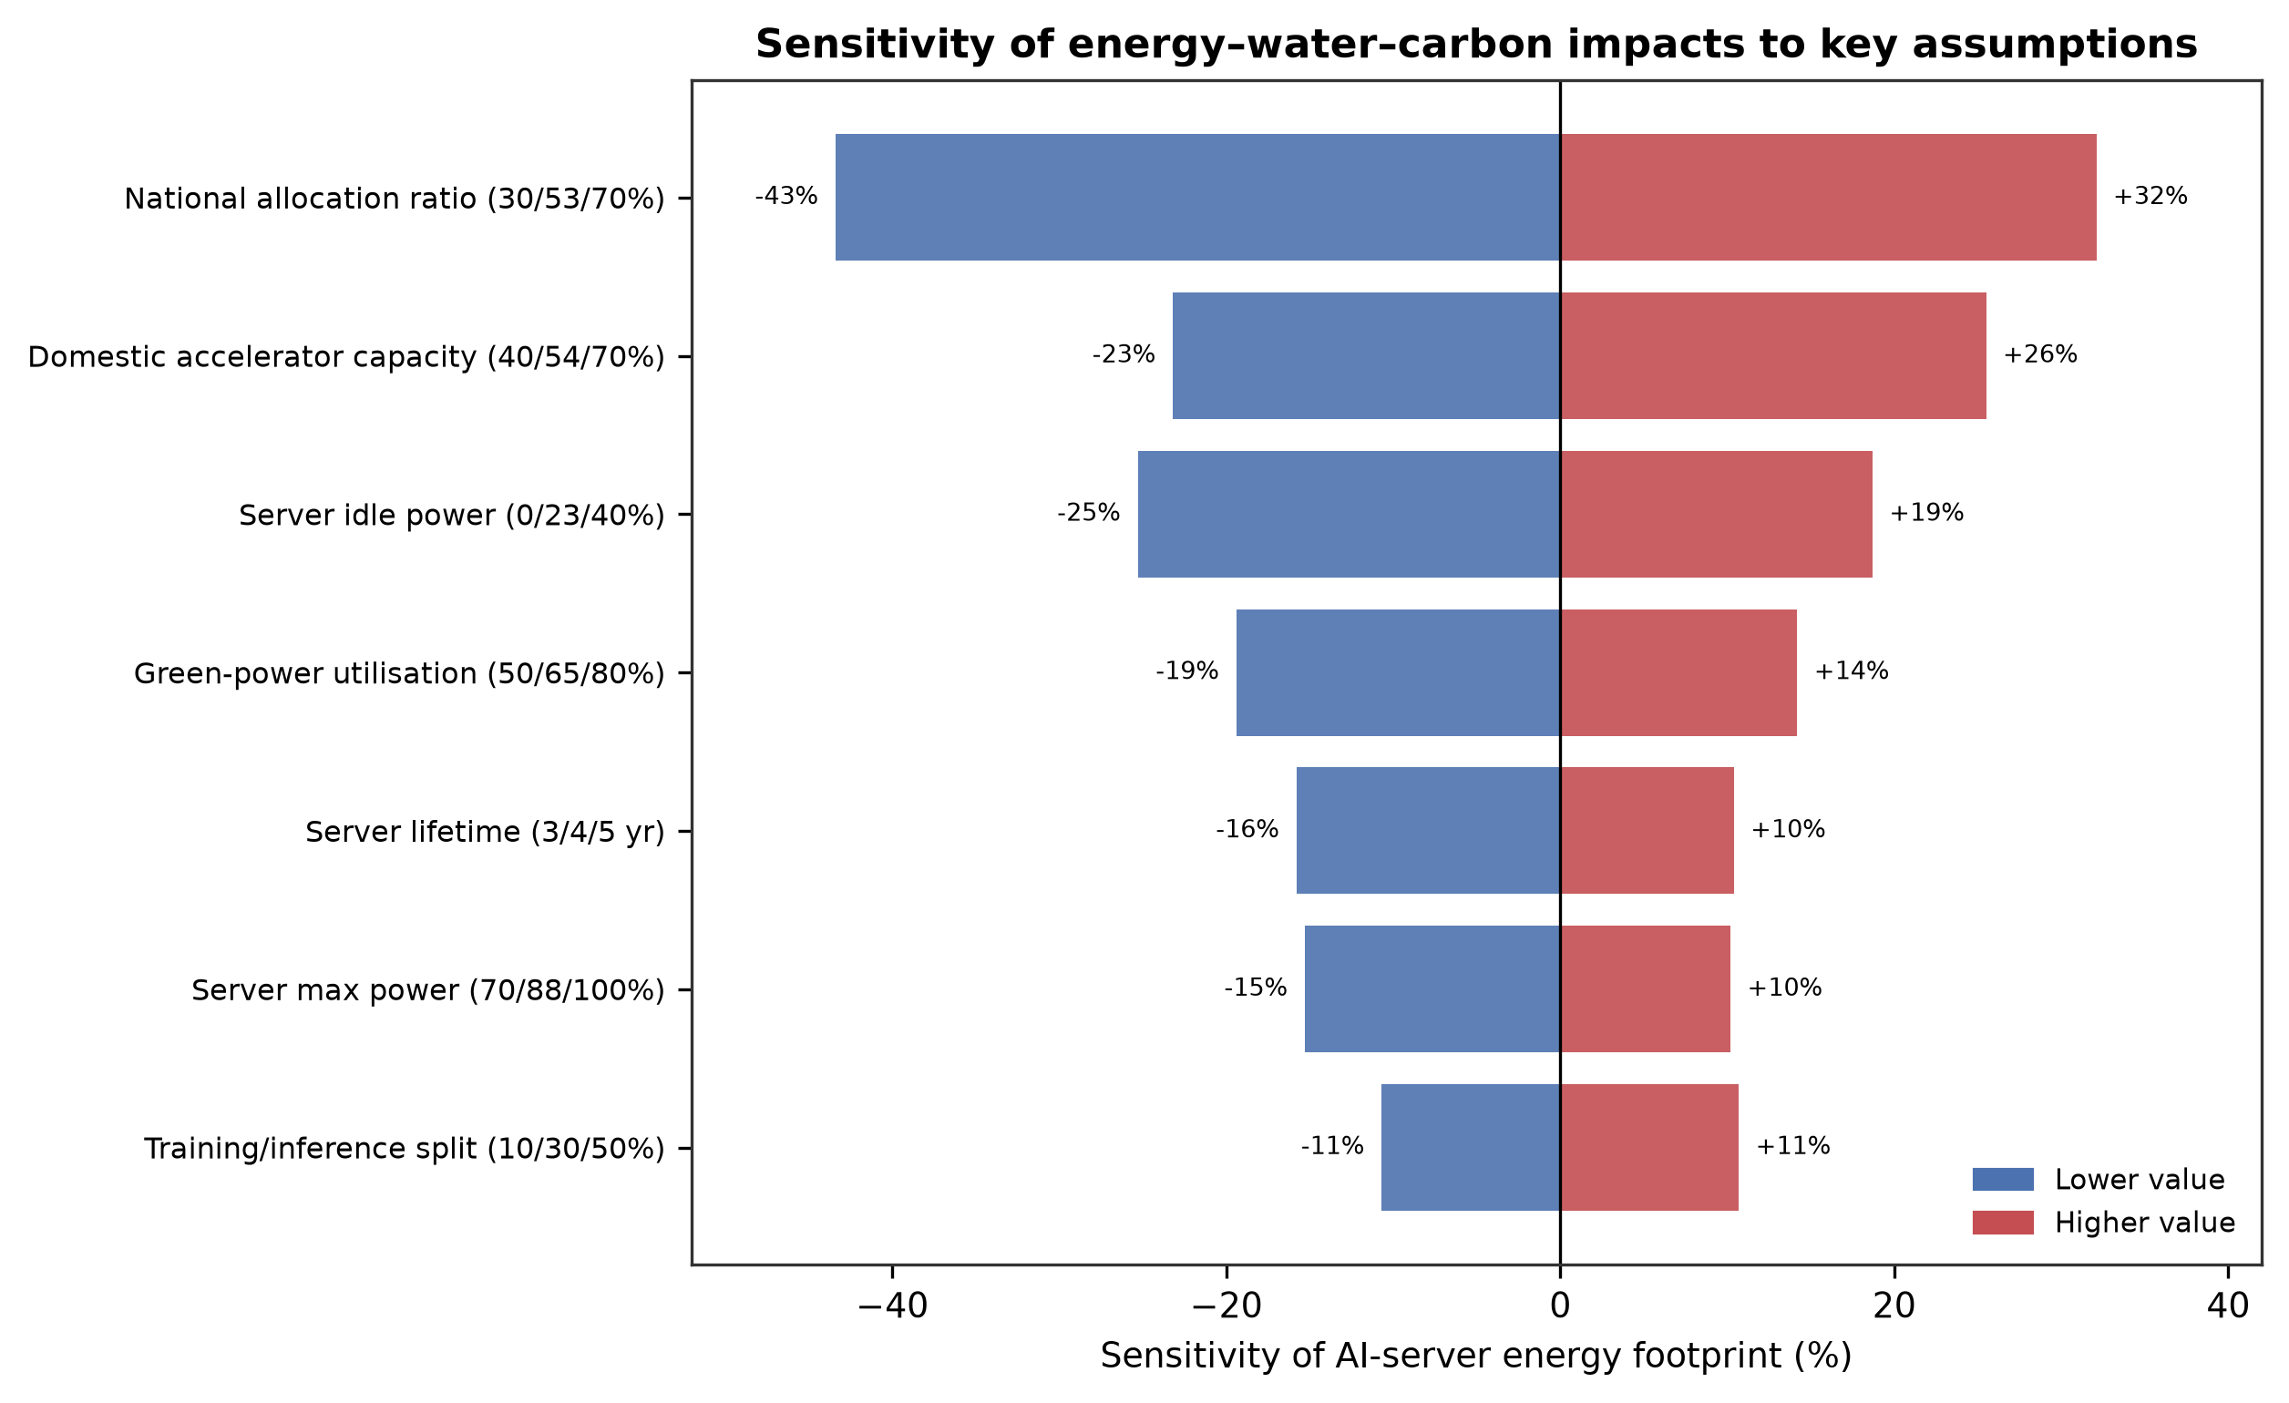
Fig. 6 | Sensitivity of AI-server energy–water–carbon impacts to key modelling assumptions. Tornado plot of the sensitivity of AI server energy consumption (closely mirrored by water and carbon) to server lifetime, domestic accelerator capacity, national allocation ratio, idle and maximum power ratios, training/inference split and green-power utilization. Listed values are low, applied and high.
Discussion
Investment in AI servers is accelerating in China, as seen in the rapid build-out of intelligent-computing centres under the ‘East Data, West Computing’ programme and in the capital-expenditure plans of major cloud operators^{13,33,46}. While AI advancement is a national priority, our study highlights its environmental cost. To mitigate these risks, we identify that concentrating AI server deployment in provinces that combine abundant wind and solar resources with manageable water stress—principally Inner Mongolia, Gansu, Ningxia, Qinghai and Xinjiang, paired with dry cooling and dedicated renewable supply—is preferable to either coal-based siting or water-intensive hydropower siting in Sichuan and Yunnan. These provinces possess substantial untapped wind and solar potential^{44,48}, enabling robust green-power portfolios and reducing competition with other sectors. However, several implementation challenges must be acknowledged. The western hubs sit in some of China’s most water-stressed basins^{9,18}, so the water advantage is realized only if evaporative cooling is avoided and renewable rather than thermal or hydro generation is procured⁴⁰. Routing the planned desert and Gobi renewable mega-bases to co-located computing load, and strengthening dedicated transmission, will be essential to prevent curtailment from eroding the climate dividend⁴⁴.
Realizing the suggested strategy may be further complicated by public-health and local-development concerns. Operational demands and construction could generate air and water pollution, and large hyperscale loads challenge utilities’ obligation to serve. We recommend that AI firms engage in public–private partnerships with provincial governments that fund green-power upgrades and transparent environmental monitoring, while governments use green-electricity targets, PUE caps and water-rights enforcement for the computing hubs to steer siting^{33,37}. Because renewable-energy certificates and carbon offsets can undermine the integrity of neutrality claims when weakly governed⁴⁵, neutrality pledges by Chinese operators should be backed by additional, local and verifiable clean generation and by third-party verification. Emerging high-efficiency models such as DeepSeek may fundamentally reshape AI server supply and demand²; while efficiency lowers cost per task, it risks a rebound that amplifies total demand, calling for real-time monitoring and AI-specific benchmarks for energy, water and carbon performance^{11–12} so that policy can respond before large impacts accrue. Finally, the effectiveness of these measures will be shaped by broader political and economic factors beyond the scope of this study.
Methods
The methodology aims to (1) characterize the energy–water–climate impacts of AI servers in China from 2024 to 2030, and (2) identify best- and worst-practice values of each influencing factor to scheme net-zero pathways consistent with the national dual-carbon milestones. Scenario-based projections are first constructed to obtain potential capacity-increasing patterns of AI servers; technology dynamics (SUO and ALC adoption), grid decarbonization and spatial distribution are each defined with best, base and worst scenarios. The models and data used are described below.
AI server power-capacity projections
AI server energy consumption is projected to be driven predominantly by top-tier accelerators designed for large-scale generative AI computing. Under US export controls restricting access to leading-edge imported accelerators, China’s top-tier AI server capacity is increasingly determined by the output of domestic accelerators (for example, the Ascend line) and by the advanced-packaging capacity of domestic foundries, which forms the production bottleneck analogous to chip-on-wafer-on-substrate (CoWoS) capacity elsewhere². We estimate the annual top-tier server shipments and average rated power as
N_AI = (C_pkg · R_top · Σ_i R_i n_i) / N_acc , P̄_AI = Σ_i R_i P_i ,
where N_AI and P̄_AI are the annually projected shipments and average rated power of top-tier AI servers, C_pkg is the projected domestic advanced-packaging capacity within each scenario, R_top is the share of packaging capacity allocated to top-tier accelerators, N_acc is the number of accelerators per server, and R_i, n_i and P_i are the adoption ratio, units yield per wafer and rated power of the i-th accelerator type in each year. Five scenarios (low demand, low power, mid-case, high application, high demand) span the uncertainty in packaging-capacity growth, rated power and adoption, with the mid-case calibrated so that 2030 facility electricity reaches about 157 TWh, consistent with reported China data-centre electricity growth dominated by intelligent computing^{11,13}.
AI server electricity-usage calculation
Server electricity usage follows a utilization-based model, P_server = (P_max − P_idle)·u + P_idle, where u is the processor utilization, P_max and P_idle are the maximum and idle power, and u = u_active · r_active is decomposed into the average utilization of active accelerators and the active ratio. Training and inference are treated separately because they exhibit distinct utilization, with a base split of 30% of capacity for training and 70% for inference^{22,24}. Facility electricity is obtained by multiplying IT electricity by the provincial PUE.
Assessment of environmental footprints
A province-level allocation method evaluates the energy, water and carbon footprints of AI servers. We compiled the locations of existing and planned large-scale AI data centres operated by major Chinese purchasers of top-tier accelerators (including Alibaba, Tencent, Baidu, ByteDance, Huawei Cloud and the three telecommunications operators) together with the eight national computing hubs, and aggregated capacity by province³³. For each province, actual energy consumption is derived from server electricity usage and the provincial PUE. Water and carbon are assessed across three scopes: Scope 1 (on-site cooling water via WUE; on-site carbon negligible), Scope 2 (off-site water and carbon contingent on the provincial grid mix) and Scope 3 (embodied water and carbon during manufacturing). A hybrid statistical and thermodynamics-based PUE/WUE model³⁶, driven by provincial climate data, estimates province-specific PUE and WUE; base values average the best and worst practices given unknown cooling specifications. Scope 2 water and carbon use province-level grid water and carbon factors derived from generation mixes consistent with national decarbonization plans^{8,38}. Water-scarcity and renewable-potential layers for each province are compiled from published hydrological and resource assessments^{9,44}.
Uncertainties and limitations
Substantial uncertainties are inherent in projecting AI server evolution. Our analysis presents a range of scenarios to evaluate operational efficiency, spatial distribution and grid development, and a sensitivity analysis (Fig. 6) on server lifetime, domestic accelerator capacity, allocation ratio, idle and maximum power, training/inference split and green-power utilization. Key unmodelled uncertainties include model and algorithm innovations (which could alter compute requirements), domestic supply-chain dynamics under export controls, hardware and facility evolution, and out-of-scope factors such as market forces and geopolitics. As Fig. 6 indicates, the study’s conclusions remain robust unless future uncertainties greatly exceed the modelled ranges, and the framework allows revision as more data become available.
Data and code availability
All simulated datasets generated in this analysis (national trajectories and provincial attributes) and the code used to produce the figures are provided with this manuscript in the accompanying repository. Provincial grid, water and renewable-potential layers are derived from the publicly available sources cited above. Numerical inputs and assumptions are summarized in the main text and figures; further calibration details are available from the corresponding author on request.
Author contributions
[Corresponding Author] conceived and supervised the study. [First Author] developed the model, performed the analysis and drafted the manuscript. All authors contributed to interpretation, review and editing and approved the final version.
Competing interests
The authors declare no competing interests.
References
1. Guan, L. Reaching carbon neutrality requires energy-efficient training of AI. Nature 626, 33 (2024).
2. DeepSeek-AI et al. DeepSeek-V3 technical report. Preprint at https://arxiv.org/abs/2412.19437 (2024).
3. Kaack, L. H. et al. Aligning artificial intelligence with climate change mitigation. Nat. Clim. Change 12, 518–527 (2022).
4. Vinuesa, R. et al. The role of artificial intelligence in achieving the Sustainable Development Goals. Nat. Commun. 11, 233 (2020).
5. de Vries, A. The growing energy footprint of artificial intelligence. Joule 7, 2191–2194 (2023).
6. Crawford, K. Generative AI’s environmental costs are soaring—and mostly secret. Nature 626, 693 (2024).
7. Mytton, D. Data centre water consumption. npj Clean Water 4, 11 (2021).
8. Jia, M. et al. Optimization of electricity generation and assessment of provincial grid emission factors from 2020 to 2060 in China. Appl. Energy 373, 123838 (2024).
9. Jiang, F., Duan, C. & Chen, B. Facility-level energy-driven water footprint and scarcity implications of data centers in China. Appl. Energy 399, 126522 (2025).
10. Malmodin, J., Lövehagen, N., Bergmark, P. & Lundén, D. ICT sector electricity consumption and greenhouse gas emissions—2020 outcome. Telecommun. Policy 48, 102701 (2024).
11. China Academy of Information and Communications Technology (CAICT). China Green Computing Power Development Research Report (中国绿色算力发展研究报告) (CAICT, 2024); https://www.caict.ac.cn/kxyj/qwfb/ztbg/202407/P020240711551514828756.pdf.
12. Greenpeace East Asia. Clean Cloud 2024: Tracking Renewable Energy Use in China’s Tech Industry (Greenpeace, 2024).
13. International Energy Agency. Energy and AI (IEA, 2025); https://www.iea.org/reports/energy-and-ai.
14. Mallapaty, S. How China could be carbon neutral by mid-century. Nature 586, 482–483 (2020).
15. Mao, F., Wei, Y. & Wang, Y. Impact of computing infrastructure on carbon emissions in China. Sci. Rep. 14, 29814 (2024).
16. Li, P., Yang, J., Islam, M. A. & Ren, S. Making AI less ‘thirsty’: uncovering and addressing the secret water footprint of AI models. Commun. ACM 68, 54–63 (2025).
17. de Vries-Gao, A. The carbon and water footprints of data centers and what this could mean for sustainable computing. Patterns 7, 101430 (2025).
18. China Water Risk. China ICT Running Dry? The Rise of AI & Climate Risks Amplify Existing Water Risks Faced by Thirsty Data Centres (China Water Risk, 2024).
19. Masanet, E., Shehabi, A., Lei, N., Smith, S. & Koomey, J. Recalibrating global data center energy-use estimates. Science 367, 984–986 (2020).
20. Siddik, M. A. B., Shehabi, A. & Marston, L. The environmental footprint of data centers in the United States. Environ. Res. Lett. 16, 064017 (2021).
21. Wu, C.-J. et al. Sustainable AI: environmental implications, challenges and opportunities. Proc. Mach. Learn. Syst. 4, 795–813 (2022).
22. Luccioni, A. S., Viguier, S. & Ligozat, A.-L. Estimating the carbon footprint of BLOOM, a 176B parameter language model. J. Mach. Learn. Res. 24, 11990–12004 (2023).
23. Luccioni, A. S., Jernite, Y. & Strubell, E. Power Hungry Processing: watts driving the cost of AI deployment? In Proc. 2024 ACM Conference on Fairness, Accountability, and Transparency 85–99 (ACM, 2024).
24. Patel, P. et al. Characterizing power management opportunities for LLMs in the cloud. In Proc. 29th ACM International Conference on Architectural Support for Programming Languages and Operating Systems Vol. 3, 207–222 (ACM, 2024).
25. Dodge, J. et al. Measuring the carbon intensity of AI in cloud instances. In Proc. 2022 ACM Conference on Fairness, Accountability, and Transparency 1877–1894 (ACM, 2022).
26. Patterson, D. et al. The carbon footprint of machine learning training will plateau, then shrink. Computer 55, 18–28 (2022).
27. Faiz, A. et al. LLMCarbon: modeling the end-to-end carbon footprint of large language models. In Proc. 12th International Conference on Learning Representations (ICLR, 2024).
28. Berthelot, A., Caron, E., Jay, M. & Lefèvre, L. Estimating the environmental impact of generative-AI services using an LCA-based methodology. Procedia CIRP 122, 707–712 (2024).
29. Lei, N., Lu, J., Shehabi, A. & Masanet, E. The water use of data center workloads: a review and assessment of key drivers. Resour. Conserv. Recycl. 219, 108310 (2025).
30. Xiao, T., Fuso Nerini, F., Matthews, H. D., Tavoni, M. & You, F. Environmental impact and net-zero pathways for sustainable artificial intelligence servers in the USA. Nat. Sustain. 8, 1541–1553 (2025).
31. Ni, W. et al. CO₂ emission-mitigation pathways for China’s data centers. Resour. Conserv. Recycl. 200, 107383 (2023).
32. Xie, X., Han, Y. & Tan, H. Greening China’s digital economy: exploring the contribution of the East–West Computing Resources Transmission Project to CO₂ reduction. Humanit. Soc. Sci. Commun. 11, 466 (2024).
33. National Development and Reform Commission, Cyberspace Administration of China, Ministry of Industry and Information Technology & National Energy Administration. Overall Layout Plan for the National Integrated Big-Data Centre Collaborative Innovation System (‘East Data, West Computing’, 东数西算) (NDRC, 2021); https://www.ndrc.gov.cn/xxgk/jd/jd/202202/t20220217_1315795.html.
34. Liu, J., Zhao, D., Gerbens-Leenes, P. W. & Guan, D. China’s rising hydropower demand challenges water sector. Sci. Rep. 5, 11446 (2015).
35. Liao, X., Hall, J. W. & Eyre, N. Water use in China’s thermoelectric power sector. Glob. Environ. Change 41, 142–152 (2016).
36. Lei, N. & Masanet, E. Climate- and technology-specific PUE and WUE estimations for US data centers using a hybrid statistical and thermodynamics-based approach. Resour. Conserv. Recycl. 182, 106323 (2022).
37. Li, G. et al. China’s green data center development: policies and carbon reduction technology path. Environ. Res. 231, 116248 (2023).
38. Siddik, M. A. B., Shehabi, A., Rao, P. & Marston, L. T. Spatially and temporally detailed water and carbon footprints of US electricity generation and use. Water Resour. Res. 60, e2024WR038350 (2024).
39. Zhang, Y., Li, H. & Wang, S. Decarbonizing data centers through regional bits migration: a comprehensive assessment. Appl. Energy 392, 126020 (2025).
40. Chang, R., Yan, Y., Wu, J., Wang, Y. & Gao, X. Projected PV plants in China’s Gobi Deserts would result in lower evaporation. Sol. Energy 256, 140–150 (2023).
41. Fan, J.-L., Huang, X., Shi, J., Li, K., Cai, J. & Zhang, X. Complementary potential of wind–solar–hydro power in Chinese provinces. Renew. Sustain. Energy Rev. 184, 113566 (2023).
42. Ren, J., Zhang, Q. & Chen, W. China’s provincial power decarbonization transition in a carbon neutral target. Energy 310, 133211 (2024).
43. Zhang, D. et al. Spatially resolved land and grid model of carbon neutrality in China. Proc. Natl Acad. Sci. USA 121, e2306517121 (2024).
44. Wang, Y. et al. Accelerating the energy transition towards photovoltaic and wind in China. Nature 619, 761–767 (2023).
45. Bjørn, A., Lloyd, S. M., Brander, M. & Matthews, H. D. Renewable energy certificates threaten the integrity of corporate science-based targets. Nat. Clim. Change 12, 539–546 (2022).
46. Zhang, N. et al. The ‘Eastern Data and Western Computing’ initiative in China contributes to its net-zero target. Engineering 52, 256–261 (2025).
47. Liu, L., Feng, T., Zhong, C., Cui, M. & Wang, H. Synergy pathway innovation of carbon emission trading, tradable green certificates and renewable portfolio standards. Humanit. Soc. Sci. Commun. 12, 1–15 (2025).
48. International Energy Agency. An Energy Sector Roadmap to Carbon Neutrality in China (IEA, 2021); https://www.iea.org/reports/an-energy-sector-roadmap-to-carbon-neutrality-in-china.

