**雅思写作大作文题型介绍：（五大题型）**

**第一类：探讨双方**

1. Some people think that（观点A） it is necessary to use [animals](https://www.zhihu.com/search?q=animals&search_source=Entity&hybrid_search_source=Entity&hybrid_search_extra={"sourceType":"article","sourceId":"391300102"}" \t "/Users/caiyan/Documents\\x/_blank) for testing [medicines](https://www.zhihu.com/search?q=medicines&search_source=Entity&hybrid_search_source=Entity&hybrid_search_extra={"sourceType":"article","sourceId":"391300102"}" \t "/Users/caiyan/Documents\\x/_blank) or other products intended for human use. Others（观点B）, however, criticize this as animal [cruelty](https://www.zhihu.com/search?q=cruelty&search_source=Entity&hybrid_search_source=Entity&hybrid_search_extra={"sourceType":"article","sourceId":"391300102"}" \t "/Users/caiyan/Documents\\x/_blank). Discuss both sides and give your own opinion.

[四段式](https://www.zhihu.com/search?q=%E5%9B%9B%E6%AE%B5%E5%BC%8F&search_source=Entity&hybrid_search_source=Entity&hybrid_search_extra={"sourceType":"article","sourceId":"391300102"}" \t "/Users/caiyan/Documents\\x/_blank)，除了开头段和结论段，主体段是两段：

探讨双方：主流写法

主体段（一）：

讨论观点A：站在A的立场说话

[主体段](https://www.zhihu.com/search?q=%E4%B8%BB%E4%BD%93%E6%AE%B5&search_source=Entity&hybrid_search_source=Entity&hybrid_search_extra={"sourceType":"article","sourceId":"391300102"}" \t "/Users/caiyan/Documents\\x/_blank)（二）：

讨论观点B：站在B的立场说话（个人观点）

第一段：

第一句：People have different views about 提炼问题讨论内容。

第二句：如果两种观点都赞同，In my opinion, museums can and should be both entertaining and educational.

只赞同一方的观点，While some argue that it would be better for students to be forced into certain key subject areas, I believe that everyone should be able to study the course of their choice. /

**Some people think that museums should be enjoyable places to entertain people, while others believe that the purpose of museums is to educate. Discuss both views and give your own opinion.**

People have different views about the role and function of museums. In my opinion, museums can and should be both entertaining and educational./ 表达同时赞同两种观点

On the one hand, it can be argued that the main role of a museum is to entertain. Museums are tourist attractions, and their aim is to exhibit a collection of interesting objects that many people will want to see. The average visitor may become bored if he or she has to read or listen to too much educational content, so museums often put more of an emphasis on enjoyment rather than learning. This type of museum is designed to be visually spectacular, and may have interactive activities or even games as part of its exhibitions.

论点+解析why.if 不这么做会怎么样。所以xxxx举例说明。

On the other hand, some people argue that museums should focus on education. The aim of any exhibition should be to teach visitors something that they did not previously know. Usually this means that the history behind the museum’s exhibits needs to be explained, and this can be done in various ways. Some museums employ professional guides to talk to their visitors, while other museums offer headsets so that visitors can listen to detailed commentary about the exhibition. In this way, museums can play an important role in teaching people about history, culture, science and many other aspects of life.

In conclusion, it seems to me that a good museum should be able to offer an interesting, enjoyable and educational experience so that people can have fun and learn something at the same time.

**Some people think that all university students should study whatever they like. Others believe that they should only be allowed to study subjects that will be useful in the future, such as those related to science and technology. Discuss both these views and give your own opinion. (University subjects)**

People have different views about how much choice students should have with regard to what they can study at university. While some argue that it would be better for students to be forced into certain key subject areas, I believe that everyone should be able to study the course of their choice. /表达只赞同一方的观点

There are various reasons why people believe that universities should only offer subjects that will be useful in the future. They may assert that university courses like medicine, engineering and information technology are more likely to be beneficial than certain art degrees. From a personal perspective, it can be argued that these courses provide more job opportunities, career progression, better salaries, and therefore an improved quality of life for students who take them. On the societal level, by forcing people to choose particular university subjects, governments can ensure that any knowledge and skill gaps in the economy are covered. Finally, a focus on technology in higher education could lead to new inventions, economic growth, and greater future prosperity.

In spite of these arguments, I believe that university students should be free to choose their preferred areas of study. In my opinion, society will benefit more if our students are passionate about what they are learning. Besides, nobody can really predict which areas of knowledge will be most useful to society in the future, and it may be that employers begin to value creative thinking skills above practical or technical skills. If this were the case, perhaps we would need more students of art, history and philosophy than of science or technology.

In conclusion, although it might seem sensible for universities to focus only on the most useful subjects, I personally prefer the current system in which people have the right to study whatever they like.

**Some people suggest higher education should be funded by the government, while others think students should pay the course fees themselves. Discuss both views and give your own [opinion](https://www.zhihu.com/search?q=opinion&search_source=Entity&hybrid_search_source=Entity&hybrid_search_extra={"sourceType":"article","sourceId":"391300102"}" \t "/Users/caiyan/Documents\\x/_blank).**

People have different views on who should pay the higher education fee for students. In my opinion, I believe that it would be better if government could help to cover the course fees.

There are various reasons why people believe that students themselves need to pay for the cost when they are pursuing higher education. They may consider that students pay the course fees by themselves would push them get a good grade. Because they need to be fully responsible for the cost they paid, so they would be much more careful about what they learn and pay more attention to the homework, all of that would mastery their skills and widen knowledge.Otherwise, they may not catch up the requirement that allow them to graduate from the universities, and what is worse they may need to study for one more year to get their diploma, which whould cost their much more money. So, in this case, some people belive that paying the course fee by students themselves would motivate them to study hard.

In spite of these arguments, I agree that government should fund the higher education for students who have got the universities’ offers . In my opinion, society will be benefit more if students are free from the cost burden of getting higher education. The tuition fee is not cheap especially for the families that live in the countries, they may prefer to let their children to make money after graduated from the high school rather than let them get higher education. However, those young generation without good education only can find a job with lower paid that even cannot may them have a good life. So if our givernment can support them to have the higher education that may encourage more and more young genration to purchase their academic path, and then they would use what they learn to build up our country.

In conclusion, although it might seem sensible for students to pay the course fees by themselves, I personally prefer the government to give their support to reduce their finance burden on getting higher education.

**第二类：半支持半反对**

1. Some people believe that when choosing a job, salary is the most important [consideration](https://www.zhihu.com/search?q=consideration&search_source=Entity&hybrid_search_source=Entity&hybrid_search_extra={"sourceType":"article","sourceId":"391300102"}" \t "/Users/caiyan/Documents\\x/_blank). To what extent do you agree or disagree？

2. Detailed description of crimes on [newspaper](https://www.zhihu.com/search?q=newspaper&search_source=Entity&hybrid_search_source=Entity&hybrid_search_extra={"sourceType":"article","sourceId":"391300102"}" \t "/Users/caiyan/Documents\\x/_blank) and TV can have bad consequences on society, so this kind of information should be restricted in the media. To what extent do you agree or disagree with this statement?

people have different views about sth, I believe thatxxxx should be , Personally I content that xxxxx would be advantageous.

there are various reason why people believe that ....... they may consider that......

**. For the simple reason that ........ Otherwise, .........So There for , in this case, jjjjjj**

There are various reasons why people believe that students themselves need to pay for the cost when they are pursuing hig**h**er education. They may consider that students pay**ing** the course fees by themselves would push them **to** get a good grade. Because they **would** need to be fully responsible for the cost they paid, so they would be much more careful about what they learn and pay more attention to the homework**;** all of that would ~~mastery~~ **improve** their skills and widen **their** knowledge. Otherwise, they may not catch up the requirement**s** that allow them to graduate from the universities, and what is worse they may need to study for one more year to get their diploma, which w~~h~~ould cost the**m** much more money. So, in this case, some people beli**e**ve that paying the course fee by students themselves would motivate them to study hard.

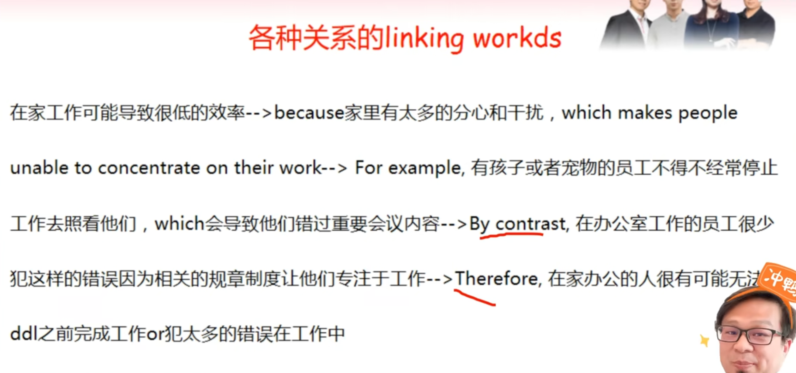

Despite of these arguments, I agree that government should fund the higher education for students who have got **(obtained)** the universities’ offers . In my opinion, society will be ben**e**fit more if students are free from the cost burden of getting higher education. The tuition fee is not cheap especially for the families that live in the country**side**, **so** they may prefer to let their children to make money after graduat**ing** from ~~the~~ high school rather than let them get higher education. However, those **of the** young**er** generation without good education ~~only~~ can **only** find a job with lower **pay** that even cannot  ~~may~~ **give** them have a good life. So if our g**o**vernment can support them to have the higher education that may encourage more and more **ot the** young gen**e**ration to purchase their academic path, and then they would use what they learn

行动A+ in my opinion, 结果c. because A, which 导致c

**第三类：优缺点讨论**

1. Exposure to international media, e.g. film, TV and magazines, has an impact on the local culture. Do the advantages of this exposure outweigh its disadvantages?

2. Some experts believe that it is better for children to begin to learn a foreign language in primary school than in secondary school. Do the advantages outweigh the disadvantages?

3. Differences between countries are becoming less evident nowadays. People tend to have the same films, music, brands, TV channels, etc. Is it a positive or negative development?

**第四类：问题解决**

1. It is generally acknowledged that [families](https://www.zhihu.com/search?q=families&search_source=Entity&hybrid_search_source=Entity&hybrid_search_extra={"sourceType":"article","sourceId":"391300102"}" \t "/Users/caiyan/Documents\\x/_blank) now are not as close as they used to be. What are some possible reasons for this and what can be done to reverse the trend?

2. Some people think the rise of living standards in a country seems to only benefit [cities](https://www.zhihu.com/search?q=cities&search_source=Entity&hybrid_search_source=Entity&hybrid_search_extra={"sourceType":"article","sourceId":"391300102"}" \t "/Users/caiyan/Documents\\x/_blank) rather than rural areas. What problems may those differences cause? How to reduce this problem?

**第五类：[混合类](https://www.zhihu.com/search?q=%E6%B7%B7%E5%90%88%E7%B1%BB&search_source=Entity&hybrid_search_source=Entity&hybrid_search_extra={"sourceType":"article","sourceId":"391300102"}" \t "/Users/caiyan/Documents\\x/_blank)或综合类**

1. People living in big cities are facing many problems today. What are the problems? Should governments encourage people to live in regional towns?

2. With the increasing use of mobile phones and computers, fewer people tend to write letters. Some people even think the skill of writing letters will disappear completely. To what extent do you agree or disagree? How important do you think letter writing is?

3. Increasing the price of petrol is the best way to solve growing traffic and pollution problems .To what extent do you agree or disagree? What other measures do you think might be effective?

Model answer

Almost every country in the world has problems with the environment, affecting its land, air or water. I believe the main problems on land are caused by building too many houses, using up land for depositing rubbish and also the destruction of trees, which leads to soil erosion.

Perhaps the most helpful thing we can do to tackle these difficulties is to try to persuade governments to stop building on certain areas so that there will be room for more trees. We should also try to use more 'biodegradable' materials so that they decay naturally and do not stay in the ground for thousands of years. We should also aim to plant more trees which will prevent soil erosion.

The ways in which air is affected are as follows. Firstly, by burning so many fossil fuels we pump large amounts of toxic gases into the atmosphere which leads to harmful climate change and the destruction of the protective ozone layer. I believe the best way to reduce these problems is by changing our transport policies: we should use more public transport or at least try to use more efficient fuels in cars.

The main effects of pollution and other environmental problems on water are the melting of the ice-caps because of global warming which leads to flooding. There is also contamination of rivers by harmful chemicals. These can be dealt with if global warming is reduced and also by such measures as taxing industries which repeatedly pollute our waterways. It is crucial that these measures are taken in order to ensure a healthy future for our planet.