Socio

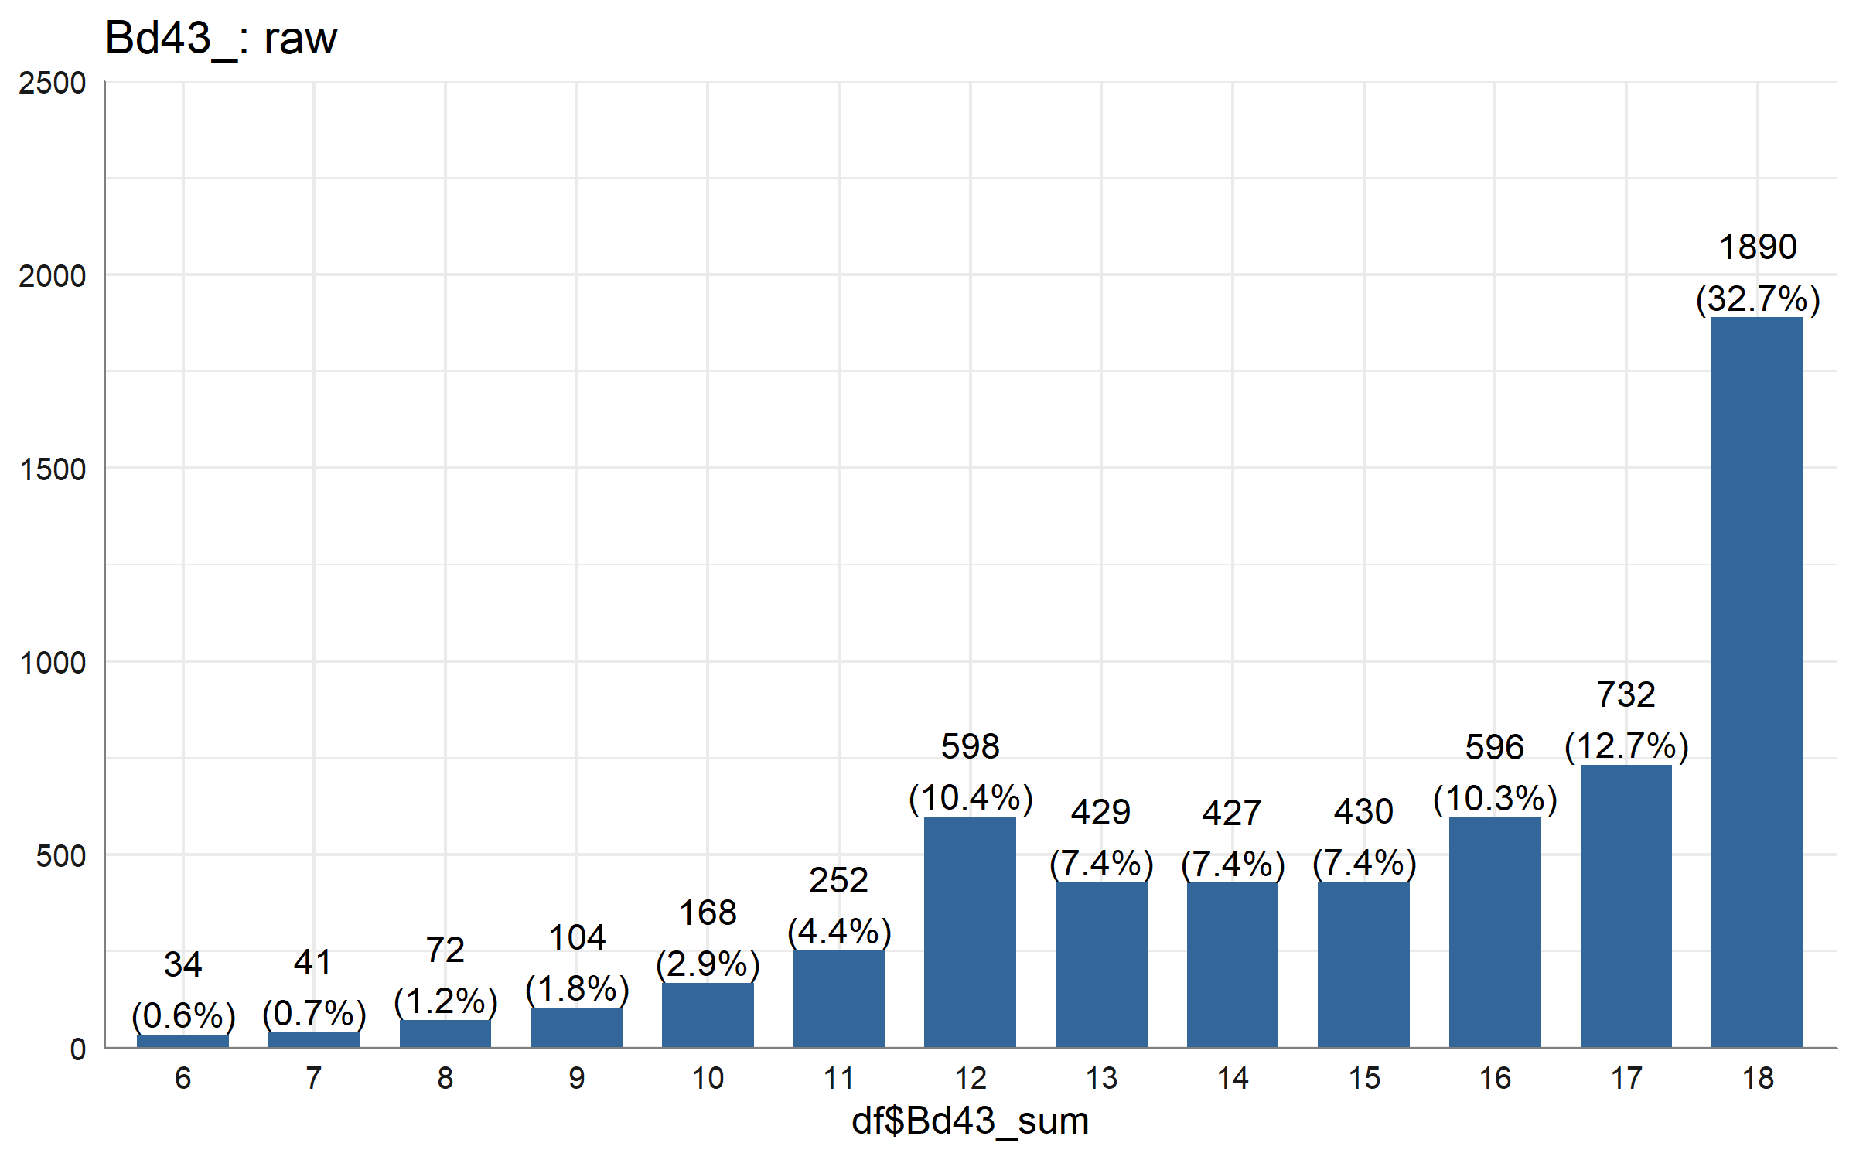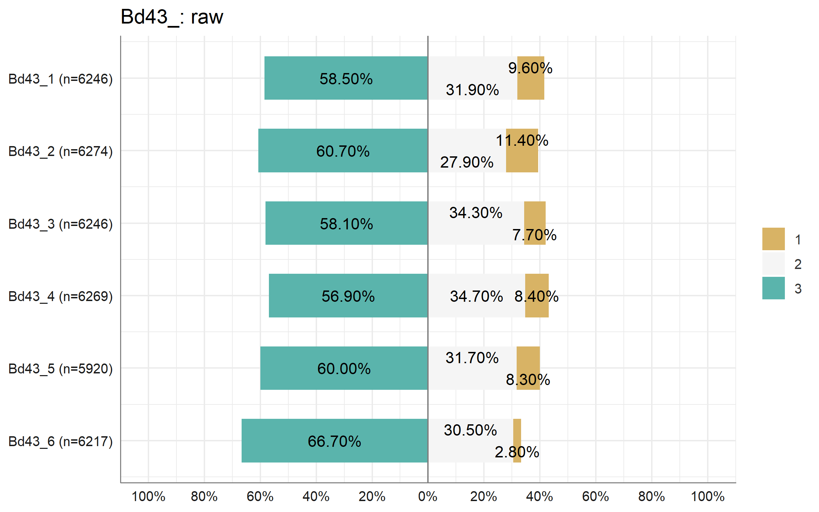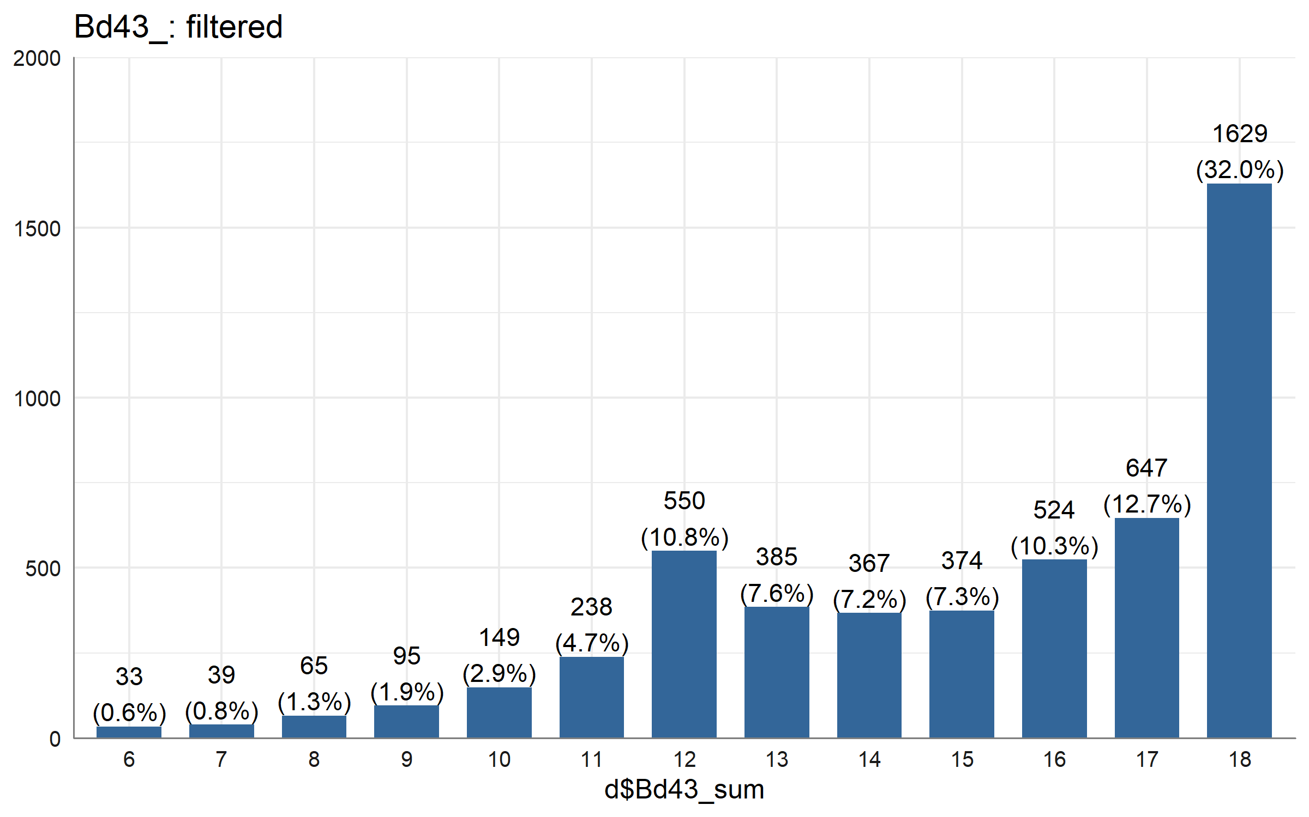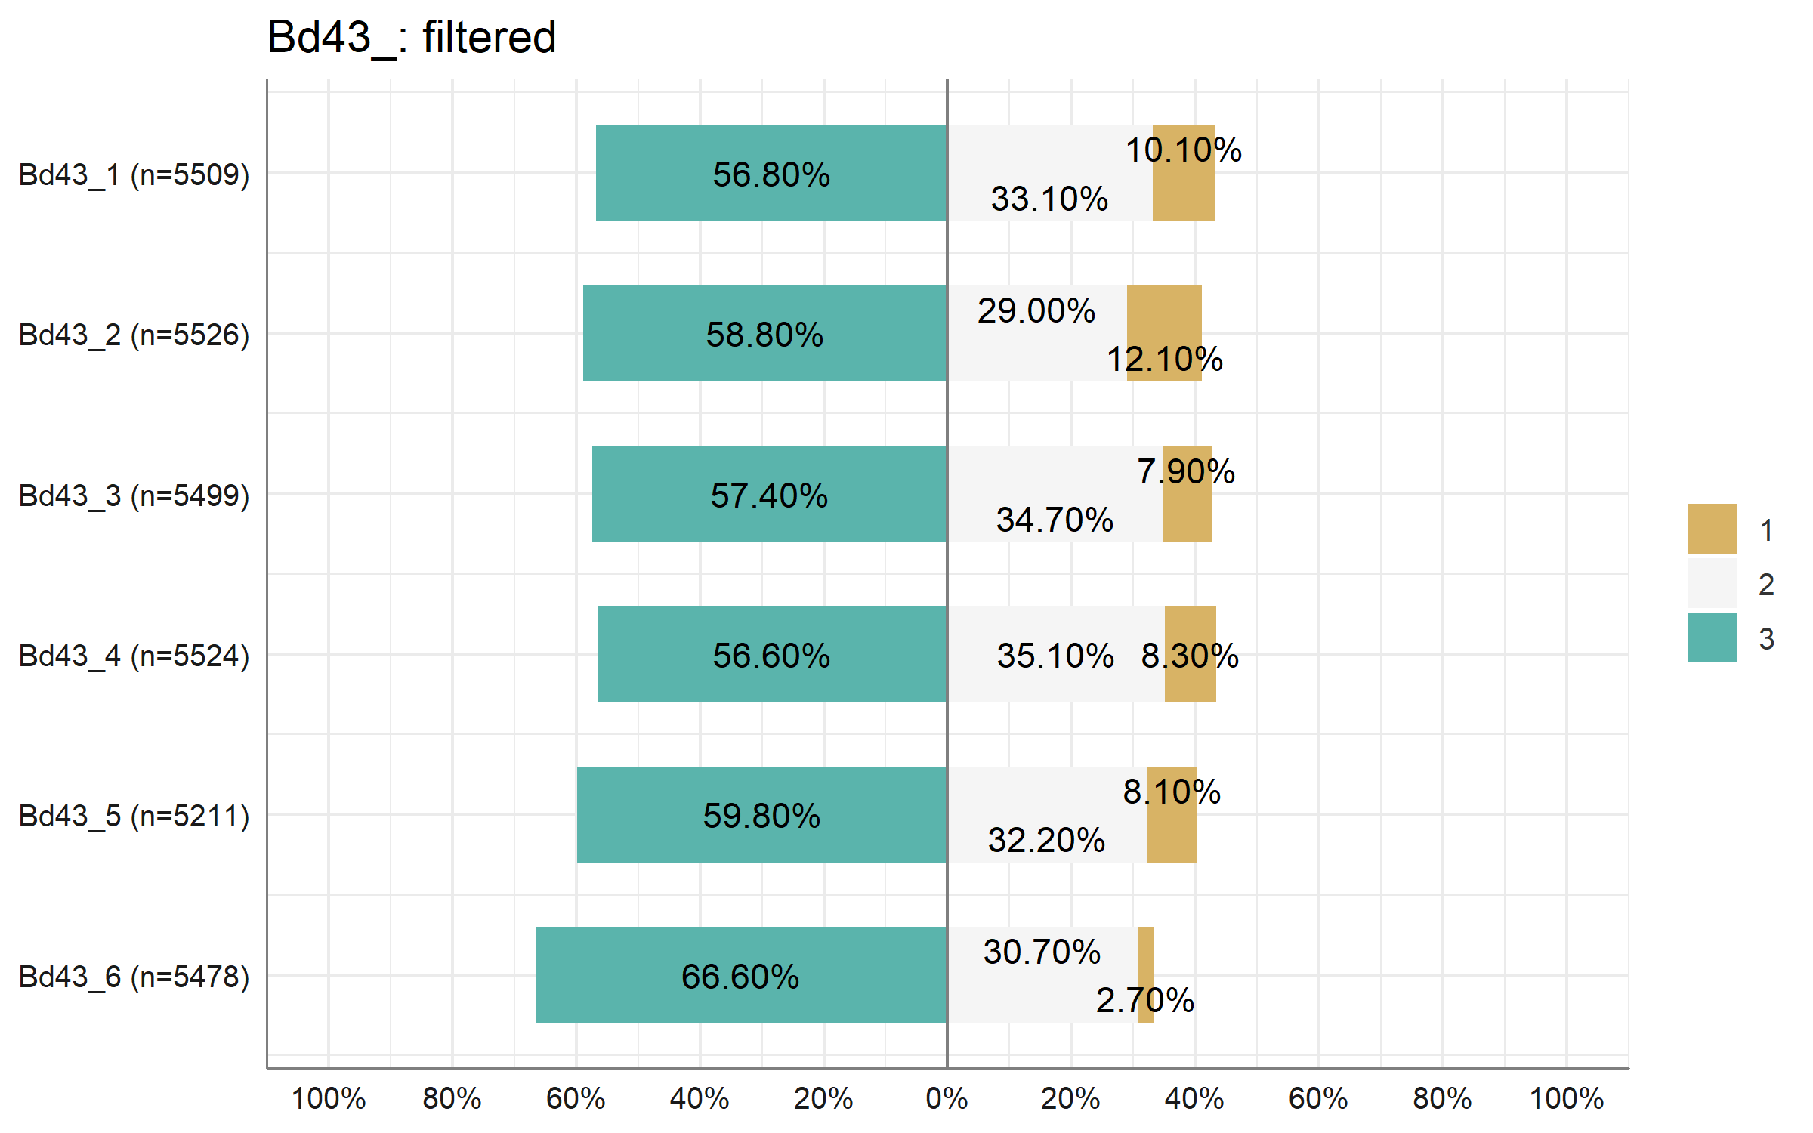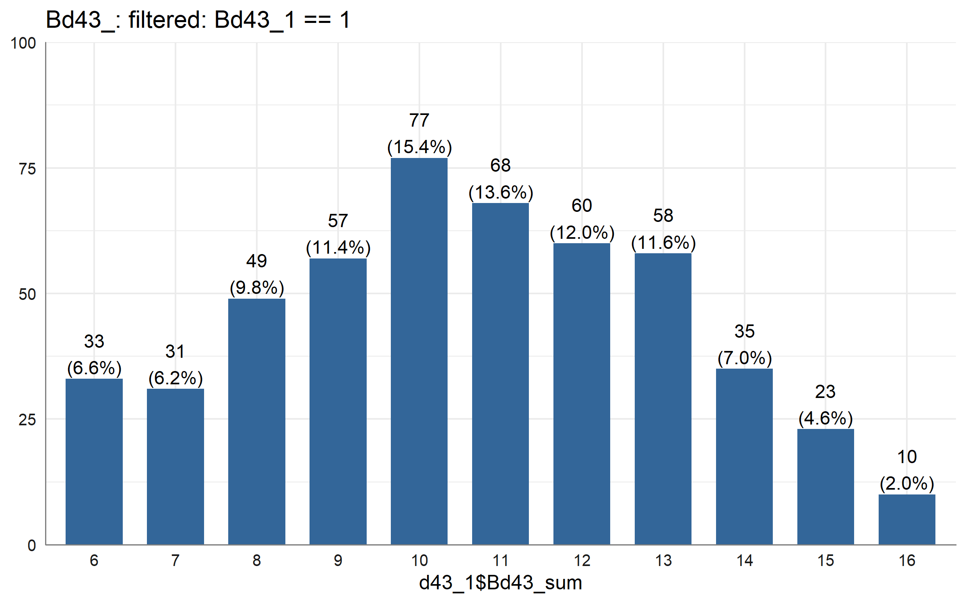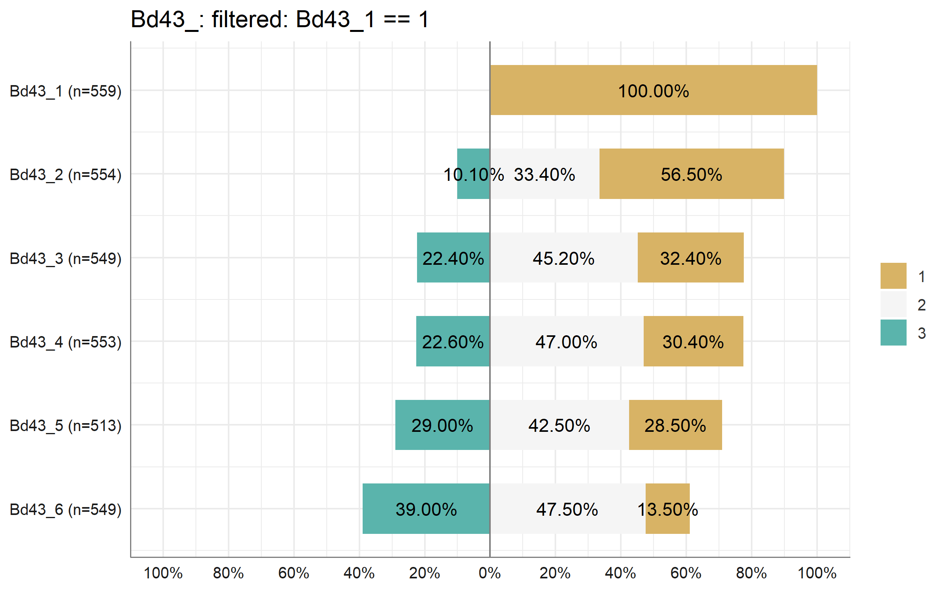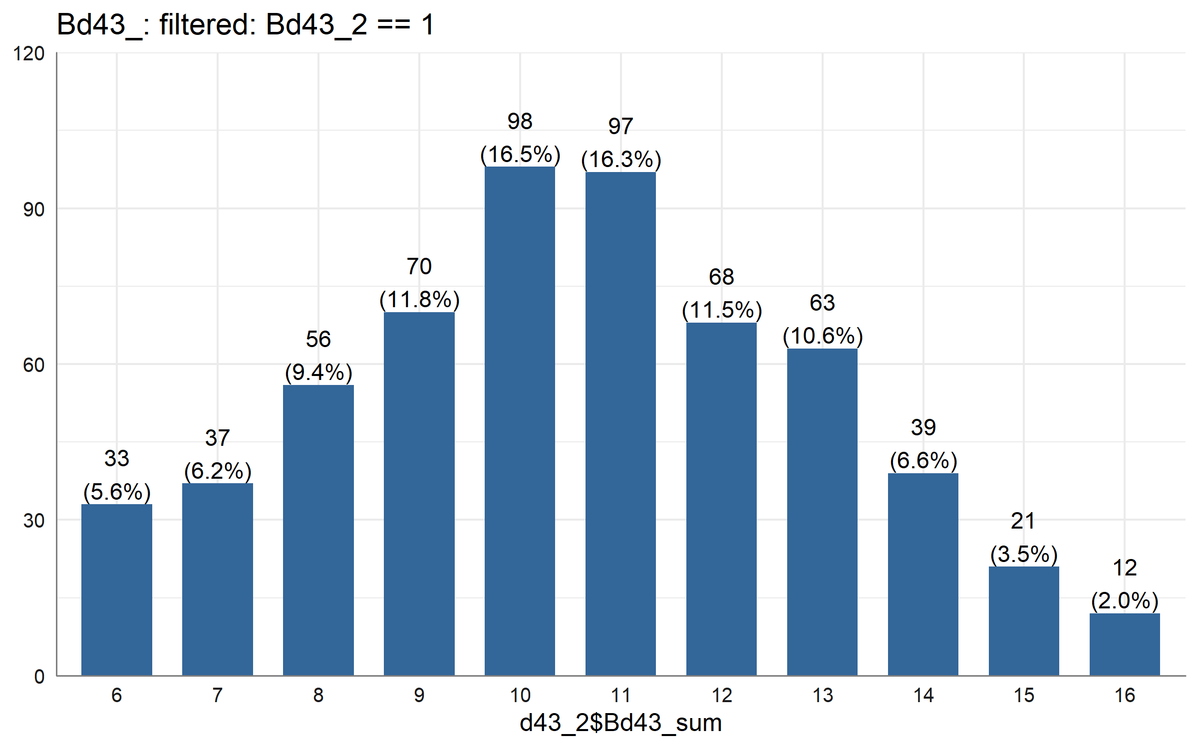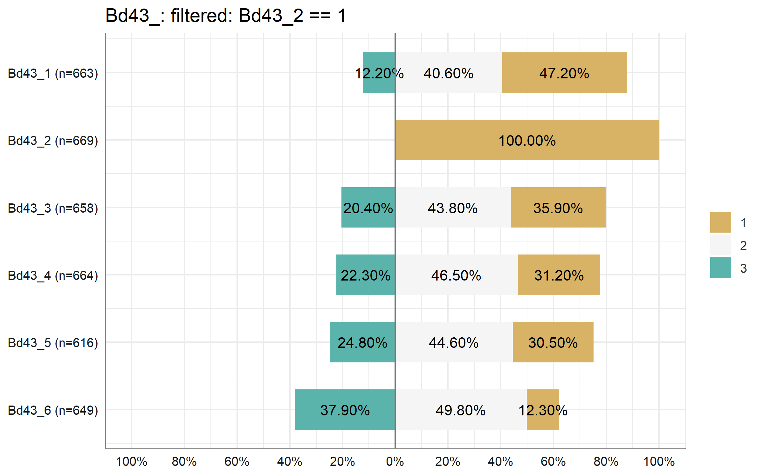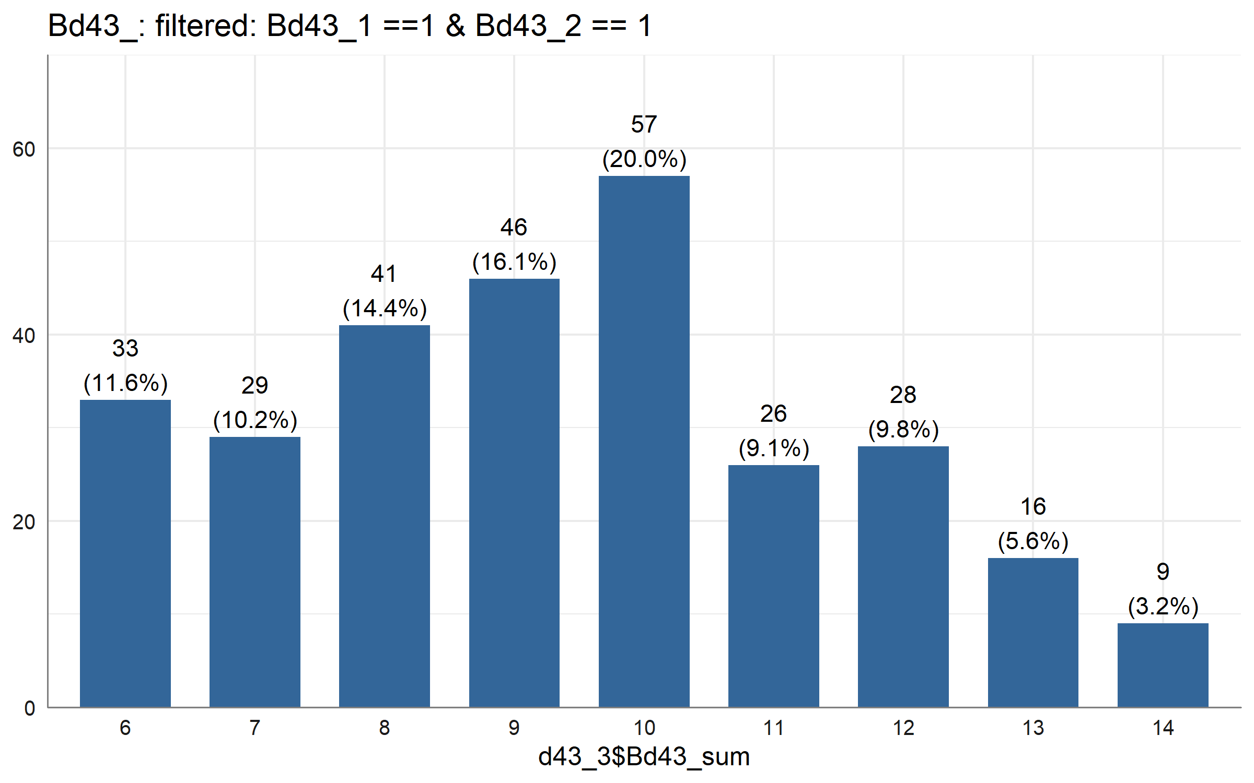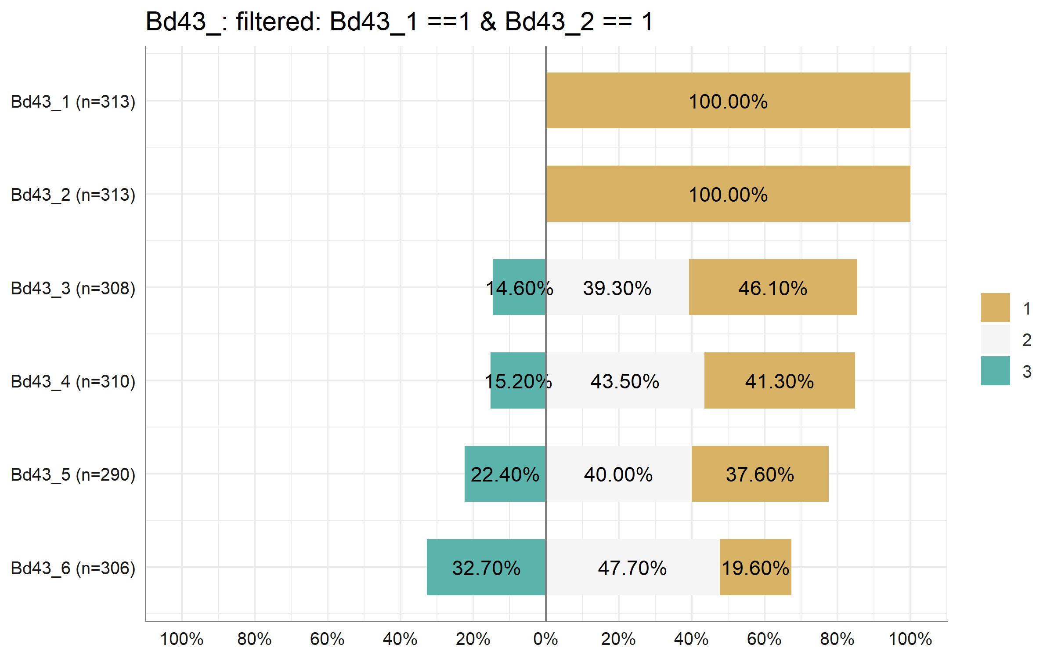

# model1: socio  
d_m1 <- d_model %>%   
 to_factor(socio, Ft9)  
# m1  
# agg  
m1 <- aov(Ch4_aggressive_sum_sd ~ Ft9 * socio, data = d_m1)  
Anova(m1, type = "II")

## Anova Table (Type II tests)  
##   
## Response: Ch4_aggressive_sum_sd  
## Sum Sq Df F value Pr(>F)   
## Ft9 14.3 2 7.3396 0.0006565 ***  
## socio 42.5 2 21.8347 0.0000000003627 ***  
## Ft9:socio 1.9 4 0.5007 0.7352613   
## Residuals 4744.4 4875   
## ---  
## Signif. codes: 0 '***' 0.001 '**' 0.01 '*' 0.05 '.' 0.1 ' ' 1

# soc  
m1 <- aov(Ch4_soc_sum_sd ~ Ft9 * socio, data = d_m1)  
Anova(m1, type = "II")

## Anova Table (Type II tests)  
##   
## Response: Ch4_soc_sum_sd  
## Sum Sq Df F value Pr(>F)   
## Ft9 7.6 2 3.9484 0.01935 *   
## socio 134.4 2 70.1019 < 0.0000000000000002 ***  
## Ft9:socio 7.0 4 1.8353 0.11911   
## Residuals 4703.1 4905   
## ---  
## Signif. codes: 0 '***' 0.001 '**' 0.01 '*' 0.05 '.' 0.1 ' ' 1

# att  
m1 <- aov(Ch4_attention_sum_sd ~ Ft9 * socio, data = d_m1)  
Anova(m1, type = "II")

## Anova Table (Type II tests)  
##   
## Response: Ch4_attention_sum_sd  
## Sum Sq Df F value Pr(>F)   
## Ft9 25.2 2 12.7707 0.000002937091 ***  
## socio 37.1 2 18.8401 0.000000007058 ***  
## Ft9:socio 1.4 4 0.3619 0.8359   
## Residuals 4910.5 4981   
## ---  
## Signif. codes: 0 '***' 0.001 '**' 0.01 '*' 0.05 '.' 0.1 ' ' 1

# withdraw  
m1 <- aov(Ch4_withdrawal_sum_sd ~ Ft9 * socio, data = d_m1)  
Anova(m1, type = "II")

## Anova Table (Type II tests)  
##   
## Response: Ch4_withdrawal_sum_sd  
## Sum Sq Df F value Pr(>F)   
## Ft9 8.9 2 4.5489 0.01062 *   
## socio 30.3 2 15.4012 0.0000002147 ***  
## Ft9:socio 2.0 4 0.5037 0.73302   
## Residuals 4922.4 5007   
## ---  
## Signif. codes: 0 '***' 0.001 '**' 0.01 '*' 0.05 '.' 0.1 ' ' 1

# m1 without int  
# agg  
m1 <- aov(Ch4_aggressive_sum_sd ~ Ft9 + socio, data = d_m1)  
Anova(m1, type = "II")

## Anova Table (Type II tests)  
##   
## Response: Ch4_aggressive_sum_sd  
## Sum Sq Df F value Pr(>F)   
## Ft9 14.3 2 7.3426 0.0006545 ***  
## socio 42.5 2 21.8436 0.0000000003595 ***  
## Residuals 4746.3 4879   
## ---  
## Signif. codes: 0 '***' 0.001 '**' 0.01 '*' 0.05 '.' 0.1 ' ' 1

# post-hoc  
ScheffeTest(m1)

##   
## Posthoc multiple comparisons of means : Scheffe Test   
## 95% family-wise confidence level  
##   
## $Ft9  
## diff lwr.ci upr.ci pval   
## 2-1 0.2217306 -0.00355712 0.4470182 0.0565 .   
## 3-1 0.1095094 0.01438158 0.2046372 0.0136 *   
## 3-2 -0.1122212 -0.34462761 0.1201853 0.6965   
##   
## $socio  
## diff lwr.ci upr.ci pval   
## 2-1 -0.1374730 -0.2760410 0.00109505 0.0532 .   
## 3-1 -0.2895471 -0.4368427 -0.14225159 0.00000022 ***  
## 3-2 -0.1520742 -0.2483251 -0.05582326 0.00009387 ***  
##   
## ---  
## Signif. codes: 0 '***' 0.001 '**' 0.01 '*' 0.05 '.' 0.1 ' ' 1

# plot means  
with(d_m1, plotMeans(Ch4_aggressive_sum_sd, Ft9, socio, error.bars = "se"))

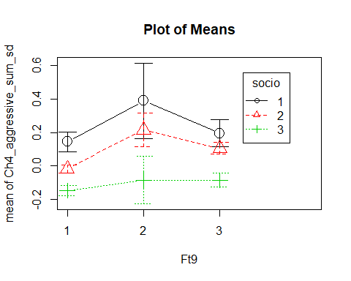

# soc  
m1 <- aov(Ch4_soc_sum_sd ~ Ft9 + socio, data = d_m1)  
Anova(m1, type = "II")

## Anova Table (Type II tests)  
##   
## Response: Ch4_soc_sum_sd  
## Sum Sq Df F value Pr(>F)   
## Ft9 7.6 2 3.9458 0.0194 *   
## socio 134.4 2 70.0542 <0.0000000000000002 ***  
## Residuals 4710.1 4909   
## ---  
## Signif. codes: 0 '***' 0.001 '**' 0.01 '*' 0.05 '.' 0.1 ' ' 1

# post-hoc  
ScheffeTest(m1)

##   
## Posthoc multiple comparisons of means : Scheffe Test   
## 95% family-wise confidence level  
##   
## $Ft9  
## diff lwr.ci upr.ci pval   
## 2-1 0.20984611 -0.014924578 0.4346168 0.0822 .   
## 3-1 0.08690707 -0.007484222 0.1812984 0.0900 .   
## 3-2 -0.12293904 -0.354851814 0.1089737 0.6148   
##   
## $socio  
## diff lwr.ci upr.ci pval   
## 2-1 -0.3132830 -0.4494453 -0.1771207 0.00000000036 ***  
## 3-1 -0.5389745 -0.6838026 -0.3941464 < 0.0000000000000002 ***  
## 3-2 -0.2256915 -0.3210697 -0.1303133 0.00000000009 ***  
##   
## ---  
## Signif. codes: 0 '***' 0.001 '**' 0.01 '*' 0.05 '.' 0.1 ' ' 1

# plot means  
with(d_m1, plotMeans(Ch4_soc_sum_sd, Ft9, socio, error.bars = "se"))

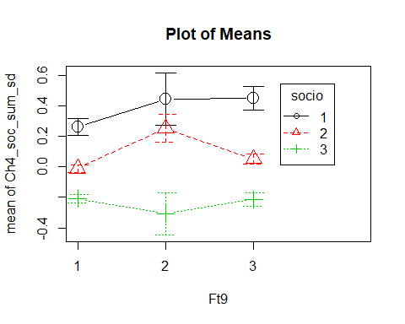

# att  
m1 <- aov(Ch4_attention_sum_sd ~ Ft9 + socio, data = d_m1)  
Anova(m1, type = "II")

## Anova Table (Type II tests)  
##   
## Response: Ch4_attention_sum_sd  
## Sum Sq Df F value Pr(>F)   
## Ft9 25.2 2 12.777 0.00000291796 ***  
## socio 37.1 2 18.850 0.00000000699 ***  
## Residuals 4912.0 4985   
## ---  
## Signif. codes: 0 '***' 0.001 '**' 0.01 '*' 0.05 '.' 0.1 ' ' 1

# post-hoc  
ScheffeTest(m1)

##   
## Posthoc multiple comparisons of means : Scheffe Test   
## 95% family-wise confidence level  
##   
## $Ft9  
## diff lwr.ci upr.ci pval   
## 2-1 0.36729444 0.142338608 0.59225028 0.000045 ***  
## 3-1 0.08963851 -0.005032619 0.18430963 0.0747 .   
## 3-2 -0.27765594 -0.509656996 -0.04565488 0.0087 **   
##   
## $socio  
## diff lwr.ci upr.ci pval   
## 2-1 -0.1340208 -0.2709586 0.002916936 0.05893 .   
## 3-1 -0.2702538 -0.4159641 -0.124543609 0.0000015 ***  
## 3-2 -0.1362330 -0.2321907 -0.040275369 0.00075 ***  
##   
## ---  
## Signif. codes: 0 '***' 0.001 '**' 0.01 '*' 0.05 '.' 0.1 ' ' 1

# plot means  
with(d_m1, plotMeans(Ch4_attention_sum_sd, Ft9, socio, error.bars = "se"))

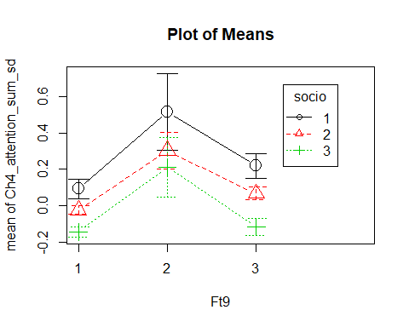

# withdraw  
m1 <- aov(Ch4_withdrawal_sum_sd ~ Ft9 + socio, data = d_m1)  
Anova(m1, type = "II")

## Anova Table (Type II tests)  
##   
## Response: Ch4_withdrawal_sum_sd  
## Sum Sq Df F value Pr(>F)   
## Ft9 8.9 2 4.5507 0.0106 *   
## socio 30.3 2 15.4073 0.0000002134 ***  
## Residuals 4924.3 5011   
## ---  
## Signif. codes: 0 '***' 0.001 '**' 0.01 '*' 0.05 '.' 0.1 ' ' 1

# post-hoc  
ScheffeTest(m1)

##   
## Posthoc multiple comparisons of means : Scheffe Test   
## 95% family-wise confidence level  
##   
## $Ft9  
## diff lwr.ci upr.ci pval   
## 2-1 0.19401997 -0.03112168 0.4191616 0.1334   
## 3-1 0.07823288 -0.01620267 0.1726684 0.1640   
## 3-2 -0.11578709 -0.34801076 0.1164366 0.6698   
##   
## $socio  
## diff lwr.ci upr.ci pval   
## 2-1 -0.1368983 -0.2735642 -0.0002324099 0.0493 *   
## 3-1 -0.2502341 -0.3956735 -0.1047946692 0.000012 ***  
## 3-2 -0.1133358 -0.2089255 -0.0177460550 0.0098 **   
##   
## ---  
## Signif. codes: 0 '***' 0.001 '**' 0.01 '*' 0.05 '.' 0.1 ' ' 1

# plot means  
with(d_m1, plotMeans(Ch4_withdrawal_sum_sd, Ft9, socio, error.bars = "se"))

