Health

Cai, Yun-Ting

2019/7/29

## 壹、總體健康

### 一、描述統計

#### 1. 總體健康（Ch2）

|  |  |  |  |
| --- | --- | --- | --- |
|  | n | % | val% |
| 極好 | 632 | 9.8 | 10.0 |
| 非常好 | 2300 | 35.5 | 36.2 |
| 好 | 2422 | 37.4 | 38.1 |
| 一般 | 928 | 14.3 | 14.6 |
| 不好 | 69 | 1.1 | 1.1 |
| NA | 129 | 2.0 | NA |

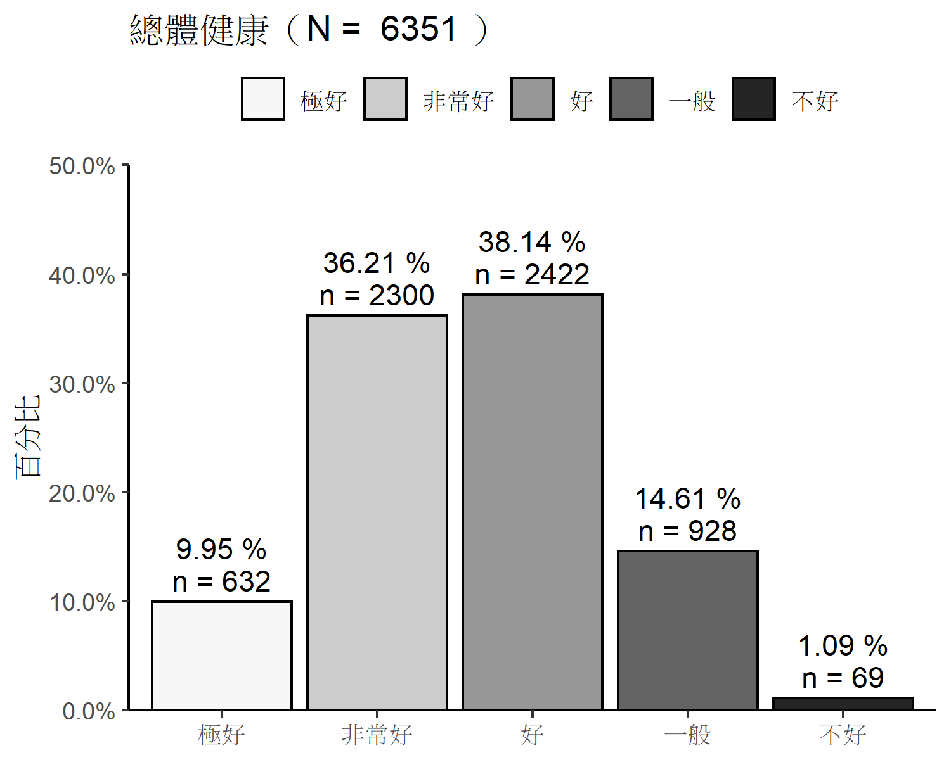

#### 2. 總體健康（Ch2） X 性別（Bd23）

##   
## =================================  
## df$Bd23  
## df$Ch2 女性 男性 Total  
## ---------------------------------  
## 極好 339 282 621   
## col % 10.86% 8.99%   
## ---------------------------------  
## 非常好 1162 1104 2266   
## col % 37.23% 35.18%   
## ---------------------------------  
## 好 1164 1221 2385   
## col % 37.30% 38.91%   
## ---------------------------------  
## 一般 427 492 919   
## col % 13.68% 15.68%   
## ---------------------------------  
## 不好 29 39 68   
## col % 0.93% 1.24%   
## ---------------------------------  
## Total 3121 3138 6259   
## 49.86% 50.14%   
## =================================  
##   
## Statistics for All Table Factors  
##   
## Pearson's Chi-squared test   
## ------------------------------------------------------------  
## Chi^2 = 14.10061 d.f. = 4 p = 0.007   
##   
## Minimum expected frequency: 33.90765

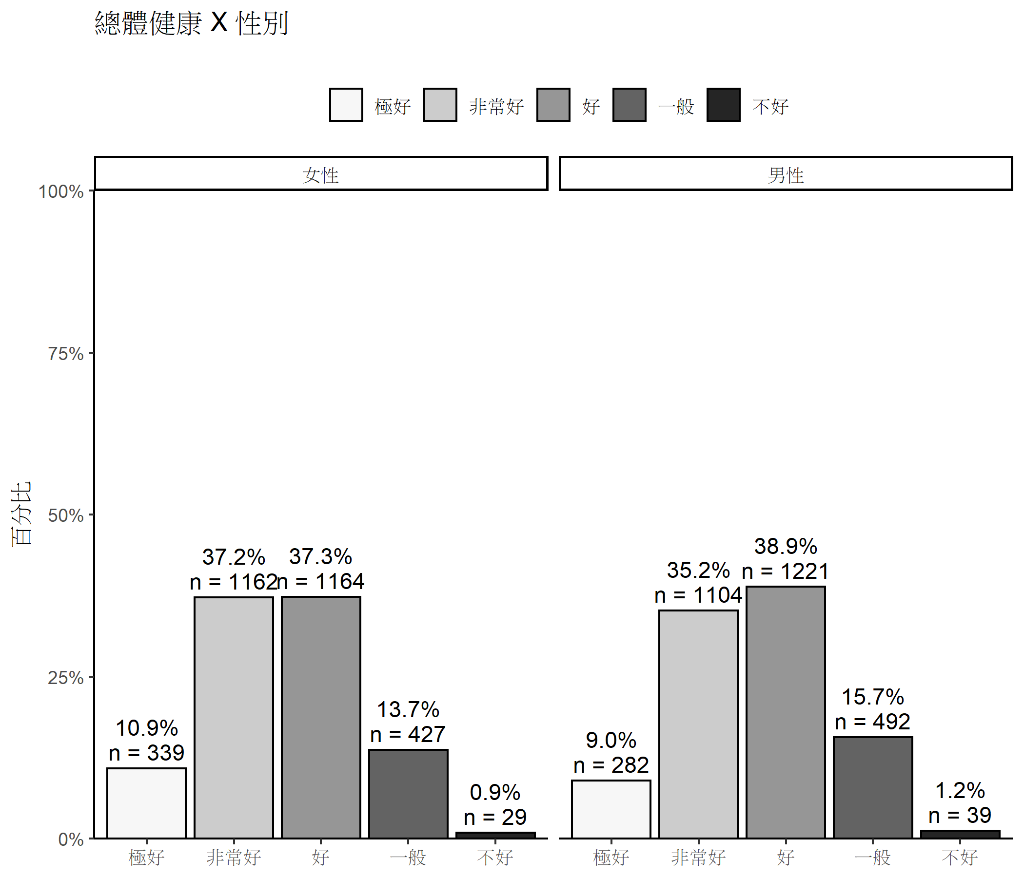

#### 3. 總體健康（Ch2） X 身心狀況（Ch3）

##   
## =================================  
## df$Ch3  
## df$Ch2 無 有 Total  
## ---------------------------------  
## 極好 617 12 629   
## col % 10.88% 2.30%   
## ---------------------------------  
## 非常好 2184 93 2277   
## col % 38.51% 17.82%   
## ---------------------------------  
## 好 2129 229 2358   
## col % 37.54% 43.87%   
## ---------------------------------  
## 一般 708 159 867   
## col % 12.48% 30.46%   
## ---------------------------------  
## 不好 33 29 62   
## col % 0.58% 5.56%   
## ---------------------------------  
## Total 5671 522 6193   
## 91.57% 8.43%   
## =================================  
##   
## Statistics for All Table Factors  
##   
## Pearson's Chi-squared test   
## ------------------------------------------------------------  
## Chi^2 = 323.7964 d.f. = 4 p <0.0000000000000002   
##   
## Minimum expected frequency: 5.2259

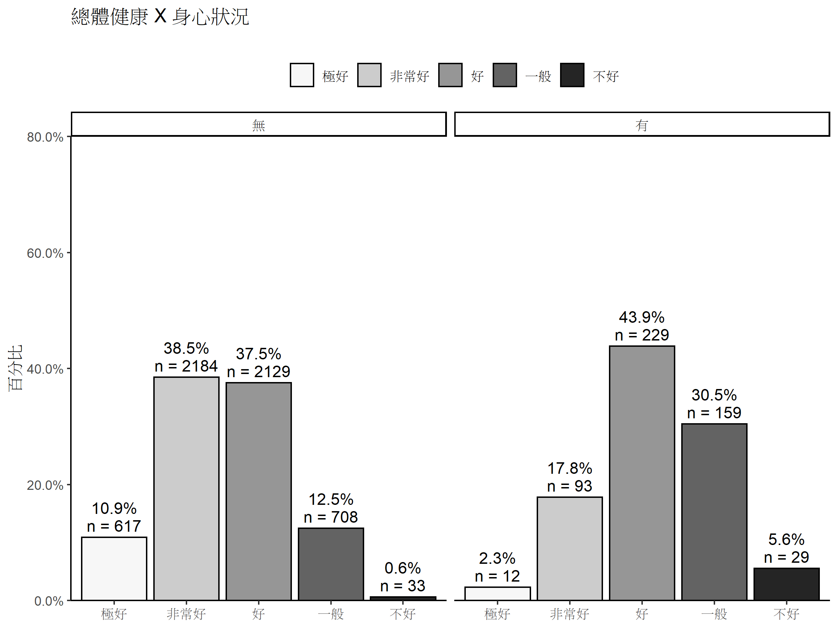

#### 4. 總體健康（Ch2） X 年級（grade）

##   
## ==========================================  
## df$grade  
## df$Ch2 一年級 三年級 五年級 Total  
## ------------------------------------------  
## 極好 208 206 218 632   
## col % 9.99% 9.33% 10.58%   
## ------------------------------------------  
## 非常好 787 797 716 2300   
## col % 37.80% 36.10% 34.74%   
## ------------------------------------------  
## 好 813 855 754 2422   
## col % 39.05% 38.72% 36.58%   
## ------------------------------------------  
## 一般 259 320 349 928   
## col % 12.44% 14.49% 16.93%   
## ------------------------------------------  
## 不好 15 30 24 69   
## col % 0.72% 1.36% 1.16%   
## ------------------------------------------  
## Total 2082 2208 2061 6351   
## 32.78% 34.77% 32.45%   
## ==========================================  
##   
## Statistics for All Table Factors  
##   
## Pearson's Chi-squared test   
## ------------------------------------------------------------  
## Chi^2 = 24.85323 d.f. = 8 p = 0.0016   
##   
## Minimum expected frequency: 22.39159

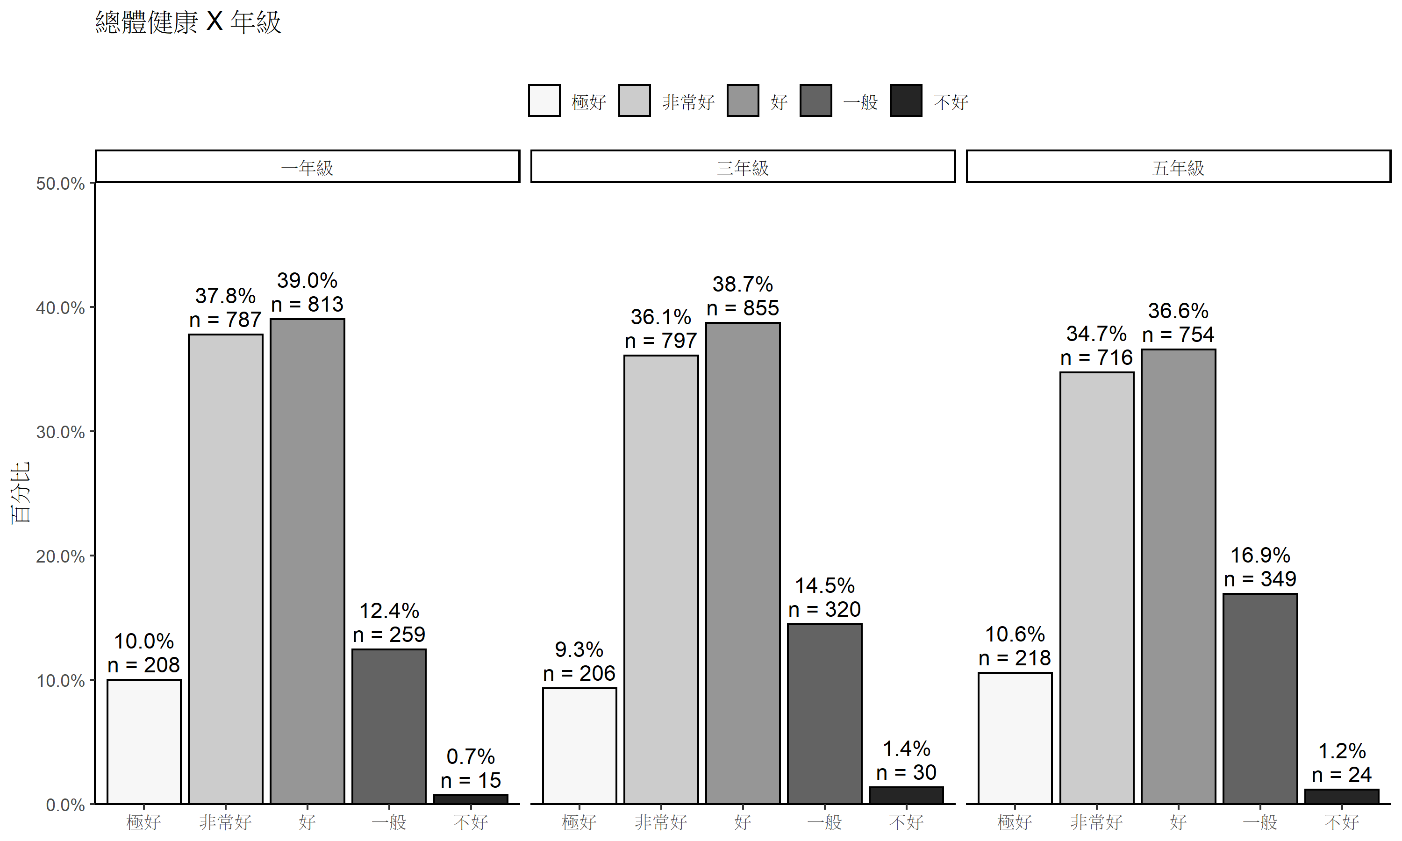

#### 5. 總體健康（Ch2） X 家庭組織型態（Sf）

##   
## =================================================================================  
## df$Sf  
## df$Ch2 單親家庭 核心家庭 三代家庭 祖孫家庭 其他 單親且同居 Total  
## ---------------------------------------------------------------------------------  
## 極好 66 293 245 13 5 2 624   
## col % 9.72% 9.53% 10.72% 9.70% 7.94% 14.29%   
## ---------------------------------------------------------------------------------  
## 非常好 268 1117 814 38 19 5 2261   
## col % 39.47% 36.31% 35.62% 28.36% 30.16% 35.71%   
## ---------------------------------------------------------------------------------  
## 好 242 1204 863 50 23 4 2386   
## col % 35.64% 39.14% 37.77% 37.31% 36.51% 28.57%   
## ---------------------------------------------------------------------------------  
## 一般 91 433 339 30 16 3 912   
## col % 13.40% 14.08% 14.84% 22.39% 25.40% 21.43%   
## ---------------------------------------------------------------------------------  
## 不好 12 29 24 3 0 0 68   
## col % 1.77% 0.94% 1.05% 2.24% 0.00% 0.00%   
## ---------------------------------------------------------------------------------  
## Total 679 3076 2285 134 63 14 6251   
## 10.86% 49.21% 36.55% 2.14% 1.01% 0.22%   
## =================================================================================

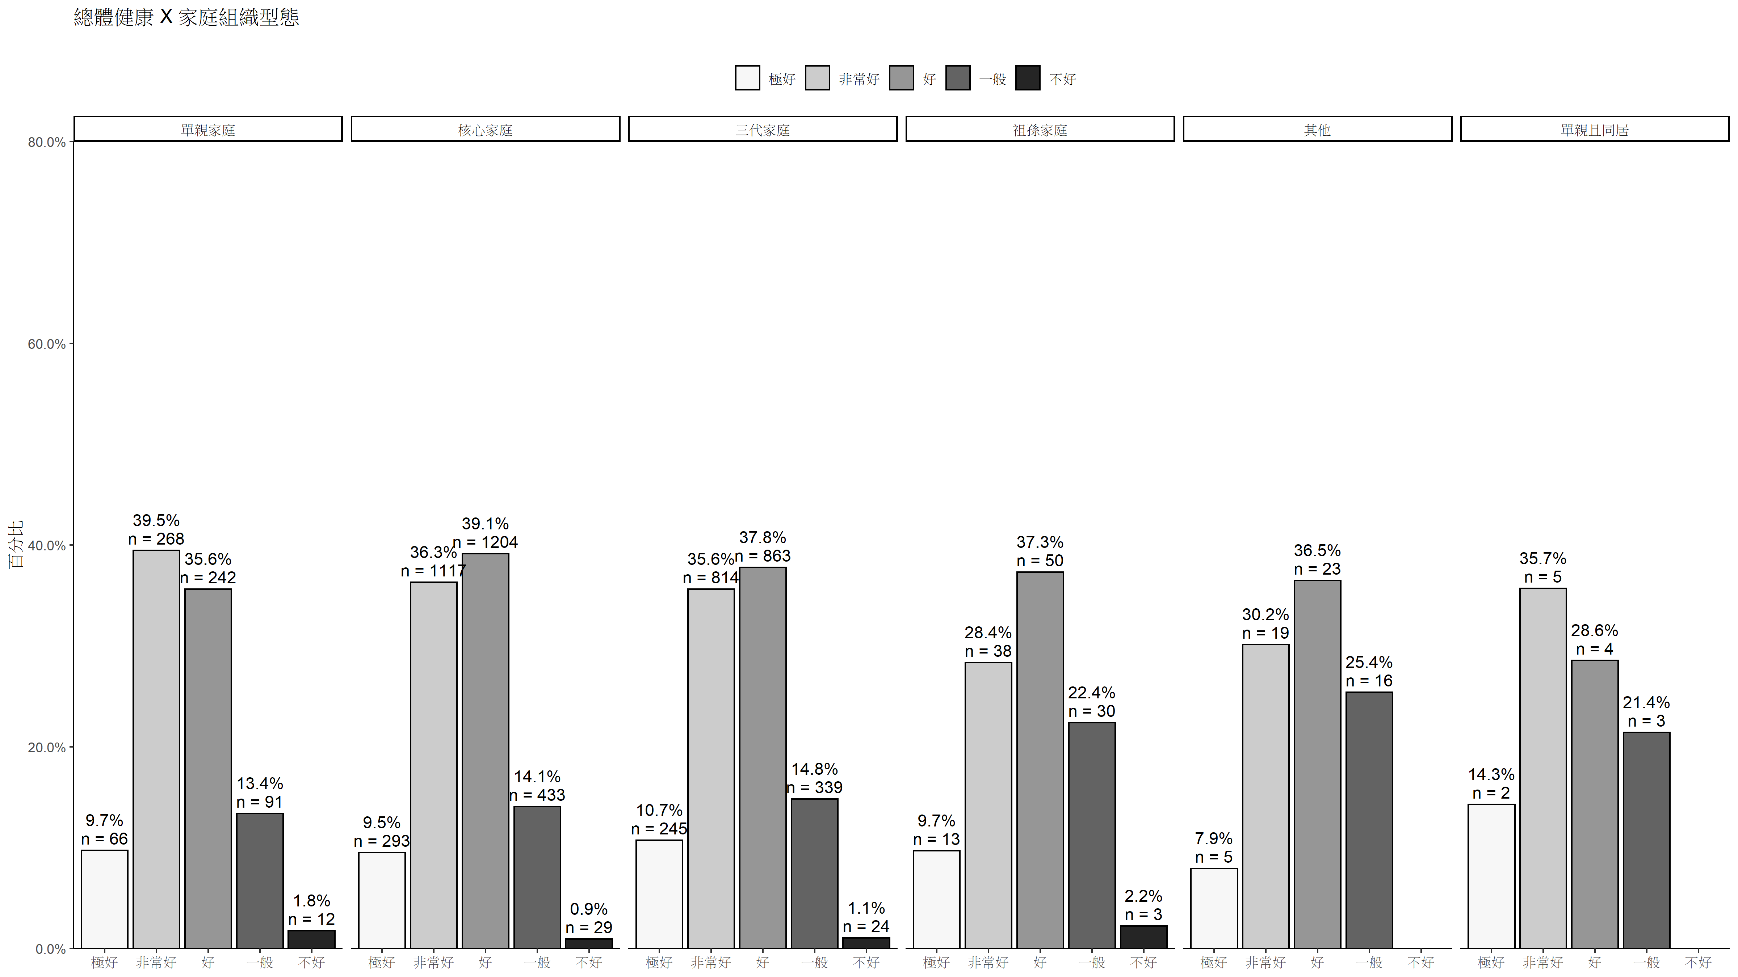

#### 6. 總體健康（Ch2） X 主要照顧者（Ft9）

##   
## =============================================================  
## df$Ft9_combin  
## df$Ch2 父母 父親 母親 祖父母或外祖父母 Total  
## -------------------------------------------------------------  
## 極好 398 24 155 28 605   
## col % 10.73% 10.21% 9.05% 6.31%   
## -------------------------------------------------------------  
## 非常好 1407 92 546 168 2213   
## col % 37.94% 39.15% 31.87% 37.84%   
## -------------------------------------------------------------  
## 好 1390 81 680 178 2329   
## col % 37.49% 34.47% 39.70% 40.09%   
## -------------------------------------------------------------  
## 一般 489 36 301 64 890   
## col % 13.19% 15.32% 17.57% 14.41%   
## -------------------------------------------------------------  
## 不好 24 2 31 6 63   
## col % 0.65% 0.85% 1.81% 1.35%   
## -------------------------------------------------------------  
## Total 3708 235 1713 444 6100   
## 60.79% 3.85% 28.08% 7.28%   
## =============================================================  
##   
## Statistics for All Table Factors  
##   
## Pearson's Chi-squared test   
## ------------------------------------------------------------  
## Chi^2 = 56.64267 d.f. = 12 p = 0.000000092   
##   
## Minimum expected frequency: 2.427049   
## Cells with Expected Frequency < 5: 2 of 20 (10%)

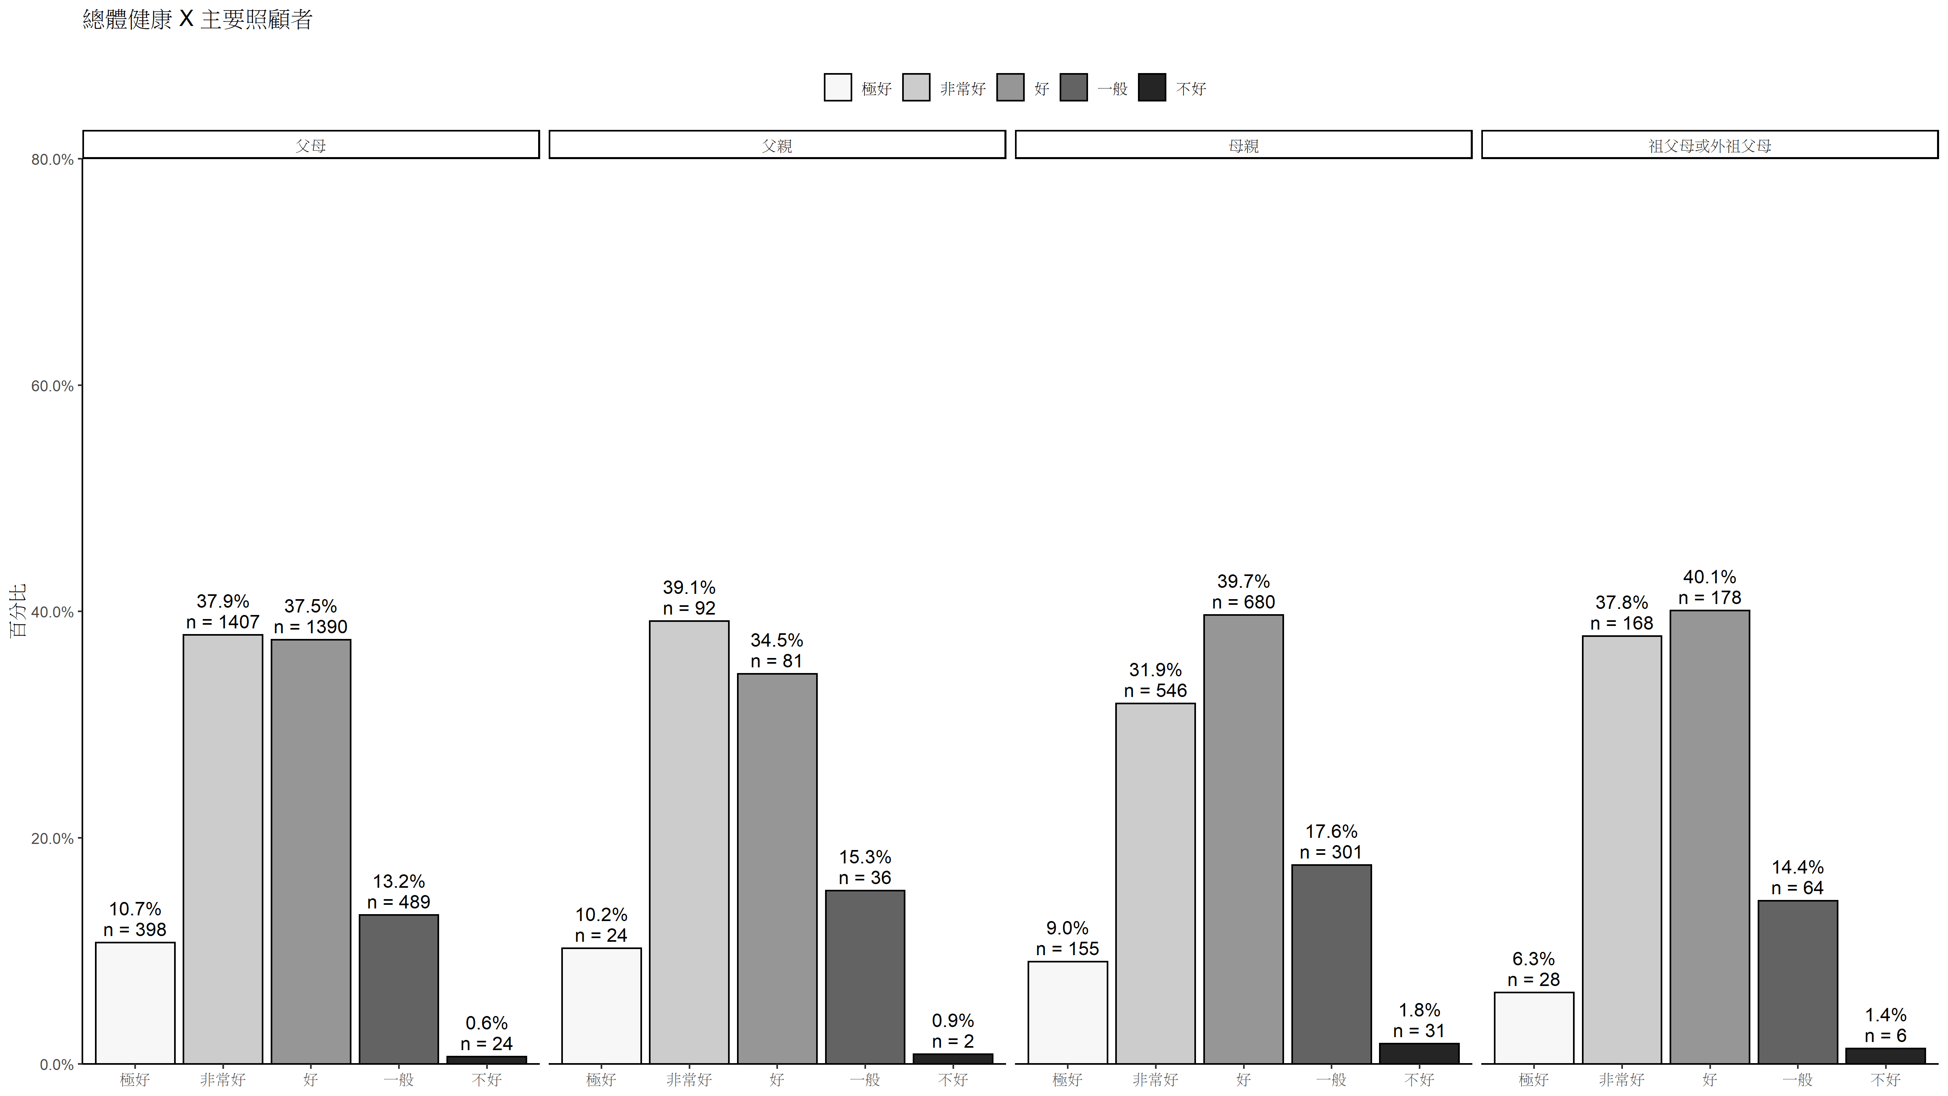

### 二、檢定分析

#### 1. 相關（總體健康 X 年級）

##   
## Spearman's rank correlation rho  
##   
## data: Ch2 and grade  
## S = 41351890669, p-value = 0.01218  
## alternative hypothesis: true rho is not equal to 0  
## sample estimates:  
## rho   
## 0.03145391

#### 2. 相關（總體健康 X 攻擊行為）

##   
## Spearman's rank correlation rho  
##   
## data: Ch2 and Ch4_attack  
## S = 37333684902, p-value < 0.00000000000000022  
## alternative hypothesis: true rho is not equal to 0  
## sample estimates:  
## rho   
## 0.1180912

#### 3. 相關（總體健康 X 社交問題）

##   
## Spearman's rank correlation rho  
##   
## data: Ch2 and Ch4_soc  
## S = 30774220721, p-value < 0.00000000000000022  
## alternative hypothesis: true rho is not equal to 0  
## sample estimates:  
## rho   
## 0.2730411

#### 4. 相關（總體健康 X 注意力問題）

##   
## Spearman's rank correlation rho  
##   
## data: Ch2 and Ch4_attention  
## S = 35480714362, p-value < 0.00000000000000022  
## alternative hypothesis: true rho is not equal to 0  
## sample estimates:  
## rho   
## 0.1610682

#### 5. 相關（總體健康 X 退縮）

##   
## Spearman's rank correlation rho  
##   
## data: Ch2 and Ch4_withdrawn  
## S = 36663189457, p-value < 0.00000000000000022  
## alternative hypothesis: true rho is not equal to 0  
## sample estimates:  
## rho   
## 0.1322868

#### 6. 相關矩陣：親子衝突（Ft7）、兒童行為（攻擊、社交、注意力、退縮）

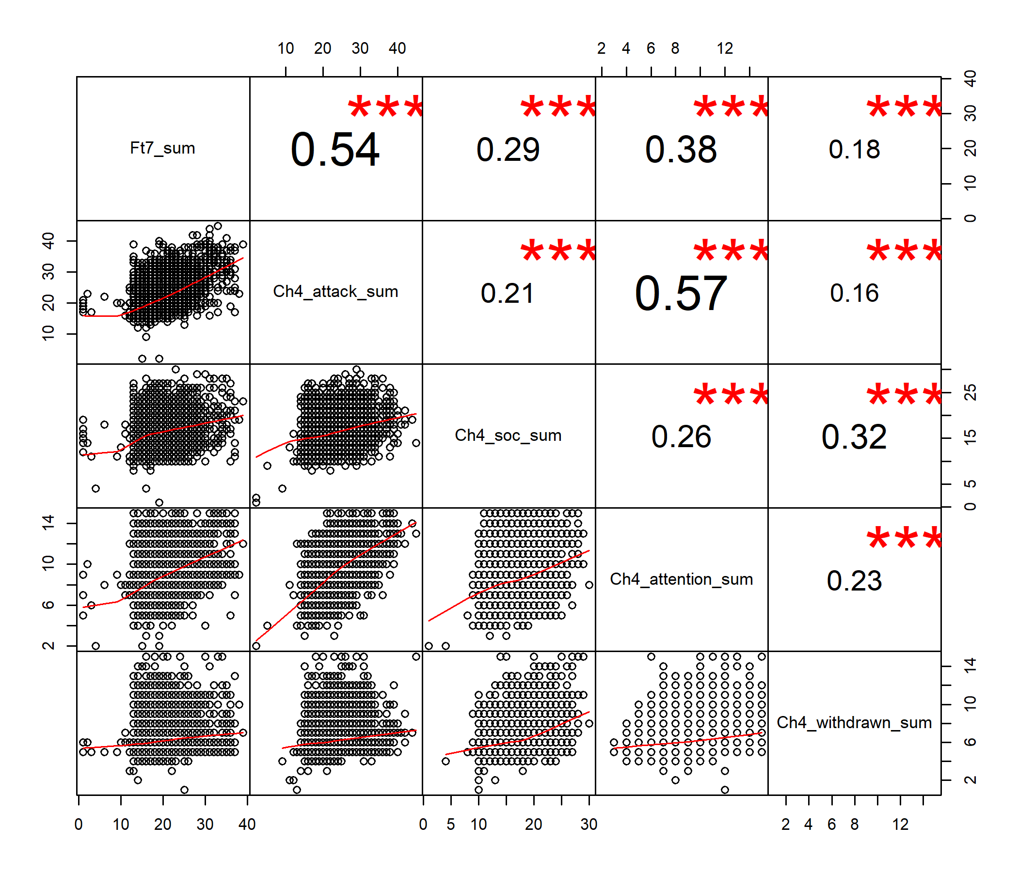

#### 7. 變異數分析（總體健康 X 主要照顧者）

## Levene's Test for Homogeneity of Variance (center = median)  
## Df F value Pr(>F)  
## group 3 1.9642 0.1171  
## 6096

## Df Sum Sq Mean Sq F value Pr(>F)   
## df$Ft9_combin 3 33 10.842 13.79 0.00000000584 ***  
## Residuals 6096 4793 0.786   
## ---  
## Signif. codes: 0 '***' 0.001 '**' 0.01 '*' 0.05 '.' 0.1 ' ' 1  
## 380 observations deleted due to missingness

##   
## Posthoc multiple comparisons of means : Scheffe Test   
## 95% family-wise confidence level  
##   
## $`df$Ft9_combin`  
## diff lwr.ci upr.ci pval   
## 父親-父母 0.02376690 -0.14301749 0.19055129 0.9840   
## 母親-父母 0.16149963 0.08906655 0.23393271 0.00000002 ***  
## 祖父母或外祖父母-父母 0.11596548 -0.00854707 0.24047803 0.0793 .   
## 母親-父親 0.13773273 -0.03474287 0.31020833 0.1729   
## 祖父母或外祖父母-父親 0.09219858 -0.10781306 0.29221022 0.6456   
## 祖父母或外祖父母-母親 -0.04553415 -0.17757269 0.08650439 0.8182   
##   
## ---  
## Signif. codes: 0 '***' 0.001 '**' 0.01 '*' 0.05 '.' 0.1 ' ' 1

## ### Oneway Anova for y=Ch2 and x=Ft9_combin (groups: 父母, 父親, 母親, 祖父母或外祖父母)

## Registered S3 methods overwritten by 'ufs':  
## method from   
## grid.draw.ggProportionPlot userfriendlyscience  
## pander.associationMatrix userfriendlyscience  
## print.CramersV userfriendlyscience  
## print.associationMatrix userfriendlyscience  
## print.confIntOmegaSq userfriendlyscience  
## print.confIntV userfriendlyscience  
## print.ggProportionPlot userfriendlyscience  
## print.meanConfInt userfriendlyscience  
## print.multiVarFreq userfriendlyscience

## Omega squared: 95% CI = [0; .01], point estimate = .01  
## Eta Squared: 95% CI = [0; .01], point estimate = .01  
##   
## SS Df MS F p  
## Between groups (error + effect) 32.52 3 10.84 13.79 <.001  
## Within groups (error only) 4792.7 6096 0.79   
##   
##   
## ### Post hoc test: games-howell  
##   
## diff ci.lo ci.hi t df p  
## 父親-父母 0.02 -0.13 0.18 0.39 262.80 .979  
## 母親-父母 0.16 0.09 0.23 6.10 3183.53 <.001  
## 祖父母或外祖父母-父母 0.12 0.01 0.23 2.71 561.90 .035  
## 母親-父親 0.14 -0.02 0.30 2.19 305.08 .127  
## 祖父母或外祖父母-父親 0.09 -0.09 0.28 1.30 452.93 .566  
## 祖父母或外祖父母-母親 -0.05 -0.16 0.07 0.99 736.70 .755

## 貳、疾病狀況

|  |  |  |  |
| --- | --- | --- | --- |
|  | n | % | val% |
| 無 | 5716 | 88.2 | 91.5 |
| 有 | 530 | 8.2 | 8.5 |
| NA | 234 | 3.6 | NA |

#### 1. 均值顯著性檢定（疾病狀況 X 攻擊行為）

## Levene's Test for Homogeneity of Variance (center = median)  
## Df F value Pr(>F)   
## group 1 49.387 0.000000000002326 ***  
## 6227   
## ---  
## Signif. codes: 0 '***' 0.001 '**' 0.01 '*' 0.05 '.' 0.1 ' ' 1

##   
## Welch Two Sample t-test  
##   
## data: Ch4_attack_0 and Ch4_attack_1  
## t = -8.5102, df = 595.02, p-value < 0.00000000000000022  
## alternative hypothesis: true difference in means is not equal to 0  
## 95 percent confidence interval:  
## -2.546008 -1.591225  
## sample estimates:  
## mean of x mean of y   
## 20.54386 22.61248

#### 2. 均值顯著性檢定（疾病狀況 X 社交問題）

## Levene's Test for Homogeneity of Variance (center = median)  
## Df F value Pr(>F)   
## group 1 35.27 0.000000003025 ***  
## 6227   
## ---  
## Signif. codes: 0 '***' 0.001 '**' 0.01 '*' 0.05 '.' 0.1 ' ' 1

##   
## Welch Two Sample t-test  
##   
## data: Ch4_soc_0 and Ch4_soc_1  
## t = -8.8992, df = 597.14, p-value < 0.00000000000000022  
## alternative hypothesis: true difference in means is not equal to 0  
## 95 percent confidence interval:  
## -1.986119 -1.267980  
## sample estimates:  
## mean of x mean of y   
## 15.70754 17.33459

#### 3. 均值顯著性檢定（疾病狀況 X 注意力問題）

## Levene's Test for Homogeneity of Variance (center = median)  
## Df F value Pr(>F)   
## group 1 53.628 0.0000000000002729 ***  
## 6225   
## ---  
## Signif. codes: 0 '***' 0.001 '**' 0.01 '*' 0.05 '.' 0.1 ' ' 1

##   
## Welch Two Sample t-test  
##   
## data: Ch4_attention_0 and Ch4_attention_1  
## t = -10.87, df = 598.21, p-value < 0.00000000000000022  
## alternative hypothesis: true difference in means is not equal to 0  
## 95 percent confidence interval:  
## -1.441516 -1.000318  
## sample estimates:  
## mean of x mean of y   
## 8.293261 9.514178

#### 4. 均值顯著性檢定（疾病狀況 X 退縮）

## Levene's Test for Homogeneity of Variance (center = median)  
## Df F value Pr(>F)   
## group 1 69.186 < 0.00000000000000022 ***  
## 6223   
## ---  
## Signif. codes: 0 '***' 0.001 '**' 0.01 '*' 0.05 '.' 0.1 ' ' 1

##   
## Welch Two Sample t-test  
##   
## data: Ch4_withdrawn_0 and Ch4_withdrawn_1  
## t = -7.6551, df = 585.91, p-value = 0.00000000000008003  
## alternative hypothesis: true difference in means is not equal to 0  
## 95 percent confidence interval:  
## -0.8438627 -0.4992660  
## sample estimates:  
## mean of x mean of y   
## 6.245260 6.916824