Index:



It’s the most amazing activity arrangement living social network service

Feature, Application, Term, Job, Suggestion, Help

User / Group / Activity

英文Logo

Visit a different social ways as a guest

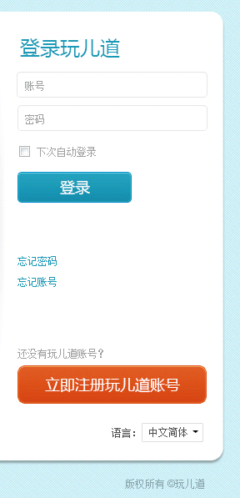

Copyright @ 2011-2013 Savorboard Corporation, All right reserved.

Language:

Switch to Sign up

New to Savorboard? Join today!

Forgot your account?

Forgot your password?

Log In

Keep me logged in

Password

Account

Login

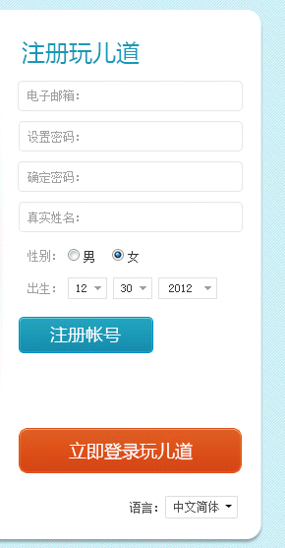

Switch to Login

Sign Up

Birthday

Sex, Male, Female

Name

Repeat

New Password

Email

Sign Up

Login_popup

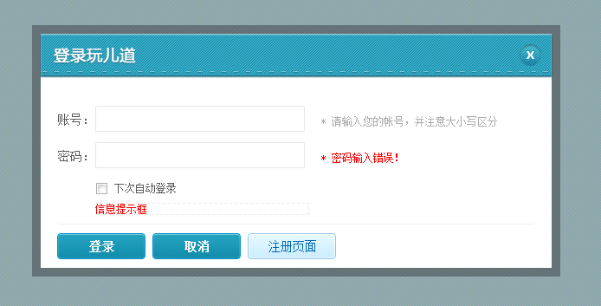

Login Savorboard

Keep me logged in

Cancel

Go to sign up

Login

Password

Account

Register_popup

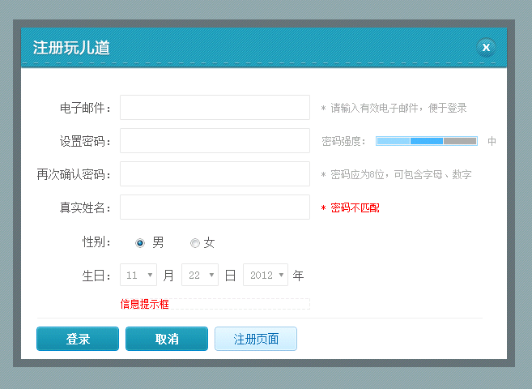

Go to Login

Cancel

Sign Up

Sex, Male, Female

Email

Name

Repeat

New Password

Birthday

Sign up Savorboard

Account_login

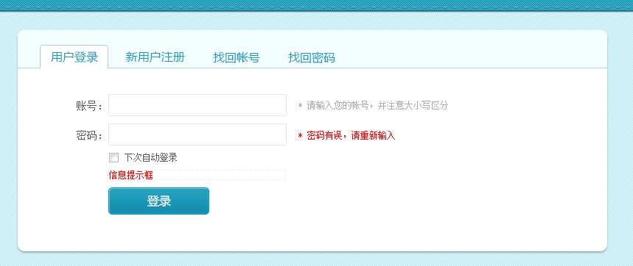

Log In, Sign Up, Find Username, Find Password

Login

Keep me logged in

Account

Password

Account_register

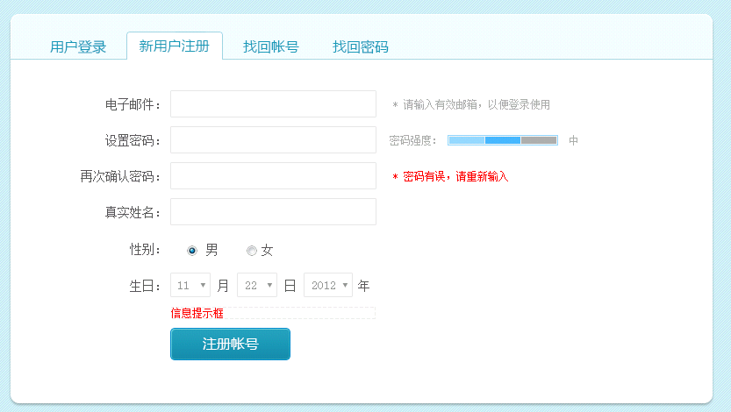

Sign Up

Name

Repeat

New Password

Email

Birthday

Sex, Male, Female

Log In, Sign Up, Find Username, Find Password

Account_find_account_step1

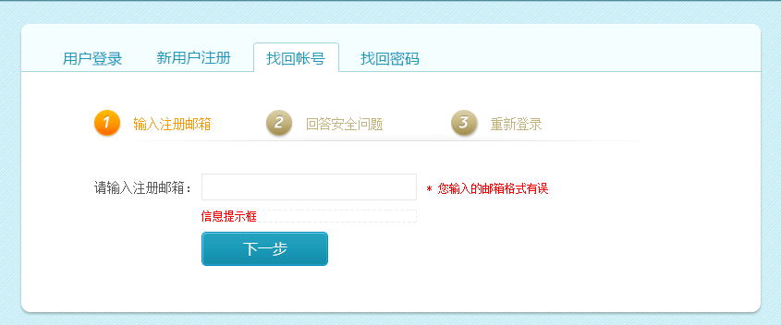

Next

Enter register email address

Login

Answer security question

Enter email address

Log In, Sign Up, Find Username, Find Password

Account_find_account_step2

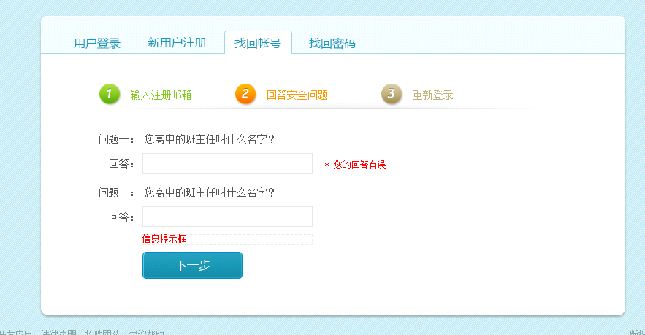

Answer

Account_find_account_step3

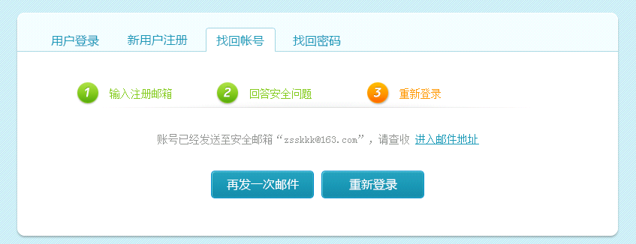

Send email again

Login

Account has been sent to ”xxx”，please check your email

Account_find_pass_step1

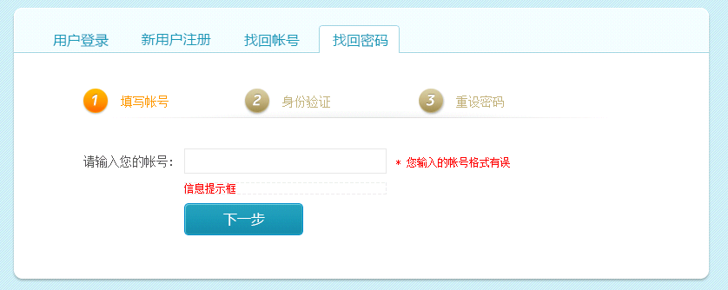

Next

Enter account

Account_find_pass_step2

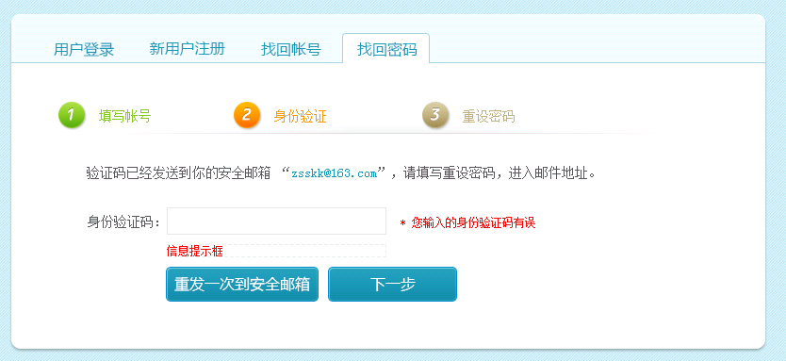

Verification code

Send email again

Next

Verification code has been sent to ”xxx”, please check your email.

Account_find_pass_step3

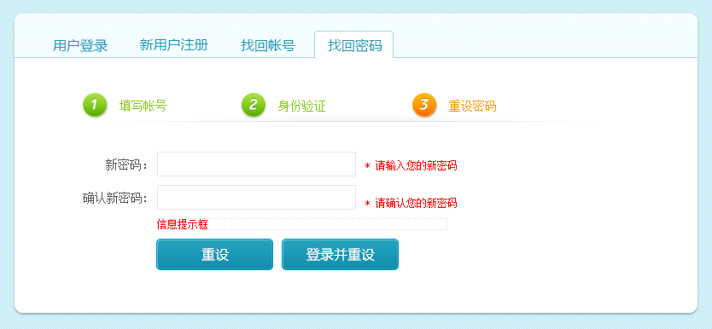

Reset and login

Reset

New password

Repeat

Account_set_security_step1

Activity / Friends / Group / Posts

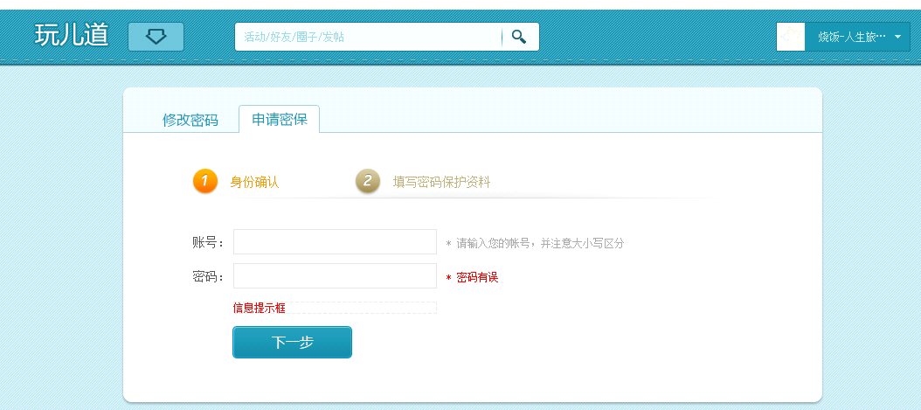

Edit password, Apply password protection

Next

Password

Account

Set protection information

Verify authorization

Account_set_security_step2

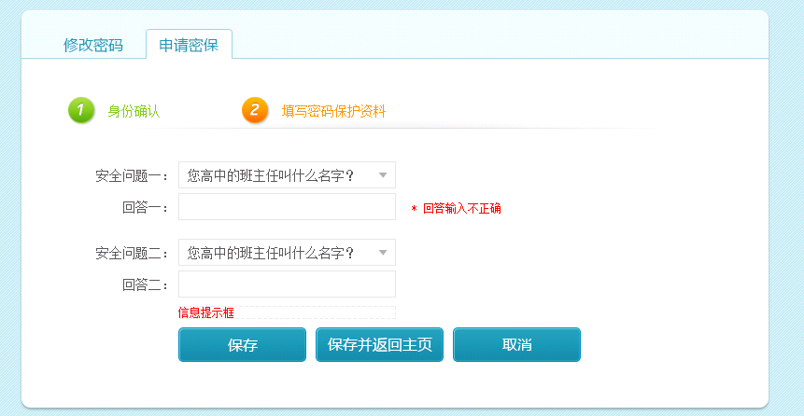

Cancel

Save and go back to main page

Save

2nd Answer:

1st Answer:

Account_edit_pass_step1

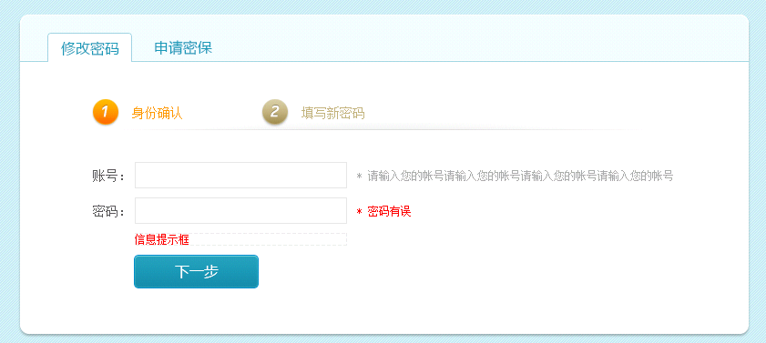

Next

Password

Account

Set new password

Verify authorization

Account_edit_pass_step2

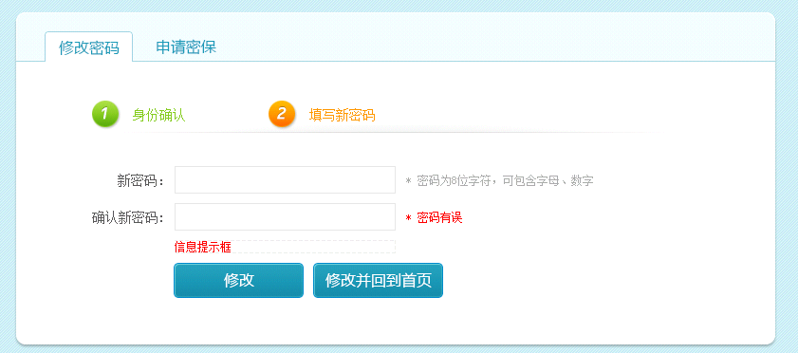

Edit and go back to main page

Edit

Repeat

New password