**Activity_module_build_schedule**

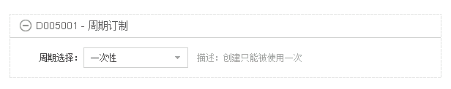

Select repeat pattern

Schedule to launch

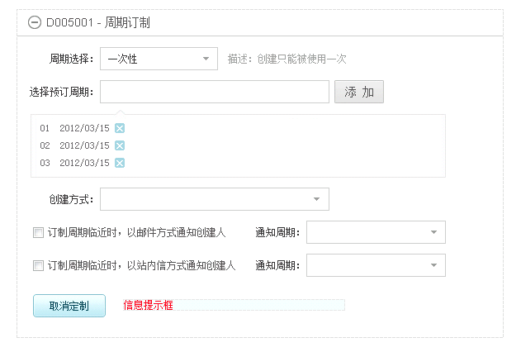

Cancel

Range

When date close, send an email to the founder

When date close, send an message to the founder

Launch type

Add

Select scheduled date

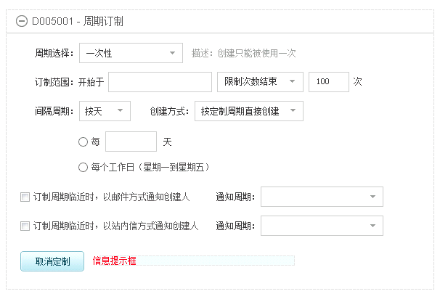

Daily

End after:

Range of repetition

day(s)

Every weekday (From Monday to Friday)

Every

occurrences

Interval range

Launch type

Start

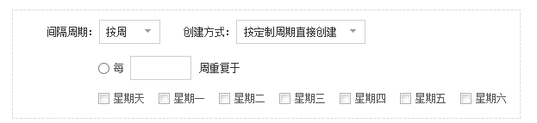

Weekly

Week (s) on:

Repeat every

Sunday, Monday, Tuesday, Wednesday, Thursday, Friday, Saturday

Monthly

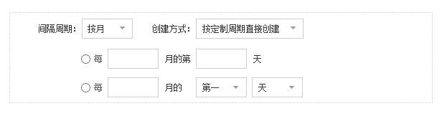

of every

Month (s)

The

Month (s)

of every

Day

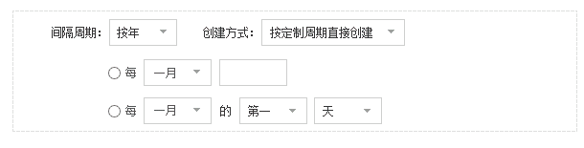

of

The

Yearly

Every

**Activity_module_draft_plan**

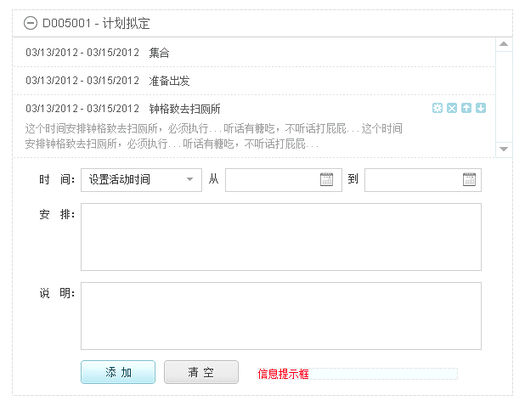

Add, Clear

Plan

Note

To

From

Date

Draft plan

**Activity_module_finance**

Finance

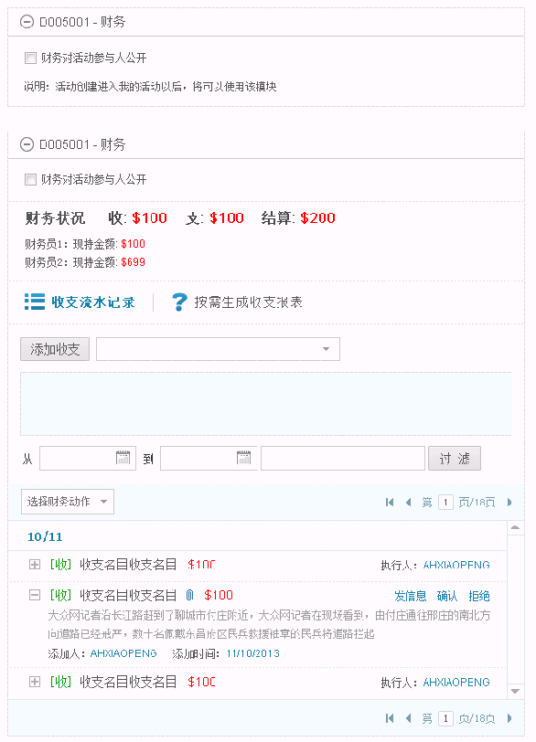

Send a message, Confirm, Decline

Action

Filter

to

From

Add balance items

Revenue flow record, Generate balance report by demand

The amount of cash held

Balance

Expense

Income

Finance

Note: Go to myactivity tab, the module will be useable.

Public to all members in the activity

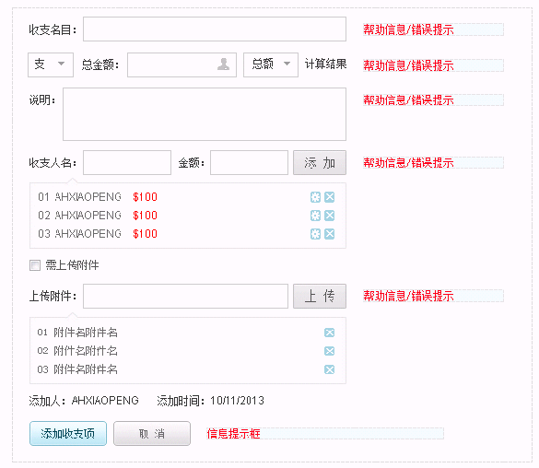

Added on:

Add, Cancel

Added by:

Upload

File:

Need attach files

Add

Money:

Payment names:

Item:

Note:

Amount

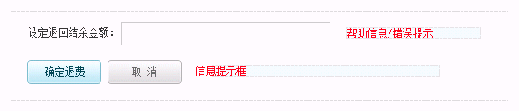

Confirm, Cancel

Set refund number:

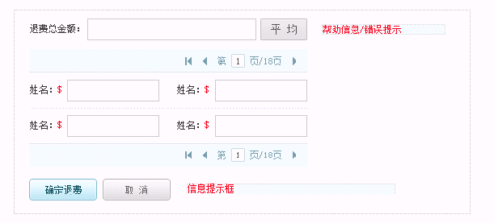

Name

Refund amount

Average

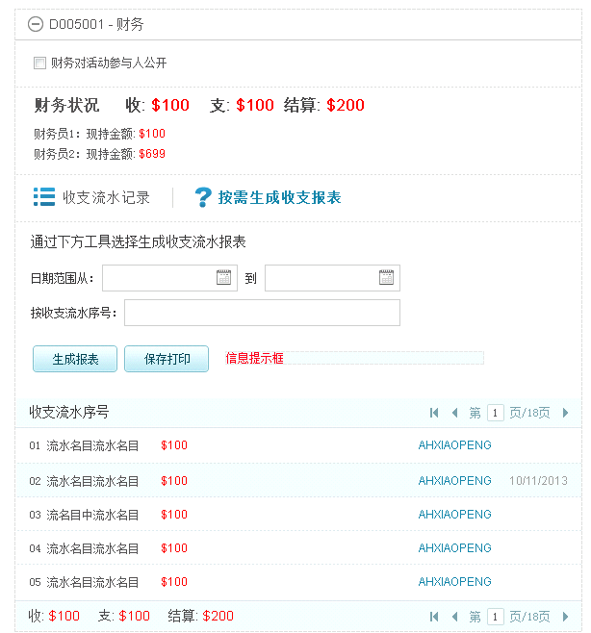

Income, expense, Balance

Generate, Save and print

Report number

to

Date from

Follow tools below to generate balance report

**Activity_module_set_basic**

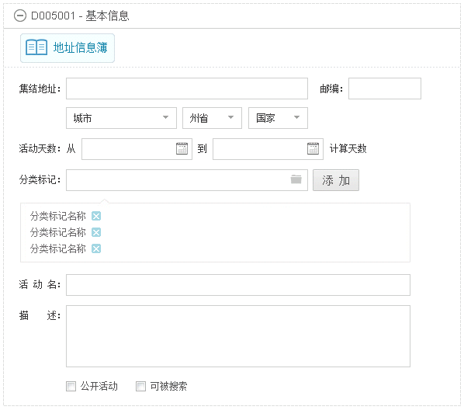

Basic information

Category tag:

Public, Can be searched

Description:

Name:

Add

from

to

Date:

Zipcode

Address

Address book

**Activity_module_set_cost**

Prepayment settings

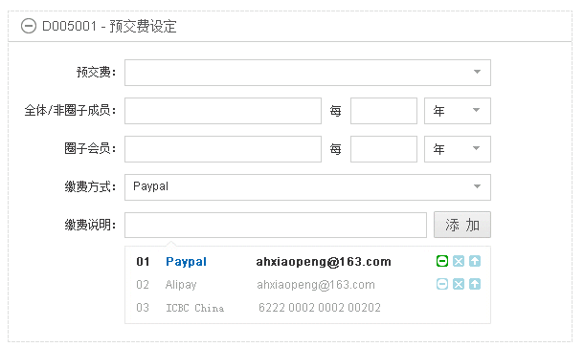

Prepayment:

Add

Description

Payment method:

Group members:

every

All members/Non-group members:

**Activity_module_set_join_conds**

Join conditions settings

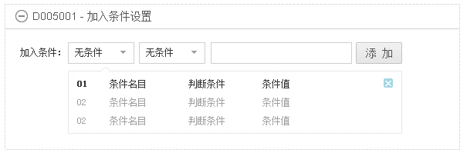

Add

Join conditions:

**Activity_moduel_set_signup**

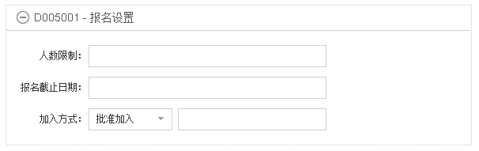

Signup settings

Approve to join

Join method:

Join deadline:

Number limitation:

**Activity_module_assign_task**

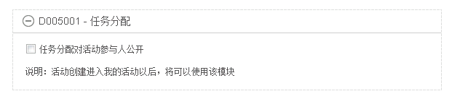

Note: Go to myactivity tab, the module will be useable.

Public to all members in the activity

Task assignment

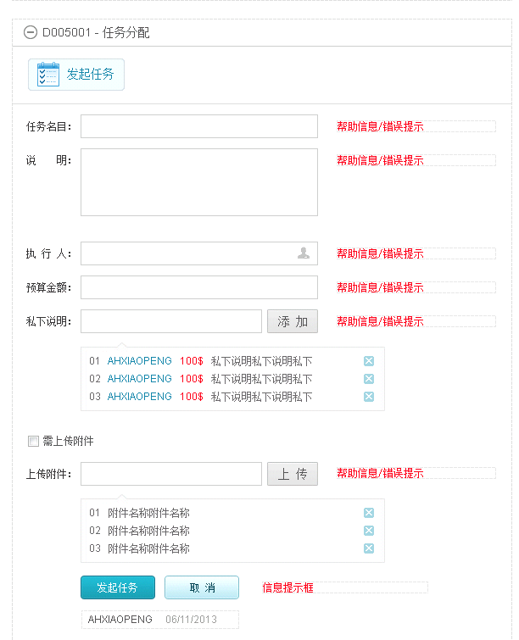

Assign, Cancel

Files:

Upload

Need attach files

Add

Privately description:

Budget amount:

Executor:

Description:

Title:

Assign tasks

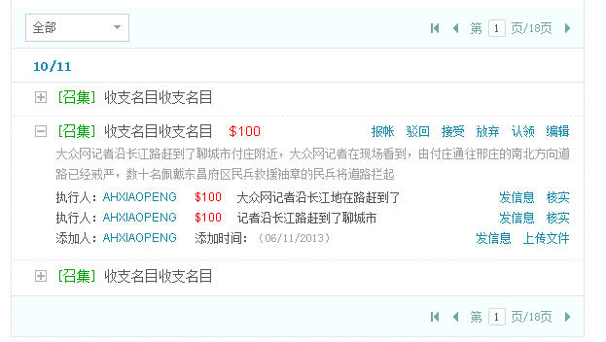

Executor:

Added by:

Reimburse, Reject, Accept, Give up, Claim，Edit

Send a message, Confirm

Send a message, Attach files

Added on:

**Activity_module_invitation**

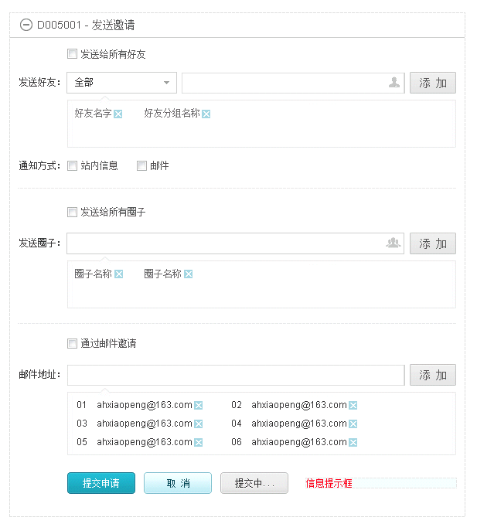

Add

Send to all friends

Message, Email

Method

Add

Send to all groups

Send to

Add

Invite by email

Email

Submit, Cancel, Submitting

Send to

Send invitations

**Activity_module_set_kickoff**

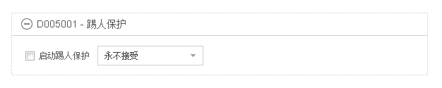

Start kick off protection

Kick off protection

**Activity_module_own_signup**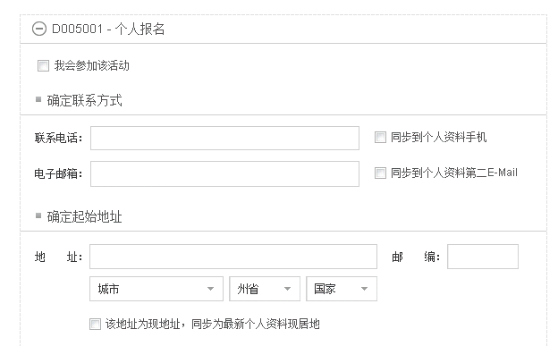

City, State, Country

Zip code:

Address:

Start address

Email:

Phone:

I will join this activity

Individual registration

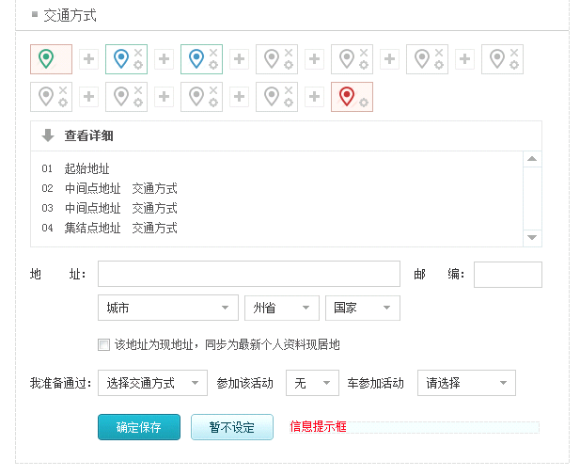

auto to join

without

I am prepare to go there by

Zip code:

Address:

Click to check details

Syn to home address in personal profile

Route plan and traffic method

Syn to phone in personal profile

Syn to Email in personal profile

Syn to home address in personal profile

Contact methods

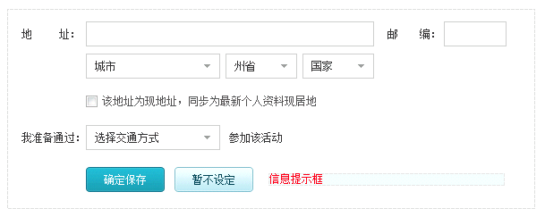

I am prepare to go there by

Save, Decide later

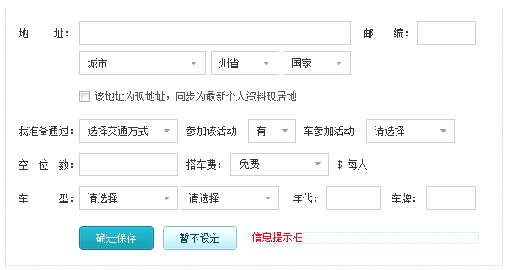

Year:

Plate:

Each person

Ride fee:

Module:

The number of vacancies

auto to join

with

I am prepare to go there by