**Activity_define_main：**

Activity home, Classified activities, Search activities, My activities, Launch an activity

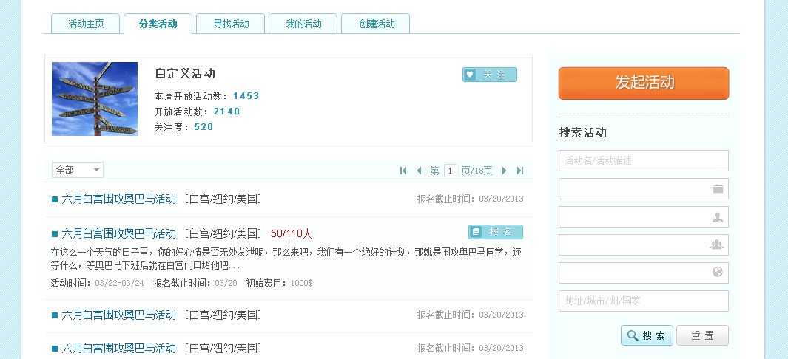

All

Custom activities

Open number in this week

Open number

Subscribers:

Name/Description

Address/City/State/ Country

Search, Reset

Deadline

Date, Deadline, Prepay

Search activities

Sign up

Launch an activity

Subscribe

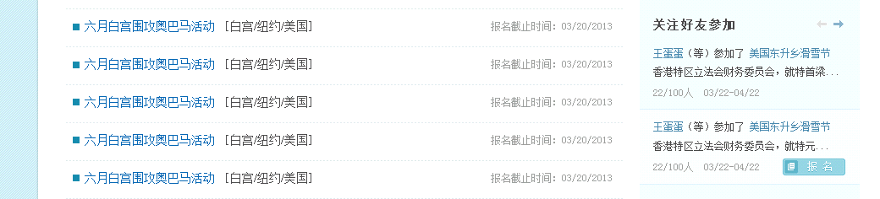

Sign up

join

Activities have subscribed friends

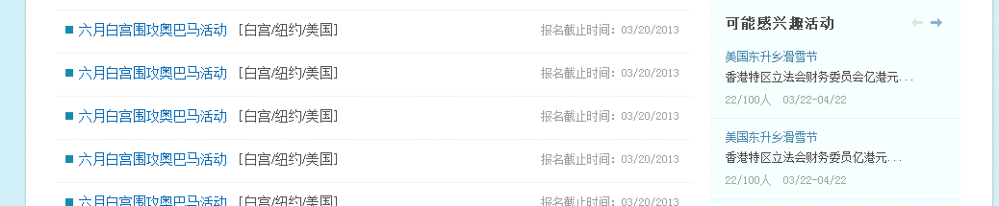

Activities may have interests

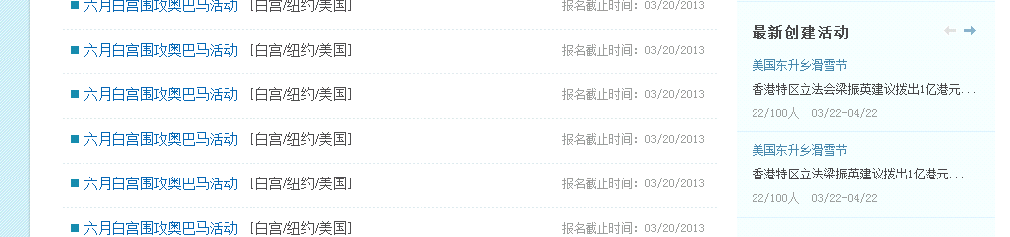

Latest activities

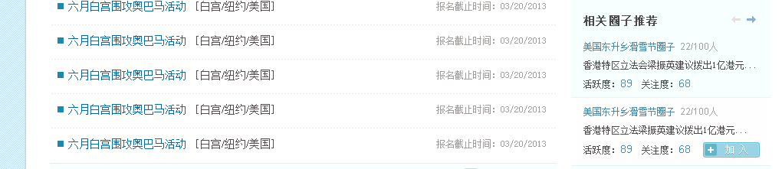

Activity score,

Subscribed score

Apply

Relative groups

**Activty_index**

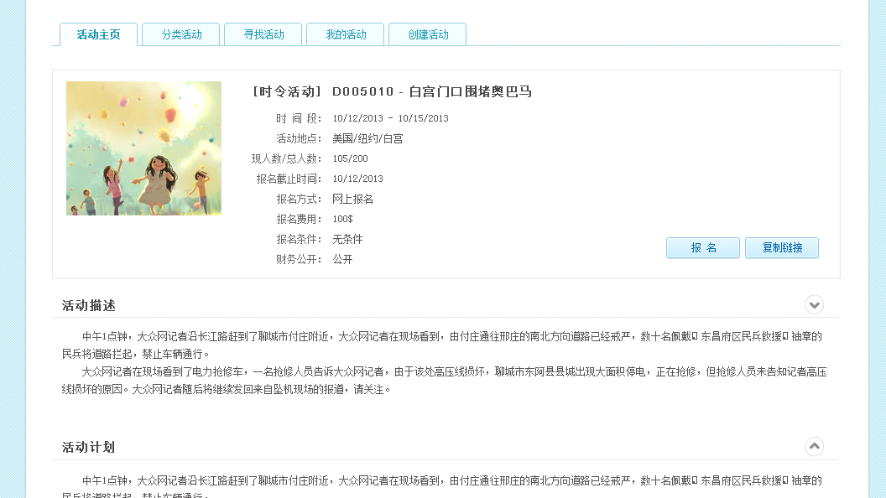

Plan

Description

Sign up, Copy activity link

Date

Address

Members/ Total

Deadline

Join method

Prepay

Join conditions

Whether Finance public

**Activity_item_main**

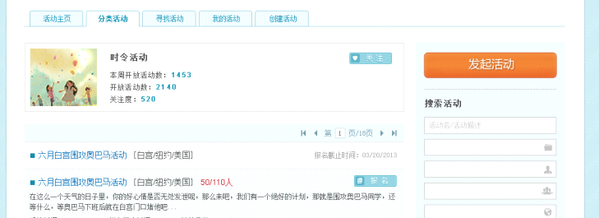

Seasonal activities

**Activity_main**

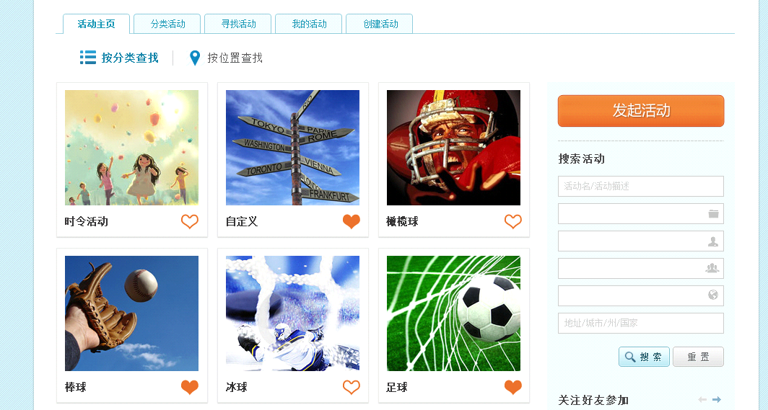

Search by Category, Search by Map

Baseball, Hockey, Soccer

, S

Season, Custom, Football



Golf, Pingpong, Fishing

Badminton, Tennis, Camping

Basketball, Hiking, Photography



Sailing, Chess & Cards, Bowling

Bicycle, Equitation, Travel

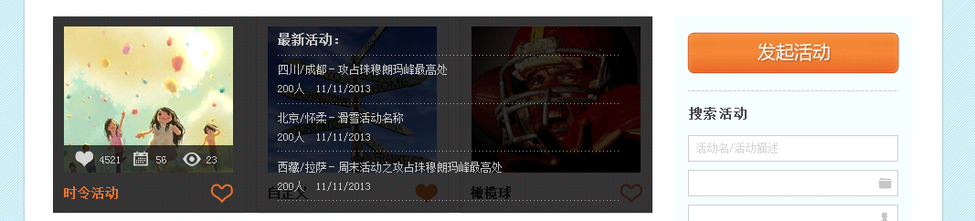

Latest activities

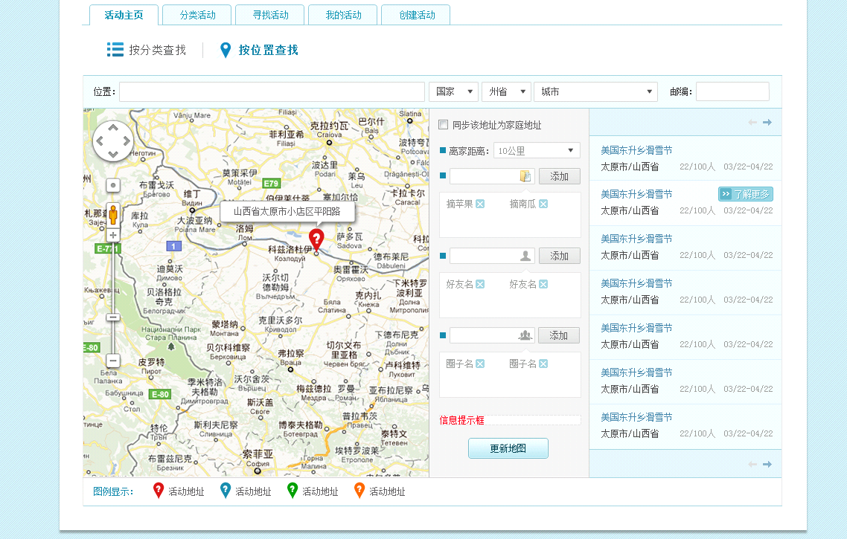

Update

More

Add

Distance

Synchronize to home address

Scale

Zipcode

Place

**Activity_search**

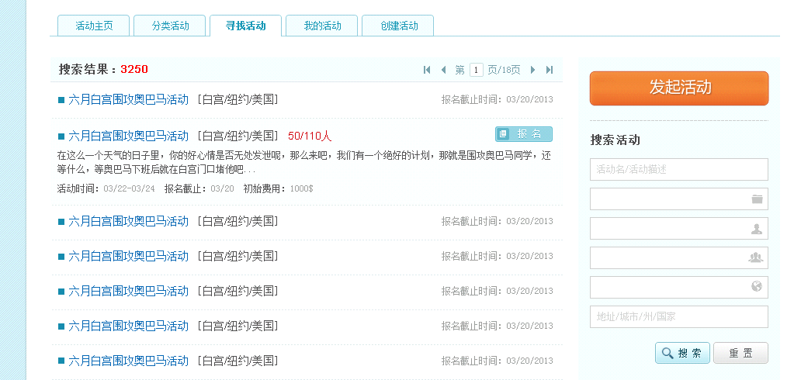

Date, Deadline, Prepay

Sign up

Search result

**Activity_season_main**

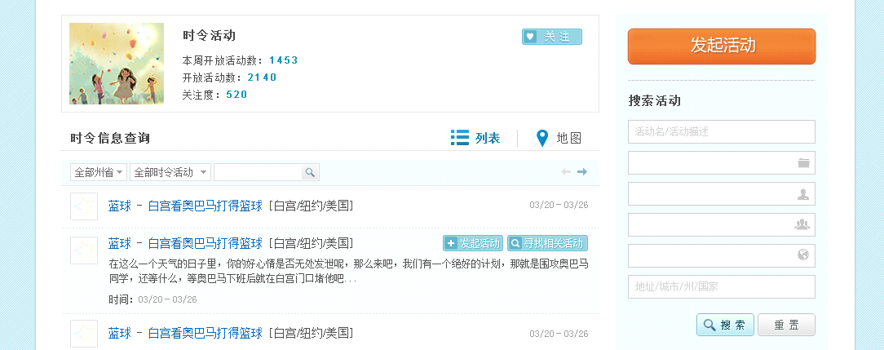

Date

Launch an activity, Find relative activities

Seasonal information search

List, Map

Subscribe

Seasonal activity

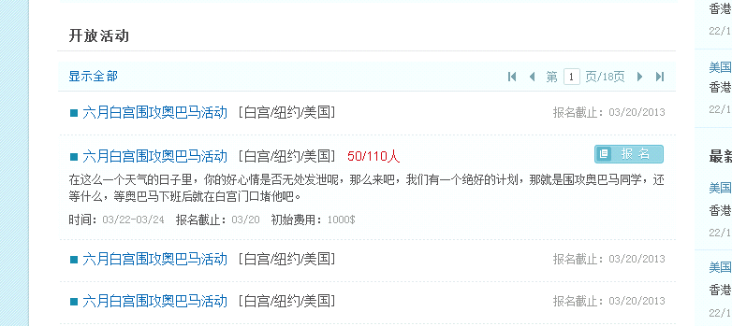

Date, Deadline, Prepay

Sign up

Show all

Open activities

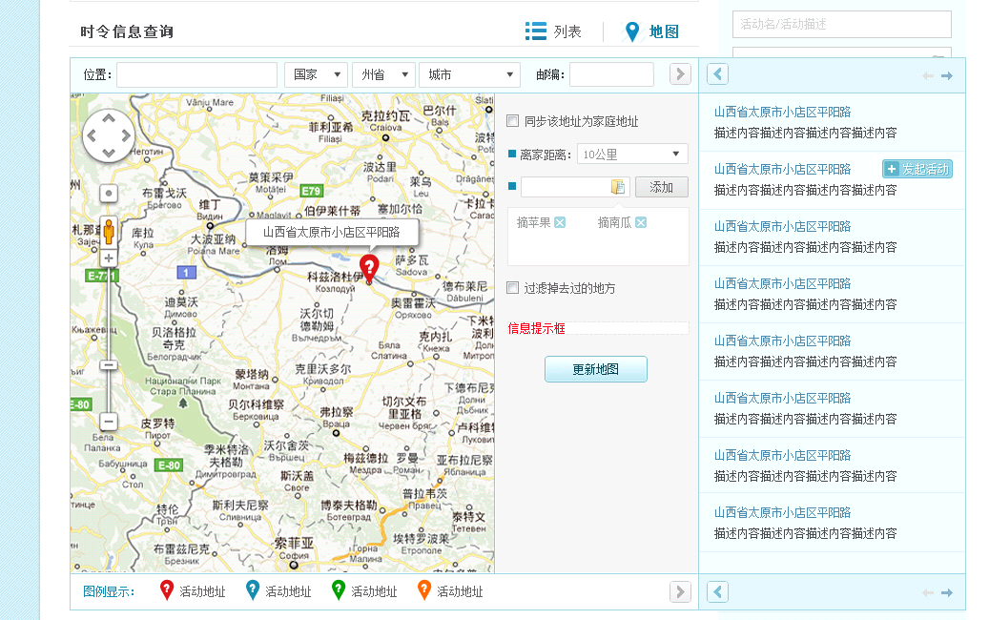

Synchronize to home address

Distance

Zipcode

Scale

Place

Launch an activity

Add

Update

**Activity_signup**

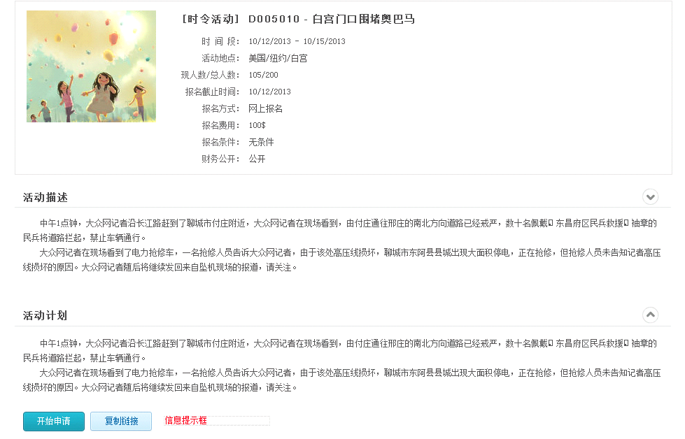

Date:

Address:

Current member/Total:

Deadline:

Signup method:

Prepayment:

Signup conditions:

Is finance public?

Apply, Copy link

Description:

Plan:

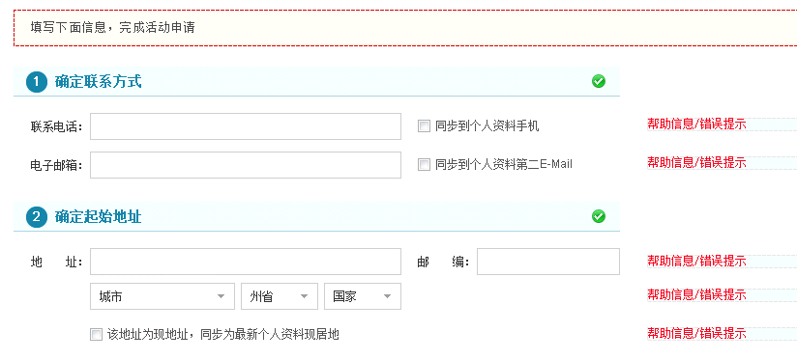

Syn to home address in personal profile

Syn to Email in personal profile

Syn to phone in personal profile

Zip code:

Address:

Start address

Email:

Phone:

Contact methods

Fill below information to finish application

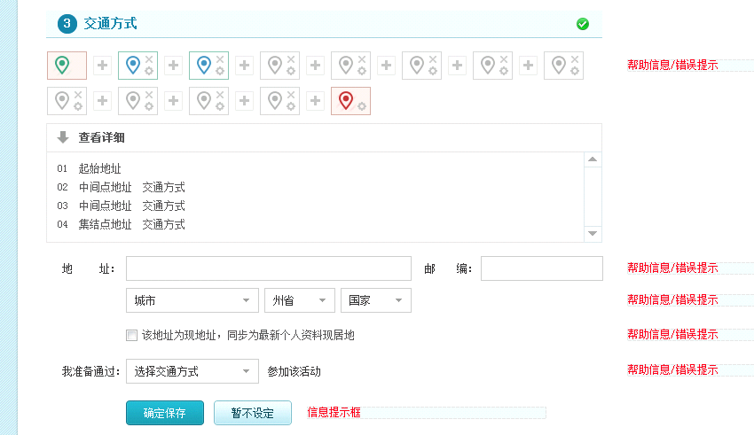

Save, Decide later

I am prepare to go there by

Syn to home address in personal profile

Zip code:

City, State, Country

Address:

Click to check details

Route plan and traffic method

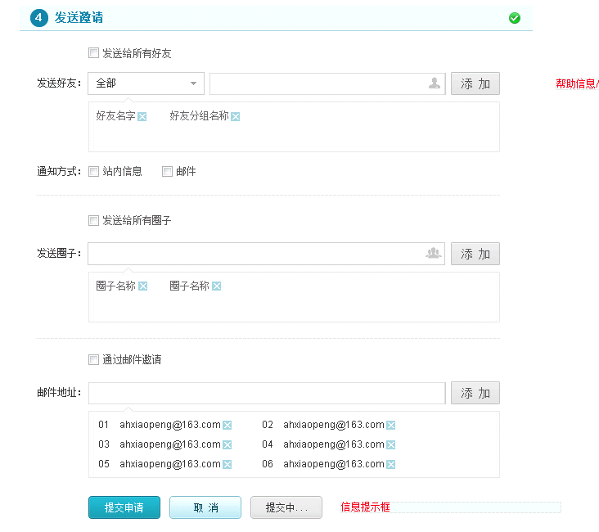

Apply, Cancel, Submitting

Email

Send to

Send to all groups

Message, Email

Method

Add

Send to

Send to all friends

Add

Invite by email

Add

Send invitations

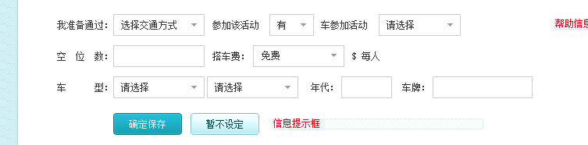

Each person

Plate:

Year:

auto to join

with

Ride fee:

Module:

The number of vacancies

I am prepare to go there by

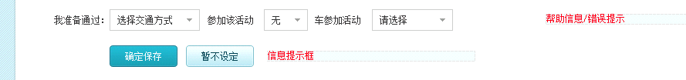

auto to join

without