Home

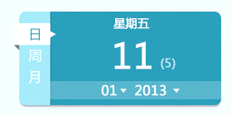

Day

Week

Month

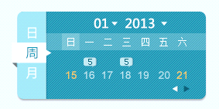

Sun Mon Tue Wed Thu Fri Sat

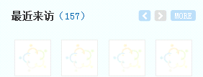

Recent visitor

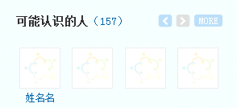

People you may know

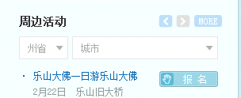

Around activities

Sign up

Interesting activities

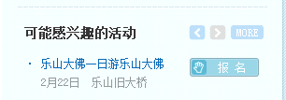

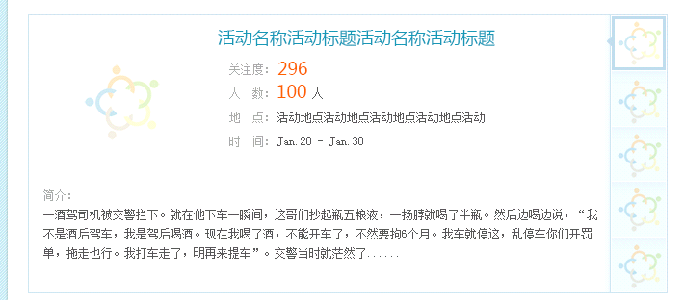

Date

Location

Participant

Subscribed score



Videos

Photos

Around

Feeds

Recent updates, Messages，Group, Activity



注意：英文只翻译了系统文字，用户内容文字不包含在内

posts new feeds

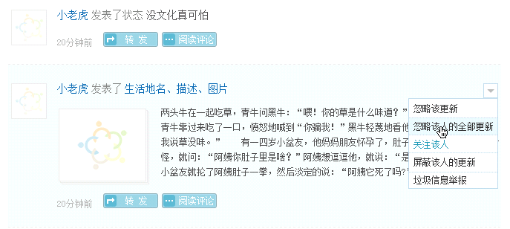

Read comments

Ignore this update

Ignore all updates from the author

Subscribe

Block updates from the author

Report malicious information

Forward

posts

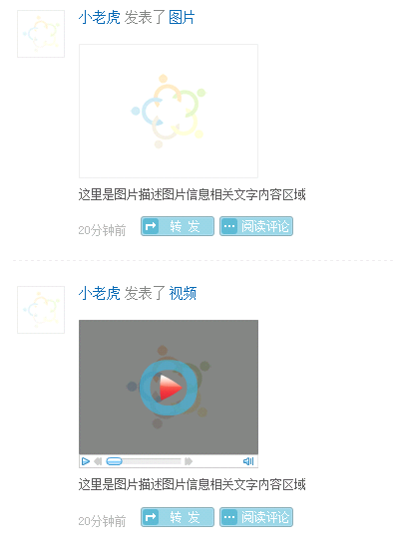

posts

posts

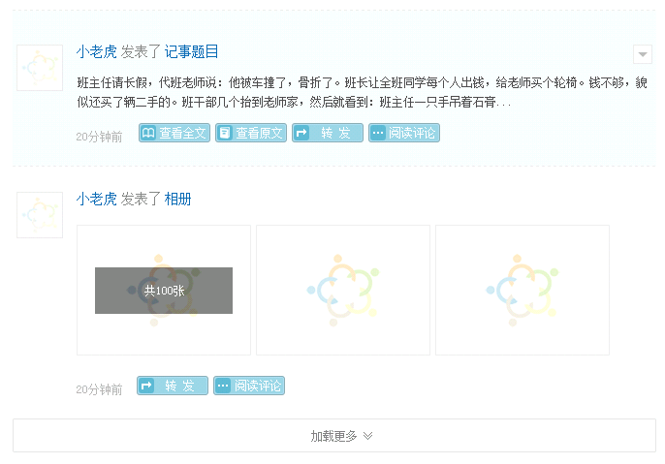

More

Read original

Read all

posts

posts

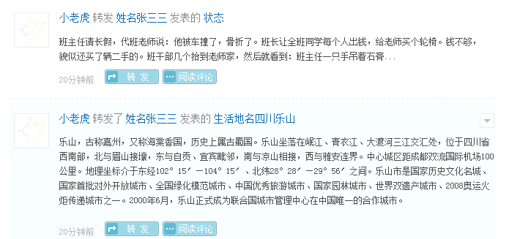

posts

forward from

posts

forward from

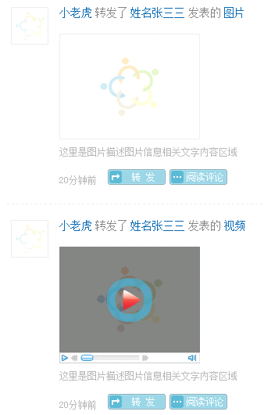

posts

forward from

posts

forward from

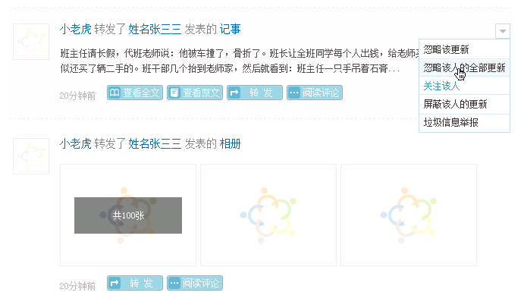

posts

posts

forward from

forward from

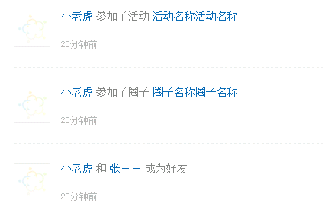

make friends with

join group

join activity

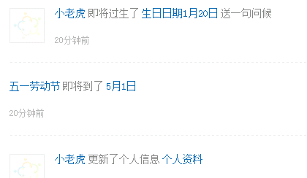

update personal profile

Will be

Send the best wishes

birthday will come

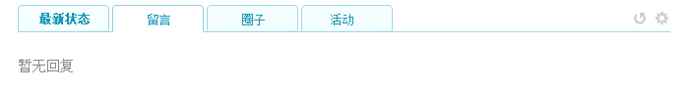

There is no message

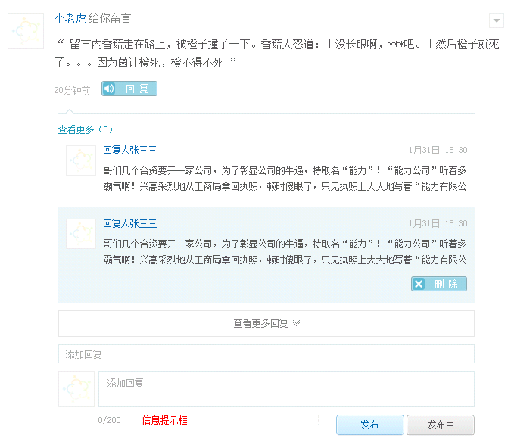

Post

Add a comment

More

Delete

Read more

Reply

left a message

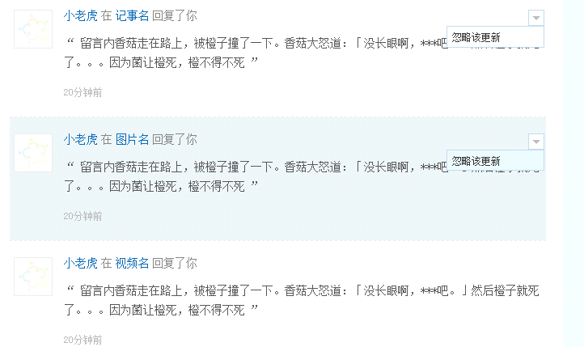

comment on

join

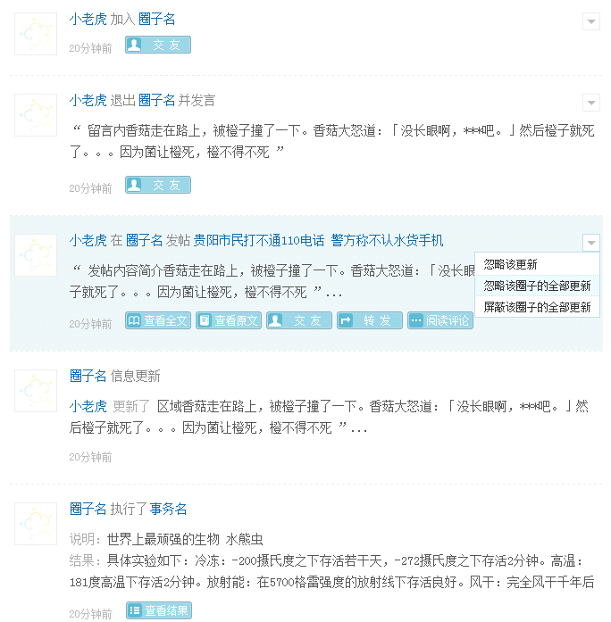

Result

Summary

Result

executed

Updated

on + 圈子名

posts

and say

exist

Friends

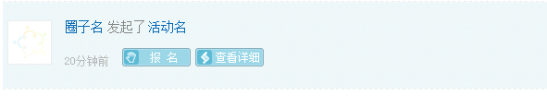

launch

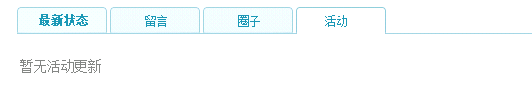

join

There is no activity update.

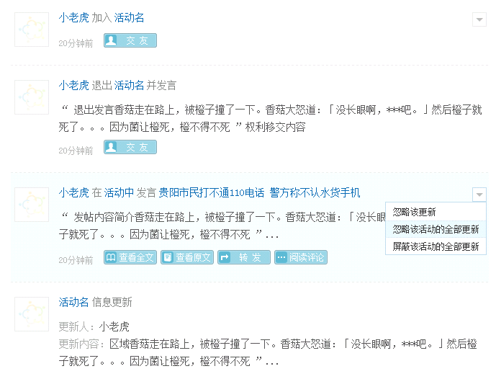

Upload, Webcam

Updated:

Summary

Updated

on + 活动名

and say

exist

Friends

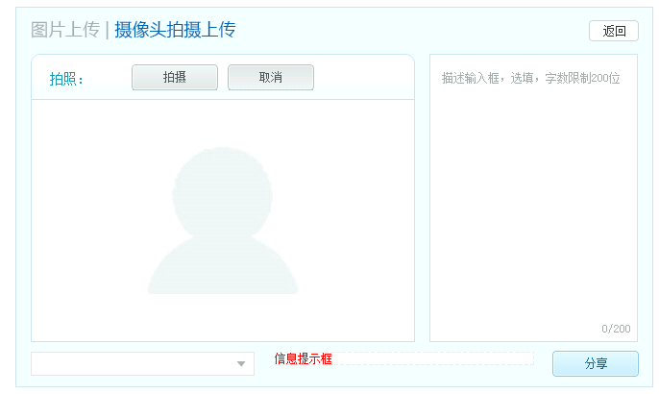

Shot, Cancel

Share

Back

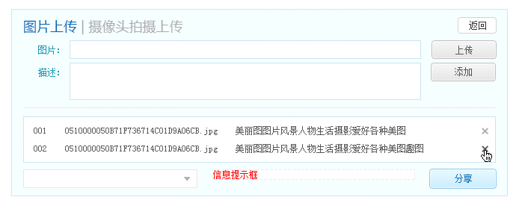

Upload

Add

Photo

Description

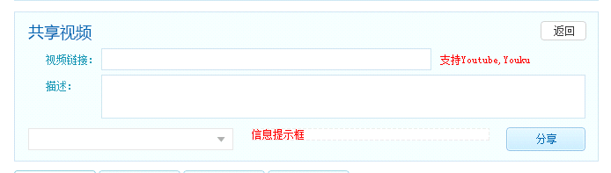

Link

Description

Share video

Share life experience, love place, favorite restaurant, comfortable hotel and more

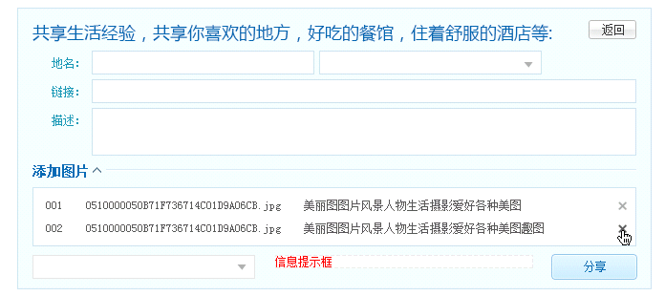

Add pictures

Address

Link

Description

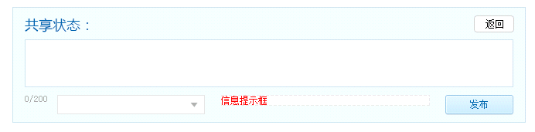

Share feeds

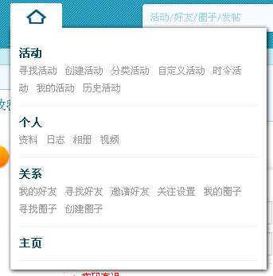

Activity

Search activities, Launch an activity, Activities by category, Custom activities, Seasonal activities, My activities

Person

Profile, Notepad, Photo album, Video folder

Group

My friends, Search friends, Invite friends, Subscription, My groups, Search groups, Create a group

Home

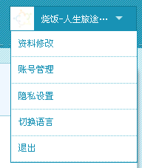

Profile

Account

Privacy

Switch Language

Logout



Copyright @ 2011-2013 Savorboard Corporation, All right reserved.

Feature, Application, Term, Job, Suggestion, Help

Home_for_visitor

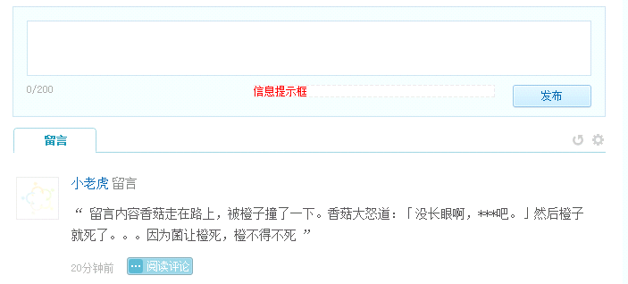

left the message

Message

Post