**Activity_info_popup**

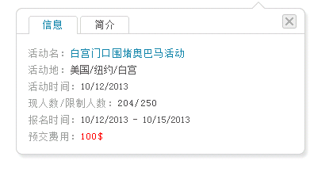

Activity name

Address

Date

Current number/Total number

Deadline

Prepay

Information, Description

**Address_book**

Address Book

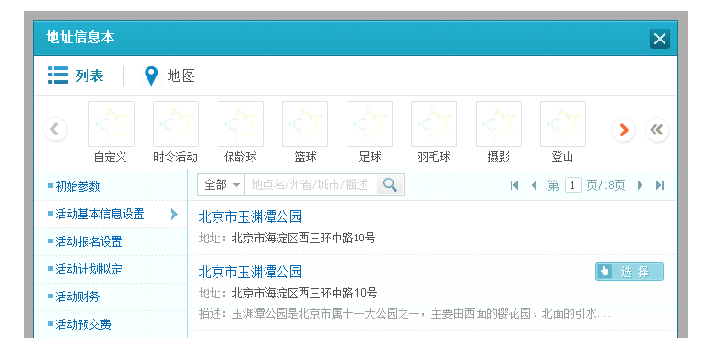

All

Name/State/City/Description

Description

Select

Address

List, Map

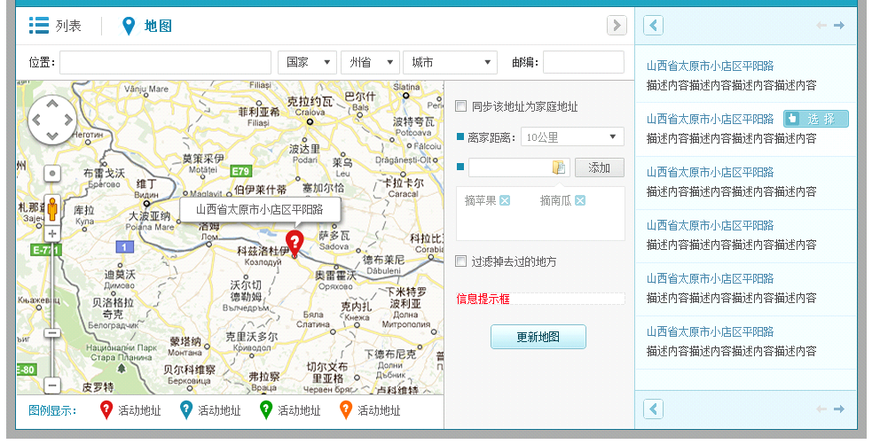

Filter places went before

Add

Distance

Synchronize to home address

Update

Scale

Country, State, City, Zipcode

Place

**Address_info_popup**

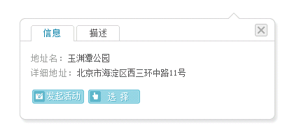

Launch an activity, Select

Name

Address

Information, Description

**Browser_check_popup**

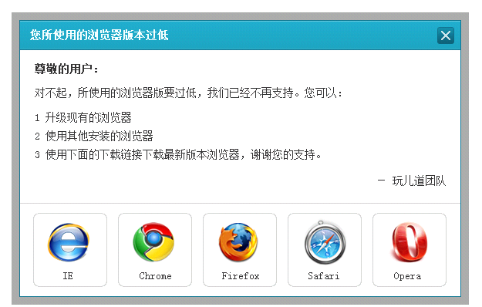

Dear customer:

We are sorry to notice you. Because your browser version is too low, we don’t provide support anymore. However you can

1. Update your current browser version;
2. Try other browsers;
3. Use links below to download the latest version;

Thank you for your support.

-Savorboard Team

Your browser version is too low

**Carpool_map_popup**

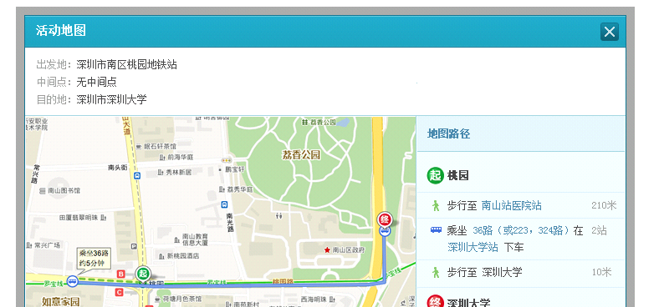

Suggested routes

Start

Mid-point

Destination

Route map

**Category_select_popup**

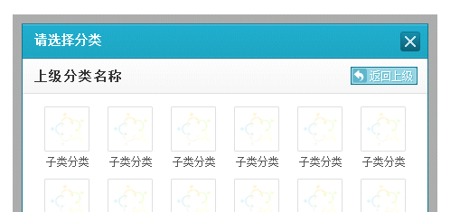

Back

Select the category

**Check_authorization_popup**

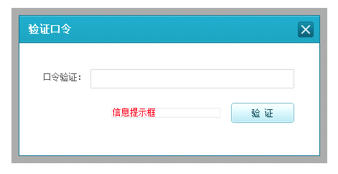

Check

Authentication password

Authentication

**Group_info_popup**

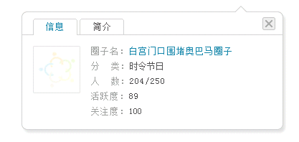

Group name

Category

Number

Activity score

Subscribed score

Information, Description

**Group_select_popup**

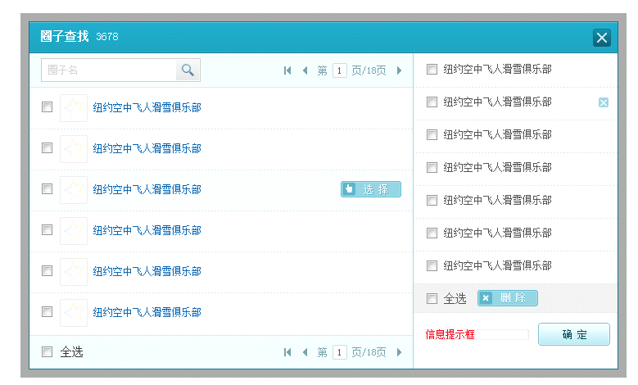

Select and close

Delete

All

Select

Name

Search groups

**Link_copy_popup**

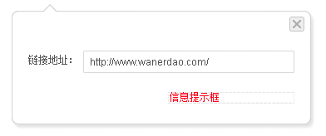

Link

**Module_info_popup**

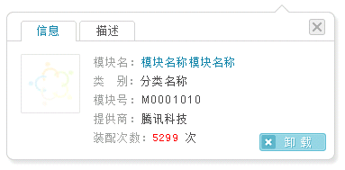

Module name

Category

Module code

Provider

Install number

Remove

Information, Description

**People_select_popup**

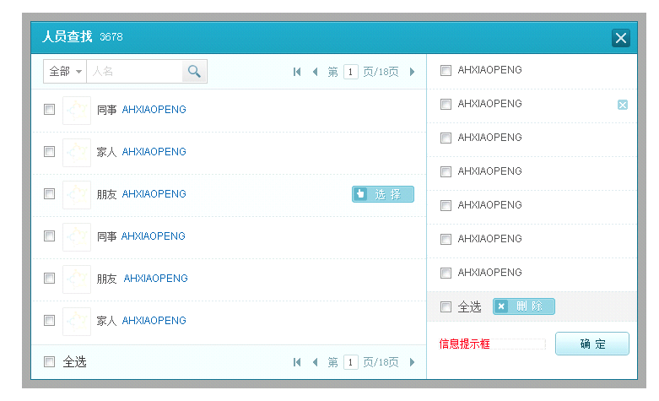

All

All

Select and close

Delete

Select

Name

Search people

**Person_info_popup**

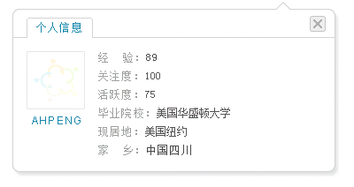

Experience

Subscribed score

Activity score

Graduated from

Current place

Home place

Information

**Photo_view_popup**

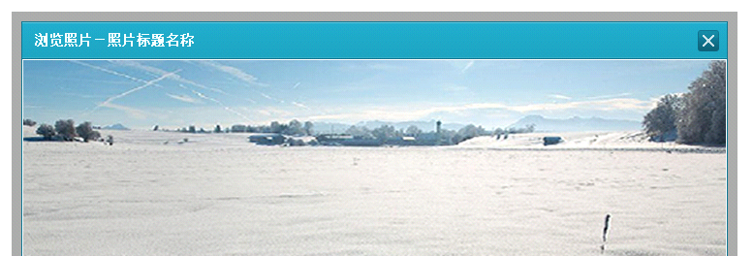

View images -

**Tool_info_popup**

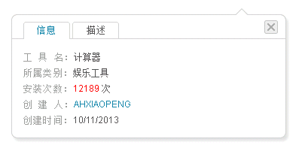

Tool name

Category

Install number

Created by

Created date

Information, Description

**Video_view_popup**

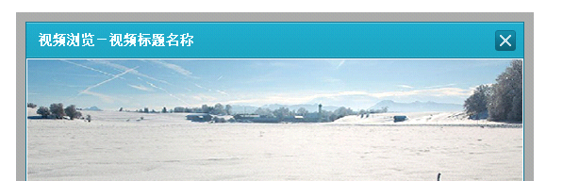

Watch videos -

**Weather_select_popup**

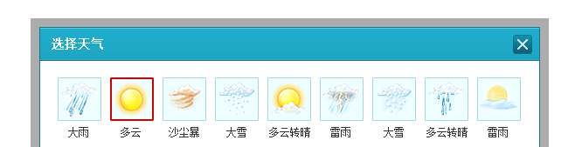

Select the weather

**Feeds_block_setting_popup**

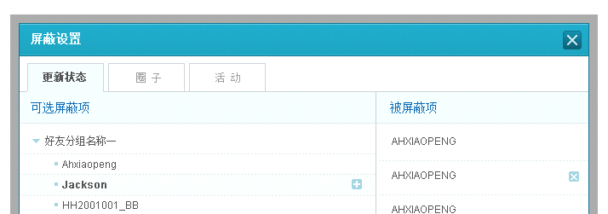

Optional items

Recent update, Group, Activity

Block items

Block settings

**Private_customize_popup**

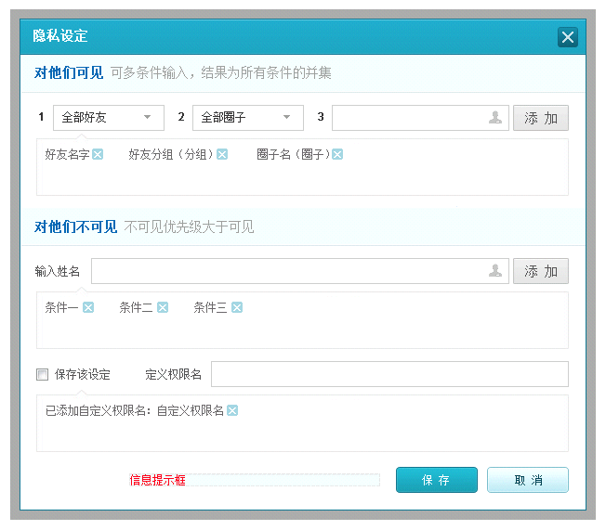

Don’t share this with, Note: Un-viewable groups have higher priority than viewable groups

Name

Share this with, Note: The result will be the collection of multi conditions

Define permission name

Save the settings

Save, Cancel

Add

Permission settings