实验手册

试验任务：对散点数据的处理

使用模型：非线性逻辑回归

实验步骤：

1. 读取数据
2. 数据处理样本升维
3. 样本归一化处理
4. 非线性预测包含梯度下降

使用函数有：

对数据的处理：

数据升维

train_1 = np.insert(train[:,:-1],0,[1],axis = 1)

test_1 = np.insert(test,0,[1],axis = 1)

#添加高次项

temp_1 = train_1[...,1] * train_1[...,1]

train_1 = np.insert(train_1,3,temp_1,axis = 1)

temp_4 = test_1[...,1] * test_1[...,1]

test_1 = np.insert(test_1,3,temp_4,axis = 1)

temp_2 = train_1[...,1] * train_1[...,2]

train_1 = np.insert(train_1,4,temp_2,axis = 1)

temp_5 = test_1[...,1] * test_1[...,2]

test_1 = np.insert(test_1,4,temp_5,axis = 1)

temp_3 = train_1[...,2] * train_1[...,2]

train_1 = np.insert(train_1,5,temp_3,axis = 1)

temp_6 = test_1[...,2] * test_1[...,2]

test_1 = np.insert(test_1,5,temp_6,axis = 1)

数据的线性映射

train_min = train_1.min(axis = 0)

test_min = test_1.min(axis = 0)

train_max = train_1.max(axis = 0)

test_max = test_1.max(axis = 0)

for i in range(1,len(train_1[0])):

train_1[...,i] = (train_1[...,i]-train_min[i])/(train_max[i] - train_min[i])

test_1[...,i] = (test_1[...,i]-test_min[i])/(test_max[i] - test_min[i])

构造函数的使用

def function(weights):

def function_1(x):

y = []

for i in x:

if (np.mat(i) * np.mat(weights)) >= 0:

y.append(1)

else:

y.append(0)

return y

return function_1

梯度下降的应用

def grad_descent(dataMathIn,classLabels):

# 把数组类型转化成矩阵类型

dataMatrix = np.mat(dataMathIn)

# 转化成矩阵类型并进行转置

labelMat = np.mat(classLabels).transpose()

# 获取特征矩阵的特征个数和样本个数

m, n = np.shape(dataMatrix)

# 构建相应的1矩阵

weights = np.ones((n, 1))

weights_1 = np.zeros((n,1))

alpha = 0.75

lamda = 0.75

maxCycle = 10000

weights_1[0] = 1

for i in range(1,len(weights_1)):

weights_1[i] = 1 * (1 - alpha * lamda / m)

# 每一个样本带入公式进行计算推导出相关系数值

for i in range(maxCycle):

h = sigmoid(dataMatrix * weights)

weights = weights_1 * np.array(weights) - alpha / m * dataMatrix.transpose() * (h - labelMat)

return weights

图像显示为

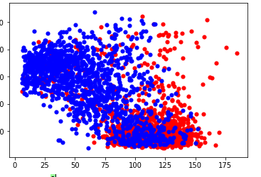

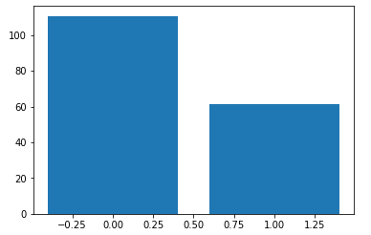

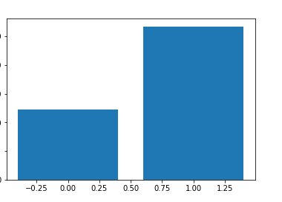

实验结果：对数据进行了有效的区分正确率为0.81428