Lecture 6 Homework

Caitlin Johnson

1/23/2020

The input to the function **protein_activity_plot** is the four letter PDB identifier for online file access in the form of a string. The function generates a line plot from a four letter PDB identifier. To use the function, simply input the PDB code. Ex: improved (‘A3F4’). The output of the function is a line plot.

library(bio3d)  
protein_activity_plot <- function(PDB) {  
 protein <- read.pdb(PDB)  
 protein.chainA <- trim.pdb(protein, chain="A", elety="CA")  
 protein.b <- protein.chainA$atom$b  
 plotb3(protein.b, sse = protein.chainA, typ="l", ylab="Bfactor")  
}

protein_activity_plot('4AKE') # kinase with drug

## Note: Accessing on-line PDB file

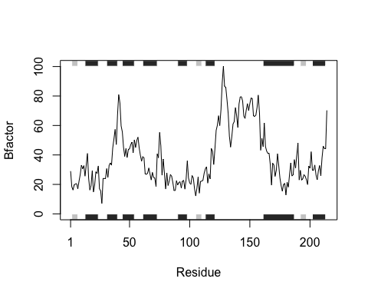

protein_activity_plot('1AKE') # kinase no drug

## Note: Accessing on-line PDB file  
## PDB has ALT records, taking A only, rm.alt=TRUE

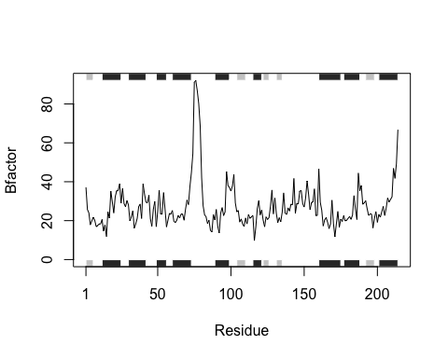

protein_activity_plot('1E4Y') # kinase with drug

## Note: Accessing on-line PDB file

