Opening up the directory on my computer for this file:
setwd("C:/Users/Manuel/Desktop/Coursera")
datafile <- read.csv("./repdata/activity.csv")
head(datafile)
## steps date interval
## 1 NA 2012-10-01 0
## 2 NA 2012-10-01 5
## 3 NA 2012-10-01 10
## 4 NA 2012-10-01 15
## 5 NA 2012-10-01 20
## 6 NA 2012-10-01 25
summary(datafile)
## steps date interval
## Min. : 0.00 2012-10-01: 288 Min. : 0.0
## 1st Qu.: 0.00 2012-10-02: 288 1st Qu.: 588.8
## Median : 0.00 2012-10-03: 288 Median :1177.5
## Mean : 37.38 2012-10-04: 288 Mean :1177.5
## 3rd Qu.: 12.00 2012-10-05: 288 3rd Qu.:1766.2
## Max. :806.00 2012-10-06: 288 Max. :2355.0
## NA's :2304 (Other) :15840
What is the mean of steps taken per day?
#Getting the mean
#Fist: Add the number of steps per day
TotalSteps <- aggregate(steps ~ date, datafile, FUN = sum)
summary(TotalSteps)
## date steps
## 2012-10-02: 1 Min. : 41
## 2012-10-03: 1 1st Qu.: 8841
## 2012-10-04: 1 Median :10765
## 2012-10-05: 1 Mean :10766
## 2012-10-06: 1 3rd Qu.:13294
## 2012-10-07: 1 Max. :21194
## (Other) :47
#Make the histogram:
hist(TotalSteps$steps, xlab = " steps", ylab = "frequency", col = "red")
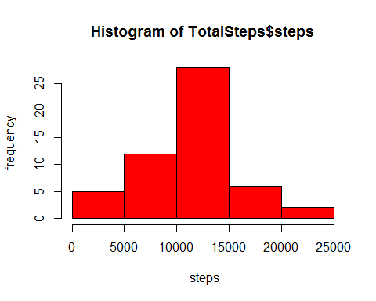
#Getting the mean:
StepsMean<- mean(TotalSteps$steps, na.rm = "TRUE")
StepsMedian <- median(TotalSteps$steps, na.rm = "TRUE")
#Printing the values for mean and median:
StepsMean
## [1] 10766.19
StepsMedian
## [1] 10765
Next: Making a time series plot
#Getting the average number of steps in a 5min interval:
AvgSteps <- aggregate(steps ~ interval , datafile , FUN = mean)
summary(AvgSteps)
## interval steps
## Min. : 0.0 Min. : 0.000
## 1st Qu.: 588.8 1st Qu.: 2.486
## Median :1177.5 Median : 34.113
## Mean :1177.5 Mean : 37.383
## 3rd Qu.:1766.2 3rd Qu.: 52.835
## Max. :2355.0 Max. :206.170
head(AvgSteps)
## interval steps
## 1 0 1.7169811
## 2 5 0.3396226
## 3 10 0.1320755
## 4 15 0.1509434
## 5 20 0.0754717
## 6 25 2.0943396
#Making the plot:
plot(AvgSteps$interval, AvgSteps$steps, type = "l", col = "red", xlab = "Interval" , ylab = "Avg Steps", main = "Average Number Steps Per 5-min Interval")
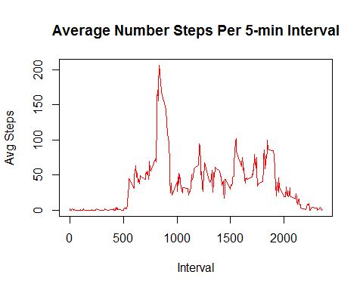
#Finding which 5 min interval has the most number of steps taken:
MostSteps <- which.max(AvgSteps$steps)
MostSteps #This returns the number of the list, which is interval 835 , which has ~209 steps
## [1] 104
#A more refined approach to getting the interval with the most steps is below:
maxInt <- AvgSteps[which.max(AvgSteps$steps),]
maxInt
## interval steps
## 104 835 206.1698
Finding and Replacing the Missing Data
#Total number of missing values is:
sum(is.na(datafile[,1]))
## [1] 2304
#Replacing the missing data with Average in 5 min interval
missing <- !complete.cases(datafile)
REMNA <- datafile[missing == TRUE,]
REMNA[,1] <- AvgSteps$steps
summary(REMNA) #Shows no NA values
## steps date interval
## Min. : 0.000 2012-10-01:288 Min. : 0.0
## 1st Qu.: 2.486 2012-10-08:288 1st Qu.: 588.8
## Median : 34.113 2012-11-01:288 Median :1177.5
## Mean : 37.383 2012-11-04:288 Mean :1177.5
## 3rd Qu.: 52.835 2012-11-09:288 3rd Qu.:1766.2
## Max. :206.170 2012-11-10:288 Max. :2355.0
## (Other) :576
#Making a newFile with replaced data
datafile1 <- rbind(datafile[complete.cases(datafile),], REMNA)
#Getting the New Average with NA values filled in
NewSum <- aggregate(steps ~ date, datafile1, FUN = sum, na.rm = TRUE)
summary(NewSum)
## date steps
## 2012-10-01: 1 Min. : 41
## 2012-10-02: 1 1st Qu.: 9819
## 2012-10-03: 1 Median :10766
## 2012-10-04: 1 Mean :10766
## 2012-10-05: 1 3rd Qu.:12811
## 2012-10-06: 1 Max. :21194
## (Other) :55
#Making a histogram of total number of steps in new file
hist(NewSum$steps, xlab = " steps", col = "red")
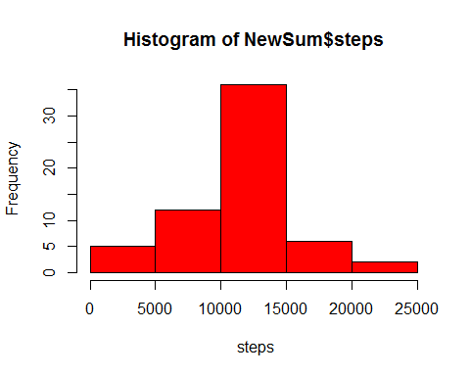
Capturing the Diferrence between Weekend and Weekday activity
#labeling Weekdays and weekends appropropiately
DayLabel <- function(date) {
day <- weekdays(date)
if (day %in% c('Monday', 'Tuesday', 'Wednesday', 'Thursday', 'Friday'))
return ("weekeday")
else if (day %in% c('Saturday', 'Sunday'))
return ("weekend")
else
stop ("Invalid Date Format.")
}
datafile1$date <- as.Date(datafile1$date)
datafile1$day <- sapply(datafile1$date, FUN = DayLabel)
Plotting the Data
LabelMean <- aggregate(steps ~ interval + day, datafile1, mean)
head(LabelMean)
## interval day steps
## 1 0 weekeday 2.25115304
## 2 5 weekeday 0.44528302
## 3 10 weekeday 0.17316562
## 4 15 weekeday 0.19790356
## 5 20 weekeday 0.09895178
## 6 25 weekeday 1.59035639
#Plotting the Data
library(lattice)
xyplot(steps ~ interval | day, data = LabelMean, type = "l", xlab = "Interval",
ylab = "Number of steps", layout = c(1, 2))
