Using Pentaho Data Integration for validating PA JumpStart transaction data

Introduction

During a typical JumpStart project, we need to validate a customer’s transaction data, as this is the critical information that drives the pricing science effort to identify opportunities. To improve this critical phase of the project, and quickly identify problematic data, a transformation has been developed within the Pentaho Data Integration product to assist with this task.

Ultimately, this transformation is intended to take a single data file as input, the pricemart transaction data, and output two files: one which contains those records from the first file which validate correctly, and one which identifies those records that contain an error of some sort.

Required Software

To use the developed validation transformation, you will need the following software installed on your machine:

- Java Runtime Environment (or JDK), version 5 or later
- Pentaho Data Integration, version 3.2
- pa-jumpstart-validation.jar, which provides the supporting validation logic for the transformation
- pa-jumpstart-validation.ktr, the transformation

Configuration

Once you have installed the Java Runtime Environment, and un-zipped the Pentaho Data Integration software:

- Copy the pa-jumpstart-validation.jar file into the “libext” directory within the directory that you installed the Pentaho Data Integration software; for example, c:\data-integration\libext.
Using the Transformation

As each customer can have a different set of waterfall elements, the data in the transaction file is different for every customer. As such, some work is required to make the generic transformation supplied, pa-jumpstart-validation.ktr, applicable for each customer; the following list takes you step-by-step through the steps:

- Launch the “Spoon” user interface, by executing the spoon.bat or spoon.sh in the Pentaho Data Integration installation directory.
- At the “Select a repository” dialog, press the “No repository” button
- Select “File -> Open” and choose the pa-jumpstart-validation.ktr file supplied, and you should see a transformation that looks like:

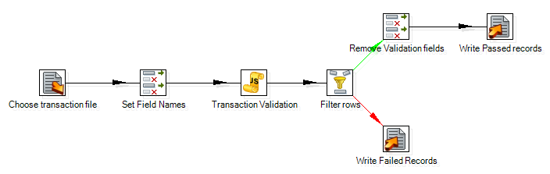

- Select File -> Save as… to save the transformation before you start configuring the transformation for your specific customer, for example customer-jumpstart-validation.ktr
- Double-click on the “Choose transaction file” icon, which will launch the following dialog:

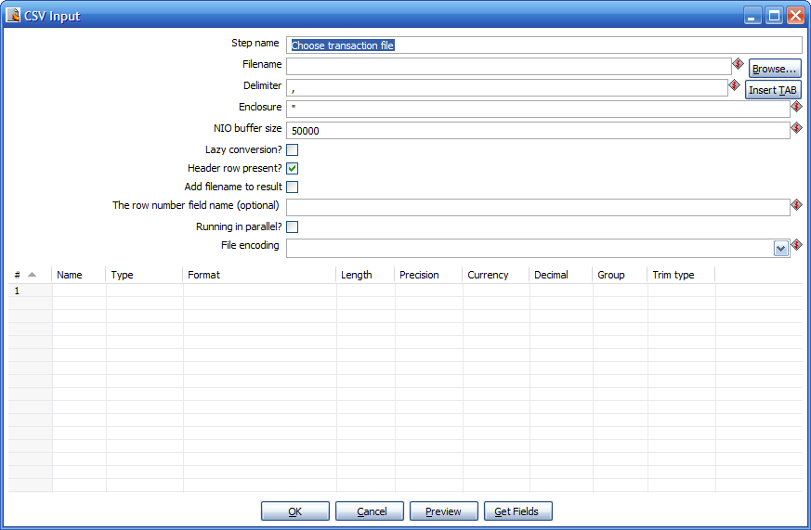

  - Click the “Browse…” button next to the “Filename” field
  - Choose the customer transaction file that you wish to validate
  - Once you have selected your file, and the field has been populated, click the “Get Fields” button at the bottom of the dialog; this will cause the “Sample size” dialog to appear:

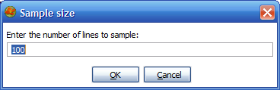

  - Click OK, and let the grid populate with the sampled data
  - Change the data in the grid, so that all fields are defined as:
    - Type – String
    - Format – blank
    - Length – maximum length of column data, for example 255
    - Precision – blank
    - Currency – blank
    - Decimal – blank
    - Group – blank
    - Trim type – none

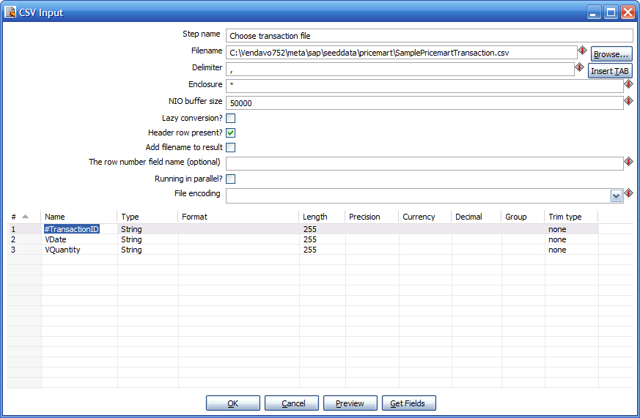

  - Click OK to confirm the changes you have made
- Double-click on the “Set Field Names” icon, which will launch the following dialog:

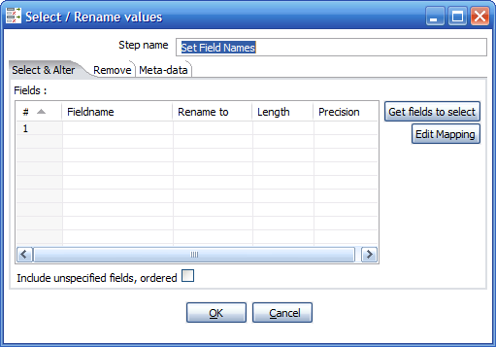

  - Click the “Get fields to select” button to populate the Fieldname column with the fields from the previous step in the transformation
  - In the “Rename to” column, enter a new field name for those fields that you wish to have validated based on the following scheme:

Field Name ends with | Validation Performed
-Adder | Validate as a positive number
-Date | Validate as a date of format dd-MMM-yy
-Percent | Validate as a number between 0 and 1
-Price | Validate as a positive number with a limit of 10 non-decimal and 2 decimal digits
-Quantity | Validate as a positive integer
-Subtractor | Validate as a negative number

  - Click OK to confirm the changes you have made
- Double-click on the “Transaction Validation” icon, which will launch the following dialog:

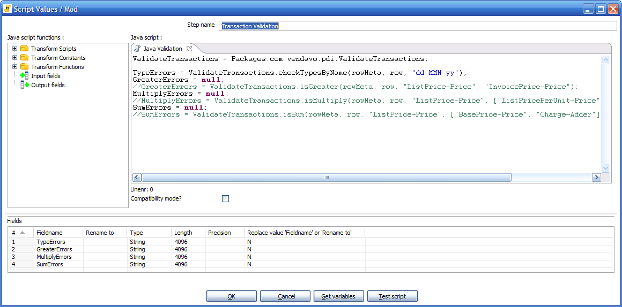

  - Adjust the Java script code based on the following scheme:

Validation to be Performed | Code Adjustment to perform
Validate fields based on their name, where the name ends with one of the suffixes listed above | - Ensure the line that starts “TypeErrors” is uncommented  - Change the 3rd argument to the checkTypesByName method to specify the pattern that you want to have any dates validated against
Validate that one price field has a higher value than another price field | - Uncomment the line that starts “//GreaterErrors”  - Change the 3rd argument to the isGreater method to specify the name of the field which should always have a higher value (“ListPrice-Price” in the example above)  - Change the 4th argument to the isGreater method to specify the name of the field which should always have a lower value (“InvoicePrice-Price” in the example above)
Validate that one price field is the result of multiplying two, or more, other fields | - Uncomment the line that starts “//MultiplyErrors”  - Change the 3rd argument to the isMultiply method to specify the name of the field which should always be the result of the multiplication (“ListPrice-Price” in the example above)  - Change the 4th argument to the isMultiply method to specify an array of field names that, when multiplied together, should match the above field (“ListPricePerUnit-Price” and “Quantity-Quantity” in the example above)
Validate that one price field is the sum of two, or more, other fields | - Uncomment the line that starts “//SumErrors”  - Change the 3rd argument to the isSum method to specify the name of the field which should be the sum (“ListPrice-Price” in the example above)  - Change the 4th argument to the isSum method to specify an array of field names that, when added together, should match the above field (“BasePrice-Price” and “Charge-Adder” in the example above)

  - Double-click on the “Write Failed Records” icon, which will launch the following dialog:

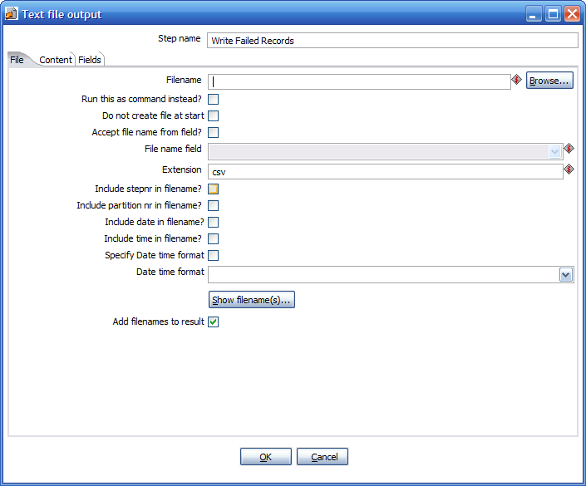

- Click the “Browse…” button next to the “Filename” field
  - Choose the file in which you wish to have failed records written
  - Navigate to the “Fields” tab
  - Click the “Get Fields” button to populate the grid
  - Click the “Minimal width” button to specify trimming of output
  - Click OK to confirm the changes you have made
- Double-click on the “Write Passed Records” icon, which will launch the following dialog:

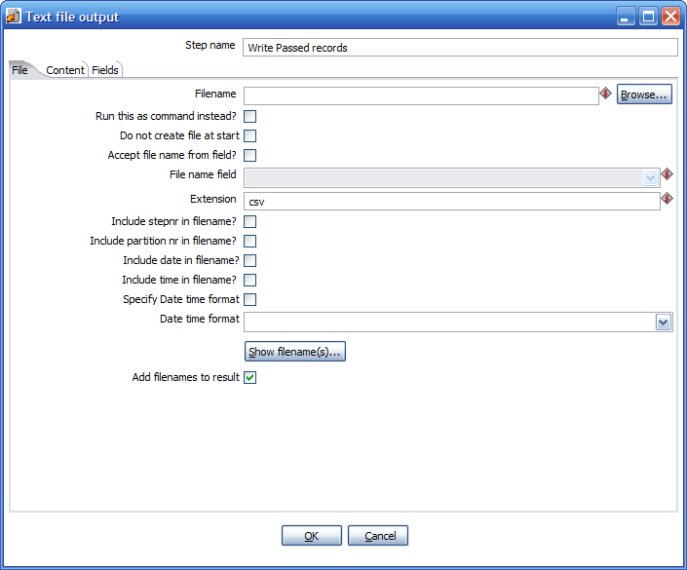

- Click the “Browse…” button next to the “Filename” field
- Choose the file in which you wish to have failed records written
- Navigate to the “Fields” tab
- Click the “Get Fields” button to populate the grid
- Click the “Minimal width” button to specify trimming of output
- Click OK to confirm the changes you have made
- From the main menu, select “File->Save” to save your changes to the transformation
- Now that you have made the necessary modifications, select “Transformation->Run” from the main menu to have the validation executed – the step metrics tab will show you how many records have been processed by each step in the transformation and, if no errors occurred, you can check the files specified in steps 6 & 7 to observe the failed and passed data

