**Thorlabs Imaging Data Store Library Specification**

**Overview:**

The new ImagingDataStoreLibrary is a common imaging data store library, used for all Thorlabs’s Imaging systems to save and load captured imaging data. The internal data structure is designed to be as close as possible to the open microscopy environment (OME) specification (<http://www.openmicroscopy.org>). The XML schema definition (XSD) is defined to exhibit maximum compatibility with the OME tiff and XML data formats. It can be opened by any software support OME tiff format.

**File Structure:**

The data files includes: One header file (OME TIFF), one additional file (ZIP), several scan data files (OME TIFF).

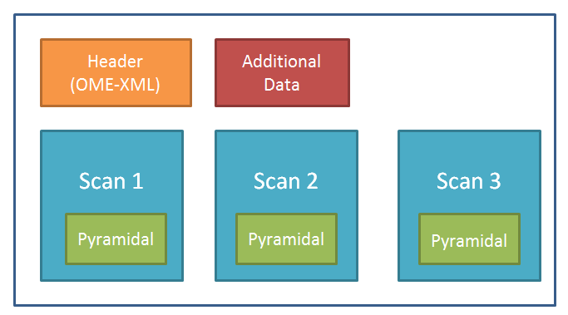

Header File: is tiff format, will only save the OME xml structure string in first directory image description.

Scan Data File: is tiff format, will save uncompressed raw data and related pyramidal format data. There may have more data files, that according to the count of the scans. One scan will have one tiff data file. The pyramidal data is optional that according to the whole scan area image size. It was saved as jpeg format in tiff. The ImagingDataStoreLibrary will have a function to auto generate it.

Additional File: is zip format, that for imaging system to save additional files (Example: ThorImage will save “Experiment.xml”, “ROIMask.raw”, “ROIs.xaml”; ThorOCT will save “Header.xml”; “VideoImage.data”; Envista will save “Experiment.envista”, “Experiment.xml”)

**Structure XML:**

**Plate (Slide) Info XML**: introduce the plate (slide) that includes the name, width, height, and internal wells’ info. Below is the example for 4 slide carrier.

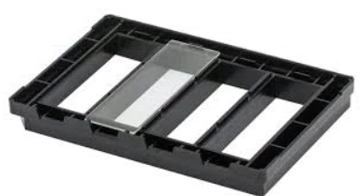

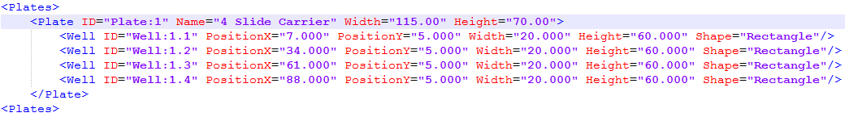

Plate Element:

|  |  |  |
| --- | --- | --- |
| **Attribute** | **Type** | **Description** |
| ID | string | Plate ID from(1~N) |
| Name | string | The plate type name |
| With | float | Physical width unit is mm |
| Height | float | Physical height unit is mm |

Well Element:

|  |  |  |
| --- | --- | --- |
| **Attribute** | **Type** | **Description** |
| ID | string | Well ID from(1~N), the id name should format with “Well:{Plate ID}.{Well ID}” |
| PositionX | float | x potion of the plate |
| PositionY | float | y potion of the plate |
| Width | float | width of the well |
| Height | float | height of the well |
| Shape | string | “Rectangle” or “Ellipse” |

**Scan Info XML**: introduce the scan information.

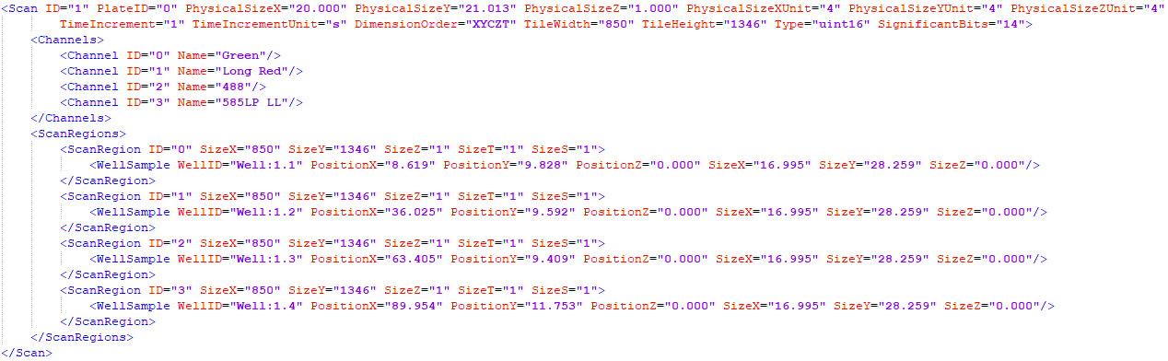

Scan element define one scan use same objective with same pixel size resolution, tile size, channels. The detailed information of attribute PixelType see link (<http://www.openmicroscopy.org/Schemas/Documentation/Generated/OME-2016-06/ome_xsd.html#PixelType> )

|  |  |  |
| --- | --- | --- |
| **Attribute** | **Type** | **Description** |
| ID | string | Id of scan, from(1~N) |
| PhysicalSizeX | float | X physical size |
| PhysicalSizeY | float | Y physical size |
| PhysicalSizeZ | float | Z physical size |
| PhysicalUnit | string | Pixel size unit (um, mm, cm) |
| TimeIncrementUnit | string | The units of the TimeIncrement - default:seconds[s] |
| DimensionOrder | string | The order in which the individual planes of data are interleaved. |
| TileWidth | uint32 | The scan tile width |
| TileHeight | uint32 | The scan tile height |
| Type | [PixelType](http://www.openmicroscopy.org/Schemas/Documentation/Generated/OME-2016-06/ome_xsd.html#PixelType) | The variable type used to represent each pixel in the image. |
| SignificantBits | uint32 | The number of bits within the type storing each pixel that are significant.  e.g. you can store 12 bit data within a 16 bit type.  This does not reduce the storage requirements but can be a useful indicator  when processing or viewing the image data. |

Channel element that with the ID and name.

|  |  |  |
| --- | --- | --- |
| **Attribute** | **Type** | **Description** |
| ID | uint32 | Id of channel, from(0~N) |
| Name | string | The channel description(name or waveform) |

ScanRegion element that define the Scan ROI image information

|  |  |  |
| --- | --- | --- |
| **Attribute** | **Type** | **Description** |
| ID | uint32 | Id of scan region(ROI), from(0~N) |
| SizeX | uint32 | X dimensional pixels of scan region image, from(1~N) |
| SizeY | uint32 | y dimensional pixels of scan region image , from(1~N) |
| SizeZ | uint32 | Z dimensional pixels of scan region image , from(1~N) |
| SizeT | uint32 | T frame count, from(1~N) |
| SizeS | uint32 | Stream frame count, from(1~N) |

WellSample element that define the Scan ROI physical information

|  |  |  |
| --- | --- | --- |
| **Attribute** | **Type** | **Description** |
| WellID | string | The well id in plate |
| PositionX | float | Physical x postion |
| PositionY | float | Physical y postion |
| PositionZ | float | Physical z postion |
| SizeX | float | The physical width of roi |
| SizeY | float | The physical height of roi |
| SizeZ | float | The physical depth of roi |

Below is an example for 2 scans, scan1 with one scan region, scan2 with 2 scan regions, so there will have four files.

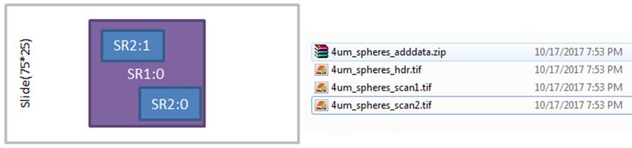

Scan xml:

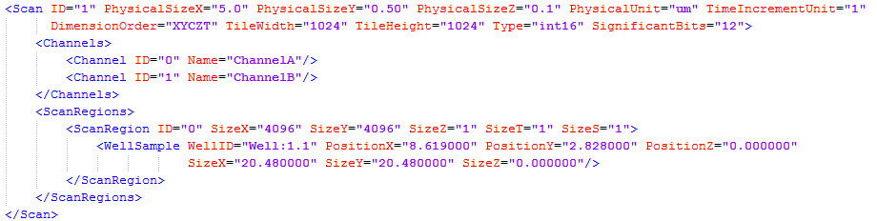

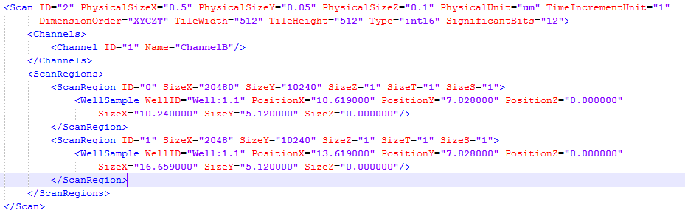

Plate xml



**Interfaces:**

The follow list show all available functions for the ImagingDataStoreLibrary. Details see “ImagingDataStoreLibrary.h”

|  |  |
| --- | --- |
| Functions | Description |
| fnAISS_open_file | open or create imaging file. |
| fnAISS_close_file | close imaging file. |
| fnAISS_clean_data | clean whole data. |
| fnAISS_set_plates_info | set plates information. |
| fnAISS_get_plates_info_size | get plates information xml string size. |
| fnAISS_get_plates_info | get plates information xml string. |
| fnAISS_add_scan_info | add new scan information. |
| fnAISS_get_scans_info_size | get scans information xml string size. |
| fnAISS_get_scans_info | get scans information xml string. |
| fnAISS_remove_scan | remove scan information and data. |
| fnAISS_save_tile_data | save captured tile image of special scan region. |
| fnAISS_get_raw_data | get scan region roi image raw data. |
| fnAISS_get_scaled_data | get scaled scan region roi image data, the pixel type of image data is always unsigned char. |
| fnAISS_generate_Pyramidal_data | auto generate the pyramidal(low level) image data, that according to scan region image size. |
| fnAISS_save_additional_data | save additional data with name. |
| fnAISS_get_additional_data_size | get additional data size. |
| fnAISS_get_additional_data | get additional data. |
| fnAISS_delete_additional_data | delete additional data. |
| fnAISS_set_field | set field to imaging file. |