

Department of Statistics, University of Auckland
Summer Scholarship 2014-2015

The OpenAPI Project

Name: Christopher Alan James Pearce
Supervisor: Paul Murrell
Degree: LLB/BSc Conjoint

Summer scholarship experience
This scholarship provided a strong basis for me to develop my programming skills. My career plans involve graduating with a background in computer science and statistics and working in a programming environment. Working for 10 weeks in this environment has given me a strong work ethic and has taught me a lot about the skills required.
I have never before worked with geographical data. Geographical data is of extreme interest to me given the latest developments in infographics technology. The geography of New Zealand, and the world at large, will become ever more prevalent in the coming decades. I now have the skills to experiment with geographical information and graphical interfaces.
This project has also provided me with data processing skills. I have always been interested in this field, and a lot of this project has been based around data management. It has piqued my interest to the point that I plan on taking data management papers in my future years of study and I am hoping to further my research in the area.

Summary
The goal of my summer research project was to explore potential uses for the OpenAPI framework. The motivation behind the creation of OpenAPI is to make it easier to connect people with data. It provides a uniform method of coding with an emphasis on statistics. It allows individuals to reuse work written by others; essentially it attempts to crowdsource code written by statisticians working with open government data.
OpenAPI is in its infancy. My job this summer was to write analyses using OpenAPI in conjunction with open government data. As such I explored a few areas of statistics I am interested using census data, tide data, geographical information and more. Since I was fresh to OpenAPI my job was to bug test the framework itself and provide suggestions based on my programming experience.
Nearing the end of my project I wrote my own 'glue system', which is essentially the engine behind OpenAPI. I wrote it in the python programming language, an entirely different language to the environment I was originally using to test the framework. OpenAPI is just a framework in itself; the glue system is what reads the framework and actually runs the code. By writing a new glue system from scratch it provided a useful standpoint for comparing the two systems, and in providing ideas for future development.
Hopefully the significance of OpenAPI will be widespread in the coming years, as it will allow statisticians to release generalised code that anyone can use (and as such limiting the rewriting of code to process the same data).

Abstract
My project was to explore the uses of the OpenAPI framework. The framework was originally developed so that anyone could take different pieces of code and piece it together in a meaningful way. My purpose for the project was predominantly to explore whether this system would be robust enough to be useful in a real world context. I approached the task by performing analyses on data that interested me with the goal of finding bugs and, where bugs were not found, write the code in a way that would be reusable.
I was mainly taken on bard as a bug tester. I came across several trivial bugs, and a few major talking points that shaped the development of the project. My own glue system differed from the original enough to provide some major talking points of its own. I found that on the whole the system was viable enough to be useful in a real world context, and it was easy to use once I got the hang of things.
The outcome of my pipelines were of less interest to the project than the process by which I reached them. With several of my pipelines I managed to recreate the result on multiple computers. This was of extreme importance to my mentor Paul Murrell, as this is the entire purpose of the project.

Table of contents

Summer scholarship experience 2
Summary 3
Abstract 4
1.0 Introduction 6
2.0 Methods 7
3.0 Results 8
4.0 Conclusions 9
5.0 References 10

1.0 Introduction
The OpenAPI framework was originally created so that individual statisticians could take code from all over the internet and combine it in a useful manner. Each piece of code would be referred to as a module and generally requires inputs and outputs. An overarching pipeline would be written that essentially connects inputs to outputs. It could be visualised as a code version of an Arduino; bringing together different generalised functions that can be linked together in a meaningful way. If this were done regularly by even a small percentage of prominent New Zealand statisticians, the eventual goal is that lay persons would use their code, add a bit of their own expertise, and come up with interesting data that could be used elsewhere.
My purpose for the project was predominantly to explore whether this system would be robust enough to be useful in a real world context. My job was essentially to perform analyses I would normally do and see how often I was repeating my work. More often than not I found this was the case. Since I was repeating code a lot to read in certain data formats, it started to make sense to me why this project would be useful. If I could release this code and make it usable to the general public, then it would be a less threatening task for other people to use my code for their own purposes. People not experienced in statistics or computer programming but highly specialised in other areas may be drawn to using my code to explore further than I ever could envisage. For example, a geographer may have no clue how to write code manipulating GIS data, but since I have already written code that uses it and provides standard inputs, it could make computer work for geographers a much easier process. This is a very linear example, and it could apply to all fields of work which could benefit from computer power but has little focus on it.
My goal was to write statistical analyses using the OpenAPI framework, using pipelines and modules. I wrote a variety of pipelines using data sourced from Wikipedia, the NZ census, LINZ, and more. Each of these pipelines were designed to test a different area of code that could potentially cause problems, and figure out a way around these problems.

2.0 Methods
I approached my task by performing statistical analyses on data that interested me using the OpenAPI framework.
I programmed these pipelines in R 3.1.2 and Python 2.7.3 using a Linux environment. All of my code can be found at my github: https://github.com/cajpearce/Studentship.
My project involved creating XML documents attached to each individual code segment representing modules, an overarching pipeline XML document, followed by reading it into Conduit (the glue system) and running the pipeline. Examples can be found at my github mentioned above.
My glue system can be found in the PyGlue folder as pipeline.py. You must install rpy2 and lxml first to run my glue system. Future developments could involve releasing this as a python library.
To run it, copy and paste the pipeline.py file to a directory with the completed OpenAPI pipeline. Currently python pipelines are unstable and should only be run in Conduit. Open up a python 2.7.3 kernel in the directory and type
execfile(“pipeline.py”)
p = Pipeline(“example.xml”)
p.run_pipeline()
A good, working example is that of ManDroughtFix. However, you will need to modify dat.r to provide your local path files and also you will need to download the GIS data. This is all specified in the readme.
The readme for ManDroughtFix explains the process. Module 0 provides key information, module 1 opens the data census data and manipulates it, module 2 creates the p values, module 3 creates the colours and module 4 plots the data. Each variable passed between modules is specified in the XML documents. If it isn't specified in the XML document it cannot be passed. This encourages good coding practice.

3.0 Results
I was a bug tester for my research, so a large amount of my results were bugs.
The first major issue I came across was the specification of modules for input 'files'. OpenAPI could only process inputs and outputs using modules and pipelines, which are essentially wrappers for code. This was problematic when I was trying to provide an external data file (e.g. a census .CSV data file). Depending on which glue system I was using there were different ways of specifying where to locate that file. This was bad for OpenAPI. We realised it would be better to provide external data as an input or output and to make this a key part of OpenAPI. This has not yet been implemented but will be in the future.
The second issue I came across was user input inside of modules. When I was using Conduit, an R module would run without any user input (even if explicitly coded to accept user input) since it ran R in batch mode. However there is no 'batch mode' in python. Thus lies the discrepancy. The purpose of OpenAPI is to make each module a closed box, with the only inputs and outputs being pre-specified by the module XML itself. Unfortunately, python broke this framework by allowing me to provide my own 'input()': which waits for the user to type in something in the kernel. This went against the desired outcome for OpenAPI, and has not yet been fixed.
Another issue I discovered was the order of pipes. Due to the nature of OpenAPI being developed in an open source way and also due to the above problem, the order of modules could be problematic once OpenAPI is released to the general public. I discovered that node graph theory could not always work properly if a module was coded to expect different user input. The example I used is in Figure 1. The pipeline in Figure 1 will not work in Conduit, though it could work in my PyGlue using R. In the example, module 4 will need to be run before module 5. There is currently no way to specify this. The problem arose when I pointed out that this pipeline could be modified as in Figure 2. By changing the order of input and output between module 2 and module 3 it is evident that there is going to be some error regarding order if module 4 is supposed to be run before module 5. Currently there is no way to specify this order.
I also found that python would not work very well in my PyGlue system, and I did not find a way to fix this.
Other than these problems, my pipelines worked. On multiple pipelines I managed to recreate the result on multiple computers. This was beneficial to OpenAPI as it showed that the framework was effective and can be used in the real world.

Figure 1:
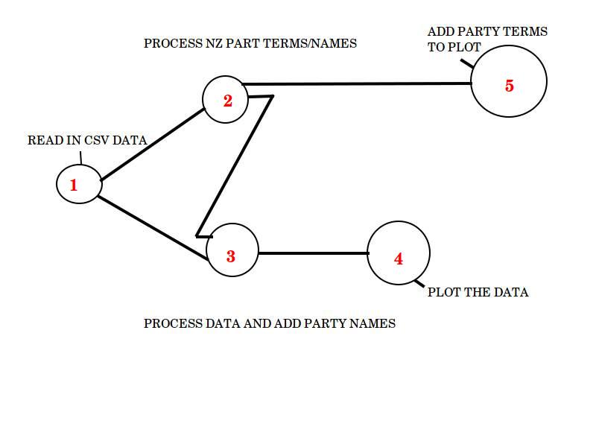

Figure 2:
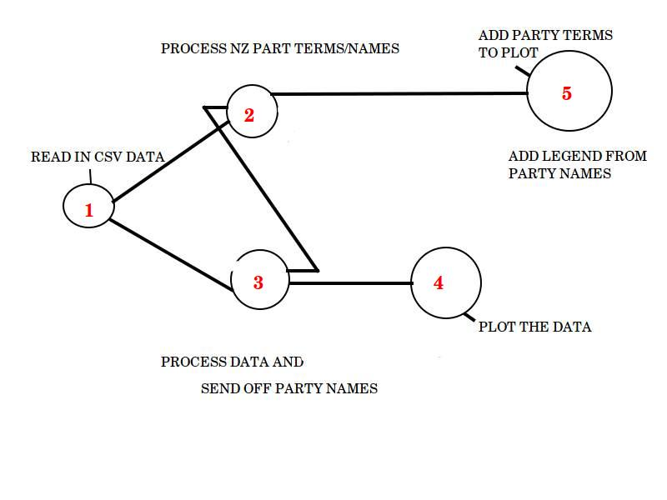

4.0 Conclusions
In conclusion I found the OpenAPI framework to be a robust system. It allowed me to reuse code that I had previously written in an immediately obvious way.
The reusability of code was a big goal in my project. I found immediately that a few pieces of code I had written were useful in most analyses I was writing. This proved to be very promising for OpenAPI as a whole as this was a major purpose of its creation. Overall the pipelines worked exactly as planned. Some code had to be rewritten to work in other pipelines but on the whole this took me much less time than rewriting this code from scratch.
In my role as a bug tester, I successfully uncovered a series of bugs that provided future discussions. I discovered several non trivial bugs that were fixed immediately and helped to refine the OpenAPI project. A few larger bugs (which I have mentioned in section 3.0) have provided valuable discussion on the purpose of the project. It has helped shape and define what OpenAPI is meant to be.
In conclusion my project has helped to shape the direction of OpenAPI and finetune it for future development. I have provided some examples that will be useful in explaining the project to new users, and I have hopefully uncovered many bugs that were not present in the original format.

5.0 References
https://www.stat.auckland.ac.nz/~paul/Talks/OpenAPI2014/openapi.html
https://www.stat.auckland.ac.nz/~joh024/LitReviews/LitReview_NZOpenData.pdf

