**ArduinoBoy**

**A “Modern” Retro Game Console**

ДОКУМЕНТАЦИЯ

**ИЗГОТВИЛИ:**

Божидар Андонов

Петко Люцканов

СЪДЪРЖАНИЕ

Списък от компоненти 3

Описание 4

Електрическа схема 5

Блок схема 6

Описание на функционалността 7

Сорс код 8

Заключение 9

# Списък от компоненти

1. Arduino Uno

2. Bluetooth HC-05 модул

3. MAX7219 модули за контролиране на LED матриците(x2)

4. LED матрици 8x8(x2)

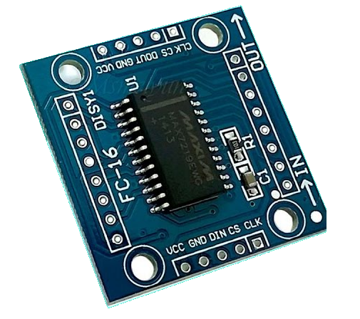

Фигура 4- MAX7219 модул, контролиращ LED матриците4

Фигура 3- LED матрицата, чрез която визуално се представят игрите

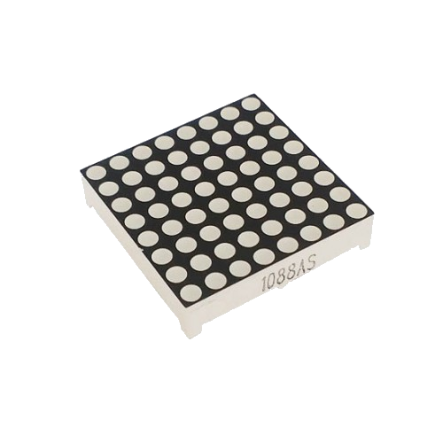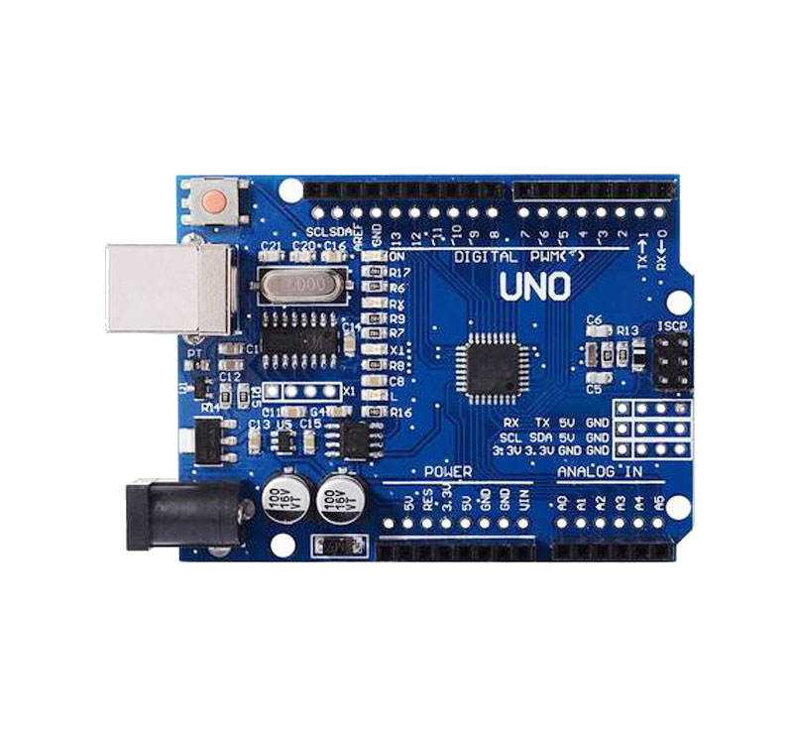

Фигура 2- Bluetooth HC-05 модул, предаваш информация към и от микроконтролера

Фигура 1- Arduino Uno, микроконтрелора, който извършва всички операции

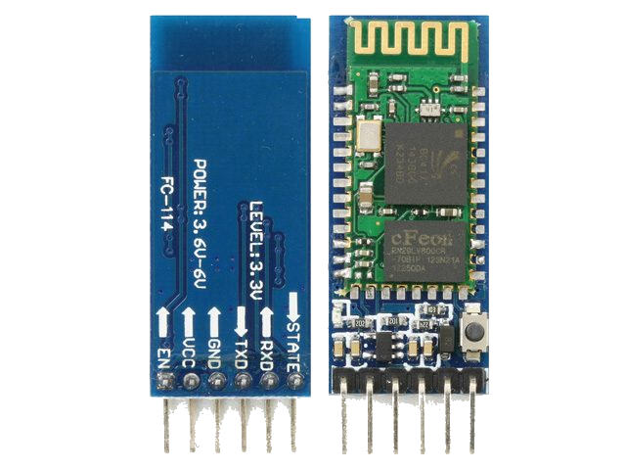

# Описание

# Електрическа схема

Фигура 5 - Електрическа схема

# Блок схема

Гтгтщк

# Описание на функционалността

Огаожж

# Сорс код

Това е целият код използван за програмиране на Arduino Uno-то. Първо инициализираме основните променливи, които ще използваме по време на изпълнение на приложението. Определяме и sprite-ове, които предефинират какво да се покаже на дисплея когато бъдат извикани.

#include <ArduinoSTL.h>

#include <LedControl.h>

#include <vector>

#define DINPin 11 // DataIn pin for the MAX7219 module

#define CSPin 12 // Load pin for the MAX7219 module

#define CLKPin 13 // Clock pin for the MAX7219 module

// The following are all used structs within the project

// Location is used to map certain game elements to the LED matrix

struct Location

{

byte x; // [0-15] the row index of the element

byte y; // [0-7] the column index of the element

};

// This struct is specifically made for the tetris game and is used to

// track where the tetromino is.

struct Tetromino

{

// All of the blocks represent one location element, so that the tetromino

// can be displayed properly

Location block1;

Location block2;

Location block3;

Location block4;

Location center; // The center is used to determine the rotation point of the tetromino

};

// This struct is used to locate both the A.I. paddle and the player controlled one in the Pong game

struct Paddle

{

// It consists of two Location objects as well, they determine where the paddle is located

Location block1;

Location block2;

};

// Direction is a struct, used in the pong game and its purpose is to determine what

// direction the ball will move in.

struct Direction

{

short x; // [-1...1] the row direction, -1 is upwards, 1 is downwards

short y; // [-1...1] the column direction, -1 is left, 1 is right

};

// All of the following are sprites, which are used to display generic information

// on the LED displays when an event is fired. All of them are in binary, represents

// whether the light is on or off.

// The sprite used in the game over screen.

byte gameOverSprite[16] =

{

B11110110,

B10001001,

B10111111,

B10011001,

B11111001,

0,

B10001111,

B11011100,

B10101111,

B10001100,

B10001111,

0,

B11110100,

B10110100,

B10110100,

B11101010

};

// These sprites are only used in the Pong game.

// These are the digits from 0 to 9

byte numberSprites[10][8]

{

{

B00000000, // 0

B00111100,

B00100100,

B00100100,

B00100100,

B00100100,

B00111100,

B00000000

},

{

B00000000, // 1

B00001000,

B00011000,

B00001000,

B00001000,

B00001000,

B00001000,

B00000000

},

{

B00000000, // 2

B00111100,

B00000100,

B00111100,

B00100000,

B00100000,

B00111100,

B00000000

},

{

B00000000, // 3

B00111100,

B00000100,

B00111100,

B00000100,

B00000100,

B00111100,

B00000000

},

{

B00000000, // 4

B00100100,

B00100100,

B00100100,

B00111100,

B00000100,

B00000100,

B00000000

},

{

B00000000, // 5

B00111100,

B00100000,

B00111100,

B00000100,

B00000100,

B00111100,

00000000

},

{

B00000000, // 6

B00111100,

B00100000,

B00111100,

B00100100,

B00100100,

B00111100,

B00000000

},

{

B00000000, // 7

B00111100,

B00100100,

B00000100,

B00000100,

B00000100,

B00000100,

B00000000

},

{

B00000000, // 8

B00111100,

B00100100,

B00111100,

B00100100,

B00100100,

B00111100,

B00000000

},

{

B00000000, //9

B00111100,

B00100100,

B00111100,

B00000100,

B00000100,

B00111100,

B00000000

}

};

// This sprite is used to tell the player that they has won the pong game.

byte winSprite[16]

{

B01010100,

B01010100,

B01010100,

B01010100,

B00101000,

B00111000,

B00010000,

B00010000,

B00010000,

B00010000,

B00111000,

B01000100,

B01100100,

B01010100,

B01001100,

B01000100

};

// This sprite is used to tell the player that they have lost the game

byte lossSprite[16]

{

B00000000,

B00000000,

B10001110,

B10001010,

B10001010,

B10001010,

B11101110,

B00000000,

B00000000,

B11101110,

B10001000,

B11101110,

B00100010,

B11101110,

B00000000,

B00000000

};

// The following variables are used by all of the games

LedControl matrixController(DINPin, CLKPin, CSPin, 2); // The controller for the LED matrix.

unsigned long timer; // timer, which uses the millis() function to determine when certain events should be fired.

bool isGameOver; // Variable, which determines whether the current game is over.

int playerScore; // Variable, used to store the player's current score.

// The following variables are used by the Tetris game

Tetromino tetromino; // The tetromino that the user currently has control of

bool tetrisMatrix[16][8]; // The matrix, used to determine which LEDs turn on

short fallingTetrominoDelay; // The delay used to determine how long it will be until the tetromino goes down one step.

// The following variables are used by the Snake game

char prevDirection; // The previous direction the snake followed.

char direction; // The current direction the snake is following

Location food; // The row and column coordinates of the food.

bool foodState; // Determines what state the blinking food is in (true -> LED on, false -> LED off)

След това декларираме основните методи, за да работи ардуиното – setup() и loop(), в които нулираме основни променливи и чакаме потребителя да избере игра. Метод playSnake() e основният метод, контролиращ играта “Snake”, а setupSnake() е този, който я подготвя преди всеки неин пуск.

short const scorePerFood = 10; // A constant used to determine how many points each eaten food gives.

short snakeMovementDelay; // The delay used to determine how long it will be until the snake follows the current direction again

std::vector<Location> snake; // A vector, containing all of the coordinates of the snake.

// Pong following variables are used by the Pong game

Paddle playerPaddle; // The paddle controlled by the player

Paddle aiPaddle; // The paddle controlled by the A.I.

Location ball; // The current location of the ball.

Direction ballDirection; // The direction in which the ball is going in

byte const pointsToWin = 10; // A constant, used to determine how many points each side needs to win the Pong game

short const aiMovementDelay = 220; // The constraint, which makes it impossible for the A.I. to win every game.

short ballDelay; // The delay used to determine how long it will be until the ball changes its position

unsigned long aiTimer; // An additional timer, whose purpose is to determine whether the A.I. can move its paddle yet.

int numberOfHits; // Number of times the ball was hit by either of the players. Each time it is hit, the velocity of the ball increases.

int aiScore; // An additional score counter, used for the A.I.

void setup()

{

// Open the serial port for communication

Serial.begin(9600);

// Wake the LED boards up

matrixController.shutdown(0, false);

matrixController.shutdown(1, false);

// Set the intensity of the display

matrixController.setIntensity(0, 0);

matrixController.setIntensity(1, 0);

// Clear the display

matrixController.clearDisplay(0);

matrixController.clearDisplay(1);

// Giving a random seed, so that the games spawn random items in random locations. Uses

// the noise the A0 port

randomSeed(analogRead(A0));

}

void loop()

{

// Wait for a signal from the smartphone app. Once a game is selected

// on the phone, the function responsible for the game is called.

if (Serial.available() >= 0)

{

char requestedGame = Serial.read();

if (requestedGame == 'T')

{

playTetris();

}

else if (requestedGame == 'S')

{

playSnake();

}

else if (requestedGame == 'P')

{

playPong();

}

}

}

// The following methods are used to play the SNAKE game.

// This method is the main one, responsible for running the SNAKE game.

void playSnake()

{

setupSnake();

// Start the timer

timer = millis();

while (!isGameOver)

{

// When information is sent through the mobile application, it is interpreted here.

if (Serial.available() >= 0)

{

char input = Serial.read();

// 'L' - Left; 'R' - Right; 'D' - Down; 'U' - Up

if (input == 'L' || input == 'R' || input == 'D' || input == 'U')

{

char prevDirection = direction;

char newDirection = input;

direction = changeSnakeDirection(prevDirection, newDirection);

}

}

// When a certain time passes, move the snake in the selected direction

if (millis() - timer >= snakeMovementDelay)

{

timer = millis();

moveSnake();

}

}

displayGameOverScreen();

}

// This method is used to setup the Snake game every time before it is run.

void setupSnake()

{

//Setting variables to their default starting values

isGameOver = false;

playerScore = 0;

foodState = true;

snakeMovementDelay = 800;

// If anything from the snake in the last game remained, it's cleared.

while (!snake.empty())

{

snake.pop_back();

}

// Set the starting location for the snake

Location startingBlock;

startingBlock.x = 7;

startingBlock.y = 4;

snake.push_back(startingBlock);

startingBlock.x = 7;

startingBlock.y = 3;

snake.push_back(startingBlock);

startingBlock.x = 7;

startingBlock.y = 2;

snake.push_back(startingBlock);

// Get a new food location and then display the game on the LED matrices

newFood();

printSnakeGameBoard();

}

// This method is used to change the direction of the snake

char changeSnakeDirection(char prevDirection, char newDirection)

{

// If the previous direction is exactly the opposite to the requested one,

// ex. Left and Right, then don't change it (The snake can't turn 180 degrees)

switch (newDirection)

{

case 'R':

if (prevDirection == 'L')

{

return 'L';

}

else return 'R';

break;

case 'L':

if (prevDirection == 'R')

{

return 'R';

}

else return 'L';

break;

case 'D':

if (prevDirection == 'U')

{

return 'U';

}

else return 'D';

break;

case 'U':

if (prevDirection == 'D')

{

return 'D';

}

else return 'U';

break;

}

}

// This method is used to generate a new food when the previous one has been collected by the snake.

void newFood()

{

bool needNewLocation = true; // Used to determine whether the generated location overlaps with the snake.

byte x, y; // The coordinates for the new food.

while (needNewLocation)

{

x = random(0, 15);

y = random(0, 7);

// Checking whether the generated location overlaps with the snake

for (std::vector<Location>::iterator i = snake.begin(); i != snake.end(); i++)

{

if (i -> x == x && i -> y == y)

{

needNewLocation = true;

break;

}

else needNewLocation = false;

}

if (!needNewLocation)

{

food.x = x;

food.y = y;

}

}

// Display the new food alongside the snake

printSnakeGameBoard();

}

// This method is used to display the Snake game elements

void printSnakeGameBoard()

{

// Clear the displays

matrixController.clearDisplay(0);

matrixController.clearDisplay(1);

// Determine what state of the LED of the blinking food must be in - On or off

foodState = !foodState;

matrixController.setLed(food.x / 8, food.x % 8, food.y, foodState);

// Light up the snake

for (std::vector<Location>::iterator i = snake.begin(); i != snake.end(); i++)

{

matrixController.setLed(i -> x / 8, i -> x % 8, i -> y, true);

}

}

// This method is used to turn off all LEDs associated with the snake itself

void turnOffOldSnakeLocation()

{

for (std::vector<Location>::iterator i = snake.begin() + 1; i != snake.end(); i++)

{

matrixController.setLed(i -> x / 8, i -> x % 8, i -> y, false);

}

}

// This method is responsible for making the snake move

void moveSnake()

{

turnOffOldSnakeLocation();

// Get the back and the front of the snake

Location backLocation = snake.back();

snake.pop_back();

Location frontLocation = snake.front();

// Get the new location of the front of the snake, dependent on the

// direction it moves in. If it goes outside the matrix, it will return

// from the other side.

Location newFrontLocation;

switch (direction)

{

case 'R':

{

newFrontLocation.x = frontLocation.x;

newFrontLocation.y = (frontLocation.y + 1) % 8;

break;

}

case 'L':

{

newFrontLocation.x = frontLocation.x;

if (frontLocation.y == 0)

{

newFrontLocation.y = 7;

}

else newFrontLocation.y = frontLocation.y - 1;

break;

}

case 'D':

{

newFrontLocation.x = (frontLocation.x + 1) % 16;

newFrontLocation.y = frontLocation.y;

break;

}

case 'U':

{

if (frontLocation.x == 0)

{

newFrontLocation.x = 15;

}

else newFrontLocation.x = frontLocation.x - 1;

newFrontLocation.y = frontLocation.y;

break;

}

}

// Insert the new front location into the snake vector and collect food if the

// snake overlaps with it

snake.insert(snake.begin(), newFrontLocation);

collectFood(backLocation);

printSnakeGameBoard();

checkIfSnakeGameOver();

}

// This method is responsible for enlarging the snake when food is collected

// and adds points to the score counter for doing so.

void collectFood(Location backLocation)

{

if (snake[0].x == food.x && snake[0].y == food.y)

{

snake.push_back(backLocation);

addSnakeScore();

newFood();

}

}

// This method is used to add points to the score counter and send that

// information to the mobile phone, which on its turn displays it.

void addSnakeScore()

{

playerScore += scorePerFood;

String stringToPrint = "C" + String(playerScore);

Serial.print(stringToPrint);

setNewSnakeSpeed();

}

// This method manages how fast the snake is moving. The more one progresses,

// the faster the snake becomes.

void setNewSnakeSpeed()

{

if (snakeMovementDelay > 300)

{

snakeMovementDelay -= 10;

}

}

// This method is responsible for determining whether it is game over.

void checkIfSnakeGameOver()

{

// Determine whether the front of the snake collides with a part of its body.

// If that's the case, then it is game over and the game stops.

Location front = snake.front();

byte count = 0;

for (std::vector<Location>::iterator i = snake.begin(); i != snake.end(); i++)

{

if (front.x == i -> x && front.y == i -> y)

{

count++;

}

}

if (count > 1)

{

isGameOver = true;

}

}

// The following methods are used for playing the TETRIS game

// This is the main method, used to play the tetris game.

void playTetris()

{

setupTetris();

// Start the timer

timer = millis();

while (!isGameOver)

{

// This is triggered when it is time for the tetromino to go down one step

if (millis() - timer >= fallingTetrominoDelay)

{

timer = millis();

shiftDown();

String stringToPrint = "C" + String(playerScore);

Serial.print(stringToPrint);

}

// Managing user input.

if (Serial.available() > 0)

{

char command = Serial.read();

if (command == 'L')

{

shiftLeft();

}

else if (command == 'R')

{

shiftRight();

}

else if (command == 'A')

{

rotate(-1, 1);

}

else if (command == 'B')

{

rotate(1, -1);

}

else if (command == 'D')

{

fastForward();

}

}

}

displayGameOverScreen();

}

// This method is used to setup the tetris game

void setupTetris()

{

// Assign default values to the variables.

playerScore = 0;

fallingTetrominoDelay = 1000;

isGameOver = false;

// Clear the tetris matrix if something remains from the last game and

// get the first tetromino

for (int i = 0; i < 16; i++)

{

for (int j = 0; j < 8; j++)

{

tetrisMatrix[i][j] = false;

}

}

getNewTetromino();

}

// This method is responsible for fast-forwarding the placement

// of the tetromino when the Down button has been pressed

void fastForward()

{

while (tetrisMatrix[tetromino.block1.x + 1][tetromino.block1.y] != 1 &&

tetrisMatrix[tetromino.block2.x + 1][tetromino.block2.y] != 1 &&

tetrisMatrix[tetromino.block3.x + 1][tetromino.block3.y] != 1 &&

tetrisMatrix[tetromino.block4.x + 1][tetromino.block4.y] != 1 &&

tetromino.block1.x != 15 && tetromino.block2.x != 15 &&

tetromino.block3.x != 15 && tetromino.block4.x != 15)

{

shiftDown();

delay(fallingTetrominoDelay / 7);

}

}

// This method is used to rotate the tetromino in the best way possible

// in a clockwise or anti-clockwise direction.

void rotate(int rotationXIndex, int rotationYIndex)

{

// The center is zero only when it is the 'O' tetromino

if (tetromino.center.x == 0 && tetromino.center.y == 0)

{

return;

}

turnOffOldTetrominoLocation();

// The numbers on those variables correspond to the Tetromino struct ones.

// This algorithm is used to determine where the new blocks will be located

// after the rotation.

Location tempPosition1, tempPosition2, tempPosition3, tempPosition4;

Location relativePosition1, relativePosition2, relativePosition3, relativePosition4;

Location newLocation1, newLocation2, newLocation3, newLocation4;

tempPosition1.x = tetromino.block1.x - tetromino.center.x;

tempPosition1.y = tetromino.block1.y - tetromino.center.y;

relativePosition1.x = rotationXIndex * tempPosition1.y;

relativePosition1.y = rotationYIndex * tempPosition1.x;

newLocation1.x = tetromino.center.x + relativePosition1.x;

newLocation1.y = tetromino.center.y + relativePosition1.y;

tempPosition2.x = tetromino.block2.x - tetromino.center.x;

tempPosition2.y = tetromino.block2.y - tetromino.center.y;

relativePosition2.x = rotationXIndex * tempPosition2.y;

relativePosition2.y = rotationYIndex * tempPosition2.x;

newLocation2.x = tetromino.center.x + relativePosition2.x;

newLocation2.y = tetromino.center.y + relativePosition2.y;

tempPosition3.x = tetromino.block3.x - tetromino.center.x;

tempPosition3.y = tetromino.block3.y - tetromino.center.y;

relativePosition3.x = rotationXIndex * tempPosition3.y;

relativePosition3.y = rotationYIndex * tempPosition3.x;

newLocation3.x = tetromino.center.x + relativePosition3.x;

newLocation3.y = tetromino.center.y + relativePosition3.y;

tempPosition4.x = tetromino.block4.x - tetromino.center.x;

tempPosition4.y = tetromino.block4.y - tetromino.center.y;

relativePosition4.x = rotationXIndex * tempPosition4.y;

relativePosition4.y = rotationYIndex * tempPosition4.x;

newLocation4.x = tetromino.center.x + relativePosition4.x;

newLocation4.y = tetromino.center.y + relativePosition4.y;

// When the new location is overlapping with an already placed

// tetromino or is outside the bounds of the screen, the rotation

// is not completed.

if (newLocation1.x < 0 || newLocation1.x > 15 ||

newLocation1.y < 0 || newLocation1.y > 7 ||

newLocation2.x < 0 || newLocation2.x > 15 ||

newLocation2.y < 0 || newLocation2.y > 7 ||

newLocation3.x < 0 || newLocation3.x > 15 ||

newLocation3.y < 0 || newLocation3.y > 7 ||

newLocation4.x < 0 || newLocation4.x > 15 ||

newLocation4.y < 0 || newLocation4.y > 7)

{

turnOnNewTetrominoLocation();

return;

}

else if (tetrisMatrix[newLocation1.x][newLocation1.y] == false &&

tetrisMatrix[newLocation2.x][newLocation2.y] == false &&

tetrisMatrix[newLocation3.x][newLocation3.y] == false &&

tetrisMatrix[newLocation4.x][newLocation4.y] == false)

{

tetromino.block1 = newLocation1;

tetromino.block2 = newLocation2;

tetromino.block3 = newLocation3;

tetromino.block4 = newLocation4;

}

turnOnNewTetrominoLocation();

}

// This method is used to bring the tetromino one step down

void shiftDown()

{

turnOffOldTetrominoLocation();

// Check whether the tetromino is already at the bottom or whether it

// is touching the matrix

if (tetromino.block1.x == 15 || tetromino.block2.x == 15 || tetromino.block3.x == 15 || tetromino.block4.x == 15)

{

tetrisMatrix[tetromino.block1.x][tetromino.block1.y] = 1;

tetrisMatrix[tetromino.block2.x][tetromino.block2.y] = 1;

tetrisMatrix[tetromino.block3.x][tetromino.block3.y] = 1;

tetrisMatrix[tetromino.block4.x][tetromino.block4.y] = 1;

addTetrisScore(5);

getNewTetromino();

return;

}

else if (tetrisMatrix[tetromino.block1.x + 1][tetromino.block1.y] == 1 ||

tetrisMatrix[tetromino.block2.x + 1][tetromino.block2.y] == 1 ||

tetrisMatrix[tetromino.block3.x + 1][tetromino.block3.y] == 1 ||

tetrisMatrix[tetromino.block4.x + 1][tetromino.block4.y] == 1)

{

tetrisMatrix[tetromino.block1.x][tetromino.block1.y] = 1;

tetrisMatrix[tetromino.block2.x][tetromino.block2.y] = 1;

tetrisMatrix[tetromino.block3.x][tetromino.block3.y] = 1;

tetrisMatrix[tetromino.block4.x][tetromino.block4.y] = 1;

addTetrisScore(5);

getNewTetromino();

return;

}

// Offset the tetromino by one to the bottom.

tetromino.block1.x++;

tetromino.block2.x++;

tetromino.block3.x++;

tetromino.block4.x++;

tetromino.center.x++;

turnOnNewTetrominoLocation();

}

// This method is used to shift the tetromino left when the user requests it

void shiftLeft()

{

// Check whether it is already at the leftmost position or the space is already occupied

if (tetromino.block1.y == 0 || tetromino.block2.y == 0 || tetromino.block3.y == 0 || tetromino.block4.y == 0)

{

return;

}

else if (tetrisMatrix[tetromino.block1.x][tetromino.block1.y - 1] == 1 ||

tetrisMatrix[tetromino.block2.x][tetromino.block2.y - 1] == 1 ||

tetrisMatrix[tetromino.block3.x][tetromino.block3.y - 1] == 1 ||

tetrisMatrix[tetromino.block4.x][tetromino.block4.y - 1] == 1)

{

return;

}

// Offset the tetromino by one to the left.

turnOffOldTetrominoLocation();

tetromino.block1.y--;

tetromino.block2.y--;

tetromino.block3.y--;

tetromino.block4.y--;

tetromino.center.y--;

turnOnNewTetrominoLocation();

}

// This method is used to shift the tetromino right when the user requests it

void shiftRight()

{

// Check whether it is already at the rightmost position or the space is already occupied

if (tetromino.block1.y == 7 || tetromino.block2.y == 7 || tetromino.block3.y == 7 || tetromino.block4.y == 7)

{

return;

}

else if (tetrisMatrix[tetromino.block1.x][tetromino.block1.y + 1] == 1 ||

tetrisMatrix[tetromino.block2.x][tetromino.block2.y + 1] == 1 ||

tetrisMatrix[tetromino.block3.x][tetromino.block3.y + 1] == 1 ||

tetrisMatrix[tetromino.block4.x][tetromino.block4.y + 1] == 1)

{

return;

}

// Offset the tetromino by one to the right.

turnOffOldTetrominoLocation();

tetromino.block1.y++;

tetromino.block2.y++;

tetromino.block3.y++;

tetromino.block4.y++;

tetromino.center.y++;

turnOnNewTetrominoLocation();

}

// This method is used to generate a new tetromino when the old one has been placed.

void getNewTetromino()

{

clearFullRows();

int tetrominoIndex = random(0, 7);

switch (tetrominoIndex)

{

// Setting all of the locations manually, depending on the chosen tetromino.

case 0:

tetromino.block1.x = 0; // - - o o o o - -

tetromino.block1.y = 2;

tetromino.block2.x = 0;

tetromino.block2.y = 3;

tetromino.block3.x = 0;

tetromino.block3.y = 4;

tetromino.block4.x = 0;

tetromino.block4.y = 5;

tetromino.center.x = 0;

tetromino.center.y = 3;

break;

case 1:

tetromino.block1.x = 0; // - - o - - - - -

tetromino.block1.y = 2; // - - o o o - - -

tetromino.block2.x = 1;

tetromino.block2.y = 2;

tetromino.block3.x = 1;

tetromino.block3.y = 3;

tetromino.block4.x = 1;

tetromino.block4.y = 4;

tetromino.center.x = 1;

tetromino.center.y = 3;

break;

case 2:

tetromino.block1.x = 0; // - - - - o - - -

tetromino.block1.y = 4; // - - o o o - - -

tetromino.block2.x = 1;

tetromino.block2.y = 2;

tetromino.block3.x = 1;

tetromino.block3.y = 3;

tetromino.block4.x = 1;

tetromino.block4.y = 4;

tetromino.center.x = 1;

tetromino.center.y = 3;

break;

case 3:

tetromino.block1.x = 0; // - - - o o - - -

tetromino.block1.y = 3; // - - - o o - - -

tetromino.block2.x = 0;

tetromino.block2.y = 4;

tetromino.block3.x = 1;

tetromino.block3.y = 3;

tetromino.block4.x = 1;

tetromino.block4.y = 4;

tetromino.center.x = 0;

tetromino.center.y = 0;

break;

case 4:

tetromino.block1.x = 0; // - - - o - - - -

tetromino.block1.y = 3; // - - o o o - - -

tetromino.block2.x = 1;

tetromino.block2.y = 2;

tetromino.block3.x = 1;

tetromino.block3.y = 3;

tetromino.block4.x = 1;

tetromino.block4.y = 4;

tetromino.center.x = 1;

tetromino.center.y = 3;

break;

case 5:

tetromino.block1.x = 0; // - - - o o - -

tetromino.block1.y = 3; // - - o o - - -

tetromino.block2.x = 0;

tetromino.block2.y = 4;

tetromino.block3.x = 1;

tetromino.block3.y = 2;

tetromino.block4.x = 1;

tetromino.block4.y = 3;

tetromino.center.x = 1;

tetromino.center.y = 3;

break;

default:

tetromino.block1.x = 0; // - - o o - - - -

tetromino.block1.y = 2; // - - - o o - - -

tetromino.block2.x = 0;

tetromino.block2.y = 3;

tetromino.block3.x = 1;

tetromino.block3.y = 3;

tetromino.block4.x = 1;

tetromino.block4.y = 4;

tetromino.center.x = 1;

tetromino.center.y = 3;

break;

}

turnOnNewTetrominoLocation();

checkIfTetrisGameOver();

}

// This method determines whether it is game over in the game of Tetris

void checkIfTetrisGameOver()

{

// If a tetromino overlaps with a location from the matrix, then there is no space

// and that means the game is over.

if (tetrisMatrix[tetromino.block1.x][tetromino.block1.y] == true ||

tetrisMatrix[tetromino.block2.x][tetromino.block2.y] == true ||

tetrisMatrix[tetromino.block3.x][tetromino.block3.y] == true ||

tetrisMatrix[tetromino.block4.x][tetromino.block4.y] == true)

{

matrixController.clearDisplay(0);

matrixController.clearDisplay(1);

isGameOver = true;

}

}

// This method is responsible for clearing any full rows that have

// formed due to placing a tetromino in a certain location.

void clearFullRows()

{

for (int i = 0; i < 16; i++)

{

// Find out whether the current row (i) is full.

bool isRowFull = true;

for (int j = 0; j < 8; j++)

{

if (tetrisMatrix[i][j] == false)

{

isRowFull = false;

break;

}

}

// If it is, clear it and move everything above it one step lower.

if (isRowFull)

{

for (int j = 0; j < 8 ; j++)

{

tetrisMatrix[i][j] = false;

}

lightUpTetrisMatrix();

delay(200);

for (int k = i; k > 0 ; k--)

{

for (int l = 0; l < 8; l++)

{

tetrisMatrix[k][l] = tetrisMatrix[k - 1][l];

tetrisMatrix[k - 1][l] = false;

}

}

lightUpTetrisMatrix();

// Add score for clearing the line.

addTetrisScore(15);

i--;

}

}

}

// This method adds points to the score counter

void addTetrisScore(short scoreToAdd)

{

playerScore += scoreToAdd;

setTetrisSpeed();

}

// This method sets the speed at which the tetromino falls. The longer

// the game goes on, the faster this speed is and the harder the game becomes.

void setTetrisSpeed()

{

if (fallingTetrominoDelay > 300)

{

fallingTetrominoDelay = 1000 - playerScore;

}

}

// This method turns off the old tetromino location.

void turnOffOldTetrominoLocation()

{

// Refresh the whole matrix first.

lightUpTetrisMatrix();

Location block = tetromino.block1;

matrixController.setLed(block.x / 8, block.x % 8, block.y, false);

block = tetromino.block2;

matrixController.setLed(block.x / 8, block.x % 8, block.y, false);

block = tetromino.block3;

matrixController.setLed(block.x / 8, block.x % 8, block.y, false);

block = tetromino.block4;

matrixController.setLed(block.x / 8, block.x % 8, block.y, false);

}

// This method lights up the tetromino on the LED matrices.

void turnOnNewTetrominoLocation()

{

// Refresh the whole matrix first.

lightUpTetrisMatrix();

Location block = tetromino.block1;

matrixController.setLed(block.x / 8, block.x % 8, block.y, true);

block = tetromino.block2;

matrixController.setLed(block.x / 8, block.x % 8, block.y, true);

block = tetromino.block3;

matrixController.setLed(block.x / 8, block.x % 8, block.y, true);

block = tetromino.block4;

matrixController.setLed(block.x / 8, block.x % 8, block.y, true);

}

// This method is used to light up the LEDs according to the tetrisMatrix array.

void lightUpTetrisMatrix()

{

for (int i = 0; i < 16; i++)

{

for (int j = 0; j < 8; j++)

{

matrixController.setLed(i / 8, i % 8, j, tetrisMatrix[i][j]);

}

}

}

// This method is responsible for displaying the game over screen on both the

// snake and tetris games.

void displayGameOverScreen()

{

for (int i = 0; i < 16; i++)

{

matrixController.setRow(i / 8, i % 8, gameOverSprite[i]);

}

while (Serial.available() == 0) {}

Serial.write('V');

matrixController.clearDisplay(0);

matrixController.clearDisplay(1);

}

// The following methods are used for playing the PONG game

// This method is the main one, used to run the Pong game properly.

void playPong()

{

// Setup the game and start the timers.

setupPong();

timer = millis();

aiTimer = millis();

while (!isGameOver)

{

// When the ball needs to move, the method responsible for that is called.

if (millis() - timer > ballDelay)

{

moveBall();

timer = millis();

}

// If the A.I. is allowed to make a move, it does so

if (millis() - aiTimer > aiMovementDelay)

{

movePongAi();

aiTimer = millis();

}

// Interpret information sent by the player's smartphone;

if (Serial.available() > 0)

{

char dir = Serial.read();

if (dir == 'R' || dir == 'L')

{

movePongPlayer(dir);

}

}

}

displayPongWinner();

}

// This method is used to setup the Pong game

void setupPong()

{

// Set variables to their default values.

String scoreToSend = "C0:0";

Serial.print(scoreToSend);

isGameOver = false;

playerScore = 0;

aiScore = 0;

// Call a method to begin a new round.

newPongRound();

}

// This method is responsible for creating new rounds after a point has

// been scored.

void newPongRound()

{

// Set variables to their default values

ballDelay = 250;

numberOfHits = 0;

ball.x = random(1, 8);

ball.y = random(1, 7);

ballDirection.y = random(-1, 2);

ballDirection.x = 1;

playerPaddle.block1.x = 15;

playerPaddle.block1.y = 3;

playerPaddle.block2.x = 15;

playerPaddle.block2.y = 4;

aiPaddle.block1.x = 0;

aiPaddle.block1.y = 3;

aiPaddle.block2.x = 0;

aiPaddle.block2.y = 4;

// Light up the proper LEDs on the display.

matrixController.clearDisplay(0);

matrixController.clearDisplay(1);

matrixController.setLed(0, 0, aiPaddle.block1.y, true);

matrixController.setLed(0, 0, aiPaddle.block2.y, true);

matrixController.setLed(1, 7, playerPaddle.block1.y, true);

matrixController.setLed(1, 7, playerPaddle.block2.y, true);

matrixController.setLed(ball.x / 8, ball.x % 8, ball.y, true);

// Wait one second so the player won't be caught off-guard.

delay(1000);

}

// This method is responsible for moving the ball in a proper direction

void moveBall()

{

// If Y is already set, we won't be able to change it at a later point.

bool isYSet = false;

// Emulate bouncing off the walls.

if (ball.y == 0)

{

if (ballDirection.y == -1)

{

ballDirection.y = 1;

isYSet = true;

}

}

else if (ball.y == 7)

{

if (ballDirection.y == 1)

{

ballDirection.y = -1;

isYSet = true;

}

}

// Emulate hitting the paddle or falling below it.

if (ball.x == 1 && ballDirection.x == -1)

{

// When the ball is about to hit the paddle, do this:

if (aiPaddle.block1.y == ball.y + ballDirection.y || aiPaddle.block2.y == ball.y + ballDirection.y)

{

ballDirection.x = 1;

numberOfHits++;

if (!isYSet)

{

ballDirection.y = random(-1, 2);

}

setBallSpeed();

}

// else the other player gets a point.

else

{

playerScore++;

checkIfPongGameOver();

return;

}

}

else if (ball.x == 14 && ballDirection.x == 1)

{

if (playerPaddle.block1.y == ball.y + ballDirection.y || playerPaddle.block2.y == ball.y + ballDirection.y)

{

ballDirection.x = -1;

numberOfHits++;

if (!isYSet)

{

ballDirection.y = random(-1, 2);

}

setBallSpeed();

}

else

{

aiScore++;

checkIfPongGameOver();

return;

}

}

// Turning the old ball location off, setting the new location, based on the

// direction it has to go and lighting up the new location.

matrixController.setLed(ball.x / 8, ball.x % 8, ball.y, false);

ball.x += ballDirection.x;

ball.y += ballDirection.y;

matrixController.setLed(ball.x / 8, ball.x % 8, ball.y, true);

}

// This method is used to determine whether it is game over, if it is

// not yet, it displayes the current scores.

void checkIfPongGameOver()

{

if (playerScore == pointsToWin || aiScore == pointsToWin)

{

isGameOver = true;

return;

}

else

{

displayScore();

}

}

// This method is used to set the ball velocity. The more times the ball is hit,

// the faster it becomes.

void setBallSpeed()

{

if (ballDelay >= 100)

{

ballDelay = 250 - numberOfHits * 10;

}

}

// This method determines what direction the A.I. will move in and whether

// it will move at all.

void movePongAi()

{

// The A.I. can only move if the ball is heading towards it.

if (ballDirection.x == -1)

{

// Specific scenarios for the A.I.

if (ball.y == 0 && ball.x == 1 && aiPaddle.block1.y == 0)

{

return;

}

if (ball.y == 7 && ball.x == 1 && aiPaddle.block2.y == 7)

{

return;

}

// Turning off the old location of the A.I. paddle.

matrixController.setLed(0, 0, aiPaddle.block1.y, false);

matrixController.setLed(0, 0, aiPaddle.block2.y, false);

// Determine what direction the paddle should go in, based on several factors.

if (ballDirection.y == 0)

{

if (ball.y < aiPaddle.block1.y)

{

aiPaddle.block1.y--;

aiPaddle.block2.y--;

}

else if (ball.y > aiPaddle.block2.y)

{

aiPaddle.block1.y++;

aiPaddle.block2.y++;

}

}

else if (ballDirection.y == 1)

{

if (ball.y < aiPaddle.block1.y)

{

aiPaddle.block1.y--;

aiPaddle.block2.y--;

}

else if (ball.y > aiPaddle.block1.y && aiPaddle.block2.y < 7)

{

aiPaddle.block1.y++;

aiPaddle.block2.y++;

}

}

else

{

if (ball.y < aiPaddle.block2.y && aiPaddle.block1.y > 0)

{

aiPaddle.block1.y--;

aiPaddle.block2.y--;

}

else if (ball.y > aiPaddle.block2.y)

{

aiPaddle.block1.y++;

aiPaddle.block2.y++;

}

}

// Light up the new A.I. paddle location.

matrixController.setLed(0, 0, aiPaddle.block1.y, true);

matrixController.setLed(0, 0, aiPaddle.block2.y, true);

}

}

// This method is used to change the position of the player paddle

void movePongPlayer(char dir)

{

// Clear the old paddle locations.

matrixController.setLed(1, 7, playerPaddle.block1.y, false);

matrixController.setLed(1, 7, playerPaddle.block2.y, false);

// Depending on the direction the paddle needs to be moved in, different actions occur.

if (dir == 'R')

{

if (playerPaddle.block2.y < 7)

{

playerPaddle.block1.y++;

playerPaddle.block2.y++;

}

}

else if (dir == 'L')

{

if (playerPaddle.block1.y > 0)

{

playerPaddle.block1.y--;

playerPaddle.block2.y--;

}

}

// Light up the new paddle location.

matrixController.setLed(1, 7, playerPaddle.block1.y, true);

matrixController.setLed(1, 7, playerPaddle.block2.y, true);

}

// This method is used to display the score after either of the two

// players scores a point.

void displayScore()

{

// Clear the displays

matrixController.clearDisplay(0);

matrixController.clearDisplay(1);

// Send information, regarding the scores to the mobile phone

String scoresToSend = "C" + String(playerScore) + ":" + String(aiScore);

Serial.print(scoresToSend);

// Display the corresponding numbers on the LED matrices.

for (int i = 0; i < 8; i++)

{

matrixController.setRow(0, i, numberSprites[aiScore][i]);

matrixController.setRow(1, i, numberSprites[playerScore][i]);

}

// Wait for user input before continuing and begin a new round.

while (Serial.available() == 0) {}

Serial.read();

newPongRound();

}

// This method is used to display the winner, once the Pong game has been finished.

void displayPongWinner()

{

if (playerScore == pointsToWin)

{

displayWin();

}

else if (aiScore == pointsToWin)

{

displayLoss();

}

// Wait for input from the user.

while (Serial.available() == 0) {}

Serial.write('V');

}

// This method uses the win sprite to display the word 'WIN' on the LED matrices.

void displayWin()

{

for (int i = 0; i < 16; i++)

{

matrixController.setRow(i / 8, i % 8, winSprite[i]);

}

}

// This method uses the loss sprite to display the word 'LOSS' on the LED matrices.

void displayLoss()

{

for (int i = 0; i < 16; i++)

{

matrixController.setRow(i / 8, i % 8, lossSprite[i]);

}

}

# Заключение

Йаойжгойъ