Alexander Rickards

ISU Requirements

1. Understand how ARFlow is designed and implemented. Demonstrate this understanding with a minimal example and the ability to explain the core techniques involved.

1. Hello world example: can be in python for the client.

2. gRPC: schema

2. Research the on-device storage option for the Unity client.

1. Create the design for UI and the on-device storage that will allow the Unity client to save the captured data on-device.

2. Note, other features, e.g., data streaming to the server, should still work.

3. Implement the UI and the on-device storage in the Unity client.

4. Demonstrate the implementation is functioning correctly with test cases and video demos.

5. Create a pull request to submit all the deliverables, including code, and the design.

**Timeline**

- Week 1: Objective 1

- Weeks 2 and 3: Objectives 2, 3

- Weeks 4 and 5: Objectives 4, 5

**Grading**

- C-level: successfully complete objectives 1 and 2

- B-level: achieve C-level and successfully complete objectives 3 and 4

- A-level: achieve B-level and successfully complete objective 5

1. gRPC Diagram

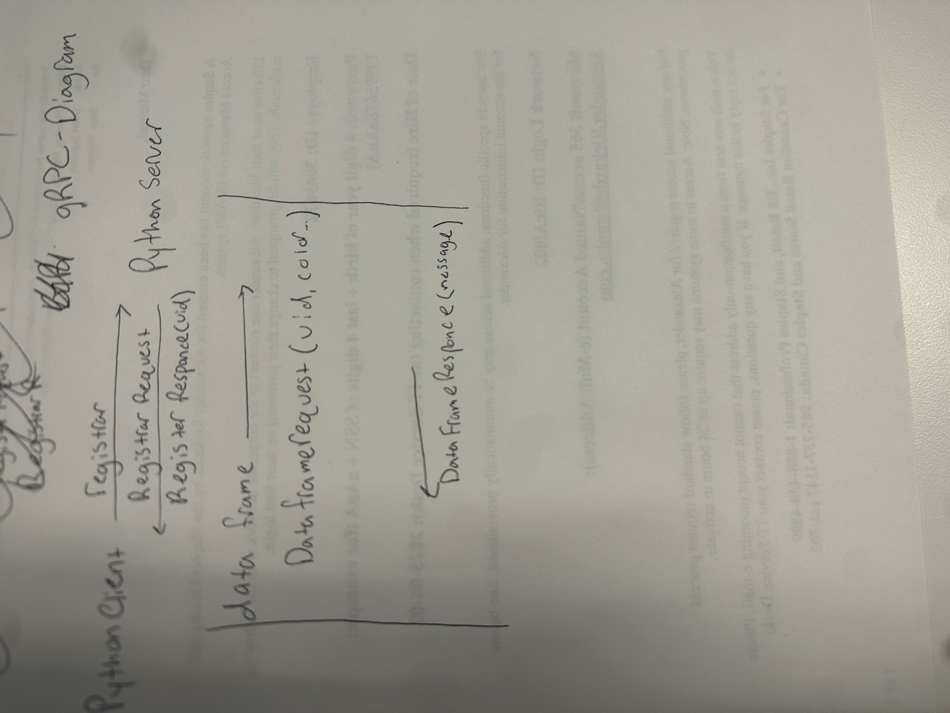

1.)

2.) Data streaming to the server still functions as intended.

**How to run the application**

First navigate to the 0.3.0 downloaded ARFlow folder > python> examples> depthanythingv2. From here run the command poetry install. Next run

**python -m venv .venv**

**.venv/bin/activate**

This will activate your vm.

* Navigate to the unity ap and open the unity folder in the ARFlow folder.
* Once open go to file build settings and under Platform click on android.
* Once it finishes loading connect your android device to your computer and select the run device option to pick your device.
  + Alternatively you can download the apk and load it on your phone by selecting default. Finally click on Build and Run.
* Once the app is downloaded onto your device, go to your computer and navigate to the command prompt. Type in **ipconfig**, take the IPV4 address and use that to enter the server IP. Enter 8500 for the port.

On your computer install poetry by running poetry install. After it has installed run poetry run python .\depthanythingv2.py. You should see ARFlow server started on port 8500. Once you see this navigate back to your phone and click connect. Rerun.io should pop up on your computer. Once you press start it will begin streaming to your laptop as well as saving to the device.

The frames will be saved on the device in the directory as follows:

Android/data/com.TheCakeLab.ARFlow/files/ARFlowData

UI On device:

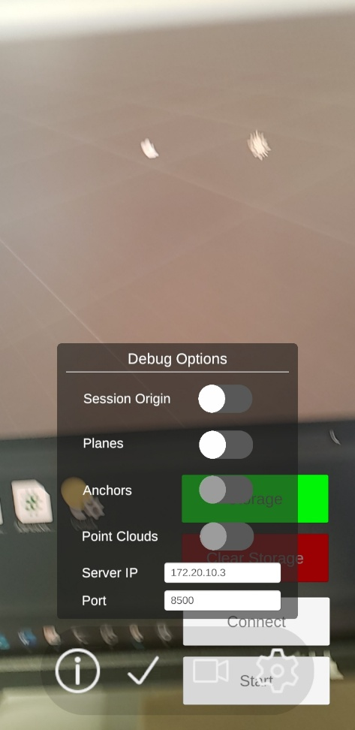

Video Proof: [IMG_0554.MOV](https://wpi0-my.sharepoint.com/:v:/g/personal/acrickards_wpi_edu/Edy0sWwYcwFElxyf2L6XP3wB8QWLhZZOqDvno6ed0LE_Tw?nav=eyJyZWZlcnJhbEluZm8iOnsicmVmZXJyYWxBcHAiOiJPbmVEcml2ZUZvckJ1c2luZXNzIiwicmVmZXJyYWxBcHBQbGF0Zm9ybSI6IldlYiIsInJlZmVycmFsTW9kZSI6InZpZXciLCJyZWZlcnJhbFZpZXciOiJNeUZpbGVzTGlua0NvcHkifX0&e=SNjW1Y)

Test Cases: