DESIGN ARTIFACT | UML SEQUENCE DIAGRAMS
BỘ SƠ ĐỒ TUẦN TỰ
VÀ ĐẶC TẢ TƯƠNG TÁC HỆ THỐNG
Phân tích, thiết kế và xây dựng hệ thống quản lý bán vé trực tuyến tại rạp chiếu phim Beta Giải Phóng
BGP-SD-001 | VERSION 1.0 | 31/10/2026
14 diagrams | 16 use cases | 6 BPMN processes | Prototype only
The diagrams express proposed interactions within a standalone cinema-booking prototype. They do not claim access to or integration with the production systems of Beta Cinemas.
All payment operations shown are mock/sandbox operations; no real payment credentials or merchant transactions are included.

01 DANH MỤC SƠ ĐỒ VÀ PHẠM VI
UML Sequence Diagrams are design-level interactions: actor, boundary (UI), controller/API, business service, database and optional external services. Their order represents the major business events; it is not a statement about the existing infrastructure of Beta Cinemas.
ID | Scenario | UC covered | BPMN | Priority
SD-01 | Authentication and session validation | UC-02 | Support | P0
SD-02 | Browse movies and inspect showtime seats | UC-01, UC-03 | BPMN-01 | P0
SD-03 | Atomic seat hold and pending order | UC-04 | BPMN-01 | P0
SD-04 | Create sandbox payment session | UC-05 | BPMN-02A | P0
SD-05 | Verified payment success and idempotent ticket issue | UC-15 | BPMN-02A | P0
SD-06 | Failed, late or conflicting payment callback | UC-15 | BPMN-02A, BPMN-02B | P0
SD-07 | Cancel pending booking before payment | UC-06 | BPMN-02B | P0
SD-08 | Automatic expiration of seat holds | UC-04, UC-06 (scheduled rule) | BPMN-02B | P0
SD-09 | Read order history and QR tickets | UC-07 | Support | P0
SD-10 | Validate and consume a QR ticket once | UC-08 | BPMN-04 | P0
SD-11 | Maintain movie catalog and seat layout | UC-09, UC-10 | Support | P0
SD-12 | Create showtime and protect price snapshots | UC-11 | BPMN-03 | P0
SD-13 | Aggregate revenue and optionally export CSV | UC-12, UC-16 | BPMN-05 | P0
SD-14 | Admin role changes and audit lookup | UC-13, UC-14 | Support | P0

02 QUY ƯỚC THIẾT KẾ
- Solid arrow: call/request. Dashed arrow: return/result. Vertical dashed line: lifeline.
- alt/else combined fragment: mutually exclusive business or exception branches.
- The database, not UI state, enforces exclusive seat reservation, payment state changes and QR scan semantics.
- Database operations marked BEGIN, COMMIT and ROLLBACK represent one atomic unit of work in the application.
- Time and expiration decisions are evaluated by the backend using UTC; UI countdown is informational.
- All labels inside diagrams use concise English technical terminology; Vietnamese UC definitions remain in the linked specification.

03 DESIGN GUARDRAILS: STATE AND CONCURRENCY
Artifact | State rule / implementation implication
Seat per showtime | AVAILABLE -> HELD -> SOLD; expired HELD can return to AVAILABLE only for its holding Order.
Order | PENDING_PAYMENT -> PAID / FAILED / CANCELLED / EXPIRED. Do not revert a terminal state automatically.
Payment | PENDING / SUCCESS / FAILED / NEEDS_REVIEW. Provider reference must be processed idempotently.
Ticket | ISSUED -> USED only once with atomic conditional update.
Price | Snapshot into OrderSeats on hold creation; changed price affects only future Orders.
Report | Only confirmed PAID Orders with issued Tickets count as sales; occupancy denominator is capacity snapshot.

04 BUSINESS RULE DECISIONS TO SYNCHRONISE WITH SRS
CR-01: A verified success arriving after EXPIRED/CANCELLED does not resurrect the Order or create Tickets. Payment is flagged NEEDS_REVIEW for manual reconciliation.
CR-02: Occupancy = valid issued tickets divided by the total eligible seating capacity of that showtime, fixed when published; never divide by currently AVAILABLE seats.
CR-03: Order cancellation, expiration and payment confirmation compete via one atomic state transition under consistent row-lock order. Hold release is scoped to that Order.
CR-04: QR tokens must be recoverable for owner-only ticket display or reproducible from a protected server-side secret; hash-only storage cannot recreate an arbitrary random token.
CR-05: When a scanned QR token does not resolve to an existing Ticket, the rejection can be stored in AuditLogs instead of a TicketScans row requiring ticket_id.

SD-01 | Authentication and session validation
Use Case: Đăng ký, đăng nhập và đăng xuất
BPMN: Support FR: FR-AUTH-02..05 TC: TC-02, TC-04
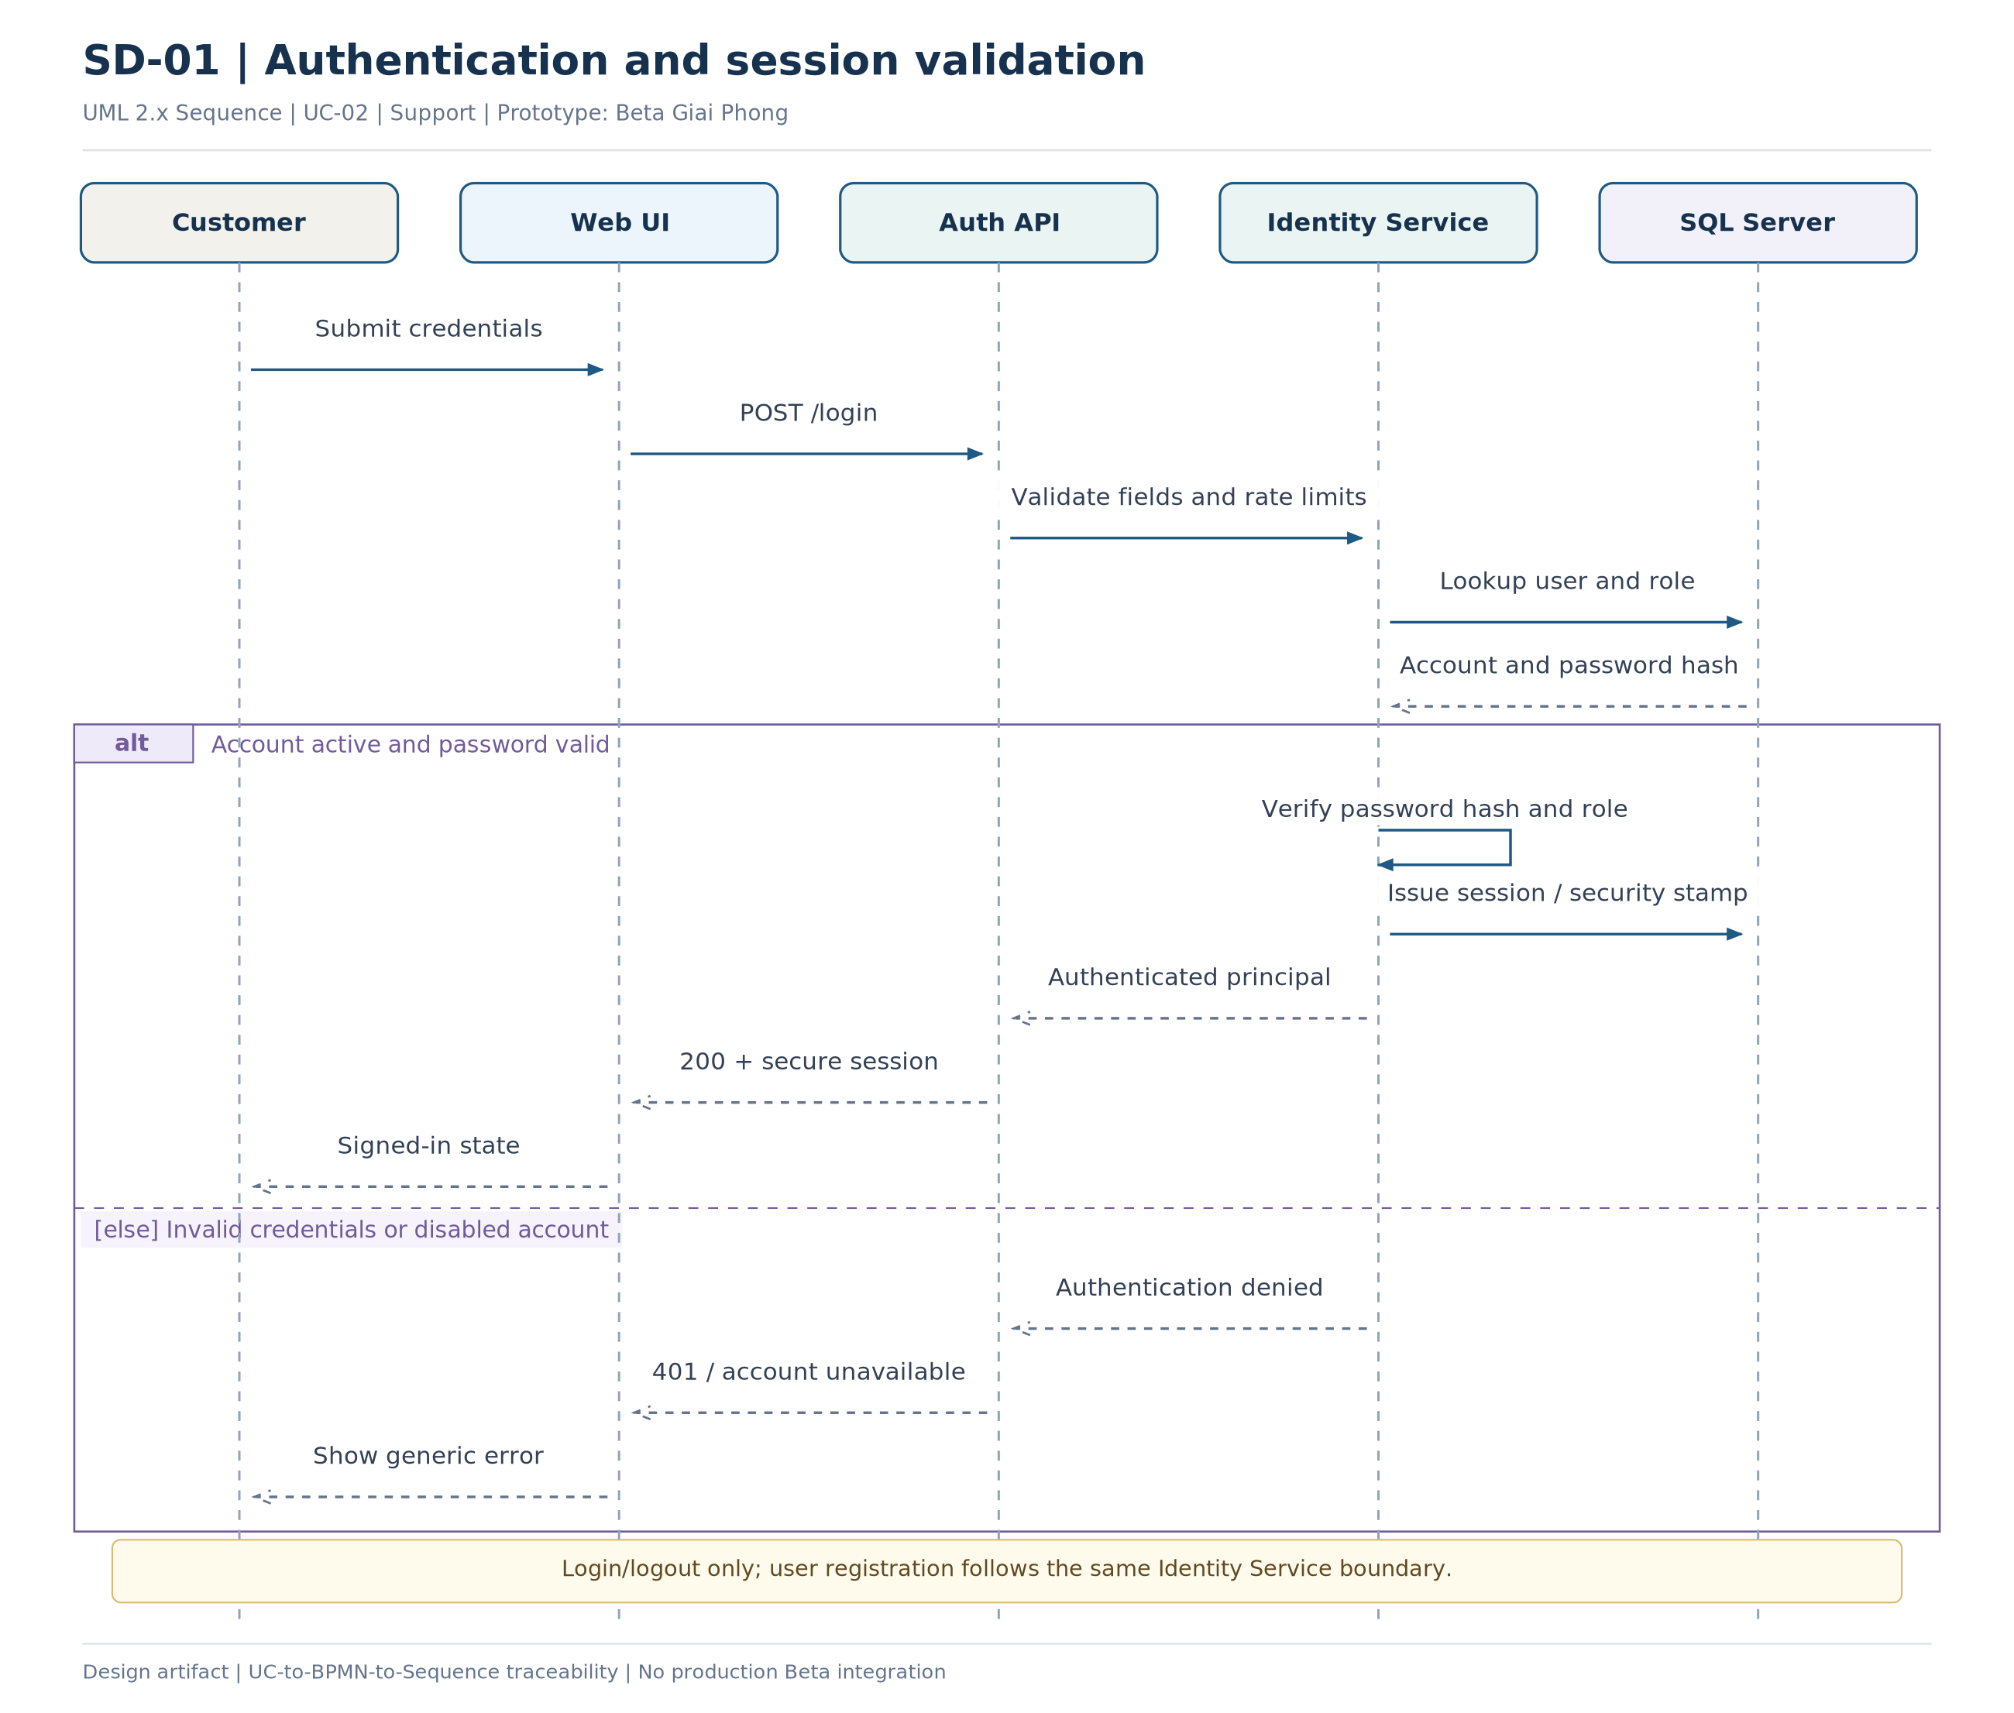
Figure SD-01 - UML sequence for Authentication and session validation
Key design decision: Passwords are never transmitted to business services as plaintext stored values.

SD-02 | Browse movies and inspect showtime seats
Use Case: Tra cứu phim và suất chiếu; Xem sơ đồ ghế và bảng giá
BPMN: BPMN-01 FR: FR-AUTH-01, FR-CAT-02, FR-SCH-06, FR-SEAT-01 TC: TC-01, TC-11
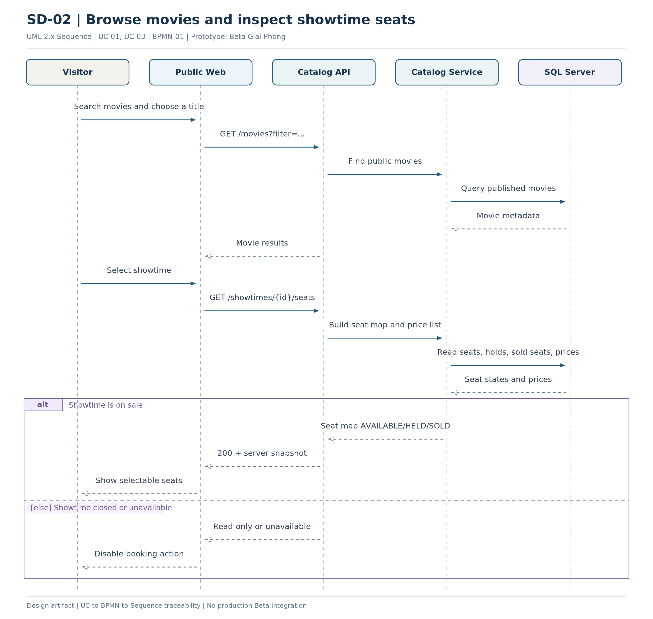
Figure SD-02 - UML sequence for Browse movies and inspect showtime seats
Key design decision: The displayed seat state is only a snapshot; UC-04 rechecks availability atomically.

SD-03 | Atomic seat hold and pending order
Use Case: Giữ ghế và tạo đơn chờ thanh toán
BPMN: BPMN-01 FR: FR-SEAT-02..08, FR-ORD-01..03 TC: TC-12..15
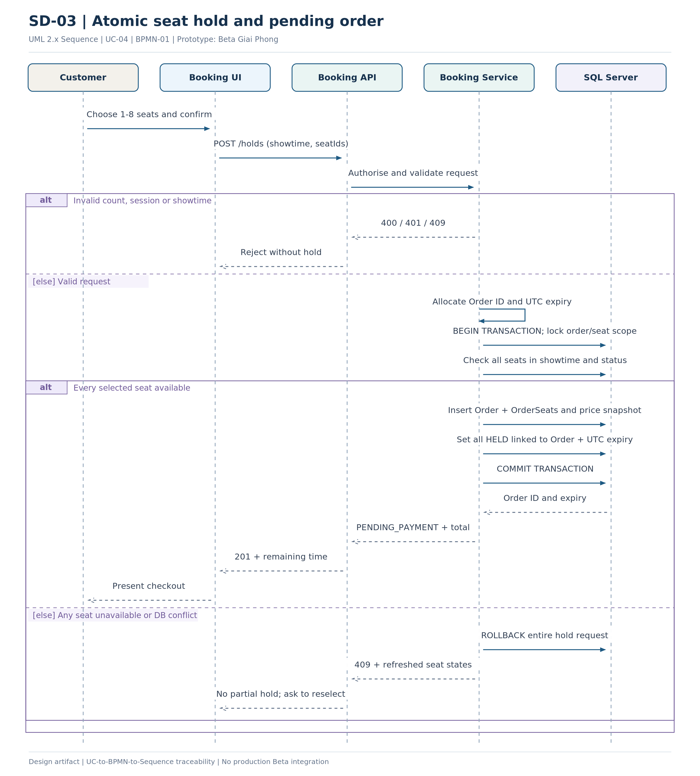
Figure SD-03 - UML sequence for Atomic seat hold and pending order
Key design decision: Concurrent buyers cannot both hold the same showtime-seat; the DB transaction is decisive.

SD-04 | Create sandbox payment session
Use Case: Khởi tạo thanh toán thử nghiệm
BPMN: BPMN-02A FR: FR-PAY-01..02, FR-ORD-03, FR-ORD-06 TC: TC-18..19
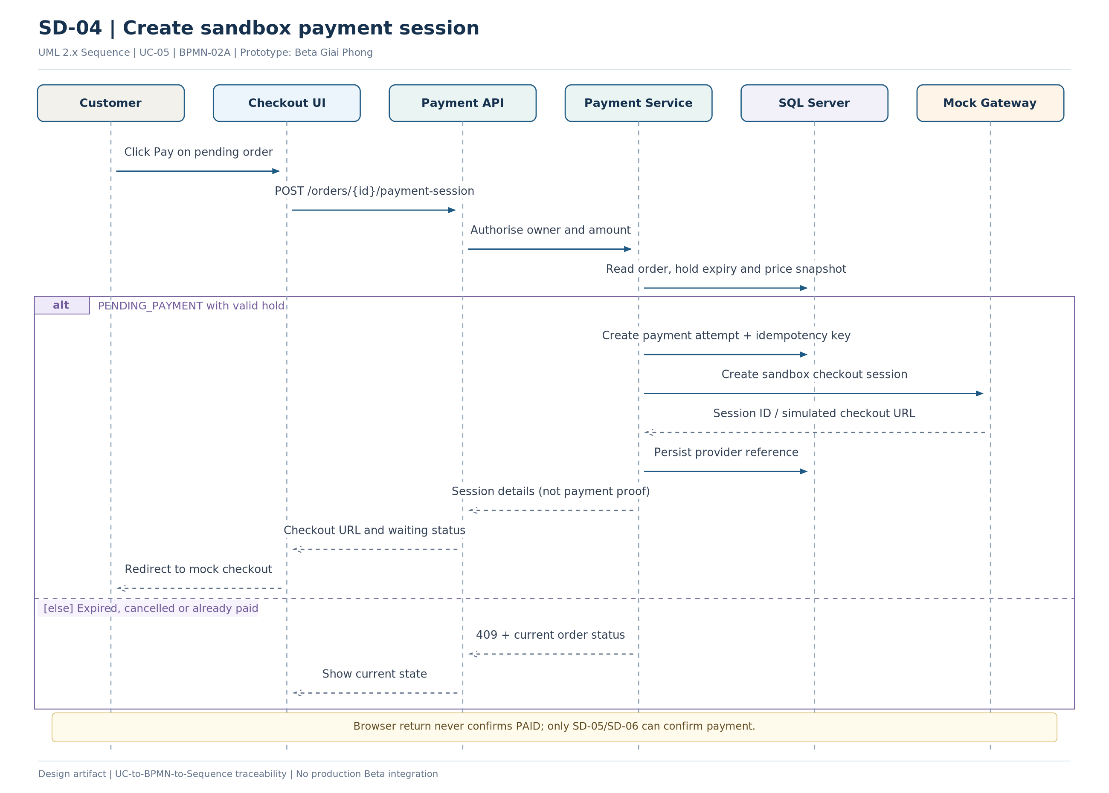
Figure SD-04 - UML sequence for Create sandbox payment session
Key design decision: Mock/sandbox only: no production payment or real card collection.

SD-05 | Verified payment success and idempotent ticket issue
Use Case: Tiếp nhận và xác minh kết quả thanh toán
BPMN: BPMN-02A FR: FR-PAY-02..04, FR-TKT-01, FR-ORD-06 TC: TC-19..22
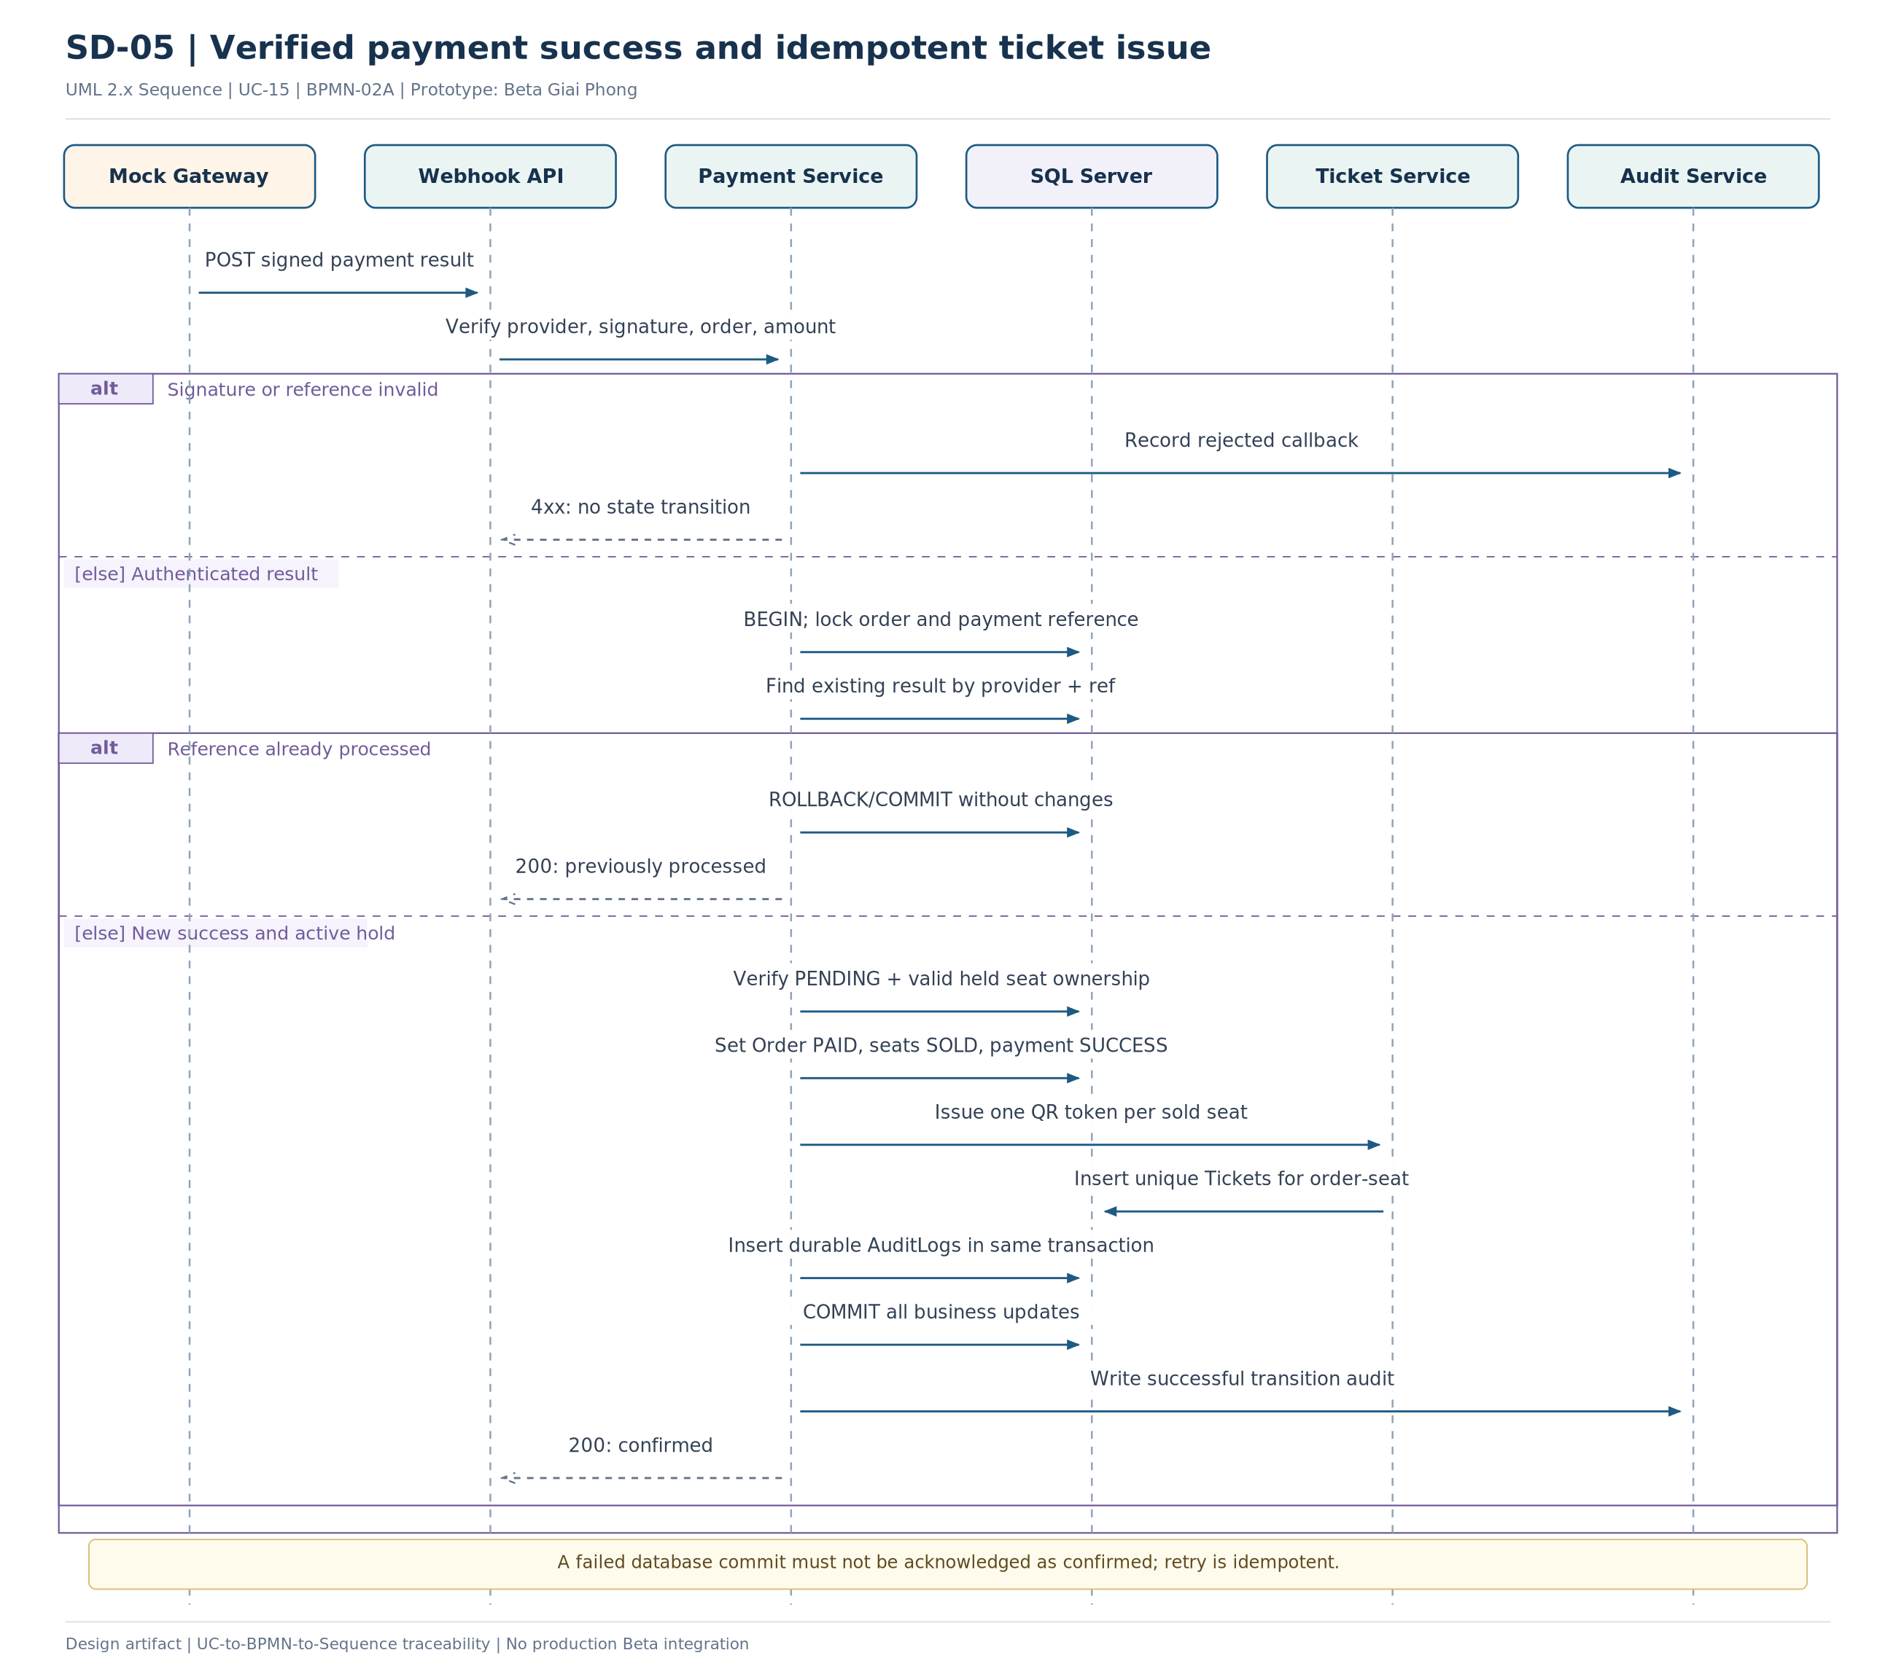
Figure SD-05 - UML sequence for Verified payment success and idempotent ticket issue
Key design decision: Only a verified server callback may make Order PAID.

SD-06 | Failed, late or conflicting payment callback
Use Case: Tiếp nhận và xác minh kết quả thanh toán
BPMN: BPMN-02A, BPMN-02B FR: FR-PAY-05..07, FR-AUD-03 TC: TC-18, TC-20..21
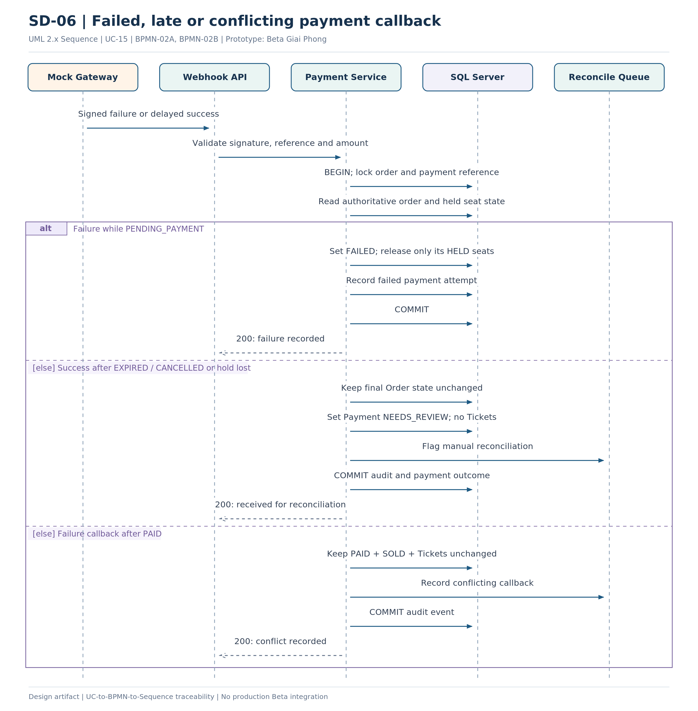
Figure SD-06 - UML sequence for Failed, late or conflicting payment callback
Key design decision: CR-01: Order remains EXPIRED/CANCELLED when success arrives after the hold is released; only Payment becomes NEEDS_REVIEW.

SD-07 | Cancel pending booking before payment
Use Case: Hủy đơn trước thanh toán
BPMN: BPMN-02B FR: FR-ORD-04..06, FR-SEAT-07 TC: TC-15..17
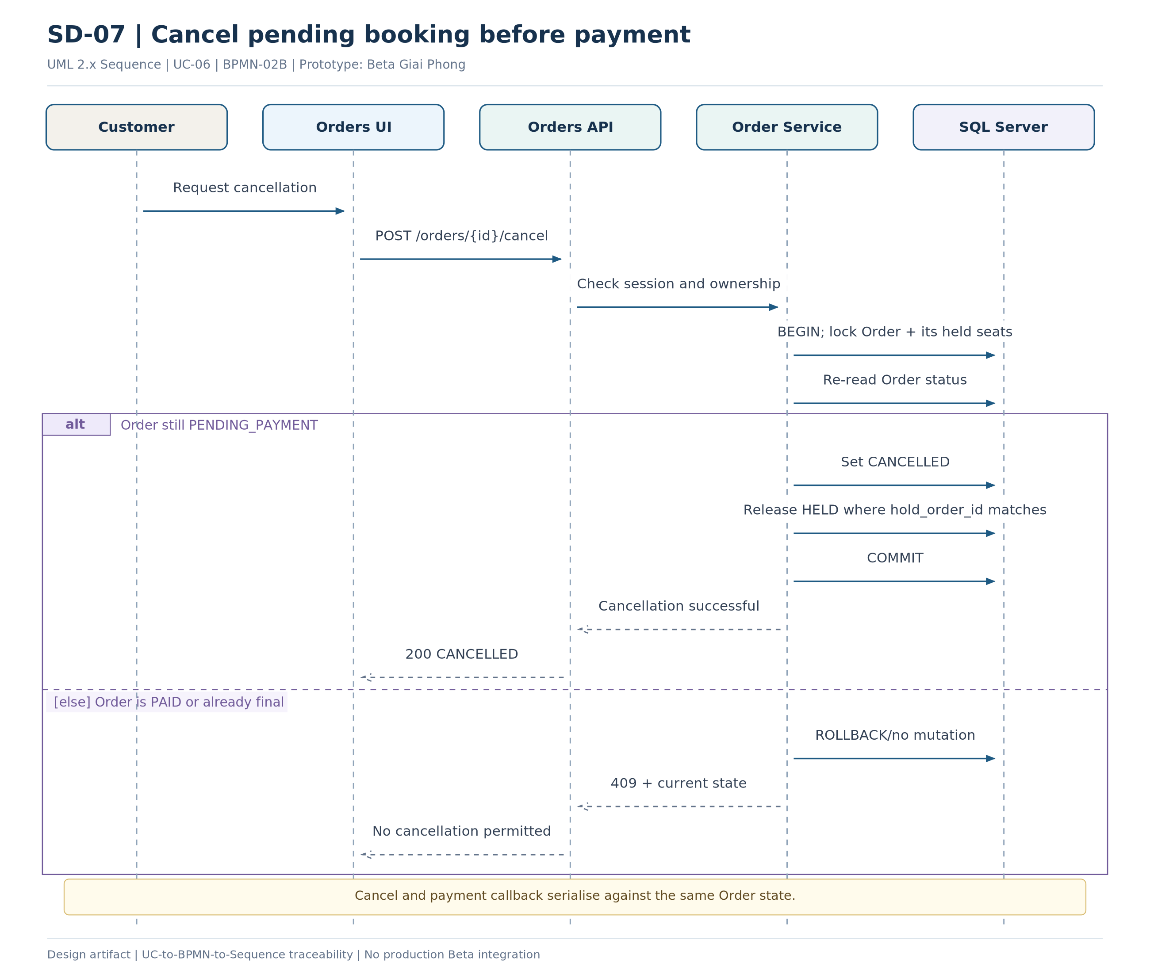
Figure SD-07 - UML sequence for Cancel pending booking before payment
Key design decision: A PAID order is immutable under P0 cancellation rules.

SD-08 | Automatic expiration of seat holds
Use Case: Giữ ghế và tạo đơn chờ thanh toán; Hủy đơn trước thanh toán
BPMN: BPMN-02B FR: FR-SEAT-06..07, FR-ORD-05 TC: TC-15..17
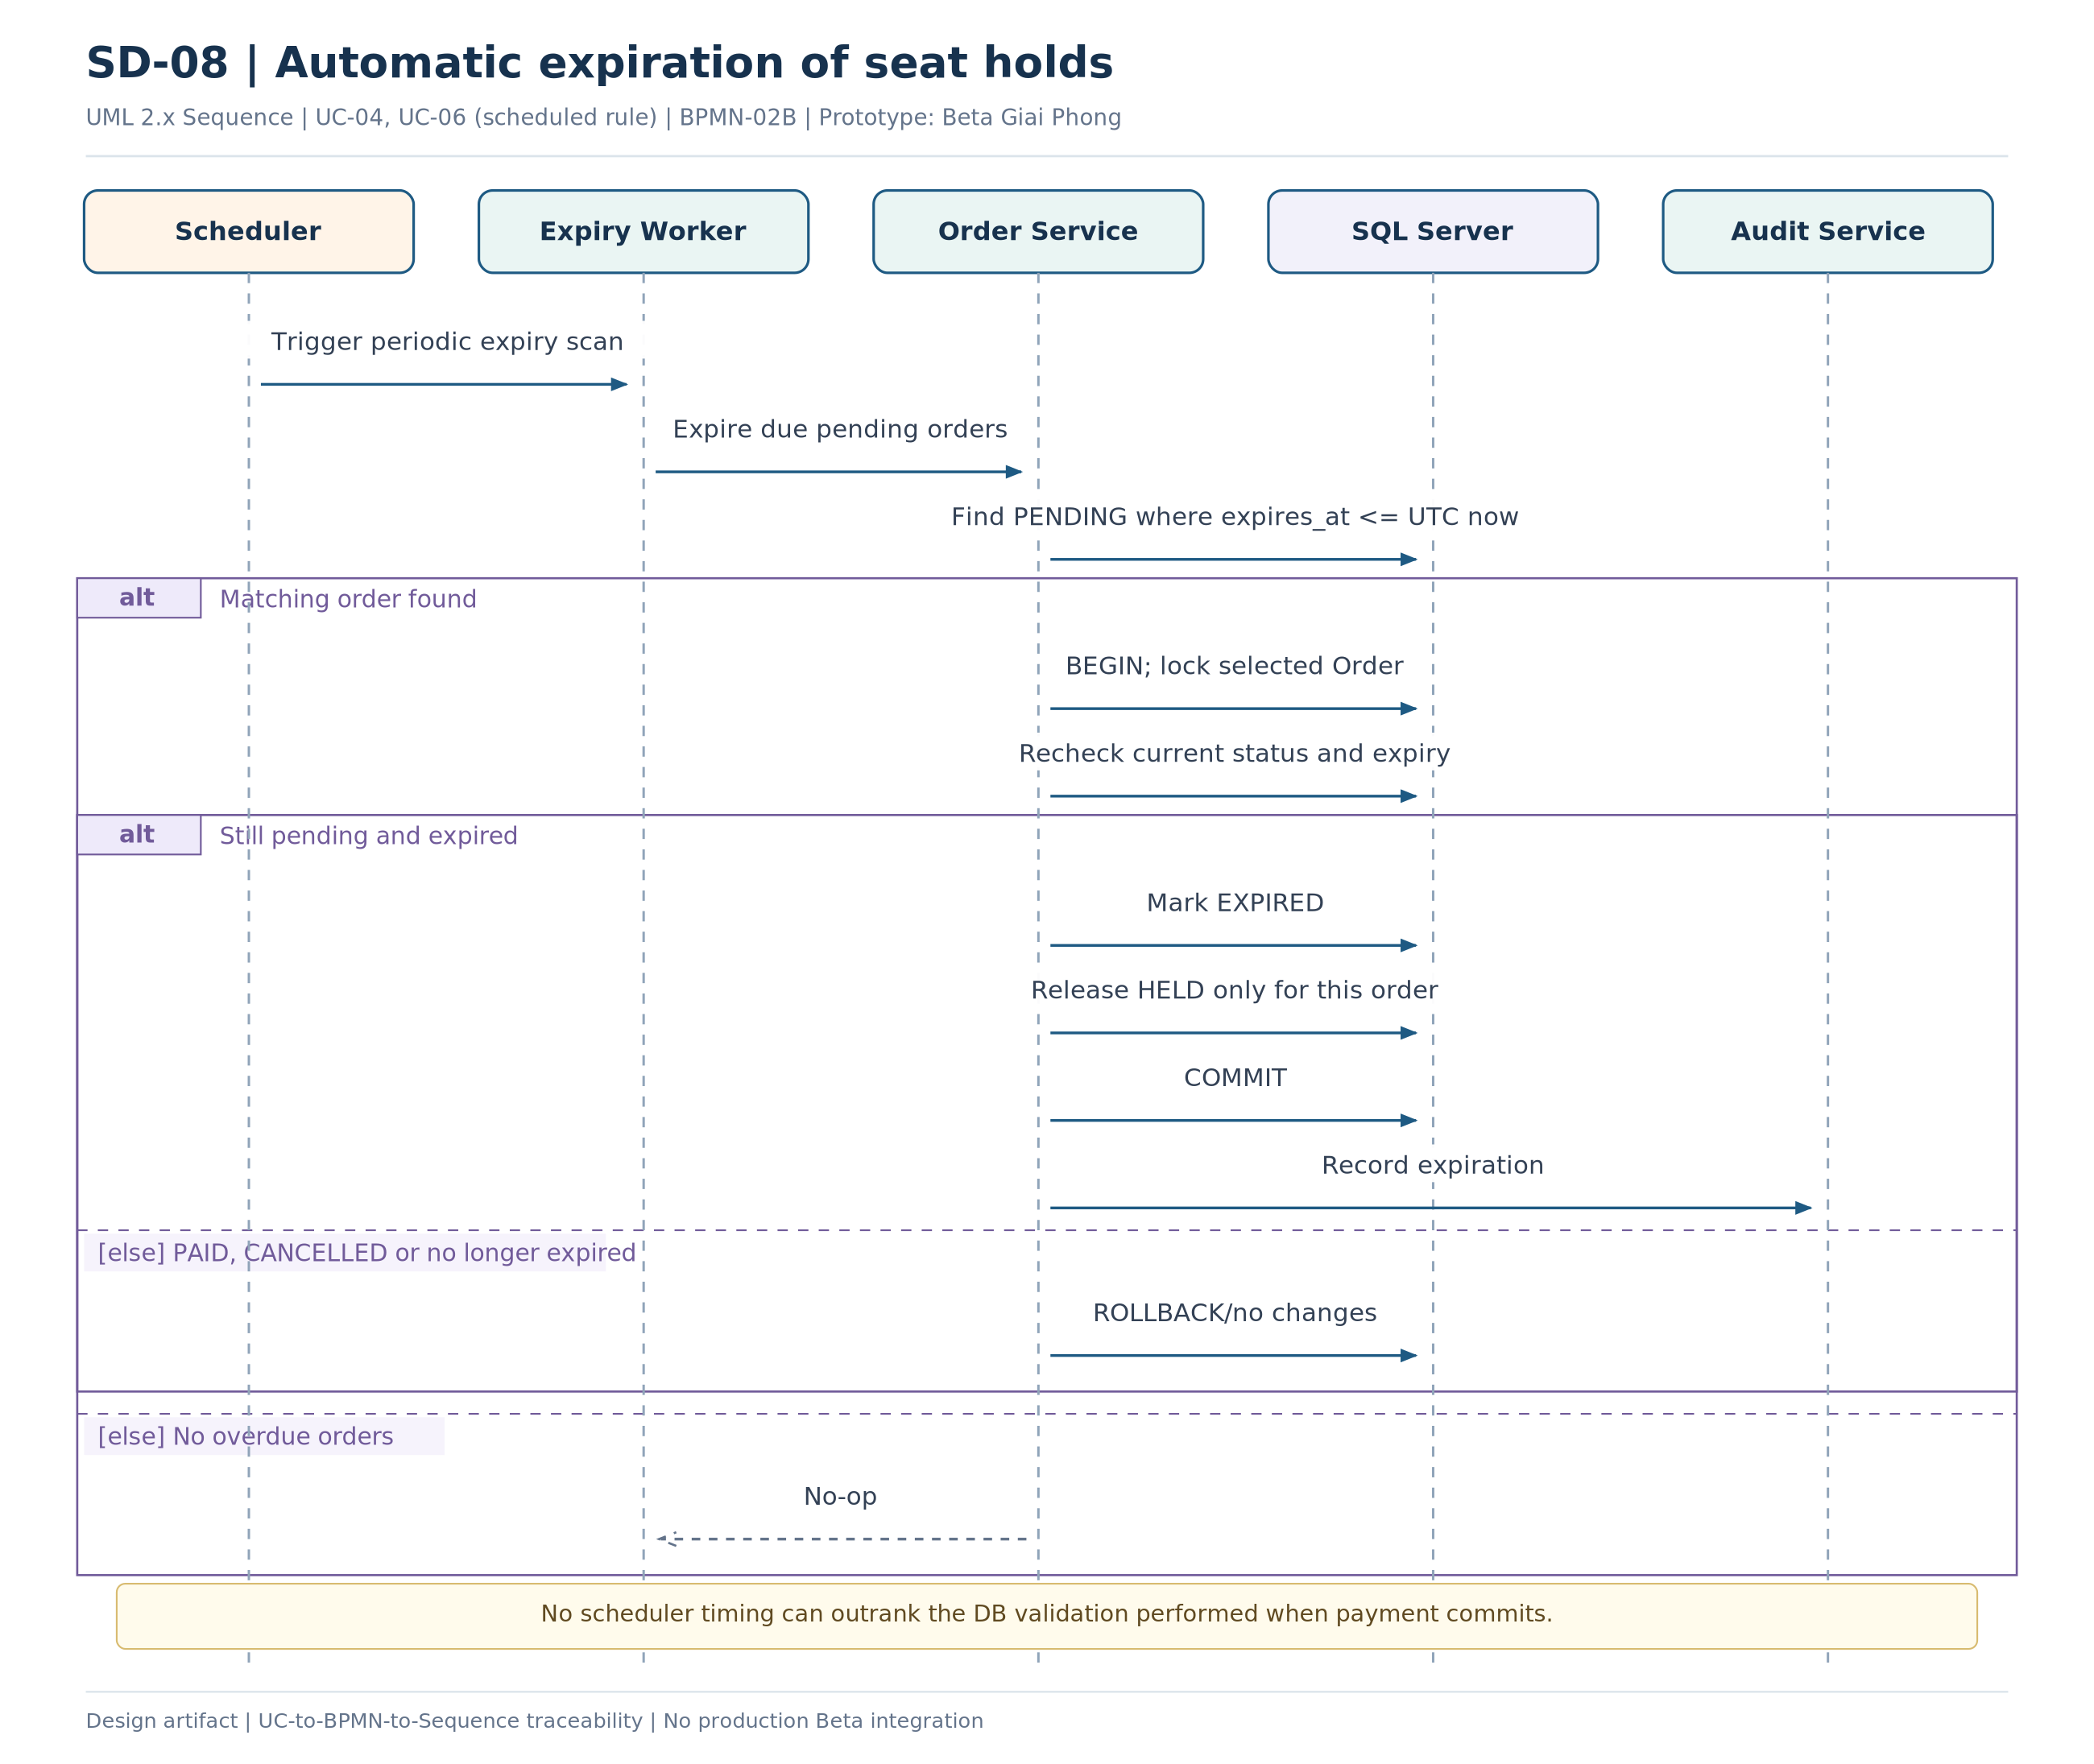
Figure SD-08 - UML sequence for Automatic expiration of seat holds
Key design decision: Use server UTC, not browser countdown, as the authoritative clock.

SD-09 | Read order history and QR tickets
Use Case: Tra cứu lịch sử đơn và vé QR
BPMN: Support FR: FR-AUTH-04, FR-ORD-07, FR-TKT-02 TC: TC-03, TC-22
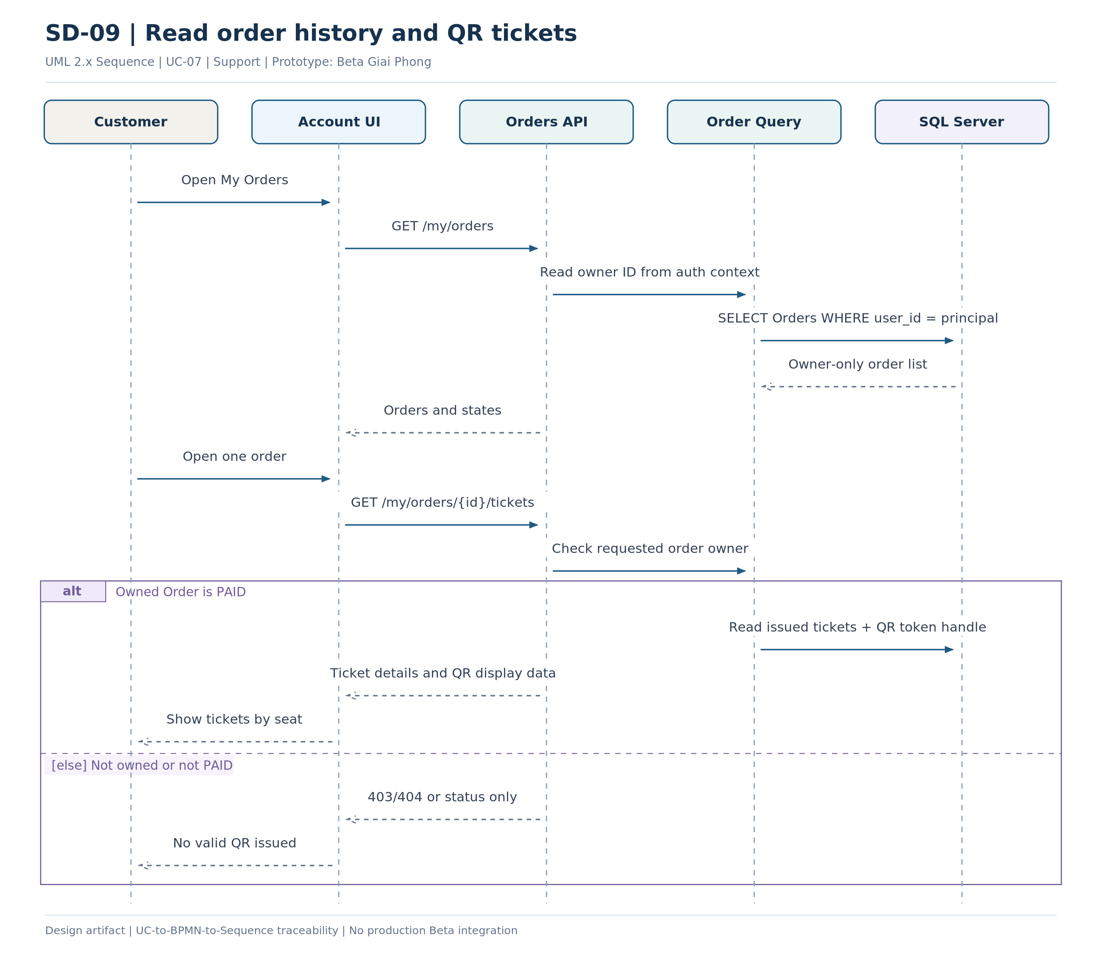
Figure SD-09 - UML sequence for Read order history and QR tickets
Key design decision: Customer data access must filter by authenticated user, not trust submitted user_id.

SD-10 | Validate and consume a QR ticket once
Use Case: Kiểm tra và xác thực vé QR
BPMN: BPMN-04 FR: FR-TKT-03..06, FR-AUD-01 TC: TC-23, TC-25
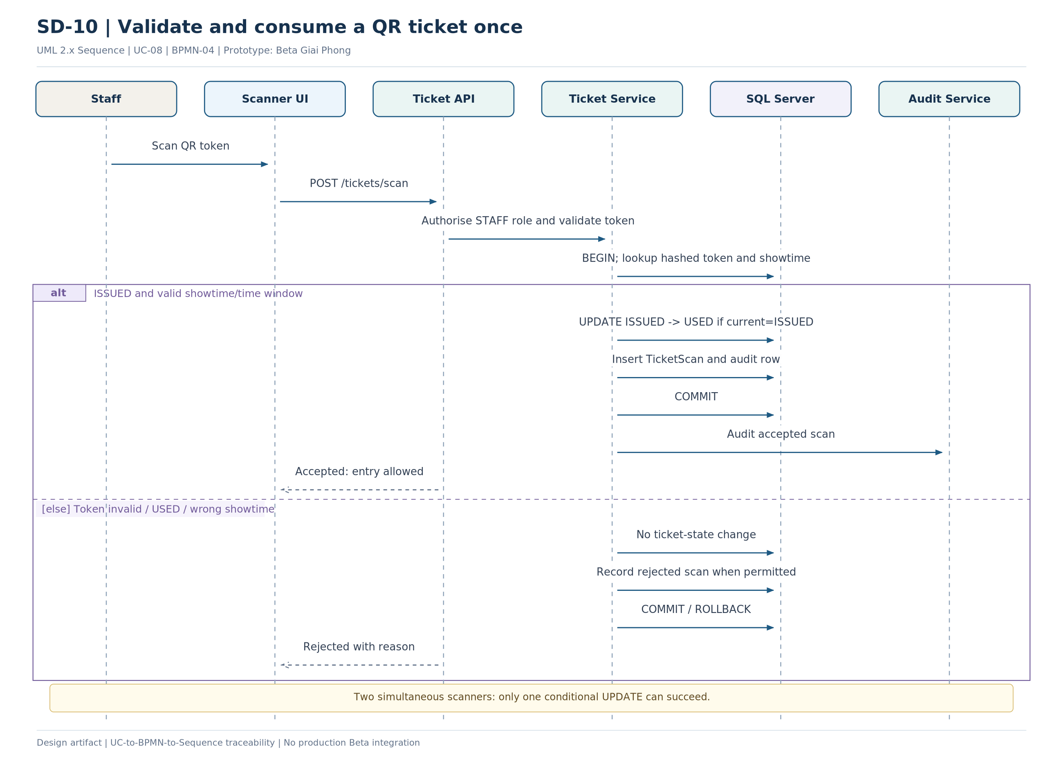
Figure SD-10 - UML sequence for Validate and consume a QR ticket once
Key design decision: Server validation of QR token, role, showtime and timing is mandatory.

SD-11 | Maintain movie catalog and seat layout
Use Case: Quản lý danh mục phim; Quản lý phòng và sơ đồ ghế
BPMN: Support FR: FR-CAT-01..04, FR-SCH-01..03 TC: TC-05..06, TC-25
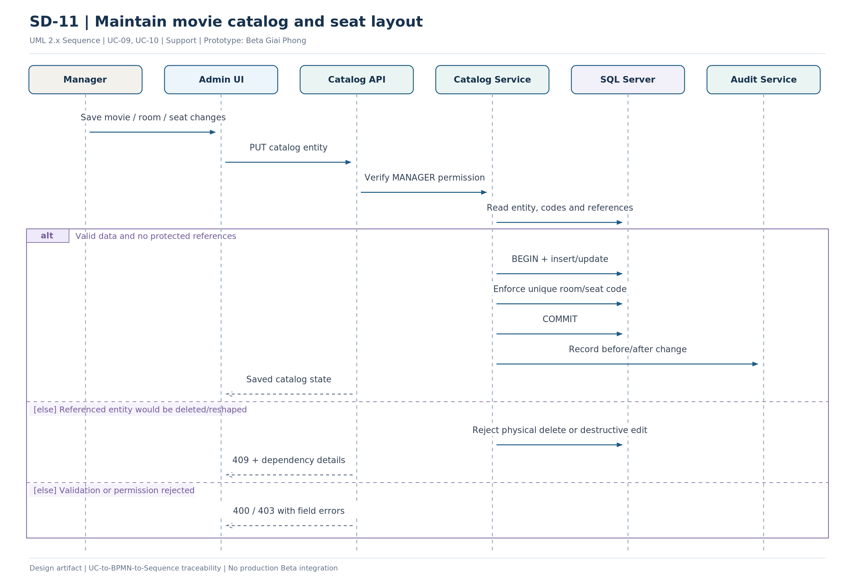
Figure SD-11 - UML sequence for Maintain movie catalog and seat layout
Key design decision: Soft-disable referenced movies, rooms and seats rather than physically deleting historical keys.

SD-12 | Create showtime and protect price snapshots
Use Case: Quản lý suất chiếu và bảng giá
BPMN: BPMN-03 FR: FR-SCH-04..08, FR-AUD-01 TC: TC-07..10, TC-25
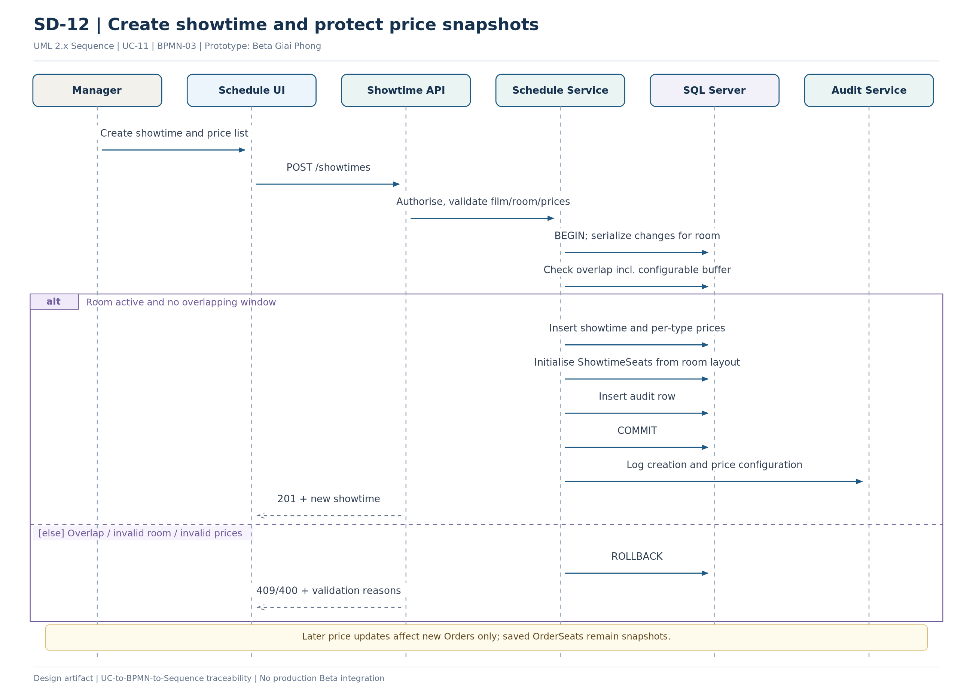
Figure SD-12 - UML sequence for Create showtime and protect price snapshots
Key design decision: Overlap checks must be concurrency-safe for the same room; do not rely only on a pre-insert SELECT.

SD-13 | Aggregate revenue and optionally export CSV
Use Case: Xem thống kê và báo cáo kinh doanh; Xuất báo cáo CSV
BPMN: BPMN-05 FR: FR-RPT-01..05 TC: TC-24
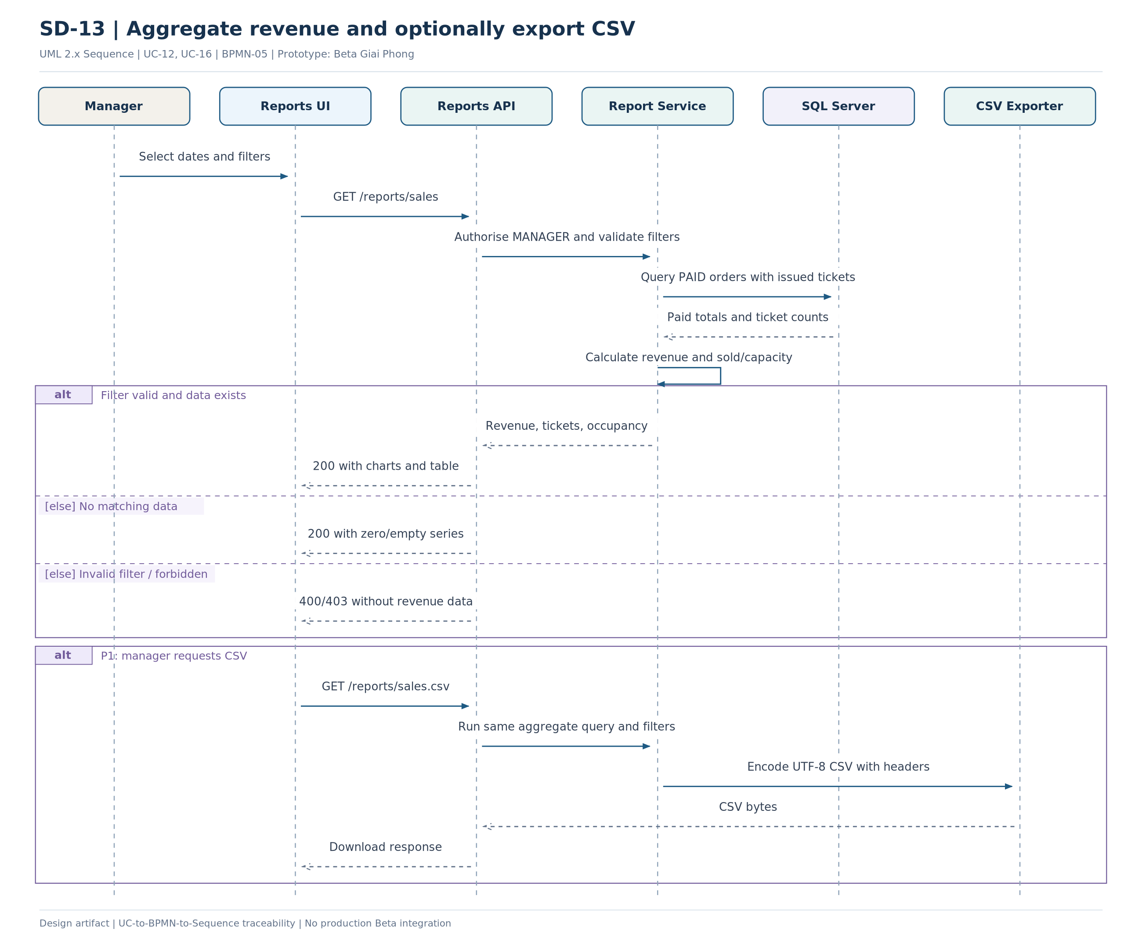
Figure SD-13 - UML sequence for Aggregate revenue and optionally export CSV
Key design decision: Revenue counts only PAID orders backed by issued Tickets; exclude NEEDS_REVIEW.

SD-14 | Admin role changes and audit lookup
Use Case: Quản lý tài khoản nhân sự và vai trò; Tra cứu nhật ký kiểm toán
BPMN: Support FR: FR-AUTH-05..06, FR-AUD-01..03 TC: TC-04, TC-25
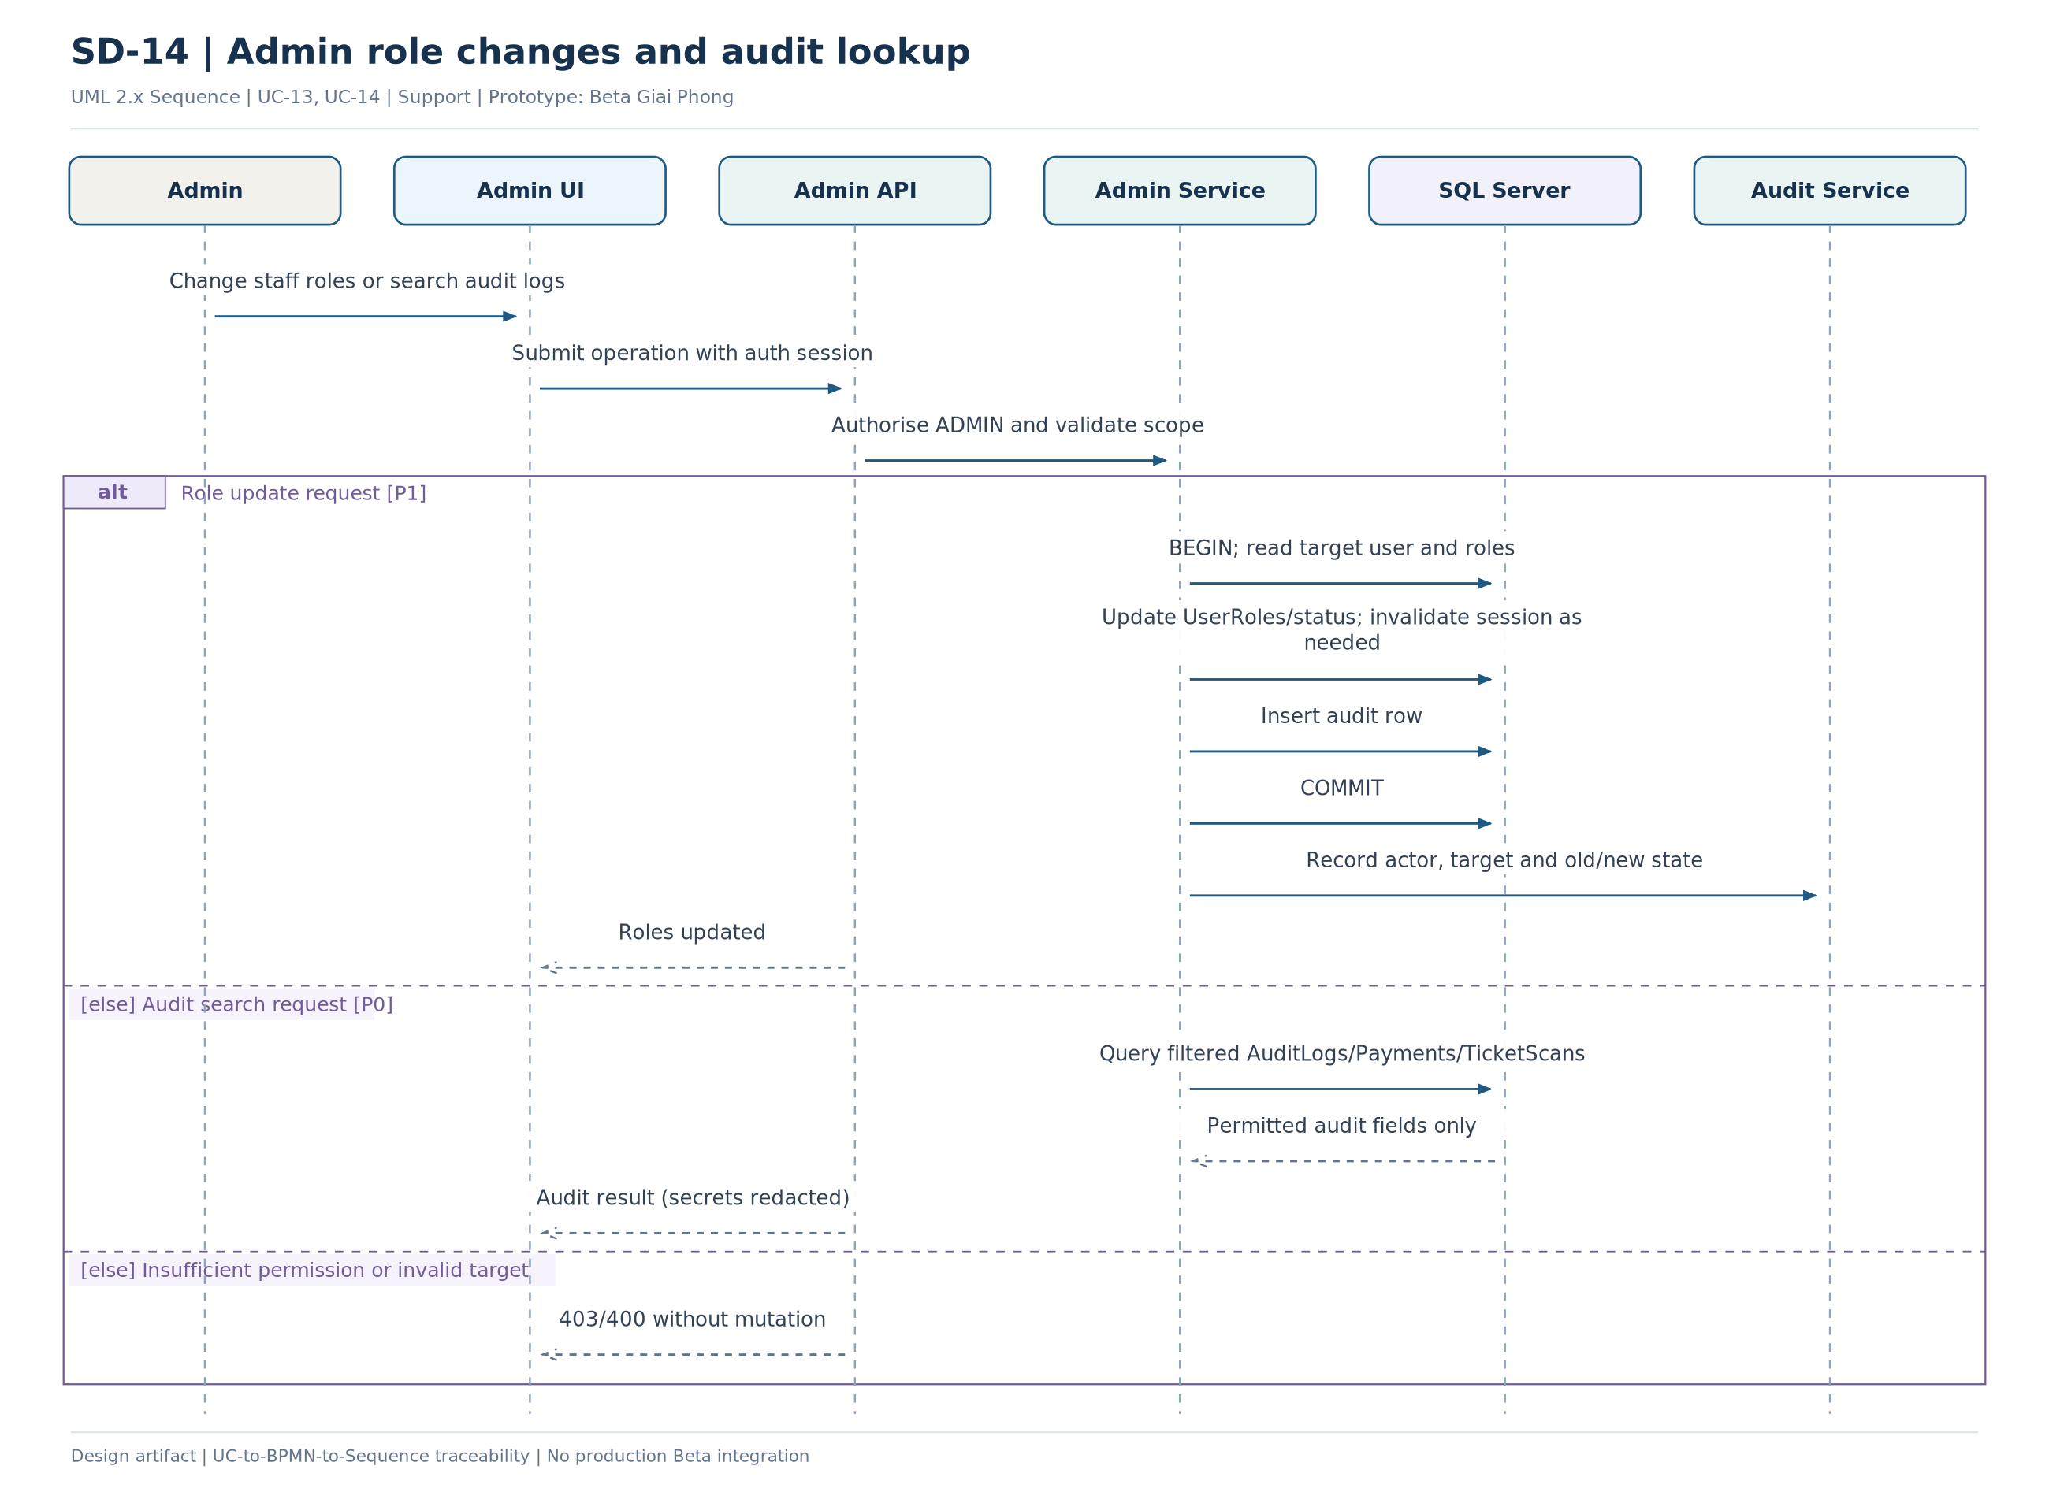
Figure SD-14 - UML sequence for Admin role changes and audit lookup
Key design decision: Role administration is P1; audit access control remains P0.

05 MA TRẬN TRUY VẾT USE CASE - SEQUENCE
UC | Nghiệp vụ | Sequence | TC | Level
UC-01 | Tra cứu phim và suất chiếu | SD-02 | TC-01 | P0
UC-02 | Đăng ký, đăng nhập và đăng xuất | SD-01 | TC-02, TC-04 | P0
UC-03 | Xem sơ đồ ghế và bảng giá | SD-02 | TC-01, TC-11 | P0
UC-04 | Giữ ghế và tạo đơn chờ thanh toán | SD-03, SD-08 | TC-11..15 | P0
UC-05 | Khởi tạo thanh toán thử nghiệm | SD-04 | TC-18..21 | P0
UC-06 | Hủy đơn trước thanh toán | SD-07, SD-08 | TC-15..17 | P0
UC-07 | Tra cứu lịch sử đơn và vé QR | SD-09 | TC-03, TC-22 | P0
UC-08 | Kiểm tra và xác thực vé QR | SD-10 | TC-23, TC-25 | P0
UC-09 | Quản lý danh mục phim | SD-11 | TC-05, TC-25 | P0 (cốt lõi), P1 (poster/trailer)
UC-10 | Quản lý phòng và sơ đồ ghế | SD-11 | TC-06, TC-25 | P0
UC-11 | Quản lý suất chiếu và bảng giá | SD-12 | TC-07..10, TC-25 | P0
UC-12 | Xem thống kê và báo cáo kinh doanh | SD-13 | TC-24 | P0
UC-13 | Quản lý tài khoản nhân sự và vai trò | SD-14 | TC-04, TC-25 | P1
UC-14 | Tra cứu nhật ký kiểm toán | SD-14 | TC-04, TC-25 | P0
UC-15 | Tiếp nhận và xác minh kết quả thanh toán | SD-05, SD-06 | TC-18..22 | P0
UC-16 | Xuất báo cáo CSV | SD-13 | TC-24 | P1
The relationship is many-to-many: e.g. UC-15 is intentionally split across SD-05 and SD-06; UC-09 and UC-10 share SD-11 because both apply catalog-maintenance constraints.

06 KIỂM TRA VÀ CHUẨN BỊ CHO ERD
Scenario | Acceptance invariant | Sequence
Concurrent holds | Two clients request the same seat: exactly one hold succeeds; the other receives 409. | SD-03
Expired hold | UTC expiry triggers EXPIRED and release only if the Order remains PENDING_PAYMENT. | SD-08
Payment race | Payment callback, cancel and expiry cannot produce two successful terminal transitions. | SD-05, SD-06, SD-07, SD-08
Duplicate callback | Same provider/ref produces the previous result; no extra Tickets or revenue. | SD-05
Late payment | After release, Order remains EXPIRED/CANCELLED; Payment -> NEEDS_REVIEW; no Ticket. | SD-06
Double QR scan | Concurrent scanners yield one ISSUED -> USED and one rejection. | SD-10
Concurrent showtime create | Two overlapping showtimes in one room cannot both commit. | SD-12
Report reconciliation | PAID totals match issued Tickets; no duplication by join; correct capacity denominator. | SD-13

07 IMPLEMENTATION HANDOFF
Recommended order: (1) agree on Order/Payment/Ticket state machine and CR decisions; (2) design ERD and DB constraints; (3) define API contracts; (4) implement transactional seat hold and callback; (5) implement QR scanning, operations and reports; (6) run concurrency tests.
The attached sources include .puml and .drawio files. SVG files are vector illustrations; PNG files are for Word and presentation insertion. Rendered images are produced from the same scenario source data as the editable models.

