CONFIDENTIAL CLIENT HANDOFF DOCUMENT


VARADA NEXUS PRIVATE LIMITED

WEBSITE USER MANUAL
& COMPLETE HANDOFF GUIDE
Prepared exclusively for
K SRINU & ASSOCIATES
Document | Website User Manual & Administrator Guide
Website | caksrinuandassociates.com
Prepared by | Varada Nexus Private Limited
Document type | Handoff Reference — Confidential

www.varadanexus.com · connect@varadanexus.com
Rajahmundry, Andhra Pradesh, India

TABLE OF CONTENTS

01 Introduction  02 Website Overview  03 Public Website Pages  04 Site Navigation Map  05 Getting Started with the Admin Panel  06 Admin Dashboard Overview  07 Managing the Compliance Calendar  08 Managing Achievements  09 Managing Team Members | 10 Managing Careers  11 Managing Notifications  12 Homepage Stats  13 Site Settings  14 Form Submissions  15 Backup & Restore  16 Best Practices & Maintenance Tips  17 Troubleshooting & FAQ  18 Support & Contact

01 INTRODUCTION
This guide is a complete handoff manual for the official website of K Srinu & Associates, built and delivered by Varada Nexus Private Limited. It explains how the public website is structured and how to use the private Admin Panel to keep the site up to date, without needing any coding knowledge.
Use this guide as your day-to-day reference. Keep it somewhere your team can access it whenever content needs to be added or changed on the website.

02 WEBSITE OVERVIEW
The website is a professional, multi-page site for a Chartered Accountancy and audit/taxation practice. It is built with HTML, Tailwind CSS, and JavaScript, and is connected to a Supabase backend database. This means most of the content you see on the public site — compliance dates, team members, careers, notifications, achievements, homepage statistics, and contact details — is not hardcoded. It is stored in a database and can be edited live through the Admin Panel described in this guide.
Live website: caksrinuandassociates.com
Brand colors: Navy Blue and Gold
Logo: K Srinu & Associates crest logo, used in the header, footer, and admin console
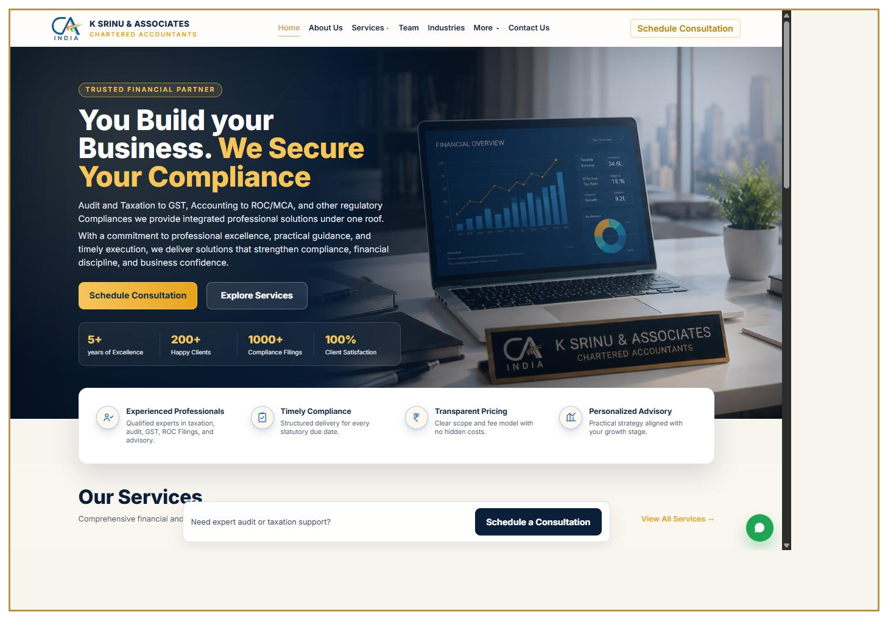
Figure 1 — The K Srinu & Associates homepage.

03 PUBLIC WEBSITE PAGES
The public website consists of the following pages:
- Home — hero introduction, homepage statistics, services preview, and call-to-action buttons
- About — firm background and "Why Choose Us" information
- Services — overview of all services offered
- Service detail pages — one dedicated page for each service:
  - Audit & Assurance
  - GST Filing
  - Income Tax Returns
  - ROC / MCA Compliance
  - Payroll Services
  - Business Advisory
  - Company Registration
  - Financial Consulting
  - Accounting & Bookkeeping
  - RERA Compliance
- Industries — industries the firm serves
- Team — profiles of partners and staff, pulled from the Admin Panel
- Careers — current job openings and internship/articleship listings
- Achievements — milestones and recognitions
- News — published notifications and updates
- Compliance Calendar — searchable due-date calendar for GST, Income Tax, TDS, ROC, PF/ESI, and other filings
- Contact — contact form, phone numbers, email addresses, WhatsApp link, and embedded map
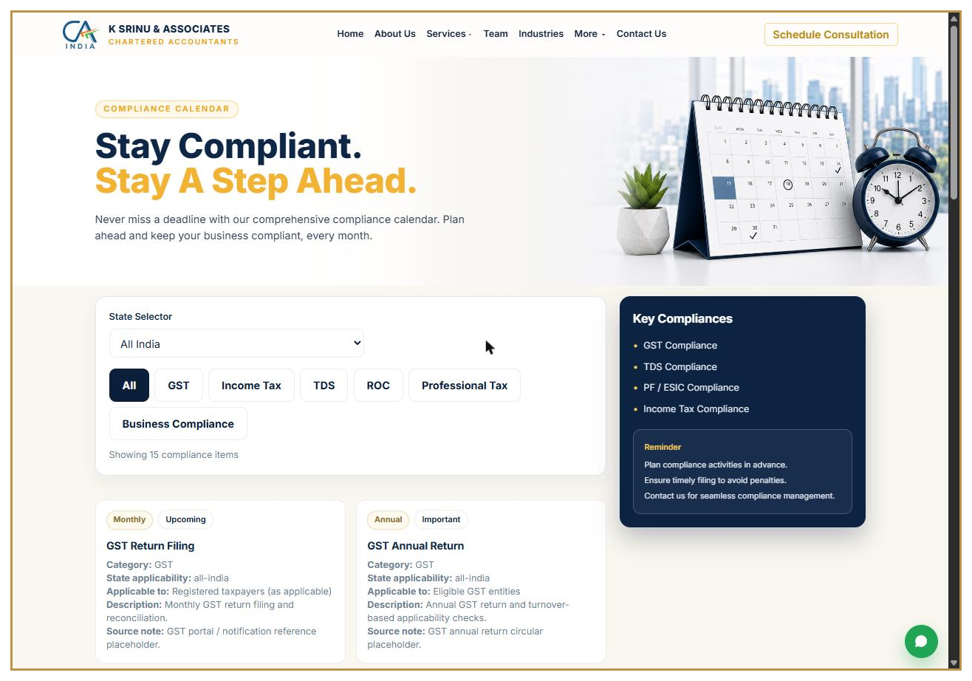
Figure 2 — The public Compliance Calendar page.

04 SITE NAVIGATION MAP
Home → About → Services → Industries → Team → Careers → Achievements → News → Compliance Calendar → Contact
Each Service detail page is reachable from the main Services page. The footer and navigation bar are shared across every page and are controlled centrally through the partials files and Site Settings in the Admin Panel.

05 GETTING STARTED WITH THE ADMIN PANEL
Admin Panel URL: caksrinuandassociates.com/adminpanel-vx9k2.html
This link is intentionally not linked anywhere on the public site — bookmark it and keep it private. Treat it the same way you would treat online banking access.

How to log in
- Open the Admin Panel URL in your browser.
- Enter your admin email address.
- Enter your admin password.
- Click Sign In.
Login is handled securely through Supabase Authentication. If you forget your password or need a new admin user added, contact Varada Nexus support (Section 18).

Security recommendations
- Never share the Admin Panel link or login credentials over email or chat without encryption.
- Use a strong, unique password for the admin account.
- Log out when finished, especially on shared or public computers.
- Only give admin access to trusted staff who need it.
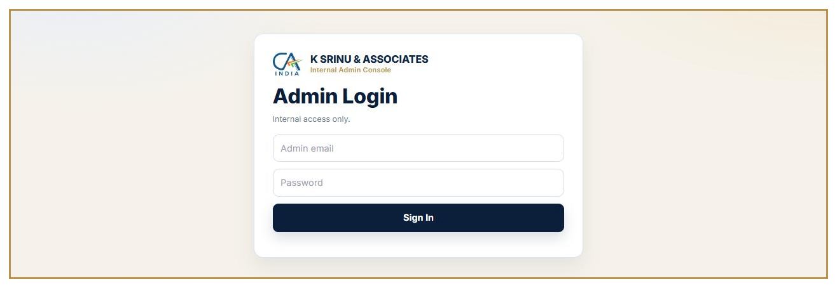
Figure 3 — The Admin Panel login screen.

06 ADMIN DASHBOARD OVERVIEW
After logging in, you will land on the Overview tab. This is your control center and shows:
- Compliance — total compliance calendar items
- Team — active team members shown on the public site
- Careers — active job openings
- Notifications — published updates
- Inquiries — new contact form submissions
- Applications — new career applications
Quick-action buttons let you jump straight to adding a compliance item, adding a team member, publishing a notification, viewing submissions, or updating settings. CSV export buttons let you download the compliance calendar, careers list, contact submissions, and career applications as spreadsheet-ready files.
The left sidebar lists every section of the Admin Panel. On mobile, tap the menu icon (three lines) in the top bar to open this sidebar.
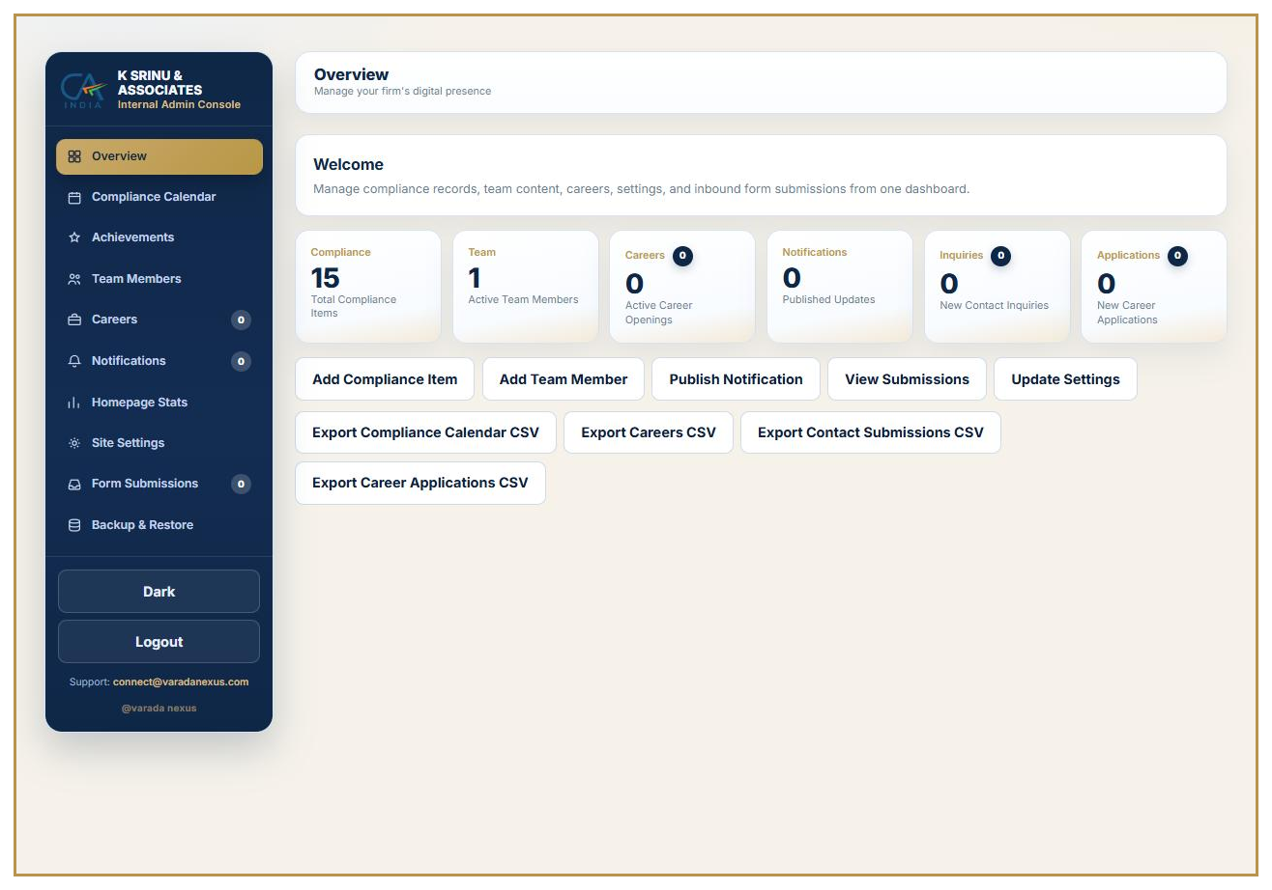
Figure 4 — The Admin Panel Overview dashboard.

07 MANAGING THE COMPLIANCE CALENDAR
Go to Compliance Calendar in the sidebar to add or edit due-date entries shown on the public Compliance Calendar page.

Fields to fill in
- Title — name of the compliance requirement
- Category — GST, Income Tax, TDS, ROC/MCA, PF/ESI, Labour Law, Professional Tax, Audit, General Compliance, or Other
- State — National or a specific Indian state
- Due date
- Frequency — One-time, Monthly, Quarterly, Half-yearly, Annual, Event-based, As notified, or Other
- Applicable to — who this requirement applies to (individuals, companies, LLPs, etc.)
- Compliance type/priority — Mandatory, Indicative, Informational, High Priority, or Other
- Source URL — link to the official government notification, if available
- Description
- "Is national" checkbox and "Is active" checkbox
Click Save Compliance Item to publish it. Use Import Baseline Compliance Items to quickly load a standard starter set of common due dates. The Live Compliance Preview panel shows exactly how the entry will appear to website visitors before you save. Use the search box below the list to quickly find an existing record to edit or deactivate.

08 MANAGING ACHIEVEMENTS
Go to Achievements to publish milestones and recognitions that appear on the public Achievements page.
Fill in the title, a year or label, the date achieved, a display order (lower numbers show first), an optional image (upload a file or paste an image URL), and a description. Use the Live Achievement Preview to check formatting, then click Save Achievement. Uncheck "is_active" to hide an achievement without deleting it.

09 MANAGING TEAM MEMBERS
Go to Team Members to add or update the people shown on the public Team page.
Fill in the person's name, designation, and a profile photo (upload a file or paste an image URL). Use the Image Crop Controls (horizontal, vertical, and zoom sliders) to frame the photo exactly as you want it to appear, and check the crop preview before saving. Add comma-separated tags (for example: Partner, Audit, Taxation), a display order, a short bio, and an optional detailed profile description that appears in a pop-up when a visitor clicks the team member's card. Uncheck "is_active" to remove someone from the public page without deleting their record.
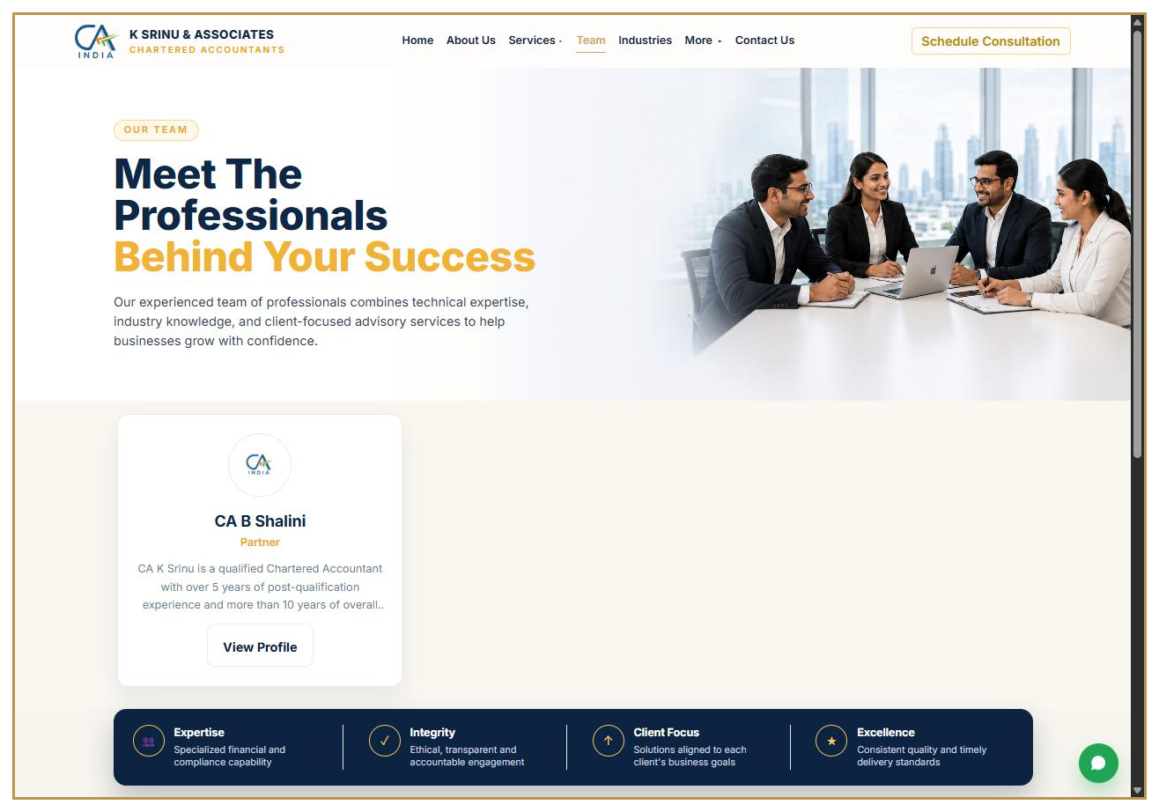
Figure 5 — The public Team page, populated from the Admin Panel.

10 MANAGING CAREERS
Go to Careers to publish or update job openings.
Fill in the job title, type (Full-time, Part-time, Internship, Articleship, Contract, or Other), experience level, location, description, and requirements. Set the status to Active or Inactive, and check "is_internship" if relevant. The Live Career Preview shows exactly how the listing will look before you publish. Applications submitted against a listing appear later in the Form Submissions tab.

11 MANAGING NOTIFICATIONS
Go to Notifications to publish updates to the homepage scrolling ticker and the News page.
Fill in a title, category (for example: Tax Update, Circular, Firm News), a short ticker summary (up to 320 characters), the full notification content (up to 10,000 characters), and an optional related webpage link. You may attach a PDF up to 10 MB — useful for circulars or official notices. Set a "Display from" date/time and an optional "Expires at" date/time to control exactly when the notification is visible, and set its display order. Visitors can click any ticker item to read the full notice. Uncheck "Publish this notification" to unpublish without deleting it.

12 HOMEPAGE STATS
Go to Homepage Stats to edit the four highlight figures shown below the homepage hero buttons (for example: "5+ Years of Excellence," "200+ Happy Clients," "1000+ Compliance Filings," "100% Client Satisfaction"). Update each value and its label, then click Save Homepage Stats. The live preview shows the final layout before you save.

13 SITE SETTINGS
Go to Site Settings to manage the contact details shown across the site's contact sections and footer:
- Phone numbers — the first number listed is used for the "Call Now" button
- Email addresses — the first email listed is used for the "Send Email" button
- WhatsApp number
- Google Maps link and embedded map iframe (get this from Google Maps → Share → Embed a map → copy the iframe source)
- Footer text
- Office address
Use the + Add buttons to add multiple phone numbers or email addresses. Review the Live Contact/Footer Preview before saving, then click Save Settings. Changes apply site-wide immediately.

14 FORM SUBMISSIONS
Go to Form Submissions to view everything visitors have sent through the website:
- Contact Inquiries — messages from the Contact page form
- Career Applications — applications submitted against job openings
Use the search box to find a submission by name, email, phone, or message content, and the status filter to view New, Reviewed, or Contacted entries. Update a submission's status as you follow up, so your team always knows what still needs a response. New and unreviewed items are highlighted with a badge count in the sidebar and on the Overview tab.

15 BACKUP & RESTORE
Go to Backup & Restore for data safety tools. This section has four parts:

1. Frontend backup
The website's code (HTML, CSS, JavaScript, images, and the admin panel itself) lives in a GitHub repository, not the browser. Use the provided links to open the repository or download a full ZIP copy, or use the git commands shown to clone and archive it.

2. Backend data backup
Click Export Backend Backup JSON to download a one-click export of every database table: site settings, compliance calendar, team members, career openings, notifications, contact submissions, career applications, and achievements.

3. Storage backup notice
Team photos are stored separately in a Supabase Storage bucket named "team-images." The JSON backup only stores image links, not the image files themselves — download the storage bucket directly from the Supabase dashboard for a complete image backup.

4. Backend restore
Upload a previously exported backup JSON file, review the validation summary, type RESTORE to confirm, then run the restore. Restoring updates existing records by ID (upsert) and does not delete anything, but it also does not restore Supabase Auth users or Storage files.
Important warnings
Always download a frontend GitHub backup before making major edits.
Always export a backend data backup before running a restore.
Restore does not bring back deleted login accounts or deleted images.

16 BEST PRACTICES & MAINTENANCE TIPS
- Log in to the Admin Panel at least weekly to review new form submissions and respond promptly.
- Keep the Compliance Calendar current each month so it stays a trusted resource for clients.
- Use the "is_active" checkboxes to temporarily hide outdated content instead of deleting it, in case you need it again later.
- Take a backend JSON backup on a regular schedule (for example, monthly) and store it somewhere safe outside the website.
- Keep image files reasonably sized before uploading, for faster page loading.
- Review the live preview panels before saving any change — they show exactly what visitors will see.
- Do not share the Admin Panel URL publicly or link to it from any public page.

17 TROUBLESHOOTING & FAQ

I can't log in.
Confirm you are using the correct admin email and password. If you've forgotten your password, contact Varada Nexus support to reset admin access — this cannot be self-served from the login screen.

My changes aren't showing on the live site.
Most content changes (compliance items, team members, careers, notifications, homepage stats, settings) appear immediately after saving since they come from the database. If something still looks wrong, try a hard refresh of the page (Ctrl+F5 or Cmd+Shift+R) to clear your browser's cache.

I accidentally deleted or deactivated something.
Uncheck versus delete — most sections let you deactivate a record instead of permanently removing it. If something was truly deleted, restore it from your most recent backend JSON backup.

An image won't upload.
Check the file type (images only, PDFs only for notification attachments) and size (PDF attachments are limited to 10 MB). Try a smaller or re-saved file if the upload fails.

I need to change website code, layout, or design (not just content).
That requires a developer, since it involves the HTML/CSS/JavaScript files in the GitHub repository rather than the Admin Panel. Contact Varada Nexus support for code-level changes.

18 SUPPORT & CONTACT
Website developed and maintained by: Varada Nexus Private Limited
Support email: connect@varadanexus.com
Website: www.varadanexus.com

K Srinu & Associates firm contact details
- Phone: +91 8897667910
- Email: kasofc4u@gmail.com
- Address: D.No: 81-23-01/3, Sri Venkateswara Nagar, Rajamahendravaram, Andhra Pradesh, 533106, India

For password resets, new admin users, code-level changes, hosting, or domain issues, please reach out to the Varada Nexus support email above.

This guide covers the Admin Panel as configured at the time of handoff. If new features are added to the website in the future, ask your developer for an updated version of this guide.

