TEB3123 MACHINE LEARNING
Group Project Final Report
Student Submission Template
September 2026
Project Title | Data-Driven Wind Turbine Performance Monitoring to Reduce Clean Energy Losses (SDG 7)
Lecture Session Group | Group 1
Project Group No. | 12
UTP Grand Challenge | Energy Security
Relevant SDG | SDG 7 – Affordable and Clean Energy
Dataset Name / Source | Wind Turbine Scada Dataset (Kaggle)
Submission Date | 13 November 2026

Group Members
No. | Student Name | Student ID
1 | MOHAMMAD FAKHRI HAKIMI BIN AZAMI | 22000317
2 | NIK MUHAMMAD AFIQ AIMAN BIN MOHD ARIFF | 22012096
3 | MUHAMMAD UMAIR ARIF BIN MOHD AZMI | 22005713
4 | MOHAMAD ASHRAF JAFFERY BIN MOHAMAD NOORNASRUL JAFFERY | 22005675
5 | MUHAMMAD SAFUAN BIN ROSMI | 22012114

Contents
Executive summary 6
Chapter 1 Introduction and Problem Definition 8
1.1 Background and context 8
1.2 Problem statement 8
1.3 Aim and measurable objectives 9
1.3.1 Project aim 9
1.3.2 Project objectives 9
1.4 Sustainability alignment and scope 10
1.5 Expected and achieved outcomes 11
Chapter 2 Data Understanding 12
2.1 Dataset provenance and suitability 12
2.2 Data dictionary 13
2.3 Target definition and data availability 13
2.4 Data quality profile 14
2.5 Exploratory visualizations 15
2.5.1 Distribution of Wind Speed 15
2.5.2 Distribution of Active Power Generation 16
2.5.3 Relationship Between Wind Speed and Active Power 17
2.5.4 Monthly Variation in Power Generation 18
2.6 Insights that shape the methodology 19
Chapter 3 Data Preprocessing 21
3.1 Preparation sequence 21
3.2 Cleaning and missing values 22
3.3 Outliers and unusual cases 24
3.4 Encoding scaling and imbalance 25
3.4.1 Wind direction encoding 25
3.4.2 Feature scaling 25
3.4.3 Unknown categories and resampling 25
3.5 Final prepared dataset 26
Chapter 4 Feature Engineering and Selection 28
4.1 Feature design rationale 28
4.1.1 Rule-based reference state (not a label) 30
4.2 Feature selection 31
4.3 Dimensionality reduction if applicable 32
4.4 Evidence of usefulness 32
4.5 Leakage and interpretation checks 32
Chapter 5 Machine Learning Methodology 34
5.1 Task formulation and pipeline 34
5.2 Baseline and selected algorithms 35
5.3 Evaluation design 35
5.4 Training and hyperparameter selection 36
5.5 Implementation details 37
Chapter 6 Evaluation Measures and Results 39
6.1 Measures that fit the decision 39
6.2 Quantitative comparison 40
6.2.1 Clustering performance 40
6.2.2 Regression performance 41
6.3 Uncertainty and consistency 43
6.4 Final selection 43
6.5 Explain the principal findings 45
6.6 Visual evidence 46
6.7 Error and subgroup analysis 47
6.8 Explainability and decision usefulness 49
6.9 Relationship to prior work 50
Chapter 7 Sustainability Insights and Recommendations 52
7.1 Linking the findings to the Grand Challenge 52
7.2 Actionable recommendations 52
7.3 Quantifying the impact responsibly 56
7.4 Adoption and monitoring 58
Chapter 8 Limitations Conclusion and Future Work 59
8.1 Data and methodological limitations 59
8.2 Conclusion 61
8.3 Prioritized future work 62
References 64
Suggested team contribution record 66

List of Figures
Figure 2.1 Distribution of Wind Speed Recorded by the Wind Turbine in 2018 16
Figure 2.2 Distribution of Actual Active Power Generation (kW) 17
Figure 2.3 Relationship Between Wind Speed, Actual Power and Theoretical Power 18
Figure 2.4 Monthly Average Actual Power Generation in 2018 19
Figure 2.5 Comparison of Original Numerical Feature Scales Before Standardization 20
Figure 3.1 Recorded 10-minute slots as a percentage of the expected total, by month (2018). Months below 100% correspond to the 32 timestamp gaps (2,030 missing slots, 3.9% of the year) documented in Table 3.1; these gaps are preserved rather than imputed. 22
Figure 4.1 Share of records (left) and shortfall energy (right) by 30° wind-direction sector (dir_sector), derived from wd_sin/wd_cos. Used for loss-by-direction reporting, not as a direct model input 30
Figure 4.2 Wind speed vs. actual power, coloured by rule_state (near_curve, underperforming, zero_output, below_operating_range), against the manufacturer theoretical curve. The vertical line marks the 3.5 m/s operating threshold (in_operating_region) 31
Figure 6.1 Actual versus out-of-fold predicted power (a) and residuals against wind speed (b) for the XGBoost model, normal training cluster (40,476 records). 46
Figure 6.2 DBSCAN group sizes on a log scale (a) and DBSCAN groups plotted on the measured power curve (b), operating region only (40,635 records). 47
Figure 6.3 MAE (a) and mean residual (b) for each held-out month under leave-one-month-out validation. 47
Figure 6.4 Permutation importance of the XGBoost inputs (a) and predicted power across wind direction with wind speed held at 6 m/s and 9 m/s (b). 49
Figure 7.1 Energy loss by suspected operating state, 2018 (ML and manufacturer baselines). 54
Figure 7.2 Pareto ranking of realistic energy loss by month and wind-direction sector. 55
Figure 7.3 Energy loss (left) and share of expected energy lost (right) by month, 2018. 55
Figure 7.4 Realistic energy loss (left) and loss rate (right) by 30° wind-direction sector. 56
Figure 7.5 Energy loss by 0.5 m/s wind-speed bin (ML and manufacturer baselines). 56

List of Tables
Table 2.1 Summary of the Wind Turbine SCADA dataset 12
Table 2.2 Data dictionary of the original variables 13
Table 2.3 Data quality profile before cleaning 15
Table 3.1 Cleaning checks, evidence and rules applied 23
Table 3.2 Physical range-validation rules for unusual values 24
Table 3.3 Preprocessing rules and their effect on the dataset 26
Table 4.1 Feature set with construction and reason for inclusion 28
Table 5.1 Reference baselines and machine learning approaches for each task 35
Table 5.2 Final model settings 36
Table 6.1 Evaluation measures for each task 39
Table 6.2 Silhouette scores for the K-Means and DBSCAN configurations 40
Table 6.3 DBSCAN group sizes (eps = 0.3) 41
Table 6.4 K-Means group sizes (k = 4) 41
Table 6.5 Regression models and baselines under leave-one-month-out cross-validation 42
Table 6.6 Final selection summary 44
Table 6.7 Out-of-fold error by rule-based state (training cluster) 48
Table 6.8 Out-of-fold error by wind speed band 48
Table 7.1 Prioritised recommendations 53
Table 7.2 Energy recovery and CO₂ scenarios for 2018 57
Table 7.3 What an operator needs to adopt the pipeline 58
Table 8.1 Limitations, their effect and practical responses 60
Table 8.2 Status of the project objectives 62

Executive summary
Wind is one of the main renewable sources of electricity, but a wind turbine does not always produce what the wind allows. Faults, stops and gradual wear can all cut its output, and every megawatt-hour lost is clean energy that has to come from somewhere else, usually fossil fuel. This project, Data-Driven Wind Turbine Performance Monitoring to Reduce Clean Energy Losses, looks at how much energy one turbine lost and why. It sits under UTP's Energy Security Grand Challenge and Sustainable Development Goal 7 (Affordable and Clean Energy).

We used the Wind Turbine SCADA Dataset published by Berk Erisen on Kaggle. It holds 50,530 ten-minute records from a single 3.6 MW turbine in Turkey for the whole of 2018. Two kinds of machine learning were applied. K-Means and DBSCAN clustering (unsupervised) were used to look for groups of similar operating behaviour, and Random Forest and XGBoost regression (supervised) were used to predict how much power the turbine should produce when it is healthy.

XGBoost was the better of the two regression models, with an MAE of 202 kW, an RMSE of 389 kW and an R² of 0.88. A simple binned power curve was slightly more accurate still (MAE 194 kW), which shows that the wind direction inputs did not help on unseen months. Clustering worked less well. DBSCAN put 99.6% of the operating records into one cluster, so we used simple rule-based operating states to break down the losses instead.

Against the healthy power curve learned by the model, the turbine lost about 617 MWh in 2018. Against the manufacturer's power curve the figure rises to about 1,600 MWh. Roughly 52% of the realistic loss happened when the turbine appeared to be shut down even though the wind was good enough to generate.

Our main recommendation is to investigate long stops first, set up alerts for zero output in good wind and use the Pareto ranking to decide where maintenance time goes. Doing this would raise the clean energy produced by turbines that already exist. The savings are still estimates, since there were no maintenance logs to confirm the causes, and the data comes from only one turbine in Turkey.

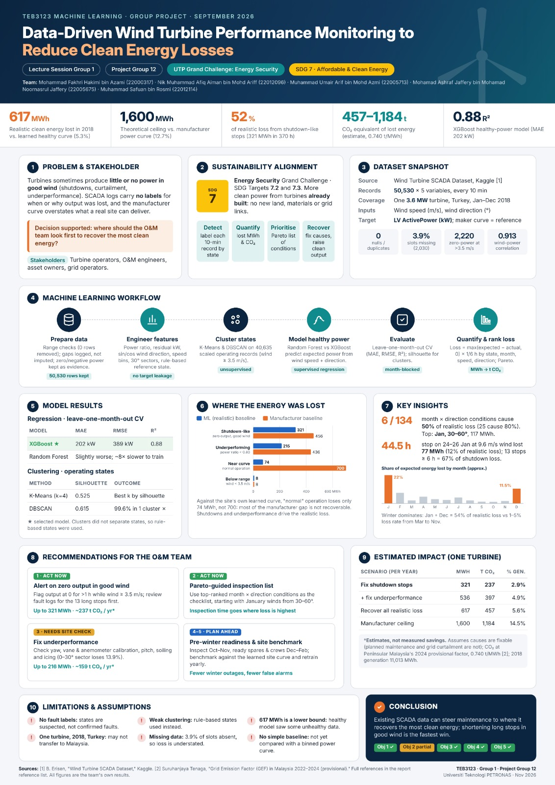

Chapter 1 Introduction and Problem Definition

1.1 Background and context
Renewable energy helps cut the use of fossil fuels and gives a cleaner, longer-lasting supply of electricity. Wind power is one of the most widely used forms: a turbine turns the kinetic energy of moving air into electricity. In practice, a turbine never captures all of the energy available to it, and a range of technical and operational factors decide how much it actually delivers.

Most modern turbines have a Supervisory Control and Data Acquisition (SCADA) system that continuously logs wind speed, wind direction and power output. Operators can use this record to see how a turbine is performing, spot unusual behaviour and check how much electricity it is really producing. Earlier studies have shown that SCADA data is valuable for both health monitoring [5] and performance assessment [6].

The hard part is working out why output drops. Power can fall even when there is plenty of wind, for example when the turbine has stopped or is running in a limited mode while the wind is perfectly usable. If nobody notices and looks into these periods, energy is lost that did not need to be.

Machine learning suits this kind of problem because it can work through large datasets and pick out patterns a person would miss. Clustering can group records that behave alike, and regression can estimate what the power should have been for a given wind condition. Comparing the two tells us how much energy may have been lost.

In this project we analyse turbine SCADA data to find operating situations that could explain lower power generation. The aim is to help operators and O&M teams see why a turbine is underperforming and where maintenance effort should go, so that existing turbines can generate renewable energy more efficiently.

1.2 Problem statement
Wind turbine operators want their machines to generate as steadily as the wind allows. Output still falls short at times, and when a turbine produces very little or nothing in good wind, it may point to a fault, curtailment or poor performance.

The problem we address has two parts: finding abnormal periods in the turbine's operation, and estimating how much clean power was lost during them. The dataset is large, but none of it is labelled, so there is no record of whether the turbine was running normally, had failed, was curtailed or was underperforming at any given time.

The manufacturer's theoretical power curve on its own is not a reliable guide to what this turbine should produce. It describes ideal test conditions, so the gap between theoretical and actual power is usually bigger than the energy that could realistically be recovered.

Clustering lets us group records with similar operating behaviour. We also built regression models to estimate the power the turbine should produce when it is working normally. Setting that expected power against the actual power shows how much energy may have been lost, and when.

This gives the O&M team a clear idea of what to check first. The conditions we identify are only suspected, though, because there are no maintenance records or fault labels to confirm them.

1.3 Aim and measurable objectives

1.3.1 Project aim
The main aim is to build a data-driven way of monitoring wind turbine performance with machine learning, one that can flag possible abnormal operating conditions, estimate the clean electricity lost and help with maintenance decisions.

1.3.2 Project objectives
The project has five main objectives:
Objective 1: Prepare and explore wind turbine SCADA data.
- Investigate the data and identify any issues with the data such as:
  - Missing values
  - Duplicates
  - Invalid readings
  - Unusual conditions
- Conduct exploratory data analysis to gain an understanding of how wind speed, wind direction and real power relate to one another.
- Prepare the data so it is ready for use in machine learning.

Objective 2: Identify possible operating conditions of the wind turbine using an unsupervised clustering approach.
- Apply K-Means and DBSCAN clustering techniques.
- Investigate the results by comparing them using appropriate metrics such as Silhouette score.
- Interpret the results to identify possible normal conditions, shutdown like situations and poor performance.
Objective 3: Regression modelling to predict expected power generation.
- Apply Random Forest and XGBoost regression models using wind speed and wind direction as inputs.
- Evaluate model performance using MAE, RMSE and R².
- Choose which model performs better to predict expected power generation under normal conditions.
Objective 4: Estimate potential clean loss of electricity.
- Compare actual power generated to the healthy power curve and theoretical power curve from the manufacturer.
- Calculate potential energy lost for different operating conditions, months, wind speeds and wind directions.
- Estimate potential carbon emissions.
Objective 5: Recommend improvements.
- Identify which operating conditions are contributing the most to the potential energy loss.
- Use Pareto analysis to identify the most important conditions to investigate.
- Recommend practical monitoring and maintenance actions to help reduce potential energy losses.

1.4 Sustainability alignment and scope
The project fits under UTP's Energy Security Grand Challenge. It also links to Sustainable Development Goal 7 (SDG 7), which aims to ensure access to affordable, reliable, sustainable and modern energy for all.

The connection to energy security comes from making better use of renewable infrastructure that is already in place. Turbines often lose generation through unexpected outages or poor performance. Once these periods are identified, operators can find out what caused them and plan the right maintenance. Recovering that lost output adds to renewable supply without building anything new.

Recovering lost renewable output also cuts carbon emissions, because each recovered megawatt-hour replaces grid electricity. We estimate the carbon benefit with the provisional 2024 grid emission factor for Peninsular Malaysia, 0.740 tonnes of CO₂ per MWh [2], which puts the results in a Malaysian sustainability context.

The analysis uses the Wind Turbine SCADA Dataset created by Berk Erisen and published on Kaggle [1]. It contains 50,530 records from a single turbine in Turkey, logged every 10 minutes from January to December 2018. We work with four of its measurements: wind speed, wind direction, actual active power and theoretical power.

On the machine learning side, K-Means and DBSCAN were used to cluster the data into possible operating conditions, and Random Forest and XGBoost were used to predict expected power. The project also covers feature engineering, model evaluation, energy loss estimation and maintenance recommendations.

All conclusions come from this dataset alone, so we cannot say exactly how the same turbines would perform in Malaysia. The data also has no verified fault labels, maintenance history or grid curtailment records. The operating conditions and loss estimates should therefore be read as analytical findings rather than confirmed facts.

1.5 Expected and achieved outcomes
The goal was a machine learning method that monitors turbine performance, flags possible fault conditions and estimates how much clean energy may have been lost.
We cleaned and processed the full SCADA dataset of 50,530 records and created features for power ratio, residual power, encoded wind direction and energy loss.

K-Means and DBSCAN were both applied to identify operating conditions. For K-Means, four clusters gave the best silhouette score (0.525). DBSCAN scored higher at 0.615, but it put 99.6% of operating records into a single cluster, which made it far less useful. We used rule-based reference states to help interpret the energy losses, so this objective was only partly met.

XGBoost predicted power with MAE = 202 kW, RMSE = 389 kW and R² = 0.88 under leave-one-month-out validation. It was slightly more accurate than Random Forest and trained about nine times faster. A simple 0.5 m/s binned power curve did a little better than both (MAE 194 kW), so the extra direction inputs did not add accuracy.

Against the machine learning healthy power curve, the estimated energy loss was 617 MWh. Against the manufacturer's theoretical curve it was up to 1,600 MWh. A Pareto analysis showed that 6 of the 134 month and wind-direction conditions accounted for about 50% of the realistic loss.

In short, the project delivered a working data preparation and machine learning pipeline, tested clustering and regression models, estimated the potential energy losses and suggested how to prioritise maintenance. These results say a lot about how the turbine performed, but maintenance records, site visits and a real trial would be needed to prove that energy is recovered and emissions fall.

Chapter 2 Data Understanding

2.1 Dataset provenance and suitability
The data comes from the Wind Turbine SCADA Dataset, published by Berk Erisen on Kaggle. It holds operational measurements from one wind turbine over 2018: 50,530 records and five original variables, namely the timestamp, actual power, wind speed, wind direction and the manufacturer's theoretical power.

Each record covers a 10-minute SCADA interval. With wind and power measured side by side, the data shows how wind conditions translate into electricity. Having both actual and theoretical power is especially useful, because it lets us compare what the turbine produced with what it was expected to produce.

The dataset suits our main task, unsupervised clustering, because it has no operating-state or fault labels. K-Means and DBSCAN can be used to find groups of records that behave differently. These groups might correspond to normal running, shutdown-like periods, curtailment-like behaviour or underperformance, but on their own they cannot prove what caused a fault.

The dataset also supports regression. Random Forest and XGBoost can be trained to estimate expected power under normal operation, and the prediction can then be compared with actual generation to estimate energy losses.

Using this data fits the project's link to the UTP Energy Security Grand Challenge and SDG 7. Studying how the turbine performs and where it loses energy gives operators evidence they can use to prioritise maintenance and get more renewable electricity out of their turbines.

Table 2.1 Summary of the Wind Turbine SCADA dataset
Dataset attribute | Project details
Source and access | Wind Turbine SCADA Dataset, Berk Erisen, Kaggle. Accessed 7 November 2026
Coverage | Single wind turbine in Turkey, January-December 2018, 10-minute intervals
Observation unit | One turbine SCADA measurement interval
Original size | 50,530rows and 5 columns
Task and outcome | Clustering operating states; regression predicting LV ActivePower (kW)
Use constraints | Publicly accessible Kaggle listing; dataset license and reuse conditions require verification

2.2 Data dictionary
The dataset has five original variables describing the turbine's operating and environmental conditions. Together they give us what we need to study power generation patterns and pick out possible abnormal behaviour.
Table 2.2 Data dictionary of the original variables
Variable | Meaning and unit | Type | Role
Date/Time | Timestamp of each 10-minute SCADA measurement | Datetime | Temporal reference
LV ActivePower (kW) | Actual electrical power generated by the turbine, measured in kilowatts | Numerical | Regression target and clustering input
Wind Speed (m/s) | Wind speed recorded at the turbine, measured in meters per second | Numerical | Input
TheoreticalPowerCurve (KWh) | Manufacturer's theoretical power output at the recorded wind speed | Numerical | Reference and derived-feature input
Wind Direction (°) | Direction from which the wind originated, measured from 0° to 360° | Numerical | Input

2.3 Target definition and data availability
Two machine learning approaches are used: unsupervised clustering and supervised regression. They have different goals and use the SCADA measurements in different ways.

Clustering has no target variable, since the dataset contains no labelled operating conditions. K-Means and DBSCAN instead group records that are similar in wind speed, active power and the performance-related features. We then interpret the clusters as suspected conditions such as normal operation, shutdown, curtailment and underperformance.

For regression, the target is LV ActivePower (kW), the actual electrical power produced by the turbine. Random Forest and XGBoost are used to estimate expected output under normal operation from wind speed and wind direction.
The theoretical power curve is kept as a reference for comparing performance, not used as a predictor. That stops the model from leaning on a value that is itself calculated from wind speed.

The records were taken every 10 minutes through 2018, so neighbouring records are closely related in time. For this reason we use month-blocked validation rather than a random split, which would give overly optimistic results.

One limitation is that the turbine is in Turkey, while our sustainability discussion is set in Malaysia's energy context. The results show how such monitoring could work, but they do not directly describe how turbines would perform under Malaysian conditions.

2.4 Data quality profile
Before any preprocessing, we checked the original dataset for missing values, duplicates, invalid measurements and gaps in time coverage.

The dataset has 50,530 records and five variables. We found no missing values, no duplicate records, no invalid timestamps and no repeated timestamps.

The timestamp sequence did show 32 gaps between consecutive records. A full year at 10-minute intervals should contain 52,560 records, which means 2,030 intervals are missing.

Table 2.3 Data quality profile before cleaning
Quality check | Evidence before cleaning | Planned response
Missing values | 0 Missing values across all five variables | No cell-level imputation required
Duplicate records | 0 exact duplicate records and 0 duplicate timestamps | Retain all unique records
Invalid timestamps | 0 invalid timestamps | Convert to datetime format and maintain chronological order
Negative wind speed | 0 Records | No removal required
Negative active power | 57 Records | Investigate and retain where operationally meaningful
Time coverage | 32 timestamp gaps, representing 2,030 missing intervals | Document gaps and preserve temporal ordering
Unusual operating conditions | 2,220 records with zero or negative power while wind speed exceeds 3.5 m/s | Retain for suspected shutdown-state analysis

2.5 Exploratory visualizations
Exploratory Data Analysis (EDA) was carried out to understand the basic statistics of the data and how wind conditions relate to turbine output.

2.5.1 Distribution of Wind Speed
Wind speed ranges from 0.00 m/s to 25.21 m/s, with a mean of about 7.56 m/s and a median of 7.10 m/s.
The standard deviation is 4.23 m/s, so wind conditions varied a lot over the year. That spread is useful, because it lets us look at turbine performance across the whole range of wind speeds.
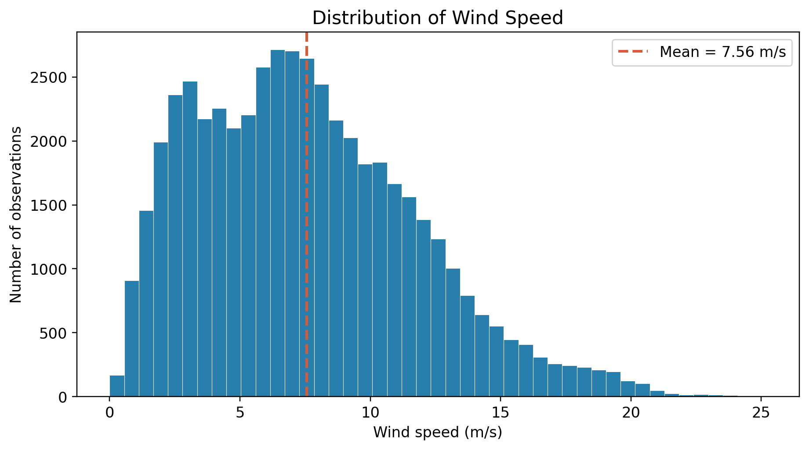
Figure 2.1 Distribution of Wind Speed Recorded by the Wind Turbine in 2018

2.5.2 Distribution of Active Power Generation
Actual active power ranges from about −2.47 kW to 3,618.73 kW, with a mean of 1,307.68 kW.
The median is only about 825.84 kW, well below the mean. Many records sit at low output, while a smaller number of high-output periods pull the average up.

The zero and negative readings matter most here, since they may mark periods when the turbine was idle or behaving abnormally.
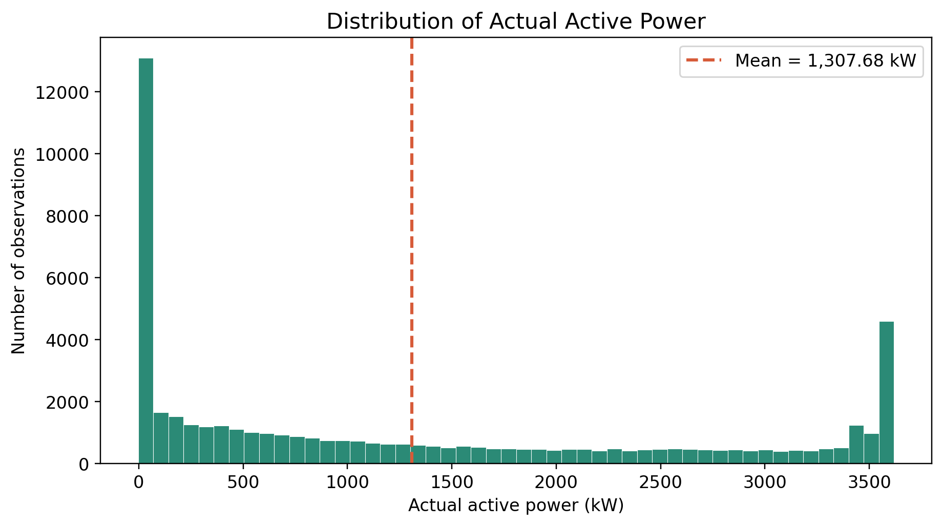
Figure 2.2 Distribution of Actual Active Power Generation (kW)

2.5.3 Relationship Between Wind Speed and Active Power
The Pearson correlation between wind speed and active power is about 0.913, a strong positive relationship.

This backs up the use of wind speed as the main predictor in regression. The relationship is not linear, however, because a turbine's power curve has distinct regions at low, medium and high wind speeds.

Actual power and theoretical power correlate at about 0.950, so actual generation broadly follows the expected curve.

Even so, the places where actual and theoretical output differ may point to operating conditions worth investigating.
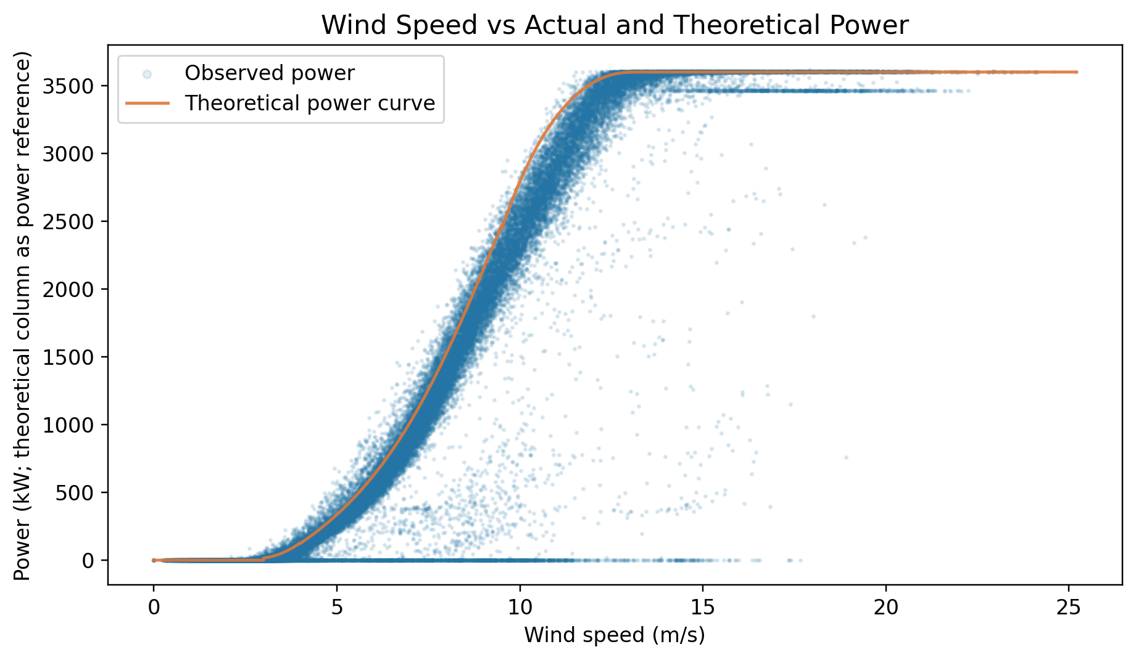
Figure 2.3 Relationship Between Wind Speed, Actual Power and Theoretical Power

2.5.4 Monthly Variation in Power Generation
Average power generation changes a lot from month to month across 2018.
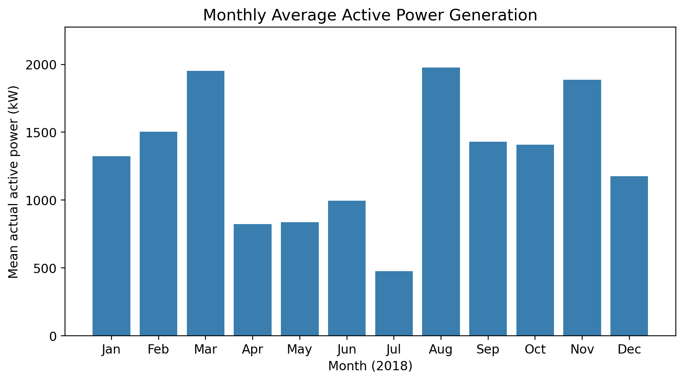
Figure 2.4 Monthly Average Actual Power Generation in 2018

August had the highest average output at about 1,978.2 kW, closely followed by March at 1,952.4 kW. July had the lowest, at about 477.0 kW.

These differences could come from seasonal wind patterns, turbine availability or operational limits, but further analysis is needed to pin down the cause.

2.6 Insights that shape the methodology
Several findings from the exploratory analysis shaped how we chose and set up the machine learning methods.

First, the strong link between wind speed and power supports using wind speed as the main regression input. Because the power curve is non-linear, we chose Random Forest and XGBoost, which can model complex relationships without assuming a straight line.

Second, there are 2,220 records with zero or negative power even though the wind was strong enough to generate. These need to stay in the data, because removing them during preprocessing would throw away evidence of possible shutdowns or underperformance. They are kept for clustering, while only suitable normal-state records are meant to be used to train the healthy power models.

Third, the numerical features sit on very different scales, so they need scaling before distance-based clustering. Standardisation stops large-valued variables from dominating K-Means and DBSCAN.

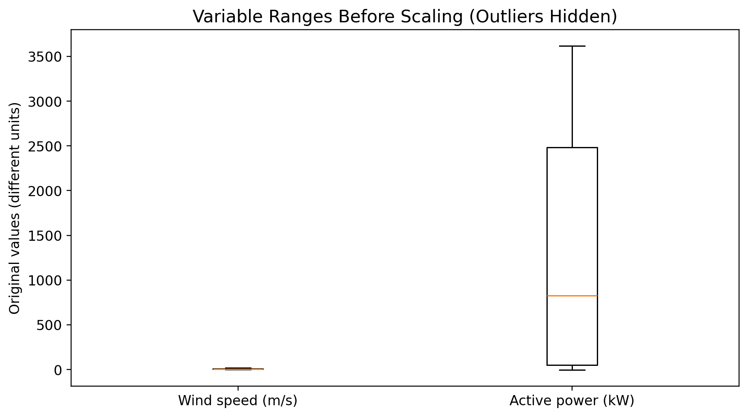
Figure 2.5 Comparison of Original Numerical Feature Scales Before Standardization
Fourth, the gaps in the timestamps and the month-to-month variation make a case for month-blocked validation in regression. It lowers the chance of near-identical neighbouring records ending up in both the training and validation sets.

Finally, because there are no operating-state labels, unsupervised clustering is the natural choice for the main task. K-Means and DBSCAN are compared to see which gives more meaningful and easier-to-interpret operating groups.

Taken together, the EDA confirms that the dataset is fit for studying turbine performance through clustering and regression. The characteristics found here set up the preprocessing, feature engineering and modelling steps in the chapters that follow.

Chapter 3 Data Preprocessing

3.1 Preparation sequence
The raw dataset (Berk Erisen, Kaggle) contains 50,530 ten-minute records covering 2018. Its five original variables are Date/Time, LV ActivePower (kW), Wind Speed (m/s), Theoretical_Power_Curve (KWh) and Wind Direction (°). Theoretical_Power_Curve peaks at 3,600, which matches the turbine's rated power in kW, so we treat it as an average power in kW rather than as energy. Both theoretical and actual power are converted to energy by multiplying by the interval length of 1/6 hour.

Preprocessing was run as one reproducible sequence, so anyone can rebuild the same cleaned dataset from the raw CSV:
- Step 1 — Load the raw file and rename columns to working names: timestamp, power_kw, wind_speed, theo_power_kw, wind_dir.
- Step 2 — Parse and sort timestamps (Section 3.2).
- Step 3 — Check and handle missing values (Section 3.2).
- Step 4 — Check and handle duplicate rows and duplicate timestamps (Section 3.2).
- Step 5 — Quantify missing 10-minute intervals in the timeline without imputing them (Section 3.2).
- Step 6 — Apply physical range-validation rules to remove impossible sensor readings only (Section 3.3).
- Step 7 — Encode wind direction and scale numerical features for the distance-based clustering pipeline only (Section 3.4).

Step 6 removed nothing, because the dataset contains no physically impossible values (Table 3.1). The cleaned dataset therefore still has all 50,530 records. Rows are only dropped later, at the modelling stage: records below the operating wind speed are left out of clustering (Section 3.3), and records outside the current “normal” reference state are left out of the regression training subset (Chapter 5).
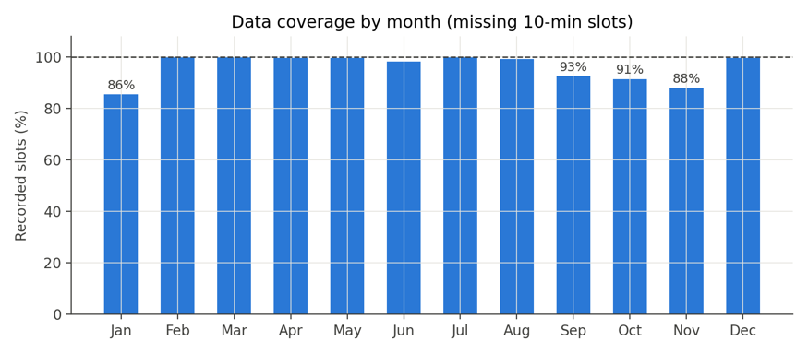
Figure 3.1 Recorded 10-minute slots as a percentage of the expected total, by month (2018). Months below 100% correspond to the 32 timestamp gaps (2,030 missing slots, 3.9% of the year) documented in Table 3.1; these gaps are preserved rather than imputed.

3.2 Cleaning and missing values
We tested each cleaning rule on the raw data instead of assuming it held. Table 3.1 gives the evidence and the action taken for every check.
Table 3.1 Cleaning checks, evidence and rules applied
Check | Evidence (raw data) | Rule applied
Raw record count | 50,530 rows, 5 columns | Baseline for all later counts
Timestamp parsing | 0 unparseable timestamps (format DD MM YYYY HH:MM) | Parsed to datetime and sorted ascending; chronological order confirmed
Missing (null) values | 0 missing cells across all 5 original variables | No cell-level imputation required
Exact duplicate rows | 0 duplicate rows | Would be dropped if present; none removed
Duplicate timestamps | 0 duplicate timestamps | Would be averaged (numeric mean) if present; none affected
Missing 10-minute intervals | 2,030 of 52,560 expected slots absent (3.9%), across 32 gaps; largest single gap = 625 slots (~4.3 days) | Not imputed — inventing power readings would invent energy and bias loss estimates; gaps are logged in a gap_before_min column and reported as a limitation
Negative active power | 57 records with power_kw < 0 (minimum ≈ −2.47 kW) | Retained — represents real grid power drawn while idle, which is operationally meaningful for identifying shutdown states

The missing intervals were left empty because no data at all was recorded for them, most likely because of a logging or communication failure. Filling them with zeros, interpolated values or averages would invent readings and distort the loss calculations in Chapter 7. We kept them empty, reported the share missing (3.9% of the year) and based all calculations on the intervals that were actually recorded.
The 57 negative power readings were also kept after we checked them. Looking at the wind speed and time around each one showed they were isolated low readings, most likely the turbine drawing a little power from the grid to run its own systems while idle or shut down, not a sensor problem. Removing them would erase exactly the kind of abnormal operation the clustering in Chapter 5 is meant to find.

3.3 Outliers and unusual cases
We did not use a generic statistical outlier rule such as a z-score or IQR cut-off. Unusual values were screened with physical range checks instead, because in this domain some of the most informative records (stoppages, curtailment, underperformance) are genuine operating states, not data errors.
Table 3.2 Physical range-validation rules for unusual values
Rule | Rationale | Result
Wind speed < 0 or > 40 m/s | Negative speed is physically impossible; readings above 40 m/s exceed credible values for this site and indicate sensor fault | 0 records removed
Wind direction outside 0–360° | Not a valid compass bearing | 0 records removed (direction re-wrapped to 0–360° using modulo 360)
Active power > 110% of rated capacity | The turbine cannot physically exceed its rated output by this margin | 0 records removed
Theoretical power outside 0–rated range | The manufacturer curve cannot fall outside its own defined range | 0 records removed

None of the four impossible-value rules were triggered, so the dataset stays at 50,530 records. The capacity used in these checks (3,600 kW) was taken from the maximum of the theoretical power column.

There is a second kind of unusual value: periods when the turbine produced zero or negative power even though the wind was strong. We found 2,220 intervals with wind speed above 3.5 m/s and power at or below 0 kW. These were deliberately left in, as they are the clearest sign of a shutdown or curtailment event, which is what the clustering in Chapter 5 is supposed to pick out. Dropping them here would also hide a large part of the energy loss measured in Chapter 7. They stay in the dataset with the flag rule_state = "zero_output" (Section 4.1). They are used in clustering and were meant to be kept out of the normal-operation data used to train the healthy power regression; Section 6.7 shows that almost all of them (2,219 of 2,220) still ended up in the DBSCAN normal cluster.

3.4 Encoding scaling and imbalance
This project has no categorical class label and no class-imbalance problem. Clustering is unsupervised and the regression target (LV ActivePower) is continuous, so this section deals with encoding and scaling rather than imbalance.

3.4.1 Wind direction encoding
Wind direction is circular: 359° is only 2° away from 1°, which breaks distance-based methods if the raw angle is used. We therefore split it into two features, wd_sin and wd_cos, the sine and cosine of wind_dir in radians. Both already lie between −1 and 1. The raw wind_dir column is kept for description only, and 30° direction sectors are used for the wind rose analysis (Section 4.1).

3.4.2 Feature scaling
Only the four numerical features (wind_speed, power_kw, power_ratio, residual_kw) were standardised to zero mean and unit variance. K-Means and DBSCAN both work on Euclidean distance, so without scaling, power_kw, which runs into thousands of kW, would swamp power_ratio, which mostly stays between about 0 and 1.5. The sine and cosine features were left as they are, since their −1 to 1 range is already close to that of the scaled features.

The scaler (scikit-learn's StandardScaler) was fitted once on the full operating-region subset (40,635 rows). Clustering has no train/test split here, unlike the regression pipeline (Chapter 5). If scaling or encoding is needed in a later step, it will be fitted on the training fold only and then applied to the validation or test fold, to avoid leakage. The scaler is saved (cluster_scaler.joblib) with its feature list, so cluster centres can be transformed back into kW and m/s for interpretation in Chapter 6.

Random Forest and XGBoost are both tree-based, so they split on feature thresholds and are not affected by monotonic scaling. No scaling was applied to the regression inputs (wind_speed, wd_sin, wd_cos).

3.4.3 Unknown categories and resampling
No input feature is categorical, so no unknown-category rule is needed. No resampling (such as SMOTE or class reweighting) was done either, because neither task involves class imbalance: clustering has no labels to balance and the regression target is continuous.
Table 3.3 Preprocessing rules and their effect on the dataset
Step | Rule and rationale | Effect on dataset
Missing 10-minute intervals | Not imputed; logged via gap_before_min to avoid fabricating energy | 2,030 slots (3.9%) left absent; 0 rows altered
Impossible sensor values | Removed if wind speed, direction, or power fell outside physically valid ranges | 0 rows removed (no violations found)
Negative / zero power at high wind | Retained as genuine shutdown/curtailment evidence rather than treated as error | 57 negative-power and 2,220 zero/negative-power-at-wind records kept
Wind direction encoding | sin/cos transform of wind_dir (training-free, deterministic) | 2 new bounded columns: wd_sin, wd_cos
Feature scaling | StandardScaler fitted on clustering subset only (40,635 rows); not applied to regression inputs | 4 new standardized columns (*_z) for clustering; regression inputs left on raw scale

3.5 Final prepared dataset
After cleaning and feature engineering, the dataset keeps all 50,530 records and has 21 columns: 5 original columns (renamed) and 16 engineered ones, all listed in Section 4.1. No rows were dropped in cleaning. Each task simply uses the subset it needs:
- Clustering subset: 40,635 records with wind speed at or above the 3.5 m/s operating threshold. The 9,895 records below it are left out, because the turbine is just waiting for wind and there is nothing useful to cluster.
- Regression reference subset: 31,197 records flagged rule_state = “near_curve”. This acts as a temporary stand-in for the “normal operation” group until the clustering in Chapter 5 gives the final operating-state assignment.

There is no class variable, so there is no class distribution table. The regression target, LV ActivePower (kW), ranges from about −2.47 kW to 3,618.73 kW, with a mean of 1,307.68 kW and a median of 825.84 kW (Chapter 2). The target is right-skewed, since many intervals had light wind and low output.

One data quality issue is carried forward: 3.9% of the 10-minute intervals are missing. Because these gaps are concentrated in a few multi-day periods, we chose month-blocked validation (Chapter 5). This makes it less likely that the same outage period appears in both the training and evaluation data.

Chapter 4 Feature Engineering and Selection

4.1 Feature design rationale
Each engineered feature was added to make a particular part of turbine behaviour visible to the models, not just in case it might help. Table 4.1 lists the full feature set used later and separates the original SCADA variables from the derived ones.
Table 4.1 Feature set with construction and reason for inclusion
Feature | Construction / source | Reason for inclusion
wind_speed (m/s) | Original SCADA variable | Primary physical driver of power output; main predictor for regression and a clustering input
power_kw | Original SCADA variable (LV ActivePower) | The quantity being judged; clustering input and regression target
theo_power_kw | Original manufacturer curve, relabelled from the source “KWh” column | Reference baseline for performance comparison only — never used as a regression input, to avoid the model leaning on a value already derived from wind speed
wind_dir (°) | Original SCADA variable | Raw bearing; replaced by wd_sin / wd_cos in all models, retained only for 30° sector reporting
power_ratio = clip(power_kw, 0) ÷ theo_power_kw | Derived, defined only within the operating region (wind ≥ 3.5 m/s) and clipped to a fixed range to avoid division blow-up near zero | Scale-free measure of how closely the turbine follows its expected curve (≈1 = on-curve, ≈0 = stopped); separates stoppage, curtailment and normal operation for clustering
residual_kw = theo_power_kw − power_kw | Derived, signed | Size of the performance gap in kW; large positive values at high wind indicate real energy being lost; kept signed (not absolute) so clustering can distinguish shortfall from mild over-performance
wd_sin, wd_cos = sin/cos(wind_dir in radians) | Derived circular encoding | Represents direction on a continuous circle so that 359° and 1° are correctly seen as close; used as regression inputs and tested as optional clustering inputs
dir_sector (30° bins) | Derived, floor(wind_dir / 30) × 30 | Groups records into 12 compass sectors for loss-by-direction reporting (yaw misalignment, wake effects); reporting only, not a model input
ws_bin (0.5 m/s bins) | Derived, floor(wind_speed / 0.5) × 0.5, matching IEC 61400-12-1 power-curve binning practice | Supports power-curve-style reporting and visual diagnostics; reporting only
month, hour | Derived from timestamp (calendar extraction, available at prediction time) | month defines the cross-validation blocking groups (Chapter 5); both support “when do losses happen” reporting; excluded as direct model inputs because they could otherwise leak seasonal identity rather than physical cause
in_operating_region (flag) | Derived: wind_speed ≥ operating threshold (3.5 m/s = data-derived cut-in of ≈3.0 m/s + 0.5 m/s buffer) | Selects the subset passed to clustering; below this threshold the turbine is simply waiting for wind and has nothing meaningful to cluster
rule_state (near_curve / underperforming / zero_output / below_operating_range) | Derived from simple physical thresholds on power_ratio and in_operating_region (Section 4.1.1) | Physically interpretable reference state used to sanity-check the data-driven clusters in Chapter 5; explicitly not a ground-truth label
actual_kwh, theo_kwh, shortfall_kwh | Derived: power (kW) × 1/6 h per 10-minute record; shortfall_kwh = max(residual_kw, 0) × 1/6 h | Converts power readings into an energy basis so losses can be summed meaningfully over time; shortfall_kwh is the manufacturer-baseline energy loss per record used in Chapter 7
gap_before_min | Derived: minutes elapsed since the previous timestamp | Documents missing 10-minute intervals (Section 3.2) so later aggregates can be reported “over recorded intervals”

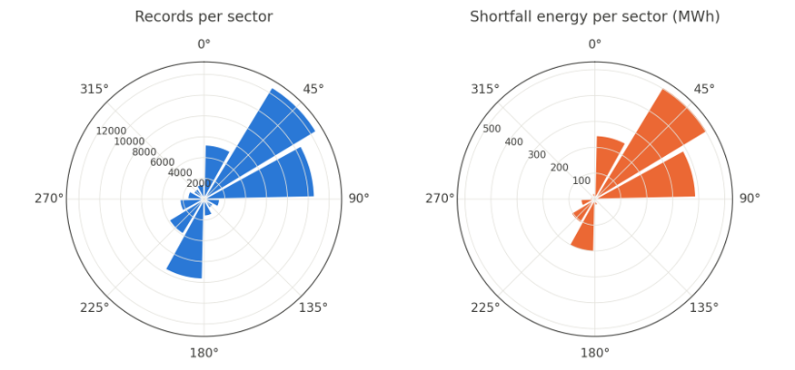
Figure 4.1 Share of records (left) and shortfall energy (right) by 30° wind-direction sector (dir_sector), derived from wd_sin/wd_cos. Used for loss-by-direction reporting, not as a direct model input

4.1.1 Rule-based reference state (not a label)
The dataset has no ground truth for the turbine's operating state, so we built a simple rule-based decision tree to sanity-check the clusters. Each row gets one of four states: below_operating_range (wind speed < 3.5 m/s), zero_output (wind speed ≥ 3.5 m/s and power ≤ 0 kW), underperforming (power ratio < 0.80) and near_curve (everything else). Applying these rules to the cleaned data gave 31,197 near_curve rows, 9,895 below_operating_range rows, 7,218 underperforming rows and 2,220 zero_output rows.

The rules have clear limits. Above about 13 m/s the output flattens at around 3,450 kW, which looks like curtailment, yet the power ratio there is about 0.96, so these rows are labelled near_curve. The rules also cannot tell real curtailment apart from a slow drop in performance. That is why clustering on power ratio, residual power and wind speed (Chapter 5) is still needed.
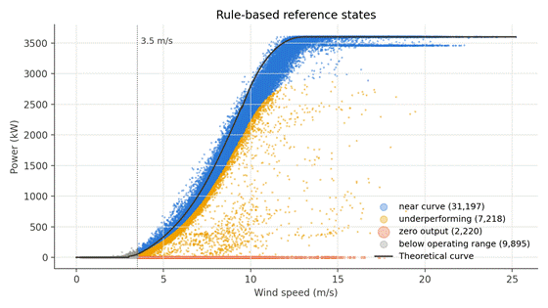
Figure 4.2 Wind speed vs. actual power, coloured by rule_state (near_curve, underperforming, zero_output, below_operating_range), against the manufacturer theoretical curve. The vertical line marks the 3.5 m/s operating threshold (in_operating_region)

4.2 Feature selection
No automated feature selection, such as recursive feature elimination, was used; every feature in Table 4.1 is included. With only four clustering features and three regression features, all chosen for clear physical reasons, automated selection would add little.

Redundancy was still checked when choosing model inputs. theo_power_kw and wind_dir were left out of both the clustering and regression inputs. theo_power_kw is calculated from wind speed and correlates strongly with power (Pearson r ≈ 0.950 with actual power, Chapter 2), so including it would make the model rely on a second copy of the wind speed signal. wind_dir was dropped because it is already represented by its sine and cosine.

Two feature sets were prepared for clustering to test whether direction adds anything: a core set (wind_speed, power_kw, power_ratio, residual_kw) and an extended set that also includes wd_sin and wd_cos. Both were judged with the same clustering metric, the silhouette score, and the result is given in Section 4.4.

The regression inputs (wind_speed, wd_sin, wd_cos), and the exclusion of month and hour, were fixed in advance for the reasons given in Section 4.1. Calendar features would let the model predict from the time of year instead of the actual wind, and that would not carry over to another year. Month is used only to form the cross-validation blocks (Chapter 5).

4.3 Dimensionality reduction if applicable
Not applicable. Each task uses only three to six numerical features, and each has a clear physical meaning that we rely on when interpreting results in Chapters 6 and 7. PCA would swap these readable axes for abstract components and make the results harder to explain, for example when transforming cluster centres back into real wind speed and power units (Section 3.4.2), with almost no gain at this number of features.

4.4 Evidence of usefulness
We ran the comparison between the core and direction-extended feature sets with K-Means for k = 3 to 6, using the same scaled features, the same 10,000-record sample for the silhouette score and the same random_state, so any difference comes from the direction features alone. Adding wd_sin and wd_cos lowered the silhouette score at every k. At k = 4 it fell from 0.525 with the core set to 0.390 with the extended set (k = 3: 0.513 to 0.384; k = 5: 0.468 to 0.381; k = 6: 0.411 to 0.407). Direction spreads the records out without adding a clearer operating structure, so the core set was kept for clustering. The regression results point the same way: Section 6.2 shows that XGBoost without the direction inputs was slightly more accurate on held-out months.

4.5 Leakage and interpretation checks
Each derived feature in Table 4.1 was checked for accidental use of target information or future data:
- power_ratio and residual_kw are both calculated from power_kw (the regression target) and theo_power_kw. They are used only as clustering inputs and never as regression inputs, so the target does not leak into its own predictors.
- theo_power_kw is kept out of the regression inputs for the reason given in Section 4.2: it is tied to wind_speed and would let the model lean on the manufacturer reference instead of the physical input.
- month and hour come only from the timestamp, so they carry no future information. They are still kept out of the models (used only for CV grouping and reporting), so that the model learns from wind conditions and not from the calendar. This is a risk close to leakage rather than true temporal leakage.
- rule_state uses only values from the same timestamp (power_ratio, in_operating_region) and serves purely as a reference check on the clusters. It is never fed into either model, so it cannot leak a label that does not exist.
- gap_before_min documents data availability and is used only for reporting, not as a model input.

One more caution about power_ratio and residual_kw: they will probably look highly important in any clustering or later analysis because they track operating state closely, but an operator cannot change them directly. They are the result of the wind and the turbine's health. A strong link between these features and an operating state is therefore evidence for diagnosing that state, not a causal instruction for what to fix. We carry this point into the explainability discussion in Chapter 6 and the recommendations in Chapter 7.

Chapter 5 Machine Learning Methodology

5.1 Task formulation and pipeline
The project has two linked machine learning tasks. The first is unsupervised clustering. Its input is the 40,635 operating-region records (wind speed ≥ 3.5 m/s), described by four standardised features: wind_speed, power_kw, power_ratio and residual_kw. Its output is a cluster label for each record, which we read as a suspected operating state. The second is supervised regression. Its inputs are wind_speed, wd_sin and wd_cos, its target is power_kw, and its output is the expected healthy power in kW for every 10-minute record. The gap between expected and actual power, added up over time, gives the energy loss.

The pipeline runs as four notebooks in the deployed repository, in this order:

- Preparation (01_windturbine.ipynb). Load and check the raw CSV, apply the range rules, build the features in Table 4.1, flag the rule-based states and save the scaled clustering input together with its scaler.
- Clustering (02_clustering.ipynb). Run K-Means for k = 3 to 6 and DBSCAN for five eps values, compare them by silhouette score, cluster size and cluster profile, and take the cluster with the highest median power ratio as the normal-operation group.
- Regression (03_regression.ipynb). Train Random Forest and XGBoost on the normal-operation group, compare them with leave-one-month-out cross-validation, retrain the better model on all normal records and predict expected power for all 50,530 records, clipped to 0–3,600 kW.
- Loss analysis (04_loss_analysis.ipynb). Replace the model prediction with the manufacturer curve below 3.5 m/s, where the model was not trained, work out the loss against both baselines, break it down by state, month, wind speed and direction, rank the conditions in a Pareto chart and convert energy to CO₂.

Each stage serves an objective: preparation covers Objective 1, clustering Objective 2, regression Objective 3, and the loss analysis Objectives 4 and 5.

A simple rule can flag zero output in good wind, and we do use rules like that as a reference. What a rule cannot do is say how much power the turbine should have produced at this site in each interval. The manufacturer curve describes test conditions rather than this site, and fixed thresholds miss gradual losses. A model trained on the turbine's own normal records learns the site's real power curve, so the loss estimate reflects what could actually be recovered. Clustering is used for a similar reason on the state side: with no labels, it is the only way to look for groups that the rules do not already define. Section 5.2 sets up simple references to test whether the models really add accuracy.

5.2 Baseline and selected algorithms
Each task was given a simple reference so we could see whether the modelling effort adds value. Table 5.1 lists the references and the algorithms compared.

Table 5.1 Reference baselines and machine learning approaches for each task
Task | Reference baseline | ML approaches compared
Clustering | Rule-based reference states (Section 4.1.1): below_operating_range, zero_output, underperforming and near_curve | K-Means (k = 3 to 6) and DBSCAN (eps = 0.3 to 1.1, min_samples = 10)
Regression | Training-mean prediction; 0.5 m/s binned power curve (mean power per wind speed bin in the training months); manufacturer curve with no training | Random Forest and XGBoost

K-Means [7], [8] was chosen because it is simple, fast on 40,000 records and gives cluster centres that can be read back in kW and m/s. Its weakness is that it assumes compact clusters of similar size and puts every record into some cluster. DBSCAN [9] was picked as the contrast. It builds clusters of any shape from point density and can mark isolated records as noise, which suits rare abnormal records, but its results depend heavily on eps.

Random Forest [10] averages many deep decision trees grown on bootstrap samples, so it handles the non-linear power curve without much tuning. XGBoost [11] builds trees one after another, with each tree correcting the errors of the ones before it, and it usually trains faster. Both are tree-based, so neither needs scaled inputs (Section 3.4.2). Neither can extrapolate beyond the wind speeds it was trained on, which is why the loss analysis switches to the manufacturer curve below 3.5 m/s.

The regression baselines were run on the same normal-operation records and the same twelve month-blocked folds as the models. Their results are reported next to the models in Section 6.2.

5.3 Evaluation design
Clustering is unsupervised, so it has no train/test split. Both methods were fitted on all 40,635 operating-region records. Silhouette scores [14] were computed on a random sample of 10,000 records (random_state = 42) to keep the calculation quick, and the same sample size was used for every configuration. DBSCAN noise records were left out of its score, since the silhouette is not defined for noise.

For regression, the data is the 40,476 records in DBSCAN cluster 0. Records close in time are strongly related, so a random split would put near-copies of test records into training [12]. We used leave-one-month-out cross-validation instead, which gives 12 folds. In each fold one month is held out for testing and the other eleven are used for training. The test folds range from 2,769 records (April) to 4,235 records (August), so each model was trained on between 36,241 and 37,707 records. Stratification was not used, because the target is continuous and the folds are defined by time.

Every model and baseline used the same folds, the same inputs and random_state = 42, so the comparison is like for like. The reported scores are the mean of the 12 fold scores. Because the data covers only one year, we did not keep back a separate final test set. The same cross-validation results were used to compare the models and to report their accuracy, so the scores for the chosen model may be slightly optimistic. Once the choice was made, the selected model was retrained on all 40,476 normal records to predict expected power for the whole year.

5.4 Training and hyperparameter selection
All models were built in Python with scikit-learn [13] and the XGBoost library [11]. For clustering, a small grid was searched. K-Means was run for k = 3, 4, 5 and 6, each with 20 random starts (n_init = 20), and the k with the highest silhouette score was kept. DBSCAN was run with eps = 0.3, 0.5, 0.7, 0.9 and 1.1 at min_samples = 10. Only eps = 0.3 produced more than one cluster, so it was selected.

For regression, no automated search was done. The Random Forest and XGBoost settings were fixed by hand from common starting values rather than chosen through validation. The models were compared on cross-validated RMSE, with MAE as a tie-break, which is how the notebook sorts them. XGBoost used a fixed 500 boosting rounds with no early stopping. Table 5.2 gives the final settings and shows which values are library defaults and which we chose.

Table 5.2 Final model settings
Model | Setting | Value | Source
K-Means | n_clusters | 4 | Selected by silhouette (k = 3 to 6)
K-Means | n_init, random_state | 20, 42 | Set by hand
K-Means | init, max_iter | k-means++, 300 | Default
DBSCAN | eps | 0.3 | Selected from the 0.3–1.1 grid
DBSCAN | min_samples | 10 | Set by hand
DBSCAN | metric | Euclidean | Default
Random Forest | n_estimators | 300 | Set by hand
Random Forest | min_samples_leaf | 3 | Set by hand
Random Forest | max_features, max_depth | 1.0, None | Default
XGBoost | n_estimators | 500 | Set by hand
XGBoost | max_depth | 6 | Set by hand (same as default)
XGBoost | learning_rate | 0.05 | Set by hand
XGBoost | subsample, colsample_bytree | 0.8, 0.8 | Set by hand
XGBoost | objective | reg:squarederror | Default
All models | random_state | 42 | Set by hand

Since the regression settings were not tuned, the scores in Chapter 6 show what these models achieve with sensible starting values, not their best possible accuracy.

5.5 Implementation details
The project was written in Python as four Jupyter notebooks, run in order from 01 to 04 in the deployed GitHub repository. The notebook files record Python 3.11.9 for clustering and regression, 3.12.7 for preprocessing and 3.13.14 for the loss analysis, so the stages were run on different team members' machines. The libraries used are NumPy, pandas, Matplotlib, scikit-learn [13], XGBoost [11] and joblib. The repository's requirements.txt lists these packages without version numbers. To check reproducibility, we re-ran the whole pipeline from the raw CSV in one environment (Python 3.11.9, scikit-learn 1.9.1, XGBoost 3.2.0, pandas 3.1.0) and got the same fold-average MAE of 202.33 kW as the original run.

Each stage saves its outputs to the out/ folder so the next stage can start from them: the cleaned feature table, the scaled clustering input, the fitted StandardScaler with its feature list (cluster_scaler.joblib), the clustered table, the model predictions and the loss tables. The fitted regression model is not saved as a file. It is rebuilt by re-running notebook 03 with random_state = 42, which gives the same model each time. Hardware details were not recorded.

Runtime is small. Leave-one-month-out cross-validation took 55.10 s for Random Forest and 5.89 s for XGBoost, and a single fit on all normal records is quicker than the full cross-validation. The whole pipeline could therefore be re-run every month on an ordinary computer without special hardware.

Chapter 6 Evaluation Measures and Results

6.1 Measures that fit the decision
The regression and clustering tasks have different goals, so each was judged with its own measures.

Table 6.1 Evaluation measures for each task
Task | Suitable evidence | Interpretation to include
Regression | MAE, RMSE and R² | Average prediction error in kW, the effect of large errors and how well the model explains variations in power output.
Clustering | Silhouette Score, cluster sizes and cluster profiles | Separation between clusters, distribution of observations and whether the groups represent meaningful turbine operating conditions.

For regression, MAE was chosen as the main metric because it gives the average prediction error directly in kilowatts, which makes it easy to see how far predicted power is from actual power. RMSE and R² were used alongside it.

$$MAE=\frac{1}{n}\sum_{i=1}^{n}{\left|y_{i}−{\hat{y}}_{i}\right|}$$
$$RMSE=\sqrt{\frac{1}{n}\sum_{i=1}^{n}{{\left(y_{i}−{\hat{y}}_{i}\right)}^{2}}}$$
$$R^{2}=1−\frac{\sum_{i=1}^{n}{{\left(y_{i}−{\hat{y}}_{i}\right)}^{2}}}{\sum_{i=1}^{n}{{\left(y_{i}−\overline{y}\right)}^{2}}}$$

Where:
- yᵢ is the actual power output of record i.
- ŷᵢ is the predicted power output of record i.
- n is the number of observations, and ȳ is the mean of the actual power output.

MAE is the average size of the errors, while RMSE gives more weight to large errors. R² shows how much of the variation in actual power the model explains, and values closer to 1 mean a better fit.

For clustering, the Silhouette Score was used to measure how well the records were grouped. A higher score usually means the clusters are better separated. A high score on its own does not guarantee useful operating groups, though, so cluster sizes and their characteristics were checked as well.

These measures fit the monitoring purpose. Accurate power predictions are needed to estimate energy losses, and meaningful clusters help point to operating conditions that need a closer look.

6.2 Quantitative comparison

6.2.1 Clustering performance
K-Means and DBSCAN were run on the same operating-region data: 40,635 records with wind speed of at least 3.5 m/s.

Table 6.2 Silhouette scores for the K-Means and DBSCAN configurations
Algorithm | Configuration | Number of clusters | Silhouette Score
K-Means | K= 3 | 3 | 0.5135
K-Means | K= 4 | 4 | 0.5252
K-Means | K= 5 | 5 | 0.4678
K-Means | K= 6 | 6 | 0.4106
DBSCAN | eps = 0.3, min_samples = 10 | 4 including noise | 0.6151

DBSCAN reached the highest Silhouette Score, 0.6151, against 0.5252 for the best K-Means setting. Its clusters, however, were extremely uneven.

Table 6.3 DBSCAN group sizes (eps = 0.3)
DBSCAN group | Number of observations
Cluster 0 | 40,476
Noise | 99
Other clusters | 42,10 and 8

Almost every record went into cluster 0, and the other clusters held only a handful of records. So even with the higher score, DBSCAN did little to separate different operating conditions.

K-Means with four clusters spread the records more evenly.

Table 6.4 K-Means group sizes (k = 4)
K-Means cluster | Number of observations
Cluster 1 | 21,701
Cluster 2 | 15,381
Cluster 3 | 2,266
Cluster 4 | 1,287

The K-Means groups are more balanced, but they still need careful interpretation, since there are no confirmed operating-state labels to check them against.

6.2.2 Regression performance
Random Forest and XGBoost were compared with Leave-One-Month-Out Cross-Validation, which gives 12 validation folds, one per month.

Table 6.5 Regression models and baselines under leave-one-month-out cross-validation
Model | Evaluation subset | MAE (kW) | RMSE (kW) | R² | Training time (s)
Random Forest | 12-fold cross-validation | 207.49 | 401.61 | 0.8754 | 55.10
XGBoost | 12-fold cross-validation | 202.33 | 388.66 | 0.8817 | 5.89
Training-mean baseline | 12-fold cross-validation | 1,150.79 | 1,281.67 | −0.2911 | –
Manufacturer curve (no training) | 12-fold cross-validation | 235.78 | 431.00 | 0.8487 | –
Binned power curve (0.5 m/s) | 12-fold cross-validation | 194.42 | 350.10 | 0.8976 | –
XGBoost, wind speed only (check) | 12-fold cross-validation | 188.62 | 346.23 | 0.8990 | –

XGBoost beat Random Forest on all three metrics. Its MAE was about 5.16 kW lower, its RMSE about 12.95 kW lower and its R² slightly higher.

It was also much faster, taking 5.89 seconds to train compared with 55.10 seconds for Random Forest. XGBoost therefore gave slightly better predictions in far less time.

We also ran three simple baselines on the same folds (Table 6.5). The training-mean prediction is far worse than either model (MAE 1,150.79 kW, R² below zero), and the manufacturer curve on its own gives an MAE of 235.78 kW. The 0.5 m/s binned power curve, however, did slightly better than both ML models, with an MAE of 194.42 kW, an RMSE of 350.10 kW and an R² of 0.8976. As a check, we re-ran XGBoost with wind speed as its only input. It did better again (MAE 188.62 kW, RMSE 346.23 kW, R² 0.8990), so the two direction inputs make the model slightly worse on unseen months rather than better. Section 6.8 looks at why.

6.3 Uncertainty and consistency
The regression models were evaluated with Leave-One-Month-Out Cross-Validation over 12 folds. Each fold holds out one month for testing and trains on the other eleven.
This suits SCADA data, where records taken close together in time are often very similar. A random split could put almost identical records in both the training and test sets and make the results look better than they are.
Fixed random states were used so the results can be reproduced. The comparison in Section 6.2 reports only the average across the 12 folds, so it hides how much the error changes from month to month. Section 6.7 breaks the error down by held-out month to show this spread.
The clustering results carry uncertainty too. DBSCAN was very sensitive to its settings: eps = 0.3 gave four groups including noise, while larger eps values merged almost everything into one cluster. The clustering outcome therefore depends heavily on the parameters chosen.
Under this evaluation method XGBoost came out ahead of Random Forest. Testing on more years and on other turbines would still be needed to show that it performs consistently in different operating conditions.

6.4 Final selection
Based on these results, XGBoost was chosen as the final regression model.

Table 6.6 Final selection summary
Selection factor | Findings | Decision
Prediction performance | Lowest MAE (202.33 kW), lowest RMSE (388.66 kW) and highest R² (0.8817) of the two ML models. A 0.5 m/s binned curve did slightly better (MAE 194.42 kW). | XGBoost performed better than Random Forest but did not beat the binned baseline.
Training time | XGBoost required 5.89 seconds, while Random Forest required 55.10 seconds. | XGBoost was more efficient to train.
Clustering performance | DBSCAN achieved a higher Silhouette Score but produced highly imbalanced clusters. | Its results were less useful for separating operating conditions.
Decision usefulness | XGBoost estimates expected power output, while clustering and rule-based states support the investigation of potential energy losses. | The methods can be used together for performance monitoring.

Of the two ML models, XGBoost was chosen because it predicted better and trained faster than Random Forest. It is the model used by the deployed loss pipeline, so all the loss figures in Chapter 7 come from it. The baselines show, however, that with the current inputs it does not beat a simple binned power curve. To see whether this matters, we recalculated the yearly loss with the binned curve as the healthy baseline. It gave about 703 MWh against 617 MWh from XGBoost, with 55% coming from zero-output stops instead of 52%. The main conclusions hold whichever curve is used, and the XGBoost figure stays on the conservative side.
DBSCAN scored higher than K-Means on the Silhouette Score, but it put nearly all records into one cluster and so could not tell operating conditions apart. Its higher score does not make it the better method for this project.
The clustering results are used together with rule-based reference states to interpret the energy losses. These states are not confirmed fault labels, which matters because the dataset holds no confirmed fault information.
In summary, XGBoost is used to predict healthy power output, while clustering and the rule-based states support the investigation of possible abnormal operating conditions.

6.5 Explain the principal findings
The results give a clear answer to the project's main question, but with some important limits. Five findings stand out.

A healthy power curve can be learned from wind speed and direction alone. Across the twelve held-out months, XGBoost explained about 88% of the variation in power (R² = 0.8817, MAE = 202.33 kW). That is accurate enough to add up energy losses over hours and days, but not to judge a single 10-minute record on its own (Section 6.7).

The ML model does not beat a simple binned power curve. On the same folds, a 0.5 m/s binned curve reached an MAE of 194.42 kW, slightly better than XGBoost, and XGBoost with wind speed alone did better still (188.62 kW). The direction inputs do not help on unseen months. The loss estimate is not very sensitive to this choice: the binned curve gives about 703 MWh against 617 MWh from XGBoost.

Much of the headline error is the energy loss itself. On the 31,191 records in the training cluster that the rules mark as near_curve, the out-of-fold MAE drops to 146 kW and R² rises to 0.957. The error is largest on the 2,219 zero-output records that DBSCAN left inside its normal cluster, where the model expected on average about 1,050 kW more than the turbine produced. These are not really model mistakes. They are the stops we are trying to measure.

Clustering did not separate the operating states. DBSCAN's higher silhouette score came from one dense cluster that held 99.6% of the operating records. The 60 records in clusters 1 to 3 were all low-output records by the rules (median power ratio between 0.11 and 0.27), and 93% of the 99 noise points were underperforming, but the long shutdowns stayed in cluster 0. The biggest single stop, 44.5 hours of zero output in late January at an average wind speed of 9.6 m/s, was placed entirely in cluster 0. This is why the loss had to be split using the rule-based states.

The realistic loss is concentrated in a few events. Against the learned curve the turbine lost 617 MWh, or 5.3% of its potential output. Shutdown-like stops make up 52% of this in only 370 hours, and 6 of the 134 month and direction conditions cover half of it. The manufacturer curve gives 1,600 MWh, but most of the extra comes from normal operation sitting a little below an ideal test curve, which maintenance cannot fix.

Since zero-output and underperforming records were part of the training data, the learned curve is pulled down slightly in the months and directions where long stops happened. The 617 MWh figure is therefore best treated as a lower bound on the recoverable loss.

6.6 Visual evidence
Figure 6.1(a) plots actual power against predicted power for the 40,476 records in the normal training cluster. To produce it, we re-ran the deployed XGBoost settings with the same leave-one-month-out split and kept, for every record, the prediction made while its own month was held out. The average fold MAE of these out-of-fold predictions is 202.3 kW, the same as the value in Section 6.2, so the plots reflect the reported model.

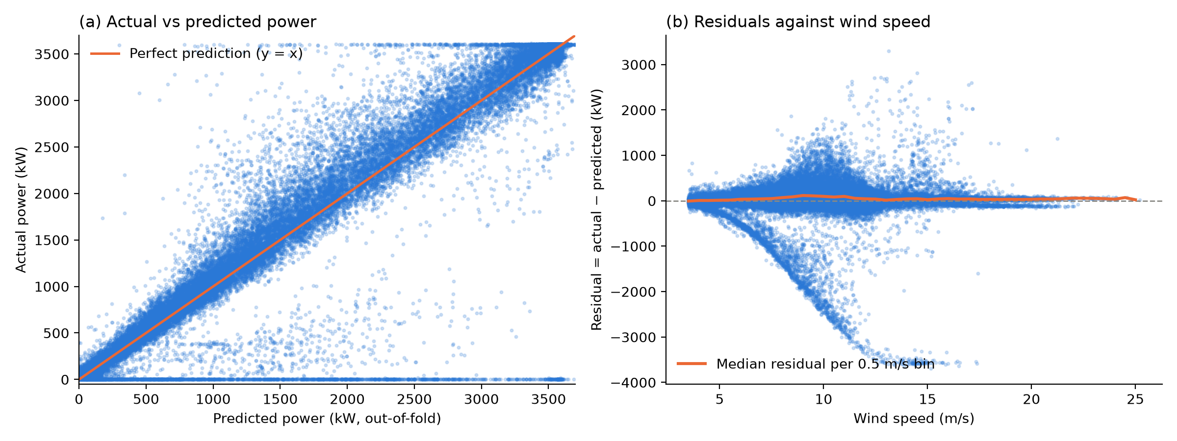
Figure 6.1 Actual versus out-of-fold predicted power (a) and residuals against wind speed (b) for the XGBoost model, normal training cluster (40,476 records).
Most points lie close to the diagonal, and the spread widens through the middle of the power curve. Two patterns stand out. First, a flat band at 0 kW runs across almost the whole range of predictions. These are stops in good wind, where the model expected anything up to 3.6 MW and the turbine produced nothing. In Figure 6.1(b) the same records form the long lower branch, which is simply the power curve turned upside down, because for a zero-output record the residual equals minus the expected power. Second, the cloud sits slightly above the diagonal for typical records. The median residual is +31 kW overall and reaches about +100 kW between 9 and 11 m/s, so the model under-predicts normal operation a little. This systematic under-prediction comes from the stops and low-output records inside the training cluster, which drag the fitted curve down.

Figure 6.2 shows the clustering evidence directly on the real axes of wind speed and power, so no projection is involved. Panel (a) uses a log scale because cluster 0 is about 400 times larger than the noise group and almost 1,000 times larger than cluster 1. Panel (b) shows why the silhouette score was misleading: cluster 0 covers the full power curve, including the 3,450 kW plateau and the zero-output band at the bottom, while clusters 1 to 3 and the noise points are small scattered groups well below the curve at high wind speed. Separation in this plot should not be taken as proof that the groups are distinct physical states.

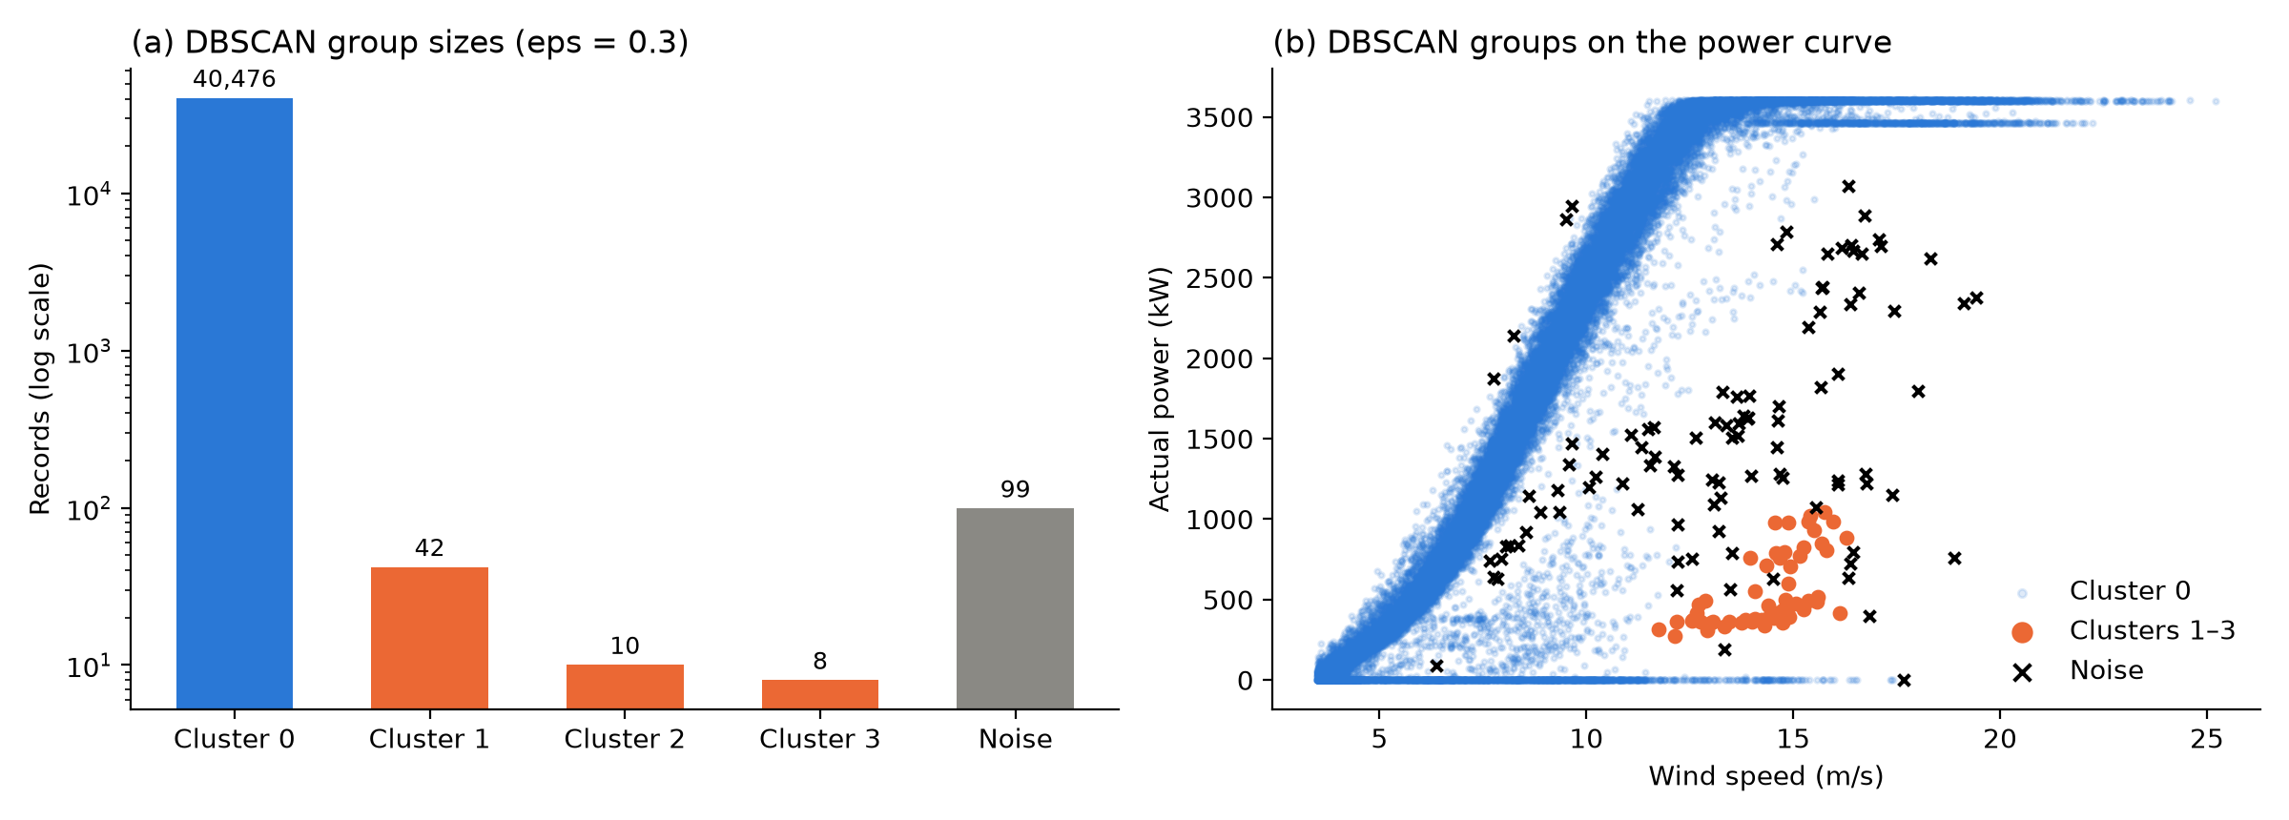
Figure 6.2 DBSCAN group sizes on a log scale (a) and DBSCAN groups plotted on the measured power curve (b), operating region only (40,635 records).

6.7 Error and subgroup analysis
Section 6.2 gave one error figure averaged over all months. Here the out-of-fold errors from the re-run in Section 6.6 are broken down by held-out month, by rule-based state and by wind speed band. Figure 6.3 shows the monthly results, and Tables 6.7 and 6.8 give the other two views together with the number of records behind each figure.

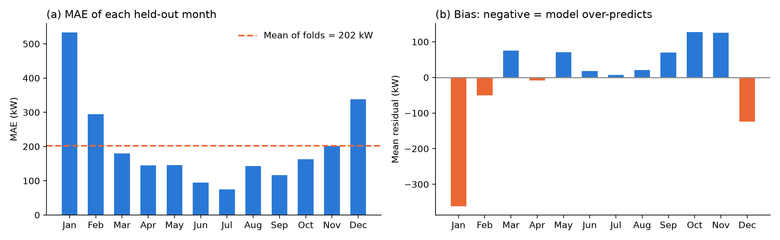
Figure 6.3 MAE (a) and mean residual (b) for each held-out month under leave-one-month-out validation.
The error varies a lot between months. MAE ranges from 74 kW in July to 533 kW in January, with a standard deviation of about 130 kW across the twelve folds, and R² ranges from 0.52 in January to 0.98 in June. January, February and December are clearly the worst. They also have a strong negative bias (−362 kW in January and −124 kW in December), meaning the model expected more power than the turbine delivered. These are the same months that dominate the losses in Chapter 7, where January alone holds 36.7% of the realistic loss. October and November show the opposite, a bias of about +125 to +127 kW, so in those months the turbine did better than the curve learned from the rest of the year. Each fold is a single month of one year, so this seasonal pattern may not repeat in another year.

Table 6.7 Out-of-fold error by rule-based state (training cluster)
Rule-based state (training cluster) | Records | MAE (kW) | Mean residual (kW)
near_curve | 31,191 | 146 | +112
underperforming | 7,066 | 177 | −152
zero_output | 2,219 | 1,056 | −1,052

By state, the zero-output records have an MAE of about 1,056 kW, roughly seven times that of near_curve records, even though they are only 5.5% of the training cluster. The near_curve records have a positive bias of about 112 kW, which confirms the downward pull described in Section 6.6. Underperforming records are over-predicted by about 152 kW on average, which is what we would expect if their low output is genuine.

Table 6.8 Out-of-fold error by wind speed band
Wind speed band (m/s) | Records | MAE (kW) | RMSE (kW) | Mean residual (kW)
3.5–5 | 5,849 | 51 | 76 | −1
5–7 | 9,021 | 103 | 173 | +3
7–9 | 8,705 | 231 | 402 | +2
9–11 | 6,633 | 403 | 697 | −1
11–13 | 4,925 | 251 | 554 | 0
13–15 | 2,614 | 248 | 687 | −8
≥15 | 2,729 | 131 | 391 | +25

By wind speed, the error peaks between 9 and 11 m/s (MAE 403 kW). This is the steepest part of the power curve, where a small change in wind speed means a large change in power, and it is also where many of the stops happened. Above 15 m/s the error falls again because output is flat at rated power. Every band has more than 2,600 records, so these comparisons are reasonably stable, although the RMSE in the upper bands is driven by a small number of very large misses.

The two types of error do not cost the same in operation. If the model over-predicts, an interval is flagged as lost energy when nothing was wrong. The cost is an engineer's time to check the SCADA alarm log, which is small and can be done remotely. If a real stop is missed, the loss continues unnoticed. The 44.5-hour January stop alone cost about 77 MWh, or roughly 57 t CO₂ at the Malaysian grid factor. For this reason it is better to accept some false flags than to miss long stops. With an average error of about 200 kW per interval, a small shortfall in one record should not trigger action. A more sensible rule is to flag zero output in wind above 3.5 m/s that lasts longer than about an hour, and to track the summed residual over a day or a week to catch gradual underperformance.

6.8 Explainability and decision usefulness
We used permutation importance on a random sample of 10,000 records from the training cluster to see what the model relies on. Shuffling wind speed raised the MAE by about 1,228 kW, while shuffling wd_sin or wd_cos raised it by only about 59 kW and 61 kW (Figure 6.4a). XGBoost's own gain importance tells the same story, with 91.9% for wind speed and 8.1% for the two direction terms combined. In practice the model is a learned power curve, with direction adding a smaller correction on top.

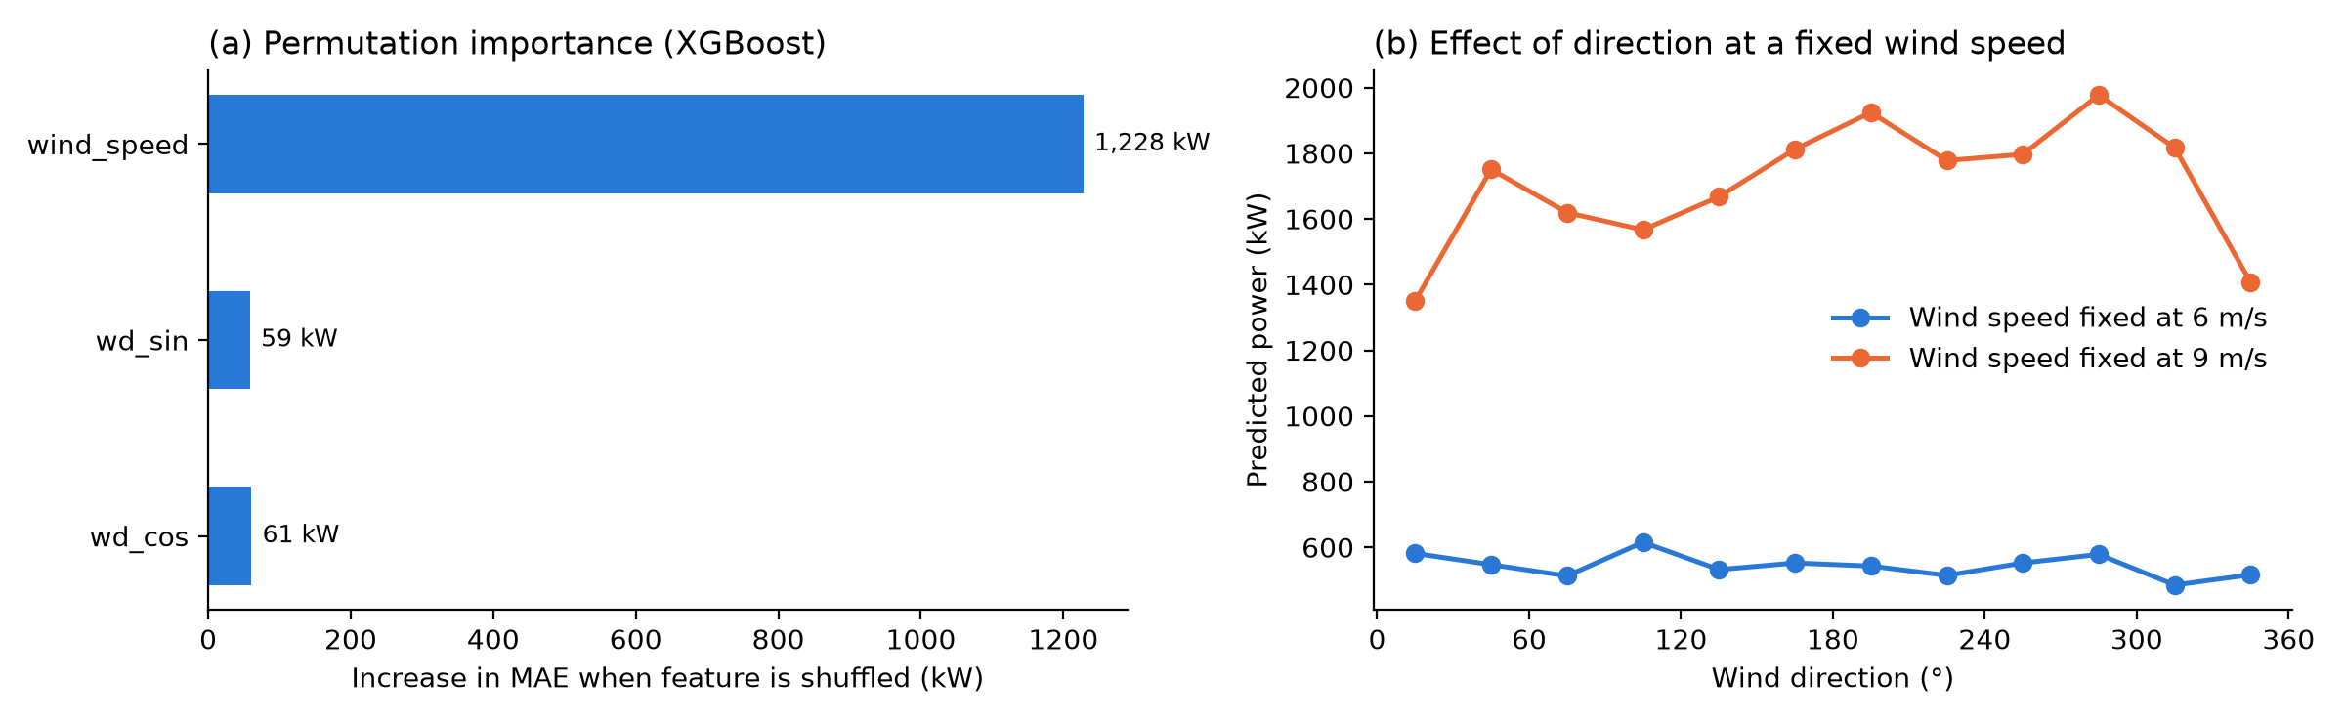
Figure 6.4 Permutation importance of the XGBoost inputs (a) and predicted power across wind direction with wind speed held at 6 m/s and 9 m/s (b).
Figure 6.4(b) shows what that correction looks like. With the wind speed held at 9 m/s, the predicted power ranges from about 1,350 kW for wind from 0–30° to about 1,978 kW for wind from 270–300°, a spread of roughly 630 kW. At 6 m/s the spread is only about 130 kW. The lowest prediction falls in the 0–30° sector, which Chapter 7 also identifies as having a high loss rate (13.9%). This could be a real site effect, such as terrain, wake from nearby turbines or yaw misalignment. It could just as easily be learned from the stops in that sector that sit inside the training cluster. The model cannot tell these apart, and we cannot either without site information. There is one clue, though. Section 6.2 showed that XGBoost without the direction inputs did better on held-out months (MAE 188.62 kW against 202.33 kW), so the direction effect learned from eleven months does not carry over well to the twelfth. That points towards the second explanation, and it means the direction effect is a lead for inspection rather than proof of a cause.

These explanations have limits. Permutation importance measures how much the model depends on a feature, not how strongly that feature drives power physically. wd_sin and wd_cos are two halves of the same variable, so their separate scores understate the combined effect of direction. The direction curves in Figure 6.4(b) hold wind speed fixed, which creates some combinations that are rare in the data, for example 9 m/s from 120–150°, a sector with only about 166 hours of wind in the year. None of these results should be read as causal.

For decision-making, what matters is that the model produces an expected power for every 10-minute record. The gap between expected and actual power can then be added up by state, month, direction and wind speed, as Chapter 7 does. A representative example is the stop from 24 to 26 January: 267 consecutive zero-output records (44.5 hours) with an average wind speed of 9.6 m/s and an average expected output of about 1,725 kW. That single event accounts for about 77 MWh, around 12% of the year's realistic loss. It is easy to explain to a maintenance team: the wind was good, the turbine produced nothing and this much energy was at stake. That is more useful than a cluster label, because DBSCAN placed all 267 records in its normal cluster.

6.9 Relationship to prior work
Direct comparison with published work is limited, because most studies use different turbines, years, inputs and validation methods. The closest is Matrenin et al. [15], who used the same Kaggle dataset. Their setup differs from ours in three main ways. They used an 80/20 train-test split, they removed records with zero power at wind speeds above 3 m/s (about 7% of the data), and they tested extra inputs, including theoretical power, calendar features and the previous interval's power. With wind speed as the only input their best RMSE was about 240 kW, the manufacturer curve alone gave about 262 kW, and with all features, including the previous power value, CatBoost reached about 113 kW.

Our RMSE of 388.66 kW is higher, but the numbers are not directly comparable. We kept the stops in the evaluation data, and they produce the largest errors. Leave-one-month-out validation is also stricter than holding out a share of records, since neighbouring 10-minute records are very similar. We also excluded theoretical power and lagged power on purpose, because lagged power would carry a shutdown forward into the “expected” value and hide the very loss we want to measure. On near_curve records only, our RMSE is about 250 kW, close to their wind-speed-only result. We therefore do not claim that our model is better or worse. Matrenin et al. also found that wind direction had only a slight influence on accuracy, which matches the small importance of the direction terms in Section 6.8.

Morrison et al. [4] studied anomaly detection for cleaning power curves and found that filtering out explicit, obvious anomalies before running anomaly detection improved every technique they tested. They also reported that Gaussian mixture models gave good accuracy while keeping the natural variability of the wind. Our results point the same way: running DBSCAN on unfiltered records left the stops inside the normal cluster. Filtering with the rule-based states before clustering, as proposed in Section 8.3, follows their approach.

Bilendo et al. [3] describe the power curve as one of the most versatile condition indicators for wind turbines, and they point out that most power curve models need normal historical data to learn from, while the question of how to obtain that data is often overlooked. This project shows the practical side of that problem. By our rules, 5.5% of the “normal” training cluster were zero-output records and 17.5% were underperforming, and this biased the learned curve downwards. What this project adds is therefore not a new modelling method but a loss breakdown by state, month and direction that operators can act on.

Chapter 7 Sustainability Insights and Recommendations

7.1 Linking the findings to the Grand Challenge
The turbine lost between 617MWh and 1,600MWh of clean electricity in 2018, and most of the realistic loss came from a small number of recoverable events. This places the project under the Energy Security Grand Challenge and SDG 7 (Affordable and Clean Energy), specifically Target 7.2 (increase the share of renewable energy) and Target 7.3 (improve energy efficiency).

The pathway from model output to sustainability benefit has four steps:

- Detect. The clustering and rule checks label each 10-minute record by suspected operating state, and the regression model gives the turbine's realistic healthy output.
- Quantify. The gap between healthy and actual output is converted into lost energy (MWh) and equivalent CO₂, broken down by state, month, wind speed and wind direction.
- Prioritize. The Pareto ranking shows operators which condition to inspect first, so limited maintenance time goes where it recovers the most energy.
- Recover. Fixing the causes of those losses raises the clean energy delivered by a turbine that is already built. Each recovered MWh displaces grid electricity that would otherwise come mostly from fossil fuels.

The benefit does not depend on building new capacity. It comes from getting more out of an existing renewable asset, with no new land, materials or grid connection needed. Because the workflow only uses standard SCADA variables (wind speed, wind direction, power, and the manufacturer curve), the same approach can be applied to every turbine in a wind farm [5], [6].

7.2 Actionable recommendations
Shutdown-like stops are the priority: they cause 52% of the realistic loss (321 MWh) in only 370 hours, and most of it comes from a handful of long stops. The recommendations below are ranked by expected energy recovered and by how soon they can be acted on.
Table 7.1 Prioritised recommendations
Priority | Evidence or insight | Stakeholder and action | Expected benefit and condition
1 (act now) | 13 stops of 6 hours or longer cause 67% of the shutdown-like loss. The longest ran for 44.5 hours on 24-26 January 2018 at an average wind speed of 9.6 m/s and alone lost 77 MWh (12% of all realistic loss). | O&M team: review the fault and stop logs for these events first. Add an alert when output stays at zero for more than 1 hour while wind speed is at least 3.5 m/s. | Up to 321 MWh and about 237 t CO₂ per year. Holds only if the stops were faults or slow restarts, not planned maintenance or grid instructions.
2 (act now) | 6 of 134 month × wind-direction conditions cause half of the realistic loss, and 25 cause 80% (Figure 7.2). | O&M team: use the top of the Pareto list as the inspection checklist, starting with January winds from 30–60° (117 MWh, 19% of the loss). | Inspection time goes to the few conditions that matter most, instead of being spread evenly across the year.
3 (needs site check) | Underperformance causes 35% of the realistic loss (216 MWh over 1,203 hours). Winds from 0–30° lose 13.9% of expected energy over 869 hours, against 3–7% for the other main sectors (Figure 7.4). | O&M team: check yaw alignment, wind vane and anemometer calibration, and blade condition (pitch settings, soiling, icing in winter). | Up to 216 MWh and about 159 t CO₂ per year. Needs on-site confirmation; a high sector loss rate can also come from wake or terrain effects that cannot be fixed.
4 (plan ahead) | January and December cause 54% of the realistic loss. January lost 22% of its expected energy and December 11.5%, against 1–5% from March to November (Figure 7.3). | O&M team: do a pre-winter inspection in October–November and keep spare parts and repair crews ready from December to February. | Shorter outages in the months when each lost hour costs the most energy. Depends on whether winter losses come from faults rather than icing or grid limits.
5 (plan ahead) | Against the manufacturer curve, "near curve" operation shows 700 MWh of loss; against the learned healthy curve it shows only 74 MWh (Figure 7.1). | Asset owner: use the learned site-specific curve as the performance benchmark and for yield forecasts. Use the manufacturer gap only as a theoretical ceiling. | Realistic targets and fewer false alarms. Requires retraining the model on new normal-operation data at least once a year.
6 (needs more data) | At wind speeds of 13 m/s or more, 21% of records sit below 3,500 kW even though rated power is 3,600 kW. | Grid operator and asset owner: match these periods against curtailment instructions. | Shows how much clean energy is lost to grid limits rather than turbine faults. Needs curtailment records, which the dataset does not have.

Figure 7.1 compares the loss in each suspected state under both baselines. Shutdown-like stops and underperformance dominate the realistic loss. Most of the manufacturer-baseline loss in normal operation disappears once the site's own healthy curve is used.

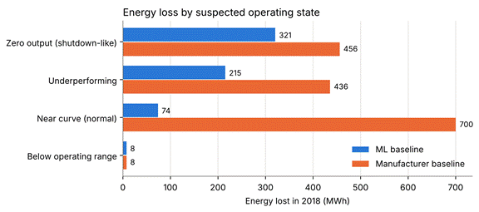
Figure 7.1 Energy loss by suspected operating state, 2018 (ML and manufacturer baselines).
Figure 7.2 ranks every month and wind-direction combination by realistic loss. The steep cumulative curve shows that 6 of 134 conditions cause half of the loss, and 25 cause 80%.
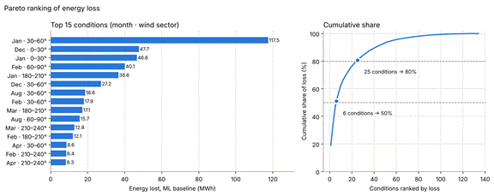
Figure 7.2 Pareto ranking of realistic energy loss by month and wind-direction sector.
Figure 7.3 shows that losses concentrate in winter. January and December cause 54% of the realistic loss, and January lost 22% of its expected energy.

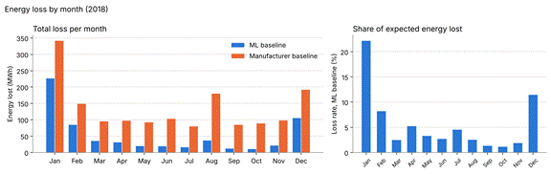
Figure 7.3 Energy loss (left) and share of expected energy lost (right) by month, 2018.
Figure 7.4 shows loss by the direction the wind blows from. Most energy is lost with winds from the north-east (0–90°), and the 0–30° sector also has a high loss rate of 13.9% over 869 hours. The 90–120° sector has the highest rate (15.8%), but over only 250 hours, so it is less reliable.
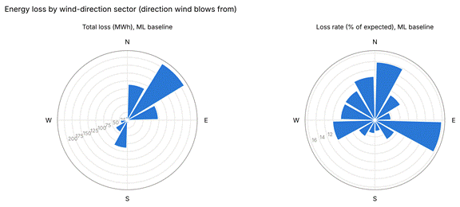
Figure 7.4 Realistic energy loss (left) and loss rate (right) by 30° wind-direction sector.
Figure 7.5 shows loss by wind speed. About 48% of the realistic loss happens between 8 and 11.5 m/s, where winds are frequent and the turbines should produce a lot of power. Only about 6% happens above 15 m/s.

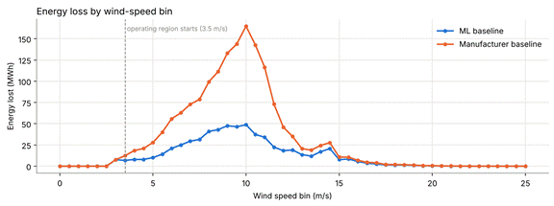
Figure 7.5 Energy loss by 0.5 m/s wind-speed bin (ML and manufacturer baselines).

7.3 Quantifying the impact responsibly
In 2018, the turbine generated 11,013 MWh and lost an estimated 617 MWh (5.3% of potential output, about 457 t CO₂) against its own healthy curve, or 1,600 MWh (12.7%, about 1,184 t CO₂) against the manufacturer curve. The realistic figure is the ML baseline, because the manufacturer curve reflects ideal testing conditions rather than this site. The manufacturer figure is a theoretical ceiling.

Energy loss and CO₂ were calculated per 10-minute record and then summed:
Energy lost per record = max (expected power − actual power, 0) × 1/6 hour
CO₂ avoided (tonnes) = energy lost (MWh) × 0.740

The scenarios below show what recovering part of the loss would mean for this one turbine.
Table 7.2 Energy recovery and CO₂ scenarios for 2018
Scenario | Energy recovered (MWh/year) | CO₂ avoided (t/year) | % of 2018 generation
Fix all shutdown-like stops | 321 | 237 | 2.9%
Fix shutdown-like stops and underperformance | 536 | 397 | 4.9%
Recover half of the realistic (ML) loss | 309 | 229 | 2.8%
Recover all of the realistic (ML) loss | 617 | 457 | 5.6%
Recover half of the manufacturer-baseline loss (proposal scenario) | 800 | 592 | 7.3%
Recover all of the manufacturer-baseline loss (theoretical ceiling) | 1,600 | 1,184 | 14.5%

These are estimates, not measured savings, and they rest on four assumptions:
- Emission factor. Each recovered MWh is assumed to displace grid electricity at Peninsular Malaysia's grid emission factor of 0.740 tCO₂/MWh (2024, provisional) [2]. The turbine is in Turkey, so this expresses the impact in a Malaysian context rather than the turbine's actual grid.
- Recovery share. The scenarios assume the causes can be fixed. Planned maintenance and grid curtailment can never be fully recovered.
- Missing data. About 2,030 ten-minute records (3.9%) are missing and count as zero loss, so the true loss is likely higher. The largest gap, about 4.3 days, starts a few hours after the longest stop ends in late January, so that outage may have lasted longer than recorded.
- Scale. All figures are for one turbine over one year. A wind farm would multiply them, but only if its turbines show similar losses.

7.4 Adoption and monitoring
An operator can adopt the pipeline with data it already collects: no new sensors are needed, only the turbine's 10-minute SCADA export and its manufacturer power curve.
Table 7.3 What an operator needs to adopt the pipeline
What is needed | How it would work
Data updates | Export the month's SCADA records and run the four notebooks in order. Each run produces an updated loss table and Pareto priority list.
Decision rule | Flag any stop where output stays at zero for more than 1 hour while wind speed is at least 3.5 m/s. Review the top five Pareto conditions each month.
Responsible people | An O&M engineer reviews the flagged stops and the priority list, then decides whether to send a crew.
Confirmation step | Every flag is a suspected state. It is checked against fault logs or an inspection before any repair, to avoid acting on false alarms.
Monitoring the benefit | Track realistic loss (MWh) and hours of shutdown-like stops month by month and compare them before and after each action.
Monitoring the model | Check the model's error on recent normal-operation data against its cross-validated MAE of 202 kW. Retrain at least once a year, and after major repairs or component changes.
The main adoption risk is trust: if many flags turn out to be planned maintenance or grid limits, staff may start ignoring them. Linking the pipeline to the operator's maintenance and curtailment logs would remove most of these false alarms.

Chapter 8 Limitations Conclusion and Future Work

8.1 Data and methodological limitations
The biggest limitation is that the clustering did not separate the operating states, so the loss estimates rely on rule-based states and the realistic loss is probably an underestimate. Table 8.1 lists each limitation, what it means for the conclusions and how it could be addressed.
Table 8.1 Limitations, their effect and practical responses
Limitation | Effect on conclusions | Practical response
No fault labels. SCADA records do not say why output was low. | States are suspected, not confirmed faults. Recommendations say where to look, not what is broken. | Link the pipeline to maintenance, fault and curtailment logs.
Clustering barely separated states. DBSCAN put 40,476 of 40,635 operating records (99.6%) into one cluster; the other clusters held 42, 10 and 8 records. Its high silhouette score (0.615) mostly reflects that one dominant cluster. | Loss by state could not be read from the clusters, so it was broken down using the rule-based reference states instead. The planned stability check across seeds was not done. | Choose DBSCAN's eps from a k-distance plot, test feature sets without wind direction, and try density methods that handle uneven clusters better.
Healthy model trained on some unhealthy data. The "normal" cluster still contains 5.5% zero-output and 17.5% underperforming records. | The learned healthy curve is pulled down, so the realistic loss of 617 MWh is most likely a lower bound. | Remove rule-flagged zero-output and underperforming records before training, then compare the loss estimate.
Tree models cannot extrapolate. Trained only on wind of 3.5 m/s or more, the model predicted about 43 kW even at zero wind. | Left uncorrected, this added about 60 MWh of artificial loss. It was corrected by using the manufacturer curve below 3.5 m/s. | Keep the correction, or train on the full wind range.
The ML models did not beat a simple baseline. A 0.5 m/s binned power curve (MAE 194 kW) was slightly more accurate than XGBoost (202 kW) on the same folds. | The direction inputs did not help on unseen months. The loss estimate moves from 617 MWh to about 703 MWh with the binned curve, so the main findings hold. | Drop the direction inputs or test them again on cleaned training data, and tune the models inside the month-blocked folds.
Missing data. 2,030 ten-minute records (3.9%) are missing, including a gap of about 4.3 days in late January. | Missing periods count as zero loss, so total loss is underestimated, especially in January. | Request the missing records or the turbine's availability log.
One turbine, one year, one site. The data covers a single turbine in Turkey during 2018; CO₂ uses Malaysia's grid factor. | The January–December concentration may not repeat in other years. Results do not transfer directly to Malaysian wind or solar sites. | Repeat with several years and several turbines, and test on local Malaysian renewable data when available.
Recovery is assumed, not measured. | Energy and CO₂ savings in Section 7.3 are scenarios, not achieved benefits. | Run a pilot: act on the top Pareto items and measure loss before and after.

8.2 Conclusion
This project set out to show how machine learning can turn unlabeled wind turbine SCADA data into evidence for reducing clean energy losses. Using one year (2018) of 50,530 ten-minute records from a 3.6 MW turbine, it found that the turbine lost 617–1,600 MWh of clean electricity, equivalent to 457–1,184 t CO₂, and that most of the realistic loss came from a few long stops in good wind. Four of the five objectives were fully met and one was partly met.
Table 8.2 Status of the project objectives
Objective | Status | Evidence
1. Prepare and explore the SCADA data | Achieved | 50,530 records checked: no nulls, duplicates or impossible values; 2,030 missing slots flagged, not imputed. Power ratio, residual, circular wind direction, wind-speed bins and direction sectors engineered.
2. Identify operating states with clustering | Partly achieved | K-Means (best k = 4, silhouette 0.525) and DBSCAN (eps = 0.3, silhouette 0.615) were compared. DBSCAN put 99.6% of records in one cluster, so rule-based states were used to interpret the loss.
3. Model the healthy power curve | Achieved | XGBoost reached MAE 202 kW, RMSE 389 kW and R² 0.88 under leave-one-month-out validation, slightly better than Random Forest and about 9 times faster to train. A simple binned curve did slightly better (MAE 194 kW).
4. Quantify recoverable energy loss | Achieved | Loss reported by state, month, wind-speed bin and direction sector, against both baselines, and converted to CO₂ at 0.740 t/MWh.
5. Support maintenance decisions | Achieved | A Pareto ranking showed that 6 of 134 conditions cause half of the realistic loss, giving a short, ordered inspection list.

The most useful result for operators is that shutdown-like stops in good wind cause about half of the realistic loss, and a single 44.5-hour stop in January caused 12% of it on its own. Catching and shortening such stops would recover clean energy from an existing turbine with no new construction.

The project shows that data operators already collect can point maintenance to where it matters most, in support of SDG7.

8.3 Prioritized future work
The next steps fix the known weaknesses before adding more complex models, in this order:
- Clean the training data for the healthy curve. Remove rule-flagged zero-output and underperforming records from the normal cluster and retrain. This turns the 617 MWh lower bound into a tighter estimate.
- Improve the separation of operating states. Tune DBSCAN with a k-distance plot, test other feature sets and check stability across seeds and subsamples. This would let loss be split by learned states rather than rules.
- Validate against maintenance and curtailment logs. Confirming what happened during the largest stops would show which losses are truly recoverable and which come from grid limits.
- Re-test the regression inputs and settings. Retrain without wind direction, tune the settings inside the month-blocked folds and keep the binned power curve as the benchmark the ML model has to beat.
- Extend and pilot. Apply the pipeline to more years and more turbines, ideally from a Malaysian site, then run a pilot with an operator to measure the energy recovered.

References
[1] | Berk Erisen, “Wind Turbine Scada Dataset,” kaggledatasets. Accessed: Oct. 17, 2026. [Online]. Available: https://www.kaggle.com/datasets/berkerisen/wind-turbine-scada-dataset
[2] | St.gov.my. Accessed: Oct. 17, 2026. [Online]. Available: https://myenergystats.st.gov.my/documents/d/guest/grid-emission-factor-gef-in-malaysia-2022-2024-provisional-
[3] | F. Bilendo, A. Meyer, H. Badihi, N. Lu, P. Cambron, and B. Jiang, “Applications and Modeling Techniques of Wind Turbine Power Curve for Wind Farms—a Review,” Energies, vol. 16, no. 1, p. 180, Jan. 2023, doi: 10.3390/en16010180.
[4] | R. Morrison, X. Liu, and Z. Lin, “Anomaly Detection in Wind Turbine SCADA Data for Power Curve Cleaning,” Renewable Energy, vol. 184, pp. 473–486, 2022, doi: 10.1016/j.renene.2021.11.118.
[5] | P. Ravi, A. Davide, J. Hong, D. Infield, and M. Santos, “SCADA Data for Wind Turbine Data-Driven Condition/Performance Monitoring : A Review on State-of-Art, Challenges and Future Trends - Strathprints,” Strath.ac.uk. Accessed: Oct. 16, 2026. [Online]. Available: https://strathprints.strath.ac.uk/82511/
[6] | J. Weinert and S. Watson, “Using SCADA Data for Wind Turbine Condition Monitoring - a Review,” figshare. Accessed: Oct. 16, 2026. [Online]. Available: https://repository.lboro.ac.uk/articles/journal_contribution/Using_SCADA_data_for_wind_turbine_condition_monitoring_-_a_review/9561752
[7] | S. Lloyd, “Least Squares Quantization in PCM,” IEEE Transactions on Information Theory, vol. 28, no. 2, pp. 129–137, Mar. 1982, doi: 10.1109/tit.1982.1056489.
[8] | D. Arthur and S. Vassilvitskii, “K-Means++: The Advantages of Careful Seeding,” 2007. Accessed: Oct. 16, 2026. [Online]. Available: https://theory.stanford.edu/~sergei/papers/kMeansPP-soda.pdf
[9] | M. Ester, H.-P. Kriegel, J. Sander, and X. Xu, “A Density-Based Algorithm for Discovering Clusters in Large Spatial Databases With Noise.” Accessed: Oct. 16, 2026. [Online]. Available: https://www.aaai.org/Papers/KDD/1996/KDD96-037.pdf
[10] | L. Breiman, “Random Forests,” Machine Learning, vol. 45, no. 1, pp. 5–32, Oct. 2001.
[11] | T. Chen and C. Guestrin, “XGBoost: A Scalable Tree Boosting System,” Proceedings of the 22nd ACM SIGKDD International Conference on Knowledge Discovery and Data Mining - KDD ’16, vol. 1, no. 1, pp. 785–794, Aug. 2016, doi: 10.1145/2939672.2939785.
[12] | C. Bergmeir and J. M. Benítez, “On the Use of Cross-Validation for Time Series Predictor Evaluation,” Information Sciences, vol. 191, pp. 192–213, May 2012, doi: 10.1016/j.ins.2011.12.028.
[13] | F. Pedregosa et al., “Scikit-Learn: Machine Learning in Python,” Journal of Machine Learning Research, vol. 12, no. 85, pp. 2825–2830, 2011, Accessed: Oct. 16, 2026. [Online]. Available: https://jmlr.org/papers/v12/pedregosa11a.html
[14] | P. J. Rousseeuw, “Silhouettes: A Graphical Aid to the Interpretation and Validation of Cluster Analysis,” Journal of Computational and Applied Mathematics, vol. 20, no. 0377–0427, pp. 53–65, Nov. 1987, doi: 10.1016/0377-0427(87)90125-7.
[15] | P. V. Matrenin, D. A. Harlashkin, M. V. Mazunina, and A. I. Khalyasmaa, “Investigation of the Features Influencing the Accuracy of Wind Turbine Power Calculation at Short-Term Intervals,” Applied System Innovation, vol. 7, no. 6, p. 105, 2024, doi: 10.3390/asi7060105.

Suggested team contribution record

Task / Activity | Lead / Supporting Member(s) | Output
Data acquisition & understanding | Fakhri | Completed the Data Description section, outlining the dataset source, attributes, characteristics, and relevance to the proposed machine learning project.
Data preprocessing | Afiq, Safuan | Successfully cleaned and scaled the dataset and prepared a data quality summary.
Feature engineering / selection | Afiq | Completed the feature table, including power ratio, residual, bins, and direction sectors, with justifications for each selected feature.
Model development | Umair | Successfully trained clustering models (K-Means, DBSCAN) and regression models (Random Forest, XGBoost), including hyperparameter tuning and documentation of the code.
Evaluation & comparison | Umair | Completed model evaluation using metric tables (MAE, RMSE, R², and silhouette score) and identified the final model based on performance.
Interpretation & sustainability analysis | Safuan | Completed the energy loss analysis by state and time, developed a ranked maintenance priority list, and provided SDG 7 recommendations.
Report / presentation preparation | Ashraf | Completed the final report, presentation slides, and supporting code documentation.

