The final assignment will be writing a chess game.

We are aiming to try to create an abstract class ChessGame which is general enough so that a number of different games can simply inherit from our structure and then play the game.

We will try to create two games : Five In a Row (五子棋) and Reversi (蘋果棋)

The program code framework is provided for you in the zip file. You can simply copy the file to your computer and then finish all the TODOs.

Upon finish, please zip all the source code so that I can review on it.

P.S. 1 The framework might not be 100% fully in line with your design of the game. So, please take it as a reference, and modify whenever you want. Don't get bounded by the frameworks. If you think you need to write another new method, please go ahead!

P.S. 2 For simplicity, the code of ChessGame.java is mainly designed for a game of two players with all the chess identical.

P.S. 3 If you are really interested, you can create a new class to write a 井字過三關(actually just same as FiveInARow but hard code the board width to be 3) or 圍棋

Steps for importing.

1. Unzip the zip file to your computer.
2. Select <Import>  
   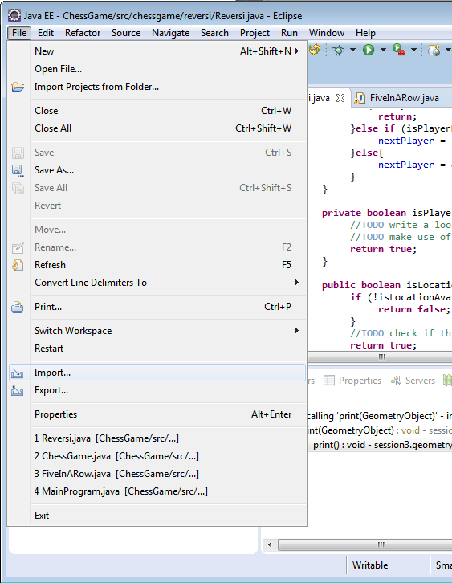
3. Import <Existing Projects into Workspace>  
   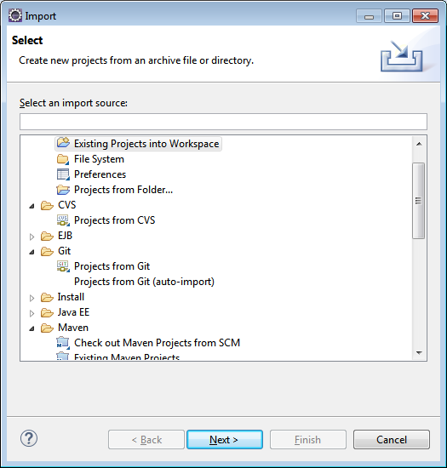
4. Choose the directory. Click <Finish>.  
   