Forschungszentrum-Jülich algal turf scrubbing pilot 2018 Data

Dean Calahan[1]

Isabel Meuser and Ladislav Nedbal[2]

21 March, 2019

# # # # # # # # # # # # # # # # # # # # # # # # # # # # # # # # # # # # # # # #  
#  
# Copyright 2018-2019 by Forschungszentrum-Jülich (FZJ)  
#  
# This file is part of digital object 10.5281/zenodo.2593844, "FZJ ATS Pilot 2018"  
# (FZJAP2018), a data set documenting the results of an algal turf scrubbing pilot  
# project performed 15.07-15.09 2018, treating secondary sewage at FZJ's campus   
# wastewater treatment plant.  
#  
# The software component of FZJAP2018 is open access: you can redistribute it and/or  
# modify it under the terms of the GNU General Public License as published by the  
# Free Software Foundation, either version 3 of the License, or (at your option)  
# any later version.  
#  
# The software component of FZJAP2018 is distributed in the hope that it will be  
# useful, but WITHOUT ANY WARRANTY; without even the implied warranty of MERCHANTABILITY  
# or FITNESS FOR A PARTICULAR PURPOSE. See the GNU General Public License for more  
# details.  
#  
# You should have received a copy of the GNU General Public License along with the  
# software component of FZJAP2018. If not, see <http://www.gnu.org/licenses/>.  
#  
# # # # # # # # # # # # # # # # # # # # # # # # # # # # # # # # # # # # # # # #  
# Execute one of the following commands to knit, rather than use the knit button.  
# rmarkdown::render("Code/Rmd/FZJAP2018.Rmd", output_dir="Drafts", output_format = c("pdf_document"))  
# rmarkdown::render("Code/Rmd/FZJAP2018.Rmd", output_dir="Drafts", output_format = c("html_document", "pdf_document", "word_document"))  
# # # # # # # # # # # # # # # # # # # # # # # # # # # # # # # # # # # # # # # #

# Introduction

Here we provide cleaned data, in the form of csv files, from the 2018 ATS pilot at Forschungszentrum-Jülich conducted by IBG-2/Alternative Biomass (for details, see Methods). Briefly: water quality and biomass productivity data were entered manually into the spreadsheet ATS Treatment.xlsx. Biomass composition data were obtained by standard analyses and recorded in the spreadsheet Analysen ZEA-3.xlsx. Temperature and irradiance data were obtained from data loggers. Data cleaning comprised rearranging, renaming, or deleting various cells or observations to achieve tidy data.

# Methods

*Floway Configuration*. A 0.54 m × 2.5 m algal turf scrubber (ATS) floway and headworks was assembled from local home improvement store materials (Bauhaus, Belp, Switzerland; Hornbach Baumarkt AG, Bornheim, Germany) and lined with surplus growth substratum originally used for a thin layer algae spray reactor (Schreiber et al. 2017). The floway was operated at the Forschungszentrum-Jülich (FZ-J) campus wastewater treatment plant (WWTP) from August 15th to October 22nd, 2018. Influent was recirculated in batch mode from a 1 m $​^{3}$ IBC tank filled to 0.5 m $​^{3}$ from the secondary treatment clarifier tank at the FZ-J WWTP. Water was exchanged by completely draining the IBC tank into a prior treatment tank then refilling with 0.5 m $​^{3}$ of influent. The inner walls and bottom of the IBC tank were scrubbed during water exchange to reduce algal growth within the tank. Water exchange was performed Mondays through Thursdays, except for Wednesday, October 3. Commercially available centrifugal sump pumps were used to recirculate the water to the floway at a rate of 37 L min $​^{−1}$ with a pulsing interval of 15-20 s, provided by a tipping bucket at the headworks.

*Harvesting and Biomass Processing*. Harvesting was performed weekly by turning off the pumps, allowing the floway to drain for approximately 15 min, then manually scraping biomass from the base and walls of the lower 1.6 m of the floway, comprising a total harvested area of 0.99 m $​^{2}$. The remainder of the biomass was left to facilitate re-colonization of the harvested area during the following growth interval. Scraped biomass was collected into a tared jar and weighed to determine the fresh weight of the harvested material. The biomass was dried by in an oven at 60°C for 24 hours and weighed. Dried biomass was homogenized by grinding with a mortar and pestle. Weighed samples were frozen at -20° in airtight plastic bags.

*Environmental Observations*. Floway water temperature and irradiance were logged once per minute using a HOBO data logger and downloaded as csv files using proprietary software (Onset Computer Corporation, Bourne, MA).

*Water Chemistry*. One water sample (15 mL) was taken from the tailworks of the floway before and one after water exchange. These were either analyzed within six hours or frozen for later analysis. Prior to analysis, samples were centrifuged at room temperature for 10 minutes at a relative centrifugal force of 3,007 g. Soluble phosphate (PO $​_{4}$-P) and Total nitrogen (TN) were determined using a DR 5000 UV-Vis spectrophotometer after processing the samples with Hach LCK 349 (PO $​_{4}$-P) and LCK 138 (TN) kits. (All: Hach Lange GmBH, Düsseldorf).

*Biomass Composition*. Two 50 mg aliquots of each dried biomass sample, each with 2 mL HNO $​_{3}$ and 1 mL H $​_{2}$ O $​_{2}$ were placed in closed Xpress containers (CEM Corporation, Matthews, NC, USA) and digested in a MARS 5 microwave digestion oven (CEM Corporation, Matthews, NC, USA) by heating to 160°C within 20 minutes and kept at this temperature for 15 minutes. The containers were then filled to 14 mL with deionized water. Two aliquots of each sample solution obtained were diluted, one at 1:20 and one at 1:50, and analyzed. Each dilution was assayed with ICP-OES (iCAP 6500, Thermo Scientific). Reference material NIST1515 (SRM1515, 2017) was included as control. Recovery for K was 101%, Ca 94%, Mg 94%, Mn 83% and P 90%. Measurements reflect the mean of two determinations. Standard deviation for two observations, recorded originally as “< 0,1” are set to NA in the cleaned data.

# Data Cleaning

To clean the water quality and biomass data, spreadsheets were loaded and reshaped into a tidier schema before being saved as csv. Some columns of ATS Treatment.xlsx (“Dilution PO4-P”, “PO4-P”, “reduction”, “Dilution TNb”, “TNb”, “remark”), were not retained in the cleaned data, while others (unnamed column with “before/after”, “commend”) were converted from character to logical for improved utility. All columns of Analysen ZEA-3.xlsx were retained. Temperature and irradiance logs (ATS_<#.dd.mm.yy>.hobo) were converted to csv using proprietary software (*.hproj contain metadata about the *.hobo and were not processed). Because the data loggers were either initialized in an office before being transported to the floway for installation, or downloaded after being removed from the floway and taken to an office, the initial and final observations of each file were discarded. Figures 1-7 and the code that generated them show which observations were discarded. Selected observations were combined into a single data frame and saved as a csv file.

# HOBO Data.

## Week 1 (ATS_1)

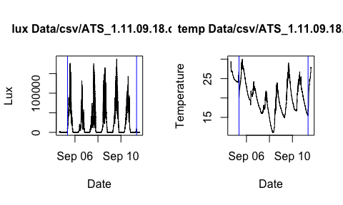

## Week 2 (ATS_2)

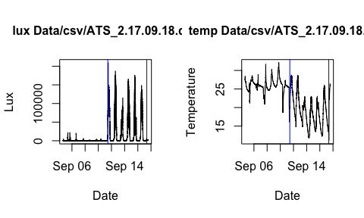

## Week 3 (ATS_1)

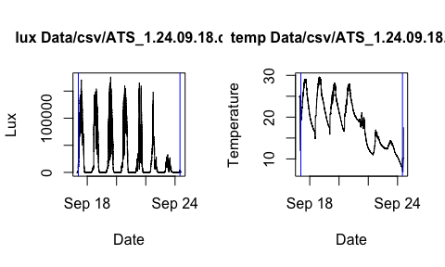

## Week 4 (ATS_2)

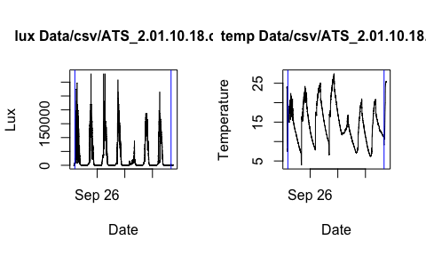

## Week 5 (ATS_1)

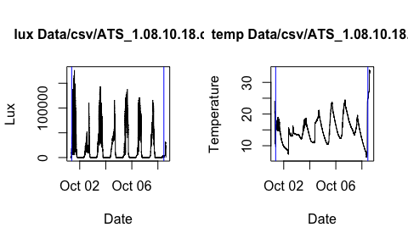

## Week 6 (ATS_2)

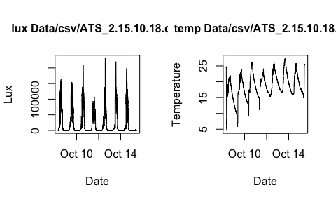

## Week 7 (ATS_1)

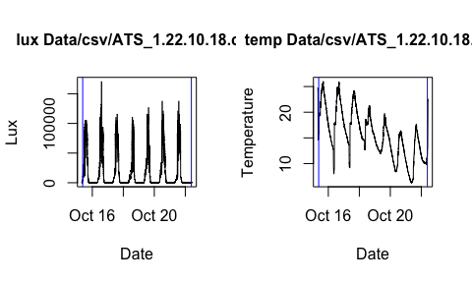

# Floway Chemistry & Biomass Productivity

On two occasions, samples were assayed both on the day they were taken and after freezing (Table 1). As the absolute differences between the readings for frozen and unfrozen samples was small, less than 5% except for two measurements, it was decided to freeze and accumulate samples for collective analysis rather than assay each sample on the day it was collected.

Differences among fresh and frozen samples

|  |  |  |  |  |
| --- | --- | --- | --- | --- |
| before | PO4Pdelta | TNdelta | PO4Ppct | TNpct |
| FALSE | 0.40 | 0.29 | 5.4869684 | 3.2842582 |
| TRUE | -0.10 | 0.10 | -0.9615385 | 1.0764263 |
| FALSE | -0.27 | 0.47 | -4.1284404 | 5.6085919 |
| TRUE | -0.17 | 0.02 | -1.7119839 | 0.2051282 |

# Biomass Composition Data

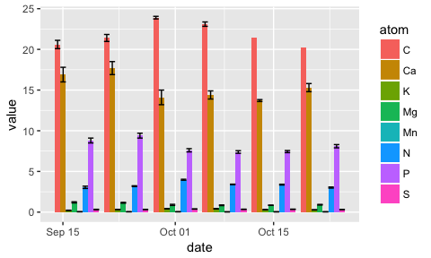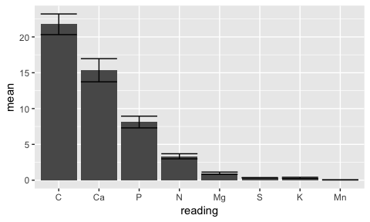

# Data Dictionaries

Data/csv/FZJAP2018 Biomass Composition.csv

|  |  |
| --- | --- |
| Column | Description |
| id | Observation ID |
| date | Harvest date |
| atom | Element assayed |
| wtprop | Mass proportion of element in sample |
| wtpropsd | Standard deviation of proportion with n = 2 |

Data/csv/FZJAP2018 Biomass Productivity.csv

|  |  |
| --- | --- |
| Column | Description |
| wet_biomass | Mass of total fresh biomass harvested |
| dry_biomass | Mass of total dried biomass |
| obsdate | Harvest date |

Data/csv/FZJAP2018 Temperature and Irradiance.csv

|  |  |
| --- | --- |
| Column | Description |
| datetime | Date and time of observation |
| temp | Temperature (°C) |
| lux | Irradiance (lux) |
| week | Week index |

Data/csv/FZJAP2018 Water Chemistry.csv

|  |  |
| --- | --- |
| Column | Description |
| datetime | Date and time of observation |
| before | Was this sample taken before or after water exchange? |
| PO4P | Soluble PO4, mg L-1 |
| TN | Total N, mg L-1 |
| pH | ph |
| frozen | Was this sample frozen? |
| assaydate | Date sample was assayed |
| obsdate | Observation date |

# Acknowledgement

This work was supported by the German Federal Ministry of Education and Research (BMBF) within the project Algnutrient-UrBioSol, Bioeconomy International FKZ031B0453A.

# References

Schreiber, Christina, Dominik Behrendt, Gregor Huber, Christian Pfaff, Janka Widzgowski, Bärbel Ackermann, Andreas Müller, Vilém Zachleder, Šárka Moudríková, and Peter Mojzeš. 2017. “Growth of Algal Biomass in Laboratory and in Large-Scale Algal Photobioreactors in the Temperate Climate of Western Germany.” *Bioresource Technology* 234 (June): 140–49. <https://doi.org/10.1016/j.biortech.2017.03.028>.

1. Smithsonian Institution, Forschungszentrum Jülich
2. Forschungszentrum Jülich