SCP Foundation

**MIDTERM EXAM**

Submitted by

Calamba, Rafael M.

CWP111 – IT1E

Submitted to

Prof. Kathleen M. Dimaano

_______________________________________________________________

|  |  |  |
| --- | --- | --- |
| **CRITERIA:** | | **Grade** |
| Completeness of Website   * (Header or Banner, Footer with external links, Navigation Links, Content Area) | 20 |  |
| Aesthetics / User Interface / Design   * (Background coordinates with the theme of the site, logo, fonts used – readable; images are clear and relevant; site is not dull – interesting) | 20 |  |
| Content Satisfaction   * (Informative with images and text; content of site is relevant; provide details of certain aspect like services or products it promotes; website is useful, with sense and value and shows functionality) | 20 |  |
| Online Transaction Processing Form (Design only)   * Aside from login, registration and feedback or contact us form there is other forms that you will include to your site to provide certain functionality (ordering form or cart system; booking or reservation form, guest or visitor form with counter how many visited the site, review, blogs, forum; admission/requirements form – for academic sites; inventory checker and others) | 20 |  |
| TOTAL SCORE | 80 |  |
| TOTAL RATING | 100 |  |

**WEBSITE SECTIONS**

**OUTPUT**

LOG IN – splash.html

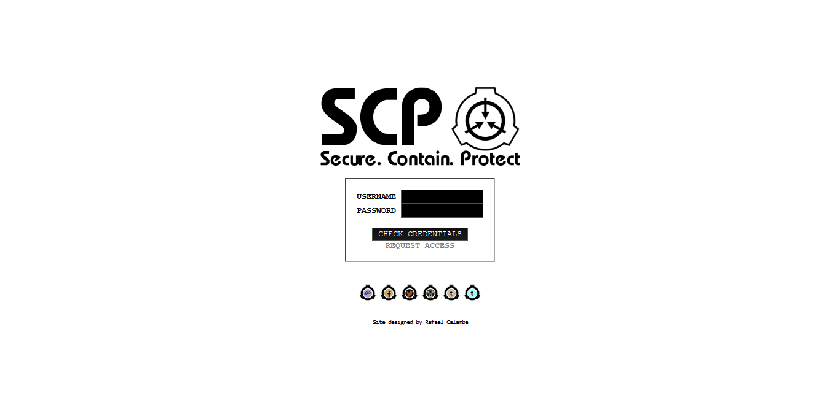

**HTML CODE**

..<title>

SCP Foundation</title></head>

<body bgcolor=black text=white link=gray vlink=gray>

<table border=0 width=100% height=100%>

<td align=center>

<img src=eb0.png height=128><br><br>

<form name='log in' action=home.html method=post>

<table border=1 cellpadding=16 rules=none><td align=center>

<font face='Courier New' size=2><b>

USERNAME <input type=text name=username size=16 maxlength=32><br>

PASSWORD <input type=password name=password size=16 maxlength=32><br><br>

<input type=submit name=submit value='CHECK CREDENTIALS'><br>

<a href=requestform.html>REQUEST ACCESS</a></b></font></td></table></form><br>

<a href=http://scp-foundation.deviantart.com/><img src=DA-icon.png></a>

<a href=https://www.facebook.com/scpfoundation><img src=FB-icon.png></a>

<a href=https://twitter.com/scpwiki><img src=Twitter-icon.png></a>

<a href=http://www.reddit.com/r/SCP><img src=Reddit-icon.png></a>

<a href=http://scp-wiki-official.tumblr.com/><img src=Tumblr-icon.png></a>

<a href=http://thescpfoundation.tumblr.com/><img src=tumblr2.png></a><br><br>

<font face='Consolas' size=1>

Site designed by Rafael Calamba</font></td></table></body></html>

**INSTYLE OR INTERNAL CSS**

<html><head><style type="text/css">

input{

font-family: Courier New;

}

</style>..

**OUTPUT**

REQUEST FORM – requestform.html

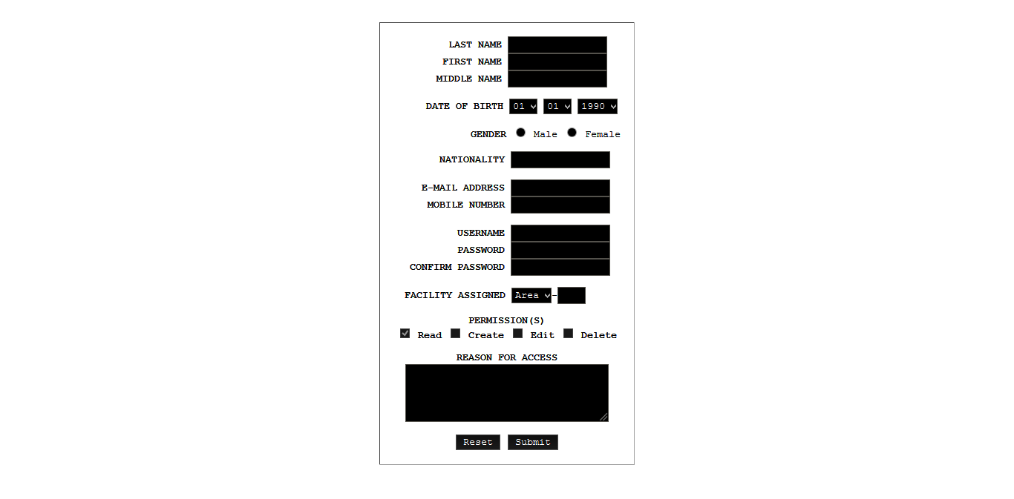

**HTML CODE**

..<body bgcolor=black text=white>

<table border=0 width=100% height=100%>

<td align=center>

<form name='request access' action=splash.html method=post>

<table border=1 cellpadding=16 rules=none><td align=center>

<font face='Courier New' size=2><b>

&nbsp;&nbsp;&nbsp;&nbsp;&nbsp;&nbsp;

LAST NAME <input type=text name=lastname size=16 maxlength=32><br>

&nbsp;&nbsp;&nbsp;&nbsp;&nbsp;

FIRST NAME <input type=text name=firstname size=16 maxlength=32><br>

&nbsp;&nbsp;&nbsp;&nbsp;

MIDDLE NAME <input type=text name=middlename size=16 maxlength=32><br><br>

&nbsp;&nbsp;&nbsp;&nbsp;

DATE OF BIRTH <select size=1><option>01</option><option>02</option><option>03</option><option>04</option><option>05</option><option>06</option><option>07</option><option>08</option><option>09</option><option>10</option><option>11</option><option>12</option></select>

<select size=1><option>01</option><option>02</option><option>03</option><option>04</option><option>05</option><option>06</option><option>07</option><option>08</option><option>09</option><option>10</option><option>11</option><option>12</option><option>13</option><option>14</option><option>15</option><option>16</option><option>17</option><option>18</option><option>19</option><option>20</option><option>21</option><option>22</option><option>23</option><option>24</option><option>25</option><option>26</option><option>27</option><option>28</option><option>29</option><option>30</option><option>31</option></select>

<select size=1><option>1990</option><option>1991</option><option>1992</option><option>1993</option><option>1994</option><option>1995</option><option>1996</option><option>1997</option><option>1998</option><option>1999</option><option>2000</option><option>2001</option><option>2002</option><option>2003</option><option>2004</option><option>2005</option><option>2006</option><option>2007</option><option>2008</option><option>2009</option><option>2010</option><option>2011</option><option>2012</option><option>2013</option><option>2014</option><option>2015</option><option>2016</option><option>2017</option></select><br><br>

&nbsp;&nbsp;&nbsp;&nbsp;&nbsp;&nbsp;&nbsp;&nbsp;&nbsp;&nbsp;&nbsp;&nbsp;

GENDER <input type=radio name=gender> </b>Male <input type=radio name=gender> Female<b><br><br>

&nbsp;&nbsp;&nbsp;&nbsp;&nbsp;

NATIONALITY <input type=text name=nationality size=16 maxlength=32><br><br>

&nbsp;&nbsp;

E-MAIL ADDRESS <input type=text name=email size=16 maxlength=32><br>

&nbsp;&nbsp;&nbsp;

MOBILE NUMBER <input type=text name=phonenumber size=16 maxlength=32><br><br>

&nbsp;&nbsp;&nbsp;&nbsp;&nbsp;&nbsp;&nbsp;&nbsp;

USERNAME <input type=text name=username size=16 maxlength=32><br>

&nbsp;&nbsp;&nbsp;&nbsp;&nbsp;&nbsp;&nbsp;&nbsp;

PASSWORD <input type=password name=password size=16 maxlength=32><br>

&nbsp;CONFIRM PASSWORD <input type=password name=password size=16 maxlength=32><br><br>

FACILITY ASSIGNED <select size=1><option>Area</option><option>Site</option></select>-<input type=text name=facilitynumber size=4 maxlength=4>

&nbsp;&nbsp;&nbsp;<br><br>

PERMISSION(S)

<br><input type=checkbox name=permission checked disabled> Read <input type=checkbox name=permission disabled> Create <input type=checkbox name=permission disabled> Edit <input type=checkbox name=permission disabled> Delete<br><br>

REASON FOR ACCESS<br>

<textarea cols=32 rows=4></textarea><br><br>

<input type=reset name=reset value=Reset>

<input type=submit name=submit value=Submit></b></font></td></table></form></td></table></body></html>

**INSTYLE OR INTERNAL CSS**

<html><head><title>

</title></head><style type="text/css">

input{

font-family: Courier New;

}

select{

font-family: Courier New;

}

</style>..

**OUTPUT**

HOME/INDEX – home.html, navigation.html, index.html, footer.html

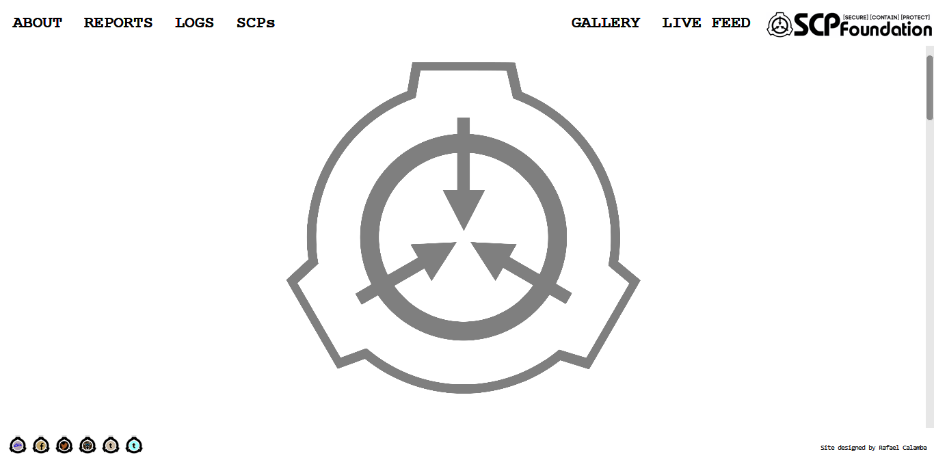

**HTML CODE (home.html)**

<html><head><title>

SCP Foundation</title></head>

<frameset rows=10%,*,7.5% frameborder=0>

<frame src=navigation.html scrolling=no>

<frame src=index.html name=content marginwidth=64>

<frame src=footer.html scrolling=no>

</frameset></html>

**HTML CODE (navigation.html)**

<html><head>

<link rel="stylesheet" href="w3.css"><title>

Navigation</title></head>

<body bgcolor=black text=white>

<table border=0 width=100% height=100%>

<tr><td>

<font face='Courier New' size=5><b>

<div class="w3-show-inline-block w3-left"><div class="w3-bar w3-black">

<a class="w3-bar-item w3-button" target=content href=index.html#about>ABOUT</a>

<a class="w3-bar-item w3-button" target=content href=index.html#reports>REPORTS</a>

<a class="w3-bar-item w3-button" target=content href=index.html#logs>LOGS</a>

<a class="w3-bar-item w3-button" target=content href=index.html#SCPs>SCPs</a></div></div>

<div class="w3-show-inline-block w3-right"><div class="w3-bar w3-black">

<a class="w3-bar-item w3-button" target=content href=gallery.html>GALLERY</a>

<a class="w3-bar-item w3-button" target=content href=SCP-895.html>LIVE FEED</a></div></div></b></font></td>

<td width=18%>

<a href=splash.html target=_top><img src=logo.png align=right></a>

</td></tr></table></body></html>

**HTML CODE (index.html)**

..<title>

</title></head>

<body bgcolor=black text=white link=gray vlink=gray>

<table border=0 width=100% height=500%>

<tr><td height=20%></td></tr>

<tr bgcolor=black>

<td height=20%>

<a name=about>

<table border=0 width=100% height=100% align=center background=bg-marble.png>

<tr><td align=center>

<font face='Courier New' size=2>

<table border=1 cellpadding=40% width=90% height=90% rules=none align=center>

<tr><td>

<p><b>Mankind in its present state

has been around for a quarter of a million years, yet only the last

4,000 have been of any significance.</b></p>

<p>So, what did we do for nearly 250,000

years? We huddled in caves and around small fires, fearful of the things

that we didn't understand. It was more than explaining why the sun came

up, it was the mystery of enormous birds with heads of men and rocks

that came to life. So we called them 'gods' and 'demons', begged them to

spare us, and prayed for salvation.</p>

<p>In time, their numbers dwindled and

ours rose. The world began to make more sense when there were fewer

things to fear, yet the unexplained can never truly go away, as if the

universe demands the absurd and impossible.</p>

<p><b>Mankind must not go back to hiding in fear.</b> No one else

will protect us, and we must stand up for ourselves.</p>

While the rest of mankind dwells in the

light, we must stand in the darkness to fight it, contain it, and shield

it from the eyes of the public, so that others may live in a sane and

normal world.<br>

<img src="scp-logo-signature.png" style="width: 63px; margin: 12px 15px 0 42px; float: left;" class="image"><br>

<b>We secure. We contain. We protect.</b>

<p><b>&mdash; The Administrator</b></p><br>

<a href=about.html>About The Foundation</td></tr></table></a>

</font></td></tr></table></a></td></tr>

<tr bgcolor=black>

<td height=20%>

<a name=reports>

<table border=0 width=100% height=100% align=center background=bg-marble.png>

<tr><td align=center>

<font face='Courier New' size=2>

<table border=1 cellpadding=40% width=90% height=90% rules=none align=center>

<tr><td>

<font face='Consolas'><font size=5><b>

Incident Reports, Eye Witness Interviews, and Personal Logs</font><hr>

<font size=4><ul type=disc>

<li><a href=SCP-143testing.html>SCP-143 Testing Log</a></li>

<li><a href=SCP-3035exploration.html>SCP-3035 Exploration Log</a></li>

<li><a href=I-3456-032incident.html>Incident Log I-3456-032</a></li>

<li><a href=SCP-2446-B4interview.html>SCP-2446-B4 Interview</a></li>

<li><a href=SCP-3148supplement.html>SCP-3148 (A2032)</a></li></ul></b></font>

</td></tr></table><br>

</font></td></tr></table></a></td></tr>

<tr bgcolor=black>

<td height=20%>

<a name=logs>

<table border=0 width=100% height=100% align=center background=bg-marble.png>

<tr><td align=center>

<font face='Courier New' size=2>

<table border=1 cellpadding=40% width=90% height=90% rules=none align=center>

<tr><td>

<font face='Consolas'><font size=5><b>

Logs</font><hr>

<font size=4><ul type=disc>

<li><a href=itemlog.html>Log Of Anomalous Items</a></li>

<li><a href=eventlog.html>Log of Extranormal Events</a></li>

<li><a href=locationlog.html>Log of Unexplained Locations</a></li></ul></font>

</td></tr></table><br>

</font></td></tr></table></a></td></tr>

<tr bgcolor=black>

<td height=20%>

<a name=SCPs>

<table border=0 width=100% height=100% align=center background=bg-marble.png>

<tr><td align=center>

<font face='Courier New' size=2>

<table border=1 cellpadding=40% width=90% height=90% rules=none align=center>

<tr><td>

<font face='Consolas'><font size=5><b>

SCPs</font><hr>

<font size=4><ul type=disc>

<li><a href=SCP-895.html>SCP-895 - Camera Disruption</a></li>

<li><a href=SCP-173.html>SCP-173 - The Sculpture</a></li>

<li><a href=SCP-087.html>SCP-087 - The Stairwell</a></li>

<li><a href=SCP-2521.html>SCP-2521 - &#9679;&#9679;|&#9679;&#9679;&#9679;&#9679;&#9679;|&#9679;&#9679;|&#9679;</a></li>

<li><a href=SCP-055.html>SCP-055 - [unknown]</a></li>

<li><a href=SCP-093.html>SCP-093 - Red Sea Object</a></li></ul></font>

</td></tr></table><br>

</font></td></tr></table></a></td></tr></table></body></html>

**INSTYLE OR INTERNAL CSS (index.html)**

<html><head><style type="text/css">

body {

background-image: url('SCP_Foundation_(emblem).png');

background-position: center center;

background-attachment: fixed;

background-size: contain;

background-repeat: no-repeat;

}

</style>..

**HTML CODE (footer.html)**

<html><head><title>

Footer</title></head>

<body bgcolor=black text=white>

<table border=0 width=100% height=100%>

<tr>

<td align=left>

<a href=http://scp-foundation.deviantart.com/><img src=DA-icon.png></a>

<a href=https://www.facebook.com/scpfoundation><img src=FB-icon.png></a>

<a href=https://twitter.com/scpwiki><img src=Twitter-icon.png></a>

<a href=http://www.reddit.com/r/SCP><img src=Reddit-icon.png></a>

<a href=http://scp-wiki-official.tumblr.com/><img src=Tumblr-icon.png></a>

<a href=http://thescpfoundation.tumblr.com/><img src=tumblr2.png></a>

</td>

<td align=right>

<font face='Consolas' size=1>

Site designed by Rafael Calamba</font></td></tr></table></body></html>

**OUTPUT**

ABOUT – about.html

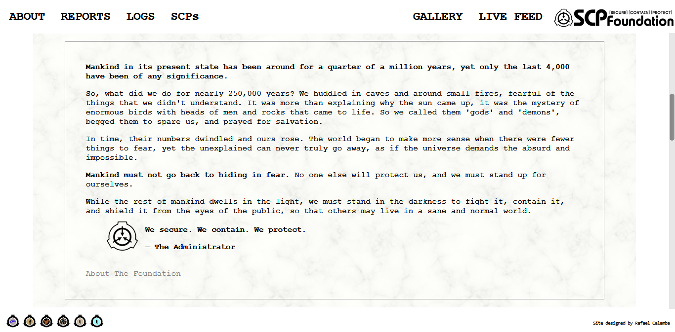

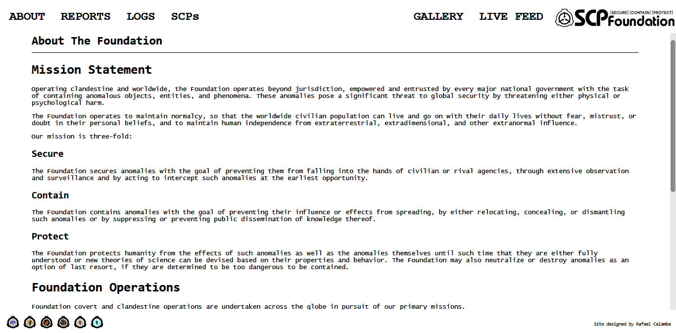

**HTML CODE**

<html><head><title>

</title></head>

<body bgcolor=black text=white link=gray vlink=gray>

<font face='Consolas' size=5><b>

About The Foundation</b></font><hr>

<font face='Lucida Console' size=2>

<font face='Consolas'><h1>Mission Statement</h1></font>

<p>Operating clandestine and worldwide, the Foundation operates beyond

jurisdiction, empowered and entrusted by every major national government

with the task of containing anomalous objects, entities, and phenomena.

These anomalies pose a significant threat to global security by

threatening either physical or psychological harm.</p>

<p>The Foundation operates to maintain normalcy, so that the worldwide

civilian population can live and go on with their daily lives without

fear, mistrust, or doubt in their personal beliefs, and to maintain

human independence from extraterrestrial, extradimensional, and other

extranormal influence.</p>

<p>Our mission is three-fold:</p>

<font face='Consolas'><h2>Secure</h2></font>

<p>The Foundation secures anomalies with the goal of preventing them

from falling into the hands of civilian or rival agencies, through

extensive observation and surveillance and by acting to intercept such

anomalies at the earliest opportunity.</p>

<font face='Consolas'><h2>Contain</h2></font>

<p>The Foundation contains anomalies with the goal of preventing their

influence or effects from spreading, by either relocating, concealing,

or dismantling such anomalies or by suppressing or preventing public

dissemination of knowledge thereof.</p>

<font face='Consolas'><h2>Protect</h2></font>

<p>The Foundation protects humanity from the effects of such anomalies

as well as the anomalies themselves until such time that they are either

fully understood or new theories of science can be devised based on

their properties and behavior. The Foundation may also neutralize or

destroy anomalies as an option of last resort, if they are determined to

be too dangerous to be contained.</p>

<font face='Consolas'><h1>Foundation Operations</h1></font>

<p>Foundation covert and clandestine operations are undertaken across the globe in pursuit of our primary missions.</p>

<font face='Consolas'><h2>Special Containment Procedures</h2></font>

<p>The Foundation maintains an extensive database of information

regarding anomalies requiring Special Containment Procedures, commonly

referred to as "SCPs". The primary Foundation database contains

summaries of such anomalies and emergency procedures for maintaining or

re-establishing safe containment in the case of a containment breach or

other event.</p>

<p>Anomalies may take many forms, be it an object, an entity, a

location, or a free-standing phenomenon. These anomalies are categorized

into one of several <a href=objectclasses.html>Object Classes</a> and are either contained at one of the Foundation's myriad Secure Facilities or contained on-site if relocation is deemed unfeasible.</p>

<font face='Consolas'><h2>Operational Security</h2></font>

<p>The Foundation operates with the utmost secrecy. All Foundation personnel must observe the Security Clearance Levels

as well as need-to-know and compartmentalization of information.

Personnel found in violation of Foundation security protocols will be

identified, detained, and subject to disciplinary action.</p>

<font face='Consolas'><h2>Rival Agencies and Groups of Interest</h2></font>

<p>The Foundation is not the only organization with knowledge of and

capability to interact with or utilize anomalies. While some of these Groups of Interest

have similar goals and may cooperate with us on issues of global

security, many more are opportunistic and profit-oriented, seeking to

adapt or use anomalies to their own ends. Foundation personnel are

instructed to treat individuals from such groups with suspicion at all

times, and collaboration with such groups without the explicit prior

consent of Foundation leadership will be cause for termination or other

disciplinary action.</p></font></body></html>

**OUTPUT**

REPORT EXAMPLE (SCP-143 Testing Log) - SCP-143testing.html

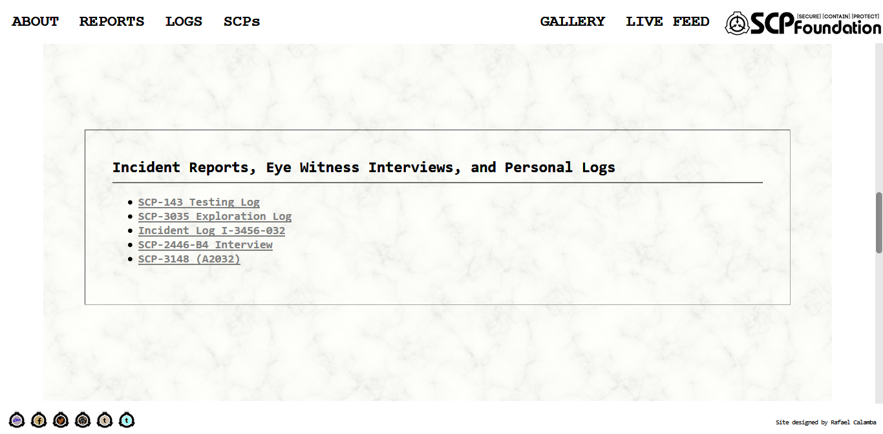

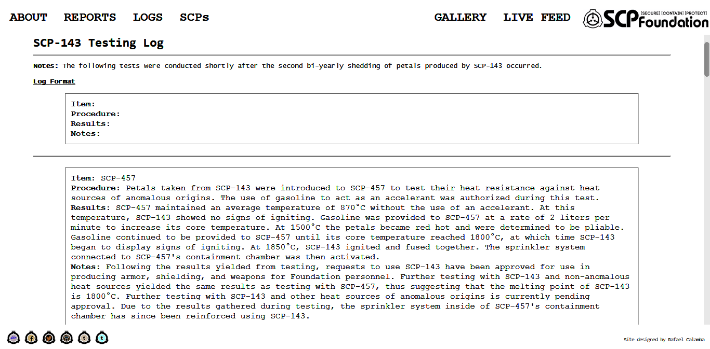

**HTML CODE**

<html><head><title>

</title></head>

<body bgcolor=black text=white link=gray vlink=gray>

<font face='Consolas' size=5><b>

SCP-143 Testing Log</b></font><hr>

<font face='Lucida Console' size=2>

<p><b>Notes:</b> The following tests were conducted shortly after the second bi-yearly shedding of petals produced by SCP-143 occurred.</p>

<p><u><b>Log Format</font></b></u></p>

<font face='Courier New' size=2>

<table border=1 cellpadding=8 width=90% rules=none align=center><td>

<b>Item:</b>

<br><b>Procedure:</b>

<br><b>Results:</b>

<br><b>Notes:</b></td></table><br><hr><br>

<table border=1 cellpadding=8 width=90% rules=none align=center><td>

<b>Item:</b> SCP-457

<br><b>Procedure:</b> Petals taken from SCP-143 were introduced to SCP-457 to test their heat resistance against heat sources of anomalous origins. The use of gasoline to act as an accelerant was authorized during this test.

<br><b>Results:</b> SCP-457 maintained an average temperature of 870&deg;C without the use of an accelerant. At this temperature, SCP-143 showed no signs of igniting. Gasoline was provided to SCP-457 at a rate of 2 liters per minute to increase its core temperature. At 1500&deg;C the petals became red hot and were determined to be pliable. Gasoline continued to be provided to SCP-457 until its core temperature reached 1800&deg;C, at which time SCP-143 began to display signs of igniting. At 1850&deg;C, SCP-143 ignited and fused together. The sprinkler system connected to SCP-457's containment chamber was then activated.

<br><b>Notes:</b> Following the results yielded from testing, requests to use SCP-143 have been approved for use in producing armor, shielding, and weapons for Foundation personnel. Further testing with SCP-143 and non-anomalous heat sources yielded the same results as testing with SCP-457, thus suggesting that the melting point of SCP-143 is 1800&deg;C. Further testing with SCP-143 and other heat sources of anomalous origins is currently pending approval. Due to the results gathered during testing, the sprinkler system inside of SCP-457's containment chamber has since been reinforced using SCP-143.</td></table><br>

<table border=1 cellpadding=8 width=90% rules=none align=center><td>

<b>Item:</b> SCP-890

<br><b>Procedure:</b> SCP-890 was provided with a set of hand crafted scalpels produced with the petals taken from SCP-143. SCP-890 was then instructed to operate on a HP brand copy machine that had short circuited the week prior. An identical machine with a similar electrical problem was also given to SCP-890 along with a set of standard scalpels. SCP-890 was instructed to preform two separate operations using the different set of tools and provide feedback on the differences of the procedures.<br><br>

<a href=SCP-143-890testing.html#result>Access Testing Results</a><br>

<br><b>Notes:</b> Any further testing completed with SCP-890 is to be documented extensively and the objects involved in the testing process are to be monitored until such a time that they are deemed fully functional.<br><br>

<a href=SCP-143-890testing.html#statement>Access Statement Made by SCP-890</a><br>

<br><b>Notes:</b> SCP-890 has been given permission to utilize the scalpels produced using SCP-143 in all future procedures that may occur. Production of other medical tools crafted using SCP-143 for use within the Foundation is currently pending approval after clinical testing is conducted.</td></table><br>

<table border=1 cellpadding=8 width=90% rules=none align=center><td>

<b>Item:</b> SCP-1006

<br><b>Procedure:</b> A small portion of the SCP-1006 colony was taken to SCP-143. Researchers established contact with the leader of SCP-1006's colony in order to inform it of the test and to prevent further discourse with the SCP-1006 colony and Foundation personnel.

<br><b>Results:</b> The colony of SCP-1006 took up residence in the largest branch of SCP-143 and quickly established a network of webs reaching the outermost portion of the branch. The established web was infused with petals taken from SCP-143 and as a result, the overall structure of the network proved to be much sturdier than previous webs made by SCP-1006 and required less repairs. The number of insects that were captured in the web remained steady and proved to be sufficient to maintain the members of the SCP-1006 colony. During the duration of the test, the SCP-1006 colony began to weave sheets of web using SCP-143. The colony was then presented with a bottle of black ink.<br><br>

The larger sheets of web produced by SCP-1006 contained spaces in the webbing that were in the form of letters taken from the English alphabet. The smaller, blank sheets of web that SCP-1006 had produced were then placed underneath the larger sheets. The SCP-1006 colony then began to work in unison to apply the black ink to the web. This was done by tipping the bottle of ink over and also by members of the SCP-1006 colony coating their bodies in ink and applying it in the spaces formed in the larger sheets of webbing. Once completed, this process was continued until one dozen exact copies of SCP-1006's correspondence were made. The contents of the letters all called for the dismantlement of western society and capitalist governments. When offered white poster board in place of the sheets created with the web infused with SCP-143, the SCP-1006 colony refused to use the poster board and continued to utilize its new method of communication.<br>

<br><b>Notes:</b> After testing concluded, the small colony in SCP-143 was taken back to the main SCP-1006 colony and petals from SCP-143 were provided to SCP-1006 for use within its web and for further communication purposes.</td></table><br>

<table border=1 cellpadding=8 width=90% rules=none align=center><td>

<b>Item:</b> SCP-1030

<br><b>Procedure:</b> Petals taken from SCP-143 were integrated into SCP-1030 in order to determine how long it would take for the petals to corrode.

<br><b>Results:</b> SCP-1030 exhibited signs of obvious discomfort eight hours after initial ingratiation with SCP-143. At this time, SCP-1030 began to slam its "hands", which were composed of various pieces of scrap metal at the time of testing, onto the walls of its containment chamber. SCP-1030 was then presented with a pile of assorted scrap metal and wires and SCP-143 was ejected from SCP-1030. SCP-143's shape had not changed, though each individual petal bore the mark of SCP-1030, and displayed obvious signs of wear. The sharp edge on each individual petal was also noted to be significantly duller after its expulsion from SCP-1030. No other additional changes were initially present.<br><br>

SCP-143 became animate thirty minutes after being expelled from SCP-1030. At which time, the petals from SCP-143 began to move on their volition and take the form of a small cyclone, rotating at a speed of 5km an hour. SCP-1030 exhibited no interest in SCP-143 and personnel were able to successfully remove SCP-143 from the containment chamber. The petals used in this experiment were placed in a low value item locker at the site of original testing. Two days after being stored, the petals ceased rotation and have since become inanimate. SCP-1030 has not expressed any knowledge of this change.<br>

<br><b>Notes:</b> Standard metalloids presented to SCP-1030 for self-repair were typically ejected after a period of time ranging between 30 minutes and three hours, at which time the metalloids would either be highly corroded or almost entirely dissolved. Due to the prolonged period of time that SCP-143 was able to be integrated into SCP-1030 and the limited amount of corrosion that appeared on SCP-143 after being ejected, requests to use SCP-143 as a more efficient source of self-repair material for SCP-1030 has since been approved.</td></table><br>

<table border=1 cellpadding=8 width=90% rules=none align=center><td>

<b>Item:</b> SCP-1048

<br><b>Procedure:</b> <b>REQUEST FOR TESTING DENIED.</b>

<br><b>Results:</b> Null.

<br><b>Notes:</b> Several weeks prior to the first appearance of SCP-1048-A, SCP-1048 approached a researcher at Site-24, the initial site responsible for containment of SCP-143, and provided a hand drawn picture to the researcher. The picture depicted SCP-1048 standing underneath a tree surrounded by petals. The researcher in question denied SCP-1048's request and due to the events that occurred afterward, any testing with any SCP-1048 instance and SCP-143 is strictly forbidden. The petals that are produced by SCP-143 are not currently thought to be the material that SCP-1048-C is composed of. Further testing, contingent on the containment of SCP-1048-C, is required.</td></table><br>

<table border=1 cellpadding=8 width=90% rules=none align=center><td>

<b>Item:</b> SCP-1100

<br><b>Procedure:</b> SCP-143 was introduced to the aerosol produced by SCP-1100. This test was conducted in a controlled setting at Bio Containment Site-71.

<br><b>Results:</b> Thirty seconds after initial exposure had occurred, automated testing of the petals revealed that their hardness, as well as sharpness, had increased, reaching 6,500 HB on the Brinell scale. An automated toxicology test was then conducted on SCP-143 and revealed that the toxicity levels of the petals had surpassed any substance currently known. When exposed to the living tissue of a <i>Sus scrofa domesticus</i><a name=footnote1a href=#footnote1b><sup>1</sup></a> the toxin caused total cell death of the organism on a molecular level. This event took place over approximately fifteen seconds of exposure. During this process, mitochondrial swelling, cytoplasm vacuolization, and swelling of the nucleus and cytoplasm were all documented before total death of the cells occurred. This level of toxicity is the highest documented of all instances of SCP-1100.

<br><b>Notes:</b> Due to the results gathered during testing, the petals used in this experiment are permanently kept at the site of original testing. No further testing with SCP-143 and SCP-1100 is to be conducted.</td></table><br>

<table border=1 cellpadding=8 width=90% rules=none align=center><td>

<b>Item:</b> SCP-2467

<br><b>Procedure:</b> A 7 meter long fiberglass boat carrying 15kg of SCP-143 was launched from the SCPS Sunderland unmanned and remotely controlled by personnel aboard the main ship. Upon entering the 5km radius of SCP-2467, heavy rain began to fall and wind speeds reaching 40km an hour were documented. Waves, measuring 4m high, pushed the boat carrying SCP-143 until SCP-2467 was in sight and the crew of SCP-2467 was able to attach a line to the smaller vessel. After using the crane on SCP-2467 to raise the smaller vessel, the ship's crew hoisted the cargo crates carrying SCP-143 onto the deck of the ship and began to use SCP-143 to reinforce the hull of SCP-2467.

<br><b>Results:</b> After three hours had passed, SCP-143 began to rot at an accelerated rate. Due to the short period of time that this occurred in, the rotting caused severe structural damage to the hull of the ship, resulting in four large, approximately 40cm in length, cracks to appear on the left side of the hull where SCP-143 had been integrated. Crew members on SCP-2467 quickly began to remove SCP-143, exhibiting obvious signs of distress and agitation as they did so. SCP-143, when severed from the hull of SCP-2467, was subsequently thrown overboard and the fiberglass from the 7m boat was utilized in its place. Observation efforts from the SCPS Sunderland further reported witnessing the crew of SCP-2467 continue to act in a distressed manner whenever they approached the hull of SCP-2467. This effect continued for a period of twelve hours, after which time the crew on SCP-2467 returned to normal behavior. No further changes have since been documented.

<br><b>Notes:</b> After testing had concluded, petals taken from SCP-143 were exposed to oceanic salt water for a period of eight hours. Over the course of the secondary experiment, SCP-143 exhibited no signs of deteriorating and after being extracted from the salt water, displayed no signs of obvious wear. Whether SCP-143 had a negative reaction to SCP-2467 or whether materials integrated into SCP-2467 have an increased rate of deterioration is currently unknown.</td></table><br>

<table border=1 cellpadding=8 width=90% rules=none align=center><td>

<b>Item:</b> SCP-2968

<br><b>Procedure 1:</b> Bark taken from SCP-143 was used to create a 3m long replica of a school bus. Afterward, the item was presented to the SCP-2968 colony.

<br><b>Results:</b> The SCP-2968 colony did not acknowledge SCP-143. Attempts made by Foundation personnel to change this result were unsuccessful. SCP-143 was successfully removed from SCP-2968's containment chamber without incident.<br>

<br><b>Procedure 2:</b> The replica bus produced using SCP-143 was covered in silver paint before being presented to the SCP-2968 colony.

<br><b>Results:</b> The SCP-2968 colony immediately took notice of SCP-143 and the largest of the SCP-2968 instances approached SCP-143. The SCP-2968 instance proceeded to attempt to ingest SCP-143 by raising the replica underneath its hood before the seam closed once more. After thirty seconds, the instance of SCP-2968 expelled SCP-143 whole and still in tact. No visible damage to SCP-143 was documented. Additional instances of SCP-2968 attempted to ingest SCP-143, however the results were unchanged. SCP-143 was successfully removed from SCP-2968's containment chamber after steel was provided to the SCP-2968 colony. SCP-2968 instances that attempted to digest SCP-143 produced 20% more waste product in the following 24 hours than usual. Metals that were typically able to be digested by SCP-2968 were expelled from its body, an action atypical of SCP-2968. The expelled materials were partially digested, but in all instances, retained at least 30% of their original mass.<br><br>

Over the next 24 hours, the effected instances of SCP-2968 refused to eat and became increasingly sluggish, only moving when prompted to by other instances. At this time, the effected instances were individually quarantined, and SCP-890 was granted authorization to examine the instances. SCP-890 examined three instances of SCP-2968 and determined that the hatch on the bottom of the instances had malfunctioned due to heavy damage sustained to the mechanisms that operate the hatch, causing it to fall open periodically. SCP-890 was given access to replacement parts for the instances and successfully replaced both the hinges and springs that were damaged during testing.<br><br>

SCP-890 then proceeded to examine the additional four instances of SCP-2968 that had come into direct contact with SCP-143. SCP-890 determined that the remaining four instances of SCP-2968 had partial "stomach blockages" and requested to remove the offending pieces of SCP-143<a name=footnote2a href=#footnote2b><sup>2</sup></a>. The request was subsequently granted. Using standard, steel scalpels<a name=footnote3a href=#footnote3b><sup>3</sup></a>, SCP-890 was able to remove the remnants of SCP-143 from the instances of SCP-2968's engines. 2 kilograms of SCP-143 was recovered during this process, though how it was retained by SCP-2968 instances is currently unknown.<br><br>

After 24 hours had passed after each set of operations, the SCP-2968 instances exhibited no further complications from testing. Why the instances effected by SCP-143 exhibited the same complications, despite having varying mechanical issues, has yet to be determined.<br>

<br><b>Notes:</b> No further testing between SCP-143 and SCP-2968 is to be conducted.</td></table><br>

<table border=1 cellpadding=8 width=90% rules=none align=center><td>

<b>Item:</b> SCP-2849

<br><b>Procedure:</b> During decontamination procedures, it was found that several rooms within SCP-2849 were inaccessible due to the massive condensed deceased biomass. After several conventional and anomalous attempts to clear it, SCP-143 edged cutting tools were requisitioned.

<br><b>Results:</b> After several failed attempts, it was found that exerting leverage could cause the enhanced tools to disrupt the biomass' structural integrity. Sonic generators were used to dissolve the structures after their integrity was weakened.

<br><b>Notes:</b> Research into using SCP-143 as standard kit piece for exploration or sample gathering from or into anomalous tissue-based structures is ongoing.</font></td></table><br>

<font face='Lucida Console'><font size=3>

<p><b>Footnotes</font></b></p>

<a name=footnote1b href=#footnote1a>1</a>. Commonly referred to as the domesticated pig<br>

<a name=footnote2b href=#footnote2a>2</a>. Due to the lack of documented damage on the replica bus constructed out of SCP-143, how pieces of SCP-143 remained in the instances' stomachs is currently unknown<br>

<a name=footnote3b href=#footnote3a>3</a>. Due to the negative results gathered during the test between SCP-143 and SCP-2968 instances, the scalpels provided to SCP-890 produced with SCP-143 were not authorized to be used during this procedure</font></body></html>

**OUTPUT**

LOG EXAMPLE (Log of Extranormal Events) – eventlog.html

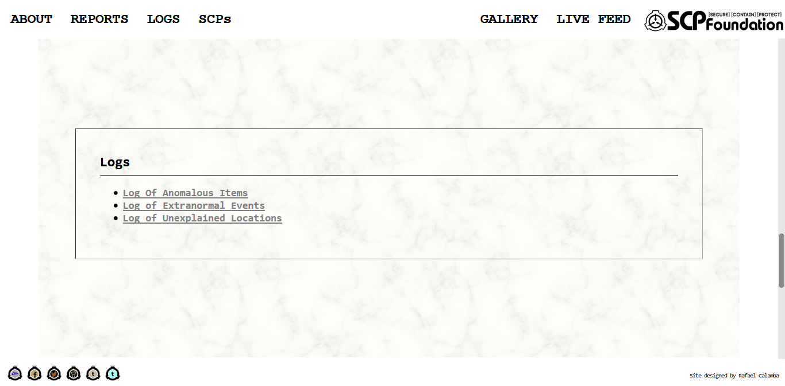

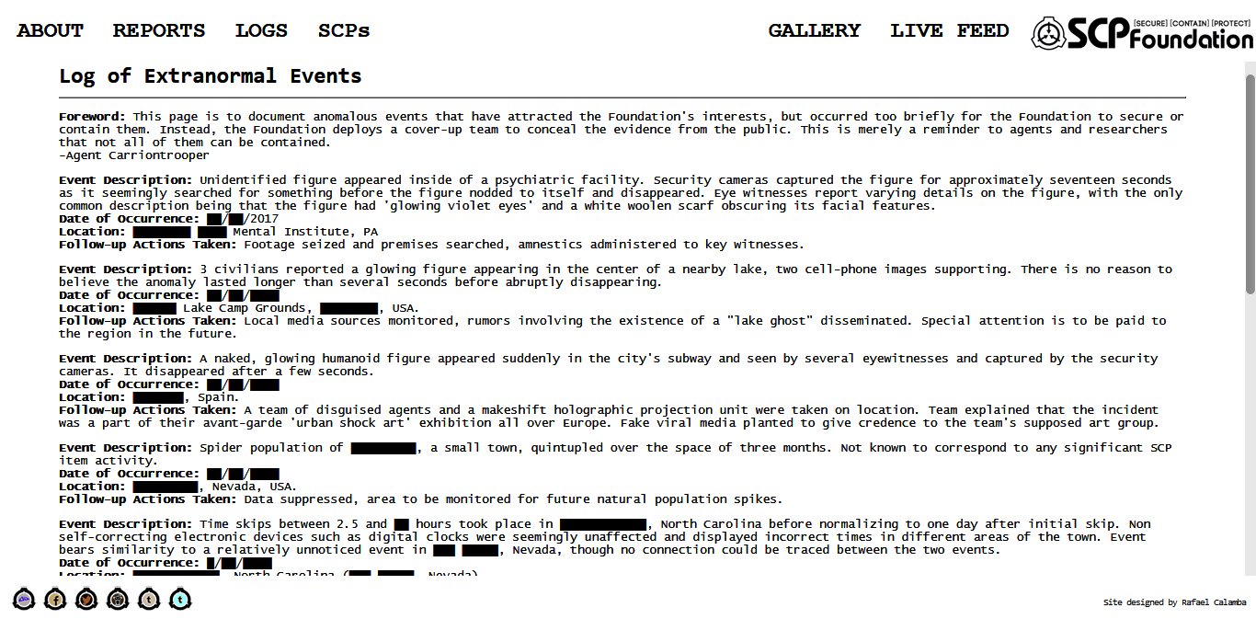

**HTML CODE**

<html><head><title>

</title></head>

<body bgcolor=black text=white>

<font face='Consolas' size=5><b>

Log of Extranormal Events</b></font><hr>

<font face='Lucida Console' size=2>

<p><b>Foreword:</b> This page is to document anomalous events that have attracted the Foundation's interests, but occurred too briefly for the Foundation to secure or contain them. Instead, the Foundation deploys a cover-up team to conceal the evidence from the public. This is merely a reminder to agents and researchers that not all of them can be contained.<br>

-Agent Carriontrooper</p>

<p><b>Event Description:</b> Unidentified figure appeared inside of a psychiatric facility. Security cameras captured the figure for approximately seventeen seconds as it seemingly searched for something before the figure nodded to itself and disappeared. Eye witnesses report varying details on the figure, with the only common description being that the figure had 'glowing violet eyes' and a white woolen scarf obscuring its facial features.

<br><b>Date of Occurrence:</b> &#9608;&#9608;/&#9608;&#9608;/2017

<br><b>Location:</b> &#9608;&#9608;&#9608;&#9608;&#9608;&#9608;&#9608;&#9608; &#9608;&#9608;&#9608;&#9608; Mental Institute, PA

<br><b>Follow-up Actions Taken:</b> Footage seized and premises searched, amnestics administered to key witnesses.</p>

<p><b>Event Description:</b> 3 civilians reported a glowing figure appearing in the center of a nearby lake, two cell-phone images supporting. There is no reason to believe the anomaly lasted longer than several seconds before abruptly disappearing.

<br><b>Date of Occurrence:</b> &#9608;&#9608;/&#9608;&#9608;/&#9608;&#9608;&#9608;&#9608;

<br><b>Location:</b> &#9608;&#9608;&#9608;&#9608;&#9608;&#9608; Lake Camp Grounds, &#9608;&#9608;&#9608;&#9608;&#9608;&#9608;&#9608;&#9608;, USA.

<br><b>Follow-up Actions Taken:</b> Local media sources monitored, rumors involving the existence of a "lake ghost" disseminated. Special attention is to be paid to the region in the future.</p>

<p><b>Event Description:</b> A naked, glowing humanoid figure appeared suddenly in the city's subway and seen by several eyewitnesses and captured by the security cameras. It disappeared after a few seconds.

<br><b>Date of Occurrence:</b> &#9608;&#9608;/&#9608;&#9608;/&#9608;&#9608;&#9608;&#9608;

<br><b>Location:</b> &#9608;&#9608;&#9608;&#9608;&#9608;&#9608;&#9608;, Spain.

<br><b>Follow-up Actions Taken:</b> A team of disguised agents and a makeshift holographic projection unit were taken on location. Team explained that the incident was a part of their avant-garde 'urban shock art' exhibition all over Europe. Fake viral media planted to give credence to the team's supposed art group.</p>

<p><b>Event Description:</b> Spider population of &#9608;&#9608;&#9608;&#9608;&#9608;&#9608;&#9608;&#9608;&#9608;, a small town, quintupled over the space of three months. Not known to correspond to any significant SCP item activity.

<br><b>Date of Occurrence:</b> &#9608;&#9608;/&#9608;&#9608;/&#9608;&#9608;&#9608;&#9608;

<br><b>Location:</b> &#9608;&#9608;&#9608;&#9608;&#9608;&#9608;&#9608;&#9608;&#9608;, Nevada, USA.

<br><b>Follow-up Actions Taken:</b> Data suppressed, area to be monitored for future natural population spikes.</p>

<p><b>Event Description:</b> Time skips between 2.5 and &#9608;&#9608; hours took place in &#9608;&#9608;&#9608;&#9608;&#9608;&#9608;&#9608;&#9608;&#9608;&#9608;&#9608;&#9608;, North Carolina before normalizing to one day after initial skip. Non self-correcting electronic devices such as digital clocks were seemingly unaffected and displayed incorrect times in different areas of the town. Event bears similarity to a relatively unnoticed event in &#9608;&#9608;&#9608; &#9608;&#9608;&#9608;&#9608;&#9608;, Nevada, though no connection could be traced between the two events.

<br><b>Date of Occurrence:</b> &#9608;/&#9608;&#9608;/&#9608;&#9608;&#9608;&#9608;

<br><b>Location:</b> &#9608;&#9608;&#9608;&#9608;&#9608;&#9608;&#9608;&#9608;&#9608;&#9608;&#9608;&#9608;, North Carolina (&#9608;&#9608;&#9608; &#9608;&#9608;&#9608;&#9608;&#9608;, Nevada).

<br><b>Follow-up Actions Taken:</b> Local news reported electromagnetic interference caused by local power plant. Small observation team assigned to area.</p>

<p><b>Event Description:</b> &#9608;&#9608;&#9608;&#9608;&#9608;&#9608;&#9608;&#9608;, Wales, was found to be abandoned. The population was found comatose in a nearby field. &#9608;&#9608; hours after the estimated time of the event, the population awoke with no recollection of the event.

<br><b>Date of Occurrence:</b> &#9608;&#9608;/&#9608;&#9608;/&#9608;&#9608;&#9608;&#9608;

<br><b>Location:</b> &#9608;&#9608;&#9608;&#9608;&#9608;&#9608;&#9608;&#9608;.

<br><b>Follow-up Actions Taken:</b> Population dosed with Class B Amnestics and a cover story was established. A road accident with a Samson-Craig Products (an SCP front company) chemical tanker was staged, an emergency evacuation camp was arranged and the population given &pound;&#9608;&#9608;&#9608; per head compensation. In the &#9608;&#9608; years since the event there has been no recurrence or abnormal behaviour in the population.</p>

<p><b>Event Description:</b> Three similar looking men were witnessed fighting in a gas station parking lot. Eyewitness reports maintain that each man claimed to be &#9608;&#9608;&#9608;&#9608;&#9608;&#9608; &#9608;&#9608;&#9608;&#9608;&#9608;&#9608;&#9608;&#9608;&#9608;, a well known local car salesman, and were fighting over which individual was the "true" one. Two of the men were killed when the third procured a crowbar. The third was fatally shot by a local police officer.

<br><b>Date of Occurrence:</b> &#9608;&#9608;/&#9608;&#9608;/&#9608;&#9608;&#9608;&#9608;

<br><b>Location:</b> &#9608;&#9608;&#9608;&#9608;&#9608;, Oklahoma.

<br><b>Follow-up Actions Taken:</b> Witnesses and involved persons were questioned and given Class B Amnestics. Close family members of &#9608;&#9608;&#9608;&#9608;&#9608;&#9608; &#9608;&#9608;&#9608;&#9608;&#9608;&#9608;&#9608;&#9608;&#9608; were questioned and given Class A Amnestics. A cover story involving the individual's suicide was established. The three bodies were recovered for autopsy and are currently maintained in a Site-19 minimum security storage freezer.</p>

<p><b>Event Description:</b> Several students attending &#9608;&#9608;&#9608;&#9608;&#9608;&#9608;&#9608;&#9608;&#9608; Collegiate began complaining about a loud buzzing noise. A custodian for the school located the source as a single monitor in the computer lab during his duties, and reported the power button was unresponsive. When the lab technicians arrived the next day, they unplugged the monitor after other attempts proved futile. Witnesses of the event report a scream playing through the computer's speakers, and the image of a digitized face screaming appeared for a moment before power was lost.

<br><b>Date of Occurrence:</b> &#9608;&#9608;/&#9608;&#9608;/&#9608;&#9608;&#9608;&#9608;

<br><b>Location:</b> &#9608;&#9608;&#9608;&#9608;&#9608;&#9608;&#9608;&#9608;&#9608; Collegiate in the &#9608;&#9608;&#9608;&#9608;&#9608;&#9608;, &#9608;&#9608;&#9608;&#9608;&#9608;&#9608;&#9608;&#9608;, USA.

<br><b>Follow-up Actions Taken:</b> The monitor was confiscated and replaced for inspection. Nothing of interest has been found.</p>

<p><b>Event Description:</b> A mission not typically present was located in the MMORPG [REDACTED]. The mission was only accessible via a bugged area of terrain but had existed for an unknown period of time. The mission was an exact replica of Site-&#9608;&#9608; with several hostile SCPs (not necessarily those housed there) as opponents. No code for the mission was found on the game's server by Foundation Investigation teams.

<br><b>Date of Occurrence:</b> Unknown. Detected &#9608;&#9608;/&#9608;&#9608;/&#9608;&#9608;&#9608;&#9608;

<br><b>Location:</b> Geographical location unclear.

<br><b>Follow-up Actions Taken:</b> A viral attack on the server was performed, resulting in a total shut down. After the server was re-initialized the mission was absent. All individuals known to have found the mission have been given Class A Amnestics. There has been no recurrence to date.</p>

<p><b>Event Description:</b> The entire stock of &#9608;&#9608;&#9608;&#9608;&#9608;&#9608;&#9608; &#9608;&#9608;&#9608;&#9608;&#9608;&#9608;&#9608; souvenirs at the &#9608;&#9608;&#9608;&#9608;&#9608;&#9608;&#9608; &#9608;&#9608;&#9608;&#9608;&#9608;&#9608;&#9608; stall on the &#9608;&#9608;&#9608;&#9608;&#9608;&#9608; waterfront were spontaneously altered so that the face of &#9608;&#9608;&#9608;&#9608;&#9608;&#9608;&#9608; &#9608;&#9608;&#9608;&#9608;&#9608;&#9608;&#9608; was removed. These objects produced a loud screaming sound when exposed to daylight, and all writing implements within the stall formed symbols associated with the Cult of the Demon &#9608;&#9608;&#9608;&#9608;&#9608;&#9608; when an attempt to write with them was made. 8 days after the event, all altered stock vanished from Foundation storage.

<br><b>Date of Occurrence:</b> &#9608;&#9608;/&#9608;&#9608;/&#9608;&#9608;&#9608;&#9608;

<br><b>Location:</b> &#9608;&#9608;&#9608;&#9608;&#9608;&#9608;&#9608;, Nova Scotia.

<br><b>Follow-up Actions Taken:</b> All altered stock seized and impounded, amnestics administered.</p></font></body></html>

**OUTPUT**

SCP EXAMPLE (●●|●●●●●|●●|●) – SCP-2521.html

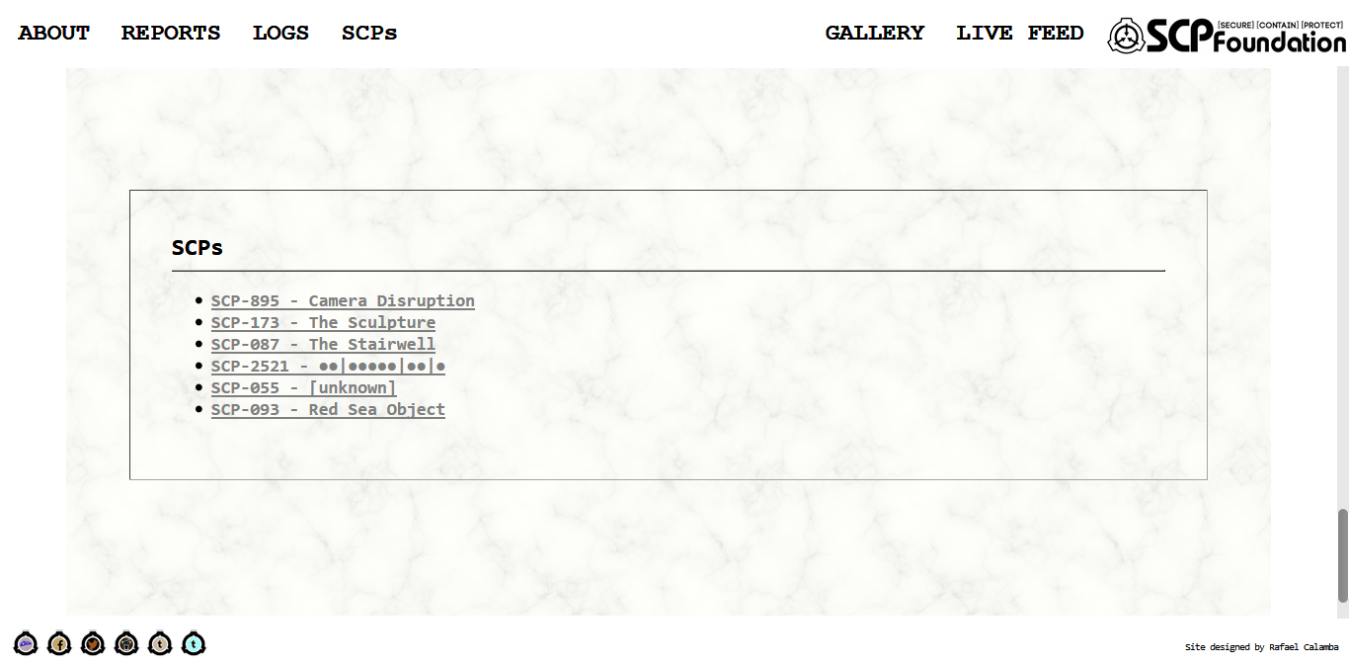

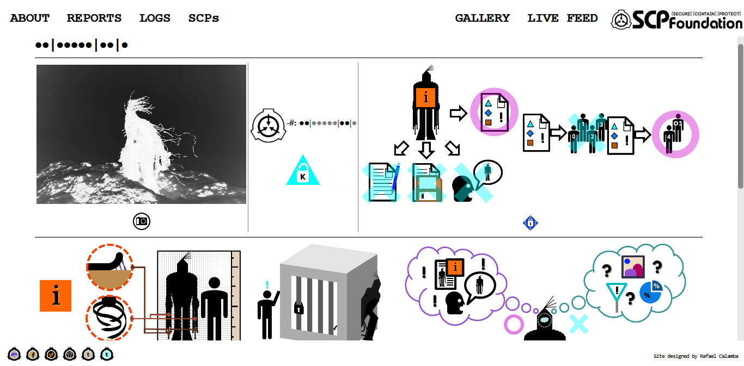

**HTML CODE**

<html><head><title>

</title></head>

<body bgcolor=black text=white link=gray vlink=gray>

<font face='Consolas' size=5><b>

&#9679;&#9679;|&#9679;&#9679;&#9679;&#9679;&#9679;|&#9679;&#9679;|&#9679;</b></font><hr>

<table border=0 width=100% rules=cols>

<tr>

<td align=center>

<p><img src=scp_number.jpg height=256></p>

<p><img src=camera_icon.png height=32></p></td>

<td align=center>

<p><img src=scp.png height=64 align=middle><b>-#:</b> &#9679;&#9679;|<font color=gray>&#9679;&#9679;&#9679;&#9679;&#9679;</font>|&#9679;&#9679;|<font color=gray>&#9679;</font></p>

<p><img src=keter.png height=64></p></td>

<td align=center>

<table border=0 width=100%><tr>

<td align=center><img src=documents4.png height=256></td>

<td align=center><img src=clearance6.png height=88></td></tr></table>

<p><img src=lock2.png height=32></p></td></tr></table>

<hr>

<table border=0 width=100%>

<tr>

<td align=center><img src=info.png height=64></td>

<td align=center><img src=physical6.png height=192></td>

<td align=center><img src=intangible3.png height=192></td>

<td align=center><img src=thought5.png height=192></td></tr></table>

<hr>

<table border=0 width=100%>

<tr>

<td align=left><img src=a.png height=64></td>

<td align=center><img src=test_logs.png height=64></td>

<td align=right><img src=b.png height=64></td></tr></table>

<table border=0 width=100% rules=cols>

<tr>

<td align=center><img src=test_a3.png height=384></td>

<td align=center><img src=test_b2.png height=384></td></tr></table></font></body></html>

**OUTPUT**

GALLERY - gallery.html

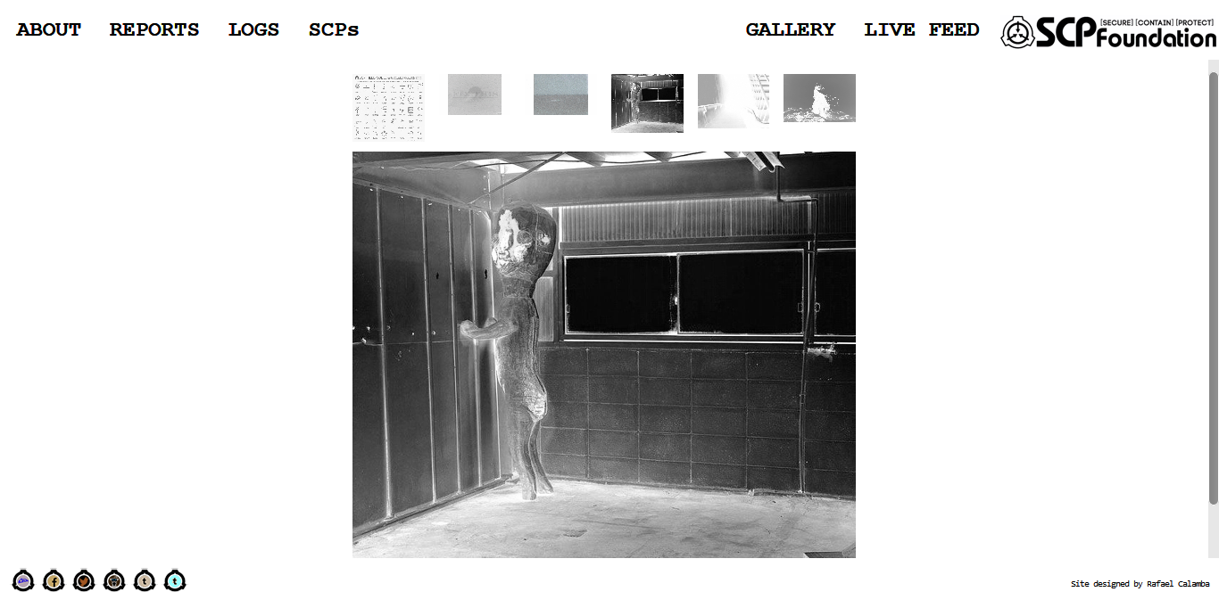

**HTML CODE**

..</head>

<body bgcolor=black text=white link=gray vlink=gray>

<div class="w3-content" style="max-width:44%">

<div class="w3-row-padding w3-section">

<div class="w3-col s2">

<img class="demo w3-opacity w3-hover-opacity-off" src=fieldcodes_bw.jpg style="width:100%" onclick="slideNumber(1)">

</div>

<div class="w3-col s2">

<img class="demo w3-opacity w3-hover-opacity-off" src=nuke4opt.gif style="width:100%" onclick="slideNumber(2)">

</div>

<div class="w3-col s2">

<img class="demo w3-opacity w3-hover-opacity-off" src=nuke6opt.gif style="width:100%" onclick="slideNumber(3)">

</div>

<div class="w3-col s2">

<img class="demo w3-opacity w3-hover-opacity-off" src=SCP-173.jpg style="width:100%" onclick="slideNumber(4)">

</div>

<div class="w3-col s2">

<img class="demo w3-opacity w3-hover-opacity-off" src=rf.png style="width:100%" onclick="slideNumber(5)">

</div>

<div class="w3-col s2">

<img class="demo w3-opacity w3-hover-opacity-off" src=scp_number.jpg style="width:100%" onclick="slideNumber(6)">

</div>

</div>

<font face='Lucida Console' size=2>

<div class="slideshow">

<div class="w3-container">

<img src=fieldcodes_bw.jpg style="width:100%">

</div></div>

<div class="slideshow">

<div class="w3-container">

<img src=nuke4opt.gif style="width:100%">

<center><p>SCP-3148-1-1962-2</center></p>

</div></div>

<div class="slideshow">

<div class="w3-container">

<img src=nuke6opt.gif style="width:100%">

<center><p>SCP-3148-1-1955-3</center></p>

</div></div>

<div class="slideshow">

<div class="w3-container">

<img src=SCP-173.jpg style="width:100%">

<center><p>SCP-173 in containment</center></p>

</div></div>

<div class="slideshow">

<div class="w3-container">

<img src=rf.png style="width:100%">

<center><p>SCP-087; Still frame taken from video footage of Exploration I</center></p>

</div></div></font>

<div class="slideshow">

<div class="w3-container">

<img src=scp_number.jpg style="width:100%">

<center><p>&#9679;&#9679;|&#9679;&#9679;&#9679;&#9679;&#9679;|&#9679;&#9679;|&#9679;</center></p>

</div></div></div>

<script>

var slideIndex = 1;

showDivs(slideIndex);

function plusDivs(n) {

showDivs(slideIndex += n);

}

function slideNumber(n) {

showDivs(slideIndex = n);

}

function showDivs(n) {

var i;

var x = document.getElementsByClassName("slideshow");

var dots = document.getElementsByClassName("demo");

if (n > x.length) {slideIndex = 1}

if (n < 1) {slideIndex = x.length}

for (i = 0; i < x.length; i++) {

x[i].style.display = "none";

}

for (i = 0; i < dots.length; i++) {

dots[i].className = dots[i].className.replace(" w3-opacity-off", "");

}

x[slideIndex-1].style.display = "block";

dots[slideIndex-1].className += " w3-opacity-off";

}

</script>

</body>

</html>

**INSTYLE OR INTERNAL CSS**

<html><head><title>

</title>

<link rel="stylesheet" href=w3.css>

<style>

.slideshow {display:none}

.demo {cursor:pointer}

</style>..

**OUTPUT**

LIVE FEED (SCP-895) - SCP-895.html

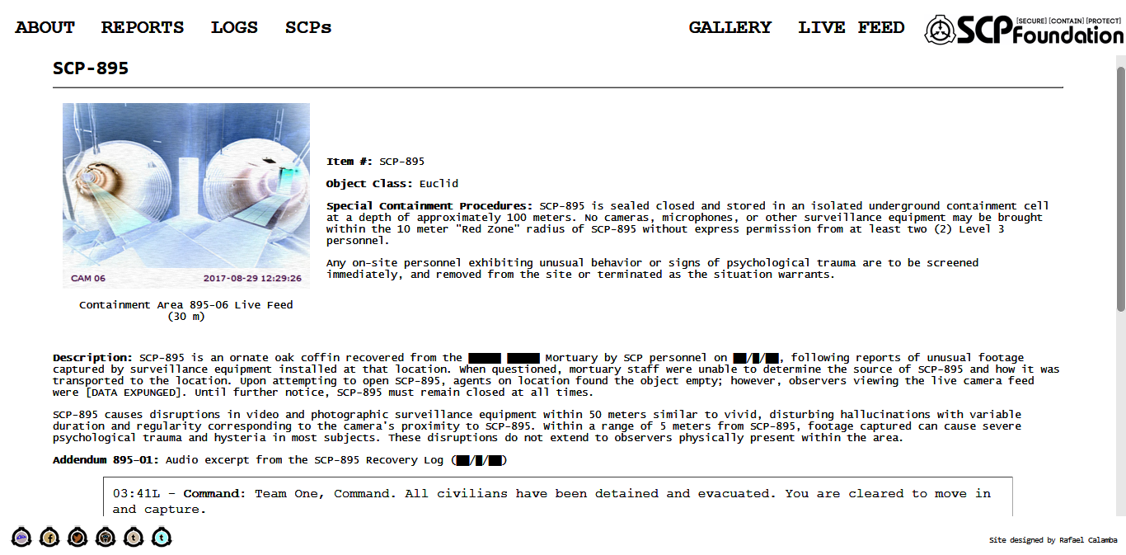

**HTML CODE**

<html><head><title>

</title></head>

<body bgcolor=black text=white link=gray vlink=gray>

<font face='Consolas' size=5><b>

SCP-895</b></font><hr>

<font face='Lucida Console' size=2>

<table border=0 cellpadding=8 width=100% align=center>

<tr>

<td align=center><iframe src="http://scpfoundation.org/895/feed.html" frameborder="0" height="225px" width="300px"></iframe>

<font size=2>

<p>Containment Area 895-06 Live Feed (30&nbsp;m)</p></font></td>

<td>

<font size=2>

<p><b>Item #:</b> SCP-895</p>

<p><b>Object Class:</b> Euclid</p>

<p><b>Special Containment Procedures:</b> SCP-895 is sealed

closed and stored in an isolated underground containment cell at a depth

of approximately 100 meters. No cameras, microphones, or other

surveillance equipment may be brought within the 10 meter "Red Zone"

radius of SCP-895 without express permission from at least two (2) Level

3 personnel.</p>

<p>Any on-site personnel exhibiting unusual behavior or signs of

psychological trauma are to be screened immediately, and removed from

the site or terminated as the situation warrants.</p></font></td></tr></table>

<p><b>Description:</b> SCP-895 is an ornate oak coffin

recovered from the &#9608;&#9608;&#9608;&#9608;&#9608; &#9608;&#9608;&#9608;&#9608;&#9608; Mortuary by SCP personnel on &#9608;&#9608;/&#9608;/&#9608;&#9608;,

following reports of unusual footage captured by surveillance equipment

installed at that location. When questioned, mortuary staff were unable

to determine the source of SCP-895 and how it was transported to the

location. Upon attempting to open SCP-895, agents on location found the

object empty; however, observers viewing the live camera feed were [DATA

EXPUNGED]. Until further notice, SCP-895 must remain closed at all

times.</p>

<p>SCP-895 causes disruptions in video and photographic surveillance

equipment within 50 meters similar to vivid, disturbing hallucinations

with variable duration and regularity corresponding to the camera's

proximity to SCP-895. Within a range of 5 meters from SCP-895, footage

captured can cause severe psychological trauma and hysteria in most

subjects. These disruptions do not extend to observers physically

present within the area.</p>

<p><b>Addendum 895-01:</b> Audio excerpt from the SCP-895 Recovery Log (&#9608;&#9608;/&#9608;/&#9608;&#9608;)</p></font>

<font face='Courier New' size=2>

<table border=1 cellpadding=8 width=90% rules=none align=center><td>

03:41L - <b>Command:</b> Team One, Command. All civilians have been detained and evacuated. You are cleared to move in and capture.<br>

03:41L - <b>T1Lead:</b> Command, One Lead. Roger, we are moving in.<br>

03:43L - <b>T1Lead:</b> We are inside the lobby. Video feed check.<br>

03:44L - <b>Command:</b> Team One, Command. We are receiving&hellip;[pause]&hellip;we are seeing blood on the walls, please confirm.<br>

03:44L - <b>T1Lead:</b> Negative, Command, it's clean in here. Nothing out of the ordinary.<br>

03:45L - <b>Command:</b> &hellip; it's gone. Team One, advise possible memetic properties in effect.<br>

03:45L - <b>T1Lead:</b> Copy, Command. Team One moving into storage area.<br>

03:47L - <b>T1Lead:</b> We are in the storage area, object located.<br>

03:48L - <b>Command:</b> Christ, it's moving&hellip; Team One, confirm, object appears to be alive and moving.<br>

03:48L - <b>T1Lead:</b> &hellip; Command, negative, we see no movement. Object appears to be normal.<br>

03:48L - <b>T1Lead:</b> Two, open it up.<br>

03:48L - <i>Sounds of weapons being readied, followed by creaking as object is opened.</i><br>

03:49L - <b>T1-2:</b> Sir, it's empty.<br>

03:50L - <b>T1Lead:</b> Command, One Lead. The object appears to be empty.<br>

03:51L - <b>T1Lead:</b> Command, do you copy?<br>

03:51L - <b>Command:</b> <i>Sounds of screaming and retching.</i><br>

03:51L - <b>T1Lead:</b> Command, do you copy?!<br>

03:52L - <b>T1Lead:</b> Shit, we're bugging out. Close that thing!</font></td></table>

<font face='Lucida Console' size=2>

<p><b>Addendum 895-02:</b> Following Incident [DATA EXPUNGED]

and the loss of 3 personnel, the Red Zone of SCP-895 has been extended

from 5 meters to 10 meters, and security personnel shifts have been

reduced to 4 hours as a precaution.</p></font></body></html>

**EXTERNAL CSS**

**W3.CSS – https://www.w3schools.com/w3css/4/w3.css**

/* W3.CSS 4.04 Apr 2017 by Jan Egil and Borge Refsnes */

html{box-sizing:border-box}*,*:before,*:after{box-sizing:inherit}

/* Extract from normalize.css by Nicolas Gallagher and Jonathan Neal git.io/normalize */

html{-ms-text-size-adjust:100%;-webkit-text-size-adjust:100%}body{margin:0}

article,aside,details,figcaption,figure,footer,header,main,menu,nav,section,summary{display:block}

audio,canvas,progress,video{display:inline-block}progress{vertical-align:baseline}

audio:not([controls]){display:none;height:0}[hidden],template{display:none}

a{background-color:transparent;-webkit-text-decoration-skip:objects}

a:active,a:hover{outline-width:0}abbr[title]{border-bottom:none;text-decoration:underline;text-decoration:underline dotted}

dfn{font-style:italic}mark{background:#ff0;color:#000}

small{font-size:80%}sub,sup{font-size:75%;line-height:0;position:relative;vertical-align:baseline}

sub{bottom:-0.25em}sup{top:-0.5em}figure{margin:1em 40px}img{border-style:none}svg:not(:root){overflow:hidden}

code,kbd,pre,samp{font-family:monospace,monospace;font-size:1em}hr{box-sizing:content-box;height:0;overflow:visible}

button,input,select,textarea{font:inherit;margin:0}optgroup{font-weight:bold}

button,input{overflow:visible}button,select{text-transform:none}

button,html [type=button],[type=reset],[type=submit]{-webkit-appearance:button}

button::-moz-focus-inner, [type=button]::-moz-focus-inner, [type=reset]::-moz-focus-inner, [type=submit]::-moz-focus-inner{border-style:none;padding:0}

button:-moz-focusring, [type=button]:-moz-focusring, [type=reset]:-moz-focusring, [type=submit]:-moz-focusring{outline:1px dotted ButtonText}

fieldset{border:1px solid #c0c0c0;margin:0 2px;padding:.35em .625em .75em}

legend{color:inherit;display:table;max-width:100%;padding:0;white-space:normal}textarea{overflow:auto}

[type=checkbox],[type=radio]{padding:0}

[type=number]::-webkit-inner-spin-button,[type=number]::-webkit-outer-spin-button{height:auto}

[type=search]{-webkit-appearance:textfield;outline-offset:-2px}

[type=search]::-webkit-search-cancel-button,[type=search]::-webkit-search-decoration{-webkit-appearance:none}

::-webkit-input-placeholder{color:inherit;opacity:0.54}

::-webkit-file-upload-button{-webkit-appearance:button;font:inherit}

/* End extract */

html,body{font-family:Verdana,sans-serif;font-size:15px;line-height:1.5}html{overflow-x:hidden}

h1{font-size:36px}h2{font-size:30px}h3{font-size:24px}h4{font-size:20px}h5{font-size:18px}h6{font-size:16px}.w3-serif{font-family:serif}

h1,h2,h3,h4,h5,h6{font-family:"Segoe UI",Arial,sans-serif;font-weight:400;margin:10px 0}.w3-wide{letter-spacing:4px}

hr{border:0;border-top:1px solid #eee;margin:20px 0}

.w3-image{max-width:100%;height:auto}img{margin-bottom:-5px}a{color:inherit}

.w3-table,.w3-table-all{border-collapse:collapse;border-spacing:0;width:100%;display:table}.w3-table-all{border:1px solid #ccc}

.w3-bordered tr,.w3-table-all tr{border-bottom:1px solid #ddd}.w3-striped tbody tr:nth-child(even){background-color:#f1f1f1}

.w3-table-all tr:nth-child(odd){background-color:#fff}.w3-table-all tr:nth-child(even){background-color:#f1f1f1}

.w3-hoverable tbody tr:hover,.w3-ul.w3-hoverable li:hover{background-color:#ccc}.w3-centered tr th,.w3-centered tr td{text-align:center}

.w3-table td,.w3-table th,.w3-table-all td,.w3-table-all th{padding:8px 8px;display:table-cell;text-align:left;vertical-align:top}

.w3-table th:first-child,.w3-table td:first-child,.w3-table-all th:first-child,.w3-table-all td:first-child{padding-left:16px}

.w3-btn,.w3-button{border:none;display:inline-block;outline:0;padding:8px 16px;vertical-align:middle;overflow:hidden;text-decoration:none;color:inherit;background-color:inherit;text-align:center;cursor:pointer;white-space:nowrap}

.w3-btn:hover{box-shadow:0 8px 16px 0 rgba(0,0,0,0.2),0 6px 20px 0 rgba(0,0,0,0.19)}

.w3-btn,.w3-button{-webkit-touch-callout:none;-webkit-user-select:none;-khtml-user-select:none;-moz-user-select:none;-ms-user-select:none;user-select:none}

.w3-disabled,.w3-btn:disabled,.w3-button:disabled{cursor:not-allowed;opacity:0.3}.w3-disabled *,:disabled *{pointer-events:none}

.w3-btn.w3-disabled:hover,.w3-btn:disabled:hover{box-shadow:none}

.w3-badge,.w3-tag{background-color:#000;color:#fff;display:inline-block;padding-left:8px;padding-right:8px;text-align:center}.w3-badge{border-radius:50%}

.w3-ul{list-style-type:none;padding:0;margin:0}.w3-ul li{padding:8px 16px;border-bottom:1px solid #ddd}.w3-ul li:last-child{border-bottom:none}

.w3-tooltip,.w3-display-container{position:relative}.w3-tooltip .w3-text{display:none}.w3-tooltip:hover .w3-text{display:inline-block}

.w3-ripple:active{opacity:0.5}.w3-ripple{transition:opacity 0s}

.w3-input{padding:8px;display:block;border:none;border-bottom:1px solid #ccc;width:100%}

.w3-select{padding:9px 0;width:100%;border:none;border-bottom:1px solid #ccc}

.w3-dropdown-click,.w3-dropdown-hover{position:relative;display:inline-block;cursor:pointer}

.w3-dropdown-hover:hover .w3-dropdown-content{display:block;z-index:1}

.w3-dropdown-hover:first-child,.w3-dropdown-click:hover{background-color:#ccc;color:#000}

.w3-dropdown-hover:hover > .w3-button:first-child,.w3-dropdown-click:hover > .w3-button:first-child{background-color:#ccc;color:#000}

.w3-dropdown-content{cursor:auto;color:#000;background-color:#fff;display:none;position:absolute;min-width:160px;margin:0;padding:0}

.w3-check,.w3-radio{width:24px;height:24px;position:relative;top:6px}

.w3-sidebar{height:100%;width:200px;background-color:#fff;position:fixed!important;z-index:1;overflow:auto}

.w3-bar-block .w3-dropdown-hover,.w3-bar-block .w3-dropdown-click{width:100%}

.w3-bar-block .w3-dropdown-hover .w3-dropdown-content,.w3-bar-block .w3-dropdown-click .w3-dropdown-content{min-width:100%}

.w3-bar-block .w3-dropdown-hover .w3-button,.w3-bar-block .w3-dropdown-click .w3-button{width:100%;text-align:left;padding:8px 16px}

.w3-main,#main{transition:margin-left .4s}

.w3-modal{z-index:3;display:none;padding-top:100px;position:fixed;left:0;top:0;width:100%;height:100%;overflow:auto;background-color:rgb(0,0,0);background-color:rgba(0,0,0,0.4)}

.w3-modal-content{margin:auto;background-color:#fff;position:relative;padding:0;outline:0;width:600px}

.w3-bar{width:100%;overflow:hidden}.w3-center .w3-bar{display:inline-block;width:auto}

.w3-bar .w3-bar-item{padding:8px 16px;float:left;width:auto;border:none;outline:none;display:block}

.w3-bar .w3-dropdown-hover,.w3-bar .w3-dropdown-click{position:static;float:left}

.w3-bar .w3-button{white-space:normal}

.w3-bar-block .w3-bar-item{width:100%;display:block;padding:8px 16px;text-align:left;border:none;outline:none;white-space:normal;float:none}

.w3-bar-block.w3-center .w3-bar-item{text-align:center}.w3-block{display:block;width:100%}

.w3-responsive{overflow-x:auto}

.w3-container:after,.w3-container:before,.w3-panel:after,.w3-panel:before,.w3-row:after,.w3-row:before,.w3-row-padding:after,.w3-row-padding:before,

.w3-cell-row:before,.w3-cell-row:after,.w3-clear:after,.w3-clear:before,.w3-bar:before,.w3-bar:after{content:"";display:table;clear:both}

.w3-col,.w3-half,.w3-third,.w3-twothird,.w3-threequarter,.w3-quarter{float:left;width:100%}

.w3-col.s1{width:8.33333%}.w3-col.s2{width:16.66666%}.w3-col.s3{width:24.99999%}.w3-col.s4{width:33.33333%}

.w3-col.s5{width:41.66666%}.w3-col.s6{width:49.99999%}.w3-col.s7{width:58.33333%}.w3-col.s8{width:66.66666%}

.w3-col.s9{width:74.99999%}.w3-col.s10{width:83.33333%}.w3-col.s11{width:91.66666%}.w3-col.s12{width:99.99999%}

@media (min-width:601px){.w3-col.m1{width:8.33333%}.w3-col.m2{width:16.66666%}.w3-col.m3,.w3-quarter{width:24.99999%}.w3-col.m4,.w3-third{width:33.33333%}

.w3-col.m5{width:41.66666%}.w3-col.m6,.w3-half{width:49.99999%}.w3-col.m7{width:58.33333%}.w3-col.m8,.w3-twothird{width:66.66666%}

.w3-col.m9,.w3-threequarter{width:74.99999%}.w3-col.m10{width:83.33333%}.w3-col.m11{width:91.66666%}.w3-col.m12{width:99.99999%}}

@media (min-width:993px){.w3-col.l1{width:8.33333%}.w3-col.l2{width:16.66666%}.w3-col.l3{width:24.99999%}.w3-col.l4{width:33.33333%}

.w3-col.l5{width:41.66666%}.w3-col.l6{width:49.99999%}.w3-col.l7{width:58.33333%}.w3-col.l8{width:66.66666%}

.w3-col.l9{width:74.99999%}.w3-col.l10{width:83.33333%}.w3-col.l11{width:91.66666%}.w3-col.l12{width:99.99999%}}

.w3-content{max-width:980px;margin:auto}.w3-rest{overflow:hidden}

.w3-cell-row{display:table;width:100%}.w3-cell{display:table-cell}

.w3-cell-top{vertical-align:top}.w3-cell-middle{vertical-align:middle}.w3-cell-bottom{vertical-align:bottom}

.w3-hide{display:none!important}.w3-show-block,.w3-show{display:block!important}.w3-show-inline-block{display:inline-block!important}

@media (max-width:600px){.w3-modal-content{margin:0 10px;width:auto!important}.w3-modal{padding-top:30px}

.w3-dropdown-hover.w3-mobile .w3-dropdown-content,.w3-dropdown-click.w3-mobile .w3-dropdown-content{position:relative}

.w3-hide-small{display:none!important}.w3-mobile{display:block;width:100%!important}.w3-bar-item.w3-mobile,.w3-dropdown-hover.w3-mobile,.w3-dropdown-click.w3-mobile{text-align:center}

.w3-dropdown-hover.w3-mobile,.w3-dropdown-hover.w3-mobile .w3-btn,.w3-dropdown-hover.w3-mobile .w3-button,.w3-dropdown-click.w3-mobile,.w3-dropdown-click.w3-mobile .w3-btn,.w3-dropdown-click.w3-mobile .w3-button{width:100%}}

@media (max-width:768px){.w3-modal-content{width:500px}.w3-modal{padding-top:50px}}

@media (min-width:993px){.w3-modal-content{width:900px}.w3-hide-large{display:none!important}.w3-sidebar.w3-collapse{display:block!important}}

@media (max-width:992px) and (min-width:601px){.w3-hide-medium{display:none!important}}

@media (max-width:992px){.w3-sidebar.w3-collapse{display:none}.w3-main{margin-left:0!important;margin-right:0!important}}

.w3-top,.w3-bottom{position:fixed;width:100%;z-index:1}.w3-top{top:0}.w3-bottom{bottom:0}

.w3-overlay{position:fixed;display:none;width:100%;height:100%;top:0;left:0;right:0;bottom:0;background-color:rgba(0,0,0,0.5);z-index:2}

.w3-display-topleft{position:absolute;left:0;top:0}.w3-display-topright{position:absolute;right:0;top:0}

.w3-display-bottomleft{position:absolute;left:0;bottom:0}.w3-display-bottomright{position:absolute;right:0;bottom:0}

.w3-display-middle{position:absolute;top:50%;left:50%;transform:translate(-50%,-50%);-ms-transform:translate(-50%,-50%)}

.w3-display-left{position:absolute;top:50%;left:0%;transform:translate(0%,-50%);-ms-transform:translate(-0%,-50%)}

.w3-display-right{position:absolute;top:50%;right:0%;transform:translate(0%,-50%);-ms-transform:translate(0%,-50%)}

.w3-display-topmiddle{position:absolute;left:50%;top:0;transform:translate(-50%,0%);-ms-transform:translate(-50%,0%)}

.w3-display-bottommiddle{position:absolute;left:50%;bottom:0;transform:translate(-50%,0%);-ms-transform:translate(-50%,0%)}

.w3-display-container:hover .w3-display-hover{display:block}.w3-display-container:hover span.w3-display-hover{display:inline-block}.w3-display-hover{display:none}

.w3-display-position{position:absolute}

.w3-circle{border-radius:50%}

.w3-round-small{border-radius:2px}.w3-round,.w3-round-medium{border-radius:4px}.w3-round-large{border-radius:8px}.w3-round-xlarge{border-radius:16px}.w3-round-xxlarge{border-radius:32px}

.w3-row-padding,.w3-row-padding>.w3-half,.w3-row-padding>.w3-third,.w3-row-padding>.w3-twothird,.w3-row-padding>.w3-threequarter,.w3-row-padding>.w3-quarter,.w3-row-padding>.w3-col{padding:0 8px}

.w3-container,.w3-panel{padding:0.01em 16px}.w3-panel{margin-top:16px;margin-bottom:16px}

.w3-code,.w3-codespan{font-family:Consolas,"courier new";font-size:16px}

.w3-code{width:auto;background-color:#fff;padding:8px 12px;border-left:4px solid #4CAF50;word-wrap:break-word}

.w3-codespan{color:crimson;background-color:#f1f1f1;padding-left:4px;padding-right:4px;font-size:110%}

.w3-card,.w3-card-2{box-shadow:0 2px 5px 0 rgba(0,0,0,0.16),0 2px 10px 0 rgba(0,0,0,0.12)}

.w3-card-4,.w3-hover-shadow:hover{box-shadow:0 4px 10px 0 rgba(0,0,0,0.2),0 4px 20px 0 rgba(0,0,0,0.19)}

.w3-spin{animation:w3-spin 2s infinite linear}@keyframes w3-spin{0%{transform:rotate(0deg)}100%{transform:rotate(359deg)}}

.w3-animate-fading{animation:fading 10s infinite}@keyframes fading{0%{opacity:0}50%{opacity:1}100%{opacity:0}}

.w3-animate-opacity{animation:opac 0.8s}@keyframes opac{from{opacity:0} to{opacity:1}}

.w3-animate-top{position:relative;animation:animatetop 0.4s}@keyframes animatetop{from{top:-300px;opacity:0} to{top:0;opacity:1}}

.w3-animate-left{position:relative;animation:animateleft 0.4s}@keyframes animateleft{from{left:-300px;opacity:0} to{left:0;opacity:1}}

.w3-animate-right{position:relative;animation:animateright 0.4s}@keyframes animateright{from{right:-300px;opacity:0} to{right:0;opacity:1}}

.w3-animate-bottom{position:relative;animation:animatebottom 0.4s}@keyframes animatebottom{from{bottom:-300px;opacity:0} to{bottom:0;opacity:1}}

.w3-animate-zoom {animation:animatezoom 0.6s}@keyframes animatezoom{from{transform:scale(0)} to{transform:scale(1)}}

.w3-animate-input{transition:width 0.4s ease-in-out}.w3-animate-input:focus{width:100%!important}

.w3-opacity,.w3-hover-opacity:hover{opacity:0.60}.w3-opacity-off,.w3-hover-opacity-off:hover{opacity:1}

.w3-opacity-max{opacity:0.25}.w3-opacity-min{opacity:0.75}

.w3-greyscale-max,.w3-grayscale-max,.w3-hover-greyscale:hover,.w3-hover-grayscale:hover{filter:grayscale(100%)}

.w3-greyscale,.w3-grayscale{filter:grayscale(75%)}.w3-greyscale-min,.w3-grayscale-min{filter:grayscale(50%)}

.w3-sepia{filter:sepia(75%)}.w3-sepia-max,.w3-hover-sepia:hover{filter:sepia(100%)}.w3-sepia-min{filter:sepia(50%)}

.w3-tiny{font-size:10px!important}.w3-small{font-size:12px!important}.w3-medium{font-size:15px!important}.w3-large{font-size:18px!important}

.w3-xlarge{font-size:24px!important}.w3-xxlarge{font-size:36px!important}.w3-xxxlarge{font-size:48px!important}.w3-jumbo{font-size:64px!important}

.w3-left-align{text-align:left!important}.w3-right-align{text-align:right!important}.w3-justify{text-align:justify!important}.w3-center{text-align:center!important}

.w3-border-0{border:0!important}.w3-border{border:1px solid #ccc!important}

.w3-border-top{border-top:1px solid #ccc!important}.w3-border-bottom{border-bottom:1px solid #ccc!important}

.w3-border-left{border-left:1px solid #ccc!important}.w3-border-right{border-right:1px solid #ccc!important}

.w3-topbar{border-top:6px solid #ccc!important}.w3-bottombar{border-bottom:6px solid #ccc!important}

.w3-leftbar{border-left:6px solid #ccc!important}.w3-rightbar{border-right:6px solid #ccc!important}

.w3-section,.w3-code{margin-top:16px!important;margin-bottom:16px!important}

.w3-margin{margin:16px!important}.w3-margin-top{margin-top:16px!important}.w3-margin-bottom{margin-bottom:16px!important}

.w3-margin-left{margin-left:16px!important}.w3-margin-right{margin-right:16px!important}

.w3-padding-small{padding:4px 8px!important}.w3-padding{padding:8px 16px!important}.w3-padding-large{padding:12px 24px!important}

.w3-padding-16{padding-top:16px!important;padding-bottom:16px!important}.w3-padding-24{padding-top:24px!important;padding-bottom:24px!important}

.w3-padding-32{padding-top:32px!important;padding-bottom:32px!important}.w3-padding-48{padding-top:48px!important;padding-bottom:48px!important}

.w3-padding-64{padding-top:64px!important;padding-bottom:64px!important}

.w3-left{float:left!important}.w3-right{float:right!important}

.w3-button:hover{color:#000!important;background-color:#ccc!important}

.w3-transparent,.w3-hover-none:hover{background-color:transparent!important}

.w3-hover-none:hover{box-shadow:none!important}

/* Colors */

.w3-amber,.w3-hover-amber:hover{color:#000!important;background-color:#ffc107!important}

.w3-aqua,.w3-hover-aqua:hover{color:#000!important;background-color:#00ffff!important}

.w3-blue,.w3-hover-blue:hover{color:#fff!important;background-color:#2196F3!important}

.w3-light-blue,.w3-hover-light-blue:hover{color:#000!important;background-color:#87CEEB!important}

.w3-brown,.w3-hover-brown:hover{color:#fff!important;background-color:#795548!important}

.w3-cyan,.w3-hover-cyan:hover{color:#000!important;background-color:#00bcd4!important}

.w3-blue-grey,.w3-hover-blue-grey:hover,.w3-blue-gray,.w3-hover-blue-gray:hover{color:#fff!important;background-color:#607d8b!important}

.w3-green,.w3-hover-green:hover{color:#fff!important;background-color:#4CAF50!important}

.w3-light-green,.w3-hover-light-green:hover{color:#000!important;background-color:#8bc34a!important}

.w3-indigo,.w3-hover-indigo:hover{color:#fff!important;background-color:#3f51b5!important}

.w3-khaki,.w3-hover-khaki:hover{color:#000!important;background-color:#f0e68c!important}

.w3-lime,.w3-hover-lime:hover{color:#000!important;background-color:#cddc39!important}

.w3-orange,.w3-hover-orange:hover{color:#000!important;background-color:#ff9800!important}

.w3-deep-orange,.w3-hover-deep-orange:hover{color:#fff!important;background-color:#ff5722!important}

.w3-pink,.w3-hover-pink:hover{color:#fff!important;background-color:#e91e63!important}

.w3-purple,.w3-hover-purple:hover{color:#fff!important;background-color:#9c27b0!important}

.w3-deep-purple,.w3-hover-deep-purple:hover{color:#fff!important;background-color:#673ab7!important}

.w3-red,.w3-hover-red:hover{color:#fff!important;background-color:#f44336!important}

.w3-sand,.w3-hover-sand:hover{color:#000!important;background-color:#fdf5e6!important}

.w3-teal,.w3-hover-teal:hover{color:#fff!important;background-color:#009688!important}

.w3-yellow,.w3-hover-yellow:hover{color:#000!important;background-color:#ffeb3b!important}

.w3-white,.w3-hover-white:hover{color:#000!important;background-color:#fff!important}

.w3-black,.w3-hover-black:hover{color:#fff!important;background-color:#000!important}

.w3-grey,.w3-hover-grey:hover,.w3-gray,.w3-hover-gray:hover{color:#000!important;background-color:#bbb!important}

.w3-light-grey,.w3-hover-light-grey:hover,.w3-light-gray,.w3-hover-light-gray:hover{color:#000!important;background-color:#f1f1f1!important}

.w3-dark-grey,.w3-hover-dark-grey:hover,.w3-dark-gray,.w3-hover-dark-gray:hover{color:#fff!important;background-color:#616161!important}

.w3-pale-red,.w3-hover-pale-red:hover{color:#000!important;background-color:#ffdddd!important}

.w3-pale-green,.w3-hover-pale-green:hover{color:#000!important;background-color:#ddffdd!important}

.w3-pale-yellow,.w3-hover-pale-yellow:hover{color:#000!important;background-color:#ffffcc!important}

.w3-pale-blue,.w3-hover-pale-blue:hover{color:#000!important;background-color:#ddffff!important}

.w3-text-red,.w3-hover-text-red:hover{color:#f44336!important}

.w3-text-green,.w3-hover-text-green:hover{color:#4CAF50!important}

.w3-text-blue,.w3-hover-text-blue:hover{color:#2196F3!important}

.w3-text-yellow,.w3-hover-text-yellow:hover{color:#ffeb3b!important}

.w3-text-white,.w3-hover-text-white:hover{color:#fff!important}

.w3-text-black,.w3-hover-text-black:hover{color:#000!important}

.w3-text-grey,.w3-hover-text-grey:hover,.w3-text-gray,.w3-hover-text-gray:hover{color:#757575!important}

.w3-text-amber{color:#ffc107!important}

.w3-text-aqua{color:#00ffff!important}

.w3-text-light-blue{color:#87CEEB!important}

.w3-text-brown{color:#795548!important}

.w3-text-cyan{color:#00bcd4!important}

.w3-text-blue-grey,.w3-text-blue-gray{color:#607d8b!important}

.w3-text-light-green{color:#8bc34a!important}

.w3-text-indigo{color:#3f51b5!important}

.w3-text-khaki{color:#b4aa50!important}

.w3-text-lime{color:#cddc39!important}

.w3-text-orange{color:#ff9800!important}

.w3-text-deep-orange{color:#ff5722!important}

.w3-text-pink{color:#e91e63!important}

.w3-text-purple{color:#9c27b0!important}

.w3-text-deep-purple{color:#673ab7!important}

.w3-text-sand{color:#fdf5e6!important}

.w3-text-teal{color:#009688!important}

.w3-text-light-grey,.w3-hover-text-light-grey:hover,.w3-text-light-gray,.w3-hover-text-light-gray:hover{color:#f1f1f1!important}

.w3-text-dark-grey,.w3-hover-text-dark-grey:hover,.w3-text-dark-gray,.w3-hover-text-dark-gray:hover{color:#3a3a3a!important}

.w3-border-red,.w3-hover-border-red:hover{border-color:#f44336!important}

.w3-border-green,.w3-hover-border-green:hover{border-color:#4CAF50!important}

.w3-border-blue,.w3-hover-border-blue:hover{border-color:#2196F3!important}

.w3-border-yellow,.w3-hover-border-yellow:hover{border-color:#ffeb3b!important}

.w3-border-white,.w3-hover-border-white:hover{border-color:#fff!important}

.w3-border-black,.w3-hover-border-black:hover{border-color:#000!important}

.w3-border-grey,.w3-hover-border-grey:hover,.w3-border-gray,.w3-hover-border-gray:hover{border-color:#bbb!important}

**NOTE: Some portions of scp-wiki.net custom theme file (SCP-Sigma-9) are also copied and pasted over several web pages as inline and internal style sheet – http://scp-wiki.wdfiles.com/local--code/component%3Atheme/1**