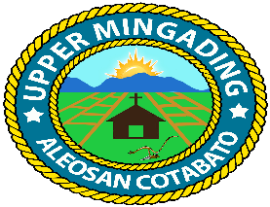
Republic of the Philippines
Province of Cotabato
Municipality of Aleosan
Barangay of Upper Mingading

OFFICE OF THE PUNONG BARANGAY

certification

TO WHOM IT MAY CONCERN:

THIS IS TO CERTIFY that {{FULL_NAME}}, {{GENDER}}, {{CIVIL_STATUS}}/, Filipino, was born on {{DATE_OF_BIRTH}} a bona fide citizen of Purok {{PUROK}}, Upper Mingading, Aleosan, Cotabato. His/ Her, reputation and moral standing in the community is beyond reproach and that is no pending case filed on said person whatsoever. From our barangay peace and order committee we are recommending him {{PURPOSE}}.

This certification is issued upon the request of above-named person for whatever legal purpose it may serve best.

Issued this {{DAY}} day of {{MONTH}} {{YEAR}} at Barangay Upper Mingading, Aleosan, Cotabato.

{{BARANGAY_CAPTAIN}}
Punong Barangay

Brgy. Seal/25
O. R. No: {{OR_NUMBER}}
Date Issued: {{DATE_ISSUED}}
CTC No.: {{CTC_NUMBER}}

