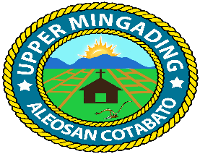
Republic of the Philippines
Province of Cotabato
Municipality of Aleosan
Barangay of Upper Mingading

OFFICE OF THE PUNONG BARANGAY

C E R T I F I C A T I O N

TO WHOM IT MAY CONCERN:

This is to certify that Russel jay C. Calamba 26 yrs. old, Filipino, single/married/widow, a bona fide resident of Purok Muslim , Barangay Upper Mingading, Aleosan, Cotabato.

This certification is being issued upon the request of the above-mentioned name person for Change Grantee of her wife working Abroad and for whatever any legal purposes.

Issued this 10th day of August 2026 at Barangay Upper Mingading, Aleosan, Cotabato.

MAMERTO C. CLARITO
Punong Barangay

OR No. 2578557
Date Issued: 11-17-23

