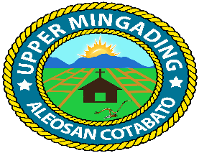
Republic of the Philippines
Province of Cotabato
Municipality of Aleosan
Barangay of Upper Mingading

OFFICE OF THE PUNONG BARANGAY

C E R T I F I C A T I O N

TO WHOM IT MAY CONCERN:

This is to certify that Russel Jay Calamba , 26 yrs. old, Filipino, single/married/widow, a bona fide resident of Purok Azucena, Barangay Upper Mingading, Aleosan, Cotabato, and he has a Purpose at the said place.

This certification is being issued upon the request of the above-mentioned name person for Business Permit Application and for whatever any legal purposes may serve him/her best.

Issued this 10 day of August 2026 at Barangay Upper Mingading, Aleosan, Cotabato.

MAMERTO C. CLARITO
Punong Barangay

OR No. ________
Date Issued: ________

