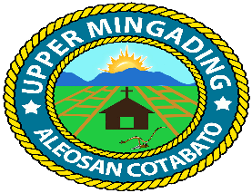
Republic of the Philippines
Province of Cotabato
Municipality of Aleosan
Barangay of Upper Mingading

OFFICE OF THE PUNONG BARANGAY

C E R T I F I C A T I O N

TO WHOM IT MAY CONCERN:

THIS IS TO CERTIFY THAT Russel Jay C. Calamba, 26 y/o, residing at Purok Kamonsil , Upper Mingading Aleosan, Cotabato, is tilling the following crop(s) Rice Field ½ hectare, and Fruits Crops 1 hectare as Owner/Farmer at Purok , Upper Mingading, Cotabato with size One ( ) hectare .

This CERTIFICATION is being issued by the Barangay solely for the purpose of the farmers and fisher folk registration to the REGISTRY SYSTEM FOR BASIC SECTORS IN AGRICULTURE (RSBSA) of the Department of Agriculture and may not be used for other purposes not mention above.

MAMERTO C. CLARITO August 10, 2026
Name and Signature of Punong Barangay Date

Name and Signature of Farmers/Fisher Name and Signature of Neutral Third- Party Witness

August 10, 2026 August 10, 2026
Date Date

Note: Not Valid without the Punong Barangay and Barangay Seal.

