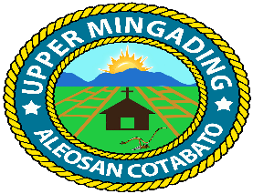
Republic of the Philippines
Province of Cotabato
Municipality of Aleosan
Barangay of Upper Mingading

OFFICE OF THE PUNONG BARANGAY

BARANGAY CLEARANCE

TO WHOM IT MAY CONCERN:

This is to certify according to our existing records that Ms./Mr/Mrs. Russel jay calamba , 26 yrs. Old, Filipino single/ maried/ /widow, whose signature and thumbmark appear below is presently a resident of Purok kamonsil Upper Mingading, Aleosan, Cotabato and no current position in the Barangay.

This is to certify further, that her /his character, reputation and moral
standing in the community are beyond reproach and that as of the date of this
issued there is no pending case whatsoever filed against the above – named person for whatever any legal purpose which may serve his/her best.

This is to certify furthermore that in view of the foregoing circumstances,
this Barangay Clearance is issued upon request of theabove – named person for OWWA and whatever any legal purpose which may serve her/his best.

Issued this 10 ^{th} day of August _at Barangay Upper Mingading, Aleosan, Cotabato.

MAMERTO C. CLARITO
Punong Barangay

FATMAH S. SUMPAO
(Signature Over Printed Name)

O. R. No. _________
Date Issued: ________
CTC. No. ________
Date Issued: _________

