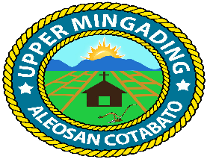
Republic of the Philippines
Province of Cotabato
Municipality of Aleosan
Barangay of Upper Mingading

OFFICE OF THE PUNONG BARANGAY

C E R T I F I C A T I O N

TO WHOM IT MAY CONCERN:
THIS IS TO CERTIFY that , 18 yrs. old single/married/Widow and a bonafide resident of Purok Buklod, Upper Mingading, Aleosan, Cotabato a low income earner family and considered as indigent.
This certification is issued upon the request of above-named person and for whatever legal purpose it may serve best.
Issued this day of _ at Barangay Upper Mingading, Aleosan, Cotabato.

MAMERTO C. CLARITO
Punong Barangay

Brgy. Seal/25
O. R. No. ______
Date Issued: ______
CTC No. ______
Date Issued: ______

