UNIVERSIDAD PERUANA

CAYETANO HEREDIA


PROJECT REPORT
Design of thermostable proteins of biotechnological interest

SPECIALIZATION COURSE
Principles of Structural Bioinformatics (PBE)

STUDENTS:
Alcántara Ríos, César Rafael
Gomez Gonzales, Diego Alexander
Leiva Pachas, Evelyn Victoria
Quispe Martinez, Sandra
Silva Molina, Juana Iris
Viguria Chavez, Yolanda Elizabeth

GROUP:
6

2026
LIMA - PERU
- BACKGROUND
- Context
Polyethylene terephthalate (PET) is a polymer widely used in the manufacture of bottles, containers, and textile fibers because of its strength, durability, and low cost. However, these same properties hinder its degradation and favor its accumulation in the environment. It is estimated that, up to 2015, approximately 8,300 million tons of plastics had been produced, a large proportion of which ended up in landfills or in the natural environment, highlighting the need to develop sustainable recycling alternatives [1].

In this context, the biological degradation of PET emerges as a promising strategy. In 2016, the bacterial strain 201-F6, isolated from a microbial consortium obtained from a site contaminated with waste of this polymer, was described and named Ideonella sakaiensis [2]. Subsequently, phylogenomic analyses led to its reclassification as Piscinibacter sakaiensis and, more recently, as Pseudideonella sakaiensis [3,4]. The three names are homotypic synonyms, since they correspond to the same species and strain. Because the original name remains widely used in studies on PETase, the name Ideonella sakaiensis (IsPETase) will be used hereafter.

The ability of this bacterium to degrade PET depends mainly on the joint action of two enzymes. First, the PETase from I. sakaiensis, known as IsPETase, hydrolyzes the ester bonds of the polymer and releases soluble products, among which mono(2-hydroxyethyl) terephthalate (MHET) predominates. Subsequently, MHETase converts this intermediate into terephthalic acid and ethylene glycol, monomers that can be recovered and reused in new PET production processes [5].

From a structural standpoint, IsPETase belongs to the α/β-hydrolase superfamily and has a catalytic triad consisting of Ser160, Asp206, and His237. Its crystal structure also reveals a binding cleft capable of accommodating PET segments and orienting their ester bonds toward the catalytic center [6]. In addition, UniProt annotates Tyr87, Met161, and Trp185 as PET-binding residues. Knowledge of these functional regions is essential to guide the design of new variants, since modifications intended to increase stability must avoid alterations that compromise catalysis or substrate recognition.

Despite its ability to degrade PET, wild-type IsPETase shows limited thermal stability, which restricts its performance during prolonged processes and hinders its application at industrial scale. This limitation is particularly relevant because increasing the temperature can favor the mobility of the polymer chains, but can also cause denaturation and loss of enzyme activity. In response, several studies have shown that the introduction of stabilizing mutations can increase its denaturation temperature, prolong its catalytic activity, and promote a greater release of degradation products [7,8].

Therefore, the computational design of thermostable variants is an alternative for identifying potentially favorable mutations before their experimental evaluation. The integration of evolutionary, structural, and energetic information makes it possible to prioritize substitutions capable of stabilizing the protein, while trying to keep intact the regions related to catalysis and PET binding. In this framework, the present study proposes the in silico design of a thermostable variant of IsPETase through the combined analysis of evolutionary conservation, proximity to functional regions, and prediction of the effects of mutations on structural stability.

- Knowledge Gap
Although improved PETase variants have been developed, it is still necessary to identify new combinations of mutations that increase its thermal stability without affecting its catalytic activity. Moreover, the effects of several combined mutations cannot always be predicted from their individual evaluation, so a structural and energetic analysis using bioinformatics tools is required.

- PROBLEM
- Research Question
Which rational mutations can increase the thermal and thermodynamic stability of the PETase enzyme from Ideonella sakaiensis without significantly altering its structure or its catalytic site?

- Hypothesis
The incorporation of point mutations in flexible, poorly conserved regions located away from the active site will increase the thermal and energetic stability of PETase. These modifications will favor new structural interactions without altering the conformation of the residues responsible for catalytic activity.

- OBJECTIVES
- General Objective
To rationally design a thermostable variant of the PETase enzyme from Ideonella sakaiensis through the computational identification and evaluation of mutations that improve its stability without compromising its catalytic activity.

- Specific Objectives
- Identify modifiable regions of PETase without affecting its lytic activity.
- Propose at least six mutations that improve its thermal stability.
- Computationally evaluate the stability of the modified PETase and verify the conservation of its functional regions.

- METHODOLOGY
- Selection and retrieval of the study protein
The PETase from Ideonella sakaiensis, known as IsPETase, was selected because it participates directly in PET degradation and has extensively characterized structural and functional information. In addition, its limited thermal stability makes it a suitable model for the design of thermostable variants.

The amino acid sequence was obtained from UniProt using the entry code A0A0K8P6T7. The FASTA file of its 290 amino acids was downloaded, and its functional annotations, catalytic residues, and processing regions were reviewed. The predicted signal peptide between residues 1 and 27 was also considered in order to distinguish the full-length sequence from the mature protein.

- Functional analysis
The sequence obtained from UniProt was analyzed in InterPro to confirm its classification within the hydrolase family, identify the functional domains present, and recognize regions important for catalytic activity or protein folding. In addition, matches with the databases integrated in InterPro were reviewed to verify its membership in the group of PET hydrolases related to cutinases and in the α/β-hydrolase superfamily.

- Structural characterization
The experimental structure of IsPETase was obtained from the Protein Data Bank using the code PDB 6EQE. This structure was determined by X-ray diffraction at a resolution of 0.92 Å, contains no mutations, and was used as the main model for the subsequent structural analyses. The construct deposited in the PDB has 298 amino acids due to the incorporation of the artificial C-terminal extension LEHHHHHH, used for recombinant expression and subsequent purification.
In the experimental structure, 265 residues were modeled: 262 correspond to the natural amino acids located between positions 29–290, while the remaining three belong to the artificial LEH segment. The 33 unmodeled residues (without three-dimensional coordinates) include the signal peptide, spanning positions 1–27, the residue Gln28 located at the beginning of the mature protein, and the five terminal histidines of the expression tag. The absence of the signal peptide and of the Gln28 coordinates did not affect the analysis, since both regions are located at the N-terminal end, outside the active site and with no direct participation in the function of the mature enzyme.
Before the analyses, the structure was prepared in ChimeraX. The protein chain was kept, and the artificial tag, water molecules, and ions were removed. The numbering was then verified against the UniProt sequence. Finally, the catalytic triad (Ser160, Asp206, and His237), the PET-binding sites (Tyr87, Met161, and Trp185), the disulfide bridges, the substrate-binding cleft, and the potentially modifiable regions were identified.
- Evolutionary analysis
Subsequently, the prepared IsPETase structure was analyzed using ConSurf to determine the degree of evolutionary conservation of each residue and to map the results onto the three-dimensional structure. For this purpose, the clean PDB file of the protein chain was used, keeping the original numbering of the natural amino acids, along with the default options of the server for the analyses.
Highly conserved amino acids and those located near the catalytic triad or the PET-binding cleft were avoided for the design of mutations, as were the amino acids close to those zones. In contrast, poorly or moderately conserved residues that are surface-exposed and far from the active center were considered as possible candidates for mutation.
- Identification and evaluation of stabilizing mutations
To analyze the mutation propensity of the different residues of the protein based on melting temperature differences (ΔTm), the PDB code (6EQE) was entered into the HoTMuSiC tool in systematic mode. From these results, mutants with positive ΔTm values and residues with a SASA value greater than 20% were considered. Subsequently, a restriction on amino acids close to the catalytic triad and the PET-binding site within a 10 Å radius was applied. Then, the results from ConSurf were integrated, considering amino acids with conservation grades equal or lower than 4 and labeled as exposed residues (e).

Candidate mutations were prioritized according to the desirability of the previously mentioned values and potential labels generated by the analysis in FireProt as a complementary analysis. Subsequently, using DynaMut2, the “Single Mutations” analysis was run with the filtered mutations. Likewise, MAESTROweb was used for the evaluation of specific independent mutations. Finally, the results obtained were merged, strictly prioritizing confidence values greater than 0.8 from the MAESTROweb results, in addition to negative ΔΔG values, while for DynaMut2 positive (stabilizing) ΔΔG values were considered.

- Selection and construction of the final variant
To analyze the combined mutations resulting from the previous filter, the candidates were entered into DynaMut in “Multiple mutations” mode and into MAESTROweb using the evaluation of specific combined mutations.

From the combined result, the candidates are examined in the MAESTROweb format, considering different criteria to choose three final variants. These criteria are the mutant with the best predicted ΔΔG with a confidence value ≥0.8, the mutant with the best confidence value, and the mutant with the best predicted ΔΔG.

- Structural comparison of the wild-type and mutant proteins
The final variant was compared with wild-type IsPETase by examining the modification sites in MAESTROweb. The distance of the mutations from the active and PET-binding sites was verified visually.

A local metadata database of the experimentally registered PETase mutations was created, and through it it was verified that there were no repetitions in the results obtained at the in silicolevel. All of this was done in order to avoid repeating work that has already been reported.

- RESULTS
Drive folder link: https://drive.google.com/drive/folders/1zyqZFlEXABoYPzgFTtMc0xHpd008NGfZ?usp=drive_link
Fig 1. UniProt entry corresponding to IsPETase (A0A0K8P6T7).


Fig 2. Amino acid sequence of IsPETase in FASTA format obtained from UniProt (A0A0K8P6T7).
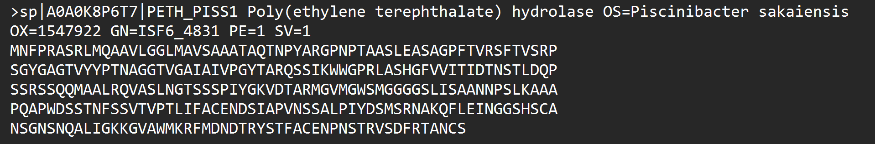
Note. The prefix sp indicates a reviewed UniProtKB/Swiss-Prot entry; OS, the source organism; OX, the taxonomic identifier; GN, the gene; PE=1, evidence at protein level; and SV=1, the first version of the sequence.

Fig. 3. Functional domains of IsPETase identified using InterPro.
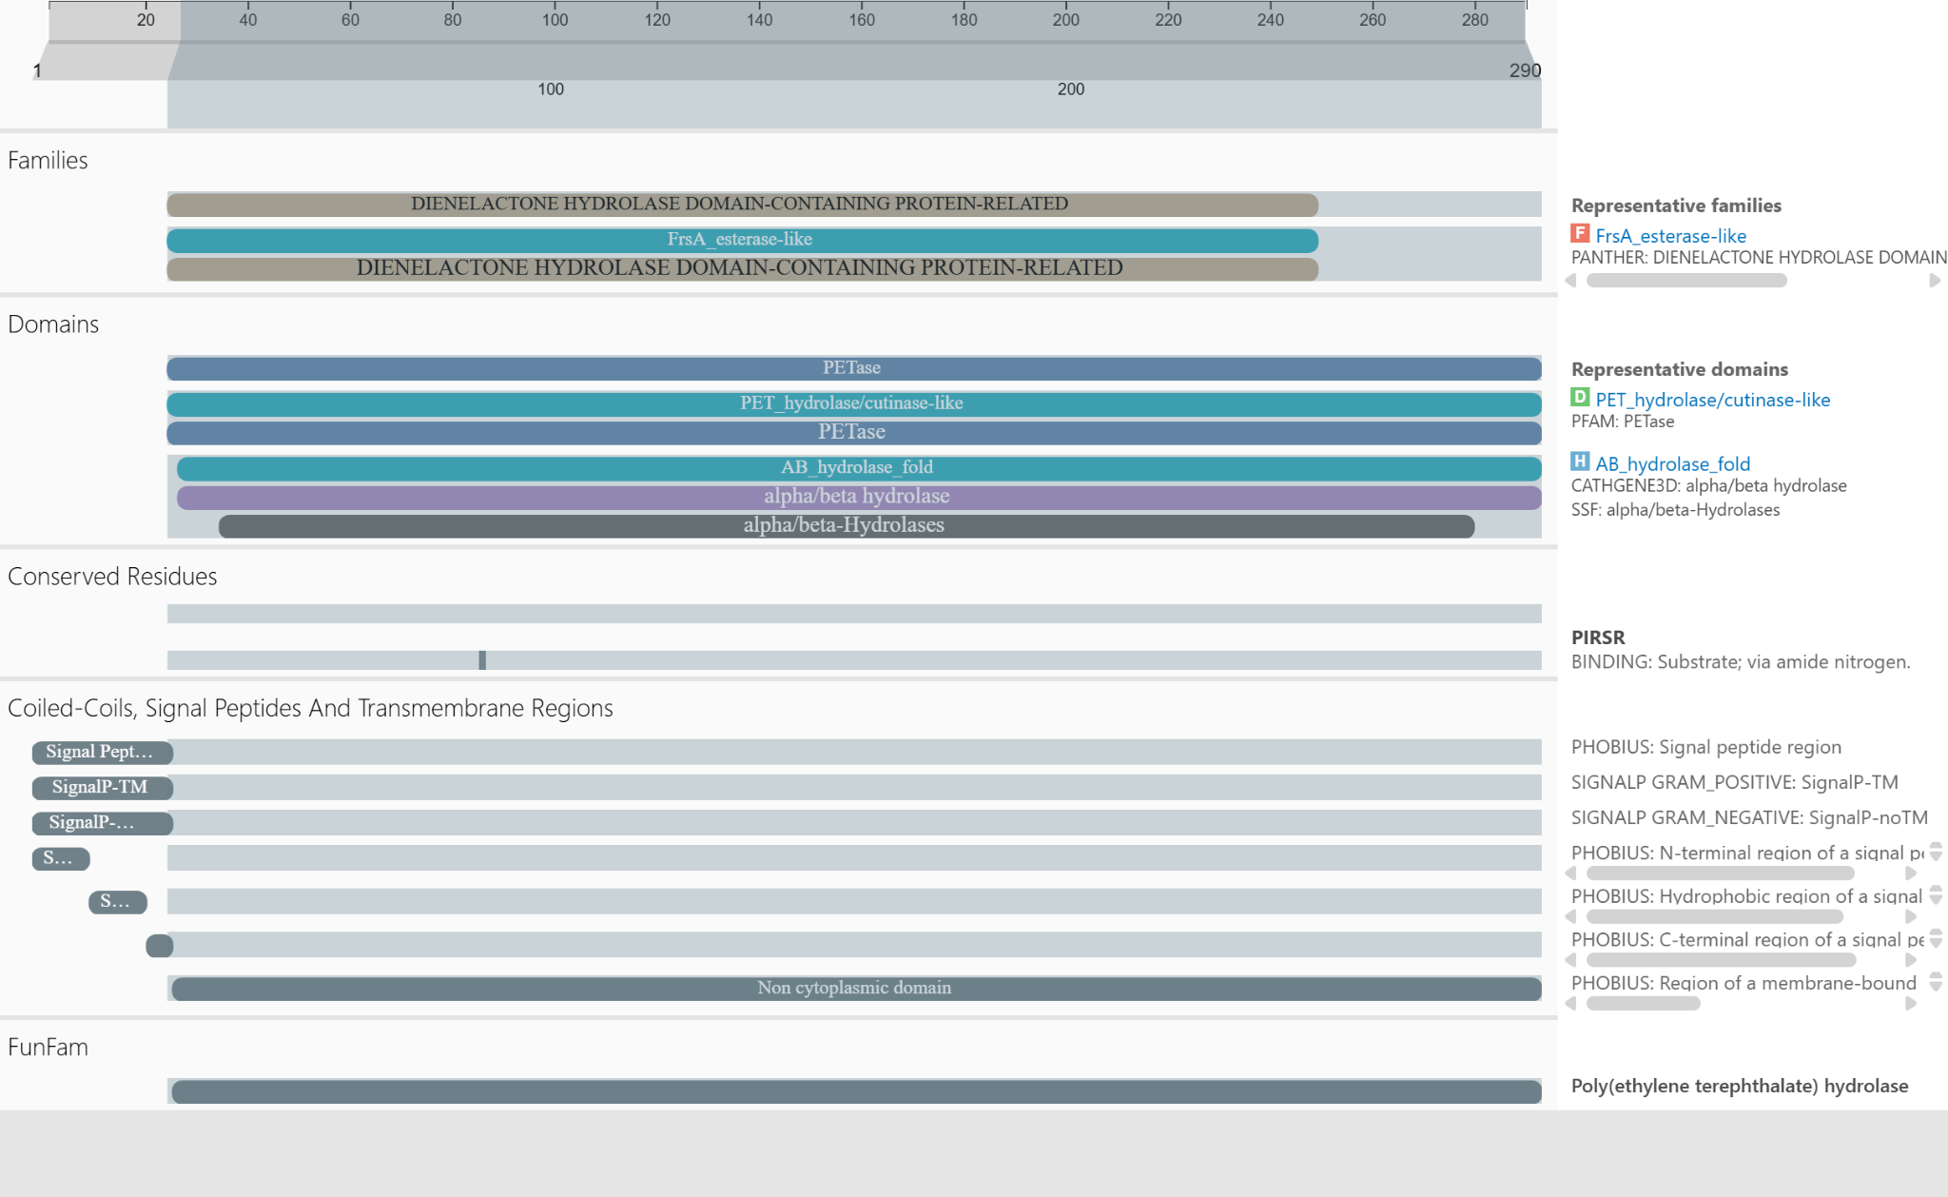

As seen in Fig. 3, the analysis of the 290-amino-acid sequence using InterPro identified domains corresponding to PETase and PET hydrolase/cutinase-like, which span most of the protein. Likewise, the α/β-hydrolase fold, characteristic of enzymes that catalyze the hydrolysis of ester bonds, was recognized. The FunFam classification assigned the sequence to the poly(ethylene terephthalate) hydrolase function, confirming its functional identity as an enzyme involved in PET degradation.

In addition, several tools integrated in InterPro predicted the presence of a signal peptide at the N-terminal end and classified the region between residues 1 and 27 as non-cytoplasmic, which is consistent with the processing of IsPETase as a secreted protein whose mature form acts outside the bacterial cytoplasm.

Fig. 4. Experimental three-dimensional structure of IsPETase before structural preparation (PDB 6EQE), visualized in ChimeraX.
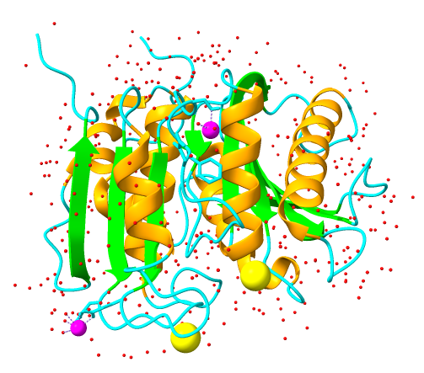
Note. α-helices are shown in orange, β-sheets in lime green, and loops in cyan. Water molecules are shown in red, sodium ions (Na⁺) in magenta, and chloride ions (Cl⁻) in yellow.

The original crystal structure of IsPETase contains water molecules and ions recorded during the crystallization process. Because these components are not part of the protein sequence and could interfere with the subsequent proximity and interaction analyses, they were removed during structural preparation.

Fig. 5. Prepared three-dimensional structure of IsPETase (PDB 6EQE), with the catalytic triad and the PET-binding residues highlighted, visualized in ChimeraX.

Note. α-helices are shown in orange, β-sheets in lime green, and loops in cyan. The catalytic triad (Ser160, Asp206, and His237) is shown in magenta, and the PET-binding residues (Tyr87, Met161, and Trp185), annotated in UniProt, are shown in red, all in stick representation. Water molecules, ions, and the artificial C-terminal LEH segment (291–293) were removed.

After structural preparation, only the protein chain was retained, allowing clear identification of the catalytic triad and the structural regions that will be evaluated for the rational design of mutations.

Fig. 6. Evolutionary conservation profile of the IsPETase sequence obtained using ConSurf.
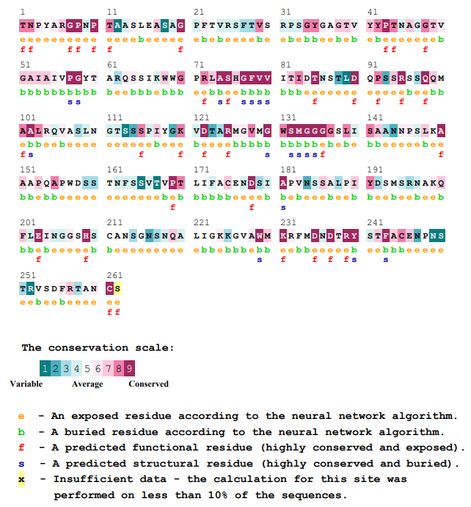
Note. The conservation scale ranges from 1 to 9, from variable to highly conserved residues. The letters indicate: e, exposed residue; b, buried; f, functional conserved and exposed; s, structural conserved and buried; and X, position with insufficient data.

The conservation analysis showed that the residues of the catalytic triad are among the most conserved in the protein, which supports their functional importance. In contrast, several surface regions show lower evolutionary conservation, making them possible candidates for the design of stabilizing mutations without compromising catalytic activity.

Fig. 7. Three-dimensional distribution of the evolutionary conservation of IsPETase residues, obtained using ConSurf.
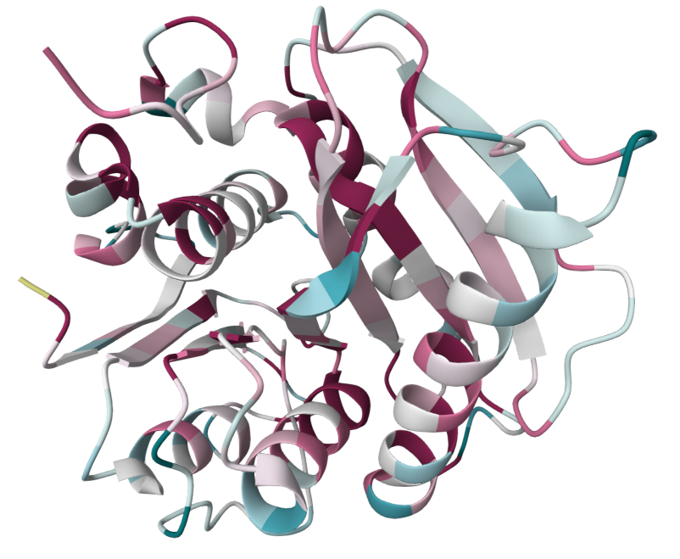
Note. The IsPETase structure is colored according to the degree of evolutionary conservation estimated by ConSurf.

The three-dimensional representation showed that highly conserved positions are concentrated mainly in internal and functional regions of the protein, while several poorly conserved residues are distributed over the surface. This distribution complemented the sequence analysis and made it possible to select exposed positions that are less likely to participate directly in catalytic function.

Table 1. Candidate IsPETase residues with low evolutionary conservation (grades 1–4) and surface exposure (e), identified using ConSurf.
Residue | Conservation Grade
T29 | 3
A40 | 3
A41 | 4
S46 | 2
P49 | 4
S54 | 4
F55 | 3
T56 | 3
R59 | 4
S61 | 4
G75 | 4
K95 | 4
S136 | 3
S141 | 3
S142 | 3
P144 | 3
G147 | 3
T151 | 2
A152 | 3
A171 | 3
N172 | 4
S192 | 4
S193 | 2
V194 | 4
T195 | 3
D220 | 4
S223 | 4
R224 | 4
N225 | 4
A226 | 4
G243 | 4
S245 | 4
N264 | 4
S269 | 4
N275 | 4
N277 | 1
S278 | 3
T279 | 3
R280 | 1
T286 | 3

To reduce the risk of altering enzymatic function, residues located at a distance equal to or less than 10 Å from the catalytic triad Ser160, Asp206, and His237, and from the PET-binding sites Tyr87, Met161, and Trp185, were excluded. The 10 Å threshold was used as a conservative structural criterion, because positions close to the active site can directly or indirectly influence catalysis and substrate recognition [9].

Table 2. Ranking of the 20 residues with a sum of ΔTm greater than 0, according to HoTMuSiC.
Residue | Secondary structure | Solvent accessibility (%) | Stabilizing potential | Best mutation | Estimated ΔTm of the mutation
217 PRO | H | 26.00 % | 48.79 | GLN | +4.69
235 GLY | C | 8.07 % | 18.57 | TRP | +4.40
58 SER | S | 93.26 % | 17.22 | TRP | +2.77
227 LYS | E | 9.13 % | 14.55 | VAL | +2.66
186 ASP | C | 10.45 % | 13.63 | TYR | +2.58
209 ALA | S | 1.55 % | 13.43 | TRP | +2.74
89 ALA | C | 11.81 % | 13.02 | CYS | +1.67
99 PRO | H | 35.24 % | 12.44 | TRP | +1.81
155 GLY | E | 0.00 % | 12.12 | PHE | +3.4
231 GLU | E | 6.96 % | 11.68 | TYR | +2.47
206 ASP | C | 6.40 % | 10.78 | CYS | +2.41
283 ASP | E | 22.57 % | 10.12 | PHE | +1.38
125 SER | H | 63.33 % | 10.11 | GLN | +1.45
183 ALA | S | 1.71 % | 9.60 | TYR | +1.77
138 ASN | H | 18.13 % | 9.37 | LEU | +1.32
292 GLU | C | 98.70 % | 9.13 | TRP | +1.95
33 ALA | C | 28.84 % | 8.93 | HIS | +0.90
204 GLU | T | 38.80 % | 8.89 | LEU | +1.13
65 ALA | E | 26.31 % | 8.49 | TYR | +1.07
54 SER | E | 49.45 % | 8.15 | ILE | +1.67
Note. Secondary structure was coded according to the classification used by HoTMuSiC: H, α-helix; E, β-sheet; C, irregular conformation; and S, turn.

Table 3. IsPETase residues located within ≤5 Å of functional regions (Ser160, Asp206, His237, Tyr87, Met161, Trp185), identified using UCSF ChimeraX.
PRO85 | GLY86
THR88 | ALA89
THR116 | LEU117
ASP118 | GLN119
PRO120 | ARG123
GLY158 | TRP159
GLY162 | GLY163
GLY164 | GLY165
SER166 | GLN182
ALA183 | PRO184
ASP186 | SER187
CYS203 | GLU204
ASN205 | SER207
ILE208 | ALA209
PRO210 | VAL211
SER213 | SER214
ILE218 | GLY235
SER236 | SER238
CYS239 | ALA240
ASN241 | —

Table 4. IsPETase residues located within ≤10 Å of functional regions (Ser160, Asp206, His237, Tyr87, Met161, Trp185), identified using UCSF ChimeraX.
ILE83 | VAL84 | PRO85
GLY86 | THR88 | ALA89
ARG90 | GLN91 | SER93
ILE94 | TRP96 | TRP97
ILE111 | ASP112 | THR113
ASN114 | SER115 | THR116
LEU117 | ASP118 | GLN119
PRO120 | SER121 | SER122
ARG123 | SER124 | SER125
GLN126 | GLN127 | VAL156
MET157 | GLY158 | TRP159
GLY162 | GLY163 | GLY164
GLY165 | SER166 | LEU167
ILE168 | SER169 | ALA180
PRO181 | GLN182 | ALA183
PRO184 | ASP186 | SER187
SER188 | THR189 | ASN190
PHE191 | LEU199 | ILE200
PHE201 | ALA202 | CYS203
GLU204 | ASN205 | SER207
ILE208 | ALA209 | PRO210
VAL211 | ASN212 | SER213
SER214 | ALA215 | LEU216
PRO217 | ILE218 | TYR219
PHE229 | LEU230 | GLU231
ILE232 | ASN233 | GLY234
GLY235 | SER236 | SER238
CYS239 | ALA240 | ASN241
SER242 | ASN244 | ILE250
SER282 | ASP283 | —

Table 5. Top 10 candidate mutations prioritized for the thermal stabilization of IsPETase after integrative screening.
Mutation | Position | Secondary structure | ΔTm (K) | ConSurf grade | SASA (%) | FireProt evaluation
T286I | 286 | β-sheet | +0.53 | 3 | 33.0 | Exact match + Majority + Ratio + FoldX (-0.26)
A152N | 152 | β-sheet | +1.03 | 3 | 62.6 | Consensus + Low risk + FoldX(-2.35)
T29W | 29 | Loop | +1.76 | 3 | 100 | -
T29Y | 29 | Loop | +1.32 | 3 | 100 | -
T29F | 29 | Loop | +1.16 | 3 | 100 | -
S121E | 121 | α-helix | +0.57 | 3 | 61.7 | Consensus + Low risk + FoldX(-0.60)
S125Q | 125 | α-helix | +1.45 | 4 | 63.3 | Consensus + Low risk + FoldX(-0.37)
S125E | 125 | α-helix | +1.41 | 4 | 63.3 | -
S125K | 125 | α-helix | +1.18 | 4 | 63.3 | -
A152D | 152 | β-sheet | +0.9 | 3 | 62.56 | Consensus + FoldX(-2.35)
Note. Screening was performed among the results of the tools with their respective thresholds, considering ConSurf (conservation grade ≤ 4), HoTMuSiC (ΔTm > 0), PyMOL/ChimeraX (SASA >20%), attached FireProt evidence, and the exclusion of residues close to the catalytic triad within a 10 Å radius.

Validation of mutations (DynaMut2 and MAESTROweb)

Table 6. Prediction of the effect of point mutations on thermodynamic stability using DynaMut2.
Mutation | Predicted Stability Change (ΔΔG^{Stability})  (kcal/mol) | Mutation Type
T286I | 0.16 | Stabilizing
A152N | 0.05 | Stabilizing
T29W | — | —
T29Y | — | —
T29F | — | —
S121E | 0.40 | Stabilizing
S125Q | -0.61 | Destabilizing
S125E | -0.55 | Destabilizing
S125K | -0.12 | Destabilizing
A152D | -0.37 | Destabilizing
Note. Positive ΔΔG values were classified by DynaMut2 as stabilizing and negative values as destabilizing. The substitutions evaluated at position T29 could not be processed by DynaMut2 due to an internal server error; therefore, they were recorded as not evaluable.
Table 7. Prediction of the effect of point mutations on thermodynamic stability using MAESTROweb.
Mutation | ΔΔG_{pred.} (kcal/mol) | C_{pred.}
T286I | -0.929 | 0.933
A152N | -0.453 | 0.895
T29W | 0.136 | 0.802
T29Y | 0.330 | 0.809
T29F | 0.341 | 0.813
S121E | -0.360 | 0.874
S125Q | -0.705 | 0.866
S125E | -0.487 | 0.868
S125K | -0.383 | 0.920
A152D | -0.332 | 0.900
Note. Negative ΔΔGpred. values indicate a stabilizing effect, whereas positive values indicate a destabilizing effect. Cpred. corresponds to the prediction confidence level, where values close to 1 represent higher confidence.

- BIBLIOGRAPHY
- Scientific Articles
- Geyer R, Jambeck JR, Law KL. Production, use, and fate of all plastics ever made. Sci Adv [Internet]. 2017;3(7):e1700782. Available from: http://dx.doi.org/10.1126/sciadv.1700782

- Tanasupawat S, Takehana T, Yoshida S, Hiraga K, Oda K. Ideonella sakaiensis sp. nov., isolated from a microbial consortium that degrades poly(ethylene terephthalate). Int J Syst Evol Microbiol [Internet]. 2016;66(8):2813–8. Available from: http://dx.doi.org/10.1099/ijsem.0.001058

- Oren A, Göker M. Validation List no. 209. Valid publication of new names and new combinations effectively published outside the IJSEM. Int J Syst Evol Microbiol [Internet]. 2023;73(1). Available from: http://dx.doi.org/10.1099/ijsem.0.005709

- Lu H, Chen L. Emended description of the genus Rhizobacter and reclassification of Ideonella sakaiensis as Pseudideonella sakaiensis gen. nov., comb. nov. Int J Syst Evol Microbiol [Internet]. 2026;76(6). Available from: http://dx.doi.org/10.1099/ijsem.0.007181

- Knott BC, Erickson E, Allen MD, Gado JE, Graham R, Kearns FL, et al. Characterization and engineering of a two-enzyme system for plastics depolymerization. Proc Natl Acad Sci U S A [Internet]. 2020;117(41):25476–85. Available from: http://dx.doi.org/10.1073/pnas.2006753117

- Joo S, Cho IJ, Seo H, Son HF, Sagong H-Y, Shin TJ, et al. Structural insight into molecular mechanism of poly(ethylene terephthalate) degradation. Nat Commun [Internet]. 2018;9(1):382. Available from: http://dx.doi.org/10.1038/s41467-018-02881-1

- Deng B, Yue Y, Yang J, Yang M, Xing Q, Peng H, et al. Improving the activity and thermostability of PETase from Ideonella sakaiensis through modulating its post-translational glycan modification. Commun Biol [Internet]. 2023;6(1):39. Available from: http://dx.doi.org/10.1038/s42003-023-04413-0

- Zhong-Johnson EZL, Voigt CA, Sinskey AJ. An absorbance method for analysis of enzymatic degradation kinetics of poly(ethylene terephthalate) films. Sci Rep [Internet]. 2021;11(1):928. Available from: http://dx.doi.org/10.1038/s41598-020-79031-5

- Abriata LA, Palzkill T, Dal Peraro M. How structural and physicochemical determinants shape sequence constraints in a functional enzyme. PLoS One [Internet]. 2015;10(2):e0118684. Available from: http://dx.doi.org/10.1371/journal.pone.0118684

- Bioinformatics Tools
- Universal Protein Resource (UniProt): https://www.uniprot.org/
- InterPro: https://www.ebi.ac.uk/interpro/
- Protein Data Bank (PDB): https://www.rcsb.org/
- UCSF Chimera X: https://www.cgl.ucsf.edu/chimerax/
- ConSurf: https://consurf.tau.ac.il/
- HoTMuSiC: https://soft.dezyme.com/
- DynaMut2: https://biosig.lab.uq.edu.au/dynamut2/
- MAESTROweb: https://pbwww.services.came.sbg.ac.at/maestro/web

PROJECT: Design of thermostable proteins of biotechnological interest
ADVISOR: Dr. Claudia Inés Gloria Machicado Rivero
GROUP 6:
- Alcántara Rios, César Rafael
- Gomez Gonzales, Diego Alexander
- Leiva Pachas, Evelyn Victoria
- Quispe Martinez, Sandra
- Silva Molina, Juana Iris
- Viguria Chavez, Yolanda Elizabeth

- METHODOLOGY
The PETase from Ideonella sakaiensis (IsPETase) was selected as the study protein because of its ability to degrade polyethylene terephthalate (PET) and its limited thermal stability, a characteristic that restricts its application in biotechnological processes. The amino acid sequence of the protein was obtained from the UniProt database using the entry code A0A0K8P6T7. The FASTA sequence corresponding to the 290 residues was downloaded, and the functional annotations, catalytic residues, and regions associated with enzymatic activity were reviewed.
The functional characterization of the sequence was carried out using InterPro in order to identify conserved domains, protein classification, and associated functional families. This analysis confirmed the identity of the protein as a PET hydrolase belonging to the α/β-hydrolase superfamily, structurally related to cutinase-type enzymes capable of catalyzing the hydrolysis of ester bonds.
For the structural analysis, the crystal structure of IsPETase deposited in the Protein Data Bank under PDB code 6EQE was used. The structure was prepared using UCSF ChimeraX, removing water molecules, crystallographic ions, and artificial regions originating from the recombinant expression system. Subsequently, the numbering correspondence with the UniProt sequence was verified, and the main functional regions of the enzyme were identified: the catalytic triad formed by Ser160, Asp206, and His237, and the PET-binding residues Tyr87, Met161, and Trp185.
The evolutionary analysis of the residues was performed using ConSurf. Residues with low evolutionary conservation (conservation grades ≤4), surface exposure, and location outside critical functional regions were used as selection criteria. Highly conserved residues and those close to the active site were discarded to reduce the probability of affecting catalytic activity.
Subsequently, a systematic search for stabilizing mutations was performed using HoTMuSiC with the PDB 6EQE structure as input. Residues with positive values of estimated change in melting temperature (ΔTm), solvent accessibility greater than 20%, and no proximity to the catalytic site or PET-binding regions were selected. As a conservative structural criterion, residues located within a 10 Å radius of Ser160, Asp206, His237, Tyr87, Met161, and Trp185 were excluded.
Candidate mutations were prioritized according to the desirability of the previously mentioned values and were subsequently evaluated using DynaMut2 and MAESTROweb to estimate changes in thermodynamic stability. For DynaMut2, positive stability ΔΔG values were considered favorable, whereas for MAESTROweb, negative ΔΔGpred values and confidence values greater than 0.8 were prioritized; in both cases, a single-mutation analysis was performed, followed by a combined-mutation analysis.
From the combined result, the candidates are examined in the MAESTROweb format, considering different criteria to choose three final variants. These criteria are the mutant with the best predicted ΔΔG with a confidence value ≥0.8, the mutant with the best confidence value, and the mutant with the best predicted ΔΔG.
The files generated during the computational analysis, including PDB structures, ConSurf, HoTMuSiC, DynaMut2, and MAESTROweb results, complete tables, and structural visualizations made in ChimeraX, were stored in a shared folder. Within it, a local metadata database of the experimentally registered PETase mutations was created, and through it it was verified that there were no repetitions in the results obtained in silico. All of this was done in order to avoid repeating work that has already been reported.
- RESULTS
The functional analysis using InterPro confirmed that the IsPETase sequence corresponds to a PET hydrolase with the characteristic fold of α/β-hydrolases. Domains associated with PETase and PET hydrolase/cutinase-like were identified, confirming the relationship of the protein with PET-degrading enzymes.
The evolutionary conservation analysis using ConSurf showed that the functional residues display high levels of conservation, whereas some surface regions show lower conservation and a greater potential tolerance to modifications. These residues correspond to the same ones predicted in the UniProt entry.
The initial analysis using HoTMuSiC identified residues with potential for increased thermal stability. After applying the filters for evolutionary conservation, surface accessibility, and distance from the functional site, 46 initial candidate mutations were obtained. The first 10 entries are shown here:

Mutation | Position | ΔTm (K) | ConSurf Conservation | SASA (%)
T286I | 286 | +0.53 | 3 | 33.0
A152N | 152 | +1.03 | 3 | 62.6
T29W | 29 | +1.76 | 3 | 100
T29Y | 29 | +1.32 | 3 | 100
T29F | 29 | +1.16 | 3 | 100
S121E | 121 | +0.57 | 3 | 61.7
S125Q | 125 | +1.45 | 4 | 63.3
S125E | 125 | +1.41 | 4 | 63.3
S125K | 125 | +1.18 | 4 | 63.3
A152D | 152 | +0.90 | 3 | 62.5
Subsequently, the mutations were evaluated using DynaMut2 and MAESTROweb to determine their possible effect on structural stability. The corresponding filters were then applied, resulting in a total of 24 candidate mutations. The first 10 entries are presented here:
Mutation | ΔΔG MAESTROweb | Cpred MAESTROweb | ΔΔG Dynamut
D283W | -0.434015450081 | 0.955669644668 | 1.42
D283I | -0.410760314201 | 0.947293704695 | 1.41
D283F | -0.561785048943 | 0.979876355192 | 1.14
D283Y | -0.325402035982 | 0.946054585379 | 1.3
S54V | -0.813805914729 | 0.934519377748 | 0.55
S54I | -1.00185148682 | 0.909124918198 | 0.36
S54L | -0.882611930565 | 0.918595584163 | 0.3
D283V | -0.161595805702 | 0.943073896974 | 1.0
T286I | -0.903806970169 | 0.935754487774 | 0.14
T279P | -0.723520765184 | 0.869782135662 | 0.1
After the filters applied to select the best mutations to test for generating combined mutants through DynaMut2 and MAESTROweb, 3 possible mutants were prioritized out of a total of 252 entries under 3 different categories:
Combined mutation | Predicted ΔΔG | Predicted confidence | Category
D283I, S54I, T286I, 279P, S121E, S125I | -1.406 | 0.755 | Best ΔΔG
D283H, S54V, T286I, 279P, S121E, S125K | -0.867 | 0.867 | Best confidence
D283V, S54V, T286F, 279P, S121E, S125K | -0.907 | 0.800 | Best ΔΔG with confidence ≥ 0.8

