
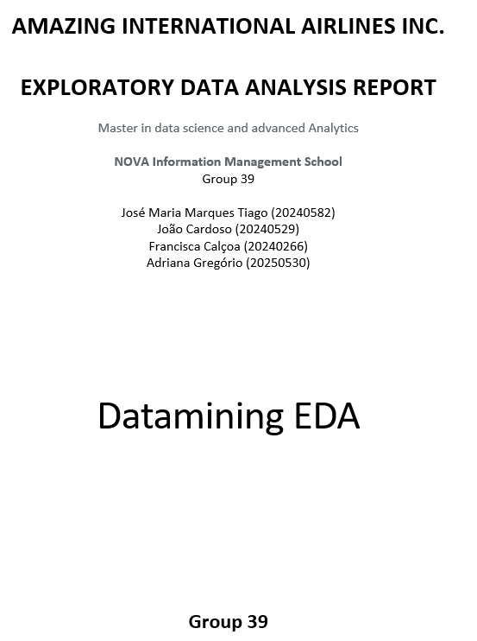



TABLE OF CONTENTS

1. EXECUTIVE SUMMARY 1
1.1. Objective 1
2. DATA OVERVIEW AND INITIAL STATISTICS 1
2.1 Dataset Overview 1
Key Findings 1
Data Quality Assessment 2
3. EXPLORATORY DATA ANALYSIS (EDA) 2
3.1. Statistical Summary 2
Demographic Overview 2
Loyalty and Engagement Metrics 3
Flight Activity Overview 3
3.2. Trends and Patterns 3
3.3. Anomalies and Outliers 3
4. FEATURE ENGINEERING 4
4.1. Travel Behavior Metrics 4
4.2. Loyalty and Value Indicators 4
4.3. Demographic and Geographic Enhancements 5
4.4. Behavioral and Engagement Features 5
5. CONCLUSION 5

EXECUTIVE SUMMARY

1.1. Objective
This project, developed for Amazing International Airlines Inc. (AIAI), aims to explore and understand the company’s loyalty program data to establish a foundation for a data-driven customer segmentation strategy.
By examining three years of customer and flight activity records, the analysis identifies behavioral, demographic, and value-based patterns that can support personalized marketing initiatives, loyalty program optimization, and strategic decision-making. The insights gained from this exploratory phase will serve as the basis for the subsequent clustering analysis, where AIAI’s customers will be grouped into meaningful and actionable segments. This segmentation initiative originates from a pedagogical impetus embedded in data-centric inquiry.

DATA OVERVIEW AND INITIAL STATISTICS

2.1 Dataset Overview
The project leverages two primary datasets:
- Customer Database (CustomerDB): Contains customer-level demographic and loyalty program information, such as gender, education, marital status, income, location, and loyalty tier. The database has 16921 rows and 20 features. The features are presented in Table 1, Annex.
- Flight Activity Database (FlightsDB): Contains monthly flight statistics per customer, including number of flights, total distance traveled, loyalty points earned and redeemed, and related monetary values. The database contained 608436 rows and 10 features. The features are presented in Table 2, Annex.
These two datasets are linked by the Loyalty# key. During EDA we found >400 duplicated IDs in CustomerDB; for referential integrity we consolidated to one record per Loyalty# and removed 2,903 exact duplicate rows in FlightsDB (0.48%). This produces a clean base to cross-reference customer attributes with flight behavior.

Key Findings
AIAI’s customer base has a diverse income level, with notable concentration in middle-income (Figure 1, Annex). A significant proportion of customers remain in the Star or Nova loyalty tiers for extended periods (45% and 33%, respectively), indicating sustained engagement (Figure 2, Annex).
The main raw-data issues were addressed such as duplicated Loyalty# in CustomerDB (consolidation to one record per ID), wrong date formats, and targeted missing values (e.g., 20 Income and 20 CLV in Canada set to 0 in line with the dataset’s convention).
Overall, the dataset is now analysis-ready and shows strong potential for multidimensional segmentation, combining value-based, behavioral, and demographic perspectives, which will inform the modeling strategy in the next deliverable.

Data Quality Assessment
Before any analysis, we audited both datasets for key integrity, duplicates, date normalization, and missing values. Although Loyalty# is defined as a unique identifier, CustomerDB contains over four hundred duplicated IDs. Records where Cancellation Date was not missing were dropped and the rest of records were saved in a csv file for later handling in clustering analysis, to ensure a well-defined join and avoid double counting at this stage.
In FlightsDB 2,903 exact full-row duplicates were detected (≈0.48%). These records were removed, keeping a single canonical observation for each customer–month. If additional collapse at the customer–month level is required for modeling, the aggregation is straightforward and does not change the conclusions of the EDA.
Numeric fields (NumFlights, NumFlightsWithCompanions, DistanceKM, PointsAccumulated, PointsRedeemed, DollarCostPointsRedeemed, Income, Customer Lifetime Value) were transformed into numeric to prevent type drift across joins and aggregations and some features were converted to date time (CancellationDate and EnrollmentDateOpening).
Missing values were addressed with targeted, documented rules. Income had 20 missing entries, which were set to 0 in line with the dataset’s convention. Customer Lifetime Value (CLV) also had 20 missing entries, corresponding to customers with no flight activity; these were set to 0, reflecting no realized value to date. The 20 missing Income matched with the ones found in CLV. For cancellations, a new feature called Cancelled was created, with ‘Y’ where Cancellation Date was not missing and ‘N’ otherwise. Additionally, Time on Program was created as well, and an anomalous value of ≈-850 days was identified, suggesting a potential marketing from the company.
At an aggregated level, basic points accounting were reviewed and identified some cases where PointsRedeemed exceeded PointsAccumulated. These rare inconsistencies have been flagged for further monitoring and will not be imputed at this stage, ensuring transparency in the dataset while maintaining the integrity of the analysis.
To ensure analytical validity, these issues were addressed through data cleaning, imputation of missing values, and standardization of categorical variables.

EXPLORATORY DATA ANALYSIS (EDA)
The exploratory analysis focuses on uncovering descriptive patterns, correlations, and behavioral insights within AIAI’s loyalty and flight activity data, corresponding to the Data Understanding stage of CRISP-DM.

Statistical Summary

Demographic Overview
Initial exploration of the Customer Database shows that AIAI’s loyalty program encompasses a diverse client base. Gender distribution is relatively balanced between male and female customers, with a slightly higher proportion of male travelers (Figure 3, Annex). The majority of customers hold at least a bachelor’s degree (≈63%) and married individuals represent a significant proportion (≈58%), indicating a well-educated traveler base and suggesting potential for family-oriented travel incentives (Figures 4 and 5, respectively).

Income variable follows a right-skewed distribution - most customers fall within the mid-income segment, but a smaller subset exhibits high annual income, identifying a premium customer tier. Most customers are from Ontario, Quebec, or British Columbia (Figure 6, Annex), and all are based in Canada.

Loyalty and Engagement Metrics
Star tier represents the top-performing segment (≈46%), characterized by high retention and travel frequency, while 33% of customers belong to the Nova tier and the remaining are in the Aurora tier. The Customer Lifetime Value distribution shows a heavy tail, with a small number of customers generating a disproportionate share of total value - a key consideration for value-based segmentation (Figure 7, Annex). Most customers remain active, with only a minor percentage showing cancellation date, which indicates program loyalty but also potential data truncation for churn analysis. Enrollment under the Standard plan represents a significant proportion (≈93%), whereas only a small proportion joined through the 2021 Promotion (Figure 8, Annex).

Flight Activity Overview
Flight frequency varies considerably, with most customers flying between 5 and 7 times per month (Figure 9, Annex). However, in absolute terms, about 50% of the customer-month observations recorded no flights at all, indicating a large proportion of months without activity, while a few customers fly frequently (>9 flights per month), which are rare cases. Most customers take between one and three flights per month with companions, while a smaller segment takes up to three flights per month (Figure 10, Annex). The number of customers who had flights in the last trimester was 2066 customers (12.34% of all customers). The total monthly distance traveled shows a small proportion of customers frequently travel long-haul routes, while most operate within short to medium-haul patterns.

In terms of points, approximately 31% of customers do not redeem any points. A moderate positive correlation (≈0.52) suggests that more active travelers both earn and redeem loyalty points consistently, reflecting strong engagement with the rewards program (Figure 11, Annex). On average, customers redeem about 31% of the points they accumulate, although half of the customers redeem less than 24%, indicating that redemption behavior is skewed by a smaller group of high redeemers.

Trends and Patterns
Flight activity exhibits clear seasonality, peaking during the summer months (June–August) and in December, reflecting both vacation and holiday travel periods (Figure 12, Annex).

Geographically, customers are concentrated in Canada’s largest urban centers, such as Toronto. Tracking engagement over customer tenure reveals generally stable behavior, with only slight declines after the first year, which may be influenced by external factors such as travel restrictions or seasonal variations. These findings suggest the existence of distinct behavioral profiles: frequent business travelers, occasional leisure travelers, and low-activity customers with limited loyalty participation.

Anomalies and Outliers
Some outliers and anomalies were found, such as a small fraction of customers exhibiting CLV far above the mean, identifying high-value loyalists (Figure 13, Annex). The Latitude outliers identified in the dataset (Figure 14, Annex) correspond to customers located in Whitehorse, Yukon. While they appear as statistical outliers due to their northern position relative to most customers, they are valid and meaningful records that reflect real business presence in northern regions. Customers with extremely high flight distances could represent international frequent fliers or corporate travelers. However, they may also reflect individuals who live further which means they can go more often by plane. A few latitude–longitude coordinates do not align with declared city names, suggesting occasional input anomalies. All inconsistencies are from the City Tremblant, showing a minor location error of about 10 km from the correct Latitude and Longitude.
Outliers were found in some features from FlightsDB, such as DistanceKM and PointsRedeemed, suggesting that customers may maximize their loyalty benefits.
These anomalies were not immediately excluded, as they may correspond to meaningful business cases (e.g., VIP clients). However, they will be flagged for review during preprocessing to avoid distorting clustering results.

FEATURE ENGINEERING
Following the exploratory analysis, several derived variables were constructed to capture more complex customer behaviors and enhance the dataset’s segmentation capability.

Travel Behavior Metrics
- Average Flights per Month (AvgMonthlyFlights)
  - Calculated as the mean number of monthly flights per customer across all recorded periods.
  - Captures flight frequency, distinguishing occasional travelers from frequent fliers.
- Average Distance per Flight (AvgDistancePerFlight)
  - Obtained by dividing total kilometers traveled by the total number of flights
  - Indicates travel range preference — short-haul vs. long-haul behavior.
- Companion Ratio (FlightsWithCompanionsRatio)
  - Defined as the proportion of flights taken with companions.
  - Differentiates business-oriented from leisure-oriented travelers.
- Seasonal Travel Index (SeasonalRatio)
  - Measures the concentration of flights during peak vacation months (June–August and December).
  - Useful for identifying seasonal flyers or family-oriented travelers.

Loyalty and Value Indicators
- Points Utilization Rate (PointsRedeemedRatio)
  - Ratio between redeemed and accumulated points per customer.
  - High values suggest engaged loyalty members who regularly convert points into benefits.
- Loyalty Tenure (Time on Program)
  - Computed as the number of months between enrollment and the last active date.
  - Indicates program retention and engagement longevity.

- Customer Value Index (LoyaltyIndex)
  - A composite indicator combining Average Monthly Flights, Average Distance Per Flights and Points Redeemed Ratio.
  - Designed to differentiate premium frequent travelers from low-value occasional customers.
- Unredeemed Points (UnredeemedPoints)
  - Difference between Total Points Accumulated and Total Points Redeemed.

Behavioral and Engagement Features
- Redemption Activity Flag (ActiveRedeemer)
  - Binary feature equal to 1 if the customer redeemed points within the last recorded quarter.
- Cancelled Indicator (Cancelled)
  - Set to Y if the customer has a CancellationDate.
  - Supports early identification of inactive or at-risk customers.

These engineered variables serve as the foundation for the next deliverable, enabling segmentation from value-based, behavioral, and demographic perspectives (Table 3, Annex).
They enhance interpretability and ensure that the clustering model aligns with business objectives.

CONCLUSION
The exploratory analysis of Amazing International Airlines Inc. (AIAI)’s loyalty and flight data provided key insights into the customer base. Customers show diverse behaviors, from occasional leisure travelers to frequent business fliers, with a small group of high-income and high-CLV customers. Travel patterns vary by location and season, and higher-tier members, especially Star customers, exhibit sustained engagement and consistent points redemption.
Engineered features such as travel frequency, loyalty tenure, points utilization, and value indices will feed into clustering analysis, capturing behavioral, demographic, and value dimensions. The next phase will apply unsupervised learning to translate these insights into actionable customer segments for personalized marketing and loyalty strategies.

Annex

Feature | Description
Loyalty# | Unique customer identifier within the loyalty program
Gender, Education, Marital Status | Demographic variables used to understand socio-economic diversity
Income | Annual income (continuous variable, useful for value-based segmentation)
LoyaltyStatus | Customer’s tier in the loyalty program (Star, Nova, or Aurora)
EnrollmentDateOpening | Date of joining the loyalty program
CancellationDate | Date of program cancellation, used to measure churn behavior
CustomerLifetimeValue | Estimated monetary value of the customer relationship
EnrollmentType | Mode of joining (standard, promotion, etc.)
Country, Province/State, City | Geographic attributes used to analyze regional behavior patterns

Table 1: Description of initial features in CustomerDB

Feature | Description
Loyalty# | Foreign key linking to the customer profile
Year, Month, YearMonthDate | Time period of flight activity
NumFlights, NumFlightsWithCompanions | Flight frequency indicators
DistanceKM | Total kilometers traveled per month
PointsAccumulated, PointsRedeemed | Loyalty system dynamics (earned vs. spent points)
DollarCostPointsRedeemed | Monetary value of redeemed points

Table 2: Description of initial features in FlightsDB

Feature Category | Examples | Purpose
Travel Behavior | AvgMonthlyFlights, AvgDistancePerFlight, FlightsWithCompanionsRatio, SeasonalRatio | Identify travel intensity and purpose
Loyalty/Value | PointsRedeemedRatio, Time on Program, LoyaltyIndex, Unredeemed Points | Evaluate customer profitability and engagement
Behavioral Flags | ActiveRedeemer, Cancelled | Detect loyalty dynamics and churn risk

Table 3: Summary of future engineering
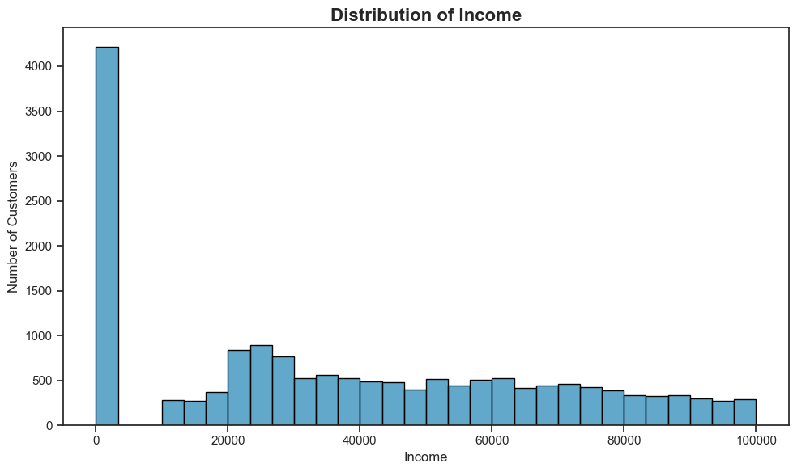
Figure 1: Distribution of Income

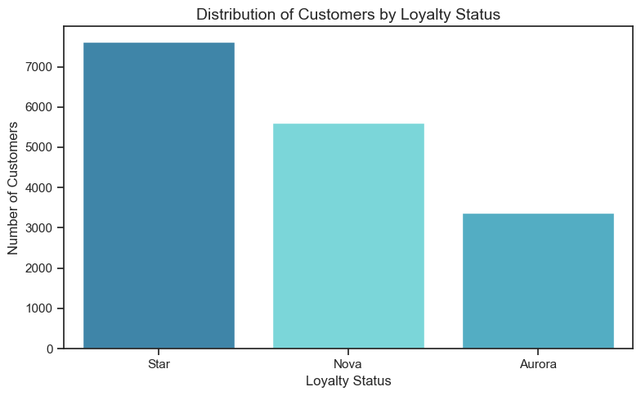
Figure 2: Distribution of Customers by Loyalty Status
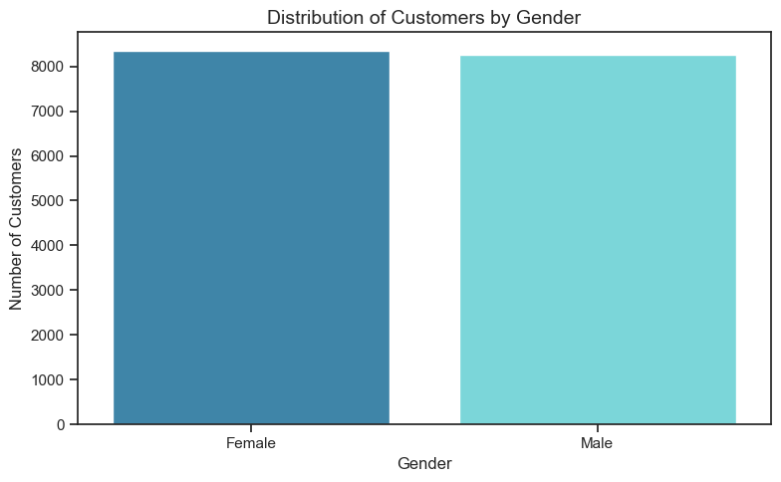
Figure 3: Distribution of Customers by Gender
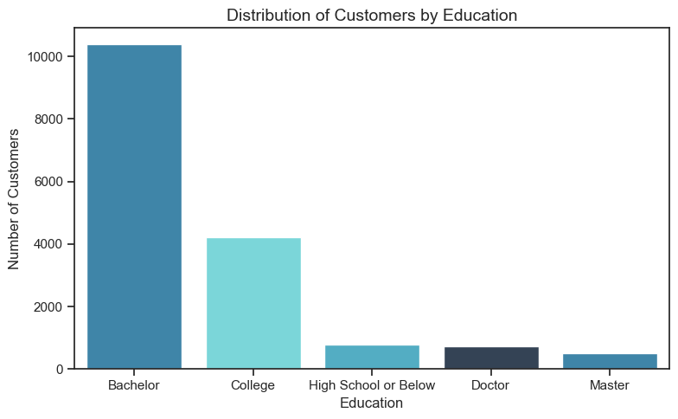
Figure 4: Distribution of Customers by Education
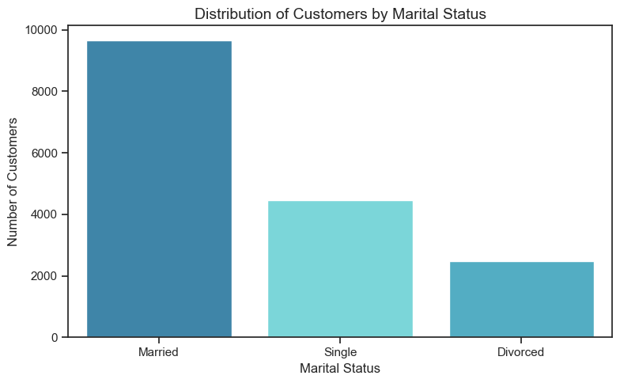
Figure 5: Distribution of Customers by Marital Status
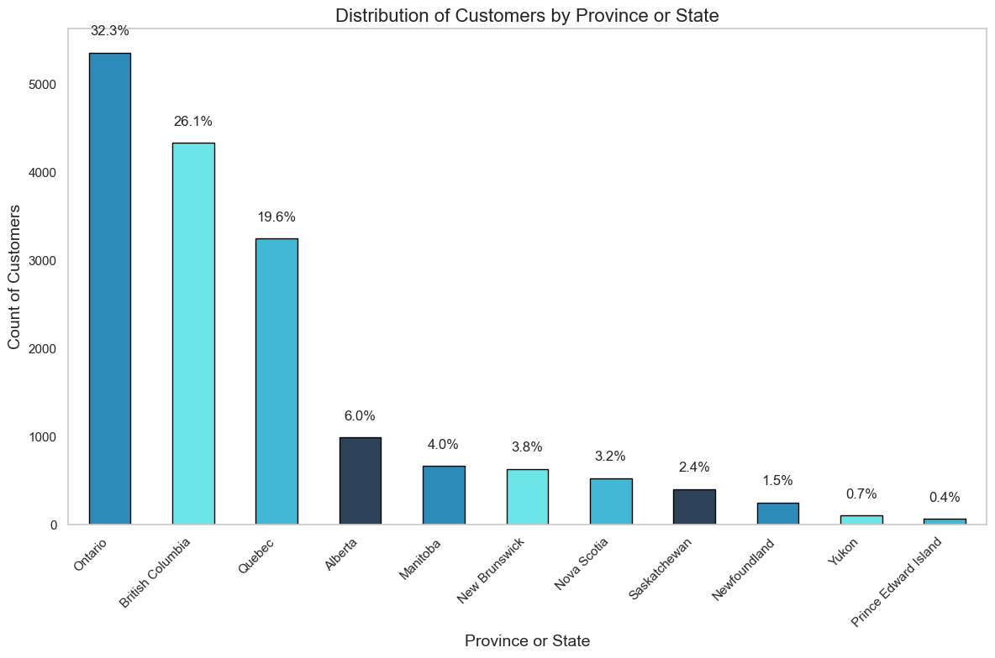
Figure 6: Distribution of Customers by Province or State
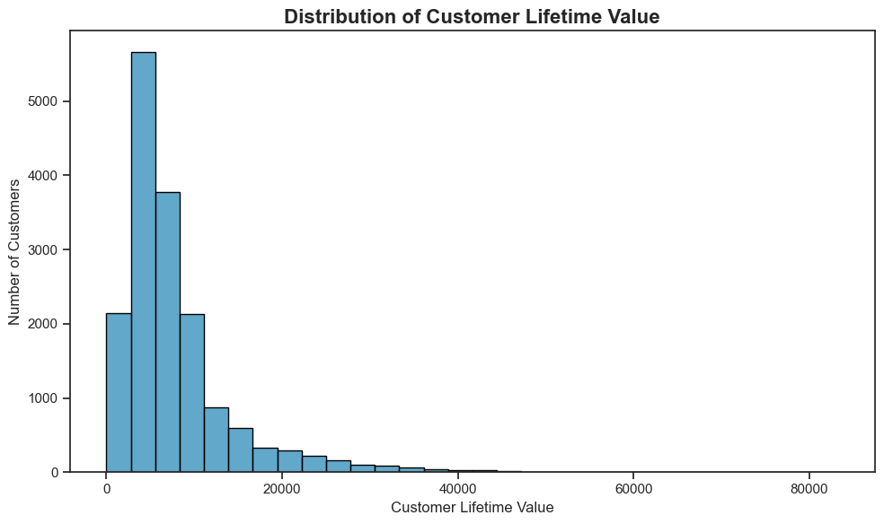
Figure 7: Distribution of Customer Lifetime Value
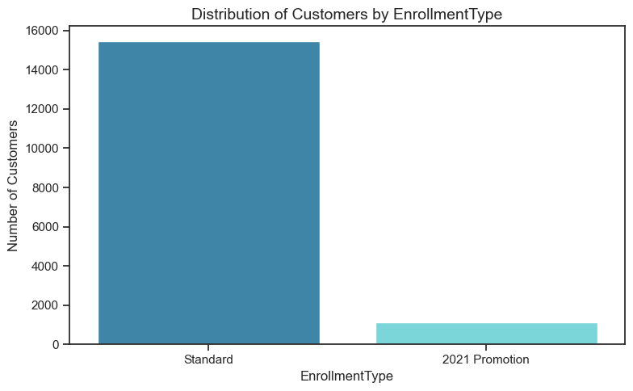
Figure 8: Distribution of Customers by Enrollment Type
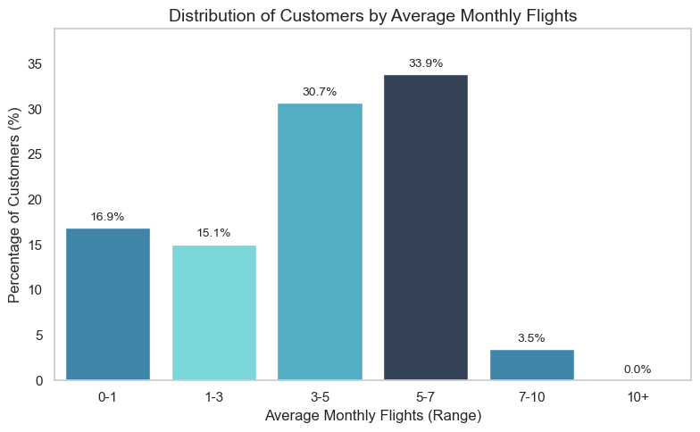
Figure 9: Average Monthly Flights
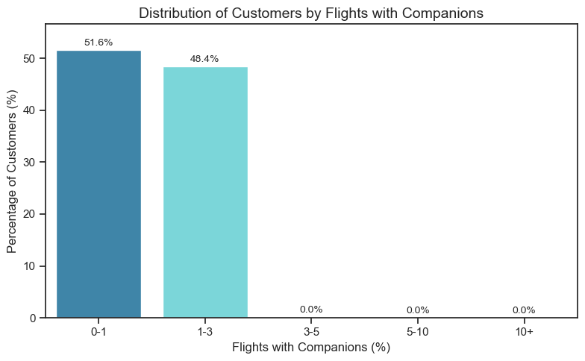
Figure 10: Average Flights per Customer with Companions

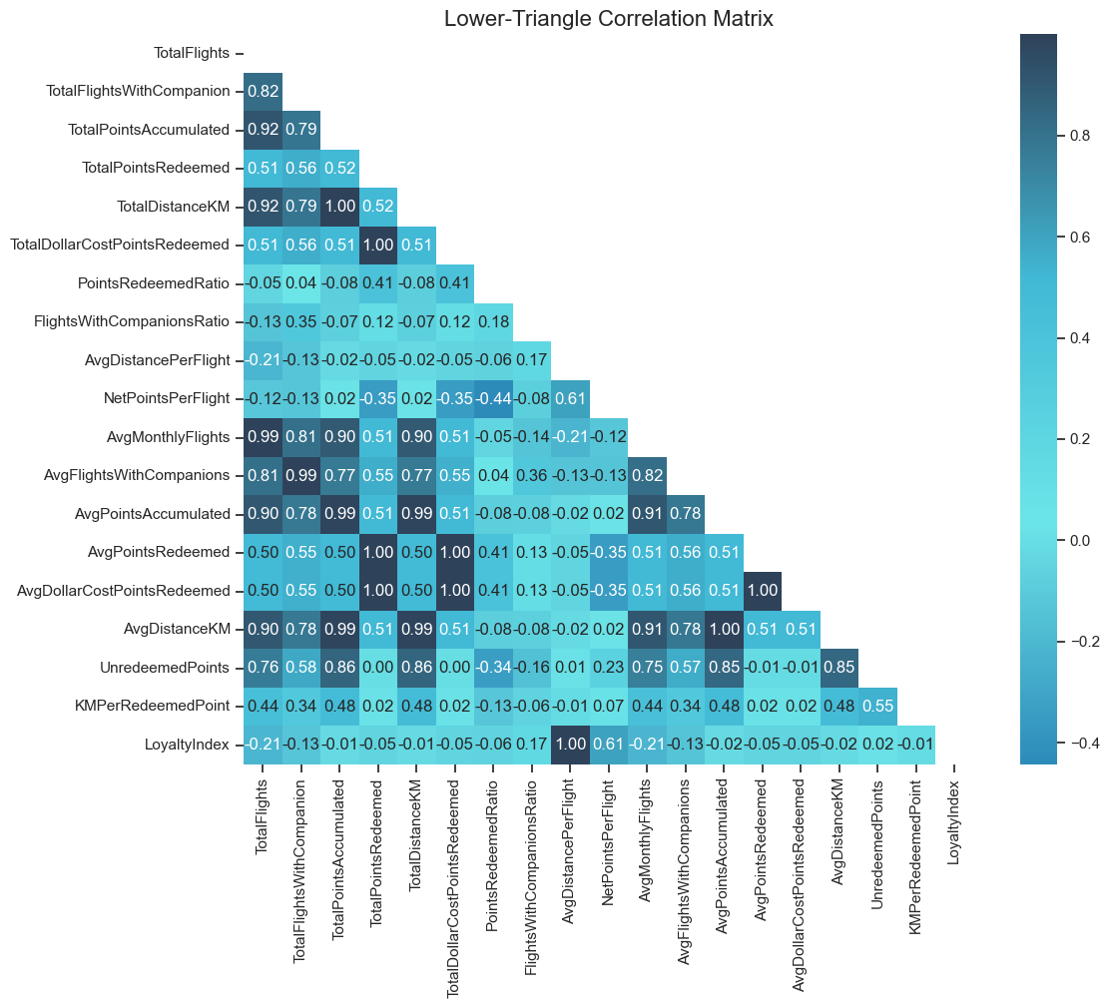
Figure 11: Correlation Matrix between features from FlightsDB

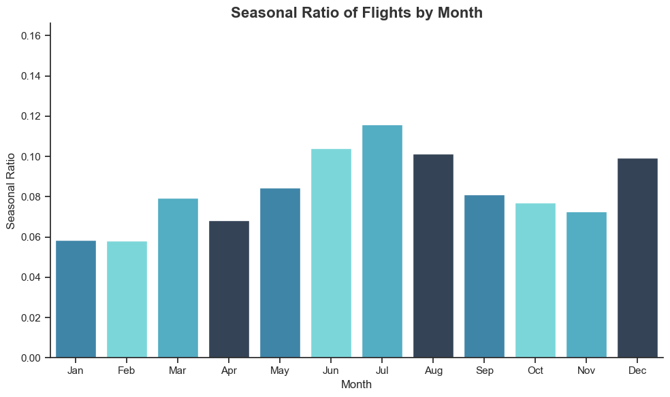
Figure 12: Seasonal Ratio of Flights By Month
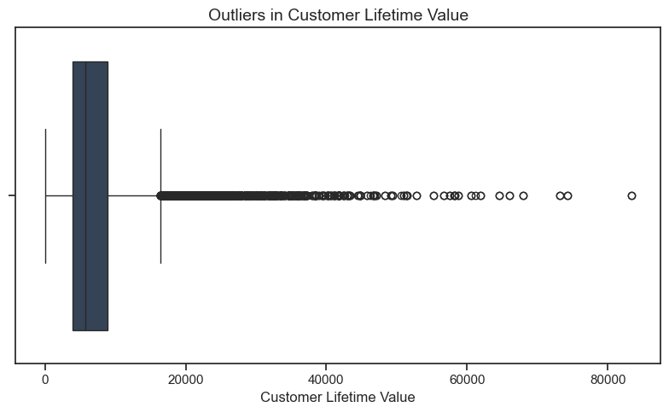
Figure 13: Boxplot of CLV
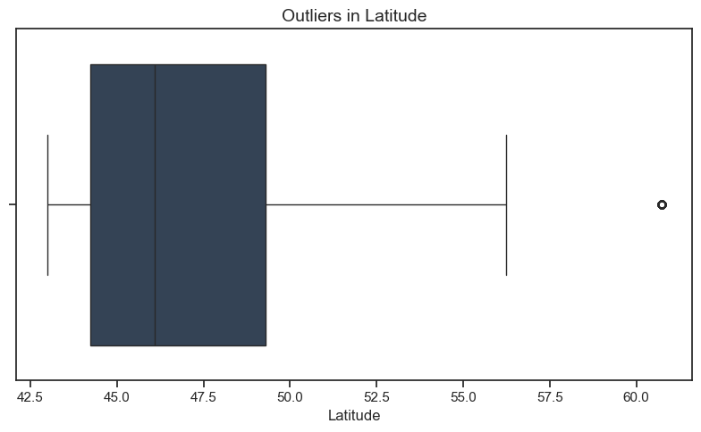
Figure 14: Boxplot of Latitude
Annex AI Usage Statement
AI tools were used for coding syntax assistance (ChatGPT for pandas operations), literature review brainstorming (ChatGPT for industry context ideas), and report proofreading (Grammarly for grammar checks). All analytical insights, business interpretations, and strategic recommendations represent original group analysis and thinking.
Annex Contribution Statement
Student ID: 20240266
- Collaborated on developing exploratory data analysis code, performing quality checks to detect inconsistencies within datasets and analysing visualizations to identify patterns.
- Development of an interactive dashboard for CustomerDB analysis (Bonus Component).
- Contributed to the preparation and drafting of the report.

Student ID: 20250530
- Infographic poster design and creation.
- Implementation of Geo-Spatial Insights for CustomerDB analysis (Bonus component).
- Marketing strategy ideation and contribution to Business Understanding.

Student ID: 20240582
- Supported the development of the exploratory data analysis code, including data quality checks, missing values imputations, and integrity verification.
- Contributed to report writing, documentation, and group discussions on data preparation and variable selection decisions

Student ID: 20240529
- Helped in developing techniques that support and justify certain data points in a more marketing-oriented way of analysis and business understanding.
- Contributed to data exploratory analysis and addressing inconsistencies found in the data analysis.
Annex Responsibility Statement
We, the group members listed above, certify that this report represents our original analytical work and interpretations. While AI tools were used as specified above, all insights, conclusions, and recommendations are the result of our independent analysis and critical thinking. We take full responsibility for the accuracy and quality of this submission.

