Jeffrey Lanning

Brandon Andrews

CS5590BD

6/16/2015

**Lab 1 Report**

The purpose of this lab was to familiarize ourselves with xCode and basic iOS programming using Objective C. The objectives for the lab were to create a new project, three different View Controllers, a Button, and ImageView. In addition, we needed to make the app somewhat interesting.

For the main view of the app, we have an ImageView showing a picture of Robome. Alongside we have a label and button Show that when clicked, changes the label. We have a next button that when clicked takes you to the second view. We thought it would be interesting to show the different robots that we could use in the project and make them say ‘hello’ to the user.

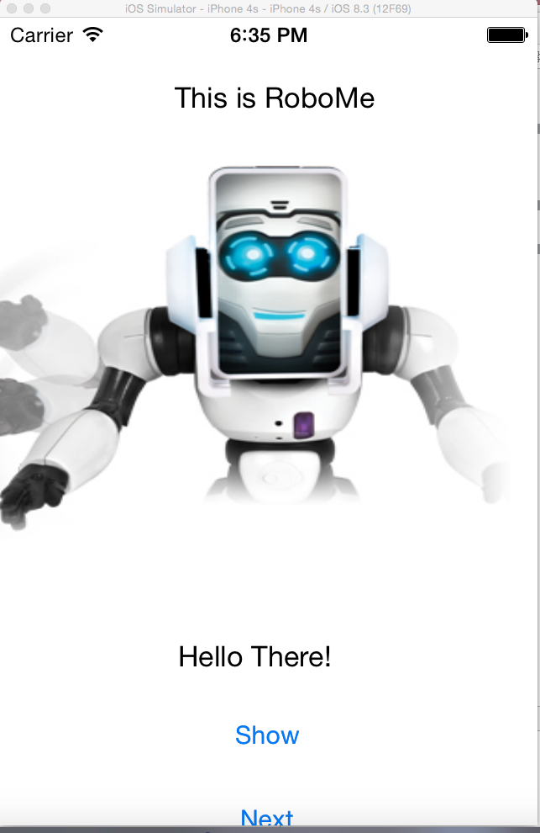

For the second view, we have the Romo, which is an interesting little robot, along with a Next button to take you to the third view.

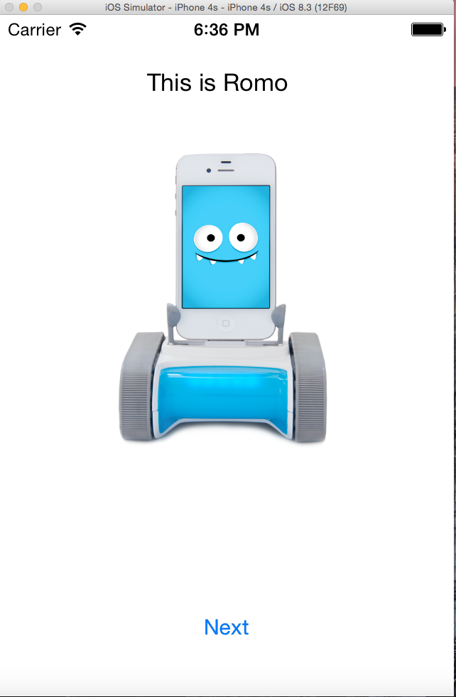

Finally, for the third view, we notify the user that this is the end of the application picture slideshow.

