**Iteration 3: NightBot**

**Application Overview**

Our project is Nightbot which includes the features like to patrol a home to check and ensure that the doors are locked, stand guard to detect motion, and to check the cane movement if it is grounded. Movement and object recognition are the core features of our project. We also implement a crime analysis from the twitter analytics API and recommendation system to detect the crimes in the US. Nighbot is controlled through socket and android application and also connects to Spark. We also have a feature to follow a path on floor to patrol our home. Other features include phone calling, posting crime report to twitter.

**Project iteration 1**

To summarize our iteration 1 we connected our android client to robot and implemented motion control and interactively communicated through voice based commands. This is done using peer to peer communication.The robot is implemented in Objective C and we use Open CV for object recognition to detect street signals to turn left and to stop at red and proceed on green signal. We also utilized GPS features for navigation.

**Project iteration 2**

In iteration 2 we implemented twitter analytics to get the crime data from twitter and report the crimes via twitter. We used the tags #Kcpolice, #Kcpd, #kcmo to find the tweets. We developed a mapreduce job in Scala to get top ten tweets, places and hashtags. We filtered using keywords using kansas city and crime. We used twitter streaming API to collect tweets every two second period interval. WE created MongoDB using Mongolabs to store the data in JSON format. We finally sent the data to iPhone using REST API. We tweeted the text to the user using Twilio API. Below are the output screen shots.

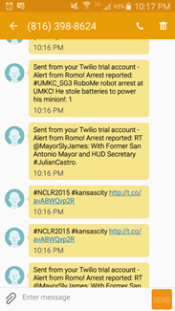Fig1:Twitter output

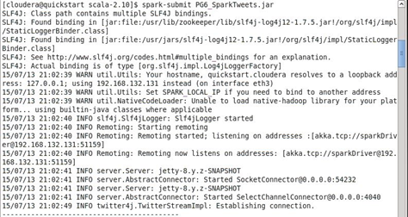

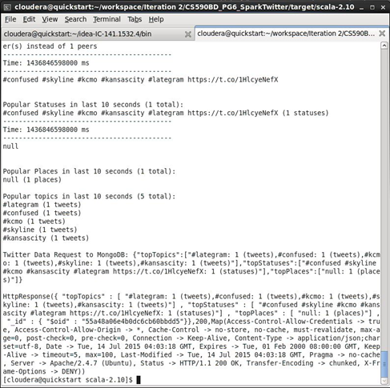

Fig2:Spark output

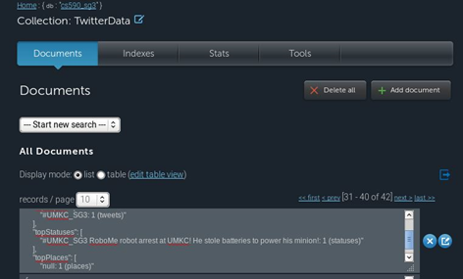

Fig3: MongoDB

**Project Iteration 3**

As a part of iteration 3 we implemented machine learning using SparkML to enable intelligent object recognition. For example, the robot will listen to incoming messages from our Spark server, which will use machine learning via Naive Bayes classification to determine what the object is. It it detects the object is an open door, it will let the user know that there is an open door by sending them a text notification. It will also detect a cane, which is typically something old people would use, and notify the user of that as well. We are also working on recommendations of health care providers based off user ratings of providers, currently we have the data but the system is in progress for the final iteration.

We used Text classification, object classification and Spark recommendation system as part of machine learning to achieve the results.

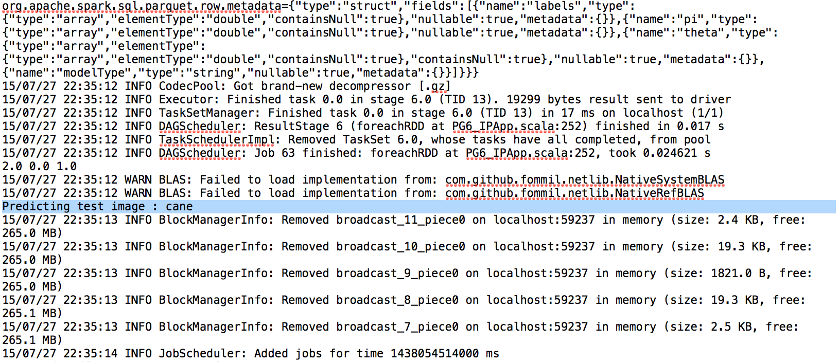

Spark Machine Learning Object Recognition (cane detection)

**References**

We mostly referred the tutorials from class

[**http://stackoverflow.com/questions/29425311/run-sbt-with-ylog-classpath**](http://stackoverflow.com/questions/29425311/run-sbt-with-ylog-classpath)

[**http://docs.mongolab.com/**](http://docs.mongolab.com/)

[**https://spark.apache.org/**](https://spark.apache.org/)